U.S. Radiocommunications Sector
Fact Sheet
Working Party: ITU-R WP 5B | Document No: USWP5B36-05
Ref: Annex 1.4 to Document 5B/435 | Date: 05 March, 2026
Document Title: Annex 1.4 to Working Party 5B Chair’s Report WORKING DOCUMENT TOWARDS A PRELIMINARY DRAFT NEW REPORT ITU-R M.[RLS_AMS_ANTENNAS]
Antenna radiation patterns of radiodetermination radar and aeronautical mobile systems

Author(s)/Contributors(s):  Eric Lee  NTIA  Raafat Nasser  ACES (for NTIA)  Gabriel E. Lafertte Diaz  ACES Inc | Phone: 202-948-1188  Email: Elee@ntia.gov  Phone : 571-277-4030  Email : Raafat.Nasser@aces-inc.com  Phone : 202 340 1109  Email : gabriel.lafertte@aces-inc.com
Purpose/Objective: Given the additional details added it is better to completely replace section 3.3 to answer question from last WP-5B. Also clarified some text and added a new section on the antenna back lobe and added MATLAB code to plot the patterns. Total integrated gain for the average antenna pattern is added.
Abstract: This input proposes replacing 3.3 with the new section.
Updates to section 3.3 for the Taylor-one parameter methodology included peak and average envelopes with mathematical derivation and the inclusion of total integrated gain for the average antenna pattern.
The corrections and the additional technical material with MATLAB code will help the reader better understand the process of generating the peak and average envelopes for the purpose of conducting interference and compatibility studies.

Radiocommunication Study Groups | 
Source: Document 5B/435 | Annex 1.4 to  Document 5B/435-E
Source: Document 5B/435 | 17 December 2025
Source: Document 5B/435 | English only

United States of America
WORKING DOCUMENT TOWARDS A PRELIMINARY DRAFT
NEW REPORT ITU-R M.[RLS_AMS_ANTENNAS]
Antenna radiation patterns of radiodetermination radar and
aeronautical mobile systems

Introduction
This contribution provides an update to the working document towards preliminary draft new Report on antenna radiation patterns of radiodetermination radar and aeronautical mobile systems contained in Annex 1.4 of the WP 5B Chair’s Report, Document 5B/435.
For low peak sidelobes, the cosine on a pedestal pattern produces adjacent sidelobes that are not monotonically decreasing beyond the peak sidelobe. The Taylor one parameter antenna pattern fixed this problem and provides a more familiar patterns especially for radar systems. Additional explanations for the peak and average pattern envelops are provided.
The USA proposes to replace section 3.3 with the new updates.
Attachment: 1

ATTACHMENT
Annex 1.4 to Working Party 5B Chair’s Report
WORKING DOCUMENT TOWARDS A PRELIMINARY DRAFT
NEW REPORT ITU-R M.[RLS_AMS_ANTENNAS]
Antenna radiation patterns of radiodetermination radar and
aeronautical mobile systems
(202X)
[Editor’s note: The material included under the Scope, Section 1, Section 4, and Section 5 has been extracted from contribution 5B/258 and remains subject to further discussion at upcoming meetings.]
[Editor’s note: The material added under section 3.3, still need further discussion at upcoming meetings including some abbreviations need to be clarified and typical parameters for front to back ratio included in TABLE 3.3-2]
Scope
This Report provides the analysis of directive antenna radiation pattern models for radar and aeronautical mobile systems. The Taylor one parameter antenna model is added.
Keywords
Antenna radiation pattern, peak and average mask patterns, radar, aeronautical mobile systems.
List of Abbreviations/Glossary
TBD
Related ITU-R Recommendations and Reports
Recommendations
ITU-R M.1851 Mathematical models for radiodetermination radar and aeronautical mobile systems antenna patterns for use in interference analyses
TBD

1 Introduction
This Report considers some directional antennas used for radar and aeronautical mobile systems except cosecant-squared elevation patterns. Two types of such antennas are analysed: antennas with circular apertures (Section 2) and antennas such as reflector antennas with non-symmetrical beam (narrow beam in one plane and wide beam in the perpendicular plane) and antenna arrays with suppressed sidelobes (Section 3). The Taylor one parameter antenna pattern is added to ensure that sidelobes adjacent to the peak sidelobe are monotonically decreasing. The question of average peak radiation patterns is considered also (Section 4).

2 Circular aperture antennas
Circular apertures are generally used to provide narrow symmetric beam due to symmetrical aperture distribution.

2.1 Antenna radiation pattern requirements
Field aperture distribution of reflector antennas is determined mainly by feed radiation pattern and its projection on the reflector aperture. As the feed radiation pattern cannot be ideally uniform in the desired angle range and equal to zero outside it, the real field aperture distribution will be between uniform distribution and distribution with zero amplitude on the antenna edge. The level of the aperture edge illumination comparing with the illumination of the center of the aperture is characterized by pedestal denoted here as $C$ (see Figure 1). This document considers only amplitude distributions.
Figure 1
Field aperture distributions with pedestal
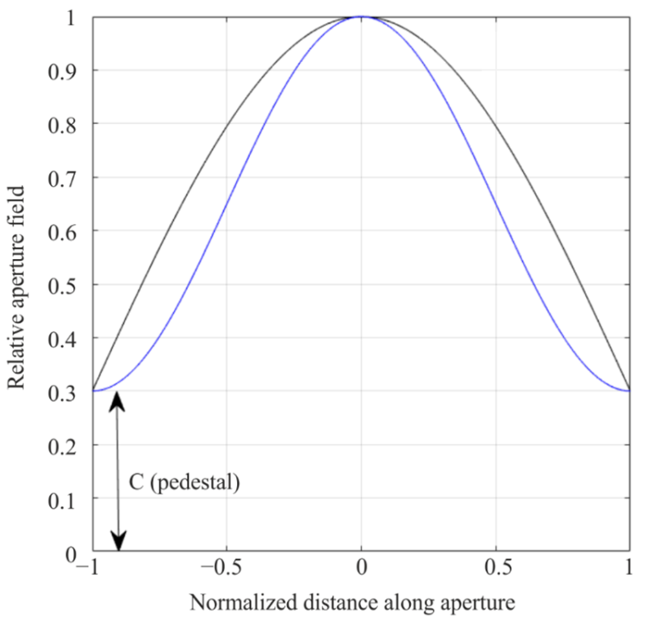
The field aperture distribution determines all main parameters of the antenna, i.e. gain, beamwidth, first side-lobe level (SLL), shape of the radiation pattern, efficiency. Some of these parameters are discussed in the sections below in order to find requirements and possible assumptions for reference radiation pattern model.

2.1.1 Side-lobe envelope
For reflector antennas with circular aperture examples of the side-lobe envelopes are given in [1, p. 15-55]: ‘An excellent treatment on very large earth antenna sidelobes was given by Korvin and Kreutel, who presented results of both theoretical and measured studies for aperture ranging from 100 to 600 wavelenghts’. These results are copied here in Figures 2 and 3 for cassegrain-fed and prime focus-fed parabolic reflectors, respectively.

Figure 2
Circular aperture envelopes from [1] for cassegrain-fed reflector antenna
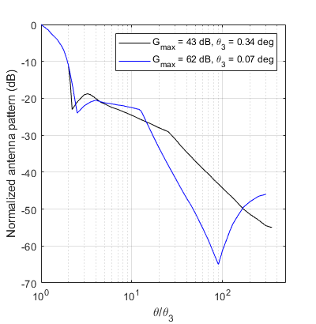

Figure 3
Circular aperture envelopes from [1] for prime focus-fed reflector antenna
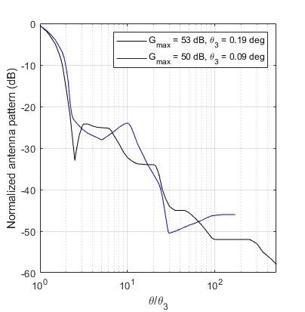

For such large antennas (apertures 100 and 600 wavelengths) in case of cassegrain antenna the ‘end’ of the envelope for 90 degrees is not less than −65 … 45 dB and in case of primary-fed antenna it is not less than −58 … −45 dB.
Even if the models in Recommendation ITU-R M.1851-2 have mask front-to-back floor level which permits to exclude the drastic decrease of radiation patterns in the angles approaching 90 degrees (front-to-back floor level is −50 dB for SLL from −24.2 to −17.66 dB, −60 dB SLL from −24.2 to −34.7 dB, −70 dB for SLL from −44.72 to −34.7 dB), the question of the side-lobe envelope remains actual. The envelope between the first side-lobe and the angle where begins front-to-back floor level may be quite different depending on the aperture distribution. One example of this effect is shown in Figure 4 for parabolic distribution raised to power 3. The first side-lobe level is the same but further side-lobes are quite different due to different amplitude taper (pedestal $C$).
Figure 4
Antenna patterns for parabolic distributions raised to power 3 with different amplitude taper
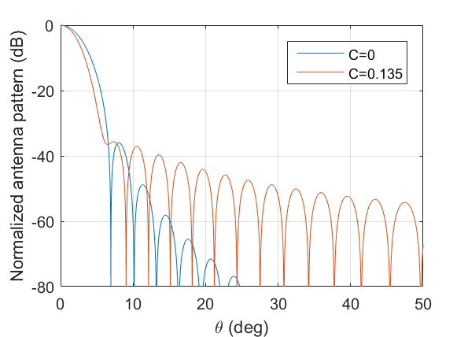
The differences in antenna radiation will be up to 18 dB. This will impact the sharing studies results.

2.1.2 First side-lobe level
The key parameter which is always given for directive radar and aeronautical mobile antennas is the first side-lobe level. The analysis of all M-series ITU-R Recommendations relating to radiodetermination and aeronautical mobile systems gives distribution of SLL for all circular aperture antennas presented in Figure 5 as of 2024 (some artefacts such as very high side-lobes were excluded). The following ITU-R Recommendations were analyzed (including currently revised versions and newly developed Recommendations): ITU-R M.1460, ITU-R M.1464, ITU-R M.1638, ITU-R M.1644, ITU-R M.1796, ITU-R M.1849, ITU-R M.2007, ITU-R M.2089, ITU-R M.2114, ITU-R M.2116, ITU-R M.2162, ITU-R M.[24.45-24.65_GHz_ARNS], M.[15.4-15.7_GHz_ARNS], ITU-R M.[AMS CHARACTERISTICS_1 780-1 850 MHz].
Figure 5
SLL of circular aperture antennas from M-series ITU-R Recommendations
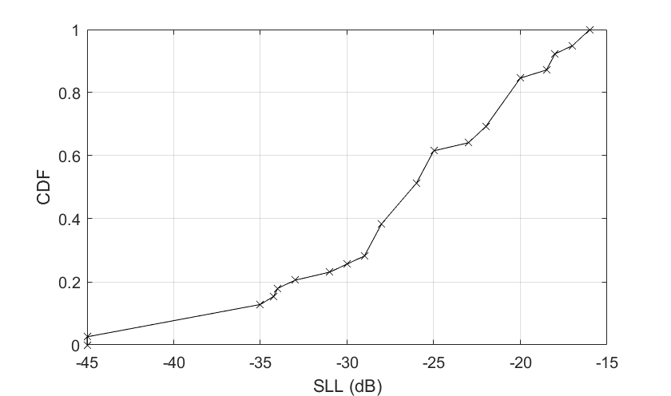
The lowest side-lobe level for circular apertures is in Recommendation ITU-R M.1849: −45 dB (−25 to −45 dB) for solid parabolic reflector with pencil beam (meteorological radar in 5 250-5 725 MHz, Radar 9). So the lowest required first side-lobe level is −45 dB for circular aperture model.

2.1.3 Efficiency
Antenna efficiency is tightly connected with the amplitude aperture distribution. Three examples from the literature are presented below to illustrate the trade-off between aperture illumination and (feed antenna radiation pattern) and efficiency.
The first example is from [2, p. 413] (Figure 6 in this Report). It is the dependence of aperture efficiency ($ε_{t}$), spillover ($ε_{s}$) and total efficiency ($ε_{i}$) as a function of edge illumination (pedestal in decibels). The feed radiation pattern is taken as idealized $\cos^{2}{θ}$.
Figure 6
Example of reflector antenna efficiency from [2]
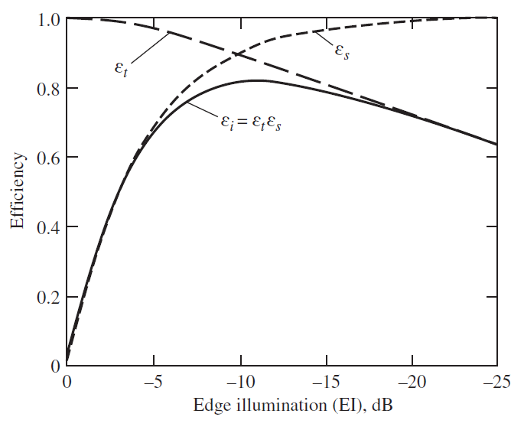
The citation from [2]: ‘The trade off between taper and spillover is evident. The peak value is about $ε_{i}$=82% and occurs for an edge illumination of about -11 dB.’ The distribution with zero pedestal corresponds to minus infinity on the horizontal axis. The same example is also contained in [1, p. 15-22].
The second example is from [3, pp. 12.8-12.9] (Figure 7 in this Report). Here also another type of loss – feed blockage – is taken into account.
Figure 7
Example of reflector antenna efficiency from [3]
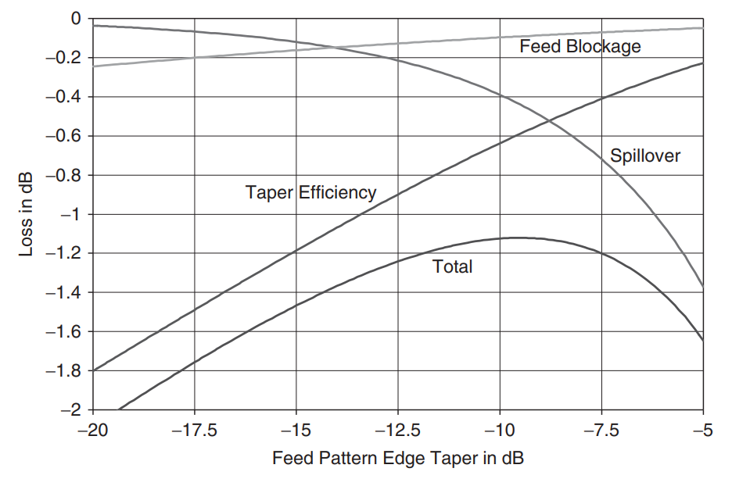
The citation from [3]: ‘Computed losses are shown in figure … for a 20-wavelength diameter center-fed circular reflector with a 10-wavelength focal length, and a gaussian feed horn (a horn with a radiation pattern described by a gaussian function) … The feed size determines the edge taper, i.e. the larger the feed, the greater the edge taper. … When the edge taper is low, virtually all the power strikes the reflector and the loss is insignificant. As taper decreases, there is more spillover, and feed power misses the reflector, increasing the loss. On the other hand, with too much taper, the taper efficiency is poor because the reflector is under illuminated.’
For this case, taking into account feed blockage, the optimal edge taper is −9.5 dB and it gives 77% of total efficiency. The zero pedestal distribution corresponds to minus infinity on the horizontal axis.
The third example is from [4, p. 921] (Figure 8 in this Report). Here the feeds are corrugated horns with different flare angles ($ψ_{0}$). The horizontal axis is ‘reflector angular aperture $θ_{0}$’.
Figure 8
Example of reflector antenna efficiency from [4]
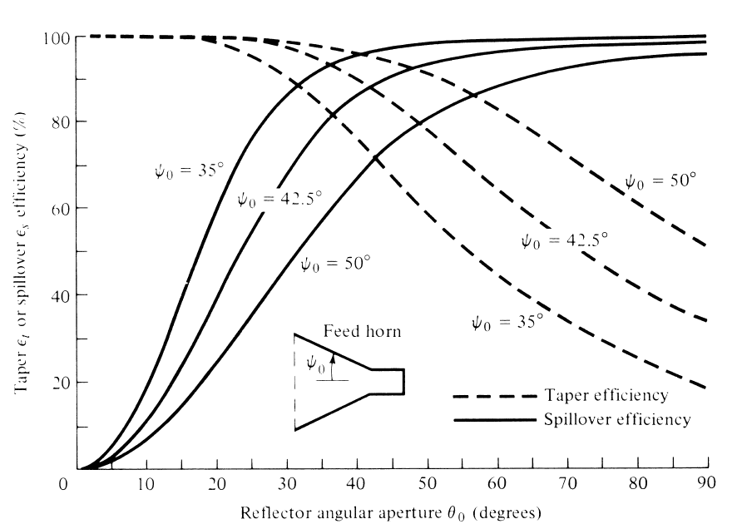
This example is a little bit different comparing with the first two examples as it doesn’t explicitly show pedestal values but reflector angle aperture $\left(θ_{0}\right)$. When this angle is equal to 0 degrees it corresponds to pedestal equal to 1 (spillover efficiency is 0, aperture (taper) efficiency is 1 – it is a uniform distribution). Reflector angle aperture equal to 90 degrees corresponds to pedestal equal to 0 (spillover efficiency is 1, aperture (taper) efficiency is low). The increase of feed horn aperture angle ($ψ_{0}$ – flare angle) leads to increase the feed beamwidth (when size of the feed aperture is fixed). It may be seen that in this example the optimum parameters are somewhere in the middle of two extremes (C=0 and C=1) as shown in Figure 9 below [4, p. 921] (it is the overall reflector antenna efficiency).
Figure 9
Example of overall reflector antenna efficiency from [4]
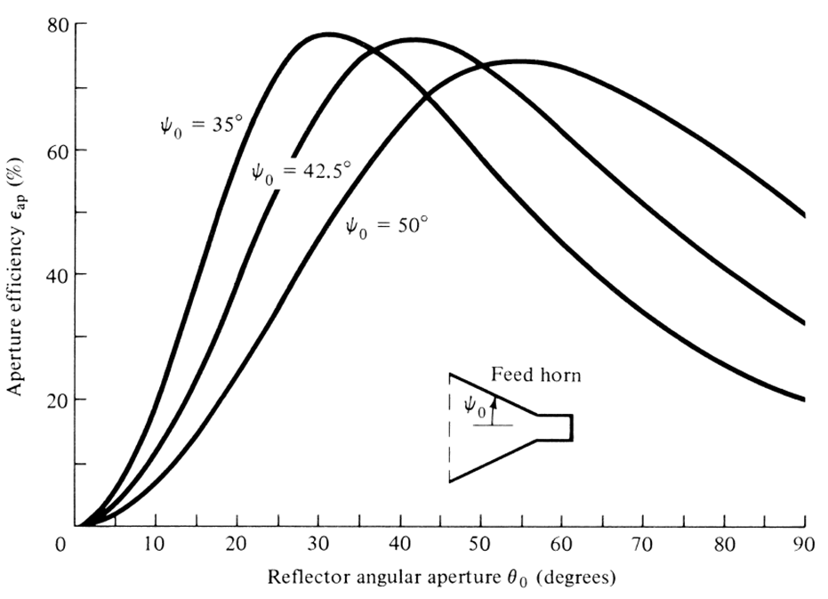
So, from antenna design point of view reflector antennas are designed in such a way to provide a compromise of aperture (taper) efficiency and spillover, i.e. between one of the two extremes – uniform amplitude distribution and amplitude distribution with zero field on the edge of the antenna. Amplitude distribution with exact zero on the edge cannot be realized and is not usable.

2.1.4 Requirements for the circular aperture reference model
Based on the material presented in Sections 2.1.1 – 2.1.3 the following requirements for reference antenna radiation pattern may be formulated:
– minimum first side-lobe level is −45 dB
– envelope should not be steeper than in Figures 2 and 3
– field on the edge of the aperture cannot be exactly zero.
Amplitude distribution on the circular aperture may be approximated in different ways but the simplest one is parabolic distribution raised to some power and on some pedestal. In Section 2.2 this aperture distribution is analyzed and reference radiation pattern is presented.

2.2 Parabolic distributions

2.2.1 Radiation patterns for parabolic distributions
Electric field of parabolic aperture distribution is as follows [2]:
$E\left(x\right)=C+(1-C){(1-x^{2})}^{n}$, (1)
where:
$x$: normalized distance along aperture (see Figure 1)
$n$: numeric parabolic taper power value.
The normalized directivity pattern for parabolic distribution with different tapers on a pedestal $C$ is given by the following equation ([2]):
$F\left(θ,n\right)=\frac{\frac{2J_{1}\left(βa\sin\left(θ\right)\right)}{βa\sin\left(θ\right)}+\frac{(1-C)}{n+1}\frac{2^{n+1}\left(n+1\right)!J_{n+1}\left(βa\sin\left(θ\right)\right)}{{\left(βa\sin\left(θ\right)\right)}^{n+1}}}{C+\frac{(1-C)}{n+1}}$ (2)
where:
$β$: free space constant = $\frac{2π}{λ}$, where λ in metre
a: radius of the antenna, in metre
$J_{n}$: Bessel function of the first kind
$λ$: wavelength
n: numeric parabolic taper power value.
In equation (2) $a=\frac{πK}{θ_{3}}$ where $K$ is beamwidth factor and $θ_{3}$ is antenna pattern 3 dB half power beamwidth, in degrees, so equation (2) can be written as:
$F\left(θ,n\right)=\frac{\frac{2J_{1}\left(\frac{πK}{θ_{3}}\sin\left(θ\right)\right)}{\frac{πK}{θ_{3}}\sin\left(θ\right)}+\frac{(1-C)}{n+1}\frac{2^{n+1}\left(n+1\right)!J_{n+1}\left(\frac{πK}{θ_{3}}\sin\left(θ\right)\right)}{{\left(\frac{πK}{θ_{3}}\sin\left(θ\right)\right)}^{n+1}}}{C+\frac{(1-C)}{n+1}}=\frac{\frac{2J_{1}\left(μ\right)}{μ}+\frac{(1-C)}{n+1}\frac{2^{n+1}\left(n+1\right)!J_{n+1}\left(μ\right)}{μ^{n+1}}}{C+\frac{(1-C)}{n+1}}$, (3)
where:
$μ=\frac{π K \sin{(θ)}}{θ_{3}}$
where:
$θ_{3}$: is the 3-dB antenna half-power beamwidth (degrees)
$K$: beamwidth factor (degrees).
$θ_{3}=K\left(\frac{λ}{a}\right)$ (4)
where:
$a$: diameter of the antenna (meter).
The equations for model without pedestal can be obtained from equations (2) or (3) substituting $C=0$.
Figure 10 shows the first side-lobe level depending on pedestal for parabolic distributions raised to powers n=0, 1, 2, 3 and 4 (n=0 is a uniform distribution).
Figure 10
SLL for parabolic distributions raised to power n with different tapers
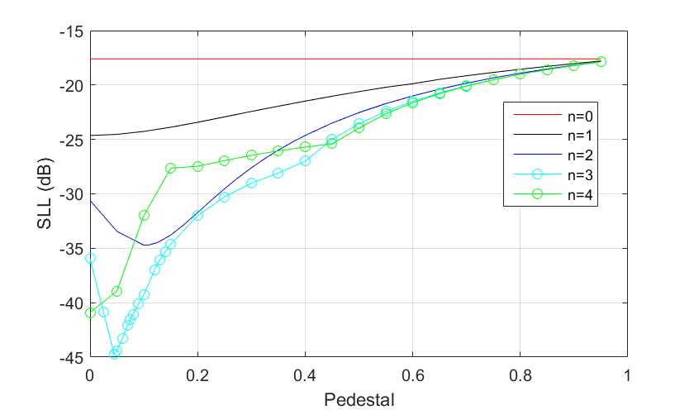
Figure 11 shows aperture efficiencies depending on pedestal for parabolic distributions raised to powers n=0, 1, 2, 3 and 4. This figure is calculated by the following equation [2]:
$ε_{aperture}=\frac{{(C+\frac{1-C}{n+1})}^{2}}{C^{2}+\frac{2C(1-C)}{n+1}+\frac{{(1-C)}^{2}}{2n+1}}$ (5)
Figure 11
Aperture efficiency for parabolic distributions raised to power n with different tapers
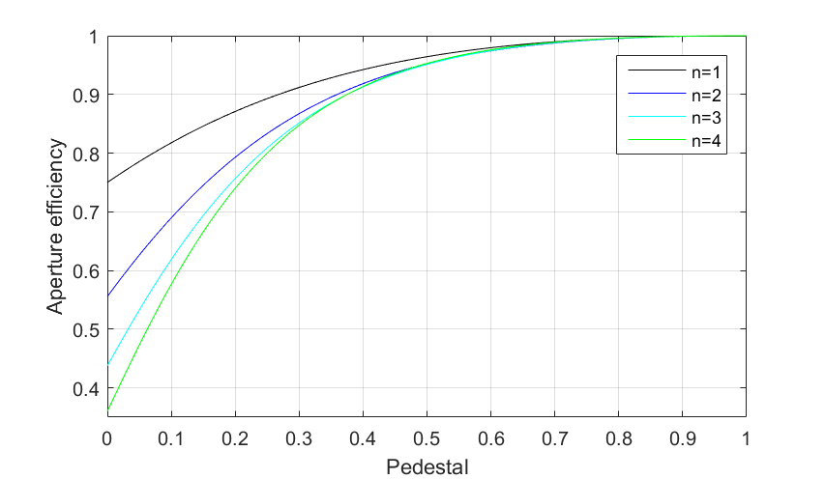
Figure 12 shows beamwidth factor $K$ depending on pedestal for parabolic distributions raised to powers n=0, 1, 2, 3 and 4. It shows that the more tapered is distribution, the bigger should be antenna to get the same beamwidth.
Figure 12
Beamwidth factor for parabolic distributions raised to power n with different tapers
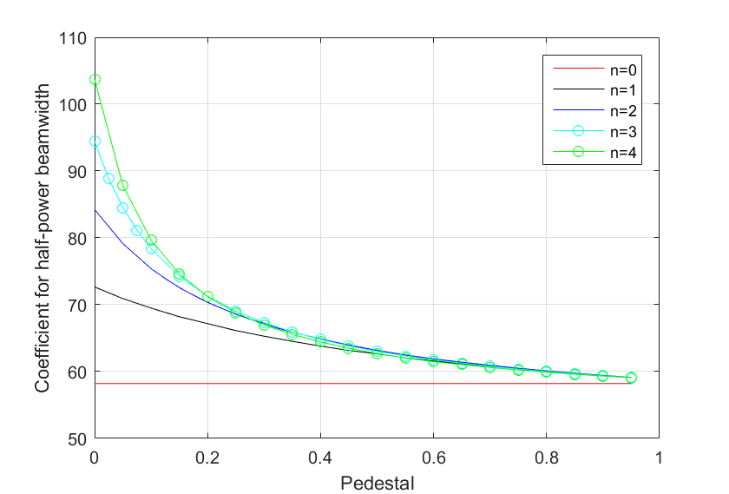
Region near $C=0$ will be considered furthermore thoroughly.
Figure 13 shows radiation patterns for distributions with $C=0$. Even if the mask front-to-back floor is −50 dB, −60 dB, −70 dB and −80 dB for n=1, 2, 3, 4 (shown with red horizontal lines), respectively, the envelopes are too steep comparing with results even for very large earth station antennas (see Figures 2 and 3, [1]).
Figure 13
Antenna pattern for parabolic distributions raised to power n with C=0
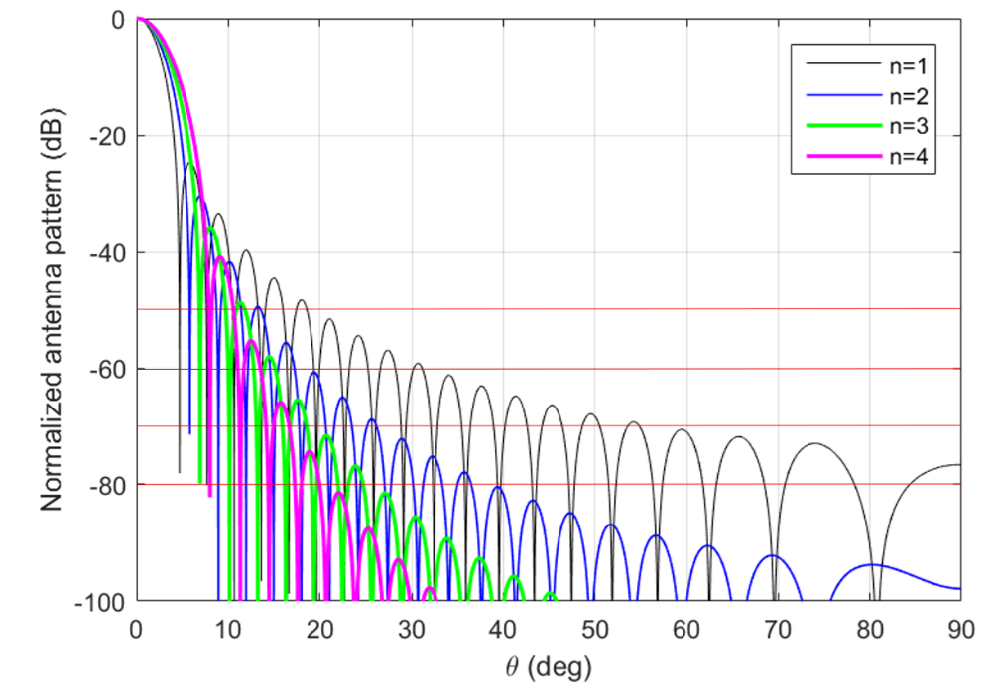
Table 1 shows in the second column the increase of the size of the aperture with zero field on the edge to get the same beamwidth as with a uniform distribution. The third column shows aperture efficiencies (the same as in Figure 11 for pedestal equal to zero).
Table 1
Characteristics of circular aperture antennas with zero pedestal distributions
Parabolic distribution raised to power $n$ with $C=0$ | The increase of the aperture to get the same beamwidth as with a uniform distribution | $$ε_{aperture}$$
1 | 1.25 | 0.75
2 | 1.44 | 0.5556
3 | 1.65 | 0.4375
4 | 1.86 | 0.36

The other point is how seriously changes the radiation pattern when amplitude on the edge of the aperture is not exactly 0, but, for example, C=0.01 (1% of the illumination of the center of the aperture). Figures 14, 15 and 16 shows radiation patterns for n=2, 3 and 4 near C=0.
Figure 14
Antenna pattern for parabolic squared distribution near C=0
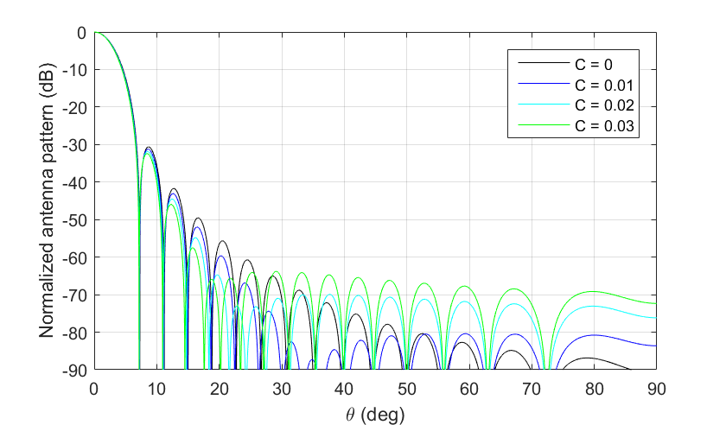
Figure 15
Antenna pattern for parabolic distribution raised to power 3 near C=0
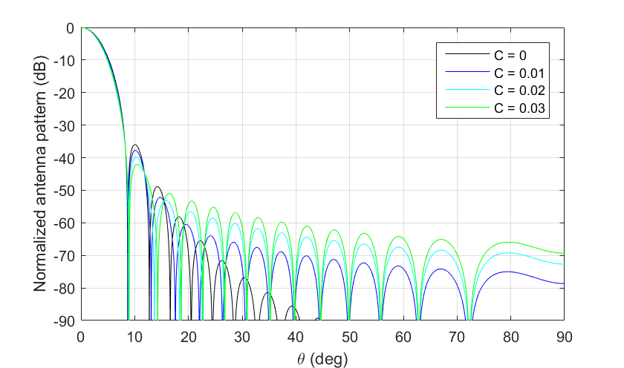
Figure 16
Antenna pattern for parabolic distribution raised to power 4 near C=0
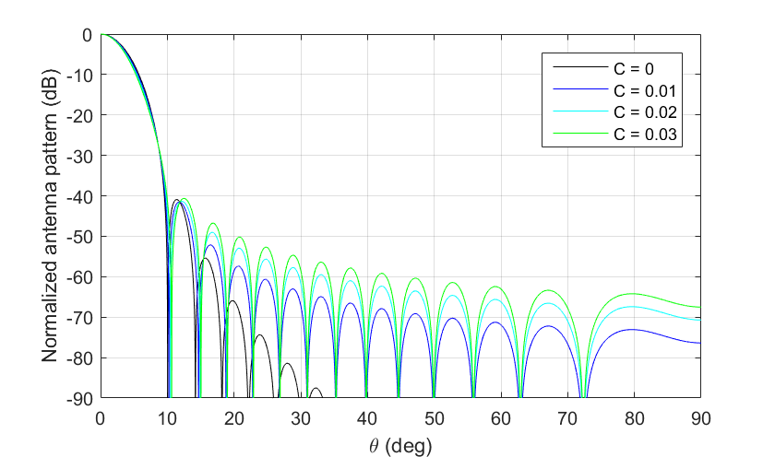
In all these three cases the change of the amplitude on the edge even on 1% lead to very serious change of the overall side-lobe envelope. Taking into account that the amplitude distribution cannot be realized without any even very small random aperture errors, the radiation pattern will be very unstable near C=0.
The other problem of the simplified approach with zero pedestal is that it gives only discrete values of SLL (see Figure 10): −17.66 dB, −24.64 dB, −30.61 dB, −35.96 dB and −40 dB and the difference between intended SLL (SLL from the characteristics of system) and SLL of the calculated output model may be very large.

2.2.2 Peak reference radiation patterns for parabolic distributions
The reference radiation pattern for circular aperture should be as follows:
– SLL from −17.66 to −45 dB (see Section 2.1.2)
– have representative envelopes (see Section 2.1.1).
The reference radiation pattern model for parabolic distributions on a pedestal is organized in the way as it is shown schematically in Figure 17.
Figure 17
Schema for formulation of the reference radiation pattern of parabolic distributions
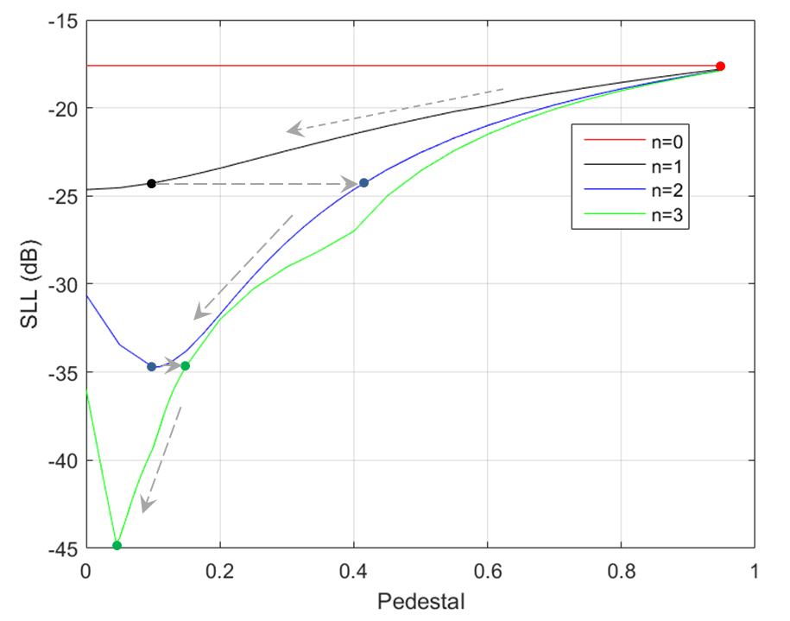
The arrows show how will change the aperture distribution with the decrease of SLL. It is sufficient to take $n$ only up to 3 as it will approximately cover SLL equal to −45 dB.
The input data for the model should be:
– 3 dB beamwidth
– SLL.
The output reference antenna model will have approximately the same SLL. The choice of power $n$ will be performed ‘automatically’ based on the input SLL.
The algorithm is as follows:
Step 1. To determine value of $n$ based on input SLL.
Step 2. To find approximation of pedestal $C$ and beamwidth factor $K$ based on SLL, Table 2 contains the corresponding formulas.
TABLE 2
Approximation of pedestal $C$ and beamwidth factor $K$ based on SLL for circular parabolic aperture antenna
Parabolic distribution raised to power $n$ | Range of maximum side-lobe level below normalized main lobe peak  (dB) | Pedestal C | Beamwidth factor K  (°)
0 | −17.66 | - | 58.2125
1 | −17.66 to −24.2 | $$C=0.0016{(SLL+24.265)}^{3}-0.009{\left(SLL+24.265\right)}^{2}+0.12\left(SLL+24.265\right)+0.1$$ | $$K=0.0051{(SLL+24.265)}^{4}-0.089{\left(SLL+24.265\right)}^{3}+0.599{\left(SLL+24.265\right)}^{2}-3.11\left(SLL+24.265\right)+69.43$$
2 | −24.2 to −34.7 | $$C=(0.0022{\left(SLL+34.7\right)}^{3}-0.032{\left(SLL+34.7\right)}^{2}+0.38\left(SLL+34.7\right)+1.1)/10$$ | $$K=0.0019{\left(SLL+34.7\right)}^{4}-0.052{\left(SLL+34.7\right)}^{3}+0.492{\left(SLL+34.7\right)}^{2}-2.63\left(SLL+34.7\right)+74.9$$
3 | −34.7 to −44.72 | $$C=0.01008 SLL+0.4959$$ | $$K=0.0057 {SLL}^{3}+0.7079 {SLL}^{2}+28.061 SLL+433.7618$$

Step 3. To calculate antenna pattern based on equation (3) and to convert it to decibels.
Step 4. To find its peak envelope, the envelope is calculated as in Table 3. The main lobe is taken from Step 3 as it is, the breakpoint between main lobe and side-lobe envelope is determined numerically.
Step 5. To limit the reference radiation pattern by the mask front-to-back floor level, if needed (see last column in Table 3).
TABLE 3
Peak normalised theoretical mask pattern for circular parabolic aperture antenna
Parabolic distribution raised to power $n$ | Mask equation beyond pattern break point where mask departs from theoretical pattern  (dB) | A | B | Mask floor level  (dB)
0 | $$-A\ln{\frac{B\left|θ\right|}{θ_{3}}}$$ | 12.55 | 2.394 | −35
1 | $$-A\ln{\frac{B\left|θ\right|}{θ_{3}}}$$ | $$A=-0.00227{(SLL+17.66)}^{5}-0.02745{(SLL+17.66)}^{4}-0.1224{(SLL+17.66)}^{3}-0.204{(SLL+17.66)}^{2}-0.1727(SLL+17.66)+12.2586$$ | if $SLL≥-24.2$ and $SLL≤-21.55$:  $$B=0.083177 {SLL}^{3}+5.4731 {SLL}^{2}+119.8649 SLL+877.4646$$  if $SLL≥-21.55$ and $SLL≤-17.66$:  $$B=-0.2471 SLL-1.6534$$ | −50
2 | $$-A\ln{\frac{B\left|θ\right|}{θ_{3}}}$$ | if $SLL≥-34.7$ and $SLL≤-31.55$:  $$A=-0.06419753 {SLL}^{3}-6.17611 {SLL}^{2}-198.013 SLL-2105.5$$  if $SLL≥-31.55$ and $SLL≤-24.2$:  $$A=0.0053 {SLL}^{2}+0.4366 SLL+18.714$$ | if $SLL≥-34.7$ and $SLL≤-32.6$:  $$B=-1.5961 {SLL}^{2}-106.45 SLL-1758.7$$  if $SLL≥-32.6$ and $SLL≤-24.2$:  $$B=0.0656 {SLL}^{2}+2.574 SLL+29.4$$ | −60
3 | $$-A\ln{\frac{B\left|θ\right|}{θ_{3}}}$$ | $$A=0.0005{(SLL+34.7)}^{3}+0.0022{(SLL+34.7)}^{2}+0.0324(SLL+34.7)+11.7177$$ | B=$-0.0219{(SLL+34.7)}^{3}-0.148{(SLL+34.7)}^{2}-0.856(SLL+34.7)+7.64$ | −70

In Figure 18 a number of reference radiation patterns obtained by the algorithm described above is presented for the full SLL range (from −17.66 to −44.72 dB) and beamwidth 6 degrees.
Figure 18
Reference radiation patterns based on parabolic distributions for different SLL
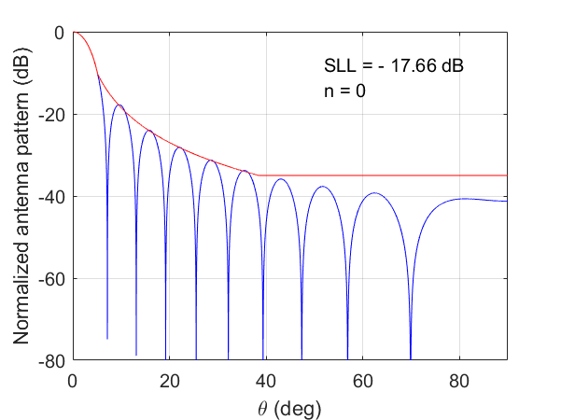 | 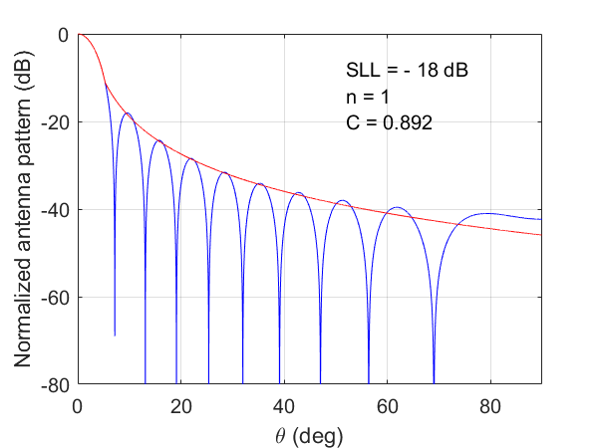
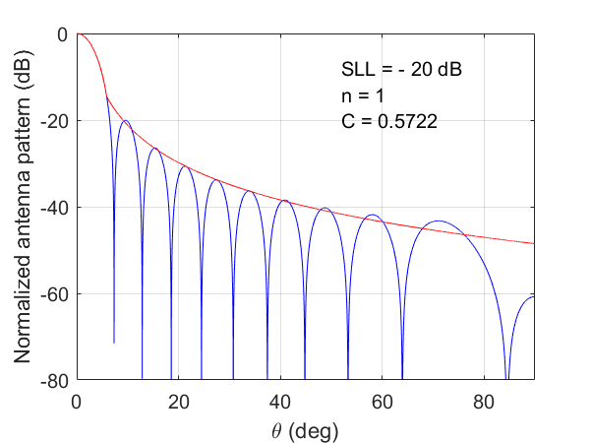 | 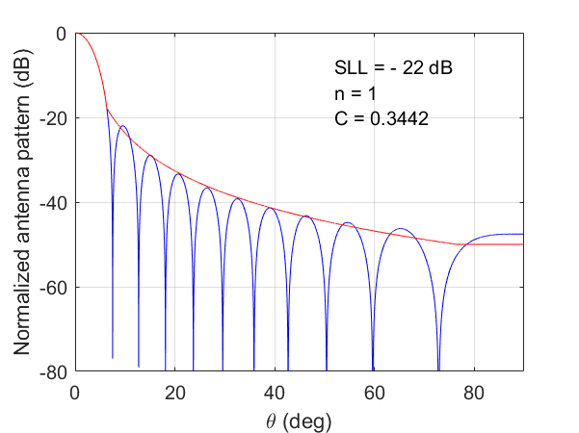
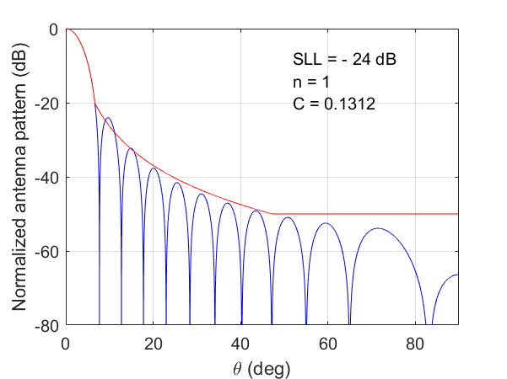 | 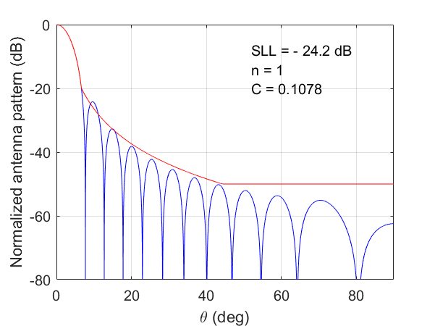
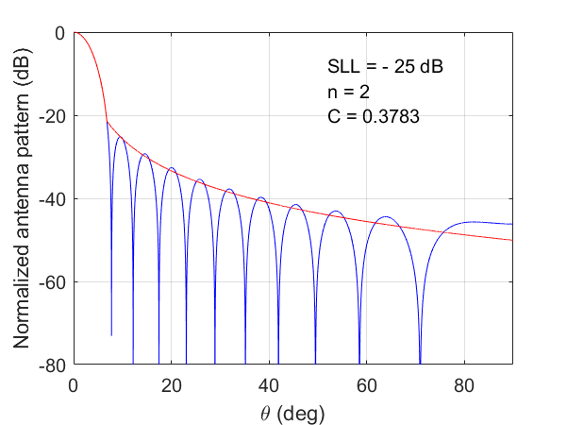 | 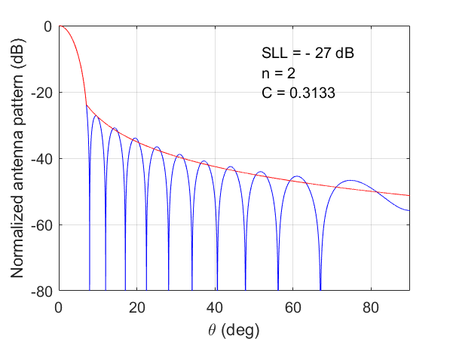
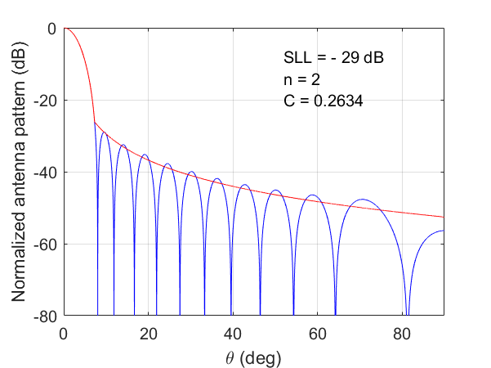 | 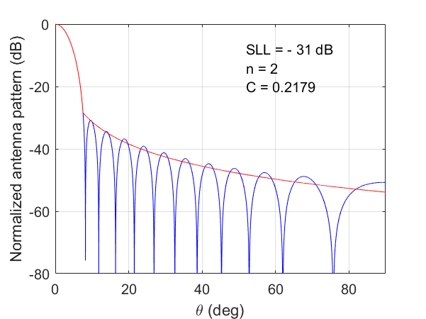
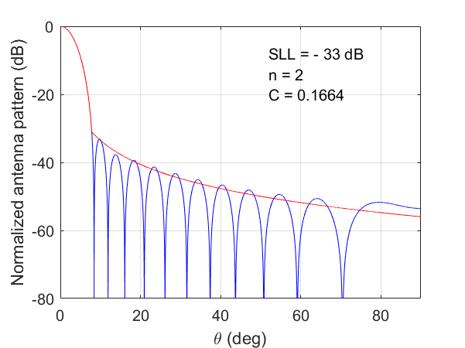 | 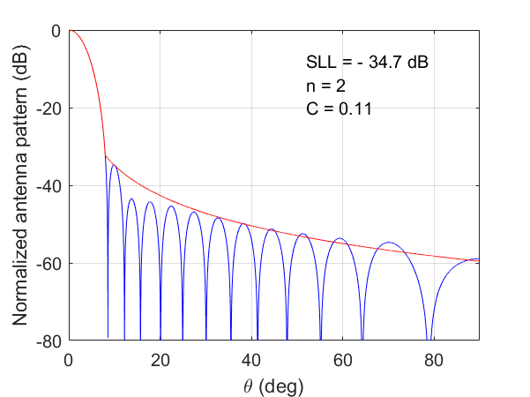
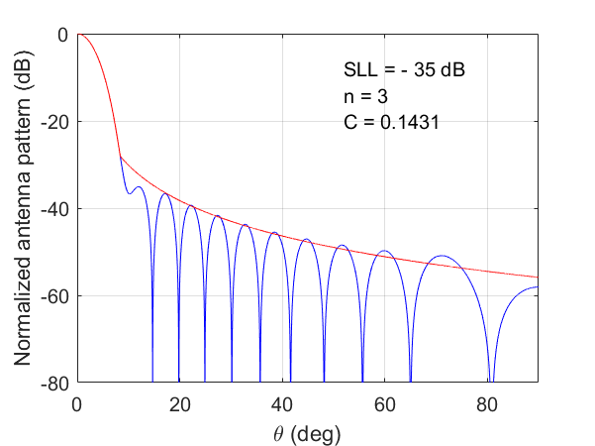 | 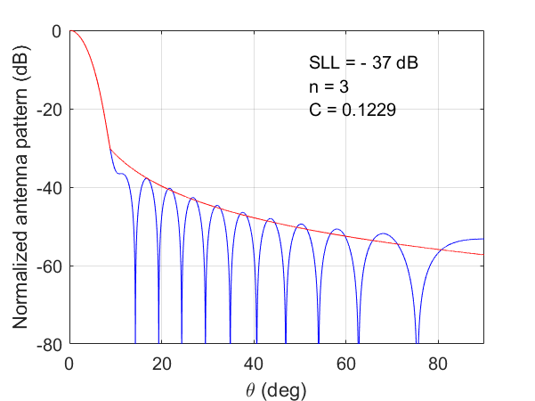
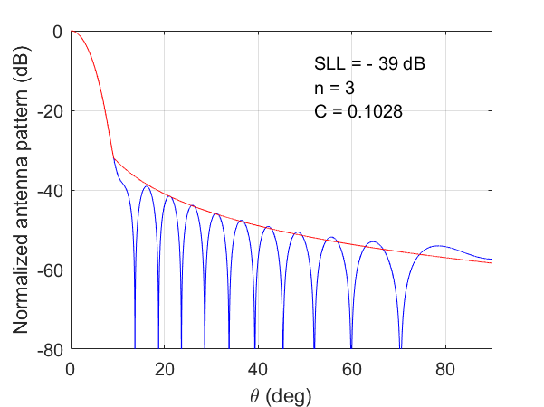 | 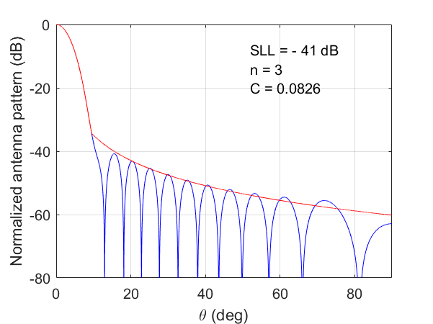
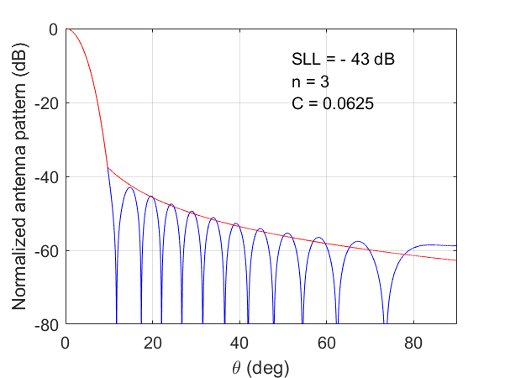 | 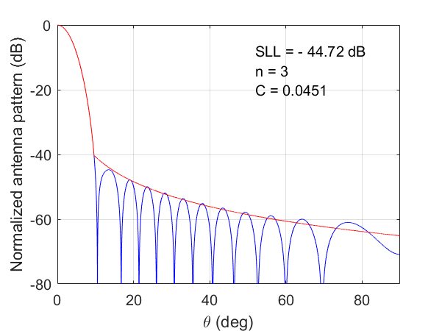

3 Rectangular aperture antennas
Rectangular aperture antennas may be reflector antennas with non-symmetrical beam (narrow beam in one plane and wide beam in the perpendicular plane) and antenna arrays with suppressed sidelobes.

3.1 Antenna radiation pattern requirements
Pedestal $C$ is determined in the same way as for circular apertures (see Figure 1) as the level of the aperture edge illumination / excitation comparing with the illumination / excitation of the center of the aperture.

3.1.1 Side-lobe envelope
For reflector antennas with rectangular apertures and for antenna arrays with suppressed sidelobes, a widely used aperture distributions in ‘low-sidelobe’ radars [3, p. 13.28] is Taylor distribution (one-parameter), and it permits to get antenna pattern for given SLL. This distribution is mentioned here as a reference distribution to compare it with the considered approach based on different cosine distributions.
In Figure 19 the comparison of cosine and cosine squared distributions (see equation (7) below) with $C=0$ and Taylor patterns are shown, the same colors are for the patterns with the same SLL. Taylor amplitude distribution is as follows:
$E\left(x\right)=I_{0}(πB\sqrt{1-x^{2}})$ (6)
where:
$x$: normalized distance along aperture
$I_{0}$: modified Bessel function of the first kind
$B$: positive real number controlling sidelobe level and beamwidth [5].
Figure 19
Comparison of cosine and cosine squared distribution antenna patterns for C=0
and Taylor distribution antenna patterns
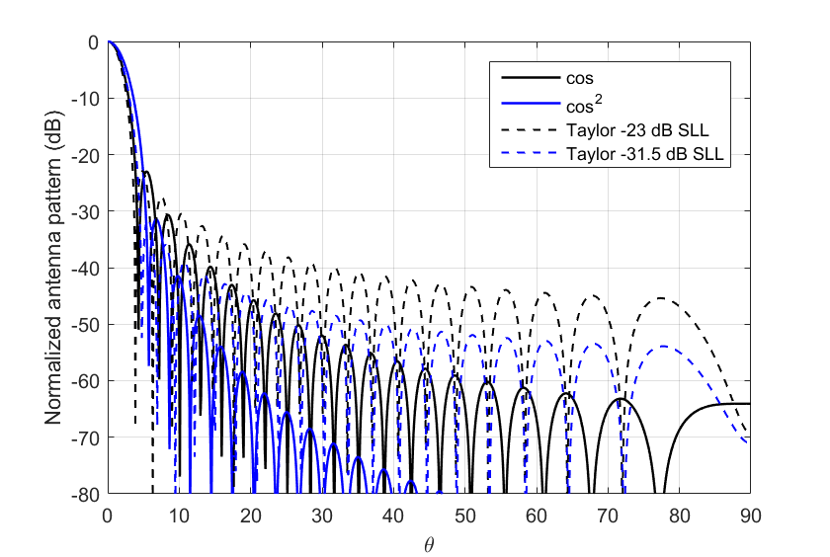
Taylor distribution which provides ‘low sidelobes at a minimum loss in gain’ [3] gives much higher level of further sidelobes (not the first sidelobe which is the same), as it can be seen from Figure 19. So, the envelope of the model should not be steeper than about Taylor pattern with the same SLL.

3.1.2 First side-lobe level
The key parameter which is always given for directive radar and aeronautical mobile antennas is the first side-lobe level. The analysis of all M-series ITU-R Recommendations relating to radiodetermination and aeronautical mobile systems gives distribution of SLL for all rectangular aperture antennas presented in Figure 20 as of 2024 (some artefacts such as very high side lobes were excluded). The following ITU-R Recommendations were analyzed (including currently revised versions and newly developed Recommendations): ITU-R M.1460, ITU-R M.1464, ITU-R M.1638, ITU-R M.1644, ITU-R M.1796, ITU-R M.1849, ITU-R M.2007, ITU-R M.2089, ITU-R M.2114, ITU-R M.2116, ITU-R M.2162, ITU-R M.[24.45-24.65_GHz_ARNS], ITU-R M.[15.4-15.7_GHz_ARNS], ITU-R M.[AMS CHARACTERISTICS_1 780-1 850 MHz].
Figure 20
SLL of rectangular aperture antennas from M-series ITU-R Recommendations
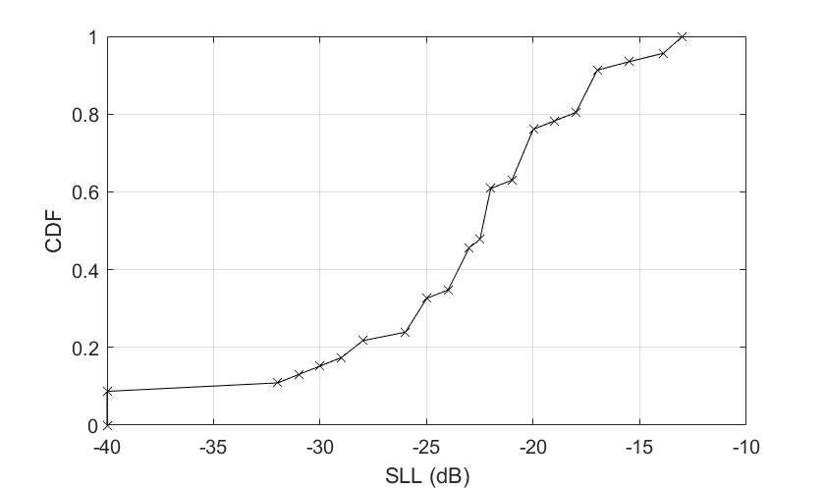
The lowest side-lobe level for rectangular apertures is in Recommendation ITU-R M.1638: −40 dB for phased array with pencil beam (Radars 14, 14A (5 300-5 800 MHz) and Radar 22 (5 400-5 850 MHz). So, the lowest required first side-lobe level is −40 dB for rectangular aperture model.

3.1.3 Requirements for the rectangular aperture reference model
Based on the material presented in Sections 3.1.1 – 3.1.2 the following requirements for reference antenna radiation pattern may be formulated:
– minimum first side-lobe level is −40 dB
– envelope should not be steeper than Taylor distribution (one-parameter)
– field on the edge of the aperture cannot be exactly zero.
Amplitude distribution on the rectangular aperture may be approximated in different ways but the simplest one is cosine distribution raised to some power and on some pedestal.
In Section 3.2 this aperture distribution is analyzed and reference radiation pattern is presented.

3.2 Cosine distributions

3.2.1 Radiation patterns for cosine distributions
Electric field of cosine aperture distribution is as follows [2]:
$E\left(x\right)=C+\left(1-C\right)\cos^{n}\left(\frac{πx}{2}\right)$, (7)
where:
$x$: normalized distance along aperture (see Figure 1)
$n$: numeric cosine taper power value.
The normalized directivity pattern for cosine distribution with different tapers on a pedestal $C$ is given by the following equations ([2, 5]):
For uniform distribution:
$F\left(θ\right)=\frac{\sin\left(μ\right)}{μ}$ (8)
For cosine distribution:
$F\left(θ\right)=\frac{C\frac{\sin{μ}}{μ}+(1-C)\frac{2}{π}\frac{\cos{μ}}{1-{\left(\frac{2μ}{π}\right)}^{2}}}{C+(1-C)\frac{2}{π}}$ (9)
For cosine squared distribution:
$F\left(θ\right)=\frac{C\frac{\sin{μ}}{μ}+\frac{(1-C)}{2μ}\frac{\sin{μ}}{1-{\left(\frac{μ}{π}\right)}^{2}}}{C+\frac{(1-C)}{2}}$ (10)
For cosine distribution raised to power 3:
$F\left(θ\right)=C\frac{\sin{μ}}{μ}+(1-C)\frac{3π\cos\left(μ\right)}{8}\left[\frac{1}{{\left(\frac{π}{2}\right)}^{2}-μ^{2}}-\frac{1}{{\left(\frac{3π}{2}\right)}^{2}-μ^{2}}\right]$ (11)
For cosine distribution raised to power 4:
$F\left(θ\right)= C\frac{\sin{μ}}{μ}+(1-C)\frac{3π^{4}\sin\left(μ\right)}{2μ\left(μ^{2}-π^{2}\right)\left(μ^{2}-4π^{2}\right)}$ (12)
$μ=\frac{π K \sin{(θ)}}{θ_{3}}$ (13)
where:
$θ_{3}$: is the 3-dB antenna half-power beamwidth (degrees)
$K$: beamwidth factor (degrees).
$θ_{3}=K\left(\frac{λ}{l}\right)$ (14)
where:
$l$: size of the antenna (meter).
The equations for model without pedestal can be obtained from equations (9) - (12) substituting $C=0$.
Figure 21 shows the highest side-lobe level depending on pedestal for cosine distributions raised to powers n=0, 1, 2, 3 and 4 (n=0 is a uniform distribution). For some cases the highest side lobe may be not the first one so always the highest value was taken to get Figure 21.
Figure 21
SLL for cosine distributions raised to power n with different tapers
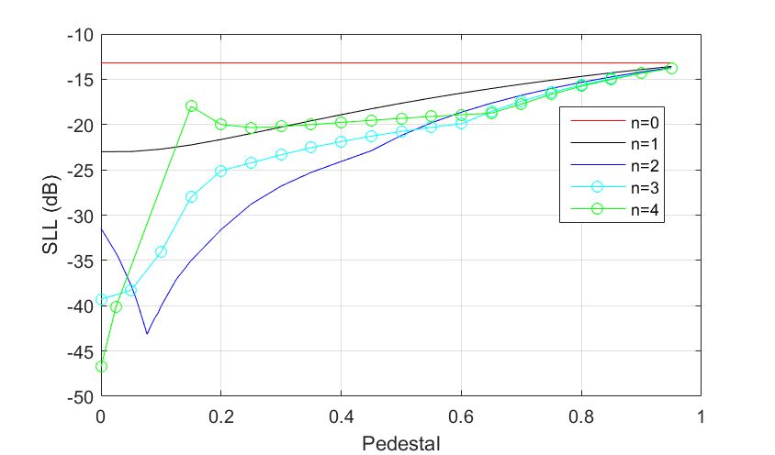
Figure 22 shows aperture efficiencies depending on pedestal for cosine distributions raised to powers n=1, 2, 3 and 4 (equation (15) from [6]), equation (16) from [6]), equation (17) and equation (18), respectively).
$ε_{aperture}=\frac{{\left(\frac{2}{π}\left(1-C\right)+C\right)}^{2}}{\frac{{(1-C)}^{2}}{2}+\frac{4}{π}C\left(1-C\right)+C^{2}}$ (15)
$ε_{aperture}=\frac{2{\left(1+C\right)}^{2}}{3+2C+3C^{2}}$ (16)
$ε_{aperture}=\frac{48π\left(\left(3π-4\right)C+4\right)}{9π^{2}\left(\left(63π-128\right)C^{2}+\left(128-30π\right)C+15π\right)}$ (17)
$ε_{aperture}=\frac{\left(5C+3\right)/8}{\left(67C^{2}+26C+35\right)/128}$ (18)
Figure 22
Aperture efficiency for cosine distributions raised to power n with different tapers
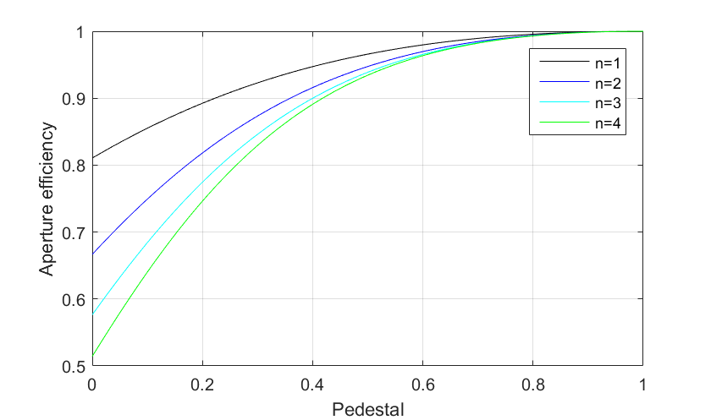
Figure 23 shows beamwidth factor $K$ depending on pedestal for cosine distributions raised to powers n=1, 2, 3 and 4.
Figure 23
Beamwidth factor for cosine distributions raised to power n with different tapers
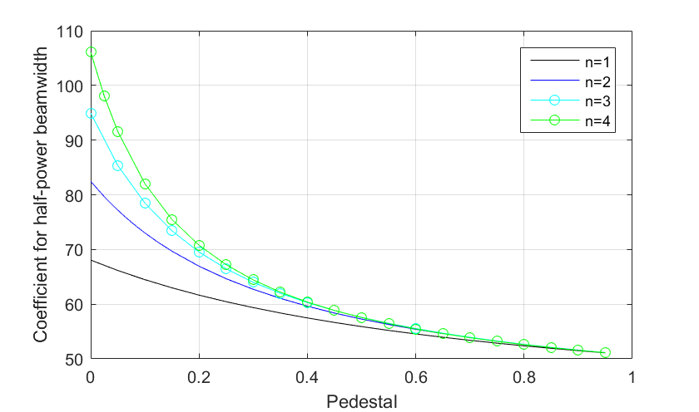
Region near $C=0$ will be considered furthermore thoroughly.
Figure 24 shows radiation patterns for distributions with $C=0$ calculated using equations (9)-(12) for n=1, 2, 3, 4, respectively. Even if the mask front-to-back floor is −50 dB, −60 dB, −70 dB and −80 dB for n=1, 2, 3, 4 (shown with red horizontal lines), respectively, the envelopes are too steep comparing with Figure 19.
Figure 24
Antenna pattern for cosine distributions raised to power n with C=0
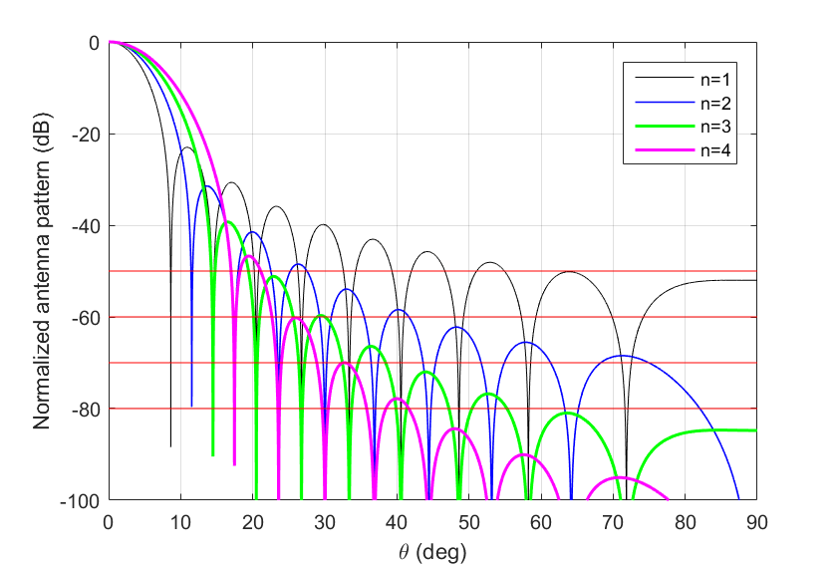
Table 4 shows in the second column the increase of the size of the aperture with zero field on the edge to get the same beamwidth as with a uniform distribution. The third column shows aperture efficiencies (the same as in Figure 22 for pedestal equal to zero).
Table 4
Characteristics of rectangular aperture antennas with zero pedestal distributions
Cosine distribution raised to power $n$ with $C=0$ | The increase of the aperture to get the same beamwidth as with a uniform distribution | $$ε_{aperture}$$
1 | 1.35 | 0.82
2 | 1.64 | 0.67
3 | 1.87 | 0.58
4 | 2.09 | 0.51

The other point is how seriously changes the radiation pattern when amplitude on the edge of the aperture is not exactly 0, but, for example, C=0.01 or even lower (1% of the illumination of the center of the aperture). Figures 25, 26 and 27 shows radiation patterns for n=2, 3 and 4 near C=0.
Figure 25
Antenna patterns for cosine squared distribution near C=0
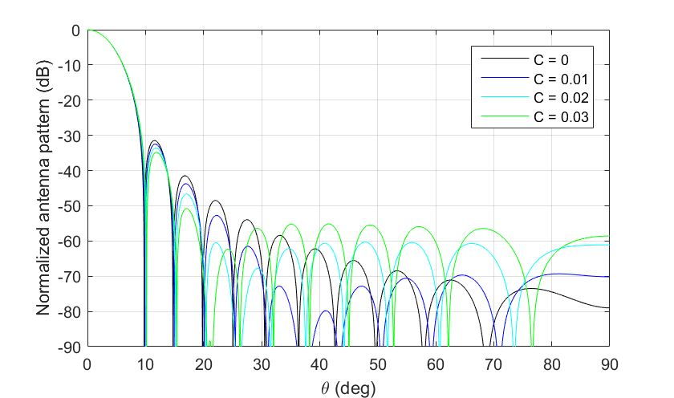
Figure 26
Antenna patterns for cosine distribution raised to power 3 near C=0
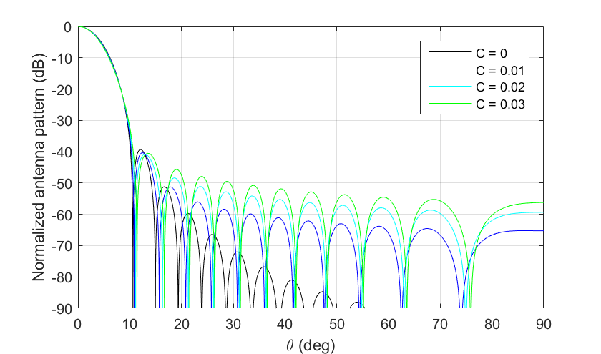
Figure 27
Antenna patterns for cosine distribution raised to power 4 near C=0
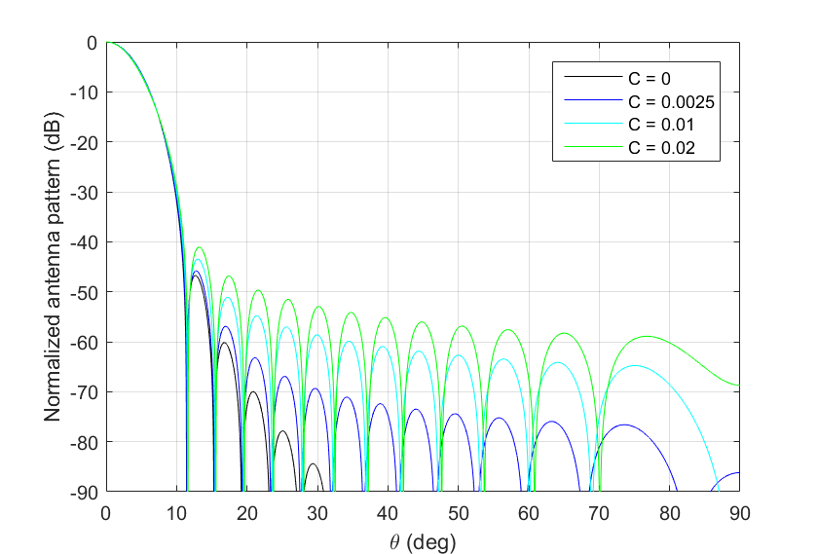
In all these three cases the change of the amplitude on the edge even on 1% or even less lead to very serious change of the overall side-lobe envelope. Taking into account that the amplitude distribution cannot be realized without any even very small random aperture errors, the radiation pattern will be very unstable near C=0.
The other problem of the simplified approach with zero pedestal is that it gives only discrete values of SLL: −13.2 dB, −23 dB, −32 dB, −40 dB and −47 dB (see Figure 21) and the difference between intended SLL (SLL from the characteristics of system) and SLL of the calculated output model may be very large.

3.2.2 Peak reference radiation patterns for cosine distributions
The reference radiation pattern for rectangular aperture should be as follows:
– SLL from −13.2 to −40 dB (see Section 3.1.2)
– have realistic envelopes (see Section 3.1.1).
The reference radiation pattern model for cosine distributions on a pedestal is organized in the way as it is shown schematically in Figure 28.
Figure 28
Schema for formulation of the reference radiation pattern for cosine distributions
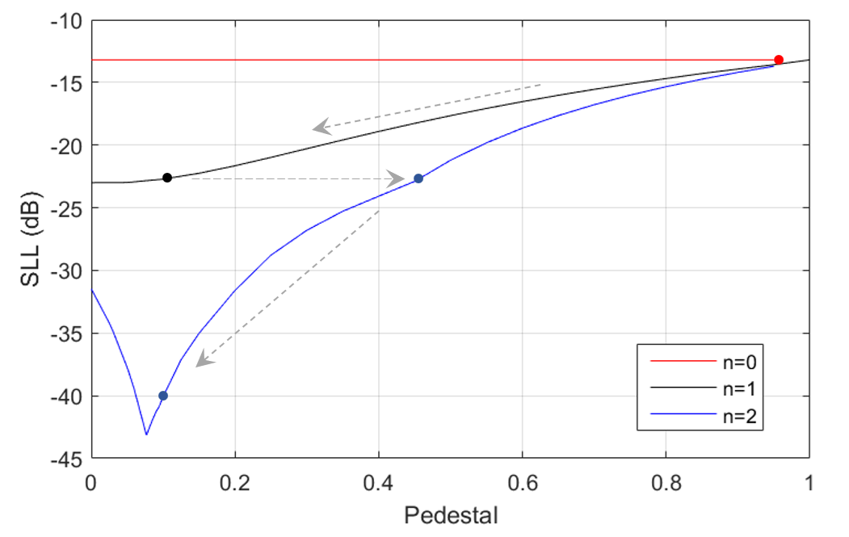
The arrows show how will change the aperture distribution with the decrease of SLL. It is sufficient to take $n$ only up to 2 as it will cover SLL equal to −40 dB.
The input data for the model should be:
– 3 dB beamwidth
– SLL.
The output reference antenna model should have approximately the same SLL. The choice of power $n$ will be performed ‘automatically’ based on the input SLL.
The algorithm is as follows:
Step 1. To determine value of $n$ based on input SLL.
Step 2. To find approximation of pedestal $C$ and beamwidth factor $K$ based on SLL, Table 5 contains the corresponding formulas.
TABLE 5
Approximations of pedestal $C$ and beamwidth factor $K$ based on SLL
for rectangular cosine distribution aperture antenna
Cosine distribution raised to power $n$ | Range of maximum side-lobe level below normalized main lobe peak  (dB) | Pedestal C | Beamwidth factor K (°)
0 | −13.2 | - | 50.8
1 | −22.7 to −13.2 | $$C=0.0007{(SLL+22.7)}^{3}-0.006{\left(SLL+22.7\right)}^{2}+0.09\left(SLL+22.7\right)+0.1$$ | $$K=-0.0117{\left(SLL+22.7\right)}^{3}+0.217{\left(SLL+22.7\right)}^{2}-2.46\left(SLL+22.7\right)+64.2$$
2 | −40 … −22.7 | $$C=0.0056{\left(SLL+40\right)}^{3}-0.04{\left(SLL+40\right)}^{2}+1.1\left(SLL+40\right)+9.9)/100$$ | $$K=-0.0013{\left(SLL+40\right)}^{3}+0.018{\left(SLL+40\right)}^{2}-0.79\left(SLL+40\right)+73$$

Step 3. To calculate radiation pattern based on equations (8), (9) or (10) depending on $n$ and to convert it to decibels.
Step 4. To find its peak envelope, the envelope is calculated as in Table 6. The main lobe is taken from Step 3 as it is, the breakpoint between main lobe and side-lobe envelope is determined numerically.
Step 5. To limit the reference radiation pattern by the mask front-to-back floor level, if needed (see last column in Table 6).
TABLE 6
Peak normalised theoretical mask pattern for rectangular cosine distribution aperture antenna
Field distribution | Mask equation beyond pattern break point where mask departs from theoretical pattern  (dB) | A | B | Mask floor level  (dB)
Uniform | $$-A\ln{\frac{B\left|θ\right|}{θ_{3}}}$$ | 8.584 | 2.876 | −30
COS | $$-A\ln{\frac{B\left|θ\right|}{θ_{3}}}$$ | $$-0.000473{\left(SLL+13.2\right)}^{5}-0.008667{\left(SLL+13.2\right)}^{4}-0.0581{\left(SLL+13.2\right)}^{3}-0.1455{\left(SLL+13.2\right)}^{2}-0.1342\left(SLL+13.2\right)+8.2489$$ | if $SLL≥-22.7$ and $SLL≤-18$:  $$0.03911 {SLL}^{3}+2.1706 {SLL}^{2}+39.803 SLL+246.52$$  if $SLL>-18$ and $SLL<-13.2$:  $$-0.461 SLL-3.058$$ | −50
COS² | $$-A\ln{\frac{B\left|θ\right|}{θ_{3}}}$$ | $$0.000119 {SLL}^{3}+0.00869 {SLL}^{2}+0.2488 SLL+10.37$$ | $$\exp{(-0.00027 {SLL}^{3}-0.02255 {SLL}^{2}-0.751 SLL-6.6)}$$ | −60
In Figure 29 a number of reference radiation patterns obtained by the algorithm described above is presented for the full SLL range (from −13.2 to −40 dB) and beamwidth 6 degrees.
Figure 29
Reference radiation patterns based on cosine distributions for different SLL
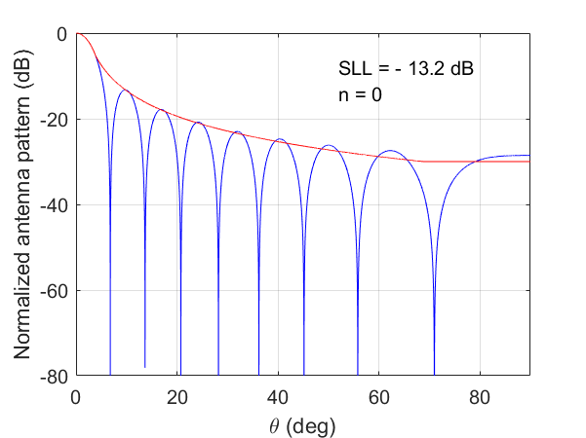 | 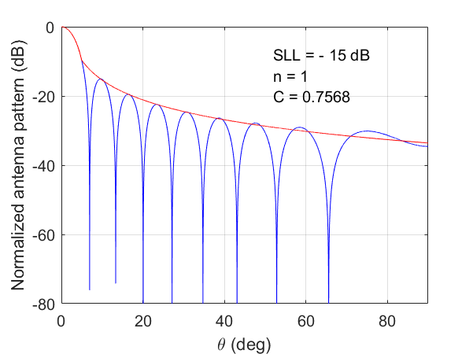
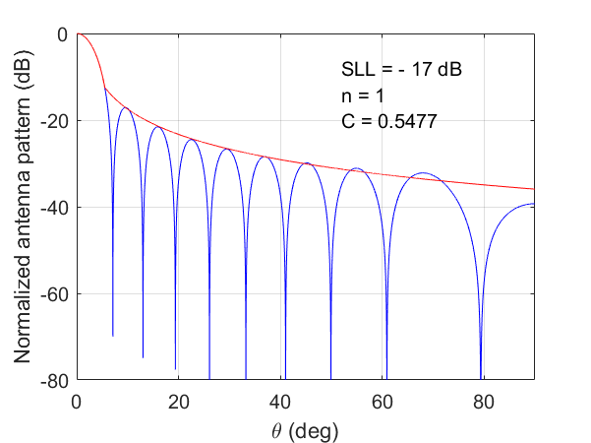 | 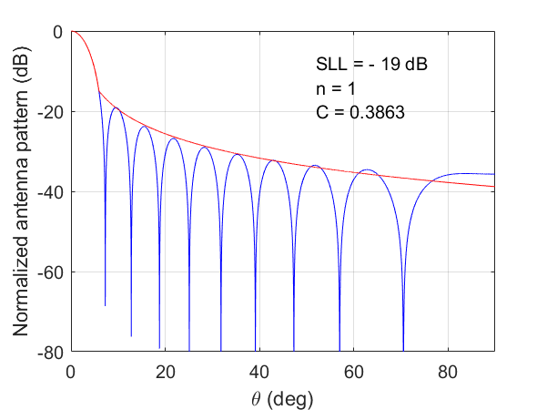
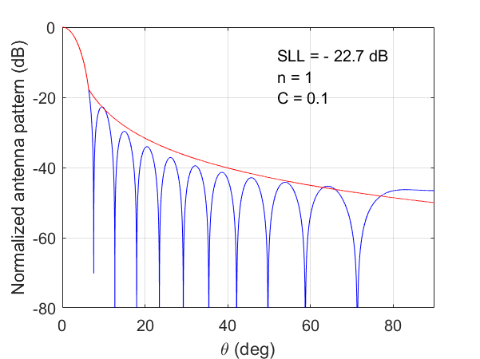 | 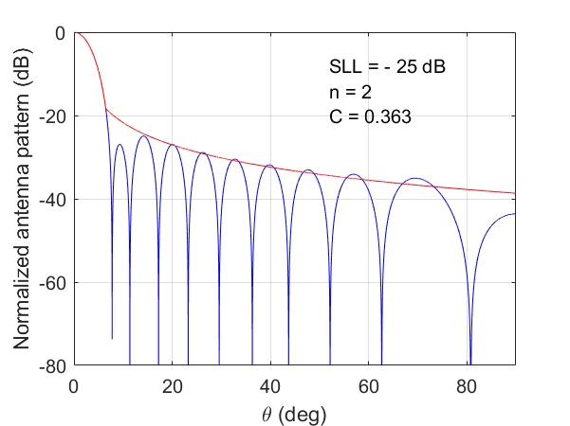
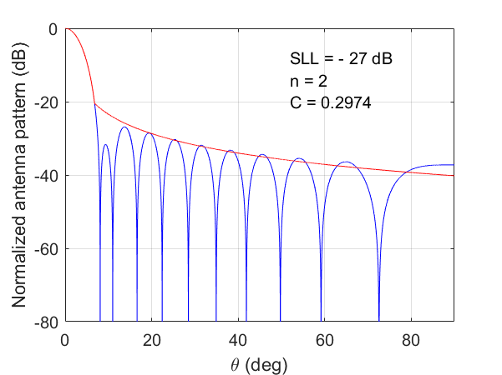 | 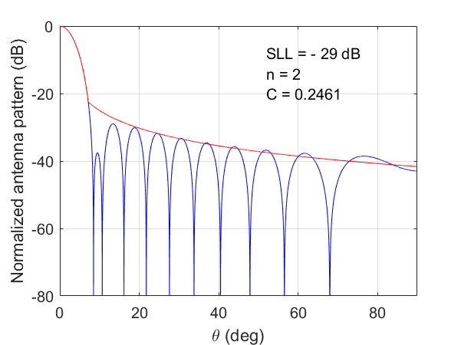
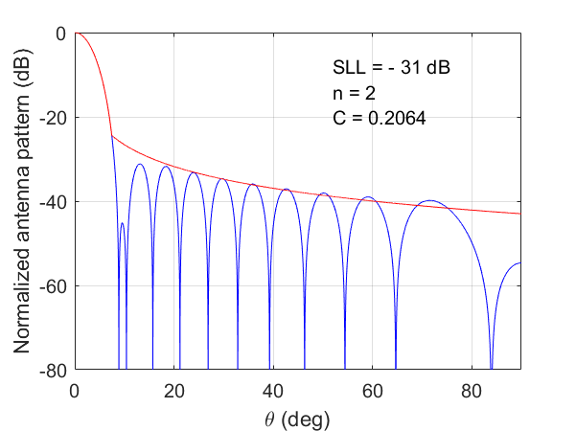 | 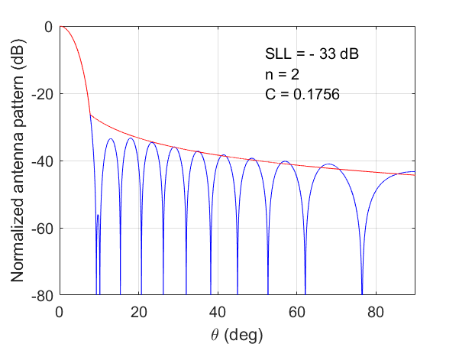
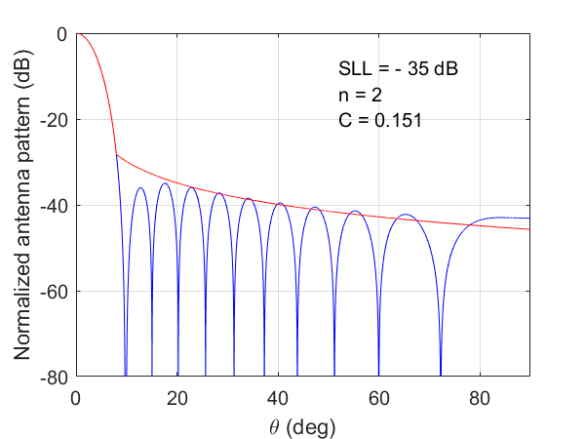 | 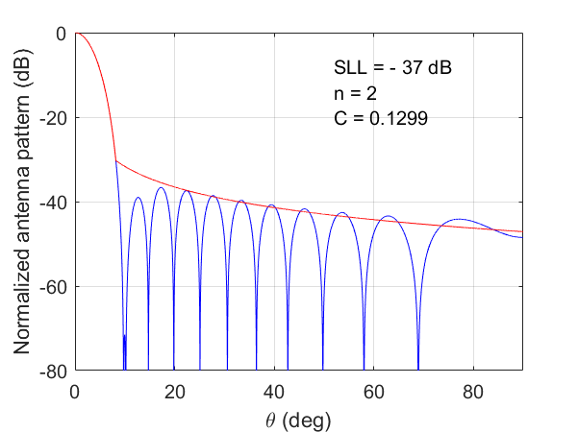
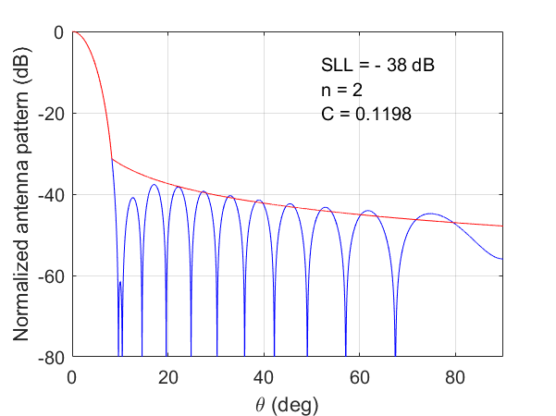 | 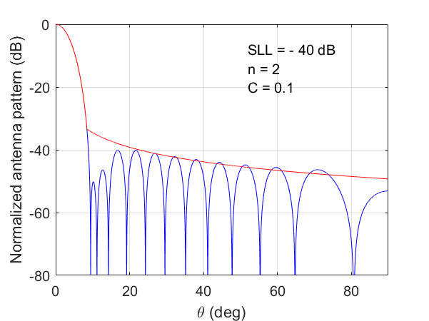

[USA Editor note: Replace existing section 3.3 with the following update]

3.3 Taylor one parameter (modified sin(x)/x) line source
In radar and low-noise system design, engineers often navigate trade-offs between key antenna performance metrics. Although narrow beamwidth and strong near-sidelobe suppression are traditionally favoured, a more effective approach may involve modest compromises in these areas to achieve a radiation pattern where all minor lobes decay consistently and monotonically as the angle increases from the main beam. This approach improves clutter rejection and lowers the risk of false target detection caused by sidelobe ambiguity. When sidelobes decay smoothly and predictably, the antenna maintains tighter control over off-axis energy, which is an essential feature in systems with high dynamic range or low signal-to-noise ratios.
Patterns generated using cosine and cos² excitations on a pedestal—especially at low peak sidelobe ratio levels—can produce a first sidelobe that is lower than its neighbours. This leads to non-monotonic sidelobe behaviour, which is generally undesirable in radar applications where consistent roll-off is critical for suppressing clutter and distinguishing targets accurately. To address this issue, the Taylor one-parameter line source pattern provides a more symmetric and well-behaved sidelobe structure. Its monotonic decay away from the main beam better aligns with radar system requirements, allowing for controlled sidelobe shaping without sacrificing beam integrity
Taylor recognized that to produce a linear aperture distribution with a sidelobe envelope approximating a 1/u falloff, the uniform amplitude sinc (sin(x)/x) pattern could be used as a starting point. He knew that the height of each sidelobe is controlled by the spacing between the aperture pattern factor zeros on each side of the sidelobe. Taylor’s key insight was that only the close-in zeros needed to be adjusted to suppress the near sidelobes, while the far-out zeros could remain at their integer positions. This selective modification preserves the desirable 1/u decay in the outer sidelobes while improving near-sidelobe performance.
From Reference 8. The normalized factor Fu is given by the expression below.
Fu=sinhπB2-u2πB2-u2, for u ≤Bsinπu2-B2πu2-B2, for u ≥B (3.3-1)
B = Taylor one parameter value for a given Sidelobe Ratio (SLR),
u=dλsinθ , is a new variable, [u-space], that defines the angular dependence
d = the aperture width (m)
λ = wavelength (m),
θ = antenna pattern angle (degrees).
The u-space transformation is used because it simplifies the mathematics of the array factor, makes grating-lobe and beamwidth behaviour easier to analyse, and provides a convenient, normalized angular coordinate for plotting and design.
The antenna pattern gain (in dB) is:
Fu (in dB)=20log10(|F(u)|) (3.3-2)
From reference 10 page 410, Fu (dB) is normalized to 0 dB at boresight by subtracting the peak value evaluated at u=0:
F0 in dB=20log10sinhπBπB (3.3-3)
Note that the single parameter B controls all characteristics of beamwidth, sidelobe level and efficiency. B is computed from the desired sidelobe (SLR) by iterative solution to the following equation, reference 8, as:
SLR=20log10sinh(π*B)/( π*B)+13.2614 dB (3.3-4)
Using reference 11, Chapter 20 Equation 20.14.5, B can be approximated for SLR (peak sidelobe level) values between 13.2614 dB and 60 dB using the following expression.
B=(0.76609(SLR - 13.2614)^0.4+0.09834(SLR - 13.2614)) / π (3.3-5)
The antenna pattern efficiency, η, is obtained from reference 8 equation 9 by:
η=2sinh2πBπBI0 2πB (3.3-6)
Where I0 is the integral of the Bessel function I0. This integral can be done, using Microsoft Excel, by the Excel equation:
I0 2πB=2(sinh2(πB)/(πB)*let(a, 0,b,(2 πB), n, 200,h, (b-a)/n,x,sequence(n-1, ,a+h, h),(h/2)(BESSELI(a,0)+2sum(BESSELI(x,0))+BESSELI(b,0)))) (3.3-7)
The antenna edge taper ηb is given in reference 7 section 3.1.6 Page 129 as:
ηb=20log10(I0πB) (3.3-8)
The one sided 3-dB width in u-space, u3 is a scaling constant that relates the physical aperture dimensions and beamwidth to the design sidelobe ratio (SLR), is solved iteratively as shown in reference 11 page 982 in the provided Matlab code.
But since it is easier to use curve fitting to the existing data that is found in Hansen reference 5 Table 3.1 for Taylor One-Parameter Characteristics the curve fit equation is:
u3= 0.0695*SLR0.5441+0.1578 (3.3-9)
To maintain a constant beamwidth while varying SLR, the aperture must be scaled by the constant u3. The relationship is defined as follows:
dλ=2*u3(180π)HPBW(in degrees), (3.3-10).
where u3 is a dimensionless u-space quantity and antenna beamwidth, HPBW, is in degrees.
The Taylor one-parameter line source characteristics are shown in the table below. Figure 3.3-1 shows the plot of each parameter as a function of SLR.
TABLE 3.3-1
Taylor one-parameter line source characteristics, calculated from the above equations
Input | Eq. 3.3-4 | Eq. 3.3-9 | Eq. 3.3-5 |  | Eq. 3.3-6
SLR, Sidelobe Ratio (dB) | B, Taylor One-Parameter B | u3, one side= θ3dB/2*(d/λ (rad) | η, Antenna Efficiency | η * u3 (rad) | ηb Edge Taper (dB)
13.26 | 0 | 0.4429 | 1.000 | 0.443 | 0.0
15 | 0.3588 | 0.4615 | 0.993 | 0.458 | 2.5
20 | 0.7341 | 0.5119 | 0.934 | 0.478 | 9.2
25 | 1.0206 | 0.5580 | 0.863 | 0.482 | 15.3
30 | 1.2767 | 0.6002 | 0.801 | 0.481 | 21.1
35 | 1.5162 | 0.6391 | 0.750 | 0.480 | 26.8
40 | 1.7448 | 0.6752 | 0.708 | 0.478 | 32.4
45 | 1.9658 | 0.7091 | 0.673 | 0.477 | 37.9
50 | 2.1809 | 0.7411 | 0.643 | 0.477 | 43.3
figure 3.3-1
Taylor one-parameter line source characteristics
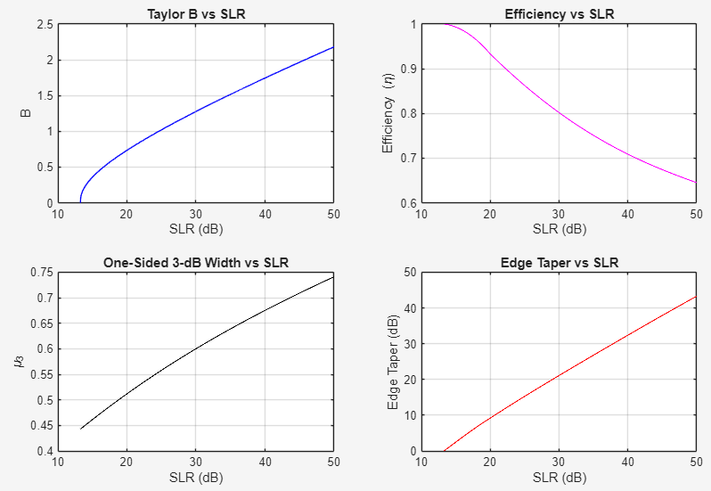
As can be seen from figure 3.3-1, increasing the Sidelobe Ratio (SLR) to achieve higher clutter rejection and lower interference involves several deterministic trade-offs in antenna performance. As the design targets a more suppressed sidelobe envelope, the following shifts occur:
- Reduction in Efficiency (η): Higher SLR values require a more aggressive aperture taper, which naturally reduces the antenna's overall radiation efficiency. For example, at a 13.26 dB SLR (uniform distribution), efficiency is 1.00, but it drops to approximately 0.643 at 50 dB SLR.
- Beamwidth Expansion (u3): To suppress sidelobes, the main beam must broaden in u-space. The scaling constant u3 increases from 0.4429 at 13.26 dB to 0.7411 at 50 dB SLR.
- Aperture Size Requirements (d/λ): To maintain a constant Half-Power Beamwidth (HPBW) while increasing the SLR, the physical size of the antenna aperture (d) must be increased to compensate for the broadening u3 factor.
- Edge Taper Intensity (η_{b}): Achieving higher SLR necessitates a significant increase in the edge taper, moving from 0 dB (uniform) to over 43 dB for a 50 dB SLR.
- Hardware Floor Dominance: While theory suggests monotonic decay, at higher SLR levels (e.g., 40 dB+), the realized performance is increasingly limited by the "hardware noise floor" rather than the theoretical distribution.
The peak envelope in the sidelobe region for angles beyond the transition point, from the main lobe to the average antenna envelope pattern, Envelopeθ, is characterized by the asymptotic decay model:
Envelope(θ)= 20*log10(BsinhπBuθ2-B2)+Offset(-3 dB) (3.3-11)
This is the asymptotic decay of the continuous Taylor one-parameter pattern in the sidelobe region, obtained by evaluating the Taylor field factor for u>B and taking the envelope of the oscillatory sinπ(uθ2-B2) term.
This is standard Taylor theory; equivalent forms are given in references 7 and 12.
The concept of an "Average Pattern" is derived from the statistical performance of antenna sidelobes. Given that the power pattern of a continuous aperture distribution is proportional to sin²(x) in the sidelobe region, the average value over one complete period is about 0.5 (or -3 dB). Therefore, to establish a physically realistic average envelope that perfectly bisects the theoretical sidelobe peaks and nulls, a constant geometric offset of -3.0 dB is applied.
In accordance with Recommendation ITU-R M.1851, the Total Integrated Gain (TIG) correction factor is derived by integrating the proposed average envelope rather than the theoretical antenna pattern. The exact theoretical Taylor One-Parameter array factor is utilized exclusively to establish the baseline main-beam directivity (D₀).
To compute the excess radiated power and validate the envelope, a 2D spherical numerical integration is performed. However, for highly directive antennas (e.g., radar arrays with HPBW < 1°), applying a strictly relative hardware floor (e.g., -40 dB) to a massive main beam directivity forces the absolute gain of the far-sidelobe region into positive territory. Integrating this constant positive noise floor across the vast area of the far-sidelobe sphere artificially inflates the global TIG to physically unrealizable levels, which obscures the energy balance of the near-in envelope.
Therefore, to ensure mathematical accuracy and physical realism, the TIG calculation utilizes a Dynamic Localized Integration. Rather than integrating the full sphere, the numerical integration is strictly bounded to the transitional angular sector: from the main beam departure out to the exact angle where the envelope intersects the tiered hardware floor (hardware noise floor), plus a 10° angular buffer. Furthermore, the rear hemisphere is explicitly masked to zero linear power to prevent the theoretical array factor's continuous mirrored backlobes from artificially inflating the integrated power.
For the average envelope pattern, the transition angle, θave, is defined as the point where the main beam falls to the level of the average sidelobe envelope. By defining the normalized argument term α:
α= 1 - sin-110 Patternave_offset(dB)20π (3.3-13)
The value of Pattern_{ave_offset(dB)} is fixed at -3.0 dB. The average envelope intersection in u-space (μave) and the physical transition angle (θave) are:
μave=B2+α2, and (3.3-14)
θave=sin-1(μavedλ) (3.3-15)
To decide on the lowest pattern floor level (back lobe) to be used in simulations for the peak and average envelopes or front to back ratio, a review of references 5, 7, 9, 10 and 13 was carried out. The references review led to the following points that are used to establish estimates of the antenna noise floor (Front-to-Back ratio) as a function of the design peak sidelobe Level (SLR).
For a Taylor One-Parameter distribution, the back-lobe level is estimated to lie approximately 10 to 20 dB or more below the design SLR, depending on the antenna beamwidth. This is justified by two main factors:
- The Taylor One-Parameter aperture distribution is characterized by a theoretical monotonic 1/u sidelobe decay. This design inherently suppresses wide-angle radiation. Numerical analysis confirms that for typical directional radar apertures, the theoretical pattern level at 90° is naturally suppressed by 15–25 dB or more. See reference 13.
- Regardless of theoretical synthesis, realized performance is bounded by a "hardware noise floor." Manufacturing tolerances, phase quantization errors, mutual coupling, and radome scattering typically limit the minimum sustainable sidelobe level to the range of -45 dB to -50 dB range.
The above points create estimated performance boundary that varies with the design SLR:
- High SLR targets (e.g., 20 dB): the back-lobe is dominated by the theoretical pattern decay (physics-limited).
- Low SLR targets (e.g., 40 dB), the back lobe is dominated by the error floor (hardware-limited).
The following benchmarks represent realizable performance limits for interference and compatibility studies:
- SLR = 13 dB (Uniform): The back lobe is typically in the 30 to 35 dB region for clean apertures (delta ≈ 20 dB).
- SLR ≈ 30 dB (Standard Radar): The back lobe is typically in the 45 to 50 dB region for well-tapered, well-shielded apertures (delta ≈ 15–20 dB).
- SLR ≈ 40 dB (High Performance): A back lobe near 55 to 60 dB represents an optimistic limit. In many fielded systems, tolerance errors and structural scattering become dominant before this theoretical taper level is fully realized (delta compresses to ≈ 10 to 15 dB).
A proposed front-to-back ratios as they relate to the SLR values are shown in Table 3.3-2.
TABLE 3.3-2
Recommendation for Pattern floor (Front-to-Back Ratio)
SLR (dB) | Recommended Limit (dB) | Recommended Pattern Floor limit (dB)
13.26 | Maximum (-(SLR + 20), -50) | -33
15 | Maximum (-(SLR + 20), -50) | -35
20 | Maximum (-(SLR + 20), -50) | -40
25 | Maximum (-(SLR + 20), -50) | -45
30 | Maximum (-(SLR – 15 to 20), -50) | -45 to -50
35 | Maximum (-(SLR – 15), -50) | -50
40 | Floor limited | -50
45 | Floor limited | -50
This result demonstrates that the intersection angle is strictly deterministic. The variable B is derived directly from the Sidelobe Ratio (SLR), and the aperture scaling factor dλ is derived from the Half-Power Beamwidth (HPBW). Consequently, θave will vary dynamically as a function of both the required SLR and the antenna beamwidth.
The following figures show the Taylor one-parameter antenna patterns for different SLR cases.
figure 3.3-2
Taylor one parameter antenna patterns for peak SLR=20 dB
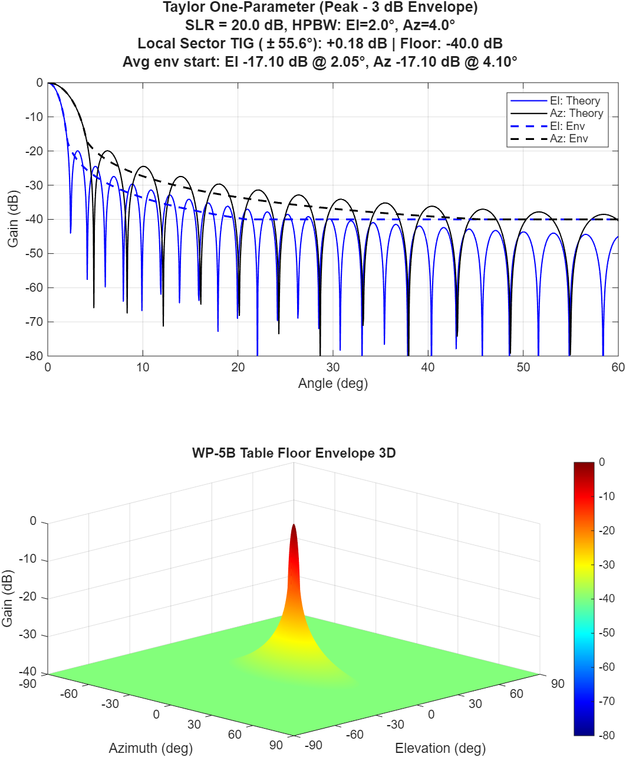
figure 3.3-3
Taylor one parameter antenna patterns for peak SLR=30 dB
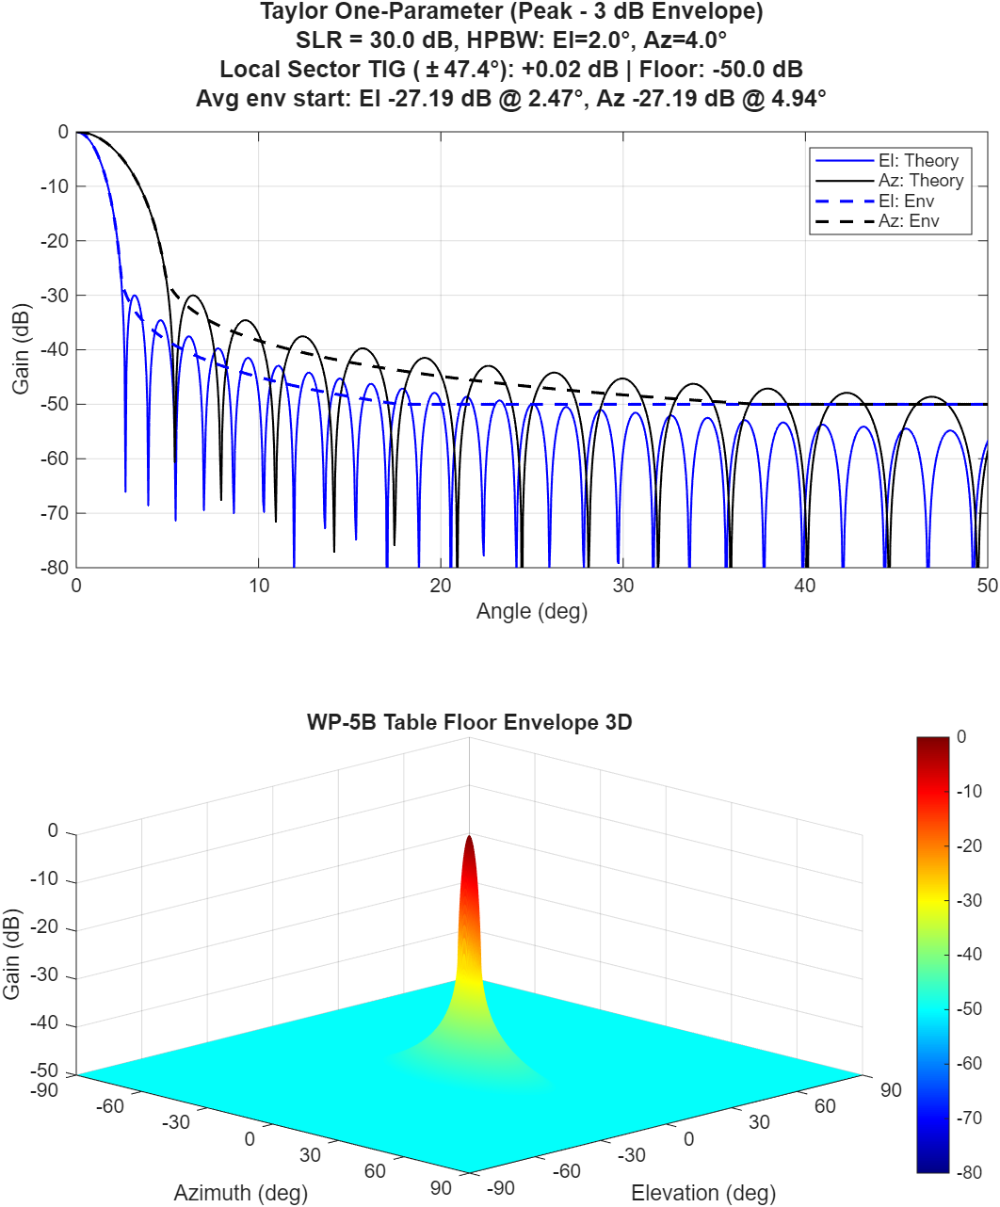
figure 3.3-4
Taylor one parameter antenna patterns for peak SLR=45 dB
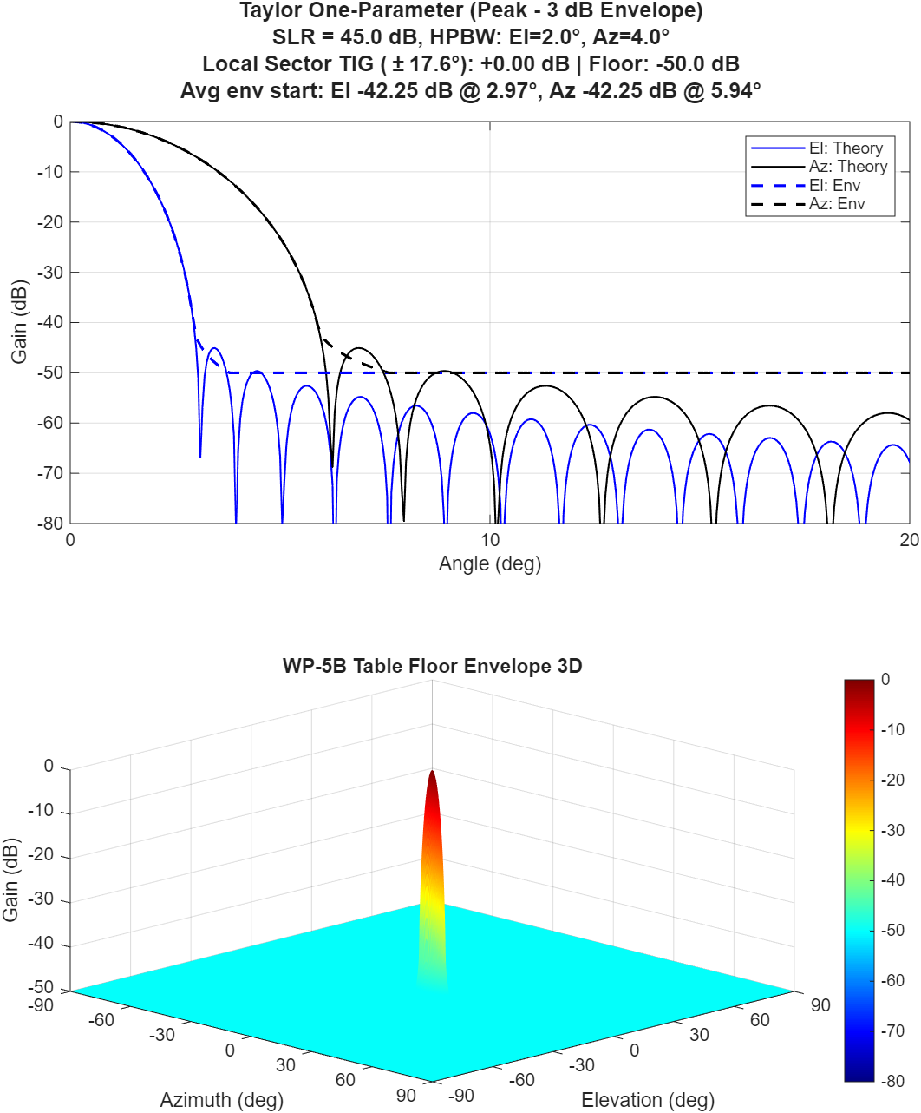

The following MATLAB code can be used to plot the pattern and the peak and average envelopes and also compute TIG.
The following figures compare the Taylor one-parameter pattern with the cosine-on-pedestal and cosine-squared patterns, highlighting how their sidelobe structures differ in behaviour and decay characteristics.
figure 3.3-6
Taylor one parameter antenna patterns for peak SLR=25 dB
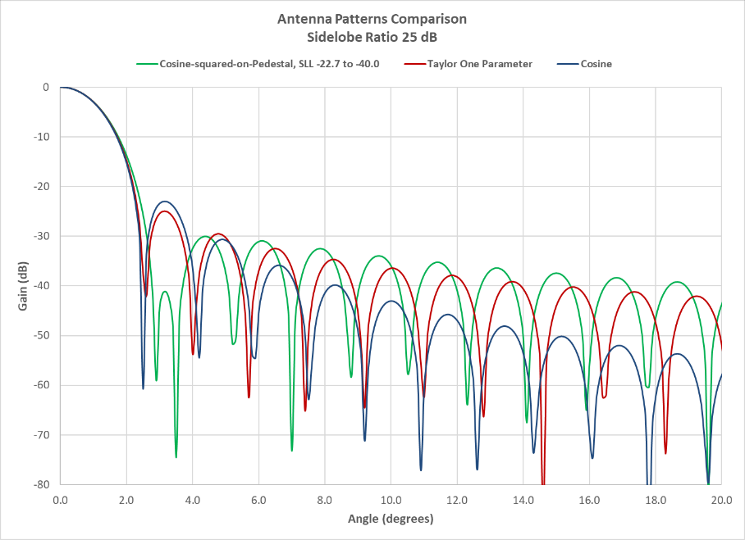
figure 3.3-7
Taylor one parameter antenna patterns for peak SLR=30 dB
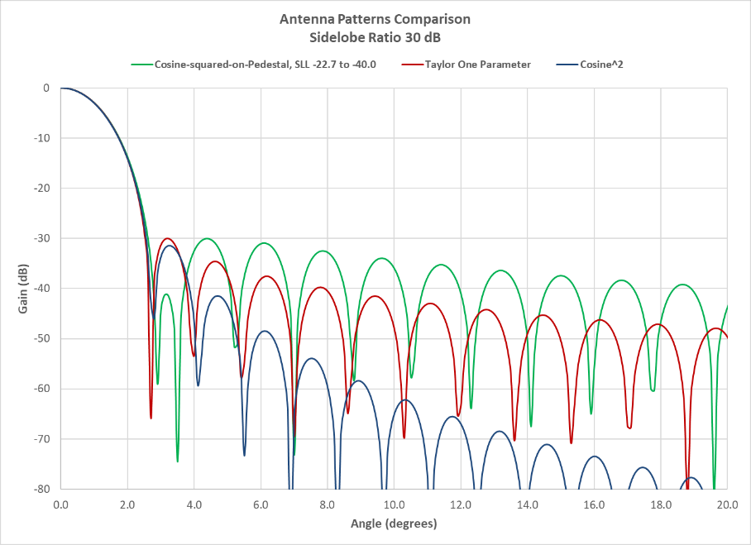
figure 3.3-8
Taylor one parameter antenna patterns for peak SLR=40 dB
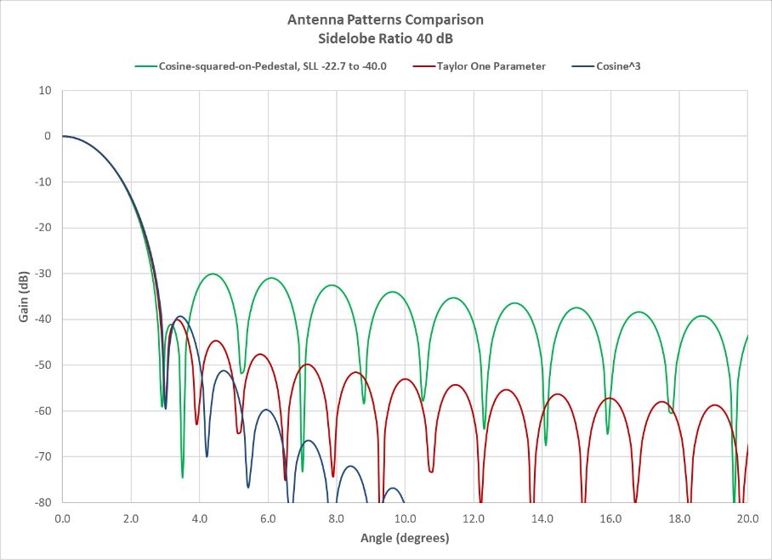
Figures 3.3-6, 3.3-7, and 3.3-8 illustrate comparative sidelobe behaviour across the Taylor one-parameter, cosine-on-pedestal, and cosine-squared antenna patterns. Pay particular attention to the first sidelobe: the cosine-on-pedestal pattern exhibits suboptimal performance for radar applications due to its relatively high and non-monotonic sidelobe structure. For systems requiring a low peak sidelobe ratio—typically below 30 dB—the Taylor one-parameter pattern is recommended for sharing studies, as it ensures adjacent sidelobes decrease monotonically, improving interference mitigation and regulatory compliance.

µ=dλsinθ
Fµ
Fµ=sinhπB2-µ2πB2-µ2, for µ ≤Bsinπµ2-B2πµ2-B2, for µ ≥B

µ=dλsinθ ,

Fµ (dB)=20log(|F(µ)|)
Fµ (dB)
20log10sinhπB2πB2

SLR=20logsinh(π*B)/( π*B)+13.2614 dB

B=(0.76609(SLR - 13.2614)^0.4+0.09834(SLR - 13.2614)) / π

η=2sinh2πBπBI0 2πB
I0 I0
I0 2πB=2(sinh2(πB)/(πB)*let(a, 0,b,(2 πB), n, 200,h, (b-a)/n,x,sequence(n-1, ,a+h, h),(h/2)(BESSELI(a,0)+2sum(BESSELI(x,0))+BESSELI(b,0))))
ηb
ηb=20log10(I0πB
µ3µ3
µ3= 0.0695*SLR0.5441+0.1578

 |  | µ3θ3dB/2 |  | µ3 | ηb

FNBWhalf
FNBWhalf(°)=0.5π-2cos-1θ3dBB2+1μ3=sin-1θ3dBB2+1μ3
B2+n2
SLL(n)°= sin-1θ3dBµ3B2+n+.52

Nlobesθ3dB
Nlobes=(70°-FNBWhalf)/FNBWhalf

ML Intersect Angle(°)= FNBWhalf(°)-θ3dB2-FNBWhalf(°)2

4 Comparison with the antenna characteristics from M-series ITU-R Recommendations
This section provides the comparison of the described above models (Sections 2.2 and 3.2) with the antennas from ITU-R documentation. In order to do it all M-series ITU-R Recommendations were analysed. Sidelobes of antennas are characterized in ITU-R Recommendations in two different ways:
‒ level of the first side-lobe level (SLL)
‒ level of antenna gain at some different angle.
So the following two comparisons were performed depending on the type of the input characteristics:
‒ comparison of the input SLL with SLL of the output antenna pattern with lobes
‒ comparison of the input radiation level at given angle and the output peak reference radiation pattern at the same angle.
The first type of the comparison is as follows:
$Error={SLL}_{input}-{SLL}_{output}$ (19)
Figure 30 shows these errors. Red colour is for simplification with zero pedestal, blue colour is for models with pedestal and continuous SLL. The upper figure is for circular aperture, the lower figure is for rectangular aperture. Red and blue crosses for each antenna are shown in pairs, the horizontal axis is just a number of each considered antenna. The negative values of errors are when the output model has higher side-lobes than required, the positive values are when the output side-lobes are lower.
FIGURE 30
SLL errors (circular aperture on the upper figure, rectangular aperture on the lower figure)
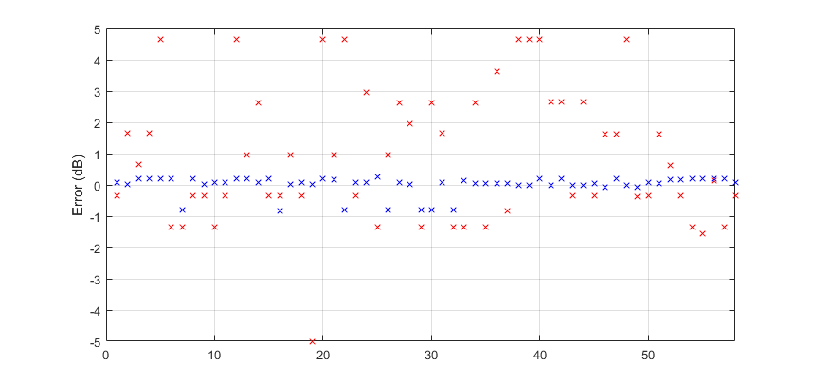
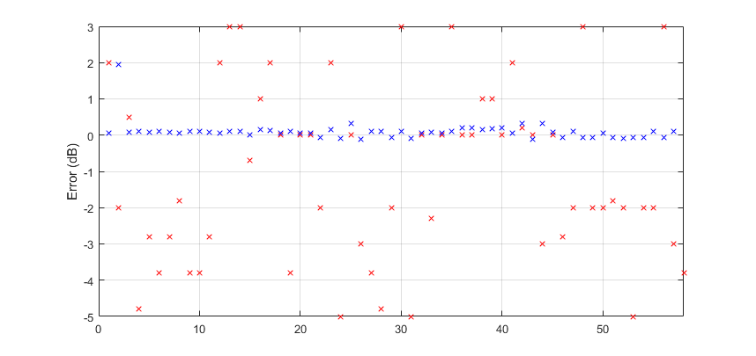
Figure 31 shows the same values of errors but presented as CDFs with same colours. Solid lines are for rectangular apertures, dashed lines – for circular apertures.
FIGURE 31
CDF of SLL errors
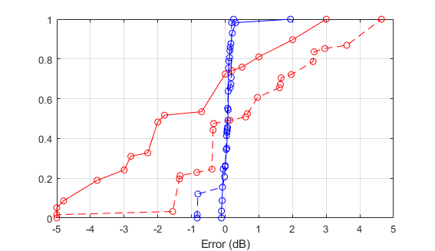
The significant difference between red and blue crosses and lines in Figures 30 and 31 are due to discrete character of output SLL of the simplified model with zero pedestal. This is schematically explained in Figure 32 for rectangular aperture as an example.
FIGURE 32
SLL level ranges when pedestal is equal to zero (rectangular aperture)
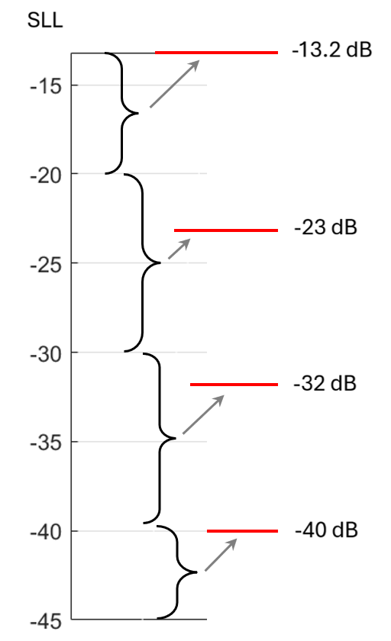
From the first comparison it can be seen that the models using principle to find an amplitude aperture distribution to get the required SLL level provide the output antenna pattern satisfying much better input requirements.
The second type of the comparison is when the input parameter is antenna gain at some different angle $θ'$, not the first side-lobe:
$Error=G_{input}(θ')-G_{peak}(θ')$ (20)
As in this case SLL or type of amplitude aperture distribution are in most cases not specified, the determination of radiation pattern is based on finding a pattern which is closer to the specified value at specified angle than other patterns or even coincides with it. In case of models with pedestal in most cases the coincidence may be provided due to the continuous character of the SLL. The errors for all founded antennas are presented in Figure 33 as values and in Figure 34 as CDFs. Colours and type of the lines are the same as in Figures 30 and 31. The negative values of errors are when the output model has higher side-lobes than required, the positive values are when the output side-lobes are lower.
FIGURE 33
Errors of radiation at some given angles (circular aperture on the upper figure,
rectangular aperture on the lower figure)
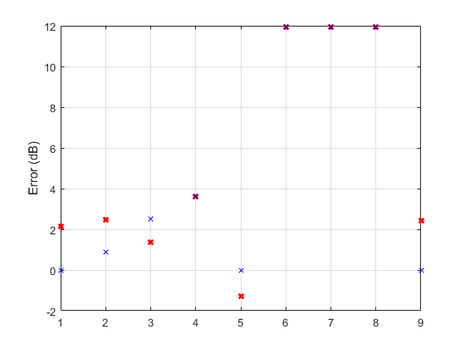
2
1
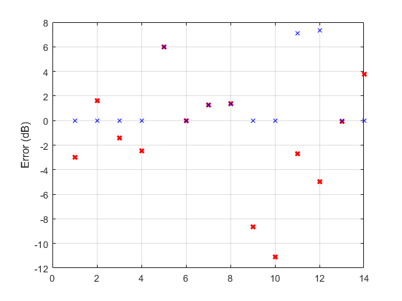
4
3
In Figure 33, four artefacts are in red circles with numbers (1-4) in order to explain these particular cases.
Case 1: in Recommendation ITU-R M.1796 there are three radars with the following antenna characteristics: beamwidth 2.4 degrees, radiation ‒20 dB at 12 degrees (below main lobe gain). Such antenna can be modelled only as a uniform distribution, but it gives the level of ‒31.2 dB for both models (the models are the same for uniform distribution).
Case 2: Recommendation ITU-R M.2089 has antenna with beamwidth 12 degrees with radiation −15.5 dB at 23 degrees (below the main lobe gain). Such antenna can be modelled only as a uniform distribution, but it gives the level of ‒19.13 dB for both models.
Case 3: Recommendation ITU-R M.1796 has antenna with beamwidth 0.75 degrees with radiation ‒ 24 dB at 10 degrees (below the main lobe gain). The closest antenna is a uniform distribution which gives -30 dB for both models.
Case 4: one of the antennas in Recommendation ITU-R M.1796 (beamwidth 0.6 degrees) is characterized by three points: ‒28 dB at 1.5 degrees, ‒30 dB at 5 degrees, ‒35 dB at 10 degrees. If we fit the model with pedestal to the first point (SLL is ‒28.87 dB) without error, two further points will be with errors 7.1 dB and 7.35 dB. But the simplified model with zero pedestal will give errors ‒ 11.1 dB, ‒2.71 dB and ‒5 dB for three points (uniform distribution).
So some radars in ITU-R Recommendations have antennas which cannot be exactly represented by any model as they have side-lobes higher than the side-lobes of uniform distributions.
FIGURE 34
CDF of radiation pattern errors at some given angles
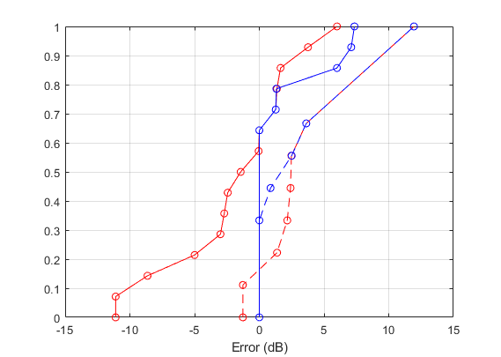
The simplification with zero pedestal (red lines) due to highly discrete character of the model gives errors of both types (negative and positive). The models with pedestal give errors only due to the lower sidelobes in some cases. This happens mainly when the required characteristics are higher than can give uniform distribution.

5 Average reference radiation patterns
Average reference radiation patterns are determined as peak reference radiation patterns minus constant $C$ without touching the main lobe:
$G_{av}(θ)=\left\{\begin{matrix}G_{peak}\left(θ\right) if θ≤θ_{br av} \\ G_{peak}\left(θ\right)-C if θ>θ_{br av} \\ G_{floor} if G_{peak}\left(θ\right)-C<G_{floor}\end{matrix}\right.$, (21)
where $θ_{br av}$ is the breakpoint between mainlobe and sidelobe envelope, $G_{floor}$ is the same level of backward radiation as for the peak reference radiation pattern.
Constant $C$ is determined in such a way that it provides the same value of integral of average radiation pattern as the integral of the lobe radiation pattern. This permits not to overestimate the radiation in the aggregate sharing studies. So the following condition should be hold:
$\int_{-90}^{90}{G_{lobe}dθ}=\int_{-90}^{90}{G_{peak}dθ}+\int_{-90}^{-θ_{br av}}{\frac{G_{peak}}{c}dθ}+\int_{θ_{br av}}^{90}{\frac{G_{peak}}{c}dθ}$ (22)
where $C=10\log_{10}{c}$, $G_{lobe}$ and $G_{peak}$ are in this formula in absolute values.
The calculation results of constant $C$ based on condition (22) are shown in Figures 35 and 36 for circular and rectangular apertures, respectively.
Figure 35
Constant $C$ for circular aperture antennas
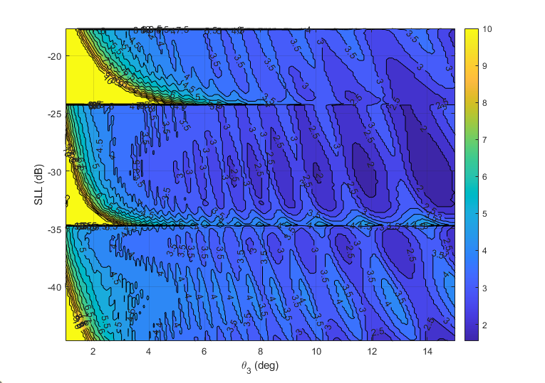
Figure 36
Constant $C$ for rectangular aperture antennas
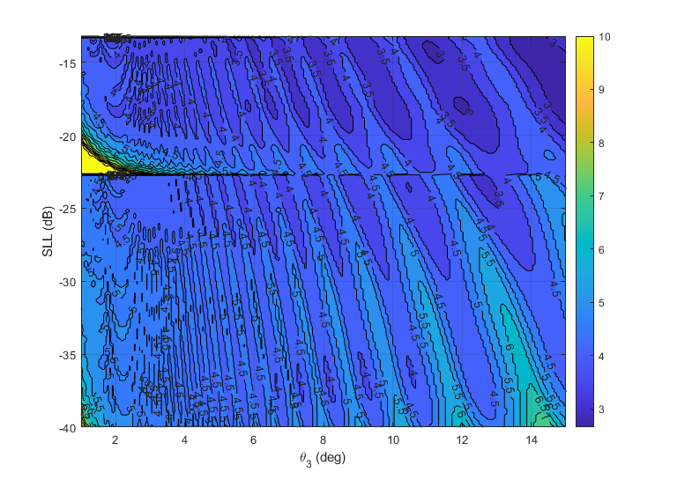
It may be seen that constant $C$ depends on SLL level as well as on beamwidth.
Figure 36 shows the CDFs of constant $C$ presented in Figures 35 and 36 above. The left graph is for circular aperture, the right graph is for rectangular aperture.
Figure 37
CDF for constant $C$ (circular aperture on the left, rectangular aperture on the right)
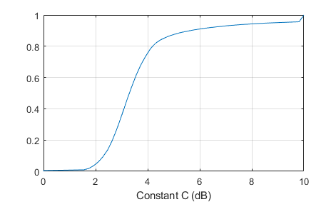 | 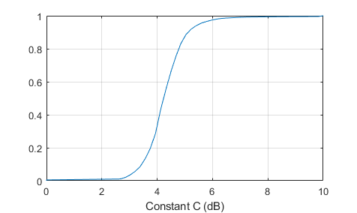
As it is not possible to determine exact value of constant $C$ for each particular case, usually a value of 3 or 4 dB is used. In Recommendation ITU-R M.1851 it is 4 dB. The mean values of constant $C$ are 3.8597 dB and 4.4031 dB for circular and rectangular apertures, respectively, so 4 dB seems appropriate.

6 Conclusions
TBD
References
[1] Volakis J. L., Antenna Engineering Handbook, 4th ed., 2007
[2] Stutzman, W. L., Thiele, G. A., Antenna Theory and Design, 3rd ed., 2013
[3] Skolnik, M., Radar Handbook, 3rd ed., 2008
[4] Balanis C. A., Antenna Theory. Analysis and Design, 3rd ed., 2005
[5] Hansen R.C., Phased Array Antennas, 2nd ed., 2009
[6] Yampolsky, A. A., Frolov, O. P., Antenny i EMS [Antennas and EMC], 1983 (in Russian).
[7] R. J. Mailloux, Phased Array Antenna Handbook, 1st ed., Artech House, 534 pp., 1994. 2nd ed., Artech House 2005.
[8] R. C. Hansen, “Array Pattern Control and Synthesis,” Proc. IEEE, Vol. 80, No. 1, pp. 141-151, January 1992.
[9] Taylor, T. T., “One-Parameter Family of Line Sources Producing Modified sin πu/πu Patterns”, Rep. TM 324, Hughes Aircraft Co., Culver City, CA, 1953. (note: this is the original paper, but it is not available on the internet)
[10] Balanis C. A., Antenna Theory. Analysis and Design, 4th ed., 2016
[11] Electromagnetic Waves and Antennas by Sophocles J. Orfanidis, Rutgers University, Copyright © 1999-2016 by Sophocles J. Orfanidis. Or https://rutgers.app.box.com/s/rwzifofsu9slf8xy38f6uwhjd5gmn2q7 https://www.ece.rutgers.edu/orfanidis (a link to all of the author’s publications)
[12] M. Al-Husseini et al., “Independent Control of the Beamwidth and Sidelobe Level of Taylor One-parameter Arrays”, https://lebcsr.org/wp-content/uploads/2018/01/C69.pdf

