U.S. Radiocommunications Sector
Fact Sheet
Working Party: ITU-R WP 5B | Document No: USWP5B36-06
Ref: Annex 2.6 to Document 5B/435-E | Date: 5th March 2026
Document Title: PRELIMINARY DRAFT NEW RECOMMENDATION
ITU-R M.[AM(R)S_AMS(R)S_CHAR_5GHZ] - Characteristics and Protection Criteria of Terrestrial and Satellite Unmanned Aircraft System Control and Non-Payload Communications Links operating in the Aeronautical Mobile (R) Service and Aeronautical Mobile Satellite (R) Service in the band 5 030-5 091 MHz

Author(s)/Contributors(s):  Name: Don Nellis  Org: Federal Aviation Administration  Name: Michael Neale  Org: ACES Corporation for the FAA  Name: Taylor King  Org: ACES Corporation for the FAA | Phone: (202) 267-9779  Email: Donald.Nellis@faa.gov  Phone: (858) 705-8978  Email: michael.neale@aces-inc.com  Phone: (443) 966-0550  Email: taylor.king@aces-inc.com
Purpose/Objective: The purpose of this contribution is to propose an update to the terrestrial characteristics in Section 2.1, based on a recent update to the RTCA MOPS DO-362A that standardizes and defines this terrestrial based CNPC Link.
Abstract: This contribution contains characteristics and protection criteria for terrestrial and satellite based systems that can be used for remote control of unmanned aircraft.

Changes from first draft are highlighted in turquoise.

Radiocommunication Study Groups | 
Received : XXX  Source: Annex 2.6 to  Document 5B/435  Subject: New Recommendation  ITU-R M.[AM(R)S_AMS(R)S_CHAR_5GHZ] | Document 5B/XXX-E
 | XXX
 | English only
United Sates of America
preliminary draft new Recommendation Itu-r m.[AM(R)S_AMS(R)S_char_5GHz]
Characteristics and Protection Criteria of Terrestrial and Satellite Unmanned Aircraft System Control and Non-Payload Communications Links
operating in the aeronautical mobile (route) service and aeronautical
mobile satellite (R) Service in the band 5 030-5 091 MHz

Introduction
At WRC-2012 it was agreed, under No. 5.443C, that the frequency band 5 030-5 091MHz could be used by the aeronautical mobile (R) service limited to internationally standardized aeronautical systems. Industry, international standards development organizations and ICAO have been working since then to develop the technology and standards necessary to use that allocation. Consequently, it is now possible to provide characteristics and protection criteria for such systems for use in any future sharing studies within ITU-R.
Proposal
The United States of America proposes to assist in answering the above need by providing characteristics for such Control and Non-Payload Communications (CNPC) links operating in the AM(R)S allocation under No. 5443C and used in air-ground applications between Unmanned Aircraft (UA) and their Control Station (CS) where the Remote Pilot (RP) is located.
The United States of America proposes that this document should be elevated to a Draft New Report at the November 2026 meeting of WP 5B and if the High Altitude Relay System compatibility study information is still unavailable at that time then the High Altitude Relay System in Section 2.2 is temporarily removed so that the PDNR can be elevated.

Attachment: 1

Radiocommunication Study Groups | 
Source: Annex 2.6 to Document 5B/435  Subject: Preliminary draft new Recommendation ITU-R M.[AM(R)S_AMS(R)S_CHAR_5GHz] | Document 5B/XXX-E
 | XXX May 2026
 | English only
PRELIMINARY DRAFT NEW RECOMMENDATION ITU-R M.[AM(R)S_AMS(R)S_CHAR_5GHZ]
Characteristics and protection criteria of terrestrial and satellite unmanned aircraft system control and non-payload communications links operating in the aeronautical mobile (route) service in the band 5 030-5 091 MHz and aeronautical mobile satellite (R) service in the band 5 000-5 150 MHz
Scope
This Recommendation specifies the characteristics of control and non-payload communications (CNPC) links, carrying command and control (C2) information, operating in the aeronautical mobile (R) service (AM(R)S) in the frequency band 5 030-5 091 MHz and aeronautical mobile-satellite (R) service (AMS(R)S) in the band 5 000-5 150 MHz in order to be used in analysing compatibility between unmanned aircraft systems (UAS) CNPC operating in the AM(R)S and AMS(R)S and other services.
Keywords
Unmanned aircraft systems
Abbreviations/Glossary
AM(R)S Aeronautical mobile (route) service
AMS(R)S Aeronautical mobile-satellite (route) service
ARRS Airborne radio relay system
ARS Airborne radio system
BGRS Beyond line-of-sight ground radio system
C2 Command and control
CNPC Control and non-payload communication
CRC Cyclic redundancy check
DVB-RCS Digital video broadcasting - return channel via satellite
FDMA Frequency division multiple access
GMSK Gaussian minimum shift keying
GRS Ground radio system
ICAO International Civil Aviation Organization
QPSK Quadrature phase shift keying
RPA Remotely piloted aircraft
RPAS Remotely piloted aircraft system
RR Radio Regulation
TCC Turbo code comparison
TDD Time division duplex
UA Unmanned aircraft
UACS Unmanned aircraft control station
UAS Unmanned aircraft system
Related ITU Reports
Reports
ITU-R M.2205 Results of studies of the AM(R)S allocation in the band 960-1 164 MHz and of the AMS(R)S allocation in the band 5 030-5 091 MHz to support control and non-payload communications links for unmanned aircraft systems
ITU-R M.2233 Examples of technical characteristics for unmanned aircraft control and non-payload communications links
ITU-R M.2171 Characteristics of unmanned aircraft systems and spectrum requirements to support their safe operation in non-segregated airspace
The ITU Radiocommunication Assembly,
considering
a) that …
recognizing
a) that the frequency bands 5 030-5 091 MHz and 5 000-5 150 MHz are allocated respectively to the aeronautical mobile (route) service (AM(R)S) and the aeronautical mobile-satellite (route) service (AMS(R)S) which are planned to be used for unmanned aircraft (UA) control and non-payload communication (CNPC) command and control (C2) links to support the safe operation of UA;
b) that the frequency band 5 000-5 150 MHz is also allocated to the aeronautical radionavigation service;
c) that some internationally standardized microwave landing systems operate in this band in accordance with Radio Regulations (RR) No. 5.444;
d) that from RR No. 5.444, in the frequency band 5 030-5 091 MHz, the requirements of microwave landing system have priority over other uses of this frequency band;
e) that use of the frequency band 5 030-5 091 MHz by the AM(R)S and 5 000-5 150 MHz by the AMS(R)S is limited to internationally standardized aeronautical systems in accordance respectively with RR No. 5.443C and RR No. 5.443D.
recommends
1 that the technical and operational characteristics of the UA CNPC links for C2 operating in the AM(R)S and AMS(R)S described in the Annex should be considered representative of AM(R)S operating in the frequency band 5 030-5 091 MHz and AMS(R)S systems operating in the frequency band 5 000-5 150 MHz and should be used in studies of compatibility with systems operating under an allocation to another service;
2 that an aggregate interference protection criterion I/N for AM(R)S systems operating in the frequency band 5 030-5 091 MHz and for AMS(R)S systems operating in the frequency band 5 000-5 150 MHz of −6 dB should be [used/considered].
Annex

1 Introduction and scope
The characteristics and protection criteria of UAS CNPC C2 links and their spectrum requirements must support the safe operation of unmanned aircraft (UA) in non-segregated airspace. There is a strong and growing demand for the use of UAS (which include remotely piloted aircraft systems (RPAS) within the international civil aviation organization (ICAO)) in civil applications. Some UA flights will share airspace with passenger carrying aircraft, so their operation needs to be managed to safely allow the introduction of this new paradigm in aviation.
As these communications are critical for a safe management of the airspaces, future ICAO standards are obviously mandatory for these kinds of communications.
The CNPC C2 Link between the unmanned aircraft control station (UACS) and the UA support the following two ways of communication:
– The forward link: Link from the UACS to the unmanned aircraft for flight and navigation equipment control.
– The return link: Link from the UA to the UACS. It is anticipated that in some flight conditions or in specific airspaces it may be necessary to downlink video streams.
The potential types of C2 information exchanges carried over the CNPC C2 link system are:
The C2 Link control data – Information to enable the remote pilot and automation in the UACS and UA to manage the operation of the C2 Link system, which includes, inter alia, the C2 Link quality of service delivered reports to the remote pilot and the UA.
The C2 Link user data – Information passing through the C2 Link in support of the remote pilot’s safe and efficient UAS operations.
One aspect of the management of safe UAS operations is the management of the interference received by the receivers that link the UA and the UA CS. To enable this interference analysis to be undertaken the characteristics and protection criteria are proposed for these links operating in the AM(R)S and AMS(R)S allocations where RR Nos. 5.443C and 5.443D apply. This recommendation contains those characteristics and protection criteria based on systems which are currently under development and that will have to comply with the international standardization being developed by ICAO.
The CNPC C2 link consists of air-to-ground links that can be used simultaneously or independently, as required, to provide operational coverage and performance. CNPC C2 Link systems include a terrestrial based component, a high-altitude relay-based component and a satellite-based component.
The terrestrial component uses an airborne radio system (ARS) on the UA to communicate with a ground radio system (GRS) that connects to the UACS. The high-altitude relay component uses a similar ARS on the UA, [which communicates via the airborne radio relay system (ARRS)] to a beyond line-of-sight ground radio system (BGRS) on the ground that connects to the UACS. The satellite component uses an airborne earth station on the UA to communicate with a ground earth station (via the geostationary satellite) that connects to the UACS.
[Figure 1
Example command and non-payload communications link system components]
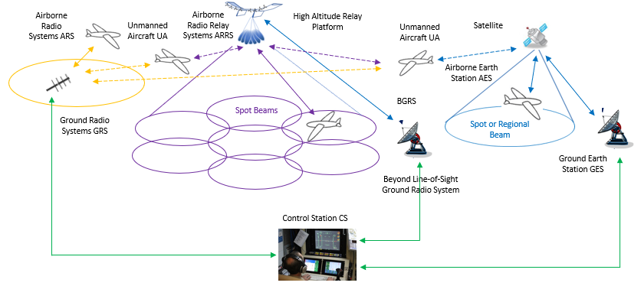
[Editor’s note: Concerns were raised with respect to the Airborne radio relay system in the figure above. According to the explanations given by ICAO, the relay system is under consideration by ICAO for standardization. It is not clear if the standardization will be completed before the adoption of this recommendation]

2 Characteristics of command and non-payload communication links at 5 GHz

2.1 Unmanned aircraft and control station characteristics for terrestrial control
and non-payload communication link
TABLE 1
Transmission and reception characteristics for the terrestrial control
and non-payload communication link System 1
Terrestrial command and non-payload communication System 1
 | Units | UA ARS | GRS
Frequency of operation | MHz | 5 030 to 5 091 | 5 030 to 5 091
Duplexing |  | Time division duplex (TDD) | TDD
Transmit/receive duration | msec | 23 Receive + 1.3 guard time  23 Transmit + 2.7 guard time | 23 Transmit + 1.3 guard time  23 Receive + 1.3 guard time
Modulation |  | GMSK or QPSK | GMSK or QPSK
Modulation symbol rates | ksps | GMSK: TBD  including error correction/detection, guard times and synchronization overhead | GMSK: TBD  including error correction/detection, guard times and synchronization overhead
Forward error correction |  | GMSK: Rate 5/8 Turbo Conv.  Code  QPSK: Rate 5/9 and Rate 1/3 TCC | GMSK: Rate 5/8 Turbo Conv. Code  QPSK: Rate 5/9 and Rate 1/3 TCC
Error detection |  | 32-bit CRC | 32-bit CRC
Baseband Input/Output Signal |  | User Data | User Data
User Data Bit Rates | kbps | GMSK: TBD  QPSK: TBD  Includes TDD duty cycle overhead | GMSK: TBD  QPSK: TBD  Includes TDD duty cycle overhead
Occupied bandwidth, C | kHz | Variable per application with a maximum of 250 | Variable per application with a maximum of 250
Antenna gain | dBi | 2 Omnidirectional | Maximum 20 (see Table 2)
Cable loss | dB | 2 | 1
Antenna pattern |  | Constant azimuth  Constant elevation | Constant azimuth  Tailored in elevation  See Table 2
Antenna polarization |  | Vertical with aircraft flying straight and level | Vertical
Maximum antenna height | m | 22 860 (mean sea level)  Typical 6 000 | 2 to 50  Typical 10
Service range | km | 550  Typical 80 | 550  Typical 80
Transmitter conducted power | dBm | 40 | 40
Transmitter in band emission limits | dBc/  1 MHz | −66 at 2 MHz offset  See Table 3 | −66 at 2 MHz offset  See Table 3
Receiver noise figure | dB | 7 | 7
Receiver sensitivity | dBm | GMSK: TBD  QPSK: TBD | GMSK: TBD  QPSK: TBD
Receiver in band rejection – except the operating channel | dB | One channel separation: 23  Two channel separation: 43  Three channel separation: 57  2 MHz or more separation: 63 | One channel separation: 23  Two channel separation: 43  Three channel separation: 57  2 MHz or more separation: 63
Protection criteria (aggregate) I/N | dB | –6 | –6

TABLE 2
System 1 GRS antenna characteristics
Parameter | Units | Intrasystem limit | High gain antenna | Omnidirectional antenna
Peak gain | dBi | 20 | 19 | 5.2
Elevation Θ₃ | Degrees | N/A | 9 | 55
Gain at
elevation degrees
0.5 | dBi | 19.0 | 18.5 | 5.2
1.5 | dBi | 19.5 | 18.9 | 4.9
2.5 | dBi | 20.0 | 19.0 | 4.5
3.5 | dBi | 19.5 | 18.9 | 1.6
7 | dBi | 17.0 | 16.0 | −1.4
11.5 | dBi | 14.0 | 8.2 | −2.8
16 | dBi | 11.5 | 3.8 | −5.0
32 | dBi | 6.5 | −12.5 | −8.0
64 | dBi | 1.5 | −26.4 | −9.5
75 | dBi | 0.5 | −29.0 | −11.7
89 | dBi | 0.5 | −31.0 | −16.5
Azimuth Θ₃ | Degrees |  | 34 | 360
Steerable/Sectoral/  Omnidirectional |  | N/A | Steerable/  Sectoral | Omnidirectional

The above table and accompanying graph below contain the characteristics of antennas that will be used to support unmanned aircraft operations using the System 1 whose RF characteristics are described in the previous tables. The information contained in Table 2 includes the GRS elevation and azimuth gains that will support unmanned aircraft (that themselves use omnidirectional antennas) operating up to approximately 65 nautical miles/120 km slant range, at altitudes up to 65 000 ft, down to close in operations including takeoff and landing. Because of the critical nature of the performance of UAS CNPC C2 links a range of antennas are required to maximize the link margin while maintaining intrasystem compatibility. The maximum gain allowed to ensure intrasystem compatibility is also shown in the table and accompanying graph. The High Gain antenna provides full azimuth coverage by being either steerable in azimuth or by using switching between one of a number of sectorized antennas with the characteristics given in the table. All antennas have the fixed elevation pattern given in the table and graph. In any geographic region at any one time, it is anticipated that there will be a mixture of antennas being used to support the wide variety of unmanned aircraft operations.
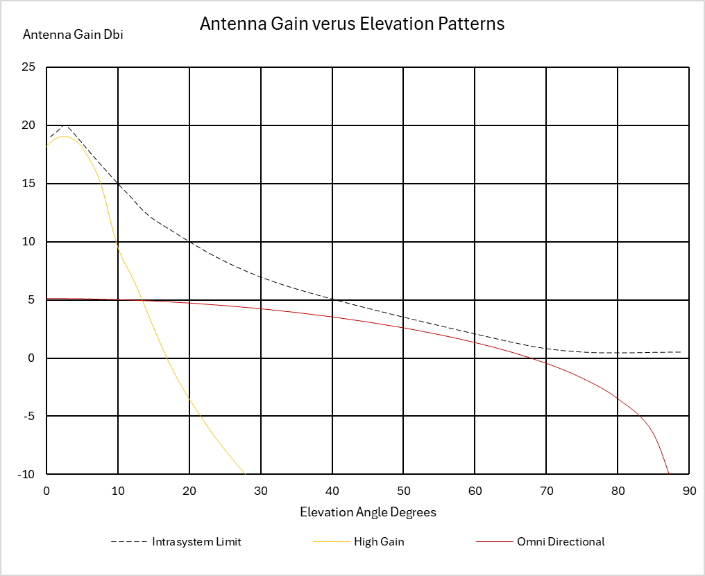

TABLE 3
Transmitter out of band emission limits in the 5 030-5 091 MHz frequency band for system 1
System 1
Offset from carrier frequency | dBc/kHz
Channel width ÷ 2 | −54
1.5 × channel width | −74
500 kHz | −90
2 000 kHz | −96

[2.2 Unmanned aircraft and ground radio station characteristics for control and non-payload communication link via high altitude relay platform
Command and non-payload communications link can also be used via high altitude relay platform. Such high-altitude relay system consists of:
a) A BGRS on the ground, with user data and link management interfaces to the host ground system.
b) An airborne relay radio system (ARRS) with user data and link management interfaces hosted on the airborne relay RPA.
c) An ARS with user data and link management interfaces hosted on the RPA.
This high-altitude relay system based C2 link system (“system 3” in this document) utilizes the frequency band 5 030–5 091 MHz to provide two-way communication between a beyond line-of-sight GRS (BGRS) and RPA flying at lower altitude via an airborne relay RPA. By using radios on the airborne relay-RPA as a relay point, C2 Link for other RPA can be extensively transmitted without deploying many radios stations on the ground.
The ARRS relays the C2 link between the ARSs and a BGRS within the coverage area of the system. As shown in Figure XX the ARRS simultaneously forms multiple beams (using one or more antennas) for the User Links between the ARRS and ARS and for the Feeder Link between the ARRS and BGRS.
Figure XX
Overview of the high-altitude relay system
The feeder link can be used as a C2 link for the airborne relay-RPA equipped with the ARRS. The airborne relay-RPA can also be controlled by another C2 link system. Communication protocols of a forward link of the User Link and a reverse link of the feeder link are both the same as those of a link from the GRS to the RPA which is an uplink of the terrestrial system. Likewise, the communication protocols of a reverse link of the user link and a forward link of the feeder link are both the same as those of a link from the RPA to the GRS which is a downlink of the terrestrial system. Therefore, the ARRS of the high-altitude relay system can be viewed as equivalent to the terrestrial system GRS, but in the sky. The ARS for the Terrestrial system can be connected to the ARRS of the high-altitude relay system without any particular modification.]
[TABLE XX
Transmission and reception characteristics of the Feeder link for the BGRS and the ARRS
 | Units | BGRS | ARRS
Frequency of operation | MHz | 5 030 to 5 091 | 5 030 to 5 091
Duplexing |  | Time division duplex (TDD) | TDD
Transmit/receive duration | msec | 60 Receive + 2.5 guard time  65 Transmit + 2.5 guard time | 60 Transmit + 2.5 guard time  65 Receive + 2.5 guard time
Modulation |  | GMSK | GMSK
Modulation symbol rates | ksps | 5 300 (max) | 5 300 (max)
Occupied bandwidth, C | kHz | 5 600 (max) | 5 600 (max)
Antenna gain | dBi | 22.5 | 18.7
Cable loss | dB | 1 | 2
Antenna pattern |  | Less than 15 degree for the wider of elevation direction and azimuth direction (3 dB bandwidth) | Less than 45 degree  (3 dB bandwidth)
Maximum antenna height | m | 2 to 50  Typical 10 | Approximately between  60 000 ft to 65 000 ft
Service range | km | 77.6 | 74
Transmitter conducted power | dBm | 30 (max) | 30 (max)
Transmitter in band emission limits | dBc/kHz | See Table XX  (See Table 3, when C is 250 kHz) | See Table XX  (See Table 3, when C is 250 kHz)
Receiver noise figure | dB | 7 | 7
Receiver sensitivity | dBm | ‒111~‒96 | ‒111~‒96
Receiver in band rejection – except the operating channel | dB | TBD | TBD
Protection criteria (aggregate) I/N | dB | TBD | TBD

TABLE XX
Transmission and reception characteristics of the User link for the ARRS and the ARSs
 | Units | ARSs | ARRS
Frequency of operation | MHz | 5 030 to 5 091 | 5 030 to 5 091
Duplexing |  | Time division duplex (TDD) | TDD
Transmit/receive duration | msec | 60 Receive + 2.5 guard time  65 Transmit + 2.5 guard time | 60 Transmit + 2.5 guard time  65 Receive + 2.5 guard time
Modulation |  | GMSK or QPSK | GMSK or QPSK
Modulation symbol rates | ksps | GMSK: TBD  including error correction/detection, guard times and synchronization overhead | GSMK: TBD  including error correction/detection, guard times and synchronization overhead
Forward error correction |  | GMSK: Rate 5/8 Turbo Conv.  Code  QPSK: Rate 5/9 and Rate 1/3 TCC | GMSK: Rate 5/8 Turbo Conv. Code  QPSK: Rate 5/9 and Rate 1/3 TCC
Error detection |  | 32-bit CRC | 32-bit CRC
Baseband Input/Output Signal |  | User Data | User Data
User data block size transmitted per TDD frame | bits | GMSK: TBD  QPSK @ TBD  QSPK @ TBS | GMSK: TBD  QPSK @ TBD  QSPK @ TBD
User data rates | kbps | GMSK Tx: 7.04, 16.0, 25.6 and 34.56  GSMK Rx: 7.04, 16.0 and 25.6  QPSK Tx/Rx @ 20 ksps: 20.64 and 34.88;  Includes TDD duty cycle overhead | GMSK Rx: 7.04, 16.0, 25.6 and 34.56  GSMK Tx: 7.04, 16.0 and 25.6  QPSK Tx/Rx @ 20 ksps: 20.64 and 34.88;  Includes TDD duty cycle overhead
Occupied bandwidth, C | kHz | Variable per application with a maximum of 250 | Variable per application with a maximum of 250
Antenna gain | dBi | 2 | 18.7
Cable loss | dB | 2 | 1
Antenna pattern |  | Constant azimuth  Constant elevation | Constant azimuth  Tailored in elevation  See Table 2
Antenna polarization |  | Vertical with aircraft flying straight and level | Vertical
Maximum antenna height | m | 22 860 (mean sea level)  Typical 8 000 | Approximately between  60 000 ft to 65 000 ft
Service range | km | 74 | 74
Transmitter conducted power | dBm | 40 | 30
Transmitter in band emission limits | dBc/kHz | −96 at 2 MHz offset  See Table 3 | −96 at 2 MHz offset  See Table 3
Receiver noise figure | dB | 7 | 7
Receiver sensitivity | dBm | GMSK: TBD  QPSK @ TBD  QSPK @ TBD | GMSK: TBD  QPSK @ TBD  QSPK @ TBD
Receiver in band rejection – except the operating channel | dB | One channel separation: 23  Two channel separation: 43  Three channel separation: 57  2 MHz or more separation: 63 | One channel separation: 23  Two channel separation: 43  Three channel separation: 57  2 MHz or more separation: 63
Protection criteria (aggregate) I/N | dB | ‒6 | ‒6

[Editor’s note: The high-altitude relay system is a system that is compatible with the system described in paragraph 2.1 and most of the communication characteristics of the user link are the same. The specific aspects of communication between the ARRS and UA ARS flying at high altitudes are highlighted in yellow.]
TABLE XX
Transmitter out of band emission limits in the 5 050-5 091 MHz frequency band
for the BGRS and ARRS (Feeder link)
Offset from carrier frequency | dBc/kHz
Channel width ÷ 2 | −54
Channel width ×1.1 | −90
Channel width ×1.5 | −96
[Editor’s note: during discussion in July 2023 and May 2024 meetings of WP 5B, some administration(s) raised a concern that compatibility studies of the high altitude relay system had not been performed in ITU-R during the study cycle in preparation of WRC-12. In order to respond to the concern, it was agreed that detailed technical specifications of the high-altitude relay system and the result of the compatibility study will be provided at a future meeting. Further clarifications and information are welcome to address this concern.]

2.3 Unmanned aircraft and control station characteristics for control and non-payload communication link via satellite

2.3.1 Control and non-payload communication via geostationary orbiting satellite systems

[TBD]

2.3.2 Control and non-payload communication via low Earth orbiting non-geostationary satellite orbiting systems
This section describes the links between the satellite and the aircraft.
TABLE 8
Example of aircraft earth station characteristics for one NGSO use case
Parameters | Units | Values
Altitude | km | 0-20
Frequency range | MHz | 5 000-5 150
Overall Tx necessary bandwidth | MHz | 15
Minimum Tx e.i.r.p. density | dBW/Hz | −37.9
Minimum Tx e.i.r.p. | dBW | 13.5
Tx loss | dB | 2
Tx bandwidth per carrier | kHz | From 20 to 140
OoB emissions | dBm | ITU-R SM.1541-7
Max antenna gain** | dBi | 3
Type antenna gain | / | Omni
Overall Rx bandwidth* | MHz | 15
Minimum Rx bandwidth carrier | kHz | 22
Protection criteria (aggregated interference): I/N*** | dB | –6
* Assumptions of 4 color reuse of the 61 MHz total available bandwidth
** steerable antenna could be considered later on
*** does not include the safety margin
TABLE 9
Example of space station characteristics for one non-GSO use case
Parameters | Units | Values
Altitude | km | 1 200
Frequency range | MHz | 5 000-5 150
Overall Tx necessary bandwidth | MHz | 15
Minimum Tx e.i.r.p. density at 30° elevation | dBW/Hz | −24.4
Minimum Tx e.i.r.p at 30° elevation | dBW | 19
Minimum Tx bandwidth per carrier | kHz | 22
OoB emissions | dBm | ITU-R SM.1541-7
Max antenna gain | dBi | 15
Type antenna gain | / | ITU-R S.1528
Overall Rx bandwidth* | MHz | 15
Rx bandwidth carrier | kHz | From 20 to 140
Protection criteria (aggregated interference): I/N** | dB | −6
* Assumptions of 4 color reuse of the 61 MHz total available bandwidth
** does not include safety margin

Safety margin is not included in the protection criteria.

