US Radiocommunication Sector
FACT SHEET
Working Party: ITU-R WP 5C | Document No: USWP5C34-xx
Reference: WRC-27 AI 1.10, Annex 2.4 Doc 5C/271 | Date: April 1, 2026
Document Title: Working document on sharing studies under Agenda Item 1.10
Author(s)/Contributor(s):  Andrew Meadows  AFSMO  Victory Nguyen  eSimplicity for AFSMO | Phone: 334-467-4720  E-mail: andrew.meadows.1@us.af.mil  Phone: 443-535-3942  E-mail: victory.nguyen@esimplicity.com
Purpose/Objective: The purpose of this document is to continue the sharing and compatibility studies for WRC-27 Agenda Item 1.10 in accordance with Resolution 775 (WRC-23).
Abstract: This contribution continues the sharing studies between the FS/AMS systems and FSS GSO system in the 71-76 and 81-86 GHz range.
Fact Sheet Preparer: Victory Nguyen

Radiocommunication Study Groups | 
Source: Annex 2.4 Doc 5C/271  Subject: WRC-27 Agenda Item 1.10 | Document 5C/XX
 | XX May 2026
 | English only
United States of America
Working document on sharing studies under agenda item 1.10
Introduction
WRC-27 Agenda Item 1.10 considers developing power flux-density and equivalent isotropically radiated power limits for inclusion in Article 21 of the Radio Regulations for the fixed-satellite, mobile-satellite and broadcasting-satellite services to protect the fixed and mobile services in the frequency bands 71-76 GHz and 81-86 GHz, in accordance with Resolution 775 (Rev.WRC-23).

This contribution provides an update to the working document presented in Annex 2.4 of the WP 5C Chair’s Report, Document 5C/271. Particular emphasis on the studies in Sections 8.1.1.1.2 and 8.2.2.1.
Attachment: 1

ATTACHMENT

Annex 2.1 to Working Party 5C Chair’s Report
WORKING DOCUMENT ON SHARING STUDIES UNDER
WRC-27 AGENDA ITEM 1.10

8.1.1.1.2 Scenario 2: Multiple Interferer (GSO Satellites)
{from 5C/188, with amendments from 5C/257}
The following relevant GSO FSS characteristics were extracted from the liaison statement by Working Party 4A in document 5C/142. The specific system used in this study is System C with modifications to the number of satellites.
Table 6
Parameters of the GSO FSS System
Parameter | System C (Satellite)
Frequency (GHz) | 71-76
Altitude (km) | 35,786
Number of planes | 1
Satellites per plane | 79
Inclination angle (deg) | 0
RAAN | N/A

The analysis was conducted assuming that the FS receiver was operating at locations at the following latitude/longitude: 39.673° N, and 104.6° W. The FS receiver antenna’s azimuth is fixed at a specific angle. Multiple simulations were conducted with azimuth angles of 0, 45, 90. 135, and 180 degrees. . The elevation angle of the receiver antenna is fixed at a specific angle. Multiple simulations were conducted with elevation angles of 0, 3, 5, 7.5 and 10 degrees.
FIGURE X
Methodology Flow Chart

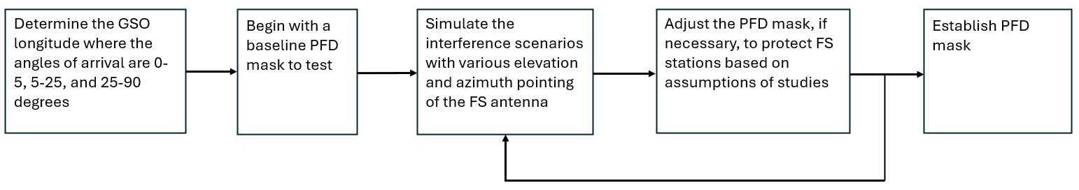
The analysis produced a complementary cumulative distribution function (CCDF) curve for the I/N levels received by the FS which was then compared to the I/N protection criteria of FS.
The following assumptions were made during the analysis:

– There are 79 GSO satellites with 2 degree spacing between 182.6° W and 26.6° W. The number is based on visibility from the FS location.

– The FS receiver’s azimuth and elevation angles are fixed.

Study results
Using the PFD mask in Table 7, the results of the simulations are presented in the following figures below.
TABLE 7
PFD Mask of GSO Satellite

Frequency band | Service* | Limit in dB(W/m²) for angles  of arrival (δ) above the horizontal plane |  |  | Reference bandwidth
Frequency band | Service* | 0°-10° | 10°-25° | 25°-90° | Reference bandwidth
71-76 GHz | Fixed-satellite (geostationary-satellite orbit) | −115 | −115 + 0.66(δ − 10) | −105 | 1 MHz

Figure X
FS receiver I/N CCDF plot, Free Space, GSO Satellites 2 Degree Spacing
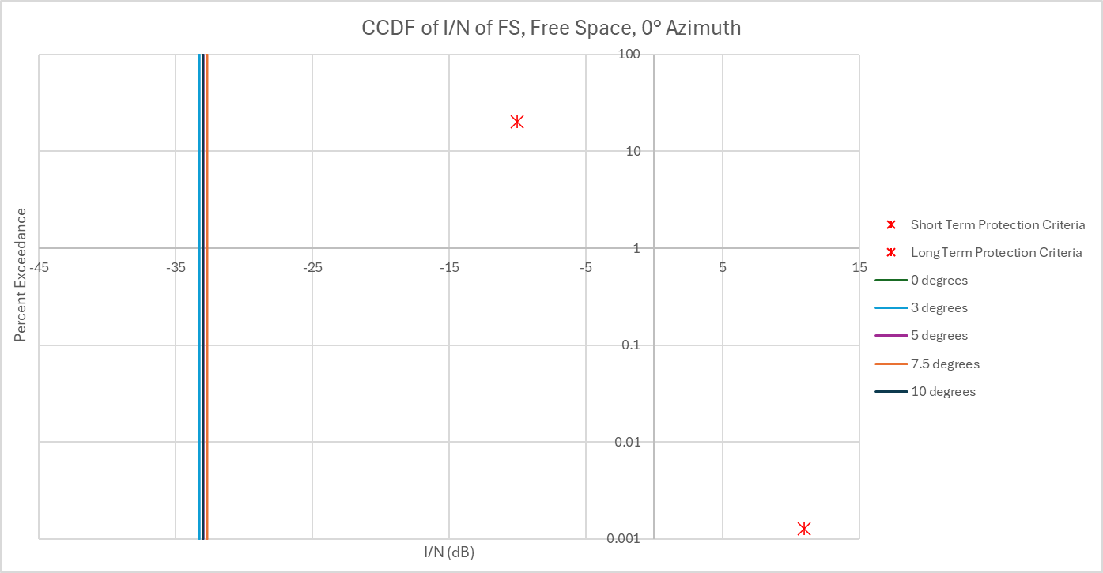
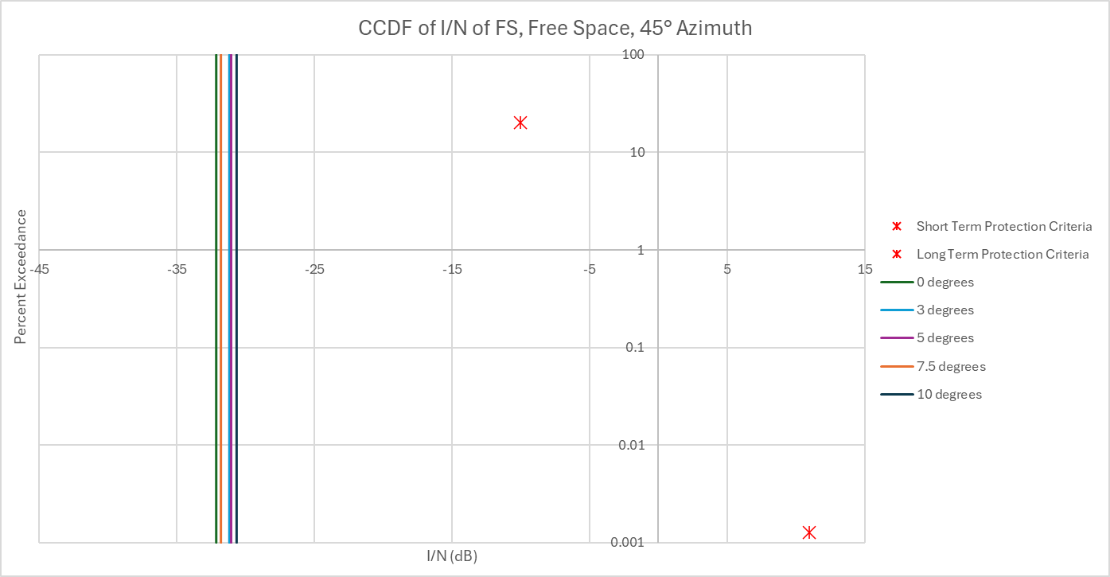
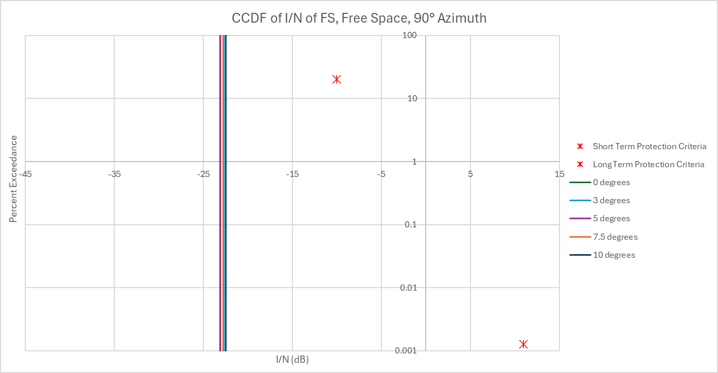
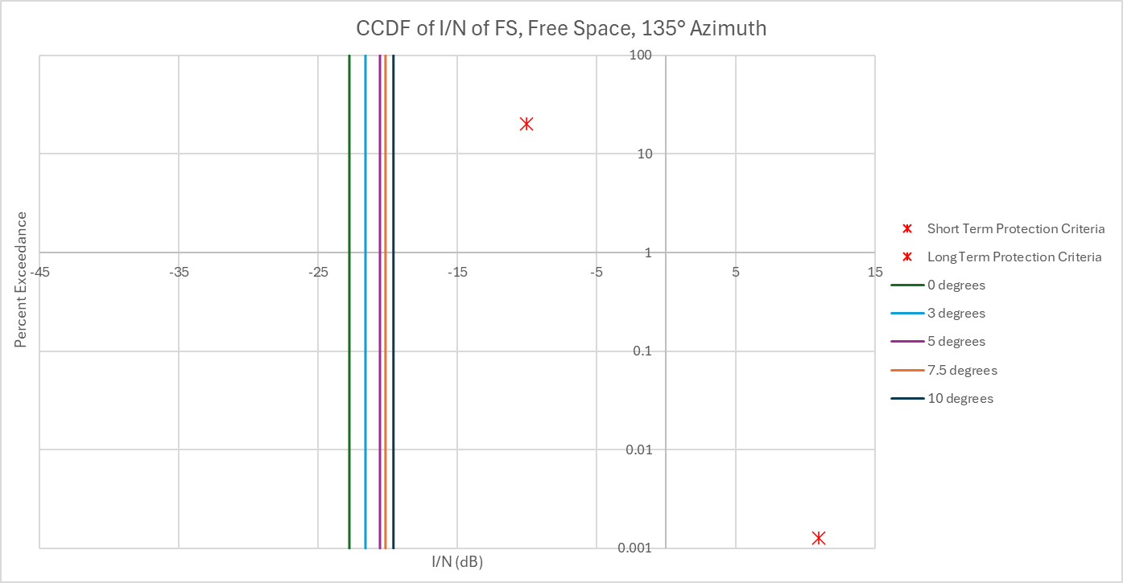
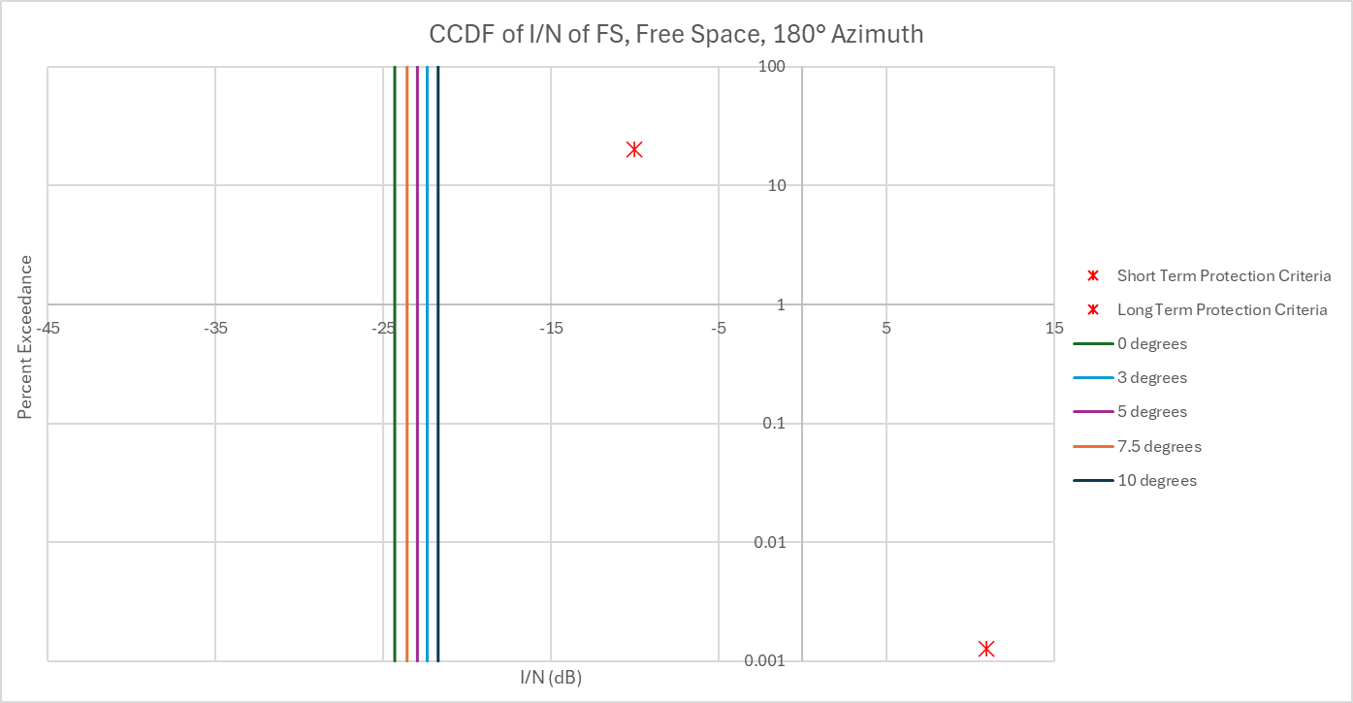
Figure X
FS receiver I/N CCDF plot, Dry Air, GSO Satellites 2 Degree Spacing
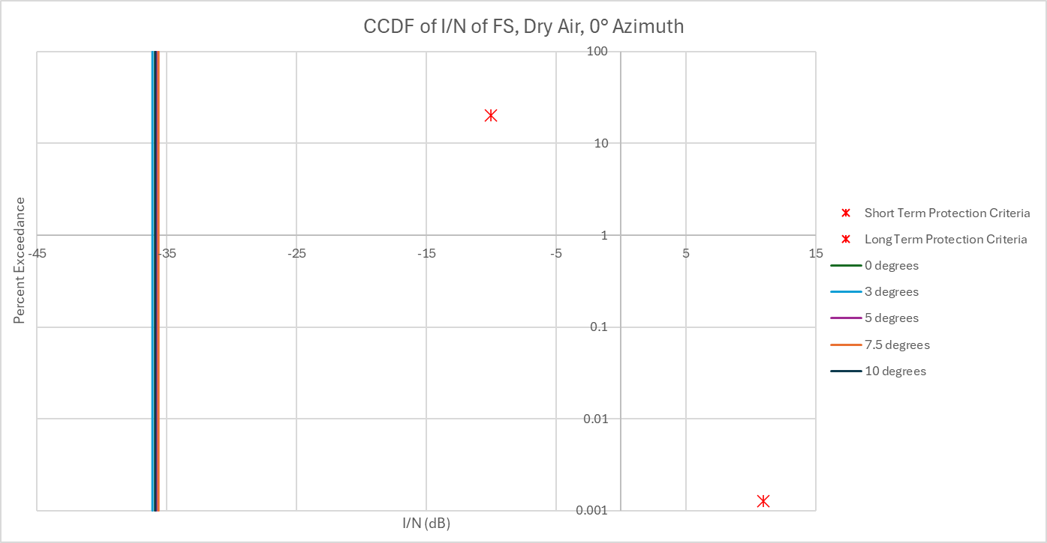
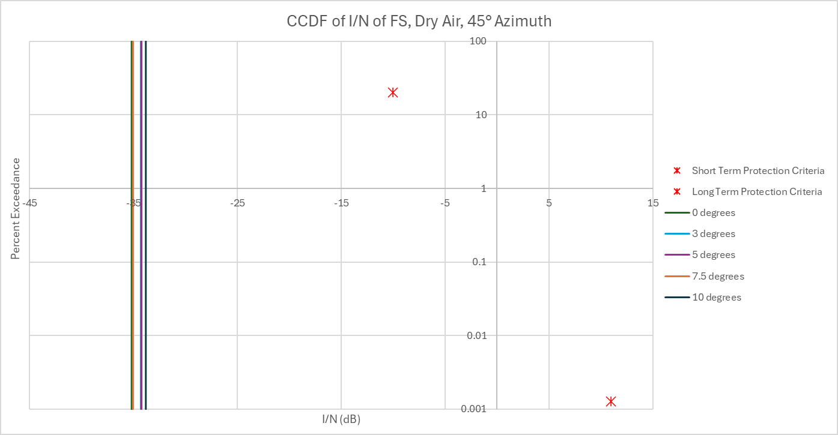
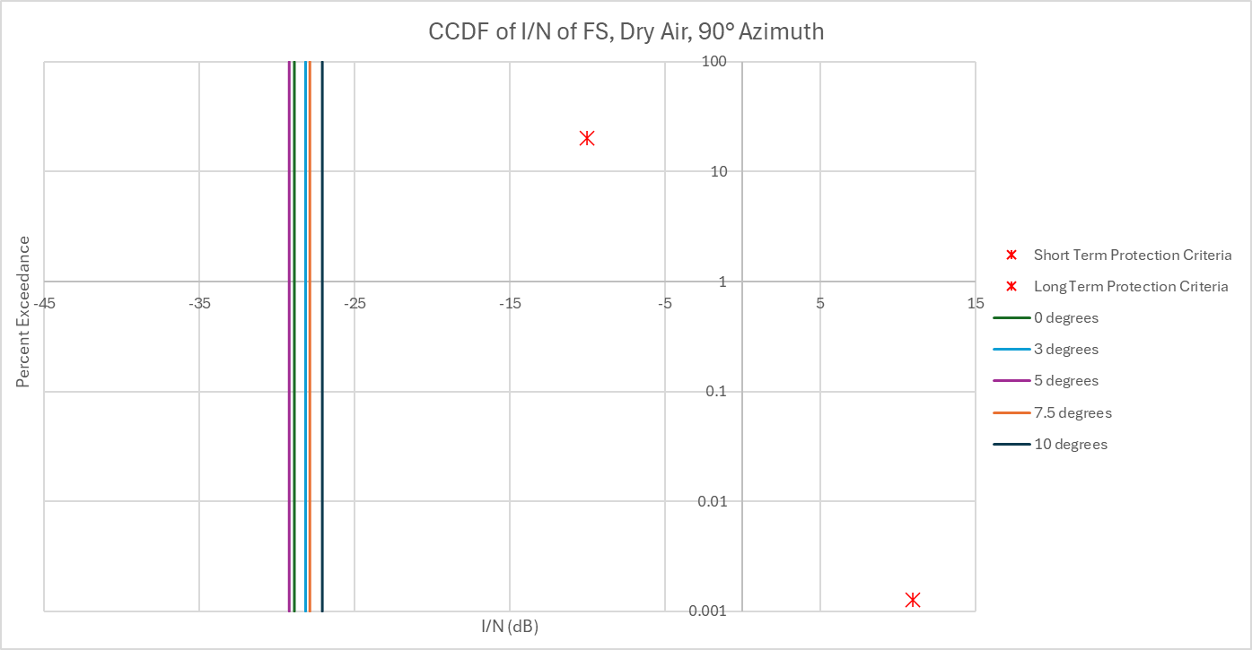
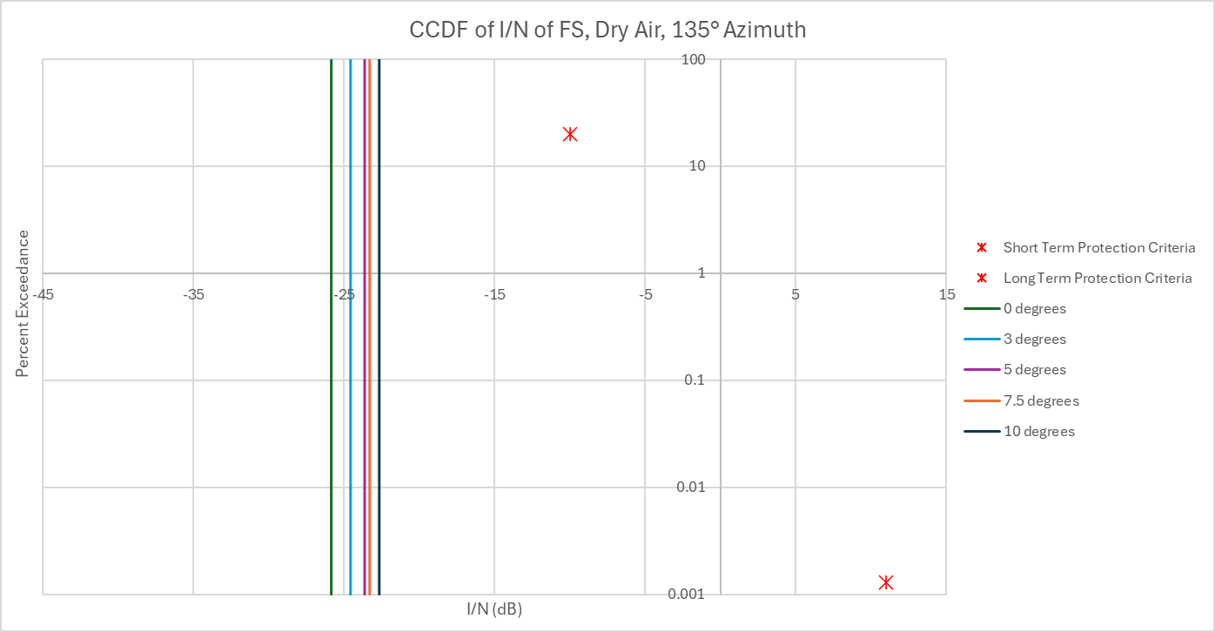
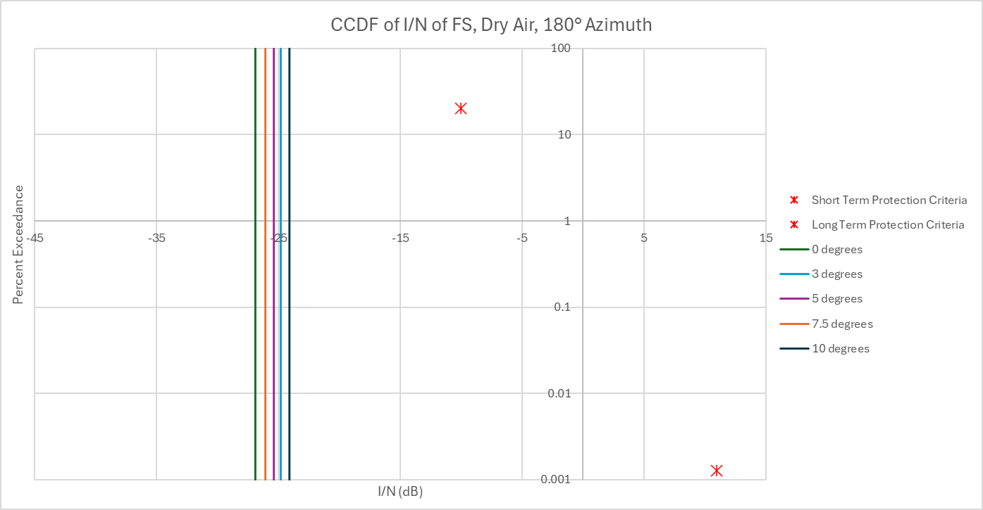

Two additional scenarios were considered for the studies. One scenario assuming the FS antenna is pointing directly to a GSO satellite with the following relative azimuth and elevation angles, 105.84 and 9.69 degrees, respectively. The second scenario is when the FS boresight has an angular separation of 2.1 degrees from the aforementioned GSO satellite. The relative FS antenna pointing is 107.94 and 9.69 degrees for the azimuth and elevation, respectively. An additional mask was also considered for the study. The masks used are shown below in Table 8.

TABLE 8
PFD Mask of GSO Satellite
 | Frequency band | Service* | Limit in dB(W/m²) for angles  of arrival (δ) above the horizontal plane |  |  | Reference bandwidth
 | Frequency band | Service* | 0°-10° | 10°-25° | 25°-90° | Reference bandwidth
Mask 1 | 71-76 GHz | Fixed-satellite (geostationary-satellite orbit) | −115 | −115 + 0.66(δ − 10) | −105 | 1 MHz
Mask 2 | 71-76 GHz | Fixed-satellite (geostationary-satellite orbit) | −139 | −139 + 2.26(δ − 10) | −105 | 1 MHz
Figure X
FS receiver I/N CCDF plot, GSO Satellites 2 Degree Spacing, Mainbeam Coupling
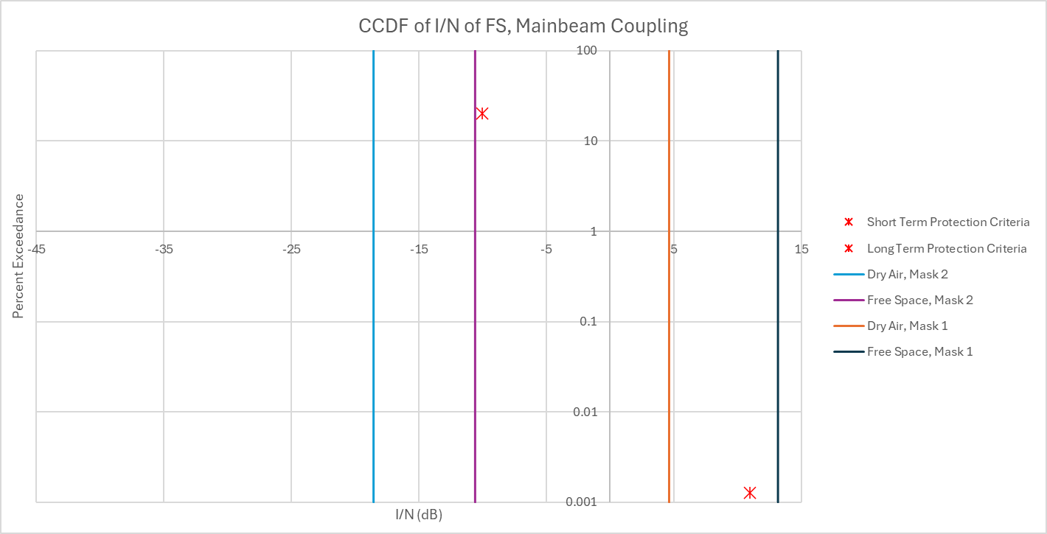
Figure X
FS receiver I/N CCDF plot, GSO Satellites 2 Degree Spacing, 2.1° Mainbeam Offset
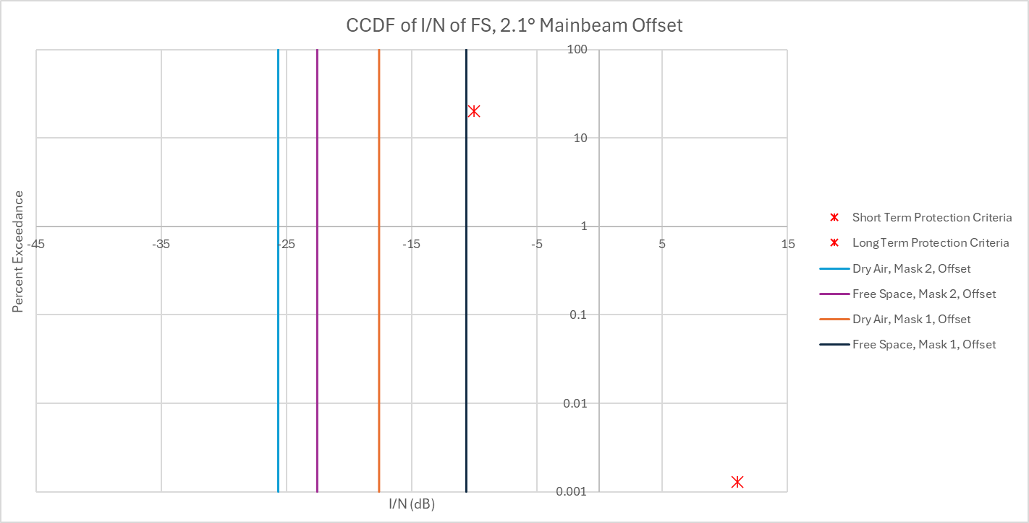

[No changes until Section 8.2.2.1]

8.2.2.1 Scenario 1: Single Interferer (GSO FSS ES, Dynamic Analysis)
Station(s) of the fixed service are defined with the parameters of the following table. The FS parameters used are found in Table 4 of the document.

The analysis was conducted assuming that the FSS ES was operating at the following latitude/longitude: 39.73° N, and 104.75° W. The location of the FS was randomized with a fixed separation distance of 60 km radius of the FSS ES that is stationed at the aforementioned location. The FS receiver antenna’s azimuth is pointing at another FS station whose location is randomized within a 0.4 to 3 km circle of the receiver.
The analysis produced a CCDF curve for the I/N levels received by the FS which was then compared to the I/N protection criteria of FS.
The following assumptions were made during the analysis:
– The SRTM V3 (3 arc second, 90m) terrain profile data was used
– A random percentage was used in the ITU-R P.452 propagation model
– There is only 1 ES deployed at 39.73° N and 104.75° W
– The FSS ES azimuth pointing is towards the FS system
– The elevation pointing angle of the FSS ES is randomized between 0 and 10 degrees
– The EIRP of the ES is adjusted in accordance with RR Nos. 21.8
– The beamwidth of the FSS ES is 0.41 degrees
– The FSS ES antenna height is 10 m.
– The FS receiver’s elevation angle is randomized between -5 and 5and -10 and 10 degrees

Study results
The results are presented in the following plots. In the following figures, the FS receiving station I/N is plotted as a CCDF plotThe results show that the FS protection criteria, short- and long-term, are met when the transmitting FSS ES and FS receiver are separated by 60 km.
FIGURE X
FS receiver I/N CCDF plot
