U.S. Radiocommunications Sector
Fact Sheet
Working Party: ITU-R WP-5B | Document No: USWP5B36-XX
Ref: 5B/435 (Annex 2.8) | Date: 19 February 2026
Document Title: WORKING DOCUMENT TOWARDS A PRELIMINARY DRAFT NEW
REPORT ITU-R M.[MODERNIZATION OF HF AM(OR)S]
Author(s)/Contributors(s):  Fumie Wingo  DON CIO  Taylor King  ACES for DON CIO  Robert Leck  ACES for DON CIO  Carmelo Rivera  ACES for DON CIO  Hank Beard  HII for DON CIO | Phone: 703-697-0066  E-mail: fumie.n.wingo.civ@us.navy.mil  Phone: 443-966-0550  E-mail: taylor.king@aces-inc.com  Phone: 321-332-2111  E-mail: robert.leck@aces-inc.com  Phone: 240-586-4028  E-mail: carmelo.rivera@aces-inc.com  Phone: 410-991-4920  E-mail: armand.beard@hii.com
Purpose/Objective: The purpose of this paper is to continue the development of the working document towards a preliminary draft new Report ITU-R M.[MODERNIZATION OF HF AM(OR)S].
Abstract: Working Party 5B is the responsible Working Party for reviewing Appendix 26 in accordance with Resolution 411 (WRC-23) and developing draft CPM text. To date, WP 5B has initiated a Working Document towards a Preliminary Draft New Report for modernization of HF AM(OR)S. This paper will propose edits to the working document towards a preliminary draft new Report ITU-R M.[MODERNIZATION OF HF AM(OR)S].

Radiocommunication Study Groups | 
Received:  Source: WP5B/435 Annex 2.8 | Document 5B/XX-E
Received:  Source: WP5B/435 Annex 2.8 | XX May 2026
Received:  Source: WP5B/435 Annex 2.8 | English only
United States of America
WORKING DOCUMENT TOWARDS A PRELIMINARY DRAFT NEW
REPORT ITU-R M.[MODERNIZATION OF HF AM(OR)S]

At its November 2026 meeting, WP 5B progressed the development on the Working Document Towards a Preliminary Draft New Report ITU-R M.[MODERNIZATION OF HF AM(OR)S]. The United States submits this revision to 5B/435 Chapter 2 Annex 2.8 based on the discussions that took place at the previous meeting.
This contribution proposes edits to the main body of the document to address editor’s notes and unresolved issues from the last meeting. Additionally, this document proposes to restructure sections 7 and 8 to improve the order of the information being provided in this document. Section 7 now contains all information pertaining to the static analysis conducted for the wideband emission mask and section 8 contains the information regarding emission measurement examples.
Attachment: 1

ATTACHMENT

Radiocommunication Study Groups
Source: | Document 5B/XX-E
Source: | XX May 2026
Source: | English only
Annex 2.8 to Working Party 5B Chair’s Report
WORKING DOCUMENT TOWARDS A PRELIMINARY DRAFT NEW
REPORT ITU-R M.[MODERNIZATION OF HF AM(OR)S]
Technical characteristics, protection criteria, and compatibility and sharing studies for the modernization of high-frequency systems operating in the aeronautical mobile (OR) service within 3.025 to 18.030 MHz

(202X)
Scope
This Report identifies technical characteristics, protection criteria, and compatibility and sharing studies required for the modernization of high frequency spectrum use in the aeronautical mobile (OR) service. It assesses compatibility with incumbent services that are allocated on a primary basis in-band and adjacent band.
Abbreviations/Glossary
ALE Automatic Link Establishment
AM Amplitude Modulation
AM(OR)S Aeronautical Mobile Off-Route Service
AM(R)S Aeronautical Mobile Route Service
BLOS Beyond Line of Sight
CSMA Carrier Sense Multiple Access
CW Continuous Wave
ASK Amplitude-Shift Keying
DSB-AM Double Sideband Amplitude Modulation
FSK Frequency-Shift Keying
FM Frequency Modulation
HF High Frequency
LUF Lowest Usable Frequency
MUF Maximum Usable Frequency
PM Phase Modulation
PSK Phase-Shift Keying
QAM Quadrature Amplitude Modulation
RF Radio Frequency
RR Radio Regulations

SSB Single-sideband
WBHF Wideband High Frequency
Definitions
Allotment (of a radio frequency or radio frequency channel): Entry of a designated frequency channel in an agreed plan, adopted by a competent conference, for use by one or more administrations for a terrestrial or space radiocommunication service in one or more identified countries or geographical areas and under specified conditions. (RR 1.17).
Aeronautical mobile route (R) service (AM(R)S): An aeronautical mobile service reserved for communications relating to safety and regularity of flight, primarily along national or international civil air routes. (RR 1. 33)
Aeronautical mobile off-route (OR) service (AM(OR)S): An aeronautical mobile service intended for communications, including those relating to flight coordination, primarily outside national or international civil air routes. (RR 1. 34)

Related ITU Recommendations and Reports
Recommendation ITU-R BS.216 – Protection ratio for sound broadcasting in the Tropical Zone
Recommendation ITU-R BS.415 – Minimum performance specifications for low-cost sound-broadcasting receivers
Recommendation ITU-R BS.560 – Definitions of radiation in LF, MF and HF broadcasting bands
Recommendation ITU-R BS.703 – Characteristics of AM sound broadcasting reference receivers for planning purposes
Recommendation ITU-R BS.705 – HF transmitting and receiving antennas characteristics and diagrams
Recommendation ITU-R BS.2144 – Planning parameters and coverage for Digital Radio Mondiale (DRM) broadcasting at frequencies below 30 MHz
Recommendation ITU-R BT.1895 – Protection criteria for terrestrial broadcasting systems
Recommendation ITU-R F.240 – Signal-to-interference protection ratios for various classes of emission in the fixed service below about 30 MHz
Recommendation ITU-R F.339 – Bandwidths, signal-to-noise ratios and fading allowances in complete systems
Recommendation ITU-R F.1761 – Characteristics of HF fixed radiocommunication systems
Recommendation ITU-R F.1762 – Characteristics of enhanced applications for high frequency (HF) radiocommunication systems
Recommendation ITU-R F.1821 – Characteristics of advanced digital high frequency (HF) radiocommunication systems
Recommendation ITU-R F.2119 – Guidance on technical parameters and methodologies for sharing and compatibility studies related to fixed and land mobile services in the frequency range 1.5-30 MHz
Recommendation ITU-R M.627 – Technical characteristics for HF maritime radio equipment using narrow-band phase-shift keying (NBPSK) telegraphy
Recommendation ITU-R M.1795 – Technical and operational characteristics of land mobile MF/HF systems
Recommendation ITU-R M.1825 – Guidance on technical parameters and methodologies for sharing studies related to systems in the land mobile service
Recommendation ITU-R P.372 – Radio noise
Recommendation ITU-R P.533 – Method for the prediction of the performance of HF circuits
Recommendation ITU-R P.1149 – Guide to the application of propagation methods of Radiocommunication Study Group 3
Recommendation ITU-R P.2108 – Prediction of clutter loss
Recommendation ITU-R TF. 2487 – Protection criteria for systems in the standard frequency and time signal services
Report ITU-R BS.458 – Characteristics of systems in LF, MF and HF broadcasting
Report ITU-R F.2061 – HF fixed radiocommunications systems
Report ITU-R F.2087 – Requirements for high frequency (HF) radiocommunication systems in the fixed service

1 Introduction
The Aeronautical Mobile (OR) Service (AM(OR)S) utilizing RR Appendix 26 frequency range between 3 025 kHz and 18 030 kHz has been a very important radio communication system for aircraft when communications is needed beyond the range of terrestrial radio systems operating at higher frequencies.. For this document, systems that use a 3 kHz channel bandwidth within RR Appendix 26 allotments are referred to as “2.8 kHz occupied bandwidth channel AM(OR)S”. To differentiate, a wideband implementation of AM(OR)S, where allotted channels are aggregated to create greater bandwidths, are referred to as WB AM(OR)S. Next generation High Frequency (HF) can accommodate digital technologies for aeronautical systems operating under AM(OR)S. AM(OR)S radio systems are expected to improve data rates, voice clarity, and link availability. To support inclusion of WBHF AM(OR)S systems, revision of RR Appendix 26 is being studied to consider appropriate regulatory actions to support modernization of systems operating in the AM(OR)S within the frequency range defined in RR Appendix 26 without modifying the existing area allotments or altering current channelization.

2 Aeronautical Mobile Off-Route (OR) Service
AM(OR)S is intended for communications, including those relating to flight coordination, primarily outside national or international civil air routes. HF communications are used where line of sight communication at very high frequency (VHF) and much higher frequencies are not possible due to range limitations.
HF systems, in accordance with RR Appendix26, are used for non-safety related communications, such as administrative coordination, logistical support, and the exchange of meteorological or operational information that does not directly impact flight safety. The long-range capabilities of HF communications make them valuable for maintaining connectivity across large distances.

WBHF technologies have been identified to improve the performance of AM(OR)S operations. These technologies allow for wider channel bandwidths, resulting in improved voice quality, higher data rates, enhanced reliability, improved ground station monitoring, and improved handover in the presence of signal degradation.

3 RR Appendix 26 overview
Aircraft use specific HF frequencies allocated for AM(OR)S as defined in the ITU Radio Regulations, RR Appendix 26. RR Appendix 26 specifically refers to the “frequency allotment plan for the aeronautical mobile (off-route) service,” essentially outlining the designated frequency bands allocated for air traffic communication within the AM(OR)S, including details on channel usage and related information.
Frequency allotments within RR Appendix 26 are based upon channel bandwidths that are limited to 3 kHz. Implementation of wider channel bandwidths will need to be accomplished within the scope of the current RR Appendix 26 allotment plan.
The AM(OR)S frequencies within RR Appendix 26 are listed below in Table 1, taken from Parts I and II of RR Appendix 26. Additional provisions related to allotments and channel specifications are listed below taken from Parts I and II of Appendix 26.
TABLE 1
RR Appendix 26 Frequency ranges exclusive to AM(OR)S (kHz)
3 025-3 155 | 8 965-9 040
3 900-3 950 (Region 1 only) | 11 175-11 275
4 700-4 750 | 13 200-13 260
5 680-5 730 | 15 010-15 100
6 685-6 765 | 17 970-18 030
26/2.2 Allotment in the aeronautical mobile (OR) service
A frequency allotment in the aeronautical mobile (OR) service which comprises:
– a frequency channel from the channels appearing in the channelling arrangement in RR No. 26/3;
– a bandwidth of up to 2.8 kHz, situated wholly within the frequency channel concerned;
– a power within the limits laid down in RR No. 26/4.4 or specified against the allotted frequency channel;
– an allotment area which is the area in which the aeronautical station can be situated and which coincides with all or part of the territory of the country, or of the geographical area, as indicated against the frequency channel concerned in the Frequency Allotment Plan.
26/3.4 The carrier (reference) frequencies 3 023 kHz and 5 680 kHz are intended for worldwide common use (see also RR Appendix 27, Nos. 27/232 to 27/238).
26/3.6 The channelling arrangement specified in RR No. 26/3.1 does not prejudice the rights of administrations to establish, and to notify assignments to stations in the aeronautical mobile (OR) service other than those using radiotelephony, provided that:
– the occupied bandwidth does not exceed 2 800 Hz and is situated wholly within one frequency channel;
– the limits of unwanted emission are met (see RR Appendix 27, No. 27/74).

4 In-band and adjacent band incumbent services
Table 2 lists the in-band and adjacent band primary allocated services per Article 5 of the ITU Radio Regulations that will need to be studied in accordance with Resolution 411 (WRC-23).
TABLE 2
Incumbent primary services in-band and adjacent to AM(OR)S allocations
Frequency Band (kHz)  RR Appendix 26  Bands (Bold) | Region 1 | Region 2 |  |  |  | Region 3
2 850-3 025 | AM(R)S 5.111 5.115
3 025-3 155 | AM(OR)S
3 155-3 200 | FIXED  MOBILE (except AM(R)) 5.116, 5.117
3 800-3 900 | FIXED  AM(OR)S  LAND MOBILE | 3750-4000  AMATEUR  FIXED  MOBILE (except AM(R)) 5.122 5.125 |  |  |  | 3500-3900  AMATEUR  FIXED  MOBILE
3 900-3 950 | AM(OR)S 5.123 |  |  |  |  | AMS  BROADCASTING
3 950-4 000 | FIXED  BROADCASTING |  |  |  |  | FIXED  BROADCASTING 5.126
4 650-4 700 | AM(R)S
4 700-4 750 | AM(OR)S
4 750-4 850 | FIXED  AM(OR)S  LAND MOBILE  BROADCASTING 5.113 | FIXED  MOBILE (except AM(R))  BROADCASTING 5.113 |  | FIXED  BROADCASTING 5.113
5 480-5 680 | AM(R)S 5.111 5.115
5 680-5 730 | AM(OR)S 5.111 5.115
5 730-5 900 | FIXED  LAND MOBILE |  | FIXED  MOBILE (except AM(R)S) |  | FIXED  MOBILE (except AM(R)S)
6 525-6 685 | AM(R)S
6 685-6 765 | AM(OR)S
6 765-7 000 | FIXED  MOBILE (except AM(R))  5.138
8 815-8 965 | AM(R)S
8 965-9 040 | AM(OR)S
9 040-9 305 | FIXED | 9040-9400  FIXED |  | FIXED
10 150-11 175 | FIXED
11 175-11 275 | AM(OR)S
11 275-11 400 | AM(R)S
12 230-13 200 | MARITIME MOBILE 5.109 5.110 5.132 5.137A 5.145
13 200-13 260 | AM(OR)S
13 260-13 360 | AM(R)S
15 005-15 010 | STANDARD FREQUENCY AND TIME SIGNAL
15 010-15 100 | AM(OR)S
15 100-15 600 | BROADCASTING
17 900-17 970 | AM(R)S
17 970-18 030 | AM(OR)S
18 030-18 052 | FIXED

5 Technical characteristics

5.1 AM(OR)S

Tables 3-6 lists typical parameters for 2.8 kHz occupied bandwidth channel AM(OR)S aeronautical and aircraft stations.
Additional technical parameters are listed below:
– Aeronautical radio stations are limited to single-side-band emissions
– The upper sideband shall be employed, and the assigned frequency shall be 1400 Hz higher than the carrier frequency
– A channel bandwidth of up to 3 kHz (occupied bandwidth of 2.8 kHz) is contained within a given frequency channel power limits as defined in Table 3.
TABLE 3
2.8 kHz occupied bandwidth channel AM(OR)S power limits for aeronautical and aircraft stations
Class of emission | Power limit values  (peak envelope power supplied to the antenna)
Class of emission | Aeronautical station | Aircraft stations
J3E | 36 dBW | 23 dBW
A1A, A1B | 30 dBW | 17 dBW
F1B | 30 dBW | 17 dBW
A2A, A2B | 32 dBW | 19 dBW
H2A, H2B | 33 dBW | 20 dBW
(R, J) 2 (A, B, D) | 36 dBW | 23 dBW
J (7,9) (B, D, X) | 36 dBW | 23 dBW

2.8 kHz occupied bandwidth channel AM(OR)S transmitter parameters and emission parameters are included in Tables 4, Table 5, and in Figure 1. 2.8 kHz occupied bandwidth channel AM(OR)S receiver parameters are included in Table 6.
TABLE 4
2.8 kHz occupied bandwidth channel AM(OR)S typical transmitter parameters
Parameter | Aeronautical Ground and Aircraft Station
Frequency Range (MHz) | 3.025-18.030
Occupied Bandwidth (kHz) | 2.8
Channel Separation (kHz) | 3
Signal to Noise Ratio (dB) | 10
Antenna Type | Directional
Antenna Gain (dBi) | 19
Power (dBW) | 30
Emission Type (Telephony) | J3E
Emission Type (Telegraphy) | A1A, A1B, F1B, (A, H) 2 (A, B)  (R, J) 2 (A, B, D), J (7, 9) (B, D, X)
Modulation Type | Upper Sideband  Single Sideband (SSB)  Quadrature Amplitude Modulation (QAM)  Frequency-Shift Keying (FSK)  Phase-Shift Keying (PSK)
Propagation Mode | Skywave
Range (km) | Aeronautical Ground Stations: >1000  Aircraft Stations: <500

TABLE 5
2.8 kHz occupied bandwidth channel AM(OR)S emission mask*
Frequency separation Δ from the assigned frequency (kHz) | Minimum attenuation below peak envelope power (PX) (dB)
1.5 ≤ Δ < 4.5 | 30
4.5 ≤ Δ < 7.5 | 38
7.5 ≤ Δ | 43**
* For aircraft station transmitters first installed after 1 February 1982 and for aeronautical stations transmitters in use after 1 February 1983
** For transmitter power up to and including 50W: 43+10log₁₀ (PX) (W). For transmitter powers more than 50W, the attenuation shall be at least 60 dB.

FIGURE 1
2.8 kHz occupied bandwidth channel AM(OR)S emission mask
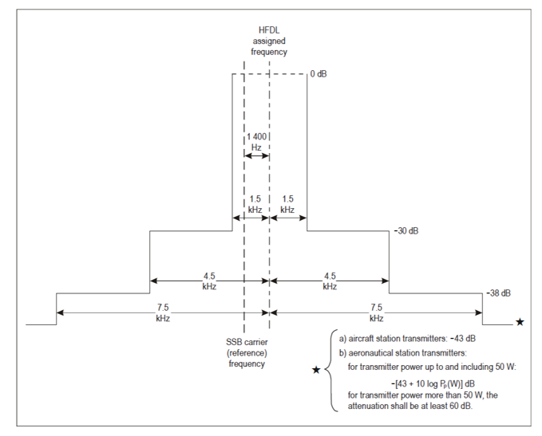
TABLE 6
2.8 kHz occupied bandwidth channel AM(OR)S Typical Receiver Parameters
Parameter | Aeronautical ground and aircraft stations
Frequency range (MHz) | 3.025-18.030
Receiver bandwidth (kHz) | 2.8
Receiver sensitivity (dB) | –113 to –110 at 10 dB SINAD
Receiver noise figure (dB) | 14-19
IF rejection (dB) | >80
I/N Protection Criteria | ‒6
Antenna gain (dBi) | 0
Antenna type | Aeronautical ground station horizontal dipole  Aircraft  Tail cap, trailing wire,  notch antenna. Multi-loop
Antenna polarization | Vertical/horizontal
Antenna height | Aeronautical ground (15-30)  Aircraft (9000 to 13000)

WBHF AM(OR)S systems with wider channel bandwidths will utilize the existing AM(OR)S allotments within the frequency range 3.025 to 18.030 MHz; therefore no additional spectrum will need to be allocated to accommodate WBHF AM(OR)S systems. New modulation waveforms consistent with the emission designators as defined in RR Appendix 26 will be implemented.
Except for channel bandwidths, modulation types, and the emission mask, the wideband receiver and transmitter parameters are the same as those listed in Tables 3 through6 for 2.8 kHz occupied bandwidth channel AM(OR)S.
The existing HF allotment plan of AM(OR)S has been based (among other things) on emission levels from anticipated unwanted emissions from the edge of a channel. Any change to the waveform or bandwidth (with or without concatenation of channels) that affect the waveform, the unwanted emissions, and(or) total power radiated compared to current AM(OR)S operations could potentially affect aviation’s use of systems operating under the allocation to AM(R)S in the range 2.85-22 MHz. Therefore, except for the bandwidth, the emission mask for the WBHF AM(OR)S systems should be same as that of 2.8 kHz occupied bandwidth channel systems.
The following emission mask, Table 7, specifications are based upon the 3 kHz channel bandwidth emission masks as show in Figure 1 above. The only difference between the mask in Figure 1 above and the mask in Figure 2, below, is the channel bandwidth. In Figure 2, the channel bandwidth can vary between 3 and 48 kHz. That is, the WBHF AM(OR)S mask supports channel bandwidths of up to 48 kHz(contiguous or non-contiguous) in 3 kHz increments. Adherence to this mask ensures non-interference with adjacent HF services.
TABLE 7
WBHF AM(OR)S emission mask
Frequency separation Δ from the assigned frequency (kHz) | Minimum attenuation below peak envelope power (PX) (dB)
BW/2 ≤ Δ < BW/2 +3 | 30
BW/2 +3 ≤ Δ < BW/2 +6 | 38
BW/2 +6 ≤ Δ | 43*
* For transmitter power up to and including 50W: 43+10log₁₀ (PX) (W). For transmitter powers more than 50W, the attenuation shall be at least 60 dB.
BW is the channel bandwidth (defined by Nx3 kHz, where N is the number of contiguous bonded 3 kHz channels)

FIGURE 2
WBHF AM(OR)S emission mask for aggregated contiguous channels
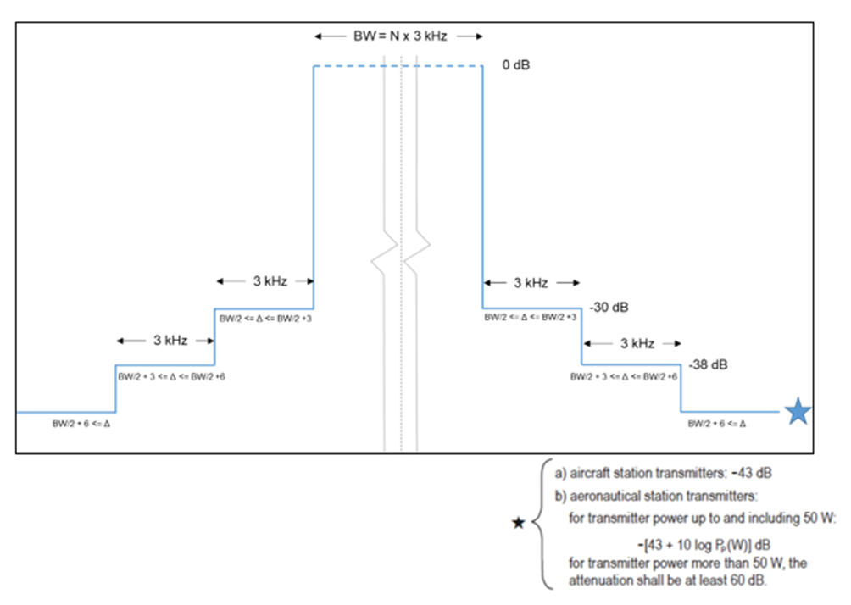
Another method to obtain WBHF AM(OR)S systems is to use the existing allotments, even if there are non-contiguous within the frequency range 2.8 to 18.05 MHz that are allotted for AM(OR)S, so no additional spectrum will need to be allocated. New modulation waveforms consistent with the emission designators as defined in RR Appendix 26 will be implemented.
The Figure 3 mask supports channel bandwidths in 3 kHz at different center frequencies. It is only the copy of the mask of the Figure 1 in each non-contiguous available allotments of 3 kHz. The wide bandwidth is assured by the use of these N separated channels of 3 kHz. N is equal to 4 in the Figure 3.
FIGURE 3
WBHF AM(OR)S emission mask for non-contiguous channels
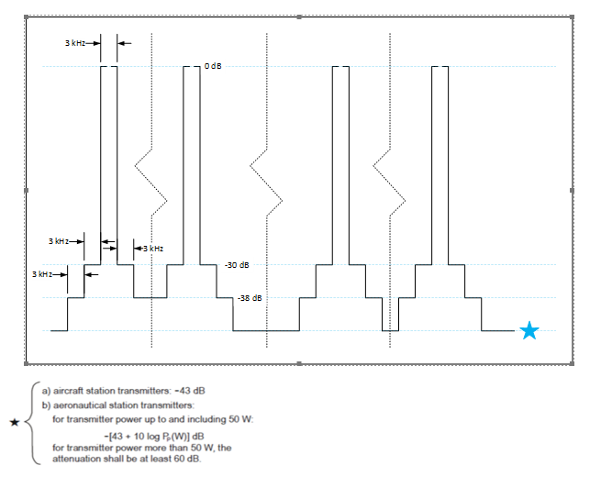

[USA Note: This section is proposed to be moved to a later section in the document.]

5.2 Incumbent services receiver technical characteristics

Incumbent services include AM(R)S, Fixed, Mobile (except AM(R), Land Mobile, Broadcasting, Maritime Mobile and Standard Frequency and Time. The in-band and adjacent band technical parameters are listed in Table 8.
TABLE 8
[In-Band and] Adjacent Band Incumbent Services Receiver Technical Parameters
Technical parameters | AM(R)S | Fixed | Mobile (except (R) | Land mobile | Broadcasting | Maritime Mobile | Standard frequency and time
Bandwidth (kHz) | 3-48 | 2.8 | 2.8 to 30 MHz | 2.8 to 30 MHz | 10 kHz | 10 to 20 | 1 to 10
Modulation | SSB,, CW, FSK | AM, FM, PM, QAM, ASK, FSK, PSK | PSK, FSK, QAM | SSB, AM, FM, ASK, FSK | AM double-sideband, COFDM (QAM) | SSB with Supressed Carrier | DSB-AM
Antenna Type | Vertical Whip | Horizontal Dipole | Vertical Whip | Vertical Whip | Telescopic rod | Vertical Whip | Dipole
Antenna Gain (dBi) | 0 to 3 | 6 to 12 | 0 to 2 | 0 to 3 | -15 | 0 | 3 to 10
Polarization | Horizontal | Horizontal/Vertical | Horizontal | Vertical | Horizontal/Vertical | Vertical | Vertical
Receiver Sensitivity (dBm unless otherwise noted) | –113 to  –110 at  10 dB SINAD | –113 to –110 | –125 to  –130 | -110 to -110 | 40 dB (µV/m) | –110 to  –130 | –110 to  –125

6 Protection criteria

6.1 AM(OR)S
An I/N value -6 dB for AM(OR)S, equivalent to the I/N criteria for AM(R)S, will provide a level of protection that would assure that an interfering signal would be significantly weaker than the background noise level to avoid disrupting communication with aircraft.

Protection for AM(OR)S is achieved through the implementation of dedicated frequency allocations, power limitations, frequency reuse techniques and strict coordination between different users within the AM(OR)S service frequency bands. Applying these concepts ensures that clear and reliable AM(OR)S communications.

6.2 Incumbent Services
Table 9 lists the I/N protection criteria for in-band and adjacent band services. These I/N values were obtained from ITU-R reports and recommendations as provided by the responsible working parties of each incumbent service.
TABLE 9
Protection criteria for services that are in-band and adjacent band to
the allocated AM(OR)S frequency bands
Service | I/N (dB)
AM(R)S | –6
Fixed | –6
Land Mobile | –10
Broadcasting | –10
Maritime mobile | –10
Standard frequency and time | –20

6.3 Derivation of Incumbent Services Maximum Interference Levels
The external noise is a combination of three components: man-made noise, galactic noise, and atmospheric noise.
Man-made noise depends on the frequency and the environment. Section 5 in Recommendation ITU-R P.372-17 shows how to derive median values of man-made noise energy, $N_{man}$, for several environments:
$N_{man}=c-d(\log_{10}\left(f\right))-204 (\frac{dBW}{Hz})$
where $f$ is the operational frequency expressed in MHz and c and d are environmental constants as defined in Table 10 from Recommendation ITU-R P.372-17, section 6.1.1.
TABLE 10
Values of the constants c and d
Environmental category | c | d
City (curve A) | 76.8 | 27.7
Residential (curve B) | 72.5 | 27.7
Rural (curve C) | 67.2 | 27.7
Quiet rural (curve D) | 53.6 | 28.6
Galactic noise (curve E) | 52.0 | 23.0

With regards to galactic noise and atmospheric noise, Figure 3 shows the noise energy contributions of noise sources across the 3-30 MHz band.
FIGURE 3
Noise energy vs. frequency
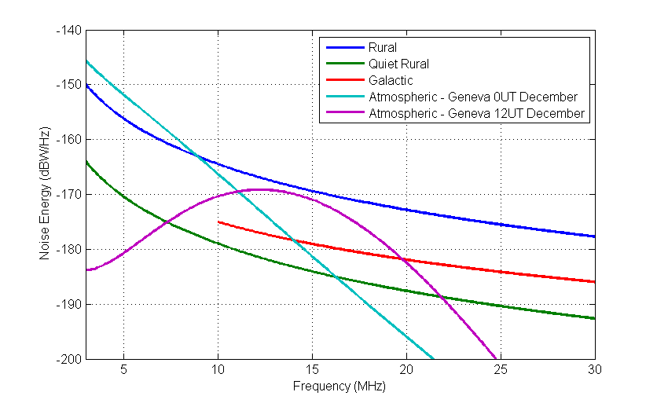
Galactic noise $N_{gal}$ only depends on frequency. The galactic noise component will not be observed at frequencies below the ionospheric critical frequency of 10 MHz (Recommendation ITU-R P.372-17).
Atmospheric noise $N_{atm}$ depends on frequency, time of day, and season. The Geneva 0 UT represents atmospheric noise energy during midnight hours vs. the 12 UT which represents atmospheric noise energy closer to noon.
For this study, the constant values, Table 10, associated with rural environments were used to calculate the man-made noise.
Applying this formula for “rural” environments, one can then derive the resulting man-made noise level $N_{man}$.

The external noise, $N$, and the maximum interference level, $I_{max}$ , into a given receivers’ bandwidth can be calculated using the formula below:
$I_{max}=N+{(\frac{I}{N})}_{long term}+10\log_{10}(RBW)$
where:
$I_{max}$ = the maximum interference level in the incumbent service receiver (dB/W)
${(\frac{I}{N})}_{long term }$ = I/N for a given service type (dB)
$N$ = the external noise value in dBW/Hz as a function of the selected noise environment (dBW/Hz)
$RBW$= Receiver Bandwidth (Hz).
The maximum interference level, $I_{max}$, is derived using the rural noise levels for center frequencies of 8.5 MHz, 10.7 MHz, and 15 MHz. Maximum interference levels for the broadcasting service are listed in Table 11. Other incumbent services maximum interference levels are shown in Tables 12, 13, and 14.
TABLE 11
Maximum interference levels for the incumbent broadcasting service (Rural)
Service to be protected | Frequency range (kHz) | Receiver Bandwidth (kHz) | Maximum interference level (dBW/RBW) at centre of range
Broadcasting | 3 200-3 400 | 10 | ‒121.1
Broadcasting | 3 900-3 950 | 10 | ‒123.2
Broadcasting | 3 950-4 000 | 10 | ‒123.3
Broadcasting | 4 750-4 995 | 10 | ‒125.8
Broadcasting | 5 005-5 060 | 10 | ‒126.2
Broadcasting | 5 900-6 200 | 10 | ‒128.4
Broadcasting | 7 200-7 450 | 10 | ‒130.7
Broadcasting | 9 400-9 900 | 10 | ‒134.0
Broadcasting | 11 600-12 100 | 10 | ‒136.5
Broadcasting | 13 570-13 870 | 10 | ‒138.3
Broadcasting | 15 100-15 800 | 10 | ‒139.7
Broadcasting | 17 480-17 900 | 10 | ‒141.3
Broadcasting | 18 900-19 020 | 10 | ‒142.2
TABLE 12
Incumbent maximum interference levels at 8.5 MHz
(Rural)
Service | I/N (dB) | Receiver bandwidth (kHz) | Maximum interference level (dBW/channel bandwidth) | Maximum interference level (dBm/channel bandwidth)
AM(R)S (3 kHz) | -6 | 3 | ‒134.23 | ‒104.23
AM(R)S (48 kHz) | -6 | 48 | ‒122.19 | ‒92.19
Fixed | –6 | 3 | ‒134.23 | ‒104.23
Land mobile | –10 | 12 | ‒132.21 | ‒102.21
Broadcasting | –10 | 10 | ‒132.3 | ‒102.3
Maritime mobile | –10 | 3 | ‒138.23 | ‒108.23
Standard frequency and time | –20 | 10 | ‒143.00 | ‒113.00
TABLE 13
Incumbent maximum interference levels at 10.7 MHz
(Rural)
Service | I/N (dB) | Receiver bandwidth (kHz) | Maximum interference level (dBW/channel bandwidth) | Maximum interference level (dBm/channel bandwidth)
AM(R)S (3 kHz) | –6 | 3 | ‒137.23 | ‒107.23
AM(R)S (48 kHz) | –6 | 348 | ‒125.19 | ‒95.19
Fixed | –6 | 3 | ‒137.23 | ‒107.23
Land mobile | –10 | 12 | ‒135.21 | ‒105.21
Broadcasting | –10 | 10 | ‒135.3 | ‒105.3
Maritime mobile | –10 | 3 | ‒141.23 | ‒111.23
Standard frequency and time | –20 | 10 | ‒146.00 | ‒116.00
TABLE 14
Incumbent maximum interference levels at 15 MHz
(Rural)
Service | I/N (dB) | Receiver bandwidth (kHz) | Maximum interference level (dBW/channel bandwidth) | Maximum interference level (dBm/channel bandwidth)
AM(R)S (3 kHz) | -6 | 3 | ‒140.23 | ‒110.23
AM(R)S (48 kHz) | -6 | 48 | ‒128.19 | ‒98.19
Fixed | –6 | 3 | ‒140.23 | ‒110.23
Land mobile | –10 | 12 | ‒138.21 | ‒108.21
Broadcasting | –10 | 10 | ‒139.00 | ‒109.00
Maritime mobile | –10 | 3 | ‒144.23 | ‒114.23
Standard frequency and time | –20 | 10 | ‒149.00 | ‒119.00

[USA note: Since this Report is measurement based, additional analysis utilizing appropriate propagation models as outlined in ITU-R P.1144 and ITU-R P.533 were not required.]

7 Compatibility and Sharing Analysis

7.1 Static Analysis Methodology
The static analysis will consider three target frequencies (8.5, 10.7, and 15 MHz) for the following incumbents (AM(R)S, Fixed, Land Mobile, Broadcasting, Maritime Mobile and Standard Frequency and Time.
The selection of 8.5 MHz, 10.7 MHz, and 15 MHz covers the AM(OR)S frequency band where WBHF could be implemented. The selection of incumbent services covers the services that could be impacted in the lower and upper adjacent bands associated by a WB AM(OR)S transmission. Since the frequencies that are allotted to AM(OR)S are for AM(OR)S only adjacent band transmissions will be considered. The signal level at the incumbent’s receiver for path lengths of 500, 1 000, 5 000 and 10 000 km will be calculated. The analysis will include plots of frequency versus received signal power at the incumbent receiver for each of the target frequencies. The plots will also show the incumbent protection criteria range and the average operational noise floor across the 3 to 18 MHz frequency range.
The result of the static pathloss analysis will provide minimum, mid-range and maximum received signal levels at an incumbents’ receiver. The pathloss calculations will take incumbent system characteristics, operating frequency, noise factors and miscellaneous signal propagation losses (these include fading margin, polarization mismatch, losses associated with the medium through which signal is travelling and other losses into consideration.
The analysis methodology is as follows. Maximum interference levels for each of the incumbent systems under study will be calculated. (See Tables 11, 12 and 13). Utilizing various path lengths, the Signal levels at the incumbent service receivers will be derived using equations 1 and 2 below. Losses due to absorption will be included in the calculation. The resultant signal level will be compared to the maximum incumbent interference levels as calculated in Section 6.3 to determine if the maximum interference level has been exceeded.
Equations that will be used to derive the received signal from an WB AM(OR) transmitter to an incumbent receiver are listed below.
Free Space Path Loss
$FSL=32.4+20\log\left(f\right)+20\log\left(d\right)$ (1)
where:
F = Frequency (MHz)
D = Distance (km)
FSL = dB
Using equation (1) and considering operational frequencies of 8.5, 10.7, and 15 MHz will yield pathlosses for each of the target frequencies.
The received signal level at each of the incumbent receivers for various path lengths will be calculated using equation 2.
Interference Signal Level
$Pr=TXp+TXg+RXg-TXL-FSL-Lp-RXL dBm$ (2)
where:
Pr = received power (dBm)
TXp = transmitter output power (dBm)
TXg = transmitter antenna gain (dBi)
RXg = receiver antenna gain (dBi)
TXL = transmit feeder and associated losses (feeder, connectors, etc.) (dB)
FSL = free space loss or path loss (dB)
Lp = miscellaneous signal propagation losses; for these calculations absorption loss values for mid-latitude regions were used and assumed to be 5 dB .

RXL = receiver feeder and associated losses (feeder, connectors, etc.) (d)B Typically 3 dB.

7.2 Static Analysis Results
Tables 15, 16 and 17 list the results of the static analysis and show interference exceedance values. A negative value indicates that the received level is below the incumbent interference level and a positive value indicated that the incumbent interference levels has been exceeded. These values were calculated using the methodology that was outlined in section 7.1 “Static Analyses Methodology”. The results show that, given the noise floor levels in lower and upper adjacent frequency bands, that received signal levels at the incumbents receives are below their maximum interference levels along path lengths of 500, 1 000, 5 000 and 10 000 km.
[Editor’s note: More text is needed to link Tables 15-17 to methodology in Section 7.1.]
Table 15
Interference Exceedance Levels (dB) center Frequency 8.5MHz
8.5 MHz Center Frequency | Interference Exceedance Level (dB)
Path Length (km) | 500 | 1 000 | 5 000 | 10 000
AM(R)S (48 kHz) | ‒103 | ‒109 | ‒123 | ‒129
AM(R)S (2.8 kHz) | ‒91 | ‒97 | ‒111 | ‒117
Fixed | ‒73 | ‒79 | ‒93 | ‒99
Land Mobile | ‒93 | ‒99 | ‒113 | ‒119
Broadcasting | ‒78 | ‒84 | ‒98 | ‒104
Maritime Mobile | ‒93 | ‒99 | ‒113 | ‒119
Standard Frequency and Time | ‒68 | ‒74 | ‒88 | ‒94
Table 16
Interference Exceedance Levels (dB) center Frequency 10.7 MHz
10.7 MHz Center Frequency | Interference Exceedance Level (dB)
Path Length (km) | 500 | 1 000 | 5 000 | 10 000
AM(R)S (48 kHz) | ‒123 | ‒129 | ‒143 | ‒149
AM(R)S (2.8 kHz) | ‒111 | ‒117 | ‒131 | ‒137
Fixed | ‒93 | ‒99 | ‒113 | ‒119
Land Mobile | ‒113 | ‒119 | ‒133 | ‒139
Broadcasting | -98 | -104 | -118 | -124
Maritime Mobile | ‒113 | ‒119 | ‒133 | ‒139
Standard Frequency and Time | ‒88 | ‒94 | ‒108 | ‒114
Table 17
Interference Exceedance Levels (dB) center Frequency 15 MHz
15 MHz Center Frequency | Interference Exceedance Level (dB)
Path Length (km) | 500 | 1 000 | 5 000 | 10 000
AM(R)S (48 kHz) | ‒101 | ‒107 | ‒121 | ‒127
AM(R)S (2.8 kHz) | ‒89 | ‒95 | ‒109 | ‒115
Fixed | ‒71 | ‒77 | ‒91 | ‒97
Land Mobile | ‒91 | ‒97 | ‒111 | ‒117
Broadcasting | ‒78 | -82 | -96 | -102
Maritime Mobile | ‒91 | ‒97 | ‒111 | ‒117
Standard Frequency and Time | ‒66 | ‒72 | ‒86 | ‒92

7.3 Emission Spectrum Measurements

The objective of making emission spectrum measurements is to show that WBHF AM(OR)S transmissions comply with the power limitations and emission masks of the 2.8 kHz occupied bandwidth channel AM(OR)S systems.

To accomplish this, spectrum analyser measurements of transmitters were measured over a range of various channel bandwidths with different patterns of non-contiguous individual channels in the frequency range of 2.8 to 18.05 MHz, with different modulation types and different transmit powers.
The measurements will be used to conduct a comparison between the in-band measured emission spectrum of a WB AM(OR)S transmission and the emission mask. The objective of making this comparison is to show that the in-band emissions of a WB AM(OR)S transmitter is compliant with the emission mask.
Compliance with the AM(OR)S operational factors and system parameters as defined in RR Appendix 26, in conjunction with adherence to the WBHF AM(OR)S emission masks (Figures 2 and 3) will provide compliance with Appendix 26 allotments and channel utilization. Maintaining compliance with the HF emission mask will assure that WBHF AM(OR)S can coexist without conflict to incumbent HF voice and data transmissions, as well as with existing systems that are in-band and adjacent to RR Appendix 26 AM(OR)S allocations.

Figure 4 is a block diagram of the setup that was used to measure the emission spectrum of a typical aeronautical WB radio transmitter.
Figure 4
Simplified Emission Measurement Block Diagram
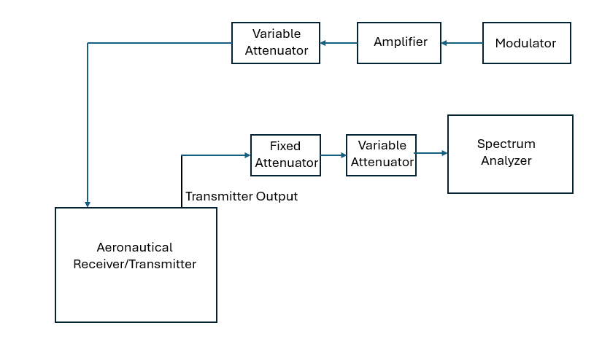

7.4 Emission Spectrum Measurement Examples

For non-contiguous adjacent band measurements of the emission spectrum can also be used to demonstrate that typical aeronautical and aircraft station transmitters meet the requirements of the WB emission mask, Figure 3. Figure 5 is an example of those measurements for a non-contiguous aggregation and, for comparative purposes, includes the overlay of the WBHF AM(OR)S emission mask, from the Figure 3, equivalent to the Figure 3. In that example, 6 non-contiguous channels of 3 kHz are used. The transmission power is 125 W, so the attenuation should be at least of 60 dB.

FIGURE 6
Example - Emission measurement versus emission mask in the case of non-contiguous channels
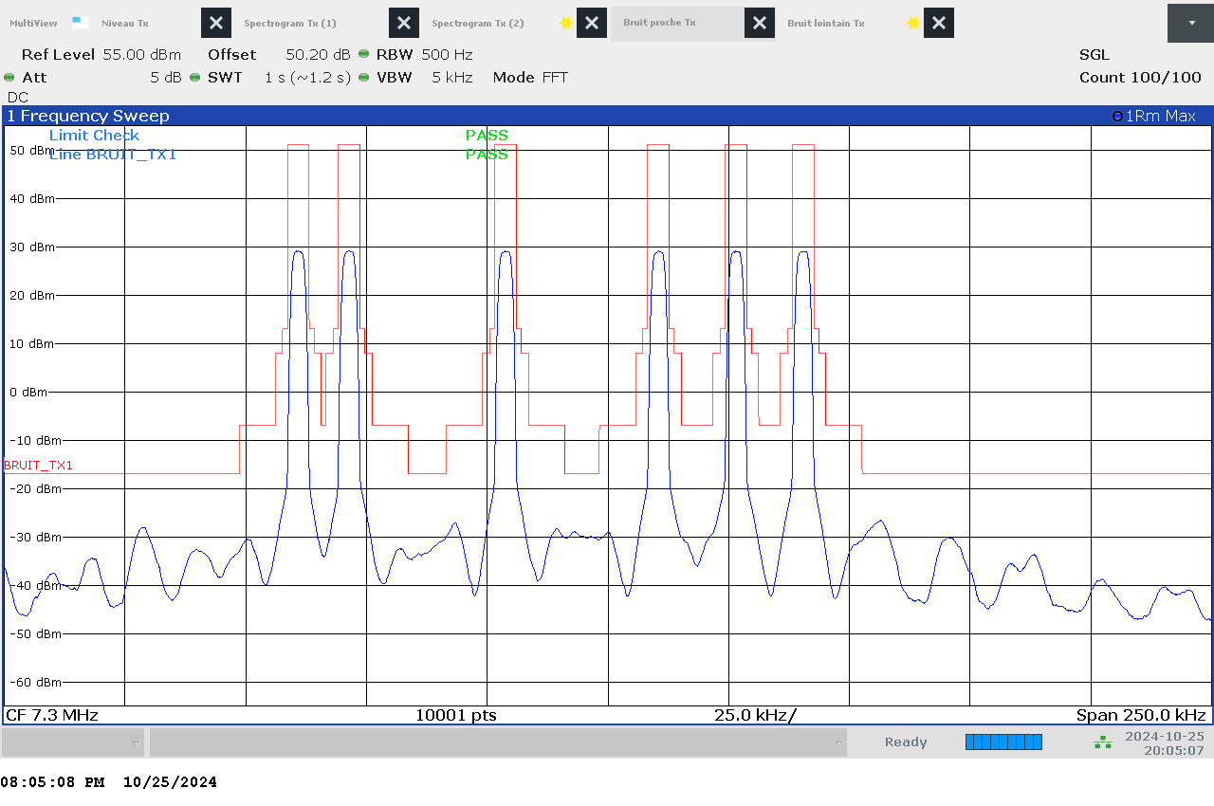
For contiguous channels, adjacent band measurements of the emission spectrum can be used to demonstrate that typical WBHF aeronautical and aircraft station transmitters meet the requirements of the WBHF emission mask, as shown in Figure 2 and that emissions in bands that are adjacent to the passband do not exceed incumbent interference levels as defined in Section 6.3.
Figure 6 shows an example of a QAM emission measurement taken at the output of an aeronautical WB radio transmitter at a center frequency of 10.7 MHz with a channel bandwidth of 24 kHz. The emission mask (red lines) has been overlaid on the measurement, as well as the value for the typical noise floor at this frequency.
This figure shows that the adjacent band emission levels from a WBHF AM(OR)S transmitter meet the emission mask criteria, are below the typical HF noise floor at 10.672 MHz, and are below incumbent maximum interference levels assuring that incumbent services will not be impacted by WBHF transmission within the lower and upper adjacent bands that are outside of the WBHF transmission primary passband.
Figure 6
Example of measurement overlayed with mask and typical noise floor at 10.7 MHz
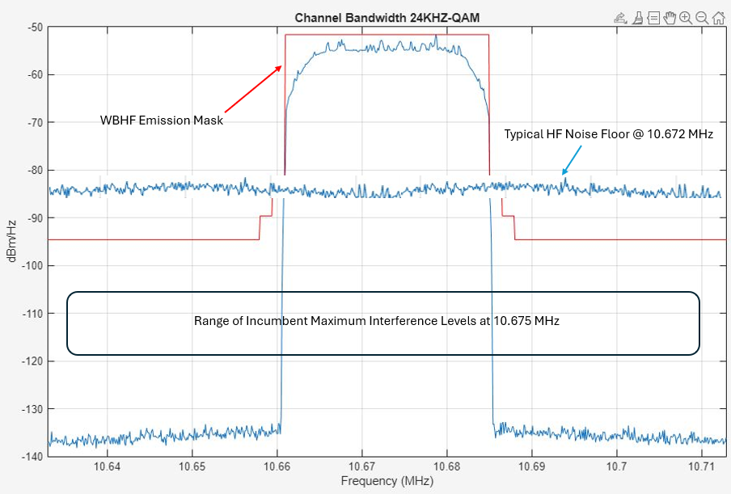
Additional emission measurements were taken at center frequencies of 8.5, 10.7, and 15 MHz at channel bandwidths of 3, 6, 12, 24, and 48 kHz using QAM and PSK modulations. The results of those measurements can be found in Appendix 1.
For the in-band case adherence to Appendix 26 is defined by adhering to the power limits as defined in Table 3 and meeting of the emission spectrum requirements.
From an interference perspective modern HF systems utilize ALE for channel selection and interference mitigation.
Automatic Link Establishment (ALE) is a technology used in radio communication, especially high-frequency (HF) radio, to automatically find and select the best frequency for communication. ALE addresses the challenges of communicating over long distances by enabling the radio system to adapt to varying signal conditions. Technologies for automatic link establishment have been in development since the 1970s, evolving through various stages. ALE is designed for global use and is a widely adopted standard for initiating and sustaining HF communications.
The primary difference between the latest generation of ALE and the previous generations of ALE is that the latest generation of ALE has the ability to identify unoccupied spectrum prior to a link setup. The latest generation of ALE was developed specifically to support WBHF (contiguous and non-contiguous), including the ability to negotiate and utilize channels up to a contiguous 48 kHz segment or 3 kHz non-contiguous segments over a 200 kHz block. The latest generation of ALE uses dynamic frequency selection, wideband waveform adaptation, and real-time spectrum sensing to avoid interference and optimize communication. The system continuously monitors the spectrum, assessing occupancy and link quality, before initiating a call assuring that unoccupied frequencies will be selected for use. This process protects incumbents that are occupying the spectrum that is being considered for use by wideband channel bandwidths.
ALE can be used by a country only for those individual channels, aggregated in contiguous or non-contiguous way, which are allotted to this country by RR Appendix 26.
WBHF AM(OR)S systems employing carrier aggregation, whether in contiguous or non-contiguous channels, shall conform to the frequency allotment plan and the associated allotment areas specified in RR Appendix 26 for this administration. Such operation shall be subject to prior examination by the Radiocommunication Bureau and shall be considered authorized only upon the publication of a favourable finding in the notification process.
Figure 8 and Figure 9 illustrate how ALE is used to identify available spectrum while mitigating interference to incumbents. ALE has the capability of sensing the radio environment. During the establishment of the link a frequency segment that can support a WBHF channel can be identified .
For this example, the incumbents are denoted by the frequency domain representation in black and are operating within spectrum that could be used by a WBHF transmission. In this example, if a WBHF transmission were to occupy the frequency band identified by the red shading (Figure 8) that transmission would cause interference to the incumbent services that are operating within the shaded area. To avoid this situation ALE can be used to identify where, within the frequency range that is identified by the red block, a WBHF signal can operate without causing interference to the incumbents..

FIGURE 8
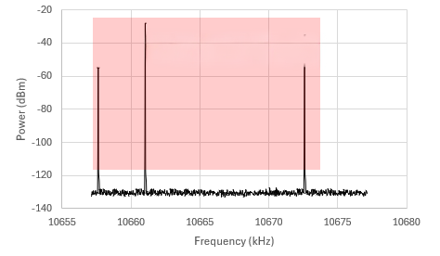
Identification of Available Spectrum
Potential WB AM(OR)S Channel Placement

A WB AM(OR)S radio transmits a sounding signal on multiple frequencies to assess the availability of available spectrum. It selects a frequency space or channel that is the best one for the link. Effectively eliminating any potential for interference. Figure 9 illustrates the results of ALE sensing of the radio environment and identifies a section of the available spectrum that can support a WB channel without causing harmful interference to the incumbents that are operating above and below the spectrum that has been identified in which the WBHF transmission can operate.

FIGURE 9
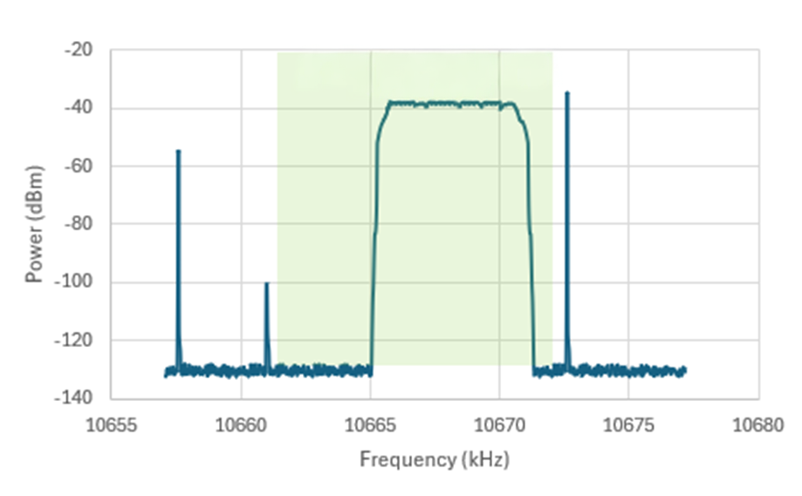
ALE adaptation to channel availability
ALE WB AM(OR)S Channel Placement

More detailed information on how ALE operates can be found in the ITU Frequency-adaptive communications systems and networks in the MF/HF bands Handbook.

8 Summary
The comparative measurement analysis results showed that adjacent band emissions and noise floor levels were below the adjacent band incumbent maximum interference levels, below the average noise floor across the 3 to 18 MHz frequency band, did not contain any anomalous emissions and met the WBHF emission mask.
The results of the static analysis showed that signal levels at the incumbent receiver are below the maximum interference levels for the incumbents along path lengths of 500, 1 000, 5 000 and 10 000 km and show a positive margin between 66 to 175 dB.
Given these results, and the fact that frequency allotments within RR Appendix 26 only apply to AM(OR)S, incumbent services operating in frequency bands adjacent to AM(OR)S transmissions would operate in an interference free environment, making WBHF AM(OR)S feasible in the context of RR Appendix 26.
§
APPENDIX 1
Emission measurement results

The following figures contain the results of emission spectrum measurements that were taken on a WBHF aeronautical radio transmitter using QAM and PSK modulations. For comparative purposes the red lines have been overlayed on the measurements and represent the emission mask.
Figure 1
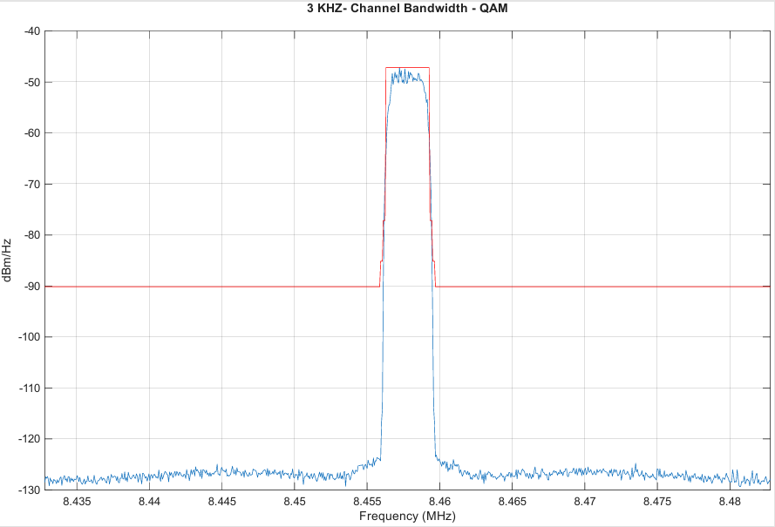
Figure 2
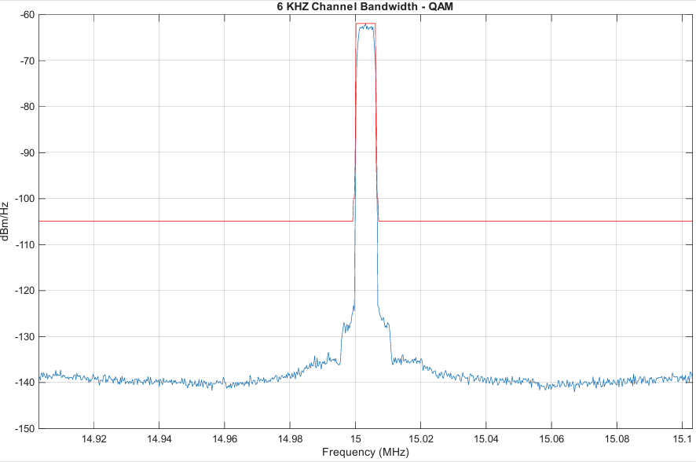
Figure 3
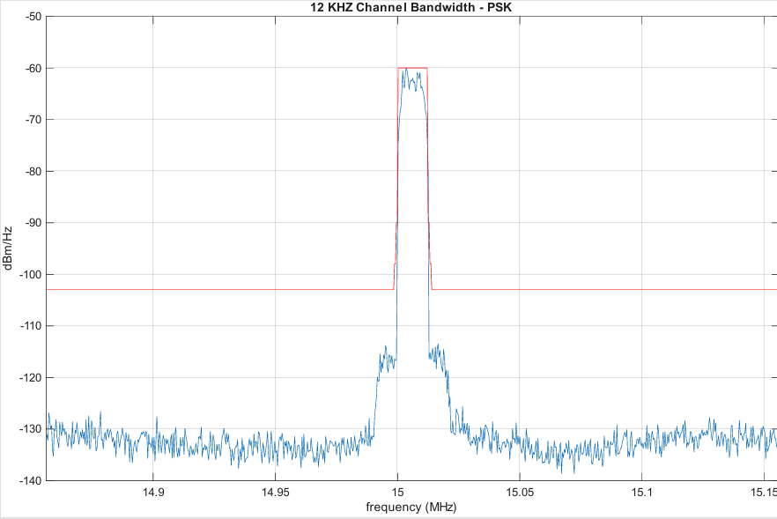
Figure 4
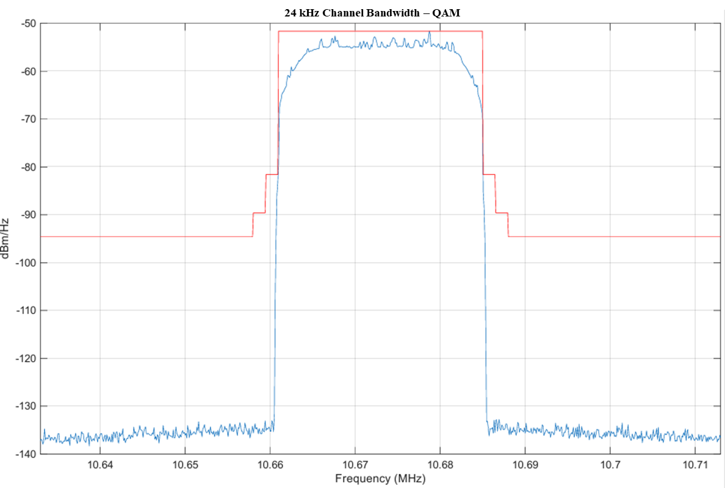
Figure 5
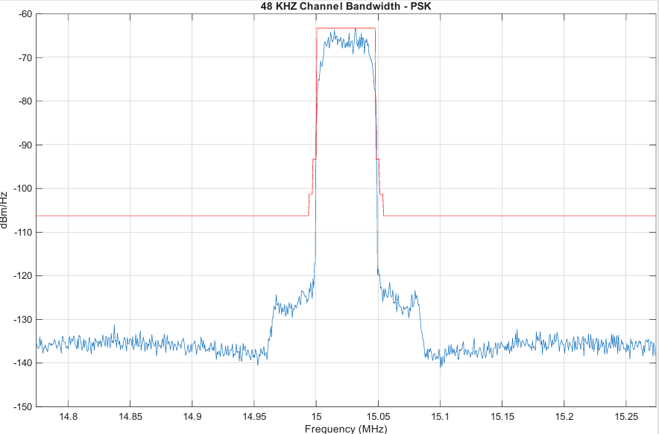

For the purposes of this document, the frequency range utilized by RR Appendix 26 (3 205 kHz to 18 030 kHz) will also be called the “HF” frequency range. This is done because the frequency range of RR Appendix 26 falls within the generally accepted “HF” frequency range which is between 3 MHz and 30 MHz.
The emission mask in Figure 1 is sourced from Annex 3.2 to Document 5C/152.
The emission mask in Figure 2 is sourced from Annex 3.2 to Document 5C/152.
The emission mask in Figure 3 is sourced from Annex 3.2 to Document 5C/152.
Under RR Appendix 27 section 27/18A “Individual contiguous or non-contiguous channels complying with the provisions of the Plan contained in this Appendix may be aggregated to provide wideband communication without changing the Plan of individual channels” RR Appendix 27 does not address specific bandwidths. Typical wideband HF channels vary from 6 to 48 kHz. While a single 3 kHz channel has an occupied bandwidth of 2.8 kHz.
Handbook Frequency-Adaptive Communication Systems and Networks in the MF/HF Bands, Edition 2002, ITU-R

