U.S. Radiocommunication Sector
Fact Sheet
Working Party: ITU-R WP-5B | Document No: USWP5B-36-12
Ref: WRC-27 Agenda Item 1.8/Res. 663 (WRC-23), 5B 435/Annex 1.8 | Date: 19 Feb 2026
Document Title: [WORKING DOCUMENT TOWARDS A] PRELIMINARY DRAFT NEW REPORT ITU-R M.[RLS_231.5-700GHZ]/SUPPORTING MATERIAL FOR WRC-27 AGENDA ITEM 1.8
Author(s)/Contributors(s):
Ryan McDonough (NASA) | Ryan.S.McDonough@nasa.gov
Purpose/Objective: To continue development for compatibility and sharing studies performed under WRC-27 Agenda Item 1.8 in accordance with Resolution 663 (WRC-23).

Abstract: Pursuant to Resolution 663 (Rev.WRC-23), Working Party (WP) 5B is the responsible group for WRC-27 Agenda Item 1.8 request to consider possible additional spectrum allocations to the radiolocation service on a primary basis in the frequency range 231.5-275 GHz and possible new identifications for radiolocation service applications in frequency bands within the frequency range 275-700 GHz for millimetric and sub-millimetric wave imaging systems. This document will update sharing and compatibility studies and their associated results for section A7 (A7.4.1 STUDY A) on EESS (passive).
Fact Sheet Preparer: Ryan McDonough, NASA

Attachment: 1

Radiocommunication Study Groups | 
Source: Document 5B/435  Subject: WRC-27 agenda item 1.8 | Annex 1.8 to  Document 5B/435-E
Source: Document 5B/435  Subject: WRC-27 agenda item 1.8 | XX April 2026
Source: Document 5B/435  Subject: WRC-27 agenda item 1.8 | English only
United States of America
[WORKING DOCUMENT TOWARDS A] PRELIMINARY DRAFT NEW REPORT ITU-R M.[RLS_231.5-700GHZ]/SUPPORTING MATERIAL FOR WRC-27 AGENDA ITEM 1.8
Frequency bands and technical characteristics for sharing and compatibility studies in support of possible allocation/identification for the radiolocation service in the frequency range 231.5-700 GHz

Introduction
This contribution provides an update to the working document towards preliminary draft new Report on WRC-27 Agenda Item 1.8 contained in Annex 1.8 of the WP 5B Chair’s Report, Document 5B/435.
The USA proposes to update the sharing and compatibility studies and associated results for section A7 (A7.4.1 STUDY A) on EESS (passive) identified by tracked changes in the attachment.
Attachment: 1

ATTACHMENT
Radiocommunication Study Groups
Source: Document 5B/TEMP/149 | Annex 1.8 to  Document 5B/435-E
Source: Document 5B/TEMP/149 | XX April 2026
Source: Document 5B/TEMP/149 | English only
Annex 1.8 to Working Party 5B Chair’s Report
[WORKING DOCUMENT TOWARDS A] PRELIMINARY DRAFT NEW REPORT ITU-R M.[RLS_231.5-700GHZ]/SUPPORTING MATERIAL FOR WRC-27 AGENDA ITEM 1.8
Frequency bands and technical characteristics for sharing and compatibility studies in support of possible allocation/identification for the radiolocation service in the frequency range 231.5-700 GHz

Editor’s Note: No changes proposed until section A7.4.

A7.4 Sharing and compatibility analysis

A7.4.1 Sharing and compatibility analysis of EESS (passive)

A7.4.1.1 STUDY A

A7.4.1.1.1 General Considerations
The study of sharing and compatibility of EESS (passive) sensors with regard to the proposed RLS radar systems is considered in several parts. This section covers general aspects and simulation methodology employed by A7.4. Section A7.4.1.1 describes reference Measurement Areas of Interest that the passive sensors and proposed radar system deployments for use in simulation studies. Section A7.4.2.1 covers scenarios involving frequency ranges below 275 GHz. This section includes allocated bands for EESS (passive) as well as RR No. 5.340 adjacency aspects. Section A7.4.2.2 covers scenarios involving frequency ranges above 275 GHz. This section includes consideration of frequency bands identified for use by EESS (passive) under RR No. 5.565.

A7.4.1.1.2 Simulation Methodology
Assessments of the aggregate RFI expected from the RLS radar systems (operating according to section 4.1 or 4.2) into EESS (passive) operating in the certain bands are achieved by dynamic simulations. The analysis is conducted in which the orbit of the EESS (passive) spacecraft under investigation is dynamically simulated, retaining only the data points when the EESS (passive) sensor antenna boresight points within a defined Measurement Area of Interest (MAI), as defined in section A7.2. Calculations are performed to determine the potential interference from each of the current active stations into the EESS (passive) sensors under study and will consider the aggregate effect from multiple active stations. The simulation will propagate the satellite based on its orbital parameters, and the simulation step size is selected to be an irrational number to ensure that the beam dynamics of the passive sensor are maximally representative and do not exhibit statistically reductive periodic behaviour. At each simulation step, a snapshot of the interference scenario is generated where the directional vectors from each active RLS radiative source to the EESS (passive) sensor is computed along with the apparent gain of the transmit and receive antennas using their respective antenna patterns. For the RLS systems the radiation patterns are modelled by section 4.1.3 and 4.2.3 for mobile/fixed radars and vehicular radars, respectively.
The interfering signal power level, $I_{i,n}$ (W), received by a spaceborne sensor at the $n^{th}$ simulation step from the $i^{th}$ active station is calculated from:
$I_{i,n}=\frac{{ P}_{TX i,n}G_{TX i,n}{ G}_{RX i,n}}{L_{a i,n}{ L}_{FSPL i,n} }$ (A3-1)
where:
${ P}_{TX i,n}$: active station out of band transmitter power in the EESS (passive) band, power density of unwanted emission (Table 3, section 4.1.2 or Table 4, section 4.2.2),
$G_{TX i,n}$: active station antenna gain towards spaceborne sensor
$G_{RX i,n}$: spaceborne receive antenna gain towards terrestrial source
$L_{a i,n}$ : propagation losses in accordance with section 6.1
$L_{FSPL i,n}$: Free Space Path Loss (if not already included in $L_{a i,n}$).

The aggregate interference from radiolocation systems at the $n^{th}$ simulation step,${ AggI}_{n}$ (W), is calculated by the summation of the received interference from all active stations within line of sight of EESS (passive) satellite:
${AggI}_{n}=\sum_{i}{I_{i,n}}=\sum_{i}{\frac{{P_{TX i,n} G}_{TX i,n}{ G}_{RX i,n}}{L_{a i,n}{ L}_{FSPL i,n} }}$ (A3-2)
Thus, the aggregate interference can be represented in the logarithmic domain as:
${AggI}_{n|dB}=10 {\log_{10}\left(\sum_{i}{\frac{{ P}_{TX i,n}{ G}_{TX i,n}{ G}_{RX i,n}}{L_{a i,n}{ L}_{FSPL i,n} }}\right) }_{|dB}$ (A3-3)
Using the resulting data containing received interfering power levels, a CCDF curve is generated to assess interference received by the sensor undergoing observations over the MAI.
Since the occupied bandwidth of all radar systems is significantly larger than the reference bandwidth of the EESS(p) protection, for in-band assessments, it is assumed that emissions fully cover the reference bandwidth.

A7.4.1.1.3 Measurement Area of Interest (MAI) selection and RLS radar system deployments
MAI are chosen to represent typical EESS (passive) sensor targets that may include intersection with significant density of proposed RLS radar systems. Reference MAI will include one or more urban localities to explore the impact of deployment density categorization on the predicted interference environment. MAI A/B of figure A7.4.1.1-1 are 2 million square kilometers in area. MAI A includes the west coast of the United States of America and MAI B includes the eastern coast. MAI C in figure A7.4.1.1-1 has an area of 10 million square kilometers. All regions are commonly studied by EESS (passive) sensors.
[Editor’s Note: more MAI may be included. For instance, to examine cross border scenarios. The east coastal scenario (MAI B) mainly involves a domestic scenario for the purposes of demonstrating compatibility. A more detailed cross-border scenario such as in MAI C would be added in subsequent updates to this study.]
figure a7.4.1.1-1 Reference MAI A/B
MAI A
39.0N 118W
MAI B
37.0N 79.8W
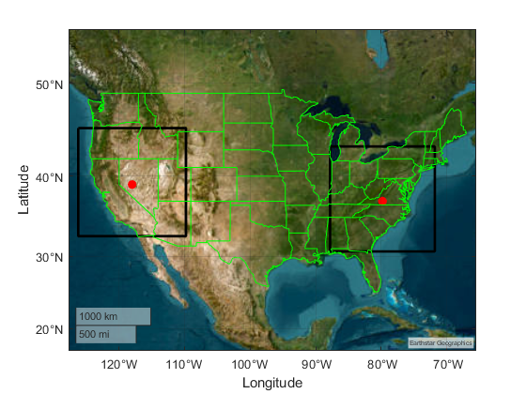
FIGURE A7.4.1.1-2 REFERENCE MAI C
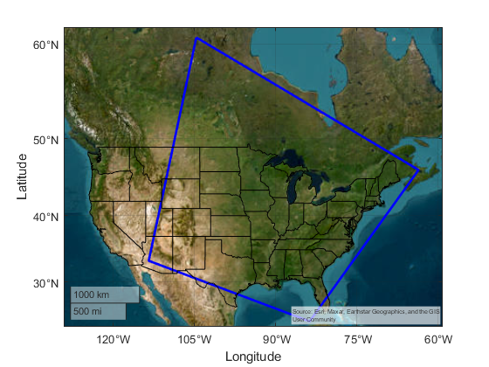

A7.4.1.1.3.1 Deployment and characterization of RLS radar systems
Deployment and operational characteristics are informed by the tables and description contained in sections 4.1 and 4.2. The deployment density entries in the tables of these sections require that categories are assigned to locations inside the MAI region. Therefore, methodology is presented below describing how categories are determined.

A7.4.1.1.3.2 Data sources for location-based categories
All systems in these sections consider deployment density values categorized by “urban”, “suburban”, and “rural” densities as specified in sections 4.1.1 and 4.1.2 for mobile/fixed radars and vehicular radars, respectively.

A7.4.1.1.4.3 Land cover-based Categorization
This is an alternative methodology to population-based categorization based on satellite imagery of ground cover that could be developed further as needed.

A7.4.1.1.4.4 Gridded Population-based Categorization
The Gridded Population of the World (GPW) dataset, developed by NASA's Socioeconomic Data and Applications Center (SEDAC), offers a globally consistent and spatially explicit representation of human population distribution. Now in its fourth version (GPWv4), this dataset provides population counts and densities at a 30 arc-second (~1 km at the equator) resolution for the years 2000, 2005, 2010, 2015, and 2020. The data are derived from approximately 13.5 million national and sub-national administrative units, ensuring high-resolution mapping of population distribution. This granularity makes GPWv4 an invaluable resource for simulations requiring detailed demographic inputs, such as urban planning, disaster response, and environmental impact assessments. By integrating GPWv4 into simulation models, researchers can accurately assess human exposure to various risks, optimize resource allocation, and inform policy decisions based on precise population metrics. See: https://www.earthdata.nasa.gov/data/projects/gpw
The categorization of urban/suburban/rural is computed from the density reported by GPW-4 extrapolated to 2020, and utilizing density ranges of:
Urban >1158 persons per square km
Suburban 386 < density <= 1158 persons per square km
Rural 0 < density <= 386 persons per square km.
This set of definitions derives from U.S. Department of Health and Human Services 42 CFR Parts 403 and 408, Federal Register /Vol. 68, No. 240 /Monday, December 15, 2003 /Rules and Regulations page 69851. See: https://www.cms.gov/Regulations-and-Guidance/Regulations-and-Policies/QuarterlyProviderUpdates/downloads/cms4063ifc.pdf
figure a7.4.1-X: Population Categories MAI East
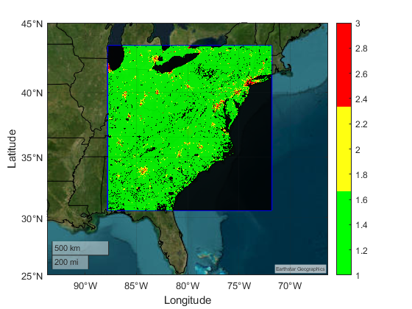
Note: State borders are drawn in black. Urban is drawn red, suburban yellow, rural green. There are also regions without data which are also drawn in black. The MAI boundary is drawn in blue.

A7.4.1.4 RLS radar system characteristics according to section 4.1 (mobile + fixed systems)

A7.4.1.4.1 Modelling mobile radar systems
The mobile radar systems described in section 4.1 are active inside and outside buildings with mixed use.
figure a7.4.1-X mobile radar System (Radar 1)
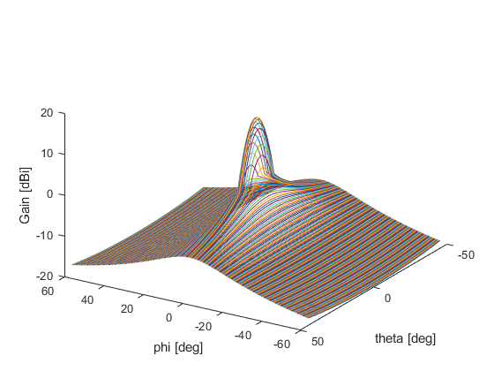
Note: This antenna pattern normalizes over all angles to average gain <=0 dBi.

A7.4.1.4.2 Modelling fixed radar systems
The fixed radar systems described in section 4.1 are active inside and outside buildings with mixed use. These systems are notable in that they have down tilt attitude.

A7.4.1.5 RLS vehicular radar system characteristics according to section 4.2 (short range + parking systems)

A7.4.1.5.1 Modelling short range radar systems
The short-range vehicular radar systems described in section 4.2 have an added aspect associating their population on or near roadways and parking facilities. These systems are considered outdoor use with respect to estimating blocking losses from buildings, or other ground cover.
Short-distance systems were simulated as fixed positions with uniform spacing along roadways according to an inference between population category shared by the centre of the roadway combined with spatially nearby roadways to ensure that overall vehicle density (either car or truck) conforms with deployment density values in the tables of 4.2.
The source of the roadway spatial data was the North American Roads (NTAD) geospatial dataset. This source provides a digital single-line representation of major roads and highways for Canada, the United States, and Mexico. The North American Roads highway network has a number of intended uses including building national and regional-level maps where major highways and arterials are an important feature, national and regional transport corridor planning, national/regional traffic analyses including the routing of freight and passenger traffic flows within and between countries, and traffic simulations based on various disruption/diversion scenarios. The specific dataset used was published 27 October 2020. See: https://geodata.bts.gov/datasets/usdot::north-american-roads/about.
The assignment of category to roadways is complicated by the fact that some routes intersect multiple categories due to their location/length. At this time, assignment is sampled by the mean spatial location of the route. There is also a complication relating the implementation of radar deployment in adherence to the densities in the tables of 4.2. The road data include roadways with single and multi-lane routes. Moreover, the density of independent routes is highly location specific. As such, uniform spacing of vehicles on-route is selected as a simple metric for deployment. The determination of vehicle (and radar cluster) spacing is achieved by sampling 1 square kilometre area in representative land categories and adjusting the uniform spacing parameter to match the respective deployment densities per square kilometre indicated by the tables of 4.2.
Below are the representative spacing values:
Urban >1158 : 5 m,
Suburban 386 < density <= 1158 : 15 m,
Rural 0 < density <= 386 : 35 m.
For the purpose of simulation the former linear spacing between cars is used. An alternative approach is randomize allocation of systems within a spatial window and constrain deployment to roadways. So the roadways are populated with a budget of transmitters determined by the land category for the window. This procedure is repeated to cover the MAI region. The density of systems per square kilometer should be retained regardless of deployment methodology.
Time-dependent variations in spacing are expected, however, nominal values are used in simulations at this point.
figure a7.4.1-X: short-range radar (Radar X)
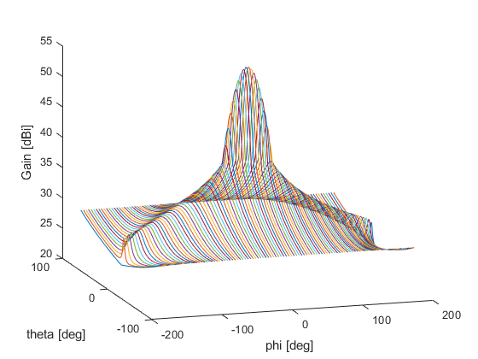
Note: This antenna pattern normalizes over all angles to average gain >0 dBi.
figure a7.4.1-X
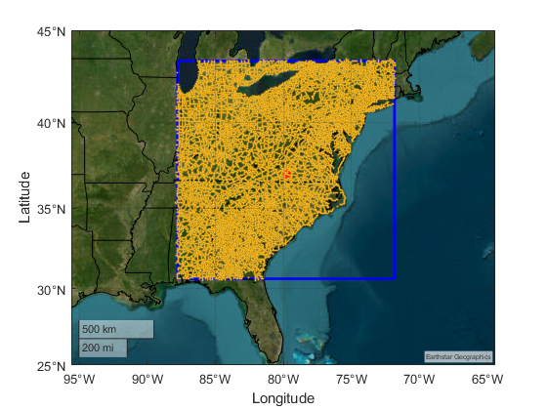
figure a7.4.1-X
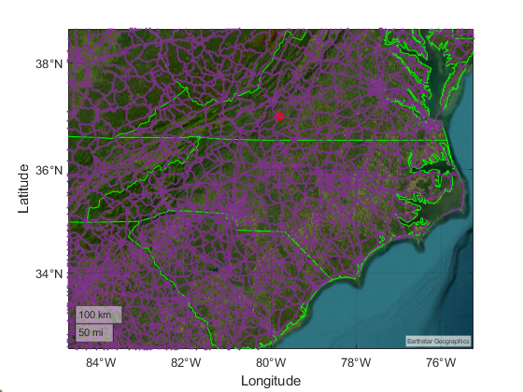
Note: All roadways are merged regardless of type (interstate, state, municipal, or local) and drawn in purple. State borders are drawn in green. The red dot is the MAI centroid.

A7.4.1.5.2 Modelling parking radar systems
The radar systems described in section 4.2 are expected to be active in segregated regions of the roadways and building infrastructure.

A7.4.1.6 Sharing and compatibility analysis EESS (passive) below 275 GHz
[Editor’s Note: This study is based on the parameters available after the May 2025 Meeting of WP 5B]
The following results show observed co-frequency receive power from vehicular deployment assuming a co-channel use at 244.6 GHz. The orbiting sensor type consists of T1 type from ITU-R RS.1861, with conical scanning mode. Figures A7.4.1-X shows local aggregation of mobile short range elements.
figure a7.4.1-X
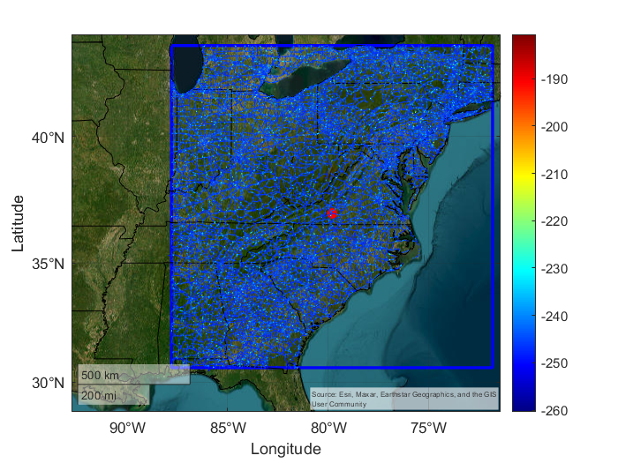
The following results show observed co-frequency receive power from fixed deployment assuming a co-channel use at 244.6 GHz. The orbiting sensor type consists of T1 type from ITU-R RS.1861, with conical scanning mode. Figures A7.4.1-X shows local aggregation of scanning (Radar A) and focused/tracking (Radar B) elements with technical parameters derived from section 4.1.
figure a7.4.1-X

These results are based on the application of the full EESS protection criterion for each of the radar categories.
figure a7.4.1-X
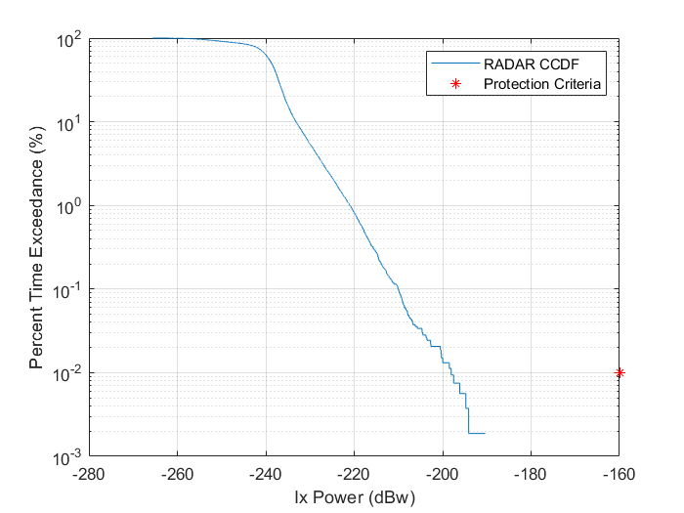
Figure A7.4.1-XX shows local aggregation of vehicle short range (Radar X) elements described in section 4.2.
figure a7.4.1-XX

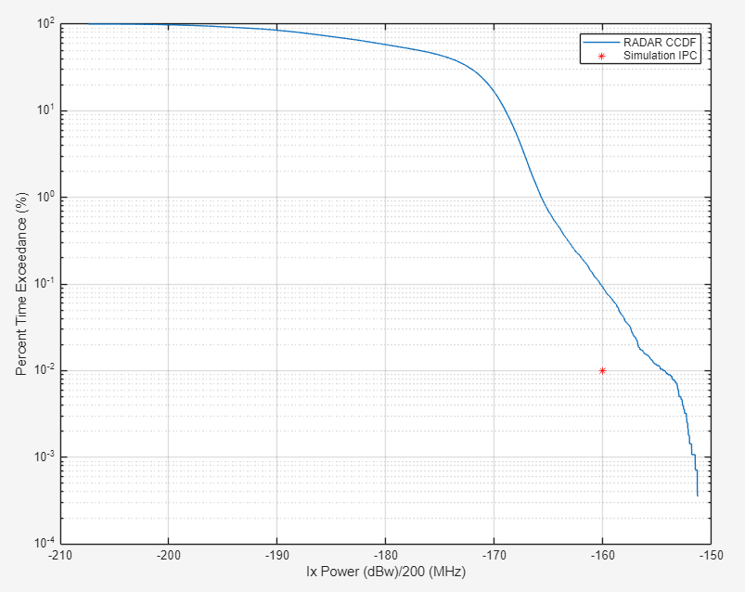

A7.4.1.7 Summary of results for study A
These calculations are addressing the adjacent band 250-252 GHz case, for the following radars: Radar A (scanning), Radar B (tracking), Vehicular radar X (short-range), and Vehicular radar Y (parking operation)
Study A shows that radars A and B (in aggregate) are maintaining compatibility with EESS (passive) with safe margin given the characteristics and deployment densities studied.
For vehicular radars X and Y this is assessed to be more potentially problematic with threshold power limit of -34 dBW/200MHz per radar system in the EESS band to ensure compatibility with EESS (passive) service.

A7.4.1.8 Sharing and compatibility analysis EESS (passive) above 275 GHz
TBD

Editor’s Note: No further changes proposed.

