U.S. Radiocommunications Sector
Fact Sheet
Working Party: ITU-R WP1A | Document No: USWP1A-02_FINAL
Ref: Annex 4 to Working Party 1A Chair’s Report (Geneva, 12-19 June 2025) Report ITU-R  WP7D LS 1A/111  WP7C LS 1A/112 | Date: April 22, 2026

Document Title: Preliminary Draft Revision of Report ITU-R SM.2505-0

Author(s)/Contributors(s):  Michael Marcus  Marcus Spectrum Solutions, LLC  Chris Keller  GuRu Wireless  Behrooz Abiri  Guru Wireless | Email: marcus@marcus-spectrum.com  Phone: 301-229-7714  Email: chris@guru.inc  Phone: (626) 673-8185  Email: abiri@guru.inc  Phone: (310) 800-2347
Purpose/Objective: We have made edits to the document based on feedback from other working groups regarding the impacts of using 24 GHz ISM band for WPT Beam and request elevation.
Abstract: These changes implement 2 requests in LSs.
An LS from WP 7C pointed out inconsistencies between Recommendation ITU-R RS.1861-1 and ITU-R SM.2505. It noted that the values in Tables 19, 20 and 21 contain minor inconsistencies with the corresponding values in Recommendation ITU-R RS. 1861-1. Changes have been made to reflect this recommendation. These changes have minimal effect on the conclusions of the study.
An LS from WP7D requests deleting a duplicative section.

Radiocommunication Study Groups | 
Received: Date 2026  Subject: Preliminary Draft Revision of Report  ITU-R SM.2505-0 | Document 1A/xx-E
 | Date 2026
 | English only
United States of America
PRELIMINARY DRAFT REVISION OF REPORT ITU-R SM.2505-0
US Proposal for Elevation

Background
Report ITU-R SM.2505-0 was approved in 2022 to provide administrations with guidelines on the impact and human hazard issues for wireless power transmission via radio frequency beam. The United States is also developing a variant of this technology for use in the 24 GHz ISM band. WP 1A received liaisons 1A/111 and 1A/112 that suggested improvements to the document.
Proposal
The United States proposes that Report ITU-R SM.2505-0 be amended with the material in the attachment to address the improvements that Working Parties 7C and 7D suggested, as well as some feedback from the 1A meeting in 2025 on the impacts of Beam WPT on IMT devices. The proposed changes only involve Study F (24.1-24.15 GHz).
Section 3.6.1 and A2.1 have been updated in reference to US rules, as well as adding the e.i.r.p formula for added clarification.
The United States further proposes that WP 1A consider elevation of the document and submission to Study Group 1.
Changes suggested in the liaison statements are highlighted in turquoise, and the resulting changes are highlighted in green. Changes in reference to US rules are highlighted in grey.

Attachment: Working document towards a preliminary draft revision of Report ITU-R SM.2505-0
[PRELIMINARY] DRAFT REVISION OF REPORT ITU-R SM.2505-0
Impact studies and human hazard issues for wireless power transmission
via radio frequency beam
(2022)
{Editor’s Note:
Some of the frequency bands mentioned in the preliminary draft revision of Recommendation ITU-R SM.2151 (900MHz, 2.4 GHz and 24GHz) for using beam WPT devices need to be further considered with respect to the blocking effect for the IMT receivers based on the information to be provided by WP 5D with respect to the threshold blocking level in those bands.}
[Note to the Secretariat: The Table of Contents needs to be editorially updated and may not show tracked changes in relation to the approved version of the Report.]
TABLE OF CONTENTS
Page
1 Introduction 4
2 Radio characteristics of beam WPT 5
3 Studies on the impact to the incumbent systems 5
3.1 Study A (915-921 MHz) 6
3.2 Study B (915-921 MHz) 9
3.3 Study C (917-920 MHz, 2 410-2 486 MHz, and 5 738-5 766 MHz) 12
3.4 Study D (2 483.5-2 500 MHz) 23
3.5 Study E (915-921 MHz) 27
3.6 Study F (24.1-24.15 GHz) 30
3.7 Study G (61-61.5 GHz) 38
3.8 Study H (915-921 MHz, 2 410-2 486 MHz and 5 738-5 766 MHz) 39
4 Human hazard issues 42
5 Summary 43
Annex 1 – RF exposure environmental control to comply with the Radio Radiation
Protection Guidelines, the case of Japan 45
A1.1 Beam WPT installation environments 45
A1.2 Compliance with the RRPG 46
Annex 2 – Details of Impact Studies of Beam WPT on EESS(passive), RAS,
and IMT in Study F 47
A2.1 EESS (Passive) and Beam WPT 47
A2.2 Summary of Results 52
A2.3 RAS and Beam WPT 53
A 2.4 Terrestrial Component of IMT (24.25-27.5 GHz) 55

Abbreviations/Glossary
ARIB Association of Radio Industries and Businesses
CISPR In French “Comité International Spécial des Perturbations Radioélectriques”,
International Special Committee on Radio Interference
DSRC Dedicated short-range communications
DUT Device under test
EESS Earth exploration-satellite service
EMF Electromagnetic field
GSM Global System for Mobile Communications
ICNIRP International Commission on Non-ionizing Radiation Protection
IEC International Electrotechnical Commission
IEEE Institute of Electrical and Electronics Engineers
IMT International Mobile Telecommunications
ISM Industrial, scientific and medical
LAN Local area network
LTE Long term evolution
LPWA Low-power wide-area network
MSS Mobile-satellite service
RF Radio frequency
RFID Radio frequency identification
RR Radio Regulations
SRD Short-range devices
WHO World Health Organization
WPT Wireless power transmission

1 Introduction
Wireless power transmission (WPT) technology is used to transfer power wirelessly from power sources to devices that use or consume power. Significant innovations in WPT can free users from needing electric power cords or changing batteries if electric power is supplied wirelessly. There are two major categories in WPT technologies. One of them is non-beam WPT technology, which transfers power to devices using magnetically, capacitively or inductively coupled means in the near field region and is typically used to charge devices, such as mobile phones and electric vehicles. The other category of WPT is beam WPT, which transfers power wirelessly using radio waves over longer distances (several metres or more, and the potential to cover wider areas).
Beam WPT regulations, standards and operational guidelines are currently being developed at national, regional and international levels for wireless charging technologies of mobile/portable and Internet of Things (IoT) sensor devices for applications of WPT via radio frequency beam. Report ITU-R SM.2392 − Applications of wireless power transmission via radio frequency beam, indicates diverse applications and technologies of beam WPT in the future. The Report focuses on applications of WPT technologies using radio frequency beam and highlights that such devices may be classified as Industrial, Scientific, Medical (ISM), short-range devices (SRD) or radio equipment. While both ISM and SRD beam WPT devices are discussed in Report ITU-R SM.2392,
Recommendation ITU-R SM.1896 provides a list of frequency ranges for global and regional harmonization of SRDs in its annexes, and Radio Regulations (RR) footnotes Nos 5.138 and 5.150 provide a list of frequency ranges for ISM devices. Furthermore, some administrations classify beam WPT as a radio service that needs rulemaking for practicable implementation with regulatory measures. To mitigate the impact of WPT devices on the operation of radiocommunication services as spectrum demand increases, some solutions that utilize frequency bands designated for ISM applications and other solutions for spectrum sharing with the incumbent radiocommunication services are discussed. In order to commercialize these WPT technologies, studies on the impact of WPT systems on radiocommunication systems and radiocommunication services are necessary.
The purpose of this Report is to show how the proposed beam WPT systems can coexist with radiocommunication systems by conducting impact studies and demonstrating compliance with international and/or national radio frequency regulations and RF exposure guidelines. The studies include test measurements in laboratory and field conditions as well as simulation and theoretical studies based on the proposed systems. The Report is also intended to provide guidance to the administrations wishing to allow implementation of beam WPT technologies in the proposed frequency ranges in order to minimize the potential impact of beam WPT on radiocommunication services. Furthermore, this Report is expected to contribute to discussions towards international frequency ranges and regulations for beam WPT applications.
Beam WPT technologies are also treated as a radio service with associated national regulatory measures in Japan as shown in § 3.3 Study C in this Report. In accordance with the frequency ranges and operation purposes, practical technical conditions are derived for coexistence with the incumbent radiocommunication services. If harmful interference occurs, interference can in some cases be corrected by moving or reorienting the charging device and/or affected device, or by changing the operating frequency of the charging device or affected device to avoid use of overlapping frequency channels.
NOTE – The studies reflect national experiences from administrations and approaches from sector members.

2 Radio characteristics of beam WPT
This section provides examples of the characteristics of the beam WPT system.
TABLE 1
Examples of radio characteristics of beam WPT systems
System | System 1 | System 2 | System 3 | System 4 | System 5 | System 6 | System 7 | System 8
Frequency | 915-921 MHz | 915-921 MHz | 915-921 MHz | 917-920 MHz | 2 410-2 486 MHz | 5 738-5 766 MHz | 24.1-24.15 GHz | 61-61.5 GHz
Output power | 4 W | 15 W | Up to 50 W | 1 W | 15 W | 32 W | 50 W | 50 W
Antenna gain | 7 dBi | 8.24 dBi | 10 dBi | 6 dBi | 24 dBi | 25 dBi | 40 dBi ⁽¹⁾ | 45 dBi ⁽¹⁾
e.i.r.p. | 43 dBm | 50 dBm | 54.8 dBm | 36 dBm | 65.8 dBm | 70 dBm | 87 dBm ⁽¹⁾ | 92 dBm ⁽¹⁾
Bandwidth | 500 kHz | 500 kHz | 500 kHz | 200 kHz | N/A ⁽²⁾ | N/A ⁽²⁾ | 10 MHz | 10 MHz
Beacon signals | Other wireless systems | Other wireless systems | Other wireless systems | Other wireless systems | Other wireless systems | Beam-WPT dedicated wireless system | Beam-WPT dedicated wireless system | Other wireless systems
TABLE 1 (end)
System | System 1 | System 2 |  | System 3 | System 4 | System 5 | System 6 | System 7 | System 8
Antenna | Wide-angle directional antenna | Wide-angle directional antenna |  | Wide-angle directional antenna | Wide-angle directional antenna | Beam forming | Beam forming | Near field beam focusing | Near field beam focusing
Applications |  |  | Wireless charging of mobile/portable devices  Wireless powered and charging of sensor networks
NOTE – The technical specifications contained in this Table describe some of the characteristics used in the respective studies and are not meant to be interpreted as regulatory limits, as there may be other beam WPT systems with higher power than those listed. In most cases, out-of-band emission limits for beam WPT devices are set by each Administration.
⁽¹⁾ The figures given for antenna gain and e.i.r.p. here are for cases where the device receiving power is in the far field of the transmitter.
⁽²⁾ The regulation on this system designates its occupied bandwidth as zero because its modulation is CW.

3 Studies on the impact to the incumbent systems
The possible incumbent systems that may require impact studies are as follows:
– Wireless LAN (2.4 GHz, 5.6 GHz band);
– DSRC (5.8 GHz band);
– IMT (900 MHz band, adjacent 24.25-27.5 GHz);
– MCA (920 MHz band);
– LPWA (920 MHz band);
– RFID (920 MHz band);
– Amateur radio (2.4 GHz band, 5.7 GHz band);
– Radar (5.6 GHz band);
– Microwave link (5.9 GHz band);
– Mobile satellite communication system (2.5 GHz band);
– Radio astronomy (1 400-1 427 MHz band, 2 600-2 700 MHz band, and 4 800-5 000 MHz band, 23.6-24.0 GHz band);
– EESS (active) (co-frequency 5 470-5 570 MHz band, 24.05-24.25 GHz band, adjacent 5 250-5 470 MHz band);
– EESS (passive) (adjacent 23.6-24.0 GHz band);
– Other systems operated in adjacent frequency bands and/or frequency range where harmonic emissions may occur.

3.1 Study A (915-921 MHz)
An over-the-air, distance charging transmitting device (DUT) operating between 915 MHz and 921 MHz was tested for impact to demonstrate interoperability with wireless devices and technologies operating in the same band. The DUT operates on a single channel with a bandwidth less than 400 kHz and maximum declared conducted average power of 37.4 dBm. The DUT is designed to charge other devices at a distance of up to 30 cm. Additionally, the DUT is compliant with Title 47, Chapter I, Subchapter A, Part 15 of the United States Electronic Code of Federal Regulations, which, inter alia, requires that devices cause no harmful interference and accept interference caused by the operation of an authorized radio station, by another intentional or unintentional radiator, by industrial, scientific and medical (ISM) equipment, or by an incidental radiator.
The tests were performed in two separate rooms. The first was a real-world test performed in a regular room and on a wooden countertop where other signals were present, as illustrated in Fig. 1. As an example of the types of signals present, a nearby train station regularly emits 900 MHz signals that are detectable in the room. The second room was an anechoic chamber, as described in ETSI EN 302 208 V3.1.1 (2016-11) Annex B.1.2 and as illustrated in Fig. 2. This anechoic chamber was used to demonstrate whether the results found in the regular room were repeatable in a free-space environment and whether any degradation of signal was due to the noisy environment. The tests were performed in the exact same manner, detailed further below, in each room. The results from each of the tests did not have any discrepancies; as such, only one set of results is presented below.
Figure 1
Test setup in room 1, open area
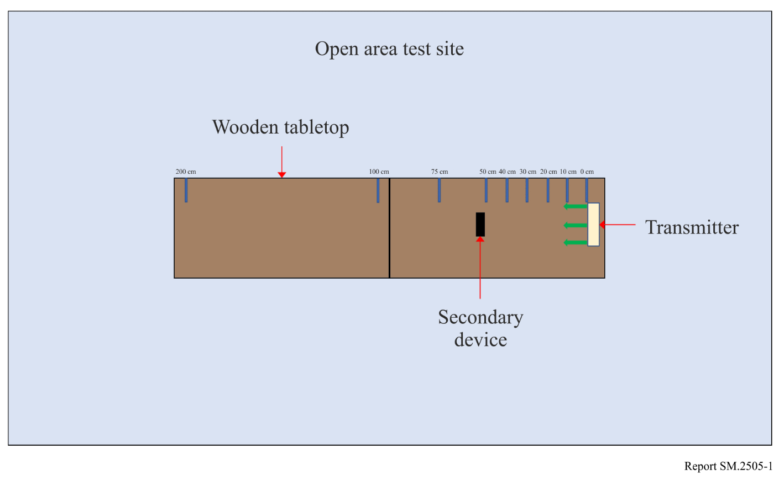
Figure 2
Test setup in room 2, anechoic chamber
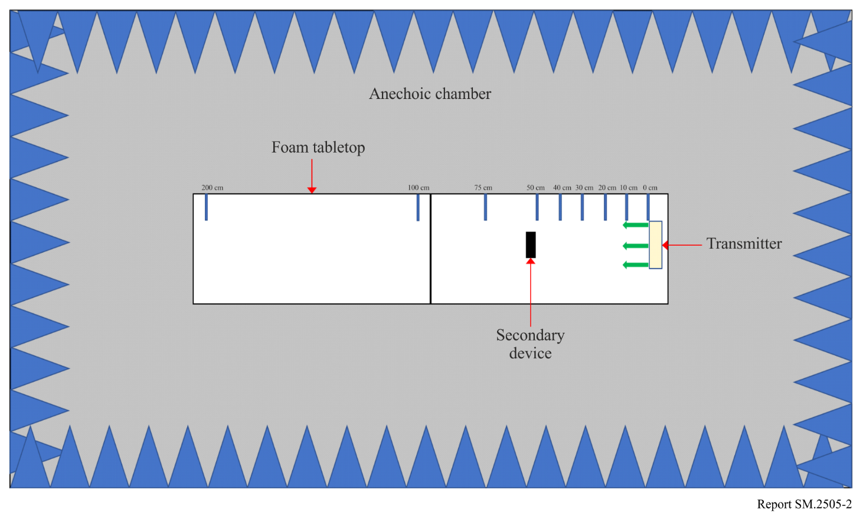
Tests were performed on the following types of wireless devices:
TABLE 2
Types of devices used, frequencies, and distances in Study A
No. | Type of device | Frequency range  (MHz) | Distances tested  (cm)
1 | Cellphone | Uplink: 888.0-915.0  Downlink: 925.2-960.0 | 0, 10, 20, 30, 40, 50, 70, 100
2 | Cellphone | Uplink: 888.0-915.0  Downlink: 925.2-960.0 | 0, 10, 20, 30, 40, 50, 70, 100
3 | Cellphone | Uplink: 888.0-915.0  Downlink: 925.2-960.0 | 0, 10, 20, 30, 40, 50, 70, 100
4 | Cellphone | Uplink: 888.0-915.0  Downlink: 925.2-960.0 | 0, 10, 20, 30, 40, 50, 70, 100
5 | Wireless Microphone and base station | 904.45-927.45  User Selectable | 0, 10, 30, 100, 200
6 | Assisted listening device | 863.25-864.75  User Selectable | 0, 10, 30, 100, 200
7 | Assisted listening device | 904.65-926.85  User Selectable | 0, 10, 30, 100, 200
8 | RFID reader | 903-927  Hopping | 0, 10, 30, 100, 200
9 | RFID reader | 865-868  Hopping | 0, 10, 30, 100, 200

Cellphone. The DUT was placed 100 cm from a mobile phone simulating a desktop environment. The cell antenna, cabled to base station simulator, was placed 3 m from the DUT and mobile phone devices. A call from the mobile phone was established to the callbox in the GSM 900 Band, on a specific frequency. After the call was established, the DUT was switched on at 917.5 MHz. The charging signal was verified with a spectrum analyser positioned in the test area. The call was monitored for 60 seconds. After which the call state was logged (call maintained, or call dropped). The distance between the DUT and mobile phone was decreased incrementally until the mobile phone was touching the DUT, measured at 0 cm. Testing was performed using five different channels.
Figure 3
Cellphone impact test setup
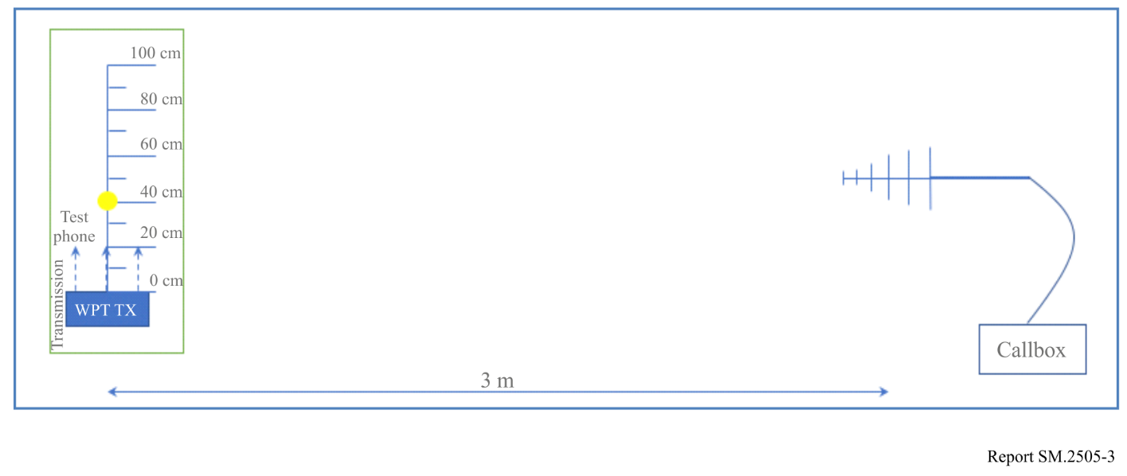
Figure 4
Other In-band device impact test set up
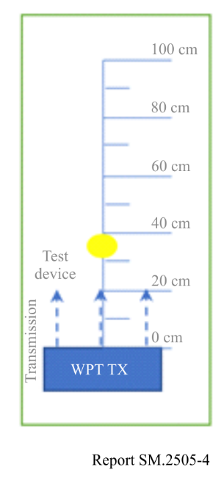
The results demonstrated that all phones were able to operate without harmful interference on at least one channel and on all channels when separated by 1 m or more from the DUT.
Wireless Microphone and base station. The base-station (receiver) was placed 30 cm from the DUT, and the Microphone (Transmitter) moved through the test distances. Subsequently, the Microphone (Transmitter) was placed 30 cm from the DUT, and the Base-station (receiver) was moved through the test distances.
Setting the audio device frequency away from that of the DUT resulted in little to no harmful interference. When operating at or close to the transmit frequency of the DUT, the devices suffered harmful interference.
Assisted listening device. The Transmitter was placed 30 cm from the DUT, and the Receiver was moved through the test distances. Following this, the Receiver was placed 30 cm from the DUT, and the Transmitter was moved through the test distances.
Setting the audio device frequency away from that of the DUT resulted in little to no harmful interference. When operating at or close to the transmit frequency of the DUT, the devices suffered harmful interference.
RFID reader. For the first device, scans were performed at 903.250; 904.250; 915.250; 915.750; 920.250; 926.750; and 927.250 MHz. The software transmitting setting was set to 30 dBm. RFID tags were then placed 30 cm from the DUT. For the second, scans were performed at 865.00; 866.00; 867.00; and 868.00 MHz with default settings. RFID tags were then placed 30 cm from the DUT.
At separation distances of 1 m or greater between the DUT and RFID reader and tags, the readers worked without error.

3.2 Study B (915-921 MHz)
A single client RF near-field contact charger, the device under testing (DUT), that operates when a receiving device is placed on the charger surface was tested for impact to demonstrate interoperability with other wireless devices and technologies. The DUT used Bluetooth Low Energy (BLE) to pair with the receiving device and transmitted a continuous carrier wave signal adjustable between 915 MHz and 921 MHz. The maximum declared average power was 33.0 dBm per port, with a measured ERP of 1.0 W, and EIRP of 1.64 W. The DUT is designed to charge other devices that rest on its surface. Additionally, the DUT is compliant with Title 47, Chapter I, Subchapter A, Part 15 of the United States Electronic Code of Federal Regulations, which, inter alia, requires that devices cause no harmful interference and accept interference caused by the operation of an authorized radio station, by another intentional or unintentional radiator, by industrial, scientific and medical (ISM) equipment, or by an incidental radiator.
The tests were performed in two separate rooms. The first was a real-world test performed in a regular room and on a wooden countertop where other signals were present, as illustrated in Fig. 5. As an example of the types of signals present, a nearby train station regularly emits 900 MHz signals that are detectable in the room. The second room was an anechoic chamber, as described in ETSI EN 302 208 V3.1.1 (2016-11) Annex B.1.2 and as illustrated in Fig. 6. This anechoic chamber was used to demonstrate whether the results found in the regular room were repeatable in a free-space environment and whether any degradation of signal was due to the noisy environment. The tests were performed in the exact same manner, detailed further below, in each room. The results from each of the tests did not have any discrepancies; as such, only one set of results is presented below.
Figure 5
Test setup in room 1, open area
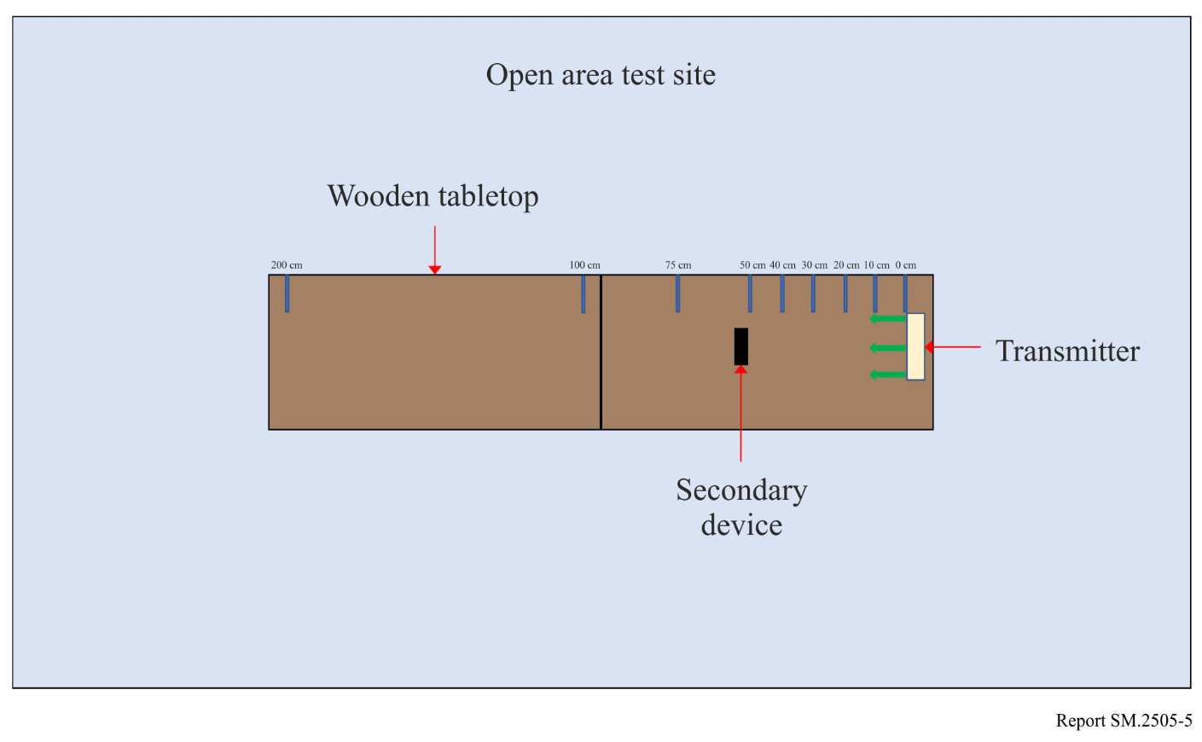
Figure 6
Test setup in room 2, anechoic chamber
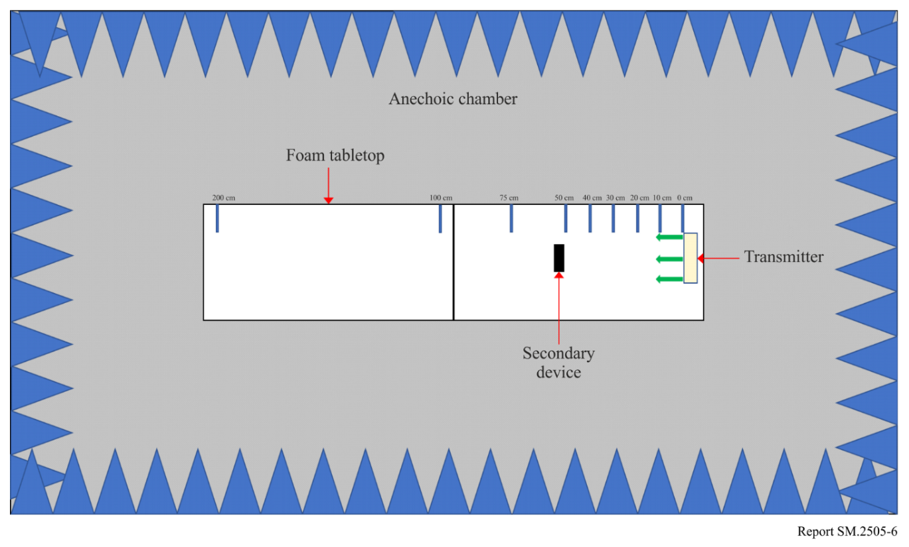
Tests were performed on the following types of wireless devices:
TABLE 3
Types of devices used, frequencies, and distances in Study B
No. | Type of device | Frequency range  (MHz) | Distances tested  (cm)
1 | Cellphone | Uplink: 888.0-915.0  Downlink: 925.2-960.0 | 0, 10, 20, 30, 40, 50
2 | Cellphone | Uplink: 888.0-915.0  Downlink: 925.2-960.0 | 0, 10, 20, 30, 40, 50
3 | Cellphone | Uplink: 888.0-915.0  Downlink: 925.2-960.0 | 0, 10, 20, 30, 40, 50
4 | Cellphone | Uplink: 888.0-915.0  Downlink: 925.2-960.0 | 0, 10, 20, 30, 40, 50
5 | Wireless Microphone and base station | 904.45-927.45  User Selectable | 0, 30, 100, 200
6 | Assisted listening device | 863.25-864.75  User Selectable | 0, 30, 100, 200
7 | RFID reader | 903-927  Hopping | 0, 10, 30, 100
8 | RFID reader | 865-868  Hopping | 0, 10, 30, 100
9 | Smart hub | 903-914 | 10, 30, 100
10 | Push button | 916 | 10, 30, 100
NOTE: The smart hub (device no. 9) and push button (device no. 10) use LoRa technology and were tested together.
Cellphone. The DUT was placed 50 cm from a mobile phone. A call to the mobile phone was setup to the callbox in the GSM 900 band on a specific frequency. The call box antenna was placed 50 cm away from the mobile phone. A call was setup between the callbox and the mobile phone under test. Then the DUT was turned on and set to a specific frequency. The call was monitored for 60 seconds. After which the call state was logged (call maintained or call dropped.). The DUT was then moved 10 cm closer to the mobile phone and the process repeated. This was continued until the DUT was touching the mobile phone (distance = 0 cm).
No harmful interference was observed for any of the test configurations.
Wireless microphone and base station. Four sets of tests were performed. For the first two, the base station (receiver) was placed 30 cm from the Charger, and the Microphone (Transmitter) was moved through the test distances. The DUT operated at 918 MHz for the first test, then 917.5 MHz for the second. For the third and fourth tests, the Microphone (Transmitter) was placed 30 cm from the Charger, and the base station (receiver) was moved through the test distances. Again, the tests were performed once with the DUT at 918 MHz then once at 917.5 MHz.
The microphone did not experience noticeable harmful interference except when it operated at 917.65 MHz; when the DUT operated at 918 MHz, this harmful interference was only experienced when the Microphone was within 30 cm of the DUT.
Assisted listening device. Four sets of tests were performed. For the first two tests, the Transmitter was placed 30 cm from the Charger, then the Receiver moved through the test distances. The DUT operated at 918 MHz for the first test, then 917.5 MHz for the second. For the third and fourth tests, the Receiver was placed 30 cm from the Charger, then the Transmitter was moved through the test distances. Again, the tests were performed once with the DUT at 918 MHz then once at 917.5 MHz.
The tests show that the assisted listening device was not affected by the DUT due to the frequency offset between the two devices.
RFID reader. The first device, scans were performed at 903.250; 904.250; 915.250; 915.750; 920.250; 926.750; and 927.250 MHz. The transmit settings was set to 30 dBm in software, and the receive was set to 0 dBm. The RFID tag was placed 30 cm from the DUT, with its operating frequencies at 918 MHz then 917.5 MHz. The second reader was set to scan at 865.00; 866.00; 867.00; and 868.00 MHz. Default settings were used for the tests. The RFID tag was placed 30 cm from the DUT, with its operating frequency set to 918 MHz.
The results show that the RFID devices operated without significant degradation at separation distances greater than 30 cm.
Smart hub with push button. The smart hub and push button were operated using default settings, with the smart hub placed 30 cm from the DUT. The results demonstrated that the smart hub with push button operated without degradation under all of the configurations assessed.

3.3 Study C (917-920 MHz, 2 410-2 486 MHz, and 5 738-5 766 MHz)
Study C shows a summary of the study taken in new rulemaking in Japan on beam WPT technology in 917-920 MHz, 2 410-2 486 MHz and 5 738-5 766 MHz. The Ministry of Internal Affairs and Communications (MIC) of Japan amended relevant ministerial ordinances in May 2022 to issue ‘premises radio station’ licenses to some types of beam WPT devices. The ‘premises radio station’ is an existing kind of station, which is not defined in the RR but is a part of national regulatory measures. A new organization named JWPT (Japan Coordinating Council for Wireless Power Transfer) was established in January 2022 for the operational coordination support to prevent harmful interference between beam WPT and other radiocommunication services. The MIC conducts examination of applications for the WPT ‘premises radio station’ licenses with reference to the result of the operational coordination.

3.3.1 Frequency bands and incumbent radiocommunication systems and services considered in the study
Incumbent radiocommunication systems and services adjacent to or included in 917-920 MHz, 2 410-2 486 MHz and 5 738-5 766 MHz, which were considered in the study, are listed in Table 4, Table 5 and Table 6 respectively.
TABLE 4
917-920 MHz radiocommunication systems and services considered in the study
System | Frequency  (MHz) | Protection criterion | References
Digital MCA Service | 930-940  (uplink) | –108.8 dBm/MHz  (in band)  –51 dBm (out of band) | ARIB⁽¹⁾ STD-T85  (Japan)
Digital MCA Service | 940-945  (downlink) | –108.8 dBm/MHz  (in band)  –51 dBm (out of band) | ARIB⁽¹⁾ STD-T85  (Japan)
Advanced MCA Service | 895-900  (uplink) | –110.8 dBm/MHz  (in band)  –44 dBm (out of band, 12.5 MHz separation) | 3GPP TS36 104 ｖ8.3.0 (2008-9)
Advanced MCA Service | 850-860  (downlink) | –119 dBm/MHz (in band)  –43 dBm (out of band, modulation)  –15 dBm (out of band, CW) | 3GPP TS36 104 ｖ8.3.0 (2008-9)
LTE-A (Band 8) | 900-915  (uplink) | –110.8 dBm/MHz  (in band)  –44 dBm (out of band, 12.5 MHz separation) | 3GPP TS36 104 ｖ8.3.0 (2008-9)
LTE-A (Band 8) | 945-960  (downlink) | –119 dBm/MHz (in band)  –43 dBm (out of band, modulation)  –15 dBm (out of band, CW) | 3GPP TS36 104 ｖ8.3.0 (2008-9)
RFID (Passive) | 916.7-923.5 | –81 dBm/MHz (in band)  –30 dBm (out of band, 2 MHz separation) | ARIB STD-T106  ARIB STD-T107  (Japan)
RFID (Active) | 915.9-929.7 | –127 dBm/MHz  (in band)  –80 dBm (out of band) | ARIB STD-T108  (Japan)
Radio astronomy | 1 400-1 427 | –197.4 dBm/MHz | Rec. ITU-R RA.769-2
⁽¹⁾ Association of Radio Industries and Businesses (https://www.arib.or.jp/english/)

TABLE 5
2 410-2 486 MHz radiocommunication systems and services considered in the study
System | Frequency  (MHz) | Protection criterion | References
Wireless LAN | 2 400-2 497 | –92 dBm (co channel)  –66 dBm (adjacent channel),  –50 dBm (alternate adjacent channel) | IEEE Std.802.11-2016
Premises radio | 2 400-2 483.5 | –98 dBm  (including 11 dBi  antenna gain) | ARIB RCR STD-1  ARIB RCR STD-29  (Japan)
Unmanned mobile image transmission system (Wireless system for drones and other unmanned vehicles) | 2 483.5-2 494 | –98 dBm (co channel)  –72 dBm (adjacent channel),  –56 dBm (alternate adjacent channel)  (including 6 dBi  antenna gain) | Report on MIC Advisory No. 2034  (Japan)
Geostationary Mobile Satellite Service | 2 500-2 535 | –124.9 dBm/MHz  (in band)  –41 dBm  (out of band,  10-25 MHz separation) | Report on MIC Advisory No. 2032  (Japan)
Non-Geostationary Mobile Satellite Service | 2 483.55-2 500 | –119.4 dBm/MHz | Report on MIC Advisory No. 82  (Japan)
Broadcasting Service: Field Pickup (FPU) | 2 330-2 370 | –102 dBm/MHz  (mobile relay Uplink) | Report on MIC Advisory No. 2024  (Japan)
Radio astronomy | 2 695 | –187 dBm/MHz | Rec. ITU-R RA.769-2
Amateur radio | 2 400-2 450 | –110.83 dBm/MHz | JARL⁽¹⁾ requirement
⁽¹⁾ The Japan Amateur Radio League, Inc. (https://www.jarl.org/English/0-2.htm)

TABLE 6
5 738-5 766 MHz radiocommunication systems and services considered in the study
System | Frequency  (MHz) | Protection criterion | References
Wireless LAN (W56) | 5 470-5 730 | –63 dBm (adjacent channel),  –47 dBm (alternate adjacent channel) | IEEE Std.802.11-2016
Dedicated Short Range Communication (DSRC) | 5 770-5 850 | –42 dBm  (class-2, spurs response rejection),  –100 dBm (class-2) | ARIB STD-T75  (Japan)
Broadcasting Service: Studio to Transmitter Link (STL) and Transmitter to Transmitter Link (TTL) | 5 850-5 925 | –101.6 dBm  (equivalent thermal noise level) | ARIB_STD-B22  (Japan)
Broadcasting Service: Field Pickup (FPU) and Transmitter to Studio Link (TSL) systems | 5 850-5 925 | –89.4 dBm  (FPU fixed relay station) | ARIB STD-B33  (Japan)
Unmanned mobile image transmission system (Wireless system for drones and other unmanned vehicles) | 5 650-5 755 | –98 dBm (in-band),  –72 dBm (adjacent channel),  –56 dBm (alternate adjacent channel) | Report on MIC Advisory No. 2034  (Japan)
Weather radar | 5 250-5 372.5 | –120 dBm (noise),  –40 dBm (CW) | Rec. ITU-R M.1849-2
Radio astronomy | 4 700-5 140,  3 000-14 000 | –187 dBm/MHz | Rec. ITU-R RA.769-2
Amateur radio | 5 650-5 850 | –110.83 dBm/MHz | JARL requirement

3.3.2 Specifications and parameters used for the study
Expected specifications and system parameters used for the study are shown in Table 7 and in Figs 7 to 9.
TABLE 7
Expected specifications of beam WPT commercial systems considered
 | System 4  920 MHz band | System 5  2.4 GHz band | System 6  5.7 GHz band
Transmitter antenna output power | 1 W (30 dBm) | 15 W (41.8 dBm) | 32 W (45.0 dBm)
Frequency channels | 918.0, 919.2 MHz  (2 channels) | 2 412, 2 437, 2 462, 2 484 MHz  (4 channels) | 5 740, 5 742, 5 744, 5 746, 5 748, 5 750, 5 752, 5 758, 5 764 MHz  (9 channels)
e.i.r.p | 36 dBm Max. | 65.8 dBm Max. | 70.0 dBm Max.
Tolerance of occupied bandwidth | 200 kHz | Not specified | Not specified
Transmitter antenna directive gain | 6.0 dBi | 24.0 dBi | 25.0 dBi
Location and height of transmitter antenna | Located indoor area | Located indoor area and set on ceiling to look down | Located indoor area and set on ceiling to look down
Location and height of transmitter antenna | 2.5 m above floor | 5.0 m above floor | 4.6 m above floor
Transmitter antenna directive pattern | Figure 7 | Figure 8 | Figure 9
Usage environment | Indoor | Indoor | Indoor
Usage environment | WPT controlled environment  and/or WPT general environment | WPT controlled environment | WPT controlled environment
Modulation | Not specified | CW | CW
Building entry loss | 10.0 dB | 14.0 dB | 16.0 dB

‘WPT controlled environment’ and ‘WPT general environment’ are defined. ‘WPT controlled environment’ is defined as:
– Indoor and closed area;
– Environment where limits of Japanese radio exposure guidelines in controllable area can be cleared, and/or the manager/administrator can cut off power transfer of beam WPT systems when limits of Japanese radio exposure guidelines in controllable area are happened to be not cleared;
– Environment where the manager/administrator can manage and control both of beam WPT systems and incumbent radio communication services in order to avoid or reduce harmful interference from beam WPT systems.
‘WPT general environment’ are defined as the other environment where the above conditions cannot be met.
FIGURE 7
Transmitter antenna directive pattern for 920 MHz band
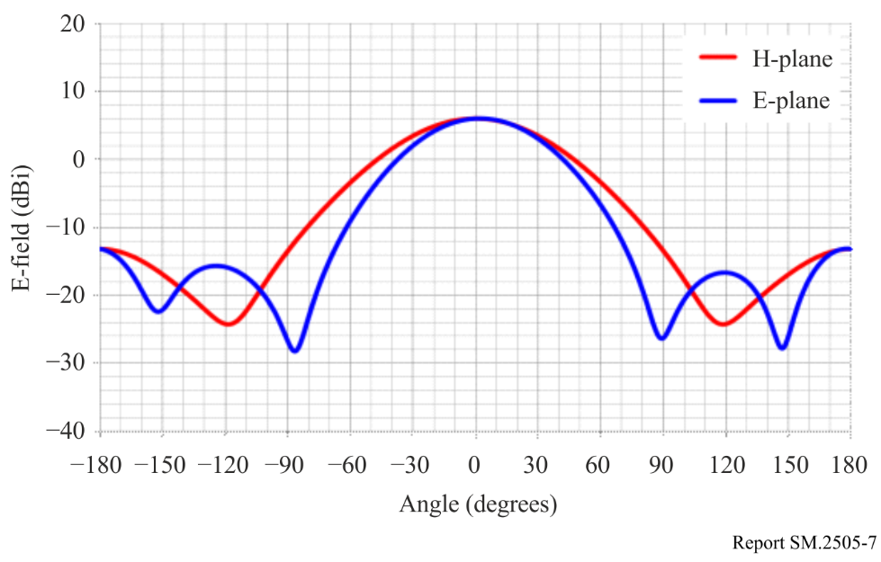
FIGURE 8
Transmitter antenna directive pattern for 2.4 GHz band
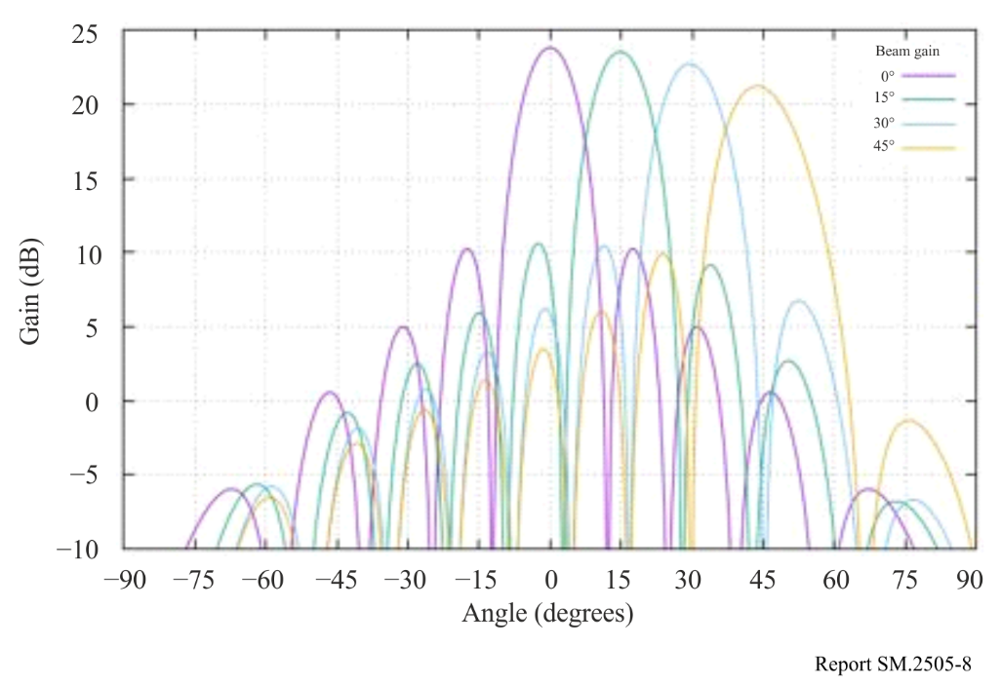
FIGURE 9
Transmitter antenna directive pattern for 5.7 GHz band
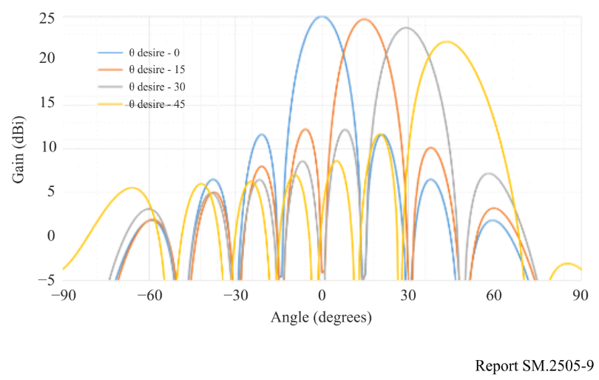

3.3.3 Building entry loss consideration
The study referred to building entry loss defined in Section 3 of Recommendation ITU-R P.2109-1.
The building entry loss value depends on the outer wall material. Two building types are shown in Recommendation ITU-R P.2109-1. One is ‘Thermally efficient’ that uses heat shield and heat insulating material with high electromagnetic wave reflection characteristics. The other is ‘Traditional’ that does not use them. The median loss L_{h} can be given by the calculation formula shown below. Moreover, the loss also depends on the frequency.
$L_{h}=r+slog\left(f\right)+t{\left(\log\left(f\right)\right)}^{2}$
where r, s, and t are the constants shown in Table 8, and f is the frequency (GHz). Table 9 shows the calculation results for the median loss for the representative frequencies of the three frequency bands used in the wireless power transmission systems via radio frequency beam.
According to Fig. 1 of Recommendation ITU-R P.2109-1, the ‘Thermally efficient’ building type has a large loss by about 15 dB compared to ‘Traditional’, but it is unlikely that thermally efficient construction materials are used for all outer walls of the buildings. The examination was based on the value of the ‘Traditional’ type.
TABLE 8
Model coefficients used for building entry loss calculation
in Recommendation ITU-R P.2109-1
Item | r | s | t
Traditional | 12.64 | 3.72 | 0.96
Thermally efficient | 28.19 | –3.00 | 8.48

TABLE 9
Calculation results of the median loss for the three frequency bands used in beam WPT
Item | 920 MHz | 2 450 MHz | 5 750 MHz
Lh (Traditional) | 12.5 dB | 14.2 dB | 16.0 dB
Lh (Thermally efficient) | 28.3 dB | 28.3 dB | 30.8 dB

TABLE 10
Building entry loss used for the studies on the impact of beam WPT
Item | 920 MHz | 2.4 GHz | 5.7 GHz
Wall loss | 10.0 dB | 14.0 dB | 16.0 dB

3.3.4 Use case scenarios and conditions for Impact Studies on beam WPT
Table 11 shows the use case scenarios and conditions for Impact Studies on beam WPT systems used for impact studies.
The System 4 is mainly used in WPT for wireless-powered sensor network. The System 4 is used in indoor and controlled environment where WPT equipment is controlled by managers of factories, nursing homes and so on. The power consumption of the sensor is about several hundred μW or less.
The System 5 and the System 6 are mainly used in WPT for small displays in addition to the application of the System 4. The System 5 and the System 6 are used in indoor and controlled environment where WPT equipment is controlled by managers of factories, plants, warehouses and so on. The power transmission to the receiver devices requires up to several watts.
TABLE 11
Use case scenarios and conditions for beam WPT systems
Beam WPT system | System 4  920 MHz band | System 5  2.4 GHz band | System 6  5.7 GHz band
Usage environment | Factory (Indoor), nursing home, etc. | Factory (indoor), plant (indoor), warehouse, etc. | Factory (indoor), plant (indoor), warehouse, etc.
Application | Charging and power supply to sensor network | Charging and power supply to sensors, display and information devices | Charging and power supply to sensors, display and information devices
Number of receiving devices per one WPT transmitter | 5 to 10 devices  (Simultaneous reception) | 1 to several ten devices  (Successive or sequential reception) | 1 to several ten devices  (Successive or sequential reception)
Power range | Several μW to several hundred μW | 50 mW to 2 W | Several mW to several hundred mW
Power transfer distance | Less than 5 m | Less than 10 m | Less than 10 m
Coexistence with other wireless systems | Feasible. Take appropriate interference mitigation and radio protection measures | Feasible. Take appropriate interference mitigation and radio protection measures | Feasible. Take appropriate interference mitigation and radio protection measures
Power transfer while human bodies exist | Possible to transfer under the condition that limits of national radio exposure guidelines are cleared | Off | Off

3.3.5 Study results
For the WPT systems intended the operation in the 920 MHz band, the system parameters assumed for the impact study (see Table 7) were compliant with the radio regulation including transmission intervals for the RFID systems currently operated in the same frequency range. Minimum separation distances were derived in accordance with the beam WPT characteristics for the case geographical separation distance is necessary to regulate. In addition, Monte-Carlo system-level simulation was performed to assess interfering likelihood from beam WPT to LTE and MCA mobile communication networks.
For the beam WPT systems intended for the operation in the 2.4 GHz band and 5.7 GHz band, the study was conducted with the system parameters (see Table 7) to determine required technical requirements and operational conditions under the current radio regulation including frequency allocation and operational conditions. Study results in 2.4 GHz band and 5.7 GHz band are summarized as follows:
1) Clear Channel Assessment (CCA) mechanism shall be adopted to coexist with WLAN systems and / or Specified Low Power Radio Stations. It turned out that WLAN system performance such as throughput can be maintained without harmful interference by adding CCA mechanism.
2) For radioastronomy, weather radar and Radio Beacon services, minimum separation distances were specified.
3) For broadcasting systems, mobile satellite communication systems and Dedicated Short Range Communication (DSRC) system, minimum separation distances were specified. In addition, operational coordination was addressed for the case beam WPT causes harmful interference.
4) For unmanned mobile image transmission system (i.e. a wireless communication system for drones and other unmanned vehicles), studies assuming practical use cases showed that spectrum sharing without causing harmful impact was possible by operational coordination as needed between WPT systems and unmanned mobile image transmission systems.
5) For amateur radio services, beam WPT installation conditions for spectrum sharing were specified. In addition, beam WPT systems shall not use the frequency band for Earth-Moon-Earth (EME) systems and repeater systems. Operational coordination is undertaken between WPT systems and amateur radio systems.
Furthermore, a comprehensive beam WPT management rule regarding WPT operation environment and WPT radio frequency EMFs was defined and can be applied specific use cases using the frequency bands to abide by the Radio Radiation Protection Guidelines. See Annex 1 for details. Thus, required technical requirements and operational conditions not to cause harmful impact to the existing systems and services were determined.
Below shows individual summaries of the study per incumbent system.

3.3.5.1 917-920 MHz
(1) Digital MCA service
The study referred to the examination methodologies and results on the past coexistence study when RFID system was introduced in 917-920 MHz. Beam WPT in the band was assumed almost the same technical conditions for assessment as RFID. Possibility of harmful impact is extremely low while keeping the given conditions and expecting additional propagation loss due to building entry loss. The condition includes the separation distance, adjustment of setting conditions and measures to mitigate interferences.
(2) Advanced MCA service
WPT can be shared by the control station (base station: downlink) by considering vertical directivity.
The mobile station (uplink) can be shared when both systems do not exist in the same room, which was shown by Monte-Carlo simulation using the extended Hata formula (300 m or less).
In the case of the same room, the required improvement amount is about 10 dB, but it can be shared because it is expected to be attenuated by obstacles and the human body in the room.
However, regarding the use with the WPT system in the same room, the WPT users will be alerted the possibility of interference to MCA stations.
(3) LTE-A (Band 8)
The WPT system can be shared in a WPT general environment even when there is no transmission time limit. On the other hand, the WPT system can be shared in the management environment by limiting the transmission time (stopping transmission for 50 ms within 4 seconds of the transmission).
(4) RFID (Passive)
The WPT system and RFID system can be shared on the same channel if a separation distance of about 6 m is secured. If the separation distance cannot be secured, those system can coexist by changing the WPT transmit channel and/or RFID channel, or shield with a wall.
(5) RFID (Active)
The passive RFID system is assumed coexisting with the active RFID system. The WPT system can be coexist with active RFID system because of the specification of WPT system is almost same as passive RFID interrogator.
(6) Radio astronomy
The minimum separation distance at the same altitudes was calculated with the free space loss model to be 37.5 km using the measured spurious emission level of –60.5 dBm/MHz. A WPT system will be located outside a restricted area with the minimum separation distance from a radio astronomy station. When a WPT system or a radio astronomy station are located with different altitude, the minimum separation distance would be different from that calculated above.

3.3.5.2 2 410-2 486 MHz
Radio characteristics example of beam WPT (non-ISM) is shown in Table 1.
(1) Wireless LAN
The simulation using the CCA mechanism on the beam WPT system was conducted to study the impact to the Wi-Fi devices located outside of the WPT controlled environment. The decline of the throughput of those Wi-Fi devices could be suppressed with appropriate parameters of CCA mechanism, compared with the case when another Wi-Fi AP was operated at the same location instead of the beam WPT inside the WPT controlled environment. Antenna directions should be adjusted not to directly face each other to prevent the device being damaged.
(2) Premises radio
Within the beam WPT controlled environment the operation of the premises radio can be managed and controlled by the same operator as for the beam WPT. Moreover, within the 84.9 m from the beam WPT location it can be suppressed the transmission with the CCA mechanism when premises radio is transmitting. Antenna directions should be adjusted not to directly face each other to prevent the device being damaged.
(3) Unmanned mobile image transmission system
Separation distance was calculated with extended Hata model and it is 3.6 km on co channel from the beam WPT to the Unmanned mobile image transmission system outdoor. However, since the system is usually operated outside the cities and the usage time and places are planned, the harmful interference can be avoided by the coordination procedure.
(4) Geostationary mobile satellite service
Separation distance was calculated with worst case scenario of out of band interference, where antenna directivity direction of the GEO MSS receiver was perfectly matched to the beam direction of the beam WPT. It is 30 m in the northern part of Japan. With the separation distance and coordination procedure if necessary, harmful interference can be avoided. If necessary, the operational coordination is performed between WPT systems and mobile satellite communication systems.
(5) Non-geostationary mobile satellite service
Separation distance was calculated of in band interference with extend Hata model and it was 0.96 km. Since Non-Geostationary Mobile Satellite Service is generally used in the location where cellular mobile system cannot be reached in Japan and the beam WPT does not possibly exist, the harmful interference can be avoided. If necessary, the operational coordination is performed between WPT systems and mobile satellite communication systems.
(6) Broadcasting service: Field Pickup (mobile Electronic News Gathering)
Separation distance was calculated in various scenarios and systems and with the antenna directivity it does not cause harmful interference when satisfying 10 m separation distance outside the WPT controlled environment. BEAM WPT systems shall abide by the condition of the necessary separation distance and installation.
(7) Radio astronomy
Separation distance was calculated for each radio astronomy station operating 2 695 MHz considering clutter loss. The minimum separation distances at the same altitudes are 5.7 km or 1.6 km depending on the environment of the site. To avoid the harmful interference to a radio astronomy station a restricted area with these separation distances around the radio astronomy station will be established. The beam WPT antenna is installed on the ceiling and radiates primarily downward. The horizontal radiation limit is defined in terms of e.i.r.p.. For this reason, horizontal radiation from inside the building to the outside will be the worst-case scenario when both a WPT station and a radio astronomy station have the same altitudes.
When the altitude of the radio astronomy station is higher than the WPT station, the directivity gain becomes lower and the separation distance becomes shorter. On the other hand, when the altitude of the radio astronomy station is lower than the WPT station, the directivity gain becomes higher and the separation distance becomes longer.
(8) Impact study for Radio Amateur
Separation distance was calculated considering clutter loss. Two out of four frequencies of beam WPT are co-channel with Radio Amateur, which need 4.4 km separation distance with 18 dBi Radio Amateur antenna. Considering antenna directive loss and using adjacent band if necessary, the harmful interference can be avoided. If necessary, the operational coordination is performed between WPT systems and amateur radio systems.

3.3.5.3 5 738-5 766 MHz
(1) Wireless LAN
Simulation was conducted to study the impact of the beam WPT system to the Wi-Fi system that operate outside the WPT controlled environment. When CCA mechanism with appropriate parameters was applied to the beam WPT system, the impact to the Wi-Fi throughput was equivalent to the case when another Wi-Fi system existed instead of the beam WPT system. In the WPT controlled environment, assuming the condition to be under control by the identical system operator of both systems, carrier sensing works well. Antenna directions should be adjusted not to directly face each other to prevent the device being damaged.
(2) Dedicated Short Range Communication (DSRC)
Study on separation distance was made for the worst-case scenario, where antenna directivity of the DSRC system perfectly matched to the beam direction of the beam WPT system. The separation distance was calculated with free space loss model to be 2.6 km from the beam WPT system to the DSRC Class 2 base station. Additional propagation loss due to building entry loss and directivity loss of DSRC antenna can be expected to further avoid harmful interference.
(3) Broadcasting service: Studio to Transmitter Link (STL) and Transmitter to Transmitter Link (TTL)
Separation distance was calculated with free space loss model to be 836 m for out band noise signal from the beam WPT to the STL/TTL base station. When difference in height is more than 5 m, 20 dB of directivity loss of STL/TTL antenna can be expected to further avoid harmful interference.
(4) Broadcasting service: Field Pickup (FPU) and Transmitter to Studio Link (TSL) systems
Separation distance was calculated to be 80 m for out band noise signal from the beam WPT to the FPU base station. When difference in height is more than 25 m, more than 14 dB of directivity loss of FPU antenna can be expected to further avoid harmful interference.
Separation distance was calculated with free space loss model to be 1 485 m for out band noise signal from the beam WPT system to the TSL base station. When difference in height is more than 7 m, 20 dB of directivity loss of STL/TTL antenna can be expected to further avoid harmful interference.
(5) Unmanned mobile image transmission system
Separation distance was calculated with free space loss model to be 23 km on co-channel and 185 m on the alternate adjacent channel from the beam WPT system to the unmanned mobile image transmission system outdoor, respectively. However, since the system is usually operated outside the cities and the usage time and places are scheduled, harmful interference can be avoided by such as coordination procedure.
(6) Weather radar
Separation distance was calculated with free space loss model to be 3 308 m for out band noise signal from the beam WPT system for each weather radar site. To avoid the harmful interference, separation distance should be kept.
(7) Radio astronomy
The minimum separation distances at the same altitudes were calculated with the free space loss model to be 1.1 km or 1.7 km for 4 995 MHz and 10 650 MHz radio astronomy stations. To avoid the harmful interference to a radio astronomy station, the minimum separation distance should be kept. The beam WPT antenna is installed on the ceiling and radiates primarily downward. The horizontal radiation limit is defined in terms of e.i.r.p. For this reason, horizontal radiation from inside the building to the outside will be the worst-case scenario.
When the altitude of the radio astronomy station is higher than the WPT station, the directivity gain becomes lower and the separation distance becomes shorter. On the other hand, when the altitude of the radio astronomy station is lower than the WPT station, the directivity gain becomes higher and the separation distance becomes longer.
(8) Impact study for Radio Amateur
Separation distance was studied considering clutter loss. The calculated separation distance with free space loss model was 1.5 km and 262 m for 30 dBi and 15 dBi Radio Amateur antennas, respectively. Antenna directivity and coordination procedure can avoid harmful interference. The operational coordination will be undertaken between WPT systems and amateur radio systems.

3.4 Study D (2 483.5-2 500 MHz)

3.4.1 General description
The frequency band 2 483.5-2 500 MHz has been used for systems of FS, Mobile, MSS, etc. Study D, provided by China, shows the simulation of compatibility analysis between the Beam WPT and the COMPASS GSO MSS system. Relevant parameters of the COMPASS GSO MSS system has been stipulated in the Recommendation ITU-R M.1184 − Technical characteristics of mobile satellite systems in the frequency bands below 3 GHz for use in developing criteria for sharing between the mobile-satellite service (MSS) and other services.
Figure 10 shows the corresponding simulation scenario, where the Beam WPT is settled in an ordinary wall room without fire-retardant coating. Assume that the transmitter of Beam WPT is placed beneath the indoor ceiling, 5 m above the ground. The COMPASS GSO MSS mobile terminal is placed outside, 10m away from the projection region of Beam WPT. When the Tx Beam WPT transmits radio signals downward, the signals penetrate the wall and may have the possibility causing interference to COMPASS GSO MSS mobile terminal.
By using the protection criteria of I/N = −6 dB and −10 dB, this study carries out the protection separation distance between the said Beam WPT transmitter and the COMPASS GSO MSS mobile terminal. Taking into account the lack of detailed parameters of Beam WPT devices, the study can only implement the parameters given in the Table 12.
FIGURE 10
The scenarios of Beam WPT with COMPASS GSO MSS receiver for interference simulation
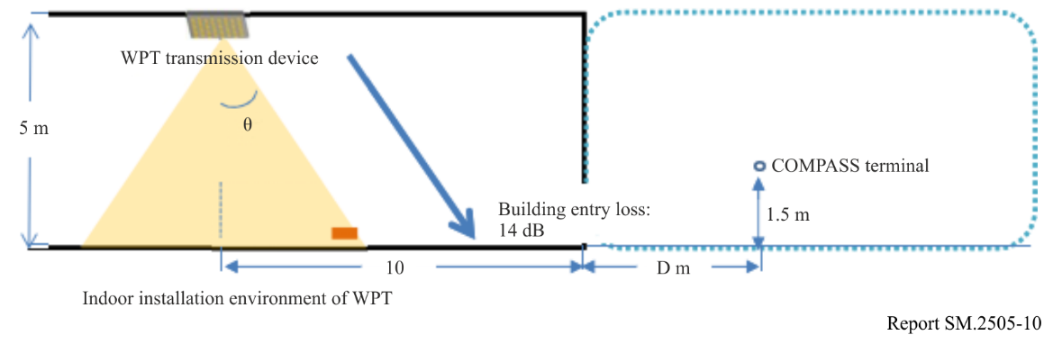

3.4.2 Parameters used in this study
The parameters used for simulation are shown in Table 12.
TABLE 12
Parameters used in the study
Beam WPT transmitters | Output Power | 15 W (41.8 dBm)
Beam WPT transmitters | Centre frequency | 2 484 MHz
Beam WPT transmitters | Bandwidth | 500 kHz,($Power Density=14.8 dBm/kHz$)  10 MHz,($Power Density =31.8 dBm/MHz$)
Beam WPT transmitters | Location and height of transmitter antenna | Located indoor area and set on ceiling to look down
Beam WPT transmitters | Location and height of transmitter antenna | 5.0 m above floor
Beam WPT transmitters | Transmitter antenna gain | Figure 11  （−5 dBi）
 | Building entry loss | 14.0 dB
COMPASS GSO MSS Receivers | Height of receivers | 1.5 m
COMPASS GSO MSS Receivers | Centre frequency | 2 491.5 MHz
COMPASS GSO MSS Receivers | Bandwidth | 16.5 MHz
COMPASS GSO MSS Receivers | Terminal noise temperature | 330K  （$N_{0}=-113.4142 dBm/MHz$）  （$N_{0}=-143.4142 dBm/kHz$）
Simulation conditions | Interference to noise ratio | −6 dB/ −10 dB
Simulation conditions | Location | Suburb
Simulation conditions | Propagation model | Hata model  $$L_{bs}=69.55+26.16 log\left(f\right)-13.82 log\left(h_{b}\right)-α\left(h_{m}\right)+\left(44.9-6.55lg\left(h_{b}\right)\right)∙log\left(d\right)-5.4-{2 (\log{(f/{28}))}}^{2}$$

Figure 11 shows the transmitter antenna pattern of WPT. This antenna pattern has been used in § 3.3 in the Study C. As is shown in the figure, due to the use of beam forming technology in WPT, it has five beams within 60 degrees of off-axis angle of the antenna. In order to calculate the maximum interference distance to COMPASS GSO MSS terminals, this study chose the same parameter as Study C, i.e. the beam with a phase adjustment of 60 degrees is mainly considered, and the off-axis angle of the transmitted signal is close to 90 degrees when the actual interference occurs (WPT height: 5 metres, MSS terminal height: 1.5 metres, the maximum interference distance between the both is greater than 100 metres). Therefore, the transmitting antenna gain can be set as −5 dBi.
Figure 11
Transmitter antenna pattern
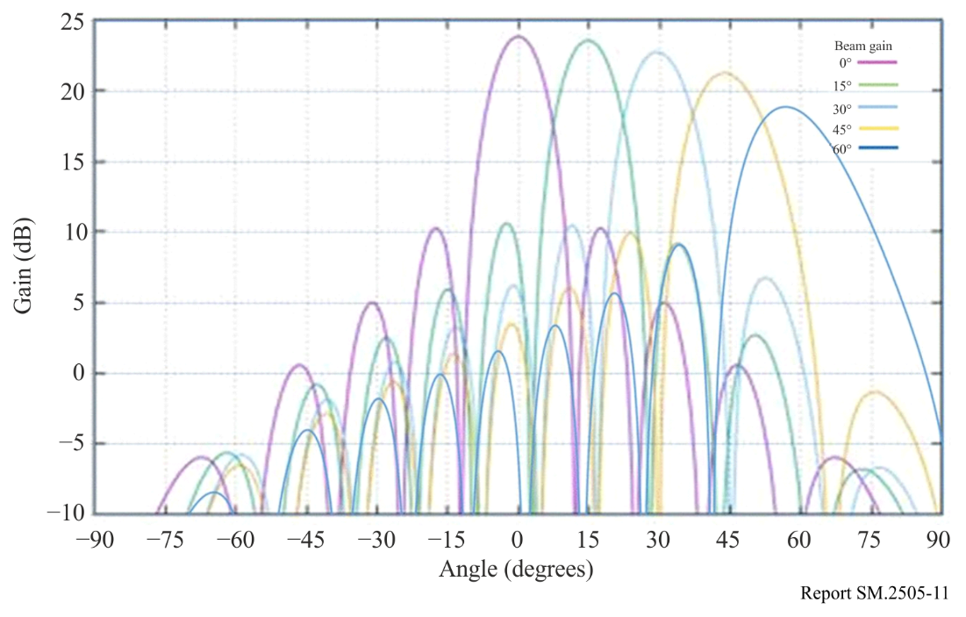

3.4.3 Study results
By considering that the Beam WPT’s transmission bandwidth is 500 kHz and 10 MHz respectively, relevant separation distances can be concluded as shown in Table 13 below. The separation ranges from 820 m to 2 160 m, between Beam WPT and COMPASS GSO MSS mobile terminal.
According to the descriptions from Report ITU-R SM.2392, some Beam WPT system operates indoor or outdoor. The actual interference situation needs further studies case by case, to determine whether the separation distance is enough or not (especially that 2 160 m is somehow a challenging separation distance for specific scenario).
It should also be highlighted, this study result is based on the parameters given in § 3.4.2, yet the parameters of future commercial products of Beam WPT and its implementing scenario are still unknown. Therefore, further studies are also needed.
TABLE 13
Maximum interference distance
I/N CRITERIA  BEAM WPT  Tx BW | −6 dB | −10 dB
500 kHz | 1.72 km | 2.16 km
10 MHz | 0.82 km | 1.03 km

3.5 Study E (915-921 MHz)
An over-the-air, distance charging transmitting device (DUT) operating between 915 MHz and 921 MHz was tested for impact to demonstrate interoperability with wireless devices and technologies operating in the same band. The DUT operates on a single channel with a bandwidth less than 400 kHz and maximum declared conducted average power of 40.0 dBm. The DUT is designed to charge other devices at a distance of up to 300 cm.
The tests were performed in two separate rooms. The first was a real-world test performed in a regular room and on a wooden countertop where other signals were present, as illustrated in Fig. 12. The second room was an anechoic chamber, as described in ETSI EN 302 208 V3.1.1 (2016-11) Annex B.1.2 and as illustrated in Fig. 13. This anechoic chamber was used to demonstrate whether the results found in the regular room were repeatable in a free-space environment and whether any degradation of signal was due to the noisy environment. The tests were performed in the exact same manner, detailed further below, in each room. The results from each of the tests did not have any discrepancies; as such, only one set of results is presented below.
Figure 12
Test setup in room 1, open area
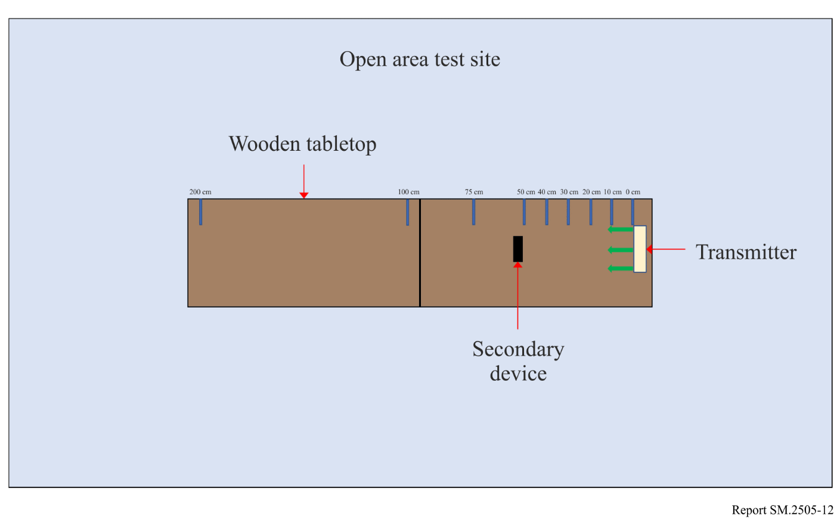
Figure 13
Test setup in room 2, anechoic chamber
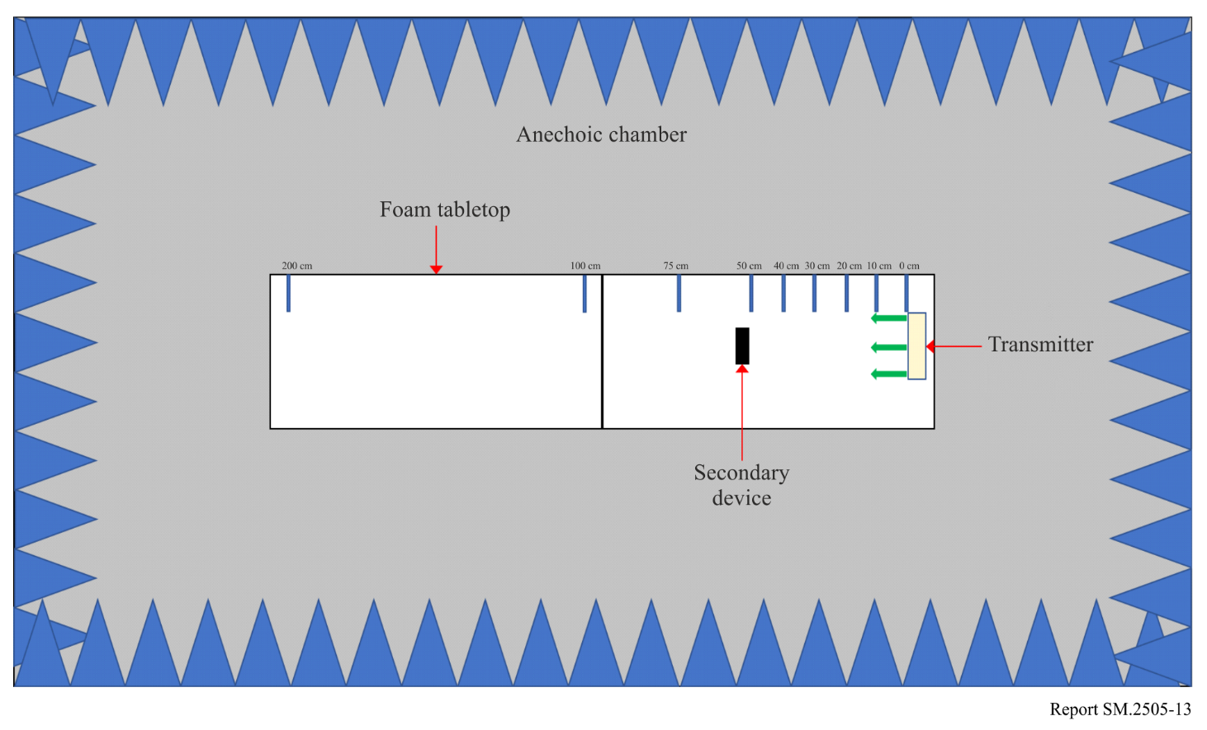
Tests were performed on the following types of wireless devices:
TABLE 14
Types of devices used, frequencies and distances in Study E
No. | Type of device | Frequency range  (MHz) | Distances tested  (cm)
1 | Cellphone | Uplink: 888.0-915.0  Downlink: 925.2-960.0 | 0, 10, 20, 30, 40, 50, 70, 100
2 | Cellphone | Uplink: 888.0-915.0  Downlink: 925.2-960.0 | 0, 10, 20, 30, 40, 50, 70, 100
3 | Cellphone | Uplink: 888.0-915.0  Downlink: 925.2-960.0 | 0, 10, 20, 30, 40, 50, 70, 100
4 | Cellphone | Uplink: 888.0-915.0  Downlink: 925.2-960.0 | 0, 10, 20, 30, 40, 50, 70, 100
5 | Wireless Microphone and base station | 904.45-927.45  User selectable | 0, 10, 30, 100, 200
6 | Assisted listening device | 863.25-864.75  User selectable | 0, 10, 30, 100, 200
7 | Assisted listening device | 904.65-926.85  User selectable | 0, 10, 30, 100, 200
8 | RFID reader | 903-927  Hopping | 0, 10, 30, 100, 200
9 | RFID reader | 865-868  Hopping | 0, 10, 30, 100, 200
Cellphone. The DUT was placed 100 cm from a mobile phone simulating a desktop environment. The cell antenna, cabled to base station simulator, was placed 3 m from the DUT and mobile phone devices. A call from the mobile phone was established to the callbox in the GSM 900 Band, on a specific frequency. After the call was established, the DUT was switched on at 917.5 MHz. The charging signal was verified with a spectrum analyser positioned in the test area. The call was monitored for 60 seconds. After which the call state was logged (call maintained, or call dropped.). The distance between the DUT and mobile phone was decreased incrementally until the mobile phone was touching the DUT, measured at 0 cm. Testing was performed using three different channels.
Figure 14
Cellphone impact test setup
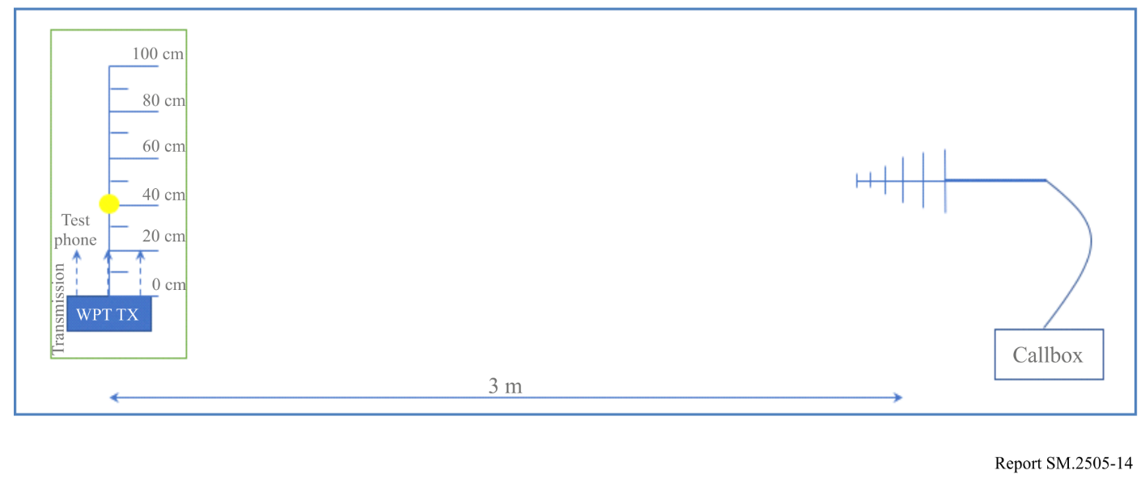
Figure 15
Other In-band device impact test set up
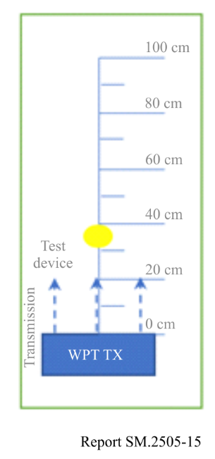
The results demonstrated that all phones were able to operate without harmful interference on at least one channel and on all channels when separated by 1 m or more from the DUT.
Wireless Microphone and base station. The base-station (receiver) was placed 30 cm from the DUT, and the Microphone (Transmitter) moved through the test distances. Subsequently, the Microphone (Transmitter) was placed 30 cm from the DUT, and the Base-station (receiver) was moved through the test distances.
When operating close to the transmit frequency of the DUT, the audio devices experienced no harmful interference.
Assisted listening device. The Transmitter was placed 30 cm from the DUT, and the Receiver was moved through the test distances. Following this, the Receiver was placed 30 cm from the DUT, and the Transmitter was moved through the test distances.
When operating at close to the transmit frequency of the DUT, the devices experienced interference however setting the audio device frequency away from that of the DUT resulted in little to no harmful interference.
RFID reader. For the first device, scans were performed at 903.250; 904.250; 915.250; 915.750; 920.250; 926.750 and 927.250 MHz. The software transmitting setting was set to 30 dBm. RFID tags were then placed 30 cm from the DUT. For the second, scans were performed at 865.00; 866.00; 867.00 and 868.00 MHz with default settings. RFID tags were then placed 30 cm from the DUT.
At separation distances of 1 m or greater between the DUT and RFID reader and tags, the readers worked without error.

3.6 Study F (24.1-24.15 GHz)

3.6.1 United States Industrial, Scientific and Medical regulations
In the US, the Federal Communications Commission (FCC) regulates the use of radiocommunications frequencies for civil applications. The FCC rules and regulations are codified in Title 47 of the US’ Code of Federal Regulations (CFR). The FCC accepts WPT charging operations under Part 18 of its rules, which deals with Industrial, Scientific and Medical (ISM) devices.

3.6.2 24 GHz ISM BAND and Radiation Limits
FCC identifies 24-24.25 GHz band with a centre frequency of 24.125 GHz and maximum operating bandwidth of 250 MHz for ISM use consistent with the provisions of RR No. 5.150. FCC radiation limits of the field strength level of emissions which lie outside the 24 GHz ISM band is a field strength limit of 25 μV/m (E) as measured at a distance of 300 metres (d). Using the e.i.r.p. formula, (e.i.r.p _{(dBW)} = 10*log₁₀((E² * d²)/30)) we get a value e.i.r.p. of –27.27 dBm, or –57.27 dBW.
For unlicensed field disturbance sensors, excluding perimeter protection systems, in 24.075-24.175 GHz and general unlicensed devices, the maximum emission outside the specified band, other than for harmonics, must attenuated by at least 50 dB below the level of the fundamental or 500 μV/m at 3 m, whichever is less.

3.6.3 24 GHz ISM Beam WPT Parameters
This section provides examples of the characteristics of the 24 GHz beam WPT system being developed in the United States.
Other sets of parameters could come from other developers for alternative 24 GHz WPT systems. Table 15 below describes the characteristics used in the respective studies. Only the e.i.r.p. limit outside the 24.0-24.250 GHz ISM band is a present US regulatory limits.
The multi-element antenna in the system being developed in the US has a different far field gain for OOBE that are uncorrelated over the various antenna elements than it has for the coherent in band signals at each antenna element.
TABLE 15
Radio Characteristics of Example Beam WPT System within 24 GHz band
System | System
Frequency | 24.1-24.15 GHz
Bandwidth | 10 MHz
Output Power (W) | 50
Antenna gain in ISM band (dBi) | 40
E.i.r.p. in ISM band (dBm) | 87
E.i.r.p. below 24 GHz (dBm) | –27.27
Field strength limit at 300 m (uV/m) | 25

3.6.4 Human hazard issues for 24.1-24.15 GHz WPT
Technology being considered for these bands used phased array multiple elements beams to focus power on a small area for efficient power transfer. This creates a high-power flux density (pfd) at and near the power receiving area that could violate applicable safety standards. This situation is avoided by active measures that detect the presence of objects near the high pfd volume and reduces or ceases power transmissions when such objects are detected.
The strategy is to make sure applicable safety standards are met. Systems will employ multiple, independently operating and independently testable safeguards that will ensure that exposure requirements are met. These sensors are arranged so that significant power is only transmitted if there is an authorized power destination in a position ready to receive power and without any humans or pets in a nearby position where that would be exposed to unacceptable RF power levels. Examples of these sensors are the ability to evaluate the orientation of the device being charged, including whether it is moving, fixed, or set on a stable surface; the ability to passively sense nearby movement and beam interruption; and the ability to detect Doppler signals from the device being charged or people that are moving. In this way, the distances between the beam, the charging device, and any people located in the vicinity can be calculated in milliseconds, ensuring that the power transfer will cease before a person enters the path of a beam. These independent safety features are all native to the WPT system, meaning that they are inherent in the function of the beam formation apparatus of the WPT system.
In the case of the US, Maximum Permissible Exposure (MPE) to radiofrequency electromagnetic fields have been established for both bands and are shown in Table 16. At these high frequencies RF is generally absorbed by the skin and specific absorption rate (SAR) standards are not applicable.
TABLE 16
US RF Safety Standard Levels for 24 GHz bands
MPE for Occupational/Controlled Exposure (mW/cm²) | MPR for General Population/Uncontrolled Exposure (mW/cm²)
5.0 | 1.0

3.6.5 Protection of Co-channel and adjacent Allocations
As discussed in the beginning of Section 3, Beam WPT in 24 GHz could potentially impact several services with co-channel or adjacent allocations. These include the 23.6-24.0 GHz allocation for Earth exploration-satellite passive (EESS(p)), the radio astronomy Service (RAS), the secondary allocation for Earth exploration-satellite active (EESS(a)) at 24.05-24.25 GHz and the terrestrial component of IMT at 24.25-27.5 GHz.

3.6.6 Protection of adjacent passive bands
The 24.1-24.15 GHz band discussed here for WPT Beam use is within the 24.0-24.25 GHz band designated for industrial, scientific and medical (ISM) uses pursuant to RR No. 5.150. Under RR No. 15.13 « Administrations shall take all practicable and necessary steps to ensure that radiation from equipment used for industrial, scientific and medical applications is minimal and that, outside the bands designated for use by this equipment, radiation from such equipment is at a level that does not cause harmful interference to a radiocommunication service ». 100 MHz below the possible WPT Beam frequency is the 23.6-24.0 GHz band that is allocated on a coprimary basis for Earth Exploration Satellite (passive) , radio astronomy, and Space Research (passive) and protected under the terms of RR No. 5.340 that states «All emissions are prohibited». Space Research (passive) is not a concern because it involves satellite-based receivers not pointing at Earth, but the potential of possible interference to radio astronomy and Earth Exploration Satellite (passive) is a concern and will be discussed below along with limits administrations could use to prevent harmful interference to these services.
3.6.7 Radio astronomy
Depending on the relative location of the interferer and the telescope, the interference occurs in the near field or the far field of the telescope. The far field area, or Fraunhofer area, lies beyond a distance of 2D²/λ, where D is the diameter of the telescope and λ the wavelength. For the RAS frequency band in 24 GHz, this distance is of the order of 400 km for a radio telescope of 50 metre diameter. While radio astronomy systems operating in this band have a range in telescope size and type, a diameter of 50 metre was considered representative of radio telescopes operating in the frequency range 22-24 GHz.
For the assumptions considered in Recommendation ITU-R RA.769, it is irrelevant whether the interferer is in the near field or in the far field of a radio telescope. The near field/far field issue is relevant only for studies that need to consider the signal path from the interfering transmitter to the receiving antenna.
The following are the radio astronomy service (RAS) system parameters for the threshold levels of interference detrimental to radio astronomy continuum observations for the 23.8 GHz band.
The interference protection criteria for RAS (Rec. ITU-R RA.769-2) is a threshold value given as -195 dBW received signal power for continuum measurements, This recommendation states “that administrations, in seeking to afford protection to particular radio astronomical observations, should take all practical steps to reduce all unwanted emissions falling within the band of the frequencies to be protected for radio astronomy to the absolute minimum.”
TABLE 17
Excerpt of RAS Protection Criteria
Parameter | Value continuum observations | Spectral-line observations
Centre frequency ⁽¹⁾ f_{c} (MHz) | 23 800 | 23 700
Assumed bandwidth Δf (MHz) continuum observations  Assumed spectral line channel bandwidth Δ f (kHz) spectral-line observations | 400 | 250
Minimum antenna noise temperature T_{A} (K) | 15 | 35
Receiver noise temperature T_{R} (K) | 30 | 30
System sensitivity⁽²⁾ (noise fluctuations)
Temperature ΔT (mK) | 0.05 | 2.91
Power spectral density ΔP (dB(W/Hz)) | –271 | –254
Threshold interference levels⁽²⁾ ⁽³⁾
Input power ΔP_{H} (dBW) | –195 | –210
pfd S_{H} Δf (dB(W/m²)) | –147 | –161
Spectral pfd S_{H} (dB(W/(m² ⋅ Hz))) | –233 | –215
Notes:
1 Calculation of interference levels is based on the centre frequency shown in this column.
2 An integration time of 2 000 s has been assumed ; if integration times of 15 min, 1 h, 2 h, 5 h or 10 h are used, the relevant values in the Table should be adjusted by +1.7, −1.3, −2.8, −4.8 or −6.3 dB respectively.
3 The interference levels given are those which apply for measurements of the total power received by a single antenna.

3.6.8 RAS regulation
For the WPT system in the 24.1-24.15 GHz band described here,, the nearby 23.6-24.0 GHz band, subject to footnote RR No. 5.340, with its RAS allocation is considered here.

3.6.9 RAS Discussion
The analysis in Section A2.3 of Annex 2 deals with use of segments of the 24.1-24.150 GHz ISM bands for Beam WPT. It is recognized in the Radio Regulations that radio astronomy receivers employ “exceptionally high sensitivity” (29.1-4). At the same time, radio astronomy observatories are often located in remote sites, with some degree of control over emissions near RAS stations (RR No. 29.6). This fact affords additional options and protection of RAS operations from ISM transmitters in nearby bands, in conjunction with administrations taking practicable steps to allow such operation. Some of these steps and options are also detailed in Article 29 of the RR.
With respect to operation of WPT systems and impacts to RAS sites, it is assumed individual administrations employ such steps as are necessary and useful to allow operation in conformance with the Radio Regulations. While administrations generally do not limit the possible locations of ISM devices, US presently prohibits low power unlicensed transmitters/short-range devices in radio quiet zones that surround some radio astronomy facilities.
The study shows that while out-of-band emissions from a large number of indoor 24 GHz WPT Beam devices may cause harmful interference to radio astronomy observatories, most radio astronomy antennas are located in remote areas where few non observatory buildings exist, i.e., its environment is rural rather than urban or suburban. The results in Table A2.3 show that if the WPT systems are kept at a distance of at least 20 km. by regulations of the administration authorizing them, more than 750 devices would be necessary at that distance to cause harmful interference to the observatory. The number necessary to create interference increases rapidly for larger distances. At present there are fewer than 100 such observatories on Earth so such WPT devices would only have to be forbidden on a minuscule part of the Earth’s surface in what are generally remote areas.

3.6.10 Earth Exploration-Satellite Service (EESS) Passive Sensors
Earth Exploration Satellite Service (passive) operates in the 23.6-24 GHz frequency band and is allocated on a primary basis in all three ITU regions. ISM operates in the adjacent band above this EESS band. RR No. 5.340 indicates that all emissions are prohibited in the 23.6-24 GHz band.
Currently, the EESS (passive) operates at least three major types of passive sensors:
– Conical scanning sensors, which are designed to rotate at a fixed angle around the nadir direction.
– Cross-track nadir sensors, which are designed to rotate through the nadir direction and perpendicular to the orbital path.
– Fixed-pointing sensors, which have a static viewing geometry and are typically pointed nearby or on the spacecraft nadir vector.

3.6.11 General considerations for EESS
Passive sensors are used in the remote sensing of the Earth and its atmosphere by Earth exploration and meteorological satellites in certain frequency bands allocated to the EESS (passive). The products of these passive sensor operations are used extensively in meteorology, climatology, and other disciplines for operational and scientific purposes. However, these sensors are sensitive to any emissions within their allocated band. Therefore, any RF emissions above a certain level may constitute interference to the passive sensors using those bands. In addition, it should be noted that passive sensors may not be able to differentiate the wanted signal from the interference and that interference may not be identifiable in the passive sensor products.
Referencing Recommendation ITU-R RS.1861, the table below provides the definitions of some of the technical and operational EESS parameters associated with passive sensors and their operation that are needed for the analysis in this report.
TABLE 18
Definitions of technical and operational EESS parameters for passive sensors
Parameter | Definition
Sensor type | Several types of radiometers are possible depending on the technology of the radiometer: interferometric radiometer, fixed pointing, conical scan, nadir/cross-track scan, push-broom, limb scan radiometer
Altitude | The height above the mean sea level
Inclination | Angle between the equator and the plane of the orbit
Repeat period | The time for the footprint of the antenna beam to return to (approximately) the same geographic location
Number of beams | The number of beams is the number of Instantaneous Field of View (IFOV) on Earth from which data are acquired at one time
Antenna size | For real aperture radiometers, it is the diameter of the antenna reflector;  For interferometric radiometers, it is the size of antenna array.
Maximum antenna gain | The maximum antenna gain (dBi)
−3 dB beamwidth | The −3 dB beamwidth, θ_{3dB}, is defined as the angle between the two directions in which the radiation intensity is one-half the maximum value.
Instantaneous field of view (IFOV) | The instantaneous field of view (IFOV) for a real aperture system is the area over which the detector is sensitive to radiation, defined as the linear dimensions of the beam on the Earth corresponding to the −3 dB beamwidth. By knowing the altitude of the satellite, the dimension of the IFOV is calculated on the Earth’s surface at the boresight direction (or at the tangent point for limb sounding sensors): the IFOV is expressed in km × km representing the minor and major axis of the footprint.
Off-nadir pointing angle | The angle between the nadir and the pointing direction.
Incidence angle at Earth | The angle between the pointing direction and the normal to the Earth’s surface.
Sensor antenna pattern | Antenna gain as a function of off-axis angle. For interferometric radiometers, it is the pattern of synthetic beam.
Sensor integration time | The sensor integration time corresponds to the short period of time allocated for the radiative measurement of the instantaneous area of observation by the detector of a sensor
Channel bandwidth | The channel bandwidth is the range of frequencies around a centre frequency used by the passive sensor

The EESS (passive) sensor parameters used in the calculations are shown below.
TABLE 19
Technical EESS parameters for passive sensors F1 to F6 in 24 GHz
Sensor | F1 | F4 (Outer) | F4 (Nadir) | F5 (Outer) | F5 (Nadir) | F6
Sensor Type | Conical scan | Mechanical nadir scan | Mechanical nadir scan | Mechanical nadir scan | Mechanical nadir scan | Conical scan
Frequency (GHz) | 23.8 | 23.8 | 23.8 | 23.8 | 23.8 | 23.8
Orbit altitude (km) | 817 | 833 | 833 | 824 | 824 | 835
Off-nadir angle (°) | 44.5 | 48.3 | 0.0 | 52.7 | 0.0 | 53.3
Antenna gain (dBi) | 40 | 34.4 | 34.4 | 30.4 | 30.4 | 40.8
Incidence angle at footprint (°) | 52.3 | 57.5 | 0.0 | 64.0 | 0.0 | 65.0
Angle from Ground to Sensor (°) | 37.7 | 32.5 | 90.0 | 26.0 | 90.0 | 25.0
Slant path distance (km) | 1227.3 | 1379.0 | 833.0 | 1562.9 | 824.0 | 1621.5
Antenna efficiency | 0.6 | 0.6 | 0.6 | 0.6 | 0.6 | 0.6
Effective antenna diameter (m) | 0.52 | 0.27 | 0.27 | 0.17 | 0.17 | 0.57
–3 dB beamwidth (horizontal) (°) | 1.81 | 3.30 | 3.30 | 5.20 | 5.20 | 1.50
–3 dB beamwidth (vertical) (°) | 1.81 | 3.30 | 3.30 | 5.20 | 5.20 | 1.50
IFOV Area (km²) | 1880 | 9298 | 1847 | 35983 | 4395 | 3411
TABLE 20
Technical EESS parameters for passive sensors F8 to F13 in 24 GHz
Sensor | F8 | F9 (MWS) (Outer) | F9 (MWS) (Nadir) | F10 (MWI) | F11 (AMR) | F12 (MWR) | F13
Sensor Type | Conical scan | Mechanical nadir scan | Mechanical nadir scan | Conical scan | Nadir | Nadir | Conical scan
Frequency (GHz) | 23.8 | 23.8 | 23.8 | 23.8 | 23.8 | 23.8 | 23.8
orbit altitude (km) | 699.6 | 830 | 830 | 830 | 1336 | 814.5 | 830
Off-nadir angle (°) | 47.5 | 49.31 | 0.0 | 44.8 | 2.65 | 1.9 | 53.3
Antenna gain (dBi) | 48.5 | 37 | 37 | 41.5 | 42.3 | 41 | 45.7
Incidence angle at footprint (°) | 55 | 58.6 | 0.0 | 52.8 | 3.2 | 2.1 | 65.0
Estimated Angle from Ground to Sensor (°) | 35.0 | 31.4 | 90.0 | 37.2 | 86.8 | 87.9 | 25.0
Slant path distance (km) | 1114.3 | 1405.2 | 833.0 | 1273.6 | 1337.7 | 815.0 | 1609.9
Antenna efficiency | 0.6 | 0.6 | 0.6 | 0.6 | 0.73 | 0.6 | 0.6
Effective Antenna diameter (m) | 1.38 | 0.37 | 0.37 | 0.62 | 0.61 | 0.58 | 0.99
-3dB beamwidth (horizontal) (°) | 0.75 | 2.70 | 2.70 | 1.65 | 1.40 | 1.80 | 1.00
-3dB beamwidth (vertical) (°) | 0.75 | 2.70 | 2.70 | 1.65 | 1.40 | 1.80 | 1.00
IFOV Area (km²) | 306 | 6769 | 1202 | 1703 | 855 | 491 | 1549

TABLE 21
Technical EESS parameters for passive sensors F14 to F18 in 24 GHz
Sensor | F14 | F15 | F16 | F17 | F18
Sensor Type | Conical scan | Conical scan | Conical scan | Fixed pointing | Conical scan
Frequency (GHz) | 23.8 | 23.8 | 23.8 | 23.8 | 23.8
orbit altitude (km) | 407 | 407 | 970 | 970 | 665.96
Off-nadir angle (°) | 48.6 | 48.5 | 44 | 2.2 | 47.7
Antenna gain (dBi) | 46.5 | 46.6 | 45 | 45 | 48.5
Incidence angle at footprint (°) | 53.0 | 52.8 | 53.0 | 2.2 | 55.0
Estimated Angle from Ground to Sensor (°) | 37.0 | 37.2 | 37.0 | 87.8 | 35.0
Slant path distance (km) | 643.1 | 641.6 | 1461.7 | 970.8 | 1061.7
Antenna efficiency | 0.594 | 0.6 | 0.6 | 0.69 | 0.6
Effective Antenna diameter (m) | 1.10 | 1.11 | 0.86 | 0.92 | 1.38
-3-dB beamwidth (horizontal) (°) | 0.80 | 0.85 | 1.12 | 0.98 | 0.65
-3-dB beamwidth (vertical) (°) | 0.80 | 0.85 | 1.12 | 0.98 | 0.65
IFOV Area (km²) | 106 | 122 | 933 | 216 | 264

3.6.12 EESS Protection Criteria
The EESS (passive) protection criteria are stated in Recommendation ITU-R RS.2017 (2012) “Performance and interference criteria for satellite passive remote sensing”.
In recommends 5, the protection criteria should not be exceeded for more than a percentage of sensor viewing area. In the 24 GHz case, that percentage is 0.01%. The measurement area is a square on the Earth of 2 000 000 km² unless otherwise justified. Therefore, the interference criteria of –166 dB(W/200 MHz) may not be exceeded in any 200 km² area.

3.6.13 EESS(a)
The secondary allocation for EESS(a) at 24.05-24.25 GHz is subject to the terms of RR No. 5.150, which states “Radiocommunication services operating within these bands must accept harmful interference which may be caused by these applications. ISM equipment operating in these bands is subject to the provisions of No. 15.13”, which states that “Administrations shall take all practicable and necessary steps to ensure that radiation from equipment used for industrial, scientific and medical applications is minimal and that, outside the bands designated for use by this equipment, radiation from such equipment is at a level that does not cause harmful interference to a radiocommunication service and, in particular, to a radionavigation or any other safety service operating in accordance with the provisions of these Regulations”

3.6.14 Terrestrial Component of IMT (24.25-27.5 GHz)
IMT is allocated above the 24 GHz ISM band in 24.25-27.5 GHz. Annex A2.4 analyzes the potential impact of WPT Beam devices in 24.1-24.1 GHz on this application using the blocking criteria provided by WP 5D. It is shown that the blocking criteria are exceeded only for WPT Beam device placed in the same room as the IMT UE device where its receiver is configured at highest sensitivity.

3.6.15 Summary
The WPT ISM technology considered at this frequency involves a narrow band transmission which has a bandwidth occupying 0.04% of the centre frequency of 24 GHz ISM band. The maximum ISM emission bandwidth used is 10 MHz within the range of 24.1-24.15 GHz.
Annex 2 shows that the number of ISM devices that can be accommodated for each of the EESS (passive) sensors vary from a minimum device density of 67 per km² to more than 350 000 devices per km² averaged over the sensor’s field of view depending on each sensor characteristics. The analysis in Annex 2 shows that, for the case of indoor use of WPT beam power sources pointing in a downward direction, with OOB emissions specified by US ISM band limits, and a building entry loss varying between 3 dB and >40 dB will permit the use of an average of tens or more WPT beam devices per sq. km. without exceeding the protection limits of ITU-R RS.2017 for the worst case of each of the EESS (passive) sensors in ITU-R RS.1861. The minimum average density calculated for the most vulnerable sensor is used to determine the level necessary to protect EESS (passive).
This analysis does not consider the contributions from other non-WPT sources that can affect the number of WPT devices that can operate in a km², due to aggregate effects from all interfering sources and makes a number of other assumptions related to building entry losses and predicted deployment density that are estimated and can also impact the results. Administrations implementing 24 GHz Beam WPT should consider means of ensuring that devices are used indoors, pointing downward to assure that the protection of allocated service required by RR No. 15.13 is met.
For IMT UE and BS in the upper adjacent band, interference levels are not exceeded for plausible densities of WPT beam equipment according to the criteria provided by WP5D, which considered only out-of-band emissions from the WPT signals in 24.1-24.15 GHz into the 24.25-27.5 GHz band. There is a possibility of blocking interference to IMT receivers from power in the ISM band (24.1-14.15 GHz) due to limited ability to reject strong signals in the lower ISM band. At this time, there is no published quantitative recommendation for receiver immunity to such signals and there is little operational experience about the ability of production units to reject strong adjacent band signals. It is possible that IMT receivers operating in the 24 GHz band in indoor rooms with 24 GHz beam WPT systems operating might experience blocking interference when operating within a few meters of the beam from the WPT transmitter to the desired power destination.
In the worst case such interference would be limited to a small area of a few square meters surrounding the highly focused transmitted signal path. The necessary RF safety feature would greatly reduce the power in many cases where a user approaches the power beam. In general, the 24.25-27.5 GHz band will be mainly used for outdoor IMT paths since there is much higher building penetration loss in this band than in lower bands. While this band is identified for IMT, its use for that will vary from administration to administration.
Administrations considering the use of 24 GHz Beam WPT in their jurisdictions that have chosen to authorize 24.25-27.5 GHz IMT band use may wish to consider the possible impact of such WPT use on indoor IMT operations in their jurisdiction.
For radio astronomy, the remote location and control of the radio environment for many sites affords protection of the receivers utilized, which are of “exceptionally high sensitivity”. In situations where WPT systems are expected to operate within the radio horizon of radio astronomy systems, administrations should take practicable steps to allow operation in conformance with the Radio Regulations. Some of these steps and options are also detailed in Article 29 of the RR.

3.7 Study G (61-61.5 GHz)

3.7.1 Radio services considered in the study
This section contains a study that examines the out-of-band emission limits necessary to ensure protection criteria are met for the Earth Exploration Satellite Service (passive) (EESS (passive)) and Radio Astronomy Service (RAS). This study deals with use of segments the ISM band at 61-61.5 GHz for beam WPT.

3.7.2 Considerations for 61-61.5 GHz
The technology being considered at this frequency involves a narrow band transmission which has a bandwidth of approximately 0.02% in the case of the 61 GHz ISM band. The maximum 10 MHz bandwidth comes from three sources: phase noise of the frequency source, incident random phase modulation on the transmitted signal from continuous minor adjustments of the phase shifters in the antenna elements to maintain focus on the intended destination, and low index modulation of the CW carrier for communications between the transmitter and power destination used to both maintain a tight focus of the band on the destination and to implement active safety features that decrease power when an object or a human or pet approach the high power flux-density (pfd) volume near the intended destination.

3.7.3 Impact 61-61.5 GHz beam WPT
This band is a designated ISM band per RR No. 5.138, which provides that “The use of these frequency bands for ISM applications shall be subject to special authorization by the administration concerned, in agreement with other administrations whose radiocommunication services might be affected. In applying this provision, administrations shall have due regard to the latest relevant ITU-R Recommendations.” The primary allocations for this band are fixed, inter-satellite, mobile and radiolocation. In addition, many administrations have designated this band and nearby bands for SRDs. Such SRDs generally have narrow beam width antennas, facilitated by the short wavelength at this band, and thus are resistant to point sources of RF power.
The nearest band allocated for EESS (passive) is at 59-59.3 GHz (1.7 GHz below) and the nearest band allocated for RAS is at 76-77.5 GHz, 14.5 GHz above. The EESS (passive band) at 59-59.3 GHz is within the ‘60 GHz’ oxygen absorption band, and has 13 dB/km attenuation by atmospheric gases at sea level for horizontal paths although this attenuation decreases at higher altitudes and for higher elevation angle paths. The conditions of RR No. 5.138 appear appropriate to protect other services regarding the use of this technology in this band.

3.7.4 Human hazard issues for 61-61.5 GHz WPT
Technology being considered for these bands used phased array multiple elements beams to focus power on a small area for efficient power transfer. This creates a high pfd at and near the power receiving area that could violate applicable safety standards. This situation is avoided by active measures that detect the presence of objects near the high pfd volume and reduces or ceases power transmissions when such objects are detected.
The strategy being followed is to make sure applicable safety standards are met: systems will employ multiple, independently operating and independently testable safeguards that will ensure that exposure requirements are met. These sensors can be arranged so that significant power is only transmitted if there is an authorized power destination in a position ready to receive power and without any humans or pets in a nearby position where they would be exposed to unacceptable RF power levels. Examples of these sensors are the ability to evaluate the orientation of the device being charged, including whether it is moving, fixed, or set on a stable surface; the ability to passively sense nearby movement and beam interruption; and the ability to detect Doppler signals from the device being charged or people that are moving. In this way, the distances between the beam, the charging device, and any people located in the vicinity can be calculated in milliseconds, ensuring that the power transfer will cease before a person enters the path of a beam. These independent safety features are all native to the WPT system, meaning that they are inherent in the function of the beam formation apparatus of the WPT system.
TABLE 22
RF safety standard levels for 61 GHz band in the United States
Band  (GHz) | Maximum permissible exposure (MPE) for  occupational/controlled exposure  (mW/cm²) | Maximum permissible exposure (MPE) for general population/uncontrolled exposure (mW/cm²)
61-61.5 | 5.0 | 1.0

3.8 Study H (915-921 MHz, 2 410-2 486 MHz and 5 738-5 766 MHz)
When radio telescopes are located in remote areas, this is in order to limit interference and to allow observation of the cosmos in frequency bands that are heavily used in urban areas. To assist in these goals, some radio telescopes operate in locally-administered radio quiet zones wherein emissions are managed across the radio spectrum as explained in Report ITU-R RA.2259.
WPT devices operating in frequency bands designated for the use of ISM applications present a case requiring particular care, given that they operate under RR No. 5.150. Radio astronomy is considered as a radiocommunication service operating under RR No. 4.6.

3.8.1 Radio services and bands considered in the study
The study considers compatibility of radio astronomy service operations with WPT devices operating in three ISM bands selected from among the entries in Table 1 as given in Table 16. The study calculates the isolation (in dB) from WPT radiation that is needed to reach to radio astronomy protection levels given in Recommendation ITU-R RA.769, at the frequency of the WPT operation (Table 16) and at three frequencies used by the radio astronomy service (Table 17). Calculations at the radio astronomy frequencies all assume the same radiated power density –71.3 dBW/1 MHz that many administrations specify when limiting radiation from ISM devices above 1 GHz, corresponding to an electric field of 500 μV/m measured at 3 m in a 1 MHz bandwidth, as converted to power using equation (2) in Report ITU-R RA.2131.

3.8.2 Details of the calculations

3.8.2.1 Radiation at WPT frequencies
The WPT frequencies, gains and power levels in Table 23 are those of Systems 2, 5 and 6 in Table 1. Specific attenuations Atten_wet and Atten_dry (dB/km) are taken from Recommendation ITU-R P.676 for dry and standard (std) atmospheres. The quantity T_769 is the radio astronomy service protection threshold power flux interpolated between values in column 8 of Table 1 in Recommendation ITU-R RA.769-2.
TABLE 23
Parameters used in the WPT frequency calculations
Frequency (GHz) | P_wpt  (dB W) | Gain_wpt  (dBi) | T_769  (dB W/m²) | Atten_dry  (dB/km) | Atten_std  (dB/km) | Δ at d=100 km  (dB)
0.920 | 11.761 | 8.24  0 | –183 | 0.005 | 0.005 | 95  87
2.4 | 11.761 | 24  0 | –177 | 0.006 | 0.006 | 105  81
5.8 | 15.051 | 25  0 | –169 | 0.0075 | 0.009 | 114  89

3.8.2.2 Radiation at radio astronomy frequencies
Characteristics of the radio astronomy bands shown in Table 24 were taken from Recommendation ITU-R RA.769 and RR No. 5.149, and the power levels into the bands are calculated by multiplying P'_wpt = –71.3 dB W/MHz by the RAS bandwidth.
TABLE 24
Parameters used in the radio astronomy frequency calculations
Frequency (GHz) | P_wpt  (dB W) | Gain_wpt  (dBi) | T_769  (dB W/m²) | Atten_dry  (dB/km) | Atten_std  (dB/km) | Δ at d=100 km  (dB)
1.400-1.427 | –57.0 | 0 | –180 | 0.005 | 0.005 | 12
2.69-2.70 | –61.3 | 0 | –177 | 0.006 | 0.006 | 5
6.65-6.6752 | –57.3 | 0 | –168 | 0.0075 | 0.009 | –1

Figure 16
Isolation needed at WPT frequencies
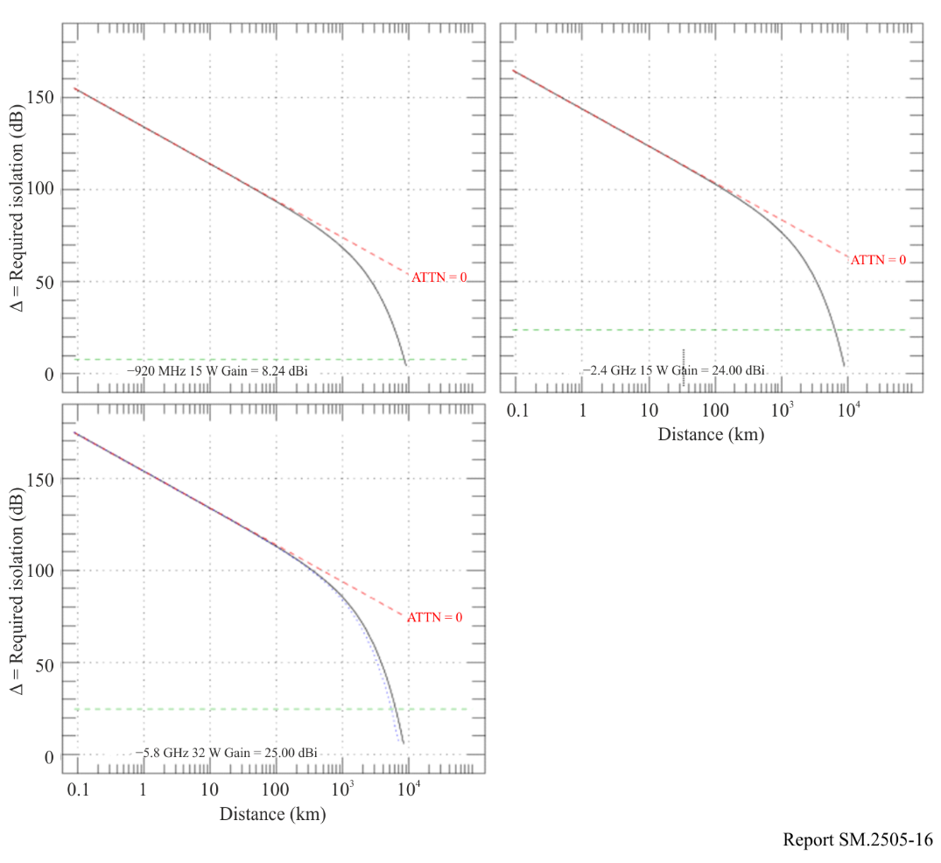

3.8.2.3 Calculations
The study calculates the power flux from WPT at distance d(m) in free space with specific attenuation A (dB/km) = Atten_dry and Atten_std, and takes the logarithmic difference of this with the threshold values in Recommendation ITU-R RA.769. Results are shown for the values of WPT gain in Table 24, including for 0 dBi. Gain of the radio astronomy system is 0 dBi as assumed to set threshold levels in Recommendation ITU-R RA.769.
Specifically, the study computes numerical values of

Δ (dB) = P_wpt + Gain_wpt – T_769 – 10 log (4π) – 20 log (d) – A*d/1000

as shown in Figs 16 and 17 for the WPT-frequency and RAS-frequency cases, respectively. In each Figure, the results are shown for the dry and standard atmospheres but the difference is barely recognizable. The WPT gain is shown in order to facilitate derivation of isolation for the case of 0 dBi WPT gain.

3.8.3 Results
Results for the calculation of Δ at the WPT frequencies are shown in Fig. 16, and the rightmost column in Table 23 shows the values of Δ calculated at d = 100 km, in this case ranging from 80 to 110 dB.
Results in radio astronomy bands are shown in Fig. 17, and values of Δ at a line-of-sight separation of 100 km are –1 to 12 dB in Table 24.
Figure 17
Isolation needed at radio astronomy frequencies
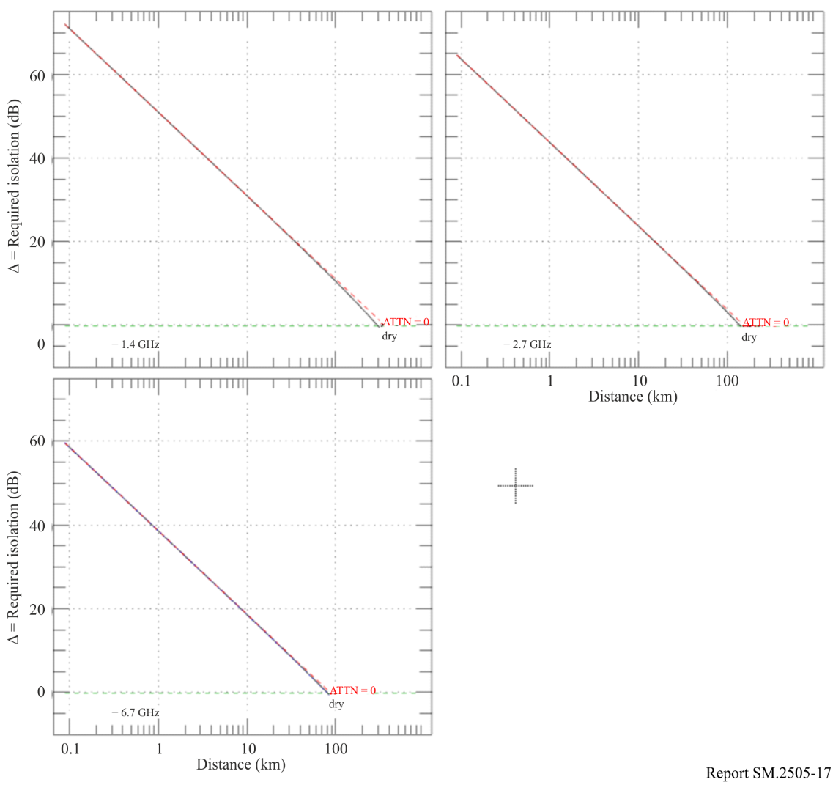

3.8.4 Summary
To meet the interference thresholds in Recommendation ITU-R RA.769, isolation of radio astronomy facilities from WPT devices operating in ISM bands is required. Under certain circumstances exclusion zones need to be considered, based on the permitted power levels and propagation losses from the local terrain. For RAS systems operating in the bands outside the fundamental emissions of beam WPT systems, national administrators need to ensure that the permitted out-of-band and spurious emissions under current national regulatory standards do not cause harmful interference by including considerations of link budgets, building entry loss, clutter and terrain loss, line of sight and diffraction considerations. This may also be determined based on a combination of measurement and analysis.

4 Human hazard issues
Administrations are encouraged to follow the guidelines set by the ICNIRP and IEEE expert groups, or limits set by their own experts. Human exposure to electromagnetic fields (EMF) is addressed by a number of regulatory agencies as well as international expert organizations such as the World Health Organization (WHO), the Institute of Electrical and Electronics Engineers (IEEE), and the International Commission on Non-Ionizing Radiation Protection (ICNIRP). Below are the ICNIRP Guidelines on EMF:
1) ICNIRP (1998): Guidelines for limiting exposure to time‐varying electric, magnetic and electromagnetic fields (up to 300 GHz);
2) ICNIRP (2020): Guidelines for limiting exposure to electromagnetic fields (100 kHz to 300 GHz).
IEEE C95.1-2019 is the “IEEE Standard for Safety Levels with Respect to Human Exposure to Electric, Magnetic, and Electromagnetic Fields, 0 Hz to 300 GHz”.
IEEE C95.1 (2019) and ICNIRP (2020) Guidelines (and ICNIRP (1998)) are largely harmonized: the power-density limits whole-body levels above 30 MHz are identical. When considering EMF exposure from beam WPT, the most relevant references are ICNIRP (2020) and IEEE C95.1-2019.
Beam WPT in the practical implementation would employ frequencies starting from UHF and higher for transmission systems. Examples are using 920 MHz band, 2.4 GHz band, and 5.7 GHz band to transmit the power. Microwaves may be beamed from an antenna, by way of point-to-point or point-to-multipoint, over a distance of several metres or more. Unlike wireless communication uses, the level of transmitted electromagnetic power required for commercial implementation of beam WPT could be greater to some extent or substantial. It is deemed appropriate that a human exposure to beam WPT EMF (including medical devices) should be assessed and managed with additional measures to be compliant with the current guidelines in the beam WPT planning and operation.
To cope with above-mentioned unique and standing technical requirements, some current beam WPT implementations are considering adoption of human body detection mechanisms in the area with expecting greater RF exposure than the guidelines to cease power transmission and / or steer the power beam direction when detected. To facilitate implementation such technical measures and ensure compliance with the guidelines, study on regulatory environmental conditions for beam WPT is also undertaken in some administrations. See Annex 1 for details.

5 Summary
It should be noted that studies provided in this Report refer mostly to specific national regulations.
The various studies in this Report have demonstrated that the proposed beam WPT systems can generally coexist with incumbent radiocommunications services and stations that have been studied. In certain cases, depending on the national regulations, some mitigations may be necessary.
Studies A, B and E presented test data for beam WPT systems in the 915-921 MHz band operating under the national regulations. The results demonstrated that such systems can coexist with incumbent devices with very little interference as permitted under the rules and with recommended user mitigation approaches.
The results presented in Study C demonstrate that the impact of beam WPT systems on other wireless devices and technologies depends on factors such as the output power of the beam WPT, the distance between devices, and whether the same operating frequencies are being used. For beam WPT systems operating in the 915-921 MHz band, results from these studies, considering national regulations, demonstrate that in most cases their operation is feasible and causes little to no interference to the following types of devices: IMT user terminals, wireless microphones and base stations, assisted listening devices, RFID readers, door/window sensors, smart hubs, and smart power outlets.
Study D carried out a case study on compatibility analysis between the Beam WPT and the COMPASS GSO MSS system (operating in the frequency band 2 483.5-2 500 MHz). The study result shows that separation ranges from 820 metres to 2 160 metres is needed to avoid harmful interference from Beam WPT to COMPASS system. Bearing in mind that some Beam WPT system operates indoor or outdoor, and the unknown commercial Beam WPT’s parameters and operating scenario, further careful studies are needed to be carried out by Administrations, even case by case, to determine whether the separation distance is enough or not (especially that 2 160 m is somehow a challenging separation distance for specific scenario).
Study C further reports frequency sharing conditions with additional measures for incumbent service protection and human body protection from WPT RF exposure. A result on beam WPT in 917-920 MHz under the WPT technical condition equivalent to the existing RFID system demonstrates coexistence capability with systems in the same and neighbouring bands. Another result in 2 410-2 486 MHz and 5 738-5 766 MHz bands addresses adoption of WLAN CCA mechanism to WPT systems and provisions on necessary separation distances. A comprehensive beam WPT operating management rule regarding WPT operation environment and EMFs is provided as a regulatory guideline.
Study F studied various applications that could be affected by WTP Beam in the 24.1-24.15 GHz, ISM band. For EESS (Passive) systems, the study demonstrated that the number of WPT (wireless power transfer) ISM devices that can safely operate varies widely—from 67 to over 350,000 devices per km²—depending on the characteristics of each EESS (passive) sensor. When WPT systems are used indoors with downward-pointing beams with building entry losses between 3 dB and >40 dB, tens or more devices per km² can typically be deployed without exceeding Recommendation ITU-R RS.2017 protection limits, even for the most sensitive sensors listed in Recommendation ITU-R RS.1861. For IMT UE and BS in the upper adjacent band, interference levels in the IMT band (24.25-27.5 GHz) are not exceeded for plausible densities of WPT beam equipment even in the case of user equipment 10m away from the WPT beam device. For radio astronomy, the remote location and control of the radio environment for many sites affords protection of the receivers utilized, which are of “exceptionally high sensitivity”. In situations where WPT systems are expected to operate within the radio horizon of radio astronomy systems, administrations should take practicable steps to allow operation in conformance with the Radio Regulations. Some of these steps and options are detailed in Article 29 of the RR. It is noted that the analysis excludes potential interference from other non-WPT sources and makes assumptions about building losses and deployment density that could affect outcomes. Administrations should ensure indoor, downward-pointing use of WPT devices to comply with RR No. 15.13 protection requirements.
Study G states that based on system performance analysis, current national regulations are adequate to protect incumbent systems at 61-61.5 GHz frequency band.
Study H indicates that to meet the interference thresholds in Recommendation ITU-R RA.769, isolation of radio astronomy facilities from WPT devices operating in ISM bands is required. Under certain circumstances exclusion zones need to be considered, based on the permitted power levels and propagation losses from the local terrain. For RAS systems operating in the bands outside the fundamental emissions of beam WPT systems, national administrators need to ensure that the permitted out-of-band and spurious emissions under current national regulatory standards do not cause harmful interference by including considerations of link budgets, building entry loss, clutter and terrain loss, line of sight and diffraction considerations. This may also be determined based on a combination of measurement and analysis.

Annex 1
RF exposure environmental control to comply with the Radio Radiation Protection Guidelines, the case of Japan

A1.1 Beam WPT installation environments
The Information and Communication Council of the Ministry of Internal Affairs and Communications (MIC) of Japan defined the WPT indoor installation environments by the names of the WPT controlled environment and the WPT general environment to manage and control radiofrequency EMF exposure generated from the beam WPT system to human bodies in the operation of Japanese 920 MHz band (915-930 MHz), 2.4 GHz band (2 400-2 499 MHz) and 5.7 GHz band (5 470-5 770 MHz) to comply with the Japanese Radio Radiation Protection Guidelines (RRPG) as follows.

A1.1.1 WPT controlled environment
The WPT controlled environment is summarized as shown below:
– It is categorized as indoor and closed space for beam WPT operation.
– In the environment, WPT radio frequency EMF levels meet the allowable range specified for the controlled environment in the RRPG. (Power transmission shall be ceased when detecting an individual entering the area where EMFs surpass the limits of the controlled environment specified in the RRPG.)
– When a beam WPT system is operated in the WPT controlled environment, for the purpose of avoiding and mitigating harmful effect to other radiocommunication systems, the WPT system installation personnel, the WPT system operator, the WPT licensee, and other authorized personnel shall be able to manage and control the use of other radiocommunication systems and device installation conditions in an integrated manner.
– When the concerned WPT controlled environment is bordering other indoor space (e.g. side-by-side rooms or upper-and-lower floors), WPT radio frequency EMF levels shall meet the allowable range of specified spectrum sharing conditions with the other radiocommunication systems even in those indoor spaces, or the identical WPT manager to the concerned indoor WPT controlled environment shall be able to manage the coordinated spectrum sharing in the integrated manner. (This clause is applied to the 2.4 GHz and 5.7 GHz bands operation only).

A1.1.2 WPT general environment
The WPT general environment is one of the categories of WPT indoor installation environment and means a WPT use environment that does not fulfil the definition of the WPT controlled environment. (e.g. wireless power transmission to quality management sensors in a logistics warehouse (920 MHz band application only), wireless power transmission to observation sensor devices in an elder nursing care facility (920 MHz band application only).

A1.2 Compliance with the RRPG

A1.2.1 Separation distance
To comply with the radio frequency EMF exposure requirements in the RRPG, the following separation distances were derived and specified.
TABLE A1.1
Separation distances to meet the RF exposure limits of the RRPG
Band | Environmental condition defined in the RRPG | Reflection coefficient  K = 1⁽¹⁾ | Reflection coefficient  K = 2.56⁽²⁾ | Reflection coefficient  K = 4⁽³⁾ | Adding 6 dB to EMF strength⁽⁴⁾
 |  |  |  |  | Reflection coefficient  K = 2.56 | Reflection coefficient  K = 4
920 MHz | Controlled environment | 0.102 m | 0.163 m | 0.203 m | 0.325 m | 0.4065 m
920 MHz | General environment | 0.227 m | 0.364 m | 0.456 m | 0.727 m | 0.912 m
2.4 GHz | Controlled environment | 2.45 m | 3.92 m | 4.90 m | 7.82 m | 9.80 m
2.4 GHz | General environment | 5.48 m | 8.76 m | 10.95 m | 17.49 m | 21.90 m
5.7 GHz | Controlled environment | 4.00 m | 6.40 m | 8.00 m | 12.80 m | 16.00 m
5.7 GHz | General environment | 9.00 m | 14.30 m | 17.80 m | 28.50 m | 35.70 m
⁽¹⁾ No reflections counted.
⁽²⁾ Reflections from the ground counted.
⁽³⁾ Reflections from the water surface and from those other than the ground counted.
⁽⁴⁾ 6 dB is added in the case greater reflection is expected to observe due to buildings such as an office building nearby the evaluation point.

A1.2.2 Directions
The beam WPT systems being considered for the operation in the 920 MHz band, the separation distance to meet the limits in the RRPG is comparatively short; and therefore, it is possible for them to operate in the WPT general environment.
Those for the 2.4 GHz band and the 5.7 GHz band assume adoption of human body detection mechanisms in the area expecting greater RF exposure than the limits specified in the RRPG to cease power transmission when detected. In addition, the systems are to take safety measures to ensure correct functioning of the detect and protect mechanism. Moreover, some alert such by indicating attentional area and setting a fence is conducted, too.
Beam WPT transmitters are not used at a very close proximity (within 20 cm) from the human body according to use case scenarios and also taking appropriate safety measures mentioned above. Therefore, study on specific energy absorption rate (SAR) for the human body nearby is not necessary.
Annex 2
Details of Impact Studies of Beam WPT on EESS(passive),
RAS, and IMT in Study F

A2.1 EESS (Passive) and Beam WPT
In the United States, beam WPT is regulated as an ISM use of spectrum subject to the national 24 GHz ISM band limit established by FCC. For the case of transmitter power less than 500 W RF power, the out-of-band limit is a field strength of 25 μV/m at a measurement distance of 300 m and a measurement bandwidth of 1 MHz. Some administrations have created national requirements that devices for indoor only use have physical characteristics limiting their potential outdoor use, including the requirement that the device must be powered from electrical mains. Administrations could also require sensors in such devices to assure they are pointed downward.

A2.1.1 Modelling impact of 24 GHz WPT beam devices on EESS (passive) sensors
In general, OOBE levels decrease as the frequency becomes separated from the carrier frequencies by multiples of the transmission half bandwidth. These transmissions are low in bandwidth compared to their separation from the nearby passive band. In this case the band separation is >100 MHz while the bandwidth of the WPT Beam emission is ≤ 10 MHz so the passive bands is more than 10 half bandwidths away. In this case ISM is only used indoor employing downward pointing antennas that transfer a large fraction of their transmitted power to the intended receiver. The antennas have multiple elements each with amplifiers and frequency synthesizers that derive the centre frequency of transmissions from a reference frequency that is much lower. If the phase locked loop of the synthesizer has a bandwidth that is much smaller than the separation of the centre frequency from the nearby passive band, then the resulting emissions near centre frequency will have highly correlated phases over a bandwidth of less than 10 MHz over the various antenna elements and have uncorrelated phases over frequencies further from the centre frequency. This, in turn, results in a highly focused beam at the centre frequency and a much more diffuse pattern with much lower gain at the frequencies more than 10 MHz from the centre frequency. The resulting out of band emissions from each antenna element result from the phase noise of individual local oscillators of each PLL and are uncorrelated.
It is noted that this is different than in the case of IMT MIMO antennas in the nearby IMT band. For the IMT case, out-of-band emissions are from both oscillator noise and the IMT modulation and have greater out-of-band correlation between the signals in each antenna element. IMT emissions have much greater bandwidth because of complex information-carrying modulation which results in many correlated sidebands. In Beam WPT signal bandwidth is not an intentional design characteristic, but rather a byproduct of circuit noise in carrier frequency synthesis in the many individual antenna elements.
As a result, while the centre frequencies of each element are in phase and permit antenna beam focusing by changing the amplitude and phase of transmission from each element, for frequencies more than 100 MHz away from the centre frequency the phase noise of the emissions are uncorrelated, so their OOBE do not focus, and the antenna array has little gain for such OOBE. This is illustrated below where the OOB emission pattern of a single antenna in an exemplary array is simulated using HFSS.
Figure A2.1
In-band and out-of-band radiation patterns
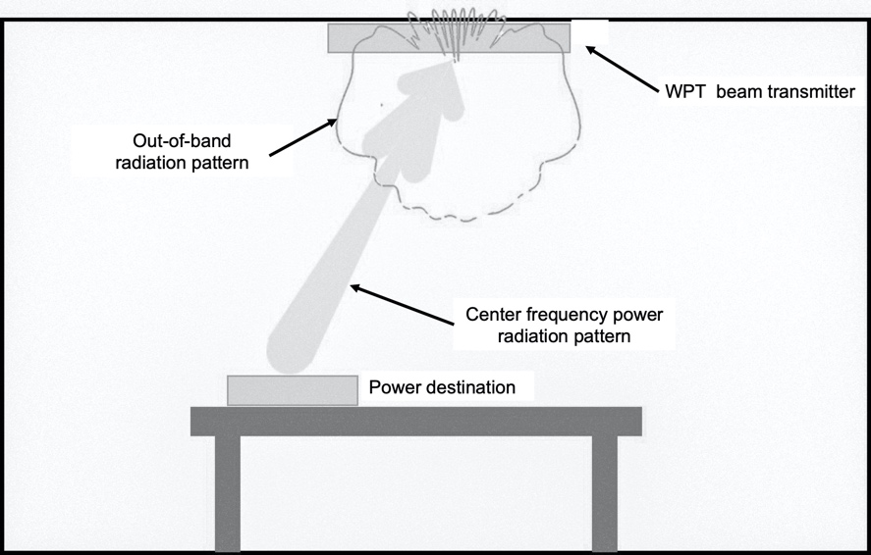
Figure A-2.2 shows the ISM device antenna gain towards selected EESS sensors for a fixed Earth to EESS elevation angle and for azimuth angles that vary between –180° to +180°.
Figure A2.2
Transmitter OOB Antenna Patterns versus Azimuth for Select Elevation Angles Matching
EESS Off-Nadir Angles

Tables A2.1 and A2.2 provide calculations to predict how much of this ISM device power reaches an EESS (passive) satellite of various types under assumption that all ISM transmitting units are indoors and are pointing downward. This is an upper-bound analysis to determine a geographic density of these devices that could be operated without adversely impacting the passive satellites. While a dynamic simulation would give a more precise result, the worst case here gives an upper bound for Beam WPT density.
The analysis provided in this document considers only direct-path propagation from the sidelobe and/or backlobe of the Beam WPT device to the main-beam of the passive remote sensor.
The calculations use the ITU-R P.2109 “Prediction of building entry loss” model that considers losses due to exterior building walls. As is shown in Figure A2.3 for high elevation angle paths to satellites the exterior wall may not be the only source of structural path loss. For a ceiling mounted transmitter all emissions reaching a satellite must pass through at least one interior floor construction before they reach the exterior wall. Depending on the satellite elevation angle and the distance of the transmitter from the exterior wall, more than one through the floor transit may be involved. There is no present recommendation for such path losses through interior floors, so it is not included in the calculation presented.
Figure A2.3
Impact of ceilings on high elevation angle paths in cases where WPT device is distant from exterior wall
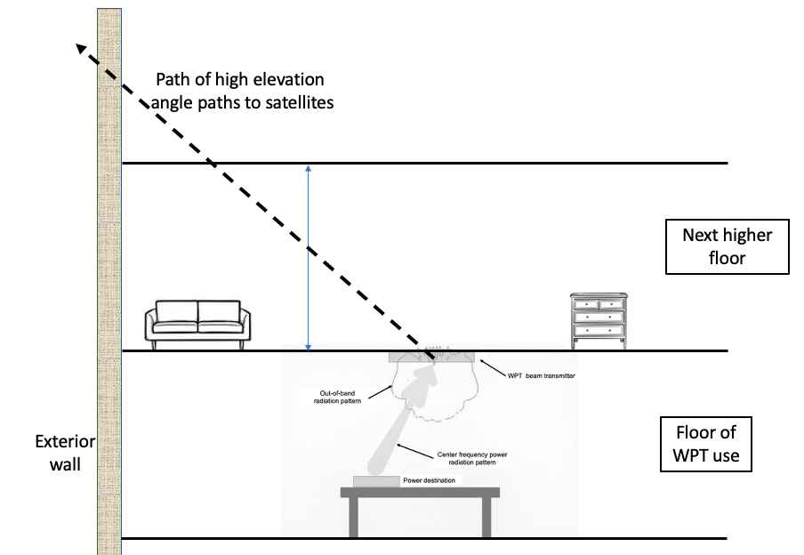
In very high population density areas with multi-storey buildings this model is conservative in that it does not address the vertical loss a signal would have on high elevation angle paths if an emitter was several floors down from the building roof. Nor does it account for signal blockage by nearby buildings higher than the emitter that could block paths to the satellite as some elevation angles.
[Editor’s note: Views were expressed that the indirect path including in particular the reflections of the main beam emissions in its surrounding will also have to be considered.]
In the case considered the maximum WPT beam transmitter density under the above assumptions that is consistent with the Recommendation ITU-R RS.2017 protection goals are shown in the table to be in the range of >67 to several thousand units per square kilometre, depending on which sensor from Recommendation ITU-R RS.1861 is considered. As mentioned above this density would be larger in the case of areas with multi-storey buildings due to both attenuation from multiple levels above the transmitter and partial signal blockage of power that leaves a building at low elevation angles. However, there is presently no generally accepted building attenuation model for computing the increased attenuation at high elevation angles for such areas with many multilevel, multi-storey buildings.
TABLE A2.1
Sample Power budget for the Aggregate Usage of Beam WPT Devices for Sensor F18
Sensor Type/Operator | Conical scan  F-18 | Comments
Sensor Orbit Altitude (km) | 665.96 | RS.1861, (term H)
Sensor Antenna Peak Gain (dBi) | 48.5 | RS.1861
Off-nadir angle (°) | 47.7 | RS.1861, (term α)
Sensor Ground Area Instantaneous Field of View (IFOV) (km²) | 263.89 | RS.1861. Horizontal resolution = Hr = 14 km  Vertical resolution = Vr = 24 km.  IFOV (km²) = π×Hr×Vr/4
Angle from ground towards Sensor (°) | 35.0 | RS.1861. Uses calculation for Incidence angle at footprint (°) = 90 - ASIN((R_{e} +H)/R_{e})*SIN(α))
ISM out of band EIRP
The field strength level, E, of emissions which lie outside the 24 GHz band. Field strength limit (µV/m) per FCC 18.305 | 25 | FCC value used in the USA
Distance of Field strength limit (m). FCC 18.305 | 300 | FCC value used in the USA
EIRP (dBm) out of band per 1 MHz where V is the unit of measurement. | –27.27 | 10log104π×E2×r20.377×V2
Device EIRP (dB(W/MHz) | –57.27 | Conversion from dBm to dBW
Reduction due to out-of-band Antenna pattern shape performance (Single Element) - (dB) | Median: 11.84 dB | Azimuth dependent. Simulated antenna pattern is used in Monte-Carlo simulation. Range = 8.1 dB to 20.6 dB.
Effective Device EIRP (dB(W/MHz)) | –57.27 | Adding antenna pattern reduction
Losses
Activity factor. Number of hours during the day where all ISM devices are active (hours/day) | 8 | Hours during the day where the ISM WPT device is active
Activity factor loss in dB | 4.77 | Activity factor loss =10*log₁₀(active hours / 24) active hours is 8 hours (dB)
Percent simultaneously active ISM devices during the active time (%) | 70 | This is the percent of all ISM WPT devices that are simultaneously active with EESS being interfered
Simultaneously active ISM devices factor, dB | 1.55 | Loss due to the fact that only a percent of devices is simultaneously active = 10xlog₁₀(0.7)
Free Space Loss P.525 (dB) | 180.54 | Frees space loss at the centre of the IFOV.
Gaseous Loss P.676 (dB) | 0.71 | Gaseous loss using P.676 at the centre on the IFOV
Polarization mismatch loss (dB) | 3 | Polarization mismatch using P.619  ISM device is assumed to have horizontal linear polarization.
Total Activity Adjustments (dB) | 6.32 | Total activity adjustment from the above (4.77+1.55)
Calculations
Total Interference at EESS dB(W/MHz) | –199.79 | This is the level after all the adjustments at the EESS in MHz
Interference at EESS dB(W in 200 MHz) | –176.79 | Convert to dB(W/200 MHz)
P.2108. Prediction of clutter loss | Median: 3.08 dB | A random Percentage location is assigned to each ISM WPT device based on P.2108 CDF.
P.2109. Prediction of building entry loss | Median: 17.5 dB | A random value for probability that loss is not exceeded is assigned to each ISM WPT device. The model can be used within a Monte Carlo method, but it should be noted that the model has only been validated against empirical data over the probability range 0.01 to 0.99. The building loss is calculated for 70% traditional buildings and 30% Thermally Efficient buildings.
Results for Number of Devices that would Exceed -166 dBW/200 MHz |  | This step we aggregate the ISM WPT device signal level at the sensor until the aggregate signal level is close to the protection criteria but does not exceed it.
Worst case (Lowest) Aggregated Number of ISM WPT Devices | 18,810 | This is the total number of devices that and be added without exceeding the EESS protection threshold level.
Device Density in one km² (Device/IFOV Area) | 71 | ISM WPT device density using the IFOV
Device Density in one km² (Devices Using 200 km² Area) | 94 | ISM WPT device density using the protection threshold area of 200 km².

[Editor’s note: Views were expressed that the interference calculations being an aggregate to EESS (passive) receivers, the statistical elements (e.g. out of band antenna gain, P.2108,...) have to be taken in average and not in median. Further discussion was also invited on the WPT device deployment density, and the effects on the results.]

A2.2 Summary of Results
The tables below show the EESS (passive) sensors and of results of simulation indicating the number of ISM devices that might be allowed to operate simultaneously in the footprint of each passive sensor. The sensors in green are highlighted in this report.
Results for the number of ISM devices that could be accommodated for each EESS (passive) sensor using the assumptions of systems characteristics and operating conditions discussed above are shown in Table A2.2.
TABLE A2.2
Summary of Results per Sensor
Sensor (RS.1861) | EESS antenna gain (dBi) | Elevation angle from ground to EESS sensor (deg) | EESS IFOV (km²) | Total ISM devices in IFOV (simulated ISM antenna gain reduction of the isotropic antenna randomized in azimuth angle) | Density using IFOV area (devices/km²) | ISM device density using 200 km² area (devices/km²)
F1 | 40 | 37.74 | 1 880.2 | 248 577 | 132 | 1 243
F4 (Outer) | 34.4 | 32.5 | 9 298.0 | 761,503 | 82 | 3 807
F4 (Nadir) | 34.4 | 90.00 | 1 847.5 | > 70 million | >37 900 | >350 000
F5 (Outer) | 30.4 | 26.02 | 35 982.7 | 2,162,096 | 60 | 10 810
F5 (Nadir) | 30.4 | 90.00 | 4 394.6 | > 60 million | >13 600 | >300 000
F6 | 40.8 | 25.0 | 3 411.0 | 211 353 | 62 | 1 057
F8 | 48.5 | 35.0 | 306.3 | 22 552 | 73 | 113
F9 (MWS) (Outer) | 37 | 31.42 | 6 769 | 424 454 | 62 | 2 122
F9 (MWS) (Nadir) | 37 | 90.00 | 1 202 | > 60 million | > 49 900 | > 300 000
F10 (MWI) | 41.5 | 37.2 | 1 703 | 163 443 | 96 | 817
F11 (AMR) | 42.3 | 86.79 | 855.3 | 3 170 860 | 3 707 | 15 854
F12 (MWR) | 41 | 87.86 | 490.9 | 2 801 872 | 5 708 | 14 009
F13 | 45.7 | 25.01 | 1 548.8 | 66 980 | 43 | 335
F14 | 46.5 | 37.0 | 106.0 | 13 751 | 130 | 69
F15 | 46.6 | 37.17 | 121.9 | 13 421 | 110 | 67
F16 | 45 | 37.0 | 933.1 | 98 636 | 106 | 493
F17 | 45 | 87.8 | 216.4 | 1 230 572 | 5 686 | 6 153
F18 | 48.5 | 35.0 | 263.9 | 18 810 | 71 | 94

The ISM device density that is possible while below the EESS protection criteria are from >350 000 to 67 devices/km² under the conservative assumptions and the building entry loss model given in Recommendation ITU-R P.2109 which considered only building wall loss and does not consider additional losses for high elevation angle paths in multi-storey buildings. This analysis makes a number of assumptions related to building entry losses and predicted deployment density that are estimated and can impact the results. Considering this, administrations implementing 24 GHz Beam WPT should consider measures to address the conditions studied, such as implementing an effective means of ensuring that devices are used indoors, pointing downward to assure that the protection of allocated service required by RR No. 15.13 is met.
Administrations may also wish to consider the types of buildings, e.g. traditional vs thermally efficient, used in urbanized areas with a possible high density of 24 GHz Beam WPT devices in their jurisdiction and consider how to model the BEL for high elevation angle OOBE in multi-storey buildings in such areas in deciding what emission limit for 24 GHz WPT is appropriate in their jurisdictions.
[Editor’s note: Views were expressed that these conclusions are based on using the full EESS (passive) protection criteria to WPT. In addition, it should be stressed that all EESS (passive) sensors need to be protected from WPT emissions, hence meaning that the worst-case calculations should be taken for any conclusions. To this respect, already showing very low WPT densities in the Table above (e.g., 69 devices / km²) may argue for saying that WPT are not compatible with EESS (passive) at 24 GHz.]

A2.3 RAS and Beam WPT
This section reviews the impact of 24 GHz Beam WPT on RAS facilities in the 23.6-24.0 GHz band that are located nearby. The Beam WPT device is indoors and downward pointing as is shown in Figure A2.1. The out-of-band power in the direction of RAS facilities is not from the main beam of the device, but from the out-of-band radiation pattern of this multi-element antenna which is much less focused. Table A2.3 shows that for distances of less than 7 km one Beam WPT device could cause interference. Beam WPT devices further away have a rapidly decreasing impact on RAS use because the total propagation loss as distances increase become the sum of a variety of propagation mechanisms and decreases with distance more rapidly than the free space attenuation of Recommendation ITU-R P.525.
Table A2.1 shows the path losses and net power reaching an RAS facility for the case of distances of 7, 10, 15, 20, and 25km. Interference is possible from a single Beam WPT emitter at 7 km. But at a distance of 20 km, over 750 emitters at that distance would be necessary before interference resulted.
TABLE A2.3
Power budget for Beam WPT impact on radio astronomy
Distance from RAS Antenna (Km) | 7.00 | 10.00 | 15.00 | 20.00 | 25.00
Atmosphere conditions | Dry
Threshold Input Power (dBW) | ‒195
RAS Antenna Gain at Horizontal (dBi) | 0.00
Observation Bandwidth (MHz) | 400.0
Threshold Input Spectral Power (dBW/MHz) | ‒221
ISM out of band EIRP
The field strength levels of emissions which lie outside the 24 GHz band. Field strength limit (uV/m) FCC 18.305 Field Strength Limits | 25
Distance of Field strength limit (m) | 300
EIRP (dBm) out of band per 1 MHz = 10*log10(4*pi*E^2*distance^2 / 0.377). Also see NTIA Technical Memorandum TM-10-469 Eq-59 | ‒27.27
Device EIRP (dB(W/MHz) | ‒57.27
Losses
Normalized Antenna Gain at Horizontal (Note that the device is ceiling mounted and points downward) | -4
Free Space Loss (dB) | 136.88 | 139.98 | 143.50 | 146.00 | 147.94
Gaseous Loss (dB) | 0.10 | 0.14 | 0.21 | 0.28 | 0.35
Polarization mismatch loss (dB) | 3.0
Building Entry Loss P.2109 (P=50%) - Traditional Buildings (dB) | 19.8
Propagation Loss by Diffraction Over Horizon P.526-15 | 0.0 | 0.0 | 4.6 | 19.5 | 34.6
Total Losses (dB) | 163.7 | 166.9 | 175.1 | 192.5 | 209.6
Calculations
Traditional Buildings
Single Interferer level at RAS Antenna dB(W/MHz) for Traditional Buildings | ‒221.0 | ‒224.1 | ‒232.3 | ‒249.8 | ‒266.9
Margin for Traditional Bldgs (dB) | 0.0 | 3.1 | 11.3 | 28.8 | 45.9
Distance from RAS Antenna (Km) | 7 | 10 | 15 | 20 | 25
Number of Devices for Traditional Bldgs (dB) BEFORE exceeding RAS protection criteria | 1 | 2 | 14 | 755 | 38,801

This table shows that at a distance of 20 km from the radio astronomy facility more than seven hundred and fifty indoor WPT Beam devices would have to be in place to result in harmful interference at the facility.
Due to this potential of harmful RAS interference, administrations that authorize the use of 24 GHz Beam WPT need to limit use of this technology near all 24 GHz RAS facilities similar to the way that they are limited in quiet zones. The exact distances of the necessary limitations depend greatly on the specific topography around the RAS facility since path loss at this frequency depends greatly on how obstructed the path is. For distances under 10 km, the propagation by diffraction given in P.526-15 can be ignored, but for greater distances it should be considered and has a large impact in preventing interference that might be predicted in a theoretical free space propagation environment.
Radio telescopes at 24 GHz are limited in number and usually in rural locations. Table A2.4 gives the estimated numbers on each continent. They are often sited in places where terrain blockage lessens their potential interference from intentional and unintentional emitters. While a few Beam WPT devices could in theory, result in interference to RAS observations within a few km in locations without terrain blockage, this can be avoided by administration that decide to permit 24 GHz Beam WPT under the provisions of RR No. 15.13 by forbidding use of the technology in area within a few km of 24 GHz radio telescopes and taking account of actual terrain.
TABLE A2.4
Summary of 24 GHz Radio Telescope Locations
Continent | Number of 24 GHz Radio Telescopes
North America | 14
South America | 0
Africa | 1
Europe | 17
Asia | 16
Australia | 8
Antarctica | 0
Total | 56

A 2.4 Terrestrial Component of IMT (24.25-27.5 GHz)
The frequency band 24.25-27.5 GHz is identified by RR No. 5.532AB for the use of IMT worldwide and allocated to the mobile service on a primary basis. A reply liaison statement from WP 5D to WP 1A stated that there was a need to assess the impact of Beam WPT on IMT stations in this band. A sensitivity level of 97 dBm / 50 MHz for BS and 88.3 dBm / 50 MHz for UE can be used to assess the impact on IMT stations in the frequency band 24.25-27.5 GHz.
For UE case, there are several situations that should be considered: 1) UE in the same room as the WPT beam device, 2) UE in the same building but on a lower floor in the case of multistory building, and 3) UE outside the building where there is attenuation by the outer wall of the building. The table considers WPT beam device to UE distances for distances of 10 m, 50 m, 100 m and 200 m. The calculations for 10m are based on free space loss/minimum path loss only. The calculations’ distances of 50 m, 100 m, and 200 m use these losses plus Recommendation ITU-R P.2109 Building Entry Loss and model the impact on UE outside the building.
Table A2.5 shows the impact of 24.1-24.15 GHz Beam WPT on IMT UE in the 24 GHz IMT band. It can be seen, that even at 10m separation with free space propagation in the same room there is no adverse out-of-band impact on the UE performance as more than 2 WPT beam transmitters would need to be present at that distance before the interference level would be met.
TABLE A2.5
Power budget for 24.25-27.5 IMT UE Impact
Distance from IMT UE Antenna (m) | 10.00 | 50.00 | 100.00 | 200.00
Atmosphere conditions | Dry
Threshold Input Power (dBm) | ‒88.3
IMT UE Antenna Gain at Horizontal (dBi) | 0.00
Observation Bandwidth (MHz) | 50.0
Threshold Input Spectral Power (dBW/MHz) | ‒135
ISM out of band EIRP
The field strength levels of emissions which lie outside the 24 GHz band. Field strength limit (uV/m) FCC 18.305 Field Strength Limits | 25
Distance of Field strength limit (m) | 300
EIRP (dBm) out of band per 1 MHz = 10*log10(4*pi*E^2*distance^2 / 0.377). Also see NTIA Technical Memorandum TM-10-469 Eq-59 | ‒27.27
Device EIRP (dB(W/MHz) | ‒57.27
Losses
Normalized Antenna Gain at Horizontal (Note that the device is ceiling monted and points downward) | -4
Free Space Loss (dB) | 79.98 | 93.96 | 99.98 | 106.00
Gaseous Loss (dB) | 0.00
Polarization mismatch loss (dB) | 3.0
Building Entry Loss P.2109 (P=50%) - Traditional Buildings (dB) | 0.0 | 19.8 | 19.8 | 16.8
Clutter loss (P.2108 at 50%) (dB) | 0.00 | 6.01 | 13.21 | 20.40
Total Losses (dB) | 87.0 | 126.7 | 139.9 | 153.2
Calculations
Single Interferer level at IMT UE Antenna dB(W/MHz) for | ‒144.2 | ‒184.0 | ‒197.2 | ‒206.4
Margin for (dB) | 9.0 | 48.7 | 61.9 | 71.1
Protection Margin (dB) | 6.0 | 6.0 | 6.0 | 6.0
Number of Devices for (dB) BEFORE exceeding IMT UE RF Sensitivity | 2 | 18,624 | 391,018 | 3,261,341

Table A2.6 shows the impact of 24.1-24.15 GHz Beam WPT on IMT BS in the 24 GHz IMT band. It can be seen, that even at 10m separation with path losses due only to free space propagation and building penetration loss a BS could operate without OOBE harmful interference even with more than twenty-five 24 GHz Beam WPT devices within this distance.
TABLE A2.6
Power budget for 24.25-27.5 IMT BS Impact
Distance from IMT BS Antenna (m) | 10.00 | 50.00 | 100.00 | 200.00
Atmosphere conditions | Dry
Threshold Input Power (dBm) | ‒-97
IMT BS Antenna Gain at Horizontal (dBi) | 0.00
Observation Bandwidth (MHz) | 50.0
Threshold Input Spectral Power (dBW/MHz) | ‒144
ISM out of band EIRP
The field strength levels of emissions which lie outside the 24 GHz band. Field strength limit (uV/m) FCC 18.305 Field Strength Limits | 25
Distance of Field strength limit (m) | 300
EIRP (dBm) out of band per 1 MHz = 10*log10(4*pi*E^2*distance^2 / 0.377). Also see NTIA Technical Memorandum TM-10-469 Eq-59 | ‒27.27
Device EIRP (dB(W/MHz) | ‒57.27
Losses
Normalized Antenna Gain at Horizontal (Note that the device is ceiling mounted and points downward) | -4
Free Space Loss (dB) | 79.98 | 93.96 | 99.98 | 106.00
Gaseous Loss (dB) | 0.00
Polarization mismatch loss (dB) | 3.0
Clutter loss (P.2108 at 50%) (dB) | 0.00 | 6.01 | 13.21 | 20.40
Building Entry Loss P.2109 (P=50%) - Traditional Buildings (dB) | 19.8
Total Losses (dB) | 106.7 | 126.7 | 139.9 | 153.2
Calculations
Single Interferer level at IMT BS Antenna dB(W/MHz) for Traditional Buildings | ‒164.0 | ‒184.0 | ‒197.2 | ‒210.4
Margin for Traditional Bldgs (dB) | 20.0 | 40.0 | 53.2 | 66.4
Protection Margin (dB) | 6.0
Number of Devices for Traditional Bldgs (dB) BEFORE exceeding IMT BS Receiver Sensitivity | 25 | 2,512 | 52,747 | 1,105,086
Tables A2.7 and A2.8 show the result of impact study due to blocking effect of high power WPT output power to the IMT UE and BS, respectively. Due to beamforming and focusing, the WPT transmitter system only sends the high intensity RF energy to the WPT receiver, and the horizontal median EIRP of the ceiling mounted transmitter is used for the impact study at various distances. The results show that an IMT UE device in the same room as the WPT device may be blocked, however, this only occurs if UE device performance does not exceed 3GPP TS 38.101-2 certification requirements and the available signal from the BS is the lowest level defined by the UE device reference sensitivity level.

TABLE A2.7
Blocking impact study of WPT device on IMT UE
Distance from IMT BS Antenna (m) | 10.00  (same room) | 10.00 | 50.00 | 100.00 | 200.00
Blocking Interference power allowed(dBm) | -52.8
IMT BS Antenna Gain at Horizontal (dBi) | 0.00
Observation Bandwidth (MHz) | 50.0
Atmosphere conditions | Dry
WPT Device Blocking Power
Total Radiated Power (dBW) | 17
Median antenna gain at horizontal (Note that the device is ceiling monted and points downward) | -10
Device EIRP at BS direction (dBm) | 37.00
Losses
Free Space Loss (dB) | 80.10 | 80.10 | 94.08 | 100.10 | 106.12
Gaseous Loss (dB) | 0.00
Polarization mismatch loss (dB) | 3.0
Clutter loss (P.2108 at 50%) (dB) | 0.00 | 0.00 | 6.01 | 13.21 | 20.40
Building Entry Loss P.2109 (P=50%) - Traditional Buildings (dB) | 0.0 | 19.8 | 19.8 | 19.8 | 19.8
Total Losses (dB) | 83.1 | 102.9 | 122.8 | 136.1 | 149.3
Calculations
Single Interferer level at IMT BS Antenna dBm for Traditional Buildings | -46.1 | -65.9 | -85.8 | -99.1 | -112.3
Margin for Traditional Bldgs (dB) | -6.7 | 13.1 | 33.0 | 46.3 | 59.5
Number of Devices for Traditional Bldgs (dB) BEFORE exceeding IMT BS Receiver blocking threshold at REFSENSE | 0 | 20 | 2,013 | 42,261 | 885,397

TABLE A2.8
Blocking impact study of WPT device on IMT BS
Distance from IMT BS Antenna (m) | 10.00 | 50.00 | 100.00 | 200.00
Blocking Interference power allowed(dBm) | -61
IMT BS Antenna Gain at Horizontal (dBi) | 0.00
Observation Bandwidth (MHz) | 50.0
Atmosphere conditions | Dry
WPT Device Blocking Power
Total Radiated Power (dBW) | 17
Median antenna gain at horizontal (Note that the device is ceiling monted and points downward) | -10
Device EIRP at BS direction (dBm) | 37.00
Losses
Free Space Loss (dB) | 80.10 | 94.08 | 100.10 | 106.12
Gaseous Loss (dB) | 0.00
Polarization mismatch loss (dB) | 3.0
Clutter loss (P.2108 at 50%) (dB) | 0.00 | 6.01 | 13.21 | 20.40
Building Entry Loss P.2109 (P=50%) - Traditional Buildings (dB) | 19.8
Total Losses (dB) | 102.8 | 122.8 | 136.1 | 149.3
Calculations
Single Interferer level at IMT BS Antenna dBm for Traditional Buildings | -65.8 | -85.8 | -99.1 | -112.3
Margin for Traditional Bldgs (dB) | 4.8 | 24.8 | 38.1 | 51.3
Number of Devices for Traditional Bldgs (dB) BEFORE exceeding IMT BS Receiver blocking threshold at REFSENSE | 3 | 305 | 6,396 | 134,010

References
{Editor´s note: review of the version numbers is needed to see if the latest version can be used }
[1] Recommendation ITU-R P.452-17, Prediction procedure for the evaluation of microwave interference between stations on the surface of the Earth at Frequencies above 0.7 (2021)
[2] Recommendation ITU-R P.525-4, Calculation of free-space attenuation (1978-1982-1994-2016-2019)
[3] Recommendation ITU-R P.676-12, Attenuation by atmospheric gases and related effects (Question ITU-R 201/3) (1990-1992-1995-1997-1999-2001-2005-2007-2009-2012-2013-2016-2019)
[4] Recommendation ITU-R P.2108-1, Prediction of clutter loss (2017-2021)
[5] Recommendation ITU-R P.2109-1, Prediction of building entry loss (2017-2019)
[6] Recommendation ITU-R RA.769, Protection Criteria used for Radioastronomical Measurements
[7] Recommendation ITU-R RA.1513-2, Levels of data loss to radio astronomy observations and percentage-of-time criteria resulting from degradation by interference for frequency bands allocated to the radio astronomy on a primary basis (2015)
[8] Recommendation ITU-R RS.1861-1, Typical technical and operational characteristics of Earth exploration-satellite service (passive) systems using allocations between 1.4 and 275 GHz (Question ITU-R 243/7) (2010-2021)
[9] Recommendation ITU-R RS.2017-0, Performance and interference criteria for satellite passive remote sensing (2012)
[10] Recommendation ITU-R SM.2129, Guidance on frequency ranges for operation of non-beam wireless power transmission systems for mobile and portable devices
[11] 3GPP TS 38.104 V18.4.0 (2023-12), NR; Base Station (BS) radio transmission a “NR; Base Station (BS) radio transmission and reception
[12] 3GPP TS 38.101-2 V18.4.0 (2023-12), NR; User Equipment (UE) radio transmission and reception; Part 2: Range 2 Standalone

The FCC discussed potential rule changes in ET Docket No. 19-226 that could affect their regulation of beam or “at-a-distance” WPT, including the possibility of defining WPT under Part 18 of FCC rules covering ISM equipment or under other FCC rule parts. Changes in the OOB limits would impact the study results.
Calculation based on BS receiver blocking characteristics available in 3GPP TS 38.104 V18.4.0 (2023-12), “NR; Base Station (BS) radio transmission a “NR; Base Station (BS) radio transmission and reception”. See § 10.3.3 and § 10.5.2.3.
Calculation based on UE receiver blocking characteristics available in 3GPP TS 38.101-2 V18.4.0 (2023-12), “NR; User Equipment (UE) radio transmission and reception; Part 2: Range 2 Standalone”. See § 7.3.2.3 and § 7.6.2.

