U.S. Radiocommunications Sector
Fact Sheet
Working Party: ITU-R WP1A | Document No: USWP1A-04_for NC
Ref: Annex 9 to Working Party 1A Chair’s Report | Date: 27 April 2026

Document Title: Proposed Revisions to Working Document Towards a Preliminary
Draft New Report ITU-R SM.[UWB.EVOLUTION]

Author(s)/Contributors(s):  Dan Mansergh  Apple Inc. | Email: dmansergh@apple.com  Phone: 408-974-4419
Purpose/Objective: This contribution intends to progress the development of the Working Document Towards a Preliminary Draft New Report ITU-R SM.[UWB.EVOLUTION] in Annex 9 of the Chair’s Report from the June 2025 meeting of ITU-R Working Party IA, adding additional content and editorial improvements. Given the current annual cadence of WP1A meetings, it is anticipated that further contributions to the document and a proposal for elevation to PDNR will be submitted in 2027 and elevation to DNR will be proposed in 2028.
Abstract: During previous meetings of ITU-R Working Party 1A, several contributions from members and discussion amongst meeting participants led to the decision to develop a Report describing the current state of ultra-wideband (UWB) technology. The United States had submitted to the June 2025 meeting of WP1A a contribution containing technical implementation details of UWB for a variety of use cases, which was subsequently incorporated along with contributions from other members into a Working Document and carried forward as Annex 9 of the Chair’s Report from that meeting.
The proposed contribution for the June 2026 meeting of WP1A will build on that foundation, supplying additional information in response to Editor’s Notes in the Working Document and suggesting editorial revisions to improve clarity.

Radiocommunication Study Groups | 
Received: XX May 2026  Subject: Evolution of UWB Technology | Document 1A/xx-E
Received: XX May 2026  Subject: Evolution of UWB Technology | XX May 2026
Received: XX May 2026  Subject: Evolution of UWB Technology | English only
United States of America
proposed revisions to WORKING DOCUMENT TOWARDS A PRELIMINARY DRAFT NEW REPORT ITU-R SM.[UWB.EVOLUTION]
Evolution of devices using ultra-wideband (UWB) technologies

Background
ITU-R Study Group 1 has previously considered the development and introduction of ultra-wideband (UWB) technology under Questions ITU-R 226/1 and ITU-R 227/1, resulting in the publication of Report ITU-R SM.2057-0 and Recommendation ITU-R SM.1755-0. Since the last of these documents was issued in 2006, UWB has evolved and seen significant market adoption with its inclusion in smartphones beginning in 2019. The current published Report and Recommendation do not reflect this evolution and there is a need for more current information.

Discussion
At its June 2024 meeting, Working Party 1A decided to begin drafting a new Report SM.[UWB.EVOLUTION] to document the recent changes in UWB technology and usage patterns for the benefit of ITU-R members, rather than attempting to update Report ITU-R SM.2057-0 and Recommendation ITU-R SM.1755-0. This work was continued at the June 2025 meeting, with several contributions being merged into a single Working Document and identification of further content contributions needed to improve the document. Editors’ Notes included in the document posed questions about the usage of the term “radar” and what frequency range should be specified.

Proposal
The attached contribution intends to progress the development of the Working Document, proposing additional content and editorial improvements. The contribution proposes to resolve the questions in the Editors’ Notes by using “ranging” and “location sensing” as general terms for 2-way and 1-way location measurement applications, and by defining the range of UWB applications discussed in the document as “between 3.1 and 10.6 GHz” incorporating IEEE Channels 1-14.

Attachment: WORKING DOCUMENT TOWARDS A PRELIMINARY DRAFT
NEW REPORT ITU-R SM.[UWB.EVOLUTION]

Attachment
Working document towards a preliminary
draft new Report ITU-R SM.[UWB.EVOLUTION]
Evolution of devices using ultra-wideband (UWB) technologies [between 3.1 GHz and 10.6 GHz]

TABLE OF CONTENTS
Page
Document Title: Proposed Revisions to Working Document Towards a Preliminary Draft New Report ITU-R SM.[UWB.EVOLUTION] 1
1 Introduction 7
2 UWB applications in the frequency range between 3.1 and 10.6 GHz 9
2.1 Ranging 9
2.2 Location Sensing 10
3 Current UWB technology 11
3.1 Background on impulse based UWB 11
3.1.1 Standardisation 11
3.1.2 UWB pulse shape 11
3.1.3 UWB channel characteristics 12
3.2 Impulse radio UWB ranging 13
3.2.1 UWB ranging basics 13
3.2.2 UWB-enabled devices determining motion and relative position 14
3.2.3 Improved security through UWB usage 14
3.3 Frequency modulated UWB 15
4 Current examples of UWB applications 15
4.1 Introduction 15
4.2 Industrial and commercial real time location services (RTLS) applications 16
4.2.1 Description 16
4.2.2 Operational and technical characteristics 16
4.3 Access control applications 17
4.3.1 Description 17
4.3.2 Vehicular access control applications 17
4.3.3 General purpose access control 19
4.3.4 Operational and technical characteristics 20
4.4 Consumer device tracking / High precision asset tracking 21
4.4.1 Description 21
4.5 Personal tracking: UWB in The Smart Home 22
4.5.1 Description 22
4.5.2 Point-and-trigger control 22
4.5.3 Presence detection and follow-me 23
4.6 UWB Sensing and material investigation 24
4.6.1 General 24
4.6.2 Medical imaging 24
4.6.3 Surveillance and presence detection 25
4.6.4 In vehicular radar/sensing 26
4.6.5 Material Investigation 26
4.7 Low latency communication / Consumer Electronics 27
5 Technical and regulatory considerations 28
5.1 Opportunistic and user-initiated transmission 28
5.2 Channel utilization 28
6 Summary 29

1 Introduction

This Report addresses devices using ultra-wideband (UWB) technologies in the frequency range between 3.1 GHz and 10.6 GHz. It provides information on current and planned use of UWB technology, including possible national experiences. The Report covers only applications using UWB technologies operating as license-exempt short-range devices (SRDs), and uses not covered by a Radiocommunication Service allocation in the Radio Regulations (RR).

Additional information about UWB technical parameters and industrial/commercial use cases may be found in Recommendation ITU-R SM.1755-0 and Report ITU-R SM.2057-0.

2 UWB applications in the frequency range between 3.1 and 10.6 GHz
Two categories of UWB applications currently represent the majority of UWB devices in use. Ranging provides high-accuracy range and bearing information between two actively communicating devices. Location Sensing identifies the position of passive objects, and potentially their material composition, by analysing reflections from a periodic transmission often emitted by the same device.

2.1 Ranging
A key advantage of the wide bandwidth of UWB LDR-LT technology is the ranging accuracy which has improved over time to centimetre accuracy. In asset tracking applications, the channel impulse response is analysed to find the shortest path between transmitter and receiver, as a measure of the distance between both devices. When this analysis is done using pseudo random sequences, it is possible to securely provide an upper bound to the distance between two devices.
This use case remained a niche application for certain markets where regulations allowed its use for asset tracking in industrial contexts and was highly focused on IEEE UWB Channel 5 (6.2-6.8 GHz). Usage was limited due to fragmented national regulations until a more common framework emerged around 2019 focusing on location tracking in the range 6-8.5 GHz. A revamp of IEEE 802.15.4 standards came at the same time and two major channels emerged: Channel 5 (6.2-6.8 GHz) and Channel 9 (7.7-8.3 GHz). Only then did UWB become a technology available in consumer devices such as smartphones.

It should be noted that other technologies are also aimed at the localisation market, including other unlicensed solutions based on Bluetooth and Wi-Fi. While these technologies already have a large market adoption, they do not provide high-precision accuracy for positioning and provide relatively little RF-level security.
In differing use cases, each technology has its own strengths. These are the key advantages UWB has over other positioning technologies:
– UWB allows systems to precisely localize devices and objects down to less than 10 cm in line-of-sight or non-line-of-sight environments.
– The refresh rate is ~200-1 000 times per second, so pinpointing a location can be achieved in real time.
– UWB pulses resist a common difficulty known as the multipath effect. This is what happens when radio signals reach the receiver by more than one path, due to reflection or refraction caused by natural or manmade objects close to the main signal path. The multipath channels cause inter-symbol-interference (ISI) in narrowband signal transmissions, since signals arriving at the receiver from different paths are destructively combined. As a result, signals are distorted when arriving at a receiver. However, in the case of UWB, the pulses are very short in time, which significantly minimizes ISI when arriving at a receiver. This is because UWB pulses arriving at different times through multiple paths, are so short in time that they do not interfere with each other. The received UWB pulses are still individually distinguishable at the receiver, giving them resistance to the multipath effect.

2.2 Location Sensing
For radar-like reflective location sensing applications, there are two different basic modulations in use. The first one is the pulse-based modulation and the other one is frequency domain modulation. For UWB sensing applications, the physical effect is more important (electromagnetic behaviour of the materials) than a given frequency range (channel plan), which is necessary for interoperability. Therefore, UWB sensing applications focus on the material characteristics and desired design performance requirements of the system. The bandwidth used is typically between 500 and 1500 MHz anywhere within the range 3.1-10.6 GHz.
For pulse-based modulation the large bandwidth of the UWB signals enables the transmission of signals with sharp rising and falling edges, often combined in the transmission of very short pulses. These short pulses allow receivers to distinguish individual multipath components.
When a receiver has knowledge of the signal being transmitted, it can use the short pulses to estimate the channel impulse response with very high resolution. This could be used also for object separation and classification in the channel.
Alternatively, location sensing applications requiring a fast sweep time may implement UWB using FMCW or variants of it. The large bandwidth of UWB allows very high resolution or to assess the spectral response of the object within the channel.
For sensing and determination applications, the transmitter and receiver are usually co-located. Features from the channel impulse responses are extracted to reveal characteristics of the environment in which the device is operating.
UWB is one of the options for location sensing applications competing with other solutions such as 60 GHz based radar, LIDAR or image processing. Its main benefit and drawback are that it permeates into materials while shorter wavelength and light-based technologies do not penetrate objects. As of today two major applications using UWB to its advantages in this regard are sensing systems for in-ground/in-building material analysis and security scanners.

3 Current UWB technology

3.1 Background on impulse based UWB

3.1.1 Standardisation
In addition to regulatory bodies such as the FCC and CEPT, the Institute of Electrical and Electronics Engineers (IEEE) became involved in UWB systems and
in 2004 established the 802.15.4a task group to develop a standard for such applications including an associated UWB physical layer (PHY). An updated version of this PHY is included in the IEEE standard.
Other groups have built upon the framefork of the IEEE 802.15.4 PHY and MAC specifications as the basis for further extensions. These include the specification of an application layer and service-specific protocols to support a variety of vertical market applications, thus creating standards for end-to-end, interoperable UWB systems.

3.1.2 UWB pulse shape
In order to match the UWB signal to the 500 MHz bandwidth, the pulse shape needs to be chosen carefully to ensure compliance with the IEEE standard and avoid distortion of adjacent channels. Additionally, stringent regulatory transmit limits must be respected. Figure 2 shows the IEEE Root Raised Cosine (RRC) HRP UWB reference pulse with a center frequency that corresponds to UWB channel 9, as well as an upconverted 8th order Butterworth low pass pulse with a −3 dB bandwidth of 500 MHz and a center frequency that corresponds to UWB channel 5. Both of these pulses would meet the requirements specified in IEEE to be used for UWB radios⁴.
Figure 1
IEEE reference pulse for channel 9 and example pulse for channel 5
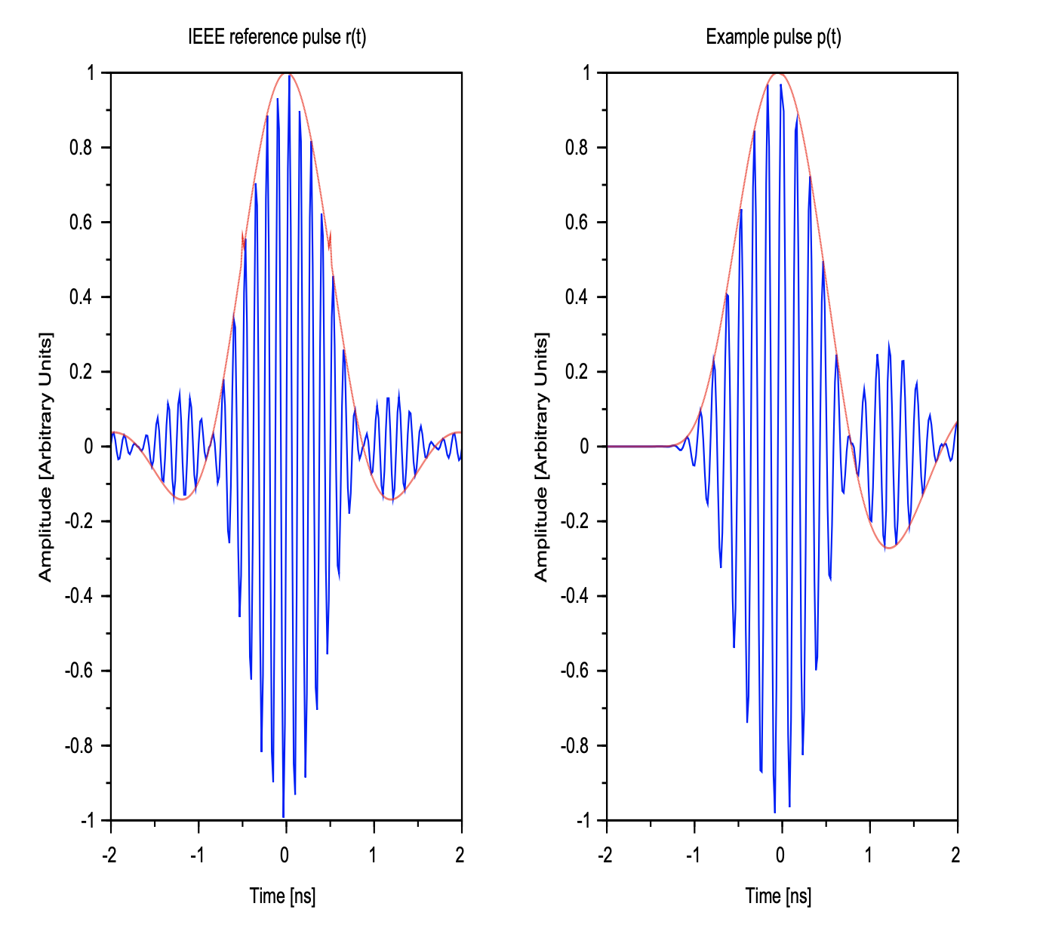

3.1.3 UWB channel characteristics
The ultimate performance limit of a communication system is determined by the channel in which it operates in, and a realistic channel model is essential in order to effectively predict performance. Channel models are typically developed by combining practical measurements in relevant environments and simulation.
Commercial UWB systems are intended to be used in residential, office or industrial indoor areas where signal reflection and diffraction play a significant role. The signal received by an antenna is the sum of the attenuated, delayed and possibly overlapping versions of the transmitted signal and may vary over time (due to movement of either the receiver or transmitter, or a change in environment). These different versions of the transmitted signal are typically referred to as multipath components (MPCs).
The large bandwidth of UWB systems ensures a high level of resilience to frequency-selective fading, a multipath effect that limits performance of narrow-band technologies. Furthermore, many of the multipath components are resolvable due to the short pulse durations and high bandwidth involved.
For the design of a receiver, it is important to understand the number of MPCs that are necessary to capture a certain amount of energy. In previously mentioned environments this can be a challenge, especially in Non-Line-of-Sight (NLOS) scenarios where the 100 strongest MPCs may carry as little as 30% of the total energy.
Furthermore, for ranging applications it is essential to identify the first path, as it is most representative of the distance between transmitter and receiver. In NLOS scenarios especially, this may not be the strongest of the MPCs [Moli09] as illustrated in Figure 3, which represents an additional challenge for the receiver.
Figure 3
Simplified example of multipath components in LOS and NLOS scenario
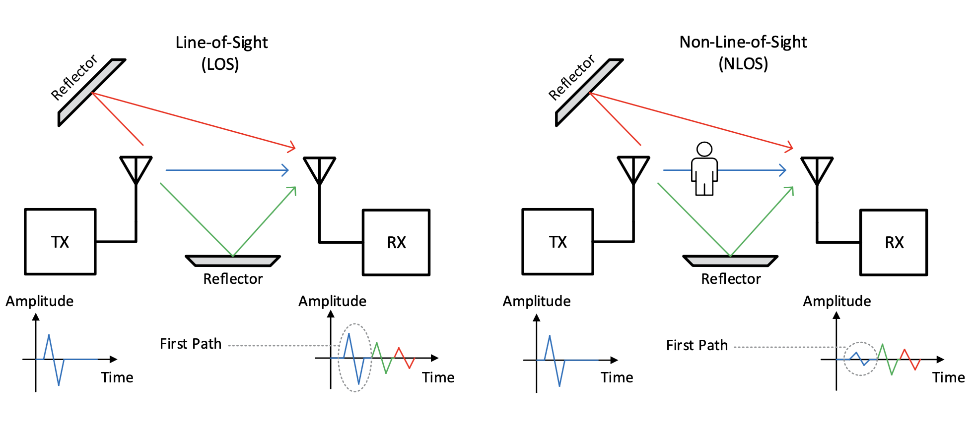

3.2 Impulse radio UWB ranging

3.2.1 UWB ranging basics
Taking into account these design considerations above, a standardised ranging protocol based on IEEE 802.15.4 was developed with the overall objective to ensure interoperability. The FiRa protocol includes a detection mechanism for UWB devices to detect each other’s presence. The ranging is done by performing Time-of-Flight (ToF) measurements (see Figure 4 between the devices. The ToF is calculated by measuring the roundtrip time of challenge/response packets. Depending on the type of application (e.g. in case of asset tracking, device localization), either the mobile or the fixed UWB device calculates the precise location of the device. In the case where the device is running an indoor navigation service, it is required to know its relative location to the fixed UWB anchors and calculate its position on an area map.
Figure 4
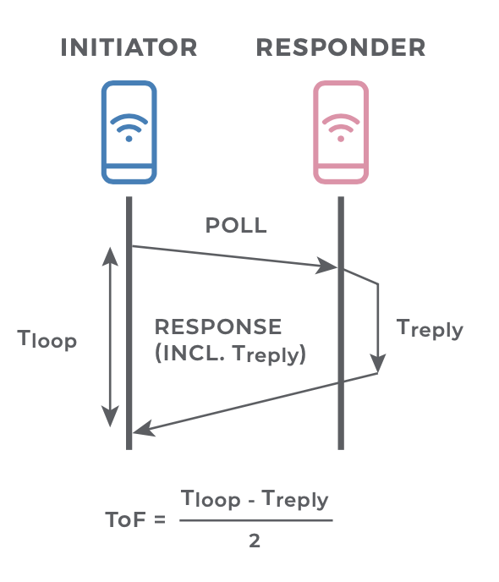

3.2.2 UWB-enabled devices determining motion and relative position
The real-time accuracy of UWB measurements means a UWB-enabled system can know, with a very high degree of certainty, the precise location of a device and whether it is stationary or moving toward or away from a given object. For example, a UWBenabled system can sense if a person is moving toward a locked door and it can know if the person is on the inside or outside of the doorway. This allows it to determine if the lock should remain closed or open when the person reaches a certain point.
The precise accuracy of UWB ranging allows a system to define the exact intended range to avoid false triggering. For example, if a person lives in a house with an attached garage, the UWB-enabled system can be configured to detect when a car approaches and open the garage door. Or that it is time to unlock the entryway from the garage to the kitchen so the person can bring in their groceries.¹⁴

3.2.3 Improved security through UWB usage
Today’s technologies for ranging primarily rely on signal strength to determine distance and location. They measure the device’s signal strength and assume a strong signal means the device is close by. Using what is called a relay station attack, attackers have found a way to trick these systems. In this type of attack, the legitimate wireless signals used to unlock a door are intercepted and amplified, causing the door to open even though the key is not close by.
What other technologies may lack is the precise calculation of actual physical distance; this is what UWB can provide. With UWB, any attempt to intercept and amplify the signal during a relay attack will only delay the arrival of the responding device’s acknowledgement signal, making it clear to the UWB-based lock that the responding device is actually further away, not closer. Any UWB signal which attackers succeed in intercepting and boosting will not trick a UWB-equipped lock into opening. Moreover, the extension of IEEE 802.15.4z adds physical layer (PHY) level protection to all known attacks on legacy UWB radios.¹⁴

3.3 Frequency modulated UWB
[Editor’s Note: To be further developed: applications for sensing]

4 Current examples of UWB applications

4.1 Introduction
This section describes examples of current UWB applications. With broad availability of UWB capabilities in smartphones from multiple manufacturers and ecosystems of compatible products on the market, consumer-facing implementations of UWB technologies are commonplace.
[Editor’s Note: Additional text needed]

4.2 Industrial and commercial real time location services (RTLS) applications

4.2.1 Description
UWB has long been deployed within a number of Real Time Location Services (RTLS) applications. RTLS deployments can precisely track assets and personnel, enabling enterprises to save billions of dollars in terms of enhanced operational efficiencies, increased worker safety and compliance, and loss prevention. In most deployments, enterprises can take advantage of multiple use cases to compound ROI and other benefits.
For example, within healthcare environments, RTLS solutions can track available beds to understand and maximize utilization, trace valuable equipment to prevent theft or losses, monitor staff for hygiene compliance purposes, track patients and staff location for safety purposes, and ensure that personnel are able to access necessary areas and equipment at all times.
UWB technology has witnessed considerable RTLS deployment growth in recent years. Various assets have UWB tags attached to them. These tags communicate with anchors deployed around the factory, warehouse, or healthcare environment, allowing items to be precisely located in real-time. UWB’s ability to deliver centimeter level location accuracy, ultra-low latency, and robustness in harsh environments gives it significant advantage over alternative technologies. This has enabled it to build success in many commercial environments for some of the more stringent asset and vehicle tracking applications. These applications include vehicle navigation and collision detection, high-value tool and equipment tracking, and worker safety applications.
[Editor’s Note: consider additional text about standardised omlox use]
Figure: …
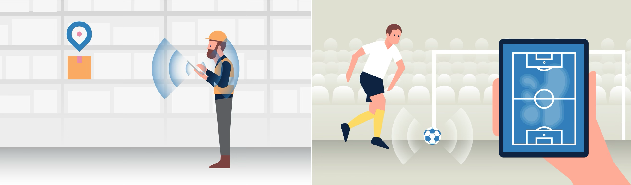

4.2.2 Operational and technical characteristics
[Editor’s Note: More discussion needed on the table. Check, that there are no new elements here/consistency with above text UWB has varying PSD levels, needs to be clearer. Is this report requesting changes?]
[
TABLE XX
Operational and technical characteristics of Location Tracking: Industrial and commercial applications
Operational characteristics | Technical characteristics/Density and activity factor
– Deployed in specific locations, mostly in industrial and commercial installations. Use could be either indoors or outdoors.  – Mostly professional users.  – Typically consists of fixed infrastructure “anchor” sending periodic signals to mobile tags like downlink TDOA (Time Difference Of Arrival) or conversely, fixed infrastructure “anchor” receiving periodic signals from mobile tags.  – Communication with a limited amount of data is performed to extract the time-of-flight or time-of-arrival information. Further communication may be included to control the ranging exchanges and share timestamp information.  – Legacy proprietary systems are increasingly being replaced by IEEE 802.15.4 compliant systems.  – Devices transmit when communicating with an associated receiver, i.e., continuous transmission requires the transmitter to receive periodic acknowledgments. | – Typical power spectral density up to −41.3 dBm/MHz (-31.3 dBm/MHz in some cases)  – Typical 3-dB bandwidth of 500 MHz, 10-dB bandwidth below 650 MHz  – Usually operating between 3,1 GHz to 4,8 GHz or 6 GHz to 9 GHz  – Low duty cycle transmissions. Typical packet durations in the order of 150-300 microseconds transmitted at 0.1-10 Hz  – Depending on the environment often active 24 hours/day or at least during working hours.  – Taking into account the overhead, the resulting device time factor is typically well below 1%.  – Density in specific locations (indoor or outdoor), density of transmitting nodes in a location limited by airtime availability and propagation loss. Higher density mobile tag deployments are envisaged for downlink TDOA so as not to saturate the UWB channel.
]

4.3 Access control applications

4.3.1 Description
Access control applications are applications to ensure that an authorized key device is securely detected to be present very close to a gate so that access to critical facilities can be provided only to persons carrying such authorized devices when they are close to the gate.
Two types of access control applications are described below: Vehicular access control and general purpose access control.

4.3.2 Vehicular access control applications
In the automotive industry, adoption of UWB for key fobs surpassed 20% of new vehicles in 2024. To support smartphone integration, the Connected Car Consortium (CCC) Digital Key standard includes UWB with a combination of radio technologies to support remote locking and unlocking, as well as remote start.
Digital Key® is the most widely used vehicular access system which is specified by the CCC. It standardizes how a vehicle can be automatically unlocked as the driver approaches. To prevent illegal access to the vehicle the identity and proximity of the user must be verified. The Digital Key standard calculates the distance to the driver using UWB to ensure that the user is within a few meters of the car. By including a secure distance measurement, the unlock procedure is much more secure and can occur without the user removing their smartphone from their pocket. The reverse would also be true as the person exits the vehicle; the vehicle would automatically lock. The same procedure is also used to secure engine start. Secure distance measurement eliminates the so-called relay attack on passive entry cars.
The distance measurement is carried out as described in section 4.2 using Time of Flight (ToF). In Digital Key, two-way ranging is a one-to-many protocol, meaning the transceiver in the UWB enabled smartphone or keyfob transmits a signal which is received by many receivers referred to as UWB anchors. During the reply portion of the protocol, each of the UWB anchors on the vehicle will take turns in replying. As a final step, the smartphone transmits back the time the secure timestamp sequence (STS) arrived from each sensor on the vehicle. The UWB sensor in the vehicle can then calculate that exact distance to the smartphone. Ultimately the more sensors in and around the vehicle, the more accurate the location measurement.
In addition, signals consisting of many short pulses are used and the sequence of the pulses are chosen to maximize the ability to discern reflections. For added security AES generated sequences are also used – allowing only those with the shared key material to even detect the modulated pulses themselves. These Scrambled Time Stamps (STS) are a unique cornerstone of the PHY level security offered by the UWB technology.
It is possible to determine the arrival time of signals in a UWB receiver using the standard method AND/OR a stealth method whereby the security of the system is extremely high. There is no other widely available technology which provides this level of security for a radio interface.
With secure signal transmission and high accuracy clocks the system can measure the distance between the mobile device hosting the Digital Key and the car to within 5 cm.
[Editor’s Note: add Picture Vehicle Access]
This has other benefits as well. As the user approaches the vehicle, the distance to the user could be divided into zones. When the user is beyond the zones, nothing will happen. As they approach zone 3 (see figure below), the vehicle flashers could blink. As they approach zone 2, the welcome lights could turn on. Finally, as they approach zone 1, the vehicle would unlock and could configure advanced features such as start the vehicle, set climate controls to the driver’s desired settings, set infotainment preferences such as music/podcasts and other type of comfort control features.
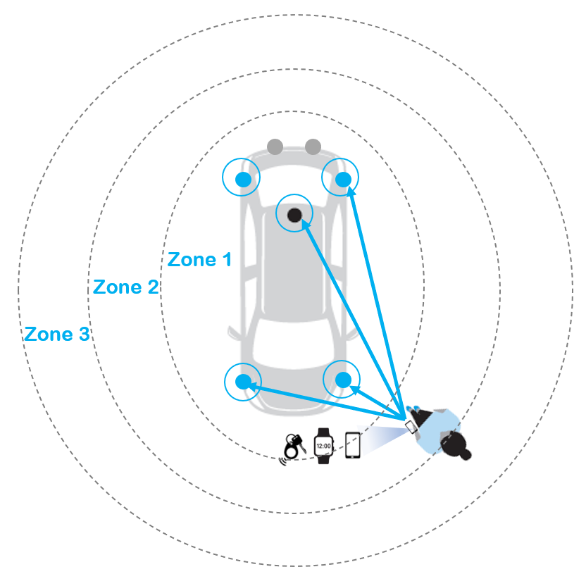
The distance bounding of mobile devices to cars is a very important part of the complete eco-system but there are many more capabilities which make up the Digital Key. Leveraging the authentication of the user and the connectivity of the mobile phone, the security of Secure Elements (SE) facilitates the complete user experience of the DIGITAL Key allowing e.g. easy sharing of Digital Keys with family and friends, for fleet applications, for valet parking and for E-charging.
Including the technology in vehicles has also opened up other possible features, including using UWB sensing to detect passengers and pets in the rear seats. (See section XX)

4.3.3 General purpose access control
The use of UWB for digital car keys in the automotive space (as specified by the CCC) can also be extended to the use of UWB for residential and/or commercial access control. Building upon their experience with UWB-enabled access systems in the commercial sector, manufacturers of residential door locks and security systems are incorporating UWB into their smart home products. While several manufacturers have released proprietary implementations of UWB, the Connectivity Standards Alliance is including a standardized implementation in the Aliro specification.
Embedding UWB within door locks and access control readers has the potential to improve security, enable better user experiences, and provide innovative advanced provisioning capabilities. Much like in the automotive realm, end-user devices such as smartphones, wearables, key fobs, or badges can be UWB-enabled to act as digital keys.
A typical deployment scenario will involve a Bluetooth Low Energy and UWB enabled reader and smartphone. Initially the devices communicate via Bluetooth Low Energy for wake up, initialization and authentication, then hand over to UWB for secure ranging to measure distance and Angle-of Arrival (AoA), and then trigger the unlock sequence as defined by a predetermined distance.
There are several advantages of leveraging UWB for access control:
– UWB offers protection from relay station attacks which makes it well suited to secure access applications versus alternative wireless technologies.
– UWB can also detect if the user is inside or outside the building, as well as if they are walking to or from an entrance or exit.
– This ensures that the door is only opened when needed and prevents unauthorized access.
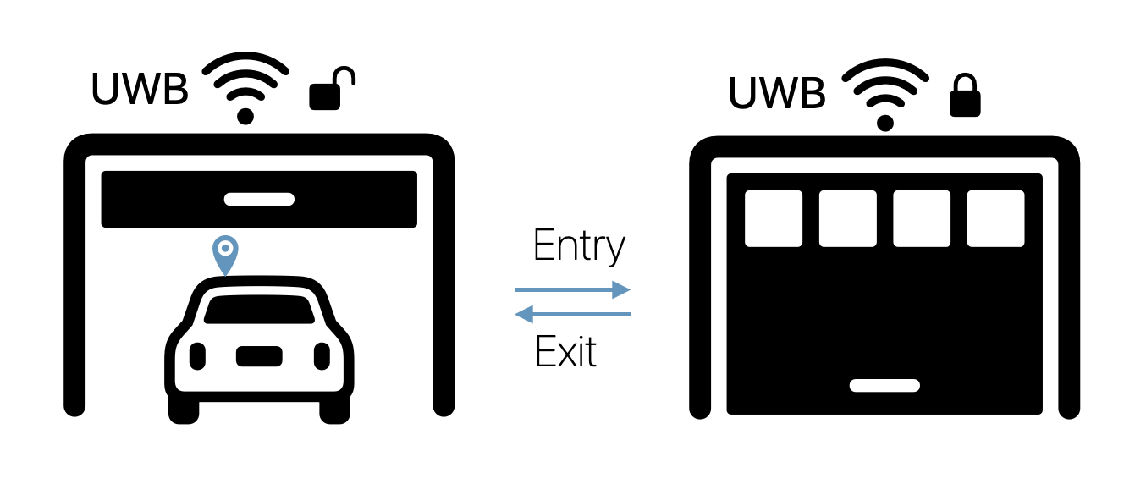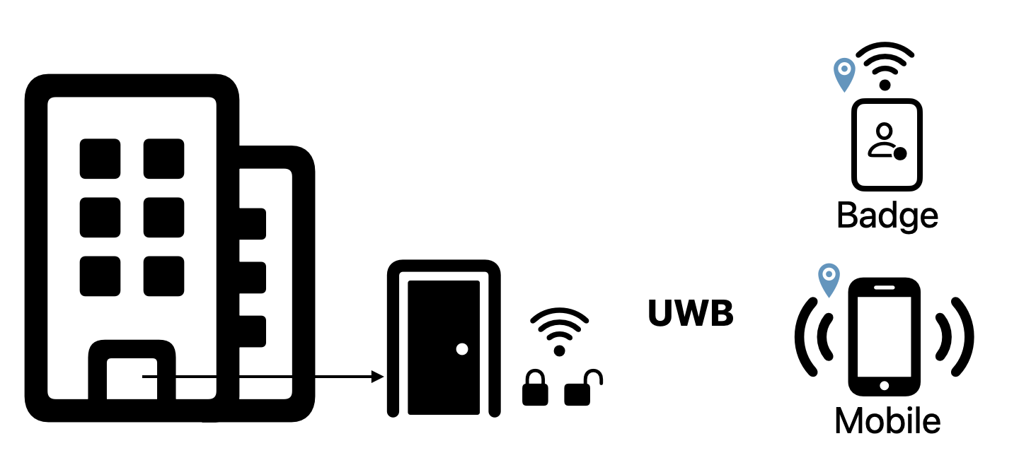
As UWB can track the user’s exact location in relation to the entrance or exit, this removes the need to perform an action such as entering a code, using a fingerprint or facial recognition system, tapping a key fob on a reader, or using a key. It also alleviates potential privacy concerns with alternative methods of authentication, reduces the time it takes to perform the task, and improves the user experience.

4.3.4 Operational and technical characteristics
[Editor’s Note: More discussion needed on the table. Check, that there are no new elements here/consistency with above text]
[

TABLE XX
Operational and technical characteristics of access control
Operational characteristics | Technical characteristics/Density and activity factor
– UWB is used to verify physical presence or proximity, e.g. to prevent relay attacks.  – Mass market use. Initial deployments in vehicular access control, mobile phones and residential access.  – Mix of mobile use cases (vehicular, mobile phones) and fixed installations (residential access control). Majority outdoor use.  – Communication with a limited amount of data is performed to extract the time-of-flight information. Further communication may be included to control the ranging exchanges and share timestamp information.  – Occasional use at infrequent intervals. UWB communication often triggered by other (wireless) technologies.  – IEEE 802.15.4 compliant systems ensure interoperability | – Power spectral density up to −41.3 dBm/MHz  – Typical 3-dB bandwidth of 500 MHz, 10-dB bandwidth below 650 MHz  – Operating between 6 GHz to 9 GHz  – Low duty cycle transmissions. Typical packet durations in the order of 150-300 microseconds.  – Extremely low activity factors, also due to reliance on external trigger mechanisms. Active a few seconds at most, usually only a few times a day  – The resulting device time factor is therefore well below 0.005%  – Density: currently limited to approximately 0.2 device per person. Future density may grow up to 2 devices per person.
]

4.4 Consumer device tracking / High precision asset tracking

4.4.1 Description
The most widespread adoption of UWB to date has been in asset trackers. While previous generations of asset tracking “tags” have used other technologies such as Bluetooth LE to provide users with a general location of an item, the addition of UWB provides accurate direction and distance information. UWB-capable tags come in multiple form factors and accessories allow attachment to virtually any item, including keys, wallets, handbags, backpacks and luggage. UWB chips are also being incorporated into electronic devices in addition to phones, such as tablets, headphones, chargers and battery banks.
solutions are available which contains UWB, Bluetooth Low Energy and NFC technology.
However, for those devices equipped with UWB, users can more accurately locate their lost items through “Precision Finding”, which will guide them to their tag using sound, haptics, and visual feedback. Lost tags can be tapped by an NFC-enabled device to bring up contact details of the tag owner.
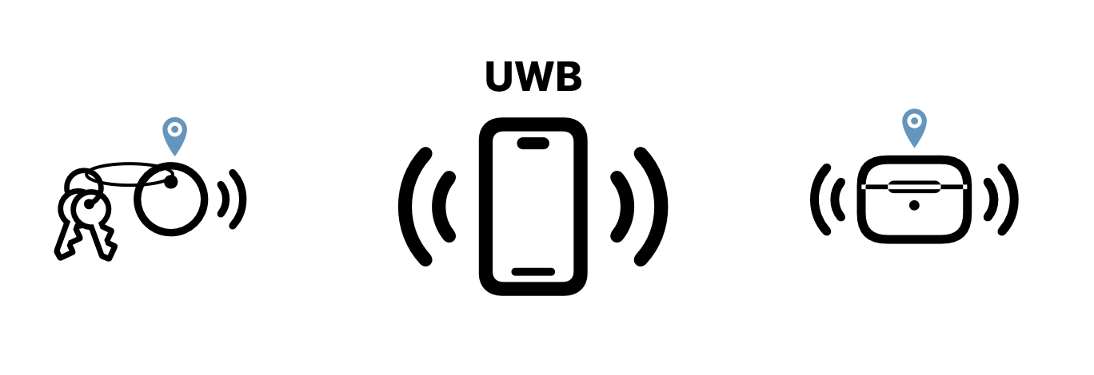
Also, Augmented Reality (AR) Finding has also been introduced by some smartphone makers. Users are visually guided to their lost device using their smartphone’s camera, making it much easier to precisely locate their items, improving the finding experience for end users. Users can tag items as missing and other smartphone owners can help to locate lost items as part of a crowdsourced network. This could also help to create new services for mobile operators and insurance companies, leading to new business models and additional value for end users.

4.5 Personal tracking: UWB in The Smart Home

4.5.1 Description
The vision of a fully automated, truly intelligent, highly personalized, and interconnected smart home has not yet been fully realized. A large part of this has been due to the absence of highly accurate indoor location technologies that are capable of enabling the smart home platform to determine precisely who and where someone is, as well as their intention. The next wave of the smart home’s evolution will come from the combination of seamless connectivity and interoperability between devices, alongside the precise localization of people and objects within the home. Thanks to its ability to precisely pinpoint the distance and direction between different UWB enabled products within the home environment, UWB has the potential to enable this seamless, automated, and personalized experience within the home. This will allow for better end-user interaction experiences as well as more intelligent automated homes that rely less on manual interaction and can adapt in real time to the specific needs for end-users. There are two major ways in which UWB can help to achieve this: (1) point-and-trigger control; and (2) presence detection and follow-me.¹⁹

4.5.2 Point-and-trigger control
As the name suggests, point-and-trigger applications involve pointing a UWB-enabled smartphone towards other UWB-enabled connected home devices such as speakers, televisions, light bulbs, thermostats, or other appliances. Based on UWB’s high accuracy and directional capabilities, the smartphone can detect exactly what device it is being pointed at, and automatically open a relevant control panel on the smartphone display. This can then be utilized to turn a television on or off, select the color and brightness of a smart light bulb, change the radio station or song, adjust the volume on a speaker, turn up the thermostat, or seamlessly cast video and audio to a television or speaker. In addition to control panels, smartphones could also pull up additional contextual information, such as song lyrics, further recommendations, and other new ways of engagement.
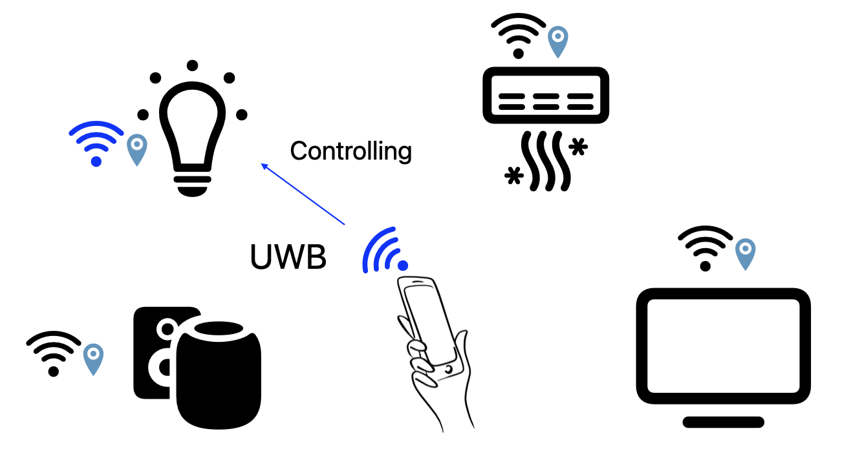
While voice control is optimal for more simple tasks that are easy to describe (e.g. playing a specific song on a speaker), for certain home automation and control tasks, describing what is required can be a lot more cumbersome. For example, selecting a specific light bulb in a room and changing it to the correct color and brightness is much easier to control via a dedicated app and touchscreen control than voice.
However, the process for this control today is not seamless. Users have to unlock their smartphone, open up the correct app, select the correct device and manually adjust the settings. With UWB, this problem can be alleviated, providing a much more desirable one-tap user experience.
Xiaomi recently demonstrated UWB being leveraged within a variety of smart home devices such as fans, lamps, and smart speakers. This demonstration highlights the growing potential of the UWB-enabled smart home ecosystem. Similarly, UWB has already be incorporated in smart speakers. It now allows streamlined handoff of content such as music, calls, and podcasts with smartphones. By leveraging UWB, the device is able to add visual and haptic feedback and provide listening suggestions when the smartphone is in close proximity to the speaker. It can also display controls on the device without needing to unlock it.

4.5.3 Presence detection and follow-me
By embedding UWB within smart home devices, they can respond to specific user movements automatically. Examples of this include turning on a light, playing a preferred playlist, or adjusting to the preferred temperature when a user enters or leaves a room, and can follow them from room to room. Personal profiles could be set up for homes with multiple occupants, enabling certain smart home devices to adjust to their own unique preferences.
UWB can determine that the end user is within a specific room, or even in a more specific location, enabling more contextual interaction. For example, when a user is sitting on the sofa, the television could automatically switch on and return to what the user was previously watching or dim the lights to the preferred settings. UWB embedded within a notebook PC could detect when the user is sitting at the desk and securely lock or unlock the device as required, preventing any intrusion.
As highlighted earlier, many smart home and building security vendors are members of the FiRa Consortium and have promoted the potential of UWB for secure hands-free access control within both residential and commercial environments. The low latency of UWB ensures a seamless and immediate experience. Users will not be frustrated while waiting for the lights to turn on or pointing to a device that takes a long time to open the correct control panel.²⁰
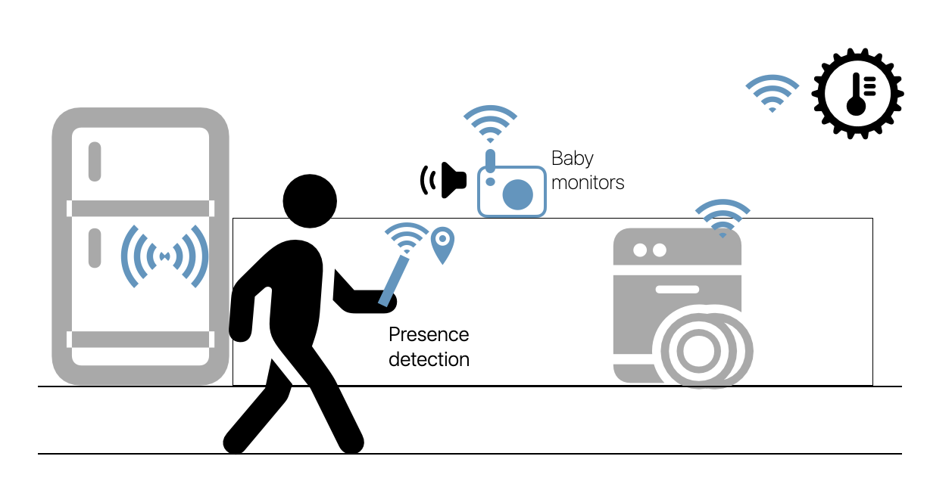
–
[Editor’s Note: Operational and technical characteristics ?]

4.6 UWB Sensing and material investigation

4.6.1 General
[Editor’s Note: Reminder Radar/Sensing Terminology]
These devices are focused to detect the behaviour of a target within a focus area. With the possible huge bandwidth such devices are able to separate between target, have a good range resolution and in addition, based on the spectral reflection an object classification (kind, speed,..) is possible.
Such applications are commonly referred to as presence detection, gesture detection and movement control.
Radar-like UWB is also used in combination with tracking applications. This allows more flexibility for the use case, e.g. hands-free door opening, monitoring of fallen people or implant communication and body area networks. The benefit for UWB is that communication/tracking and sensing could be realized under the same regulation, within the same frequency range and with the same hardware.
The huge bandwidth and the adjustment possibility for the best PHY frequency range allow UWB material investigation applications to separate nested objects or to determine the material behaviour.
The Use of such applications are widespread. We can find UWB sensing applications in the medical domain e.g. for hearth/breath monitoring/measurement or tumor detection (see 6.5.2). In the building sector we can find it for ground and wall scanning (object detection) or humidity measurement (see clause 6.5.5). In the Industrial sector we can find UWB for material mix determination (% of one material within another one) or material behaviour (humidity, speed, …)(see clause 6.5.5).
But not only in these sectors the possibility of material investigation is used in farming (humidity, material classification...) within vehicles (driver monitoring) (see clause 6.5.4) and many more.

4.6.2 Medical imaging
[Editor’s Note: More description needed]
[Editor’s Note: More discussion needed on the table. Check, that there are no new elements here/consistency with above text]
[
TABLE XX
Operational and technical characteristics of medical imaging
Operational characteristics | Technical characteristics/Density and activity factor
– Mostly occasional use by professionals in limited numbers  – Use is limited to specific locations  – May be used for a variety of health applications for imaging inside the body of a person or an animal  – Indoor stationary occasional use by trained personnel  – Transmission is directed towards a body | – Power spectral density up to −41.3 dBm/MHz  – Typical bandwidth between 1 and 5 GHz  – Usually operating between 2 GHz to 7 GHz  – Varying duty cycles, typically 10% up to a maximum of 40%  – Depending on the application, varying from sporadic use to up to 8 hours/day.  – Taking into account the overhead, the resulting device time factor is typically well below 1% but could increase up to 3%.  – Density: Concentrated in medical facilities.

]

4.6.3 Surveillance and presence detection
[Editor’s Note: More description needed]
[Editor’s Note: More discussion needed on the table. Check, that there are no new elements here/consistency with above text]
[
TABLE XX
Operational and technical characteristics of surveillance and presence detection
Operational characteristics | Technical characteristics/Density and activity factor
– Operate as “security fences” by establishing a stationary RF perimeter field and detecting the intrusion of persons or objects in that field  – Outdoor and indoor use in a stationary manner | – Power spectral density up to −41.3 dBm/MHz  – Bandwidth between 1 and 2.5 GHz  – Usually operating between 6 and 9 GHz  – Duty cycle up to 2% on average and 10% in maximum (during detection event)  – Usually active typically 12 hours per day and up to 24 hours per day  – Resulting device time factor of 2%  – Density: maximum 1 out of 10 buildings have 2 devices
– Indoor use | – Typical BW > 500 MHz necessary  – Power spectral density up to −41.3 dBm/MHz  – Bandwidth between 0.5 and 3 GHz  – Usually operating between 6 and 9 GHz  – Duty cycle up to typically 1%  – Density: maximum 1 out of 10 buildings have 5 devices
]

4.6.4 In vehicular radar/sensing
[Editor’s Note: More description needed]
[Editor’s Note: More discussion needed on the table. Check, that there are no new elements here/consistency with above text]
[
TABLE XX
Operational and technical characteristics of in vehicular radar
Operational characteristics | Technical characteristics/Density and activity factor
– Mobile usage  – In-cabin use for child presence, seat occupancy, driver status | – Typical BW > 500 MHz necessary  – Power spectral density up to −41.3 dBm/MHz  – Bandwidth between 0.5 and 3 GHz  – Usually operating between 6 and 9 GHz  – Duty cycle up to typically 1%  – Average usage of a personal car: 2 hour per day  – Resulting device time factor of 8%  – Density: 2 devices per personal car. With a maximum of 100 cars/km² (urban) and peak average 300 cars/km²
]

4.6.5 Material Investigation
[Editor’s Note: More description needed]
[Editor’s Note: More discussion needed on the table. Check, that there are no new elements here/consistency with above text]
[
TABLE XX
Operational and technical characteristics of material investigation
Operational characteristics | Technical characteristics/Density and activity factor
– Stationary indoor/outdoor use  – Object determination and classification | – Bandwidth: up to 5 GHz bandwidth  – Location precision/accuracy: ≤ 10 mm  – Spectrum band: 2 GHz to 10.6 GHz, for some application lower frequency components might be required  – Maximum Duty Cycle: ≤ 20% per minute in operational bandwidth  – Typical duty cycle: ≤ 2% in operational bandwidth  – Maximum mean e.i.r.p. spectral density: −41,3 dBm/MHz  – Activity factor AF: between 1 and 8 h per day, 2%  – Resulting device maximum time factor of 0,666%  – Densities: 5/50/500 devices per km² (rural/suburban/urban)
]

4.7 Low latency communication / Consumer Electronics
Some companies are using UWB as an alternative to Bluetooth for high-fidelity audio, with several headphone and UWB hub products announced since 2024.
[Editor’s Note: More description needed]
[Editor’s Note: More discussion needed on the table. Check, that there are no new elements here/consistency with above text]
[
TABLE XX
Operational and technical characteristics of low latency communication
Operational characteristics | Technical characteristics/Density and activity factor
– UWB is used for communications in highly reflective environments and applications where low latency is critical. It offers moderate data rates at low power  – High multipath resistance matters in certain industrial and professional environments  – Indoor use only  – Low latency is valued in professional audio applications. It is also being considered for certain consumer applications like gaming, AR/VR and home theatre. Majority of the use is indoors and restricted to specific locations  – Mixture of proprietary and IEEE 802.15.4 systems | – Power spectral density up to −41.3 dBm/MHz  – Typical bandwidth of 500 MHz or more  – Usually operating between 3,1 GHz to 4,8 GHz or 6 GHz to 9 GHz  – Latency typically 2 ms or better  – Typical duty cycle 15%, maximum duty cycle of 30%, indoor only.  – Typically used for 2 hours per day or less, resulting in an overall device time factor of 0,0833%  – Density: for gaming: 1 hours per day. One per 4 personal residence. For home theater: 1 hours per day: 1 per 6 personal residence
]

5 Technical and regulatory considerations
Regulations written in the early 2000’s did not anticipate how UWB technology would eventually evolve. Much of the initial concern of incumbents was focused on high-data-rate communications being delivered by networks of continuously operating UWB transmitters, especially outdoors. Further, the wide individual channel bandwidth and very broad range of spectrum potentially used by UWB devices included many different incumbent operations using a range of different wireless technologies. As a result, national regulatory authorities (NRA’s) drafted conservative rules to limit power and location to protect against unknown risk. As the UWB market has developed, however, some of these early assumptions may need to be reassessed at the national level by NRA’s to reflect experience and current applications of the technology.

5.1 Opportunistic and user-initiated transmission
One key mitigation that reduces risk of interference to incumbents is reducing overall duty cycle. All of the consumer use cases described in Section 6 are characterized by limited transmission durations over short distances that are controlled by a user or use an alternate radio technology to enable the UWB connection. This is particularly important for portable devices such as smartphones, key fobs and small UWB tags, where battery life is a key development constraint. Even the UWB audio use case has a low duty cycle, since the data bandwidth is so large relative to the payload.

5.2 Channel utilization
Another mitigation is the relatively limited number of channels used by most UWB implementations. Of the fifteen channels specified for High Data Rate operation in IEEE 802.15.4 and shown in Figure 1, only two (Channels 5 and 9) are used for most consumer applications.
FIGURE 1
UWB channels in IEEE 802.15.4
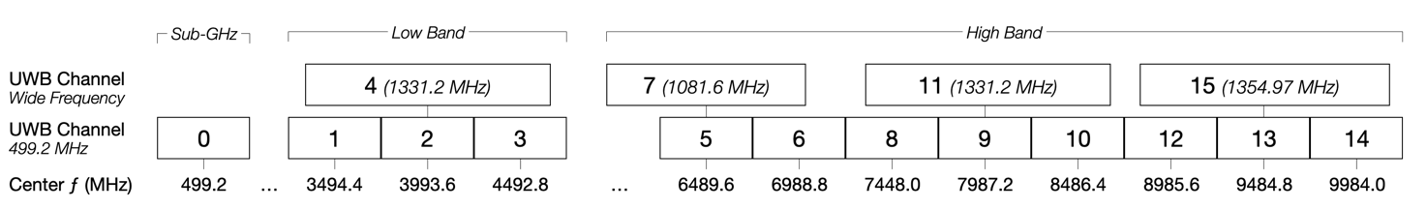
This focus on two specific channels is due to a combination of regulatory and technical factors. First, not all channels are available for use in every regulatory domain and the consumer UWB market is global. Second, while UWB can be quite resistant to interference it operates better in bands where there are fewer high-power operations. This led chipmakers to focus on developing products for Channel 5 and Channel 9, where incumbent operations include fixed service, PMSE, satellite and radar systems that are best suited to coexist with the relatively low-power and intermittent consumer UWB use cases.
It is important to note, however, that many industrial and commercial UWB products use the other available UWB channels depending on the suitability of specific frequencies for different applications. Further, some UWB applications utilize bandwidths wider than 500 MHz within the 3.1-10.6 GHz frequency range.

6 Summary
UWB is a maturing technology with use cases and operating parameters very different than what was envisioned when the technology was in its infancy. In particular, the rise of smartphone-enabled consumer use cases has driven growth in adoption while the operational characteristics of these applications may serve to mitigate some of the risks originally anticipated by incumbents and NRA’s.

See FiRa Whitepaper on Unleashing the Potential of UWB: Regulatory Considerations.
See Hans-Juergen Pirch, Frank Leong, FiRa Whitepaper on Introduction to Impulse Radio UWB Seamless Access Systems.
IEEE 802.15.4-2015: “IEEE Standard for Low-Rate Wireless Networks”, IEEE, 2015.
See A.F. Molisch: “Wireless Communications”, New York, IEEE Press/Wiley, 2005.
See Andreas F. Molisch, Dajana Cassioli, Chia-Chin Chong, Shahriar Emami, Andrew Fort, Balakrishnan Kannan, Johan Karedal, Juergen Kunisch, Hans Gregory Schantz, Kazimierz Siwiak, and Moe Z. Win: “A Comprehensive Standardized Model for Ultrawideband Propagation Channels”, IEEE Transactions on Antennas and Propagation, 2006.
See Johan Karedal, Shurjeel Wyne, Peter Almers, Fredrik Tufvesson, Andreas F. Molisch: “A Measurement-Based Statistical Model for Industrial Ultra-Wideband Channels”, IEEE Transactions on Wireless Communications, 2007.
See M. Z. Win and R.A. Scholtz: “Impulse Radio: How it works”, IEEE Commun. Lett. Vol.2, 1993.
See A.F. Molisch: “Ultra-Wide-Band Propagation Channels”, Proceedings of the IEEE Vol.97 No.2, 2009.
Johan Karedal, Shurjeel Wyne, Peter Almers, Fredrik Tufvesson, Andreas F. Molisch: “A Measurement-Based Statistical Model for Industrial Ultra-Wideband Channels”, IEEE Transactions on Wireless Communications, 2007.
See Hans-Juergen Pirch, Frank Leong, FiRa Whitepaper on Introduction to Impulse Radio UWB Seamless Access Systems.
https://www.firaconsortium.org/about.
See FiRa Whitepaper on Unleashing the Potential of UWB: Regulatory Considerations.
See FiRa Whitepaper on Unleashing the Potential of UWB: Regulatory Considerations.
https://www.autosinnovate.org/resources/papers-reports/Ultra-Wideband%20%28UWB%29%20Technology.pdf.
https://carconnectivity.org/wp-content/uploads/2022/11/CCC_Digital_Key_Whitepaper_Approved.pdf.
https://csa-iot.org/all-solutions/aliro/.
See FiRa Whitepaper on Unleashing the Potential of UWB: Regulatory Considerations.
See FiRa Whitepaper on Unleashing the Potential of UWB: Regulatory Considerations.
See FiRa Whitepaper on Unleashing the Potential of UWB: Regulatory Considerations.

