U.S. Radiocommunication Sector
Fact Sheet
Working Party: ITU-R WP-5B | Document No: USWP5B-37-18
Ref: WRC-27 Agenda Item 1.8/Res. 663 (WRC-23), 5B 435/Chapter 1 Annex 1.1 | Date: 17 Aug 2026
Document Title: [WORKING DOCUMENT TOWARDS A] PRELIMINARY DRAFT NEW REPORT ITU-R M.[RLS_231.5-700GHZ]/SUPPORTING MATERIAL FOR WRC-27 AGENDA ITEM 1.8
Author(s)/Contributors(s):
Ryan McDonough (NASA)  Joseph Cramer (NASA) | Ryan.S.McDonough@nasa.gov  joseph.s.cramer@nasa.gov
Purpose/Objective: To continue development for compatibility and sharing studies performed under WRC-27 Agenda Item 1.8 in accordance with Resolution 663 (WRC-23).

Abstract: Pursuant to Resolution 663 (Rev.WRC-23), Working Party (WP) 5B is the responsible group for WRC-27 Agenda Item 1.8 request to consider possible additional spectrum allocations to the radiolocation service on a primary basis in the frequency range 231.5-275 GHz and possible new identifications for radiolocation service applications in frequency bands within the frequency range 275-700 GHz for millimetric and sub-millimetric wave imaging systems. This document will update sharing and compatibility studies and their associated results for section A7 (A7.4.1 STUDY A) on EESS (passive).
Fact Sheet Preparer: Ryan McDonough, NASA

Attachment: 1

Radiocommunication Study Groups | 
Source: Document 5B/TEMP/193 | Annex 1.1 to  Document 5B/526-E
Source: Document 5B/TEMP/193 | 22 June 2026
Source: Document 5B/TEMP/193 | English only

Annex 1.1 to Working Party 5B Chair’s Report
PRELIMINARY DRAFT NEW REPORT ITU-R M.[RLS_231.5-700GHZ]
Sharing and compatibility studies in support of possible allocation/identification for the radiolocation service in the frequency range 231.5-700 GHz

Annex 7

A7.4.1.1 STUDY A

A7.4.1.1.1 General Considerations
The study of sharing and compatibility of EESS (passive) sensors with regard to the proposed RLS radar systems is considered in several parts. This section covers general aspects and simulation methodology employed by A7.4. Section A7.4.1.1 describes reference Measurement Areas of Interest that the passive sensors and proposed radar system deployments for use in simulation studies. Section A7.4.2.1 covers scenarios involving frequency ranges below 275 GHz. This section includes allocated bands for EESS (passive) as well as Radio Regulations (RR) No. 5.340 adjacency aspects. Section A7.4.2.2 covers scenarios involving frequency ranges above 275 GHz. This section includes consideration of frequency bands identified for use by EESS (passive) under RR No. 5.565.
FIGURE A7.4.1.1.1-1
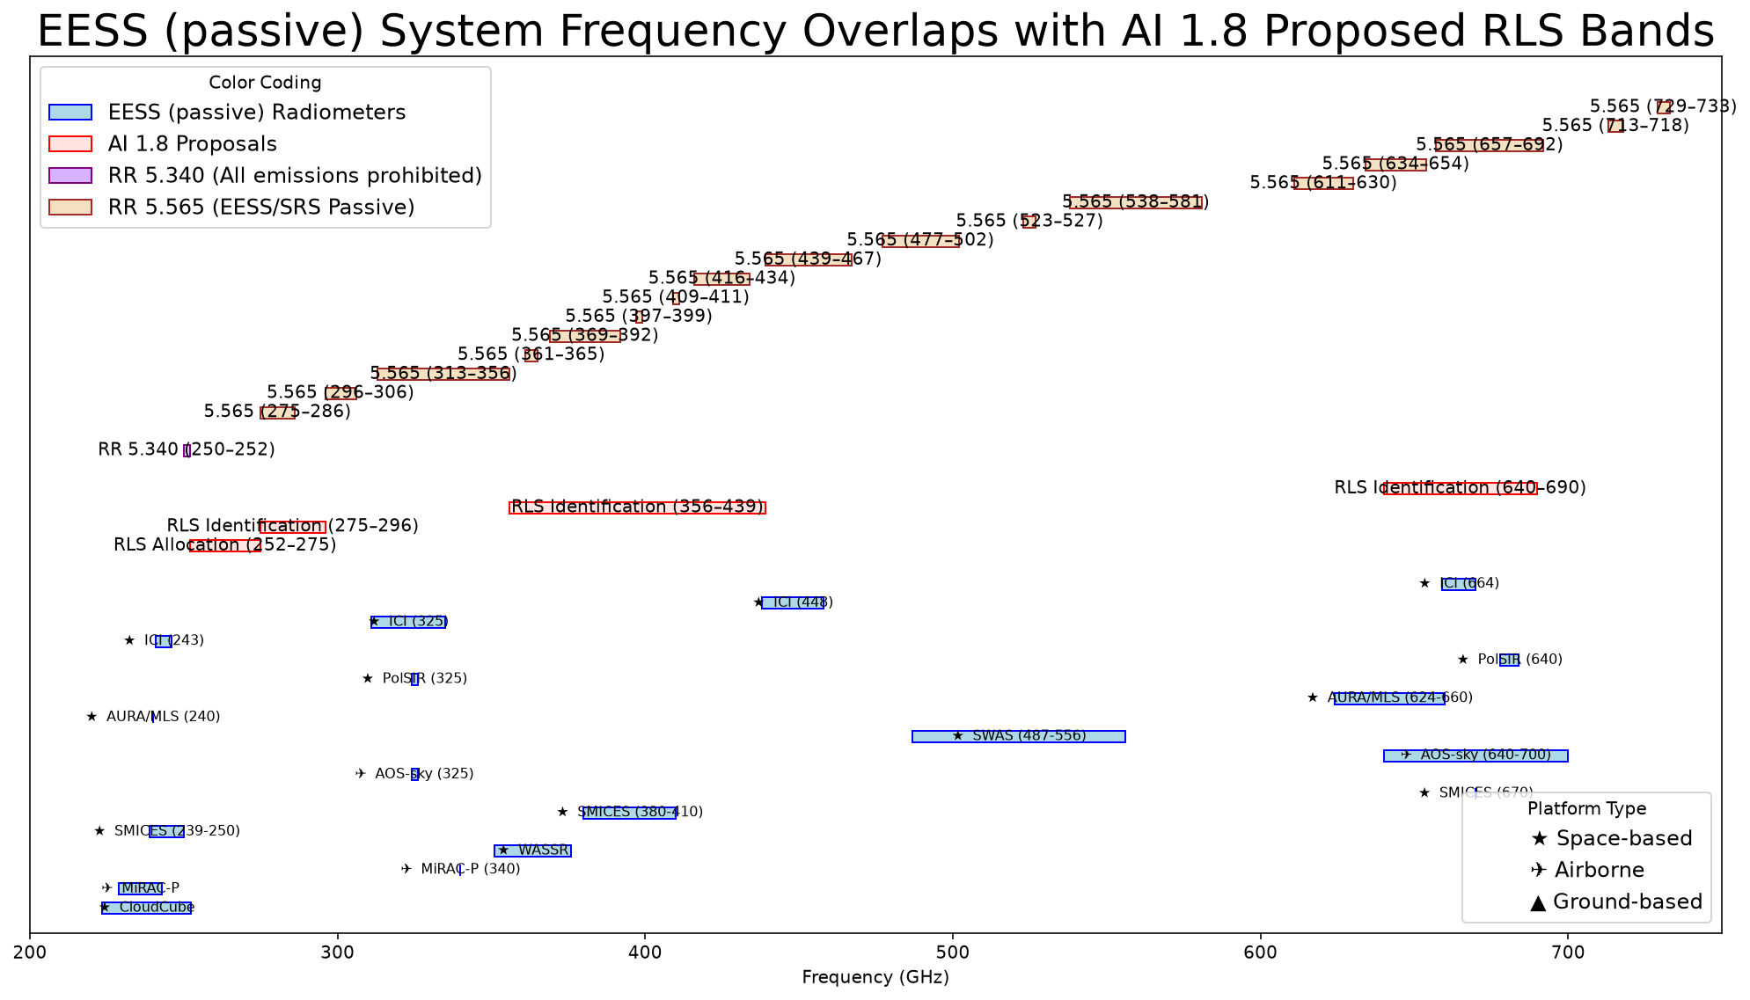

This chart shows the currently considered frequency ranges for CPM as part of the methods to satisfy WRC-27 AI 1.8 against select EESS (passive) systems and their corresponding typical operational linewidths in the 231.5-750 GHz range. Also shown are the frequency ranges under RR 5.340 and RR 5.565.

______________

