U.S. Radiocommunications Sector
Fact Sheet
Working Party: ITU-R WP 5B | Document No: USWP5B37-08 Second Draft
Ref: Annex 2.6 to Document 5B/526-E | Date: 8th September 2026
Document Title: DRAFT NEW RECOMMENDATION
ITU-R M.[AM(R)S_AMS(R)S_CHAR_5GHZ] - Characteristics and Protection Level of Terrestrial and Satellite Unmanned Aircraft System Control and Non-Payload Communications Links operating in the Aeronautical Mobile (R) Service and Aeronautical Mobile Satellite (R) Service in the band 5 030-5 091 MHz

Author(s)/Contributors(s):  Name: Don Nellis  Org: Federal Aviation Administration  Name: Michael Neale  Org: ACES Corporation for the FAA  Name: Jeff Hougland  Org: ACES Corporation for the FAA | Phone: (202) 267-9779  Email: Donald.Nellis@faa.gov  Phone: (858) 705-8978  Email: michael.neale@aces-inc.com  Phone : (410) 271-3255  Email : Jeff.Hougland@acescorp.net
Purpose/Objective: The purpose of this contribution is to update the terrestrial characteristics, based on a recent update to the RTCA MOPS DO-362A that standardizes and defines this terrestrial based CNPC Link. This contribution encapsulates the outcomes of the previous meeting and moves to elevate the preliminary draft new recommendation to a draft new recommendation.
Abstract: This contribution contains characteristics and protection criteria for terrestrial and satellite-based systems that can be used for remote control of unmanned aircraft. Changes from were made in response to the outcome of previous meetings including the removal of the references to the Japanese High-altitude relay.

Radiocommunication Study Groups | 
Source: Document/5B/526-E  Subject: New Recommendation ITU-R M.[AM(R)S_AMS(R)S_char_5GHz] | Document 5B/XXX
 | Nov 2026
 | English only
Annex 2.6 to Working Group 5B Chair’s Report
DRAFT NEW RECOMMENDATION
ITU-R M.[AM(R)S_AMS(R)S_CHAR_5GHZ]
Characteristics and protection level of terrestrial and satellite unmanned aircraft system control and non-payload communications links operating in the aeronautical mobile (route) service in the band 5 030-5 091 MHz and aeronautical mobile satellite (R) service in the band 5 000-5 150 MHz
Editor’s note: How protection is addressed in this recommendation is still to be discussed in next WP 5B meeting. See WG 5B-2 report.
Scope
This Recommendation specifies the characteristics of control and non-payload communications (CNPC) links, carrying command and control (C2) information, operating in the aeronautical mobile (R) service (AM(R)S) in the frequency band 5 030-5 091 MHz and aeronautical mobile-satellite (R) service (AMS(R)S) in the band 5 000-5 150 MHz in order to be used in analysing compatibility between unmanned aircraft systems (UAS) CNPC operating in the AM(R)S and AMS(R)S and other services.
Keywords
Unmanned aircraft systems
Abbreviations/Glossary
AM(R)S Aeronautical mobile (route) service
AMS(R)S Aeronautical mobile-satellite (route) service
ARRS Airborne radio relay system
ARS Airborne radio system
BGRS Beyond line-of-sight ground radio system
C2 Command and control
CNPC Control and non-payload communication
CRC Cyclic redundancy check
DVB-RCS Digital video broadcasting - return channel via satellite
FDMA Frequency division multiple access
GMSK Gaussian minimum shift keying
GRS Ground radio system
ICAO International Civil Aviation Organization
QPSK Quadrature phase shift keying
RPA Remotely piloted aircraft
RPAS Remotely piloted aircraft system
RR Radio Regulation
TCC Turbo code comparison
TDD Time division duplex
UA Unmanned aircraft
UACS Unmanned aircraft control station
UAS Unmanned aircraft system
Related ITU Reports
Reports
ITU-R M.2205 Results of studies of the AM(R)S allocation in the band 960-1 164 MHz and of the AMS(R)S allocation in the band 5 030-5 091 MHz to support control and non-payload communications links for unmanned aircraft systems
ITU-R M.2233 Examples of technical characteristics for unmanned aircraft control and non-payload communications links
ITU-R M.2236 Compatibility study to support the line of sight control and non-payload communication links for unmanned aircraft systems proposed in the frequency bands 5 000-5 010 and 5 010-5 030 MHz
ITU-R M.2171 Characteristics of unmanned aircraft systems and spectrum requirements to support their safe operation in non-segregated airspace
The ITU Radiocommunication Assembly,
considering
a) that standardization of operations of Remotely Piloted Aircraft System (RPAS) in non-segregated airspace is under purview of the ICAO for international operations;
b) that AM(R)S in the 5 030-5 091 MHz band and AMS(R)S in the 5 000-5 150 MHz band are allocated worldwide and can provide communications relating to safety and regularity of flights,
recognizing
a) that the frequency bands 5 030-5 091 MHz and 5 000-5 150 MHz are allocated respectively to the aeronautical mobile (route) service (AM(R)S) and the aeronautical mobile-satellite (route) service (AMS(R)S) which are planned to be used for unmanned aircraft (UA) control and non-payload communication (CNPC) command and control (C2) links to support the safe operation of UA, among other aeronautical safety-of-life and regularity of flight applications;
b) that the frequency band 5 000-5 150 MHz is also allocated to the aeronautical radionavigation service;
c) that some internationally standardized microwave landing systems operate in this band in accordance with Radio Regulations (RR) No. 5.444;
d) that from RR No. 5.444, in the frequency band 5 030-5 091 MHz, the requirements of microwave landing system have priority over other uses of this frequency band;
e) that use of the frequency band 5 030-5 091 MHz by the AM(R)S and 5 000-5 150 MHz by the AMS(R)S is limited to internationally standardized aeronautical systems in accordance respectively with RR No. 5.443C and RR No. 5.443D.
recommends
1 that the technical and operational characteristics of the UA CNPC links for C2 operating in the frequency band 5 030-5 091 MHz under AM(R)S and in the frequency band 5 000-5 150 MHz under AMS(R)S, as described in the Annex, should be used in studies of compatibility with systems operating under an allocation to another service;
2 that an aggregate interfering signal power to receiver noise power level, I/N of -6 dB, should be used as the required protection level for AM(R)S safety-of-life systems operating in the frequency band 5030-5091 MHz and for AMS(R)S safety-of-life systems operating in the frequency band 5000-5150 MHz, and that this I/N represents the net protection level if multiple interferers are present (see Note 1).

Annex

1 Introduction and scope
The present ANNEX is scoping the UAS CNPC C2 links among other aeronautical safety of life and regularity of flight applications.
The characteristics and [protection criteria/level for protection] of UAS CNPC C2 links and their spectrum requirements must support the safe operation of unmanned aircraft (UA) in non-segregated airspace. There is a strong and growing demand for the use of UAS (which include remotely piloted aircraft systems (RPAS) within the international civil aviation organization (ICAO)) in civil applications. Some UA flights will share airspace with passenger carrying aircraft, so their operation needs to be managed to safely allow the introduction of this new paradigm in aviation.
As these communications are critical for a safe management of the airspaces, future ICAO standards are obviously mandatory for these kinds of communications.
The CNPC C2 Link between the unmanned aircraft control station (UACS) and the UA support the following two ways of communication:
– The forward link: Link from the UACS to the unmanned aircraft for flight and navigation equipment control.
– The return link: Link from the UA to the UACS. It is anticipated that in some flight conditions or in specific airspaces it may be necessary to downlink video streams.
The potential types of C2 information exchanges carried over the CNPC C2 link system are:
The C2 Link control data – Information to enable the remote pilot and automation in the UACS and UA to manage the operation of the C2 Link system, which includes, inter alia, the C2 Link quality of service delivered reports to the remote pilot and the UA.
The C2 Link user data – Information passing through the C2 Link in support of the remote pilot’s safe and efficient UAS operations.
One aspect of the management of safe UAS operations is the management of the interference received by the receivers that link the UA and the UA CS. To enable this interference analysis to be undertaken the characteristics and [protection criteria/level for protection] are proposed for these links operating in the AM(R)S and AMS(R)S allocations where RR Nos. 5.443C and 5.443D apply. This recommendation contains those characteristics and [protection criteria/level for protection] based on systems which are currently under development and that will have to comply with the international standardization being developed by ICAO.
The CNPC C2 link consists of air-to-ground links that can be used simultaneously or independently, as required, to provide operational coverage and performance. CNPC C2 Link systems include a terrestrial based component and a satellite-based component.
The terrestrial component uses an airborne radio system (ARS) on the UA to communicate with a ground radio system (GRS) that connects to the UACS. The satellite component uses an airborne earth station on the UA to communicate with a ground earth station (via the geostationary satellite) that connects to the UACS.
[Figure 1
Example command and non-payload communications link system components]
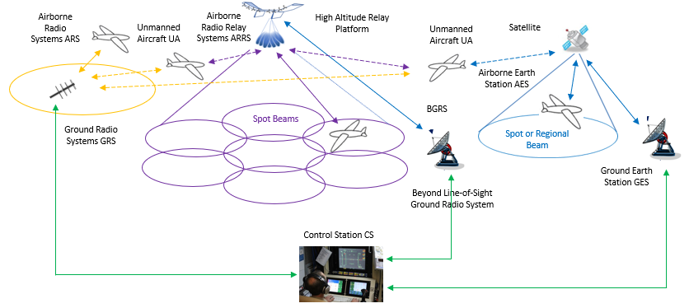

2 Characteristics of command and non-payload communication links at 5 GHz

2.1 Unmanned aircraft and control station characteristics for terrestrial control
and non-payload communication link
TABLE 1
Transmission and reception characteristics for the terrestrial control
and non-payload communication link System 1
Terrestrial command and non-payload communication System 1
 | Units | UA ARS | GRS
Frequency of operation | MHz | 5 030 to 5 091 | 5 030 to 5 091
Duplexing |  | Time division duplex (TDD) | TDD
Transmit/receive duration | msec | 23 Receive + 1.3 guard time  23 Transmit + 2.7 guard time | 23 Transmit + 1.3 guard time  23 Receive + 2.7 guard time
Modulation |  | GMSK or QPSK | GMSK or QPSK
Modulation symbol rates | ksps | GMSK: TBD  including error correction/detection, guard times and synchronization overhead | GMSK: TBD  including error correction/detection, guard times and synchronization overhead
Forward error correction |  | GMSK: Rate 5/8 Turbo Conv.  Code  QPSK: Rate 5/9 and Rate 1/3 TCC | GMSK: Rate 5/8 Turbo Conv. Code  QPSK: Rate 5/9 and Rate 1/3 TCC
Error detection |  | 32-bit CRC | 32-bit CRC
Baseband Input/Output Signal |  | User Data | User Data
User Data Bit Rates | kbps | GMSK: TBD  QPSK: TBD  Includes TDD duty cycle overhead | GMSK: TBD  QPSK: TBD  Includes TDD duty cycle overhead
Occupied bandwidth, C | kHz | Variable per application with a maximum of 250 | Variable per application with a maximum of 250
Antenna gain | dBi | 2 Omnidirectional | Maximum 20 (see Table 2)
Cable loss | dB | 2 | 1
Antenna pattern |  | Constant azimuth  Constant elevation | Constant azimuth  Tailored in elevation  See Table 2
Antenna polarization |  | Vertical with aircraft flying straight and level | Vertical
Maximum antenna height | m | 22 860 (mean sea level)  Typical 6 000 | 2 to 50  Typical 10
Service range | km | 550  Typical 80 | 550  Typical 80
Transmitter conducted power | dBm | 40 | 40
Transmitter in band emission limits | dBc/  1 MHz | −66 at 2 MHz offset  See Table 3 | −66 at 2 MHz offset  See Table 3
Receiver noise figure | dB | 7 | 7
Receiver sensitivity | dBm | GMSK: TBD  QPSK: TBD | GMSK: TBD  QPSK: TBD
Receiver in band rejection – except the operating channel | dB | One channel separation: 23  Two channel separation: 43  Three channel separation: 57  2 MHz or more separation: 63 | One channel separation: 23  Two channel separation: 43  Three channel separation: 57  2 MHz or more separation: 63
Protection Level (aggregate) I/N | dB | –6 | –6
* The protection level does not include the safety margin.
TABLE 2
System 1 GRS antenna characteristics
Parameter | Units | Intrasystem limit | High gain antenna | Omnidirectional antenna
Peak gain | dBi | 20 | 19 | 5.2
Elevation Θ₃ | Degrees | N/A | 9 | 55
Gain at
elevation degrees
0.5 | dBi | 19.0 | 18.5 | 5.2
1.5 | dBi | 19.5 | 18.9 | 4.9
2.5 | dBi | 20.0 | 19.0 | 4.5
3.5 | dBi | 19.5 | 18.9 | 1.6
7 | dBi | 17.0 | 16.0 | −1.4
11.5 | dBi | 14.0 | 8.2 | −2.8
16 | dBi | 11.5 | 3.8 | −5.0
32 | dBi | 6.5 | −12.5 | −8.0
64 | dBi | 1.5 | −26.4 | −9.5
75 | dBi | 0.5 | −29.0 | −11.7
89 | dBi | 0.5 | −31.0 | −16.5
Azimuth Θ₃ | Degrees |  | 34 | 360
Steerable/Sectoral/  Omnidirectional |  | N/A | Steerable/  Sectoral | Omnidirectional

The above table and accompanying graph below contain the characteristics of antennas that will be used to support unmanned aircraft operations using the System 1 whose RF characteristics are described in the previous tables. The information contained in Table 2 includes the GRS elevation and azimuth gains that will support unmanned aircraft (that themselves use omnidirectional antennas) operating up to approximately 65 nautical miles/120 km slant range, at altitudes up to 65 000 ft, down to close in operations including takeoff and landing. Because of the critical nature of the performance of UAS CNPC C2 links a range of antennas are required to maximize the link margin while maintaining intrasystem compatibility. The maximum gain allowed to ensure intrasystem compatibility is also shown in the table and accompanying graph. The High Gain antenna provides full azimuth coverage by being either steerable in azimuth or by using switching between one of a number of sectorized antennas with the characteristics given in the table. All antennas have the fixed elevation pattern given in the table and graph. In any geographic region at any one time, it is anticipated that there will be a mixture of antennas being used to support the wide variety of unmanned aircraft operations.

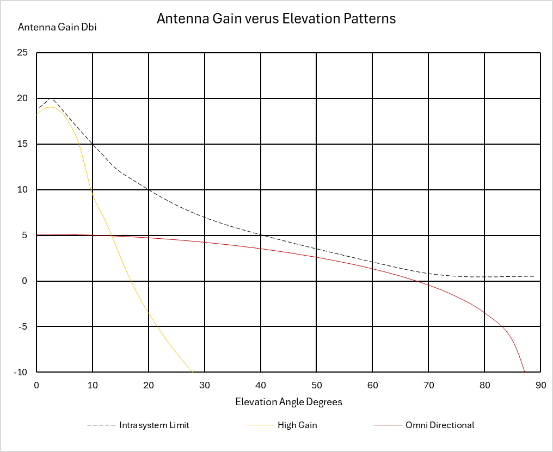
TABLE 3
Transmitter out of band emission limits in the 5 030-5 091 MHz frequency band for system 1
System 1
Offset from carrier frequency | dBc/kHz
Channel width ÷ 2 | −54
1.5 × channel width | −74
500 kHz | −90
2 000 kHz | −96

[

2.3 Unmanned aircraft and control station characteristics for control and non-payload communication link via satellite

2.3.1 Control and non-payload communication via geostationary orbiting satellite systems
Technical characteristics of control and non-payload communication via GSO systems are contained in Table 4.
Table 4: Technical characteristics of control and non-payload communication via GSO systems
Satellite GSO command and non-payload communication
 | Units | Aircraft receiver | GSO satellite receiver
Frequency of operation | MHz | 5 000 to 5 150 | 5 000 to 5 150
Occupied bandwidth, C | kHz | 22.2 per carrier | 139.8 per carrier
Antenna gain | dBi | 3 Omnidirectional | 45.1
Cable loss | dB | 2 | 0.5
Antenna pattern |  | Constant azimuth  Constant elevation | Rec ITU-R S.672
Antenna polarization |  | RHCP | RHCP
Maximum antenna height | m | 22 860 (mean sea level)  Typical 6 000 | -
Transmitter conducted power | dBm | 43.5 dBm per carrier | 44.1 dBm per carrier
Transmitter in band emission limits | dBc/  1 MHz | ITU-R SM.1541-7 | ITU-R SM.1541-7
Receiver noise figure | dB | 5 | 5
Protection level (aggregate) I/N* | dB | -6 | -6

* The protection level does not include the safety margin

2.3.2 Control and non-payload communication via low Earth orbiting non-geostationary satellite orbiting systems
This section describes the links between the satellite and the aircraft.
TABLE 5
Example of aircraft C2 Link earth station characteristics for one NGSO use case
Parameters | Units | Values
Altitude | km | 0-20
Frequency range | MHz | 5 000-5 150
Tx necessary bandwidth for each channel* | MHz | Up to 60
Tx e.i.r.p. density | dBW/Hz | Up to −10
Tx e.i.r.p. | dBW | Up to 41.7
Tx loss | dB | 2
Minimum Tx bandwidth per carrier | kHz | 15
OoB emissions | dBm | ITU-R SM.1541-7
Max antenna gain** | dBi | 3
Type antenna gain | / | Omni
Rx bandwidth for each channel | MHz | Up to 60
Minimum Rx bandwidth per carrier | kHz | 15
Noise figure | dB | 5
Protection Level (aggregated interference): I/N*** | dB | –6
* The channel may be filled by one or several carriers, and the frequency range may be divided in several channels.
** steerable antenna could be considered later on.
*** The protection level does not include the safety margin.
TABLE 6
Example of space station characteristics for one NGSO use case
Parameters | Units | Values
Altitude | km | 415 - 1 500
Frequency range | MHz | 5 000-5 150
Tx necessary bandwidth of each channel* | MHz | Up to 60
Tx e.i.r.p. density at Nadir | dBW/Hz | -25.2
Tx e.i.r.p at Nadir | dBW | 41.7
Minimum Tx bandwidth per carrier | kHz | 15
OoB emissions | dBm | ITU-R SM.1541-7
Max antenna gain | dBi | 15
Type antenna gain | / | ITU-R S.1528
Rx bandwidth of each channel* | MHz | Up to 60
Minimum Rx bandwidth carrier | kHz | 15
Noise figure | dB | 5
Protection level (aggregated interference): I/N** | dB | −6
* The channel may be filled of carriers, and the frequency range may be divided in several channels.
** The protection level does not include safety margin

1 The protection level does not include the safety margin.

