No Changes from first draft. Several changes still being contemplated.
U.S. Radiocommunications Sector
Fact Sheet
Working Party: ITU-R WP-5B | Document No: USWP5B36-13
Ref: Annex 1.07 to Document 5B/526-E | Date: 17 August 2026
Document Title: WORKING DOCUMENT TOWARDS A HANDBOOK ITU-R M. [HDBK_STATUS.SPECTRUM.RPAS_DAA] - Handbook on status of availability of spectrum for detect-and-avoid radars [onboard] remotely piloted aircraft.
Author(s)/Contributors(s):  Don Nellis  Federal Aviation Administration  800 Independence Ave., S.W.  Washington, DC 20591 | Phone: (202) 267-9779  e-mail: Donald.Nellis@faa.gov  Phone:  e-mail:
Purpose/Objective: This Handbook was intended as a replacement for Report ITU-R M.2204-0 (11/2010) “Characteristics and spectrum considerations for sense and avoid systems used on unmanned aircraft systems”. Earlier efforts were made to update to Report ITU-R M.2204-0; however, it was decided that a Handbook would be a more appropriate location to catalog the information currently found in Report ITU-R M.2204-0. Unfortunately, there is no consensus on appropriate frequency bands for Detect and Avoid (DAA) radar, characteristics for DAA, nor deployment of DAA in support of unmanned aircraft systems (onboard, ground-based, or both).

Abstract: This contribution continues the US position in Document 5B/421 that, since work on the new ITU-R Handbook has been underway for more than 10 years without consensus, and that many administrations believe that ICAO should decide which frequency bands are best for unmanned aircraft DAA, that further work in ITU-R Working Party 5B on this Handbook be discontinued until such time as ICAO provides guidance on which bands they would like to use for onboard and ground based DAA systems.

Radiocommunication Study Groups | 
Source: Annex 1.07 to Document 526-E | Annex 1.7 to  Document 5B/526-E
Source: Annex 1.07 to Document 526-E | 22 June 2026
Source: Annex 1.07 to Document 526-E | English only
United States of America
WORKING DOCUMENT TOWARDS A HANDBOOK ITU-R M.[HDBK_STATUS.SPECTRUM.RPAS_DAA]
Handbook on status of availability of spectrum for
detect-and-avoid radars for remotely
piloted aircraft systems

Introduction
This Handbook was intended as a replacement for Report ITU-R M.2204-0 (11/2010) “Characteristics and spectrum considerations for sense and avoid systems used on unmanned aircraft systems”. Earlier efforts were made to update to Report ITU-R M.2204-0, however, it was decided that a Handbook would be a more appropriate location to catalog the information currently found in the report. This new ITU-R Handbook was intended to provide information on appropriate frequency bands for Detect and Avoid (DAA) radar systems onboard unmanned aircraft or for ground-based DAA radar systems to support unmanned aircraft operations.

Proposal
The United States believes that there is a general consensus that ICAO should decide which of the frequency bands are best suited for aviation use. Therefore, the United States proposes that WP-5B continue the work on tis Handbook in collaboration with ICAO to ensure consistency between the ITU-R and ICAO. The US proposals are highlighted in turquoise.

Attachment

ATTACHMENT
WORKING DOCUMENT TOWARDS A HANDBOOK ITU-R M.[HDBK_STATUS.SPECTRUM.RPAS_DAA]
Handbook on status of availability of spectrum for
detect-and-avoid radars for remotely
piloted aircraft systems

(202X)

[
Editor’s Note: The Handbook provides consolidated technical information on ARNS bands and on detect-and-avoid systems. The document is intended to be descriptive and highlights challenges that may exist with particular frequency bands for airborne DAA.]
Editor’s Note: One Administration recommends stopping the work on this handbook if consensus cannot be reached soon due to amount of time to achieve finalization.]
[Editor’s Note: Review the use of RPAS and UAS in document, ensure definition of terminology, and which term should be used in this document.]

Handbook
on
status of availability of spectrum for detect-and-avoid radars for remotely piloted aircraft systems
Edition of 202X
ITU-R | 

Preface
[TBD]
Foreword
[TBD]
TABLE OF CONTENTS
1 Introduction 4
1.1 Detect and avoid radars for remotely piloted aircraft systems 4
1.2 Objective 4
1.3 Terminology 5
1.4 Related ITU recommendations and reports 5
2 Principles of detect and avoid 6
2.1 Detect and avoid systems 6
2.2 Applicability of detect and avoid to overall collision avoidance approach 7
2.3 Aircraft-based detect and avoid 9
2.4 Ground-based detect and avoid 13
3 Status of the uses of the frequency bands allocated to frequency bands
allocated to radionavigation or aeronautical radionavigation services 15
3.1 Extract from Report ITU-R M.2204 15
3.2 Current and planned uses 21

1 Introduction

1.1 Detect and avoid radars for remotely piloted aircraft systems
Remotely piloted aircraft (RPA) are powered aircraft that do not carry a human pilot, use aerodynamic forces to provide vehicle lift, and employ a remote pilot, fly semi-autonomously, or autonomously. The safe operation of Remotely piloted aircraft systems (RPAS) in civil airspace requires addressing the same issues as manned aircraft, namely integration into the air traffic control (ATC) system. Because the pilot is no longer onboard, a method of replacing the pilot’s responsibility to “see and avoid” other aircraft is required (see International Civil Aviation Organization’s (ICAO’s) Annex 2 “Rules of the Air”). While systems like ACAS (Airborne Collision Avoidance System) already used for manned aircraft can be used also for RPAS to avoid cooperative aircraft specific systems are expected to avoid collision with non-cooperative aircraft: detect and avoid (DAA) radars.

1.2 Objective
The present ITU-R Handbook provides technical and regulatory information on spectrum options for detect and avoid radars for non-cooperative aircraft, with particular emphasis on airborne applications requiring broad international operability. Its purpose is to identify the parts of the radiofrequency spectrum in which DAA radars could operate and to assess whether existing spectrum allocations and associated regulatory provisions can support such operations.
The Handbook is descriptive and guidance-oriented. It does not designate a preferred frequency band. Rather, it examines candidate frequency bands, the relevant technical and regulatory considerations, and the extent to which existing spectrum resources may meet the operational needs of DAA radars. The RR No. 4.10 stipulates that “Member States recognize that the safety aspects of radionavigation and other safety services require special measures to ensure their freedom from harmful interference; it is necessary therefore to take this factor into account in the assignment and use of frequencies”.
Consequently, if a frequency band allocated to radionavigation or aeronautical services is used or planned to be used for another application in the same service or in another service by a spectrum regulator on its territory, then it would not be possible to operate worldwide onboard DAA radars unless compatibility could be ensured with these applications.
For example, the case of radio altimeters onboard aircraft in the frequency band 4 200-4 400 MHz is a typical safety-of-life system operated worldwide under the radionavigation service.
Two types of DAA radars for non-cooperative targets may be considered:
– Airborne DAA, which is necessary for the automated collision detection and avoidance mandated for UAS operations in non-segregated airspace. Global harmonization of RPAS operation require a harmonized spectrum use for on-board detect and avoid.
– Ground-based DAA, which may be used complementarily to augment airborne surveillance capability over a defined area.
The distinction here concerns the need for spectrum harmonization. Airborne DAA radars generally require a higher degree of international harmonization than ground-based DAA radars, because they are intended to support operations across multiple countries and airspace environments. By contrast, ground-based DAA radars are typically deployed within a defined area and may therefore allow greater flexibility in spectrum implementation.

1.3 Terminology
Control and non-payload communications: [The data link between the remotely piloted aircraft and the remote pilot station for the purposes of managing the flight.] The functions of command and non-payload communication (CNPC) can be related to different types of information such as: telecommand messages, non-payload telemetry data, support for navigation aids, air traffic control voice relay, air traffic services data relay, target track data, airborne weather radar downlink data, non-payload video downlink data.
Detect and avoid system: [A system(s) using sensor information to detect conflicting traffic or other hazards and provide appropriate alerting and manoeuvre guidance to support DAA.]
Intruder: An aircraft that enters the DAA surveillance volume and tracked by the DAA system.
Remotely piloted aircraft: Designates types of aircraft remotely controlled for category certified.
Remotely piloted aircraft control station: Facilities from which an RPA is controlled remotely.
Remotely piloted aircraft systems: Include the following subsystems:
– Remotely piloted aircraft;
– Aircraft control station;
– Control non payload communication;
– Air traffic control (ATC) communications subsystem;
– DAA radars.
Separation provision: The tactical process of keeping aircraft away from hazards by at least the appropriate separation minima.
Separation minima: The minimum displacements between an aircraft and a hazard which maintain the risk of collision at an acceptable level of safety.
Strategic conflict management: Airspace organization and management, demand and capacity balancing and traffic synchronization components.

1.4 Related ITU Recommendations and Reports
Recommendations
ITU-R M.1372 Efficient use of the radio spectrum by radar stations in the radiodetermination service
ITU-R M.1582 Method for determining coordination distances, in the 5 GHz band, between the international standard microwave landing system stations operating in the aeronautical radionavigation service and stations of the radionavigation-satellite service (Earth-to-space)
ITU-R M.1638 Characteristics of and protection criteria for sharing studies for radiolocation (except ground based meteorological radars) and aeronautical radionavigation radars operating in the frequency bands between 5 250 and 5 850 MHz
ITU-R M.1639 Protection criterion for the aeronautical radionavigation service with respect to aggregate emissions from space stations in the radionavigation-satellite service in the band 1 164-1 215 MHz
ITU-R M.1642 Methodology for assessing the maximum aggregate equivalent power flux-density at an aeronautical radionavigation service station from all radionavigation-satellite service systems operating in the 1 164-1 215 MHz band
ITU-R M.1796 Characteristics of and protection criteria for terrestrial radars operating in the radiodetermination service in the frequency band 8 500-10 680 MHz
ITU-R M.1827 Guideline on technical and operational requirements for stations of the aeronautical mobile (R) service limited to surface application at airports in the frequency band 5 091-5 150 MHz
ITU-R M.1901 Guidance on ITU-R Recommendations related to systems and networks in the radionavigation-satellite service operating in the frequency bands 1 164-1 215 MHz, 1 215-1 300 MHz, 1 559-1 610 MHz, 5 000-5 010 MHz and 5 010-5 030 MHz
ITU-R M.2007 Characteristics of and protection criteria for radars operating in the aeronautical radionavigation service in the frequency band 5 150-5 250 MHz
ITU-R M.2008 Characteristics and protection criteria for radars operating in the aeronautical radionavigation service in the frequency band 13.25-13.40 GHz
ITU-R M.2059 Operational and technical characteristics and protection criteria of radio altimeters utilizing the band 4 200-4 400 MHz
ITU-R M. [New ITU-R Recommendation on DAA radars in 15.4–15.7 GHz – title/number to be inserted]
ITU-R M. [New ITU-R Recommendation on DAA radars in 24.45–24.65 GHz – title/number to be inserted]
TBD
Reports
ITU-R M.2204 Characteristics and spectrum considerations for sense and avoid systems use on Unmanned Aircraft Systems (UAS)

2 Principles of detect and avoid
[Editor’s note: This section is copied from ITU-R M.2204 released in 11/2010 and needs to be updated with the last up to date information that may be asked to ICAO.]

[2.1 Detect and avoid systems
The principle of a DAA system is that it fits into the total systems approach to collision avoidance. As shown in Figure 1, the approach to collision avoidance uses a layered approach. Current technologies that may accommodate these layers include ATC procedures, ground and surface ATC surveillance systems, automatic dependent surveillance-broadcast (ADS-B), airborne collision avoidance system also called traffic collision avoidance system (TCAS), and DAA.
Figure 1
Layered collision avoidance approach
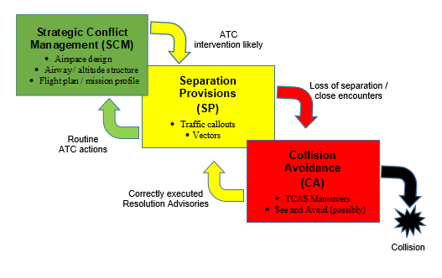

2.2 Applicability of detect and avoid to overall collision avoidance approach
An important point to consider in the design of a detect and avoid system is how it fits into the total systems approach to collision avoidance. Using the three layer approach described in ICAO Document 9854 (strategic conflict management, separation provision, and collision avoidance) for conflict management will limit, to an acceptable level, the risk of collision between aircraft and hazards. ICAO Doc 10019 specifically defines conflict management approach towards DAA. As shown in Figure 1, The DAA system provides the “remain well clear” function as the separation provision and “collision avoidance” function as the collision avoidance.
Figure 2
Three layers of conflict management approach towards detect and avoid
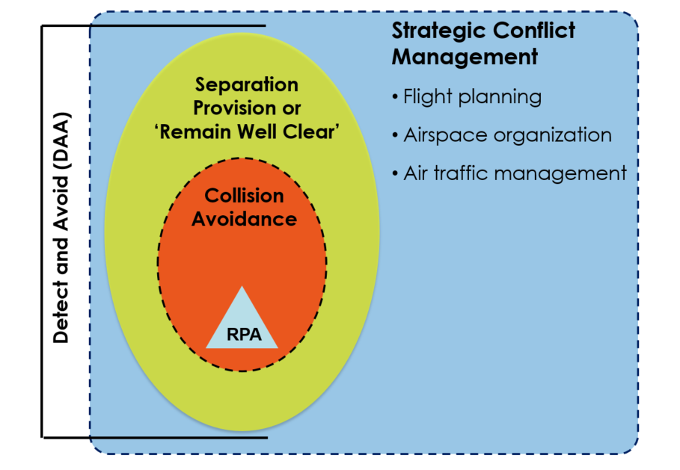

2.2.1 Strategic conflict management
Strategic conflict management includes pre-flight actions performed to minimize potential flight path conflicts with, and maximize separation from, intruders. Strategic conflict management also includes risk mitigation that is achieved through airspace organization and management, demand and capacity balancing, and traffic synchronization.

2.2.2 Remain well clear/separation provision
In this phase, actions are undertaken by all participants to ensure the safe execution of the flight depending on the airspace classification. Separation provisions by ATC and “remain-well-clear (RWC)” by pilots/remote pilots are utilized in this phase. At the remain well clear level of DAA, the system identifies the pilot to a potential violation of the DAA Remain Well Clear volume. Based on the information provided by the DAA system, the pilot identifies whether, and if so, what type of a manoeuvre is necessary to avoid the intruder, and then executes that manoeuvre. If operating under an ATC clearance, the UA Pilot coordinates with ATC to obtain an amended clearance before executing the manoeuvre.

2.2.3 Collision avoidance
Collision avoidance is the last layer to of conflict management and aims to prevent an intruder from penetrating the near mid-air collision (NMAC) volume. The airborne collision avoidance system is a system that is currently used to this effect on manned aircraft. As indicated in the figure above, DAA systems are expected to perform the collision avoidance function in addition to the “remain well clear function”.

2.3 Aircraft-based detect and avoid
There are factors that drive the performance requirements needed from an RF-based airborne DAA sensor as shown in Figure 2. The number of factors that drive the performance requirements for an airborne DAA sensor is large resulting in a very difficult multidimensional trade space containing both dependent variables and independent variables. These factors include characteristics of the encounter including NMAC volume, the latencies in the actual airborne DAA system implementation, and the performance parameters of the radar used as the airborne DAA sensor.
Figure 3
Detect and avoid sensor performance requirement factors
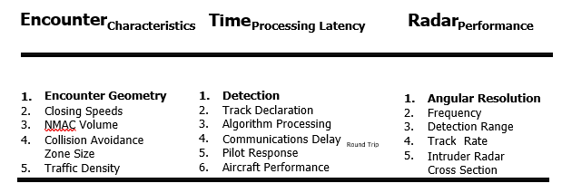

2.3.1 Encounter characteristics for aircraft-based detect and avoid
The first major factor driving the sensor performance requirements shown in Figure 3 is Encounter characteristics, which include collision course geometries, closing speeds between the UA and the intruder, the selected NMAC or remain well clear volume, collision avoidance zone size and overall aircraft traffic density. The second major class of factor driving the needed sensor performance includes the latencies in the system implementation. Specific latency drivers that need to be taken into account are minimum allowable detection/detection times, pilot response latencies, UA communications system latencies, airborne DAA sensor data processing delays and expected UA aero-performance characteristics. The last major factor driving airborne DAA sensor performance includes the characteristics of the radar such as angular accuracy, available power-aperture (i.e. detection range), radar cross-section of the intruder aircraft and track rate.
Closing speeds between the UA and an intruder and the NMAC or well clear volume, on the other hand, do have bearing on the necessary detection range needed to detect, track and perform a collision avoidance manoeuvre. Obviously, the faster the closing speed between the two aircraft, the longer the detection range from the radar that is needed. Additionally, larger NMAC or well clear volumes also increase detection range. Each plot in Figure 3 shows the distance between the UA and the intruder aircraft as a function of time before a manoeuvre is needed, and the time at which each curve is at a minimum is the point of closest approach assuming that the UA can perform a turn at a 15° bank angle. Using the minimum as a proxy for horizontal NMAC distance, one can see that a larger NMAC volume drives the system designer to needing a longer detection range.
Figure 4
Near mid-air collision size vs time required to start avoidance manoeuvre
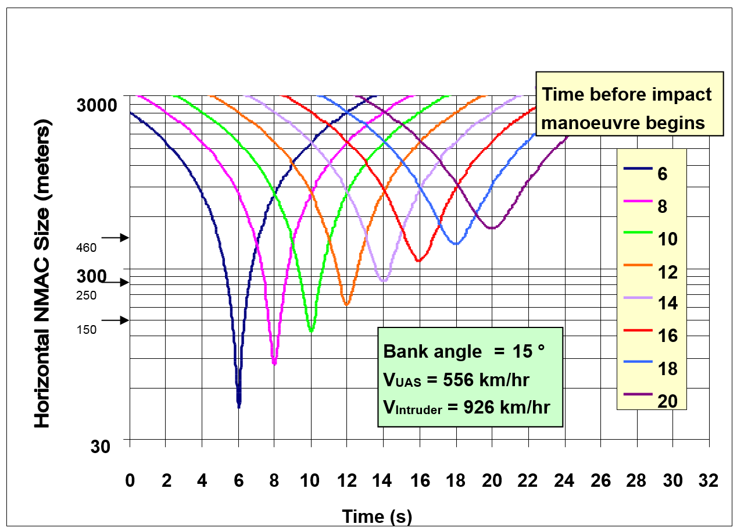

2.3.2 System latencies for aircraft-based detect and avoid
The DAA encounter timeline shown in Figure 4 defines the 8 major elements that need to be accounted for in an airborne DAA scenario. Again, as with the considerations associated with encounter geometries, system latencies ultimately drive the radar sensor detection range.
UA performance has a large impact on the system latencies. Obviously, a slower moving aircraft has more time to devote to detecting an intruder but is often less manoeuvrable so it will probably have less ability to affect a collision avoidance manoeuvre in order to avoid a collision. On the other hand, UA that fly faster will have less time to devote to detecting an intruder, but these UA are often more manoeuvrable so they will probably have a greater ability to turn away from the collision.
Figure 5
Collision encounter timeline
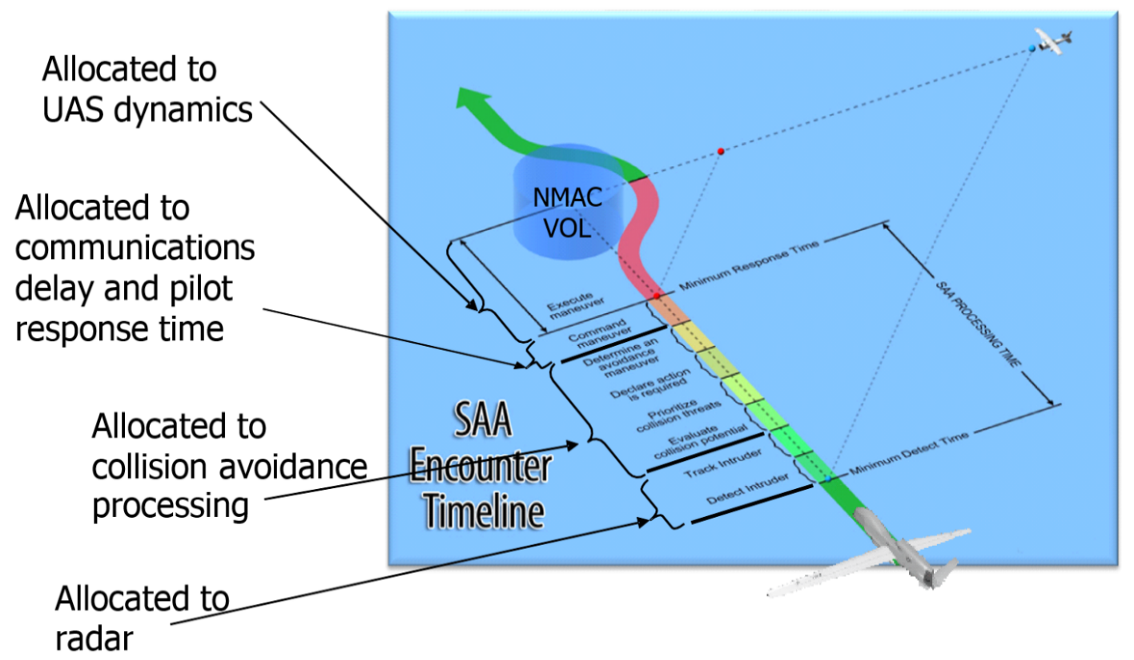

2.3.3 Radar performance considerations for aircraft-based detect and avoid
Lastly, specific requirements on the performance of the radar component of the DAA system will affect the radar design and performance and be a main driver in frequency band selection. In particular, size weight and power (SWAP) and the required accuracy of intruder position (as measured by angular and range resolution) will affect determination of a suitable frequency for an airborne radar sensor.

2.3.4 The detection range of an intruder
The detection range of an intruder is highly dependent on the transmit power-gain product of the radar. Transmit power is usually the highest power consuming element in the radar, which will affect power consumption directly and other SWAP elements indirectly. In order to constrain the radar transmit power and power consumption, lower frequencies are preferred for two factors:
– in general, lower frequencies have lower rain attenuation and atmospheric absorption factors as shown in Figure 5 below;
– higher efficiency amplifiers are more readily available at lower frequencies and hence same output power can be obtained at lower power consumption.
For antenna gain evaluation, higher frequencies will have higher antenna gain for same antenna size.
Figure 6
Plot of atmospheric absorption at microwave frequencies
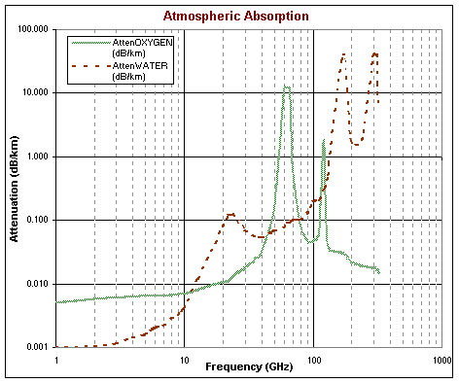

2.3.5 The accuracy of the intruder position
In order to estimate the intruder position, the radar measures the range, azimuth (bearing) and elevation angle of the intruder relative to the ownership UA.
The range resolution and accuracy is mainly dependent on the frequency bandwidth of the waveform and is usually sufficient to achieve required accuracy.
The radar usually relies on monopulse processing to improve angle accuracy. Typical accuracies are in the 1:10-1:20 of the 3 dB beamwidth of the antenna. For same antenna size, the beamwidth is reduced as the frequency is increased, and hence the accuracy is improved as the frequency is increased. Note that reducing the beamwidth may have the adverse effect of needing a longer frame time to cover all the required field of regard, hence these parameters are usually traded in a system optimization.
Thus, the proper selection of frequency is critical to the success of the airborne DAA radar. There is no optimum solution that fits all UAS classes, the solution will depend on the UAS class, and operational environment. As shown in Figure 6, the X band gives a compromise for trading all parameters. A lower band would have lower power consumption for same range requirement but may need a larger size antenna to achieve the required antenna gain and intruder position accuracy. Frequencies below C band are not expected to achieve required angle accuracy.
On the high frequency side, Ku band and higher can achieve required gain and position accuracy with smaller size but may need higher power to achieve required detection range.
Figure 7
Qualitative evaluation of parameters that affect choice of frequency band
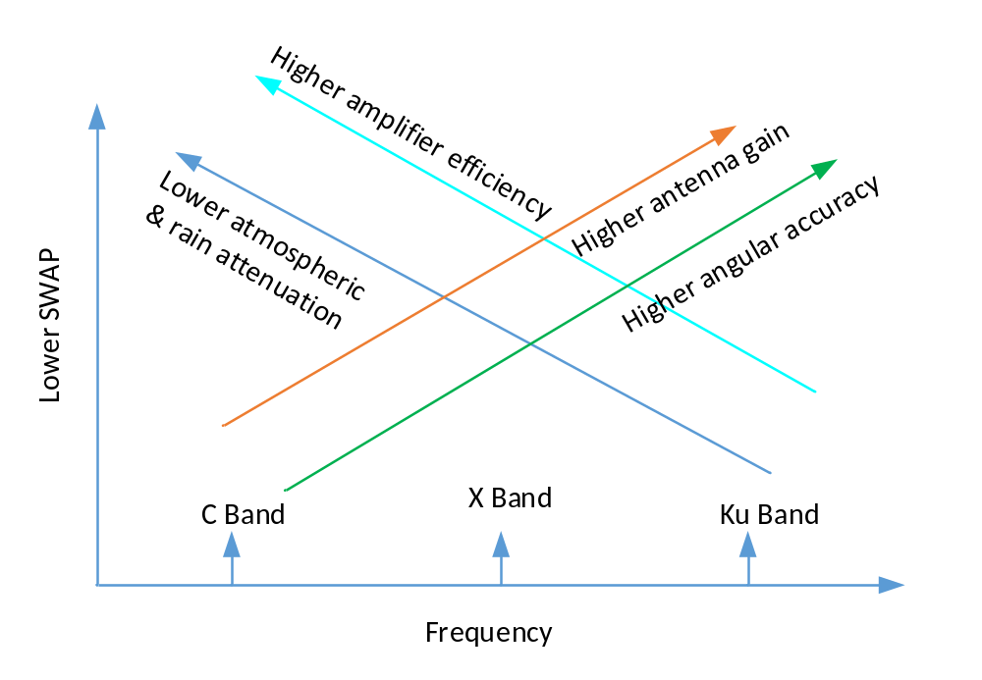

2.3.6 Other technical considerations for aircraft-based detect and avoid
Another factor that must be taken into account in the determination of a suitable frequency for an airborne radar sensor is electromagnetic interference compatibility, both local compatibility on the UA, as well as compatibility with co-primary users of the spectrum. For example, if a UA is carrying another radar as part of its mission payload, one would prefer that the DAA sensor frequency be out-of-band from the mission payload radar in order to minimize interference between the two radars. In addition, the prevalence of other radars (e.g. weather radars) in a certain frequency band may impact the use of that frequency band for airborne DAA.

2.4 Ground-based detect and avoid
The radiofrequency part of a ground-based detect and avoid (GBDAA) for unmanned aircraft could use already existing air traffic control systems to locate and provide information on the location of the various aircraft in the considered by UAS for DAA purposes. However, air traffic control systems are not optimized to meet the needs of small low flying UAs. Therefore, additional GBDAA is needed to augment existing air traffic control surveillance.
GBDAA systems detect and generate tracks within its Declaration Volume (DV) of airborne traffics. Unlike air traffic control radars, DAA radars detect aircraft that fly at relatively low altitudes with smaller radar cross-sections.
As with the airborne DAA (ABDAA), GBDAA compliments other surveillance sensors by providing detection of non-cooperative traffic (i.e., those without operating transponders or ADS-B Out capabilities). Aircraft tracks are established at sufficient range and accuracy to enable an UA flying within GBDAA Operational Volume (OV) to remain well clear of other aircraft.
FIGURE 8
Ground-based detect and avoid
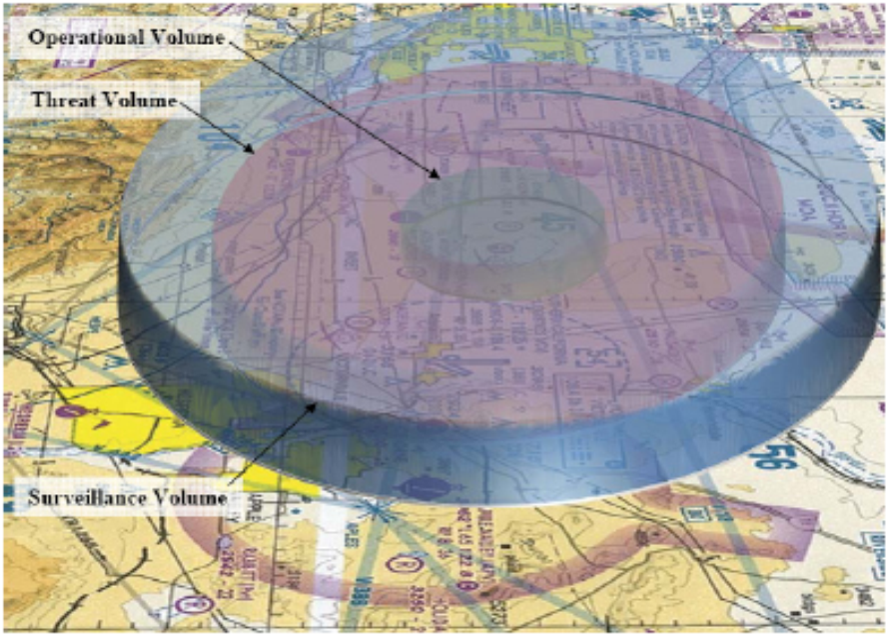
In some cases, there are no significant differences between the GBDAA and ABDAA systems. The requirements are simply to support the safety case, whether that’s achieved with airborne sensors, ground-based sensors, or both. However, it should be noted that the capability of ground-based vs airborne radar is different. A GBDAA radar looking up can see both in front and behind an aircraft of interest, whereas an ABDAA radar onboard the aircraft is generally pointed in the direction of flight and can only detect objects across a field of view in the direction it is flying. Additionally, smaller UAS are limited in the size and power of radar they can carry, whereas ground-based radar has less limitation with regards to size or weight of the DAA radars. There are also different technical challenges; for example, with GBDAA where line-of-sight over hills and buildings will need to be considered during implementation whereas with ABDAA implementation may require careful consideration of ground clutter (and returns from objects on the ground more generally) at low altitudes.
GBDAA systems use ground-based sensor as the surveillance sensor and may have multiple GBDAA sensors to cover the necessary Surveillance Volume. The GBDAA can be utilized to enable transit operations, or operations at lower altitudes in area near airports as well as to enable extended operations.]

3 Status and the uses of the frequency bands allocated to radionavigation or aeronautical radionavigation services

3.1 Review of ARNS and RNS frequency bands

This section reviews frequency bands allocated to the aeronautical radionavigation service (ARNS) or the radionavigation service (RNS) that may be relevant to detect-and-avoid (DAA) applications. It first considers ARNS bands associated with established aviation standards, identified in Table 1, and then other ARNS frequency bands supporting aeronautical radionavigation applications more generally, identified in Table 2.
The purpose of this section is to provide a structured overview of the existing regulatory and technical landscape, including relevant Radio Regulations provisions and current aeronautical uses.

3.1.1 Possible use of airborne DAA within ARNS allocations
Table 1 presents the ARNS bands for which existing airborne radar standards have been identified, together with the relevant RR 2024 provisions and associated ITU-R Recommendations.
TABLE 1
ARNS allocations for airborne radars
Band | Status | Relevant RR provisions for band assessment | Example  of Aviation Standards | Relevant ITU-R  Recommendations
4 200-4 400 MHz | primary | 5.436, 5.437, 5.438, 5.439, 5.440 | C67⁽¹⁾, C92c⁽²⁾ | M.2059
5 350-5 470 MHz | primary | 5.448B, 5.448C, 5.448D, 5.449 | C63c⁽³⁾ | M.1638
8 750-8 850 MHz | primary | 5.470, 5.471 | C65a⁽⁴⁾ | M.1796
9 300-9 500 MHz | primary | 5.427, 5.474, 5.475, 5.475A, 5.475B, 5.476A | C63c⁽³⁾ | M.1796
13.250-13.400 GHz | primary | 5.497, 5.498A, 5.499 | C65a⁽⁴⁾ | M.2008
⁽¹⁾ Department of Transportation, Federal Aviation Administration, Aircraft Certification Service, Washington DC, Technical Standard Order TSO-C67, Airborne Radar Altimeter Equipment (For Air Carrier Aircraft), 15 November 1960.
⁽²⁾ Department of Transportation, Federal Aviation Administration, Aircraft Certification Service, Washington DC, Technical Standard Order TSO-C92c, Airborne Ground Proximity Warning Equipment, 19 March 1996.
⁽³⁾ Department of Transportation, Federal Aviation Administration, Aircraft Certification Service, Washington DC, Technical Standard Order TSO-C63c, Airborne Weather and Ground Mapping Pulsed Radars, 18 August 1983.
⁽⁴⁾ Department of Transportation, Federal Aviation Administration, Aircraft Certification Service, Washington DC, Technical Standard Order TSO-C65a, Airborne Doppler Radar Ground Speed and/or Drift Angle Measuring Equipment (for Air Carrier Aircraft), 18 August 1983.

3.1.1.1 Regulatory implications of potential airborne DAA use within ARNS allocations for airborne radars
This section summarizes the RR provisions relevant to the ARNS airborne-radar bands identified in this section and explains their regulatory significance for potential airborne DAA use.
4 200-4 400 MHz
5.438 Use of the frequency band 4 200-4 400 MHz by the aeronautical radionavigation service is reserved exclusively for radio altimeters installed on board aircraft and for the associated transponders on the ground. (WRC-15)
This footnote excludes the use of DAA in the frequency band 4 200-4 400 MHz.
5 350-5 470 MHz
5.449 The use of the band 5 350-5 470 MHz by the aeronautical radionavigation service is limited to airborne radars and associated airborne beacons.
DAA would be included in this frequency range under the existing provision No. 5.449.
8 750-8 850 MHz
5.470 The use of the band 8 750-8 850 MHz by the aeronautical radionavigation service is limited to airborne Doppler navigation aids on a centre frequency of 8 800 MHz.

9 300-9 500 MHz
5.475 The use of the band 9 300-9 500 MHz by the aeronautical radionavigation service is limited to airborne weather radars and ground-based radars. In addition, ground-based radar beacons in the aeronautical radionavigation service are permitted in the band 9 300-9 320 MHz on condition that harmful interference is not caused to the maritime radionavigation service. (WRC-07)

9500-9800 MHz
The 9500-9800 MHz band is allocated for radionavigation.
13.25-13.4 GHz
5.497 The use of the band 13.25-13.4 GHz by the aeronautical radionavigation service is limited to Doppler navigation aids.

3.1.2 Additional ARNS frequency bands examined for potential [airborne] DAA use
In addition to the bands identified in Table 1, there are other frequency bands allocated to ARNS that are used to support a variety of ARNS applications and shownin Table 2. Existing standards are available for ARNS systems in many of these bands.

TABLE 2
Frequency bands allocated to ARNS
Band | Status | Relevant RR provisions for band assessment | Example of Aviation Standards | Relevant ITU-R  Recommendations
190- 315 kHz | primary | 5.68, 5.69, 5.70, 5.74 | C41d⁽¹⁾
325-405 kHz | primary |  | C41d⁽¹⁾
415-435 kHz | primary | 5.77, 5.78, 5.79 | C41d⁽¹⁾
510-535 kHz | primary | 5.79A, 5.84, 5.86, 5.88 | C41d⁽¹⁾
74.8-75.2 MHz | primary | 5.180, 5.181 | C35d⁽²⁾
108-117.975 MHz | primary | 5.197, 5.197A, | C36e⁽³⁾, C40c⁽⁴⁾
328.6-335.4 MHz | primary | 5.258, 5.259 | C34e⁽⁵⁾
960-1 215 MHz | primary | 5.327A, 5.328, 5.328A, 5.328AA, 5.328B | C66c⁽⁶⁾ | M.1642-2,  M.1639-1,  M.1901-3
1 300-1 350 | primary | 5.149, 5.337, 5.337A
5 000-5 030 MHz | primary | 5.328B , 5.443AA, 5.443B |  | M.1582,  M.1901-3
5 030-5 150 MHz | primary | 5.443AA, 5.443C, 5.443D, 5.444, 5.444A, 5.444B , , | C104⁽⁷⁾ | M.1582
5 150-5 250 MHz | primary | 5.446, 5.446A, 5.446B, 5.446C,  5.446D,  5.447, 5.447A, 5.447B, 5.447C |  | M.2007  M.1454,  S.1426,  S.1427
15.400-15.700 GHz | primary | 5.511A, 5.511C, 5.511D, 5.511E, 5.511F, 5.511G, 5.511H | C63c⁽⁸⁾ | S.1340, S.1341
(1) Department of Transportation, Federal Aviation Administration, Aircraft Certification Service, Washington DC, Technical Standard Order TSO-C41d, Airborne Automatic Direction Finding (ADF) Equipment, 6 May 1985.
(2) Department of Transportation, Federal Aviation Administration, Aircraft Certification Service, Washington DC, Technical Standard Order TSO-C35d, Airborne Radio Marker Receiving Equipment, 5 May 1971.
(3) Department of Transportation, Federal Aviation Administration, Aircraft Certification Service, Washington DC, Technical Standard Order TSO-C36e, Airborne ILS Localizer Receiving Equipment Operating within the Radio Frequency Range of 108-112 Megahertz (MHz), 25 January 1988.
(4) Department of Transportation, Federal Aviation Administration, Aircraft Certification Service, Washington DC, Technical Standard Order TSO-C40c, VOR Receiving Equipment Operating within the Radio Frequency Range of 108-117.95 Megahertz (MHz), 25 January 1988.
(5) Department of Transportation, Federal Aviation Administration, Aircraft Certification Service, Washington DC, Technical Standard Order TSO-C34e, Airborne ILS Glide Slope Receiving Equipment Operating within the Radio Frequency Range of 328.6-335.4 Megahertz (MHz), 15 January 1988.
(6) Department of Transportation, Federal Aviation Administration, Aircraft Certification Service, Washington DC, Technical Standard Order TSO-C66c, Distance Measuring Equipment (DME) Operating within the Radio Frequency Range of 960-1215 Megahertz (MHz), 18 January 1991.
(7) Department of Transportation, Federal Aviation Administration, Aircraft Certification Service, Washington DC, Technical Standard Order TSO-C93, Microwave Landing System (MLS) Airborne Receiving Equipment, 22 June 1982.
(8) Department of Transportation, Federal Aviation Administration, Aircraft Certification Service, Washington DC, Technical Standard Order TSO-C63c, Airborne Weather and Ground Mapping Pulsed Radars, 18 August 1983.

Many of the existing ARNS allocated frequency ranges are already in use and the incumbent users of these bands will need to be considered when selecting ARNS bands for DAA applications.
Note: In addition to the bands listed in Table 2, RR 2024 also contains other ARNS allocations that are not included here, mainly because they are regional or national additional allocations, or because their use is restricted to ground-based systems. These include, for example, 74.6-74.8 MHz and 75.2-75.4 MHz under No. 5.179, 1 240-1 300 MHz under No. 5.331, 1 350-1 370 MHz under No. 5.334, and 5 470-5 650 MHz under No. 5.450. Bands such as 1 300-1 350 MHz, 2 700-2 900 MHz, and 9 000-9 200 MHz are also subject to restrictions limiting ARNS use to ground-based systems.

3.1.2.1 Additional ARNS frequency bands examined for potential airborne DAA use
190-315 kHz
This range does not appear well suited to airborne DAA applications, as the limited bandwidth available would likely be insufficient to support the required resolution and discrimination performance. Moreover, regulatory conditions are not globally uniform and vary within the range, with parts of the band also associated with incumbent broadcasting, aeronautical mobile, and maritime radionavigation use. These factors further limit its suitability for harmonized worldwide airborne DAA deployment.
325-405 kHz
This range does not appear well suited to airborne DAA applications, as the limited bandwidth available would likely be insufficient to support the required resolution and discrimination performance. Although it includes ARNS allocations, non-uniform regulatory conditions and incumbent use in some Regions reduce its suitability for harmonized worldwide airborne DAA deployment.
415-435 kHz
This range does not appear well suited to airborne DAA applications, since the limited bandwidth available would likely be insufficient to support the required resolution and discrimination performance. Its non-uniform regulatory status and sharing with other services further limit its suitability for harmonized worldwide airborne DAA deployment.
510-535 kHz
This range does not appear well suited to airborne DAA applications, since the limited bandwidth available would likely be insufficient to support the required resolution and discrimination performance. Extensive incumbent use and sharing constraints further limit its suitability for harmonized worldwide airborne DAA deployment.
74.8-75.2 MHz
The band offers the regulatory advantage of already having a primary ARNS allocation and an established aeronautical use. Its main regulatory constraint is that it is specifically associated with marker beacons under No. 5.180, while No. 5.181 reflects additional regulatory conditions in certain countries. The regulatory framework therefore reflects legacy aeronautical radionavigation use.
108-117.975 MHz
This ARNS allocation is currently used by internationally standardized aeronautical radionavigation systems, notably ILS localizer, VOR and GBAS.
5.197A Additional allocation: the frequency band 108-117.975 MHz is also allocated on a primary basis to the aeronautical mobile (R) service, limited to systems operating in accordance with recognized international aeronautical standards. Such use shall be in accordance with Resolution 413 (Rev.WRC-23). The use of the frequency band 108-112 MHz by the aeronautical mobile (R) service shall be limited to systems composed of ground-based transmitters and associated receivers that provide navigational information in support of air navigation functions in accordance with recognized international aeronautical standards. (WRC-23)
328.6-335.4 MHz
5.258 The use of the band 328.6-335.4 MHz by the aeronautical radionavigation service is limited to Instrument Landing Systems (glide path).
This footnote excludes the use of DAA in the frequency band 328.6-335.4 MHz.
960-1 215 MHz
5.328 The use of the band 960-1 215 MHz by the aeronautical radionavigation service is reserved on a worldwide basis for the operation and development of airborne electronic aids to air navigation and any directly associated ground-based facilities. (WRC-2000)
The current use of this frequency range includes multiple standardized aeronautical applications within the ARNS allocation and may not support the additional application of DAA.
1 300-1 350 MHz
5.337 The use of the bands 1 300-1 350 MHz, 2 700-2 900 MHz and 9 000-9 200 MHz by the aeronautical radionavigation service is restricted to ground-based radars and to associated airborne transponders which transmit only on frequencies in these bands and only when actuated by radars operating in the same band.
This footnote excludes the use of DAA in the frequency band 1 300-1 350 MHz.
5 000-5 030 MHz
This frequency range is currently used by multiple ARNS, RNSS and AMS(R)S systems and may not support the additional application of DAA.
5 030-5 150 MHz
5.444 The frequency band 5 030-5 150 MHz is to be used for the operation of the international standard system (microwave landing system) for precision approach and landing. In the frequency band 5 030-5 091 MHz, the requirements of this system shall have priority over other uses of this frequency band. For the use of the frequency band 5 091-5 150 MHz, No. 5.444A and Resolution 114 (Rev.WRC-15) apply. (WRC-15)
This footnote excludes the use of DAA in the frequency range 5 030-5 150 MHz.
5 150-5 250 MHz
This frequency range has an ARNS allocation and is subject to additional provisions related to other services, including the fixed-satellite service and mobile service (e.g. under Nos. 5.446A, 5.446B and 5.447A). As a result, the band is subject to a combination of regulatory provisions associated with multiple services.
15.400-15.700 GHz
5.511C Stations operating in the aeronautical radionavigation service shall limit the effective e.i.r.p. in accordance with Recommendation ITU-R S.1340-0. The minimum coordination distance required to protect the aeronautical radionavigation stations (No. 4.10 applies) from harmful interference from feeder-link earth stations and the maximum e.i.r.p. transmitted towards the local horizontal plane by a feeder-link earth station shall be in accordance with Recommendation ITU-R S.1340-0. (WRC-15)
DAA systems are being developed for use in this frequency range 15.4-15.7 GHz.

3.2 RNS frequency bands examined for potential airborne DAA use
24.45-24.65 GHz
TBD

3.3 Current and planned uses
Frequency bands allocated to Radionavigation or Aeronautical radionavigation | Current or planned uses | [Constraints for airborne DAA usage] | Reason/Recommendation
190-285 kHz | Non Directional Beacons and Locators | [Characteristics of HF band may make the usage of of airborne and ground-based DAA in this band difficult]
325-405 kHz | Non Directional Beacons and Locators | [Characteristics of HF band may make the usage of of airborne and ground-based DAA in this band difficult]
415-435 kHz | Non Directional Beacons and Locators | [Characteristics of HF band may make the usage of of airborne and ground-based DAA in this band difficult]
510-535 kHz | Non Directional Beacons and Locators | [Characteristics of HF band may make the usage of of airborne and ground-based DAA in this band difficult]
74.8-75.2 MHz | Markers | [Characteristics of this band may make the usage of of airborne and ground-based DAA in this band difficult]
108-117.975 MHz | VHF voice communication  VHF omnidirectional range (VOR)  Instrument landing system (ILS) (Localiser)  Ground based augmentation system (GBAS)VHF data link Mod 2 | [Characteristics of this band, as well as the existing systems operating in this band, may make the usage of of airborne and ground-based DAA in this band difficult] | [This band is already significantly used by other civil aviation systems, in particular by VOR (VHF omnidirectional range), and ILS Localizer]
328.6-335.4 MHz | Instrument landing system (ILS) | RR No. 5.258 precludes the use of airborne and ground-based DAA in this ban | [No 5.258 states “the use of the band 328.6-335.4 MHz by the aeronautical radionavigation service is limited to Instrument Landing Systems (glide path)”]
960-1 215 MHz | Distance measuring equipment (DME)  Universal Access Transceiver (UAT)  Automatic dependant surveillance-broadcasting (ADS-B)  L-Band datalink communication system (LDACs)  Secondary Surveillance RADAR (SSR)  Airborne Collision Avoidance System (ACAS)  Radio navigation satellite service | [The existing systems operating in this band, may make the usage of airborne and ground-based DAA in this band difficult] | Co-existence with DAA systems onboard aircraft is not ensured due to the presence of various aeronautical systems. The use of RNSS (space-to-Earth) and (space-to-space) services in 1 164-1 215 MHz on a ubiquitous basis, presents additional co-existence issues
2 700-2 900 MHz | Surveillance radars  Meteorological radars | RR No. 5.337 precludes the use of airborne DAA in this band  Ground based DAA are possible depending on local/regional frequency management between the several radiodetermination usages in this band | [RR No. 5.337 limits the use of the 2.7-2.9 GHz band to ground-based systems by stating: “The use of the bands 1 300-1 350 MHz, 2 700-2 900 MHz and 9 000-9 200 MHz by the aeronautical radionavigation service is restricted to ground-based radars and to associated airborne transponders which transmit only on frequencies in these bands and only when actuated by radars operating in the same band”]
2 900-3 100 MHz | Maritime radars  Surveillance radars | RR No. 5.337 precludes the use of airborne DAA in this band  Ground based DAA are possible depending on local/regional frequency management between the several radiodetermination usages in this band | Operation of the ground based DAA systems shall be compatible with maritime radars that operate in this band. Compatibility with shipboard maritime radionavigation systems is a significant issue.  Operation of DAA systems onboard unmanned aircraft is not suitable due to ground based only restriction in RR No. 5.337
4 200-4 400 MHz | Radio-altimeters  Wireless aviation intra-communication | [Regulatory]  This frequency band is not suitable for airborne DAA nor for ground-based DAA | No. 5.438 indicates “Use of the frequency band 4 200-4 400 MHz by the aeronautical radionavigation service is reserved exclusively for radio altimeters installed on board aircraft and for the associated transponders on the ground. (WRC-15)”
5 350-5 470 MHz | Ground meteorological radars  Governmental radars  Earth exploration satellite service (active) |  | This frequency band is identified for on-board weather radars. Ground meteorological and governmental radars that operate on a non-interference basis, are planned to be deployed in that frequency band. Furthermore Earth exploration satellite service (active) operates in this frequency band on a NIB to the radionavigation service. Due to the heavily usage, significant sharing and compatibility challenges already occurs between these systems (which systems?).
8 750-8 850 MHz | Airborne radars | [The existing systems operating in this band may make the usage of DAA in this band difficult. In addition, any on-board radar will have to comply with the Doppler limitation of No 5.470]  RR No. 5.470 precludes the use of ground-based DAA in this band. | [No. 5.470 indicates: “The use of the band 8 750-8 850 MHz by the aeronautical radionavigation service is limited to airborne  Doppler navigation aids on a centre frequency of 8 800 MHz.”  Doppler technology would not be optimal for on-board DAA usage]
9 000-9 200 MHz | Ground meteorological radars  Primary surveillance radars | RR No. 5.337 precludes the use of airborne DAA in this band  Ground based DAA are possible depending on local/regional frequency management between the several radiodetermination usages in this band
9 300-9 500 MHz | Ground meteorological radars  On-board weather radars | [Regulatory situation limiting on-board radars except for airborne weather radars or any ground based radionavigation radars including DAA.] | Most of on-board weather radars are deployed in this frequency band. This frequency band is also heavily used by governmental, aviation, maritime and weather applications. There are already significant compatibility challenges faced between the systems operated in incumbent services allocated in the frequency band. A combined weather/DAA radar is possible.  [No. 5.475 indicates “The use of the band 9 300-9 500 MHz by the aeronautical radionavigation service is limited to airborne weather radars and ground-based radars”]
13.25-13.4 GHz | Airborne radars  Satellite altimeter | [Any on-board DAA radar will have to comply with the Doppler limitation of No. 5.497] | Operation of ground based DAA systems is suitable provided the DAA system employs Doppler frequency shift processing to comply with the Doppler aids requirement in RR No. 5.470.  Coexistence of DAA with EESS (active) would be difficult if Doppler radar are not limited to antenna pointing towards the ground.  Compatibility between existing aviation radar system and ground DAA system may be difficult. Further, compatibility with ground based DAA systems will also be required  No. 5.497 states that “The use of the band 13.25-13.4 GHz by the aeronautical radionavigation service is limited to Doppler navigation aids”
14-14.3 GHz | Earth station transmission | [Compliance with No. 5.504] | No. 5.504 states that “The use of the band 14-14.3 GHz by the radionavigation service shall be such as to provide sufficient protection to space stations of the fixed-satellite service.”
15.4-15.7 GHz | Airborne radars | [Potential sharing with aeronautical ground-based radars (ASDE used for civil aviation purpose) deployed at a local scale]
24.45-24.65 GHz | IMT | [No RNS/ARNS allocation in Region 1]
24.45-24.65 GHz |  | [TBD]  in Region 2
24.45-24.65 GHz |  | [TBD]  in Region 3
31.8-33.4 GHz | Fixed service (High density)  Enhanced flight vision system (EFVS) | [The existing systems operating in this band may constrain the usage of DAA in this band] | [FS is already widely deployed. In addition, the deployment of two radars in the same band on the same aircraft would be hardly achievable]
43.5-47.0 GHz |  | [TBD] | [This frequency band has significant technical challenge for on-board DAA]
66.0-71.0 GHz |  | [TBD] | [This frequency band has significant technical challenge for on-board DAA]
95.0-100.0 GHz | Enhanced flight vision system (EFVS) | [The existing systems operating in this band may make the usage of DAA in this band difficult] | [This frequency band has significant technical challenge for on-board DAA]
123.0-130.0 GHz |  | [TBD] | [This frequency band has significant technical challenge for on-board DAA]
191.8-200.0 GHz |  | [TBD] | [This frequency band has significant technical challenge for on-board DAA]
235.0-238.0 GHz |  | [TBD] | [This frequency band has significant technical challenge for on-board DAA]

______________

