US Radiocommunication Sector
FACT SHEET
Working Party: ITU-R WP5B | Document No: USWP5B37-10
Reference: 5B/526, Chapter 1 - Annex 1.3 | Date: September 10, 2026
Document Title: WORKING DOCUMENT TOWARD A PRELIMINARY DRAFT REVISION OF RECOMMENDATION ITU-R M.1644-0
Author(s)/Contributor(s):  Andrew Meadows  AFSMO  Dominic Nguyen  eSimplicity for AFSMO  Victory Nguyen  eSimplicity for AFSMO | Phone: 334-467-4720  E-mail: andrew.meadows.1@us.af.mil  Phone: 703-606-7394  E-mail: dominic.nguyen@esimplicity.com  Phone: 443-535-3942  E-mail: victory.nguyen@esimplicity.com
Purpose/Objective: The purpose of this document is to provide additional edits to the revision of M.1644.

Abstract: Recommendation ITU-R M.1644-0 contains technical characteristics and protection criteria for radars operating in the frequency band 13.75-14 GHz. It is proposed to include characteristics of an additional radar in Table 4.
Fact Sheet Preparer: Victory Nguyen

Radiocommunication Study Groups | 
Source: Document | Document 5B/XX
Source: Document | 27 May 2026
Source: Document | English only
United States of America
Introduction

This contribution proposes characteristics of a new radar, Radar H, in Table 4 to the Working Document towards a Preliminary Draft Revision of Recommendation ITU-R M.1644-0 presented in Chapter 1 - Annex 1.3 of the WP 5B Chair’s Report, Document 5B/526. Edits are highlighted in cyan.

Attachment: 1

WORKING DOCUMENT TOWARD A PRELIMINARY DRAFT REVISION
OF RECOMMENDATION ITU-R M.1644-1
Technical and operational characteristics, and criteria for protecting
the radars operating in the radiolocation and radionavigation
service operating in the frequency band 13.75-14 GHz

(2003-202x)
Summary of revision
TBD
[Editor’s note: As of the November 2025 meeting, the content of the update to this document is not yet agreed.]
Summary
This Recommendation provides the technical and operational characteristics, and criteria for protecting the radiolocation and radionavigation radars operating in the 13.75-14 GHz band. It contains a detailed description and characteristics of airborne, shipborne and ground radiolocation radars in the frequency band.
The ITU Radiocommunication Assembly,
considering
a) that the antenna, signal propagation, target detection, and large necessary bandwidth characteristics of radars needed to achieve their functions are optimum in certain frequency bands;
b) that the technical characteristics and protection criteria of radiolocation and radionavigation radars are determined by the mission of the system and vary widely even within a band;

c) that representative technical and operational characteristics of radiolocation and radionavigation radars are required to determine the feasibility of introducing new types of systems into frequency bands in which the radars are operated;
d) that criteria for protection of the radars’ missions are also needed for that same purpose;
e) that some radiolocation and radionavigation radars operate in both the 13.75-14 GHz band and the 13.4-13.75 GHz band;
f) that radiolocation and radionavigation radars operate in both airborne and shipborne platforms as well as on land ,
recommends
1 that the technical and operational characteristics of the radars described in Annex 1 be considered representative of radars operating in the frequency band 13.75-14 GHz;
2 that the appropriate criteria for protecting the operational performance of those radars presented in Annex 1;
3 that those criteria be used in analysing compatibility between those radars and systems in other services;
4 that []the ratio of interfering signal power to radar receiver noise power level, I/N, of –6 dB [should] be used as the level of protection for the radars described in Annex 1, consistent with the guidance contained in Recommendation ITU-R M.1461.

This level of protection applies in presence of single or multiple interferers.

Annex 1
Characteristics of radiolocation and radionavigation radars
and criteria for protection of their mission

1 Introduction
The band 13.75-14 GHz is allocated on a primary basis to the radiolocation service, the FSS (Earth-to-space), and certain functions of the space research service. It is also allocated for the radionavigation service by some administrations. The standard frequency and time signal-satellite service (Earth-to-space) operates in this band on a secondary basis.

2 Shipborne and land based radars description

2.1 Mission
The shipborne radars described in § 2 of this Annex are used worldwide, and is the primary radar usage in this band. They operate in sea and coastal areas, and there are a few land-based sites. They are used to detect and track discrete approaching airborne and surface objects (conventionally referred to in radar literature as targets). Many ships are equipped with several of these radars, and radars of this type aboard one ship cannot serve the needs of other ships even if they are nearby. Since some of the targets of interest are airborne at very low altitude, the 13.75-14 GHz band offers an ideal compromise between multipath phenomena and atmospheric attenuation for performance of this mission. Similarly, many land-based radars perform the same function as the shipborne radar systems.

2.2 Technical characteristics
The radiolocation system characteristics contained herein represent the predominant type of shipborne radar operating in the 13.75-14 GHz band. Table 4 in Appendix 1 to this Annex provide characteristics for other airborne, shipborne, and land-based radar systems operating in the band 13.75-14 GHz. The characteristics in § 2 through 5 of this Annex should be used in studies of sharing with these shipborne radars, and the characteristics in Appendix 1 should be used with the other types of radars.

2.2.1 Transmitter
The transmitter is a klystron with peak output power of 30 kW (45 dBW). Search loss from transmitter to antenna is –5 dB; track loss from transmitter to antenna is – 4 dB.

2.2.1.1 Search
Search peak equivalent isotropically radiated power (dBW) = transmitter peak power (dBW) – transmission line loss (dB) + antenna gain (dBi):
Beam 1 peak e.i.r.p. = 45 – 5 + 31.5 = 71.5 dBW;
Average e.i.r.p. = 57.2 to 54.9 dBW1;
Beams 2, 3, and 4 peak e.i.r.p. = 45 – 5 + 28.5 = 68.5 dBW;
Average e.i.r.p. = 54.2 to 51.9 dBW¹.

2.2.1.1.2 Search waveforms
The search system uses a coherent transmitter/receiver for digital moving target indicator processing.

2.2.1.1.2.1 Low pulse repetition frequency mode
Pulse width (PW): 2.2 μs phase coded with 0.2 μs segments
Pulse repetition interval (PRI): minimum = 60 μs; maximum = 100 μs
Duty factor: maximum = 3.7% (–14.3 dB); minimum = 2.2% (–16.6 dB).

2.2.1.1.2.2 High pulse repetition frequency (clutter) mode
Pulse width: 0.2 μs
Pulse repetition interval: between 10 and 14 μs.

2.2.1.2 Track
Track peak e.i.r.p. (dBW) = transmitter peak power (dBW) – transmission line loss (dB) + antenna gain (dBi):
Track peak e.i.r.p. = 45 – 4 + 38.5 = 79.5 dBW;
Average acquisition e.i.r.p. = 62.5 to 61.0 dBW¹;
Average track e.i.r.p. = 59.5 to 58.0 dBW¹.

2.2.1.2.1 Track waveform
The track system uses a coherent transmitter/receiver for pulse-Doppler processing.
Pulse width: 0.2 μs in acquisition; 0.1 μs in track
Pulse repetition interval: between 10 and 14 μs
Duty factor: acquisition 2% (–17 dB) to 1.4% (–18.5 dB);
track 1% (–20 dB) to 0.7% (–21.5 dB).

2.2.2 Receiver

2.2.2.1 Radar receiver noise level
N = Radar receiver thermal noise = –134 dBW in a 10 MHz bandwidth.
This is the noise level of the terrestrial environment in a 10 MHz reference bandwidth without any receiver-added noise.
NF = Radar noise figure = 5 dB.
Receiver noise level = –129 dBW (10 MHz bandwidth).
This is the level with the receiver-added noise included.
L_{RF} = RF transmission line loss between the radar antenna and preamplifier = 2 dB.
The overall receiving-system noise level referred to the antenna port and expressed in a 10 MHz reference bandwidth is therefore:
–129 + 2 = –127 dBW

2.2.3 Antenna characteristics
Each of these radars contains two separate antenna assemblies. One set of antennas is used for the search function, and another antenna is used for the acquisition and track functions.

2.2.3.1 Search antennas
Configuration 1 elevation coverage is accomplished using one 10° antenna centred at 4.5° (1F) and one 20° antenna (4F) centred at 60°, both facing forward, and two 20° antennas centred at 20° (2B) and 40° (3B), both facing backward. Figure 1 presents the composite elevation coverage pattern with all antennas superimposed. Table 1 lists parameters of the search antennas.
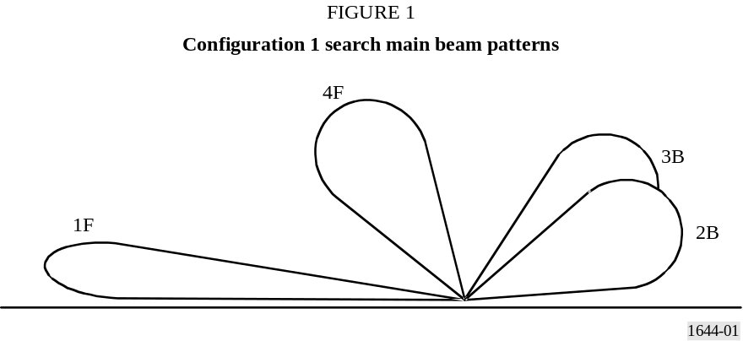
Azimuth rotation rate is 540°/s. On ships with two systems, each radar covers 310° of azimuth.
TABLE 1
Search antenna parameters – Configuration 1
Antenna position | Elevation beamwidth  (degrees) | Elevation beam centre  (degrees) | Gain  (dBi) | Azimuth beamwidth  (degrees)
1F  2B  3B  4F | 10  20  20  20 | 4.5  20  40  60 | 31.5  28.5  28.5  28.5 | 2.2  2.2  2.2  2.2

Configuration 2 elevation coverage is accomplished using two 2.5° antennas centred at 0° (1F and 2B) and two 10° antennas (3B and 4F) centred at 6.25 and 16.25 respectively. Figure 2 presents the composite elevation coverage pattern with all antennas superimposed. Table 2 lists parameters of the search antennas.
Azimuth rotation rate is 540°/s. On ships with two systems, each radar covers 310° of azimuth.
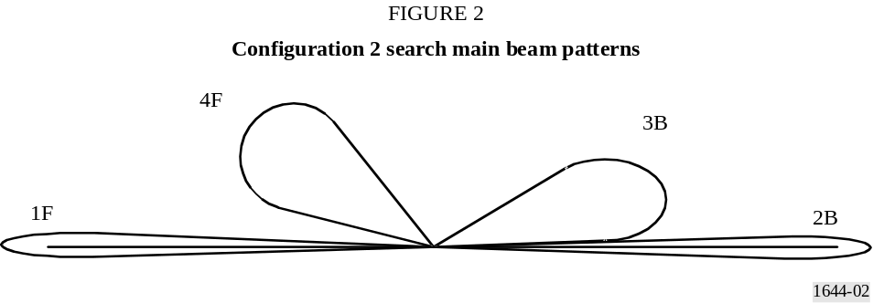
TABLE 2
Search antenna parameters – Configuration 2
Antenna  position | Elevation beamwidth  (degrees) | Elevation beam centre  (degrees) | Gain  (dBi) | Azimuth  beamwidth  (degrees)
1F  2B  3B  4F | 2.5  2.5  10  10 | 0  0  6.25  16.25 | 37.5  37.5  31.5  31.5 | 2.2  2.2  2.2  2.2

[TABLE 3
Radar antenna off-axis gain in azimuth
Off-axis angle  (degrees) | Configuration 1 gain  (dBi) | Configuration 2 gain  (dBi)
–180 | 0 | 0
–10 | 0 | 0
–9.5 | 2 | 8
–4.5 | 8 | 14
–3.3 | 23.7 | 29.7
–3 | 24 | 30
–2.5 | 26.9 | 32.9
–1.5 | 29.2 | 35.2
–1.1 | 31.2 | 37.2
0 | 31.5 | 37.5
1.1 | 31.2 | 37.2
1.5 | 29.2 | 35.2
2.5 | 26.9 | 32.9
3 | 24 | 30
3.3 | 23.7 | 29.7
4.5 | 8 | 14
9.5 | 3 | 8
10 | 0 | 0
180 | 0 | 0

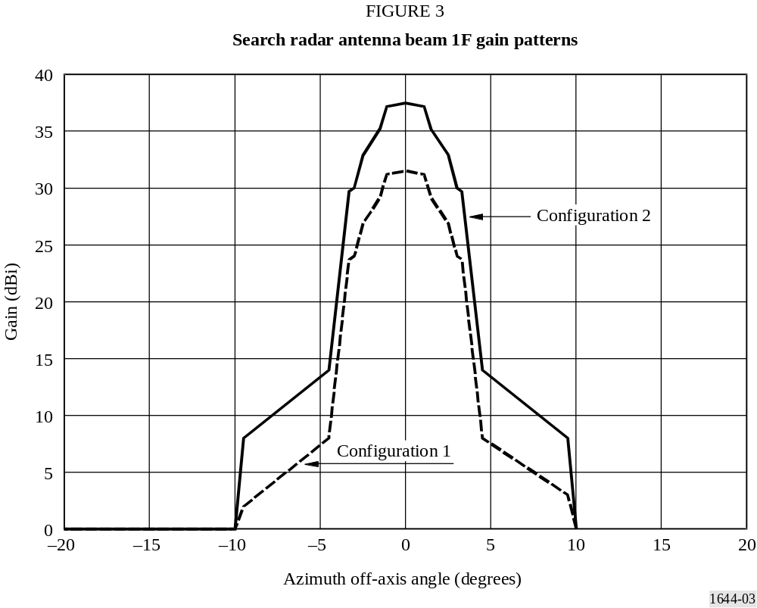
Recommendation ITU-R M.1851 cosine model can be used to model the complete antenna pattern.]
[Editor’s note: More consideration is needed for updating the antenna pattern.]

2.2.3.2 Track antenna
The track antenna is a monopulse four-horn fed parabolic dish segment with elevation beamwidth of 1.2° and azimuth beamwidth of 2.4°; gain is 38.5 dBi and side lobe levels are more than 20 dB below the main lobe. When designated to acquire a target, the antenna executes a limited size raster pattern and goes into track when the target is detected.
[Recommendation ITU-R M.1851 cosine model can be used to model the track antenna.]

2.2.4 Radiolocation system modifications
Radar detection of objects at low-elevation angles is being improved by increasing antenna gain on the horizon using existing search waveforms. Increased e.i.r.p. levels will be transmitted with the scan beam centred on the horizon as follows:
Peak e.i.r.p. < 2° elevation = 79 dBW: average e.i.r.p. = 64 dBW (search mode)
Peak e.i.r.p. > 2° elevation = 79 dBW: average e.i.r.p. = 59 dBW (track mode).
The modified search antenna aperture is identical to the existing track antenna aperture. The modified search antenna is only used below 2° elevation. The original track antenna is the source of the maximum peak and average e.i.r.p. (79 dBW and 59 dBW respectively). In the modified radar, the peak e.i.r.p. will remain at 79 dBW since the track and low-elevation search apertures is the same, but the average e.i.r.p. below 2° (search) increases due to the greater pulse widths used in search than in track.

2.3 Operational characteristics

2.3.1 System radiation time
For deployed ships/systems, when the ships are in potentially hazardous areas, the systems must radiate continuously.

2.3.2 Radiolocation system geographic distribution
[Approximately 800 of these radars are in use So far as interactions with geostationary satellites are concerned, it can be assumed that the radars are uniformly distributed on the Earth’s sea surface and that one-third of them are visible to a geostationary satellite. However, locally up to 70 of these radars could be operating within a 200 km² area and located from 1 km offshore to the radar horizon.
The number of radars operating in the 13.75-14 GHz band is approximately 333.]
[Editor’s note; From Doc. 5B/396: “There’s a need to understand this number, whether it is maintained since it was first introduced, increased/decreased, what is the source? This figure has to be factual, objective and information-based.”]
The probability, P_{c}, that a single FSS transmitter would operate co-frequency with a given radar operating in the 13.75-14 GHz band is approximately:
Pc = BW / 250
where BW is the interferer’s bandwidth (MHz).
The probability that an interferer’s emission spectrum would overlap the passband of one or more radars aboard a cluster of ships can be much higher than that.

2.3.3 Range of radiolocation antenna heights
The system mount deck height varies from 3 to 36 m above the waterline. The search antenna is approximately 5 m above the deck and the track antenna is approximately 4 m above the deck.

3 Airborne radars description

3.1 Technical characteristics
The radars D, E and F of the Table 4 in Appendixes 1 and 2 to this Annex describe typical characteristics of airborne radar systems operating in the band 13.75-14 GHz.

3.2 Operational characteristics
Airborne radars are operating from take-off until landing during the whole flight and are able to point in multiple directions.
Among the various possibilities of radar antenna pointing for tracking functions, some operational scenario to be considered are capacities to track in all or part of the elevation range from 0° (corresponding to the horizontal) to -90° (corresponding to down angles) and in various sectors splitting 360° in azimuth.
Among the various possibilities for program search functions, two of the operational scenarios to be considered are capacities to search a continuous scan by sweeping:
‒ in sectors from different angular sizes in azimuth and from 0° to -90° in elevation or
‒ in 360° in azimuth of the radar antenna pointing for various elevations from 0° to -90°.

4 Criteria for protection of the radars

4.1 Surveillance and track requirements
This radiolocation device is not only a traditional surveillance type radiolocation device, but may also be an integrated part of a larger surveillance system provided to protect a ship or an area from incoming threats. Its use is driven by the threat environment and could occur anywhere. The demand for use is 100% for example when operating close to shorelines for shipborne radar. Consequently due to the operational nature of the missions carried out with the radars operating in the 13.75-14 GHz frequency band, whether shipborne, airborne or ground based, it has to be taken into account that these radars are operated continuously throughout the duration of their missions in which their protection needs to be ensured.

4.2 Interference threshold
Recommendation ITU-R M.1461 – Procedures for determining the potential for interference between radars operating in the radiodetermination service and systems in other services, contains information on the interference threshold power level to be used in calculations of the potential for interference into radars.

An increase of I₀ + N₀, relative to N₀, of about 1 dB would constitute significant degradation for the radiolocation service, even if it occurs only when the interference couples via the radar main beam. Such an increase corresponds to an (I + N)/N ratio of 1.26, or an I/N ratio of about –6 dB.
This applies to the aggregate effect of multiple interferers, when present; the tolerable I/N ratio for an individual interferer depends on the number of simultaneous interferers and their geometry, and needs to be assessed in the context of a given scenario.
Because the –6 dB I/N ratio desensitization threshold applies when the strongest coupling condition occurs, including coupling via the radar’s main beam, as well as when coupling is weaker (as via radar-antenna side-lobes) it can be expressed for any particular radar as a pfd limit. For the shipborne systems, if the antenna main beam capture area is 0.5 m², the desensitization threshold for interference from communications transmitters will then be –164 dB(W/(m² ⋅ 4 kHz)) for coupling via the main beam.
For coupling via side-lobes or a combination of main beam and side-lobes from multiple sources, the impinged pfd’s must be weighted according to the pertinent side-lobe suppression factors and aggregated before comparing them with this pfd limit. If that limit is exceeded for any radar beam-pointing direction, it will unacceptably degrade radar coverage.
The effect of pulsed interference is more difficult to quantify and is strongly dependent on receiver/processor design and mode of operation. In particular, the differential processing gains for valid-target return, which is synchronously pulsed, and interference pulses, which are usually asynchronous, often have important effects on the impact of given levels of pulsed interference. Several different forms of performance degradation, notably including false target generation, can be inflicted by such unwanted pulsed signals. In general, numerous features of radiodetermination radars can be expected to help suppress low-duty cycle pulsed interference, especially from a few isolated sources. Techniques for suppression of low-duty cycle pulsed interference are contained in Recommendation ITU-R M.1372 – Efficient use of the radio spectrum by radar stations in the radiodetermination service.

In order that the shipborne radar might be able to effectively locate and discriminate targets in the presence of noise-like continuous interference, the above aggregate interference threshold level of -164 dB(W/(m² ⋅ 4 kHz)) must not be exceeded at the radars described in § 2. .

5 Tabular summary of characteristics
The characteristics of the radars described in § 2 through 4 are summarized in Appendix 1, separately for the search and track functions for relevant radars. These radars operate in all ITU-R regions.
The protection criteria for these other radars in the presence of interferences consists of an I/N ratio of –6 dB. Interference received via side-lobes and/or from multiple sources must be weighted according to side-lobe suppression factors and aggregated.

Part 2
Appendix 1
to Annex 1
TABLE 4
Characteristics | Radar A  Track | Radar B  Search |  | Radar D | Radar E | Radar F | Radar G  Track |  | Radar H
Platform type (airborne, shipborne, ground) | Shipborne | Shipborne |  | Airborne | Airborne | Airborne | Ground |  | Ground
Type of service  Radiolocation: RL  [Radionavigation: RN] | RL | RL |  | RL | RL | RL | RL |  | RL
Frequency range (GHz) | 13.75-14 | 13.75-14 |  | 13.75-14 | 13.75-14 | 13.75-14 | 13.75-14 |  | 13.75-14
Modulation (unmodulated pulses, chirp, phase-code) | Unmodulated | Unmodulated and phase code |  | Not given | Not given | Not given | Unmodulated and chirp pulses |  | Pulsed
Transmitter peak power into antenna (dBW) | 41 | 40 |  | Not given | Not given | 40 | 25.5 (nomimal) |  | [39]
Average e.i.r.p. (dBW) | 59.5 (62.5 in acquisition) | 63 (currently ≤ 58.2) |  | Not given | Not given | 30.4 to 41.4 (nominal) | 47.64 |  | Not given
Average e.i.r.p. density at antenna port (dBW/MHz) | / | / |  | 25 | 28 | 14 to 39 | / |  | Not given
Peak e.i.r.p. (dBW) | 79.5 | 79 |  | > 40 | > 50 | 60 to 71 (nominal) | 61.5 |  | [80.6]
Peak e.i.r.p. density at antenna port (dBW/MHz) | / | / |  | 45 | 55 | 43 to 68 | /
Pulse width minimum (μs) | 0.1 | 0.2 |  | Not given | Not given | 0.6 | 0.15 |  | 1
Pulse width maximum (μs) | 0.2 | 2.2 |  | Not given | Not given | Not given | 12.2 |  | 100
Pulse repetition rate minimum (pps) | 71 400 | 10 000 (2.2 μs  pulse width)  60 000 (2 μs  pulse width) |  | Not given | Not given | 1 800 | 2 700 |  | 4 000

TABLE 4 (continued)
Characteristics | Radar A  Track | Radar B  Search |  | Radar D | Radar E | Radar F | Radar G  Track |  | Radar H
Pulse repetition rate maximum (pps) | 100 000 | 14 000 (2.2 μs  pulse width)  100 000 (2 μs  pulse width) |  | Not given | Not given | Not given | 3 300 |  | 60 000
Transmit duty cycle, minimum (%) | 0.7 | 2.2 |  | Not given | Not given | 0.11⁽²⁾ | 3.33 |  | 20
Transmit duty cycle, maximum (%) | 2.0 | 3.7 |  | Not given | Not given | Not given | 4.08 |  | 40
RF emission bandwidth (MHz):  –3 dB | 10 | 5 |  | Not given | Not given | Not given | Not given |  | 9-150
Antenna pattern type (pencil, fan, cosecant-squared, etc.) | [Pencil beam/ ITU-R M.1851-2 cosine squared model]  Equation 10] | [Fan beam/ ITU-R M.1851-2 cosine model  Equation 10] |  | See Appendix 2 | See Appendix 2 | See Appendix 2 | [Fan/ITU-R M.1851-2 cosine squared model  Equation 11] |  | [ITU-R M.1851-2 uniform model  Equation 9]

TABLE 4 (continued)
Characteristics | Radar A  Track | Radar B  Sarchí |  | Radar D | Radar E | Radar F | Radar G  Track |  |  | Radar H
Antenna mainbeam gain(s) (dBi):  Search  Track | –  38.5 | 37.5 (currently ≤ 31.5)  – |  | See Appendix 2 | See Appendix 2 | See Appendix 2 | -  33-36 |  |  | [41.6]
Antenna elevation beamwidth (degrees) | 1.2 | 2.5 and 10  (currently 10 and 20. See p. 5 and 6) |  | See Appendix 2 | See Appendix 2 | See Appendix 2 | 15-20 |  |  | [0.73]
Antenna traverse or azimuthal beamwidth (degrees) | 2.4 | 2.2 |  | See Appendix 2 | See Appendix 2 | See Appendix 2 | 0.25-0.5 |  |  | [0.84]
Beam motion(s) | Tracking | Programmed search scan |  | Programmed search scan  Tracking | Programmed search scan  Tracking | Programmed search scan  Tracking | Tracking |  |  | Programmed  search scan  Tracking
Antenna horizontal scan rate (degrees/s) | Follows target | 540 |  | [Search: not given  Track: follows target] | [Search: not given  Track:  follows target] | [Programmed search scan  Tracking] | 60-108 |  |  | 213
Antenna horizontal scan type (continuous, random, 360°, sector, etc.) (degrees) | Follows target | Continuous over 180 |  | [Search: not given  Track: follows target] | [Search: not given  Track: not applicable] | [Search: not given  Track: not applicable] | Track: follows target, 360° |  |  | Raster
[Antenna vertical scan rate (degrees/s)] | [Not applicable] | [Not applicable] |  | [Search: not given  Track: not applicable] | [Search: not given  Track: not applicable] | [Not applicable] | [Not applicable] |  |  | 1 000

TABLE 4 (end)
Characteristics | Radar A  Track | Radar B  Search |  | Radar D | Radar E | Radar F | Radar G  Track |  |  | Radar H
[Antenna vertical scan type (continuous, random, 360º, sector, etc.) (degrees)] | [Not applicable] | [Step scan] |  | [Search: not given  Track: not applicable] | [Search: not given  Track: not applicable] | [Search: Not given  Track: not applicable] | [Not applicable] |  |  | Raster
Antenna side-lobe (SL) levels (1st SLs and remote SLs) | –18.5 dB | –15.5 dB |  | See Appendix 2 | See Appendix 2 | See Appendix 2 | ‒23 dB or less |  |  | [13 dB]
Antenna height (m) | 41 | 41 |  | ≤ 15 000 | ≤ 15 000 | ≤ 15 000 | 40-240 |  |  | 30 to 300
Receiver IF 3 dB bandwidth (MHz) | 10 | 10 |  | 10;50 | 10;50 | 10;50 | 14 (nominal) |  |  | [62.5]
Desensitization threshold pfd (dB(W/(m² ⋅ 4 kHz)) | –164 | –164 |  | –145 | –155 | –156 | ‒161 |  |  | [-169]
Receiver noise level including noise figure (10 MHz bandwidth) | –129 dBW | –129 dBW |  | ‒129 dBW | ‒132 dBW | ‒130 dBW | Estimated  ‒127 dBW |  |  | -132 dBW
⁽²⁾ Duty cycle was calculated from the pulse width and pulse repetition rate provided.

[Editor’s note: Check the terminology “Annex 2”]
Appendix 2
to Annex 1
Antenna pattern for airborne radiolocation radar in 13.75-14 GHz
The following equations in the following table and parameters are recommended to calculate the antenna pattern while the gain level is above ‒10 dBi, otherwise the gain level is set to ‒10 dBi.
Relative shape of field distribution f(x) with pedestal C  where −1 ≤ x ≤ 1 | Directivity pattern F(μ)  (μ in radians) | Coefficient K  (°) | θ₃ half power beam-width (degrees) | μ (in radians) as a  function of θ₃ (in degrees)
C+1-Ccosπx2  with C=0.0007(SLL+22.7)3-0.006SLL+22.72+0.09SLL+22.7+0.1) | Csinμμ+(1-C)2πcosμ1-2μπ2C+(1-C)2π | K=-0.0117SLL+22.73+0.217SLL+22.72-2.46SLL+22.7+64.2 | Kλl | π.K.sin(θ-ω)θ3

Note: These equations correspond to equations 3, 5, and 6 from Recommendation ITU-R M.1851.
With:
For radar D:
Gmax= 18 dBi, 3 dB beamwidth: 18° and SLL = 16 dB
For radar E:
Gmax= 25 dBi, 3 dB beamwidth: 8° and SLL = 18 dB
For radar F:
Gmax= 31 dBi, 3 dB beamwidth: 4° and SLL = 19 dB
The side lobe level (SLL) refers to the reduction in gain relative to the main beam gain.

The 3D representation is obtained by revolution in relation to the direction of maximum gain.

______________

1 The average powers given here are for periods of time equal to a fraction of a second, and should not be compared to the e.i.r.p. limit in No. 5.502 of the Radio Regulations, which applies for a period of time equal to one second.

