U.S. Radiocommunications Sector
Fact Sheet
Working Party: ITU-R WP 5C | Document No: USWP5C35-02
Ref: Document 5C/322 (Annex 2.2) | Date: October 1, 2026
Document Title: WORKING DOCUMENT ON SHARING STUDIES UNDER WRC-27 AGENDA ITEM 1.10
Author(s)/Contributors(s):  Zahid Islam  SpaceX  Joe McMichael  SpaceX  Nader Damavandi  SpaceX  Jameson Dempsey  SpaceX | Email: km.islam@spacex.com  Email: Joseph.McMichael@spacex.com  Email: Nader.Damavandi@spacex.com  Email: jameson.dempsey@spacex.com
Purpose/Objective: Add studies to the Working Doc on AI 1.10, i.e. 5C/322 (Annex 2.2)

Abstract: The last WP5C meeting in May 2026 finalized the CPM text for AI 1.10. The US proposed mask made it to the options. The US NGSO mask is equivalent to the one proposed by CEPT. It is methods A3 and A4 of the CPM. Studies showed how the proposed NGSO mask would protect FS victims with an elevation of 10 deg. With this input, the US will perform a very similar study as the one performed by CEPT. Additionally, another study is presented, which uses the “compromise” NGSO mask that is supposed to represent a solution to have a single mask at CPM in April 2027 and that the US can support. Lastly, a third study is added with the goal of pushing the “compromise” mask to the limit in order to understand up to which combination of max number of sats and N_co this mask protects the 10 deg victim case. The total number of non-GSO satellites in this last study is 153,268 and the aggregate Nco is190. This scenario is really extreme, thus giving additional certainty that the compromise mask is also future-proof. This study also aligns with the US proposal to include text referring to the operational parameters used in studies in relation to the proposed mask.

Radiocommunication Study Groups | 
Received: TBD November 2026  Source: Document 5C/322 (Annex 2.2)  Subject: AI 1.10 | Document TBD
 | Date:
 | English only
United States
WORKING DOCUMENT ON SHARING STUDIES UNDER AGENDA ITEM 1.10
The last WP5C meeting in May 2026 finalized the CPM text for AI 1.10. The US-proposed NGSO mask is contained method A4 of the CPM text. This mask is equivalent to the one proposed by CEPT and included in method A3. With this input, the US performed a study (Study #YZ) with this mask, showing protection for FS victims at 10-degree elevation. Additionally, a new study (Study #ZZ) is performed using the so-called compromise mask, i.e. a NGSO mask initially discussed during the 5C meeting in May 2026, which has the potential of meeting the needs of all interested stakeholders. Such a mask could be adopted as a single NGSO mask option already during CPM in April 2027. A further sensitivity study (Study #ZZ-2) is presented, including an additional non-GSO system (System-X), bringing the total number of non-GSO satellites to 153,268 and the aggregate $N_{co}$ to 190 This scenario is really extreme, thus giving additional certainty that the compromise mask is also future-proof. This is in response to the comments from some stakeholders with respect to scenarios exceeding the operational parameters agreed in the general guidance from November 2025. And indeed, the US is fine in including text in the CPM text referring to the operational parameters used in studies in relation to the proposed mask.

All three studies use the same dynamic method, WP 5C FS characteristics, a 10° FS elevation, and the same long-term and short-term I/N criteria. They differ in the non-GSO PFD mask and in how many non-GSO systems are included.

Study #YZ applies the US NGSO PFD mask of 5C/288 (CPM methods A3/A4; Table 2). Interferers are the four Table 1 non-GSO systems (B, D, L, M), with aggregate Nco = 90 and about 53,268 non-GSO satellites. Operational assumptions are conservative relative to the WP 4A liaison.

Study #ZZ keeps that scenario unchanged and substitutes the May 2026 WP 5C “compromise” mask (Table 4). The tighter 5°–15° segment reduces mid-elevation PFD relative to methods A3/A4.

Study #ZZ-2 is a sensitivity case on #ZZ. It adds non-GSO System-X (100,000 satellites, Nco = 100). The ensemble is five non-GSO systems, 153,268 satellites and aggregate Nco = 190.

Study #YZ
This study considers FS characteristics as provided in doc 5C/322 (Annex 2.2) and assuming 10 degrees as maximum elevation. With respect to the parameters of non-GSO systems (including minimum elevation, GSO exclusion zone, and max number of co-frequency beams at a specific location), the analysis considered cases with different operational conditions than those communicated by 4A as described below. The various assumptions different from the 4A liaison statement are on purpose all worse than the parameters communicated by 4A. That said, the assumptions remain within the envelope of parameters agreed as high-level guidance in November 2025 by WP5C. Additionally, the methodology considers scenarios with propagation characteristics as per Doc. 5C/74 (guidance provided by WP 3J and 3M).
The statistics of the interference power against time for each power flux density (PFD) mask specified is calculated at each timestep using the method described below:

1) Collocate an FSS earth station (ES) with the terrestrial FS station.
2) Based on the parameters of the selected non-GSO systems, determine number of visible satellites to the FS station, $N_{v}$ (satellites above an elevation angle of 0°).
3) Determine the pool of eligible satellites for each of the selected non-GSO systems complying with the system-specific minimum elevation angle, $ε$, and minimum GSO exclusion angle, $α$ at the ES location.
4) Select maximum number of non-GSO satellites allowed to transmit with overlapping frequencies towards the same location on the ground, $N_{co},$ using random satellite selection strategy. Determine the contribution from the $N_{co}$ satellites to the FS station.
$I_{N_{co}}= PFD-10\log_{10}\left(\frac{4π}{λ^{2}}\right)- L_{a}+G\left(α\right)$ (eq. 1)
$PFD$ is the assumed power flux density at the Earth’s surface in dB(W/m²/MHz) under free-space condition
$λ$ is the wavelength in meters
$L_{a}$ is the atmospheric loss (gaseous attenuation) experienced by non-$N_{co}$ satellites of NGSO link when performing dynamic simulation. Such propagation loss should be considered based on ITU-R Recommendations ITU-R P.676 when applicable.
$G\left(α\right)$ is the gain of the FS receiving antenna at off-axis angle $α$ degrees

5) For the remaining visible $N_{v}- N_{co}$ satellites (also known as non-$N_{co}$ satellites), determine contribution of the sidelobes towards the FS station assuming random placement of the beams from the satellite with its field of view.
$I_{{non-N}_{co}}= EIRP\left(θ\right)-20\log_{10}\left(\frac{4πd}{λ}\right)- L_{a} +G\left(α\right)$ (eq. 21)
$EIRP\left(θ\right)$ is the assumed effective isotropic radiated density from the non-$N_{co}$ satellite to the FS station direction in dB(W/MHz) at off-axis angle $θ$ degrees. Peak EIRP of the non-$N_{co}$ satellite is calculated for that satellite to maintain the PFD under free-space condition according to the proposed PFD mask given a randomly selected scan angle within its eligible scan angles.
$λ$is the wavelength in meters
$d$is the distance between the non-$N_{co}$ satellite and FS station in meters
$L_{a}$ is the atmospheric loss (gaseous attenuation) experienced by non-$N_{co}$ satellites of NGSO link when performing dynamic simulation.
$G\left(α\right)$ is the gain of the FS receiving antenna at off-axis angle $α$ degrees

6) Aggregate power levels received at the FS station by combining the received interference power from all $N_{v}$ satellites of the non-GSO systems.
7) Aggregate power levels received at a FS station by combining the received interference power from the selected non-GSO systems. The FS station effective system noise temperature is also increased with atmospheric attenuation according to equation (69) in ITU-R P.618-14 and ITU-R P.676-13 Section 4, when atmospheric effect (gaseous attenuation) is considered in simulation.

Parameters of the Selected non-GSO Systems
The selected parameters of the selected four non-GSO systems are shown in Table 1. According to the WP4A guidance, 1.5° minimum angular separation is used among the three non-GSO systems’ beams serving the same location on Earth.
Table 1
Parameters of the Selected GSO and non-GSO Systems (as per 4A guidance)
GSO/Non-GSO System | Height  (km) | Number of planes | Satellites per plane | Inclination angle (deg) | Number of co-frequency beams, $N_{co}$ | Min. GSO Exclusion angle, $α$
System-B (non-GSO) | 590, 610, 630 | 28, 36, 34 | 28, 36, 34 | 33, 42, 51.9 | 32 | 1°
System-D (non-GSO) | 1050 | 12 | 28 | 89 | 8 (assumed) | 1°
System-L (non-GSO) | 500, 500, 600, 600, 700, 700, 800, 800, 900, 900, 1000, 1000, 1100, 1100, 1200, 1200, 1300, 1300, 1400, 1400, 8100, 8100, 8100, 8100, 8100, 8100, 8100, 8100, 12000, 12000, 12000, 12000, 12000, 12000, 12000, 12000, 16000, 16000, 16000, 16000, 16000, 16000, 16000, 16000, 20000, 20000, 20000, 20000, 20000, 20000, 20000, 20000, 23222, 23222, | 36, 36, 36, 36, 34, 34, 30, 30, 28, 28, 24, 24, 24, 24, 22, 24, 20, 20, 18, 18, 1, 12, 12, 12, 12, 12, 12, 12, 1, 12, 12, 12, 12, 12, 12, 12, 1, 12, 12, 12, 12, 12, 12, 12, 1, 12, 12, 12, 12, 12, 12, 12, 1, 12 | 36, 36, 32, 32, 32, 32, 32, 32, 30, 30, 24, 24, 24, 24, 24, 24, 24, 24, 20, 20, 96, 10, 10, 10, 10, 10, 10, 10, 96, 10, 10, 10, 10, 10, 10, 10, 96, 10, 10, 10, 10, 10, 10, 10, 96, 10, 10, 10, 10, 10, 10, 10, 96, 9 | 50, 85, 50, 85, 50, 85, 50, 85, 50, 85, 50, 85, 50, 85, 50, 89, 50, 85, 50, 85, 0, 15, 45, 60, 65, 70, 75, 80, 0, 15, 45, 60, 65, 70, 75, 80, 0, 15, 45, 60, 65, 70, 75, 80, 0, 15, 45, 60, 65, 70, 75, 80, 0, 56 | 10  (assumed) | 1°
System-M (non-GSO) | 340, 345, 350, 360, 525, 530, 535, 604, 614 | 12, 18, 48, 48, 48, 30, 28, 28, 28 | 110, 110, 110, 120, 120, 120, 120, 12, 18 | 53, 46, 38, 97, 53, 43, 33, 148, 116 | 40  (assumed) | 1°

This study considers the following operational conditions for the GSO and non-GSO systems:
- There is a total of 18 identical GSO systems along with the three non-GSO systems. The satellites are assumed to be spaced on the GSO arc every 3° between 22.5°W to 28.5°E.

- $N_{co}$ of System-M is assumed to be 40.

PFD masks
Table 2 lists the pfd mask used in the Study #YZ for the selected non-GSO systems. This is the identical PFD mask proposed by US in 5C/288 as method for the non-GSO FSS to satisfy the agenda item. All satellites that are in view of the FS station are assumed to be possibly interfering satellites for this study. The $N_{co}$ satellites transmitting towards the location of FS station are randomly selected from each set of prospective transmitting satellites.
Table 2
PFD masks for the Selected non-GSO systems
PFD in dB(W/m²) for angles of arrival ($δ$)  above the horizontal plane |  |  |  | Reference Bandwidth
0°-5° | 5°-12° | 12°-15° | 15°-90° | Reference Bandwidth
-125 | -125+1.43($δ-5$) | -115+3.33($δ-12$) | -105 | 1 MHz

FS Link Characteristics
FS link characteristics has been used following WP 5C guidance as listed in Table 3.
Table 3
FS Link Characteristics
Parameters | Specifications
Frequency (GHz) | 73.5
FS Antenna maximum Receive Gain (dBi) | 41.5 (0.2 m), 51(0.6 m)
FS Antenna Pattern | Rec. ITU-R F.1245-3,  EN 302 217-4 Class-3
Latitude (degrees) | 24° N, 45° N and 60° N
Longitude (degrees) | 3° E
Elevation Angles | 10°
Receiver Noise Figure (dB) | 8
Antenna height(m) above mean sea level (AMSL) | 30
Above mean sea level (AMSL) (m) | 24° N, 3° E: 528 m  45° N, 3° E: 1014 m  60° N, 3° E: 0 m

The protection criteria for FS safeguard used in this analysis are:
a Long-term: I/N should not exceed –10 dB for more than 20% of the time (derived from Recommendation ITU-R F.758-8)
b Short-term: I/N should not exceed +11 dB for more than 0.00128% of the time in any month.

Results of study # YZ

ITU-R F.1245-3 FS station antenna pattern
Figure 1-6 shows aggregate I/N from the selected four non-GSO systems for
the ITU-R F.1245-3 FS station antenna pattern,
pointing at two different azimuth directions (results can be provided with 20° intervals upon request)
at a representative frequency (i.e., 73.5 GHz)
Figure 1
Aggregate I/N from Selected Systems at 24°N, Azimuth 0°
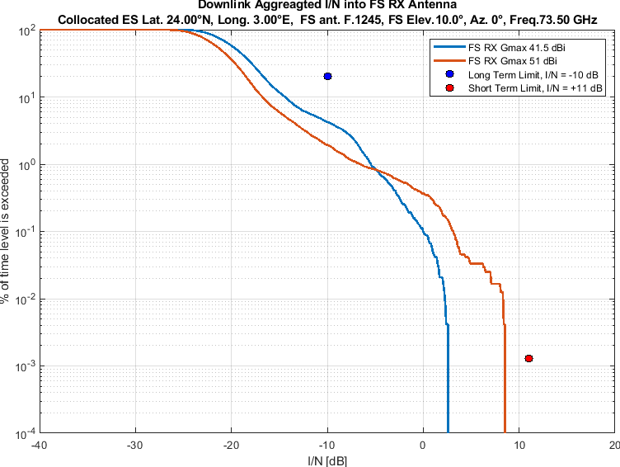
Figure 2
Aggregate I/N from Selected Systems at 24°N, Azimuth 180°
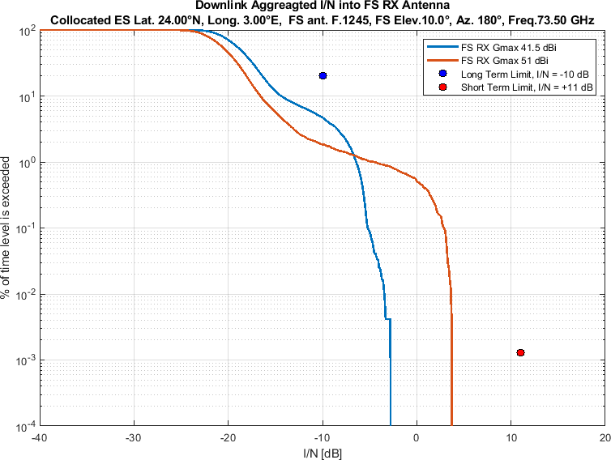
Figure 3
Aggregate I/N from Selected Systems at 45°N, Azimuth 0°
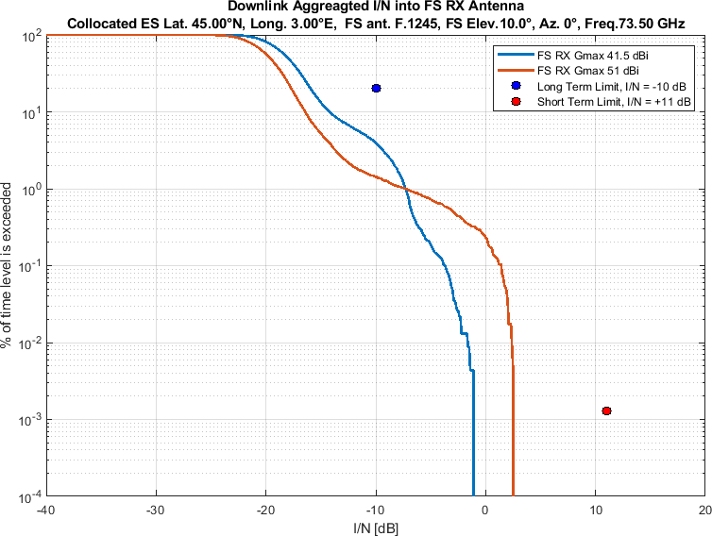
Figure 4
Aggregate I/N from Selected Systems at 45°N, Azimuth 180°
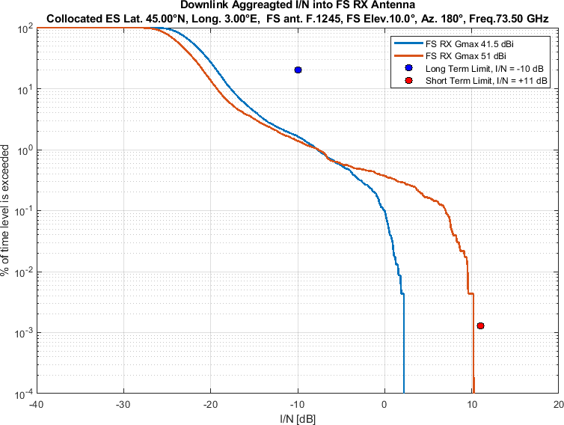

Figure 5
Aggregate I/N from Selected Systems at 60°N, Azimuth 0°
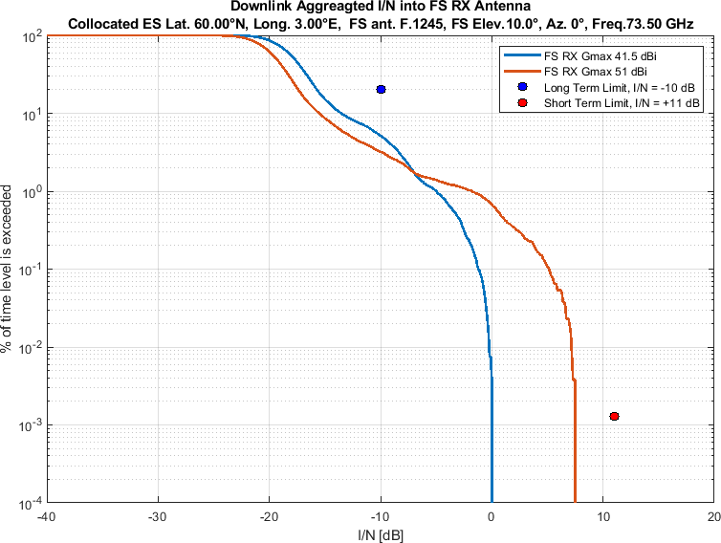
Figure 6
Aggregate I/N from Selected Systems at 60°N, Azimuth 180°
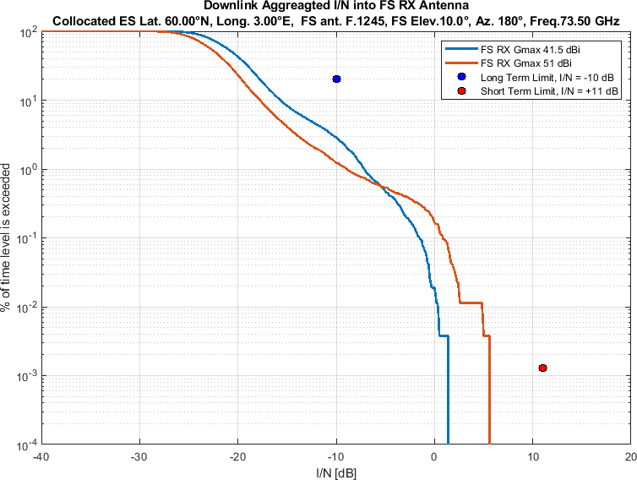

EN 302 217-4 Class-3FS station antenna pattern
Similarly, Figure 7-12 shows aggregate I/N from the same selected four non-GSO systems for
the EN 302 217-4 Class-3 FS station antenna pattern,
pointing at two different azimuth directions (results can be provided with 20° intervals upon request)
at same representative frequency (i.e., 73.5 GHz)
Figure 7
Aggregate I/N from Selected Systems at 24°N, Azimuth 0°
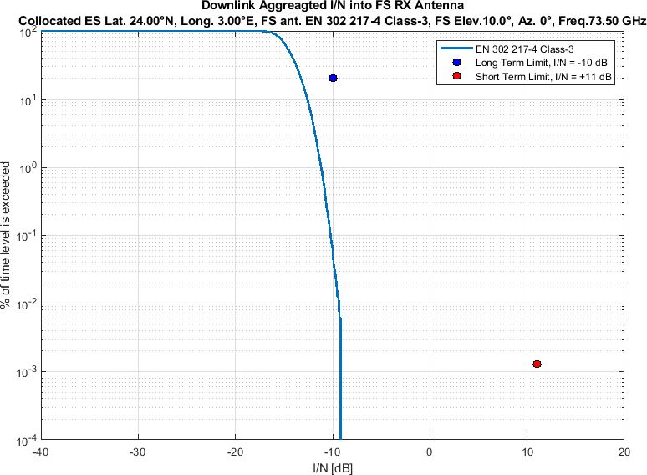
Figure 8
Aggregate I/N from Selected Systems at 24°N, Azimuth 180°
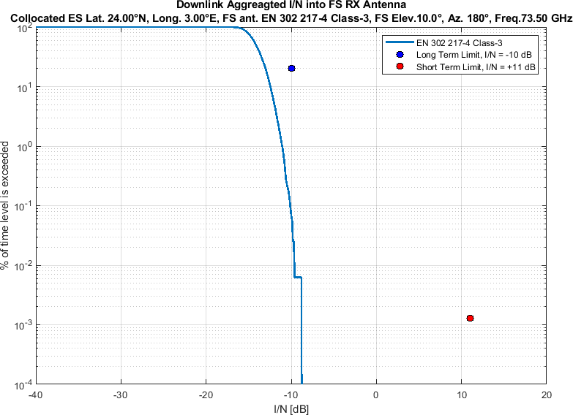
Figure 9
Aggregate I/N from Selected Systems at 45°N, Azimuth 0°
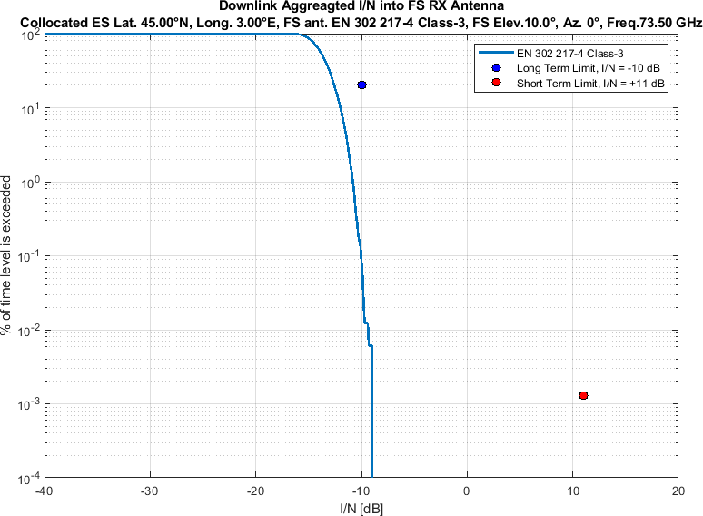
Figure 10
Aggregate I/N from Selected Systems at 45°N, Azimuth 180°
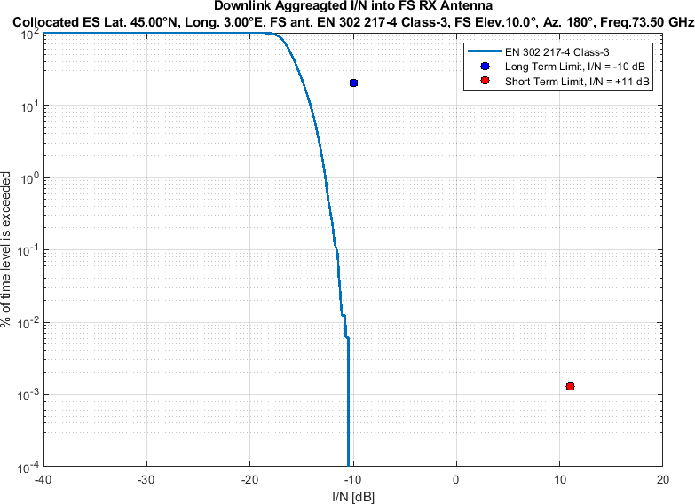

Figure 11
Aggregate I/N from Selected Systems at 60°N, Azimuth 0°
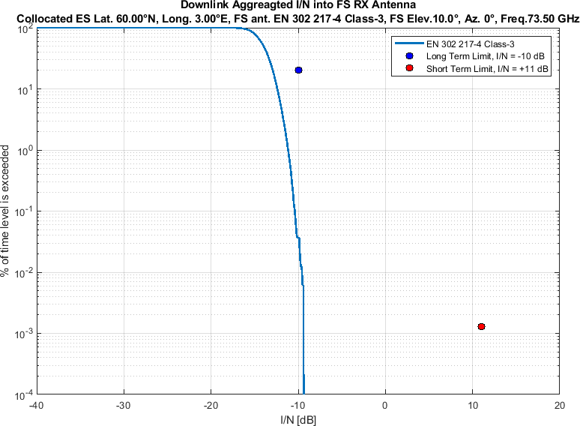
Figure 12
Aggregate I/N from Selected Systems at 60°N, Azimuth 180°
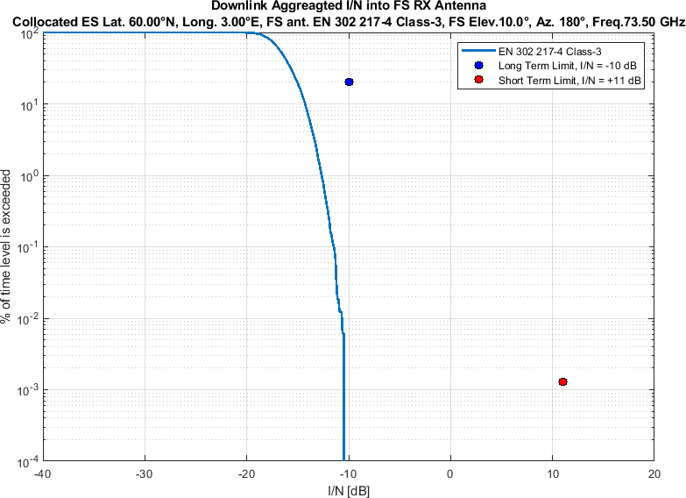

Study #ZZ

At the May 2026 meeting of WP 5C, an additional non-GSO PFD mask was informally discussed among the interested administrations and industry members. Table 4 presents this mask, and the following plot compares Table 1 and Table 4.
Table 4
Compromise non-GSO PFD mask initially discussed at the May 2026 WP 5C meeting
PFD in dB(W/m²) for angles of arrival ($δ$)  above the horizontal plane |  |  |  | Reference Bandwidth
0°-5° | 5°-10° | 10°-15° | 15°-90° | Reference Bandwidth
-125 | -125+0.8($δ-5$) | -121+3.2($δ-10$) | -105 | 1 MHz

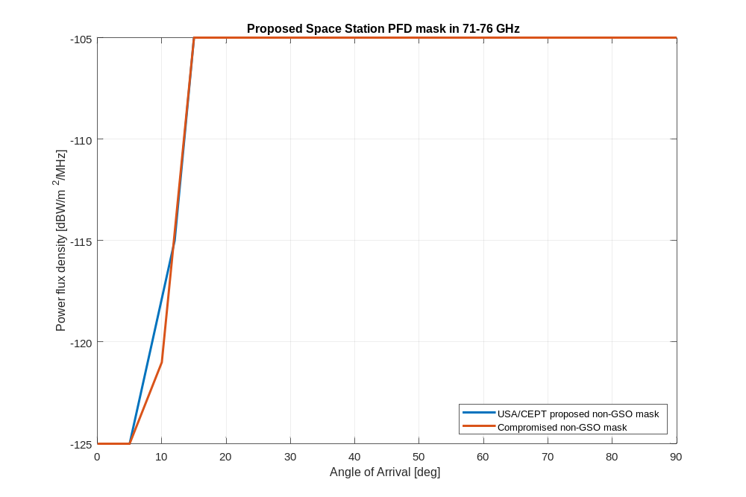
Study #ZZ uses NGSO PFD mask while keeping everything else as in Study #YZ; the methodology in steps 1)–7), the selected non-GSO systems and operational conditions (Table 1), the FS link characteristics (Table 3), and the long-term and short-term FS protection criteria are unchanged.

Results of study # ZZ

ITU-R F.1245-3 FS station antenna pattern
Figure 13-18 shows aggregate I/N from the selected four non-GSO systems for
the ITU-R F.1245-3 FS station antenna pattern,
pointing at two different azimuth directions (results can be provided with 20° intervals upon request)
at a representative frequency (i.e., 73.5 GHz)
Figure 13
Aggregate I/N from Selected Systems at 24°N, Azimuth 0°
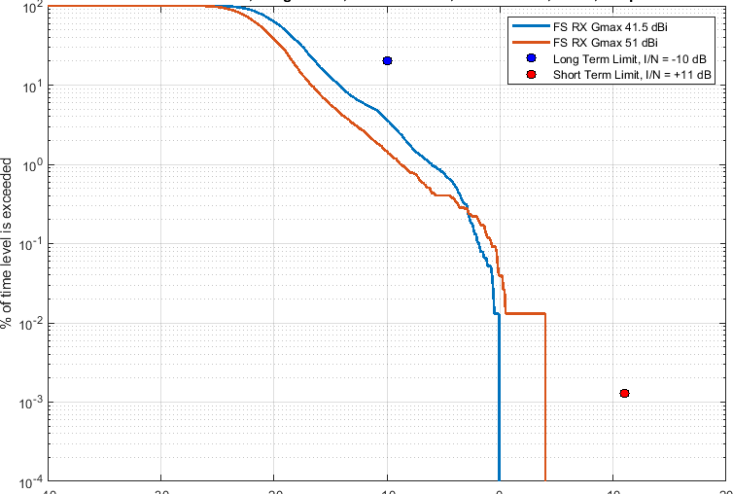
Figure 14
Aggregate I/N from Selected Systems at 24°N, Azimuth 180°
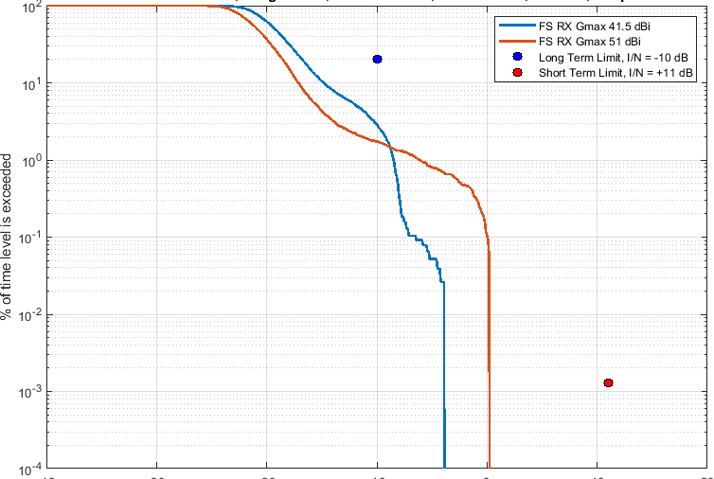
Figure 15
Aggregate I/N from Selected Systems at 45°N, Azimuth 0°
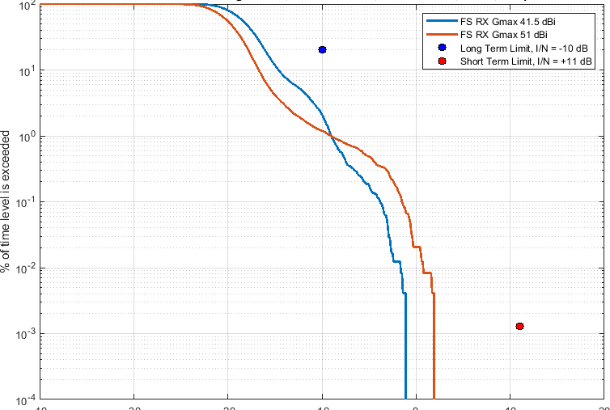
Figure 16
Aggregate I/N from Selected Systems at 45°N, Azimuth 180°
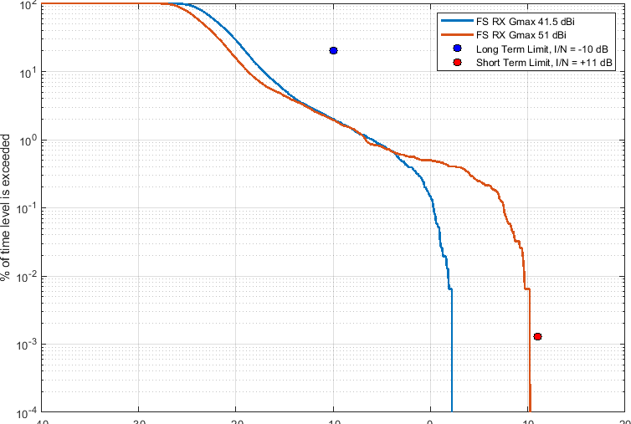

Figure 17
Aggregate I/N from Selected Systems at 60°N, Azimuth 0°
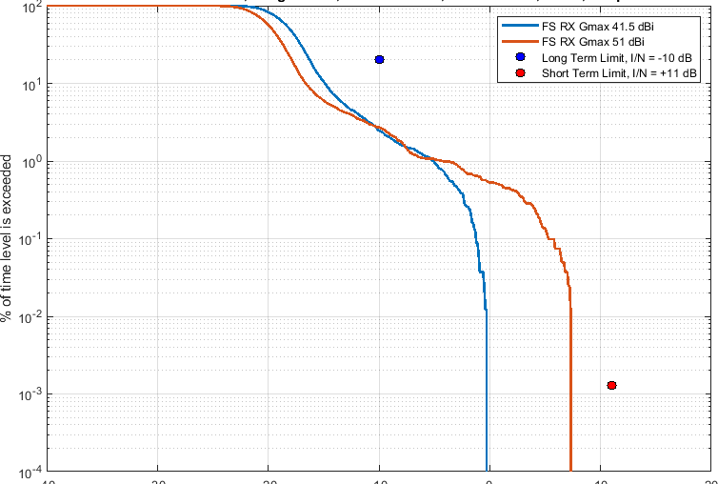
Figure 18
Aggregate I/N from Selected Systems at 60°N, Azimuth 180°
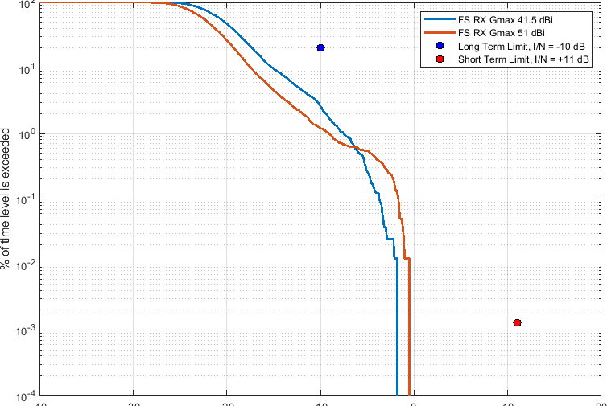

EN 302 217-4 Class-3FS station antenna pattern
Similarly, Figure 19-24 shows aggregate I/N from the same selected four non-GSO systems for
the EN 302 217-4 Class-3 FS station antenna pattern,
pointing at two different azimuth directions (results can be provided with 20° intervals upon request)
at same representative frequency (i.e., 73.5 GHz)
Figure 19
Aggregate I/N from Selected Systems at 24°N, Azimuth 0°
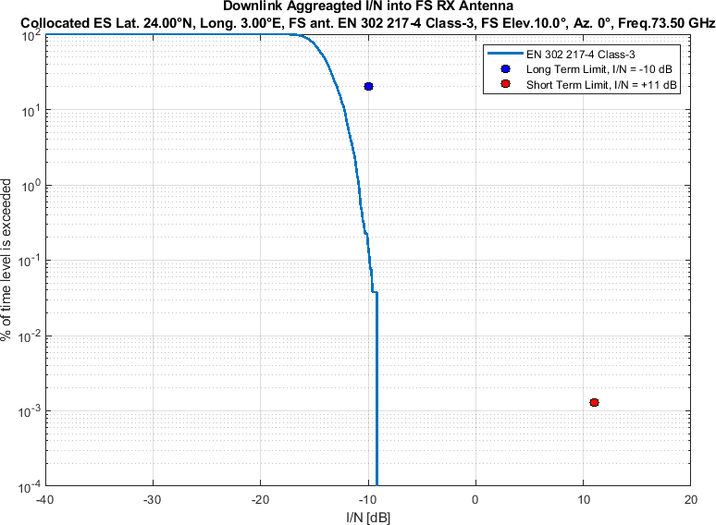
Figure 20
Aggregate I/N from Selected Systems at 24°N, Azimuth 180°
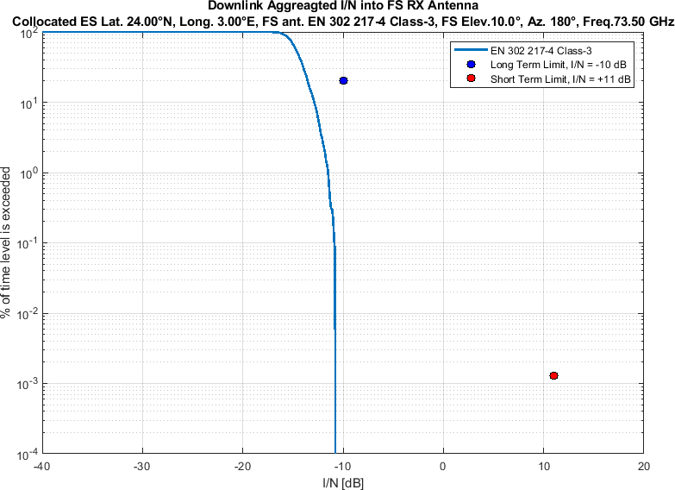
Figure 21
Aggregate I/N from Selected Systems at 45°N, Azimuth 0°
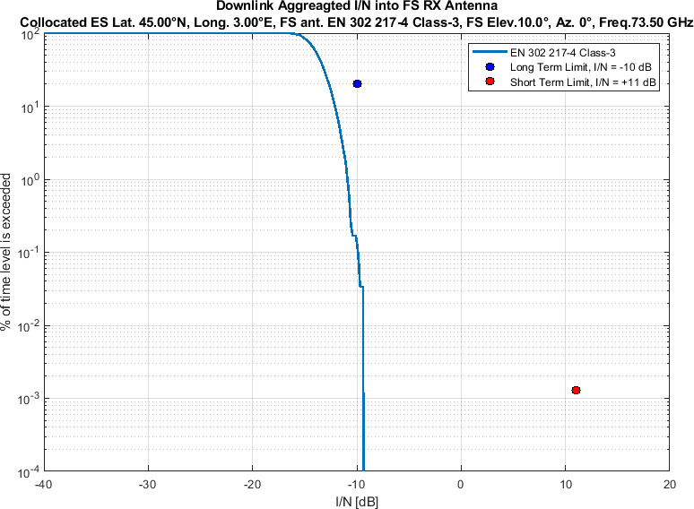
Figure 22
Aggregate I/N from Selected Systems at 45°N, Azimuth 180°
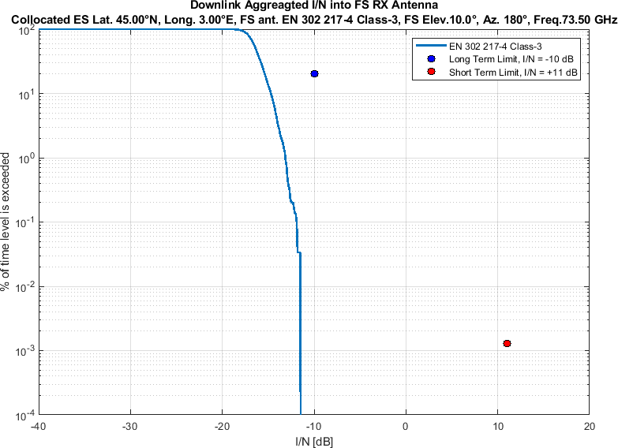

Figure 23
Aggregate I/N from Selected Systems at 60°N, Azimuth 0°
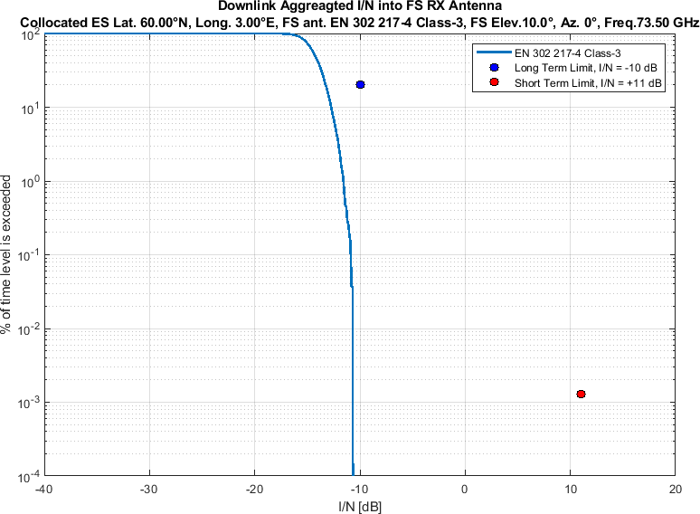
Figure 24
Aggregate I/N from Selected Systems at 60°N, Azimuth 180°
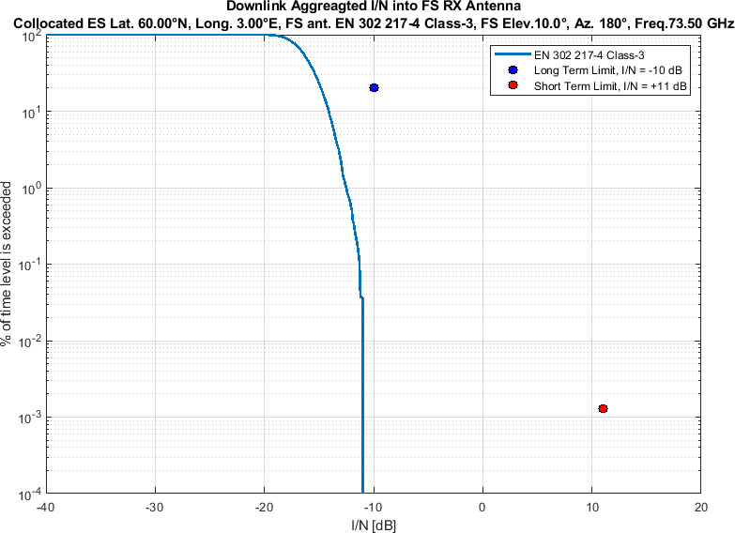

Study #ZZ-2

Study #ZZ-2 is a sensitivity analysis of Study #ZZ. The methodology in steps 1)–7), the FS link characteristics (Table 3), the compromise non-GSO PFD mask (Table 4), and the long-term and short-term FS protection criteria are unchanged. In addition to the four non-GSO systems in Table 1, an additional non-GSO system, System-X, is included. System-X is modelled with $N_{co}$ = 100. The 1.5° minimum angular separation among non-GSO systems’ beams serving the same location on Earth is retained. The resulting ensemble comprises 153,268 non-GSO satellites with an aggregate number of co-frequency beams $N_{co}$ = 190. Relative to the WP 4A guidance (56,000 non-GSO satellites and $N_{co}$ = 90), this represents an extreme scenario, with 2.7 times the total number of non-GSO satellites and 2.1 times the $N_{co}$. Table 5 summarises the sensitivity-case parameters.
Table 5
Sensitivity-case parameters for Study #ZZ-2
Parameter | Value
Additional non-GSO system | System-X
System-X Orbital configuration
  GSO/Non-GSO System | Height  (km) | Number of planes | Satellites per plane | Inclination angle (deg) | Number of co-frequency beams, $N_{co}$ | Min. GSO Exclusion angle, $α$
  System-X (non-GSO) | 323, 473, 323.5, 473.5, 324, 474, 324.5, 474.5, 325, 475, 325.5, 475.5, 326, 476, 326.5, 476.5, 327, 477, 327.5, 477.5 | 5000, 5000, 5000, 5000, 5000, 5000, 5000, 5000, 5000, 5000, 5000, 5000, 5000, 5000, 5000, 5000, 5000, 5000, 5000,  5000 | 1, 1, 1, 1, 1, 1, 1, 1, 1, 1, 1, 1, 1, 1, 1, 1, 1, 1, 1, 1 | 26, 26, 32, 32, 38, 38, 43, 43, 48, 48, 53, 53, 60, 60, 69, 69, 76, 76, 96.9, 96.9 | 100 (assumed) | 1°
$N_{co}$ of System-X | 100
$N_{co}$ exceedance relative to WP 4A guidance (Table 1 $N_{co}$ = 90) | 2.1 (190 / 90)
Total non-GSO satellites (Systems B, D, L, M and X) | 153,268
Totalnon-GSO satellites exceedance relative to Table 1 (56,000) | 2.7 (153,268 / 56,000)
Aggregate $N_{co}$ | 190
PFD mask | Compromise mask of Table 4
Other assumptions | Same as Study #ZZ

Results of study # ZZ-2

ITU-R F.1245-3 FS station antenna pattern
Figure 25-30 shows aggregate I/N from the selected five non-GSO systems (Table 1 plus System-X) for
the ITU-R F.1245-3 FS station antenna pattern,
pointing at two different azimuth directions (results can be provided with 20° intervals upon request)
at a representative frequency (i.e., 73.5 GHz)
Figure 25
Aggregate I/N from Selected Systems including System-X at 24°N, Azimuth 0°
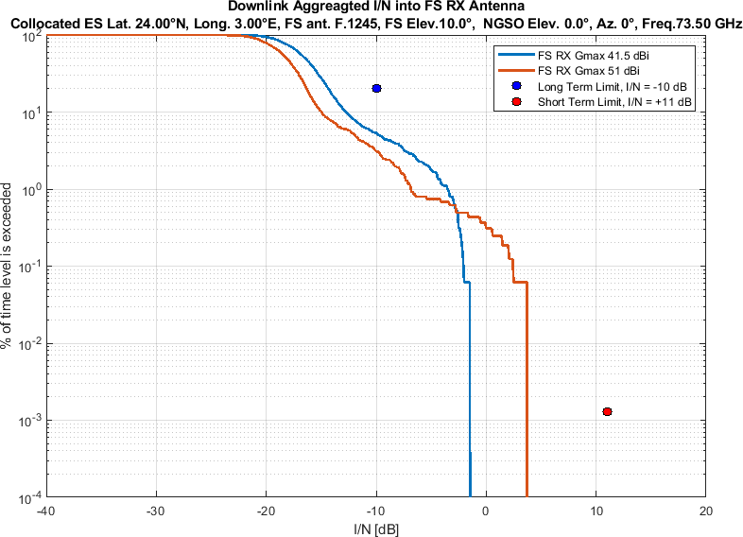
Figure 26
Aggregate I/N from Selected Systems including System-X at 24°N, Azimuth 180°
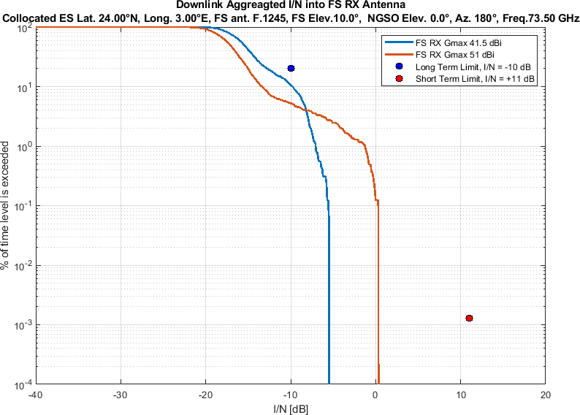
Figure 27
Aggregate I/N from Selected Systems including System-X at 45°N, Azimuth 0°
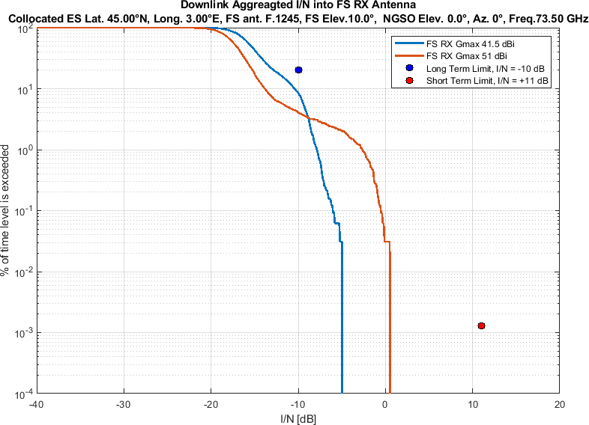
Figure 28
Aggregate I/N from Selected Systems including System-X at 45°N, Azimuth 180°
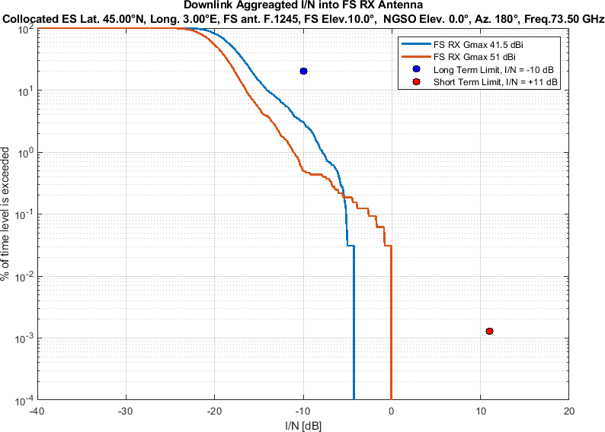

Figure 29
Aggregate I/N from Selected Systems including System-X at 60°N, Azimuth 0°
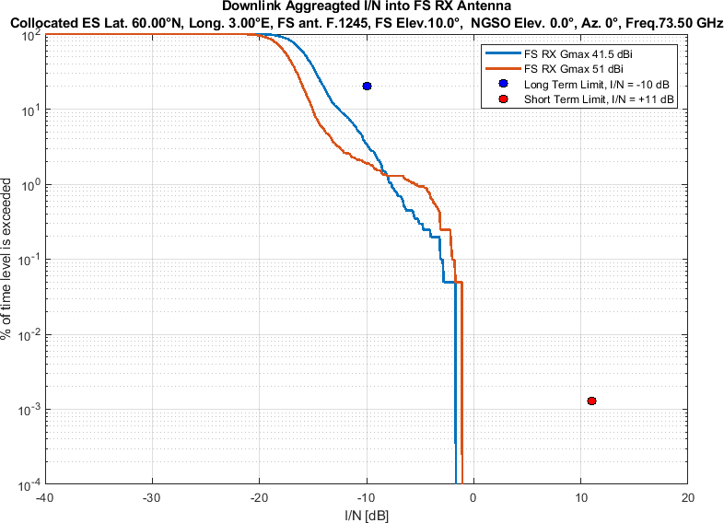
Figure 30
Aggregate I/N from Selected Systems including System-X at 60°N, Azimuth 180°
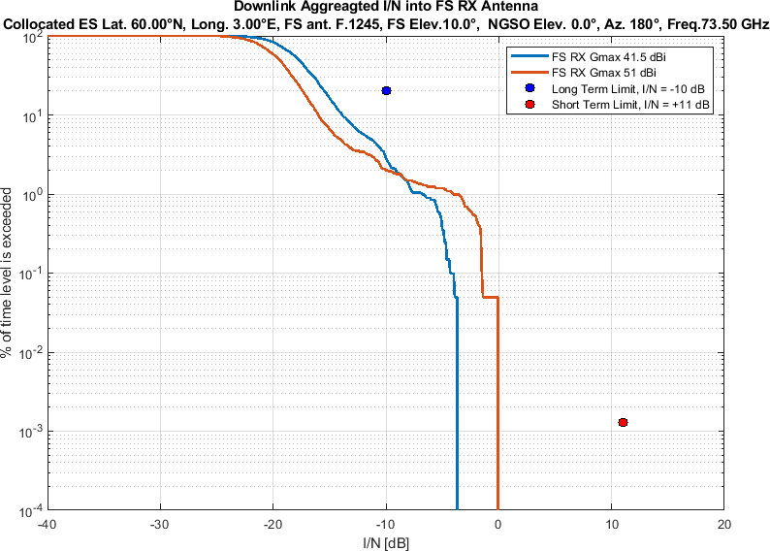

EN 302 217-4 Class-3FS station antenna pattern
Similarly, Figure 31-36 shows aggregate I/N from the same selected five non-GSO systems (Table 1 plus System-X) for
the EN 302 217-4 Class-3 FS station antenna pattern,
pointing at two different azimuth directions (results can be provided with 20° intervals upon request)
at same representative frequency (i.e., 73.5 GHz)
Figure 31
Aggregate I/N from Selected Systems including System-X at 24°N, Azimuth 0°
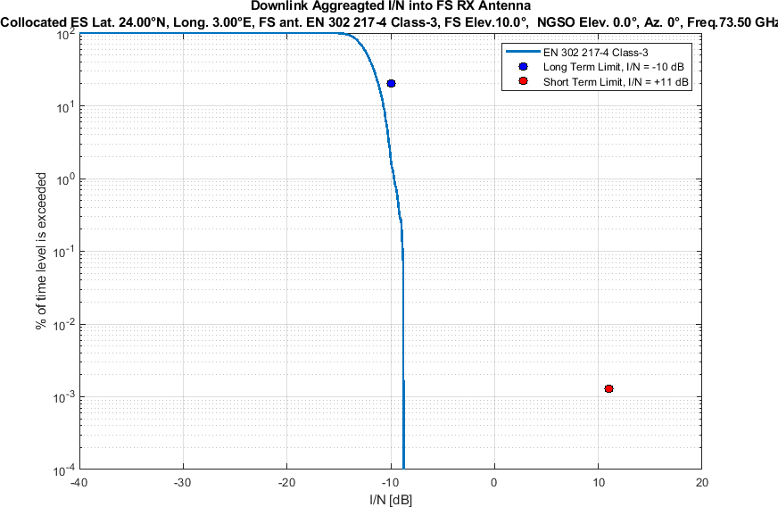
Figure 32
Aggregate I/N from Selected Systems including System-X at 24°N, Azimuth 180°
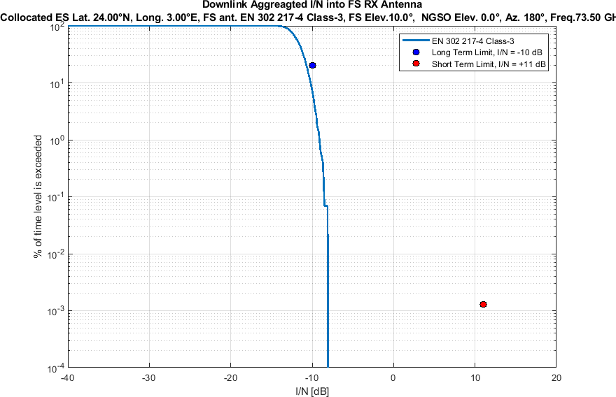
Figure 33
Aggregate I/N from Selected Systems including System-X at 45°N, Azimuth 0°
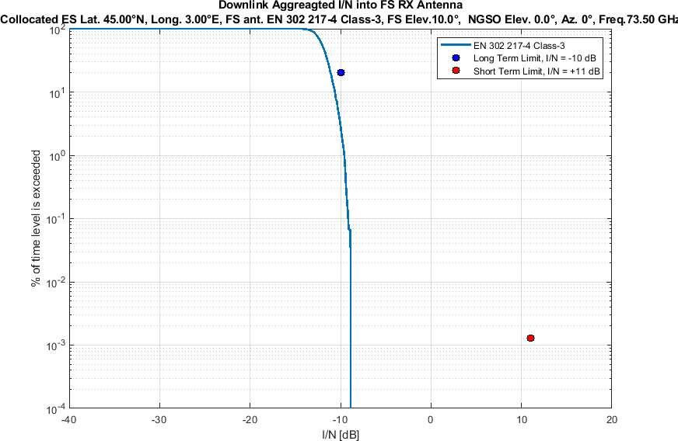
Figure 34
Aggregate I/N from Selected Systems including System-X at 45°N, Azimuth 180°
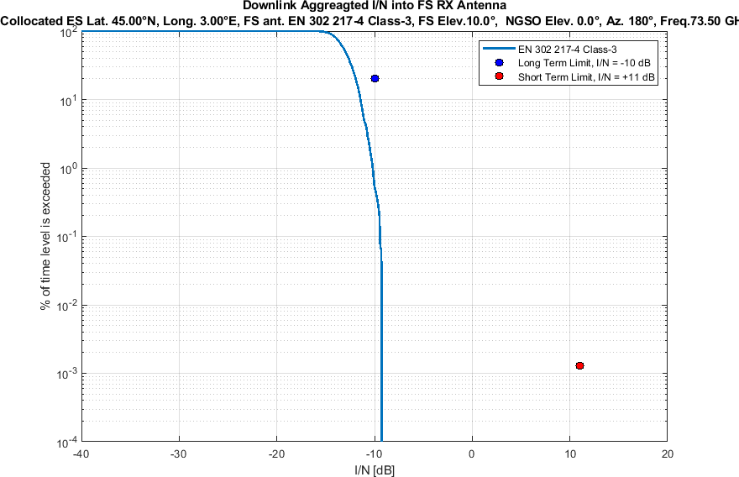

Figure 35
Aggregate I/N from Selected Systems including System-X at 60°N, Azimuth 0°
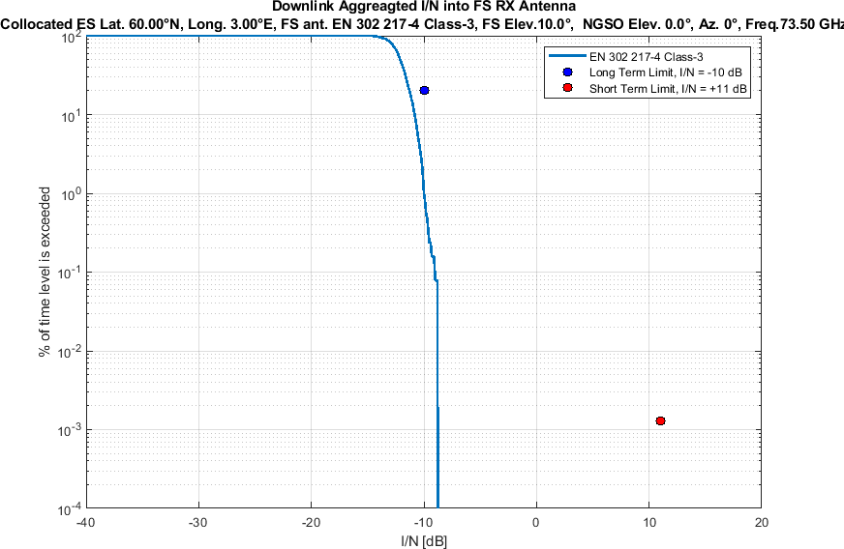
Figure 36
Aggregate I/N from Selected Systems including System-X at 60°N, Azimuth 180°
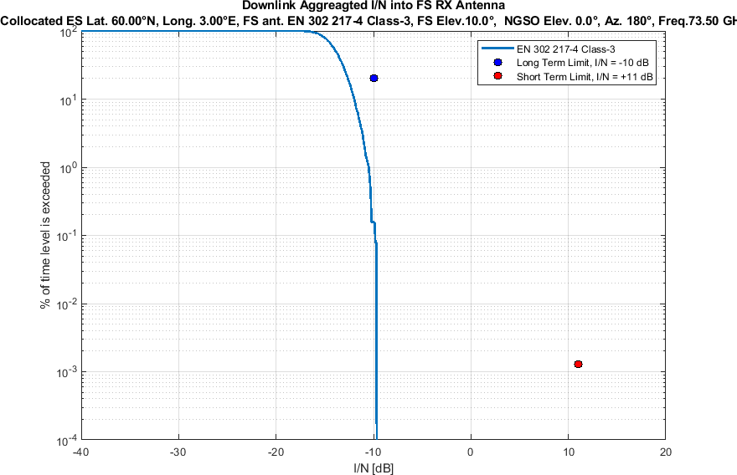

Conclusion

Studies #YZ, #ZZ and #ZZ-2 show protection of FS victims at 10-degree is ensured. Moreover, study #ZZ using the “compromise” mask presented informally in May 2026 introduces additional protection with respect to the NGSO mask in methods A3/A4. Study #ZZ-2 confirms that this protection is maintained in a sensitivity case that includes System-X, with 153,268 non-GSO satellites and aggregate $N_{co}$ = 190, exceeding WP 4A guidance by 100 co-frequency beams. Relative to Table 1, the exceeding factor is 2.7 for the total number of non-GSO satellites and 2.1 for $N_{co}$.

Sidelobe radiation pattern for each of the visible $N_{v}- N_{co}$ satellites of a non-GSO system have been calculated conservatively as per Recommendation ITU-R S.1528 recommends 1.2. In some other working parties’ studies, Recommendation ITU-R S.1528 recommends 1.4 has been considered for sidelobe radiation pattern. The satellite antenna transmit peak gain of 48 dBi, 48 dBi, 51.1 dBi and 52 dBi have been assumed for System B, System D, System L and System M, respectively, with L_n = -20 dB.
For interference analysis, minimum elevation angle 0° have been considered for the non-GSO systems.

