U.S. Radiocommunications Sector
Fact Sheet
Working Party: ITU-R WP5B | Document No: USWP5B37-03
Reference:  Document 5B/526 Annex 3.9 | Date: 1 October 2026
Document Title: WORKING DOCUMENT TOWARDS A PRELIMINARY DRAFT
NEW REPORT ITU-R M.[DIGITAL_VOICE]
Author(s)/Contributors(s):  Pamela Murray  USCG  Johnny Schultz  Sev1tech Inc  Ross Norsworthy  REC Inc | Phone: (202) 657-3081  Email: pamela.j.murray@uscg.mil  Phone: 727-403-4029  Email: johnnyschultz@sev1tech.com  Phone: 727-515-8025  Email: ross_norsworthy@msn.com
Purpose/Objective:
The purpose of this proposal is to address and clarify technical points in Annex 2 of the working document by adding a new Annex 3 that compares DMR and dPMR technologies in a maritime application.
Abstract:
The working document compares two technologies which are being considered as candidates for implementing digital voice communications in Appendix 18 of the Radio Regulations. This proposal adds a new Annex 3 that compares DMR and dPMR technologies in a maritime application.

Radiocommunication Study Groups | 
Source: Document 5B/526/Annex 3.9  Subject: Report ITU-R M.[DIGITAL_VOICE] | Document 5B/USWP5B37-03
 | 1 October 2026
 | English only
United States of America
WORKING DOCUMENT TOWARDS A PRELIMINARY DRAFT
NEW REPORT ITU-R M.[DIGITAL_VOICE]
Assessment of the future use of VHF maritime mobile band for
digital radio voice communication
(20XX)

Introduction
The working document compares two technologies considered candidates for implementing digital voice communications in Appendix 18 of the Radio Regulations. This proposal balances the technical points by adding a new Annex 3 that compares DMR and dPMR technologies in a maritime application.
Summary of proposed changes
A new Annex 3 has been added.

Radiocommunication Study Groups
Source: Document 5B/TEMP/184  Subject: Report ITU-R M.[DIGITAL_VOICE] | Annex 3.9 to  Document 5B/526-E
 | 24 June 2026
 | English only
Annex 3.9 to Working Party 5B Chair’s Report
WORKING DOCUMENT TOWARDS A PRELIMINARY DRAFT
NEW REPORT ITU-R M.[DIGITAL_VOICE]
Assessment of the future use of VHF maritime mobile band for
digital radio voice communication

Scope
This report describes the technical and operational characteristics required to expand the number of VHF maritime voice channels through digital technology. It evaluates methods for improving frequency efficiency within the VHF maritime frequency band and establishes the technical and operational criteria necessary for the coexistence of analogue and digital channels. Additionally, the report describes current trends and utilisation by stations in the maritime mobile service within the 156–174 MHz band.
Keywords
Analogue communications, digital communications, migration, GMDSS, VHF radio, DSC
Glossary of abbreviations
ACELP Algebraic code-excited linear prediction
ADPCM Adaptive differential pulse-code modulation
AIS Automatic identification system
AMBE Advanced multi-band excitation
AMR-WB Adaptive multi-rate wideband
ASM Application specific message
ATIS Automatic transmitter identification system
CIRM Comité International Radio-Maritime
CEPT European Conference of Postal and Telecommunications Administrations
CODEC Coder-decoder
CS-ACELP Conjugate-structure algebraic-code excited linear prediction
DSC Digital selective call
DMR Digital mobile radio
DPMR Digital private mobile radio
ETSI European Telecommunications Standards Institute
EU European Union
FDMA Frequency division multiple access
FEC Forward error correction
FRAND Fair, reasonable and non-discriminatory
FSK Frequency shift keying
GNSS Global navigation satellite service
GMDSS Global maritime distress and safety system
HF High frequency
IALA International Association of Marine Aids to Navigation and Lighthouse Authorities
IMO International Maritime Organization
LD-CELP Low delay code excited linear prediction
MF Medium frequency
MMSI Maritime mobile service identity
MoU Memorandum of understanding
MSC Maritime Safety Committee
NXDN Next generation digital narrowband
PAMR Public access mobile radio
PESQ Perceptual evaluation of speech quality
PMR Private mobile radio
POTS Plain old telephone service
PSTN Public switched telephone network
PTT Push to talk
RAINWAT Regional Arrangement on the Radiocommunication Service for Inland Waterways
RALCWI Robust advanced low complexity waveform interpolation
RR Radio Regulations
SB-ADPCM Sub-band adaptive differential pulse code modulation
SMS Short message service
SNR Signal to noise ratio
SOLAS Safety of Life at Sea
TETRA Trans-European trunked radio system
TDMA Time division multiple access
TCP/IP Transmission control protocol/internet protocol
TWELP Tri-wave excited linear prediction
Tx Transmission
VDE VHF data exchange
VDES VHF data exchange system
VHF Very high frequency
VTS Vessel traffic service
WRC World Radiocommunication Conference
Related ITU Recommendations and Reports
ITU-R M.493 Digital selective-calling system for use in the maritime mobile service
ITU-R M.541 Operational procedures for the use of digital selective-calling equipment in the maritime mobile service
ITU-R M.585 Assignment and use of identities in the maritime mobile service
ITU-R M.1084 Interim solutions for improved efficiency in the use of the band 156-174 MHz by stations in the maritime mobile service
ITU-R M.1171 Radiotelephony procedures in the maritime mobile service
ITU-R M.1309 Digitally coded speech in the land mobile service
ITU-R M.1808 Technical and operational characteristics of conventional and trunked land mobile systems operating in the mobile service allocations below 869 MHz to be used in sharing studies in bands below 960 MHz
ITU-R BT.2140 Transition from analogue to digital terrestrial broadcasting
ITU-R M.2010 Improved efficiency in the use of the band 156-174 MHz by stations in the maritime mobile service
ITU-R M.2231 Use of Appendix 18 to the Radio Regulations for the maritime mobile service
ITU-R M.2288 Digital voice communication system on MF/HF radio channels of the maritime mobile service for shore-to-ship/ship-to-shore applications
ITU-R M.2474 Conventional digital land mobile radio systems
ITU-R M.2530 Digital voice communication in the VHF maritime frequency band
ITU-R SM.2022 The effect on digital communications systems of interference from other modulation schemes
[Editor’s note – TOC to be inserted]

1 Introduction

1.1 The VHF maritime mobile band
The international VHF maritime mobile band operates within the frequency range 156 to 174 MHz band, and is governed by Radio Regulations (RR) Appendix 18, which allocates dedicated frequencies for safety systems, inter-ship communications, port operations, ship movement, and data exchange. These allocations are primarily channelised with a 25 kHz spacing format natively optimized for analogue frequency modulation (FM) telephony.
RR Appendix 18 covers the frequency ranges 156.0125 to 157.4375 MHz and 160.6125 to 162.0375 MHz, with a gap in the mid-band spectrum between 157.4375 MHz and 160.6125 MHz. and it is channelized in 25 kHz channels with channel numbers in two digits and four digits in accordance with Recommendation ITU-R M.1084.
The performance standards for VHF shipborne radio installations are contained in IMO Resolution MSC.511(105), Recommendation ITU-R M.489 and Recommendation ITU-R M.493. In addition, the transmitting apparatus should comply with RR Appendix 18, which has incorporated ITU technical standards that apply to VHF marine radios including Recommendation ITU-R M.541, Recommendation ITU-R M.585, Recommendation ITU-R M.1084, Recommendation ITU-R M.1371, Recommendation ITU-R M.2092 and Recommendation ITU-R M.2135.
RR Appendix 18 contains simplex and duplex channels, and some of the duplex channels may be used in simplex mode, designated by four-digit channel numbers.
Footnotes are used in RR Appendix 18 to designate how the channels are used, for example:
‒ For DSC, Channel 70, footnotes j) and f).
‒ For AIS, channels AIS 1 and AIS 2, footnotes f), l), and p).
‒ For ASM and VDE (VDES), numerous channels in both the lower and upper frequency ranges, footnote w).
Specific channels in the VHF maritime mobile band are designated for safety systems in RR Appendix 18, supporting digital selective calling (DSC), automatic identification system (AIS) including AIS search and rescue transmitter (AIS-SART), application specific message (ASM), VHF data exchange (VDE), search and rescue coordination (Channel 06), ship-to-ship communication (Channel 13), voice distress, safety and calling communication (Channel 16) and other safety-related communications.
Report ITU-R M.2231 provides a comprehensive history and description of the VHF maritime mobile band.

1.2 Introduction of digital radio voice communication in the VHF maritime mobile band
The introduction of a digital radio voice communication system within the 156-174 MHz VHF maritime mobile band is required to modernise and address a global scarcity of channels available for maritime communications. By transitioning from analogue frequency modulation to advanced digital architectures, the maritime community can expand channel capacity and improve frequency efficiency.

2 Objective
The objective of this report is to describe the technical, operational, and regulatory frameworks required to introduce digital radio voice communication systems within the 156-174 MHz VHF maritime mobile band. The report evaluates candidate digital technologies for improving frequency efficiency and expanding channel capacity. Furthermore, it describes the technical and operational criteria that allows digital technologies to coexist alongside legacy analogue voice and other system (AIS, DSC, VDE, etc.,) channels without interfering with vital safety-of-life functions.

3 Organization
This report is structured into five annexes:
‒ Annex 1: Technical and operational characteristics of a VHF digital radio voice communication system defines the technical parameters and operational capabilities of digital radio voice systems, assessing the potential to expand the overall number of available VHF maritime voice channels through digital technology.
‒ Annex 2: A comparative analysis of candidate VHF digital radio voice communication systems evaluates the most appropriate methodologies and digital technologies to maximise the efficiency and utilisation of VHF maritime voice channels.
‒ Annex 3: Comparing DMR and dPMR Technologies in a Maritime Application where these technologies are evaluated in a maritime application.

‒ Annex 4: Operational, migration and coexistence considerations in the VHF maritime frequency band establishes the technical and operational criteria required to facilitate the stable coexistence of legacy analogue voice and other system (AIS, DSC, VDE, etc.,) channels directly adjacent to new digital channels, including consideration of migration.
‒ Annex 5: Current trends and use in the band 156–174 MHz provides an overview of the current global usage of VHF maritime voice channels, analyses adjacent channel spectrum usage within the 156–174 MHz band, and identifies trends affecting the maritime mobile service.

4 Conclusions
[Editor’s note: TBD]

Annex 1
Technical and operational characteristics of a VHF digital radio voice
communication operating system

1 General description of a VHF digital radio voice communication system
The VHF digital radio voice communication system provides a means for increasing the number of available voice channels in RR Appendix 18 by multiplexing an available 25 kHz voice channel to provide additional subchannels. The frequency band 156-174 MHz outside RR Appendix 18, could be considered to be used for digital radio voice communication in the maritime mobile service.

2 Key technical characteristics

2.1 Simplex and duplex operation
The VHF digital radio voice communication system may operate in either simplex or duplex mode.

2.2 Channel usage
The VHF digital radio voice communication system will use only those channels that are not designated for safety systems in RR Appendix 18, such as digital selective calling (DSC), the automatic identification system (AIS) and including AIS search and rescue transmitters (AIS-SART), application specific message (ASM), VHF data exchange (VDE), search and rescue coordination (Channel 06), bridge-bridge communication (Channel 13), voice distress, safety and calling communication (Channel 16) and other safety-related communications.
In some administrations, further limitations on the availability of VHF digital radio voice communications may exist if the administration has assigned these frequencies for fixed and/or mobile services. Further detail is provided in Report ITU-R M.2231 and Annex 4 of this report.

2.3 Existing performance standards
Marine VHF radios with digital selective calling (DSC) (used for distress calling and general automated calling purposes, and it is required by most administrations) capability are divided into three main classes:
‒ Class A, mandatory carriage for ships under SOLAS Chapter IV (i.e. GMDSS)
‒ Class D, voluntary carriage by non-SOLAS ships.
‒ Class H, handheld radios for non-SOLAS voluntary carriage.
Legacy analogue radios operate in accordance with Recommendation ITU-R M.489.
Some of these have integral Global Navigation Satellite System (GNSS), and some also have texting capability (RTCM SC123 standard).
These performance standards define the minimal requirements for the use, availability, performance, installation, and robustness of VHF shipborne radio installations.
Digital radio voice-capable radios would need to meet the current requirements of their respective classes.

2.4 Channel access and channel numbering

2.4.1 An example for dPMR
Channel number assignments for implementing digital radio voice communications with 6.25 kHz channel spacing between the four subchannels on 25 kHz channels in the VHF maritime frequency band should be in accordance with Table 1.
The channel centre frequency retains its channel number in the VHF maritime frequency band, and it is used exclusively for 25 kHz voice communications. Digital radio voice communications should not be used when the 25 kHz channel is being utilized for normal 25 kHz voice communications.
Table 1
Example of channel number assignments with 6.25 kHz channel spacing
Channel No.  (6.25 kHz spacing between subchannels) |  |  |  |  | Ship | Ship and coast | Coast
 |  | 801 |  |  | 156.059375 |  | 160.659375
 | 701 |  |  |  | 156.053125 |  | 160.653125
01 |  |  |  |  | 156.050 |  | 160.650
 | 601 |  |  |  | 156.046875 |  | 160.646875
 |  | 501 |  |  | 156.040625 |  | 160.640625

2.4.2 An example for DMR
[Editor’s note: TBD]

3 Technical objectives for voice communication and associated digital selective calling in the VHF maritime mobile band
The following objectives should be based on the regulations for VHF DSC radios (the sources of the regulations are provided in brackets):
– Should be capable of operating on single-frequency channels or on single- and two frequency channels (IMO).
– Operating in the bands 156.025 MHz to 157.425 MHz and 160.625 MHz to 162.025 MHz on single-frequency and two-frequency channels (ITU/IMO), except coast stations should not use bands 156.025 MHz to 157.425 MHz and 160.625 MHz to 162.025 MHz if an administration has allocated these frequencies for fixed and/or mobile services.
– Should provide at least three priorities of communications using voice (IMO).
– A dedicated DSC watchkeeping facility to maintain a continuous watch on Channel 70 (IMO).
– DSC facility should be capable of operating on Channel 70 (IMO).

4 Voice codecs
The transition from legacy analogue frequency modulation to digital radio voice systems requires a specialized voice codec. In their raw state, digital radio voice streams generate bitrates too high to fit within narrow-band channel allocations, such as 12.5 kHz or 6.25 kHz spacings. A voice codec compresses the raw audio into a smaller bitrate stream (typically 2.4 to 3.6 kbps). This allows the digital signal to be transmitted efficiently.
Numerous voice codecs are available to perform this function, and one should be selected for this application. The selected CODEC should also conform to the patent policy of the ITU.

4.1 Advanced multi-band excitation (AMBE)
[Editor’s note: TBD]
[Editor’s note: Other codec may be identified as suitable and conforming to the patent policy of the ITU and can be included here.]

Annex 2
A comparative analysis of candidate VHF digital radio
voice communication systems

1 Introduction
Against the backdrop of Question ITU-R 266/5, the following contains a comparative analysis report of TDMA-based Digital Mobile Radio (DMR) and FDMA-based Digital Private Mobile Radio (dPMR) for VHF digitization to contribute to the three questions raised, particularly regarding how to leverage digital technologies for more efficient use of frequencies currently employed by VHF maritime voice channel.
DMR and dPMR are two primary communication technologies used in modern digital two-way radios. Compared to conventional analog radio systems, both have achieved significant improvements in voice clarity and system capacity. However, fundamental differences in technical design, multiple access methods, and system implementation directly influence their effectiveness and applicability across various scenarios.
This document aims to systematically summarize and analyze the key differences between DMR and dPMR technology systems, and to carry out an extensive comparative analysis considering the standard development status, technical capabilities, industrial ecology and market efficacy, so as to provide reference for the completion of WRC-31 preliminary issue 2.7 and subsequent work.

2 Technology comparison and analysis

2.1 TDMA-based DMR overview
DMR is a digital radio voice and data communication standard developed by the European Telecommunications Standards Institute (ETSI) for two-way radio communication systems. The standard (ETSI TS 102 361) was first released in April 2005.
As shown in Figure 1, DMR utilizes the Time Division Multiple Access (TDMA) technology. Dividing the frequency into 30-millisecond time slots enables two separate calls to be conducted concurrently on the identical 12.5 kHz frequency, achieving spectral efficiency equivalent to that of dPMR. Additionally, each user is assigned a distinct colour code, ensuring that terminals are limited to receiving transmissions specifically designed for them. The system employs 4FSK modulation with a transmission rate of 9.6 kbit/s.
Figure 1
Schematic diagram of DMR TDMA
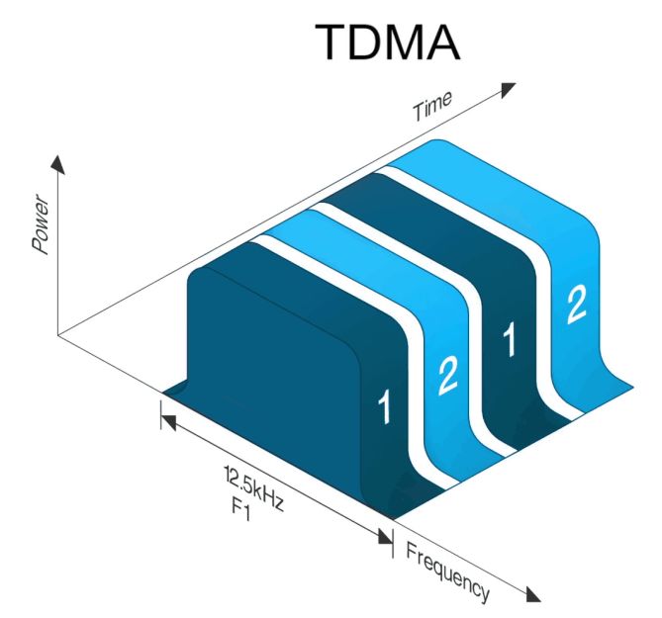
DMR has three working modes, which are:
– Tier 1: Unlicensed direct mode, operating on the 446 MHz license-free frequency band. It allows basic voice communication between terminals, but does not support relay or other advanced functions.
– Tier 2: Licensed conventional mode, operating on the licensed frequency band, such as VHF and UHF. Tie2 supports advanced functions such as relay, two-slot communication, and data transmission.
– Tier 3: Licensed trunk mode, used for large-scale systems that require high capacity and wide coverage. It features advanced functions such as network management, voice and data encryption, and satellite positioning.

2.2 FDMA-based dPMR overview
dPMR is also a digital two-way radio communication standard developed by ETSI, which was first released in December 2005 (ETSI TS102 490).
As shown in Figure 2, dPMR employs a Frequency Division Multiple Access (FDMA) system that splits a 12.5 kHz channel interval into two 6.25 kHz channels. Using the 4FSK modulation, it delivers a transmission rate of 4.8 kbit/s. Unlike DMR, dPMR does not support advanced features.
Figure 2
Schematic diagram of FDMA in dPMR
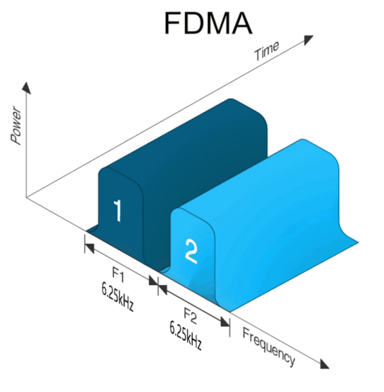
dPMR has two working modes:
– Tier 1: Also known as dPMR446, this type of dPMR works on the unlicensed 446 MHz frequency band for short-range communications.
– Tier 2: This type of dPMR operates on licensed frequencies and has three modes: peer-to-peer mode (mode 1), repeater mode (mode 2), and trunking mode (mode 3). The Tie2 standard is specified in TS 102 658.

2.3 Technical parameter comparison between DMR and dPMR
The key technical parameters of the two technologies are compared in Table 1. Theoretically, the overall difference between them is insignificant, with both attaining the equivalent channel efficiency of 6.25 kHz. In terms of coverage capability, their coverage ranges are comparable to those of existing narrowband FM systems due to similar modulation methods and symbol rates. However, differences in certain critical characteristics render DMR more robust and all-encompassing in specific application scenarios.
Table 1
Comparison of technical parameters between DMR and dPMR
Technical system | DMR | dPMR
Multi-access mode | Two-slot TDMA | FDMA
Bandwidth | 12.5 kHz | 6.25 kHz
Data rate | 9.6 kbps (symbol rate 4.8 ksym/s) | 4.8 kbps
Modulation | 4FSK | 4FSK
Encoded mode | Hamming + BPTC | Hamming code
Code check | 1/2,3/4,1 | 2/3
Vocoder | AMBE+2 | AMBE+2
Speech coding rate | 3.6 kbps | 3.6 kbps

2.4 Key performance differences between DMR and dPMR
1) High-priority interruption ability comparison
As shown in Figure 3, the DMR system inherently supports the interruption function. The reverse channel signalling in the alternate time slot will indicate the talking party to stop transmitting immediately, for the prompt high-priority service such as emergency calls.
In contrast, dPMR has no reverse channel, therefore the talking party will keep transmitting until the push-to-talk (PTT) key is released or the transmission timeout, which is not able to support an immediate interruption.
Figure 3
Schematic diagram of FDMA and TDMA comparison
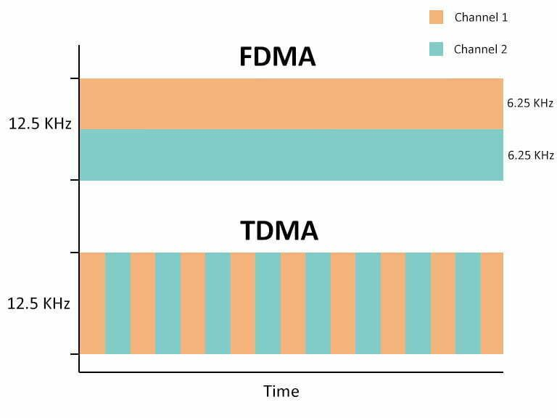
2) Static sensitivity comparison
Figure 4
Bit error rate curve of DMR and dPMR before and after channel decoding
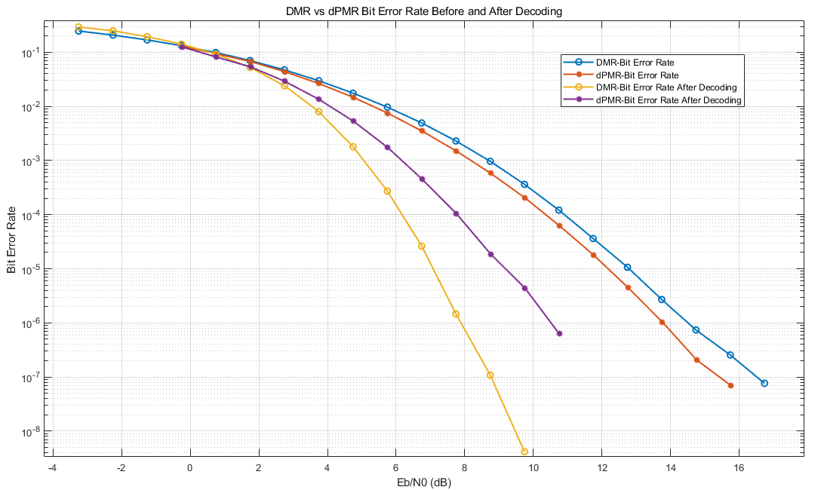
The simulation comparison of static sensitivity is shown in Figure 4: Before decoding, with BER=5% as the benchmark, dPMR shows approximately 0.15 dB improvements over DMR. After decoding, with BER=10e-5 as the benchmark, dPMR exhibits approximately 2.3 dB degradation compared to DMR.
Table 2
Comparison of channel coding and code rate parameters between DMR and dPMR
 | dPMR |  |  |  | DMR
Channel/signals | CCH | MI/HI | END-Info | Appended-Data | Ctrl sig/  Unconfirmed and Confirmed data | Embedded sig | Reverse Ch | CACH sig | Unconfirmed and Confirmed data
encoded mode | Hamming(12,8)*N,N = [6,10,3,10] |  |  |  | BPTC(196,96) | BPTC Hamming (16,11,4)+parity checks |  | BPTC  Hamming (17,12,3) +parity checks | Rate ¾ Trellis code | -
code check | 2/3 |  |  |  | ≈1/2 | ≈1/2 | ＜1/2 | ≈1/2 | 3/4 | 1

3) Comparison of frequency error sensitivity
6.25 kHz channel bandwidth radio systems (e.g. dPMR) put forward stricter requirements on frequency accuracy and stability than 12.5kHz channel bandwidth radio systems (e.g. DMR). Reduced channel spacing increases sensitivity to oscillator errors, frequency drift and Doppler shift, which may degrade communication robustness. Due to wider channel bandwidth (e.g., 12.5 kHz in DMR), 12.5 kHz TDMA systems are less sensitive to frequency accuracy, stability and Doppler effects than 6.25 kHz FDMA systems, resulting in improved communication robustness as shown as follows, especially for the larger frequency error.
Under the frequency error of 0 Hz, 640 Hz (corresponding to 2 ppm under 160 MHz working frequency), and 960 Hz (corresponding to 3 ppm under 160 M working frequency), the simulation comparison curves of DMR and dPMR bit error rate and synchronization miss detection rate are shown in Figure 5.
Figure 5
Bit error rate performance curves of DMR and dPMR under different frequency error
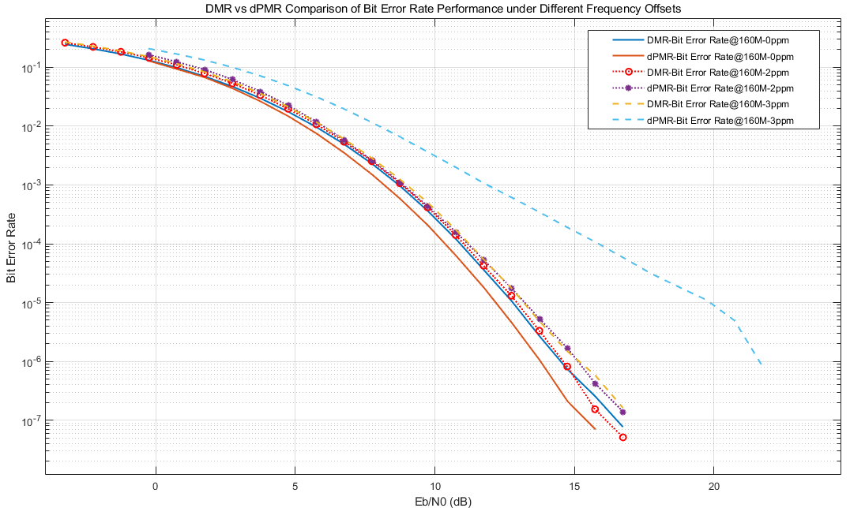
As shown in Figure 5, the bit error rate performance of the two systems is close to each other within the frequency error of 640 Hz. When the frequency error increases to 960 Hz, the sensitivity point of dPMR bit error rate (BER=5%) drops by nearly 2 dB, while the performance of DMR does not change significantly.
4) Comparison of base station cost
As shown in Figures 6 and 7, DMR operates on two-slot TDMA, allowing access to two service channels. Therefore, it requires only one channel unit, a single antenna, and a simple, cost-effective duplexer at the base station. In contrast, dPMR also supports two service channels but necessitates two channel units and an expensive combiner for sharing single base station antennas. Due to its power loss, the additional combiner introduces extra RF power amplifier to maintain transmission power levels and ensure coverage. Consequently, dPMR demonstrates lower efficiency and higher costs compared to the DMR systems.
Figure 6
Schematic diagram of DMR base station composition
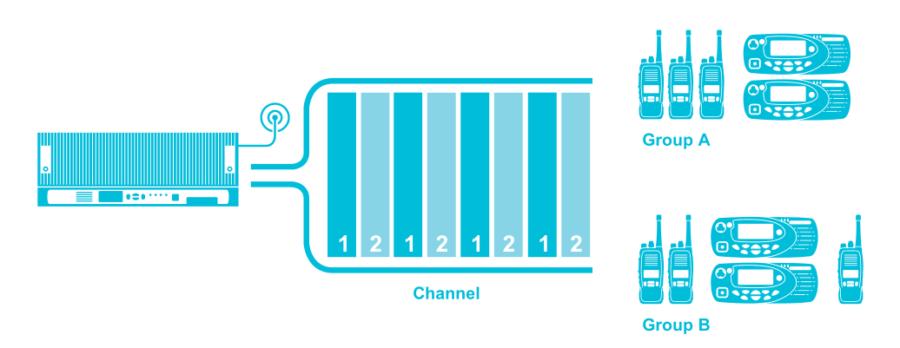
Figure 7
Schematic diagram of dPMR base station composition
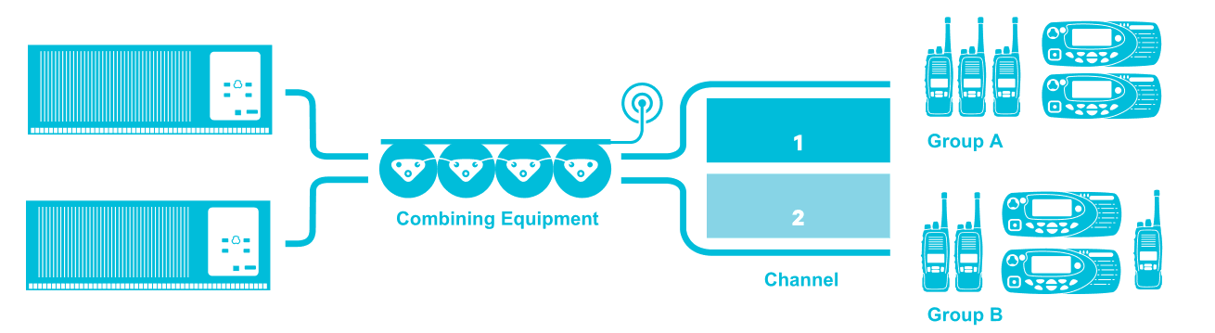
5) Comparison of terminal endurance
Compared to analog FM, DMR terminals with two-slot TDMA use only one slot for transmission, which significantly reduces battery power consumption. In standard operating mode (5% for transmission, 5% for reception, and 90% for standby), power consumption is reduced by 40%, greatly extending the operational duration of DMR terminals.
For the same call time and the same transmission power, dPMR operates on a constant transmission, while DMR operates on a time slot transmission, which can turn off the unused time slots, so DMR is more power-saving. Compared with that of dPMR terminals, the battery duration of DMR terminals is extended by 20%.

3 Analysis of smooth migration and spectrum refarming schemes
It is recognized that, in addition to the narrowband interleaving schemes (e.g. 6.25 kHz channels) recommended in Recommendation ITU-R M.1084, the adoption of 12.5 kHz DMR-based digital technology provides a practical and efficient alternative for smooth spectrum refarming and digital migration within existing 12.5 kHz FM analogue bands. The key advantages include:
A Reuse of existing infrastructure
– Existing sites and RF facilities (e.g. duplexers, repeaters, antennas and feeders) can be reused without major modifications, significantly reducing network upgrade costs.
B Consistent carrier spacing and coexistence capability
– The use of identical 12.5 kHz carrier spacing enables direct replacement of analogue channels by digital ones, avoiding complex replanning or frequency interleaving.
– Analogue and digital systems can coexist with manageable interference through appropriate filtering and transmitter power control.
C Field experience and proven practices
– Most existing 25 kHz analogue equipment already supports 12.5 kHz operation through filter bandwidth adjustment and software configuration.
– A stepwise evolution — from 25 kHz analogue to 12.5 kHz analogue (via interleaving), then to 12.5 kHz TDMA digital — has proven to be the most seamless and practical migration path.

D High equipment compatibility
– Existing 25 kHz analogue radios can be configured to operate on 12.5 kHz channels with minimal technical modifications, enabling gradual deployment and reuse of legacy assets.
E Ease of dual-mode terminal implementation
– For 12.5 kHz FM + 12.5 kHz DMR dual-mode operation, both modes can share the same RF front-end, power amplifier and filters, requiring only additional digital modulation functions. This approach ensures low hardware cost and backward compatibility (e.g. automatic analogue/digital detection, self-adaptive communication, etc.).
– For 25 kHz/12.5 kHz analogue + 6.25 kHz dPMR dual-mode designs, distinct RF and filter designs are required, resulting in higher complexity and cost, making large-scale deployment less feasible.
F Avoidance of non-urgent use of emergency channel
– For non-urgent use of emergency channels in a high-traffic VTS scenario, simply increasing the number of FDMA channels does not effectively address congestion or improve operational efficiency in some special case due to extra time required for channel selection and switching. By contrast, TDMA-based DMR can support multiple communication flows within a single carrier through time-slot multiplexing, while maintaining existing operational practices. This enables improved spectrum utilization, more voice channels, reduced channel congestion and better protection of emergency communications. For example, one time slot may be reserved for emergency communications (similar to CH16), while another supports routine VTS operations and ship-to-ship communication, enabling separation and parallel operation of emergency and non-emergency traffic.
G Conclusion
– Migration based on 12.5 kHz DMR technology represents a more efficient and technically viable approach to spectrum refarming compared with 6.25 kHz interleaving, providing advantages in infrastructure reuse, cost efficiency, coexistence, and dual-mode terminal development.

4 Co-channel interference
In ship-to-ship communication scenarios with overlapping coverage, co-channel interference is an important consideration. As illustrated in Figure 8, vessels A and B may not be able to communicate directly, while interference may occur in the overlapping coverage region.
In TDMA-based systems (e.g., DMR), time-slot-based transmission over the air interface, together with optional GNSS timing, enables slot alignment among terminals. In the absence of base station or GNSS assistance, synchronisation can be extended through beacon relay mechanisms, supporting a degree of autonomous operation. This helps mitigate interference while maintaining efficient spectrum utilisation and has been validated in terrestrial deployments and maritime testing.
By contrast, FDMA-based systems (e.g., dPMR) primarily rely on frequency planning and coordination to manage interference, with no effective mechanism currently available to address co-channel interference in overlapping coverage areas.
Figure 8
Co-channel interference mitigation in overlapping coverage areas
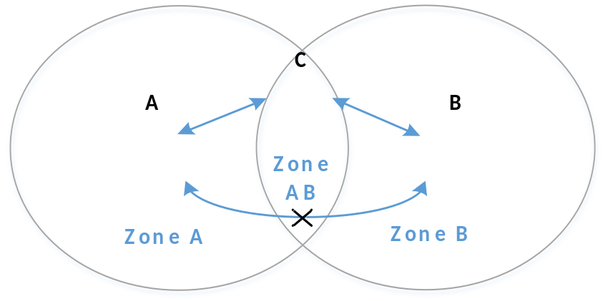

5 DMR timing synchronization and calibration scheme

5.1 Timing synchronization mechanisms for TDMA-based DMR systems
In maritime communications, both ship-to-ship direct communication and ship-to-shore communication, which may involve base stations, need to be considered. In both scenarios, reliable timing synchronisation is essential for TDMA system operation. TDMA-based DMR systems support several mature synchronisation mechanisms (see Figure 9), including base station-based timing, GNSS-based timing, and terminal synchronisation beaconing, which together address synchronisation requirements across diverse maritime scenarios.

5.1.1 Base station air-interface timing for ship-to-shore communication
Within network coverage, terminals obtain a timing reference from the base station downlink air-interface signal and maintain synchronisation with the TDMA slot timing.

5.1.2 GNSS-assisted timing for ship-to-shore and ship-to-ship communication
Outside network coverage, where terminals are equipped with GNSS capability, GNSS timing may be used to establish and maintain TDMA slot synchronization.

5.1.3 Terminal synchronisation beaconing for ship-to-ship communication
In direct communication scenarios without base station coverage or GNSS assistance, terminals may establish synchronisation via received air-interface signals from other terminals or through synchronisation beacons (see ETSI TS 102 361-2 V2.5.1 (2023-05), Clause 6.2). A transmitting terminal may act as a temporary timing reference, and synchronization beacons can be relayed among terminals to extend synchronization coverage and enable coordinated direct communication over a wider area. These beacons carry timing source and priority information, allowing terminals to select the most appropriate reference.
[Editor’s note: It would be useful to include information on how long it takes stations to synchronize under the various scenarios].

5.2 Synchronization Procedure
Within the shore-based coverage area, all equipment shall synchronize with the shore-based signal. For equipment operating outside the shore-based coverage area, devices supporting satellite timing calibration shall use the satellite-based timing reference and shall have priority to act as the master unit, broadcasting their own timing beacons. Devices that do not support satellite calibration and fail to receive a synchronization beacon within a defined timeout period may also apply to become the master unit. Once the master unit is determined, other devices shall operate as slave units. Slave units meeting the forwarding conditions shall relay the received timing beacons.
Synchronization beacons shall indicate the synchronization source. A beacon synchronized via satellite calibration shall have a higher priority than that without satellite calibration. Other slave units shall synchronize preferentially to the higher-priority beacon. An illustration of device synchronization is provided in Figure 9, and the detailed synchronization procedure is shown in Figure 10.
Figure 9
Synchronization mechanism for TDMA devices
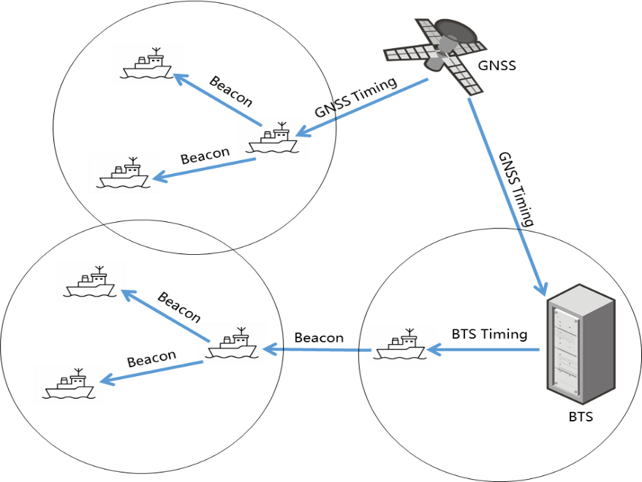
The synchronization procedure is as follows:
1 The system slot timing extension adopts a master–slave mode. A device applying to become a master unit shall first initiate a synchronization request. A higher-priority synchronization source shall be given preference for becoming the master unit. Devices that fail to synchronize within a timeout period may also send a synchronization request and, upon receiving a positive synchronization acknowledgment, become the master unit.
2 Devices within the shore-based coverage area shall use the shore-based signal as the synchronization source and shall have priority to act as master units broadcasting synchronization beacons.
3 For devices operating outside the shore-based coverage area and unable to synchronize with shore-based devices, those supporting satellite calibration shall have priority to become master units and broadcast synchronization beacons. Devices without satellite calibration capability that fail to receive any synchronization beacon within the timeout period may also apply to become master units and broadcast synchronization beacons. Synchronization beacons shall contain source and priority indicators to support synchronization arbitration and conflict resolution.
4 The device that first receives a synchronization acknowledgment shall become the master unit, enter the master synchronization state, and start periodic broadcasting of its synchronization beacon.
5 Upon receiving the synchronization beacon from the master unit, a device shall enter the slave synchronization state. When forwarding conditions are met, the device shall relay the synchronization beacon following polite transmission rules to extend synchronization timing.
6 During the idle state, synchronization requests, synchronization broadcasts, and synchronization relays shall be repeated 1–5 times (configurable) using a TDMA pattern with a 60 ms interval. Synchronization beacons transmitted during active services may be sent only once. All transmissions shall follow the same random backoff control and retransmission count (configurable).
7 If an unsynchronized device or a device not supporting the synchronization process initiates service communication, the synchronized devices shall temporarily align with the initiator for the service duration, and then revert to the original synchronization after recalibration.
8 When a conflict is detected between the Master ID and the locally mapped ID, the local device shall regenerate a new mapped ID smaller than the Master ID. If a Master ID conflict occurs (i.e., two devices with identical IDs both act as master units with a timing deviation exceeding 1.25 ms), the device with the higher synchronization source priority shall remain as the master unit. If the priorities are identical, the device detecting the conflict shall automatically upgrade to master status to resolve the conflict, updating the conflicting master unit to slave status.
Figure 10
Device synchronization process
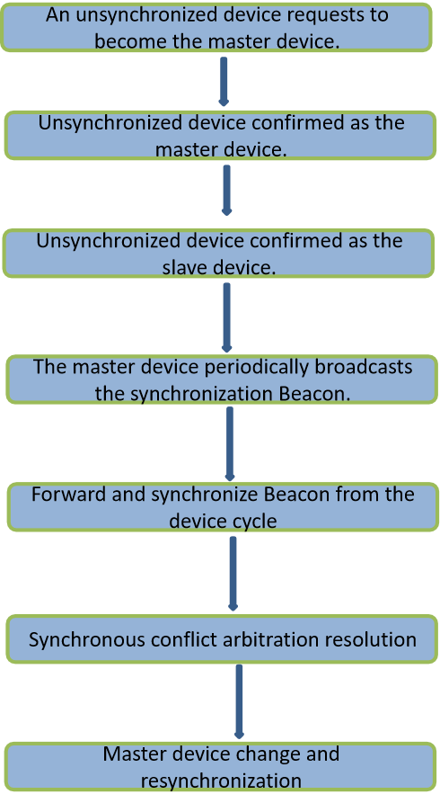

6 Technology ecology and standards

6.1 DMR standard case
Latest standards released (2023) include:
– ETSI TR 102 398 V1.5.1 (November 2023)
– ETSI TS 102 361-1 V2.6.1 (May 2023)
– ETSI TS 102 361-2 V2.5.1 (May 2023)
– ETSI TS 102 361-4 V1.12.1 (July 2023)
Progress in Standard Revision: The DMR standard is undergoing continuous updates. The latest revision discussions took place at the 79th ETSI ERM TGDMR meeting in May 2025. Multiple technical committees (TCs) are currently engaged in discussions, including CR158 (Typos), CR159 (P-Clear), CR160 (Talk Groups), CR161 (DGNAI), CR162 (Call Diversion), CR163 (UDT UTF8), CR166 (TSCC Hibernation), and CR167 (TSCC Re-assignment).
Strong alliance members: There are more than 210 member enterprises around the world, including MOTOROLA, Cisco, AT&T, CML, Harris, Leonardo, Sepura, ZTE GaoDa, Dongxin, Haige, Hytera and so on.

6.2 dPMR standard case
Latest standard released (2019) include:
– ETSI TR 102 884 V1.3.1 (November 2018)
– ETSI TS 102 795 V2.1.1 (June 2011)
– ETSI TS 102 658 V2.6.1 (January 2019)
Status of standard revision: No discussions on related topics have been held since the 60th meeting of ETSI ERM TGDMR in January 2019. Since the proposals CR002, CR003, CR030, and CR031 were put forward in early 2018, no new modifications have been released.
The alliance includes 7 companies, i.e. CML, Jianwu, ALINCO, Cobham, ICOM, BEEBEST, and Lisheng.
To sum up, the DMR standard continues to be updated, actively adapting to market demand, constantly introducing new functions, and continuously enhancing its technical capabilities; in contrast, the dPMR standard has been in a state of stagnation for an extended period without update or revision, and the industry activity is obviously insufficient.

7 Applications in market and industry
Market analysis by the renowned consultancy Omdia reveals that DMR significantly surpasses dPMR in global sales volume, as shown in Figure 11.
Common applications of DMR radio include:
– Public safety: extensively employed in law enforcement, firefighting and first aid to enhance communication safety and clarity;
– Transportation: applicable to taxi and bus operations, and express delivery, etc., all demanding reliable communication;
– Industry: employed in manufacturing, construction and mining sectors to guarantee safety and enhance production efficiency.
Common applications of dPMR radio include:
– Retail: frequently seen in department stores and supermarkets, convenient for staff communication and inventory control;
– Hotel and catering services: widely used in hotels and restaurants to enhance guest service and operational effectiveness;
– Medical services: for hospitals and clinics to facilitate effective communication among health care professionals.
Figure 11
Comparison of annual sales volume of DMR and dPMR
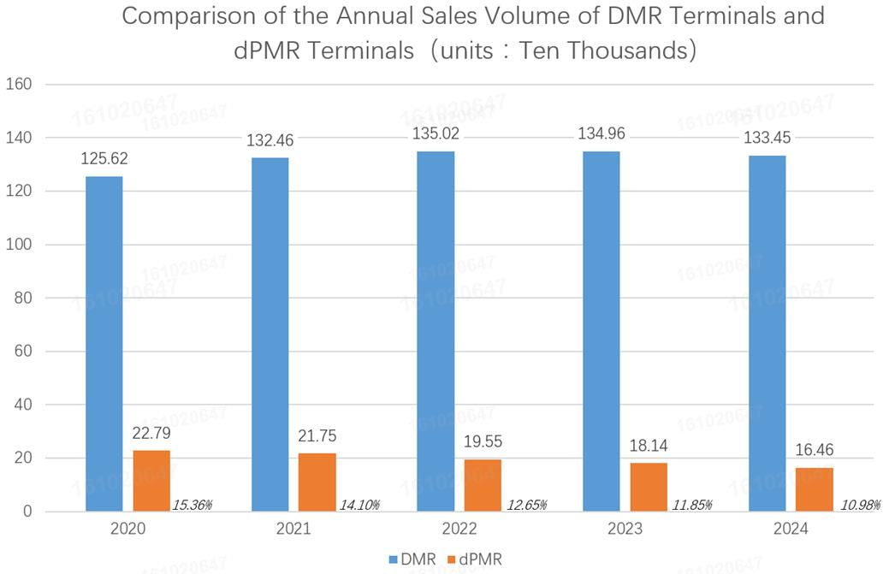
With strong industrial ecology, technological advancement potential, and ongoing standard development, DMR is offered a broader market prospect and enhanced vitality in the industry.

8 Conclusions and recommendations
In summary, DMR demonstrates superior overall performance and scalability, attributed to its two-slot TDMA system design, enhanced frequency deviation resistance, comparatively lower base station expenses, and a broader standardization structure. Concurrently, its ongoing standard development and vibrant industrial environment have enabled it to sustain a significantly larger share of the global market than dPMR. In contrast, dPMR has seen stagnation in standard updates and industry collaboration, resulting in relatively limited applicability.
Therefore, it is recommended to take into account the DMR system when building or upgrading voice systems, especially in industry scenarios where there is a strong need for terminal battery life, extended functions and environmental compatibility.

Annex 3
Comparing DMR and dPMR Technologies in a Maritime Application

1 Technology comparison and analysis

1.1 TDMA-based DMR overview
DMR is a digital radio voice and data communication standard developed by the ETSI for two-way radio communication systems. The standard (ETSI TS 102 361) was first released in April 2005.
As shown in Figure 1, DMR utilizes the TDMA technology. Dividing the frequency into 30-millisecond time slots enables two separate calls to be conducted concurrently on the same 12.5 kHz frequency, achieving spectral efficiency equivalent to that of dPMR; however, the channel numbering should ensure that both 12.5 kHz channels are contained in one Appendix 18 channel. This would necessitate a revision to Recommendation ITU-R M.1084-5 Annex 5. Additionally, each user is assigned a distinct colour code, ensuring that terminals are limited to receiving transmissions specifically designed for them. The system employs 4FSK modulation with a transmission rate of 9.6 kbit/s.
Figure 1
Schematic diagram of DMR TDMA
DMR has three working modes, which are:
– Tier 1: Unlicensed direct mode, operating on the 446 MHz license-free frequency band. It allows basic voice communication between terminals but does not support relay or other advanced functions.
– Tier 2: Licensed conventional mode, operating on the licensed frequency band, such as VHF and UHF. Tier 2 supports advanced functions such as relay, two-slot communication, and data transmission.
– Tier 3: Licensed trunk mode, used for large-scale systems that require high capacity and wide coverage. It features advanced functions such as network management, voice and data encryption, and satellite positioning.

1.2 FDMA-based dPMR overview
dPMR is also a digital two-way radio communication standard developed by ETSI and first released in December 2005 (ETSI TS102 490).
As shown in Figure 2, dPMR employs a FDMA system that splits a 12.5 kHz channel interval into two 6.25 kHz channels. Like DMR, this also requires a revision to Recommendation ITU-R M.1084-5 Annex 5. dPMR supports digital messaging at 4.8 kbps.

Schematic diagram of FDMA in dPMR
dPMR has two working modes:
– Tier 1: Also known as dPMR446, this type of dPMR works on the unlicensed 446 MHz frequency band for short-range communications.
– Tier 2: This type of dPMR operates on licensed frequencies and has three modes: peer-to-peer mode (mode 1), repeater mode (mode 2), and trunking mode (mode 3). The Tier 2 standard is specified in TS 102 658.

1.3 Technical parameter comparison between DMR and dPMR
Table 1 compares the key technical parameters of the two technologies. Theoretically, the overall difference between them is insignificant, with both attaining the equivalent channel efficiency of 6.25 kHz. In terms of coverage, their ranges are comparable to existing narrowband FM systems because they use similar modulation methods and symbol rates. However, differences in certain critical characteristics render DMR more robust in specific scenarios.

Table 1
Comparison of technical parameters between DMR and dPMR
Technical system | DMR | dPMR
Multi-access mode | Two-slot TDMA | FDMA
Bandwidth | 12.5 kHz | 6.25 kHz
Data rate | 9.6 kbps (symbol rate 4.8 ksym/s) | 4.8 kbps
Modulation | 4FSK | 4FSK
Encoded mode | Hamming + BPTC | Hamming code
Code check | 1/2,3/4,1 | 2/3
Vocoder | AMBE+2 | AMBE+2
Speech coding rate | 3.6 kbps | 3.6 kbps

1.4 Key performance differences between DMR and dPMR
1.4.1 High-priority interruption ability comparison
As shown in Figure 3, the DMR system inherently supports interruption. Reverse-channel signaling in the alternate time slot indicates to the talking party to stop transmitting immediately for prompt high-priority services such as emergency calls.
In contrast, dPMR has no reverse channel; therefore, the talking party keeps transmitting until the PTT key is released or the transmission times out, which does not support immediate interruption.
Since the four 6.25 kHz channels in the dPMR system are independent and unsynchronized, interruptions do not occur from other channels. Furthermore, in Appendix 18 of the RR, emergency calls are made on the GMDSS-designated channels using analog FM 25 kHz modulation. Thus, emergency calls are not subject to interruption.
Figure 3
Schematic diagram of FDMA and TDMA comparison
1.4.2 Static sensitivity comparison
Figure 4
Bit error rate curve of DMR and dPMR before and after channel decoding
Figure 4 shows the static sensitivity comparison: before decoding, with BER=5% as the benchmark, dPMR shows about a 0.15 dB improvement over DMR. After decoding, with BER=10e-5 as the benchmark, dPMR exhibits approximately 2.3 dB degradation compared to DMR in a 12.5 kHz channel.
Because the dPMR channels occupy only 6.25 kHz of bandwidth (3 dB lower), the minimum sensitivity of each 6.25 kHz channel is comparable to DMR.

1.4.3 Comparison of frequency error sensitivity
6.25 kHz channel bandwidth radio systems (e.g. dPMR) put forward stricter requirements on frequency accuracy and stability than 12.5kHz channel bandwidth radio systems (e.g. DMR). Reduced channel spacing increases sensitivity to oscillator errors, frequency drift and Doppler shift, which may degrade communication robustness unless a more stable crystal oscillator is used. Modern equipment that uses these improved crystal oscillators offsets these differences between the two systems at a comparable cost.
1.4.4 Comparison of base station cost
As shown in Figures 6 and 7, DMR may operate on two-slot TDMA, allowing access to two service channels. Therefore, it requires only one channel unit, a single antenna, and a simple, cost-effective duplexer at the base station. In contrast, dPMR also supports two service channels but necessitates two channel units and an expensive combiner for sharing single base station antennas. Due to its power loss, the additional combiner introduces extra RF power amplifier to maintain transmission power levels and ensure coverage. Consequently, dPMR is less efficient and more expensive than DMR, but only when a base station requires only two service channels. However, when a base station requires more than two service channels, both DMR and dPMR systems will require combiners and extra RF power to overcome combiner losses.
Figure 6
Schematic diagram of DMR base station composition
Figure 7
Schematic diagram of dPMR base station composition
1.4.5 Comparison of terminal endurance

Compared to analog FM, DMR terminals with two-slot TDMA use only one slot for transmission to a single receiver, which significantly reduces battery power consumption. In standard operating mode (5% for transmission, 5% for reception, and 90% for standby), power consumption is reduced by 40%, greatly extending the operational duration of DMR terminals.
For the same call time and the same transmission power, dPMR operates on a constant transmission, while DMR operates on a time slot transmission, which can turn off the unused time slots, so DMR is more power saving. Compared with that of dPMR terminals, the battery duration of DMR terminals is extended by 20%.
In the maritime service, radios are typically mounted on ships and powered by the ship’s power, making power consumption less important.

2 Analysis of smooth migration and spectrum refarming schemes
It is recognized that, in addition to the narrowband interleaving schemes (e.g. 6.25 kHz channels) recommended in Recommendation ITU-R M.1084, the adoption of 12.5 kHz DMR-based digital technology provides a practical and efficient alternative for smooth spectrum refarming and digital migration within existing 12.5 kHz FM analog bands. The key advantages include:
2.1 Reuse of existing infrastructure
– Existing sites and RF facilities (e.g. duplexers, repeaters, antennas and feeders) can be reused without major modifications, significantly reducing network upgrade costs. This is true for both DMR and dPMR systems.

2.2 Consistent carrier spacing and coexistence capability
– The use of 12.5 kHz carrier spacing enables replacement of analog channels by digital ones. However, this requires revising Recommendation ITU-R M.1084-5 Annex 5 to ensure that both channels are contained in the Appendix 18 25KHz channels.
– Analog and digital systems can coexist with manageable interference through appropriate filtering and transmitter power control.

2.3 Field experience and proven practices
– Most existing 25 kHz analog equipment in terrestrial service already supports 12.5 kHz operation through filter bandwidth adjustment and software configuration.
– A stepwise evolution — from 25 kHz analog to 12.5 kHz analog (via channel renumbering), then to 12.5 kHz TDMA digital — seems to be a seamless and practical migration path.
_ Although, Appendix 18 of the RR for the maritime service allows 12.5 kHz service, current 25 kHz radios on the maritime market do not support 12.5 kHz operation without modifying filter bandwidth and software.

2.4 Dual-mode terminal implementation
– For 12.5 kHz FM + 12.5 kHz DMR dual-mode operation, both modes can share the same RF front-end, power amplifier and filters, requiring only additional digital modulation functions. This approach ensures low hardware cost and backward compatibility (e.g. automatic analogue/digital detection, self-adaptive communication, etc.).
– For 25 kHz+ 6.25 kHz dPMR dual-mode designs, an RF front-end and power amplifier can be used, but filter designs are required, resulting in a slightly higher cost.

2.5 Avoidance of non-urgent use of emergency channel
– Appendix 18 of the RR states that distress and other emergency calls must use GMDSS with DSC on channel 70, a 25 kHz channel. Channel 16 and other important channels are also exclusively assigned to 25 kHz channels using analogy FM.

3 Co-channel interference
In ship-to-ship communication scenarios with overlapping coverage, co-channel interference is an important consideration. As illustrated in Figure 8, vessels A and B may not be able to communicate directly, while interference may occur in the overlapping coverage region.
In TDMA-based systems (e.g., DMR), time-slot-based transmission over the air interface, together with GNSS timing, enables slot alignment among terminals. Without base station or GNSS assistance, beacon relay mechanisms can extend synchronization, supporting a degree of autonomous operation. This helps mitigate interference while maintaining efficient spectrum utilization when slots are available and has been validated in terrestrial deployment and maritime testing; however, TDMA-based systems face the inherent problem of slot reuse, as in AIS, a type of co-channel interference.
FDMA-based systems (e.g., dPMR) use frequency planning and coordination to manage interference
.
Figure 8
Co-channel interference mitigation in overlapping coverage areas

4 DMR timing synchronization and calibration scheme

4.1 Timing synchronization mechanisms for TDMA-based DMR systems
In maritime communications, both ship-to-ship direct communication and ship-to-shore communication, which may involve base stations, need to be considered. In both scenarios, reliable timing synchronization is essential for TDMA system operation. TDMA-based DMR systems support several mature synchronization mechanisms (see Figure 9), including base station-based timing, GNSS-based timing, and terminal synchronization beaconing, which together address synchronization requirements across diverse maritime scenarios, but these schemes all require GNSS availability.

4.2 Base station air-interface timing for ship-to-shore communication
In the network coverage area, terminals obtain a timing reference from the base station do air-interface signal and maintain synchronization with the TDMA slot timing; however, in the maritime environment, base stations will be limited to port areas and some coastal locations.

4.3 GNSS-assisted timing for ship-to-shore and ship-to-ship communication
Outside network coverage, terminals equipped with GNSS capability may use GNSS timing to establish and maintain TDMA slot synchronization; however, SOLAS class shipborne radios on the maritime market do not include an internal GNSS receiver and adding one would increase cost.

4.4 Terminal synchronization beaconing for ship-to-ship communication
In direct communication scenarios without base station coverage or GNSS assistance, terminals may establish synchronization via received air-interface signals from other terminals or through synchronization beacons (see ETSI TS 102 361-2 V2.5.1 (2023-05), Clause 6.2). A transmitting terminal may act as a temporary timing reference, and terminals can relay synchronization beacons to extend coverage and enable coordinated direct communication over a wider area. These beacons carry timing source and priority information, allowing terminals to select the most appropriate reference.
4.5 dPMR does not need synchronization
Because SOLAS class shipborne radios do not contain a GNSS receiver, and because dPMR does not require time synchronization to operate, dPMR communications are not impacted when GNSS is impaired or unavailable. For collision avoidance and safety communications, ships must always be able to communicate with each other under all conditions. Thus, dPMR is the preferred technology.

5 Technology ecology and standards

5.1 DMR standard case
Latest standards released (2023) include:
– ETSI TR 102 398 V1.5.1 (November 2023)
– ETSI TS 102 361-1 V2.6.1 (May 2023)
– ETSI TS 102 361-2 V2.5.1 (May 2023)
– ETSI TS 102 361-4 V1.12.1 (July 2023)
Progress in Standard Revision: The DMR standard is undergoing continuous updates. The latest revision discussions took place at the 79th ETSI ERM TGDMR meeting in May 2025. Multiple technical committees (TCs) are currently engaged in discussions, including CR158 (Typos), CR159 (P-Clear), CR160 (Talk Groups), CR161 (DGNAI), CR162 (Call Diversion), CR163 (UDT UTF8), CR166 (TSCC Hibernation), and CR167 (TSCC Re-assignment).
Strong alliance members: There are more than 210 member enterprises around the world, including MOTOROLA, Cisco, AT&T, CML, Harris, Leonardo, Sepura, ZTE GaoDa, Dongxin, Haige, Hytera and so on.

5.2 dPMR standard case
Latest standard released (2019) include:
– ETSI TR 102 884 V1.3.1 (November 2018)
– ETSI TS 102 795 V2.1.1 (June 2011)
– ETSI TS 102 658 V2.6.1 (January 2019)
Status of standard revision: No discussions on related topics have been held since the 60th meeting of ETSI ERM TGDMR in January 2019. Since the proposals CR002, CR003, CR030, and CR031 were put forward in early 2018, no new modifications have been released.
The alliance includes 7 companies, i.e. CML, Jianwu, ALINCO, Cobham, ICOM, BEEBEST, and Lisheng.
To sum up, the DMR standard continues to evolve to meet terrestrial market demand, introduce new functions, and enhance its technical capabilities. However, in contrast, the dPMR standard has remained stable for an extended period without updates or revisions.
Thus, dPMR's stability is a benefit, not a liability.

6 Conclusions and recommendations
For over 6 years, dPMR technology has been studied both by IALA and ITU and contributed to Report ITU-R M.2530. Kingdom of the Netherlands and Japan have successfully completed and documented the dPMR field testing and contributed the test results to the Report.
Although DMR has demonstrated better performance characteristics in land mobile applications, it comes with serious concerns. Commercially available crystal oscillators can address some performance differences. TDMA synchronization requirements are a concern when GNSS is disrupted. Although DMR has fallback modes to address this, ship’s communications must not be impaired or disrupted during critical communications. The consequences of failure to communicate imposes a safety hazard that could be enormous, with loss of life and vessel. DMR is also a base station-centric system, in maritime applications, base stations will be limited to port areas and some coastal locations. Any benefits that a base station provides will not always be available.
The dPMR technology has been a stable platform for many years and has not required continuous updates to meet new land mobile applications. Based on the justification outlined in this Annex, dPMR would better support the maritime applications because of its stability, simplicity, and avoidance of the failure modes associated with TDMA synchronization.

Annex 4
Operational, migration and coexistence considerations
in the VHF maritime frequency band
[Editor’s note: This section could also consider resiliency requirements, and any enhancements, such as data transmission.]

1 Operational adaptability and spectrum-efficiency considerations for digital maritime VHF technologies
The objective of this section is to examine how digital radio technologies may support existing maritime operational practices while improving spectrum utilization within the current maritime VHF band. Particular attention is given to the operational aspects including broadcast communications, VTS operation, distress monitoring, synchronization, direct-mode operation, coexistence of multiple systems, and communication continuity in infrastructure-limited environments.

1.1 Efficient broadcast simplex operation
To examine broadcast communication mechanisms in maritime environments, including direct simplex and infrastructure-based operation, and compare TDMA coordinated slot operation with FDMA fixed channel allocation approaches.

1.2 Efficient utilization of limited VHF spectrum resources for VTS operation
To examine spectrum-efficiency and traffic-management considerations for VTS operation in high-density maritime environments, including multi-user access, group communications, traffic prioritization, dynamic resource allocation, and centralized versus fixed channel management approaches.

1.3 Spectrum-efficiency and operational coordination for multi-system operation in shared and adjacent maritime environments
To examine how TDMA- and FDMA-based systems may support coexistence of multiple maritime communication systems in shared and adjacent environments, including synchronization, channel coordination, interference mitigation, and efficient spectrum utilization in high-density maritime areas.

1.4 Dual-watch for distress monitoring
To examine how digital radio technologies may support simultaneous monitoring of working and distress channels, improve distress detection and prioritization, and enhance operational robustness and spectrum efficiency during the transition toward digital maritime VHF communications.

1.5 Convergence of DSC
To examine how digital radio technologies may support integration of DSC signalling within a common digital radio voice and data framework, including shared modulation, synchronization and signalling mechanisms, software-based implementation approaches, and evolution toward fully digital maritime VHF communication systems.

1.6 Direct-mode operation monitoring for ship-to-ship communications
To examine how direct-mode operation may support ship-to-ship communications beyond infrastructure coverage, including multi-channel and time-slot monitoring, distress and priority communication handling, and operational considerations for maritime direct communications.

1.7 Direct mode (simplex) operation
To examine TDMA- and FDMA-based direct-mode operation in maritime VHF communications, including conventional and two-slot TDMA operation, synchronization and coordinated slot mechanisms, interference mitigation, and spectrum-efficiency considerations for infrastructure-independent maritime communications.

1.8 Enhancement through relay communication
To examine how relay and multi-hop communication mechanisms may support extended-range maritime communications, including synchronized relay operation, infrastructure-independent communication, coverage extension, interference mitigation, and spectrum-efficiency considerations for ship-to-ship and ship-to-shore communications.

2 Migration from and coexistence with current analogue voice channels
The objective of this section is to examine technical and operational considerations for migration from existing analogue maritime VHF voice communications toward digital technologies, while maintaining interoperability, continuity of service and protection of safety-related communications during the transition period.

2.1 Key principles for the transition scheme
To examine guiding principles for a seamless and low-risk migration toward digital maritime VHF communications, including interoperability, compatibility, cost-efficient implementation, spectrum efficiency, operational continuity and protection of safety-of-life services.

2.1.1 Compatibility with existing maritime VHF channel arrangements
To examine how digital radio voice technologies may operate within the existing RR Appendix 18 channel plan while minimizing disruption to current maritime VHF operations and avoiding major band re-planning.

2.1.2 Coexistence of analogue and digital systems
To examine coexistence mechanisms between analogue and digital maritime VHF systems during the migration period, including interoperability, adjacent-channel compatibility and operational coordination considerations.

2.1.3 Dual-mode operation during transition
To examine operational and technical considerations for dual-mode analogue/digital shipborne and shore-based equipment during the migration period, including backward compatibility and gradual deployment approaches.

2.1.4 Spectrum-efficiency considerations during migration
To examine how digital technologies may improve spectrum utilization during the transition period, including multi-slot operation, trunking and coordinated channel management within the existing maritime VHF band.

2.1.5 Safety-of-life communication considerations
To examine how distress, urgency and safety communications may be maintained and prioritized during migration toward digital maritime VHF communications, including compatibility with existing GMDSS procedures.

2.1.6 Coverage, reliability and operational continuity
To examine coverage, reliability and communication continuity considerations for digital maritime VHF systems under maritime propagation conditions, including relay communication and infrastructure-independent operation.

2.1.7 Cost-efficient implementation considerations
To examine practical deployment considerations, including reuse of existing infrastructure, software-based upgrades, gradual equipment replacement and minimization of implementation costs for administrations and maritime users.

2.2 Migration approaches for digital maritime VHF communications
Considering the objectives and principles of migration, this section examines possible approaches for introducing digital radio voice technologies into maritime VHF communications within the existing maritime VHF channel plan. Considerations include phased deployment, channel transition strategies, coexistence with existing analogue voice and DSC systems, interoperability, adjacent-channel compatibility and potential impacts on spectrum planning.

2.2.1 On-center channel migration (aligned transition)
To examine migration approaches in which digital channels remain aligned with existing maritime VHF channel center frequencies, supporting backward compatibility, preservation of the current channel structure, and a low-disruption transition toward 12.5 kHz digital operation.

2.2.2 Interstitial interleaved transition
To examine migration approaches based on insertion of narrowband digital channels between existing analogue assignments, including coexistence considerations, adjacent-channel compatibility, interference management and spectrum-planning implications during phased migration.
[Editor’s note: Other migration approaches may be possible and should be included here]

3 Additional considerations

3.1 Ecosystem and industry sustainability
To examine ecosystem maturity, multi-vendor interoperability, supply-chain sustainability and long-term industry support considerations for digital maritime VHF technologies.

3.2 Intellectual property considerations
To examine standards openness, interoperability, licensing and IPR considerations supporting affordable and globally interoperable maritime digital VHF systems.

3.3 Long-term sustainability and technological evolution
To examine future evolution capabilities of digital maritime VHF technologies, including spectrum-efficiency enhancement, modulation evolution, coding improvement and next-generation digital services.

3.4 Energy efficiency
To examine terminal and infrastructure energy-efficiency considerations for digital maritime VHF systems, including battery life, power consumption and sustainable network deployment.

3.5 Digitalization in maritime operations
To examine how digital radio technologies may support maritime digitalization, including IoT integration, AI-enabled applications, voice-data convergence and support for future digital maritime services.

Annex 5
Current trends and use in the band 156-174 MHz

1 Use of the band 156-174 MHz

1.1 Current use of channels listed in Appendix 18
The international VHF maritime mobile band operates within the frequency ranges 156.0125 to 157.4375 MHz and 160.6125 to 162.0375 MHz. Natively, this allocation is structured with 25 kHz channel spacing primarily optimized for analogue frequency modulation (FM) telephony, utilizing both two-digit and four-digit channel numbering conventions. Figure 1 shows a representation of the RR Appendix 18 allocations. Report ITU-R M.2231 provides a comprehensive description of the use of RR Appendix 18 by stations of the maritime mobile service.
Figure 1
The international VHF maritime mobile band (RR Appendix 18)
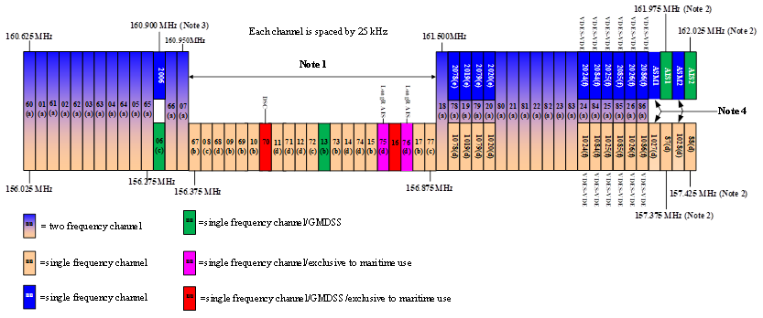

[Editor’s note: this figure may not be useful for describing RR Appendix 18 in the context of this document, noting it is a reproduction from a revision of Report ITU-R M.2231. Consideration to an alternative representation is required.]
Channels bound to specific applications within RR Appendix 18:
‒ Digital Selective Calling (DSC): Restricted to channel 70 (156.525 MHz) under the regulatory constraints of footnotes j) and f) of RR Appendix 18. Performance and operational guidelines are contained in Recommendations ITU-R M.493 and ITU-R M.541.
‒ Automatic Identification System (AIS): Operates on dedicated channels AIS 1 (161.975 MHz) and AIS 2 (162.025 MHz), designated via footnotes f), l), and p) of RR Appendix 18, and further specified in Recommendation ITU-R M.1371.
‒ Long range AIS applications: Under footnotes n) and s), channels 75 (156.775 MHz) and 76 (156.825 MHz) are allocated to the mobile-satellite service (Earth-to-space) for the reception of long-range AIS broadcast messages (Message 27 in Recommendation ITU-R M.1371). Channels 75 and 76 are also available for navigation-related voice communications under footnote n) and limited to an output power of 1 W.
‒ VHF Data Exchange System (VDES): Incorporates both Application Specific Messages (ASM) and VHF Data Exchange (VDE) over multiple channels across the upper and lower bands under footnote w) of RR Appendix 18 and further specified in Recommendation ITU-R M.2092.
‒ Distress, urgency and safety voice: Operational voice communication relies on Channel 16 (156.800 MHz) for voice distress, urgency and safety calling, Channel 06 (156.300 MHz) for search and rescue coordination, and Channel 13 (156.650 MHz) for bridge-to-bridge safety of navigation.
‒ AMRD Group B: The frequency 160.9 MHz (channel 2006) is allocated to the maritime mobile service and designated for autonomous maritime radio devices (AMRD) Group B that do not enhance the safety of navigation, using AIS technology, in accordance with Recommendation ITU-R M.2135. AMRD Group B are limited to a transmitter e.i.r.p. of 100 mW and an antenna height not exceeding 1 m above the surface of the sea.

1.2 Usage of the band 157.4375-160.6125 MHz
This frequency range represents the mid-band spectrum gap sitting between the lower and upper limits of RR Appendix 18 allocations. Under national tables of frequency allocations harmonized with Article 5 of the Radio Regulations, this spectrum is widely allocated to the Fixed and Mobile services on a primary basis. The spectrum is heavily occupied by land mobile radio systems, public safety agencies, or private business bands. Recommendation ITU-R M.1808 contains technical and operational criteria for conventional and trunked land mobile services operating in the mobile service below 869 MHz.

1.3 Usage of the band 160.9625-161.4875 MHz
This sub-band represents an internal block within the broader 156–174 MHz range. Many administrations assign the 160.9625–161.4875 MHz sub-band for terrestrial land mobile radio systems, public safety agencies, or private business bands. Recommendation ITU-R M.1808 contains technical and operational criteria for conventional and trunked land mobile services operating in the mobile service below 869 MHz.
Under regional or national arrangements (such as the RAINWAT agreement for inland waterways in Europe), portions of these frequencies are utilized for automated transmitter identification systems (ATIS), inland VTS operations, or specific duplex arrangements that diverge from standard open-ocean maritime allocations.

1.4 Usage of the band 162.0375-174 MHz
This frequency range is positioned immediately above the upper boundary of the standard RR Appendix 18 maritime allocation. This spectrum is typically allocated globally or regionally to Fixed and Land Mobile services. It is extensively utilized by land mobile radio systems, public safety agencies, or private business bands. Recommendation ITU-R M.1808 contains technical and operational criteria for conventional and trunked land mobile services operating in the mobile service below 869 MHz.

2 Trends in the maritime mobile service in the band 156-174 MHz

2.1 Trends in the shipping industry
[Editor’s note: TBD]

2.2 Trends in the fishing industry
WRC-19 updated RR Appendix 18 notes f) and r) from
f) The frequencies 156.300 MHz (channel 06), 156.525 MHz (channel 70), 156.800 MHz (channel 16), 161.975 MHz (AIS 1) and 162.025 MHz (AIS 2) may also be used by aircraft stations for the purpose of search and rescue operations and other safety-related communication. (WRC-07)
r) In the maritime mobile service, this frequency is reserved for experimental use for future applications or systems (e.g. new AIS applications, man over board systems, etc.). If authorized by administrations for experimental use, the operation shall not cause harmful interference to, or claim protection from, stations operating in the fixed and mobile services. (WRC-12)
to
f) The frequencies 156.300 MHz (channel 06), 156.525 MHz (channel 70), 156.800 MHz (channel 16), 161.975 MHz (AIS 1) and 162.025 MHz (AIS 2) may also be used by aircraft stations for the purpose of search and rescue operations and other safety-related communication. The frequencies 156.525 MHz (channel 70), 161.975 MHz (AIS 1) and 162.025 MHz (AIS 2) may also be used by autonomous maritime radio devices Group A that enhance the safety of navigation, using digital selective calling and/or AIS technology. Such use should be in accordance with the most recent version of Recommendation ITU-R M.2135. (WRC-19)
r) In the maritime mobile service, the frequency 160.9 MHz (channel 2006) is designated for autonomous maritime radio devices Group B that do not enhance the safety of navigation, using AIS technology, in accordance with the most recent version of Recommendation ITU-R M.2135. Autonomous maritime radio devices Group B are limited to a transmitter e.i.r.p. of 100 mW and an antenna height not exceeding 1 m above the surface of the sea.
In the maritime mobile service, this frequency may also be used for experimental use for future applications or systems (e.g. new AIS applications, man over board systems, etc.). If authorized by administrations for experimental use, the operation shall not cause harmful interference to, or claim protection from, stations operating in the fixed and mobile services, including the use of autonomous maritime radio devices Group B. (WRC-19)
hence limiting the use of AIS frequencies 1 and 2 to autonomous maritime radio devices (AMRD) Group A that enhance the safety of navigation and designating channel 2006 with a power limit of 100 mW for AMRD Group B that don’t enhance the safety of navigation.
Since then, these provisions have been enforced at the regional or national level with some administrations ruling against the use of AIS frequencies 1 and 2 by AMRD group B such as MOB AIS without DSC or fishnet markers.
In areas where these devices are still in use, administrations in charge of traffic monitoring complains about collisions warnings created by these devices.
Yet, the fishing industry requires long-term solutions for fishnet markers, and some stakeholders are of the view that the EIRP limit of 100 mW for group B AMRD using channel 2006 should be raised to 1 W.

2.3 Trends in administrations and port authorities
[Editor’s note: TBD]

2.4 Trends in work boat fleets
Work boats include tugs, mooring handlers, windfarm support boats and a plethora of other small vessels involved in commercial operations but falling below the size regulated by the IMO’s SOLAS regulations. VHF communications are essential aboard these vessels to facilitate safe and efficient control of their operations.

2.5 Trends in leisure boat fleets
Around the world many tens of thousands of leisure boats rely on VHF communications for emergency communications, receipt of maritime safety information, safety of navigation, berth allocation and race organization. Whilst some administrations allow operation on channels outside those listed in RR Appendix 18 it remains essential for these craft to retain the ability to communicate with commercial shipping, Coastguard shore stations and Port authorities on internationally recognized VHF channels.
Larger leisure vessels may well install fixed 25W Class D VHF equipment but very many more rely on hand-held devices with a power output of 6W.
Leisure vessels operate in all possible marine environments ranging from inland waterways through port areas to open oceans many hundreds of miles from land.

2.6 Trends in search and rescue
[Editor’s note: TBD]
______________

