U.S. Radiocommunications Sector
Fact Sheet
Working Party: ITU-R WP 5B | Document No: USWP5B37-09 Final Draft
Ref: Annex 2.2 to Document 5B/526 | Date: 8th September 2026
Document Title: WORKING DOCUMENT TOWARDS A PRELIMINARY DRAFT NEW REPORT ITU-R M.[RNSS_AM(R)S_5GHZ_SHARING] – Sharing and compatibility study between RNSS and AM(R)S systems operating in the 5 000 to 5 150MHz Frequency Band

Author(s)/Contributors(s):  Name: Don Nellis  Org: Federal Aviation Administration  Name: Michael Neale  Org: ACES Corporation for the FAA  Name: Jeff Hougland  Org: ACES Corporation for the FAA | Phone: (202) 267-9779  Email: Donald.Nellis@faa.gov  Phone: (858) 705-8978  Email: michael.neale@aces-inc.com  Phone: (410) 271-3255  Email: Jeff.Hougland@acescorp.net
Purpose/Objective: The purpose of this contribution is to begin the development of a sharing and compatibility study report between RNSS receivers operating in the 5 010 – 5 030 MHz frequency band and the AM(R)S service supporting Unmanned Aircraft Systems operating in the 5 030 to 5 091 MHz frequency band. This study is aimed at finalizing the e.i.r.p. density limit that is currently provisional in RR No. 5.443C. However, this effort is waiting on information from WP 4C and we are meeting with US stakeholders from 4C at the end of this month to discuss and look to include information from that meeting in the final draft of this contribution.
Abstract: This contribution provides an outline for the study and the characteristics of the two systems.

Radiocommunication Study Groups | 
Source: New  Subject: WDPDNR  ITU-R M.[RNSS_AM(R)S_5GHZ_SHARING] | Document 5B/XXX-E
 | XXX
 | English only
United Sates of America
WORKING DOCUMENT TOWARDS A preliminary draft new RePORT Itu-r m.[RNSS_AM(R)S_5GHz_SHARING]
Sharing and compatibility study between RNSS and AM(R)S systems operating in the 5 010 to 5 091 MHz Frequency Band
Introduction
At WRC-2012 it was agreed, under No. 5.443C, that the frequency band 5 030-5 091MHz could be used by the aeronautical mobile (R) service limited to internationally standardized aeronautical systems. Industry, international standards development organizations and ICAO have been working since then to develop the technology and standards necessary to use that allocation. Consequently, it is now possible to provide characteristics and protection criteria for such systems for use in any future sharing studies within ITU-R.
Proposal
The United States of America proposes to assist in answering the above need by developing a Report containing the characteristics for such Control and Non-Payload Communications (CNPC) links operating in the AM(R)S allocation and the characteristics (Section 1) and of the Galileo Positioning System, and the Global Positioning System, the two most widely used GNSS constellation in Region 2 of the RNSS services operating in the 5 010 – 5 030 MHz frequency band as found in ITU-R M.2031-1 (section 2).
Once those characteristics are adequately mature a sharing and compatibility study can be undertaken between the two systems. Section 3 of this Report contains information on the various cases and the processes as well as (in future versions) the results of the analysis.

Attachments: 1

Radiocommunication Study Groups | 
Source: New  Subject: WDPDNR  ITU-R M.[RNSS_AM(R)S_5GHZ_SHARING] | Document 5B/XXX-E
 | XXX May 2026
 | English only
WORKING DOCUMENT TOWARDS A preliminary draft new RePORT Itu-r m.[RNSS_AM(R)S_5GHz_SHARING]
Sharing and compatibility study between RNSS and AM(R)S systems operating in the 5 010 to 5 091 MHz Frequency Band
Scope
At WRC-2012 it was agreed, under No. 5.443C, that the frequency band 5 030-5 091MHz could be used by the aeronautical mobile (R) service limited to internationally standardized aeronautical systems. However, the −75 dBW/MHz e.i.r.p. density limit to protect RNSS receivers in the frequency band 5 010-5 030 MHz under RR No. 5.443C is provisional “Until such time that an appropriate value is established in a relevant ITU-R Recommendation”.
Industry, international standards development organizations and ICAO have been working since 2012 to develop the technology and standards necessary to use the AM(R)S allocation for Unmanned Aircraft System Control and Non-Payload Communication (CNPC) links and those systems are now characterized to a sufficient maturity (Annex 2.6 to Document 5B/435) to begin the analysis necessary to remove the provisional nature of the e.i.r.p. density limit in RR No. 5.443C.
This Report contains a sharing and compatibility study between the AM(R)S UAS CNPC systems operating in the 5 030-5 091MHz frequency band and RNSS receivers operating in the 5 010-5 030MHz frequency band.
Once finalized this Report will be able to be used to determine what e.i.r.p. density limit is appropriate to protect RNSS receivers and remove the provisional nature of said limit.
Introduction
This Report consists of three sections. Section 1 contains the characteristics for the CNPC links operating in the 5 030-5 091MHz AM(R)S allocation. Section 2 contains the characteristics of the Galileo Positioning System, and the Global Positioning System, the two most widely used GNSS constellation in Region 2 whose receivers operate in the 5 010 – 5 030 MHz frequency band as found in ITU-R M.2031-1. Section 3 contains information on the sharing study cases and the processes used in the study as well as (in future versions) the results of the analysis.
Keywords
Unmanned aircraft systems
…..
Abbreviations/Glossary
…..
Related ITU Reports
…..

1 UAS CNPC Characteristics

1.1 Introduction and scope
UAS CNPC Characteristics are taken from PDNR ITU-R M.[AM(R)S_AMS(R)S_CHAR_5GHZ] - Characteristics and Protection Criteria of Terrestrial and Satellite Unmanned Aircraft System Control and Non-Payload Communications Links operating in the Aeronautical Mobile (R) Service and Aeronautical Mobile Satellite (R) Service in the band 5 030-5 091 MHz.
[Figure 1]
Example command and non-payload communications link system components

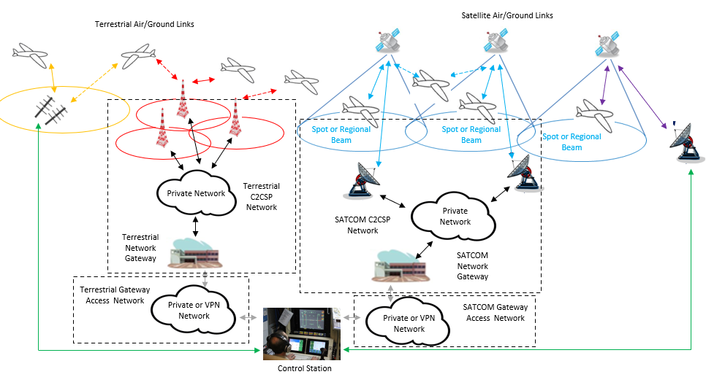

1.2 Unmanned aircraft and control station characteristics for terrestrial control and non-payload communication link

The terrestrial component uses an airborne radio system (ARS) on the UA to communicate with a ground radio system (GRS) that connects to the UACS.
TABLE 1
Transmission and reception characteristics for the terrestrial control
and non-payload communication link System 1
Terrestrial command and non-payload communication System 1
 | Units | UA ARS | GRS
Frequency of operation | MHz | 5 030 to 5 091 | 5 030 to 5 091
Duplexing |  | Time division duplex (TDD) | TDD
Transmit/receive duration | msec | 23 Receive + 1.3 guard time  23 Transmit + 2.7 guard time | 23 Transmit + 1.3 guard time  23 Receive + 2.7 guard time
Modulation |  | GMSK or QPSK | GMSK or QPSK
Modulation symbol rates | ksps | 3 to 138  including error correction/detection, guard times and synchronization overhead | 34 to 138  including error correction/detection, guard times and synchronization overhead
Forward error correction |  | GMSK: Rate 5/8 Turbo Conv.  Code  QPSK: Rate 5/9 and Rate 1/3 TCC | GMSK: Rate 5/8 Turbo Conv. Code  QPSK: Rate 5/9 and Rate 1/3 TCC
Error detection |  | 32-bit CRC | 32-bit CRC
Baseband Input/Output Signal |  | User Data | User Data
User Data Bit Rates | kbps | 20 to 80  Includes TDD duty cycle overhead | 20-80  Includes TDD duty cycle overhead
Occupied bandwidth, C | kHz | Variable per application with a maximum of 250 | Variable per application with a maximum of 250
Antenna gain | dBi | 2 Omnidirectional | Maximum 20 (see Table 2)
Cable loss | dB | 2 | 1
Antenna pattern |  | Constant azimuth  Constant elevation | Constant azimuth  Tailored in elevation  See Table 2
Antenna polarization |  | Vertical with aircraft flying straight and level | Vertical
Maximum antenna height | m | 22 860 (mean sea level)  Typical 6 000 | 2 to 50  Typical 10
Service range | km | 550  Typical 80 | 550  Typical 80
Transmitter conducted power | dBm | 40 | 40
Transmitter in band emission limits | dBc/  1 MHz | −66 at 2 MHz offset  See Table 3 | −66 at 2 MHz offset  See Table 3
Receiver noise figure | dB | 7 | 7
Receiver sensitivity | dBm | 120 | 120
Receiver in band rejection – except the operating channel | dB | One channel separation: 23  Two channel separation: 43  Three channel separation: 57  2 MHz or more separation: 63 | One channel separation: 23  Two channel separation: 43  Three channel separation: 57  2 MHz or more separation: 63
Protection level (aggregate) I/N | dB | –6 | –6

TABLE 2
System 1 GRS antenna characteristics
Parameter | Units | Intrasystem limit | High gain antenna | Omnidirectional antenna
Peak gain | dBi | 20 | 19 | 5.2
Elevation Θ₃ | Degrees | N/A | 9 | 55
Gain at
elevation degrees
0.5 | dBi | 19.0 | 18.5 | 5.2
1.5 | dBi | 19.5 | 18.9 | 4.9
2.5 | dBi | 20.0 | 19.0 | 4.5
3.5 | dBi | 19.5 | 18.9 | 1.6
7 | dBi | 17.0 | 16.0 | −1.4
11.5 | dBi | 14.0 | 8.2 | −2.8
16 | dBi | 11.5 | 3.8 | −5.0
32 | dBi | 6.5 | −12.5 | −8.0
64 | dBi | 1.5 | −26.4 | −9.5
75 | dBi | 0.5 | −29.0 | −11.7
89 | dBi | 0.5 | −31.0 | −16.5
Azimuth Θ₃ | Degrees |  | 34 | 360
Steerable/Sectoral/  Omnidirectional |  | N/A | Steerable/  Sectoral | Omnidirectional

The above table and accompanying graph below contain the characteristics of antennas that will be used to support unmanned aircraft operations using the System 1 whose RF characteristics are described in the previous tables. The information contained in Table 2 includes the GRS elevation and azimuth gains that will support unmanned aircraft (that themselves use omnidirectional antennas) operating up to approximately 65 nautical miles/120 km slant range, at altitudes up to 65 000 ft, down to close in operations including takeoff and landing. Because of the critical nature of the performance of UAS CNPC C2 Links a range of antennas are required to maximize the link margin while maintaining intrasystem compatibility. The maximum gain allowed to ensure intrasystem compatibility is also shown in the table and accompanying graph. The High Gain antenna provides full azimuth coverage by being either steerable in azimuth or by using switching between one of a number of sectorized antennas with the characteristics given in the table. All antennas have the fixed elevation pattern given in the table and graph. In any geographic region at any one time, it is anticipated that there will be a mixture of antennas being used to support the wide variety of unmanned aircraft operations.
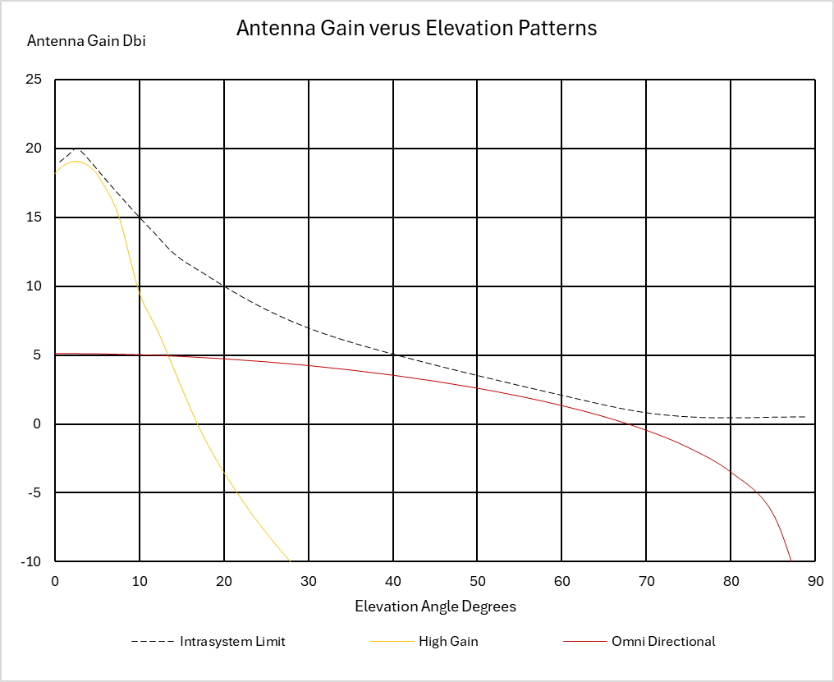

TABLE 3
Transmitter out of band emission limits in the 5 030-5 091 MHz frequency band for system 1
System 1
Offset from carrier frequency | dBc/kHz
Channel width ÷ 2 | −54
1.5 × channel width | −74
500 kHz | −90
2 000 kHz | −96

2 RNSS Characteristics

2.1 Introduction and scope
As recommended by WP 4C (Document 5B/312), RNSS characteristics and protection criteria are taken from Recommendation ITU-R M.2031-1 - Characteristics and protection criteria of receiving earth stations and characteristics of transmitting space stations in the radionavigation-satellite service (space-to-Earth) operating in the band 5 010-5 030 MHz.

[Editor’s note: Draft Liaison Statement to WP5B indicates WP4C initiating an update/revision to ITU-R M.2031-1.]
TABLE 1-1
Service link characteristics and protection criteria for receiving earth stations
operating in the band 5 010-5 030 MHz
Parameter | Galileo | GPS
Signal frequency range (MHz)
Maximum receiver antenna gain (dBi)
RF filter 3 dB bandwidth (MHz)
Pre-correlation filter 3 dB bandwidth (MHz)
Receiver system noise temperature (K)
Tracking mode threshold power level of aggregate narrow-band interference at the passive antenna output (dBW) | –157.1 | −154.6
Acquisition mode threshold power level of aggregate narrow-band interference at the passive antenna output (dBW) | –160.1 | −157.6
Tracking mode threshold power density level of aggregate wideband interference at the passive antenna output (dB(W/MHz)) | –147.1 | −144.6
Acquisition mode threshold power density level of aggregate wideband interference at the passive antenna output (dB(W/MHz)) | –150.1 | −147.6
TABLE 1-2
Feeder link characteristics for receiving earth stations
operating in the band 5 010-5 030 MHz
Characteristics of receiving feeder-link earth stations
operating in the band 5 010-5 030 MHz
Parameter | GPS | QZSS
Antenna diameter (m)
Polarization
Antenna pattern
Theoretical antenna gain (dBi)
Antenna efficiency loss (dB)
Maximum receive antenna gain (dBi)
Receiver system noise temperature (K)
Minimum elevation (degrees)

Feeder downlink transmissions in the band 5 010-5 030 MHz
Parameter | GPS | QZSS
Signal frequency range (MHz) (Note 1)
Encoded bit rate (bit/s)
Signal modulation method
Polarization
Ellipticity (dB)
Transmit e.i.r.p. (dBW)
NOTE 1 – Carrier frequency of the RNSS signal of interest ± half the signal bandwidth.
Feeder Link Protection Criteria
Parameter | GPS | QZSS
Aggregate interfering power not to exceed Δ T_sys (percentage) | 6% | 6%

3 RNSS Characteristics

3.1 Introduction and scope
At WRC-2012 it was agreed, under RR No. 5.443C, that the frequency band 5 030-5 091 MHz could be used by the aeronautical mobile (R) service limited to internationally standardized aeronautical systems.
RR No. 5.443C states that “Unwanted emissions from the aeronautical mobile (R) service in the frequency band 5 030-5 091 MHz shall be limited to protect RNSS system downlinks in the adjacent 5 010-5 030 MHz band. Until such time that an appropriate value is established in a relevant ITU-R Recommendation, the e.i.r.p. density limit of −75 dBW/MHz in the frequency band 5 010-5 030 MHz for any AM(R)S station unwanted emission should be used. (WRC-12)”
It is the intention of this study to investigate the e.i.r.p. density limit that needs to be applied to the emissions of UAS CNPC (whose characteristics are provided in Section 1) in order to protect the RNSS whose characteristics and protection criteria are provided in Section 2 and in so doing enable the provisional nature of the current e.i.r.p. density limit to be resolved.

1.1 RNSS and UAS CNPC Frequency Allocation
The frequency arrangement is shown below. The RNSS systems operating in the 5 010-5 030 MHz frequency band which is adjacent to the CNPC frequency band, are to be protected.
Figure 1
Frequency Placement of RNSS, CNPC and AM(R)S operating in the 5 000-5 150 MHz frequency band
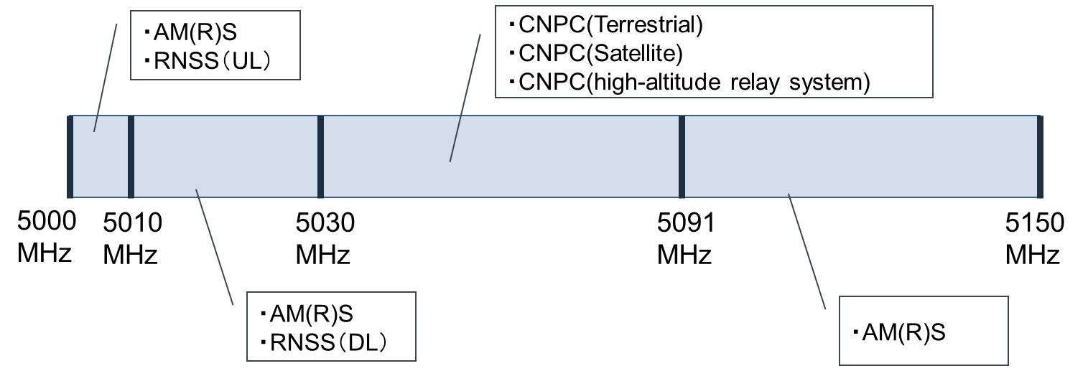

NOTE 1: Compatibility studies among UAS CNPC systems are currently being conducted mainly by aeronautical standardization bodies and are outside the scope of this shared-use study.
NOTE 2: RNSS (UL) in the 5 000-5 010 MHz frequency range is out of scope as there is sufficient frequency separation.
[Editor's Note: There is an AM(R)S system operating at 5 010-5 030 MHz and 5 091-5 150 MHz called AeroMACS. However, its operational status is still under investigation and will be addressed in a future WP 5B meeting.]

3.2 Terrestrial CNPC Link Compatibility studies with RNSS
In this section, the terrestrial control and non-payload communication link consists of a single ground radio system, or a network of multiple ground radio systems in a CNPC link with a single or multiple UAs. A sharing study will be conducted to protect the following RNSS services: service links which provide the end-user services, and the feeder links which support control and maintenance of the RNSS satellite constellation. This study will focus on protecting the downlink portion (space-to-earth) of the RNSS services, which is allocated in the band adjacent to the CNPC frequencies as seen in the previous section.
The sharing study intends to provide insights for resolving the provisional nature of the current e.i.r.p. density limit of −75 dBW/MHz of terrestrial CNPC link unwanted emissions to adequately protect RNSS services operating in the adjacent frequency band of 5 010-5 030 MHz. The overall RF environment consists of multiple GRS stations in a network providing CNPC links to multiple UAs in a specific area where other multiple ground and airborne mobile vehicles utilize RNSS end-user services. A single fixed ground RNSS feeder station also exists in the specific area of the RF environment involved in feeder link services with an RNSS satellite. Figure 2 depicts the overall RF environment of the sharing study.
FIGURE 2
Example System Diagram of the CNPC link transmissions and downlink portions of the RNSS Services

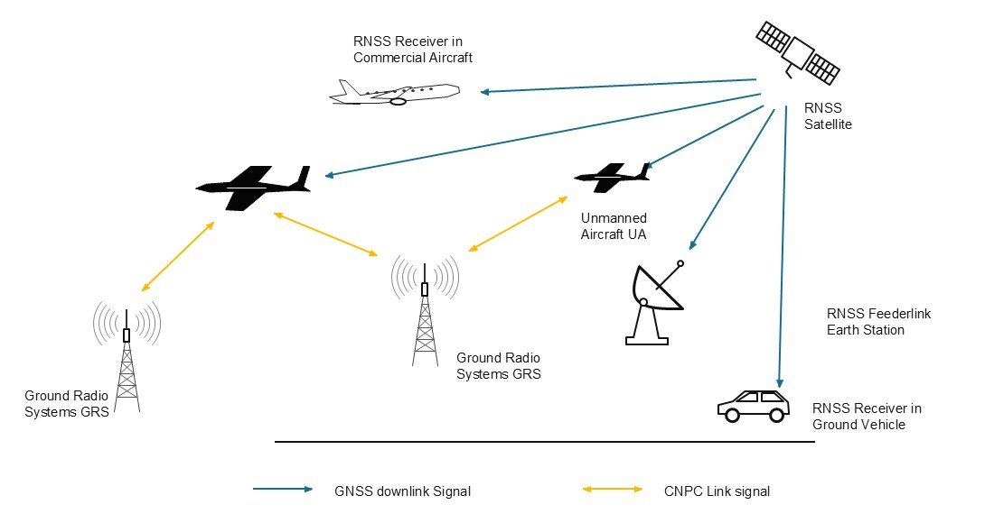

The study is broken down into the following cases below:

3.2.1 Case A.1: Potential interference from GRS stations to mobile station RNSS end-users (ground and airborne)
Figure 3 shows a single instance of one GRS station potentially affecting RNSS services to a mobile ground RNSS user, and an airborne RNSS user. The analysis will further extend this case to multiple GRS stations in a network.
FIGURE 3

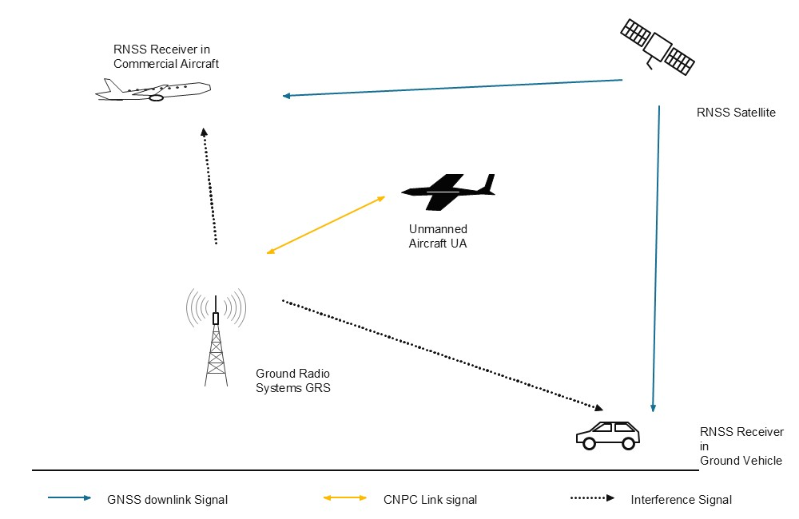

3.2.2 Case A.2: Potential interference from GRS to fixed station RNSS feeder space-to-Earth link
Figure 4 shows a single instance of one GRS station potentially affecting a single fixed ground RNSS feeder station.
FIGURE 4

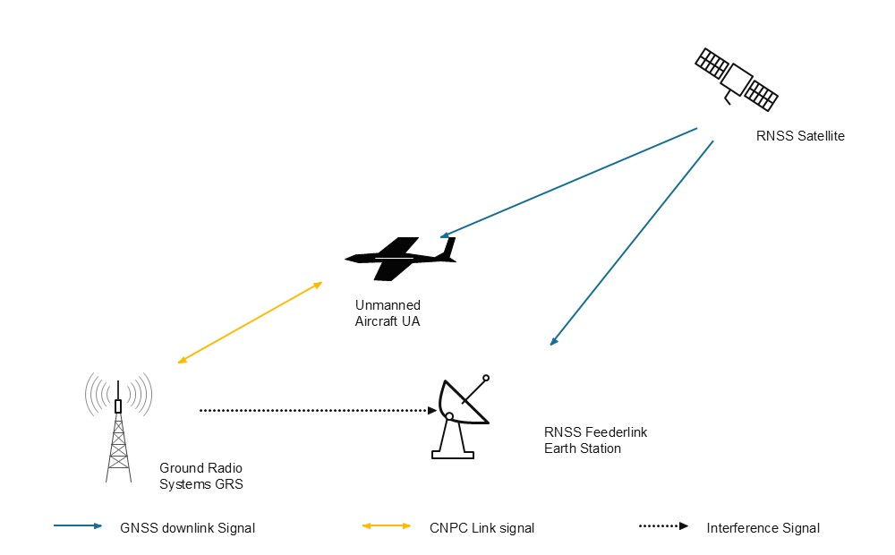

3.2.3 Case A.3: Potential interference from the UA to mobile station RNSS users (ground and airborne)
Figure 5 shows a single UA station potentially affecting RNSS services to a single mobile ground RNSS user, and an airborne RNSS user. The analysis will further extend this case to multiple UA stations flying in the vicinity of these mobile RNSS users.
FIGURE 5

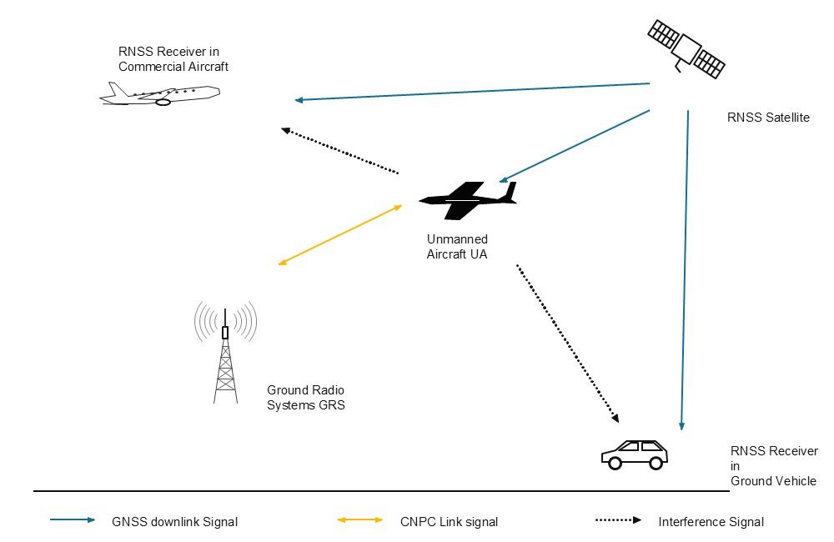

3.2.4 Case A.4: Potential interference from UA to fixed station RNSS feeder space-to-Earth link
Figure 6 shows a single UA station potentially affecting a single fixed ground RNSS feeder station.
FIGURE 6

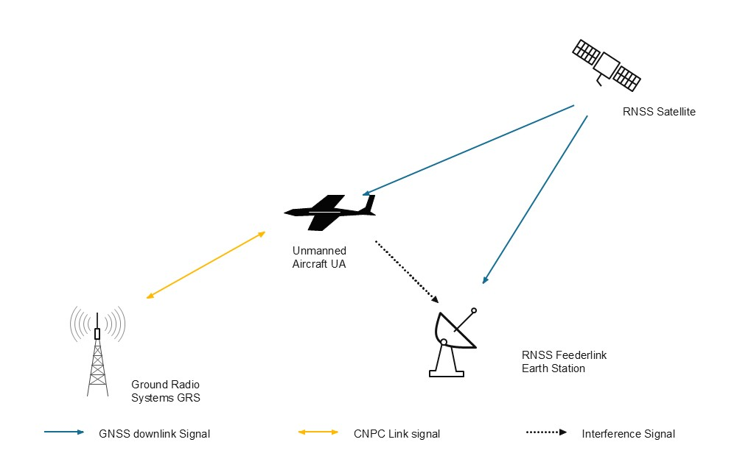
[Editor’s Note: The geographical and situational environmental scenarios to use in each of these cases are still being developed.]
In each of these cases, the protection criteria in Section 2 will be used to assess adequate protection to RNSS services.

____________

