|  |  |  |
| --- | --- | --- |
| U.S. Radiocommunications Sector  Fact Sheet | | |
| **Working Party:** ITU-R WP 5B | **Document No:** USWP5B26-13R1 | |
| **Ref:** 5B/225-E Annex 25 | **Date:** February 8, 2021 | |
| **Document Title:** Proposed updates to Working Document towards a Preliminary Draft New Report, ITU-R M.[RADAR SIMULATIONS], “Simulations of performance for specific primary surveillance radars” | | |
| **Author(s)/Contributors(s):**  Chris Tourigny  FAA Spectrum Engineering Services  Dave Franc  Department of Commerce  Robert Leck  ACES Inc.  Michael Tran  MITRE | | Phone: 202-267-3071  Email: chris.tourigny@faa.gov  Phone : 301-628-5647  Email: david.franc@noaa.gov  Phone : 321-246-2987  Email: robert.leck@aces-inc.com  Phone: 703-983-1295  Email: mtran@mitre.org |
| **Purpose/Objective:** This contribution provides updates to annex 1 of Document 5B/225 annex 25 to include simulation results of the impact on radar due to pulsed and broadband signal interference. | | |
| **Abstract:** This contribution provides updates to annex 1 of Document 5B/225 annex 25 to advance the modelling of example radar receivers to simulate the impact of pulsed and broadband signal interference on radar performance. | | |

|  |  |
| --- | --- |
| **Radiocommunication Study Groups** |  |
|  |  |
|  |  |
| Source: Document 5B/225 Annex 25  Subject: New Report ITU-R M.[RADAR SIMULATIONS] | **Document 5B/** |
| **10 May 2021** |
| **English only** |
| United States of America | |
| Proposed updates to working document towards a preliminary draft new report itu-r M.[radar simulations]  **Simulations of performance for specific primary surveillance radars** | |
|  | |

**Introduction**

This contribution provides updates to annex 1 of Document 5B/225 Annex 25 to advance the modelling of example radar receivers to simulate the impact of pulsed and broadband signal interference on radar performance. There is no proposed changes to annex 2 of Document 5B/225 Annex 25.

Attachment: 1

ATTACHMENT

proposed updates to working document towards a preliminary draft new report itu-r M.[radar simulations]

**Simulations of performance for specific primary surveillance radars**

Scope

Keywords

Radar, pulse compression filter, probability of detection, wideband communication signals.

Glossary / Abbreviations

A/D: Analog-to-digital converters

ATC: Air traffic control

BPF: Bandpass filter

CA-CFAR: Cell averaging CFAR

CIC: Cascaded integrator comb

CFAR: Constant false alarm rate

CPI: Coherent processing interval

CUT: Cell under test

DFT: Discrete Fourier transform

DSP: Digital signal processing

FFT: Fast Fourier transform

IF: Intermediate frequency

*I/N:* Interference to noise ratio

LFM: Linear frequency modulation

LNA: Low-noise amplifier

LP: Long pulse

MP: Medium pulse

NLFM: Non-linear frequency modulation

OFDM: Orthogonal frequency-division multiplexing

OOB: Out-of-band

PRF: Pulse repetition frequency

PRI: Pulse repetition interval

PSR: Primary surveillance radar

QPSK: Quadrature phase shift keying

RF: Radio frequency

RCS: Radar cross-section

SNR: Signal to noise ratio

SP: Short pulse

WCSS: Wideband communication system signal

Related ITU Recommendations and Reports

*Recommendations*

ITU-R [M.1461-2](https://www.itu.int/rec/R-REC-M.1461-2-201801-I/en) Procedures for determining the potential for interference between radars operating in the radiodetermination service and systems in other services

ITU-R [M.1463-3](https://www.itu.int/rec/R-REC-M.1463-3-201502-I/en): Characteristics of and protection criteria for radars operating in the radiodetermination service in the frequency band 1 215-1 400 MHz

ITU-R [M.1464-2](https://www.itu.int/rec/R-REC-M.1464-2-201502-I/en): Characteristics of radiolocation radars, and characteristics and protection criteria for sharing studies for aeronautical radionavigation and meteorological radars in the radiodetermination service operating in the frequency band 2 700-2 900 MHz

ITU-R [M.1465-3](https://www.itu.int/rec/R-REC-M.1465-3-201801-I/en): Characteristics of and protection criteria for radars operating in the radiodetermination service in the frequency range 3 100-3 700 MHz

Introduction

Primary surveillance radars (PSR) are used in an extensive range of applications, including air traffic control, weather monitoring and emergency search and rescue operations. Many PSRs are fixed and ground based, while those that are used for search and rescue activities are typically mounted on mobile platforms such as ships and aircraft.

Although the principles of operation of all PSRs are the same, there is a high level of diversity in radio frequency (RF) pulse generation (transmit chain) and detection algorithms (receive chain). Therefore, detailed analysis of both the transmit and receive chains, including differences in signal processing algorithms is required to obtain a measure of system performance.

Modern PSRs are typically designed using software models of electronic components. Since there is a high level of diversity between PSR transmit and receive chains, radar performance under different interference scenarios can be effectively modelled in a software environment.

The software modelling approaches that are demonstrated in this report provide a way to estimate system performance with respect to a range of example interference sources and radar types. This flexibility offers the ability to change various parameters at various stages and obtain information on resultant radar performance.

This report demonstrates and provides examples for the:

a) simulation of radar transmit pulses;

b) simulation of receiver chain signal processing steps;

c) simulation of various interference sources; and

d) prediction of PSR performance when affected by a selected set of interference sources.

Given the diversity of radar types, the impact on a PSR from a given interference source is application dependent. For example, the performance criteria of interest for weather radars can be different to that of air traffic control radar. The weather radars are not modelled in this report.

It is noted that each radar deployed has its own contract of performance and all of them cannot be addressed or studied at ITU-R level. This report is specific and uses some architecture of one or two designs of PSR since not all radar processing blocks are modelled due to their unavailability. Hence, the simulation results can’t be generalized to other radars in the same band or in different frequency bands.

Example results from software simulation are presented in one or more of the following formats:

a) probability of detection as a function of signal-to-noise ratio at various interference signal levels‑expressed with respect to receiver noise floor.

b) probability of detection as a function of signal-to-interference ratio for a given radar receiver.

c) maximum range of detection as a function of interference level, expressed with respect to receiver noise floor, for a given constant radar cross section; and

d) minimum detectable (at a given probability of detection) radar cross-section at a fixed distance as a function of the level of interference.

Furthermore, simulation of transmit chain can be particularly useful for studying performance of other systems that could be impacted by radars.

This report provides examples of simulated results of select radars that are in operation in some administrations in the presence of various interference sources based on various software implementations and a range of relevant parameters (e.g., probability of detection, frequency range, radar type, etc.). This report is not intended to initiate changes to the established radar protection criteria in ITU-R Recommendations.

This Report contains two Annexes that provide example simulations performed for a given set of assumptions. The assumptions that were used and the results that were obtained are unique to the types of radars and the specific simulation tools chosen. Thus, it should not be generalized to give the impression that these simulations and their associated conditions would be applicable to all situations.

**Annex 1** presents simulations of the radar performance for several air traffic control PSRs in the presence of various example interference sources (pulsed and continuous). PSRs are used worldwide to separate and control air traffic in the airport terminal areas, in en-route airspace between airports, and on the surface of airport runways. Many of the PSRs also provide weather data that can be used to assist pilots with navigating around storms; however, the weather applications are not modelled in this Annex.

**Annex 2** presents a comprehensive technical investigation on the radar simulated performance degradation in the presence of high duty cycle digitally modulated signals, particularly to enhance the understanding of effects of potential interference into radars from the signal waveforms of modern wideband communication systems.

Annex 1

Example simulations of performance for particular primary surveillance radar

# A1.1 Introduction

The basic principle of a PSR is to transmit high-energy electromagnetic signals of modulated or unmodulated waveforms through a directive high-gain antenna and to receive the reflections of those signals for processing to extract target information such as object range, azimuth, and velocity. A simple block diagram of a PSR is shown in Figure A1-1.

Figure A1-1

A simplified block diagram of a modern primary surveillance radar

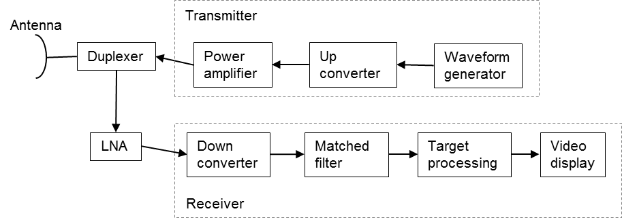

En-route air traffic control (ATC) PSRs currently use the frequency band 1 215-1 350 MHz (up to 1 370 MHz in some Countries) and the airport-area ATC PSRs use the frequency band 2 700‑2 900 MHz. The system characteristics and protection criteria for the en-route ATC PSRs are found in Recommendation ITU-R M.1463 and the airport-area ATC PSRs are found in Recommendation ITU-R M.1464. PSRs may be located at other locations than at airports according to the operational requirement.

# A1.2 Transmitters

ATC PSRs peak output power ranges from 25 kW solid-state transmitters to high power 5 MW klystron transmitters. They use a variety of modulations including continuous wave pulses, linear frequency modulated (chirped) pulses, and non-linear frequency modulated (chirped) pulses. PSRs utilize either a single frequency or multiple frequencies with and without sub-carrier frequencies for frequency diversity for target detection enhancement in poor weather.

A subset of the system characteristics for three sample ATC en-route PSRs operating in the frequency band 1 215‑1 390 MHz, found in Recommendation ITU-R M.1463, are provided in Table A1-1:

Table A1-1

Sample of Characteristics of air traffic control, en-route primary surveillance radars   
operation in the frequency band 1 215-1 390 MHz

| **Parameter** | **Units** | **System 2** | **System 8** |
| --- | --- | --- | --- |
| Peak power into antenna | dBm | 80 | 78.8 |
| Frequency range | MHz | 1215-1390 | 1240-1350 |
| Pulse duration | µs | 88.8; 58.8 (Note 1) | 115.5; 17.5 (Note 2) |
| Pulse repetition rate | pps | 291.5 or 312.5 average | 319 average |
| Chirp bandwidth | MHz | 0.77 | 1.2 |
| Compression ratio |  | 68.3:1 and 45.2:1 | 150:1; 23:1 |
| RF emission bandwidth (3 dB) | MHz | 1.09 | 1.2 |
| Antenna azimuthal beamwidth | degrees | 1.4 | 1.2 |
| Antenna horizontal scan characteristics | rpm | 360o at 5 rpm | 360o at 5 rpm |
| Receiver IF bandwidth | kHz | 690 | 1 200 |
| Receiver noise figure | dB | 2 | 3.2 |
| Platform type |  | Fixed | Fixed |
| NOTE 1 – The radar has 44 RF channel pairs with one of 44 RF channel pairs selected in normal mode. The transmitted waveform consists of an 88.8 µs pulse at frequency f1 followed by a 58.8 µs pulse at frequency f2. Separation of f1 and f2 is 82.854 MHz.  NOTE 2 – This radar utilizes two fundamental carriers, F1 and F2, with two sub-pulses each, one for medium range detection and one for long range detection. The carriers are tunable in 0.1 MHz increments with a minimum separation of 26 MHz between F1 (below 1 300 MHz) and F2 (above 1 300 MHz). The carrier sub-pulses are separated by a fixed value of 5.18 MHz. The pulse sequence is as follows: 115.5 μs pulse at F1 + 2.59 MHz, then a 115.5 μs pulse at F2 + 2.59 MHz, then a 17.5 μs pulse at F2 – 2.59 MHz, then a 17.5 μs pulse at F1 – 2.59 MHz. All four pulses are transmitted within a single pulse repetition interval. | | | |

A subset of the system characteristics for three sample ATC airport PSRs operating in the frequency band 2 700‑2 900 MHz, found in Recommendation ITU-R M.1464, are provided in Table A1-2:

Table A1-2

Sample Characteristics of air traffic control airport primary surveillance radar   
operating in the frequency band 2 700 - 2 900 MHz

| Parameter | Units | Radar A | Radar B | Radar C |
| --- | --- | --- | --- | --- |
| Platform type (airborne, shipborne, ground) |  | Ground, ATC | Ground, ATC | Ground, ATC |
| Peak power | kW | 1 400 | 1 320 | 25 |
| Pulse duration | µs | 0.6 | 1.03 | 1.0, 89.0; (note 1) |
| Pulse repetition rate | pps | 973-1 040 (selectable) | 1 059-1 172 | 722-935 (short impulse)  788-1 050 (long impulse) |
| Duty cycle | % | 0.07 max | 0.14 max | 9.34 max |
| Chirp bandwidth | MHz | N/A | N/A | 2 |
| Compression ratio |  | N/A | N/A | 89 |
| RF emission bandwidth (-20 dB)  (-3 dB) | MHz | 6 | 5  0.6 | 2.6 (short impulse)  5.6 (long impulse)  1.9 |
| Antenna azimuthal beamwidth | degrees | 1.35 | 1.3 | 1.45 |
| Antenna horizontal scan characteristics | degrees/s | 75 | 75 | 75 |
| Receiver IF bandwidth | MHz | 13 | 0.7 | 1.1 |
| Receiver noise figure | dB | 4 | 4 | 3.3 |
| (1) This radar utilizes two fundamental carriers with a minimum separation of 30 MHz | | | | |

Modelling primary surveillance radar transmitter signals

The transmitted electromagnetic signal can be expressed as:

*s*(*t*) = *A*(*t*) sin (2π*f*o*t* + θ(*t*)) (1)

where:

*f*0= radar transmit carrier frequency (Hz);

*A*(*t*)= signal amplitude (Volts) as a function of Swerling I distribution (varying from scan to scan) and the fixed signal amplitude at a specified distance;

θ(*t*)= signal down-chirp instantaneous phase (rad) = 2π(f0t – (π*df/τ0)t2) for -τ0/2 ≤ t ≤ τ0/2, where f0 = radar center frequency, τ0 = radar pulse width, and df = radar chirp frequency

The phase of the transmitting signal, θ(*t*), can be modelled for unmodulated narrow pulse or linear frequency modulated (LFM) long pulse, or non-linear frequency modulated (NLFM) long pulse.

It is important that the software model of the ATC PSRs match closely to the actual systems. A comparison of modelled signal spectrum with the measured spectrum is necessary to validate the model.







## A1.2.2 Modeling radar C

This radar utilizes two fundamental carriers, F1 and F2, with a minimum separation of 30 MHz between F1 and F2. Two frequencies are provided to compensate the atmospheric fading, distortion, and other effects on any one frequency. Effects that degrade one frequency are not expected to affect the other frequency farther away. Radar C transmits on four different frequencies, F1 ± 0.5 MHz and F2 ± 0.5 MHz, as shown on Figure A1-7.

Figure A1-7

Radar C transmitting sequence

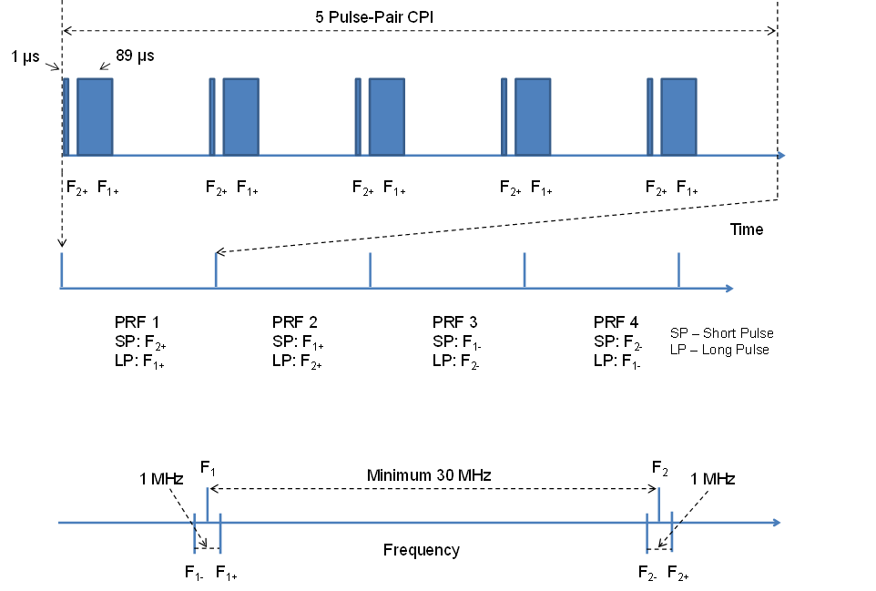

## A1.2.3 Modeling radar system 8

Figure A1-9 shows the complex baseband chirp signal with 2 long pulses (modulated with F1 + 2.59 MHz and with F2 + 2.59 MHz, respectively) and 2 medium pulses (modulated with F2 – 2.59 MHz and with F1 – 2.59 MHz, respectively) with a gap of 4 µs between each pulse.

Figure A1-9

Radar system 8 normalized baseband chirp pulses



# A1.3 General descriptions of radar receivers

The general radar architecture and values can be different from other manufacturers, depending on the type and application of the radar.

In modern solid-state PSRs, reflected radar signals are received and processed through a chain of electronic components such as RF filters, low-noise amplifiers (LNA), beamformers, RF down-converters, analog-to-digital converters (A/D), matched filters, pulse compressors, Doppler filters, envelope detectors, coherent/non-coherent integrators, constant false alarm rate processors, and target detectors. Depending on the specific design and purpose of a PSR system, some signal processing methods are not used. Figure A1-10 shows a simplified block diagram of a modern PSR receiver.

Figure A1-10

Simplified block diagram of a modern primary surveillance radar receiver

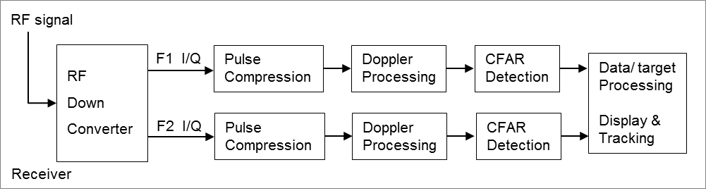

RF down converter

The RF signal received from the radar antenna goes to a RF filter and to a wideband LNA amplifier that operates over a large dynamic range (> 90 dB) and can accept signals up to –20 dBm without saturation. The noise figure of the LNA is typically less than 3 dB. This effectively establishes the system noise figure for a radar. This received RF signal is routed into the F1 bandpass-filter (BPF) and the F2 BPF before down-converting to intermediate frequencies (IF #1 and IF #2), respectively. The signals are passed through several stages of the IF processing chain (amplifier and filter) such that they fall within the dynamic range of the A/D converters. The I/Q splitter separates the digital signals into in-phase data (I) and quadrature-phase (Q), F1 I/Q signals and F2 I/Q signals, as shown in Figure A1-10.

Pulse compression

Radar range resolution depends on the bandwidth of the received signal, which is inversely proportional to the pulse duration. So, short pulses (SPs) are better for range resolution. The received signal strength is proportional to the pulse duration. Since the amplitude of the transmit pulse is limited by the maximum power of the radar, long pulses (LPs) provide higher energy and are better for signal reception. Pulse compression is employed to transmit a long pulse that has a bandwidth of a short pulse, by frequency modulating (linear FM or non-linear FM) or phase modulating (phase coded) the transmitted long pulse. The bandwidth of the linear/non-linear FM waveform is known as the chirp bandwidth. The matched filter is designed to maximize the signal-to-interference ratio in the presence of receiver noise. The pulse compression matched filter matches the received waveform with the reference waveform, through a correlation process or fast Fourier transform (FFT)-process, which provides the delays corresponding to the target ranges. Hence, each pulse is compressed down to 1 µs (the radar range resolution).

Figure A1-11 provides the details of the generation of the discrete complex signal to be input to the pulse compression block.

Figure A1-11

Simplified block diagram of a last IF stage receiver

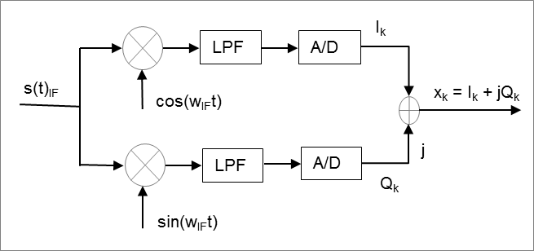

Let *xk* = *I*k + *jQk*, the received complex samples, be the inputs to the pulse compression block and *yk* be the replica waveform samples, then the correlation of *xk* and *yk* is given below:

for *n* = 0, 1, 2, …, *M*-1, where M is the number of samples covering the entire radar pulse.

Figure A1-12 shows a simplified block diagram for radar pulse compression using a fast convolution technique, where the complex waveform samples, *xk* = *Ik* + *jQk*, are used as the inputs.

Figure A1-12

Simplified block diagram of radar pulse compression using fast Fourier transform technique

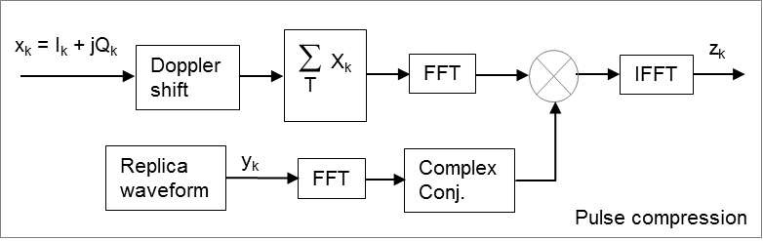

Fast convolution is used to implement the correlator. Taking the discrete Fourier transform (DFT), which can be efficiently computed using FFT algorithms, on both sides of the above equation, we have:

for *k* = 0, 1, 2, …, *M*-1.

Rearranging the above equation, we have:

where:

Now, the time-domain correlation sequence can be computed by taking the inverse *DFT* of *Z*(*k*):

for *n* = 0, 1, 2, …, *M*-1.

# A1.4 Example simulated performance in various noise environments

## A1.4.1 Radar system 8 analysis and simulation

Figure A1-13 shows the radar medium pulse (cosine-square shape for the rising edge and falling edge) and the normalized power spectrum (shape pulse and rectangular pulse). The spectrum of the shape pulse has better emission levels outside the main lobe than the spectrum of the rectangular (rec) pulse.

Figure A1-13

Radar medium pulse and its normalized power spectrum

|  |  |
| --- | --- |
|  |  |











The following assumptions are made for the purpose of this example: the System 8 radar is required to meet a probability of detection (PD) of 80%, the target is a Swerling I with radar cross section of 2.2 m2 at 200 NM, and the probability of false alarm (PFA) is 1x10-6. Table A1-4 shows the derivation of the single-pulse (long pulse (LP)) received signal-to-noise from a target radar cross section of 2.2 m2 at 200 NM, based on the equation below:

The above assumptions are not strictly link to System 8 and some applications may have other performances, sometimes even more stringent.

Table A1-4

**Derived single-pulse received signal-to-noise for a 2.2 m2 radar cross-section target at 200 NM**

| Parameters | Units | Long pulse (113 µs) | Long Pulse (115.5 µs) |
| --- | --- | --- | --- |
| Pt = Transmit power, (50kW LP) | dBW | 46.99 | 46.99 |
| G = Max antenna gain | dBi | 35.00 | 35.00 |
| Carrier frequency (1 240-1 350 MHz) | MHz | 1 350 | 1 350 |
| Wavelength, λ | m | 0.22 | 0.22 |
| Target cross section area, σ | m2 | 2.20 | 2.20 |
| Transmit pulse width (115.5+/−2.5 µs), τ | s | 1.130E-04 | 1.155E-04 |
| ***Receiver*** |  |  |  |
| Thermal noise, No = kT0 | dBW/Hz | −203.98 | −203.98 |
| Rx noise figure, F | dB | 3.20 | 3.20 |
| Rx noise, No + F | dBW/Hz | −200.78 | −200.78 |
| Rx noise bandwidth, (1/τ) | Hz | 8 849.56 | 8 658.01 |
| System implementation Loss, L | dB | 1.00 | 1.00 |
| Range, R = 200 NM, in dB | dB | 55.69 | 55.69 |
| Received single-pulse S/N from 200 NM | dB | 11.93 | 12.03 |

The received signal level from the target fluctuates due to reflections that occur due to complex formed surfaces across the target’s radar cross-section (RCS). The Swerling models (I – V), based on the Chi-square probability distribution with specific degrees of freedom, are used to describe the statistical properties of the radar cross-section of complex objects:

– Swerling I model, a Chi-square distribution with two degrees of freedom, applies to a target consisting of many independent scatterers of roughly equal areas like airplanes, where the radar cross-section is constant from pulse to pulse in a single scan, but varies independently from scan to scan. The Swerling I model is a good model to use for a surveillance radar.

– Swerling II model is similar to Swerling I model, except the RCS values are independent and vary from pulse to pulse. The Swerling II model is a good model for a target tracking radar.

– Swerling III model, a Chi-square distribution with four degrees of freedom, applies to a target consisting of one dominant reflector with many independent small scatterers, where the radar cross-section is constant from pulse to pulse in a single scan, but varies independently from scan to scan.

– Swerling IV model is like the Swerling III model, except the RCS varies from pulse to pulse, rather than from scan to scan. Examples include some helicopters and propeller driven aircraft.

– Swerling V model, also known as Swerling 0, applies to the targets (without any fluctuation) with a constant RCS.

The radar simulation models the received amplitude variations from only RCS fluctuation in order to compare with the previous measured radar tests, for comparison purpose. Hence, the simulation didn’t take into the received signal power variations due to atmospheric, clutter, diffraction, ducting, etc.

Based on the radar scan rate and the 3-dB radar beamwidth, there are about 12 radar pulses hitting the slow-moving target per the 3-dB radar beamwidth. However, for the fast-moving targets, the number of radar pulses hitting the target per 3-dB radar beamwidth will be smaller. System 8 radar is built to provide a 5-pulse non-coherent processing technique to improve the probability of target detection. Utilizing 5-pulse non-coherent processing and assuming the probability of false alarm (PFA) of 1x10-6, Figure A1-17 plots the System 8 probability of detection (PD), as a function of a single-pulse signal power to noise power ratio (S/N in dB). Figure A1-17 also include the case of PFA = 3.5x10-6 and the case where the number of pulses for non-coherent processing is reduced by 1, keeping PFA at 1x10-6.

Figure A1-17

System 8 radar: Single-pulse signal to noise ratio as a function of PD and PFA



From Figure A1-17, the single pulse S/N of 11.9 dB is required to meet a Swerling-I probability of detection, PD = 80% with a probability of false alarm, PFA = 1x10-6. Hence, the single-pulse (long pulse) received S/N of 11.93 dB in Table A1-4 meets the required single-pulse S/N from Figure A1‑18.

Cascaded integrator comb (CIC) decimation filter is a computationally efficient, linear phase, narrowband low-pass filter, which is used to filter out the signals at the 5.18 MHz offset. When the received RF signal is down-converted to IF and then from IF to baseband, the resulting signal will have a combination of long pulse (LP) and medium pulse (MP) signals at 0 Hz and at 5.18 MHz, depending on desired LP or MP processing chains. For example, the processing chains for the LP signal will have the LP signal at the baseband and the MP signal at 5.18 MHz. Similarly, the processing chains for the MP signal will have the MP signal at the baseband and the LP signal at 5.18 MHz. CIC decimation filter designed with very deep null at 5.18 MHz is used to filter out the undesired signal in each chain and has the following transfer function:

Figure A1-18 shows the CIC filter frequency response, where the signal at the baseband will pass through and the signal with spectrum around 5.18 MHz will be filtered out.

Figure A1-18

Cascaded integrator comb filter magnitude frequency response



Figure A1-19 shows an example of the LP radar signal processing chains from LP IF signal (after A/D converter) through IF phase rotation processing, CIC filter processing, IF gain correction, and the LP compressed signal processing: the normalized received IF long pulse (top left), the normalized compressed LP – In-phase (I) component (top right), the normalized compressed LP – Quad-phase (Q) component (bottom left), and the normalized compressed LP – I minus Q (bottom right), where the compressed signal is normalized to the maximum amplitude of (I – Q). The normalized compressed (I – Q) provides an enhanced signal detection (the presence of a peak clearly shown the presence of the LP signal from noise), as compared to the use of normalized compressed I alone or Q alone.

Figure A1-19

Example of radar processing from the received IF signal to the pulse compressed signal

|  |  |
| --- | --- |
|  |  |
|  |  |

Using the required probability of false alarm, PFA = 1x10-6 and a required radar cross section of 2.2 m2 at 200 NM, Figure A1-20 shows that the Swerling I simulated probability of detection (PD) with the integration of 5 pulses, as a function of single pulse S/N (dB), closely matches the Swerling I theoretical PD with the integration of 5 pulses. For each S/N value, each PD in Figure A1-20 is the average of 11 PD from 11 runs, each run of 50,000 long pulses (sampling at 82.88 MHz).

Figure A1-20

Swerling I – Probability of Detection (integration of 5 pulses)



Figure A1-21 shows the simulated Swerling I probability of detection as a function of I/N under pulsed interference with various pulse widths and duty cycles with no frequency offset. Each point ‘o’ is based on 8,000 scans of 5 pulses, sampling at 82.88 MHz. Note that in Figure A1-21, the I/N represents the peak pulse interference power over the receiver average noise power. The simulation includes the Doppler effects of aircraft traveling either toward the radar or away from the radar, which results in pulses advancing or delaying at the radar receiver. The blue horizontal line represents the desired SNR with PD = 80%. The red horizontal line is the probability of detection when the desired SNR is reduced by 1 dB from interference (see Figure A1-20).

Figure A1-21

Swerling I – Probability of detection with on-tune peak pulse interference



Annex 2

**Impact on radar probability of detection due to interference from   
wideband communication signals**

**Scope**

An investigation on the radar performance degradation due to the presence of high duty cycle digitally modulated communication signals (such as orthogonal frequency-division multiplexing (OFDM)) is presented in this report. The aim of this study is to enhance the understanding of effects of interference into radars from the signal waveforms of modern wideband communication systems.

This report provides a comprehensive technical investigation on the radar performance, i.e., degradation in the probability of detection in the presence of high duty cycle digitally modulated miscellaneous nature communication signals, particularly to enhance the understanding of effects of interference into radars from the signal waveforms of modern wideband communication systems.

# A2.1 Introduction

The interference analysis between a radiodetermination service and systems in other services to date has considered an interference-to-noise ratio (*I/N*) limit that should not be exceeded as a given protection criteria (refer to Recommendation ITU-R M.1461). This limit is set so that the increase in the noise floor due to interference is not exceeded typically by 1 dB at the input of the detector.

Radar receiver matched filters are designed to maximize the signal-to-interference ratio in the presence of receiver noise. Some digital communications modulation techniques, whilst “noise like” when averaged over hundreds of milliseconds, have a significant structure in both the frequency and time domains over the shorter periods typical of a radar pulse (e.g., microseconds) and radar coherent processing interval (CPI). When applied to the pulse compression filter, this structure may produce “peaks” in the compressed output which may result in localized noise floor increases after coherent processing. The localized noise floor increases may result in false alarms and greater desensitization of the radar.

Hence when the interfering signal is of high duty cycle, at even low power levels as much as 6 dB below noise level, there will be degradation to radar detection performance. Objects that would otherwise be detected will be lost due to the presence of low level interference that is not necessarily visible on the radar display.

Hence the degradation of the probability of detection depends on the nature of the communication signals.

Section 2 includes a schematic of typical radar, descriptions of the widely used processing methods of pulse compression, Doppler filtering, and constant false alarm rate (CFAR) detection. Section 3 outlines the simulation process and types of interference signals used in the simulations. The results of the analysis are provided in annexes 1-3. Section 4 has conclusions and an interpretation of the results.

# A2.2 Radar schema

Figure A2-1 shows a simplified radar block diagram. Some signal processing steps are omitted for clarity. Most signal processing steps are linear and could happen in different order to shown in the Figure A2-1.

Figure A2-1



The Report analyses the output at each of four observation points A, B, C and D.

At point (A): Radar returns in fast-time (uncompressed range) and slow-time (pulse index) domain. Assumes a single channel after beamforming stage.

At point (B): Radar returns after applying matched filter based pulse compression. In compressed range and slow-time domain.

At point (C): Range-Doppler map after Doppler processing.

At point (D): A detection map in binary form is obtained after CFAR detection. Monte-Carlo simulations are used to generate probability of detection curves from detection maps.

## A2.2.1 Radar processing steps

A simplified radar schematic diagram is shown in Figure A2-1. In this radar schematic two different sections are readily identifiable, analogue RF stage and the digital signal processing (DSP) stage. The current interference analysis between radar and systems in other services is assessed within the RF stages. This is conducted with respect to two different criteria; the saturation of the low noise amplifier and the *I/N* ratio at the IF stage. The focus of this Report is how the DSP stages act on different interfering signals. These DSP stages include pulse compression, Doppler filtering, and CFAR detection.

## A2.2.2 Pulse compression

Pulsed Doppler radars typically send a burst of pulses in the direction of interest. The amplitude of each transmit pulse is limited by the maximum power constraints of the radar. Therefore, pulse energy is dependent on the pulse width. Increasing the pulse energy improves the signal to noise ratio (SNR) of target returns, hence detection performance. On the other hand, the range resolution of radar is directly proportional to the pulse width. Better resolution requires shorter pulses. In order to satisfy these contrasting requirements pulse compression waveforms are used.

Pulse compression waveforms are obtained by adding frequency or phase modulation to a simple pulse. The most common types of pulse compression waveforms include linear FM, non-linear FM, bi-phase and poly-phase codes. The bandwidth of the linear/non-linear FM waveform is known as the chirp bandwidth. The pulse compression filter in the receiver chain is matched to this transmit waveform, which effectively peaks its response to a returned pulse at a delay corresponding to target range. This is done by sampling the returned pulse within the pulse width, known as fast-time sampling.

Linear and non-linear FM waveforms are considered in this Report. Pulse width and chirp bandwidth as specified in Recommendations ITU-R M.1463 and ITU-R M.1464 used in the analysis. Matched filter based pulse compression is applied.

*[Editor’s note: Clarification on the difference of the Tx BW and the Rx IF bandwidth should be included here, and wherever required. Should radar Tx BW match the Rx bandwidth?]*

*[Australia comment: Non-linear chirps create wider emissions not captured by 3 dB BW, so wider IF BW is required.* *For System 9 in Recommendation ITU-R M.1463*, *3 MHz RF emissions is for the primary radar mode. Radar has other modes which requires wider RF emissions (up to 8 MHz). Additionally, radar received data are oversampled for reasons like reducing straddling losses, and this requires IF BW to be sufficiently large.]*

*[Chairman’s note: Several references in the ITU refer to the necessary bandwidth of a radar being the 20 dB BW and not the 3 dB BW]*

## A2.2.3 Doppler processing

Doppler processing refers to spectral analysis of the radar returns from a fixed range over several pulses. The sampling of radar returns at a fixed range is referred to as slow-time sampling. Doppler processing usually involves coherent integration of target returns from several pulses within an interval referred as CPI. Doppler processing differentiates targets based on their radial velocities and improves target SNR, hence detection, proportional to the coherent processing gain.

The period between two consecutive pulses or slow-time sampling interval is called pulse repetition interval (PRI). The reciprocal of PRI is called pulse repetition frequency (PRF). A simple form of Doppler processing involves applying a windowed Fourier transform in slow time on complex radar returns to generate a Doppler spectrum. The unambiguous Doppler spectrum will be limited from   
–PRF/2 to +PRF/2. This form of Doppler processing is used in the analysis with Chebyshev windowing with sidelobe level 40 dB below the mainlobe magnitude in the frequency domain.

## A2.2.4 Constant false alarm detection

A range-Doppler map is obtained after pulse compression and Doppler processing stages. This range-Doppler map is then passed through a detector to identify possible targets. Modern radars usually use an adaptive threshold detection scheme called CFAR detection to achieve predictable detection and false alarm behaviours. Each cell in the range-Doppler map is tested for possible target existence. The underlying interference of each cell under test (CUT) is estimated using set of reference cells in the neighbourhood. A number of immediately neighbouring cells (guard cells) are omitted when choosing reference cell, to avoid target energy spill over to adjacent cells. CFAR algorithms defer on how reference cells are used to estimate the interference in CUT.

The simplest form of CFAR scheme is known as cell averaging CFAR (CA-CFAR) and visualised in Figure A2-2. In CA-CFAR reference cells are summed to get the interference estimate in CUT. This interference estimate is multiplied by a threshold multiplier (set by the acceptable false alarm rate) to compute the threshold. The threshold is compared to CUT to declare a target detect. The threshold is computed for each cell in the range-Doppler map. The output of the CFAR will be a binary map indicating target detects.

In this Report, CA-CFAR with 32 reference cells (8 cells with 4 guard cells in each direction unless CUT is at an edge of the range-Doppler map) is used. Threshold multiplier is set to obtain a probability of false alarm (*Pfa*) of 10-4.

Figure A2-2

The schematic of the typical constant false alarm rate process



# A2.3 Simulation process and types of output

*[Editor’s note: Clarify the terminology used for interfering signals]*

*[Australia comment: Characteristics of the interfering signals are described in section 3.2]*

### A2.3.1 Radar characteristics

Three studies are considered in this annex: airborne radars in the frequency band 1 300-1 400 MHz, ground-based radars in frequency band 1 300-1 400 MHz and shipborne radars in frequency band 2 700-3 500 MHz. Two of these radars are modern electronically steerable type radars using multiple antenna elements. These radars have a wide IF bandwidth and ability to track objects simultaneously in multiple directions. The other is a conventional horn-fed reflector antenna which is mechanically rotated for search and tracking of objects. The results are for average and worst case probability of detection degradation due to interference at a level compatible with protection criteria currently recommended in Recommendations ITU-R M.1461-2, ITU-R M.1463-3, ITU‑R M.1464-2 and ITU-R M.1465-3.

Table A2-1

|  |  |  |  |  |
| --- | --- | --- | --- | --- |
| Parameter | Units | Airborne radar (Systems 9 Rec. ITU-R M.1463) | Ground based radar (Systems 8 Rec. ITU-R M.1463) | Shipborne radar  (Radar M Rec. ITU-R M.1464) |
| Pulse width | μs | 14 | 115.5* | 20 |
| Chirp bandwidth | MHz | 2 | 1.2 | 2  *[Editor’s note: Check this value]Rec. states “up to 20 MHz”, we chose 2 MHz.* |
| Pulse repetition frequency | kHz | 7 | 0.319 | 10 |
| Receiver IF bandwidth | MHz | 10 | 1.2 | 10  *[Check the value]Rec. states “10-30 MHz”. We chose 10 MHz.* |
| Receiver noise figure | dB | 3 | 3.2 | 1.5 |
| * Single transmit frequency and single pulse width is used. | | | | |

## A2.3.2 Modern wideband communication system signal characteristics

Two types of interference are applied. In both cases the interference level is set at 6 dB below the receiver noise level.

1 Interference caused by OFDM communications signals. Interference signals are generated according to 3rd Generation partnership project Release 8 specifications. Fully loaded frames with 25 resource blocks (5 MHz channel bandwidth) with frequency division duplexing, quadrature phase shift keying (QPSK) modulation, single transmission antenna, and single receiving antenna are used. Each frame is 10 ms in duration. The spectrogram of a single ‘fully loaded’ co-channel frame is shown in Figure A2-3. Some of the visible structure in the OFDM signal is explained in the Figure.

2 Gaussian interference is also applied to investigate whether interference caused by wideband communications signals differs from typical Gaussian interference. The spectrogram of the signal is shown in Figure 4.

3 SC-OFDM uplink interference [TBD]

*[Editor’s note: Add a time signal representing the signal below.]*

*[Australia comment: Visible structures in the OFDM signal are explained in Figure 3.]*

Figure A2-3

Spectrogram of the interfering wideband quadrature phase shift keying communication signal fully loaded with user data downlink only (scale in dBW) (Baseband signal no carrier)

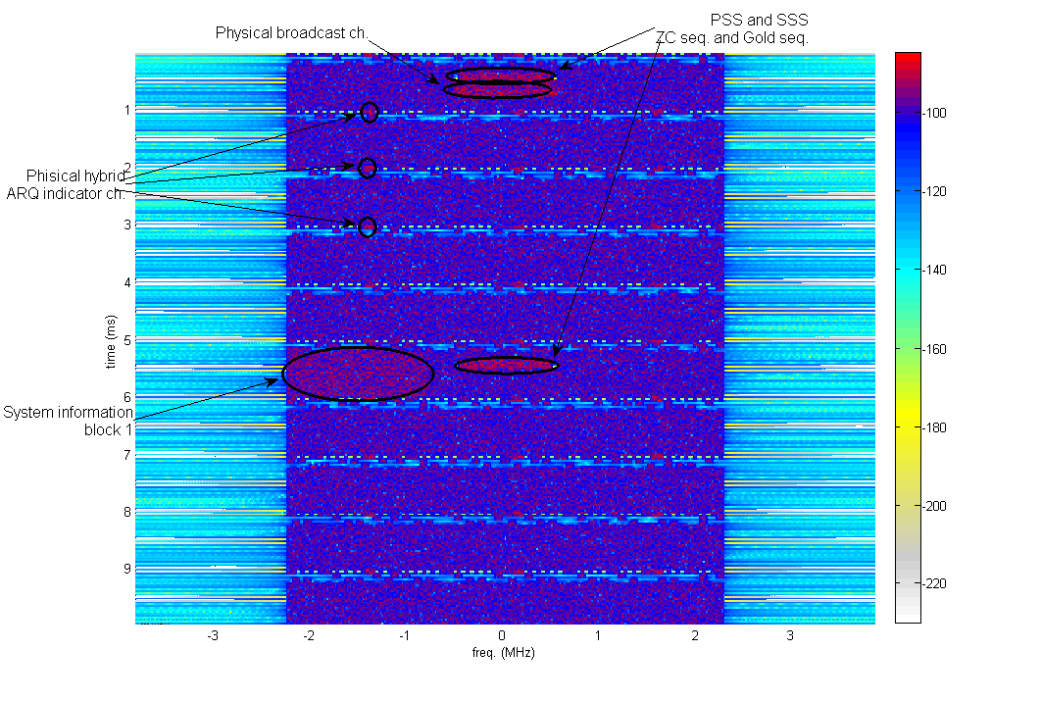Figure A2-4

Spectrogram of the interfering Gaussian signal (scale in dBW)

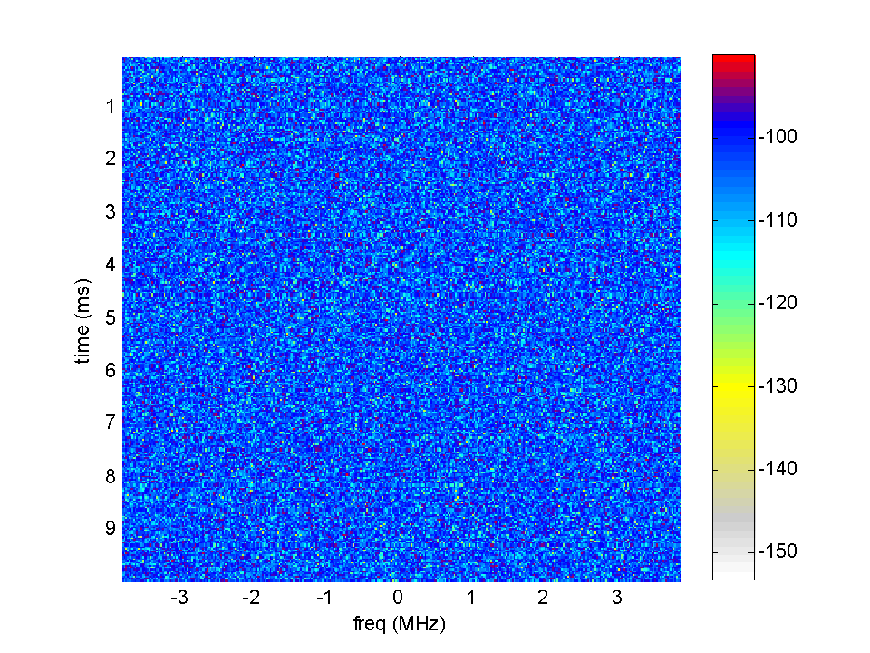

## A2.3.3 Simulation process

Simulations have been carried out in several steps:

**Step 1**

Input the interfering wideband communication system signal (WCSS) signal to the radar receiver chain after the digital receiver. The output at the locations A, B and C of Figure 1 are shown in Figure A1.1, Figure A1.2 and Figure A1.4, respectively. Radar waveform and signal processing parameters are given in Annex 1.

**Step 2**

Objects of varying amplitudes (SNR) are randomly placed at cells in the range-Doppler map. Probability of detection of such Objects for various SNR levels is computed using Monte-Carlo simulations at a fixed false alarm rate. The SNR is swept from 2‑22 dB (see Figure A1.5 and others).

**Step 3**

Objects of varying amplitudes are placed at the range-Doppler cell where the highest noise floor increase exits. This is referred as the “worst case” scenario. The SNR is swept from 2‑22 dB (see Figure A1.5 and others).

**Step 4**

Repeat the Steps 1 to 3 with a Gaussian signal as an interferer.

Note that interference signal levels are 6 dB below the receiver noise floor in all cases.

*[Chairman’s note: Which are figures A1.1-A1.5 referred to above]*

# A2.4 Conclusions

The study investigated radars using modern electronically steerable antennas and conventional horn-fed mechanically rotated reflector type antennas for their performance in the presence of interference 6 dB below the noise floor. The aim is to quantify the probability of detection degradation in the presence of a modern communication signal interferer.

Typically the increase in SNR required to achieve the same *Pd*in the presence of Gaussian interference is 1 dB which is equivalent to the noise floor increase when *I/N* = ‑6 dB. However, in case of some radars, additional loss of probability of detection is found at the presence of wideband communication signal interference compared to the Gaussian interference. The differences are prominent in the worst case scenarios, where objects falls within most affected range-Doppler cells.

*[Australia Note 1: In these preliminary studies the I/N = -6 dB has been assumed to apply for an entire Coherent Processing Interval (100% during a period of approx. 100 ms). Further studies will be conducted to represent the dynamic nature of OFDM networks.*

*Australia Note 2: The OFDM signal used here is downlink QPSK only and analysis w.r.t Uplink SC-OFDM and other modulation schemes is pending.]*

*[Editor’s note:*

1. *Put the two figures side-by-side and point to the structure.*

*[Australia comment: The structure present in the range-Doppler map is highlighted in Figure A1.4]*

1. *Find a more appropriate place for figures outside of the conclusion.*

*[Australia comment: Figures are moved to Annex]*

1. *The figures of Range-Doppler maps are not well understood by the ITU-R community. There is some confusion around interpretation of such figures. Add a few paragraphs and better description of these figures.]*

*[Australia comment: More text is added to better describe range-Doppler maps]*

*[Editor’s Note: The reason for this difference needs to be described in this report.]*

*[Australia comment: The reason for difference can be attributed to physical hybrid ARQ indicator channel in OFDM frames, and discussed in more detail in Annex 1.]*

Results indicate that the treatment of interference from WCSS, assumed to be noise-like, may not be valid in some cases, especially with modern radars with wider IF bandwidth and pulse compression. The key difference is in the localised increase of noise due to WCSS interference compared to Gaussian noise signal. The objects falling within the cells in the vicinity of this localised noise floor increases are difficult to be detected by the radar. The probability of detection versus SNR curves clearly quantifies this phenomenon.

Annex 2-1

# A2-1.1 Results of interference with airborne radar in the frequency range 1 300‑1 400 MHz

A CPI consisting of 600 pulses as typical in radars with long range detection capability is considered. Given PRF is 7 kHz, PRI is equal to 143 μs. When 14 μs pulses are used, the radar operates with 9.8% duty cycle. The CPI time is 85.7 ms.

Data from 9 frames (each frame is 10 ms) of the interfering WCSS signal is required to fill up a single radar CPI. Interference at the radar receiver before any signal processing steps is shown in Figure A2-1-1 in typical range (fast-time) – pulse (slow-time) domain.

Figure A2-1-1

A radar coherent processing interval with wideband communication system signal interference before any signal processing steps (scale in dBW) (observed at A in Figure A2-1)



NOTE – Only the WCSS interference is presented here without receiver noise.

Interference into a receiver with linear compression and Doppler processing

In the radar, received echoes are matched filtered to the transmission pulse to maximise the SNR of target returns. The interference is matched filtered to a linear FM waveform with 14 μs in duration and 2 MHz chirp bandwidth as per the airborne radar system 9 specifications. Results are shown in Figure A2-1-2. It is evident that some structure is present (caused by the WCSS interference) which is different to typical noise after pulse compression. The structure repeats itself every 5 ms, which is equivalent to half of an OFDM frame.

This structure can be attributed to primary and secondary synchronisation channels, physical broadcast channel, and system information block signals which are transmitted at an elevated power level compared to user data and which repeats in subframe 0 and subframe 5 in every OFDM frame. Such structure in the interference may pass through the radar signal processing chain, and may result in a detection loss.

figure A2-1-2

A radar coherent processing interval after pulse compression   
(matched filtered to linear frequency modulation waveform) (scale in dBW) (observed at B in Figure A2-1)



*[Editor’s note: To add a figure with different pulses for a fixed distance. To explain why there is an increase of the signal every 35 samples so about every 5 ms. Is there any link with the Figure 3 of the annex or with the paragraph 3.2?]*

*[Australia comment: This increase of the signal can be attributed to primary and secondary synchronisation channels, Physical Broadcast Channel, and System Information Block signals in the OFDM frames.]*

*[Editor’s note: Convert the vertical axis of the map in time. Use term map. More explanation of the figures is required to avoid confusion.]*

*[Australia comment: Vertical axis is changed to time. More explanation added.]*

NOTE – Only the WCSS interference is presented here without receiver noise.

Figure A2-1-3

Characteristics of the linear frequency modulation waveform used in the matched filter



After the pulse compression, Doppler processing is applied in slow-time to coherently integrate target returns at specific velocities. A range-Doppler map after Doppler processing is shown in Figure A2-1-4. Though the structure which was seen after the pulse compression stage is partially diminished due to coherent integration process which rejects interference unless it integrates across pulses for a fixed range position, some artefacts of the interference can still be seen in the range‑Doppler map. Some Doppler bins seem to be more susceptible to OFDM interference than others. This structure in Doppler repeats at every 1 kHz and has wider spread in range. It can be attributed to physical hybrid ARQ indicator channel in OFDM frames, which appears at the beginning of each subframe (which is 1 ms separated in time, consistent with 1 kHz repetition in Doppler) and also appears at three frequencies thus inducing a wider structure in range. This may result in a masking effect where targets present in or close to such Doppler bins may not get detected.

Figures A2-1-4 and A2-1-4B compare the differences in range-Doppler maps with wideband QPSK communication signal as interferer and the Gaussian signal as an interferer, respectively. The key difference is the absence of structure in processed Gaussian signal. This localised noise floor increase either, introduces additional false alarms, or degrades detection probability for a set false alarm rate.

figure A2-1-4

Range-Doppler map of wideband communication system signal interference after pulse compression   
(Linear frequency modulation) and Doppler processing (scale in dBW) (observed at C in Figure A2-1)





*[Editor’s note: To explain why in this figure the increase of the signal looks like a noise and not anymore with a steep like in Figure A1-2.]*

*[Australia comment: It is due to the coherent integration process, which rejects interference unless it integrates across pulses for a fixed range position. This explanation is also added to text above.]*

*[Editor’s note: More explanation on these maps.]*

NOTE – Only the wideband communication interference is presented here without receiver noise.

Figure A2-1-4B

Range-Doppler map of Gaussian signal interference after pulse compression   
(Linear frequency modulation) and Doppler processing (scale in dBW)



Next, a probability analysis was undertaken in order to quantify possible degradation in radar detection performance in the presence of wideband communication signal interference. A non‑fluctuating target was injected at different SNR levels in the presence of wideband communication signal interference and receiver noise, and the probability of target detection was estimated. Results were then compared with the case where only the receiver noise is present without wideband communication signal interference. Interference-to-noise (*I/N*) level was set at   
–6 dB as per Recommendation ITU-R M.1461-1*.*

A CA-CFAR adaptive threshold detector was used to detect the injected target. The threshold multiplier was set to 10.94 dB, which results in a false alarm rate (*Pfa*) of 10-4. Probability of detection results are shown in Figure A2-1-5 for a range of target SNR levels with and without interference. In the ‘average case’, the target was injected with a random range and velocity, thus it has an equal likelihood of appearing in any range-Doppler cell. In the ‘worst case’, the target was injected with particular range and velocity parameters such that it will appear in a range‑Doppler cell where more structural interference is present.

Figure A2-1-5

Probability of detection of a non-fluctuating target with and without wideband   
communication signal and Gaussian interference for linear frequency modulation waveform



*[Editor’s note: To find a difference between average and worst case is logical. Focused on the average results, the parameters used to find a SNR loss of 1.4 dB instead of 1 dB should be provided: radar sensitivity, post-processing, directivity, distances between victim and interferer, the characteristics of the interferer,…]*

*[Australia comment: Characteristics of the interferers are as given in section 3.2. No assumptions were made on the distance between the interferer and the radar, as this analysis is based on the assumption that interference level at the radar receiver is -6 dB below the noise level. Post processing steps are as described in sections 2.2-2.4.]*

*[Editor’s note: Additional information for clarification. Provide information how any of the parameters affects the results presented here.]*

Note that “worst case” refers to the case where the target was injected on or around a strong interference structure present in the range-Doppler map. “Average case” refers to the case where target was injected randomly in the range-Doppler map regardless of interference structure. A linear FM waveform was used.

If wideband communication signal interference is “noise like” to the radar receiver, 1 dB increase in the noise floor at *I/N* of –6 dB is expected. But for the “average case” 1.4 dB loss in SNR is observable when comparing linear regions of the probability of detection (*Pd*) curves. It suggests that some underlying structure is present in the interference after passing through a typical radar signal processor, which is different to Gaussian noise. For the “worst case”, detection loss is much more significant. An SNR of 15.3 dB is required to achieve a detection probability of 0.5 in the ‘worst case’ interference; where as an SNR of 10.6 dB is sufficient in the noise only case to achieve the same detection performance.

These results are consistent with NTIA Report TR-06-444 *Effects of RF Interference on Radar Receivers* (available at: <http://www.its.bldrdoc.gov/publications/2481.aspx>) which states “The *Pd* of simulated radar targets for single channel operation was always measurably degraded, by as much as 0.15 (with *Pd* dropping to 0.75 from a nominal 0.90), at *I/N* = –6 dB.” In the results presented in Figure A1.5, *Pd* has dropped from 0.9 to 0.71 at SNR of 13.1 dB for the ‘average case’.

Interference into a receiver with non-linear compression and Doppler processing

The above analysis was repeated for a non-linear FM waveform (Figure A2-1-7) which is widely used in modern radars. Wideband communication signal interference matched filtered to a non‑linear FM pulse with 14 μs duration and 2 MHz bandwidth is shown is shown in Figure A2‑1-6. Similar to the linear FM case, a structure in the interference can be seen after pulse compression.

Figure A2-1-6

A radar coherent processing interval after pulse compression   
(matched filtered to non-linear frequency modulation waveform) (Scale in dBW)



NOTE – Only the wideband communication signal interference is presented here without receiver noise.

Figure A2-1-7

Characteristics of the non-linear frequency modulation waveform used in the matched filter



Doppler processed results are shown in Figure A2-1-8.

Figure A2-1-8

Range-Doppler map of wideband quadrature phase shift keying communication signal interference after pulse compression (non-linear frequency modulation) and Doppler processing (scale in dBW)



NOTE – Only the wideband communication signal interference is presented here without receiver noise.

A probability of detection analysis was performed similar to the linear FM waveform case. *I/N* level was set at –6 dB, and non-fluctuating target with different SNR settings was injected using the procedure described previously.

CA-CFAR detector was used with the threshold multiplier set to 10.30 dB which results in a false alarm rate (*Pfa*) of 10-4. Probability of detection results for the non‑linear FM radar waveform are shown in Figure A2-1-9.

Compared to the linear FM case, all the *Pd* curves are shifted towards left, indicating that an NLFM waveform is capable of achieving better detection performance for the same target parameters, and same noise/interference settings; but degrade in detection due to WCSS interference is still significant. In the ‘average case’ where the target was randomly placed in the range-Doppler map, an SNR of 11.6 dB is required to achieve a detection probability of 0.5. This is 1.3 dB additional SNR requirement compared to the no interference case. The fact that this loss is greater than 1 dB indicates the presence of some structure (unlike noise) in the WCSS interference when matched filtered to NLFM radar waveform and Doppler processed.

In the “worst case” scenario where target was injected to a particular range-Doppler cell where an interference structure is present, i.e., thus generating a high CA-CFAR noise estimate, a 4 dB loss in SNR is found compared to the noise only case.

Figure A2-1-9

Probability of detection of a non-fluctuating target with and without wideband communication signal   
and Gaussian interference for non-linear frequency modulation waveform



NOTE – “Worst case” refers to the case where target was injected on or around strong interference structure present in the range-Doppler map. “Average case” refers to the case where target was injected randomly in the range-Doppler map. NLFM waveform was used and false alarm rate was set to 10-4.

Table A2-1-1 summarises the main findings of the study by comparing target SNR levels required to achieve a detection probability of 0.5 in different interference scenarios including Gaussian and WCSS waveforms with respect to two different radar waveforms considered. It can be seen that the NLFM waveform is slightly robust to communication signal interference compared to the LFM waveform, but degradation in detection due to OFDM interference at *I/N* = –6 dB is still significant for both waveforms.

Table A2-1-1

Target signal to noise ration levels required to achieve a detection probability of 0.5 in the presence of interference for linear and non-linear frequency modulation radar waveforms.   
In all cases false alarm rate is set to 10-4

|  |  |  |  |
| --- | --- | --- | --- |
|  | *I/N* = -∞ dB (noise only) | *I/N* = –6 dB (‘average case’) | *I/N* = –6 dB (‘worst case’) |
| WCSS interference into linear FM radar receiver | 10.6 dB | 12.0 dB | 15.3 dB |
| Gaussian interference into linear FM radar receiver | 10.6 dB | 11.6 dB | 13.8 dB |
| WCSS interference into non-linear FM radar receiver | 10.3 dB | 11.6 dB | 14.3 dB |
| Gaussian interference into non-linear FM radar receiver | 10.3 dB | 11.3 dB | 12.6 dB |

Annex 2-2

# A2-2.1 Results of interference with ground-based radar in the frequency range 1 300‑1 400 MHz

Two types of interference (WCSS and Gaussian) are applied to Radar 8 in Recommendation ITU-R M.1463. In both cases the interference level is set at 6 dB below the receiver noise level.

Figure A2-2-1

Probability of detection of a non-fluctuating target in System 8 with international mobile telecommunication   
and Gaussian interference for linear frequency modulation waveform



Figure A2-2-2

Probability of detection of a non-fluctuating target in System 8 with international mobile telecommunication   
and Gaussian interference for non-linear frequency modulation waveform



Table A2-2-1 summarises the results. In this case the detection loss due to a wideband communication signal is almost the same as that by a Gaussian interferer. Note the IF bandwidth of 1.2 MHz compared to 10 MHz IF bandwidth for the two other radars in this study. The bandwidth of the interferer is much greater than the IF bandwidth of the radar. This may be the reason why results for WCSS interferer and Gaussian interferer only differ slightly.

Table A2-2-1

Target signal to noise ration levels required to achieve a detection probability of 0.5 in the presence of interference for linear and non-linear frequency modulation radar waveforms.   
In all cases false alarm rate is set to 10-4

|  |  |  |  |
| --- | --- | --- | --- |
|  | *I/N* = -∞ dB (noise only) | *I/N* = –6 dB (‘average case’) | *I/N* = –6 dB (‘worst case’) |
| WCSS interference into linear FM waveform | 10.6 dB | 11.7 dB | 12.5 dB |
| Gaussian interference into linear FM radar receiver | 10.6 dB | 11.6 dB | 12.4 dB |
| WCSS interference into non-linear FM radar receiver | 10.0 dB | 11.0 dB | 12.2 dB |
| Gaussian interference into non-linear FM radar receiver | 10.0 dB | 11.0 dB | 12.1 dB |

*[Editor’s note: It can be noticed no significant impact of an IMT interference compared to a Gaussian interference. The comparison between the bandwidths of the receiver and of the transmitter may lead to suggest as a mitigation technic the reduction of the receiver bandwidth that would directly decrease the noise level due to the interference.]*

*[Australia comment: Reducing the receiver IF BW will help reducing the effects of the interferer directly. But most modern electronically steerable radars operate in multiple modes with non-linear FM waveforms, thus require a wider IF BW.]*

Annex 2-3

# A2-3.1 Results of interference with ship borne radar in the frequency range 2 700‑3 500 MHz

Two types of interference (WCSS and Gaussian) are applied to shipborne radar M given in Recommendation ITU-R M.1464. In both cases the interference level is set at 6 dB below the receiver noise level.

Results, summarised in Table A2-3-1, show a significant detection loss in the presence of wideband communication signal interference. To achieve the same detection probability of 0.5 compared to the noise only case, an additional target SNR of 1.3 dB is required in the ‘average’ case, and in the ‘worst’ case additional target SNR of 4.5 dB is required when linear FM waveform is used.

Results also indicate that wideband communication signals cannot be treated as typical Gaussian interference, and effects of the wideband communication interference on the radar is more than just the noise floor increase. The loss in the presence of Gaussian interference is 1 dB which is equivalent to the noise floor increase when *I/N* = –6 dB. However, increased detection loss is observed in the presence of wideband communication interference at the same interference power level.

Figure A2-3-1

Probability of detection of a non-fluctuating target in System M with international mobile telecommunication and Gaussian interference for linear frequency modulation waveform



Figure A2-3-2

Probability of detection of a non-fluctuating target in system M with international mobile telecommunication   
and Gaussian interference for non-linear frequency modulation waveform



Table A2-3-1

Target signal to noise ration levels required to achieve a detection probability of 0.5 in the presence of interference for linear and non-linear frequency modulation radar waveform for system M.   
In all cases false alarm rate is set to 10-4

|  |  |  |  |
| --- | --- | --- | --- |
|  | *I/N* = -∞ dB (noise only) | *I/N* = -6 dB (‘average’ case) | *I/N* = -6 dB (‘worst’ case) |
| WCSS interference into linear FM radar receiver | 10.6 dB | 11.9 dB | 15.1 dB |
| Gaussian interference into linear FM radar receiver | 10.6 dB | 11.6 dB | 13.3 dB |
| WCSS interference into non-linear FM radar receiver | 10.4 dB | 11.8 dB | 14.2 dB |
| Gaussian interference into non-linear FM radar receiver | 10.4 dB | 11.4 dB | 13.2 dB |

Annex 2-4

# A2-4.1 Results of interference with air traffic control radar in the frequency range 1 215‑1 400 MHz

Two types of interference (WCSS and Gaussian) are applied to air traffic control radar System 1 and System 2 given in Recommendation ITU-R M.1463. In both cases the interference level is set at 6 dB below the receiver noise level.

Figure A2-4-1

Probability of detection of a non-fluctuating target in system 1 with international mobile telecommunication   
and Gaussian interference for non-linear frequency modulation waveform

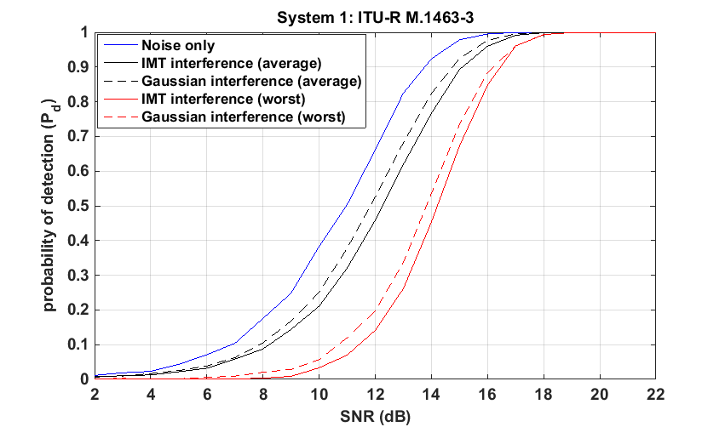

Table A2-4-1

Target signal to noise ration levels required to achieve a detection probability of 0.5 in the presence of interference for System 1. In all cases false alarm rate is set to 10-4

|  |  |  |  |
| --- | --- | --- | --- |
|  | *I/N* = -∞ dB (noise only) | *I/N* = -6 dB (‘average’ case) | *I/N* = -6 dB (‘worst’ case) |
| WCSS interference into radar receiver | 11.0 dB | 12.2 dB | 14.2 dB |
| Gaussian interference into radar receiver | 11.0 dB | 11.8 dB | 13.8 dB |

Figure A2-4-2

Probability of detection of a non-fluctuating target in system 2 with international mobile telecommunication   
and Gaussian interference for non-linear frequency modulation waveform

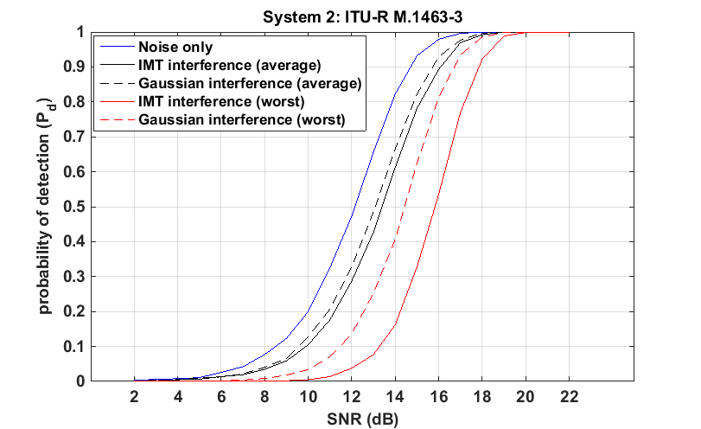

Table A2-4-2

Target signal to noise ration levels required to achieve a detection probability of 0.5 in the presence of interference for system 2. In all cases false alarm rate is set to 10-4

|  |  |  |  |
| --- | --- | --- | --- |
|  | *I/N* = -∞ dB (noise only) | *I/N* = -6 dB (‘average’ case) | *I/N* = -6 dB (‘worst’ case) |
| WCSS interference into radar receiver | 12.1 dB | 13.4 dB | 15.8 dB |
| Gaussian interference into radar receiver | 12.1 dB | 13.1 dB | 14.4 dB |

Analysis is based on 88.8 μs duration linear chirp modulated waveform at a single frequency with PRF of 291.5 Hz. Dual frequency operation is not analysed.