|  |  |
| --- | --- |
| U.S. Radiocommunications Sector  Fact Sheet | |
| **Working Party:** ITU-R WP 5B | **Document No:** USWP5B |
| **Ref:** 5B/225 Annex 29 | **Date:** 3 March, 2021 |
| Document Title: Working document towards preliminary draft new report ITU-R M.[Aero-Wideband-HF] | |
| **Author(s)/Contributors(s):**  Ron McGowan  Collins Aerospace  Andrew Roy  ASRI  Damon Ladson  Harris, Wiltshire & Grannis | Phone: (443) 336-1158  Email: [ronald.mcgowan@collins.com](mailto:gdb@asri.aero)  Phone: (443) 951-0340  Email: [acr@asri.aero](mailto:acr@asri.aero)  Phone: (202) 730-1315  Email: [dladson@hwglaw.com](mailto:dladson@hwglaw.com) |
| **Purpose/Objective:** To further development of the material for Agenda Item 1.9 working document Report ITU-R M.[AERO-WIDEBAND-HF] | |
| **Abstract:** At the last 5B meeting the working document towards a preliminary draft new Report ITU-R M.[AERO-WIDEBAND-HF] (Annex 29) built a framework for system characteristics, sharing studies and regulatory considerations. This contribution seeks to build upon that work with the currently available information for these three different areas. | |
| **Fact Sheet Preparer:** Ron McGowan | |

|  |  |
| --- | --- |
| **Radiocommunication Study Groups** |  |
|  |  |
|  |  |
| Source: Document 5B/TEMP/67  Subject: New Report ITU-R M.[AERO-WIDEBAND-HF] | **Annex 29 to Document 5B/225-E** |
| **May 2021** |
| **English only** |
| Annex 29 to Working Party 5B Chairman’s Report | |
| Working Document towards preliminary draft new report ITU-R M.[Aero-Wideband-hf] | |
| Aeronautical Wideband HF | |

Keywords

Wideband HF; Aeronautical Communications; Appendix 27

Glossary/Abbreviations

ADS-C Automatic dependence surveillance - contract

ATU Antenna tuning unit

CPDLC Controller-pilot data link communications

HF High frequency

HFDL High frequency data link

LDOC Long distance operational control

MIFR Master International Frequency Register

MWARAs Major world air route areas

RCP-240 Required communication performance 240 seconds

RDARAs Regional and domestic air route areas

VHF Very high frequency

Related ITU Recommendations, Reports

Recommendations

ITU-R [BS.216](https://www.itu.int/rec/R-REC-BS.216/en) Protection ratio for sound broadcasting in the Tropical Zone

ITU-R [BS.559](https://www.itu.int/rec/R-REC-BS.559/en) Objective measurement of radio-frequency protection ratios in LF, MF and HF broadcasting

ITU-R [BS.560](https://www.itu.int/rec/R-REC-BS.560/en) Radio-frequency protection ratios in LF, MF and HF broadcasting

ITU-R [BS.639](https://www.itu.int/rec/R-REC-BS.639/en) Necessary bandwidth of emissions in LF, MF and HF broadcasting

ITU-R [BS.703](https://www.itu.int/rec/R-REC-BS.703/en) Characteristics of AM sound broadcasting reference receivers for planning purposes

ITU-R [BS.1514](https://www.itu.int/rec/R-REC-BS.1514/en) System for digital sound broadcasting in the broadcasting bands below 30 MHz

ITU-R [BS.1615](https://www.itu.int/rec/R-REC-BS.1615/en) "Planning parameters" for digital sound broadcasting at frequencies below 30 MHz

ITU-R [BT.1895](https://www.itu.int/rec/R-REC-BT.1895/en) Protection criteria for terrestrial broadcasting systems

ITU-R [M.1458](https://www.itu.int/rec/R-REC-M.1458/en) Use of the frequency bands between 2.8-22 MHz by the aeronautical mobile (R) service for data transmission using class of emission J2D

ITU-R [SM.328](https://www.itu.int/rec/R-REC-SM.328/en) Spectra and bandwidth of emissions

ITU-R [SM.329](https://www.itu.int/rec/R-REC-SM.329/en) Unwanted emissions in the spurious domain

Reports

ITU-R [BS.302](https://www.itu.int/pub/R-REP-BS.302) Interference to sound broadcasting in the shared bands in the Tropical Zone

ITU-R [BS.458](https://www.itu.int/pub/R-REP-BS.458) Characteristics of systems in LF, MF and HF broadcasting

ITU-R [BS.2144](https://www.itu.int/pub/R-REP-BS.2144) Planning parameters and coverage for Digital Radio Mondiale (DRM) broadcasting at frequencies below 30 MHz

ITU-R [BS.2251](https://www.itu.int/pub/R-REP-BS.2251) Digital Radio Mondiale in the 26 MHz band (25 670-26 100 kHz)

The most relevant propagation models and coverage calculations are available in the ITU-R Recommendations listed below:

P.368 – Ground-wave propagation curves for frequencies between 10 kHz and 30 MHz

P.371 – Choice of indices for long-term ionospheric predictions

P.372 – Radio noise

P.373 – Definitions of maximum and minimum transmission frequencies

P.533 – Method for the prediction of the performance of HF circuits

P.534 – Method for calculating sporadic-E field strength

P.581 – The concept of "worst month"

P.845 – HF field-strength measurement.

# 1 Introduction

This report considers both the technical and regulatory studies for the introduction of new aeronautical wideband HF systems into Appendix **27** of the ITU Radio Regulations in accordance with Resolution **429** **(WRC-19)**.

[The application of HF radio technologies has not seen modernization in quite a number of years. The introduction of HFDL twenty-plus years ago was the only substantial paradigm shift in aeronautical HF’s application to air traffic communications in quite a number of decades. Newer technologies are emerging that can make more efficient use of the Aeronautical Mobile (R) spectrum, and utilization of that spectrum using legacy applications is on a steep decline. The time is appropriate to revisit the regulations and update them accordingly to allow more modern applications access to this protected resource that will continue to go underutilized if not addressed.]

HF communication equipage is required by [all] commercial aircraft requesting oceanic clearance. Introduction of new wideband HF systems enable benefits to aircraft operators including:

• Improved voice quality

• [Ability to meet RCP 240 requirements]

• Avionics size, weight, and power reduction

• Ease of use

• Capacity and network improvements

• User authentication

New wideband HF systems will bring the listed benefits to the aviation industry in numerous areas but first and foremost would be Major Air Routes, Polar routes and remote land masses with poor VHF infrastructure. The network would be constructed to increase capacity and optimize use for high aircraft density, which may be accomplished with network densification and directionality of transmission and reception antennas.

The new aircraft radio system will allow significant savings in size, weight, and required power to operate. Smaller, lighter, and more powerful processors and digital signal processing components will be used to replace the solid-state components used in legacy avionics. The aircraft radio and antenna tuning unit (ATU) will be consolidated into one unit and moved closer to the antenna in most aircraft to minimize feeder losses and reduce weight. These improvements directly translate into fuel savings by the airline.

Modification of Appendix 27 of the Radio Regulations will allow spectrally efficient advanced waveforms, which were not previously considered for use in 3 kHz channel allotments for legacy HF voice and High Frequency Data Link (HFDL). This will be the enabler that would facilitate the development of higher throughput HF systems that could provide digital voice for significantly reduced noise and improved clarity, as well as 100+ kbps data rates. Various modulation waveforms (up to 256 QAM) and channel bandwidths (up to 48 kHz) combine to support a wide range of data rates, based on available signal quality. [Through use of the advanced modulations and greater bandwidths achieved through channel bonding, increased data throughput can be realized in order to achieve RCP-240 compliance]. This will bring utility to HF not previously obtained via HFDL by enabling terrestrial based data system to be used for Controller-Pilot Data Link Communications (CPDLC) and Automatic Dependence Surveillance Contract (ADS-C) in oceanic or remote land areas.

This increased throughput will also be the enabler that will allow for the transmission of digitized voice interleaved with data messaging. Previously, HF voice systems and HF data systems were separated because they were designed for use as one-or-the-other within a 3kHz channel allotment. A wideband HF system breaks down that barrier and enables both data and voice simultaneously. Greater bandwidth and data throughput will allow for more enhanced security.

Introduction of new wideband HF systems will complement existing long-range aeronautical communications links such as L-Band SATCOM. HF and SATCOM have different environmental susceptibilities and failure modes (e.g., solar events, rain fade, jamming, satellite failures, ground station failures, etc.), thus wideband HF will provide a spectrally diverse, terrestrial based long-range communications path supporting high availability aeronautical systems through dissimilar redundancy and increase the useful bandwidth available for aircraft communications.

# 2 Aeronautical mobile (route) service allotments for HF communications between 2.8-22 MHz

The table below lists the carrier (reference) frequencies allotted in the bands allocated exclusively to the aeronautical mobile (R) service below 30 MHz, from the Appendix 27 channel plan. This contains a total of 427 3 kHz channels (435 for region 2) over all frequency bands.

|  |  |  |  |
| --- | --- | --- | --- |
| 2 850-3 025 kHz | | | |
|  |  |  |  |
| 2 851 |  | 2 938 |  |
| 2 854 |  | 2 941 |  |
| 2 857 |  | 2 944 |  |
| 2 860 |  | 2 947 |  |
| 2 863 |  | 2 950 |  |
| 2 866 |  | 2 953 |  |
| 2 869 |  | 2 956 |  |
| 2 872 |  | 2 959 |  |
| 2 875 |  | 2 962 |  |
| 2 878 |  | 2 965 |  |
| 2 881 |  | 2 968 |  |
| 2 884 |  | 2 971 |  |
| 2 887 |  | 2 974 |  |
| 2 890 |  | 2 977 |  |
| 2 893 |  | 2 980 | 57 |
| 2 896 |  | 2 983 | chan- |
| 2 899 |  | 2 986 | nels |
| 2 902 |  | 2 989 |  |
| 2 905 |  | 2 992 |  |
| 2 908 |  | 2 995 |  |
| 2 911 |  | 2 998 |  |
| 2 914 |  | 3 001 |  |
| 2 917 |  | 3 004 |  |
| 2 920 |  | 3 007 |  |
| 2 923 |  | 3 010 |  |
| 2 926 |  | 3 013 |  |
| 2 929 |  | 3 016 |  |
| 2 932 |  | 3 019 |  |
| 2 935 |  |  |  |
|  |  |  |  |
|  |  |  | (R) |
|  |  | 3 023 | and |
|  |  |  | (OR) |
|  |  |  |  |
| 3 400-3 500 kHz | | | |
|  |  |  |  |
| 3 401 |  | 3 452 |  |
| 3 404 |  | 3 455 |  |
| 3 407 |  | 3 458 |  |
| 3 410 |  | 3 461 |  |
| 3 413 |  | 3 464 |  |
| 3 416 |  | 3 467 |  |
| 3 419 |  | 3 470 |  |
| 3 422 |  | 3 473 | 33 |
| 3 425 |  | 3 476 | chan- |
| 3 428 |  | 3 479 | nels |
| 3 431 |  | 3 482 |  |
| 3 434 |  | 3 485 |  |
| 3 437 |  | 3 488 |  |
| 3 440 |  | 3 491 |  |
| 3 443 |  | 3 494 |  |
| 3 446 |  | 3 497 |  |
| 3 449 |  |  |  |
|  |  |  |  |
|  |  |  |  |
|  |  |  |  |
|  |  |  |  |

|  |  |  |  |
| --- | --- | --- | --- |
| 4 650-4 700 kHz | | | |
|  |  |  |  |
| 4 651 |  | 4 675 |  |
| 4 654 |  | 4 678 |  |
| 4 657 |  | 4 681 | 16 |
| 4 660 |  | 4 684 | chan- |
| 4 663 |  | 4 687 | nels |
| 4 666 |  | 4 690 |  |
| 4 669 |  | 4 693 |  |
| 4 672 |  | 4 696 |  |
|  |  |  |  |
| 5 450-5 480 kHz | | | |
| *Region2* | | | |
|  |  |  |  |
| 5 451 |  | 5 466 |  |
| 5 454 |  | 5 469 | 9 |
| 5 457 |  | 5 472 | chan- |
| 5 460 |  | 5 475 | nels |
| 5 463 |  |  |  |
|  |  |  |  |
| 5 480-5 680 kHz | | | |
|  |  |  |  |
| 5 481 |  | 5 580 |  |
| 5 484 |  | 5 583 |  |
| 5 487 |  | 5 586 |  |
| 5 490 |  | 5 589 |  |
| 5 493 |  | 5 592 |  |
| 5 496 |  | 5 595 |  |
| 5 499 |  | 5 598 |  |
| 5 502 |  | 5 601 |  |
| 5 505 |  | 5 604 |  |
| 5 508 |  | 5 607 |  |
| 5 511 |  | 5 610 |  |
| 5 514 |  | 5 613 |  |
| 5 517 |  | 5 616 |  |
| 5 520 |  | 5 619 |  |
| 5 523 |  | 5 622 |  |
| 5 526 |  | 5 625 |  |
| 5 529 |  | 5 628 | 66 |
| 5 532 |  | 5 631 | chan- |
| 5 535 |  | 5 634 | nels |
| 5 538 |  | 5 637 |  |
| 5 541 |  | 5 640 |  |
| 5 544 |  | 5 643 |  |
| 5 547 |  | 5 646 |  |
| 5 550 |  | 5 649 |  |
| 5 553 |  | 5 652 |  |
| 5 556 |  | 5 655 |  |
| 5 559 |  | 5 658 |  |
| 5 562 |  | 5 661 |  |
| 5 565 |  | 5 664 |  |
| 5 568 |  | 5 667 |  |
| 5 571 |  | 5 670 |  |
| 5 574 |  | 5 673 |  |
| 5 577 |  | 5 676 |  |
|  |  |  |  |
|  |  |  | (R) |
|  |  | 5 680 | and |
|  |  |  | (OR) |
|  |  |  |  |

|  |  |  |  |
| --- | --- | --- | --- |
| 6 525-6 685 kHz | | | |
|  |  |  |  |
| 6 526 |  | 6 607 |  |
| 6 529 |  | 6 610 |  |
| 6 532 |  | 6 613 |  |
| 6 535 |  | 6 616 |  |
| 6 538 |  | 6 619 |  |
| 6 541 |  | 6 622 |  |
| 6 544 |  | 6 625 |  |
| 6 547 |  | 6 628 |  |
| 6 550 |  | 6 631 |  |
| 6 553 |  | 6 634 |  |
| 6 556 |  | 6 637 |  |
| 6 559 |  | 6 640 |  |
| 6 562 |  | 6 643 | 53 |
| 6 565 |  | 6 646 | chan- |
| 6 568 |  | 6 649 | nels |
| 6 571 |  | 6 652 |  |
| 6 574 |  | 6 655 |  |
| 6 577 |  | 6 658 |  |
| 6 580 |  | 6 661 |  |
| 6 583 |  | 6 664 |  |
| 6 586 |  | 6 667 |  |
| 6 589 |  | 6 670 |  |
| 6 592 |  | 6 673 |  |
| 6 595 |  | 6 676 |  |
| 6 598 |  | 6 679 |  |
| 6 601 |  | 6 682 |  |
| 6 604 |  |  |  |
|  |  |  |  |
| 8 815 -8 965 kHz | | | |
|  |  |  |  |
| 8 816 |  | 8 891 |  |
| 8 819 |  | 8 894 |  |
| 8 822 |  | 8 897 |  |
| 8 825 |  | 8 900 |  |
| 8 828 |  | 8 903 |  |
| 8 831 |  | 8 906 |  |
| 8 834 |  | 8 909 |  |
| 8 837 |  | 8 912 |  |
| 8 840 |  | 8 915 |  |
| 8 843 |  | 8 918 |  |
| 8 846 |  | 8 921 |  |
| 8 849 |  | 8 924 |  |
| 8 852 |  | 8 927 | 49 |
| 8 855 |  | 8 930 | chan- |
| 8 858 |  | 8 933 | nels |
| 8 861 |  | 8 936 |  |
| 8 864 |  | 8 939 |  |
| 8 867 |  | 8 942 |  |
| 8 870 |  | 8 945 |  |
| 8 873 |  | 8 948 |  |
| 8 876 |  | 8 951 |  |
| 8 879 |  | 8 954 |  |
| 8 882 |  | 8 957 |  |
| 8 885 |  | 8 960 |  |
| 8 888 |  |  |  |
|  |  |  |  |
|  |  |  |  |

|  |  |  |  |
| --- | --- | --- | --- |
| 10 005-10 100 kHz | | | |
|  |  |  |  |
| 10 006 |  | 10 054 |  |
| 10 009 |  | 10 057 |  |
| 10 012 |  | 10 060 |  |
| 10 015 |  | 10 063 |  |
| 10 018 |  | 10 066 |  |
| 10 021 |  | 10 069 |  |
| 10 024 |  | 10 072 | 31 |
| 10 027 |  | 10 075 | chan- |
| 10 030 |  | 10 078 | nels |
| 10 033 |  | 10 081 |  |
| 10 036 |  | 10 084 |  |
| 10 039 |  | 10 087 |  |
| 10 042 |  | 10 090 |  |
| 10 045 |  | 10 093 |  |
| 10 048 |  | 10 096 |  |
| 10 051 |  |  |  |
|  |  |  |  |
| 11 275-11 400 kHz | | | |
|  |  |  |  |
| 11 276 |  | 11 339 |  |
| 11 279 |  | 11 342 |  |
| 11 282 |  | 11 345 |  |
| 11 285 |  | 11 348 |  |
| 11 288 |  | 11 351 |  |
| 11 291 |  | 11 354 |  |
| 11 294 |  | 11 357 |  |
| 11 297 |  | 11 360 |  |
| 11 300 |  | 11 363 |  |
| 11 303 |  | 11 366 | 41 |
| 11 306 |  | 11 369 | chan- |
| 11 309 |  | 11 372 | nels |
| 11 312 |  | 11 375 |  |
| 11 315 |  | 11 378 |  |
| 11 318 |  | 11 381 |  |
| 11 321 |  | 11 384 |  |
| 11 324 |  | 11 387 |  |
| 11 327 |  | 11 390 |  |
| 11 330 |  | 11 393 |  |
| 11 333 |  | 11 396 |  |
| 11 336 |  |  |  |
|  |  |  |  |
|  |  |  |  |
|  |  |  |  |
|  |  |  |  |
|  |  |  |  |
|  |  |  |  |
|  |  |  |  |
|  |  |  |  |
|  |  |  |  |
|  |  |  |  |
|  |  |  |  |
|  |  |  |  |
|  |  |  |  |
|  |  |  |  |
|  |  |  |  |
|  |  |  |  |
|  |  |  |  |

|  |  |  |  |
| --- | --- | --- | --- |
| 13 260-13 360 kHz | | | |
|  |  |  |  |
| 13 261 |  | 13 312 |  |
| 13 264 |  | 13 315 |  |
| 13 267 |  | 13 318 |  |
| 13 270 |  | 13 321 |  |
| 13 273 |  | 13 324 |  |
| 13 276 |  | 13 327 |  |
| 13 279 |  | 13 330 |  |
| 13 282 |  | 13 333 | 33 |
| 13 285 |  | 13 336 | chan- |
| 13 288 |  | 13 339 | nels |
| 13 291 |  | 13 342 |  |
| 13 294 |  | 13 345 |  |
| 13 297 |  | 13 348 |  |
| 13 300 |  | 13 351 |  |
| 13 303 |  | 13 354 |  |
| 13 306 |  | 13 357 |  |
| 13 309 |  |  |  |
|  |  |  |  |
| 17 900-17 970 kHz | | | |
|  |  |  |  |
| 17 901 |  | 17 937 |  |
| 17 904 |  | 17 940 |  |
| 17 907 |  | 17 943 |  |
| 17 910 |  | 17 946 |  |
| 17 913 |  | 17 949 | 23 |
| 17 916 |  | 17 952 | chan- |
| 17 919 |  | 17 955 | nels |
| 17 922 |  | 17 958 |  |
| 17 925 |  | 17 961 |  |
| 17 928 |  | 17 964 |  |
| 17 931 |  | 17 967 |  |
| 17 934 |  |  |  |
|  |  |  |  |
| 21 924-22 000 kHz | | | |
|  |  |  |  |
| 21 925 |  | 21 964 |  |
| 21 928 |  | 21 967 |  |
| 21 931 |  | 21 970 |  |
| 21 934 |  | 21 973 |  |
| 21 937 |  | 21 976 |  |
| 21 940 |  | 21 979 | 25 |
| 21 943 |  | 21 982 | chan- |
| 21 946 |  | 21 985 | nels |
| 21 949 |  | 21 988 |  |
| 21 952 |  | 21 991 |  |
| 21 955 |  | 21 994 |  |
| 21 958 |  | 21 997 |  |
| 21 961 |  |  |  |
|  |  |  |  |
|  |  |  |  |
|  |  |  |  |
|  |  |  |  |
|  |  |  |  |
|  |  |  |  |
|  |  |  |  |
|  |  |  |  |
|  |  |  |  |

# 3 Regulatory Background

*[Editor’s note: The intent of this section is to provide some historical context to the development and use of the HF AM(R)S allocations for aviation. It is not intended to be a historical record but should help explain the origins of Appendix 27]*

The Aeronautical Mobile Route Service allocation was finalized at the International Radio Conference (Atlantic City, 1947), shortly after the ICAO came into being on 4 April 1947. The initial allotment plan for what is now Appendix 27 was created over two International Administrative Aeronautical Radio Conferences in 1948 and 1949, with the 1st session laying the agreed technical rules and framework for the 2nd session. Between sessions, administrations submitted operational usage and flight data to the International Frequency Registration Board (IFRB) to determine channel usage for planning of the RDARAs and MWARAs. This was done again over two International Administrative Aeronautical Radio Conferences in 1964 and 1966 which also created a framework for transitioning from DSB to SSB, added VOLMET channels (Meteorological broadcast transmissions), and refined the RDARAs boundaries. The final World Administrative Radio Conference on the Aeronautical Mobile (R) Service (WARC-Aer2) (Geneva, 1978) revised the allotment plan to create a mandatory transition to SSB increasing capacity from 171 to 411 channels, created “World-wide allotment areas” (i.e. LDOC frequencies), and further refined RDARAs boundaries.

# 4 Technical and Operational Characteristics

*[Editor’s note:* *This section contains a set of parameters as available during WP 5B’s November meeting. Administrations are kindly invited to complement this set of parameters by due date in order to be able to perform the sharing studies]*

Wideband HF will be operated as a network of WBHF ground stations communicating with aircraft equipped with WBHF avionics. HF is typically used in areas that lack VHF coverage, such as oceanic and remote areas. Wideband HF is expected to be deployed and co-located with existing HFDL ground installations and compatible with co-site HFDL and voice channels. There is a potential for additional ground stations once Wideband HF is adopted in order to complete ubiquitous global coverage. The list of existing HFDL ground stations is provided in the table below:

Table 1

HF Data link ground stations

|  |  |  |
| --- | --- | --- |
| Station | Lat., Deg | Long., Deg. |
| Al Muharraq, Bahrain | 26.27 N | 50.64 E |
| Auckland, New Zealand | 37.02 S | 174.81 E |
| Barrow, AK, USA | 71.30 N | 156.78 W |
| Daecho-ri, Republic of Korea | 34.97 N | 126.23 E |
| Dixon, CA, USA | 38.38 N | 121.76 W |
| Hat Yai, Thailand | 6.94 N | 100.39 E |
| Johannesburg, South Africa | 26.13 S | 28.21 E |
| Krasnoyarsk, Russia | 56.17 N | 92.51 E |
| Las Palmas, Canary Island | 28.12 N | 15.28 W |
| Molokai, HI, USA | 21.18 N | 157.18 W |
| Pulantant, Guam | 13.47 N | 144.40 E |
| Reykjavik, Iceland | 64.08 N | 21.85 W |
| Riverhead, NY, USA | 40.88 N | 72.64 W |
| Santa Cruz, Bolivia | 17.67 S | 63.16 W |
| Shannon, Ireland | 52.73 N | 8.93 W |

Due to the increased bandwidth, an increase in power is necessary in order to maintain the same coverage as HFDL. The total authorized power will be directly proportional to the bandwidth of the channel. From a practicality and cost-benefit perspective, ground station transmitters will probably not exceed 10 kW in power because of the diminishing returns in upsizing transmit power. The same power spectral density profile as HFDL will be maintained, both within the channel, adjacent channels and bands. This will make both technical and regulatory compatibility simple and will allow an overlay onto the existing Appendix 27 regulatory framework. The protection criteria for the Wideband HF system will be calculated using the existing 15 dB desired-to-undesired criteria, but this will be calculated using a 3 kHz channel bandwidth. The spectrum mask will be the same as the existing HFDL system, allowing the same amount of energy on existing adjacent band services. The total power authorized for the aircraft will remain the same.

Table 2

Technical characteristics

|  |  |  |
| --- | --- | --- |
|  | Ground Station | Aircraft Station |
| Peak power | 6 kW – [25 kW*] | 400 W |
| Power spectral density | 6 kW/3 kHz | 400 W/3 kHz |
| Modulation | SSB | SSB |
| Polarization | Horizontal | Vertical/Elliptical |
| Channel bandwidth (kHz) | 3,6,9,12,15,18,21,24,27,  30,33,36,39,42,45,48 | 3,6,9,12,15,18,21,24,27,  30,33,36,39,42,45,48 |
| Antenna gain | See Section 4.1 | −4 dBi |
| Emission type | J2D | J2D |
| Propagation | Skywave | Skywave |
| Transmitter spectrum mask | See Figures 1 and 2 | See Figures 1 and 2 |
| Protection criteria | 15 D/U per 3 kHz | 15 D/U per 3 kHz |
| * 25 kW would be an upper limit of what might be required, however 10 kW may be most likely. | | |

Considerations in the design of wideband HF systems using contiguous 3 kHz channels:

– The WBHF modulation waveforms will fall under the same J2D emission designator as the existing HF Datalink (HFDL), operating in the existing AM(R)S allocations, as defined in Recommendation ITU-R M.1458-0.

– The WBHF signal will comply with the legacy HFDL spectral mask regarding adjacent channel power as defined in Recommendation ITU-R M.1458-0 (see Figure 1 and Figure 2 below), with the goal of ensuring compatibility with legacy systems operating in the same or adjacent MF/HF frequency bands.

– The WBHF channels will be defined around the reference frequency and bandwidth of the wideband channel (see Wideband Spectral Mask diagram). Reference frequency and assigned frequency of individual 3 kHz channels comprising a bonded wideband utilization would remain unchanged.

Figure 1

Spectrum mask



Figure 2

Spectrum mask (visual)

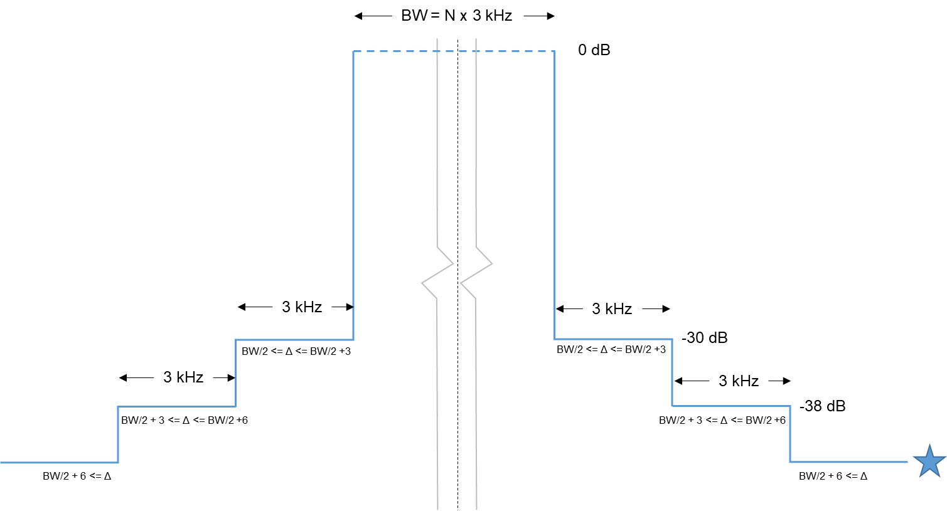

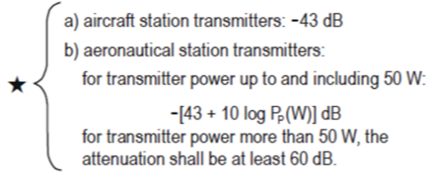

Note: Assigned frequency is offset by BW/2 - 100 Hz above SSB carrier reference frequency, as with legacy HFDL.

## 4.1 Ground station antenna characteristics

A wideband HF system will require improved ground infrastructure in order to achieve required performance. Several strategies will likely be employed to achieve improved performance in order to pass large amounts of data, such as transmit diversity and high gain directional antennas (log-periodic) which will be optimized for major air routes. Existing commercially available antennas will be utilized, with gains between 10-15 dBi. Two transmitter or receive paths, each with their own antenna separated by several wavelengths, can achieve additive benefits that counteract the negative effects of signal fading and fluctuations in propagation that could impede performance at higher data rates. An example antenna pattern is show in the figure below, that should be representative of commercially available antennas.

Table 3

Example log periodic

|  |  |  |  |  |  |  |
| --- | --- | --- | --- | --- | --- | --- |
|  | 4 MHz | | 15 MHz | | 25 MHz | |
|  | Azimuth | Elevation | Azimuth | Elevation | Azimuth | Elevation |
| Gain (dB) | 16 | | 16 | | 16 | |
| Beamwidth (degrees) | 40 |  | 40 |  | 40 |  |
| Upper 3 dB |  | 42 |  | 29 |  | 24 |
| Take off angle |  | 27 |  | 20 |  | 15 |
| Lower 3 dB |  | 15 |  | 10 |  | 8 |

# 5 Compatibility analysis

*[Editor’s note : This section is to be populated later on with appropriate and detailed sharing studies that would be reflected in relevant subsections]*

[TBD]

[Iran has registered in the MIFR, 85 stations in the fixed services, aeronautical mobile service and aeronautical (route) service.]

## 5.1 Co-site ground station analysis

Editor’s note: Insert a technical discussion about the non-interference of WBHF implementation at existing HF sites at the same location, particularly in the context of split transmit and receive site architecture as a best practice.

As specified in section 4 above, the WBHF signal will comply with the legacy HFDL spectral mask regarding adjacent channel power, as defined in Recommendation ITU-R M.1458-0.  As a result, the power spectral density profile for the WBHF signal will not exceed that of a legacy HFDL signal, ensuring compatibility and interoperability with legacy HF voice and HFDL users on adjacent channels, as well as existing adjacent band services in the HF spectrum.  Compatibility testing will be conducted to verify this before WBHF systems will be deployed.

## 5.2 5 450-5 480 kHz Region 1 & 2 and Region 2 & 3 Boundary Analysis

Region 1 – Europe, Africa, the former Soviet Union, Mongolia, and the Middle East west of the Persian Gulf, including Iraq

Region 2 – The Americas including Greenland, and some of the eastern Pacific Islands

Region 3 – Most of non-Former Soviet Union Asia east of and including Iran, and most of Oceania

Editor’s Note: Insert propagation analysis of the various regions and discussion about reuse distance, interference, etc.

# 6 Regulatory discussion

Approvals to operate a wideband HF system should be relatively straightforward considering that the strategy to update Appendix 27 would be that of an “overlay” of the existing 3 kHz construct – don’t make any out-of-band emissions that do not conform to today’s spectral mask definitions, and don’t interfere with any existing data or voice applications. Whether a wideband implementation would use contiguous channels or non-contiguous channels, the protection criteria for adjacent users in the same region or in-band assignees in different regions would remain unchanged.

The existing Aeronautical HF allotment plan is built off of adjacent channels being assigned in different regions of the world outside of a calculated re-use distance specifically designed to minimize interference. In an application where adjacent channels would be sought out within the same region for use in an aggregated fashion, a mechanism to form a wideband channel must be determined. In order to use frequency “X” in a particular region, frequencies “X+3 kHz” and “X+6 kHz” currently allocated for use in other regions would need to be authorized for use in conjunction with frequency “X” in the region in question.

To address inter-region reassignments, the various ICAO regions would track the assignments and any movement thereof in the MIFR. That would allow changes to happen over time by mutual agreement of the ICAO regions and not require constant and regular modification of the Appendix 27 allotment table as the systems evolve.

[TBD]

# 7 Summary

[TBD]

ANNEX

Propagation considerations

# 1 Ionospheric radio wave propagation

In several scenarios, ionospheric radio wave propagation will be the dominant propagation mechanism in the frequency range 2 850 to 22 000 kHz. Refracted waves by the ionosphere may be received at distances up to 3 500 km. Multiple reflections between ionosphere and the Earth (‘multi‑hop propagation’) may even cover the entire globe. Additional reflections and greater path length increase the path loss, therefore single-hop paths have a lower path loss.

Ionospheric refraction is frequency dependent. Vertically emitted radio waves are reflected only when their frequency is less than the critical frequency (peak plasma frequency) of the E- or F‑region. But radio waves emitted at lower grazing angles are still reflected at frequencies that are 4-5 times higher. As a result, the radio wave propagation at the lower end of the frequency range of interest differs significantly from propagation in the middle or at the higher end of the frequency range.

Ionospheric radio wave propagation varies significantly over the day. One of the main drivers of the electron density production in the ionosphere is the radiation of the sun. Consequently, the electron density in the ionosphere, responsible for the refraction of radio waves, shows a strong diurnal variation and also changes with the seasons. Due to the 11-year cycle of the sun, the electron density worldwide follows a more or less sinusoidal variation with the same period.

Furthermore, the electron density distribution is not equal across the globe. The high-latitude ionosphere differs significantly from the mid-latitude and low-latitude regions.

# 2 Different scenarios and associated HF propagation models

The propagation models cannot be selected unless the interference scenarios are known. However, an answer to WP 5B’s question can be formulated by sketching different variations of the relative location of AM(R)S and victim, and the associated propagation mechanisms. These scenarios are not exhaustive. If WP 5B defines other scenarios that are not described here, WP 3L will be glad to provide additional advice on them.

Figures 1, 2, 3 and 4 depict several different scenarios, with increasing separation distance. The associated propagation models will be discussed.

Figure 1

Close-range scenarios, all frequencies

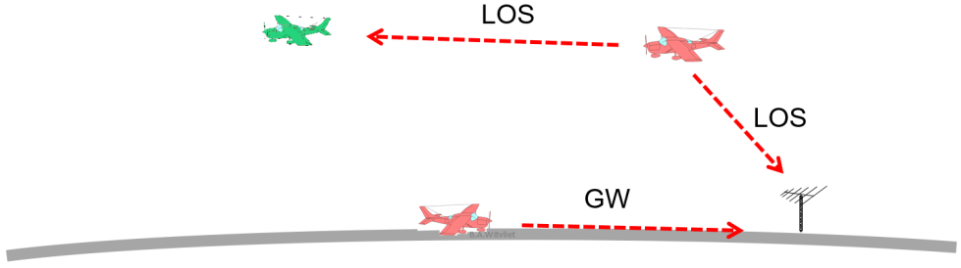

LOS = line-of-sight; GW = ground wave

Figure 2

Short-range scenario up to 400 km. NVIS = Near Vertical Incidence Skywave.   
Frequency 2 is much higher than frequency 1. Heights are not to scale

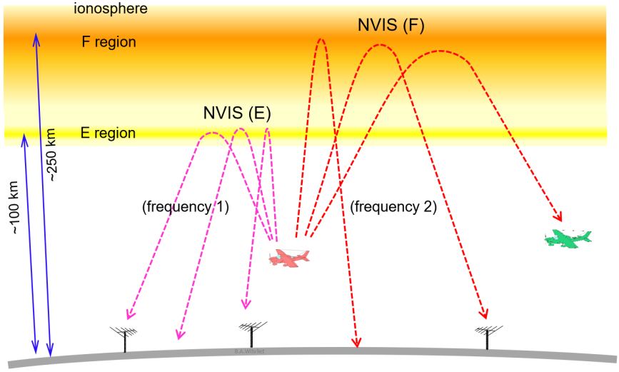

Figure 3

Single-hop mid-range scenarios, up to 3,500 km (F-region) or 2,000 km (E-region).   
1F = single hop propagation via the F-region. Es = Sporadic E. Heights are not to scale

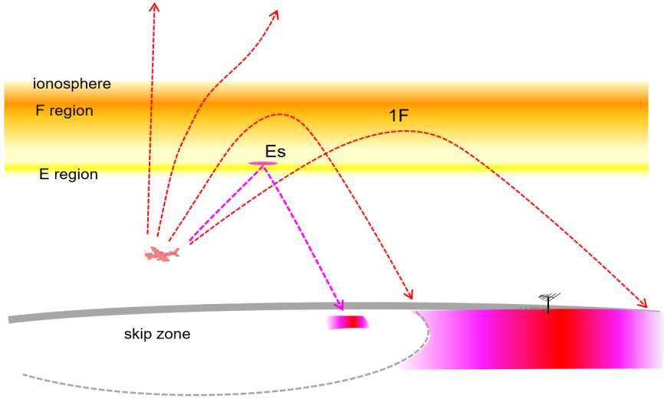

Figure 4

Example of a multi-hop scenario for long-range ionospheric propagation.   
2F = two hops via the F-region; 3F = three hops via the F-region. Heights not to scale

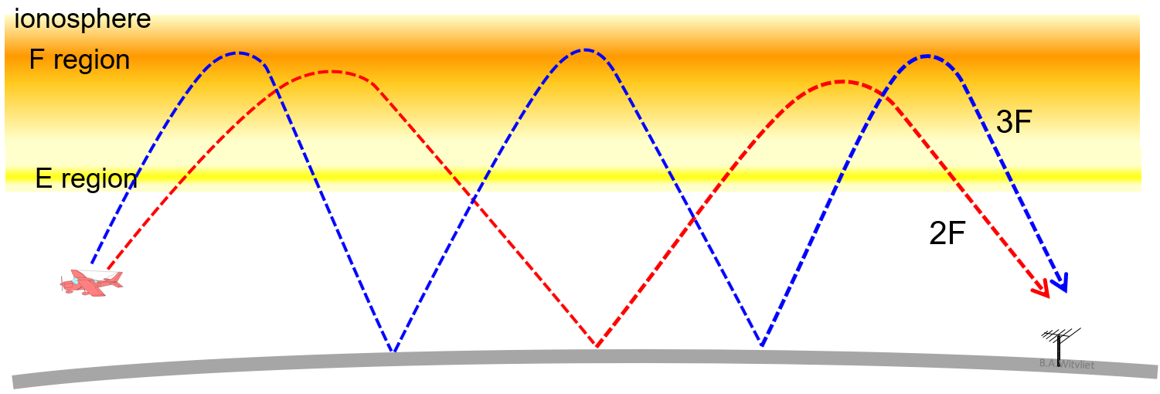

# 3 Line-of-sight propagation

When both the AM(R)S and the victim are airborne and within sight of each other, the dominant propagation mechanism is ‘free space propagation’ and the Friis theorem applies. This is depicted in Figure 1. Path loss can be calculated using Recommendation ITU-R P.525-4 “Calculation of free space attenuation,” formula 3. The same is true when the AM(R)S is within sight of a terrestrial victim.

# 4 Ground wave propagation

When both the AM(R)S and the victim are on the ground, ground wave propagation will provide a coupling path between them. This is also depicted in Figure 1. The associated path loss can be calculated using Recommendation ITU-R P.368-9 “Ground-wave propagation curves for frequencies between 10 kHz and 30 MHz” and associated “GRWAVE” software.

# 5 Near vertical incidence skywave propagation

When the transmit frequency is below the critical frequency of the E- or F-region of the ionosphere, even vertically emitted radio waves will be reflected back to Earth. Due to the important height of the F-region (200-250 km), a continuous area around the AM(R)S is covered. The signal strength is homogenous in the entire area. This is depicted in Figure 2. NVIS path loss is low.

Near the AM(R)S, both the ground wave and the NVIS skywave will be received. At very short distances the ground wave is dominant. As the ground wave attenuation increases rapidly with frequency, the sky wave path will become dominant at a certain distance from the victim.

Whether the AM(R)S and/or victim are airborne or on the ground does not alter the propagation properties. The path loss and probability can be calculated using Recommendation ITU-R P.533-14 “Method for the prediction of the performance of HF circuits” and related software. Some of the required input parameters can be found in Recommendation ITU-R P.371-8 “Choice of indices for long-term ionospheric predictions.”

# 6 Single-hop mid-range propagation (1E, 1F)

Single-hop E-region propagation (1E) will cover distances up to approx. 2 000 km. Single-hop F‑region propagation (1F) will reach at least 3 500 km. This is depicted in Figure 3. Similar to NVIS, the calculation of path loss and probability of single-hop E- and F-region propagation can be done with Recommendation ITU-R P.533. The difference with NVIS propagation is the existence of a skip zone, a large zone around the AM(R)S in which its signal is not received.

# 7 Sporadic E-region reflection

Sporadically, thin patches of high electron density are formed in the E-region. Their electron density is significantly higher than the background E-region. Due to their lower altitude, the associated range is much shorter than the F-region reflections on the same frequency. This is depicted in Figure 3. Path loss is very low. Its occurrence is random and sporadic. Methods to calculate the probability and signal strength of Sporadic-E propagation are described in Recommendation ITU-R P.534-5 “Method for calculating sporadic-E field strength”.

# 8 Multi-hop long-range propagation (e.g. 3F)

Multi-hop propagation will cover very long distances, up to the antipodes. Several propagation modes may exist simultaneously. When the path loss of two paths is comparable, their interference will cause deep periodic fading. An example is depicted in Figure 4.

# 9 Radio noise

At HF, the ambient electromagnetic noise level (‘radio noise’) is relatively high. That implies that in many cases reception is ‘radio noise-limited’ and not exclusively ‘path loss limited’. The background radio noise level as a function of frequency is described by Recommendation ITU‑R P.372-14, sections Parts I and II (natural noise) and VI (man-made noise). This radio noise is defined for an omnidirectional antenna. When beamforming is used, the received radio noise is proportionally lower reduced with respect of these levels.

# 10 Other effects of ionospheric propagation

Radio wave propagation through a plasma (the ionosphere) not only causes path loss; it also causes Doppler shift, time dispersion and multi-path fading. These propagation effects are not covered in Recommendation ITU-R P.533, but they can be found in Recommendation ITU-R F.1487-0, which is maintained by Study Group 5.