|  |  |
| --- | --- |
| U.S. Radiocommunications Sector  Fact Sheet | |
| **Working Party:** ITU-R WP 1A | **Document No:** USWP1A23_08_rev3 - WD PDR Report SM.2451 on WPT-EV |
| **Ref:** ITU-R SM.2451 | **Date:** 2 April 2021 |
| Document Title: Continuation of previous US contribution to update the “Working Document Towards a Preliminary Draft Revision of Report ITU-R SM.2451”, Assessment of impact of wireless power transmission for electric vehicle charging on radiocommunication services. | |
| **Author(s)/Contributors(s):**  Ky Sealy  WiTricity Corp.  Jon Sirota  WiTricity Corp. | **Email**: ky.sealy@witricity.com **Phone**: +1 617-926-2700 x3002  **Email**: jon.sirota@witricity.com **Phone**: +1 617-926-2700 x2239 |
| **Purpose/Objective:** Proposal to finish corrections, clarifications, and updates to SM.2451-0 including the previously contributed new appendix with a recent study on impact of WPT-EV on amateur radio performed on an OATS. Subsequently the working document towards a preliminary draft should be elevated for adoption. | |
| **Abstract:** The United States Delegation to WP1A contributed to the June 2020 meeting that was subsequently postponed until November 2020. The contribution included the addition of a new study included in Annex 12 as well as some corrections and clarifications in the report SM.2451. Due to the limited meeting time to finalize the working document, the meeting determined that work should continue on the *Working Document Towards a Preliminary Draft Revision of Report ITU-R SM.2451-0*.  This document proposes updates in-line with the previous U.S. contribution and proposes the following, in addition to other editorials and clarifications:   * Noting that a primary point of discussion in the document is the main body text describing the results of various studies; this document proposes revised main body text to provide a well-balanced summary of the various studies – including background, results, AND limitations of the studies. * Noting that some have expressed question or concern about the background environmental noise levels in the Annex 12 study and whether they represent typical conditions; this document proposes to add information to the Annex 12 study about additional data collected regarding the background environmental noise levels at the test site. Some of this data has already been available and some is newly available during the US WP1A discussion on this contribution.   For the benefit of the U.S. Delegation, additional information is provided in the attached document. This was also agreed upon by the attending interested U.S. November 2020 delegates to WP1A. This information can be used by the U.S. Delegation to assist in discussions and to make any additional clarifications deemed necessary by the next meeting. | |

|  |  |
| --- | --- |
| **Radiocommunication Study Groups** |  |
|  |  |
|  |  |
| Received: Date 2021  Subject: Question [ITU-R 210-3/1](https://www.itu.int/pub/R-QUE-SG01.210) | **Document XX/-E** |
| **XX Month 2021** |
| **English only** |
| **United States of America** | |
| Proposed Revisions TO WORKING Document Towards a Preliminary Draft Revision of Report ITU-R SM.2451 | |

**Background**

In preparation for consideration of the topic at the World Radiocommunication Conference (WRC-19), Study Group 1 completed, and the ITU published, Report ITU-R SM.2451, *Assessment of impact of wireless transmission for electric vehicle charging on radiocommunication services*, in June 2019. The United States proposed updates to Report ITU-R SM.2451 for the May/June 2020 meeting, which meeting was subsequently postponed. In November 2020 WP1A created a *Working Document Towards a Preliminary Draft Revision of Report ITU-R SM.2451* based on various contributions, including the United States’ contribution, which also included a new Annex 12. Due to the time-constraints of the virtual meeting, it was not possible to complete this effort. This contribution is a continuation of the previous efforts and provides additional information.

**Discussion**

The United States has undertaken a continued review of the *Working Document Towards a Preliminary Draft Revision of Report ITU-R SM.2451, Annex 11 of the WP1A Chairman’s report from the November 2020 meeting*. Upon further scrutiny of the main body text under discussion in the document, the United States recommends that the referenced conclusions from the various studies contained in Annexes, contain three summarized components consisting of the following: 1) a short background of the study, 2) a brief recognition of the limitations of the study, and 3) a short summary of the results of the study. It is important that the main body text be an unbiased summary of the studies performed without unnecessary redundancy.

As an example, the study in Annex 10 is referenced in section 4.5 for impact considerations on amateur radio. In this case the main body text suggests that protection levels (from WPT-EV) be derived based on ITU-R Recommendations F.240 and ITU-R M.1044 and generally concludes that levels between -45 dBµA/m and -61.5 dBµA/m are appropriate. Unfortunately, these suggested levels are only based on a combination of theoretical calculations and use of data from measurements obtained through reversebeacon.net with uncalibrated equipment using a similar metrology for measuring white-gaussian noise (WGN) as described in ITU-R P.372 for man-made noise (MMN). These WGN and MMN measurement methods, as prescribed in ITU-R SM.1753 are different from the methods used for EMC testing. In contrast, the impact study summarized in Annex 12 is unique work that summarizes correlation between standardized EMC test methodology, noise levels present on an OATS in a lite commercial and residential environment and its impact on radio communications in similar environments. Annex 12 also presents data showing the impact of WPT-EV single-carrier noise (SCN) on several signals typical of those used by operators in the amateur service. Due to the nature of the OATS location, however, this testing might not represent signals routinely used by amateurs in more quiet locations. On-going work is being undertaken in the United States of America to provide further characterization in this respect.

Furthermore, the levels suggested in Annex 10 are far below levels which can be measured in an EMC chamber or any accredited OATS due to the fact they are lower than the system noise of the measurement equipment when using standardized EMC metrology and widely available test equipment. Finally, the referenced protection criterion in F.240 and related referenced documents does not specifically include consideration for ITU-R signal types of “N0N”, for which the harmonics from a WPT-EV system would be considered. It is very likely that a steady tone would be less objectionable to some listeners than a signal modulated with a digital or on/off-keyed data, so “N0N” emissions must be considered separately from the listed emission types. Accordingly, appropriate information as to the context of these suggested levels must be given along with the metrology used for such a measurement.

Another example of imbalanced conclusions without appropriate context is given section 4.4 and is repeated in section 5.2.1, where large portions of the text are copied from Annex 8 and its attachments. In this study, ITU-R Recommendations BS.560 and BS.703 are referenced in addition to a BBC Whitepaper WHP 332[1]. In this case, EBU has previously proposed and continues to propose setting limits on WPT-EV in the LF and MF bands based primarily upon theoretical analytical calculations using protection ratios that also do not apply to ITU-R “N0N” type single-carrier noise or interferers. The worst-case of these protection ratios (56 dB, derived from 40 dB + 16 dB for worst-case baseline and offset values) is used in combination with the BBC whitepaper. However, the following issues must be considered when applying such methods to find reasonable limits:

1. ITU-R Recommendation BS.560 is based on the interference between two AM broadcast stations for conditions of excellent reception quality of radio broadcasts. AM Radio Broadcasts are modulated and therefore have side-lobes and can be indicated as an ITU-R signal type of “A3E” or “A8E” which are very different from single-carrier harmonics or emissions caused by WPT or other general switch-mode electronics which are of an ITU-R signal type “N0N” (<https://en.wikipedia.org/wiki/Types_of_radio_emissions>). Accordingly, the protection ratios in BS.560 cannot be assumed to directly apply. However, in a white-paper, WHP 332, BBC has attempted to make such a correlation.
2. The “40 dB” value used from ITU-R BS.560 is used without correct context and in an incorrect way. There is significant discrepancy on this value even within ITU-R BS.560. For example, BS.560 states immediately after indicating a recommended 40 dB protection ratio that “The protection ratio values specified above will permit a service of excellent reception quality. For planning purposes, however, lower values may be required. In this respect, proposals have been made by some countries and organizations (See Annex 3).” Then an immediate Note 2 follows, “NOTE 2- A co-channel protection ratio of 26 dB was used by the Regional Administrative MF Broadcasting Conference (Region 2) for both ground-wave and sky-wave services.” Note 3 follows and says, “NOTE 3 – Co-channel protection ratios of 30 and 27 dB were used by the Regional Administrative LF/MF Broadcasting Conference (Regions 1 and 3) (Geneva, 1975), for ground-wave and sky-wave services, respectively.” This is further clarified in Annex 3, Section 6.1 under “RF protection ratios for sky-wave services” “Bands 5 (LF) and 6 (MF)” where it states, “As a result of the studies carried out by the EBU, in bands 5 (LF) and 6 (MF), a co-channel RF protection-ratio value of 27 dB has been proposed and in fact adopted, by the Region Administrative LF/MF Broadcasting Conference (Regions 1 and 3) (Geneva, 1975)”.
   * In short, the appropriate values may vary from 26 dB to 40 dB and these represent “excellent reception quality” for AM radio although “lower values may be required” for planning purposes. It appears that a more acceptable value is “27 dB” as having been adopted by the “Regional Administrative LF/MF Broadcasting Conference”.
3. The additional “16 dB” that is applied is based on one specific offset condition between two broadcast stations. In reality, the protection ratio varies based on the offset according to Figure 1 in BS.560 and results mostly in protection ratios that are lower than the baseline except for some very specific co-channel offset conditions. Furthermore, there are four RF protection ratio offset curves yet only the worst-case curve “A” is referenced to obtain the 16 dB value.
4. According to ITU-R Recommendation BS.703 and Note 1 in BS.560, 60 dBµV/m (LF) and 66 dBµV/m (MF) are used in the EU as minimum levels for planning of receiver sensitivity. BS.703, however, states, “These values are based upon an AF signal-to-unweighted noise (r.m.s.) ratio of 26 dB and are related to a modulation of 30%.” These minimum carrier signal levels translate to 8.5 dBµA/m (LF band) and 14.5 dBµA/m (MF band) (in the far-field only). It is important to recognize that under the weakest signal conditions for a broadcast signal, the audio-frequency signal-to-noise ratio (AF SNR) is much less than it would be for typical broadcast signal conditions. To further support the importance of this fact and corresponding quality of the broadcast, Section 6 in BS.703 indicates that, “the AF signal-to-noise ratio will improve linearly to at least 40 dB, with increasing input signal level.” As a result, the broadcast quality for the worst-case sensitivity conditions described in BS.703 would be poorer than the conditions considered in BS.560, wherein the background ambient noise was not a primary factor used for determining the protection ratios.
5. WPT-EV systems (and generally WPT systems utilizing magnetic field energy transfer), as a potential interferer, utilize a predominant localized evanescent (near-field reactive) magnetic field. Impact assessments show that primary concerns for broadcast receivers that could be near these types of systems occur within a 10 m distance. For the LF and MF bands, the shortest wavelength of interest is ~100 m. In this case any magnetic H-Fields from the WPT-EV system would exist within the near-field of broadcast receivers. In the near-field, the assumption of far-field characteristic free-space impedance (i.e., ~377 Ω) is no longer valid, but rather the free-space conversion impedance will decrease. To further this issue, localized evanescent fields do not behave in the same way as near-field fields created by far-field antennas. The figure below gives an example of characteristic free-space impedance as a function of the ratio between distance and wavelength for a specific source structure.

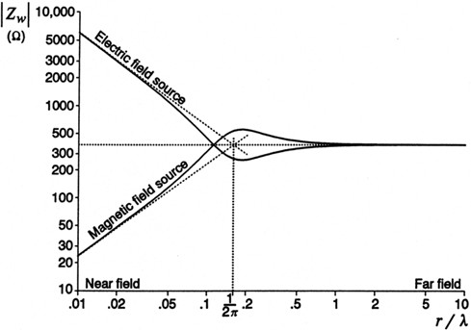

“The wave impedance measures the relative strength of electric and magnetic fields. It is a function of source structure.”[2]

Given these issues, it can be summarized that the use of ITU-R Recommendations BS.560 and BS.703 for analysis of appropriate limits for WPT is not strictly appropriate and furthermore is used out of context. Specifically, it is incorrect to combine these two recommendations and only consider a 40 dB baseline protection ratio combined with the minimum recommended sensitivity of to 8.5 dBuA/m (LF) and 14.5 dBuA/m (MF) (converted from the electric field sensitivity values using far-field assumptions). This is especially true considering that, in the weakest field conditions, an audio-frequency signal-to-noise ratio (AF SNR) of only 26 dB (as opposed to 40 dB in typical conditions) is expected, and hence the presence of background noise is likely to impact radio quality assessment of protection needed. The fundamental difference in AF SNR and associated signal conditions might have been one reason why BS.560 indicates a wide variation in baseline protection ratios from 26 dB to 40 dB.

Furthering this rationale, sections 4.4 and 5.2.1 (based on Annex 8) of ITU-R SM.2451 utilize unstated assumptions and suggest extremely restrictive magnetic field limits for WPT-EV systems. These calculations are based solely on the very worst-case conditions of interference and unique parameters of a victim receiver and the broadcast station; as a result, the magnetic field limits suggested are far below what can be reasonably measured using well-known and well-accepted standardized EMC methods, which are used globally for assessment of EMC regulation. To correctly consider ITU-R BS.560 and BS.703 with the appropriate considerations and parameters mentioned in the document, the following equations are more inclusive in considering the wide range of limits that could apply for an excellent AM radio reception quality condition in the LF and MF bands.

EQ1:

*where*:

is the range of limits imposed on a potential magnetic field interferer (in dBµA/m),

is the minimum sensitivity field level planned for a broadcast receiver (in dBµV/m),

is the range of protection ratios that might apply depending on various parameters (in dB), and

is the conversion factor in decibels for the E-Field strength (dBµV/m) to H-Field limit (dBµA/m). This factor is dependent on the distance between the interferer and the receiver, the wavelength of the desired received signal, and the mode of reception by the receiving antenna (i.e., E-Field versus H-Field reception capability and antenna polarization). In the very worst-case (i.e., far-field assumption of interferer signal or no H-Field suppression AND worst-case polarization of interferer alignment with receiving antenna) the highest expected value would be 51.5 dB, which corresponds with a perfect reception of the interfering signal utilizing the far-field free-space assumption of 377 Ω (i.e., 51.5 dB = 20 log10 377 Ω). However, it is conceivable that this value could be as low as -∞ dB in the case where the polarization of the interferer does not match the polarization of the receiver.

Considering (i.e., range of protection ratios), it is important to understand the potential protection ratio parameters of the AM Broadcast System (transmission and reception). Namely, , based on the information given in ITU-R Recommendations BS.560 and BS.703 can be written in the following way:

EQ2:

*where*:

is the baseline protection ratio in BS.560 in the LF and MF bands which range from 26 dB to 40 dB with 27 dB having been “proposed and in fact adopted, by the Regional Administrative LF/MF Broadcasting Conference”. In other words, the baseline protection ratio applied depends on various circumstances and/or parameters.

is the relative protection ratio offset from the baseline protection ratio. The actual offset is both a function of the broadcast transmission and type (e.g., audio compression in transmission typical of that applied in a studio, bandwidth of the modulating signal, modulation index, etc.), the receiver (e.g., selectivity, bandwidth, noise rejection etc.), and offset frequency from the carrier. In other words, the relative protection ratio offset is a function of the carrier-frequency separation and a complex set of transmission and reception parameters. This value ranges from -55 dB to +16 dB depending on the specific frequency offset and other parameters (with +16 dB being the peak for only one single condition).

is the sensitivity factor when considering the original signal strength and quality at the receiver. In particular, BS.703 provides minimum suggested usable E-field strength for an average receiver. BS.703 indicates that an audio-frequency signal-to-noise ratio for such values corresponds to 26 dB; however, the text also states that “the AF signal-to-noise ratio will improve linearly to at least 40 dB, with increasing input signal level.” It is unclear exactly how these SNR differences would impact a qualitative assessment; however, it is reasonable to consider that the qualitative expectations of a listener with a weak signal reception are not the same as the qualitative expectations for a strong signal reception. Accordingly, the protection ratio may need to be adjusted to consider equivalent qualitative interference conditions.

is a noise type relaxation factor which must be considered given that an interferer, for the conditions being discussed, is not likely to be equivalent to a broadcast station. This is especially true when the interferer is a plain-carrier interferer (i.e., SCN). BBC WHP 332[3] provides a single study based on fixed and controlled parameters in a laboratory condition. The abstract and conclusion suggest a relaxation value of 22 dB for small offsets, but a review of the data indicates values between 22 dB and 30 dB (corresponding to overall protection ratios between 18 dB and 10 dB respectively) could be appropriate. The whitepaper also claims that there should be no relaxation for larger offsets, but very little data is available to confirm such a conclusion or to verify the suggested primary mode of audible interference in these cases.

Putting all of this information together, the range of possible H-Field limits can be deduced – *although these values depend heavily on a wide range of conditions as well as the method being used to apply the associated limit (e.g., standard EMC metrology such as that in SM.329 and CISPR standards only considers worst-case setup whereas other metrologies such as those in ITU-R SM.1753 use statistical considerations)*.

The following values are used to obtain a range corresponding to available information:

= **60 dBµV/m** (for MF Band) to **66 dBµV/m** (for LF Band)

= **-59 dB** to **+56 dB** (based on the range of condition indicated from the corresponding calculation)

= **51.5 dB** (for far-field free-space impedance and corresponding polarization) to **29 dB** (for one possible near-field condition)

= **26 dB** to **40 dB** (from BS.560-4)

= **-55 dB** to **+16 dB** (from BS.560-4)

= **0 dB** (corresponding to SNR differences but set to 0 since correlation is unclear and not included in assessment of BS.560)

= **0 dB** to **30 dB** (depending on interferer type and frequency offset as well as baseline PR)

This range results in a worst-case H-Field limit of **-47.5 dBµA/m** (60-56-51.5=-47.5 from eq1.), corresponding to the value suggested by EBU in SM.2451 for the MF band. Applying more reasonable conditions would result in a value of **+21 dBµA/m** (60-10-29=+21 from eq1.) for the MF band and **+27 dBµA/m** (66-10-29=+27 from eq1.) for the LF band, which corresponds to a plain-carrier interferer within some reasonably small offset in the near-field. Finally, a maximum considered limit of **+96 dBµA/m** (66+59-29 from eq1.) for the LF band would be unreasonably higher than typical EMC limits but is indicated solely to show that parameters and conditions must be considered.

In all of the examples and studies referenced above, the United States recognizes the importance of including relevant studies; however, appropriate context of the study along with the conclusion must be brought forth in the main body text in a succinct and clear way.

In addition to these clarification for the main body of the text, there has been some discussion about the background or ambient noise conditions for the study in Annex 12, “Impact Studies on HF Amateur Radio in United States for WPT-EV”. Much of this discussion stems from a misunderstanding of the types of noise experienced by radio, as referenced in ITU-R Recommendation SM.1753, and the differences with how each type of noise is measured. In particular, the impact study in Annex 12 references typical EMC measurement metrology and methods as specified by CISPR and ITU-R Recommendation SM.329. These standardized EMC methods are used to ascertain levels for potential interference noise, usually time-varying single carrier noise (SCN) being dominate from general electronic systems, such as WPT-EV. Due to the time-varying nature of the SCN combined with the fact that such SCN from an electronic system may have a non-uniform radiation pattern, peak measurements are made to find the worst-case conditions (e.g., worst case rotation, setup, etc.) for potential interference. Once the worst-case conditions are ascertained, the worst-case peak, quasi-peak, and average values of the SCN can be obtained.

On an Open Area Test Site (OATS) there may also be some noise present in the environment consisting primarily of both white-gaussian noise (WGN) and SCN. In order to distinguish noise from the environment as opposed to noise from the potential interfering electronic system or equipment under test (EUT), the EMC test engineer reviews the spectral plots and measurements with the EUT turned off and on to observe the differences. In static plots, the time-varying nature of the SCN is not captured and therefore a peak-hold plot is provided to help general observers understand what noise might be emanating from the equipment under test (EUT) versus what is present in the ambient environment. With this in mind, measurements taken using this standardized EMC metrology will inevitably appear to be higher than other types of radio noise measurements wherein only WGN is measured primarily for radio planning purposes (using methods described in SM.1753).

More particularly, there has been suggestion that the background ambient noise plots in Annex 12 might be abnormally higher than typical residential environments due to the fact that the apparent noise levels in the plot are higher than the man-made noise (MMN) levels indicated in ITU-R Recommendation P.372. Fundamentally this comparison is flawed because levels in ITU-R P.372 are based on statistical median measurements of white-gaussian noise (WGN) with some periodic impulse noise (IN) included. All single-carrier noise (SCN) and locally identifiable impulse noise (IN) and galactic noise is removed from the MMN levels as indicated in ITU-R Recommendation SM.1753, which includes the basis for the P.372 MMN levels. Furthermore, these P.372 measurements are taken over several seasons and across 24-hour periods to obtain the statistical results. For comparison of understanding, it is important to note that ITU-R P.372 MMN has the following distinct characteristics in the spurious bands of interest below 30 MHz:

* ITU-R P.372 represents ONLY WGN (not SCN) and ITU-R SM.1753 clearly indicates that both SCN and WGN are important. ITU-R SM.1753 also clearly states that “it is virtually impossible to find a location that is not at least temporarily dominated by noise or emissions from a single source…” and that “it may be unrealistic to exclude these components from radio noise measurements.” ITU-R SM.1753 also indicates that “ITU-R P.372 … specifically excludes emissions from single, identifiable sources.” ITU-R SM.1753 reiterates how important both the SCN and WGN are to radio by noting that, “radiocommunications have to cope with all unwanted signals, whether it is noise or interference, to function properly. For practical reasons it may therefore be desirable to measure the sum of both.” Particularly in the HF band, it also notes that, “In the HF frequency band, it is virtually impossible to find a frequency that is free of wanted emissions for the whole 24 h measurement period.”
* The ITU-R P.372 values that are being referenced are based ONLY on man-made noise (MMN) which specifically removes any natural environmental effects. More particularly, ITU-R SM.1753 states that “Even on one frequency the radio noise level, especially when dominated by MMN, varies depending on time and location. In frequency bands below 30 MHz, noise levels mainly change over time due to propagation conditions.”
* The ITU-R P.372 WGN MMN values below 30 MHz are based on median values of measurements which occurred in at least 10 locations over 24-hour periods and across multiple seasons. Specifically, in ITU-R SM.1753, it states that in addition to a standard measurement period of 24 hours, it is important “To take into account variation due to seasons, HF measurements may be repeated a number of times each year.” This is noteworthy considering that HF propagation conditions change frequently.
* The ITU-R P.372 WGN MMN values are based on RMS measurements – not peak or quasi-peak. The ITU-R P.372 values do not represent the only source of noise and clearly do not represent the dominant source of noise, which is SCN as also indicated in ITU-R SM.1753.

The impact study in Annex 12 contributed previously contained some comparisons as seen by the amateur radio receiver; however, some additional measurements were taken by TDK RF Solutions of the ambient environment using similar metrology to that used to measure MMN in P.372. This is shown below for reference.

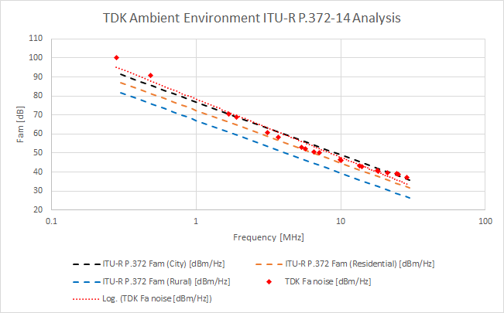

The primary differences in the measurement done by TDK for this plot included the following: 1) these measurements were taken using a standard CISPR loop antenna rather than a monopole antenna, 2) these measurements were taken over a short period of time only (during the day only when the levels are expected to be highest), 3) these measurements were taken in only one season (close to time period of original data in Annex 12), 4) these measurements were taken only at the single site and do not include other locations. In any case, these additional measurements taken at the accredited OATS are for reference only and indicate that the background noise is typical of a lite commercial and residential environment.

This conclusion that the ambient environment noise is typical of a residential environment is further supported by independent data and tests shared with the European CEPT SE 24 group[4]. In a separate study performed entirely independently by Swiss amateur radio experts (USKA) and Brusa[5] using a different WPT-EV system operating in a residential Switzerland neighborhood, ambient environment measurements were also taken and compared with those taken in Texas, U.S.A. (referenced in the Annex 12 study). The measurements in Switzerland were also taken by BAKOM using the standardized CISPR EMC settings, as is typical globally for such measurements. In the USKA/Brusa study[6], the independent assessors reference the data from the contributed U.S. study in Annex 12 and provide the following plot for reference.



Finally, since the time that the Annex 12 contribution was provided by the U.S.A., additional characterization of the amateur radio monopole antenna used in the study (HD-FMJ antenna by Alpha Antennas) has been performed as well as characterization of the receiver (Airspy HF+ Discovery software defined amateur radio receiver). Characterization of the antenna and the receiver together allow direct conversion of the data seen by the receiver to an equivalent E-Field. This E-Field conversion gives appropriate context to the qualitative data and reinforces the fact that the conversion between E-Field and H-Field is not appropriate within the 10 m distance of measurement. The figure below provides the E-Field equivalent for the single worst-case measurement condition taken for qualitative analysis (noting that many other cases did not show interference at all and thus were excluded from the report).

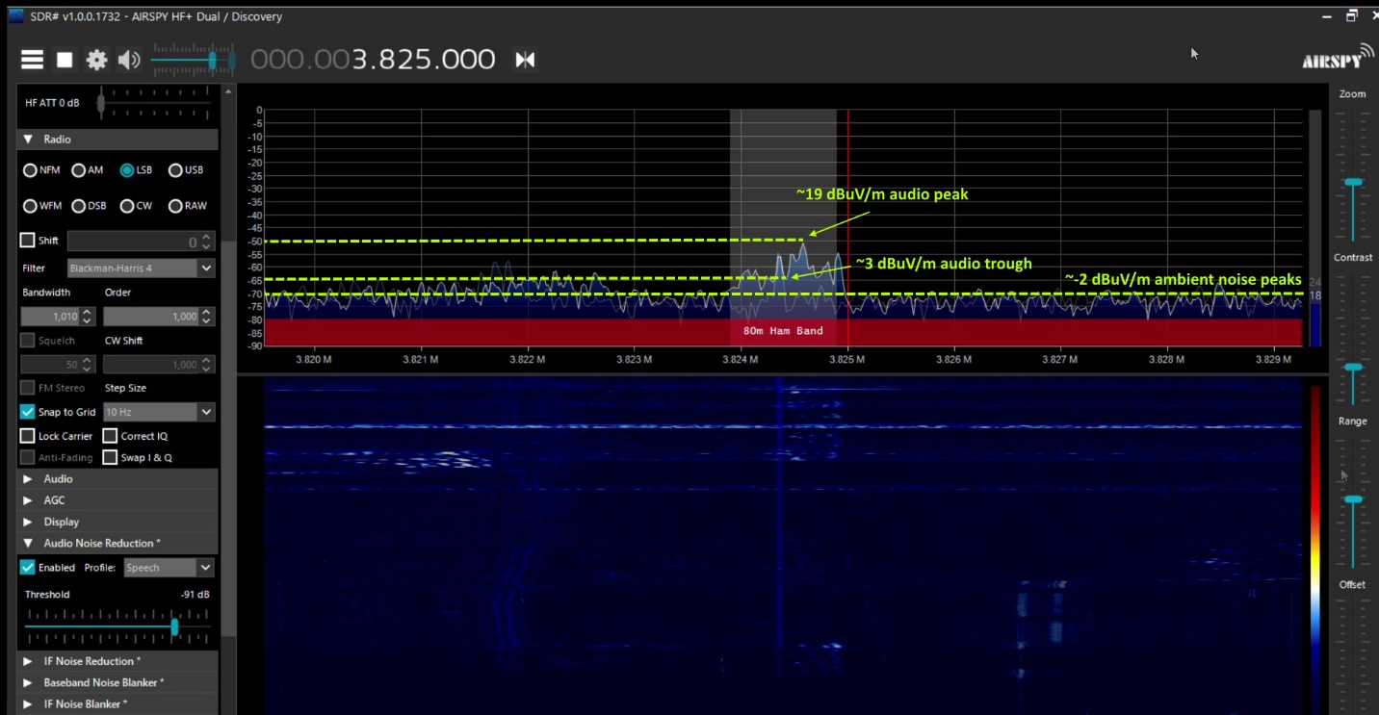

One can formally conclude from the referenced information that the impact study provided by the U.S.A in Annex 12 is valid, and the environment in which the measurements were taken is both typical and appropriate for performing the impact study. For clarification of these facts, the United States provides this information for discussion and relevant inclusion in ITU-R Report SM.2451.

**Proposal**

In the proposed revision, the United States proposes the following succinct summary of changes to the *Working Document Towards a Preliminary Draft Revision of Report ITU-R SM.2451*:

* Editorial corrections
* Reference to ITU-R SM.329 in related ITU-R Recommendations, Reports
* Clarifications and succinct summaries of referenced Annexes in the main body text
* Additional information related to the environmental background noise in Annex 12

The Unites States also proposes to elevate the status of the *Working Document Towards a Preliminary Draft Revision of Report ITU-R SM.2451* based on this contribution for subsequent adoption as an update to ITU-R SM.2451.

**Attachment:** Proposed revisions to the Working Document Towards a Preliminary Draft Revision of Report ITU-R SM.2451

**Attachment**

**Proposed revisions to the WORKING DOCUMENT TOWARDS A PRELIMINARY DRAFT REVISION OF REPORT ITU-R SM.2451**

[U.S. Note: The U.S. proposes that all tracked changes in Annex 11 to the Chairman’s report, the Working Document Towards a Preliminary Draft Revision of Report ITU-R SM.2451, should be accepted. Changes in this contribution are indicated as “USA1”. New notes in this contribution are highlighted green. No further changes proposed prior to this point.]

Related ITU Recommendations, Reports

Recommendation ITU-R SM.329

Recommendation ITU-R P.372

Recommendation [ITU-R SM.1056](https://www.itu.int/rec/R-REC-BS.1056/en)

Recommendation ITU-R SM.1753

Recommendation [ITU-R SM.1896](https://www.itu.int/rec/R-REC-BS.1896/en)

Recommendation ITU-R SM.2129-0

Report [ITU-R SM.2153](https://www.itu.int/pub/R-REP-SM.2153)

Report [ITU-R SM.2303](https://www.itu.int/pub/R-REP-BS.2303).**…**

## 3.3 79-90 kHz WPT-EV usage scenario

### 3.3.1 Brief Explanation of WPT systems being standardized by SDOs

…

During operation, the voltage generated by the Power Converter excites the Compensation Network that operates using resonance with the Primary Device coil. A resultant sinusoidal current in the Primary Device coil then induces a proportional magnetic field. The energy is coupled between the Primary Device and the Secondary Device through the means of this magnetic field. Both coils can be described using a model of a loosely coupled transformer structure. Because the current generated in the Primary Device coil is sinusoidal and not modulated during power transfer, the field produced is a Continuous Wave (CW).

…

### 4.3.5 Impact studies for the amateur service

In the studies presented in Annex 7 field measurements were conducted for the 135.7-137.8 kHz and 472-479 kHz amateur frequency bands. These frequencies allocated to the amateur service on a primary or secondary basis are unlikely to be affected by the emissions at the operating frequency of WPT-EV.

Limited information is available about the harmonic radiated emissions from WPT-EV operating at this frequency other than in Annex 12. In the studies presented in Annex 12, field measurements were conducted for the 3.50-4.00 MHz, 7.00-7.30 MHz, 10.10-10.15 MHz, and 14.00-14.35 MHz amateur bands. The study was performed on an accredited Open Area Test Site (OATS) with ambient environmental noise typical of a residential and lite commercial area. While general conclusions cannot be drawn about every ambient environment or type of amateur radio equipment, the conclusion of this study indicates that the amateur services in the studied bands are unlikely to be significantly impacted by the harmonic emissions of WPT-EV systems designed in accordance with the noted SDOs. Of course, the degree to which WPT-EV will disturb amateur service communications will depend *inter alia* on the pre-existing background noise levels at the specific reception sites as well as the characteristics of the specific WPT-EV system. The tests in Annex 12 included many non-interference qualitative tests; however, reception of one worst-case condition resulted in an amateur service signal in the presence of an operating WPT-EV system with a harmonic located at the same frequency. This study represents work to correlate commonly performed EMC testing of systems to EMC limits in various regulations with existing ambient noise levels and their impact on radio services, with WPT-EV emissions and amateur radio service serving as convenient examples. This single study, however, allows conclusions to be drawn only for the referenced conditions and further studies of impact are required. The matter of harmful interference from harmonic radiated emissions is also covered in § 4.5.

.…

## 4.4 Limits of WPT-EV radiated emission for the protection of AM broadcasting







Various limits have been proposed for absolute maximum levels for the electric and magnetic field strengths for inductive applications operating over short ranges and at implied, though not specified, low power levels. There are proposals to adapt or extend these same limits to medium/high power inductive power transfer applications such as WPT-EV, which will operate at powers of the order of tens to hundreds of kilowatts. However, it is possible based on theoretical studies in Annex 8 that adherence to existing field strength limits might not offer adequate protection to avoid interference of any type to radio services in some circumstances. It should be noted, however, that impact studies such as those in Annex 12 show that the type and effective aperture of the receiving antenna along with its distance can make a difference in the results.It is assumed that interference into an AM broadcast receiver will be a single sinusoid, harmonic of the WPT fundamental frequency that falls within an (approximately[7]) 10 kHz wide AM Broadcast channel and hence into the acceptance bandwidth of the receiver. Further studies may be required to understand how such a single sinusoid may be different from an interfering broadcast station for which ITU-R Rec. BS.560 provides protection criteria between AM radio stations. Annex 8 uses provisions of ITU-R Rec. [BS.703](https://www.itu.int/rec/R-REC-BS.703-0-199006-I/en) *Characteristics of AM sound broadcasting reference receivers for planning purposes*; however, it must be recognized that the planning signal strengths only have a stated signal-to-noise ratio of 26 dB as opposed to 40 dB for typical conditions. In Annex 8, using only the worst-case 56 dB protection ratio (40 dB baseline + 16 dB worst-case offset) as specified for interference between AM radio stations, would give rise to a tolerable level of interference at the receiver operating in the MF broadcast band of:

**•** –47.5 dBμA/m. – at the location of the receiver

A more thorough derivation of this along with an equivalent figure for the LF Broadcast band is given in Annex 8. This figure is ‘worst case’ and dependent on the precise frequency of the interfering harmonic; there being a 20 dB variation across the circa 5 kHz audio bandwidth of a typical receiver. Subsequent work carried out by the BBC and reported in Attachment 6 to Annex 8 shows that this figure can be relaxed (using the same noted assumptions indicated above) to:

**•** –43.0 dBμA/m. – at the location of the receiver

The tolerable interference level is valid at the location of the receiver itself. In any generic formulation of limits for a ‘device’ the interference level must be specified at a standardised distance from the device itself. In many existing standards (e.g. in CISPR) the standard measurement distance is always specified as being 10 m from the device. It is possible that a victim receiver might not be found at the standardised measurement distance and so a correction may need to be applied.

More detail on the reasons for this and the necessary constraints are given in Section 5.4.1 and considerable detail on the derivation of all the figures in this section are given in Annex 8.

## 4.5 Impact of spurious and harmonic radiated emissions on the amateur service and relevant protection requirements

The three frequency ranges being considered for WPT-EV do not overlap with, and have reasonable separation from, the 135.7-137.8 kHz and 472 kHz amateur frequency bands. Therefore, receiver sensitivity suppression (out-of-band) has not been considered a problem.

Report ITU-R [SM.2303](https://www.itu.int/pub/R-REP-SM.2303) states that interference to amateur services was not studied. Subsequent papers submitted to ITU-R by IARU in Annex 10 have suggested that the harmonic radiated emissions limits, as defined by ITU-R and/or CISPR could, by themselves, fall short of providing adequate protection from harmful interference to amateur services from WPT-EV in this frequency range. In addition to the purpose of correlating EMC measurements with ambient noise levels, Annex 12 also serves as an important datapoint to assess the impact of WPT-EV harmonics on stations operating in the amateur service. Protection levels for the amateur service, which are set out in Recommendations ITU-R F.240 and ITU-R M.1044 and used in the studies in Annex 10, can be used to guide the development of appropriate protection criteria though these recommendations do not apply to single-carrier interference specifically.

Annex 12 also contains an impact study of WPT-EV harmonic emissions emanating from a system following the requirements in industry standards for systems operating in the 79-90 kHz band, measured using the standardized EMC test methodology and equipment as well as amateur radio equipment. Impact is dependent on distance, antenna type, and other factors such as background ambient noise and the environment in which different radio services and WPT-EV systems may be located. Issues of wideband noise from WPT-EV systems has not been studied, but the developed protection requirements could be applicable to such radiation, which may also be common to typical power electronics such as switch-mode power supplies and are not harmonically related to WPT-EV specifically. The likely separation distance from systems operating at 20 and 60 kHz is likely to provide reasonable protection from harmonic radiated emissions from the WPT-EV systems, although this remains to be validated.

The high duty cycle of 79-90 kHz WPT-EV systems, their planned location close to or inside dwellings (and therefore close to amateur service antennas), and their anticipated deployment density show that harmonic radiated emissions from WPT-EV systems in this frequency range need to be controlled if harmful interference is to be avoided.

Specifically, the adoption of radiated emission limits from inductive device limits for other applications and devices by themselves is one option but might not provide the level of protection required. See Annex 12 for further details.

The study in Annex 10 models the protection necessary for the amateur service for WPT-EV based on protection ratios from ITU-R F.240, which do not include unmodulated single-carrier interference (type “N0N”) like what would be expected by a harmonic interferer from a WPT-EV system. The radiated emission limit suggested by this study to provide appropriate protection is:

*−45.5 dBµA/m at 300 kHz reducing by 8 dB per frequency decade to −61.5 dBµA/m at 30 MHz.*

*Measurements conducted at 10m distance in a 10 kHz bandwidth.*



However, according to Annex 10, the necessary limits for harmonic radiated emissions from WPT-EV systems can be relaxed from this level by about 20 dB if:

a) all WPT-EV systems adopt a harmonized, tightly tolerance frequency of operation; and

b) the phase noise and noise sidebands from WPT-EV are no higher than the above limit.

Some harmonic radiated emission data has been provided for WPT-EV systems operating at 79‑90 kHz. Annex 12 represents some of this data collected with a WPT-EV system that follows previously noted SDO requirements highlighted in § 3.3.1. The single-carrier harmonic emissions from the WPT-EV system shown are higher than levels suggested in Annex 10 and do not show harmful interference for the conditions stated in Annex 12.

…

## 5.2 Mitigation measures

### 5.2.1 Mitigation Strategies to reduce the impact on the broadcasting service

The operation of AM broadcast transmitters is covered by the Radio Regulations. In Regions 1 and 3 the relevant instrument is the [Geneva 1975 Frequency Plan](https://www.itu.int/en/ITU-R/terrestrial/broadcast/Pages/LFMF.aspx) (GE75) and in Region 2 the [Rio de Janeiro 1981 Frequency Plan](https://www.itu.int/en/ITU-R/terrestrial/broadcast/Pages/LFMF.aspx) (RJ81). These international agreements allocate operating frequencies to LF and MF transmitters such that they do not cause interference to each other based on factors such as geographical separation, transmitter power and antenna characteristics. The underlying basis for the plans is Recommendations ITU‑R BS.703 and ITU‑R BS.560. Importantly, the regional assignment plans set the transmitter operating frequencies on a grid or raster; under the [GE75](https://www.itu.int/pub/R-ACT-RRC.3-1975/enf) Plan each (carrier) frequency is a multiple of 9 kHz and under the [RJ81](https://www.itu.int/pub/R-ACT-RRC.4-1981/en) Plan a multiple of 10 kHz

A significant benefit of having all the carriers on a common raster is that co-channel interference is up to 16 dB less intrusive than if the frequencies were chosen randomly. This can be seen in Fig. 1 of Recommendation ITU-R BS.560.

A similar principle can be applied to a WPT-EV system if its operating frequency can be chosen and fixed to be a multiple of 9 kHz or 10 kHz. If the operating frequency is chosen in this way any harmonics will also (automatically) lie on the broadcast frequency raster. Studies to investigate the subjective effects of interference from an un-modulated carrier situated on or off the raster were carried out by the BBC in November 2017 and are described in BBC Research and Development White Paper [WHP 332](https://www.bbc.co.uk/rd/publications/wireless-power-transfer-plain-carrier-interference-to-am-reception), November 2017 – Wireless Power Transfer: Plain Carrier Interference to AM Reception, which is reproduced as Attachment 6 to Annex 8.

The technique and its potential application are described in detail in Annex 8 and could form the basis of a mitigation strategy. For ‘on raster’ operation, the tolerable level of interference can, as stated in Section 4.4 above, be relaxed.

[USA Note: The additional information proposed by EBU regarding details of the study and its suggested limits in Annex 8 are both redundant and irrelevant to the topic of “mitigation strategies” and are therefore left out in this section. Section 4.4 contains appropriate references and information.]

…

Annex 12  
  
Impact Studies on HF Amateur Radio in United States for WPT-EV

[USA Note: Several figures were removed in the working document and this document proposes adding some new figures. Figure numbering and references will need to be editorially updated accordingly.]

…

## A12.2 Characteristics of Standardized WPT-EV Systems

For the purposes of this impact study, only WPT-EV systems designed to meet the SAE J2954 and related WPT-EV standards, with specific characteristics outlined in § 3.3.1, were considered.

…

### A12.3.2 Characteristics of the OATS

…

While it is generally expected that ambient conditions would be even lower in un-populated areas of the U.S. (e.g., forests, mountains, fields, etc.) where many amateur radio operators enjoy setting up portable stations for low-noise conditions, it is not expected that WPT-EV systems would be generally located nearby (e.g., much greater than 30 m) in such areas.

After testing, additional questions were raised as to the levels of ambient emissions shown in previous figures and whether the test environment is typical to those in which a WPT-EV system would operate (e.g., residential / commercial). The peak-hold ambient figures shown cannot be compared to the ITU-R P.372 man-made noise (MMN) levels because the measurement methods for MMN, containing white-gaussian noise (WGN) and some periodic impulse noise (IN) (with all galactic noise removed), are very different from those used for measuring single-carrier noise (SCN) such as harmonic emissions from WPT-EV. More particularly, there has been suggestion that the background ambient noise plots in Annex 12 might be abnormally higher than typical residential and commercial environments since the apparent noise levels in the plot are higher than the man-made noise (MMN) levels indicated in ITU-R Recommendation P.372. Fundamentally this comparison is flawed because levels in ITU-R P.372 are based on statistical median measurements of white-gaussian noise (WGN) with some periodic impulse noise (IN) included. All single-carrier noise (SCN) and locally identifiable impulse noise (IN) and galactic noise is removed from the MMN levels as indicated in ITU-R Recommendation SM.1753, which includes the basis for the P.372 MMN levels. Furthermore, these P.372 measurements are taken over several seasons and across 24-hour periods to obtain the statistical results. For comparison of understanding, it is important to note that ITU-R P.372 MMN has the following distinct characteristics in the spurious bands of interest below 30 MHz:

* ITU-R P.372 represents ONLY WGN (not SCN) and ITU-R SM.1753 clearly indicates that both SCN and WGN are important. ITU-R SM.1753 also clearly states that “it is virtually impossible to find a location that is not at least temporarily dominated by noise or emissions from a single source…” and that “it may be unrealistic to exclude these components from radio noise measurements.” ITU-R SM.1753 also indicates that “ITU-R P.372 … specifically excludes emissions from single, identifiable sources.” ITU-R SM.1753 reiterates how important both the SCN and WGN are to radio by noting that, “radiocommunications have to cope with all unwanted signals, whether it is noise or interference, to function properly. For practical reasons it may therefore be desirable to measure the sum of both.” Particularly in the HF band, it also notes that, “In the HF frequency band, it is virtually impossible to find a frequency that is free of wanted emissions for the whole 24 h measurement period.”
* The ITU-R P.372 values that are being referenced are based ONLY on man-made noise (MMN) which specifically removes any natural environmental effects. More particularly, ITU-R SM.1753 states that “Even on one frequency the radio noise level, especially when dominated by MMN, varies depending on time and location. In frequency bands below 30 MHz, noise levels mainly change over time due to propagation conditions.”
* The ITU-R P.372 WGN MMN values below 30 MHz are based on median values of measurements which occurred in at least 10 locations over 24-hour periods and across multiple seasons. Specifically, in ITU-R SM.1753, it states that in addition to a standard measurement period of 24 hours, it is important “To take into account variation due to seasons, HF measurements may be repeated a number of times each year.” This is noteworthy considering that HF propagation conditions change frequently.
* The ITU-R P.372 WGN MMN values are based on RMS measurements – not peak. The ITU-R P.372 values do not represent the only source of noise and clearly do not represent the dominant source of noise, which is SCN as also indicated in ITU-R SM.1753.

The previous comparisons made were done using peak measurements (using methods described in ITU-R SM.329, annex 2) as seen by the amateur radio receiver; however, some additional measurements were taken by TDK RF Solutions of the ambient environment using similar metrology to that used to measure MMN in ITU-R P.372. This is shown below for reference.

Figure A12-XX

Additional TDK WGN Ambient Measurements



The primary differences in the measurement done by TDK for this plot and the method described in ITU-R SM.1753 included the following: 1) these measurements were taken using a standard CISPR loop antenna rather than a monopole antenna, 2) these measurements were taken over a short period of time only (during the day only when the levels are expected to be highest), 3) these measurements were taken in only one season (close to the time period of the original study), 4) these measurements were taken only at the single site and do not include other locations. These additional measurements taken at the accredited OATS are for reference only and are not definitive by themselves. On-going work is being undertaken in the United States of America to provide further characterization in this respect.

The conclusion that the ambient environment noise is typical of a residential environment is further supported by independent data and tests shared with the European CEPT SE 24 group [23]. In a separate study performed entirely independently by Swiss amateur radio experts from USKA and Brusa [24], using a different WPT-EV system operating in a residential Switzerland neighborhood, ambient environment measurements were also taken and compared with those taken in Cedar Park Texas, U.S.A. These measurements taken in Ersigen, Switzerland next to an amateur radio station in a residential neighborhood were also taken by BAKOM using the standardized CISPR EMC settings as is typical globally for such measurements (and as described in Annex 2 of ITU-R SM.329). In the USKA/Brusa study [25], the independent assessors reference the data from the contributed U.S. study and provide the following comparison plot for review.

Figure A12-XX

Ambient comparison measurements performed in a separate study by USKA & Brusa



…

#### A12.3.4.1.2 Amateur Radio Monopole Antenna Testing

…

In addition to the various plots collected from the calibrated spectrum analyser, the amateur radio transceiver and receiver were used to assess qualitative audio impact of the WPT-EV system on communications. In general, at the various distances, no visual or audio impact in the tested amateur radio bands (80 m, 40 m, 30 m, 20 m) was detected above the ambient environment levels present at this site whenever the vehicle was reasonably aligned and rotated on the turn table. However, in one specific worst-case condition where the ground assembly coil and vehicle assembly coil were misaligned to maximum offset, the turn table was set to a specific angle relative to the amateur monopole antenna, and the antenna had an NVIS line attached to increase near-field sensitivity at a distance of 10 m from the WPT-EV system, audio characteristics from the WPT-EV were detectable as a faint “whistle”. In this same condition, a soft SSB voice transmission was also recorded directly over top of the interference signal at 3.825 MHz.

Despite the faintly heard WPT-EV interference, this voice transmission was clearly audible and intelligible. A before and after image of the recorded transmission using the Airspy HF+ Discovery receiver and SDRSharp radio software are shown below along with an overlay.

The interference signal from the WPT-EV system at 3.825 MHz using the SDRSharp software is shown below.

Figure A12-66

SDR# Software snapshot of WPT-EV interference signal at 3.825 MHz in worst-case condition

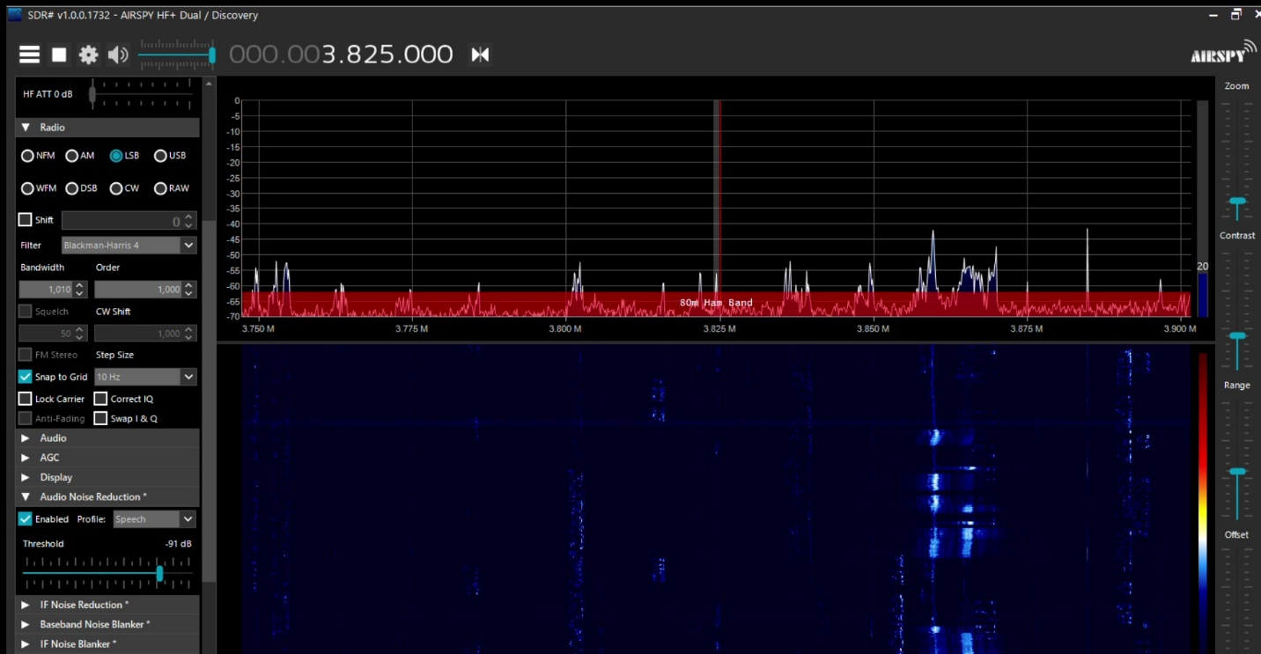

Figure A12-67

SDR# Software zoomed snapshot of WPT-EV interference signal at 3.825 MHz in worst-case condition

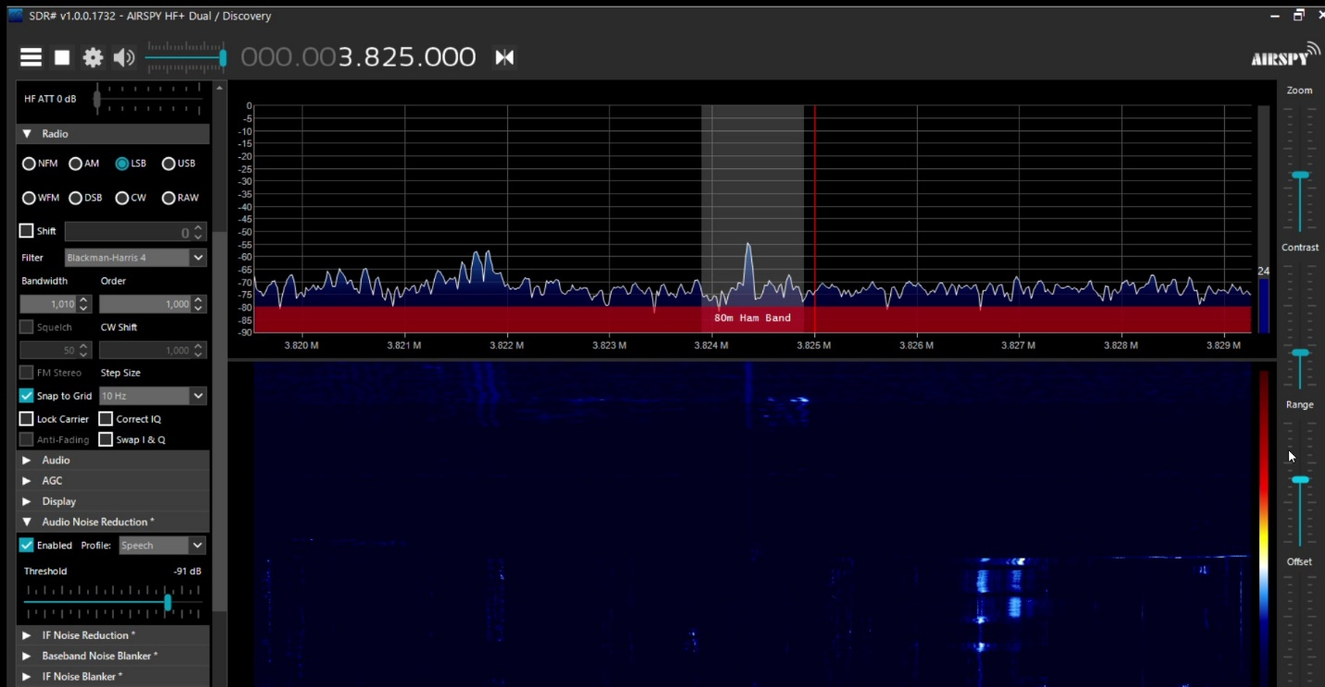

A distant amateur radio voice transmission occurred at the same frequency as the WPT-EV harmonic interference captured and is shown below.

Figure A12-68

SDR# Software zoomed snapshot of distant amateur radio verbal audio broadcast at 3.825 MHz

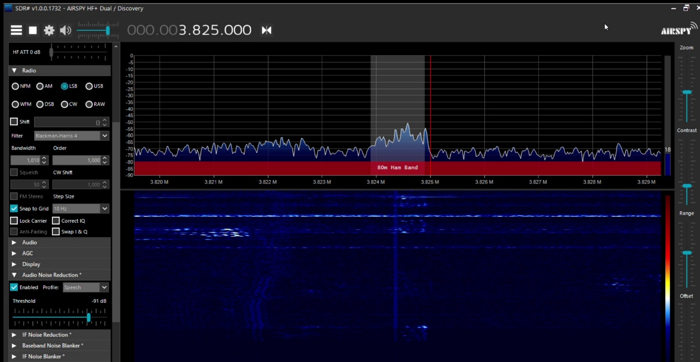

An overlay of the interference and the SSB AM transmission together and shown below.

Figure A12-69

SDR# Software zoomed snapshot of distant amateur radio verbal audio broadcast at 3.825 MHz   
with WPT-EV interference signal underlay

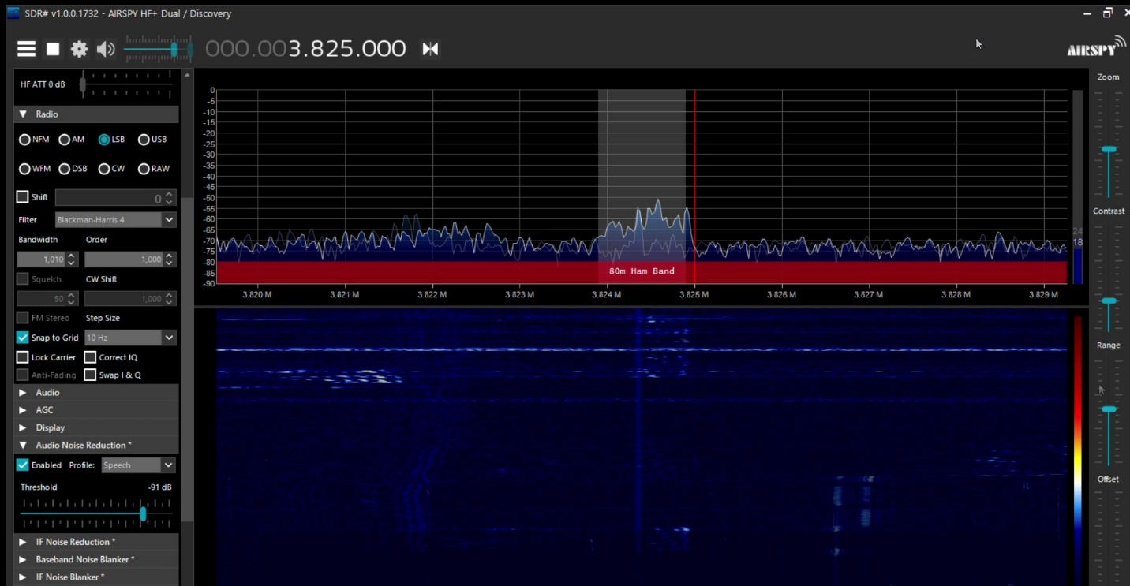

Following the qualitative testing, additional characterization of the amateur radio monopole and the software-defined receiver (SDR) were performed to convert the signal strengths from the levels shown in the software to vertically polarized electric-field levels. The result of this conversion is shown in the figure below.

Figure A12-XX

SDR# Software zoomed snapshot of distant amateur radio verbal audio broadcast at 3.825 MHz   
with WPT-EV interference signal underlay and E-Field levels



## A12.4 Summary of Results

A WPT-EV system as defined by the referenced SDOs operating at ~11 kW input power and ~90% efficiency AC grid input to DC battery output mounted on a Nissan Leaf with a 62 kWh battery was measured on a third-party accredited Open Area Test Site (OATS). The characteristics of the ambient environment were collected for comparison of emissions with the WPT-EV system transferring power and turned off. Ambient characteristics measured using a recommended HF amateur radio monopole antenna for the designated operating bands were collected at the OATS and compared directly with the same measurement performed in a rural area separated by ~1300 miles or ~2100 km. In the 80 m and 40 m bands, the ambient measurements showed similar characteristics, whereas in the 30 m and 20 m bands, the levels in Nibley, Utah were typically up to ~10 dB lower than those in Cedar Park, Texas. Other ambient environment comparisons were also made, including one in Erigen, Switzerland. These additional comparisons indicate that the ambient conditions of the study are similar to other residential environments around the world. The ambient environment comparison, however, can be applied to other locations and amateur installations only if the environment and ambient conditions are similar to what they are in the specific locations measured. Additionally, these measurements were made using EMC measurement techniques, so they do not represent the median man-made noise (MMN) values indicated in ITU-R P.372.

The WPT-EV system was setup to operate continuously at full-power transfer and in worst-case misaligned conditions. Radiated emission data in the 9 kHz to 30 MHz range was collected by a third-part accredited lab using calibrated equipment used to perform certification measurements required by local administrations. Measurements were performed with a standard calibrated CISPR 60 cm loop antenna at a distance of 10 m. The magnetic loop antenna showed the WPT-EV operating fundamental as well as some other emissions above the ambient conditions present at the OATS. Detailed quasi-peak and average measurements were also taken with the magnetic loop antenna on discernible WPT-EV odd harmonics seen above ambient conditions in the 80 m to 20 m amateur radio bands. Radiation patterns were obtained for the fundamental as well as the measured harmonics.

For direct comparison and correlation with the calibrated measurements taken, additional data was collected by licensed amateur radio operators using a monopole antenna with a large effective antenna height. The amateur radio antenna was placed at distances of 10 m, 20 m, and 30 m over real earth from the WPT-EV system that was located on the OATS (and rotated for maximum interference potential). In several unique cases, very narrow-band harmonics were discernible with the amateur radio monopole antenna but their amplitude was no higher than the typical ambient peaks seen without the WPT-EV system operating.

Qualitative listening tests were also conducted in the presence of WPT emissions. One amateur service signal operating in the far-field with an average E-Field strength of ~16 dBµV/m (-35 dBµA/m) was heard at a frequency coinciding with a WPT harmonic and resulted in an intelligible and audible voice transmission yielding non-harmful interference. In this case, the approximate amateur signal-to-ambient-noise-peak ratio was about 13 dB with the ambient noise peaks occurring at an average of ~-2 dBµV/m (-53.5 dBµA/m). In the near-field, where the WPT-EV system is located at a 10 m distance, the calibrated H-Field EMC measurements cannot be converted to E-Field using far-field approximations. Further work is encouraged to examine the full impact of the measured levels of WPT emissions on general communications in the amateur service in multiple environments.

## A12.5 References

[1] FCC Electronic Code of Federal Regulations Title 47 Part 97 - <https://www.ecfr.gov/cgi-bin/text-idx?node=pt47.5.97>

[2] ARRL – <https://www.arrl.org>

[3] ARRL Table of FCC License Counts - <http://www.arrl.org/fcc-license-counts>

[4] United States Census Bureau - <https://www.census.gov/>

[5] FCC Universal Licensing System - <https://wireless2.fcc.gov/UlsApp/UlsSearch/searchLicense.jsp>

[6] TDK RF Solutions, Inc., Cedar Park, Texas, U.S.A. - <https://tdkrfsolutions.com/>

[7] “ICNIRP Guidelines for limiting time-varying electric and magnetic fields (1 Hz – 100 kHz)”, 2010 - <https://www.icnirp.org/en/frequencies/low-frequency/index.html>

[8] ISO14117:2019, “Active implantable medical devices — Electromagnetic compatibility — EMC test protocols for implantable cardiac pacemakers, implantable cardioverter defibrillators and cardiac resynchronization devices” - <https://www.iso.org/standard/73915.html>

[9] SAE Technical Paper, “Bench Testing Validation of Wireless Power Transfer up to 7.7 kW Based on SAE J2954” - <https://www.sae.org/publications/technical-papers/content/07-11-02-0009/>

[10] SAE Technical Paper, “Validation of Wireless Power Transfer up to 11 kW Based on SAE J2954 with Bench and Vehicle Testing” - <https://www.sae.org/publications/technical-papers/content/2019-01-0868/>

[11] SAE J2954 Recommended Practice, “Wireless Power Transfer for Light-Duty Plug‑in/Electric Vehicles and Alignment Methodology” - <https://www.sae.org/standards/content/j2954_201904/>

[12] ARRL, “Amateur Radio : 100 Years of Discovery” by Jim Maxwell - <http://www.arrl.org/files/file/About%20ARRL/Ham_Radio_100_Years.pdf>

[13] “700,000 Amateur Radio Operators in the US? Perhaps the real number is 157,000” - https://frrl.wordpress.com/2012/01/21/700000-amateur-radio-operators-in-the-us-perhaps-the-real-number-is-157000/

[14] “Reviews For: Alpha Antenna FMJ Multiband, HF directional/vertical” - <https://www.eham.net/reviews/view-product?id=10357>

[15] “Recommendation ITU-R P.372-14 Radio Noise” - <https://www.itu.int/dms_pubrec/itu-r/rec/p/R-REC-P.372-14-201908-I!!PDF-E.pdf>

[16] “Measurement Methodology and Results of Measurements of the Man-Made Noise Floor on HF in The Netherlands”, T.W.H Fockens/A.P.M. Zwamborn/F. Leferink, - <https://ieeexplore.ieee.org/document/8396864>

[17] “External Noise Measurements in the Medium Wave Band”, G. Prieto/M. Vélez/A. Arrinda/U. Gil/D. Guerra/D. de la Vega, University of Basque Country – UPV/EHU - <http://www.ehu.eus/tsr_radio/images/International_Journals/PRIE-07-01.pdf>

[18] “US Amateur Radio Population Grows Slightly in 2018” - <http://www.arrl.org/news/us-amateur-radio-population-grows-slightly-in-2018>

[19] “The Measurement of Radiated Emissions on Frequencies below 30 MHz – Materials for the ANSI C63 Committee”, Joseph McNulty, FCC, 24 January 1991

[20] “PC63.30 Draft American National Standard for Methods of Measurement and Radio-frequency Emissions from Wireless Power Transfer Equipment”, ANSI C63.30 - <http://www.c63.org/documents/misc/matrix/c63_standards.htm>

[21] “Liaison Request to CISPR/A on the development of a sensitive measurement method for magnetic fields below 30 MHz”, CISPR B Subcommittee, CIS/B/736/INF, 2019‑11‑22, - [https://www.iec.ch/dyn/www/f?p=103:30:0::::FSP_ORG_ID,FSP_  
LANG_ID:1412,25](https://www.iec.ch/dyn/www/f?p=103:30:0::::FSP_ORG_ID,FSP_LANG_ID:1412,25)

[22] “The Background Noise on the HF Amateur Bands”, Radio Society of Great Britain - <http://rsgb.org/main/files/2017/12/221216-Noise-leaflet-issue-2.pdf>

[23] “Short Range Devices”, CEPT ECC Working Group SE 24 - <https://www.cept.org/ecc/groups/ecc/wg-se/se-24/client/introduction/>

[24] “Interference_Between_EV_Inductive_charging and Radio Amateur Service”, Contribution by Brusa to CEPT SE 24 - <https://www.cept.org/ecc/groups/ecc/wg-se/se-24/client/meeting-documents/file-history/?fid=62748>

[25] “Interference Between EV Inductive charging (WPT) and Radio Amateur Service”, Brusa - <https://www.cept.org/Documents/se-24/62748/wi6026-01_rev1_interference_between_ev_inductive_charging-and-radio-amateur-service>

______________

1. <http://downloads.bbc.co.uk/rd/pubs/whp/whp-pdf-files/WHP332.pdf>
2. <https://www.rfcafe.com/references/electrical/near-far-field.htm>
3. <http://downloads.bbc.co.uk/rd/pubs/whp/whp-pdf-files/WHP332.pdf>
4. <https://www.cept.org/ecc/groups/ecc/wg-se/se-24/client/introduction/>
5. <https://www.cept.org/ecc/groups/ecc/wg-se/se-24/client/meeting-documents/file-history/?fid=62748>
6. <https://www.cept.org/Documents/se-24/62748/wi6026-01_rev1_interference_between_ev_inductive_charging-and-radio-amateur-service>
7. 9 kHz In Regions 1 & 3 and 10 kHz in Region 2