|  |  |
| --- | --- |
| U.S. Radiocommunications Sector  Fact Sheet | |
| **Working Party:** ITU-R WP1A | **Document No:** USWP1A23_12_FS – WD PDN Report SM.[WPT.BEAM.IMPACTS] |
| **Ref:**  Report on the sixth 2015-2019 meeting of Working Party 1A– [Annex 08](https://www.itu.int/dms_ties/itu-r/md/15/wp1a/c/R15-WP1A-C-0454!N08!MSW-E.docx) – Working document towards a preliminary draft new Report ITU-R SM.[WPT.BEAM.IMPACTS] | **Date:** 4 March 2021 |
| Document Title: Proposed revisions to Working Document Towards a Preliminary Draft New Report ITU-R SM.[WPT.BEAM.IMPACTS] | |
| **Author(s)/Contributors(s):**  Matthew Greenspan  Telecommunications Management Group, Inc. (TMG) | **Email**: mgreenspan@tmgtelecom.com **Phone**: +1 (703) 472-0897 |
| **Purpose/Objective:** Add information on the impacts of Beam WPT and elevate the status to a Preliminary Draft New Report. | |
| **Abstract:** This document was created to house impact study information related to Beam WPT. As such, the proposed changes incorporate additional impact study information, specifically a proposed Study D conducted at higher power levels than previous studies to be added as subsection 3.4. In line with the work plan, the status is proposed to be elevated to Preliminary Draft New Report. | |

|  |  |
| --- | --- |
| **Radiocommunication Study Groups** |  |
|  |  |
|  |  |
| Received: Date 2021  Subject: Question [ITU-R 210-3/1](https://www.itu.int/pub/R-QUE-SG01.210) | **Document 1A/XX-E** |
| **XX Month 2021** |
| **English only** |
| United States of America | |
| Proposed Revisions To Working Document Towards a Preliminary DRaft New Report ITU-R SM.[WPT.BEAM.IMPACTS] | |

Background

During the May-June 2019 meeting of Working Party 1A, this document was created as a repository for impact study information related to Beam WPT. The information initially added was borrowed from what is now Working Document Towards a Preliminary Draft Revision of Report ITU-R SM.2392-0, as that document was cleaned up to remove references to non-Beam WPT and all content related to impact studies was moved to this working document. In the November-December 2020 meeting of Working Party 1A, additional studies were added to the document, and a revised work plan was approved to reflect the elevation of the document in May-June 2021.

At the same time when this document was created, another new Working Document Towards a Preliminary Draft New Recommendation ITU-R SM.[WPT.BEAM.FRQ] was formed. That recommendation aims to provide guidance on what frequencies should be used for Beam WPT systems based on the studies provided in this document.

The Work Plan for the Development of a Working Document Towards a Preliminary Draft New Report ITU-R SM.[WPT.BEAM.IMPACTS] was created to accompany this document as well. According to the work plan, during the 2021 meeting of Working Party 1A, the meeting should produce a new version of this document and elevate its status.

Proposal

The United States proposes to add new impact study information related to Beam WPT systems operating in the 915-921 MHz range at higher power levels than those currently examined. Additionally, and in line with the work plan, the United States also proposes to elevate the status of the working document to Preliminary Draft New Report.

|  |
| --- |
| Attachment |
| WORKING DOCUMENT TOWARDS A PRELIMINARY DRAFT NEW  REPORT ITU-R SM.[WPT.BEAM.IMPACTS] |
| Impact study and human hazard issues for Wireless Power Transmission via radio frequency beam |

**1 Introduction**

…

## 3.4 Study D

An over-the-air, distance charging transmitting device (DUT) operating between 915 MHz and 921 MHz was tested for impact to demonstrate interoperability with wireless devices and technologies operating in the same band. The DUT operates on a single channel with a bandwidth less than 400 kHz and maximum declared conducted average power of 40.0 dBm. The DUT is designed to charge other devices at a distance of up to 300 cm.

The tests were performed in two separate rooms. The first was a real-world test performed in a regular room and on a wooden countertop where other signals were present, as illustrated in Figure 7. The second room was an anechoic chamber, as described in ETSI EN 302 208 V3.1.1 (2016-11) Annex B.1.2 and as illustrated in Figure 8. This anechoic chamber was used to demonstrate whether the results found in the regular room were repeatable in a free-space environment and whether any degradation of signal was due to the noisy environment. The tests were performed in the exact same manner, detailed further below, in each room. The results from each of the tests did not have any discrepancies; as such, only one set of results is presented below.

Figure 7

Test setup in room 1, open area

Figure 8

Test setup in room 2, anechoic chamber

Tests were performed on the following types of wireless devices:

Table 11

Types of devices used, frequencies, and distances in Study D

|  |  |  |  |
| --- | --- | --- | --- |
| No. | Type of device | Frequency range (MHz) | Distances tested (cm) |
| 1 | Cellphone | Uplink: 888.0-915.0  Downlink: 925.2-960.0 | 0, 10, 20, 30, 40, 50, 70, 100 |
| 2 | Cellphone | Uplink: 888.0-915.0  Downlink: 925.2-960.0 | 0, 10, 20, 30, 40, 50, 70, 100 |
| 3 | Cellphone | Uplink: 888.0-915.0  Downlink: 925.2-960.0 | 0, 10, 20, 30, 40, 50, 70, 100 |
| 4 | Cellphone | Uplink: 888.0-915.0  Downlink: 925.2-960.0 | 0, 10, 20, 30, 40, 50, 70, 100 |
| 5 | Wireless Microphone and base station | 904.45-927.45  User Selectable | 0, 10, 30, 100, 200 |
| 6 | Assisted listening device | 863.25-864.75  User Selectable | 0, 10, 30, 100, 200 |
| 7 | Assisted listening device | 904.65-926.85  User Selectable | 0, 10, 30, 100, 200 |
| 8 | RFID reader | 903-927  Hopping | 0, 10, 30, 100, 200 |
| 9 | RFID reader | 865-868  Hopping | 0, 10, 30, 100, 200 |

**Cellphone**. The DUT was placed 100 cm from a mobile phone simulating a desktop environment. The cell antenna, cabled to base station simulator, was placed 3 m from the DUT and mobile phone devices. A call from the mobile phone was established to the callbox in the GSM 900 Band, on a specific frequency. After the call was established, the DUT was switched on at 917.5 MHz. The charging signal was verified with a spectrum analyzer positioned in the test area. The call was monitored for 60 seconds. After which the call state was logged (call maintained, or call dropped.). The distance between the DUT and mobile phone was decreased incrementally until the mobile phone was touching the DUT, measured at 0 cm. Testing was performed using 3 different channels.

Figure 9

Cellphone impact test setup

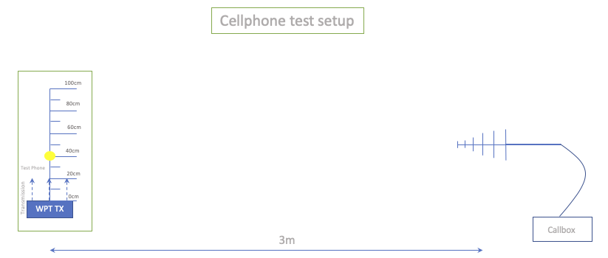

Figure 10

Other In-band device impact test set up

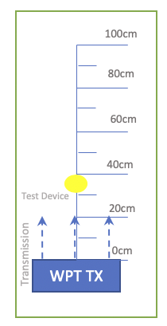

The results demonstrated that all phones were able to operate without harmful interference on at least one channel and on all channels when separated by 1 m or more from the DUT.

**Wireless Microphone and base station**. The base-station (receiver) was placed 30 cm from the DUT, and the Microphone (Transmitter) moved through the test distances. Subsequently, the Microphone (Transmitter) was placed 30 cm from the DUT, and the Base-station (receiver) was moved through the test distances.

When operating close to the transmit frequency of the DUT, the audio devices experienced .no harmful interference

**Assisted listening device**. The Transmitter was placed 30 cm from the DUT, and the Receiver was moved through the test distances. Following this, the Receiver was placed 30 cm from the DUT, and the Transmitter was moved through the test distances.

When operating at close to the transmit frequency of the DUT, the devices experienced interference however setting the audio device frequency away from that of the DUT resulted in little to no harmful interference.

**RFID reader**. For the first device, scans were performed at 903.250; 904.250; 915.250; 915.750; 920.250; 926.750; and 927.250 MHz. The software transmitting setting was set to 30 dBm. RFID tags were then placed 30 cm from the DUT. For the second, scans were performed at 865.00; 866.00; 867.00; and 868.00 MHz with default settings. RFID tags were then placed 30 cm from the DUT.

At separation distances of 1 m or greater between the DUT and RFID reader and tags, the readers worked without error.

**4 Human hazard issues**

…