U.S. Radiocommunications Sector
Fact Sheet
Working Party: ITU-R WP1A | Document No: USWP1A23_16_rev1 - Ann 6 PDN Report SM.[WPT.BEAM.IMPACTS]
Ref: Report on the second 2019-2023 meeting of Working Party 1A (25 May - 2 June 2021)– Annex 6 – PRELIMINARY DRAFT NEW  REPORT ITU-R SM.[WPT.BEAM.IMPACTS] | Date: 2 June 2021

Document Title: Proposed revisions to Preliminary Draft New Recommendation ITU-R SM.[WPT.BEAM.IMPACTS]

Author(s)/Contributors(s):  Michael Marcus  Marcus Spectrum Solutions LLC  Matt Greenspan  Telecommunications Management Group, Inc. (TMG) | Email: mjmarcus@marcus-spectrum.com  Phone: +1 (301-229-7714)  Email: mgreenspan@tmgtelecom.com  Phone: +1 (703) 224-1501
Purpose/Objective: Submit further information on impact of 24 and 61 GHz Beam WPT systems;
support the approval of the WPT Beam Impacts document.
Abstract: This contribution adds information on the impact of 24 and 61 GHz Beam WPT, both ISM bands, with respect to nearby allocations and the out-of-band-emission limits necessary to protect such allocations.

Based on the maturity of the document as well as the overall stability of the text, and in accordance with the agreed upon work plan, it proposes to approve the document and elevate it to Draft New Report status during the November 2021 meeting of ITU-R WP1A.

Radiocommunication Study Groups | 
Source: Document 1A/TEMP/31 (edited) | Document 1A/XX-E
Source: Document 1A/TEMP/31 (edited) | ______ 2021
Source: Document 1A/TEMP/31 (edited) | Original: English
United States of America
Proposed revisions to PRELIMINARY DRAFT NEW
REPORT ITU-R SM.[WPT.BEAM.IMPACTS]

Background
During the May-June 2019 meeting of Working Party 1A, this document was created as a repository for impact study information related to Beam WPT. The information initially added was borrowed from what is now Report ITU-R SM.2392-1, as that document was cleaned up to remove references to non-Beam WPT and all content related to impact studies was moved to this working document. In the November-December 2020 meeting of Working Party 1A. The document was subsequently elevated to PDNR status during the May-June 2021 meeting.

When this document was created in 2019, another new Working Document Towards a Preliminary Draft New Recommendation ITU-R SM.[WPT.BEAM.FRQ] was also formed. That recommendation aims to provide guidance on what frequencies should be used for Beam WPT systems based on the studies provided in this document. That document was also elevated to PDNR status during the May-June 2021 meeting.

The Work Plan for the Development of a Working Document Towards a Preliminary Draft New Report ITU-R SM.[WPT.BEAM.IMPACTS] was created to accompany this document as well. According to the work plan, most recently revised during the May-June 2021 meeting of Working Party 1A, the November-December 2021 meeting should produce a new version of this document and elevate its status.
Proposal
The United States proposes to add new impact study information related to Beam WPT systems operating in the 24 GHz and 61 GHz ranges. Additionally, and in line with the work plan, the United States also proposes to elevate the status of this document to Draft New Report. Finally, any proposed studies that the Working Party does not reach agreement on should not postpone the elevation of this document, as they can be added later as modifications to the upgraded recommendation or in future revisions of the approved document.

Attachment

DRAFT NEW
REPORT ITU-R SM.[WPT.BEAM.IMPACTS]

Impact studies and human hazard issues for wireless power transmission via radio frequency beam

Table of Contents
Page
1 Introduction 3
2 Radio characteristics of beam WPT 3
3 Studies on the impact to the incumbent systems 4
3.1 Study A 5
3.2 Study B 8
3.3 Study C 11
3.3.1 Frequency bands and incumbent radiocommunication systems and services
considered in the study 12
3.3.2 Specifications and parameters used for the study 14
3.4 Study D 22
3.5 Study E 26
3.5.1 Radio services considered in the study 26
3.5.2 Considerations for 24.1-24.15 GHz and 61.0-61.5 GHz 26
3.5.3 Impact of 24.1-24.15 GHz beam WPT on passive allocations 27
3.5.4 Human hazard issues for 24.1-24.15 GHz and 61.0-61.5 GHz WPT 27
4 Human hazard issues 27
5 Summary 28
A1.1 Beam WPT installation environments 29
A1.1 WPT controlled environment 29
A1.2 WPT general environment 29
A1.2 Compliance with the RRPG 29
A1.2.1 Separation distance 29
A1.2.2 Directions 30

1 Introduction
Wireless Power Transmission (WPT) technology is used to transfer power wirelessly from power sources to devices that use or consume power. Significant innovations in WPT can free users from needing electric power cords or changing batteries if electric power is supplied wirelessly. There are two major categories in WPT technologies. One of them is non-beam WPT technology, which transfers power to devices using magnetically, capacitively or inductively coupled means in the near field region and is typically used to charge devices, such as mobile phones and electric vehicles. The other category of WPT is beam WPT, which transfers power wirelessly using radio waves over longer distances (several meters or more, and the potential to cover wider areas).
Beam WPT regulations, standards, and operational guidelines are currently being developed at national, regional, and international levels for wireless charging technologies of mobile/portable and IoT sensor devices for applications of WPT via radio frequency beam. Report ITU-R SM.2392 “Applications of wireless power transmission via radio frequency beam” indicates diverse applications and technologies of beam WPT in the future. The Report focuses on applications of WPT technologies using radio frequency beam and highlights that such devices may be classified as Industrial, Scientific, Medical (ISM) , short-range devices (SRD) or radio equipment. While both ISM and SRD beam WPT devices are addressed in Report ITU-R SM.2392, Report ITU-R SM.1896 provides a list of frequency ranges for global and regional harmonization of SRDs in its annexes, and Radio Regulations footnote 5.150 provides a list of frequency ranges for ISM devices. Furthermore, some administrations classify beam WPT as a radio service that needs rulemaking for practicable implementation with regulatory measures. To mitigate the impact of WPT devices on the operation of radiocommunication services as finding increasing technology and spectrum demand, some solutions that utilize frequency bands designated for ISM applications and other solutions for spectrum sharing with the incumbent radiocommunication services are discussed. In order to commercialize these WPT technologies, studies on the impact of WPT systems on radiocommunication systems are necessary.
The purpose of this Report is to indicate the possibilities of coexistence with radiocommunication systems by conducting impact studies and demonstrating compliance with international and/or national radio frequency regulations and RF exposure guidelines even in the proposed beam WPT operation conditions. It is also intended to provide guidance to the administrations wishing to allow implementation of beam WPT technologies in the proposed frequency ranges in order to minimize the potential impact of beam WPT on radiocommunication services. Furthermore, this Report is expected to contribute to discussions towards international frequency ranges and regulations for beam WPT applications.
National regulations, such as those in the United States, offer reasonable protection against harmful interference from these devices in a residential installation, but such limits do not guarantee that interference will not occur in a particular instance. However, as demonstrated in the studies contained in this document, beam WPT technologies have the benefit of causing little to no harmful interference to other devices at distances equal to or less than 30 cm. Any harmful interference that does exist can easily be mitigated by the user moving the charging device and/or affected device. As such, users are encouraged to try to correct any such interference. If harmful interference occurs, interference can in some cases be corrected by moving or reorienting the charging device and/or affected device, or by changing the operating frequency of the charging device or affected device to avoid use of overlapping frequency channels.”

2 Radio characteristics of beam WPT
This section provides examples of the characteristics of the beam WPT system.
TABLE 1
Examples of radio characteristics of beam WPT systems
System | System 1 | System 2 | System 3 | System 4 | System 5 | System 6 | System 7 | System 8
Frequency | 915-921 MHz | 915-921 MHz | 915-921 MHz | 917-920 MHz | 2.410-2.486 GHz | 5.738-5.766 GHz | 24.1-24.15 GHz | 61-61.5 GHz
Output Power | 4 W | 15 W | Up to 50 W | 1 W | 15 W | 32 W | 50 W | 50 W
Antenna gain | 7 dBi | 8.24 dBi | Not to exceed e.i.r.p. | 6 dBi | 24 dBi | 25 dBi | 40 dBi# | 45 dBi#
e.i.r.p. | 20 W | 100 W | 300 W | 36 dBm | 65.8 dBm | 70 dBm | 87 dBm # | 92 dBm#
Modulation | CW | CW | CW | CW or Other modulation | CW | CW
Bandwidth | 500 kHz | 500 kHz | 500 kHz | 200 kHz | - | - | 10 MHz | 10 MHz
Beacon signals | Other wireless systems | Other wireless systems | Other wireless systems | Other wireless systems | Other wireless systems | Beam-WPT dedicated wireless system
Antenna | Wide-angle directional antenna | Wide-angle directional antenna | Wide- angle directional antenna | Wide- angle directional antenna | Beam forming | Beam forming | Near field beam focusing | Near field beam focusing
Applications | Wireless Charging of Mobile/Portable Devices  Wireless Powered & Charging of Sensor Networks
Note: The technical specifications contained in this table describe some of the characteristics used in the respective studies, and are not meant to be interpreted as regulatory limits, as there may be other beam WPT systems with higher power than those listed.

# The figures given for antenna gain and e.i.r.p. here are for cases where the device receiving power is in the far field of the transmitter. These systems can also focus in the near field of the multielement antenna for closer devices. In the near field case, antenna gain and e.i.r.p. are lower and because of RF absorption by receiving unit e.i.r.p. do not relate to interference potential to other systems.

3 Studies on the impact to the incumbent systems
The possible incumbent systems that may require impact studies are as follows:
– Wireless LAN (2.4 GHz, 5.6 GHz band);
– DSRC (5.8 GHz band);
– IMT (900 MHz band);
– MCA (920 MHz band);
– LPWA (920 MHz band);
– RFID (920 MHz band);
– Amateur radio (2.4 GHz band, 5.7 GHz band);
– Radar (5.6 GHz band);
– Microwave link (5.9 GHz band);
– N-STAR (Mobile satellite communication system) (2.5 GHz band);
– Radio astronomy (1.4 GHz band, 2.7 GHz band, 4.8 GHz band etc.), adjacent 23.6-24.0 GHz;
– EESS (active) (co-frequency 5 470-5 570 MHz, adjacent 5 250-5 470 MHz);
– EESS (passive) (adjacent 23.6-24.0 GHz);
– Radio astronomy (adjacent 23.6-24.0 GHz);
– Other systems operated in adjacent frequency bands and/or frequency range where harmonic emissions may occur;
– etc.

3.1 Study A
An over-the-air, distance charging transmitting device (DUT) operating between 915 MHz and 921 MHz was tested for impact to demonstrate interoperability with wireless devices and technologies operating in the same band. The DUT operates on a single channel with a bandwidth less than 400 kHz and maximum declared conducted average power of 37.4 dBm. The DUT is designed to charge other devices at a distance of up to 30 cm. Additionally, the DUT is compliant with Title 47, Chapter I, Subchapter A, Part 15 of the United States Electronic Code of Federal Regulations, which, inter alia, requires that devices cause no harmful interference and accept interference caused by the operation of an authorized radio station, by another intentional or unintentional radiator, by industrial, scientific and medical (ISM) equipment, or by an incidental radiator.
The tests were performed in two separate rooms. The first was a real-world test performed in a regular room and on a wooden countertop where other signals were present, as illustrated in Figure 1. As an example of the types of signals present, a nearby train station regularly emits 900 MHz signals that are detectable in the room. The second room was an anechoic chamber, as described in ETSI EN 302 208 V3.1.1 (2016-11) Annex B.1.2 and as illustrated in Figure 2. This anechoic chamber was used to demonstrate whether the results found in the regular room were repeatable in a free-space environment and whether any degradation of signal was due to the noisy environment. The tests were performed in the exact same manner, detailed further below, in each room. The results from each of the tests did not have any discrepancies; as such, only one set of results is presented below.
Figure 1
Test setup in room 1, open area
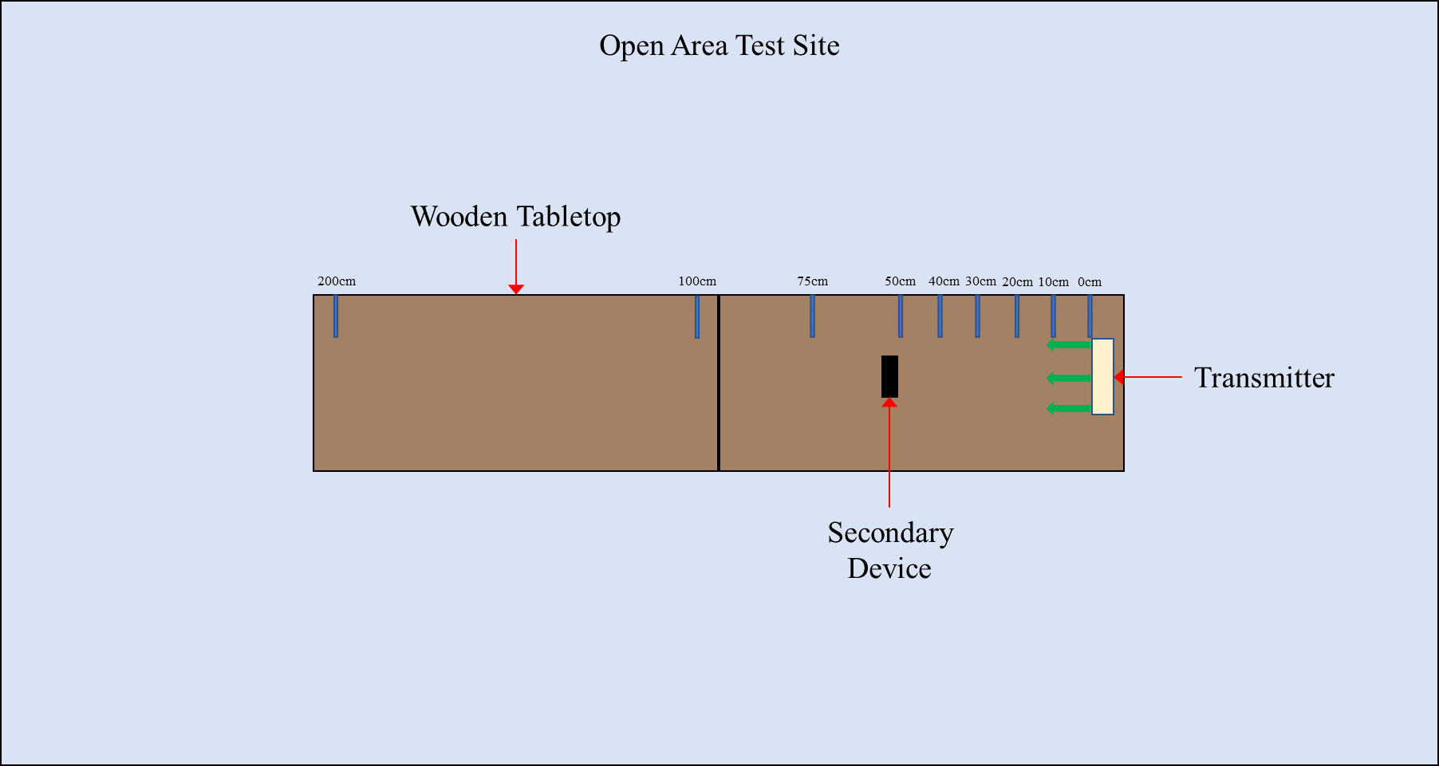
Figure 2
Test setup in room 2, anechoic chamber
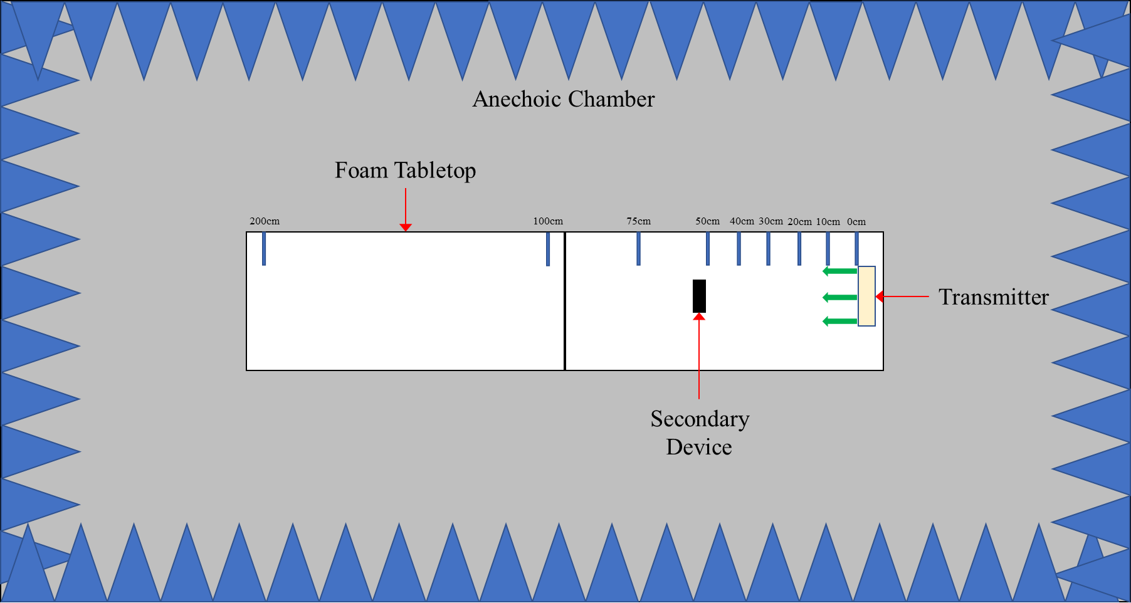
Tests were performed on the following types of wireless devices:
Table 2
Types of devices used, frequencies, and distances in Study A
No. | Type of device | Frequency range (MHz) | Distances tested (cm)
1 | Cellphone | Uplink: 888.0-915.0  Downlink: 925.2-960.0 | 0, 10, 20, 30, 40, 50, 70, 100
2 | Cellphone | Uplink: 888.0-915.0  Downlink: 925.2-960.0 | 0, 10, 20, 30, 40, 50, 70, 100
3 | Cellphone | Uplink: 888.0-915.0  Downlink: 925.2-960.0 | 0, 10, 20, 30, 40, 50, 70, 100
4 | Cellphone | Uplink: 888.0-915.0  Downlink: 925.2-960.0 | 0, 10, 20, 30, 40, 50, 70, 100
5 | Wireless Microphone and base station | 904.45-927.45  User Selectable | 0, 10, 30, 100, 200
6 | Assisted listening device | 863.25-864.75  User Selectable | 0, 10, 30, 100, 200
7 | Assisted listening device | 904.65-926.85  User Selectable | 0, 10, 30, 100, 200
8 | RFID reader | 903-927  Hopping | 0, 10, 30, 100, 200
9 | RFID reader | 865-868  Hopping | 0, 10, 30, 100, 200

Cellphone. The DUT was placed 100 cm from a mobile phone simulating a desktop environment. The cell antenna, cabled to base station simulator, was placed 3 m from the DUT and mobile phone devices. A call from the mobile phone was established to the callbox in the GSM 900 Band, on a specific frequency. After the call was established, the DUT was switched on at 917.5 MHz. The charging signal was verified with a spectrum analyzer positioned in the test area. The call was monitored for 60 seconds. After which the call state was logged (call maintained, or call dropped.). The distance between the DUT and mobile phone was decreased incrementally until the mobile phone was touching the DUT, measured at 0 cm. Testing was performed using 5 different channels.
Figure 3
Cellphone impact test setup
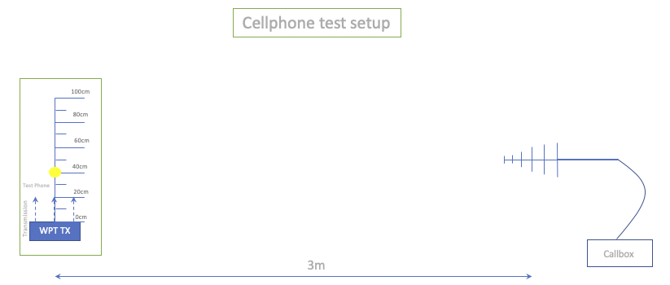
Figure 4
Other In-band device impact test set up
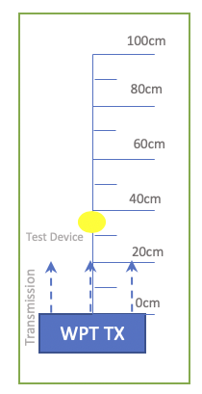
The results demonstrated that all phones were able to operate without harmful interference on at least one channel and on all channels when separated by 1 m or more from the DUT.
Wireless Microphone and base station. The base-station (receiver) was placed 30 cm from the DUT, and the Microphone (Transmitter) moved through the test distances. Subsequently, the Microphone (Transmitter) was placed 30 cm from the DUT, and the Base-station (receiver) was moved through the test distances.
Setting the audio device frequency away from that of the DUT resulted in little to no harmful interference. When operating at or close to the transmit frequency of the DUT, the devices suffered harmful interference.
Assisted listening device. The Transmitter was placed 30 cm from the DUT, and the Receiver was moved through the test distances. Following this, the Receiver was placed 30 cm from the DUT, and the Transmitter was moved through the test distances.
Setting the audio device frequency away from that of the DUT resulted in little to no harmful interference. When operating at or close to the transmit frequency of the DUT, the devices suffered harmful interference.
RFID reader. For the first device, scans were performed at 903.250; 904.250; 915.250; 915.750; 920.250; 926.750; and 927.250 MHz. The software transmitting setting was set to 30 dBm. RFID tags were then placed 30 cm from the DUT. For the second, scans were performed at 865.00; 866.00; 867.00; and 868.00 MHz with default settings. RFID tags were then placed 30 cm from the DUT.
At separation distances of 1 m or greater between the DUT and RFID reader and tags, the readers worked without error.

3.2 Study B
A single client RF near-field contact charger, the device under testing (DUT), that operates when a receiving device is placed on the charger surface was tested for impact to demonstrate interoperability with other wireless devices and technologies. The DUT used Bluetooth Low Energy (BLE) to pair with the receiving device and transmitted a continuous carrier wave signal adjustable between 915 MHz and 921 MHz. The maximum declared average power was 33.0 dBm per port, with a measured ERP of 1.0 W, and EIRP of 1.64 W. The DUT is designed to charge other devices that rest on its surface. Additionally, the DUT is compliant with Title 47, Chapter I, Subchapter A, Part 15 of the United States Electronic Code of Federal Regulations, which, inter alia, requires that devices cause no harmful interference and accept interference caused by the operation of an authorized radio station, by another intentional or unintentional radiator, by industrial, scientific and medical (ISM) equipment, or by an incidental radiator.
The tests were performed in two separate rooms. The first was a real-world test performed in a regular room and on a wooden countertop where other signals were present, as illustrated in Figure 5. As an example of the types of signals present, a nearby train station regularly emits 900 MHz signals that are detectable in the room. The second room was an anechoic chamber, as described in ETSI EN 302 208 V3.1.1 (2016-11) Annex B.1.2 and as illustrated in Figure 6. This anechoic chamber was used to demonstrate whether the results found in the regular room were repeatable in a free-space environment and whether any degradation of signal was due to the noisy environment. The tests were performed in the exact same manner, detailed further below, in each room. The results from each of the tests did not have any discrepancies; as such, only one set of results is presented below.
Figure 5
Test setup in room 1, open area
Figure 6
Test setup in room 2, anechoic chamber
Tests were performed on the following types of wireless devices:
Table 3
Types of devices used, frequencies, and distances in Study B
No. | Type of device | Frequency range (MHz) | Distances tested (cm)
1 | Cellphone | Uplink: 888.0-915.0  Downlink: 925.2-960.0 | 0, 10, 20, 30, 40, 50
2 | Cellphone | Uplink: 888.0-915.0  Downlink: 925.2-960.0 | 0, 10, 20, 30, 40, 50
3 | Cellphone | Uplink: 888.0-915.0  Downlink: 925.2-960.0 | 0, 10, 20, 30, 40, 50
4 | Cellphone | Uplink: 888.0-915.0  Downlink: 925.2-960.0 | 0, 10, 20, 30, 40, 50
5 | Wireless Microphone and base station | 904.45-927.45  User Selectable | 0, 30, 100, 200
6 | Assisted listening device | 863.25-864.75  User Selectable | 0, 30, 100, 200
7 | RFID reader | 903-927  Hopping | 0, 10, 30, 100
8 | RFID reader | 865-868  Hopping | 0, 10, 30, 100
9 | Smart hub | 903-914 | 10, 30, 100
10 | Push button | 916 | 10, 30, 100
Note: The smart hub (device no. 9) and push button (device no. 10) use LoRa technology and were tested together.
Cellphone. The DUT was placed 50 cm from a mobile phone. A call to the mobile phone was setup to the callbox in the GSM 900 band on a specific frequency. The call box antenna was placed 50 cm away from the mobile phone. A call was setup between the callbox and the mobile phone under test. Then the DUT was turned on and set to a specific frequency. The call was monitored for 60 seconds. After which the call state was logged (call maintained or call dropped.). The DUT was then moved 10 cm closer to the mobile phone and the process repeated. This was continued until the DUT was touching the mobile phone (distance = 0 cm).
No harmful interference was observed for any of the test configurations.
Wireless Microphone and base station. Four sets of tests were performed. For the first two, the base station (receiver) was placed 30 cm from the Charger, and the Microphone (Transmitter) was moved through the test distances. The DUT operated at 918 MHz for the first test, then 917.5 MHz for the second. For the third and fourth tests, the Microphone (Transmitter) was placed 30 cm from the Charger, and the base station (receiver) was moved through the test distances. Again, the tests were performed once with the DUT at 918 MHz then once at 917.5 MHz.
The microphone did not experience noticeable harmful interference except when it operated at 917.65 MHz; when the DUT operated at 918 MHz, this harmful interference was only experienced when the Microphone was within 30 cm of the DUT.
Assisted listening device. Four sets of tests were performed. For the first two tests, the Transmitter was placed 30 cm from the Charger, then the Receiver moved through the test distances. The DUT operated at 918 MHz for the first test, then 917.5 MHz for the second. For the third and fourth tests, the Receiver was placed 30 cm from the Charger, then the Transmitter was moved through the test distances. Again, the tests were performed once with the DUT at 918 MHz then once at 917.5 MHz.
The tests show that the assisted listening device was not affected by the DUT due to the frequency offset between the two devices.
RFID reader. The first device, scans were performed at 903.250; 904.250; 915.250; 915.750; 920.250; 926.750; and 927.250 MHz. The transmit settings was set to 30 dBm in software, and the receive was set to 0 dBm. The RFID tag was placed 30 cm from the DUT, with its operating frequencies at 918 MHz then 917.5 MHz. The second reader was set to scan at 865.00; 866.00; 867.00; and 868.00 MHz. Default settings were used for the tests. The RFID tag was placed 30 cm from the DUT, with its operating frequency set to 918 MHz.
The results show that the RFID devices operated without significant degradation at separation distances greater than 30 cm.
Smart hub with push button. The smart hub and push button were operated using default settings, with the smart hub placed 30 cm from the DUT. The results demonstrated that the smart hub with push button operated without degradation under all of the configurations assessed.

3.3 Study C
Study C shows a summary of the study taken in new rulemaking in Japan on beam WPT technology in 917-920 MHz, 2.410-2.486 GHz, and 5.738-5.766 GHz. [1] The report on the study was released in July 2020, which describes technical conditions operating in these frequency bands the use indoors (e.g., factories, offices) with human body protection requirements from RF exposure. Moreover, the report describes beam WPT as a radio service that needs rulemaking for practicable implementation with regulatory measures.
[1] https://www.soumu.go.jp/main_content/000697267.pdf

3.3.1 Frequency bands and incumbent radiocommunication systems and services considered in the study
Incumbent radiocommunication systems and services adjacent to or included in 917-920 MHz, 2.410-2.486 GHz, and 5.738-5.766 GHz, which were considered in the study, are listed in Table 4, Table 5, and Table 6, respectively.
TABLE 4
917-920 MHz radiocommunication systems and services considered in the study
System | Frequency | Protection criterion | References
Digital MCA Service | 930 MHz – 940 MHz (uplink) | −108.8 dBm/MHz  (in band)  −51 dBm (out of band) | ARIB^{*1} STD-T85  (Japan)
Digital MCA Service | 940 MHz – 945 MHz  (downlink) | −108.8 dBm/MHz  (in band)  −51 dBm (out of band) | ARIB^{*1} STD-T85  (Japan)
Advanced MCA Service | 895 MHz – 900 MHz  (uplink) | −110.8 dBm/MHz (in band)  −44 dBm (out of band, 12.5 MHz separation) | 3GPP TS36 104 ｖ8.3.0 (2008-9)
Advanced MCA Service | 850 MHz – 860 MHz  (downlink) | −119 dBm/MHz (in band)  −43 dBm (out of band, modulation)  −15 dBm (out of band, CW) | 3GPP TS36 104 ｖ8.3.0 (2008-9)
LTE-A (Band 8) | 900 MHz – 915 MHz  (uplink) | −110.8 dBm/MHz (in band)  −44 dBm (out of band, 12.5 MHz separation) | 3GPP TS36 104 ｖ8.3.0 (2008-9)
LTE-A (Band 8) | 945-960 MHz (downlink) | −119 dBm/MHz (in band)  −43 dBm (out of band, modulation)  −15 dBm (out of band, CW) | 3GPP TS36 104 ｖ8.3.0 (2008-9)
RFID (Passive) | 916.7 MHz – 923.5 MHz | −81 dBm/MHz (in band)  −30 dBm (out of band, 2 MHz separation) | ARIB STD-T106  ARIB STD-T107  (Japan)
RFID (Active) | 915.9 MHz – 929.7 MHz | −127 dBm/MHz (in band)  −80 dBm (out of band) | ARIB STD-T108  (Japan)
Radio astronomy | 1 400 MHz – 1 427 MHz | −197.4 dBW/MHz | ITU-R RA.769-2
^{*1}: Association of Radio Industries and Businesses (https://www.arib.or.jp/english/)

TABLE 5
2 410-2 486 MHz radiocommunication systems and services considered in the study
System | Frequency | Protection criterion | References
Wireless LAN | 2 400 MHz – 2 497 MHz | −92 dBm (co channel)  −66 dBm (adjacent channel),  −50 dBm (alternate adjacent channel) | IEEE Std.802.11-2016
Premises radio | 2 400 MHz – 2 483.5 MHz | −98 dBm  (including 11 dBi antenna gain) | ARIB RCR STD-1  ARIB RCR STD-29  (Japan)
Unmanned mobile image transmission system (Wireless system for drones and other unmanned vehicles) | 2 483.5 MHz – 2 494 MHz | −98 dBm (co channel)  −72 dBm (adjacent channel),  −56 dBm (alternate adjacent channel)  (including 6 dBi antenna gain) | Report on MIC Advisory No. 2034  (Japan)
Geostationary Mobile Satellite Service | 2 500 MHz – 2 535 MHz | −124.9 dBm/MHz (in band)  −41 dBm  (out of band, 10-25 MHz separation) | Report on MIC Advisory No. 2032  (Japan)
Non-Geostationary Mobile Satellite Service | 2 483.55 MHz – 2 500 MHz | −119.4 dBm/MHz | Report on MIC Advisory No. 82  (Japan)
Broadcasting Service: Field Pickup (FPU) | 2 330 MHz – 2 370 MHz | −102 dBm/MHz  (mobile relay Uplink) | Report on MIC Advisory No. 2024  (Japan)
Radio astronomy | 2 695 MHz | −187 dBW/MHz | ITU-R RA.769-2
Amateur radio | 2 400 MHz – 2 450 MHz | −110.83 dBm/MHz | JARL^{*2} requirement
^{*2}: The Japan Amateur Radio League, Inc. (https://www.jarl.org/English/0-2.htm)

TABLE 6
5 738-5 766 MHz radiocommunication systems and services considered in the study
System | Frequency | Protection criterion | References
Wireless LAN (W56) | 5 470 MHz – 5 730 MHz | −63 dBm (adjacent channel),  −47 dBm (alternate adjacent channel) | IEEE Std.802.11-2016
Dedicated Short Range Communication (DSRC) | 5 770 MHz – 5 850 MHz | −42 dBm  (class-2, spurs response rejection),  −100 dBm (class-2) | ARIB STD-T75  (Japan)
Broadcasting Service: Studio to Transmitter Link (STL) & Transmitter to Transmitter Link (TTL) | 5 850 MHz – 5 925 MHz | −101.6 dBm  (equivalent thermal noise level) | ARIB_STD-B22  (Japan)
Broadcasting Service: Field Pickup (FPU) & Transmitter to Studio Link (TSL) systems | 5 850 MHz – 5 925 MHz | −89.4 dBm  (FPU fixed relay station) | ARIB STD-B33  (Japan)
Unmanned mobile image transmission system (Wireless system for drones and other unmanned vehicles) | 5 650 MHz – 5 755 MHz | −98 dBm (in-band),  −72 dBm (adjacent channel),  −56 dBm (alternate adjacent channel) | Report on MIC Advisory No. 2034  (Japan)
Weather radar | 5 250 MHz – 5 372.5 MHz | −120 dBm (noise), −40 dBm (CW) | ITU-R M.1849-2
Radio astronomy | 4 700 – 5 140 MHz, 3 000 MHz – 14 000 MHz | −187 dBW/MHz | ITU-R RA.769-2
Amateur radio | 5 650 MHz – 5 850 MHz | −110.83 dBm/MHz | JARL requirement

3.3.2 Specifications and parameters used for the study
Expected specifications and system parameters used for the study are shown in Table 7, Figure 7, Figure 8 and Figure 9.
TABLE 7
Expected specifications of beam WPT commercial systems considered
 | System 1  920 MHz band | System 2  2.4 GHz band | System 3  5.7 GHz band
Transmitter antenna output power | 1W (30 dBm) | 15W (41.8 dBm) | 32W (45.0 dBm)
Frequency channels | 918.0, 919.2 MHz  (2 channels) | 2 412, 2 437, 2 462, 2 484 MHz  (4 channels) | 5 740, 5 742, 5 744, 5 746, 5 748, 5 750, 5 752, 5 758, 5 764 MHz  (9 channels)
e.i.r.p | 36 dBm Max. | 65.8 dBm Max. | 70.0 dBm Max.
Tolerance of occupied bandwidth | 200 kHz | Not specified | Not specified
Transmitter antenna directive gain | 6.0 dBi | 24.0 dBi | 25.0 dBi
Location and height of transmitter antenna | Located indoor area | Located indoor area and set on ceiling to look down | Located indoor area and set on ceiling to look down
Location and height of transmitter antenna | 2.5 m above floor | 5.0 m above floor | 4.6 m above floor
Transmitter antenna directive pattern | Figure 7 | Figure 8 | Figure 9
Usage environment | Indoor | Indoor | Indoor
Usage environment | WPT controlled environment  and/or WPT general environment | WPT controlled environment | WPT controlled environment
Modulation | Not specified | CW | CW
Building entry loss | 10.0 dB | 14.0 dB | 16.0 dB

“WPT controlled environment” and “WPT general environment” are defined. “WPT controlled environment” is defined as,
– Indoor and closed area,
– Environment where limits of Japanese radio exposure guidelines in controllable area can be cleared, and/or the manager/administrator can cut off power transfer of beam WPT systems when limits of Japanese radio exposure guidelines in controllable area are happened to be not cleared,
– Environment where the manager/administrator can manage and control both of beam WPT systems and incumbent radio communication services in order to avoid or reduce harmful interference from beam WPT systems.
“WPT general environment” are defined as the other environment where the above conditions cannot be met.
FIGURE 7
Transmitter antenna directive pattern for 920 MHz band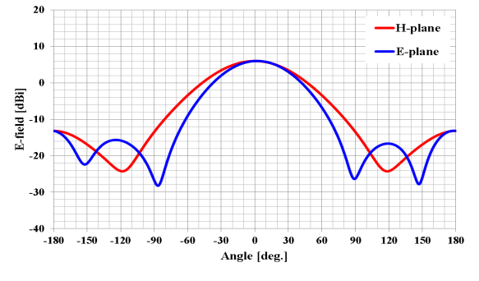
FIGURE 8
Transmitter antenna directive pattern for 2.4 GHz band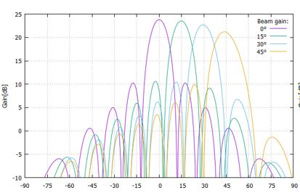
FIGURE 9
Transmitter antenna directive pattern for 5.7 GHz band
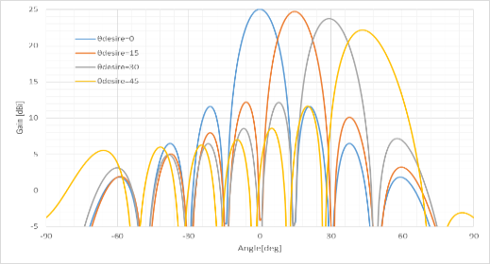

3.3.3 Building entry loss consideration
The study referred to building entry loss defined in Section 3 of Recommendation ITU-R P.2109-1 “Prediction of building entry loss”.
The building entry loss value depends on the outer wall material. Two building types are shown in Recommendation ITU-R P.2109-1. One is "Thermally efficient" that uses heat shield and heat insulating material with high electromagnetic wave reflection characteristics. The other is "Traditional" that does not use them. The median loss L_{h} can be given by the calculation formula shown below. Moreover, the loss also depends on the frequency.
$L_{h}=r+slog\left(f\right)+t{\left(\log\left(f\right)\right)}^{2}$
where r, s, and t are the constants shown in Table 8, and f is the frequency (GHz). Table 9 shows the calculation results for the median loss for the representative frequencies of the three frequency bands used in the wireless power transmission systems via radio frequency beam.
According to FIGURE 1 of Recommendation ITU-R P.2109-1, the "Thermally efficient" building type has a large loss by about 15 dB compared to "Traditional", but it is unlikely that thermally efficient construction materials are used for all outer walls of the buildings. The examination was based on the value of the "Traditional" type.
Table 8
Model coefficients used for building entry loss calculation in Recommendation ITU-R P.2109-1
Item | r | s | t
Traditional | 12.64 | 3.72 | 0.96
Thermally efficient | 28.19 | –3.00 | 8.48
Table 9
Calculation results of the median loss for the three frequency bands used in beam WPT
Item | 920 MHz | 2 450 MHz | 5 750 MHz
Lh (Traditional) | 12.5 dB | 14.2 dB | 16.0 dB
Lh (Thermally efficient) | 28.3 dB | 28.3 dB | 30.8 dB
Table 10
Building entry loss used for the studies on the impact of beam WPT
Item | 920 MHz | 2.4 GHz | 5.7 GHz
Wall loss | 10.0 dB | 14.0 dB | 16.0 dB

3.3.4 Use case scenarios and conditions for Impact Studies on beam WPT
Table 11 shows the use case scenarios and conditions for Impact Studies on beam WPT systems used for impact studies.
The System 4 is mainly used in WPT for wireless-powered sensor network. The System 4 is used in indoor and controlled environment where WPT equipment is controlled by managers of factories, nursing homes and so on. The power consumption of the sensor is about several hundred μW or less.
The System 5 and the System 6 are mainly used in WPT for small displays in addition to the application of the System 1. The System 5 and the System 6 are used in indoor and controlled environment where WPT equipment is controlled by managers of factories, plants, warehouses and so on. The power transmission to the receiver devices requires up to several watts.
TABLE 11
Use case scenarios and conditions for beam WPT systems
beam WPT system | System 1  920 MHz band | System 2  2.4 GHz band | System 3  5.7 GHz band
Usage environment | Factory (Indoor), nursing home, etc. | Factory (indoor), plant (indoor), warehouse, etc. | Factory (indoor), plant (indoor), warehouse, etc.
Application | Charging and power supply to sensor network | Charging and power supply to sensors, display and information devices | Charging and power supply to sensors, display and information devices
Number of receiving devices per one WPT transmitter | 5 to 10 devices  (Simultaneous reception) | 1 to several ten devices  (Successive or sequential reception) | 1 to several ten devices  (Successive or sequential reception)
Power range | Several μW to several hundred μW | 50 mW to 2 W | Several mW to several hundred mW
Power transfer distance | Less than 5 m | Less than 10 m | Less than 10 m
Coexistence with other wireless systems | Feasible. Take appropriate interference mitigation and radio protection measures | Feasible. Take appropriate interference mitigation and radio protection measures | Feasible. Take appropriate interference mitigation and radio protection measures
Power transfer while human bodies exist | Possible to transfer under the condition that limits of national radio exposure guidelines are cleared | Off | Off

3.3.5 Study results
For the WPT systems intended the operation in the 920 MHz band, the system parameters assumed for the impact study (See Table 7) were compliant with the radio regulation including transmission intervals for the RF-ID systems currently operated in the same frequency range. Minimum separation distances were derived in accordance with the beam WPT characteristics for the case geographical separation distance is necessary to regulate. In addition, Monte-Carlo system-level simulation was performed to assess interfering likelihood from beam WPT to LTE and MCA mobile communication networks.
For the beam WPT systems intended for the operation in the 2.4 GHz band and 5.7 GHz band, the study was conducted with the system parameters (See Table 7) to determine required technical requirements and operational conditions under the current radio regulation including frequency allocation and operational conditions. Study results in 2.4 GHz band and 5.7 GHz band are summarized as follows:
1 Clear Channel Assessment (CCA) mechanism shall be adopted to coexist with WLAN systems and / or Specified Low Power Radio Stations. It turned out that WLAN system performance such as throughput can be maintained without harmful interference by adding CCA mechanism.
2 For radioastronomy, weather radar, and Radio Beacon services, minimum separation distances were specified.
3 For broadcasting systems, mobile satellite communication systems, and Dedicated Short Range Communication (DSRC) system, minimum separation distances were specified. In addition, operational coordination was addressed for the case beam WPT causes harmful interference.
4 For unmanned mobile image transmission system (i.e., a wireless communication system for drones and other unmanned vehicles), studies assuming practical use cases showed that spectrum sharing without causing harmful impact was possible by operational coordination as needed between WPT systems and unmanned mobile image transmission systems.
5 For amateur radio services, beam WPT installation conditions for spectrum sharing were specified. In addition, beam WPT systems shall not use the frequency band for Earth-Moon-Earth (EME) systems and repeater systems. Operational coordination is undertaken between WPT systems and amateur radio systems.
Furthermore, a comprehensive beam WPT management rule regarding WPT operation environment and WPT radio frequency EMFs was defined and can be applied specific use cases using the frequency bands to abide by the Radio Radiation Protection Guidelines. See Annex 1 for details. Thus, required technical requirements and operational conditions not to cause harmful impact to the existing systems and services were determined.
Below shows individual summaries of the study per incumbent system.

3.3.5.1 917-920 MHz
(1) Digital MCA Service
The study referred to the examination methodologies and results on the past coexistence study when RFID system was introduced in 917-920 MHz. Beam WPT in the band was assumed almost the same technical conditions for assessment as RFID. Possibility of harmful impact is extremely low while keeping the given conditions and expecting additional propagation loss due to building entry loss. The condition includes the separation distance, adjustment of setting conditions, and measures to mitigate interferences.
(2) Advanced MCA Service
WPT can be shared by the control station (base station: downlink) by considering vertical directivity.
The mobile station (uplink) can be shared when both systems do not exist in the same room, which was shown by Monte-Carlo simulation using the extended Hata formula (300 m or less).
In the case of the same room, the required improvement amount is about 10 dB, but it can be shared because it is expected to be attenuated by obstacles and the human body in the room.
However, regarding the use with the WPT system in the same room, the WPT users will be alerted the possibility of interference to MCA stations.
(3) LTE-A (Band 8)
The WPT system can be shared in a WPT general environment even when there is no transmission time limit. On the other hand, the WPT system can be shared in the management environment by limiting the transmission time (stopping transmission for 50 msec within 4 seconds of the transmission).
(4) RFID (Passive)
The WPT system and RFID system can be shared on the same channel if a separation distance of about 6 m is secured. If the separation distance cannot be secured, those system can coexist by changing the WPT transmit channel and/or RFID channel, or shield with a wall.
(5) RFID (Active)
The passive RFID system is assumed coexisting with the active RFID system. The WPT system can be coexist with active RFID system because of the specification of WPT system is almost same as passive RFID interrogator.
(6) Radio Astronomy
The separation distance was calculated with free space loss model to be 37.5 km using the spurious ability value (-60.5 dBm / MHz). The WPT system has set that distance from radio astronomy as a restricted installation area.

3.3.5.2 2.410-2.486 GHz
Radio characteristics example of beam WPT (non-ISM) is shown on Table 1.
(1) Wireless LAN
The simulation using the CCA mechanism on the beam WPT system was conducted to study the impact to the Wi-Fi devices located outside of the WPT controlled environment. The decline of the throughput of those Wi-Fi devices could be suppressed with appropriate parameters of CCA mechanism, compared with the case when another Wi-Fi AP was operated at the same location instead of the beam WPT inside the WPT controlled environment. Antenna directions should be adjusted not to directly face each other to prevent the device being damaged.
(2) Premises Radio
Within the beam WPT controlled environment the operation of the premises radio can be managed and controlled by the same operator as for the beam WPT. Moreover, within the 84.9 m from the beam WPT location it can be suppressed the transmission with the CCA mechanism when premises radio is transmitting. Antenna directions should be adjusted not to directly face each other to prevent the device being damaged.
(3) Unmanned mobile image transmission system
Separation distance was calculated with extended Hata model and it is 3.6 km on co channel from the beam WPT to the Unmanned mobile image transmission system outdoor. However, since the system is usually operated outside the cities and the usage time and places are planned, the harmful interference can be avoided by the coordination procedure.
(4) Geostationary Mobile Satellite Service
Separation distance was calculated with worst case scenario of out of band interference, where antenna directivity direction of the GEO MSS receiver was perfectly matched to the beam direction of the beam WPT. It is 30 m in the northern part of Japan. With the separation distance and coordination procedure if necessary, harmful interference can be avoided. If necessary, the operational coordination is performed between WPT systems and mobile satellite communication systems.
(5) Non-Geostationary Mobile Satellite Service
Separation distance was calculated of in band interference with extend Hata model and it was 0.96 km. Since Non-Geostationary Mobile Satellite Service is generally used in the location where cellular mobile system cannot be reached in Japan and the beam WPT does not possibly exist, the harmful interference can be avoided. If necessary, the operational coordination is performed between WPT systems and mobile satellite communication systems.
(6) Broadcasting Service: Field Pickup (mobile Electronic News Gathering)
Separation distance was calculated in various scenarios and systems and with the antenna directivity it does not cause harmful interference when satisfying 10 m separation distance outside the WPT controlled environment. BEAM WPT systems shall abide by the condition of the necessary separation distance and installation.
(7) Radio Astronomy
Separation distance was calculated for each radio astronomy site operating 2 695 MHz considering clutter loss. The separation distances are 5.7 km or 1.6 km depending on the environment of the site. To avoid the harmful interference to radio astronomy restricted area around the sites are set with those separation distances.
(8) Impact study for Radio Amateur
Separation distance was calculated considering clutter loss. 2 out of 4 frequencies of beam WPT are co-channel with Radio Amateur, which need 4.4 km separation distance with 18 dBi Radio Amateur antenna. Considering antenna directive loss and using adjacent band if necessary, the harmful interference can be avoided. If necessary, the operational coordination is performed between WPT systems and amateur radio systems.

3.3.5.3 5.738-5.766 GHz
(1) Wireless LAN
Simulation was conducted to study the impact of the beam WPT system to the Wi-Fi system that operate outside the WPT controlled environment. When CCA mechanism with appropriate parameters was applied to the beam WPT system, the impact to the Wi-Fi throughput was equivalent to the case when another Wi-Fi system existed instead of the beam WPT system. In the WPT controlled environment, assuming the condition to be under control by the identical system operator of both systems, carrier sensing works well. Antenna directions should be adjusted not to directly face each other to prevent the device being damaged.
(2) Dedicated Short Range Communication (DSRC)
Study on separation distance was made for the worst case scenario, where antenna directivity of the DSRC system perfectly matched to the beam direction of the beam WPT system. The separation distance was calculated with free space loss model to be 2.6 km from the beam WPT system to the DSRC Class 2 base station. Additional propagation loss due to building entry loss and directivity loss of DSRC antenna can be expected to further avoid harmful interference.
(3) Broadcasting Service: Studio to Transmitter Link (STL) & Transmitter to Transmitter Link (TTL)
Separation distance was calculated with free space loss model to be 836 m for out band noise signal from the beam WPT to the STL/TTL base station. When difference in height is more than 5 m, 20 dB of directivity loss of STL/TTL antenna can be expected to further avoid harmful interference.
(4) Broadcasting Service: Field Pickup (FPU) & Transmitter to Studio Link (TSL) systems
Separation distance was calculated to be 80 m for out band noise signal from the beam WPT to the FPU base station. When difference in height is more than 25 m, more than 14 dB of directivity loss of FPU antenna can be expected to further avoid harmful interference.
Separation distance was calculated with free space loss model to be 1 485 m for out band noise signal from the beam WPT system to the TSL base station. When difference in height is more than 7 m, 20 dB of directivity loss of STL/TTL antenna can be expected to further avoid harmful interference.
(5) Unmanned mobile image transmission system
Separation distance was calculated with free space loss model to be 23 km on co-channel and 185 m on the alternate adjacent channel from the beam WPT system to the unmanned mobile image transmission system outdoor, respectively. However, since the system is usually operated outside the cities and the usage time and places are scheduled, harmful interference can be avoided by such as coordination procedure.
(6) Weather radar
Separation distance was calculated with free space loss model to be 3 308 m for out band noise signal from the beam WPT system for each weather radar site. To avoid the harmful interference, separation distance should be kept.
(7) Radio Astronomy
Separation distance was calculated with free space loss model to be 1.1 km or 1.7 km for 4 995 MHz and 10 650 MHz radio astronomy sites. To avoid the harmful interference, separation distance should be kept.
(8) Impact study for Radio Amateur
Separation distance was studied considering clutter loss. The calculated separation distance with free space loss model was 1.5 km and 262 m for 30 dBi and 15 dBi Radio Amateur antennas, respectively. Antenna directivity and coordination procedure can avoid harmful interference. The operational coordination will be undertaken between WPT systems and amateur radio systems.

3.4 Study D
An over-the-air, distance charging transmitting device (DUT) operating between 915 MHz and 921 MHz was tested for impact to demonstrate interoperability with wireless devices and technologies operating in the same band. The DUT operates on a single channel with a bandwidth less than 400 kHz and maximum declared conducted average power of 40.0 dBm. The DUT is designed to charge other devices at a distance of up to 300 cm.
The tests were performed in two separate rooms. The first was a real-world test performed in a regular room and on a wooden countertop where other signals were present, as illustrated in Figure 10. The second room was an anechoic chamber, as described in ETSI EN 302 208 V3.1.1 (2016-11) Annex B.1.2 and as illustrated in Figure 11. This anechoic chamber was used to demonstrate whether the results found in the regular room were repeatable in a free-space environment and whether any degradation of signal was due to the noisy environment. The tests were performed in the exact same manner, detailed further below, in each room. The results from each of the tests did not have any discrepancies; as such, only one set of results is presented below.
Figure 10
Test setup in room 1, open area

Figure 11
Test setup in room 2, anechoic chamber
Tests were performed on the following types of wireless devices:
Table 12
Types of devices used, frequencies, and distances in Study D
No. | Type of device | Frequency range  (MHz) | Distances tested  (cm)
1 | Cellphone | Uplink: 888.0-915.0  Downlink: 925.2-960.0 | 0, 10, 20, 30, 40, 50, 70, 100
2 | Cellphone | Uplink: 888.0-915.0  Downlink: 925.2-960.0 | 0, 10, 20, 30, 40, 50, 70, 100
3 | Cellphone | Uplink: 888.0-915.0  Downlink: 925.2-960.0 | 0, 10, 20, 30, 40, 50, 70, 100
4 | Cellphone | Uplink: 888.0-915.0  Downlink: 925.2-960.0 | 0, 10, 20, 30, 40, 50, 70, 100
5 | Wireless Microphone and base station | 904.45-927.45  User Selectable | 0, 10, 30, 100, 200
6 | Assisted listening device | 863.25-864.75  User Selectable | 0, 10, 30, 100, 200
7 | Assisted listening device | 904.65-926.85  User Selectable | 0, 10, 30, 100, 200
8 | RFID reader | 903-927  Hopping | 0, 10, 30, 100, 200
9 | RFID reader | 865-868  Hopping | 0, 10, 30, 100, 200

Cellphone. The DUT was placed 100 cm from a mobile phone simulating a desktop environment. The cell antenna, cabled to base station simulator, was placed 3 m from the DUT and mobile phone devices. A call from the mobile phone was established to the callbox in the GSM 900 Band, on a specific frequency. After the call was established, the DUT was switched on at 917.5 MHz. The charging signal was verified with a spectrum analyzer positioned in the test area. The call was monitored for 60 seconds. After which the call state was logged (call maintained, or call dropped.). The distance between the DUT and mobile phone was decreased incrementally until the mobile phone was touching the DUT, measured at 0 cm. Testing was performed using 3 different channels.
Figure 12
Cellphone impact test setup
Figure 13
Other In-band device impact test set up
The results demonstrated that all phones were able to operate without harmful interference on at least one channel and on all channels when separated by 1 m or more from the DUT.
Wireless Microphone and base station. The base-station (receiver) was placed 30 cm from the DUT, and the Microphone (Transmitter) moved through the test distances. Subsequently, the Microphone (Transmitter) was placed 30 cm from the DUT, and the Base-station (receiver) was moved through the test distances.
When operating close to the transmit frequency of the DUT, the audio devices experienced .no harmful interference
Assisted listening device. The Transmitter was placed 30 cm from the DUT, and the Receiver was moved through the test distances. Following this, the Receiver was placed 30 cm from the DUT, and the Transmitter was moved through the test distances.
When operating at close to the transmit frequency of the DUT, the devices experienced interference however setting the audio device frequency away from that of the DUT resulted in little to no harmful interference.
RFID reader. For the first device, scans were performed at 903.250; 904.250; 915.250; 915.750; 920.250; 926.750; and 927.250 MHz. The software transmitting setting was set to 30 dBm. RFID tags were then placed 30 cm from the DUT. For the second, scans were performed at 865.00; 866.00; 867.00; and 868.00 MHz with default settings. RFID tags were then placed 30 cm from the DUT.
At separation distances of 1 m or greater between the DUT and RFID reader and tags, the readers worked without error.

3.5 Study E

3.5.1 Radio services considered in the study
This section will contain a study that determines the out-of-band emission limits necessary to ensure protection criteria are met for the Earth Exploration Satellite Service (passive) (EESS (passive)) and Radio Astronomy Service (RAS) . This study deals with use of segments the ISM bands at 24.0-24.250 GHz and 61.0- 61.5 GHz for beam WPT.
[Editor’s Note: Once a study is submitted, the text in section 3.5.1 needs to be updated to reflect the fact that a study is contained and not just anticipated.]

3.5.2 Considerations for 24.1-24.15 GHz and 61.0-61.5 GHz
The technology being considered at these frequencies involves a narrow band transmission which has a bandwidth of 0.04% of the center frequency of 24 GHz and .02% in the case of 61 GHz. The maximum 10 MHz bandwidth comes from three sources: phase noise of the frequency source, incident random phase modulation on the transmitted signal from continuous minor adjustments of the phase shifters in the antenna elements to maintain focus on the intended destination, and low index modulation of the CW carrier for communications between the transmitter and power destination used to both maintain a tight focus of the band on the destination and to implement active safety features that decrease power when an object or a human or pet approach the high power flux density (p.f.d.) volume near the intended destination.
Table 2 of Rec. ITU-R RS.2017-0 gives the interference criteria for satellite passive remote sensing. For the nearest passive band to the 24.1-24.15 GHz band being considered for WPT, 23.6-24 GHz, the maximum interference level from all sources is -166 dBW measured over a 200 MHz bandwidth, not to be exceeded for more than 0.01% of the measurement area or 0.01% of the measurement time.
Rec. ITU-R RA.769-2 gives protection criteria used for radio astronomical measurements. This states “that administrations, in seeking to afford protection to particular radio astronomical observations, should take all practical steps to reduce all unwanted emissions falling within the band of the frequencies to be protected for radio astronomy to the absolute minimum.”

3.5.3 Impact of 24.1-24.15 GHz beam WPT on passive allocations

.

The 24.1-24.15 GHz band that will be used for WPT Beam applications is within the 24-24.25 GHz ISM band. 5.150 states that “Radiocommunication services operating within these bands must accept harmful interference which may be caused by these applications” so the impact of WPT power within 24.1-21.15 GHz must be accepted by other services in that band. 15.13 that requires that “administrations shall take all practicable and necessary steps to ensure that radiation from equipment used for industrial, scientific and medical applications is minimal and that, outside the bands designated for use by this equipment, radiation from such equipment is at a level that does not cause harmful interference to a radiocommunication service and, in particular, to a radionavigation or any other safety service operating in accordance with the provisions of these Regulations”. Thus, any administrations authorizing use of WPT Beam ISM equipment must specify appropriate out-of-band emission limits for such devices that assures the protection of the EESS (passive) and RAS allocated in adjacent or near-adjacent frequency bands. In the case of RAS protection, it will also be necessary for an administration authorizing this technology to develop a minimum spacing criteria, which might be terrain rather than just distance based, between such devices and RAS facilities. Some administrations already have specified such criteria for some other types of ISM devices in order to protect other radio services.

3.5.3.1 Impact of present USA 24.1-24.15 GHz band out-of-band emission limits
In the USA case, beam WPT has been determined to be an ISM use of spectrum subject to the national 24 GHz ISM band limit established by FCC. For the case of transmitter power less than 500W RF power, the out-of-band limit is a field strength of 25μV/m at a measurement distance of 300m and a measurement bandwidth of 1 MHz. In ANNEX 2 it is shown that for the case of indoor use of WPT beam power sources pointing in a downward direction this limit will permit the use of thousands of WPT beam devices per sq. km. without exceeding the protection limits of RS.2017 for the worst case of each of the EESS (passive) sensors give in RS.1861 or its pending revision.

The USA administration has also established coordination zones surrounding RAS facilities that can protect such facilities from harmful interference from such devices.

3.5.4 Impact 61.0-61.5 GHz beam WPT
This band is a designated ISM band per 5.138 which provides that “The use of these frequency bands for ISM applications shall be subject to special authorization by the administration concerned, in agreement with other administrations whose radiocommunication services might be affected. In applying this provision, administrations shall have due regard to the latest relevant ITU-R Recommendations.” The primary allocations for this band are FIXED, INTER-SATELLITE,
MOBILE and RADIOLOCATION. In addition, many administrations have designated this band and nearby bands for Short Range Devices. Such short range devices generally have narrow beam antennas, facilitated by the short wavelength at this band, and thus are resistant to point sources of RF power.

The nearest band allocated for EESS (passive) is at 59 – 59.3 GHz (1.7 GHz below) and the nearest band allocated for RAS is at 76-77.5 GHz, 14.5 GHz above. The EESS (passive band) at 59 – 59.3 GHz is within the “60 GHz” oxygen absorption band and has 13 dB/km attenuation by atmospheric gases at sea level for horizontal paths although this attenuation decreases at higher altitudes and for higher elevation angle paths. The conditions of 5.138 appear appropriate to protect other services regarding the use of this technology in this band.

3.5.4 Human hazard issues for 24.1-24.15 GHz and 61.0-61.5 GHz WPT
Technology being considered for these bands used phased array multiple elements beams to focus power on a small area for efficient power transfer. This creates a high-power flux density (pfd) at and near the power receiving area that could violate applicable safety standards. This situation is avoided by active measures that detect the presence of objects near the high p.f.d. volume and reduces or ceases power transmissions when such objects are detected.
The strategy being followed is to make sure applicable safety standards are met: Systems will employ multiple, independently operating and independently testable safeguards that will ensure that exposure requirements are met. Examples of these are the ability to evaluate the orientation of the device being charged, including whether it is moving, fixed, or set on a stable surface; the ability to passively sense nearby movement and beam interruption; and the ability to detect Doppler signals from the device being charged or people that are moving. In this way, the distances between the beam, the charging device, and any people located in the vicinity can be calculated in milliseconds, ensuring that the power transfer will cease before a person enters the path of a beam. These independent safety features are all native to the WPT system, meaning that they are inherent in the function of the beam formation apparatus of the WPT system.

4 Human hazard issues
Administrations are encouraged to follow the guidelines set by the ICNIRP and IEEE expert groups, or limits set by their own experts. Human exposure to electromagnetic fields (EMF) is addressed by a number of regulatory agencies as well as international expert organizations such as the World Health Organization (WHO), the Institute of Electrical and Electronics Engineers (IEEE), and the International Commission on Non-Ionizing Radiation Protection (ICNIRP). Below are the ICNIRP Guidelines on EMF:
1 ICNIRP (1998): Guidelines for limiting exposure to time‐varying electric, magnetic and electromagnetic fields (up to 300 GHz);
2 ICNIRP (2010): Guidelines for limiting exposure to time‐varying electric and magnetic fields (1 Hz-100 kHz);
3 ICNIRP (2020): Guidelines for limiting exposure to electromagnetic fields (100 kHz to 300 GHz).
The limits below 100 kHz are the ones published in ICNIRP (2010). With the publication of the 2020 RF guidelines, the 1998 guidelines have become obsolete.
IEEE C95.1-2019 is the “IEEE Standard for Safety Levels with Respect to Human Exposure to Electric, Magnetic, and Electromagnetic Fields, 0 Hz to 300 GHz”.
IEEE C95.1 (2019) and ICNIRP (2020) Guidelines (and ICNIRP (1998)) are largely harmonized: the power-density limits whole-body levels above 30 MHz are identical.
Unlike non-beam WPT, beam WPT in the practical implementation would employ microwave transmission systems using 920 MHz band, 2.4 GHz band, and 5.7 GHz band to transmit the power. Microwaves may be beamed from an antenna, by way of point-to-point or point-to-multipoint, over a distance of several meters or more. Unlike wireless communication uses, the level of transmitted electromagnetic power required for commercial implementation of beam WPT could be greater to some extent or substantial. It is deemed appropriate that a human (including medical devices) exposure to beam WPT EMF should be assessed and managed with additional measures to be compliant with the current guidelines in the beam WPT planning and operation.
To cope with above-mentioned unique and standing technical requirements, some current beam WPT implementations are considering adoption of human body detection mechanisms in the area with expecting greater RF exposure than the guidelines to cease power transmission and / or steer the power beam direction when detected. To facilitate implementation such technical measures and ensure compliance with the guidelines, study on regulatory environmental conditions for beam WPT is also undertaken in some administrations. See Annex 1 for details.

5 Summary
The studies presented in this document demonstrate that the impact of beam WPT systems on other wireless devices and technologies depends on factors such as the output power of the beam WPT, the distance between devices, and whether the same operating frequencies are being used. For beam WPT systems operating in the 915-921 MHz band, results from the studies demonstrate that in most cases their operation is feasible and causes little to no interference to the following types of devices: IMT user terminals, wireless microphones and base stations, assisted listening devices, RFID readers, door/window sensors, smart hubs, and smart power outlets.
Another study on beam WPT systems reports frequency sharing conditions with additional measures for incumbent service protection and human body protection from WPT RF exposure. A result on beam WPT in 917-920 MHz under the WPT technical condition equivalent to the existing RFID system demonstrates coexistence capability with systems in the same and neighbouring bands. Another result in 2.410-2.486 GHz and 5.738-5.766 GHz addresses adoption of WLAN CCA mechanism to WPT systems and provisions on necessary separation distances. A comprehensive beam WPT operating management rule regarding WPT operation environment and EMFs is provided as a regulatory guideline.

Annex 1
RF exposure environmental control to comply with
the Radio Radiation Protection Guidelines, the case of Japan

A1.1 Beam WPT installation environments
Information and Communication Council of the Ministry of Internal Affairs and Communications (MIC) of Japan defined the WPT indoor installation environments by the names of the WPT controlled environment and the WPT general environment to manage and control radiofrequency EMF exposure generated from the beam WPT system to human bodies in the operation of Japanese 920 MHz band (915-930 MHz), 2.4 GHz band (2.400-2.499 GHz), and 5.7 GHz band (5.470-5.770 GHz) to comply with the Japanese Radio Radiation Protection Guidelines (RRPG) as follows.

A1.1 WPT controlled environment
The WPT controlled environment is summarized as shown below:
– It is categorized as indoor and closed space for beam WPT operation
– In the environment, WPT radio frequency EMF levels meet the allowable range specified for the controlled environment in the RRPG. (Power transmission shall be ceased when detecting an individual entering the area where EMFs surpass the limits of the controlled environment specified in the RRPG.)
– When a beam WPT system is operated in the WPT controlled environment, for the purpose of avoiding and mitigating harmful effect to other radiocommunication systems, the WPT system installation personnel, the WPT system operator, the WPT licensee, and other authorized personnel shall be able to manage and control the use of other radiocommunication systems and device installation conditions in an integrated manner.
– When the concerned WPT controlled environment is bordering other indoor space (e.g., side-by-side rooms or upper-and-lower floors), WPT radio frequency EMF levels shall meet the allowable range of specified spectrum sharing conditions with the other radiocommunication systems even in those indoor spaces, or the identical WPT manager to the concerned indoor WPT controlled environment shall be able to manage the coordinated spectrum sharing in the integrated manner. (This clause is applied to the 2.4 GHz and 5.7 GHz bands operation only)

A1.2 WPT general environment
The WPT general environment is one of the categories of WPT indoor installation environment and means a WPT use environment that does not fulfil the definition of the WPT controlled environment. (e.g., wireless power transmission to quality management sensors in a logistics warehouse (920 MHz band application only), wireless power transmission to observation sensor devices in an elder nursing care facility (920 MHz band application only).

A1.2 Compliance with the RRPG

A1.2.1 Separation distance
To comply with the radio frequency EMF exposure requirements in the RRPG, the following separation distances were derived and specified.
Table A1.1
Separation distances to meet the RF exposure limits of the RRPG
 | Environmental condition defined in the RRPG | Reflection coefficient  K = 1^{(*1)} | Reflection coefficient  K = 2.56^{(*2)} | Reflection coefficient  K = 4^{(*3)} | Adding 6 dB to EMF  strength^{(*4)}
 |  |  |  |  | Reflection coefficient  K = 2.56 | Reflection coefficient  K = 4
920 MHz band | Controlled environment | 0.102 m | 0.163 m | 0.203 m | 0.325 m | 0.4065 m
920 MHz band | General environment | 0.227 m | 0.364 m | 0.456 m | 0.727 m | 0.912 m
2.4 GHz band | Controlled environment | 2.45 m | 3.92 m | 4.90 m | 7.82 m | 9.80 m
2.4 GHz band | General environment | 5.48 m | 8.76 m | 10.95 m | 17.49 m | 21.90 m
5.7 GHz band | Controlled environment | 4.00 m | 6.40 m | 8.00 m | 12.80 m | 16.00 m
5.7 GHz band | General environment | 9.00 m | 14.30 m | 17.80 m | 28.50 m | 35.70 m
^{(*1)} No reflections counted.
^{(*2)} Reflections from the ground counted.
^{(*3)} Reflections from the water surface and from those other than the ground counted.
^{(*4)} 6 dB is added in the case greater reflection is expected to observe due to buildings such as an office building nearby the evaluation point.

A1.2.2 Directions
The beam WPT systems being considered for the operation in the 920 MHz band, the separation distance to meet the limits in the RRPG is comparatively short; and therefore, it is possible for them to operate in the WPT general environment.
Those for the 2.4 GHz band and the 5.7 GHz band assume adoption of human body detection mechanisms in the area expecting greater RF exposure than the limits of RRPG to cease power transmission when detected. In addition, the systems are to take safety measures to ensure correct functioning of the detect and protect mechanism. Moreover, some alert such by indicating attentional area and setting a fence is conducted, too.
Beam WPT transmitters are not used at a very close proximity (within 20 cm) from the human body according to use case scenarios and also taking appropriate safety measures mentioned above. Therefore, study on specific energy absorption rate (SAR) for the human body nearby is not necessary.

Annex 2
Protection of EESS (passive) in 23.6-24.0 GHz band from 24.1-24.15 WPT Beam, the case of USA

A2.1 Existing USA limits on OOBE from 24 GHz ISM devices.
The USA Administration has classified WPT Beam equipment as ISM devices and has implemented the ISM bands OOBE requirement to protect allocated services by established a field limit for the case of ISM equipment less than 500W RF power of 25 μV/m at a measurement distance of 300m and a measurement bandwidth of 1 MHz in 47 C.F.R §18.305. This is equivalent to a devices EIRP in the passive band of 57.27 dB(W/MHz).

A2.1 Modelling impact of 24 GHz WPT beam devices on EESS (passive) systems.

OOBE emissions from WPT Beam devices being developed in USA for 24.1-24.15 GHz are low, e.g. compared to the case of 24 GHz IMT transmissions, for several reasons. The transmissions are low in bandwidth compared to their separation from the nearby passive band. In this case the band separation is >100 MHz while the bandwidth of the WPT Beam emission is <10 MHz so the passive bands is more than 10 half bandwidths away. Only indoor use with downward pointing well focused antennas is being considered. The antennas have multiple elements each with amplifiers and frequency oscillators that drive the center frequency of transmissions from a reference frequency that is much lower. As a result, while the center frequencies of each element are in phase and permit focusing by changing the amplitude and phase of transmission from each element, for frequencies more than 100 MHz away from the center frequency the phase noise of the emissions are uncorrelated so their OOBE do no focus and the antenna array has little gain for such OOBE. This is illustrated below
Figure A2.1
In-band and out-of-band radiation patterns

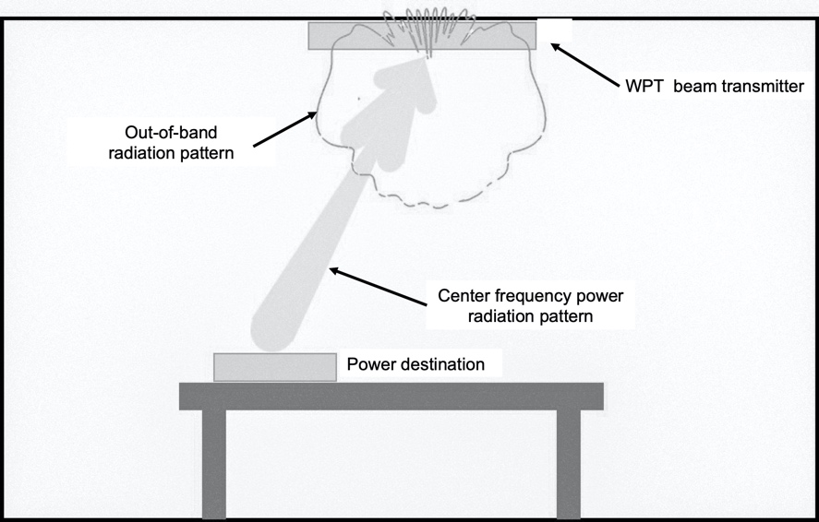

Table A2.1 gives the calculations to predict how much of this power reaches an EESS (passive) satellite of various types as shown in the right 2 columns under assumption that all transmitting units are indoors and are pointing downward. (The columns show the 2 worst results for satellite impact using satellite parameters from both the current version of RS.1861.

All power reaching the satellite must go through both a reflection in the room where the device is used as well as having attenuation through the building structure. In very high population density areas with multistory buildings this model is conservative in that it does not address the vertical loss a signal would have if it was several floors down from the building roof. Nor does if account for signal blockage from nearby buildings.

In both cases considered the maximum WPT beam transmitter density under the above assumptions that is consistent with the RS.2017 protection goals is shown to be in the order of 8000 units/sq. km. As mentioned above this would be larger in the case of multistory buildings by there is no generally accepted building attenuation for computing the increased attenuation at high elevation angles in that case.
Table A2.1
Power budget for WPT Beam impact on EESS (passive) satellites and transmitter spatial density likti for meeting RS.2017 protection goals

Parameter | RS.1861 (2010)  F4 (Nadir) Mechanical nadir scan | RS.1861 (2010)  F8 Conical scan
EESS Sensor Orbit Altitude (km) | 833 | 699.6
EESS Sensor Antenna Peak Gain (dBi) | 34.4 | 48.5
EESS antenna off-nadir angle (°) | 0 | 47.5
EESS sensor Ground Area Instantaneous Field of View (IFOV) (km2) | 1847.5 | 306.3
EESS Angle from ground towards Sensor (°) | 90.0 | 35.1
ISM out of band EIRP: The field strength levels of emissions which lie outside the 24 GHz band. Field strength limit (uV/m) FCC 18.305 Field Strength Limits | 25 | 25
ISM Distance of Field strength limit (m) | 300 | 300
ISM out of band EIRP: EIRP (dBm) out of band per 1 MHz = 10*log10(4*pi*E^2*distance^2 / 0.377). Also see NTIA Technical Memorandum TM-10-469 Eq-59 | -27.3 | -27.3
ISM out of band EIRP (dB(W/MHz)) | -57.3 | -57.3
Device loss due to indoor device signal reflection (dB) (Note that the device is ceiling mounted and points downward) Energy is absorbed by the device being charged. | 5 | 5
Device activity factor. All device are simultaneously Active hours in one day (hours) | 8 | 8
Device loss due to activity factor =10*log10(active hours / 24) active hours is 8 hours (dB) | -4.8 | -4.8
Percent simultaneously active devices during the active time (%) | 70 | 70
Loss factor due to random parts of activity in one day | -1.5 | -1.5
Factor for percent of open areas to the total area (%) | 10 | 10
Loss for percent of open areas to the total area (dB) | -0.46 | -0.46
Free Space Loss (dB) | 178.39 | 180.92
Gaseous Loss P.676 (dB) | 0.47 | 0.81
Antenna polarization mismatch loss (dB) | 3 | 3
Calculations
EESS received power level (ISM EIRP+EESS Ant GAIN-FSL-Gas-Pol) dB(W/MHz) | -204.73 | -193.50
EESS received power level (ISM EIRP+EESS Ant GAIN-FSL-Gas-Pol) dB(W/200MHz) | -181.72 | -170.49
EESS antenna Beam Shape Loss (Relative antenna Gain varies for where the devices are located in any place within the beam -3 dB Beamwidth) (dB) | 0 | 0
Clutter Loss at EESS for devices P.2108 (p=50%) | 0 | 3.6
Losses at EESS including: Energy Reflec+Activity+Simul Active+Open space+clutter | 11.78 | 15.38
EESS Margin Before building Loss (dB(W/200MHz) for a single device | 27.50 | 19.86
Number of devices in order to reach the EESS threshold before building penetration loss (assuming EESS antenna peak gain for all devices) | 563 | 97
Percent Traditional building (70% traditional and 30% thermally-efficient) https://docs.fcc.gov/public/attachments/FCC-20-51A1.pdf | 0.7 | 0.7
Percent Traditional building (70% traditional and 30% thermally-efficient) https://docs.fcc.gov/public/attachments/FCC-20-51A1.pdf | 0.3 | 0.3
P.2109 Traditional building Loss (dB) for P=1% | 10.6 | 3.8
P.2109 Traditional building Loss (dB) for P=20% | 28.3 | 16.9
P.2109 Traditional building Loss (dB) for P=50% | 38.7 | 27.1
P.2109 Traditional building Loss (dB) for P=80% | 48.9 | 37.2
P.2109 Traditional building Loss (dB) for P=99% | 67.9 | 56.2
P.2109 Traditional building loss whole CDF integrated from p=1% to p=99% | 26.5 | 16.8
P.2109 Thermally efficient building Loss (dB), P=1% | 16.5 | 10.2
P.2109 Thermally efficient building Loss (dB), P=20% | 43.5 | 32.1
P.2109 Thermally efficient building Loss (dB), P=50% | 59.4 | 47.8
P.2109 Thermally efficient building Loss (dB), P=80% | 74.7 | 63.1
P.2109 Thermally efficient building Loss (dB), P=99% | 103.6 | 91.9
P.2109 Thermally efficient building loss whole CDF integrated from p=1% to p=99% | 35.5 | 26.7
Number of Devices for Traditional buildings Before EESS threshold is exceeded
Number of devices, P.2109 Traditional buildings, P=1% | 6517 | 234
Number of devices, P.2109 Traditional buildings, P=20% | 379451 | 4728
Number of devices, P.2109 Traditional buildings, P=50% | 4208352 | 50025
Number of devices, P.2109 Traditional buildings, P=80% | 43265409 | 511363
Number of devices, P.2109 Traditional buildings, P=99% | 3443699335 | 40667745
Number of devices, P.2109 Traditional buildings. P.2109 whole CDF integrated from p=1% to p=99% | 251711 | 4628
Number of Devices for Thermally Efficient buildings before EESS threshold is exceeded
Number of devices, P.2109 Thermally efficient buildings, P=1% | 25372 | 1011
Number of devices, P.2109 Thermally efficient buildings, P=20% | 12698212 | 156120
Number of devices, P.2109 Thermally efficient buildings, P=50% | 489522019 | 5802562
Number of devices, P.2109 Thermally efficient buildings, P=80% | 16783092327 | 198267025
Number of devices, P.2109 Thermally efficient buildings, P=99% | 12821686803392 | 151413263123
Number of devices, P.2109 Thermally efficient buildings. P.2109 whole CDF integrated from p=1% to p=99% | 1995825 | 45534
Number of devices in mix traditional and thermally efficient buildings before EESS threshold is exceeded
Number of devices, P.2109 mix Building loss Traditional + Thermally Efficient, P=1% | 12173 | 467
Number of devices, P.2109 mix Building loss Traditional + Thermally Efficient, P=20% | 4075080 | 50146
Number of devices, P.2109 mix Building loss Traditional + Thermally Efficient, P=50% | 149802452 | 1775786
Number of devices, P.2109 mix Building loss Traditional + Thermally Efficient, P=80% | 5065213484 | 59838061
Number of devices, P.2109 mix Building loss Traditional + Thermally Efficient, P=99% | 3848916630552 | 45452446358
Number of devices, P.2109 mix Building loss Traditional + Thermally Efficient. P.2109 whole CDF integrated from p=1% to p=99% | 774945 | 16900

The FCC discussed potential rule changes in ET Docket No. 19-226 that could affect their regulation of beam or “at-a-distance” WPT, including the possibility of moving such devices out of Part 18 of FCC rules covering ISM equipment.”

