|  |  |
| --- | --- |
| **U.S. Radiocommunications Sector**  **Fact Sheet** | |
| **Working Party:** ITU-R WP-5B | **Document No:** USWP5B27-30-FS |
| **Ref:** Annex 33 to Document 5B/355-E | **Date:** 15 September 2021 |
| **Document Title:** WORKING DOCUMENT TOWARDS A HANDBOOK ON UNMANNED AIRCRAFT DETECT AND AVOID SYSTEMS [HDBK.UAS_DAA] - Guidance on suitable frequency bands and services to be used by airborne unmanned aircraft detect-and-avoid non-cooperative systems | |
| **Author(s)/Contributors(s):**  Don Nellis  Federal Aviation Administration  800 Independence Ave., S.W.  Washington, DC 20591  Mohammed Rahman  Federal Aviation Administration  800 Independence Ave., S.W.  Washington, DC 20591 | Phone: (202) 267-9779  e-mail: Donald.Nellis@faa.gov  Phone: (202) 267-6573  e-mail: Mohammed.Rahman@faa.gov |
| **Purpose/Objective:** The purpose of this contribution is to further developmental of the handbook that would provide information on appropriate frequency bands for Detect and Avoid (DAA) radar systems installed on unmanned aircraft or for ground DAA radar systems to support unmanned aircraft operations. | |
| **Abstract:** This contribution will continue the process of developing a handbook to supplement ITU-R Report M.2204-0 to identify the use of appropriate frequency bands for DAA radar systems on board aircraft and on the ground. This handbook will replace earlier effort of continue the process of drafting a new report for Detect and Avoid radar systems installed on unmanned aircraft and on the ground found in Annex 32 and 33 of the Chairman’s Report of the November 2020 WP-5B meeting. The initial efforts of developing these two documents explored various frequency bands to populate Section 5 (Spectrum analysis on suitability for detect and avoid system onboard unmanned aircraft) and the Summary Table in Section 6 are best suited for handbook. This new handbook will explore the list of frequency bands allocated to the Aeronautical Radionavigation and Radionavigation Services, which could be used for Detect and Avoid radar systems installed on unmanned aircraft and at the ground. The handbook will also provide information on other systems and services in these bands, coexistence issues, and an evaluation of the suitability of the band for UAS Detect and Avoid radar systems. This handbook will ultimately supplement Chapter 4, Spectrum considerations for UAS sense and avoid system of the Report ITU-R M.2204-0 (11/2010).  This contribution will be an update to the new report found in Annex 33 of the Chairman’s Report of the 15 June 2021 Document 5B/355-E meeting. | |

|  |  |
| --- | --- |
| **Radiocommunication Study Groups** |  |
|  |  |
|  |  |
| Source: Document 5B/TEMP/118  Subject: New Handbook on UA DAA Systems | **Annex 33 to Document 5B/355-E** |
| **15 June 2021** |
| **English only** |
| Annex 33 to the Working Group 5B Chairman’s Report | |
| WORKING DOCUMENT TOWARDS A HANDBOOK ON UNMANNED AIRCRAFT DETECT AND AVOID SYSTEMS [HDBK.UAS_DAA] | |
|  | |

(202X)

*[Editor’s note: The intent of establishing this new Handbook is to replace Working Document Towards a Preliminary Draft New Report ITU-R M.[UA_AIRBORNE_DAA] (Annex 32 to 5B/225) and Working Document Towards a Preliminary Draft New Report ITU-R M.[UA_GROUND_DAA] (Annex 33 to 5B/225). A framework for the Handbook is presented here that includes relevant UAS information provided by ICAO. Administrations are urged to bring contributions to the next meeting of WP-5B to continue the process of developing this Handbook.]*

**Foreword**

[TBD]

# TABLE OF CONTENTS

*Page*

# CHAPTER 1 - The Unmanned Aircraft

# 1.1 Unmanned Aircraft Systems

# 1.2 Terminology

# 1.3 Related ITU-R Recommendations and Reports

# CHAPTER 2 - Principles of Detect and Avoid

# 2.1 Detect and Avoid Systems

# 2.2 Applicability of detect and avoid to overall collision avoidance approach

# 2.2.1 Strategic conflict management

# 2.2.2 Remain well clear/separation provision

# 2.2.3 Collision avoidance

# 2.3 Aircraft-based detect and avoid

2.3.1 Encounter characteristics for aircraft-based detect and avoid

2.3.2 System latencies for aircraft-based detect and avoid

2.3.3 Detect and Avoid Systems

2.3.4 The detection range of an intruder

# 2.3.5 The accuracy of the intruder position

# 2.3.6 Other technical considerations for aircraft-based detect and avoid

# 2.4 Ground-based detect and avoid

# CHAPTER 3 - Spectrum Requirements

# 3.1 [TBD]

CHAPTER 1  
  
THE UNMANNED AIRCRAFT

## 1.1 Unmanned Aircraft Systems

Unmanned aircraft are powered aircraft that do not carry a human pilot, use aerodynamic forces to provide vehicle lift, and employ a remote pilot, fly semi-autonomously, or autonomously. The current state-of-the-art in unmanned aircraft system (UAS) design and operation has led to the rapid development of UAS applications to fill many diverse requirements. UAS applications include agricultural applications, communications relays, aerial photography, mapping, emergency management, scientific research, environmental monitoring, hurricane tracking, cloud seeding, volcano monitoring, forest fire suppression, emergency management, search and rescue operations, and law enforcement applications. The safe operation of UAS in civil airspace requires addressing the same issues as manned aircraft, namely integration into the air traffic control (ATC) system. Because the pilot is no longer onboard, a method of replacing the pilot’s responsibility to “see and avoid” other aircraft is required (see International Civil Aviation Organization’s (ICAO’s) Annex 2 “Rules of the Air”). While existing aircraft systems have been adapted or modified to accommodate detect and avoid (DAA) requirements for cooperative targets, new electronic technologies are needed to address the DAA requirements for non-cooperative targets.

## 1.2 Terminology

**Control and non-payload communications:** The radio links, used to exchange information between the unmanned aircraft (UA) and UACS, that ensure safe, reliable, and effective UA flight operation. The functions of command and non-payload communication (CNPC) can be related to different types of information such as: telecommand messages, non-payload telemetry data, support for navigation aids, air traffic control voice relay, air traffic services data relay, target track data, airborne weather radar downlink data, non-payload video downlink data.

**Detect and avoid:** The capability to see, sense or detect conflicting traffic or other hazards and take the appropriate action

**Intruder:** An aircraft (manned or unmanned) that enters the DAA surveillance volume and tracked by the DAA system.

**Unmanned aircraft:** Designates all types of aircraft remotely controlled.

**Unmanned aircraft control station:** Facilities from which a UA is controlled remotely.

**Unmanned aircraft systems**: Consists of the following subsystems:

– UA: (i.e. the aircraft itself);

– UACS;

– CNPC;

– ATC communications subsystem (not necessarily relayed through the UA);

– DAA;

– Payload subsystem (e.g. Video camera …).

**Separation Provision:** The tactical process of keeping aircraft away from hazards by at least the appropriate separation minima.

**Separation minima:** The minimum displacements between an aircraft and a hazard which maintain the risk of collision at an acceptable level of safety.

**Strategic Conflict Management:** Airspace organization and management, demand and capacity balancing and traffic synchronization components.

1.3 [TBD]

CHAPTER 2  
  
Principles of Detect and Avoid

## 2.1 Detect and avoid systems

The principle of a DAA system is that it fits into the total systems approach to collision avoidance. As shown in Figure 1, the approach to collision avoidance uses a layered approach. Current technologies that may accommodate these layers include ATC procedures, ground and surface ATC surveillance systems, automatic dependent surveillance-broadcast (ADS-B), airborne collision avoidance system also called traffic collision avoidance system (TCAS), and DAA.

Figure 1

Layered collision avoidance approach

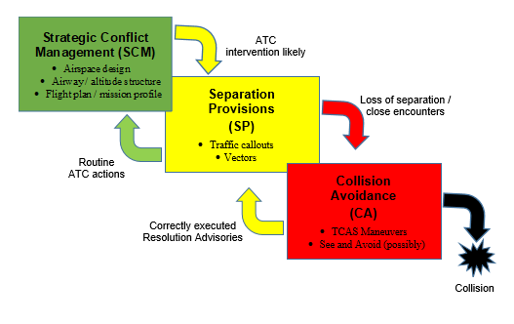

## 2.2 Applicability of detect and avoid to overall collision avoidance approach

An important point to consider in the design of a detect and avoid system is how it fits into the total systems approach to collision avoidance. Using the three layers approach described in ICAO Document 9854[1] (strategic conflict management, separation provision, and collision avoidance) for conflict management will limit, to an acceptable level, the risk of collision between aircraft and

hazards.. ICAO Doc 10019[2] specifically defines conflict management approach towards DAA. As shown in Figure 1, the DAA system provides the “remain well clear” function as the separation provision and “collision avoidance” function as the collision avoidance.

Figure 2

**Three layers of conflict management approach towards DAA**

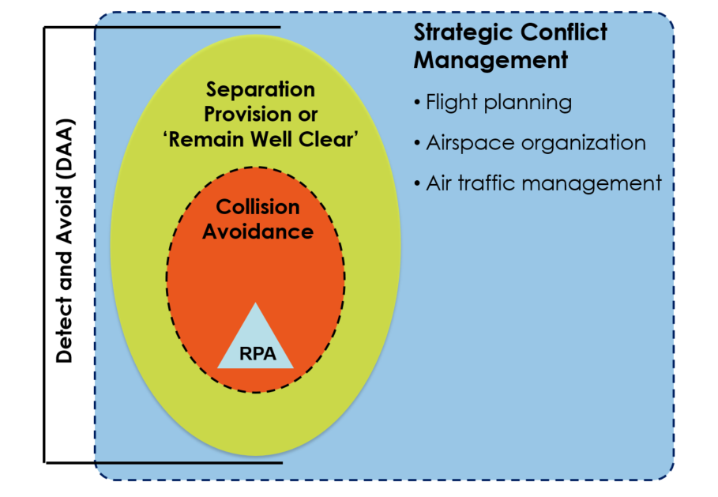

### 2.2.1 Strategic conflict management

Strategic conflict management includes pre-flight actions performed to minimize potential flight path conflicts with, and maximize separation from, intruders. Strategic conflict management also includes risk mitigation that is achieved through airspace organization and management, demand and capacity balancing, and traffic synchronization.

### 2.2.2 Remain well clear/separation provision

In this phase, actions are undertaken by all participants to ensure the safe execution of the flight depending on the airspace classification. Separation provisions by ATC and “remain-well-clear (RWC)” by pilots/remote pilots are utilized in this phase. At the remain well clear level of DAA, the system identifies the pilot to a potential violation of the DAA Remain Well Clear volume. Based on the information provided by the DAA system, the pilot identifies whether, and if so, what type of a manoeuvre is necessary to avoid the intruder, and then executes that manoeuvre. If operating under an ATC clearance, the UA Pilot coordinates with ATC to obtain an amended clearance before executing the manoeuvre.

### 2.2.3 Collision avoidance

Collision avoidance is the last layer to of conflict management and aims to prevent an intruder from penetrating the near mid-air collision (NMAC) volume. The airborne collision avoidance system is a system that is currently used to this effect on manned aircraft. As indicated in the figure above, DAA systems are expected to perform the collision avoidance function in addition to the “remain well clear function”.

## 2.3 Aircraft-based detect and avoid

There are factors that drive the performance requirements needed from an RF-based airborne DAA sensor as shown in Figure 2. The number of factors that drive the performance requirements for an airborne DAA sensor is large resulting in a very difficult multidimensional trade space containing both dependent variables and independent variables. These factors include characteristics of the encounter including NMAC volume, the latencies in the actual airborne DAA system implementation, and the performance parameters of the radar used as the airborne DAA sensor.

Figure 3

Detect and avoid sensor performance requirement factors

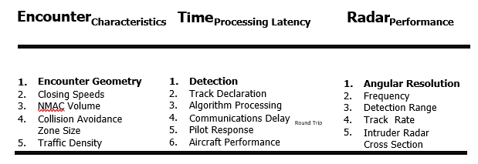

### 2.3.1 Encounter characteristics for aircraft-based detect and avoid

The first major factor driving the sensor performance requirements shown in Figure 3 is Encounter characteristics, which include collision course geometries, closing speeds between the UA and the intruder, the selected NMAC or remain well clear volume, collision avoidance zone size and overall aircraft traffic density. The second major class of factor driving the needed sensor performance includes the latencies in the system implementation. Specific latency drivers that need to be taken into account are minimum allowable detection/detection times, pilot response latencies, UA communications system latencies, airborne DAA sensor data processing delays and expected UA aero-performance characteristics. The last major factor driving airborne DAA sensor performance includes the characteristics of the radar such as angular accuracy, available power-aperture (i.e. detection range), radar cross-section of the intruder aircraft and track rate.

Closing speeds between the UA and an intruder and the NMAC or well clear volume, on the other hand, do have bearing on the necessary detection range needed to detect, track and perform a collision avoidance manoeuvre. Obviously, the faster the closing speed between the two aircraft, the longer the detection range from the radar that is needed. Additionally, larger NMAC or well clear volumes also increase detection range. Each plot in Figure 3 shows the distance between the UA and the intruder aircraft as a function of time before a manoeuvre is needed, and the time at which each curve is at a minimum is the point of closest approach assuming that the UA can perform a turn at a 15° bank angle. Using the minimum as a proxy for horizontal NMAC distance, one can see that a larger NMAC volume drives the system designer to needing a longer detection range.

Figure 4

Near mid-air collision size vs. time required to start avoidance manoeuvre

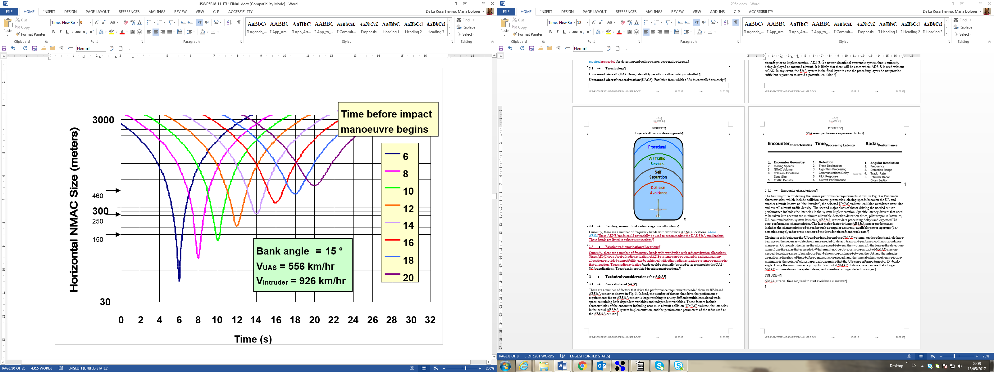

### 2.3.2 System latencies for aircraft-based detect and avoid

The DAA encounter timeline shown in Figure 4 defines the 8 major elements that need to be accounted for in an airborne DAA scenario. Again, as with the considerations associated with encounter geometries, system latencies ultimately drive the radar sensor detection range.

UA performance has a large impact on the system latencies. Obviously, a slower moving aircraft has more time to devote to detecting an intruder, but is often less manoeuvrable so it will probably have less ability to affect a collision avoidance manoeuvre in order to avoid a collision. On the other hand, UA that fly faster will have less time to devote to detecting an intruder, but these UA are often more manoeuvrable so they will probably have a greater ability to turn away from the collision.

Figure 5

Collision encounter timeline

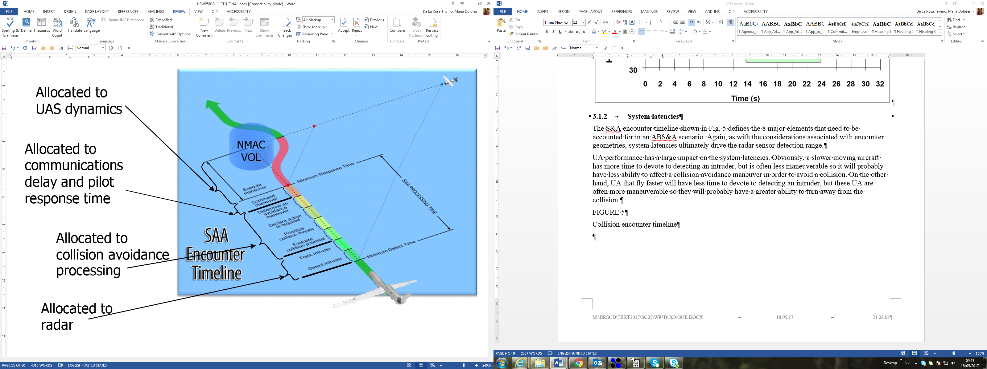

### 2.3.3 Radar performance considerations for aircraft-based detect and avoid

Lastly, specific requirements on the performance of the radar component of the DAA system will affect the radar design and performance and be a main driver in frequency band selection. In particular, size weight and power (SWAP) and the required accuracy of intruder position (as measured by angular and range resolution) will affect determination of a suitable frequency for an airborne radar sensor.

2.3.4 The detection range of an intruder

The detection range of an intruder is highly dependent on the transmit power-gain product of the radar. Transmit power is usually the highest power consuming element in the radar, which will affect power consumption directly and other SWAP elements indirectly. In order to constrain the radar transmit power and power consumption, lower frequencies are preferred for two factors:

– in general, lower frequencies have lower rain attenuation and atmospheric absorption factors as shown in Figure 5 below;

– higher efficiency amplifiers are more readily available at lower frequencies and hence same output power can be obtained at lower power consumption.

For antenna gain evaluation, higher frequencies will have higher antenna gain for same antenna size.

Figure 6

Plot of atmospheric absorption at microwave frequencies

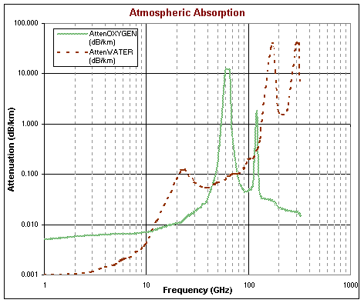

2.3.5 The accuracy of the intruder position

In order to estimate the intruder position, the radar measures the range, azimuth (bearing) and elevation angle of the intruder relative to the ownership UA.

The range resolution and accuracy is mainly dependent on the frequency bandwidth of the waveform and is usually sufficient to achieve required accuracy.

The radar usually relies on monopulse processing to improve angle accuracy. Typical accuracies are in the 1:10-1:20 of the 3 dB beamwidth of the antenna. For same antenna size, the beamwidth is reduced as the frequency is increased, and hence the accuracy is improved as the frequency is increased. Note that reducing the beamwidth may have the adverse effect of needing a longer frame time to cover all the required field of regard, hence these parameters are usually traded in a system optimization.

Thus, the proper selection of frequency is critical to the success of the airborne DAA radar. There is no optimum solution that fits all UAS classes, the solution will depend on the UAS class, and operational environment. As shown in Figure 6, the X band gives a compromise for trading all parameters. A lower band would have lower power consumption for same range requirement but may need a larger size antenna to achieve the required antenna gain and intruder position accuracy. Frequencies below C band are not expected to achieve required angle accuracy.

On the high frequency side, Ku band and higher can achieve required gain and position accuracy with smaller size but may need higher power to achieve required detection range.

Figure 7

Qualitative evaluation of parameters that affect choice of frequency band



### 2.3.6 Other technical considerations for aircraft-based detect and avoid

Another factor that must be taken into account in the determination of a suitable frequency for an airborne radar sensor is electromagnetic interference compatibility, both local compatibility on the UA, as well as compatibility with co-primary users of the spectrum. For example, if a UA is carrying another radar as part of its mission payload, one would prefer that the DAA sensor frequency be out-of-band from the mission payload radar in order to minimize interference between the two radars. In addition, the prevalence of other radars (e.g. weather radars) in a certain frequency band may impact the use of that frequency band for airborne DAA.

## 2.4 Ground-based detect and avoid

[TBD]

CHAPTER 3  
  
SPectrum Requirements

# 3.1 Spectrum analysis on suitability for detect and avoid system onboard unmanned aircraft

## 3.1.1 Criteria for suitability of spectrum for detect and avoid systems

1/ The spectrum analysis on suitability is limited to frequency band for which an allocation to radionavigation service or to aeronautical radionavigation service on a primary allocation.

[Editor’s note: Administrations are invited to provide rationale on the previous sentence.]

Worldwide allocation would be needed for certified UA but for open or some specific unmanned, regional allocation may be appropriate. The impact of regional harmonization compared to a global one will need to be addressed.

[Editor’s note: The consideration of regional allocation may be different is we dealing with airborne DAA or ground based DAA.]

2/ Frequencies below 500 MHz are considered not suitable for DAA onboard aircraft equipment neither those above [40] GHz considering the technology not mature enough at this stage.

[Editor’s note: Administrations are invited to provide rationale on the previous sentence. For high frequency band that 40 GHz, there are RNS and ARNS allocations that might be also studied depending also of the conclusion of WRC-19.]

3/ Coexistence with other incumbent services/existing applications

Some of the frequency bands currently allocated to the radionavigation service and/or the aeronautical radionavigation service may also be allocated to other services and used by other applications that would make difficult to use for DAA.

When a frequency band is allocated in the same band to one or more other services, co-existence has to be ensured taking into account priories identified in allocation footnotes and that article 4.10 applies for the radionavigation service.

Where no priority between co-primary users exists, 4.10 also does not provide priority, so deployment of detect and avoid systems requires further analyses to determine compatibility with other services prior to its operational deployment.

4/ Performance

[To be developed]

## 3.2 Suitability of frequency bands

[Editor's note: The following sections contain applicable provisions from the Radio Regulations, including allocations and relevant footnotes, and are provided as a baseline to facilitate the determination of the suitability of spectrum for DAA operations. The suitability of frequency bands will take into account co-existence with other services/systems operating in that band.]

# 3.3 Summary:

**Editor notes:** This is representative of potential band that would be good candidate people can comment on organization_

[Editor's note: The Summary section will identify the suitability of each band for DAA operations based on a review of the applicable provisions of the Radio Regulations as well as taking into account co-existence with other services/systems operating in each band.]

| Radionavigation  frequency band | Suitability for Airborne DAA | Suitability for Ground DAA | Reason |
| --- | --- | --- | --- |
| 960-1 215 MHz | This frequency band 960-1 215 MHz is not suitable for DAA systems onboard UA. | This frequency band 960-1 215 MHz is suitable for ground DAA systems. | [TBD] |
| 1 215-1 300 MHz | The frequency band 1 215-1 300 MHz is not suitable for DAA onboard UA due to the difficulty in coordinating with existing high powered ground based radars and the limited number of administrations where this band may be used. | The frequency band 1 215-1 300 MHz may be suitable for Ground DAA. | [TBD] |
| 1 300-1 350 MHz | [TBD] | [TBD] |  |
| 1 559-1 610 MHz | [TBD] | [TBD] |  |
| 1 610-1 626.5 MHz | [TBD] | [TBD] |  |
| 2 700-2 900 MHz | [TBD] | [TBD] |  |
| 2 900-3 100 MHz | [TBD] | [TBD] |  |
| 4 200-4 400 MHz | [TBD] | [TBD] |  |
| 5 000-5 250 MHz | [TBD] | [TBD] |  |
| 5 350-5 470 MHz | [TBD] | [TBD] |  |
| 8 750-8 850 MHz | [TBD] | [TBD] |  |
| 9 000-9 200 MHz | [TBD] | [TBD] |  |
| 9 300-9 500 MHz | [TBD] | [TBD] |  |
| 9 500-9 800 MHz | [TBD] | [TBD] |  |
| 13.25-13.4 GHz | [TBD] | [TBD] |  |
| 14-14.3 GHz | [TBD] | [TBD] |  |
| 15.4-15.7 GHz | [TBD] | [TBD] |  |
| 24.45-24.65 GHz | [TBD]  in Region 1 | [TBD] |  |
| [TBD]  in Region 2 | [TBD] |  |
| [TBD]  in Region 3 | [TBD] |  |
| 31.8-33.4 GHz | [TBD] | [TBD] |  |
| 43.5-47.0 GHz | [TBD] | [TBD] |  |
| 66.0-71.0 GHz | [TBD] | [TBD] |  |
| 95.0-100.0 GHz | [TBD] | [TBD] |  |
| 123.0-130.0 GHz | [TBD] | [TBD] |  |
| 191.8-200.0 GHz | [TBD] | [TBD] |  |
| 235.0-238.0 GHz | [TBD] | [TBD] |  |

### 4.0 ANNEX

This section contains applicable provisions from the Radio Regulations, including allocations and relevant footnotes, and are provided as a baseline to facilitate the determination of the suitability of spectrum for DAA operations. The suitability of frequency bands will take into account co-existence with other services/systems operating in that band.

### 4.1 Frequency band 960-1 215 MHz

#### 4.1.1 Allocations to operate detect and avoid and other services in the frequency band 960‑1 215 MHz

|  |  |  |
| --- | --- | --- |
| Allocation to services | | |
| Region 1 | Region 2 | Region 3 |
| 960-1 164 AERONAUTICAL MOBILE (R) 5.327A  AERONAUTICAL RADIONAVIGATION 5.328  5.328AA | | |
| 1 164-1 215 AERONAUTICAL RADIONAVIGATION 5.328  RADIONAVIGATION-SATELLITE (space-to-Earth) (space-to-space) 5.328B  5.328A | | |

**5.327A** The use of the frequency band 960-1 164 MHz by the aeronautical mobile (R) service is limited to systems that operate in accordance with recognized international aeronautical standards. Such use shall be in accordance with Resolution **417 (Rev.WRC-15)**. (WRC-15)

5.328 The use of the band 960-1 215 MHz by the aeronautical radionavigation service is reserved on a worldwide basis for the operation and development of airborne electronic aids to air navigation and any directly associated ground-based facilities.     (WRC-2000)

5.328AA The frequency band 1 087.7-1 092.3 MHz is also allocated to the aeronautical mobile-satellite (R) service (Earth‑to‑space) on a primary basis, limited to the space station reception of Automatic Dependent Surveillance-Broadcast (ADS‑B) emissions from aircraft transmitters that operate in accordance with recognized international aeronautical standards. Stations operating in the aeronautical mobile-satellite (R) service shall not claim protection from stations operating in the aeronautical radionavigation service. Resolution **425** **(WRC‑15)** shall apply.     (WRC‑15)

#### 4.1.2 Related ITU-R documents and aviation documents in the frequency band 960‑1 215 MHz

Recommendations ITU-R M.1318, ITU-R M.1787, ITU-R M.1901, ITU-R M.1904, ITU-R M.1905, and ITU-R M.2030 apply to the radionavigation-satellite service (RNSS) in the band 1 164-1 215 MHz. Resolution 417 (Rev.WRC-15) also contains provisions for the protection of RNSS in the 1 164-1 215 MHz band from AM(R)S airborne and ground-based stations in the frequency band 960-1 164 MHz.

### 4.2 Frequency band 1 215-1 300 MHz

#### 4.2.1 Allocations to operate detect and avoid and other services in the frequency band 1 215-1 300 MHz

|  |  |  |
| --- | --- | --- |
| Allocation to services | | |
| Region 1 | Region 2 | Region 3 |
| 1 215-1 240 EARTH EXPLORATION-SATELLITE (active)  RADIOLOCATION  RADIONAVIGATION-SATELLITE (space-to-Earth) (space-to-space) 5.328B 5.329 5.329A  SPACE RESEARCH (active)  5.330 5.331 5.332 | | |
| 1 240-1 300 EARTH EXPLORATION-SATELLITE (active)  RADIOLOCATION  RADIONAVIGATION-SATELLITE (space-to-Earth) (space-to-space) 5.328B 5.329 5.329A  SPACE RESEARCH (active)  Amateur  5.282 5.330 5.331 5.332 5.335 5.335A | | |

**5.329** Use of the radionavigation-satellite service in the band 1 215-1 300 MHz shall be subject to the condition that no harmful interference is caused to, and no protection is claimed from, the radionavigation service authorized under No. **5.331**. Furthermore, the use of the radionavigation-satellite service in the band 1 215-1 300 MHz shall be subject to the condition that no harmful interference is caused to the radiolocation service. No. **5.43** shall not apply in respect of the radiolocation service. Resolution **608 (WRC-03)\*** shall apply.     (WRC‑03)

**5.329A** Use of systems in the radionavigation-satellite service (space-to-space) operating in the bands 1 215-1 300 MHz and 1 559-1 610 MHz is not intended to provide safety service applications, and shall not impose any additional constraints on radionavigation-satellite service (space-to-Earth) systems or on other services operating in accordance with the Table of Frequency Allocations.     (WRC‑07)

**5.330** *Additional allocation:* in Angola, Saudi Arabia, Bahrain, Bangladesh, Cameroon, China, Djibouti, Egypt, the United Arab Emirates, Eritrea, Ethiopia, Guyana, India, Indonesia, Iran (Islamic Republic of), Iraq, Israel, Japan, Jordan, Kuwait, Nepal, Oman, Pakistan, the Philippines, Qatar, the Syrian Arab Republic, Somalia, Sudan, South Sudan, Chad, Togo and Yemen, the band 1 215-1 300 MHz is also allocated to the fixed and mobile services on a primary basis.     (WRC‑12)

**5.331** *Additional allocation:* in Algeria, Germany, Saudi Arabia, Australia, Austria, Bahrain, Belarus, Belgium, Benin, Bosnia and Herzegovina, Brazil, Burkina Faso, Burundi, Cameroon, China, Korea (Rep. of), Croatia, Denmark, Egypt, the United Arab Emirates, Estonia, the Russian Federation, Finland, France, Ghana, Greece, Guinea, Equatorial Guinea, Hungary, India, Indonesia, Iran (Islamic Republic of), Iraq, Ireland, Israel, Jordan, Kenya, Kuwait, The Former Yugoslav Republic of Macedonia, Lesotho, Latvia, Lebanon, Liechtenstein, Lithuania, Luxembourg, Madagascar, Mali, Mauritania, Montenegro, Nigeria, Norway, Oman, Pakistan, the Netherlands, Poland, Portugal, Qatar, the Syrian Arab Republic, Dem. People’s Rep. of Korea, Slovakia, the United Kingdom, Serbia, Slovenia, Somalia, Sudan, South Sudan, Sri Lanka, South Africa, Sweden, Switzerland, Thailand, Togo, Turkey, Venezuela and Viet Nam, the band 1 215-1 300 MHz is also allocated to the radionavigation service on a primary basis. In Canada and the United States, the band 1 240-1 300 MHz is also allocated to the radionavigation service, and use of the radionavigation service shall be limited to the aeronautical radionavigation service.     (WRC‑12)

**5.332** In the band 1 215**-**1 260 MHz, active spaceborne sensors in the Earth exploration-satellite and space research services shall not cause harmful interference to, claim protection from, or otherwise impose constraints on operation or development of the radiolocation service, the radionavigation-satellite service and other services allocated on a primary basis.     (WRC‑2000)

**5.335** In Canada and the United States in the band 1 240-1 300 MHz, active spaceborne sensors in the Earth exploration-satellite and space research services shall not cause interference to, claim protection from, or otherwise impose constraints on operation or development of the aeronautical radionavigation service.     (WRC‑97)

**5.335A** In the band 1 260-1 300 MHz, active spaceborne sensors in the Earth exploration-satellite and space research services shall not cause harmful interference to, claim protection from, or otherwise impose constraints on operation or development of the radiolocation service and other services allocated by footnotes on a primary basis.     (WRC‑2000)

#### 4.2.2 Related ITU-R documents and aviation documents in the frequency band 1 215-1 300 MHz

Recommendation ITU-R M.1463 contains characteristics and protection criteria for radar systems operating in the aeronautical radionavigation and radiolocation service in the band 1 215-1 300 MHz.

Recommendations ITU-R M.1318, ITU-R M.1787, ITU-R M.1901, ITU-R M.1902, ITU-R M.1904, and ITU-R M.2030 apply to the radionavigation-satellite services in the band 1 215-1 300 MHz.

Recommendations ITU-R RS.577, ITU-R RS.1166, and ITU-R RS.2105 apply to the Earth exploration-satellite (active) and space research (active) services in the bands 1 215-1 300 MHz.

Editor’s Note: More bands will be added as appropriate.

__________________

1.
2. *Global Air Traffic Management Operational Concept,* International Civil Aviation Organization Document 9854, First Edition, 2005 Manual on Remotely Piloted Aircraft Systems (RPAS), International Civil Aviation Organization (Doc 10019), 1st edition 2015,