US Radiocommunication Sector
FACT SHEET
Working Party: ITU-R WP 5B | Document No: USWP5B27-10
Reference: 5B/355 Annex 30 | Date: 19 October 2021
Document Title: Working document towards a preliminary draft new Report ITU-R M.[NON-SAFETY AMS CHARACTERISTICS AND SHARING STUDIES] related to agenda item 1.10
Author(s)/Contributor(s):  Andrew Meadows  Air Force  Dominic Nguyen  eSimplicity for AFSMO | Phone: 334-467-4720  E-mail: andrew.meadows.1@us.af.mil  Phone: 703-606-7394  E-mail: dominic.nguyen@esimplicity.com
Purpose/Objective: The purpose of this document is to initiate the sharing studies between non-safety aeronautical mobile service (AMS) and Radiolocation service in support of WRC-23 AI 1.10.

Abstract: WRC-19 approved AI 1.10 for the WRC-23 study cycle to consider a possible introduction of new non-safety AMS applications in the 15.4-15.7 GHz band. During the May 2021 meeting, a working document was developed on parameters of the non-safety AMS to be used in sharing and compatibility studies. Additional parameters may be necessary to conduct the sharing and compatibility studies between non-safety AMS and the incumbents. This contribution comments on those additional parameters and initiate the sharing studies between non-safety AMS and Radiolocation service.

Fact Sheet Preparer: Dominic Nguyen

Radiocommunication Study Groups | 
Source: Document 5B/355 Annex 30  Subject: WRC-23 agenda item 1.10 sharing study | Document 5B/XX
 | XX November 2021
 | English only
United States of America
Technical characteristics, operational scenarios, spectrum needs, coexistence, and sharing studies of non-safety aeronautical mobile systems in the frequency bands 15.4-15.7 GHz and 22-22.21 GHz

1 Introduction

The United States of America would like to propose an initial sharing study between non-safety AMS and Radiolocation in the frequency band 15.4-15.7 GHz.

Attachment revisions are presented for consideration.

ATTACHMENT
Working document towards a preliminary draft new
report ITU-R [NON-SAFETY AMS characteristics and SHARIng studies] RELATED TO AGENDA ITEM 1.10
Technical characteristics, operational scenarios, spectrum needs, coexistence, and sharing studies of non-safety aeronautical mobile systems in the
frequency bands 15.4-15.7 GHz and 22-22.21 GHz
Keywords
TBD
Glossary/Abbreviations
ADT: Airborne data terminal
ALS: Aircraft landing system
ATPC: Automatic transmit power control
AMS: Aeronautical mobile service
BER: Bit error rate
CDMA: Code division multiple access
C/N: Carrier to noise
DA2GC: Direct air to ground connectivity
EESS: Earth exploration satellite service
GDT: Ground data terminal
IFBC: In-flight broadband connectivity
IR: Infrared
LIDAR: Light detection and ranging
LoS: Line-of-sight
OOB: Out-of-band
OTR: On-tune rejection
RF: Radio frequency
RR: Radio Regulations
SAR: Synthetic aperture radar
SRS: Space research service
WB LoS DL Wideband line of sight datalink

1 Relevant ITU-R Recommendations and Reports
Recommendations
ITU-R F.637-4 Radio-frequency channel arrangements for fixed wireless systems operating in the 21.2-23.6 GHz band
ITU-R F.758-7 System parameters and considerations in the development of criteria for sharing or compatibility between digital fixed wireless systems in the fixed service and systems in other services and other sources of interference
ITU-R P.699-8 Reference radiation patterns for fixed wireless system antennas for use in coordination studies and interference assessment in the frequency range from 100 MHz to 86 GHz
ITU-R F.758-7 System parameters and considerations in the development of criteria for sharing or compatibility between digital fixed wireless systems in the fixed service and systems in other services and other sources of interference
ITU-R F.1336-5 Reference radiation patterns of omnidirectional, sectoral and other antennas for the fixed and mobile service for use in sharing studies in the frequency range from 400 MHz to about 70 GHz
ITU-R M.1825-0 Guidance on technical parameters and methodologies for sharing studies related to systems in the land mobile service
ITU-R M.1851-1 Mathematical models for radiodetermination radar systems antenna patterns for use in interference analyses
ITU-R P.528-4 A propagation prediction method for aeronautical mobile and radionavigation services using the VHF, UHF and SHF bands
ITU-R P.619-4 Propagation data required for the evaluation of interference between stations in space and those on the surface of the Earth
ITU-R RA.769-2 Protection criteria used for radio astronomical measurements
ITU-R RS.1861-0 Typical technical and operational characteristics of Earth exploration-satellite service (passive) systems using allocations between 1.4 and 275 GHz
ITU-R RS.2017-0 Performance and interference criteria for satellite passive remote sensing
ITU-R S.1340-0 Sharing between feeder links for the mobile-satellite service and the aeronautical radionavigation service in the Earth-to-space direction in the band 15.4-15.7 GHz
ITU-R SM.337-6 Frequency and distance separations
ITU-R SM.1541-6 Unwanted emissions in the out-of-band domain
Report
ITU-R M.2170 Compatibility analysis and results for radiolocation systems planned to operate in the 15.4 to 17.3 GHz band and aircraft landing system operating in the 15.4-15.7 GHz band as well as the radio astronomy service operating in the adjacent band 15.35-15.40 GHz, FSS systems and aeronautical radionavigation systems

2 Introduction
WRC-19 approved WRC-23 agenda item 1.10 “to conduct studies on spectrum needs, coexistence with radio communication services and regulatory measures for possible new allocations for the aeronautical mobile service for the use of non-safety aeronautical mobile applications, in accordance with Resolution 430 (WRC-19)”.
Resolution 430 (WRC-19) invites inter alia to conduct sharing and compatibility studies on possible new primary allocations to the aeronautical mobile service for non-safety aeronautical applications in the frequency bands 15.4-15.7 GHz and 22-22.21 GHz, while ensuring the protection of primary services and, as appropriate, adjacent services.
This Report introduces the technical and operational characteristics, typical scenarios and associated spectrum needs of non-safety aeronautical mobile systems in the frequency bands 15.4-15.7 GHz and 22-22.21 GHz to support WRC-23 agenda item 1.10 in accordance with Resolution 430 (WRC-19).
The Report further contains sharing and compatibility studies between the aeronautical mobile service (AMS) and other systems in the frequency ranges 15.4-15.7 GHz 22-22.21 GHz.

3 Wideband line of sight datalinks operating in the aeronautical mobile service

3.1 Definition
According to RR No. 1.32, the AMS is a radiocommunication service between an aircraft station and an aeronautical station, or between two aircraft stations. The aircraft station can be an airplane or a rotorcraft, which can be unmanned for instance when flying conditions are deemed too hazardous for safely operating a manned platform.
Wideband line-of-sight data links (WB LoS DLs) represent a particular use case of the AMS, and are defined by two essential features:
– Stations that communicate must have LoS visibility as transmission beyond the horizon is not practicable. This is mainly due to the fact that WB LoS DLs often operate in higher frequency bands where LoS is the only transmission mode
– Channels of several tens of MHz may be used, to potentially transport significant amount of data.
In the context of WB LOS DLs, aircraft stations are referred to as airborne data terminals (ADTs) and aeronautical stations as ground data terminals (GDTs). GDT may be installed at a permanent location or they can be transportable, and in that case they are referred to as portable GDT.

3.2 Typical applications
WB LoS DLs are especially useful to transmit data captured by sensors installed on-board a flying platform. In some cases, state of the art sensors could be used. Some examples of typical sensors are listed below:
– High-definition optical cameras that are used for observations by day, whenever and wherever weather and atmospheric conditions permit it.
– Infrared (IR) cameras are used principally for observations by night, or to locate hot spots on the ground that could be wildfires or human bodies in the snow after an avalanche.
– Humidity or pressure sensors that are used in meteorological or Earth exploration missions.
– Synthetic aperture radars (SAR) that are used to produce high definition images of the ground surface, independently of the weather and daylight conditions.
– Light detection and ranging (LIDAR) that can also produce high definition images of the ground. Contrary to SAR, LIDAR make use of laser light to evaluate distances.
Typical (uncompressed) data rates produced by these sensors are provided in Table 1 below.
In that regard, WB LoS DLs can be used as technical solution to transport data in different contexts such as:
– Imagery: video or image recording performed from a manned or unmanned aircraft in a context of terrain mapping and topographical surveys in Earth exploration missions.
– Communication: voice or data exchange between two ADTs or between an ADT and a GDT; Data dissemination between several aircraft in some search and rescue operations.
– Surveillance: Border surveillance; Law enforcement; Land management; Surveillance of strategic facilities; Pipeline monitoring.
– Search and rescue missions: live data collection and exchange between flying platforms taking part in search and rescue operations.
WB LoS DLs are mostly found in professional and governmental missions, which are very limited in time (mission duration rarely exceeds a few hours because of platform autonomy) and space (not more than a few platforms are used to complete the mission).
TABLE 1
Typical user data rate of typical sensors installed on-board flying platforms
Sensor | User data rate (uncompressed) | Comments
High-definition optical camera | 5 Mbps | See note 1
Infrared camera | 5 Mbps | See note 2
Synthetic Aperture Radar | 30 Mbps | See note 3
Light detection and ranging | 30 Mbps | See note 4
Humidity/pressure sensors | A few kbps | See note 5

Note 1: The output data rate of an optical camera depends on the required image resolution, the codec used to compress data, etc. In a typical setup, the camera produces 1920x1080 pixels images at a repetition rate of 24 frames per second, using a colour depth of 8 bits, a motion index of 2 (medium speed motion) and the H.264 codec, which totals an output data rate of 5 Mbps.
Note 2: Assumed to be the same as for an optical camera.
Note 3: This corresponds to the nominal output data rate of a SAR in a typical setup.
Note 4: Assumed to be the same as for a SAR.
Note 5: very limited amount of data are produced by this kind of sensor.

3.3 Multiplexing techniques
WB LoS DLs must achieve efficient use of the spectrum and hence have limited bandwidth to operate. This is the reason why, when used to create RF communication networks, WB LoS DLs are subject to self-interference effects, which occur when multiple links within a limited geographical area operate on the same frequency without proper mitigation techniques.
In some contexts like Wi-Fi, the problem can be solved by defining a central node (often referred to as “master”) that dynamically coordinates and assigns channels to the other nodes within the network. However, WB LoS DLs must be established on a quicker and more flexible manner, which is why other alternatives must be considered, like for instance:
– Frequency division multiple access. The available spectrum is divided into multiple communication channels and two links in close proximity never operate on the same channel. This can be achieved using a carrier sensing algorithm. The principle is that nodes sense all channels for idle or busy to find the most suitable from the interference perspective.
– Code division multiple access. Before transmission, signals are multiplied with a code. All communication links can be established on the same channel and signals are separated during the de-modulation process at the receiver.
Furthermore, in the case where WB LoS DLs are bi-directional, and the two directions of communication could be separated in the frequency domain using frequency division duplex, or in the time domain using time division duplex, in which case the link only allows half-duplex communication.

3.4 Configuration of the sensors
WB LoS DLs are most of the time unidirectional to transmit the data collected by the sensors. Return links may nonetheless be implemented for the configuration of the platform sensors or to convey feedback or synchronization information. However, in some cases, these return links could also use other frequency bands that are out of scope of this document.

3.5 Frequency planning
Due to the fact that WB LoS DLs of the AMS are often operated within the same geographical area (or even on-board the same platform or installation) as several other aeronautical systems, frequency planning is recommended as already used in many frequency bands. This frequency planning could be set dynamically during the AMS operation.

3.6 Antennas
WB LoS DLs must overcome distances that can on some occasions reach several hundreds of kilometres and often have to be operated in higher frequency bands, which in turn can significantly contribute to degrading link performance.
To address these challenges, ADTs and GDTs could in some scenarios be equipped with directional antennas instead of omnidirectional antennas. The most immediate advantage is the improvement of the link budget when sending and receiving antennas are closely aligned. As side benefit, directional antennas can also improve coexistence or sharing with other systems because emissions outside of the maim beam can be kept to an acceptable level.
ADTs are often operated as communication nodes within a network composed of a high number of participants that can move very quickly between different locations. In that case, directional antennas at the sending and at the receiving stations must as well be coupled with a tracking system to steer the antenna in the right direction.
In that regard, directional antennas may provide an electronical steering capability which allows an agile tracking of all networking nodes. A fast beam steering capability improves also the overall network throughput efficiency which helps to minimize the required bandwidth of particular point-to-point connections.

3.7 Spectrum efficiency
The flow chart in Figure 1 below shows the different steps the data produced by the sensors goes through:
– The data generated by the sensors is bundled into a single flow whose data rate is denoted by DR (expressed in bps).
– This single data flow is sequentially processed through the different communication layers which add some overhead to the user’s data. This overhead may comprise coding factors, error correction codes, framing, access scheme information, metadata, and so on. This can be accounted for by a factor O that typically ranges from 2 to 4 that multiplies the user’s data rate DR. At the physical layer, the bit flow is therefore DR*O (expressed in bps).
– The bit flow DR*O (expressed in bps) is then multiplied by a carrier signal to obtain an RF signal that has a bandwidth B (expressed in Hz). B can be computed as the reverse of the symbol time, which in turn is related to the number of modulation states.
– As explained in Section 6.3 of this report, spreading techniques like Direct Spread Spectrum (DSSS) may be used as an additional stage to spread the signal over a much higher bandwidth and improve robustness, in particular when interfered with narrowband signals. This is characterized by a spreading factor SF that multiplies the bandwidth B. The total resulting bandwidth is therefore B*SF (expressed in Hz).
FIGURE 1

Flow chart of the transmission chain
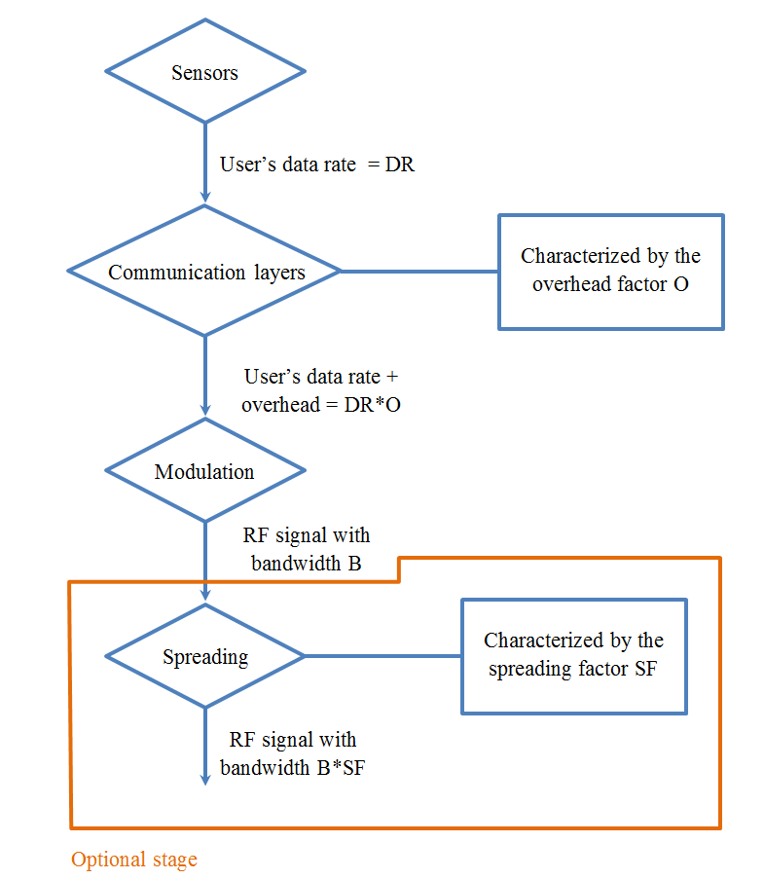
Two characteristics of the transmission chain can be defined:
– The user’s spectrum efficiency, which is defined as the ratio between the user’s data rate, and the bandwidth of the RF signal fed to the antenna, i.e. $\frac{DR}{B}$ if no spreading technique is used, and $\frac{DR}{B*SF}$ otherwise.
– The modulation spectrum efficiency, which is defined as the ratio between the overall data rate that has to be transmitted and the bandwidth of the RF signal fed to the antenna, i.e. $\frac{DR*O}{B}$ if no spreading is used, and $\frac{DR*O}{B*SF}$ otherwise.
A typical value from 1 to 2 bps/Hz can be assumed for the modulation’s spectrum efficiency, which corresponds to robust modulation schemes. This is because WB LoS DLs have in some cases to cover distances of several hundreds of kilometers, which may cause significant power attenuation and therefore a lower signal to noise ratio. Moreover, Doppler shift effects pose some challenges when the ADT is installed on-board high-speed aircraft. Divided by the overhead factor O that lies between 2 and 4, this leads to a typical user’s spectrum efficiency of 0.25 to 1 bps/Hz.

3.8 Transmission modes
WB LoS DLs can operate in a point-to-point mode, where one terminal communicates with a single other terminal, or in a point to multipoint mode, where one terminal disseminates data among a number of terminals. In both cases, at least one node is equipped with a directional antenna.

4 Operational scenarios

4.1 Introduction
Building upon potential applications for WB LoS DLs presented in Section 6.2, Figure 2 below provides an overview of typical operational scenarios.
FIGURE 2

Typical scenarios involving wideband line of sight datalinks
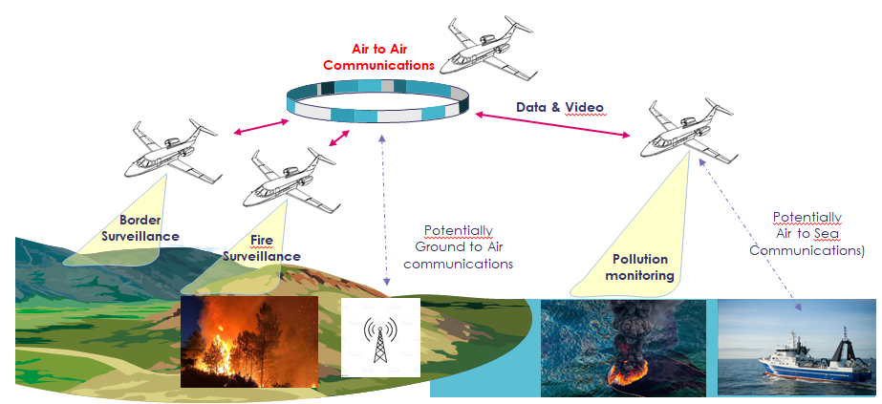
This chapter aims at selecting and extensively describing four typical scenarios that were deemed representative of the WB LoS DLs usages in the frequency bands 15.4-15.7 GHz and 22-22.21 GHz. Each scenario includes a brief description of the mission, the type of ADTs and GDTs involved, alongside with their geographical position (in particular the flying altitude of the ADTs), the types of sensors, and the corresponding data rate. Furthermore, the equipment used in each scenario is linked to the systems presented in Table 1.

[4.2 Wildfire observation
[Editor’s note: comments were raised on the mission, purpose, scope, responsibility, authorisation and verification]
Global effects of climatic change have made natural disasters more frequent and difficult to predict. In particular, wildfires often occur in remote areas like natural reserves and have led over the recent years to dramatic destructions of the environment. Such consequences could in many cases be avoided if wildfires would be detected and fought in time.
In that regard, large forestry areas could be monitored from the sky using small unmanned aircraft equipped with both a visual camera to observe smoke columns together with a thermal sensor that could easily detect hot spots inside the vegetation which could indicate a fire outbreak.
More than just a preventive measure, forest observation using aircraft could also be used to improve situational awareness of emergency responders taking part in rescue or evacuation operations in the case where the fire has already spread over large areas. In that case, the data acquired from the aircraft would allow for predicting in the short term how the wildfire is likely to behave, and in particular in which direction it will spread.
The operational scenario shown in Figure 3 below describes a typical setup for such an observation mission. A fire truck is sent to a forest zone where the risk of a wildfire is exceptionally high, due to special atmospheric conditions like drought and searing heat. This zone has quite a large radius of 10 km, which makes it difficult for the vehicle to cover all the area, even more if dense vegetation is present.
To counter this, ten small aircraft equipped with thermal and visual optical cameras are used to monitor this area. To be able to detect heat abnormalities with the best precision, these aircraft fly at not more than 100 m altitude. Each individual aircraft is able to observe a square of about 500 meters.
Aircraft fly in 10 concentric circles (with one aircraft per circle) around the fire truck. The first circle has 1 km radius, the second 2 km, up to the last circle which has 10 km radius. In this way, a 10 km radius zone can be closely watched, which is deemed sufficient, bearing in mind that the most serious wildfires recorded up to date happened within a radius of about this magnitude.
Aircraft have a speed of flight of about 100 km/h, and therefore images can be obtained with a refresh rate of about 7 mins in the centre of the observation area, where the fire is the most likely to outbreak, and about 38 mins on the outer circle where the risk is lowest.

FIGURE 3

Typical scenario of a wildfire observation mission
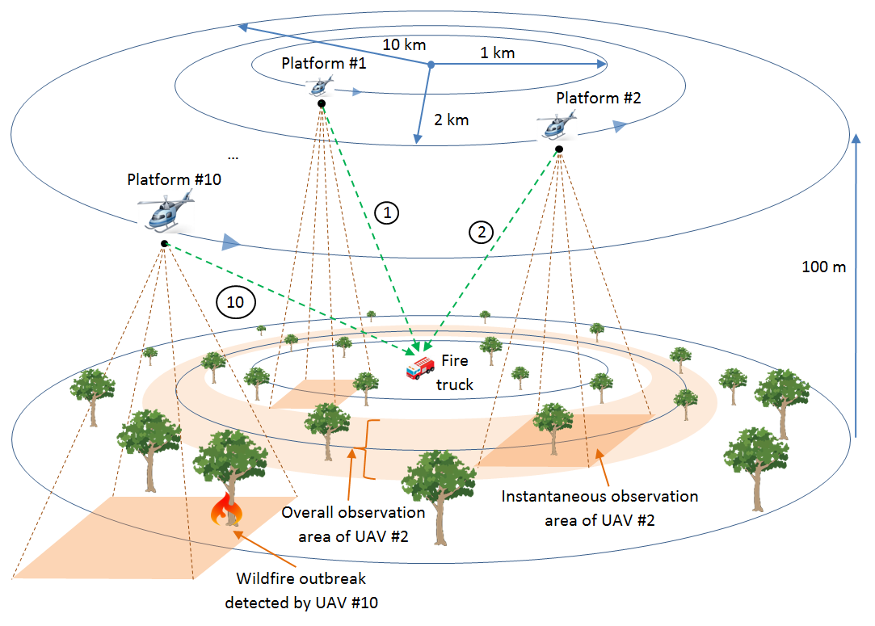
The antenna mounted on the fire truck should be able to communicate simultaneously with all ten aircraft and therefore it should have an omnidirectional radiation pattern coupled with some elevation properties. A half-wave dipole over a conducting plane (the roof of the vehicle itself) can provide such a radiation pattern. Aircraft on their side are equipped with omnidirectional antennas that only radiate below the horizon. Monopoles could be used for example.
The data recorded by the aircraft is simultaneously sent to the fire truck in real-time on different communication channels separated in frequency. These 10 communication links are tagged 1 to 10 in Figure 3. The sensors on-board the aircraft are remotely controlled from the fire truck using return links that are however not considered in the context of A.I. 1.10. Aircraft can further synchronize and share metadata information among them to improve the mission efficiency, but the necessary links are also not considered here.
The fire truck uses System 4 and each of the aircraft use System 2. ]

4.3 Search and Rescue
The scenario depicted in this section takes place in the context of a search and rescue mission. The goal is to locate a crash zone in a remote area partially or fully covered with dense vegetation. To that purpose, seven small aircraft are used to observe the area and locate the crash zone. These aircraft are equipped with SAR and would use those sensors instead of optical cameras for various reasons:
– The vegetation is so dense that an optical camera would probably miss the crash zone that could be hidden by foliage. If the right frequency band is chosen, SAR radio waves can penetrate the foliage and produce images of the ground. Post-processing interferometry algorithms can then locate the crash zone using surface deformations as evidences.
– The search work may need to begin by night with severe weather conditions. Therefore, SARs are preferred for this mission because of their all-weather, day and night imaging capability.
– Modern SARs have attained a technological maturity that enable decametric resolution, which makes them excellent tools for accurate spotting of and identifying objects on the ground.
The seven aircraft involved in this mission (tagged 1 to 7) fly in a formation depicted in Figure 4 below. They have a cruise altitude of 3,600 m. At this elevation, the ground coverage of their SAR has an individual width estimated at about 4 km. In order to maximize the overall observation capability of the formation, the separation distance between two adjacent aircraft alongside the x-axis is maintained at approximately 4 kilometres. However, to increase separation distances, aircraft 1, 3, 5 and 7 are laterally offset by a few kilometres.
The SAR data collected by the individual aircraft involved in this mission cannot be exploited to locate the crash zone without intermediate post-processing:
– Images may be degraded due to turbulence experienced at such low flying altitudes, and some post-processing correction algorithms need to be applied.
– Interferometry algorithms must be applied to the SAR images in order to discover evidence of a potential crash zone.
Such signal processing techniques require significant computational effort and dedicated hardware resources, as well as potential integration of data from multiple aircraft. For this reason, they cannot be performed on-board each aircraft involved in this mission. One solution would be to record and store SAR images for later post-processing in ground facilities. However, this would dramatically affect the reactivity, the flexibility, and the duration of the mission and potentially reduce the chances of rescuing victims of the crash in time. On the other side, direct sending of the SAR data to a ground station is not practically feasible given how geographically remote the search area is.
To offset this problem, six aircraft of the formation transmit their SAR data to a central aircraft (tagged 4 in Figure 4) that is equipped with the necessary hardware to analyse the SAR images in real time and hence identify the crash zone. Six unidirectional links must therefore be established (tagged 1 to 6 in Figure 4), each having an individual capacity of 30 Mbps. To avoid interference between the various signals at the central aircraft, the links are separated in frequency, and therefore use different channels. To receive signals originating from all six aircraft at the same time, aircraft 4 is equipped with an omnidirectional antenna, whilst other aircraft have a high-directivity antenna pointed all the time in the direction of aircraft 4 thanks to a tracking system.
Aircraft 4 is equipped with System 2, whilst all other aircraft are equipped with System 1.

FIGURE 4

Typical scenario of a search and rescue mission
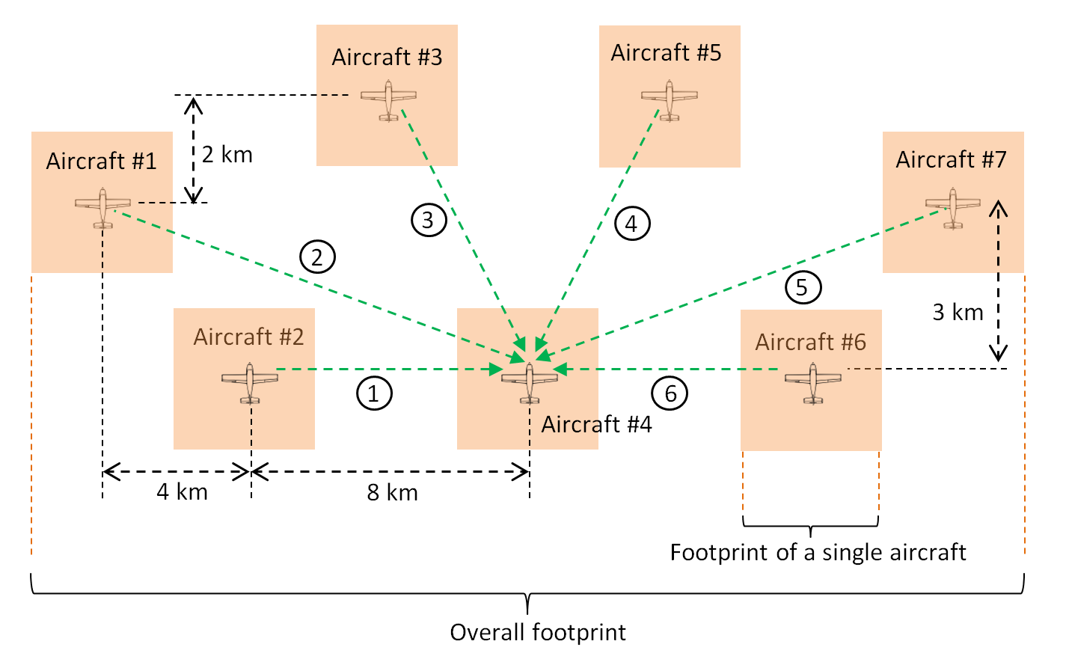

4.4 Surveillance mission
Surveillance of remote areas from the sky can prove especially useful in different contexts like law enforcement, border control, or facility monitoring. As compared to on-site surveillance, this can indeed result in substantial savings of time and money, as well as be the only practical means in certain relatively inaccessible areas.
Figure 5 below describes a typical scenario of such a surveillance mission, in which a wide and remote area must be observed from a mission centre located 300 kilometres away. To that purpose, two special surveillance aircraft (tagged 1 and 2 in Figure 5) equipped with high-definition optical cameras and infrared sensors are used. The data obtained from this observation mission is ultimately gathered, synchronized and post-processed at the mission centre. Therefore, a communication link between the two observation aircraft and the mission centre is essential.
However, the two observation aircraft have to fly at a relatively low altitude of 3,000 m above ground level in order to ensure an acceptable data quality. At such low altitudes, LOS communication with the mission centre is not feasible, as the radio horizon is not more than 200 km. Therefore, the data is first sent to a relay aircraft that flies just above the observation aircraft at an altitude of 7,000 m (using links 1 and 2) and transmitted in a second step (using link 3) to the mission centre.
The observation aircraft are equipped with an omnidirectional antenna to communicate with the relay. The relay aircraft may be equipped with an electronically steerable antenna which provides sufficiently high gain for long communication ranges (for instance to reach the mission centre). An electronically steered antenna will also provide the agility to communicate with several observation aircraft in a quasi-continuous way. Overall, this will allow establishing an airborne network with multiple participants. The mission centre may also be equipped with an electronically steerable antenna that would also allow tracking of several relay aircraft simultaneously.
The two observation aircraft use System 2, the relay aircraft uses System 1, and the mission centre uses System 3.
FIGURE 5
Typical scenario of a surveillance mission
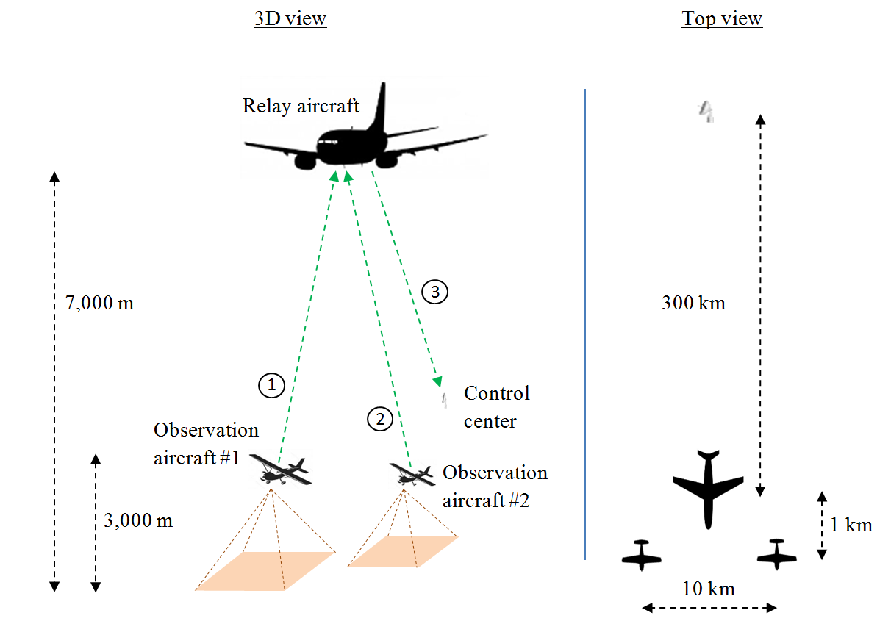

[4.5 Internet above the clouds
Airlines are constantly striving to improve passengers’ experience. This includes for example broadband connectivity services during all phases of flight. This concept is commonly referred to as “Internet above the clouds” or in-flight broadband connectivity (IFBC) and has now become a major driver of competition between airlines.
IFBC can be provided using direct air to ground solutions (DA2GC), where aircraft are connected to a network of base stations deployed on the ground. Currently available commercial solutions offer upstream and downstream throughputs per aircraft of about 20 and 100 Mbps, respectively. However, the absence of connectivity over remote airspace and oceanic regions represents the major limitation of DA2GC, although base stations may in some cases also be installed on islands and petroleum platforms to alleviate the problem.
Over remote areas where no base stations are in sight, a satellite connection may also take over as backup solution. This option which is referred to as satellite air to ground connectivity is nonetheless associated with some major disadvantages that prevent its general use among airlines. For example, costs are rather high compared to DA2GC, the available throughput is limited and latency periods of several hundreds of milliseconds make certain delay-sensitive applications like video streaming or Voice over IP impracticable.
Another alternative would be to extend the coverage of the ground network over oceanic regions. This can be realised through air-to-air links to create multi-hop ad-hoc networks. Some aircraft flying over the mainland or close to the coast side serve as gateways for other aircraft that are out of range of the ground network. Further, every aircraft relays data to the next aircraft. This solution is independent of any satellite links and can therefore achieve good latency performance. In addition, it goes hand in hand with substantial cost savings for the airlines, as no additional infrastructure installation is required. Finally, this technical solution may also be used for other purposes than IFBC. For instance, aircraft could transmit reports on fuel consumption and engine performance to the airlines in real time.
The concept is illustrated on the basis of the typical scenario shown in Figure 6 below. This scenario considers a chain of five aircraft flying at a cruising altitude of about 10,000 m above sea level with 500 km horizontal separation with one another. Aircraft 1 is connected to the ground network using links 1 and 2 which are established using a DA2GC service and hence out of the scope of this report. This aircraft serves as a gateway for aircraft 2 to 5. Aircraft 2 serves as a relay for aircraft 3 to 5, etc.
To meet performance requirements, each aircraft of the chain should have 100 Mbps downstream and 20 Mbps upstream. The dimensioning WB LOS DLS for this scenario are then links 3 and 10 that must support the overall downstream and upstream traffic of the chain of aircraft. Link 3 should therefore have a capacity of 400 Mbps, and link 10, 80 Mbps.
To overcome large separation distances, enable a potential reconfiguration of the network at any time, and keep interference effects at an acceptable level between different links of the network, antenna arrays with high directivity are used on-board each aircraft, i.e. System 1 or System 3.
The distance between the base station on the mainland and the aircraft #1 is between 10 and 300 km.
FIGURE 6

Typical scenario of in-flight broadband connectivity
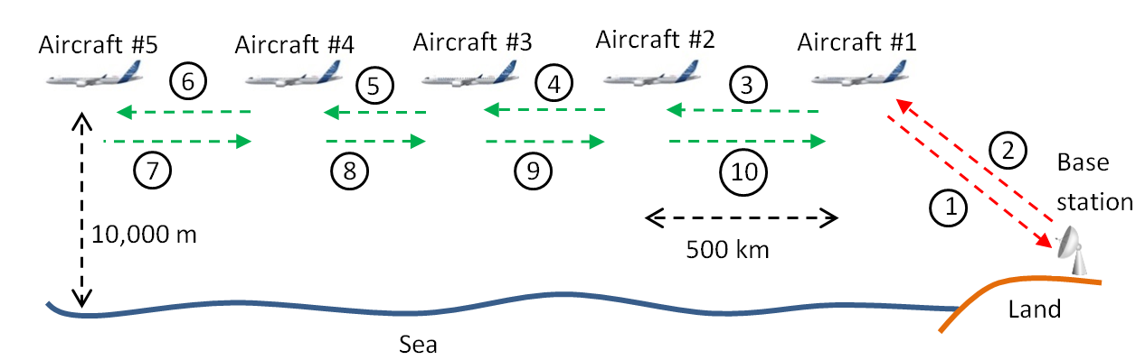
[Editor’s note: the legend of Figure 6 should indicate that red arrows are not covered by non-safety AMS, and therefore out of the scope of this report.]

4.6 Deployment density for non-safety aeronautical mobile service
TBD
[Editor’s note: This section will provide the deployment density of the non-safety AMS to be used for sharing studies. Each scenario will be associated a density of flying platforms to be considered in sharing and coexistence studies. This section is expected to be completed by WP 5B in November 2021]

5 Spectrum requirements
Table 2 below summarizes the spectrum resource which is needed to implement the operational scenarios described in Section 6.2, 6.3, 6.4 and 6.5 of this report. Note that only wideband communication is taken into account. Narrowband transmissions for the command of the sensors and platform synchronization are not accounted for in the assessment of the spectrum needs.
TABLE 2
Spectrum needs associated to the operational scenarios
Scenario | Scenario 7.2 | Scenario 7.3 | Scenario 7.4 | Scenario 7.5
Mission Type | Wild fire observation | Search and Rescue | Surveillance | Internet above the clouds
Data exchanged | HD Video + infrared | SAR images | HD video + infrared | Video, voice calls, etc.
Total number of platform in the network | TBD | TBD | TBD | TBD
Network area (km²) | TBD | TBD | TBD | TBD
Frequency reuse factor | TBD | TBD | TBD | TBD
User data rate per link  DR | 10 Mbps | 30 Mbps | 10 Mbps or 20 Mbps | 480 Mbps
Maximum number of links  N | TBD | TBD | TBD | TBD
Activity factor  A | TBD | TBD | TBD | TBD
Spreading factor  SF | TBD | TBD | TBD | TBD
Spectrum requirement if FDMA is implemented
Aggregate user’s data rate  DR.N.A | TBD | TBD | TBD | TBD
User spectrum efficiency  E | 0.25-1 bps/Hz | 0.25-1 bps/Hz | 0.25-1 bps/Hz | 0.25-1 bps/Hz
Spectrum requirement  DR.N.A  E | TBD | TBD | TBD | TBD
Spectrum requirement if CDMA is used
User spectrum efficiency | TBD | TBD | TBD | TBD
Spectrum requirement | TBD | TBD | TBD | Not applicable

6 Sharing and compatibility studies

6.1 Allocation information

6.1.1 In the frequency range 15.4-15.7 GHz
An extract of the Table of Frequency Allocations from the Radio Regulations (Edition of 2020) is provided in Table 3 below, showing details of the bands under study.
TABLE 3
Allocation information in the frequency band 15.4-15.7 GHz
Allocation to services
Region 1 | Region 2 | Region 3
15.35-15.4 | EARTH EXPLORATION-SATELLITE (passive)  RADIO ASTRONOMY  SPACE RESEARCH (passive)  5.340 5.511
15.4-15.43 | RADIOLOCATION 5.511E 5.511F  AERONAUTICAL RADIONAVIGATION
15.43-15.63 | FIXED-SATELLITE (Earth-to-space) 5.511A  RADIOLOCATION 5.511E 5.511F  AERONAUTICAL RADIONAVIGATION  5.511C
15.63-15.7 | RADIOLOCATION 5.511E 5.511F  AERONAUTICAL RADIONAVIGATION

6.1.2 In the frequency range 22-22.21 GHz
An extract of the Table of Frequency Allocations from the Radio Regulations (Edition of 2020) is provided in Table 4 below, showing details of the bands under study
TABLE 4
Allocation information in the frequency band 22-22.5 GHz
Allocation to services
Region 1 | Region 2 | Region 3
22-22.21 | FIXED  MOBILE except aeronautical mobile  5.149
22.21-22.5 | EARTH EXPLORATION-SATELLITE (passive)  FIXED  MOBILE except aeronautical mobile  RADIO ASTRONOMY  SPACE RESEARCH (passive)  5.149 5.532

[6.2 Study Methodologies

6.2.1 Methodology A
The possibility of sharing the frequency bands 15.4-15.7 and 22-22.21 GHz between the AMS and incumbent co-primary services, as well as the coexistence with services in adjacent bands may be assessed through a Monte Carlo simulation. In contrast to a more conservative minimum coupling loss analysis, this approach can take into account the probability of interference. Depending on the considered victim system, other methodologies may be considered as more appropriate.
This section proposes a methodology which may be used for AMS sharing and compatibility studies, which involves a single victim surrounded by a number of so-called “interfering clusters”. Each of these clusters represents one of the AMS scenarios, which is again composed of multiple AMS stations.
The general setup of the simulation is depicted in Figure 7 below and obtained through the following steps:
1 Depending on the operational characteristics extracted from the relevant ITU-R Recommendation or Report, the victim receiver is randomly positioned according to a uniform distribution between a minimum and a maximum altitude above ground level. The pointing direction of its antenna is also uniformly distributed in its scanning range, as well as the operating channel that is chosen in the tuning range.
2 Interfering clusters are uniformly deployed inside the simulation volume. The simulation volume is defined as the space volume surrounding the victim in which interfering clusters are deployed. We make the assumption that, in such a frequency band, beyond horizon propagation modes can be neglected. Therefore, the simulation volume can be defined as the spherical cap whose base’s radius is the sum of the victim’s radio horizon and the interferer’s radio horizon when flying at maximum height and whose height corresponds to the maximum flying altitude of interfering clusters as defined in Section 5 of this Report.
Each cluster is representing an operational scenario. A discussion on the number of clusters to be rolled out will be led in Section 5 of this Report. The freqeuncy channel of each terminal within is chosen randomly within the tuning range. However, within a cluster the channels of the terminals should not overlap to avoid self interference. The transmit power of each terminal is chosen in such a way that the target C/N is achieved.
3 Interfering clusters are uniformly deployed inside the simulation volume. As explained further above, each cluster is composed of a number of ADTs and GDTs that communicate with one another according to the scenarios depicted in Section 7 of WDPDN Report [AMS non-safety characteristics]. In the example given in Figure 7, each cluster comprises 4 ADTs (tagged 1 to 4 in Figure 7) that are connected in pairs through a so-called “wanted link” (tagged black in Figure 7). ADT 1 is connected to 1’ through link I and 2 to 2’ through link II. Note that this example does not reflect any of the operational scenarios considered in Section 5 of this Report.
4 To each wanted link in each interfering cluster corresponds a so-called “unwanted path” (tagged red in Figure 7). For instance, to the wanted link I in cluster #1 corresponds the inerfering link I. Each of these interfering paths produces a single interference level $I_{single}$ at the victim receiver.
5 The overall interference level $I_{aggregate }$at the victim is calculated from the sum of all individual contributions $I_{single}$
6 The $I_{aggregate }$can then be used to obtain the aggregate I/N level at the victim system
7 Steps 1 to 5 produce a value of aggregate I/N at the victim receiver, which is computed as the difference between $I_{aggregate }$ and N, the thermal noise in the victim receiver, that depends on the receiver bandwidth and the noise figure. As this value of I/N strongly depends on the choice of position for the interfering clusters in the simulation area, as well as on the positon of the AMS stations inside the clusters themselves.
8 Therefore, Steps 1 to 6 are repeated a number of times and each of these repetitions produces an aggregate I/N value.
9 The cumulative distribution function of the aggregate I/N values is plotted and compared to the protection criterion of the victim receiver
The proposed methodology allows to perform sharing and compatibility studies either with the same type of interfering clusters or, if needed, with different types of interfering clusters.
FIGURE 7
Simulation setup
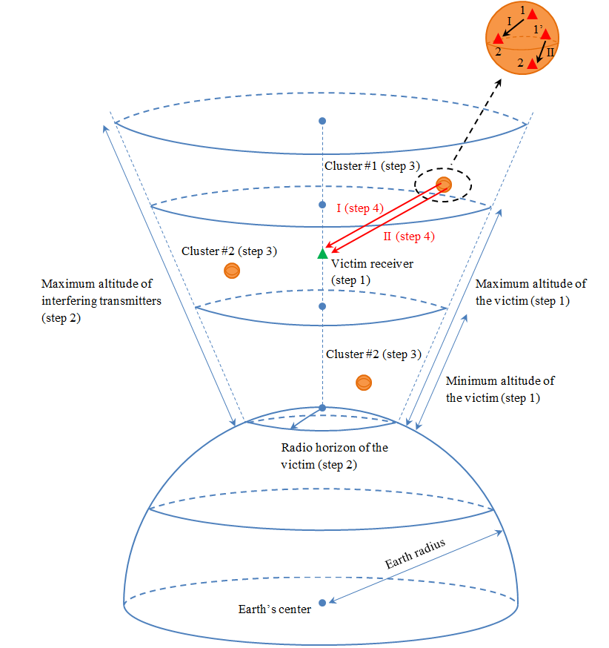

6.2.2 Methodology B
To be populated later. ]

6.3 Propagation model
The propagation models to be used in sharing and compatibility studies between the AMS and incumbent services have been provided by WPs 3M and 3K and are referenced in Table 5 below.
TABLE 5
Propagation models to be used for sharing and compatibility studies with
the non-safety aeronautical mobile service
Frequency band |  | Incumbent service | Propagation model
15 GHz |  | ARNS | Rec. ITU-R P.528-4ª
 |  | Radiolocation | Rec. ITU-R P.528-4ª
 |  | FSS (Earth-to-space) | Rec. ITU-R P.619-4
 |  | EESS (passive) | Rec. ITU-R P.619-4
 |  | SRS (passive) | Rec. ITU-R P.619-4
22 GHz |  | FS | TBD^{c}
 |  | LMS | TBD^{c}
 |  | Radioastronomy | TBD^{c}
 |  | EESS (passive) | Rec. ITU-R P.619-4
 |  | SRS (passive) | Rec. ITU-R P.619-4
Notes:
a: | This ITU-R Recommendation contains a method for predicting basic transmission loss in the frequency range 125 MHz to 15.5 GHz for air-to-air, ground-to-air, and air-to-ground paths. It provides a step-by-step method to compute the basic transmission loss for time percentages of 1 to 99 %. The only data needed for this method are the distance between antennas, the heights of the antennas above mean sea level, the frequency, and the time percentage.
b: | This ITU-R Recommendation provides ground-space methodologies to calculate individual propagation effects (for example, gaseous attenuation, tropospheric refraction or beam spreading loss) as well as methods to combine the individual calculations for single-entry or multiple-entry interference analysis. The frequency range for each effect is given in the Recommendation and in general, is valid up to 100 GHz.
c: | Extensions of Recommendation ITU-R P.528 to support higher frequencies are currently being investigated within CG 3K-3M-9 and WP 3K will keep WP 5B informed of any updates.

6.4 Results of studies
To be populated later.

7 Summary

ANNEX 1
Technical characteristics of systems operating in the aeronautical mobile service and sharing and compatibility studies
in the frequency band 15.4-15.7 GHz

A1.1 Technical characteristics of the new non-safety aeronautical mobile service systems
Representative technical and operational characteristics of the non-safety AMS systems in the frequency band 15.4-15.7 GHz are provided in Table 5 below.
A system is to be understood as a transceiver that may communicate with another transceiver of the same or of another system.
TABLE 6
Representative technical characteristics of the aeronautical mobile service systems
in the frequency range 15.4-15.7
Parameter | System 1  Airborne/Ground | System 2  Airborne | System 3  Airborne/Ground | System 4  Ground
Operational altitude (see Note 1) | Up to 50,000 ft. for airborne and 3 m for ground | Up to 50,000 ft. | Up to 50,000 ft. for airborne and 3 m for ground | 3 m
Comments |  | Only used for air-to-air links | Receive only if ground-based | Receive only
Transmitter characteristics
Transmitter Tuning Range | 15.4-15.7 GHz | 15.4-15.7 GHz | 15.4-15.7 GHz | Not applicable
Transmitter bandwidth | From 10 up to 200 MHz | From 10 up to 100 MHz | From 10 up to 100 MHz | Not applicable
Transmitter power at antenna port (see Note 2) | Variable from 0 to 40 dBm ATPC (see Note 3) | Variable from 0 to 40 dBm ATPC (see note 3) | Variable from 0 to 40 dBm (see Note 3) | Not applicable
Spectrum emission mask, unwanted emissions in the Out-of-Band (OOB) and in the spurious domains | See Figure 8 (see Note 4) | See Figure 8 (see Note 4) | See Figure 8 (see Note 4) | Not applicable
Transmitter modulation | PSK | QAM/PSK | QAM/PSK | Not applicable
Receiver characteristics
Receiver tuning range | 15.4-15.7 GHz | 15.4-15.7 GHz | 15.4-15.7 GHz | 15.4-15.7 GHz
Protection criterion expressed as C/(N+I) (see Note 5) | From -20 to 0 dB for typical values | From -20 to 0 dB for typical values | From -20 to 0 dB for typical values | From -20 to 0 dB for typical values
Receiver bandwidth | Same as the transmitter bandwidth | Same as the transmitter bandwidth | Same as the transmitter bandwidth | Same as the transmitter bandwidth
Receiver noise figure | 5 dB | 5 dB | 5 dB | 5 dB
Antenna characteristics
Type of antenna | Active antenna array | Omnidirectional | Active antenna array | Half wave dipole over conducting surface
Antenna pattern | [Rec. ITU-R M.1851] | Not applicable | [Rec. ITU-R M.1851] | See Note 6
Antenna peak gain | 25 dBi for airborne and 38 dBi for ground | From - 3 dBi up to 3 dBi | 38 dBi | 10 dBi
Typical side lobe level with respect to the main beam | -20 dB | Not applicable | -25 dB | Not applicable
Half-power beam width (in the azimuth and elevation planes) | 12° can be assumed as a default value | Not applicable | 5° can be assumed as a default value | Not applicable
Polarization | Circular | Horizontal, vertical or circular | Horizontal, vertical or circular | Horizontal, vertical or circular
Note 1: Typical values at which platforms are operated can be found in Section 7 of this Report.
Note 2: The transmitter power is adjusted dynamically during the communication depending on the required C/N at the receiver and the automatic transmit power control (ATPC) algorithm.
Note 3: ATPC (also simply referred to as power control) is implemented as an additional feature to limit interference with other services operating in the same or in adjacent frequency bands. The power control algorithm is based on a feedback from the receiver related to the quality of the received signal.
Note 4: The Spectrum Emission Mask shown in Figure 8 respects the maximum levels of unwanted emissions in the OOB domain as per Rec. ITU-R SM.1541-6 and in the spurious domain as per RR Appendix 3.
Note 5: The required protection criterion C/(N+I) value varies within the specified range depending on the spreading factor used during transmission (the higher the spreading factor, the higher the processing gain at the receiver and the lower the required C/(N+I)).
Note 6: The radiation pattern for this antenna can be determined based in the formulas provided in Table 7 below. Note that the electric field produced by the antenna, as well as the radiated power are only used as theoretical intermediate values, given the fact that this antenna is only menat to receive signals.
[Editor’s note: Recommendation ITU-R M.1851 is currently under revision.]
FIGURE 8
Spectrum emission mask of aeronautical mobile service systems in the frequency range 15.4-15.7 GHz
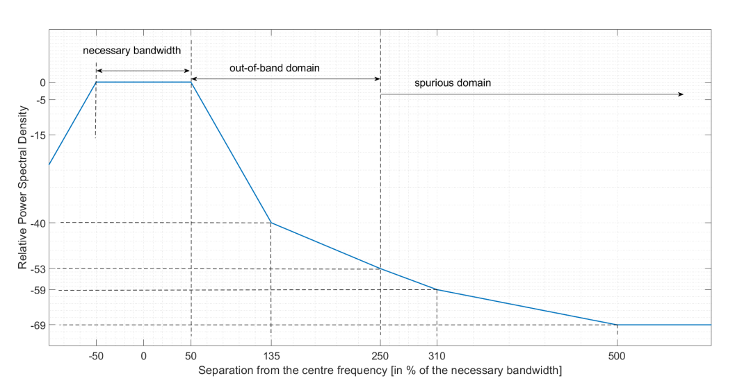
TABLE 7
Formulas for the computation of the radiation pattern of System 4
 | Formula
Electric field | $$E_{θ}=j∙\frac{Z_{0}∙I_{0}e^{-β∙r}}{2πr}∙\frac{cos\left(\frac{π}{2}∙cos\left(θ\right)\right)}{sin\left(θ\right)}∙2cos⁡(β∙h∙cos\left(θ\right))$$
Power flux density | $$P=\frac{1}{2Z_{0}}∙{\left|E_{θ}\right|}^{2}$$
Total radiated power | $$P_{total}= \int_{0}^{2π}{\int_{0}^{π}{P∙r^{2}∙sin\left(θ\right)dθdφ}}$$
Average power flux density | $$P_{average}= \frac{P_{total}}{4πr²}$$
Directivity (expressed in the linear domain) | $$G=\frac{P}{P_{avg}}$$
Note: $Z_{0 }$ denotes the electromagnetic impedance of the free space, $β=\frac{2π}{lambda}$ is the wave number, h is the height of the dipole above the conducting plane, and $θ$ is the offset angle from the zenith.

[Editor’s note: It was noted that additional parameters such as operational altitude and antenna pattern (e.g., reference to ITU-R Recommendation) will be needed for studies and are expected to be provided at the next WP 5B meeting]
[Editor’s note: The maximum power fed to the antenna may be lowered depending on the results of coexistence and sharing studies.]

A1.2 Technical characteristics of the systems in the incumbent services

A1.2.1 Characteristics of radiolocation service
The following characteristics of radiolocation systems are taken from Table 1 of Preliminary Draft Revision of Recommendation ITU-R M.1730-1.
TABLE 8
Radiolocation systems characteristic in the frequency band 15.4-15.7 GHz
Characteristics | System-6
Function | Search, track and ground-mapping  (multi-function)
Platform type | Airborne (300 - 13 700 m)
Tuning range (GHz) | 15.4-17.3
Modulation | Linear FM chirp
Transmit peak power (W) | 500, 2k, 10k
Pulse width (μs) | 0.05-50
Pulse rise/fall time (ns) | 5-100
Pulse repetition rate (pps) | 200-20 000
Maximum duty cycle | Up to 0.2
Output device | Travelling wave tube
Antenna pattern type | Pencil (ITU-R M.1851 cosine square distribution)
Antenna type | Phased array
Antenna polarization | Linear
Antenna gain (dBi) | 35
Antenna elevation beamwidth (degrees) | 3.2
Antenna azimuthal beamwidth (degrees) | 3.2
Antenna horizontal scan rate | 1-30°/s
Antenna horizontal scan type (continuous, random, sector, etc.) | ±45° (electronic)
Antenna vertical scan rate | 1, 5°/s
Antenna vertical scan type | +5° to −45° (electronic)
Antenna 1st side-lobe level | 3.5 dBi at 5.2°
Antenna height | Aircraft altitude
1st/2nd receiver IF −3 dB bandwidths (MHz) | 25
Receiver noise figure (dB) | 5
Minimum discernible signal (dBm) | −100
Chirp bandwidth (MHz) | < 1 900
Transmitter RF emission bandwidth (MHz):  −3 dB  −20 dB | 1 850  1 854

A1.2.2 Characteristics of aeronautical radionavigation service
Parameters of surface-based radars, aircraft landing systems (ALS), Aircraft multipurpose radars (MPR), and radar sensing and measurement systems are presented in Recommendation ITU-R S.1340-0. This released has been published in 1997 and an update of these parameters would be necessary.
Parameters of an ALS system which is implemented by some administrations are provided in Report ITU-R M.2170.
A working document preliminary draft new Recommendation has been initiated and would contain the characteristics to be addressed in this study.

A1.2.3 Characteristics of systems operating in the fixed satellite service (Earth-to-space)
[Editor’s note: To be updated according to the RLS from WP 4A]

A1.2.4 Characteristics of systems operating in the Earth exploration satellite service (passive)
Relevant information on typical technical and operational characteristics of systems operating in the Earth exploration satellite service (EESS) (passive) systems using allocations between 1.4 and 275 GHz can be found in Recommendation ITU-R RS.1861-0,
However, for the EESS (passive) allocation in the band 15.35-15.4 GHz still there are no characteristics of EESS (passive) systems available.

A1.2.5 Characteristics of systems operating in the space research service (passive)
No relevant Recommendations or parameters have been identified for systems operating in the space research service (SRS) in this frequency band.

A1.2.6 Characteristics of radioastronomy
Protection criteria for the radioastronomy service can be found in Table 2 of Recommendation ITU-R RA.769-2, which is provided as Table 9 and 10 below for reference.
TABLE 9
Threshold levels of interference detrimental to radio astronomy continuum observations
Centre  frequency  f_{c}  (MHz) | Assumed bandwidth  Δf  (MHz) | Minimum antenna noise temperature  T_{A}  (K) | Receiver noise temperature  T_{R}  (K) | System sensitivity  (noise fluctuations) |  | Threshold interference levels
 |  |  |  | Temperature  ΔT  (mK) | Power spectral  density  ΔP  (dB(W/Hz)) | Input power  ΔP_{H}  (dBW) | pfd  S_{H} Δf  (dB(W/m²)) | Spectral pfd  S_{H}  (dB(W/(m² ⋅ Hz)))
15 375 | 50 | 15 | 15 | 0.095 | –269 | –202 | –156 | –233

TABLE 10
Typical radio telescopes for which compatibility studies might be performed
Administration | Name | N. Latitude | E. Longitude | Height AMSL (m) | Diameter  (m)
Germany | Effelsberg | 50° 31' 29" | 06° 53' 03" | 369 | 100
South Africa | MeerKAT | −30° 43′ 16" | 21° 24' 40" | 1 054 | 64 × 13.5 m
USA | Green Bank Telescope | 38° 25' 59" | −79° 50' 23" | 250 | 100
USA | Jansky VLA | 33° 58' 22" to  34° 14' 56" | −107° 24' 40" to  −107° 48' 22" | 2 000 | 27 × 25 m
Australia | Parkes | −33º 00' 00" | 148º 15' 44" | 372 | 64
China | Tianma | 31° 05′ 13" | 121° 09′ 48" | 5 | 65
Japan | Nobeyama | 35º 56' 40" | 138º 28' 21" | 1 350 | 45
France | Plateau de Bure | 44º 38' 02" | 05° 55' 28.5" | 2 250 | 12 × 15 m

A1.3 Results of the sharing and compatibility studies

A1.3.1 Studies with the radiolocation service

A1.3.1.1 Sharing study A
The analysis calculates the interference of AMS airborne and ground stations to the radiolocation system.
The protection criteria for the radiolocation service is assumed to be I/N=–6 dB.
The following equation can be used to determine if interference to the radiolocation System 6 receiver from AMS System-6 transmissions is likely to occur and what separation distance is required to eliminate the interference:

I = P_{Tx} + G_{Tx} + G_{Rx} – L_{Trans} – FDR (1)
where:
I : interference power at the receiver (dBm),
P_{Tx} : power of the interfering system (dBm), 30 dBm is used as an example,
G_{Tx} : antenna gain of the interfering transmitter in the direction of the victim receiver (dBi), we assume that the antenna of the AMS system is omni directional and the antenna gain is 0 dB,
G_{Rx} : antenna gain of the victim receiver in the direction of the interfering transmitter (dBi),
L_{Trans} : transmission loss between transmitting and receiving antennas (dB) using free space loss for air to air, and using Recommendation ITU-R P.528-5 for ground to air. Free space loss = 20 log(F) + 20 log(R) + 32.44,
F : frequency (MHz),
R : separation distance (km),
FDR_{IF} : frequency-dependent rejection produced by the receiver IF selectivity curve on an unwanted transmitter emission spectra (dB).
The FDR_{IF} value can be determined from Recommendation ITU-R SM.337-6. Since the radars will operate on a co-frequency basis, only the on-tune rejection (OTR) is considered. OTR for non-coherent chirped pulsed signals is given by:

OTR = 10 log (Rx_BW/Tx_BW) for Rx_BW ≤ Tx_BW (2)
Otherwise OTR = 0
where:
Rx_BW : receiver bandwidth (MHz),
Tx_BW : transmitter bandwidth (MHz).
When the transmitting bandwidth is set to be 50 MHz and the receiving bandwidth to be 25 MHz, FDR_{IF} is 3 dB.
The results for airborne AMS analysis are summarized in Table 3, and the ground / shipboard AMS analysis are summarized in Table 4. The assessment can be made regarding the separation distances that are required to ensure compatibility between the AMS system and the radiolocation system.
TABLE 11
The separation distance for the airborne aeronautical mobile service system
interfering with radiolocation system
 | Separation distances
The main lobe of radiolocation system | [219 km]
1st side-lobe level of radiolocation system | [5.8 km]
TABLE 12
The separation distance for the ground / shipboard aeronautical mobile service
system interfering with radiolocation system
 | Separation distances
The main lobe of radiolocation system | [187 km]
1st side-lobe level of radiolocation system | [1 km]

[Editor’s note: the values provided in Tables 9 and 10 should be updated based on the AMS characteristics in Table 5.]

A1.3.1.2 Study B:
A1.3.1.2.1 Introduction
This section introduces the co-frequency sharing and compatibility study between a non-safety AMS transmitter and a radiolocation system operating in the frequency range 15.4-15.7 GHz. The study determines the required separation distance between a non-safety AMS transmitter and a radiolocation system. Analysis scenarios will be based on Figures 3, 4, 5, and 6.
A1.3.1.2.2 Sharing studies scenario, assumptions, and methodology for a single cluster
Figures 9, 10, 11, and 12 below depict the interference analysis scenario used in the sharing studies according to Figures 3, 4, 5, and 6.
Figure 9
Sharing studies between non-safety AMS and Radiolocation based on the Wildfire observation scenario
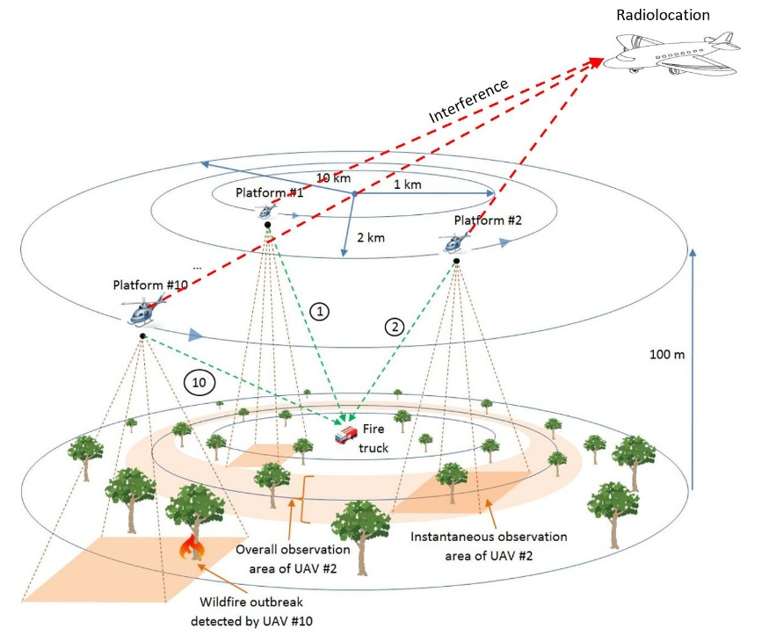

Below are the assumptions and methodology for a single cluster analysis based on Figure 9:
1. For the single entry analysis with the transmitted bandwidth of 25 MHz, only one transmitter which is assumed to be platform #10 can interfere with the Radiolocation receiver. The radiolocation receiver and the platform’s center frequency are 15.4 GHz. The transmitter is randomized within a 10 km radius from the fire truck.
2. For the single entry analysis with the transmitted bandwidth of 10 MHz, up to 3 transmitters can interfere with the Radiolocation receiver. The radiolocation receiver’s center frequency is 15.4 GHz. The center frequency for the 3 transmitters are: 15.3925, 15.4025, and 15.4125 GHz. Three transmitters are randomized within a 10, 5, and 1 km radius from the fire truck.
3. For the analysis as show in 1 and 2 above, the following assumptions are used:
a. The location of a fire truck is fixed.
b. Transmission loss using Recommendation ITU-R P.528-4 – A propagation prediction method for aeronautical mobile and radionavigation services using the VHF, UHF, and SHF bands. The time percentage of 5% is used.
c. The altitude for all transmitting platforms is 100 m above the Earth’s surface, and 300 m above the Earth’s surface for the Radiolocation receiver.
d. The analysis assumes co-frequency.
e. The Radiolocation receiver is randomized within a 150 km radius of a transmitting platform.
f. The antenna pattern for a transmitting platform is an Omni antenna. The antenna pattern for the Radiolocation receiver can be modelled using Recommendation ITU-R M.1851 cosine square pattern.
g. The analysis is performed with both maximum and minimum transmitter power (0 and 40 dBm), and antenna gain (-3 and 3 dBi).
h. The pointing angle of the radiolocation receiver antenna is randomized between ± 45° horizontally, and +5° to −45° vertically.
- The analysis was performed with 1 million sampling points since the protection criteria is I/N of -6 dB.
Figure 10
Sharing studies between non-safety AMS and Radiolocation based on the Search and Rescue scenario
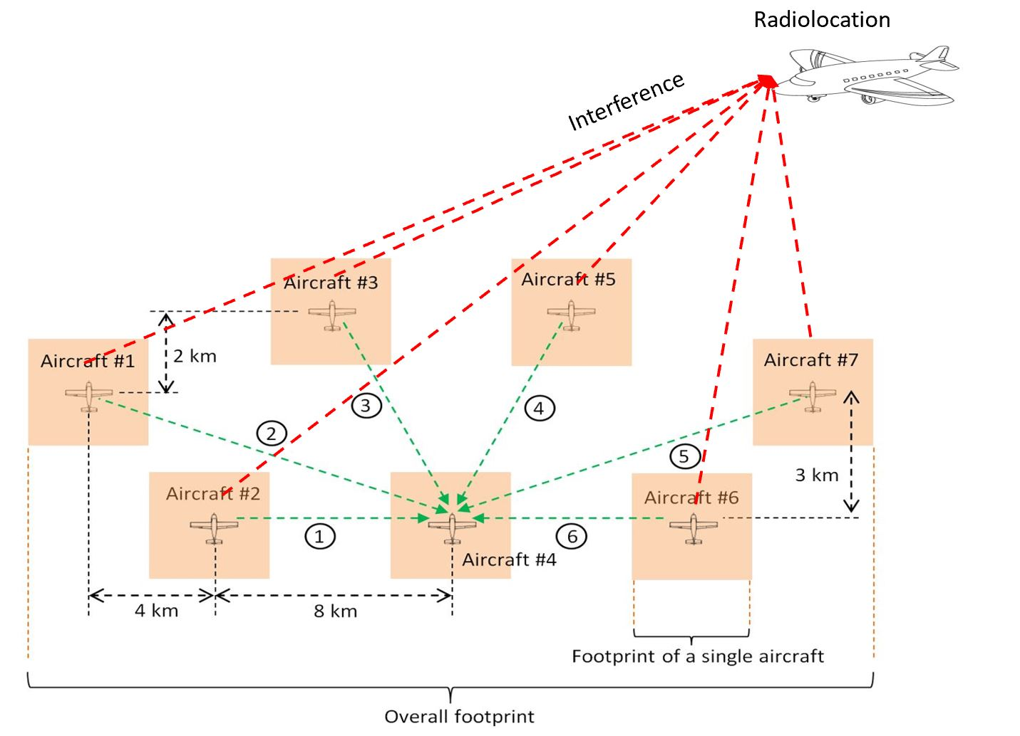

Below are the assumptions and methodology for a single cluster analysis based on Figure 10:
- For the single entry analysis with the transmitted bandwidth of 25 MHz, only one transmitter which is assumed to be aircraft #2 can interfere with the Radiolocation receiver. The radiolocation receiver and aircraft transmitters’ center frequency are 15.4 GHz. The transmitter location is randomized within a ring of 8 km radius from the receiver (Aircraft #4).
- For the single entry analysis with the transmitted bandwidth of 10 MHz, up to 3 transmitters which are assumed to be aircraft #1, #2, and #3, can interfere with the Radiolocation receiver. The radiolocation receiver’s center frequency is 15.4 GHz. The center frequency for the 3 transmitters are: 15.3925, 15.4025, and 15.4125 GHz. Three transmitters are randomized within a ring 12, 8, and 6 km radius from the receiver (Aircraft #4).
- For the analysis as show in 1 and 2 above, the following assumptions are used:
  - Transmission loss using Recommendation ITU-R P.528-4 – A propagation prediction method for aeronautical mobile and radionavigation services using the VHF, UHF, and SHF bands. The time percentage of 5% is used.
  - The altitude for all non-safety AMS aircraft and Radiolocation aircraft is 3.6 km above the Earth’s surface.
  - The analysis assumes co-frequency.
  - The Radiolocation aircraft is randomized within a 600 km radius of a transmitted aircraft.
  - The antenna pattern for a transmitting aircraft can be modelled using Recommendation ITU-R M.1851 cosine pattern, with a cosine square pattern used for the Radiolocation receiver antenna.
  - The analysis is performed with both maximum and minimum transmitter power (0 and 40 dBm).
  - The pointing angle of the radiolocation receiver antenna is randomized ±45° horizontally, and +5° to −45° vertically.
  - The analysis was performed with 1 million sampling points since the protection criteria is I/N of -6 dB.
Figure 11
Sharing studies between non-safety AMS and Radiolocation based on the Surveillance mission scenario
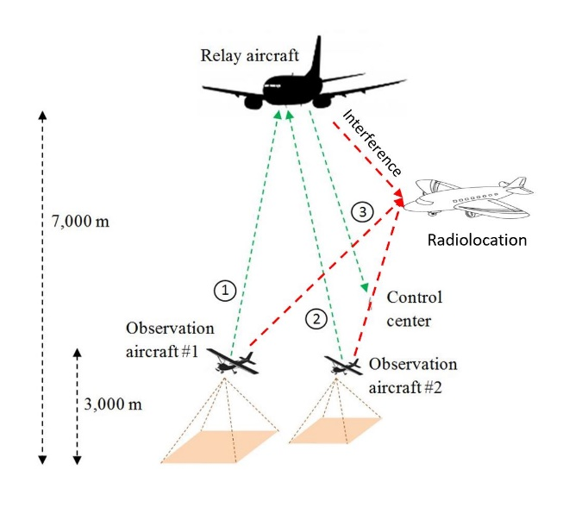

Below are the assumptions and methodology for a single cluster analysis based on Figure 11:
- For the single entry analysis with the transmitted bandwidth of 25 MHz, only one transmitter which is assumed to be a relay aircraft can interfere with the Radiolocation receiver. The radiolocation receiver and aircraft transmitters’ center frequency are 15.4 GHz. The transmitter is randomized within a 300 km radius from the control center.
- For the single entry analysis with the transmitted bandwidth of 10 MHz, up to 3 transmitters can interfere with the Radiolocation receiver. The radiolocation receiver’s center frequency is 15.4 GHz. The center frequency for the 3 transmitters link is: 15.3925, 15.4025, and 15.4125 GHz. The relay aircraft is randomized within a 300 km radius from the control center. The two observation aircraft are randomized within a 5 km radius from the relay aircraft.
- For the analysis as show in 1 and 2 above, the following assumptions are used:
  - The location of the control center is fixed.
  - Transmission loss using Recommendation ITU-R P.528-4 – A propagation prediction method for aeronautical mobile and radionavigation services using the VHF, UHF, and SHF bands. The time percentage of 5% is used.
  - The altitude for two observation aircraft, and relay aircraft are at 3 and 7 km above the Earth’s surface respectively. The altitude for the Radiolocation aircraft is randomized between 3 and 7 km.
  - The analysis assumes co-frequency.
  - The Radiolocation aircraft is randomized within an 800 km radius of a transmitted relay aircraft.
  - The antenna pattern for the relay aircraft can be modelled using Recommendation ITU-R M.1851 cosine pattern, and cosine square pattern for Radiolocation receiver antenna. The antenna pattern for observation aircraft is an Omni antenna.
  - The analysis was performed with both maximum and minimum transmitter power (0 and 40 dBm), and antenna gain (-3 and 3 dBi) for Omni antenna.
  - The pointing angle of the radiolocation receiver antenna is randomized ±45° horizontally, and +5° to −45° vertically.
  - The analysis was performed with 1 million sampling points since the protection criteria is I/N of -6 dB.
Figure 12
Sharing studies between non-safety AMS and Radiolocation based on the Internet above the clouds scenario
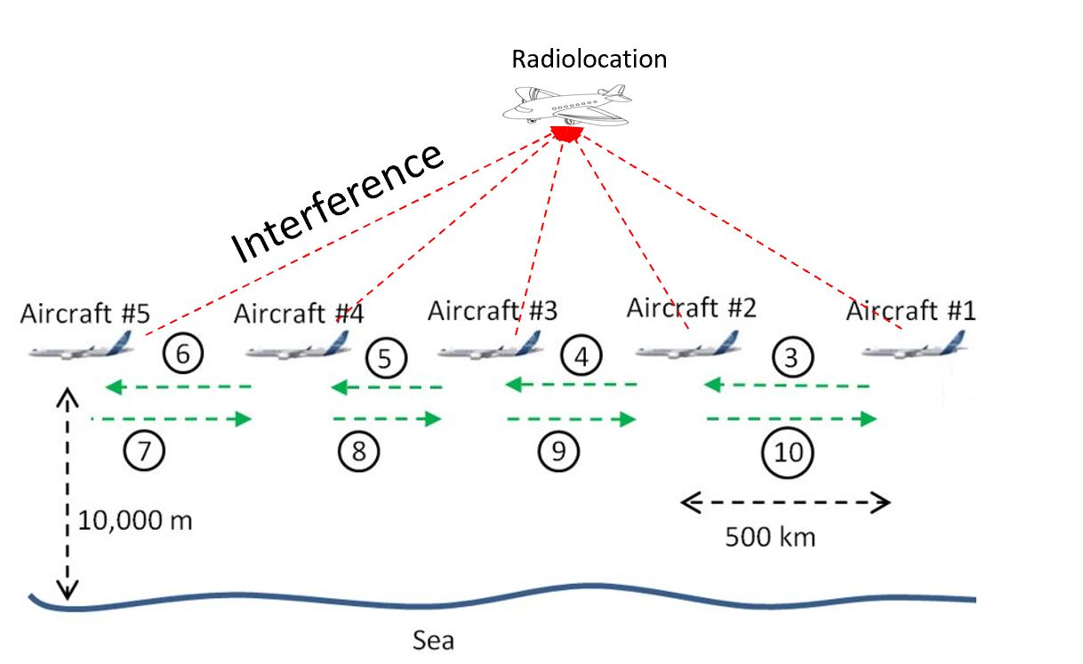

Below are the assumptions and methodology for a single cluster analysis based on Figure 12:
- For the single entry analysis with the transmitted bandwidth of 25 MHz, only one transmitter which is assumed to be aircraft #2 can interfere with the Radiolocation receiver. The radiolocation receiver and aircraft transmitters’ center frequency are 15.4 GHz. The transmitter is randomized within a ring of 500 km radius from aircraft #1.
- For the single entry analysis with the transmitted bandwidth of 10 MHz, up to 3 transmitters which are assumed to be aircraft #1, #2, and #3 can interfere with the Radiolocation receiver. The radiolocation receiver’s center frequency is 15.4 GHz. The center frequency for the 3 transmitters are: 15.3925, 15.4025, and 15.4125 GHz. Aircraft #2 is randomized within a ring of 500 km radius from aircraft #1. Aircraft #3 is randomized within a ring of 500 km radius from aircraft #2.
- For the analysis as show in 1 and 2 above, the following assumptions are used:
  - Transmission loss using Recommendation ITU-R P.528-4 – A propagation prediction method for aeronautical mobile and radionavigation services using the VHF, UHF, and SHF bands. The time percentage of 5% is used.
  - The altitude for all transmitting aircraft, and the Radiolocation aircraft is 10 km above the Earth’s surface.
  - The analysis assumes co-frequency.
  - The Radiolocation aircraft’s position is randomized within a 900 km radius of aircraft #2.
  - The antenna pattern for both a transmitting aircraft and the Radiolocation receiver can be modelled using Recommendation ITU-R M.1851 cosine square pattern.
  - The analysis was performed with both maximum and minimum transmitter power (0 and 40 dBm).
  - The radiolocation receiver antenna is scanning ±45° horizontally, and +5° to −45° vertically.
  - The analysis was performed with 1 million sampling points since the protection criteria is I/N of -6 dB.
A1.3.1.2.3 Sharing studies results
Figures 13, 14, 15, and 16 provide the Cumulative Distribution Functions (CDFs) of I/N values based on Figures 9, 10, 11, and 12 respectively. The bandwidth of the non-safety AMS system is 25 MHz.
Figure 13
Separation distance between non-safety AMS and Radiolocation based on the Wildfire observation scenario

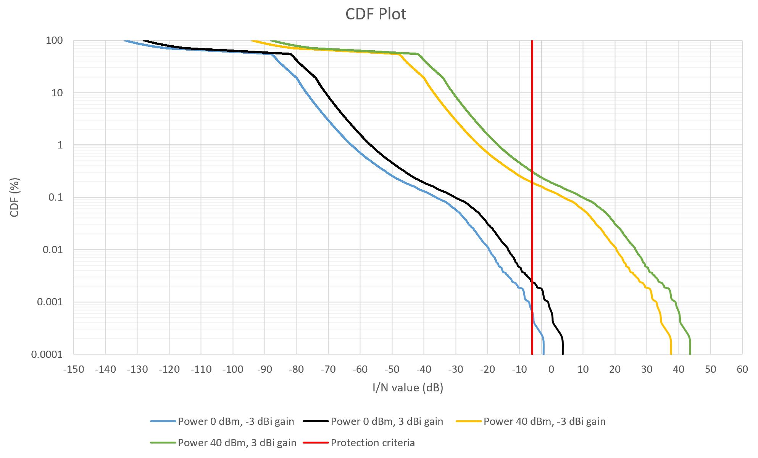
Figure 14
Separation distance between non-safety AMS and Radiolocation based on the Search and Rescue scenario

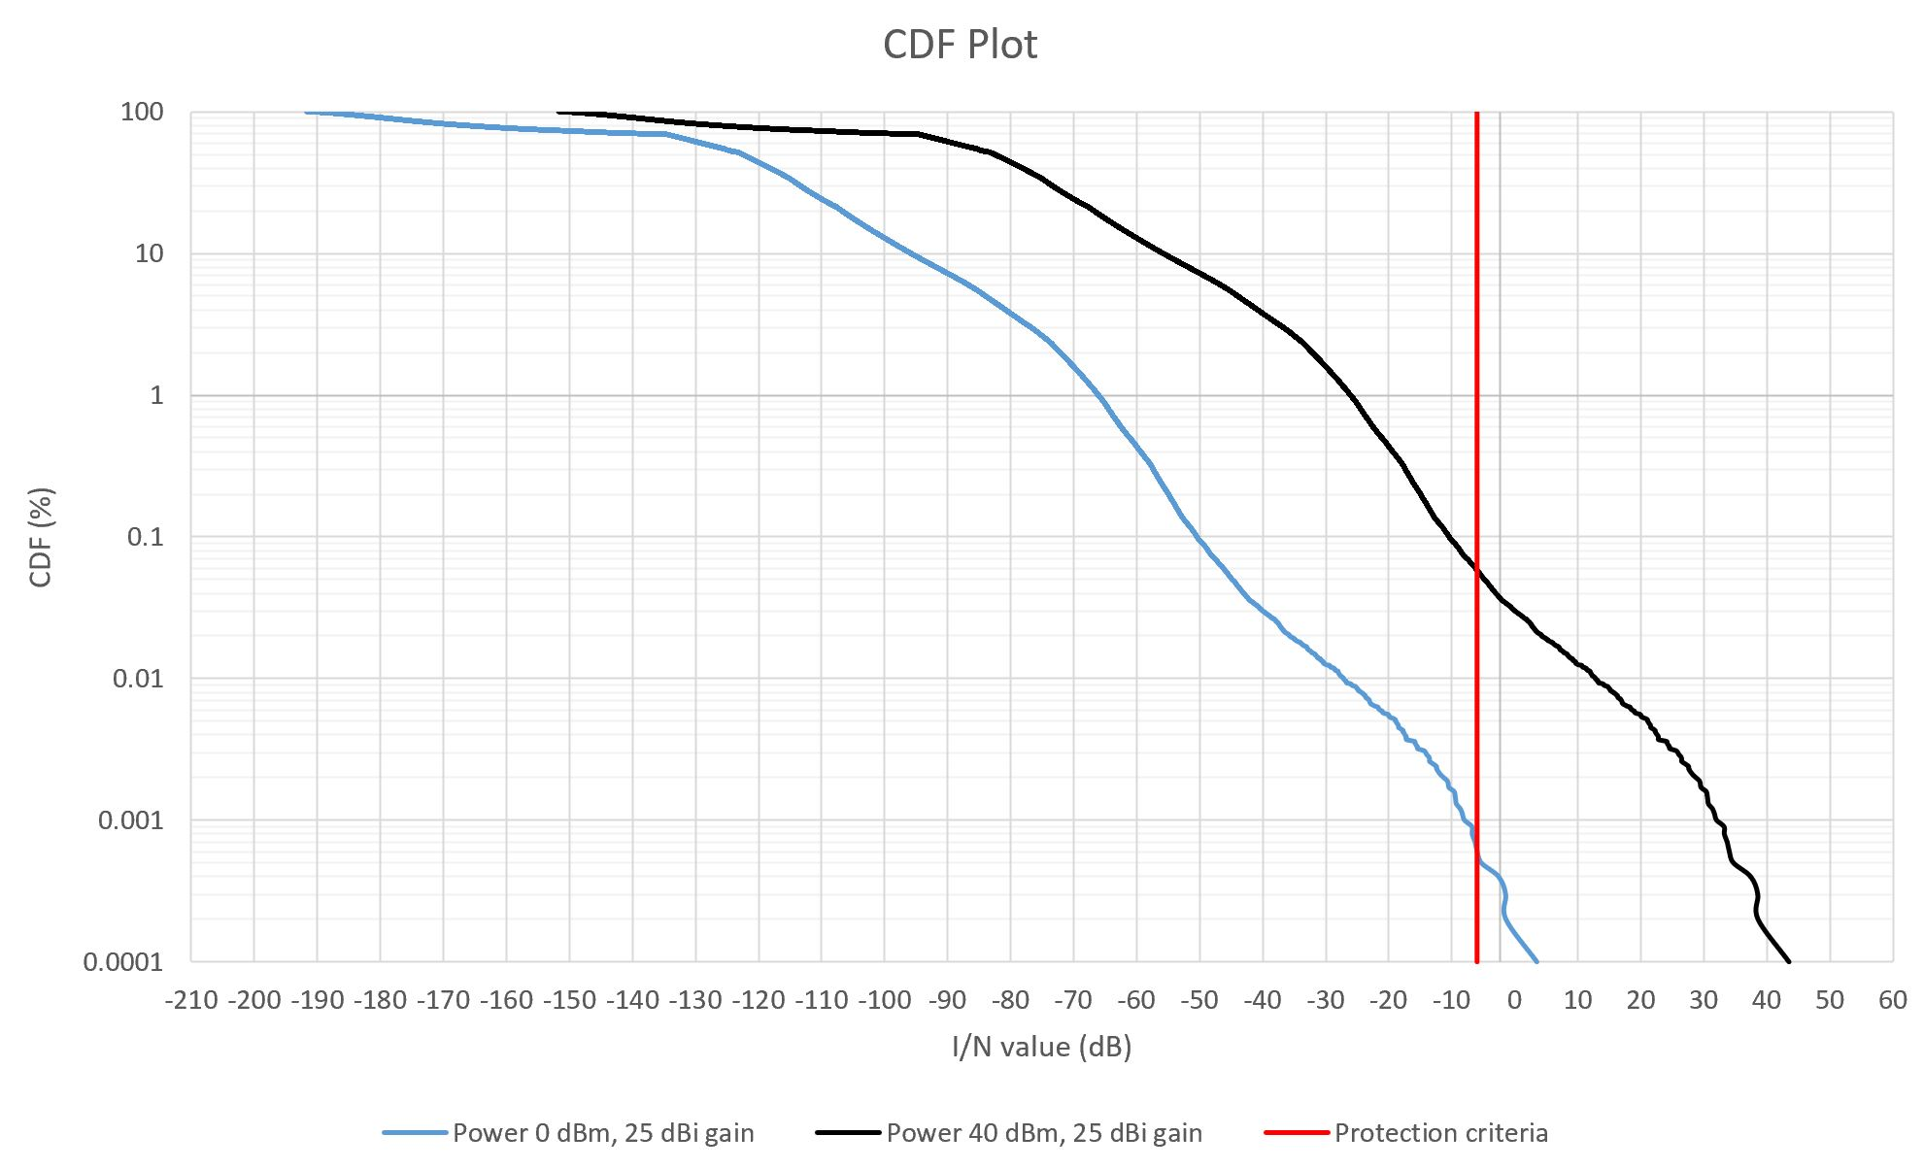
Figure 15
Separation distance between non-safety AMS and Radiolocation based on the Surveillance mission scenario

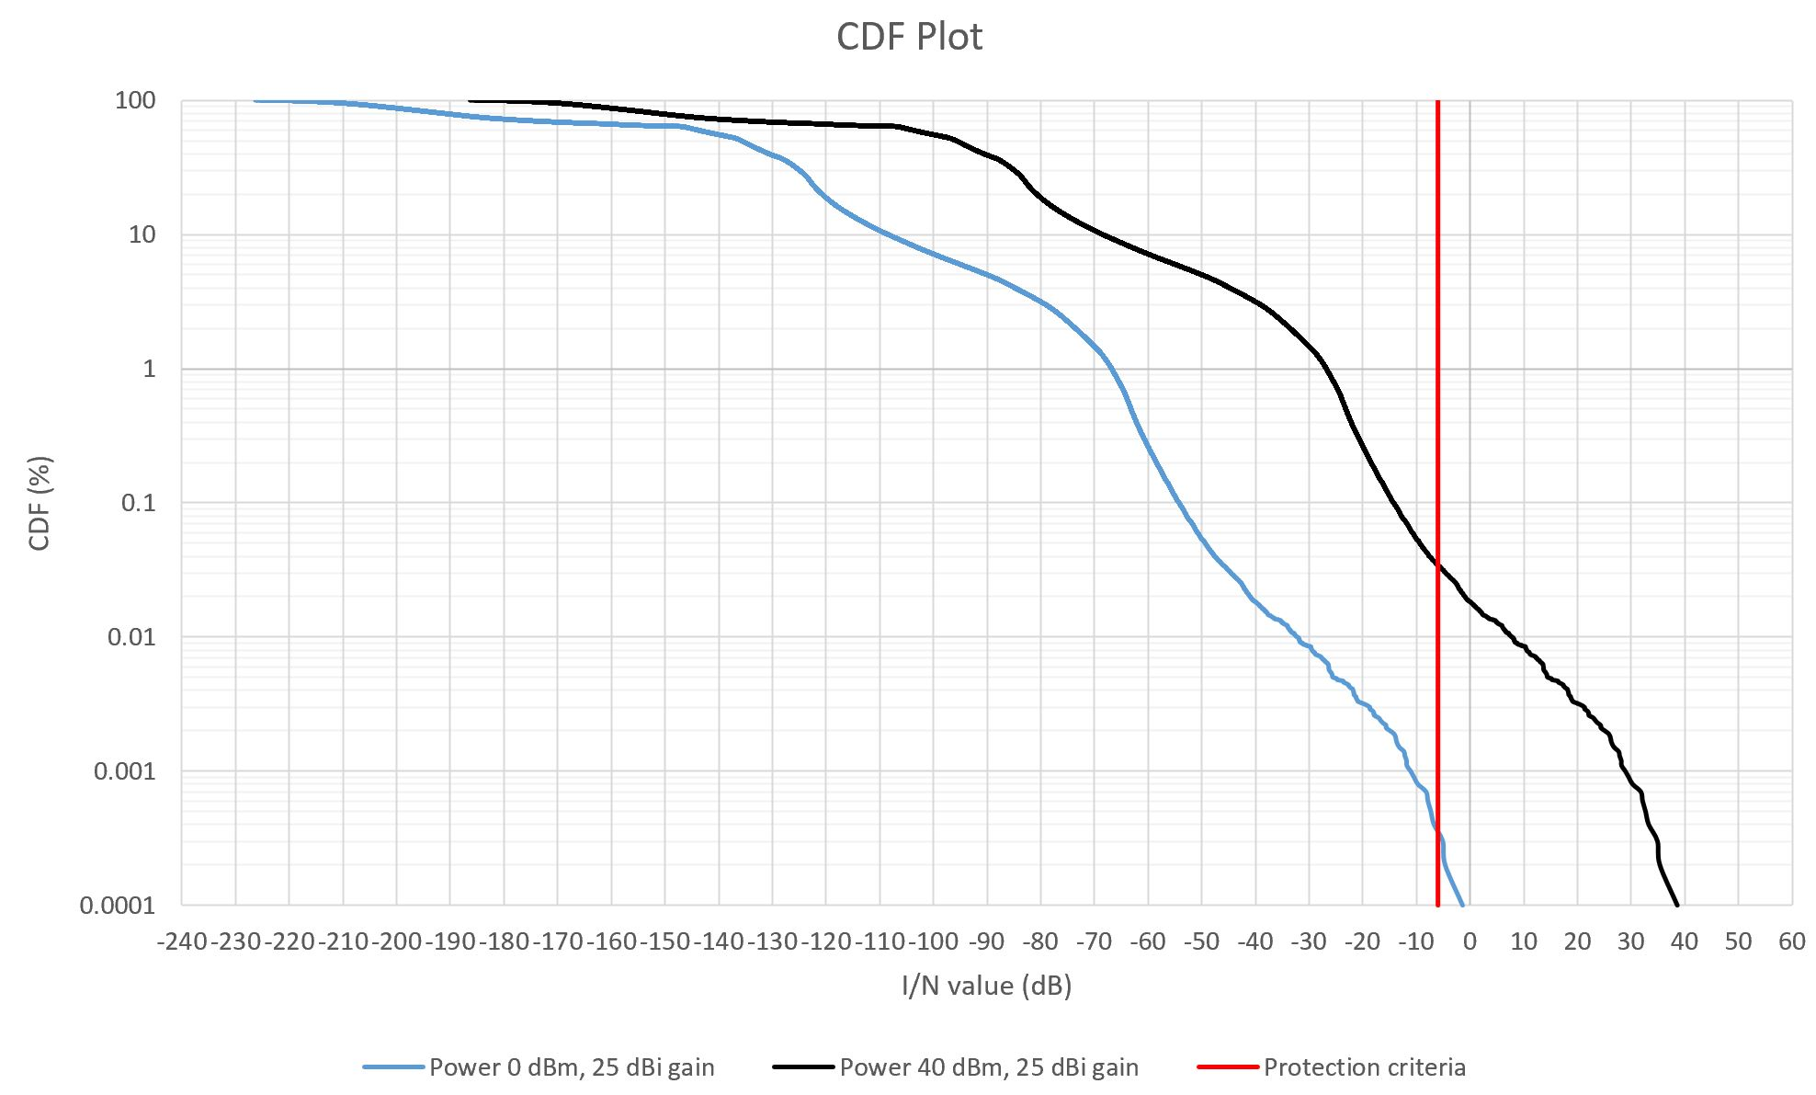
Figure 16
Separation distance between non-safety AMS and Radiolocation based on the Internet above the clouds scenario

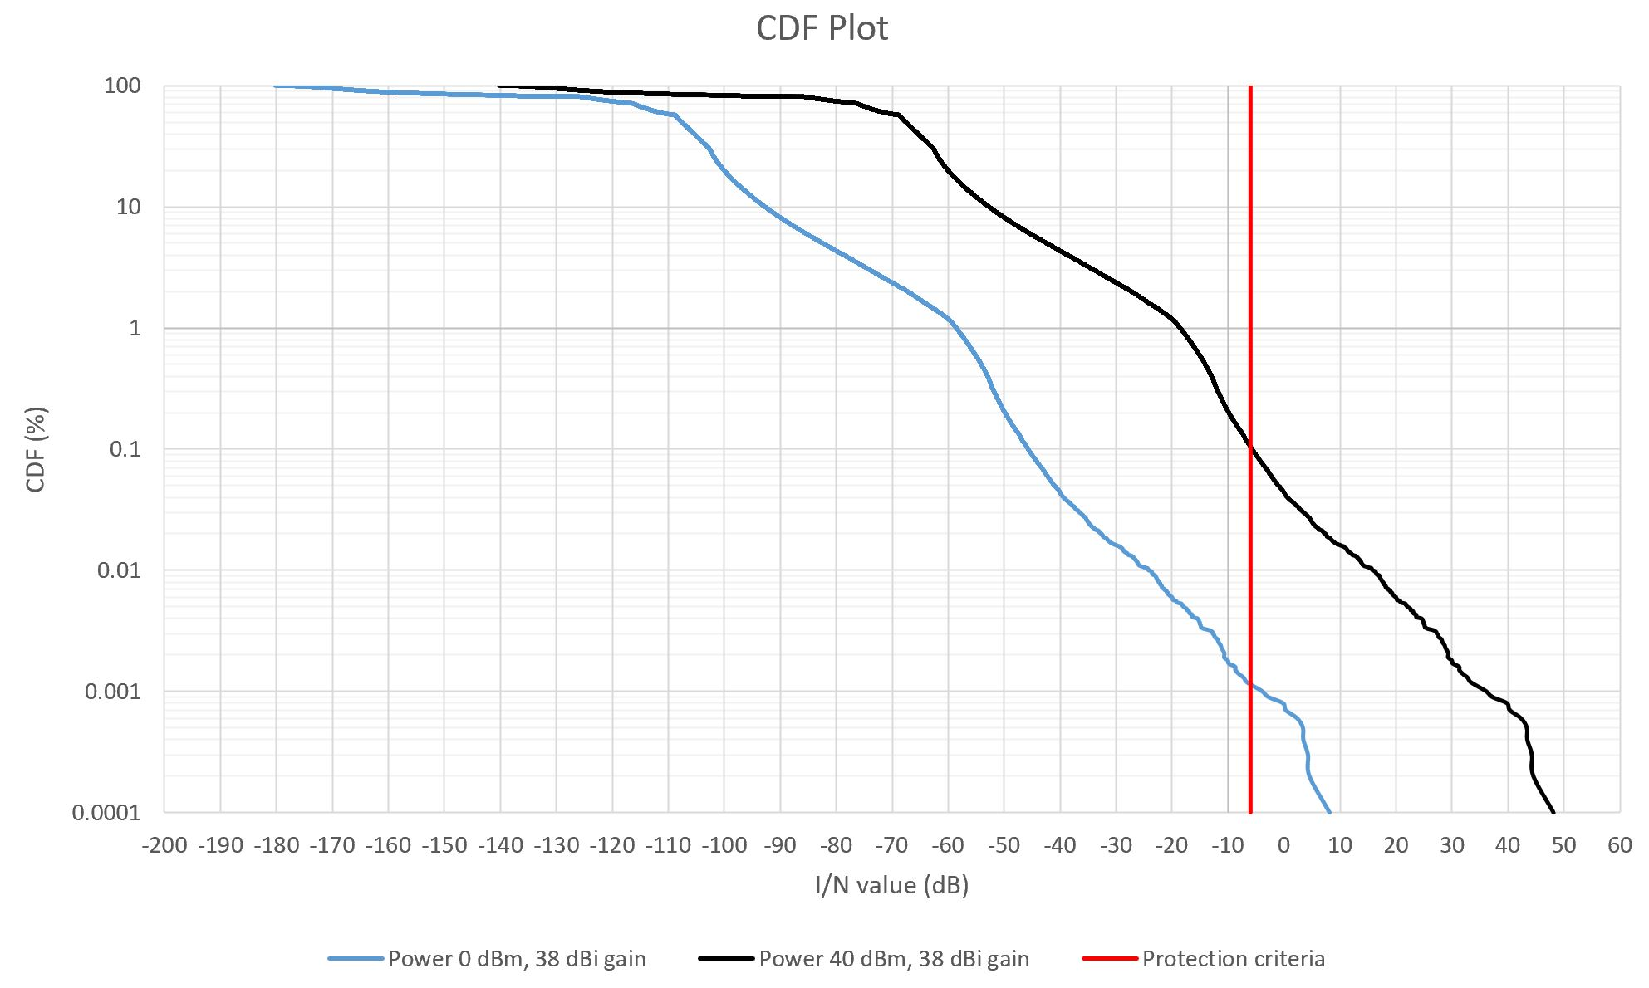
Figures 17, 18, 19, and 20 provide the CDFs of I/N values based on Figures 9, 10, 11, and 12 respectively. The bandwidth of the non-safety AMS system is 10 MHz.
Figure 17
Separation distance between non-safety AMS and Radiolocation based on the Wildfire observation scenario

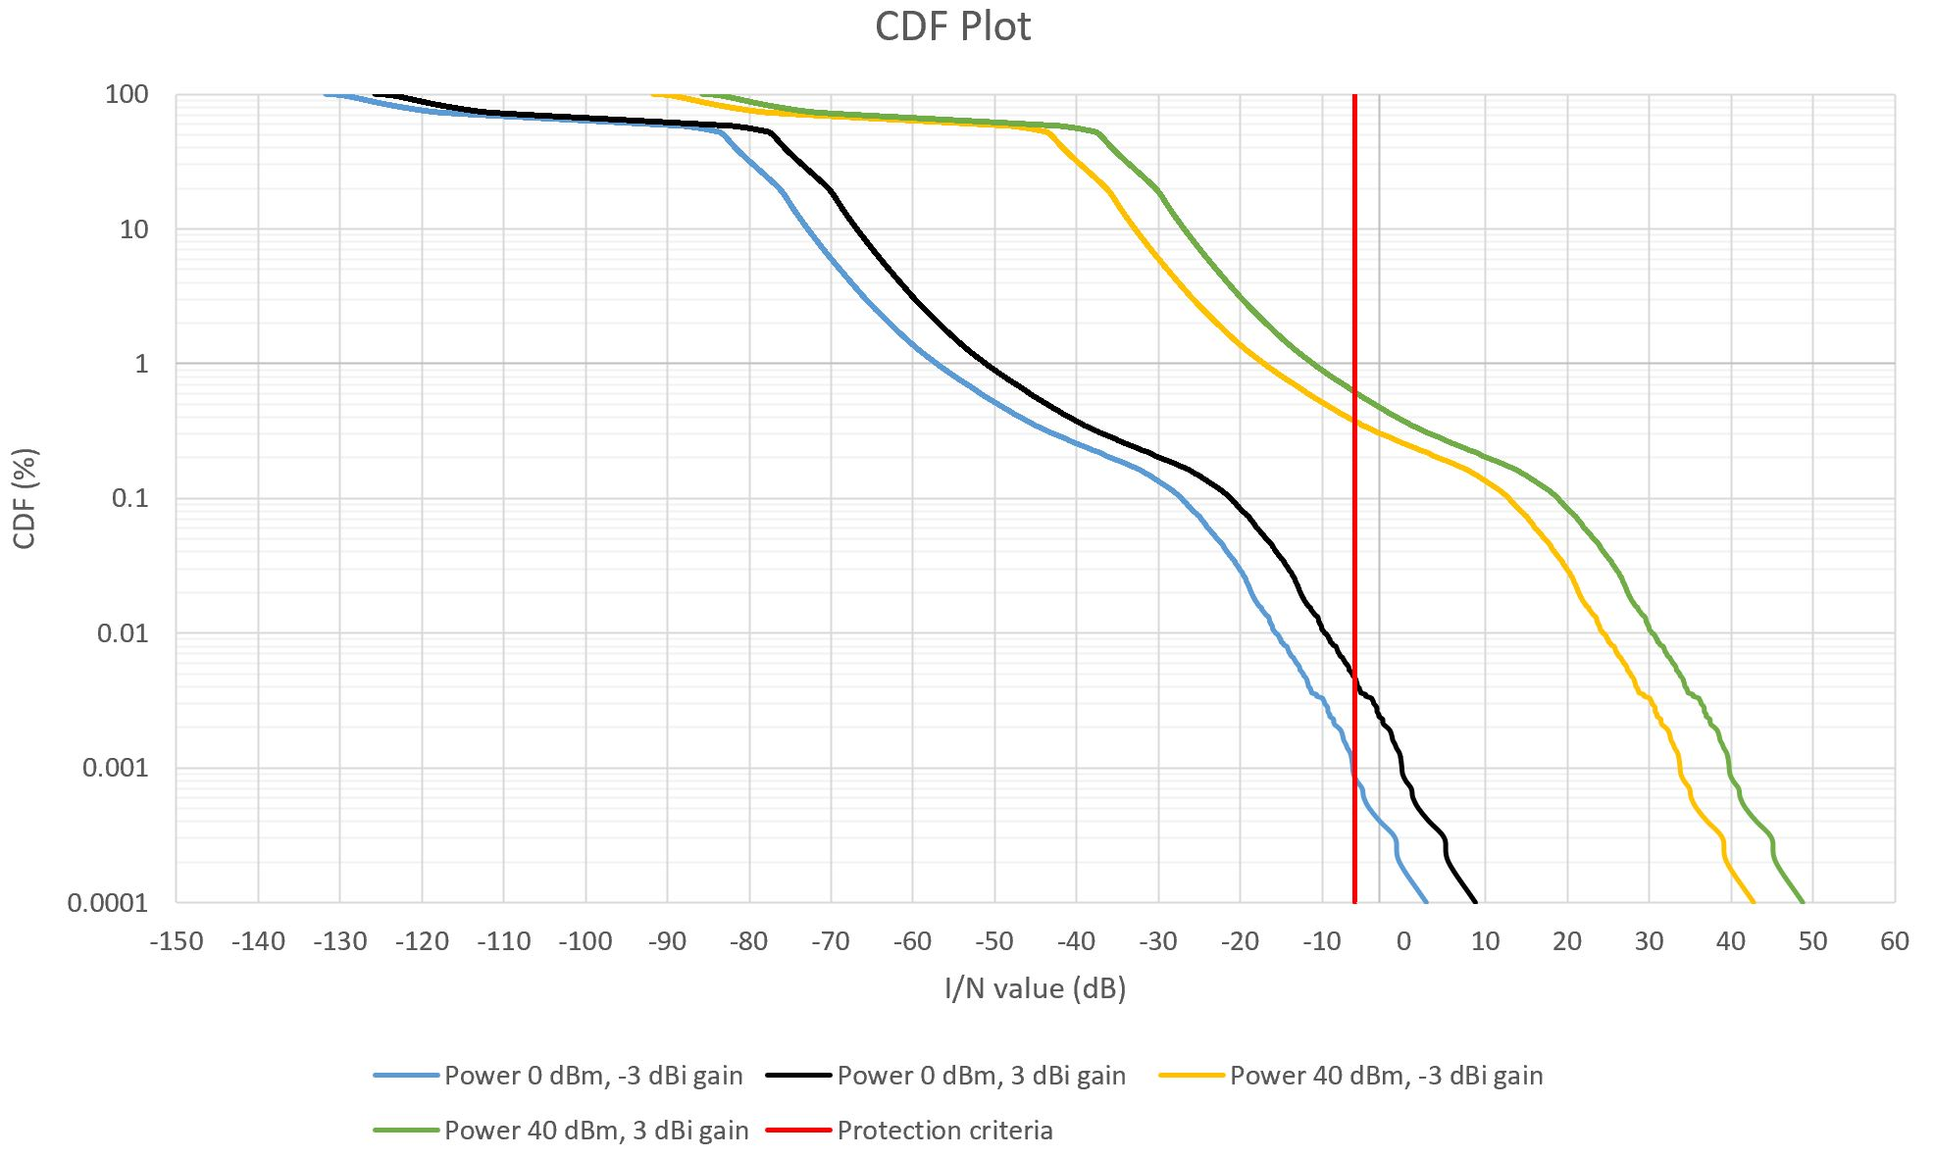
Figure 18
Separation distance between non-safety AMS and Radiolocation based on the Search and Rescue scenario

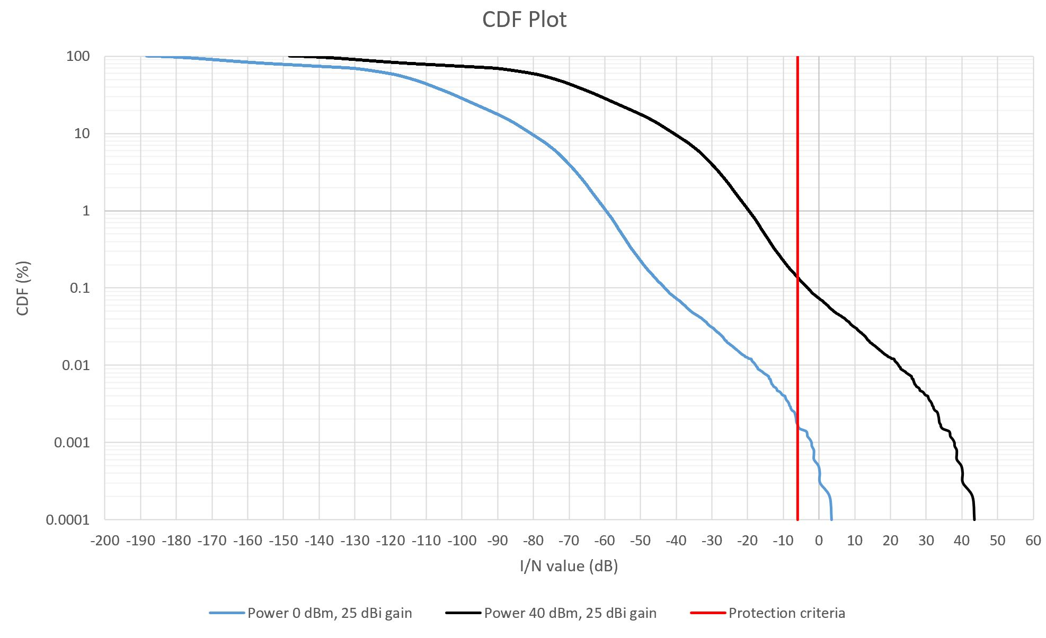
Figure 19
Separation distance between non-safety AMS and Radiolocation based on the Surveillance mission scenario

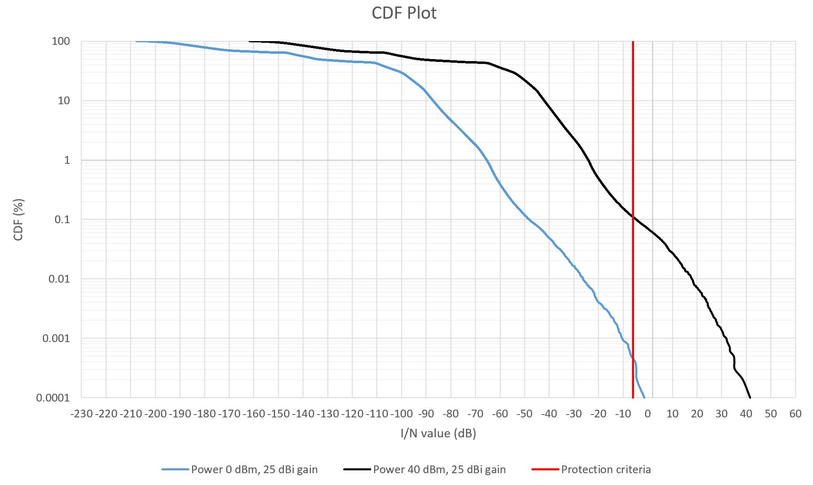
Figure 20
Separation distance between non-safety AMS and Radiolocation based on the Internet above the clouds scenario

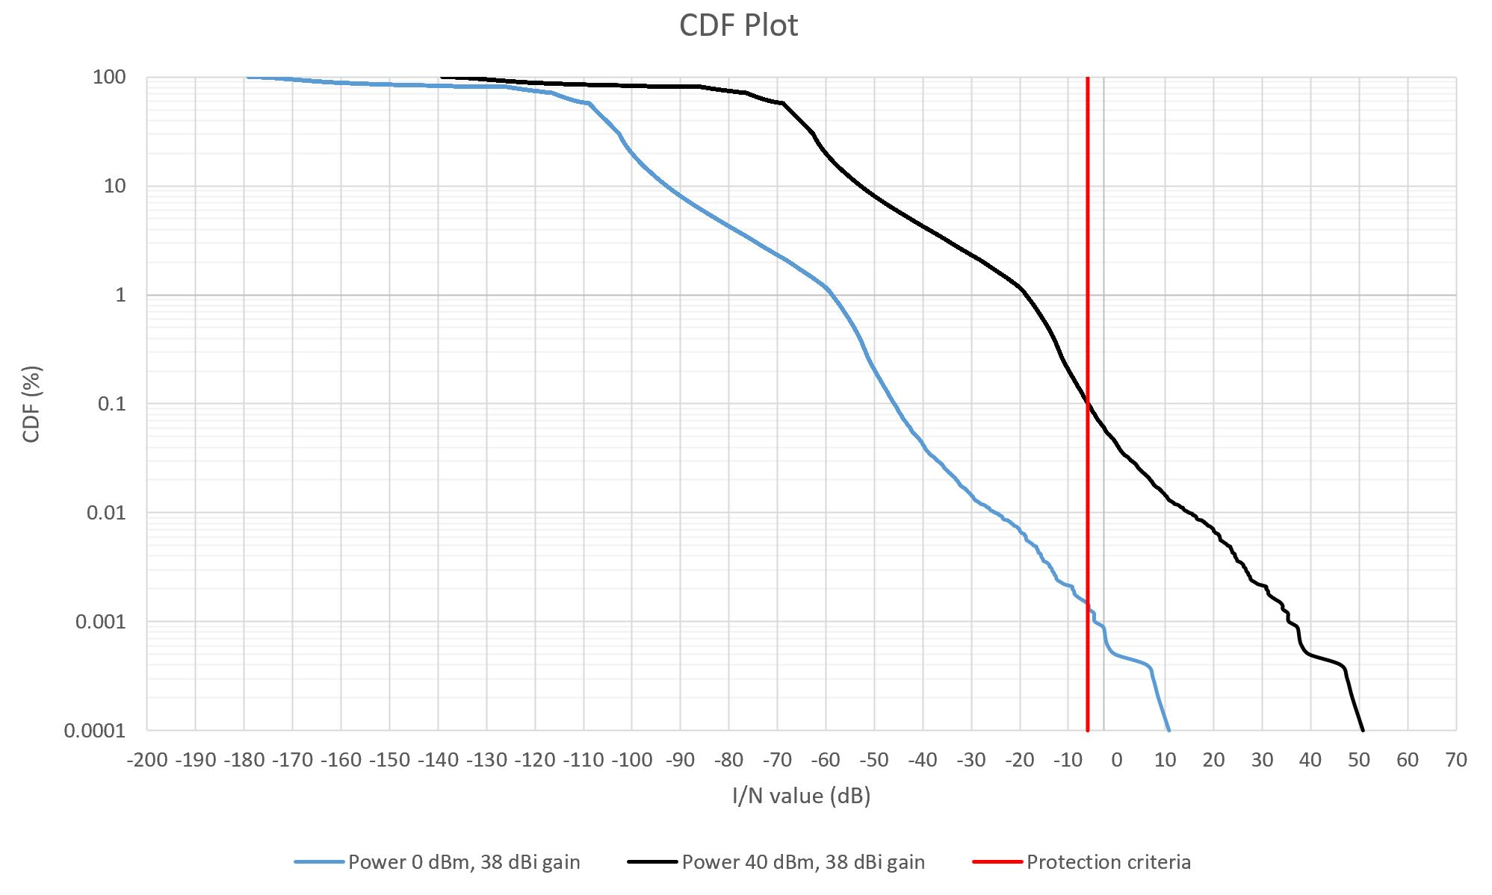

Table 13 below provides the separation distance between non-safety AMS and Radiolocation.
Table 13
Separation distance between non-safety AMS and Radiolocation
 | Non-safety AMS transmitter bandwidth (MHz) | Non-safety AMS transmitter EIRP (dBW) | Separation distance between non-safety AMS and Radiolocation (Km)
Figure 3 Wildfire observation scenario | 25 | -33 | 11
Figure 3 Wildfire observation scenario | 25 | -27 | 19
Figure 3 Wildfire observation scenario | 25 | 7 | 119
Figure 3 Wildfire observation scenario | 25 | 13 | 122
Figure 3 Wildfire observation scenario | 10 | -33 | 13
Figure 3 Wildfire observation scenario | 10 | -27 | 30
Figure 3 Wildfire observation scenario | 10 | 7 | 128
Figure 3 Wildfire observation scenario | 10 | 13 | 129
Figure 4  Search and recure scenario | 25 | -5 | 202
Figure 4  Search and recure scenario | 25 | 35 | 500
Figure 4  Search and recure scenario | 10 | -5 | 253
Figure 4  Search and recure scenario | 10 | 35 | 500
Figure 5  Surveillance mission scenario | 25 | -5 | 367
Figure 5  Surveillance mission scenario | 25 | 35 | 656
Figure 5  Surveillance mission scenario | 10 | -5 | 367
Figure 5  Surveillance mission scenario | 10 | 35 | 656
Figure 6  Internet above the clouds scenario | 25 | 8 | 623
Figure 6  Internet above the clouds scenario | 25 | 48 | 818
Figure 6  Internet above the clouds scenario | 10 | 8 | 623
Figure 6  Internet above the clouds scenario | 10 | 48 | 818
A1.3.1.2.4 Sharing studies between non-safety AMS and radiolocation service for a multiple clusters
[Editor’s note: To be populated later.]

A1.3.1.2.4 Summary of preliminary results
The results from the dynamic analysis are summarized in Table 13 above. Depend on the interference scenario and systems characteristics, a separation distance is required between non-safety AMS and Radiolocation.

To be populated later.

A1.3.2 Studies with aeronautical radionavigation service

A1.3.3 Studies with systems operating in the fixed satellite service (Earth-to-space)

A1.3.4 Studies with systems operating in the Earth exploration satellite service (passive)
To be populated later.

A1.3.5 Studies with systems operating in the space research service (passive)
To be populated later.

A1.3.6 Studies with radioastronomy
To be populated later.

ANNEX 2

Technical characteristics of systems operating in the aeronautical mobile service and sharing and compatibility studies in the
frequency band 22-22.21 GHz

A2.1 Technical characteristics of the new non-safety aeronautical mobile service systems
Representative technical and operational characteristics of the non-safety AMS systems in the frequency band 22-22.21 GHz are provided in Table 1 below.
A system is to be understood as a transceiver that may communicate with another transceiver of the same or of another system.
TABLE 13
Representative technical characteristics of systems operating in the aeronautical mobile service
within the frequency range 22-22.21 GHz

Parameter | System 1  Airborne/Ground | System 2  Airborne | System 3  Airborne/Ground | System 4  Ground
Operational altitude (see Note 1) | Up to 50,000 ft. for airborne and 3 m for ground | Up to 50,000 ft. | Up to 50,000 ft. for airborne and 3 m for ground | 3 m
Comments |  | Only used for air-to-air links | Receive only if ground-based | Receive only
Transmitter characteristics
Transmitter Tuning Range | 22 – 22.21 GHz | 22 – 22.21 GHz | 22 – 22.21 GHz | Not applicable
Transmitter bandwidth | From 10 up to 200 MHz | From 10 up to 100 MHz | From 10 up to 100 MHz | Not applicable
Transmitter power at antenna port (see Note 2) | Variable from 0 to 40 dBm ATPC (see Note 3) | Variable from 0 to 50 dBm ATPC (see Note 3) | Variable from 0 to 50 dBm (see Note 3) | Not applicable
Spectrum emission mask, unwanted emissions in the Out-of-Band (OOB) and in the spurious domains | See Figure 8 (see Note 4) | See Figure 8 (see Note 4) | See Figure 8 (see Note 4) | Not applicable
Transmitter modulation | PSK | QAM/PSK | QAM/PSK | Not applicable
Receiver characteristics
Receiver tuning range | 22-22.21 GHz | 22-22.21 GHz | 22-22.21 GHz | 22-22.21 GHz
Protection criterion expressed as C/(N+I) (see Note 5) | From -20 to 0 dB for typical values | From -20 to 0 dB for typical values | From -20 to 0 dB for typical values | From -20 to 0 dB for typical values
Receiver bandwidth | Same as the transmitter bandwidth | Same as the transmitter bandwidth | Same as the transmitter bandwidth | Same as the transmitter bandwidth
Receiver noise figure | 5 dB | 5 dB | 5 dB | 5 dB
Antenna characteristics
Type of antenna | Active antenna array | Omnidirectional | Active antenna array | Half wave dipole over conducting surface
Antenna pattern | [Rec. ITU-R M.1851] | Not applicable | [Rec. ITU-R M.1851] | See Note 6
Antenna peak gain | 25 dBi for airborne and 38 dBi for ground | From - 3 dBi up to 3 dBi | 38 dBi | 10 dBi
Typical side lobe level with respect to the main beam | -20 dB | Not applicable | -25 dB | Not applicable
Half-power beam width (in the azimuth and elevation planes) | 12° can be assumed as a default value | Not applicable | 5° can be assumed as a default value | Not applicable
Polarization | Circular | Horizontal, vertical or circular | Horizontal, vertical or circular | Horizontal, vertical or circular
Note 1: Typical values at which platforms are operated can be found in Section 7 of this report.
Note 2: The transmitter power is adjusted dynamically during the communication depending on the required C/N at the receiver and the ATPC algorithm.
Note 3: ATPC (also simply referred to as power control) is implemented as an additional feature to limit interference with other services operating in the same or in adjacent frequency bands. The power control algorithm is based on a feedback from the receiver related to the quality of the received signal.
Note 4: The Spectrum Emission Mask shown in Figure 1 respects the maximum levels of unwanted emissions in the OOB domain as per Rec. ITU-R SM.1541 and in the spurious domain as per RR Appendix 3.
Note 5: The required protection criterion C/(N+I) value varies within the specified range depending on the spreading factor used during transmission (the higher the spreading factor, the higher the processing gain at the receiver and the lower the required C/(N+I)).
Note 6: The radiation pattern for this antenna can be determined based in the formulas provided in Table 7. Note that the electric field produced by the antenna, as well as the radiated power are only used as theoretical intermediate values, given the fact that this antenna is only menat to receive signals.
[Editor’s note: Recommendation ITU-R M.1851 is currently under revision.]
[Editor’s note: It was noted that additional parameters such as operational altitude and antenna pattern (e.g., reference to ITU-R Recommendation) will be needed for studies and are expected to be provided at the next WP 5B meeting]
[Editor’s note: The maximum power fed to the antenna may be lowered depending on the results of coexistence and sharing studies.]

A2.2 Technical characteristics of the systems in the incumbent services

A2.2.1 Characteristics of the fixed service
Recommendation ITU-R F.758-7 is the reference document for the FS, containing the principles for the development of sharing criteria:
– The I/N value for long-term interference can be found in Table 5 of Annex 2.
– Guidance on short-term interference can be found in Section 4.2 of Annex 1.
Parameters of typical fixed service systems in the frequency band 21.2-23.6 GHz are taken from Table 9 of Recommendation ITU-R F.758-7 and provided in Table 14 below for reference.
WP 5C, at its July 2020 meeting (20-29 July 2020), received several contributions containing information on systems operating in the fixed service within the frequency band 22-22.21 GHz. WP 5C is currently reviewing this new information with a view to revise Recommendation ITU-R F.758-7. WP 5C will provide a further reply to WP 5B containing more up-to-date information at a future meeting, before the deadline of 15 June 2021.
TABLE 14
System parameters for point to point systems operating in the fixed service
within the frequency band 21.2-23.6 GHz
Frequency range (GHz) | 21.2-23.6
Reference ITU-R Recommendation | F.637
Modulation | FSK | 128-QAM
Channel spacing and receiver noise bandwidth (MHz) | 2.5, 3.5, 7, 14, 25⁽²⁾, 28, 50, 56, 112 | 2.5, 3.5, 7, 14, 28, 30⁽²⁾, 50, 56, 112
Tx output power range (dBW) | −10 | −13
Tx output power density range (dBW/MHz)⁽¹⁾ | −24.0 | −27.8
Feeder/multiplexer loss range (dB) | 0…3 | …
Antenna gain range (dBi) | 34.8 | …
e.i.r.p. range (dBW) | 21.8…  24.8 | …
e.i.r.p. density range (dBW/MHz)⁽¹⁾ | 7.8…10.8
Receiver noise figure typical | 11 | 6
Receiver noise power density typical (=N_{RX}) (dBW/MHz) | −133 | −138
Normalized Rx input level for  1 × 10⁻⁶ BER (dBW/MHz) | −119.6 | −108.5
Nominal long-term interference power density (dBW/MHz) | −133 + I/N | −138 + I/N
⁽¹⁾ To calculate the values for the Tx/e.i.r.p. densities, channel spacing/bandwidth needs to be identified. In these tables, the channel spacing indicated in the bold text is used.
⁽²⁾ This channel spacing value is not specified in the reference Recommendation.

32 fixed service stations have been registered to the master international frequency register.
The long term protection criterion for sharing studies is I/N = -10 as specified in Recommendation ITU-R F.758-7 Table 5 which may be exceeded by 20% of the time.
[Editor’s note: It seems useful to clarify in the text if this number of FS stations is for one country only.]

A2.2.2 Characteristics of the land mobile service
Working Party 5B notes the liaison statement from WP5A:
“As such, WP5A has currently identified, inter alia, the following ITU-R Recommendations and Reports related to the land mobile service, excluding IMT, that may be relevant for the studies in WP 5B related to WRC-23 agenda item 1.10:
– Recommendation ITU-R F.1336-5 “Reference radiation patterns of omnidirectional, sectoral and other antennas for the fixed and mobile services for use in sharing studies in the frequency range from 400 MHz to about 70 GHz”
– Recommendation ITU-R M.1825-0 “Guidance on technical parameters and methodologies for sharing studies related to systems in the land mobile service”.”
However, ITU-R M.1825-0 does not provide specific parameters. It lists several Recommendations for the land mobile service but none of the listed Recommendations applies to the frequency band under study.
Working Party 5A is confident that any additional information received from the membership, as well as any other available information in the BR databases together with any information in ITU-R Recommendations and Reports, will be provided to WP 5B prior to the 15 June 2021 deadline as established by CPM23-1.

A2.2.3 Characteristics of radioastronomy
Protection criteria for radioastronomy service are taken from Tables 1 and 2 of Recommendation ITU-R RA.769-2.
TABLE 15
Threshold levels of interference detrimental to radio astronomy continuum and spectral-line observations
Centre  frequency  f_{c}  (MHz) | Assumed bandwidth  Δf  (MHz) | Minimum antenna noise temperature  T_{A}  (K) | Receiver noise temperature  T_{R}  (K) | System sensitivity  (noise fluctuations) |  | Threshold interference levels
 |  |  |  | Temperature  ΔT  (mK) | Power spectral  density  ΔP  (dB(W/Hz)) | Input power  ΔP_{H}  (dBW) | pfd  S_{H} Δf  (dB(W/m²)) | Spectral pfd  S_{H}  (dB(W/(m² ⋅ Hz)))
22 355 (continuum observation, central frequency) | 290 | 35 | 30 | 0.085 | –269 | –195 | –146 | –231
22 200 (spectral-line observation) | 250 | 35 | 30 | 2.91 | –254 | –210 | –162 | –216

TABLE 16
Typical radio telescopes for which compatibility studies might be performed
Administration | Name | N. Latitude | E. Longitude | Height AMSL (m) | Diameter  (m)
Germany | Effelsberg | 50° 31' 29" | 06° 53' 03" | 369 | 100
South Africa | MeerKAT | −30° 43′ 16" | 21° 24' 40" | 1 054 | 64 × 13.5 m
USA | Green Bank Telescope | 38° 25' 59" | −79° 50' 23" | 250 | 100
USA | Jansky VLA | 33° 58' 22" to  34° 14' 56" | −107° 24' 40" to  −107° 48' 22" | 2 000 | 27 × 25 m
Australia | Parkes | −33º 00' 00" | 148º 15' 44" | 372 | 64
China | Tianma | 31° 05′ 13" | 121° 09′ 48" | 5 | 65
Japan | Nobeyama | 35º 56' 40" | 138º 28' 21" | 1 350 | 45
France | Plateau de Bure | 44º 38' 02" | 05° 55' 28.5" | 2 250 | 12 × 15 m

A2.2.4 Characteristics of systems operating in the earth exploration satellite service (passive)
The typical technical and operational characteristics of EESS (passive) sensors are captured in Recommendation ITU R RS.1861-0, which is currently under revision at WP 7C (see Document 7C/186, Annex 14). Table 16 below contains the characteristics of EESS (passive) sensors as included in the latest version of the working document towards a preliminary draft revision of Recommendation ITU-R RS.1861-0.
Table 16
Earth exploration satellite service (passive) sensor characteristics in the 22.21-22.5 GHz range
 | Sensor R1
Sensor type | Conical
Orbit parameters
Altitude | 833 km
Inclination | 98.6°
Eccentricity | 0
Repeat period | 25 days
Sensor antenna parameters
Number of beams | 1
Antenna size | 0.61 m
Maximum beam gain | 40.0 dBi
Polarization | V
–3 dB beamwidth | 2.09° (max)
Instantaneous field of view | 46.5 x 73.6 (Footprint size due to 1x2 averaging)
Off-nadir pointing angle | 45°
Incidence angle at Earth | 53.1°
Swath width | 1707 km
Antenna efficiency | 0.50
Beam dynamics | 1.9 s
Sensor antenna pattern | Rec. ITU R RS.1813
Cold calibration ant. Gain | NA
Cold calibration angle (degrees re. satellite track) | NA
Cold calibration angle (degrees re. nadir direction) | NA
Total FOV cross/along-track | Effective field of view (EFOV): 44.8 km (along scan) x 73.6 km (90° to scan); 1x2 spatial averaging
Sensor receiver parameters
Sensor integration time | 4.22 ms (for a single {unaveraged} sample)
Channel bandwidth | 450 MHz (max) centred at 22.235 GHz
Measurement spatial resolution
Horizontal resolution | 73.6 km
Vertical resolution | 46.5 km

Recommendation ITU-R RS.2017-0 contains the relevant performance and interference criteria for satellite passive remote sensing to be used in the sharing and compatibility studies.”
Protection criteria for EESS (passive) are taken from Table 2 of Recommendation ITU-R RS.2017-0.
TABLE 17
Interference criteria for satellite passive remote sensing
Frequency band(s)  (GHz) | Reference bandwidth (MHz) | Maximum interference level  (dBW) | Percentage of area or time permissible interference level may be exceeded⁽¹⁾ (%) | Scan mode  (N, C, L)⁽²⁾
22.21-22.5 | 100 | −169 | 0.1 | N
⁽¹⁾ For a 0.01% level, the measurement area is a square on the Earth of 2 000 000 km², unless otherwise justified; for a 0.1% level, the measurement area is a square on the Earth of 10 000 000 km² unless otherwise justified; for a 1% level, the measurement time is 24 h, unless otherwise justified.
⁽²⁾ N: Nadir, Nadir scan modes concentrate on sounding or viewing the Earth’s surface at angles of nearly perpendicular incidence. The scan terminates at the surface or at various levels in the atmosphere according to the weighting functions. L: Limb, Limb scan modes view the atmosphere “on edge” and terminate in space rather than at the surface, and accordingly are weighted zero at the surface and maximum at the tangent point height. C: Conical, Conical scan modes view the Earth’s surface by rotating the antenna at an offset angle from the nadir direction.

A2.2.5 Characteristics of systems operating in the space research service (passive)
Working Party 5B understands from the reply liaison statement received from Working Party 7C that no relevant Recommendations or parameters are available for the SRS in this frequency band.

A2.3 Results of the sharing and compatibility studies

A.2.3.1 Studies with fixed service

A2.3.1.1 Study A
This section contains a single entry study with respect to fixed service station for scenario shown on Figure 1. It is assumed that an aeronautical mobile station is providing air-to-air or air-to-ground links. The aim of the calculations is to determine maximum e.i.r.p. for non-safety aeronautical mobile station.
FIGURE 9
Interference scenario
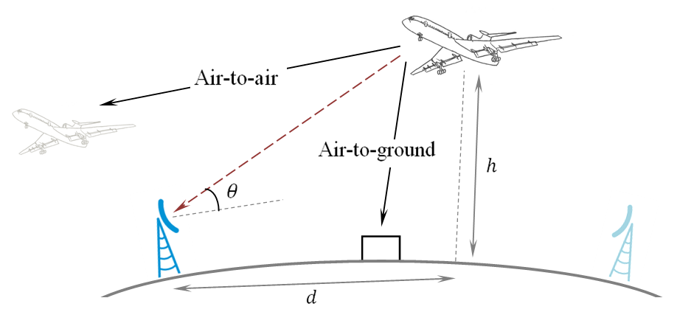
The following formula is used to calculate maximum e.i.r.p. of non-safety aeronautical mobile station:
${EIRP}_{max}\left(θ,h\right)=N_{RX}+\frac{I}{N}-G_{FS}\left(θ\right)+L(θ,h)$ (3)
where:
${EIRP}_{max}\left(θ\right)$: maximum e.i.r.p. for non-safety aeronautical mobile station, [Editor’s note: The EIRP mentioned here refers to the EIRP Fixed in the direction of the fixed service station and not to the maximum EIRP.]
$N_{RX}$: receiver noise power density from Table ‘System parameters for PP FS systems in 21.2-23.6 GHz band’ (-138 dBW/MHz for 128-QAM modulation),
$\frac{I}{N}$: long-term protection criteria (-10 dB), [Editor’s note: According to ITU-R F.758-7, this relates to the long term protection criterion which may be exceeded for bv 20% of the time. ]
$G_{FS}\left(θ\right)$: FS antenna gain in the direction of non-safety aeronautical mobile station, maximum antenna gain is taken as 34.8 dBi from Table ‘System parameters for PP FS systems in 21.2-23.6 GHz band’,
$L(θ,h)$: basic transmission loss taken as free space loss, since Recommendation ITU-R P.528-4 is limited to 125 MHz – 15.5 GHz frequency band.
[Editor’s note: This model underestimates the propagation losses and therefore the EIRP limit derived from this study could be relaxed if a more realistic propagation model would be used.]
Reference antenna radiation pattern for 34.8 dBi FS antenna according to Recommendation ITU-R F.699-8 is shown on Figure 2.
FIGURE 10
Fixed service reference antenna radiation pattern for 34.8 dBi
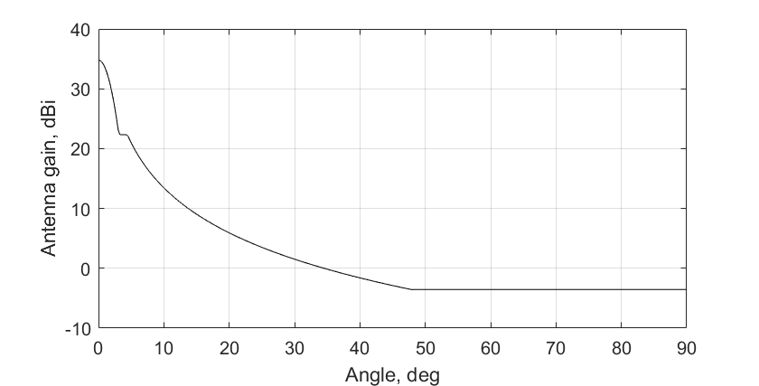
The results of maximum e.i.r.p. are shown on Figures 3-5 for different heights of non-safety aeronautical mobile station (15 km, 10 km, 5 km) for different FS elevation angles (5 degrees on Figure 3, 0 degrees on Figure 4, -5 degrees on Figure 5). Table 1 contains some points for height of aeronautical mobile station 10 km and elevation angle of FS station 0 degrees.
[Editor’s note: The term "elevation angle" is misleading in this context. This could be replaced by "down/up tilt".]
FIGURE 11
Maximum effective isotropic radiated power for scenario with a fixed service elevation angle 5 deg
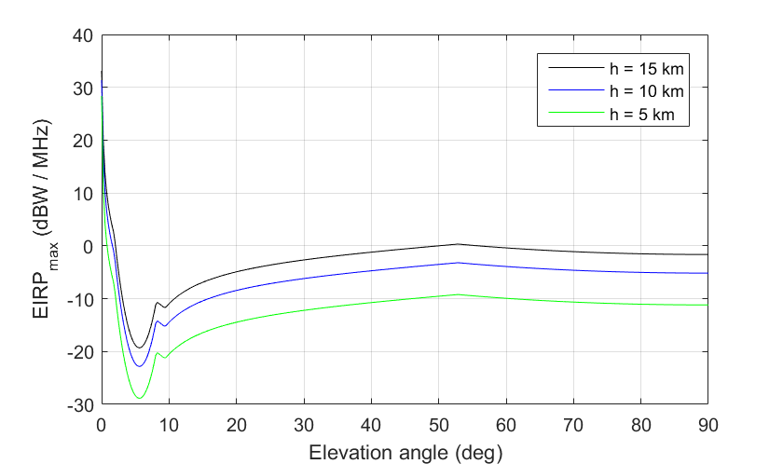
FIGURE 12
Maximum effective isotropic radiated power for scenario with fixed service elevation angle 0 deg
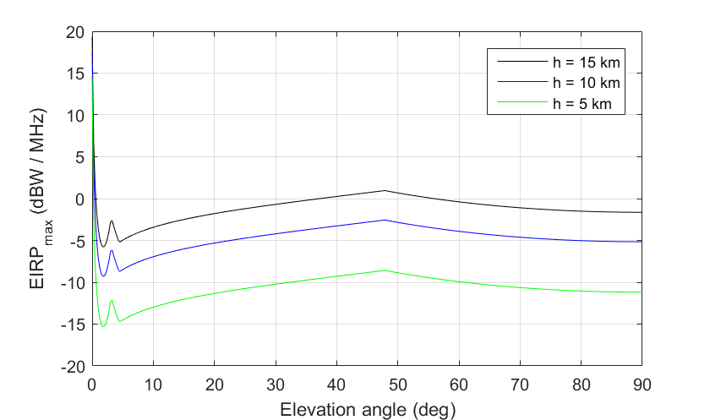
FIGURE 13
Maximum effective isotropic radiated power for scenario with fixed service elevation angle -5 deg
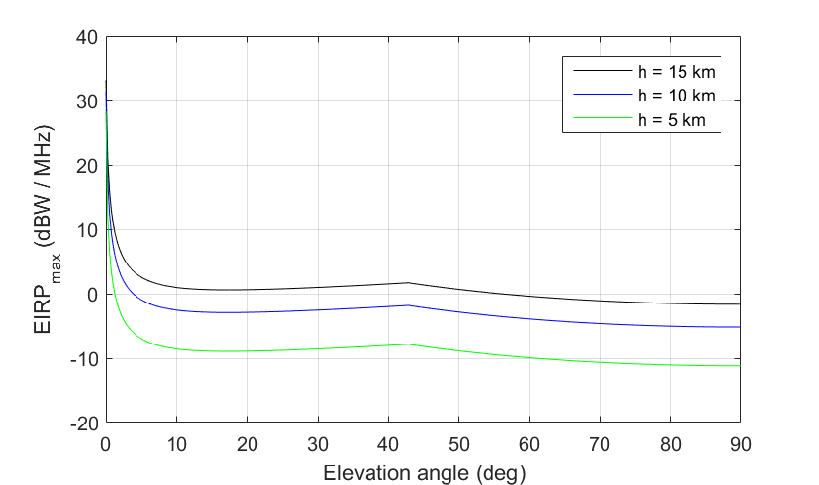

TABLE 18
Examples of calculations for h = 10 km
Elevation angle ($θ$), deg | Great-circle distance ($d$), km | Path length, km | Free space loss ($L$), dB | $G_{FS}\left(θ\right)$, dBi | ${EIRP}_{max}$, dBW/MHz
0 | 11288  [Editor’s note: This is beyond the radio horizon at 10 km altitude (which is about 350km)] | 11288 | 200.3 | 34.8 | 17.5
30 | 17.3 | 20 | 145.3 | 1.5 | -4.2
60 | 5.8 | 11.5 | 140.5 | -3.55 | -3.9
90 | 0 | 10 | 139.3 | -3.55 | -5.2

[According to the preliminary results presented on Figures 3-5, values of transmit power from Table ‘Preliminary technical characteristics of the non-safety aeronautical mobile service systems in the frequency band 22-22.21 GHz’ should be decreased to meet the FS protection requirements.]
[Editor’s note: The EIRP limit only applies only in the direction of the fixed station. Hence, it can’t be used as an absolute limit for the EIRP.]
However, this study has not considered any time percentage associated to the long term protection criterion. Furthermore, the proposed limits could be relaxed if a more realistic propagation model would be used.

A2.3.1.2 Study B
[TBD]

A2.3.2 Studies with the land mobile service
To be populated later.

A2.3.3 Studies with radioastronomy
To be populated later.

A2.3.4 Studies with the Earth exploration satellite service (passive)

A.2.3.4.1 Study A: Earth exploration satellite service (passive) adjacent band compatibility analysis: dynamic analysis based on interference with spacecraft orbit simulation

A.2.4.4.1.1 Calculation of aggregate interference
An assessment of the aggregate RFI expected from non–safety AMS systems into EESS (passive) is achieved by a dynamic simulation. The analysis will be conducted in which the orbit of the EESS (passive) spacecraft under investigation is dynamically simulated. Calculations will be performed to determine the potential interference from the proposed non–safety AMS systems into the EESS (passive) band and will consider the aggregate effect from multiple sources. The simulation will propagate the satellite based on its orbital parameters, and the time step is selected to be an irrational number to ensure that the beam dynamics of the passive sensor do not exhibit periodic behavior.. At each time step, the simulation will compute the directional vectors from each source to the EESS (passive) and then compute the gain of the transmit and receive antennas using their respective antenna patterns.
The interfering signal power level, $I_{i,n}$ (W), received by a spaceborne radiometer at the $n^{\text{th}}$ timestep from the $i^{\text{th}}$ active transmitter is calculated from:
$$\begin{aligned}I_{i,n}=\frac{{ P}_{\text{TX} i,n}G_{\text{TX} i,n}{ G}_{\text{RX} i,n}}{L_{\text{a} i,n}{ L}_{\text{FSPL} i,n} L_{\text{pol} i,n}} \#\left(\text{A1-1}\right)\end{aligned}$$
where:
${ P}_{\text{TX} i,n}$: source transmitter power in the EESS (passive) band (W);
$G_{\text{TX} i,n}$: source antenna gain towards spaceborne sensor;
$G_{\text{RX} i,n}$: spaceborne receive antenna gain towards terrestrial source;
$L_{\text{a} i,n}$ : attenuation due to atmospheric absorption;
$L_{\text{FSPL} i,n}$: Free Space Path Loss;
$L_{\text{pol} i,n}$: losses due to polarization mismatch.
The aggregate interference at the $n^{\text{th}}$ timestep,${ AggI}_{n}$ (W), is calculated by the summation of the received interference from active stations within line of sight of EESS (passive):
$$\begin{aligned}{AggI}_{n}=\sum_{i}{I_{i,n}}=\sum_{i}{\frac{{P_{\text{TX }i,n} G}_{\text{TX} i,n}{ G}_{\text{RX} i,n}}{L_{\text{a} i,n}{ L}_{\text{FSPL} i,n} L_{\text{pol} i,n}}} \#\left(\text{A1-}\text{2}\right)\end{aligned}$$
Thus, the aggregate interference can be represented in the logarithmic domain as:
$$\begin{aligned}{AggI}_{n|\text{dB}}={\left(\sum_{i}{\frac{{ P}_{\text{TX} i,n}{ G}_{\text{TX} i,n}{ G}_{\text{RX} i,n}}{L_{\text{a} i,n}{ L}_{\text{FSPL} i,n} L_{\text{pol} i,n}}}\right) }_{|\text{dB}}\#\left(\text{A1-}\text{3}\right)\end{aligned}$$
Based on time series values for the interfering signal power level, a CCDF curve will be generated in order to assess if the result exceeds the recommended performance and interference criteria that are defined in Recommendation ITU-R RS.2017-0. The criteria will used as a metric to assess the impact the non–safety AMS identification would have on the EESS (passive) systems operating 22.21-22.5 GHz band. From Recommendation ITU-R RS.2017-0, outlined in Section A2.1.2.3, the following is prescribed:
– For frequency range: 22.21-22.5 GHz, reference bandwidth: 100 MHz:
• Maximum interference level: -169 dBW,
• Percentage of area or time permissible interference level may be exceeded: 0.1%. The area analyzed should be 10 000 000 km².
The selection of the simulation area will be chosen to reflect the operational area of sensors operating in the 22.21-22.5 GHz band.

A.2.4.4.1.2 Simulation
[TBD]
{Editor’s note: Additional parameters such as operational altitude, antenna pattern (e.g., reference to ITU-R Recommendation), and transmitter out-of-band information will be needed for studies with respect to EESS (passive)}

A.2.4.4.1.3 Results of Analysis
[TBD]

A2.3.4.2 Study B
[TBD]

A2.3.5 Studies with the space research service (passive)
To be populated later.

From the aircraft to the ground network.
From the ground network to the aircraft.
Recommendation ITU-R RS.1861-0 is currently under revision at WP 7C (see Document 7C/186, Annex 14)
WP 7C cannot confirm any use of the band 15.35-15.4 GHz by passive sensors or provide any technical characteristics, operational parameters.

