| **US Radiocommunication Sector**  **FACT SHEET** | | | |
| --- | --- | --- | --- |
| **Study Group:** USWP 5B | | **Document No:** USWP5B-26-FS | |
| **Reference:** [Document 5B/355](https://www.itu.int/md/R19-WP5B-C-0355/en) Annex 27 | | **Date:** 13 October 2021 | |
| **Document Title:** Updates to Working document towards a preliminary draft new  report ITU-R M.[FOD_EESS_SHARE] | | | |
| **Authors** | **Telephone** | | **E-Mail** |
| Daniel Bishop, NASA  Josh Whitlinger, NASA (ADS) Michael Gasper, NASA | 216-433-5220  216-433-6288 216-433-3881 | | [daniel.w.bishop@nasa.gov](mailto:daniel.w.bishop@nasa.gov)  [joshua.m.whitlinger@nasa.gov](mailto:joshua.m.whitlinger@nasa.gov) [michael.r.gasper@nasa.gov](mailto:michael.r.gasper@nasa.gov) |
| **Purpose/Objective**:  Propose updates to Working document towards a preliminary draft new  report ITU-R M.[FOD_EESS_SHARE], building upon discussions and proposals at the May 2021 WP 5B meeting. | | | |
| **Abstract**:  This contribution seeks to further this work by updating the studies between FOD detection radars in the 92-100 GHz frequency range, to account for updated characteristics provided at the last meeting of WP 5B, and EESS (passive) in 86-92 GHz and EESS (active) in 94-94.1 GHz. | | | |
| **Fact Sheet Preparer:** Michael Gasper, NASA | | | |

|  |  |
| --- | --- |
| **Radiocommunication Study Groups** |  |
|  |  |
|  |  |
| Source:  Subject: FOD | **Document 5BC/XXX-E 2021 English only** |
| United States of America | |
| Updates to Working document towards a preliminary draft new report ITU-R M.[FOD_EESS_SHARE] | |
|  | |

Introduction

This contribution proposes to provide updates to Annex 2 of Preliminary Draft New Report ITU-R M.[FOD_EESS_SHARE], which contains compatibility studies between FOD and EESS (passive). Specifically, this contribution will incorporate changes to FOD characteristics and update the analyses accordingly.

Modifications against the existing text in the Chairman’s Report are shown in track changes.

**Attachment:** 1

[Content prior to section A2-1.2 remains unchanged.]

[…]

## A2-1.2 Dynamic analysis based on interference observed with spacecraft orbit simulation

The analysis will be conducted in which the orbit of the EESS (passive) spacecraft under investigation is dynamically simulated, retaining only the data points when the EESS (passive) sensor antenna boresight points within a defined Measurement Area of Interest (MAI), as defined in Recommendation ITU-R RS.2017. Calculations will be performed to determine the potential interference from each of the FOD detection radars into the EESS (passive) sensors under study and will consider the aggregate effect from multiple FOD transmitters. The simulation will propagate the satellite based on its orbital parameters, and the simulation step size is selected to be an irrational number to ensure that the beam dynamics of the passive sensor do not exhibit periodic behavior. At each simulation step, a snapshot of the interference scenario will be generated where the directional vectors from each FOD source to the EESS (passive) sensor will be computed along with the gain of the transmit and receive antennas using their respective antenna patterns.

The interfering signal power level, (dBW/100 MHz), received by a spaceborne radiometer at the simulation step from the terrestrial source is calculated from:

where:

: peak terrestrial source transmitter out-of-band emission power (dBW/100 MHz);

: terrestrial source antenna gain towards spaceborne sensor (dBi);

: spaceborne radar antenna gain towards terrestrial source (dBi);

*:* Free Space Path Loss (dB);

: other losses considered (dB).

The aggregate interference at the simulation step, (dBW/100 Hz), is calculated by the linear summation of the received interference from all transmitting, terrestrial sources within line of sight of spaceborne radiometer under consideration:

Using the resulting data containing received interfering power levels, CCDF curves will be generated to assess interference observed over the MAI.

### A2-1.2.1 Deployment of foreign object debris detection systems

This analysis considers a deployment of FOD detection systems over Japan. The FOD detection systems have a down tilt focused on the runways. The FOD detection systems are placed every 200 meters along the runways. In the case where the runway was not a multiple of 200 m, a ceiling function was used to ensure that the entire runway surface would be covered for detection of foreign objects. Two FOD deployment scenarios are considered, over large airports as well as large plus medium airports. Large airports are land airports with scheduled major airline service with millions of passengers/year, or a major military base. Medium airports are land airports with scheduled regional airline service, or regular general aviation or military traffic. The resulting FOD deployment considers 350 FOD systems placed over 13 large airports with 23 runways and 1472 FOD systems placed over 106 large plus medium airports with 130 runways. The FOD deployment is illustrated in Figure X.

FIGURE X

FOD deployment over Japan (X=large airports, O=large and medium airports).

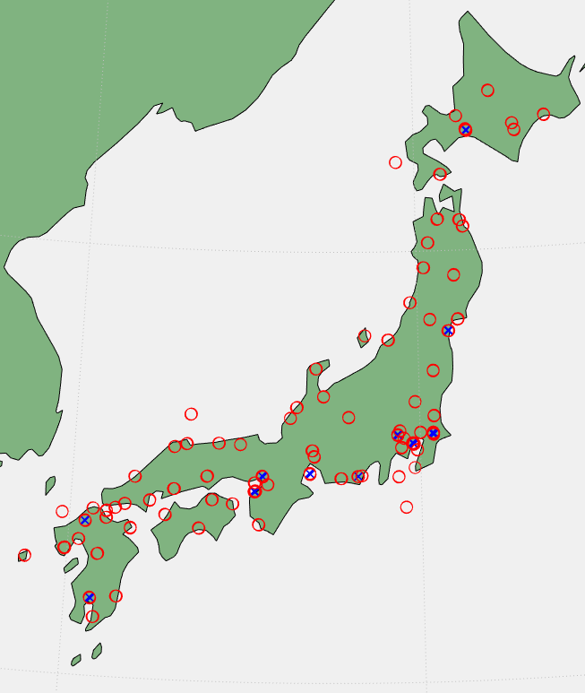

### A2-1.2.2 Characteristics of foreign object debris detection systems

The parameters of the FOD detection systems used for this initial analysis are summarized in Table X, with parameters taken from Table 1. The received interference is calculated based on the aggregate power received by all FOD detection systems. The analysis uses the FOD out-of-band power within the 86-82 GHz EESS (passive) band. As a conservative, worst-case assumption, the out-of-band power in this analysis is assumed to remain constant across the 100 MHz bandwidth considered for EESS (passive) protection. Additionally, the analysis considers all FOD systems to be operating on the same channel with 100% duty cycle.

Table X

Characteristics of FOD detection system networks

|  |  |
| --- | --- |
| Parameter | Value |
| Maximum out-of-band emission power | -50 dBm/MHz |
| Antenna gain | 44 dBi |
| Antenna Pattern | F.699-8 |
| Antenna Height | 7 m |
| Scan Rate | 15 RPM |
| Antenna Elevation Angle | -1.8° |
| Radiated Rotation Angle (azimuth scan) | +/- 60° |
| Spacing | 200 m |

#### A2-1.2.3 Characteristics of Earth exploration satellite service (passive) system



Relevant information on typical technical and operational characteristics of systems operating in the Earth exploration satellite service (EESS) (passive) systems using allocations between 1.4 and 275 GHz can be found in Recommendation ITU-R RS.1861-0, which is currently under revision in WP 7C as Draft revision of Recommendation ITU-R RS.1861 (see Document [7/38](https://www.itu.int/md/R19-SG07-C-0038/en)). All NGSO sensors from operating between 86-92 GHz are examined in this study. The EESS sensors under study were considered to have infinite out-of-band attenuation and zero in-band attenuation in this analysis.

contains the performance and interference criteria for satellite passive remote sensing.T f.

/100 MHz

#### A2-1.2.3.1 Earth exploration satellite service (passive) sensor area of interest test cases

As described in Section A2-1.2.1, this study will focus on the airports inside of Japan. Table X defines the corners of the measurement area of interest.

FIGURE X

Corner Coordinates for MAI

|  |  |  |
| --- | --- | --- |
| **-** | **Latitude, °N** | **Longitude, °E** |
| **Point 1** | 47 | 137 |
| **Point 2** | 41 | 148 |
| **Point 3** | 29 | 134 |
| **Point 4** | 36 | 123 |

### A2-1.2.4 Simulation parameters and results

#### A2-1.2.4.1 General simulation parameters

The following table gives the relevant aspects of the simulation.

Table X

General simulation parameters

|  |  |  |
| --- | --- | --- |
| Parameter | Units | Value |
| Duration | days | 20 |
| Time step | s | π/100 |
| Atmospheric losses |  | P.676 |
| Polarization losses | dB | 3 |

#### A2-1.2.4.2 Simulation results

The results of FOD interference from large airports into EESS (passive) are shown in Figure X. The results of FOD interference from large plus medium airports into EESS (passive) are shown in Figure X.

FIGURE X

Interference from FOD detection systems at large airports into EESS (passive).

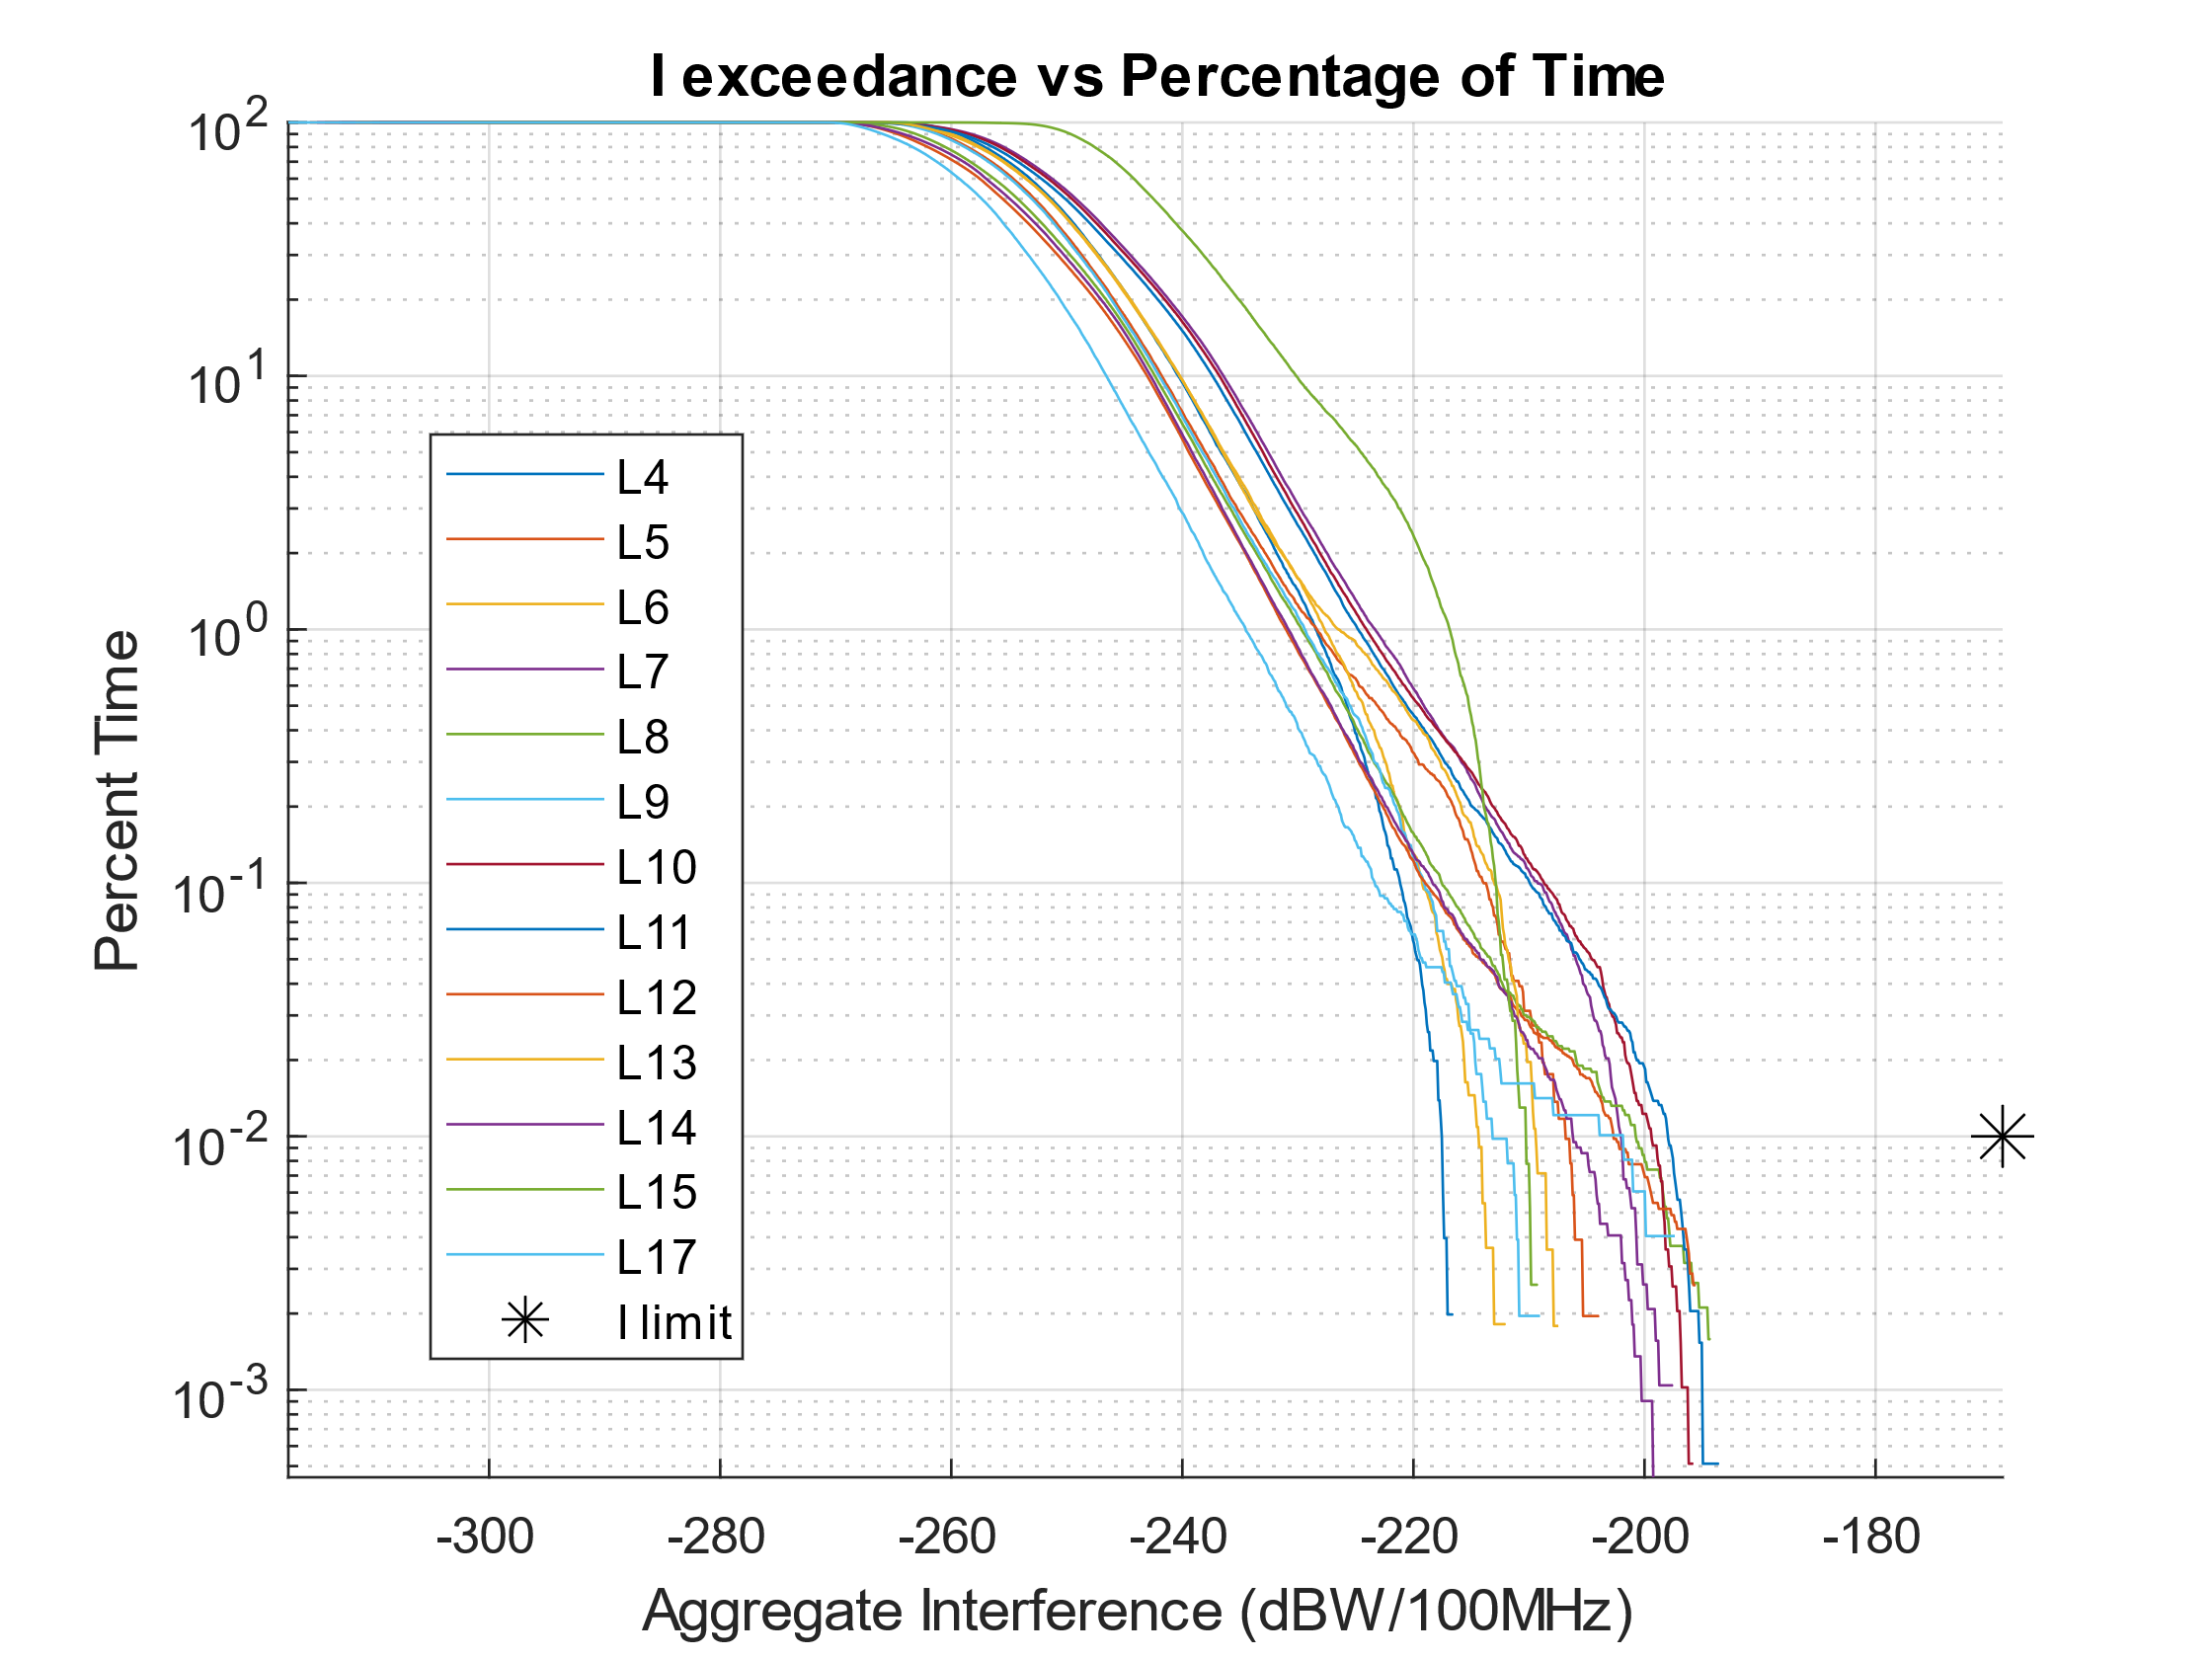

FIGURE X

Interference from FOD detection systems at large plus medium airports into EESS (passive).

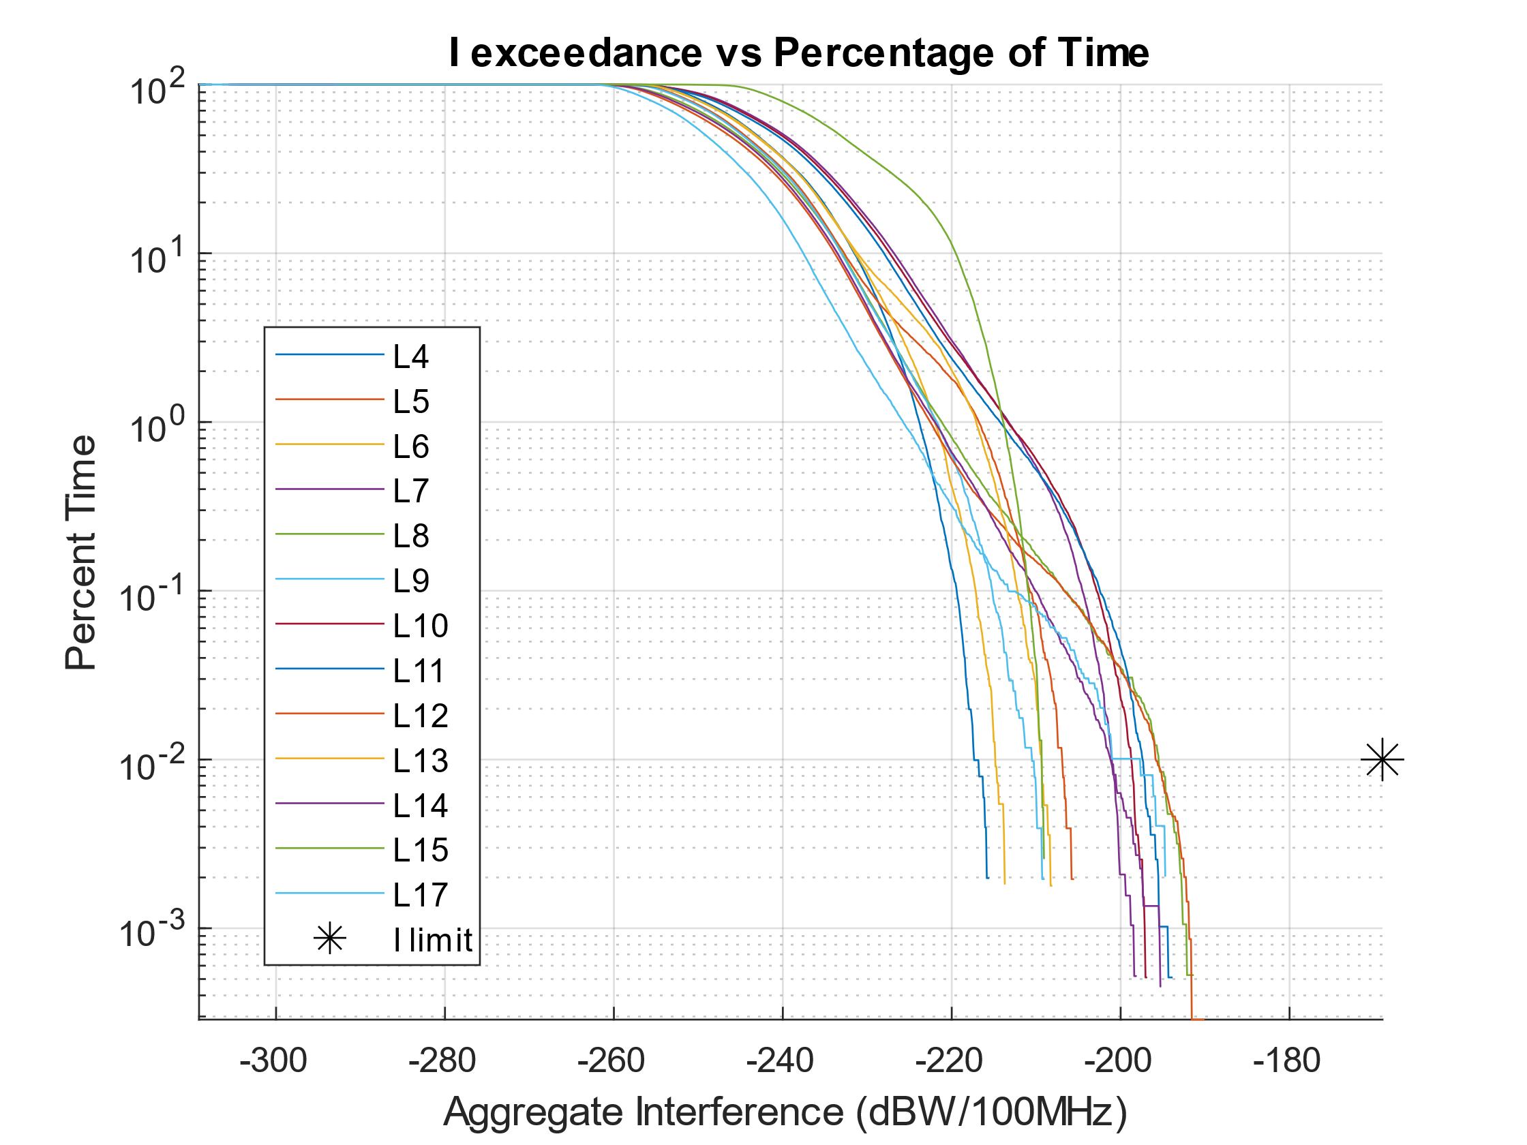

# A2-2 Summary of results

As a result of studying the interference cases outlined above, there is no expectation of interference from FOD detection systems exceeding the protection limits of EESS (passive). The worst-case results, co-frequency FOD with 100% duty cycle, between the two cases of deployment studied show a margin of at least 26.54 dB for 0.01% of time. There are only minor differences between the two deployment scenarios. The deployment on large airport runways dominates the anticipated interference, as large airport runways are most likely to have the highest number of FOD detection systems in the main beam of an EESS (passive) sensor. Conical sensors, specifically sensors L8, L10, L11, and L12, display the highest susceptibility to interference from FOD detection systems. Further studies are needed to evaluate other geographic areas that may have higher densities of airports or larger runways that may cause greater aggregation of interference from an increased number of FOD detection systems.

______________