|  |  |
| --- | --- |
| **U.S. Radiocommunications Sector**  **Fact Sheet** | |
| **Working Party:** ITU-R WP 5B | **Document No:** USWP5B27-31 (Final Draft) |
| **Ref:** WRC-23 AI 1.8/Res 171  5B/165 | **Date:** 13 October 2021 |
| **Document Title:** WORKING DOCUMENT TOWARDS DRAFT CPM REPORT Chapter 2 AGENDA ITEM 1.8 (WRC-23) - Use of fixed-satellite service (FSS) networks by control and non-payload communications of unmanned aircraft systems | |
| **Author(s)/Contributors(s):**  Don Nellis  Federal Aviation Administration  800 Independence Ave., S.W.  Washington, DC 20591  Mohammed Rahman  Federal Aviation Administration  800 Independence Ave., S.W.  Washington, DC 20591  Michael Neale  ACES Corporation for the FAA  Scott Kotler  Director, Technical Regulatory Affairs  Civil & Regulatory Affairs  Lockheed Martin Corporation  2121 Crystal Drive Suite 100 Arlington, VA 22202 | Phone: (202) 267-9779  e-mail: Donald.Nellis@faa.gov  Phone: (202) 267-6573  e-mail: Mohammed.Rahman@faa.gov  Phone: (858) 705-8978  e-mail: michael.neale@ACES-INC.COM  Phone: (703) 413-3102  e-mail: scott.kotler@lmco.com |
| **Purpose/Objective:** The purpose of this contribution is to update the initial draft of CPM Text for Agenda Item 1.8 (WRC-23) in document 5B/165. | |
| **Abstract:** This contribution will propose updates to the draft CPM Text for Agenda Item 1.8 (WRC-23). The updates will add additional elements that need to be in the CPM text. | |

|  |  |
| --- | --- |
| **Radiocommunication Study Groups** |  |
|  |  |
|  |  |
| Received: XX November 2021  Source: Document 5B/165-E  Subject: WRC-23 agenda item 1.8 Resolution **171 (WRC-19)** | **Document 5B/XXX-E** |
| **13 October 2021** |
| **English only** |
| United States of America | |
| Working Document towards a draft  CPM report – Chapter 2 – WRC-23 agenda item 1.8 | |
|  | |

**Introduction**

This contribution replaces Document 5B/165 that updates the proposal for a Working Document Towards Draft CPM Text for Agenda Item 1.8 in order to satisfy the provisions of Resolution **155 (Rev.WRC-19)** for Earth Stations on Unmanned Aircraft. The redline/strikeout text identifies the updates to Document 5B/165

**Proposal**

The United States proposes that this document be reviewed and used to begin the process of developing CPM Text for Agenda Item 1.8. Note, this Draft CPM Text does not include a proposed modification of Resolution **155** since updates to that Resolution are being considered separately. Updates to Resolution **155** will be incorporated into the Draft CPM text at a later date.

**Attachment**:

ATTACHMENT

Working Document towards a draft   
CPM report – Chapter 2 – WRC-23 agenda item 1.8

CHAPTER 2

Aeronautical and maritime issues

(Agenda items 1.6, 1.7, 1.8, 1.9, 1.10, 1.11)

Agenda item 1.8

(**WP 5B[1]\*** / **WP 4A, WP 4B**)

*1.8 to consider, on the basis of ITU R studies in accordance with Resolution****171 (WRC‑19)****, appropriate regulatory actions, with a view to reviewing and, if necessary, revising Resolution* ***155 (Rev.WRC-19)*** *and No.* ***5.484B*** *to accommodate the use of fixed-satellite service (FSS) networks by control and non-payload communications of unmanned aircraft systems;*

Resolution **171 (WRC-19)** – *Review and possible revision of Resolution* ***155 (Rev.WRC-19)*** *and No.* ***5.484B*** *in the frequency bands to which they apply*

### 2/1.8/1 Executive summary

*[Text of the executive summary, not more than half a page of text to describe briefly the purpose of the agenda item, summarize the results of the studies carried out and, most importantly, provide a brief description of the method(s) identified that may satisfy the agenda item. See also § A2.1 of Annex 2 to* [*Resolution ITU-R 2-8*](http://www.itu.int/pub/R-RES-R.2-8-2019)*]*

Report ITU-R M.2171 identified the spectrum requirements for unmanned aircraft (UA) command and non-payload communication (CNPC) that would be needed to support flight through non-segregated airspace. Those requirements identified the need for both line of sight (LOS) and beyond line of sight (BLOS) spectrum. While the LOS requirements were addressed at the World Radiocommunication Conference held in 2012 the BLOS requirements were only partially addressed at the World Radiocommunications Conference held in 2015.

Agenda item 1.8 was therefore established to continue the BLOS work and take action, if necessary, to accommodate the use of fixed-satellite service (FSS) networks by UA CNPC Links.

*[Editor’s Note: a summary of the results of the studies and a brief description of the method(s) is still needed in the Executive Summary.]*

### 2/1.8/2 Background

*[Text of the background, not more than half a page of text to provide general information in a concise manner, in order to describe the rationale of the agenda items (or issue(s)). See also §A2.2 of Annex 2 to* [*Resolution ITU-R 2-8*](http://www.itu.int/pub/R-RES-R.2-8-2019)*]*

In the context of this agenda item, an unmanned aircraft system (UAS) consist of a geostationary satellite operating under a fixed-satellite service (FSS) allocation, an unmanned aircraft (UA) with an Earth stations on-board to interconnect the communication link between this UA and associated remote Earth station, called "unmanned aircraft control station” (UACS). UA are aircraft that do not carry a human pilot but that are piloted remotely, i.e. through a reliable communication link from outside the aircraft.

There are a variety of existing and envisioned applications of UAS in the fields of economy, public safety and science. Further details on UAS applications in can be found in Report ITU-R M.2171. The operation of UA requires addressing the same issues as manned aircraft, namely safe and efficient integration into the air traffic control system.

### 2/1.8/3 Summary and analysis of the results of ITU-R studies

*[This section should contain a summary of the technical and operational studies performed within ITU-R, including a list of relevant ITU-R Recommendations. Depending on the agenda item, this section could be divided in two parts, one part dealing with the summary and the other part dealing with the analysis. The results of the ITU-R studies should also be analysed with respect to the possible methods of satisfying the agenda item, and presented in a concise manner.]*

## 2/1.8/3.1 Summary of technical and operational studies

[TBD]

## 2/1.8/3.2 Relevant ITU-R recommendations and reports

ITU-R Recommendations, relevant for studies under WRC-23 agenda item 1.8, as appropriate, are:

– ITU-R [F.758-5](http://www.itu.int/rec/R-REC-F.758/en), ITU-R [F.1494](http://www.itu.int/rec/R-REC-F.1494/en), ITU-R [F.1495](http://www.itu.int/rec/R-REC-F.1495/en), ITU-R [F.1565](http://www.itu.int/rec/R-REC-F.1565/en);

– ITU-R [M.1180](http://www.itu.int/rec/R-REC-M.1180/en), ITU-R [M.1233](http://www.itu.int/rec/R-REC-M.1233/en), ITU-R [M.1372](http://www.itu.int/rec/R-REC-M.1372/en), ITU-[R M.1643](http://www.itu.int/rec/R-REC-M.1643/en), ITU-R [M.1644](http://www.itu.int/rec/R-REC-M.1644/en), ITU‑R [M.1730](http://www.itu.int/rec/R-REC-M.1730/en), ITU-R [M.2008](http://www.itu.int/rec/R-REC-M.2008/en);

– ITU-R [SF.1650](http://www.itu.int/rec/R-REC-SF.1650/en), ITU-R [S.524-9](http://www.itu.int/rec/R-REC-S.524/en), ITU-R [SF.1006](http://www.itu.int/rec/R-REC-SF.1006/en), ITU-R [S.1432](http://www.itu.int/rec/R-REC-S.1432/en).

ITU-R Reports, relevant for the studies under WRC-23 agenda item 1.8 are:

– ITU-R [M.2171](http://www.itu.int/pub/R-REP-M.2171), [ITU-R M.2233](http://www.itu.int/pub/R-REP-M.2233).

New ITU-R Reports developed for this topic are:

– Preliminary draft new Report ITU-R [UA_PFD]

## 2/1.8/3.3 Analysis of the results of studies

There are four different types of links between unmanned aircraft earth stations and the fixed-satellite service (FSS) space stations:

**Link 1** UACS Earth station to FSS space station.

**Link 2** FSS space station to UA Earth station

**Link 3** UA Earth station to FSS space station

**Link 4** FSS space station to UACS Earth station

A depiction of these links can be found in Figure 1.

Figure 1

**Elements of UAS architecture using the FSS**

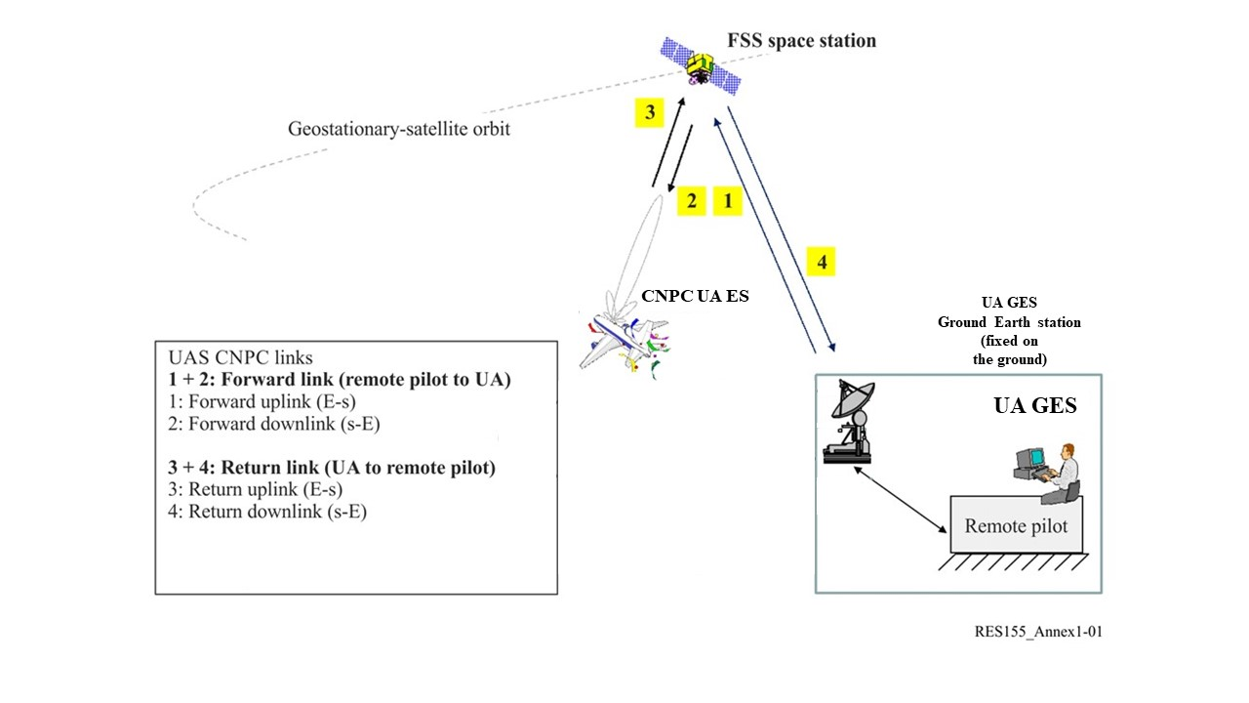

Links 1 and 4, are locate at fixed locations and are thus consistent with existing FSS Earth station operations. Links 2 and 3 are mobile and require additional consideration. This additional consideration involves ensuring that:

1. the operations of the mobile Earth stations on-board the unmanned aircraft are consistent with expected FSS performance (Links 2 and 3);
2. the mobile Earth stations on-board the unmanned aircraft are designed to ensure acceptable operations in the presence of expected emissions from the terrestrial services (Link 2). and;
3. the terrestrial services that operate in the same bands are protected from harmful interference from the mobile Earth station on-board the unmanned aircraft (Link 3).

### 2/1.8/4 Methods to satisfy the agenda item

*[This section should contain the brief description of the Method or Methods to satisfy the agenda item as per Section A2.4 of Annex 2 to* [*Resolution ITU-R 2-8*](http://www.itu.int/pub/R-RES-R.2-8-2019)*]*

After considering the progress obtained by the International Civil Aviation Organization (ICAO) in the process of preparing Standards and Recommended Practices (SARPs) for unmanned aircraft systems, the studies to protect the terrestrial services from harmful interference, and the implementation of Resolution **156 (WRC-15)**, revisions to No. **5.484B** and Resolution **155 (Rev. WRC-19)** are proposed to satisfy this Agenda Item. The intention being that compliance with the Resolution would ensure that all required ITU-R technical, operational, and regulatory conditions are met, permitting the use of compliant FSS links to support UAS CNPC operations without adversely affecting existing and future FSS networks or terrestrial services.

### 2/1.8/5 Regulatory and procedural considerations

*[Example(s) of regulatory text relating to the Method(s) to satisfy the agenda item]*

In response to resolves 1 and resolves 2 of Resolution **171 (WRC-19)** and with input from Administrations and the International Civil Aviation Organization (ICAO), the following modifications are provided for consideration.

MOD

**5.484B** The operation of earth stations on board unmanned aircraft communicating with geostationary fixed-satellite service (FSS) space stations within the frequency bands 10.95-11.2 GHz (space-to-Earth), 11.45-11.7 GHz (space-to-Earth), 11.7-12.2 GHz (space-to-Earth) in Region 2, 12.2-12.5 GHz (space-to-Earth) in Region 3, 12.5-12.75 GHz (space-to-Earth) in Regions 1 and 3 and 19.7-20.2 GHz (space-to-Earth), and in the frequency bands 14-14.47 GHz (Earth-to-space) and 29.5-30.0 GHz (Earth-to-space) are an application of the FSS and shall be subject to the application of Resolution **155 (Rev. WRC-23)**. (WRC-23)

MOD

Resolution **155 (WRC-19)**

[Editor’s note: The above mentioned modification of Resolution 155 is being considered separately and will be incorporated into this CPM Text once the text of the Resolution has been agreed upon.]

SUP

RESOLUTION 171 (WRC‑19)

Review and possible revision of Resolution 155 (Rev.WRC-19) and  
No. 5.484B in the frequency bands to which they apply

_________________

1. * Note: See relevant text in CPM23-1 meeting report (Annex 4 to BR Administrative Circular [CA/251](https://www.itu.int/md/R00-CA-CIR-0251/en)) on how to facilitate the work related to satellite.