|  |  |
| --- | --- |
| U.S. Radiocommunications Sector  Fact Sheet | |
| **Working Party:** ITU-R WP 5B | **Document No:** USWP5B27-12-FD |
| **Ref:** Resolutions 155 and 171  Document [5B/284](http://www.itu.int/md/R19-WP5B-C-0284/en) | **Date:** 21 October 2021 |
| **Document Title:** EXAMPLE REVISION TO RESOLUTION 155 (Rev.WRC-19) IN SUPPORT OF STUDIES UNDER WRC-23 AGENDA ITEM 1.8 | |
| **Author(s)/Contributors(s):**  Name: Don Nellis  Org: Federal Aviation Administration  Name: Michael Neale  Org: ACES Corporation for the FAA  Name: Scott Kotler  Org: Lockheed Martin Corporation | Phone: (202) 267-9779  Email: [Donald.Nellis@faa.gov](mailto:Donald.Nellis@faa.gov)  Phone: (858) 705-8978  Email: [michael.neale@aces-inc.com](mailto:michael.neale@aces-inc.com)  Phone: (703) 789-3923  Email: [scott.kotler@LMCO.com](mailto:scott.kotler@LMCO.com) |
| **Purpose/Objective:** The purpose of this contribution is to develop an example revision of Resolution 155 (Rev.WRC-19) being considered under WRC-23 agenda item 1.8. | |
| **Abstract:** Under Resolution 171 (WRC-19) for WRC-23 Agenda Item 1.8, WP 5B is required to complete, in time for WRC-23, relevant studies of the regulatory aspects in relation to the implementation of Resolution 155 (Rev.WRC-19). It is also required to review Resolution 155 (Rev.WRC-19) taking into account the results of those studies. This contribution considers discussions taking place through the Correspondence Group and the last WP 5B to develop a revision of Resolution 155. | |

|  |  |
| --- | --- |
| **Radiocommunication Study Groups** |  |
|  |  |
|  |  |
| Received: XX August 2021  Source: Resolution **155 (Rev.WRC-19)** Resolution **171 (WRC-19) 5B/284** | **Document 5B/XXX-E** |
| **X August 2021** |
| **English only** |
| United States of America | |
| example REVISION TO  RESOLUTION **155** **(Rev.WRC-19)** IN SUPPORT OF STUDIES UNDER  WRC-23 AGENDA ITEM 1.8 | |
|  | |

# 1 Introduction and proposals

Based on the discussions in WP 5B and the Correspondence Group, an example revision of Resolution **155 (Rev.WRC-19)** is necessary for CNPC links using Earth Stations on Unmanned Aircraft and for protecting radiocommunication services under WRC-23 agenda item 1.8. Using Resolution **155 (Rev.WRC-19),** Resolution **169 (WRC-19)**, and document 5B/284 as source material, the United States proposes that Working Party (WP) 5B consider the attached example to improve the clarity and conciseness of Resolution **155 (Rev.WRC-19)**.

**Attachment:** 1

Attachment

RESOLUTION 155 (REV.WRC‑23)

Regulatory provisions related to earth stations on board unmanned aircraft which operate with geostationary-satellite networks in the fixed-satellite   
service in certain frequency bands not subject to a Plan of Appendices 30,   
30A and 30B for the control and non-payload communications of   
unmanned aircraft systems in non-segregated airspaces[1]*

The World Radiocommunication Conference (XXX, 2023),

considering

*a)* that the operation of unmanned aircraft systems (UAS) requires reliable control and non-payload communication (CNPC) links, in particular to relay air traffic control communications and for the remote pilot to control the flight;

*b)* that satellite networks may be used to provide CNPC links of UAS beyond the line-of-sight, as shown in Annex 1 to this Resolution;

*c)* that CNPC links between space stations and stations on board unmanned aircraft (UA) are permitted to be operated under this Resolution in the primary fixed-satellite service (FSS) in frequency bands shared with other primary services, including terrestrial services, however that would not preclude the use of other available allocations to accommodate this application,

considering further

that UAS CNPC links relate to the safe operation of UAS and have to comply with certain technical, operational and regulatory requirements,

noting

*a)* that WRC‑15 adopted Resolution **156 (WRC‑15)** on the use of earth stations in motion communicating with geostationary FSS space stations in the frequency bands 19.7-20.2 GHz and 29.5-30.0 GHz;

*b)* that Report ITU‑R M.2171 provides information on characteristics of UAS and spectrum requirements to support their safe operation in non-segregated airspace,

recognizing

*a)* that the UAS CNPC links will operate in accordance with international standards and recommended practices (SARPs) and procedures established in accordance with the Convention on International Civil Aviation;

*b)* that, in this Resolution, conditions are provided for operations of CNPC links without prejudging whether the International Civil Aviation Organization (ICAO) would be able to develop SARPs to ensure safe operation of UAS under these conditions;

*c)* that Section VI of Article **22** contains limits on equivalent isotropically radiated power at off-axis angles of 3 degrees or more for earth stations of a geostationary satellite network in the fixed-satellite service in the frequency bands 14-14.47 GHz and 29.5-30 GHz;

*d)* that terrestrial services operate in the frequency bands 10.95-11.2 GHz, 11.45-11.7 GHz, 11.7-12.1 GHz (Region 2), 12.1-12.2 GHz (on the territory of the country listed in No. **5.489**), 12.2-12.5 GHz (Region 3), 12.5-12.75 GHz (on the territory of the countries listed in No. **5.494** and in Region 3);

*e)* that terrestrial services also operate in the frequency bands 14.0-14.3 GHz (on the territory of countries listed in No. **5.505**), 14.25-14.3 GHz (on the territory of countries listed in No. **5.508**), 14.3-14.4 GHz (Regions 1 and 3), and 14.4-14.47 GHz;

*f)* that CNPC links using Earth stations onboard Unmanned Aircraft are not subject to the regulatory provisions that apply to Earth Stations in Motion (ESIM),

resolves

1 that, for CNPC links using Earth stations onboard Unmanned Aircraft (“CNPC UA ES”) communicating with a GSO FSS space station within the frequency bands 10.95-11.2 GHz (space-to-Earth), 11.45-11.7 GHz (space-to-Earth), 11.7-12.2 GHz (space-to-Earth) in Region 2, 12.2-12.5 GHz (space-to-Earth) in Region 3, 12.5-12.75 GHz (space-to-Earth) in Regions 1 and 3 and 19.7-20.2 GHz (space-to-Earth), and in the frequency bands 14‑14.47 GHz (Earth-to-space) and 29.5-30.0 GHz (Earth-to-space), or parts thereof, are an application of the primary FSS (Fixed-Satellite Service) and the following conditions shall apply:

1.1 with respect to space services in the frequency bands referred to in *resolves* 1, the notifying administration of the GSO FSS network shall ensure that its CNPC UA ES complies with the following conditions:

1.1.1 with respect to satellite networks or systems of other notifying administrations, the CNPC UA ES characteristics shall remain within the envelope of characteristics of the Typical Earth stations associated with the satellite network with which the CNPC UA ES communicates;

1.1.2 that CNPC UA ES shall be designed and operated so as to be able to meet their required performance with interference caused by other satellite networks resulting from application of Articles **9** and **11** andthe use of CNPC UA ES shall not cause more interference and shall not claim more protection than any Typical Earth station in that GSO FSS network;

1.1.3 the operation of CNPC UA ES shall comply with the coordination agreements for the frequency assignments of the Typical Earth station of the GSO FSS networks obtained under the relevant provisions of the Radio Regulations, taking into account *resolves 3.4*;

1.1*.*4 for the implementation of *resolves*1.1.1, the notifying administration for the GSO FSS networks with which the CNPC UA ES communicate shall, in accordance with this Resolution, send to the Radiocommunication Bureau (BR) information on assignments for which the UG station class shall be applied or, alternatively, the relevant Appendix 4 notification information related to the characteristics of the CNPC UA ES intended to communicate with those GSO FSS networks, together with the commitment that the CNPC UA ES operation shall be in conformity with the Radio Regulations, including this Resolution;1.2 with respect to terrestrial services in the frequency bands referred to in *resolves* 1, the notifying administration of the GSO FSS network shall ensure that its CNPC UA ES complies with the following conditions:

1.2.1 receiving CNPC UA ES in the frequency bands referred to in *recognizing d)* shall be designed and operated so as to be able to accept the interference from stations of terrestrial services to which the frequency band is allocated when those stations of terrestrial services operate in accordance with the Radio Regulations;

1.2.2 transmitting CNPC UA ES in the frequency bands referred to in *recognizing e)* shall be designed and operated so as to not cause harmful interference to stations of terrestrial services to which the frequency band is allocated when those terrestrial stations operate in accordance with the Radio Regulations, and Annex 2 (See *instructs the Director of the Radiocommunication Bureau* 1) to this Resolution shall apply so as to set the conditions for protecting terrestrial services from harmful interference in neighbouring countries in these frequency bands;

1.2.3 higher pfd levels than those provided in Annex 2 produced by CNPC UA ES on the surface of the Earth within any administration shall be subject to the prior agreement of that administration;

1.3 that, in order to protect the radio astronomy service in the frequency band 14.47-14.5 GHz, the notifying administration of the GSO FSS network operating CNPC UA ES in accordance with this Resolution in the frequency band 14-14.47 GHz within line-of-sight of radio astronomy stations are urged to take all practicable steps to ensure that the emissions from CNPC UA ES in the frequency band 14.47-14.5 GHz do not exceed the level and percentage of data loss given in the most recent versions of Recommendations ITU-R RA.769 and ITU-R RA.1513;

2 that CNPC UA ES

2.1 using station class UG are permitted to communicate with a space station of a geostationary FSS satellite network operating in the frequency bands listed in *resolves* 1 and limited to the frequency bands listed in *resolves* 1 when communicating with a space station of a geostationary FSS satellite network under this resolution;

2.2 assignments of an FSS satellite network shall not constrain other FSS satellite networks beyond those already imposed by Typical Earth stations associated with the network during the application of the provisions of Articles **9** and **11** norresult in additional coordination constraints on terrestrial services under Articles**9** and **11**;

2.3 in application of this Resolution does not provide a regulatory status that is different from that derived from the GSO FSS networks with which they communicate, taking into account the provisions referred to in this Resolution (see *resolves 3.4*);

3 that, in order to ensure freedom from harmful interference, that may affect operation of UAS, the notifying administration of the GSO FSS network shall cooperate with the administration of the country in which the UA is registered to:

3.1 ensure that the use of CNPC UA ES is in accordance with international standards and recommended practices (SARPs) consistent with Article 37 of the Convention on International Civil Aviation;

3.2 take the required measures, consistent with No. **4.10**,to ensure freedom from harmful interference to CNPC UA ES and operated in accordance with this Resolution;

3.3 act immediately when their attention is drawn to any such harmful interference, as freedom from harmful interference to CNPC UA ES is imperative to ensure their safe operation, taking into account *resolves* 1.2.1;

3.4 use assignments associated with the FSS networks for CNPC UA ES (see Figure 1 in Annex 1), including assignments to space stations, Specific or Typical Earth stations and CNPC UA ES (see *resolves* 2.2), that have been successfully coordinated under Article **9** (including provisions identified in *resolves* 1.1.4) and recorded in the Master International Frequency Register (MIFR) with a favourable finding under Article **11**,including Nos. **11.31, 11.32** or **11.32A** where applicable, and except those assignments that have not successfully completed coordination procedures under No. **11.32** by applying Appendix **5** § 6.d.i (see *instructs the Director of the Radiocommunication Bureau* 2);

3.5 use techniques to maintain antenna pointing accuracy for the operation of CNPC UA ES with the associated GSO FSS satellites, without inadvertently tracking adjacent GSO satellites;

3.6 take all necessary measures so that CNPC UA ES `are subject to permanent monitoring and control by a network control and monitoring centre (NCMC) or equivalent facility in order to comply with the provisions in this Resolution;

3.7 provide NCMC or equivalent facility permanent points of contact for the purpose of tracing any suspected cases of harmful interference from CNPC UA ES and to immediately respond to requests from the points of contact of authorizing administrations;

4 that the procedures in Section VI of Article 15 apply when

4.1 CNPC UA ES causes harmful interference to stations of primary allocated services that are operating in accordance with the Radio Regulations;

4.2 CNPC UA ES receives harmful interference from stations of a primary allocated service that are not operating in accordance with the Radio Regulations;

5 that the notifying administration of the GSO FSS network shall ensure that the operation of CNPC UA ES within the territories, including territorial waters and territorial airspaces, of an administration shall be carried out only if authorized by that administration,

instructs the Director of the Radiocommunication Bureau

1 upon receipt of the notification information referred to in *resolves*1.1.4, the BR shall examine it with respect to the provisions referred to in *resolves*1.1.1, the commitments received with respect to the provisions referred to in *resolves* 1.1.4, conformity with *resolves* 3.4, and with respect to the conformity with the power flux-density (pfd) limits on the Earth’s surface specified in Annex 2 along with any agreements obtained as referred to in *resolves* 1.2.3;

2 if the finding from the examination in *instructs* 1 is favourable, the BR shall publish the modified or additional assignment along with the results of such examinations in the International Frequency Information Circular (BR IFIC) and the modified or additional assignment shall retain the priority date of protection with that of the existing assignment,

instructs the Secretary-General

to bring this Resolution to the attention of the Secretary General of ICAO.

Annex 1 to Resolution 155 (rev.WRC‑19)

UAS CNPC links

Figure 1

Elements of UAS architecture using the FSS

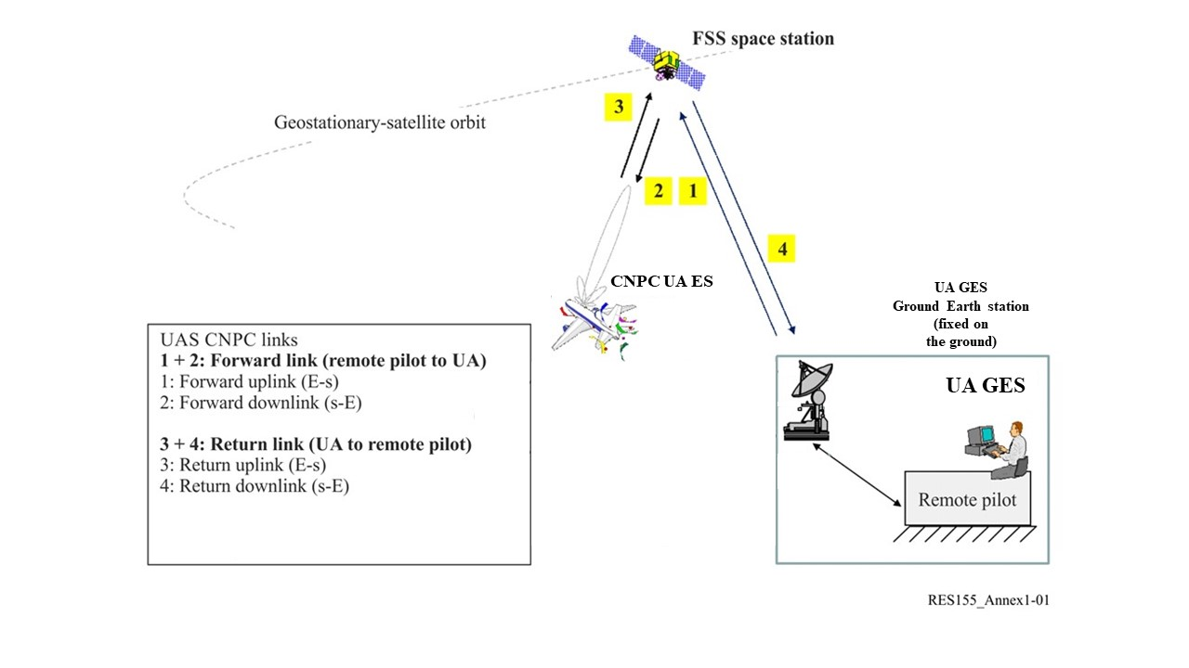

Annex 2 to Resolution 155 (rev.WRC‑23)

Protection of the fixed service from CNPC UA ES emissions

*Editor’s note: Annex 2 is to be reviewed and appropriate modifications to be made.*

a) Example provided to WRC-15

The fixed service is allocated by table entries and footnotes in several countries with co-primary status with FSS. Conditions of UA using CNPC shall be such that the fixed service is protected from any harmful interference as follows:

An earth station on board UA in the frequency band 14.0-14.47 GHz shall comply with provisional power flux-density (pfd) limits described below:

−132 + 0.5 · θ dB(W/(m2 · MHz)) for 0° ≤ θ ≤ 40°

−112 dB(W/(m2 · MHz)) for 40° < θ ≤ 90°

where θ is the angle of arrival of the radio-frequency wave (degrees above the horizontal).

NOTE – The aforementioned limits relate to the pfd and angles of arrival that would be obtained under free‑space propagation conditions.

b) Example provided to WRC-19

An earth station on board UA in the frequency band 14.0-14.3 GHz shall comply with the pfd limits described below, on the territory of countries listed in No.**5.505**:

     for 0° ≤ θ ≤ 90°

where θ is the angle of arrival of the radio-frequency wave (degrees above the horizontal).

An earth station on board UA:

– in the frequency band 14.25-14.3 GHz on the territory of countries listed in No. **5.508**;

– in the frequency band 14.3-14.4 GHz in Regions 1 and 3;

– in the frequency band 14.4-14.47 GHz worldwide,

shall comply with the pfd limits described below:

     for 0° ≤ θ ≤ 90°

where θ is the angle of arrival of the radio-frequency wave (degrees above the horizontal).

NOTE – The aforementioned limits relate to the pfd and angles of arrival that would be obtained under free‑space propagation conditions.

______________

1. * May also be used consistent with international standards and practices approved by the responsible civil aviation authority.