U.S. Radiocommunications Sector
Fact Sheet
Working Party: ITU-R WP 5B | Document No: USWP5B28-02
Ref: 5B/481 Annex 1 on AI 1.6 | Date: February 18, 2022
Document Title: Working Document towards Draft CPM Text for WRC-23 Agenda Item 1.6
Author(s)/Contributors(s):  Chris Tourigny  FAA Spectrum Engineering Services  Michael Tran  MITRE  Nader Damavandi  Space Exploration Technologies  Damon Ladson  Harris, Wiltshire & Grannis  Donald Jansky  Joseph Cramer  Boeing |  | Phone: 202-267-3071  Email: chris.tourigny@faa.gov  Phone: 703-983-1295  Email: mtran@mitre.org  Phone: 310-219-7854  Email: nader.damavandi@spacex.com  Phone: (202) 730-1315  Email: dladson@hwglaw.com  Phone: 202-415-1834  Email: don@jansky-barmat.com  Phone: 703-465-3486  Email: joseph.cramer@boeing.com
Purpose/Objective: This contribution provides updates to the Working Document towards Draft CPM Text for WRC-23 Agenda Item 1.6 to facilitate the introduction of sub-orbital vehicles (SoV).
Abstract: Resolution 772 (WRC-19), in preparation for Agenda Item 1.6 (WRC-23), invites the ITU-R to study the spectrum needs for stations on board sub-orbital vehicles, any appropriate modification to the Radio Regulations, excluding any new allocations or changes to the existing allocations in Article 5, and to identify whether there is a need for access to additional spectrum that should be addressed after WRC-23 by a future competent conference. This contribution provides some regulatory provisions to the WD-Draft CPM Text for WRC-23 AI 1.6 to facilitate the introduction of sub-orbital vehicles.

Radiocommunication Study Groups | 
Source: Document 5B/481 – Annex 1  Subject: WRC-23 AI 1.6 Draft CPM Text | Document 5B/
 | 29 March 2022
 | English only
United States of America
working document towards draft cpm text for WRC-23 agenda item 1.6

Introduction
Resolution 772 (WRC-19), in preparation for Agenda Item 1.6 (WRC-23), invites the ITU-R to study the spectrum needs for stations on board sub-orbital vehicles, any appropriate modification to the Radio Regulations, excluding any new allocations or changes to the existing allocations in Article 5, and to identify whether there is a need for access to additional spectrum that should be addressed after WRC-23 by a future competent conference. This contribution provides some regulatory provisions to the WD-Draft CPM Text for WRC-23 AI 1.6 to facilitate the introduction of sub-orbital vehicles.
Attachment: 1

ATTACHMENT
working document towards draft cpm text for wrc-23 agenda item 1.6

CHAPTER 2
Aeronautical and maritime issues
(Agenda items 1.6, 1.7, 1.8, 1.9, 1.10, 1.11)
Agenda item 1.6
(WP 5B* / WP 3M, WP 4A, WP 4C, WP 7B, WP 7D)

1.6 to consider, in accordance with Resolution 772 (WRC 19), regulatory provisions to facilitate radiocommunications for sub-orbital vehicles;
Resolution 772 (WRC 19) - Consideration of regulatory provisions to facilitate the introduction of sub-orbital vehicles.

2/1.6/1 Executive summary
[Text of the executive summary, not more than half a page of text to describe briefly the purpose of the agenda item, summarize the results of the studies carried out and, most importantly, provide a brief description of the method(s) identified that may satisfy the agenda item. See also § A2.1 of Annex 2 to Resolution ITU-R 2-8]

To address this agenda item, ITU-R has undertaken studies, including a review of existing M-Series Reports and Recommendations, ICAO Standards and Recommended Practices (SARPs), and RR provisions, pursuant to Resolution 772 (WRC-19), to facilitate the safe integration of sub-orbital vehicles.
Four Methods are proposed to address this agenda item:
Method A
No change to the Radio Regulations (RR).
Method B
A WRC Resolution, not incorporated by reference in the RR.
Method C
Modification of RR Article 4.

Method D
No Change to RR Article 4.

2/1.6/2 Background
[Text of the background, not more than half a page of text to provide general information in a concise manner, in order to describe the rationale of the agenda items (or issue(s)). See also § A2.2 of Annex 2 to Resolution ITU-R 2-8]
Within Report ITU-R M.2477, suborbital flight is described as “The intentional flight of a vehicle expected to reach the upper atmosphere with a portion of its flight path that may occur in space without completing a full orbit around the Earth before returning back to the surface of the Earth”, and a suborbital vehicle is “a vehicle executing suborbital flight.”
WRC-23 agenda item 1.6 is intended, among other aspects, to safely integrate suborbital vehicles into the same airspace as conventional aircraft during their transition to and from space in order to minimize the airspace disruption.

2/1.6/3 Summary and Analysis of the results of ITU-R studies
[This section should contain a summary of the technical and operational studies performed within ITU-R, including a list of relevant ITU-R Recommendations. Depending on the agenda item, this section could be divided in two parts, one part dealing with the summary and the other part dealing with the analysis. The results of the ITU-R studies should also be analysed with respect to the possible methods of satisfying the agenda item and presented in a concise manner.]

Radio stations operating onboard suborbital vehicles are expected to operate in frequency bands currently allocated for both terrestrial and space services. Some inconsistencies were raised during the preparations for WRC-23 agenda item 1.6, between the operational use of stations on-board suborbital vehicles, and the definitions of terrestrial stations in RR No 1.62, earth stations in RR No 1.63, and space stations in RR No 1.64. While in the RRs, each station shall be classified by the service in which it operates permanently or temporarily (RR No. 1.61), the suborbital vehicle may be physically located within the major portion of Earth’s atmosphere or beyond for a brief period of time, but the physical location of the suborbital vehicle on which the stations are located does not necessarily change the need for, or purpose of, the use of specific radiocommunication services.

Studies found in Report ITU-R M.2477 show that suborbital vehicle operations require making unavailable large areas of international and national airspace during their transition to and from space. This results in airspace disruptions, extra travel time, re-routing flight paths, additional aircraft fuel consumption, etc. The studies also shows the feasibility of using the current aircraft avionics systems onboard suborbital vehicles, to facilitate the safe integration of suborbital vehicles into the same airspace as conventional aircraft during their transition to and from space in order to minimize the airspace disruption. The report also identified several existing radiocommunications services that can be used by stations onboard suborbital vehicles, but may not necessarily be limited to: a) AM(R)S for VHF voice and data communications and ADS-B; b) RNSS for navigation with GNSS systems in 1 164-1 215 MHz and 1 559-1 610 MHz; MSS for voice and data communications; and MS and MSS for TT&C applications. The use of existing aircraft avionics systems by suborbital vehicles can be supported by the existing Article 5 RR provisions without modification.

2/1.6/4 Methods to satisfy the agenda item
[This section should contain the brief description of the Method or Methods to satisfy the agenda item as per section A2.4 of Annex 2 to Resolution ITU-R 2-8]

2/1.6/4.1 Method A: No change (NOC).
[This method NOC covers the case in which the assessment of suborbital vehicles operating relative to the current regulatory conditions under the Radio Regulations are sufficient to address their requirements.]

2/1.6/4.2 Method B: Example text for a new WRC-23 Resolution on the assignment and use of frequencies

This method is for a WRC-23 Resolution to specify that terrestrial and earth stations onboard sub-orbital vehicles may use frequencies allocated to mobile, mobile-satellite, radionavigation, and radionavigation-satellite services during all phases of flight. This provision does not preclude the use of space stations onboard sub-orbital vehicles.

2/1.6/4.3 Method C: Modification to Article 4 of the Radio Regulations: Assignment and use of frequencies
This method is an alternative of Method B that clarifies the use of terrestrial and Earth stations operating in the mobile, mobile-satellite, radionavigation, and radionavigation-satellite service allocations for radiocommunications with and used by suborbital vehicles, in all phases of flight,through a new provision to be added to RR Article 4.

2/1.6/4.4 Method D: No change to Article 4 of the Radio Regulations

2/1.6/5 Regulatory and procedural considerations
[Example(s) of regulatory text relating to the Method(s) to satisfy the agenda item]

2/1.6/5.1 For Method A: No Change
[Example(s) of regulatory text for the first method to satisfy the agenda item]
NOC

2/1.6/5.2 For Method B: New WRC-23 Resolution
[Example(s) of regulatory text for the method to satisfy the agenda item]

MOD
RESOLUTION [XYZ] (WRC-23)

Radiocommunication Services for Use by Stations Onboard Suborbital Vehicles
The World Radiocommunication Conference ( 2023),
Considering
a) that sub-orbital vehicles operate at higher altitudes than conventional aircraft, with a sub-orbital trajectory;
b) that sub-orbital vehicles operate through the lower levels of the atmosphere, where they may operate in the same airspace as conventional aircraft;
c) that sub-orbital vehicles may perform various missions (e.g. conducting scientific research or providing transportation) and then return to the Earth’s surface without completing a full orbital flight around the Earth;
d) that stations on board sub-orbital vehicles have a need for voice/data communications, navigation, surveillance, and telemetry, tracking and command (TT&C);
e) that sub-orbital vehicles must be safely accommodated into airspace used by conventional aircraft during certain phases of flight;
f) that there is a need to ensure that equipment installed on sub-orbital vehicles can communicate with air traffic management systems and relevant ground control facilities;
g) that vehicles operating at the boundary of space and the atmosphere or re-entering the atmosphere may generate a plasma sheath that may envelop all or most of the vehicle;

recognizing
a) that some sub-orbital flights could reach altitudes for a brief period of time in space without sufficient energy to sustain persistent orbit.
b) that there is no internationally agreed legal demarcation between the Earth’s atmosphere and the space domain;
c) that Report ITU-R M.2477 describes sub-orbital flight as an intentional flight of a vehicle expected to reach the upper atmosphere with a portion of its flight path that may occur in space without completing a full orbit around the Earth before returning back to the surface of the Earth;
d) that Report ITU-R M.2477 describes a sub-orbital vehicle as a vehicle executing sub-orbital flight;
dc) that stations on-board sub-orbital vehicles may use systems operating under space and/or terrestrial services;

e) that Annex 10 to the Convention on International Civil Aviation contains Standards and Recommended Practices (SARPs) for aeronautical radionavigation and radiocommunication systems used by international civil aviation;

f) that most space launch systems may include components or items not reaching orbital trajectories, but some of these components or items may be developed as reusable items operating on sub-orbital trajectories;

noting

a) that Report ITU-RM.2477 provides information on radiocommunications for sub-orbital vehicles, including a description of the flight trajectory, categories of sub-orbital vehicles, technical studies related to possible avionics systems used by sub-orbital vehicles, and service allocations of those systems;
b) that the provisions of No. 4.10 may apply to certain aspects of these operations;
c) that the development of compatibility criteria between International Civil Aviation Organization (ICAO) standardized aeronautical systems is the responsibility of ICAO;

resolves

1 that terrestrial and Earth stations onboard suborbital vehicles may communicate using the mobile, mobile-satellite, radionavigation, and radionavigation-satellite services during all phases of flight, as necessitated by the application. This provision does not preclude the use of space stations on-board sub-orbital vehicles.

instructs the Secretary-General
to bring this Resolution to the attention of ICAO.
invites the International Civil Aviation Organization
to take into account this Resolution and relevant portions of Report ITU-R M.2477 in the course of developing SARPs for ICAO systems that may be used by sub-orbital vehicles.

Reasons: This action will clarify that sub-orbital vehicles may communicate with terrestrial and Earth stations operating in the mobile, mobile-satellite, radionavigation, and radionavigation-satellite services, during all phases of flight, as necessitated by the application.

2/1.6/5.3 For Method C: Modification to Article 4

ARTICLE 4
Assignment and use of frequencies
ADD
4.XX Terrestrial and Earth stations located on-board suborbital vehicles are authorized to use frequencies allocated to mobile, mobile-satellite, radionavigation, and radionavigation-satellite services, during all phases of flight, as necessitated by the application.
(see Nos. 1.61, 1.62, 1.63, and 1.64). This provision does not preclude the use of space stations on-board sub-orbital vehicles.
SUP
RESOLUTION 772 (WRC-19)
Consideration of regulatory provisions to facilitate
the introduction of sub-orbital vehicles

2/1.6/5.4 For Method D: No Method C
No Change to Article 4 of the Radio Regulations
[Example(s) of regulatory text for the method to satisfy the agenda item]

Annex
Figure 1
Examples of the operational concepts of a suborbital flight.
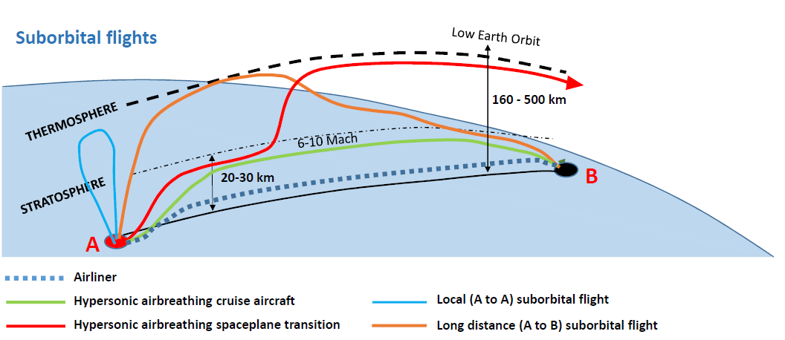

* Note: See relevant text in CPM23-1 meeting report (Annex 4 to BR Administrative Circular CA/251) on how to facilitate the work related to satellite.

