| **US Radiocommunication Sector**  **FACT SHEET** | | | |
| --- | --- | --- | --- |
| **Study Group:** USWP 5B | | **Document No:** USWP5B-AMS_EESSShare | |
| **Reference:** [Document 5B/481](https://www.itu.int/md/R19-WP5B-C-0481/en) Annex 31 | | **Date:** 17 February, 2022 | |
| **Document Title:** Updates to Working document towards a preliminary draft new  report ITU-R [NON-SAFETY AMS CHARACTERISTICS AND SHARING STUDIES] | | | |
| **Authors** | **Telephone** | | **E-Mail** |
| Daniel Bishop, NASA  Ryan S. McDonough, NASA | 216-433-5220  216-433-2862 | | [daniel.w.bishop@nasa.gov](mailto:daniel.w.bishop@nasa.gov)  [Ryan.S.McDonough@nasa.gov](mailto:Ryan.S.McDonough@nasa.gov) |
| **Purpose/Objective**:  Propose updates to Working document towards a preliminary draft new report ITU-R [NON-SAFETY AMS CHARACTERISTICS AND SHARING STUDIES], building upon the chairman’s report from the October 2021 WP 5B meeting. | | | |
| **Abstract**:  This contribution seeks to further this work by expanding and updating the studies of adjacent band compatibility between the potential new AMS allocation in 22-22.21 GHz and EESS (passive) in 22.21-22.5 GHz in section A.2.3.3 of the working document. This work will address comments from the October 2021 WP 5B drafting group discussion on this section. Also, it will incorporate consideration of scenarios 4.3 “search and rescue” and 4.4 “border surveillance”. | | | |
| **Fact Sheet Preparer:** Ryan McDonough, (NASA) | | | |

|  |  |
| --- | --- |
| **Radiocommunication Study Groups** |  |
|  |  |
|  |  |
| Source: Document 5B/TEMP/169  Subject: Draft new Report on WRC-23 agenda item 1.10 | **Annex 31 to Document 5B/481-E** |
| **23 December 2021** |
| **English only** |
| Annex 31 to Working Party 5B Chairman’s Report | |
| WORKING DOCUMENT TOWARDS A PRELIMINARY DRAFT NEW  REPORT ITU-R [NON-SAFETY AMS CHARACTERISTICS AND SHARING STUDIES] RELATED TO wrc-23 AGENDA ITEM 1.10 | |
| **Technical characteristics, operational scenarios, spectrum needs, coexistence, and sharing studies of non-safety aeronautical mobile systems in the  frequency bands 15.4-15.7 GHz and 22-22.21 GHz** | |

[Note to Editor: Content prior to section A2.3.3 of the CR contain no modifications proposed by this document.]

[…]

#### A2.3.3 Compatibility studies with the EESS (passive)

##### A.2.3.3.1 Compatibility Study A

###### A.2.4.4.1.1 Calculation of Aggregate Interference

An assessment of the aggregate RFI expected from non–safety AMS systems into EESS (passive) is achieved by a dynamic simulation. The analysis will be conducted in which the orbit of the EESS (passive) spacecraft under investigation is dynamically simulated. Calculations will be performed to determine the potential interference from the proposed non–safety AMS systems into the EESS (passive) band and will consider the aggregate effect from multiple sources. The simulation will propagate the satellite based on its orbital parameters, and the time step is selected to be an irrational number to ensure that the beam dynamics of the passive sensor do not exhibit periodic behavior. At each time step, the simulation will compute the directional vectors from each source to the EESS (passive) and then compute the gain of the transmit and receive antennas using their respective antenna patterns.

The interfering signal power level, (W), received by a spaceborne radiometer at the timestep from the active transmitter is calculated from:

where:

: source transmitter power in the EESS (passive) band (W);

: source antenna gain towards spaceborne sensor;

: spaceborne receive antenna gain towards terrestrial source;

 : attenuation due to atmospheric absorption;

: Free Space Path Loss;

: losses due to polarization mismatch.

The aggregate interference at the timestep, (W), is calculated by the summation of the received interference from active stations within line of sight of EESS (passive):

Thus, the aggregate interference can be represented in the logarithmic domain as:

Based on time series values for the interfering signal power level, a CCDF curve will be generated in order to assess if the result exceeds the recommended performance and interference criteria that are defined in Recommendation ITU-R RS.2017-0. The criteria will used as a metric to assess the impact the non–safety AMS identification would have on the EESS (passive) systems operating 22.21-22.5 GHz band. From Recommendation ITU-R RS.2017-0, outlined in Section A2.1.2.3, the following is prescribed:

– For frequency range: 22.21-22.5 GHz, reference bandwidth: 100 MHz:

• Maximum interference level: -169 dBW,

• Percentage of area or time permissible interference level may be exceeded: 0.1%. The area analyzed should be 10 000 000 km2.

The selection of the simulation area will be chosen to reflect the operational area of sensors operating in the 22.21-22.5 GHz band.

###### A.2.4.4.1.2 Simulation

The transmitter OOB information was numerically integrated from Figure 8 received power into the target range 22.21-22.31 GHz. The operational altitude of the EESS sensor and antenna pattern are described in A2.2.4 and are 833 km and Recommendation ITU-R RS.1813-1 respectively. With respect to the data networks above the clouds scenario (operational scenario 4.5), the operational altitude of the AMS systems was 10km and the antenna pattern was omnidirectional with maximum gain of 3dB. With respect to the wildfire observation scenario (operational scenario 4.2), the operational altitude of the flight systems were 0.1km and antenna pattern were omni-directional. The ground systems for this scenario utilized an omnidirectional pattern.

[***Editor’s note***– USA acknowledged that if the deployment densities computed in this section are significantly different from the values provided in section 4, the simulation will need an update.]

The 22.21-22.5 GHz EESS (passive) analysis of this study will focus on current available representative characteristics of AMS systems within this frequency range. If the deployment densities are significantly different from the assumed values, the simulation will need an update to verify co-existence potential. The calculation methodology from Section A.2.4.4.1.1 is inherited for consideration of aggregated emission reception.

A.2.4.4.1.2.1 Simulation parameters and methodology

The analysis band for this study is 22.21-22.31 GHz centered at 22.26 GHz. An AMS emission center frequency of 22.175 GHz, 25 MHz from the band edge, with a 50 MHz bandwidth was chosen to be in line with the EESS (passive) protection criteria of -169 dBW/100 MHz. Subsequent channels incorporate a 50 MHz offset further away from the band edge to accommodate channel assignment specific to AMS scenarios. Analysis was done along the band edge to determine the level of unwanted emissions into the EESS (passive) band. Table A3-8 gives the rest simulation parameters that were assumed for this simulation.

[***Editor’s note*** - It was asked why is the EESS (passive) band under study 22.21-22.31 GHz and not 22.21-22.5 GHz. USA replied that the protection criteria of RS.2017-0 Table 2 prescribes total interference power occurring inside a reference bandwidth. This means interference power may not exceed the stated value for the percentage time (or area) within the reference bandwidth regardless of total bandwidth utilized by the system (if greater). We chose to study the band edge case 100MHz reference bandwidth for this study. This results in the 22.21-22.31 GHz range which is indeed may be smaller than the full operational range.

There were also questions regarding the assummed bandwidth of the AMS systems and USA remarked that bandwidth values were taken from Table 13 where all scenarios include the possibility of 100MHz bandwidth. It was remarked that 50MHz is the updated value for wildfire observation. However, is it a median value or some systems use larger or smaller bandwidth?]

Table A2.4.4.1.2.1-1

**General simulation parameters**

|  |  |  |
| --- | --- | --- |
| Parameter | Units | Value |
| Simulation Frequency | MHz | 22 160 |
| Duration | days | 25 |
| Time Step | S | 1×π |
| Atmospheric Losses |  | P.676-12 |
| RF Prop. Models  Air-space ground-space |  | P.1409 P.619 |
| Polarization Losses | dB | 3 (C-V) |
| FDR | dB | 10.3 (C1),  47.0 (C2) |
| EESS (passive) Band Power | dBW/100MHz | -54 |

The simulation was run for a 25 day duration with a 1×π second time step to collect an appropriate amount of sample points to achieve statistical significance of results. Atmospheric losses (La ) were calculated using Recommendation ITU-R P.676-12. According to guidance from WP 3K and 3M liaison statement [5B/369](https://www.itu.int/md/R19-WP5B-C-0369/en) the preferred propagation model for ground-space interference computations is [ITU-R P.619](https://www.itu.int/rec/R-REC-P.619/en) and the preferred propagation model for ground-air interference computations is [ITU-R P.1409](https://www.itu.int/rec/R-REC-P.1409/en). These were implemented to produce propagation losses noting that ITU-R P.619 and ITU-R P.1409 internally account for atmospheric losses attributed to use of ITU‑R P.676. The irrational time step of 1×π was chosen to create a random non-uniform distribution of the EESS locations and azimuth pointing angles during satellite orbit within the simulation run time.

This analysis assumes the band edge reduction and incursion into the OOB region as described in Section A1.1 and Figure 8. This equates to -10.3 dB FDR (Channel 1) and -47.0 dB FDR (Channel 2) in the EESS (passive) frequency band of 22.21 to 22.31 GHz. If more than two channels are utilized by a scenario (e.g. scenario 4.5), then channels further away from the band edge than the two immediately adjacent band are subject to even more FDR and will have significantly less impact on observed interference power in-band of the EESS passive than the nearest two to the band edge.. If the FDR is lower than the presumed value, the simulation and co-existence may have to be revaluated.

The RF and general parameters of the AMS system under simulation were derived from System 1 of Table 13 in Section A.2.1. In the absence of an explicit deployment, a generic one was considered and provisionally proposed to be representative. Two configurations were constructed: one aimed to approximate the description of the “Wildfire observation” found in section 4.2, and the other adopts aspects of “Internet above the clouds” found in Section 4.5.

For the first configuration (operational scenario 4.2, wildfire observation), a density of randomly deployed ground central locations were placed in the a ground centered 10 million sq. km EESS passive mission area of interest (MAI) centered at 68 W, 0 N, with associated ground stations taken in ratio 2 to 1 ground to air stations. See Figure A.2.4.4.1.2.1-1A and A.2.4.4.1.2.1-4. Circular flight paths of radius 1 km-10 km were inscribed about the central focal point as described in Section 4.2. Communication between air and ground station enforced a pointing arrangement consistent with Section 4.2 were based on shortest distance to ground receiver. Channel assignment was allocated on a sequential basis in accordance with section 5 Spectrum Requirements Table 7. A single experimental simulation was performed for each transmitter density deployment and the repetition of the run may serve to establish bounds of uncertainty in a subsequent iteration of this study. The aim of this analysis was to determine what density of systems could operate a downlink main beam within the MAI without imposing harmful interference to the EESS passive service.

For the second configuration (operational scenario 4.5, data networks above the clouds), a list of commercial air-routes was used to serve as the navigational reference basis for AMS device air platform station emissions. The density of flight paths is taken to be representative of the route traffic given by the dataset. Air-air transmissions consistent with the description in Section 4.5 were established which enforced a pointing arrangement based on shortest distance to air-based receiver. Channel assignment was allocated on a sequential basis in accordance with section 5 Spectrum Requirements Table 7. A single experimental simulation was performed and the repetition of the run may serve to establish bounds of uncertainty in a subsequent iteration of this study. The aim of this analysis was to determine the density of systems that could operate a downlink (air-air link) within the MAI without imposing harmful interference to the EESS passive service. Two 10 million sq. km EESS passive MAIs centered at (68 W, 0 N) and (91 W, 0 N) were considered as representatives of overground and oversea areas, respectively. See Figures A.2.4.4.1.2.1-1A/B and A.2.4.4.1.2.1-3A/B.

A region of this size was selected over the Amazon River basin to be used for this simulation.

When the EESS R1 sensor main beam is within the MAI, the active air-air and air-ground links with line-of-sight to the R1 were computed and aggregated receive power density computed using Section A.2.4.4.1.1. Interference events are considered only for that time that the EESS R1 sensor is making measurements from within the MAI. However, an extension of the MAI of 1 degree in each direction was used to determine those aeronautical systems that could additionally contribute interference.

[***Editor’s note*** – France and Germany remarked that if AMS densities are derived from continental routes, a conservative activity factor should be introduced.]

Figure A.2.4.4.1.2.1-1A

EESS R1 MAI (overland)

Figure A.2.4.4.1.2.1-1A shows the ground demark of the EESS R1 Area of Interest utilized for all simulation runs of configurations 1 and 2 (overland case).

Figure A.2.4.4.1.2.1-1B

EESS R1 MAI (oversea)

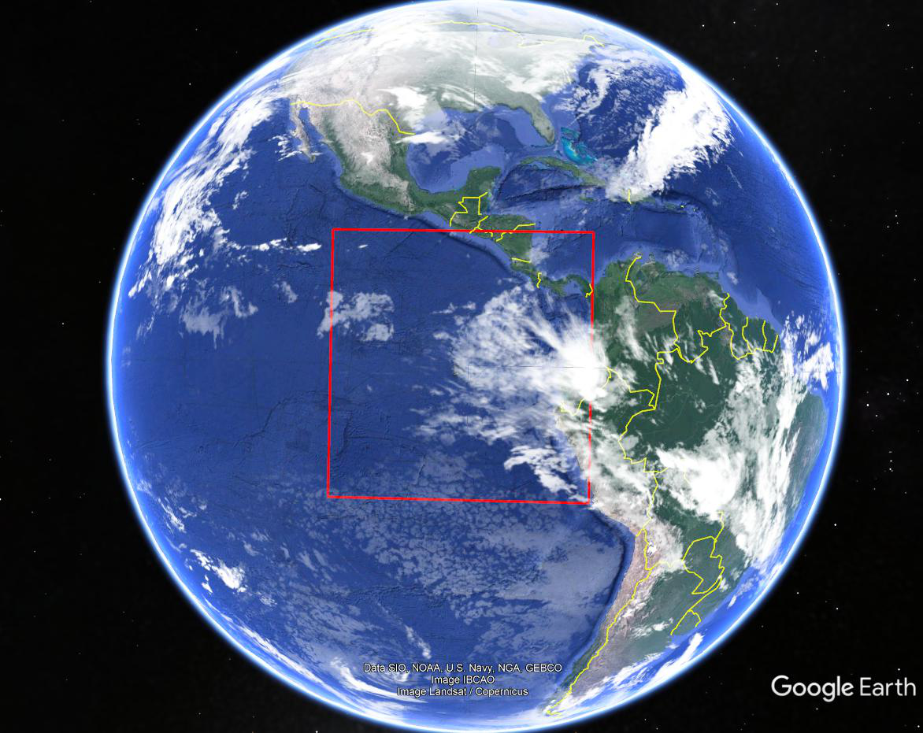

Figure A.2.4.4.1.2.1-1B shows the ground demark of the EESS R1 Area of Interest utilized for all simulation runs of configurations 2 (oversea case).

Figure A.2.4.4.1.2.1-2

Aeronautical route deployment

Figure A.2.4.4.1.2.1-2 shows the aeronautical flight paths utilized by subsequent simulation runs of configuration 2. The source of this data set given in public domain by [link](https://openflights.org/data.html).

Figure A.2.4.4.1.2.1-3A

Aeronautical route deployment

Figure A.2.4.4.1.2.1-3A shows routes in and immediately around the MAI utilized by subsequent simulation runs of configuration 2 (overland).

Figure A.2.4.4.1.2.1-3B1

Aeronautical route deployment (low route number)

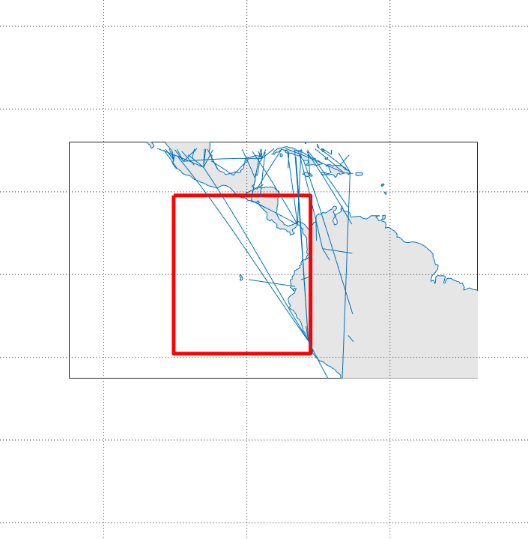

Figure A.2.4.4.1.2.1-3B2

Aeronautical route deployment (high route number)

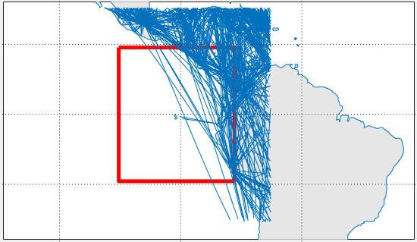

Figure A.2.4.4.1.2.1-3B shows routes in and immediately around the MAI utilized by subsequent simulation runs of configuration 2 (oversea).

Figure A.2.4.4.1.2.1-4

Ground station segment deployment (low density)



Figure A.2.4.4.1.2.1-4 shows the ground station segment utilized by subsequent simulation runs of configuration 1. Also plotted is the EESS R1 MAI for reference.

Figure A.2.4.4.1.2.1-5:

Ground station segment deployment (medium density)

Figure A.2.4.4.1.2.1-5 shows the air station segment utilized by subsequent simulation runs of configuration 1. Also plotted is the EESS R1 MAI for reference.

Figure A.2.4.4.1.2.1-6:

EESS (Passive) Sensor R1 Gain



Figure A.2.4.4.1.2.1-6 shows the antenna pattern (ITU-R RS.1813-1) for sensor R1 utilized by subsequent simulation runs.

Figure A.2.4.4.1.2.1-7

AMS air-stations Gain

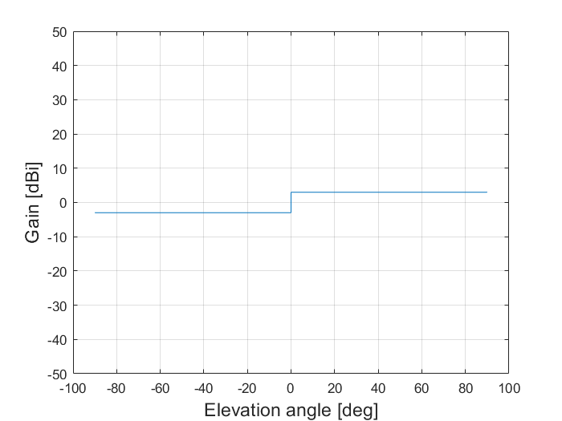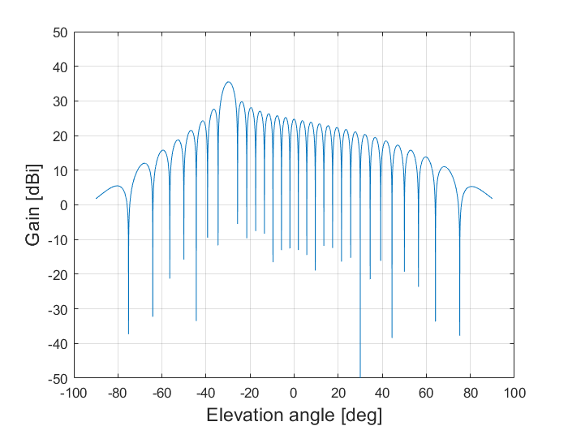

Figure A.2.4.4.1.2.1-7 shows the antenna pattern systems 2 (left) and 3 from A1.1.2 (right) for AMS air-stations utilized by subsequent simulation runs. Downtilt for the system 3 was -30 degrees.

A.2.4.4.1.2.2 Simulation results

The following figures illustrate the findings from the study of the RF interference impact configuration 1 and 2 type systems on EESS R1 sensors.

Figure A.2.4.4.1.2.2-1a

Received Interference Configuration 1 (Wildfire Observation) (aggregate source) (downlinks)

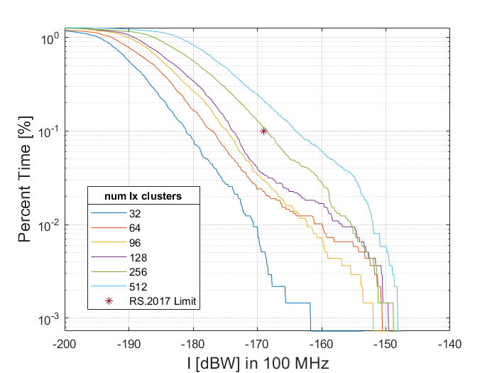

Figure A.2.4.4.1.2.2-1 shows interference level CCDFs seen for operation system downlinks conforming to configuration 1 (wildfire observation section 4.2), where the total number of transmitters within or immediately around the MAI are stated in the legend. FDR and RF propagation losses are included in these plots.

Figure A.2.4.4.1.2.2-1b

Received Interference Configuration 1 (Wildfire Observation) (aggregate source) (uplinks)

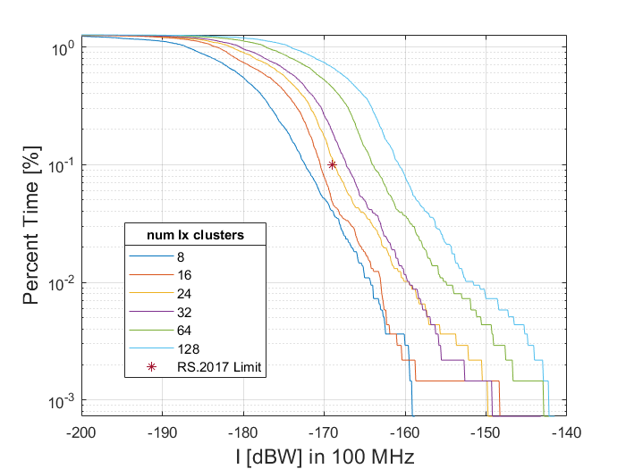

Figure A.2.4.4.1.2.2-1 shows interference level CCDFs seen for operation system uplinks conforming to configuration 1 (wildfire observation section 4.2), where the total number of transmitters within or immediately around the MAI are stated in the legend. FDR and RF propagation losses are included in these plots.

Figure A.2.4.4.1.2.2-2A

Received Interference Configuration 2 interference source (Internet Above Clouds operating over land) (aggregate source )

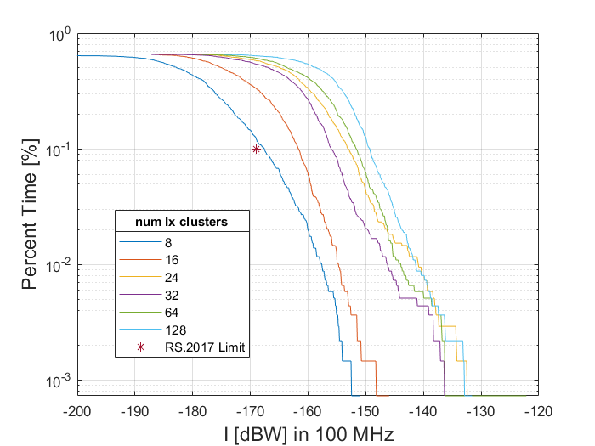 Figure A.2.4.4.1.2.2-2A shows interference level CCDF for the air-air downlinks for configuration 2 (internet above the clouds, section 4.5) for aggregate representative interference sources. FDR and RF propagation losses of are included in this plot. The legend indicates the number of air systems considered with 4576 nearing the full capacity aeronautical routes. So for the 4576 case all available routes from the datavase are populated with systems that use the two channels for nearest neighbor air-air communications.

Figure A.2.4.4.1.2.2-2B

Received Interference Configuration 2 interference source (Internet Above Clouds operating over sea) (aggregate source )

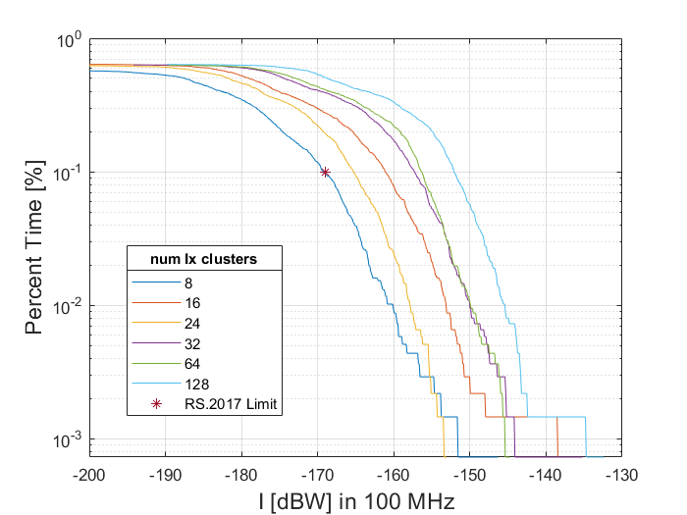 Figure A.2.4.4.1.2.2-2B shows interference level CCDF for the air-air downlinks for configuration 2 (internet above the clouds, section 4.5) for aggregate representative interference sources. FDR and RF propagation losses of are included in this plot.

###### A.2.4.4.1.3 Results of Analysis

The results of section A.2.4.4.1.2.2 indicate that the first configuration (operational scenario 4.2, wildfire observation) can support without imposing harmful interference into the EESS (passive) not more than approximately 256 clusters, defined by ground station platforms and their associated aeronautical users operating within the specially defined region, for the downlink transmission direction. Considering the uplink transmission direction, this upper limit is 24 clusters.

The results of section A.2.4.4.1.2.2 indicate that the second configuration (operational scenario 4.5, data networks above the clouds) can support without imposing harmful interference into the EESS (passive) not more than approximately 8 aeronautical platforms operating over inland regions as well as not more than approximately 8 aeronautical platforms operating over oversea (near shore) regions.

The majority of the contribution to this harmful interference comes from AMS systems operating immediately adjacent to the EESS (passive) band specifically within 50 MHz of the band edge of 22.21 GHz. A guard region of very low deployment density immediately adjacent to the band edge would be necessary to ensure protection of EESS (passive) operations.

[Note to Editor: Content subsequent to section A2.4.4.1.3 of the CR contain no modifications proposed by this document.]

[…]