U.S. Radiocommunications Sector
Fact Sheet
Working Party: ITU-R WP 5B | Document No: USWP5B28-04
Ref: 5B/481 Annex 30 on AI 1.6 | Date: January 31, 2022
Document Title: Working document on WRC-23 AI 1.6 [SUBORBITAL VEHICLES STUDIES], “Regulatory, operational, and technical studies of radiocommunications for suborbital vehicles.”
Author(s)/Contributors(s):  Chris Tourigny  FAA Spectrum Engineering Services  Michael Tran  MITRE  Nader Damavandi  Space Exploration Technologies  Damon Ladson  Harris, Wiltshire & Grannis  Donald Jansky  Joseph Cramer  Boeing |  | Phone: 202-267-3071  Email: chris.tourigny@faa.gov  Phone: 703-983-1295  Email: mtran@mitre.org  Phone: 310-219-7854  Email: nader.damavandi@spacex.com  Phone: (202) 730-1315  Email: dladson@hwglaw.com  Phone: 202-415-1834  Email: don@jansky-barmat.com  Phone: 703-465-3486  Email: joseph.cramer@boeing.com
Purpose/Objective: This contribution provides regulatory, operational, and technical studies to respond to Resolution 772 (WRC-19).
Abstract: Resolution 772 (WRC-19), in preparation for Agenda Item 1.6 (WRC-23), invites the ITU-R to study the spectrum needs for stations on board sub-orbital vehicles, any appropriate modification to the Radio Regulations, excluding any new allocations or changes to the existing allocations in Article 5, and to identify whether there is a need for access to additional spectrum that should be addressed after WRC-23 by a future competent conference. This contribution provides those studies to support the agenda item.

Radiocommunication Study Groups | 
Source: Document 5B/481 – Annex 30  Subject: WRC-23 AI 1.6 Report | Document 5B/
 | 29 March 2022
 | English only
United States of America
WORKING DOCUMENT TOWARDS PRELIMINARY DRAFT NEW REPORT ON WRC-23 AGENDA ITEM 1.6
[SUBORBITAL VEHICLES studies]

Regulatory, operational, and technical studies of radiocommunications for suborbital vehicles
Introduction
Resolution 772 (WRC-19), in preparation for Agenda Item 1.6 (WRC-23), invites the ITU-R to study the spectrum needs for stations on board sub-orbital vehicles, any appropriate modification to the Radio Regulations, excluding any new allocations or changes to the existing allocations in Article 5, and to identify whether there is a need for access to additional spectrum that should be addressed after WRC-23 by a future competent conference. The United States offers this contribution to provide those studies to support the agenda item.
Attachment: 1

ATTACHMENT
working document TOWARDS PRELIMINARY DRAFT NEW REPORT on wrc-23 agenda item 1.6
[suborbital vehicles studies]

Regulatory, operational, and technical studies of radiocommunications for suborbital vehicles

Editor’s Note: The content of this document was not agreed by WP5B (November-December 2021]

1 Introduction
Resolution 772 (WRC-19), in preparation for WRC-23 agenda item 1.6, invites the ITU-R:
"1 to study spectrum needs for communications between stations on board sub-orbital vehicles and terrestrial/space stations providing functions such as, inter alia, voice/data communications, navigation, surveillance and TT&C;
2 to study appropriate modification, if any, to the Radio Regulations, excluding any new allocations or changes to the existing allocations in Article 5, to accommodate stations on board sub-orbital vehicles, whilst avoiding any impact on conventional space launch systems with the following objectives:
– to determine the status of stations on sub-orbital vehicles, and study corresponding regulatory provisions to determine which existing radiocommunication services can be used by stations on sub-orbital vehicles, if necessary;
– to determine the technical and regulatory conditions to allow some stations on board sub-orbital vehicles to operate under the aeronautical regulation and to be considered as earth stations or terrestrial stations even if a part of the flight occurs in space;
– to facilitate radiocommunications that support aviation to safely integrate sub-orbital vehicles into the airspace and be interoperable with international civil aviation;
– to define the relevant technical characteristics and protection criteria relevant for the studies to be undertaken in accordance with the bullet point below;
– to conduct sharing and compatibility studies with incumbent services that are allocated on a primary basis in the same and adjacent frequency bands in order to avoid harmful interference to other radiocommunication services and to existing applications of the same service in which stations on board sub-orbital vehicles operate, having regard to the sub-orbital flight application scenarios.
3 to identify, as a result of the studies above, whether there is a need for access to additional spectrum that should be addressed after WRC-23 by a future competent conference."
2 Abbreviations and relevant ITU-R Recommendations / Reports

Abbreviations

ADS-B: Automatic dependant surveillance – broadcast
ADS-C: Automatic dependant surveillance – contract
AMS: Aeronautical mobile satellite
AMT: Aeronautical mobile telemetry
ATM: Air traffic management
GNSS: Global navigation satellite service
ICAO: International Civil Aviation Organization
MSS: Mobile satellite service
RNSS: Radionavigation satellite service
RR: Radio Regulations
TT&C: Telemetry, tracking & telecommand

Relevant ITU-R Recommendations and Reports
Recommendations
ITU-R M.1038-0 Efficient use of the geostationary-satellite orbit and spectrum in the 1-3 GHz frequency range by mobile-satellite systems
ITU-R M.1184-3 Technical characteristics of mobile satellite systems in the frequency bands below 3 GHz for use in developing criteria for sharing between the mobile-satellite service and other services
ITU-R M.1316-1 Principles and a methodology for frequency sharing in the 1 610.6-1 613.8 MHz and 1 660-1 660.5 MHz bands between the mobile-satellite service (Earth-to-space) and the radio astronomy service
ITU-R M.1471-1 Guide to the application of the methodologies to facilitate coordination and use of frequency bands shared between the mobile-satellite service and the fixed service in the frequency range 1-3 GHz
ITU-R M.1741-0 Methodology for deriving performance objectives and its optimization for IP packet applications in the mobile-satellite service
ITU-R M.1787-3 General characteristics of the systems and networks of radionavigation-satellite services
ITU-R M.1903-1 Characteristics and protection criteria for receiving earth stations in the radionavigation-satellite service (space-to-Earth) and receivers in the aeronautical radionavigation service operating in the band 1 559-1 610 MHz
ITU-R M.1905-1 Characteristics for RNSS receivers in the frequency bands 1 164-1 215 MHz
Report
ITU-R M.2413-0 Reception of automatic dependent surveillance broadcast via satellite and compatibility studies with incumbent systems in the frequency band 1 087.7-1 092.3 MHz
ITU-R M.2477-0 Radiocommunications for suborbital vehicles

3 Suborbital vehicles
A) Definition of suborbital vehicles
According to Report ITU-R M.2477, a suborbital vehicle is a vehicle executing suborbital flight and suborbital flight is defined as the intentional flight of a vehicle expected to reach the upper atmosphere with a portion of its flight path that may occur in space without completing a full orbit around the Earth before returning to the surface of the Earth.
B) Operational concepts
Currently, there are a variety of technical solutions to achieve suborbital flight. Launch modes include horizontal and vertical, landing modes include horizontal landing and vertical landing, recovery modes include self-controlled return and parachute recovery, and thrust modes include rocket power and combined power. Suborbital flights can be implemented by different combinations of the above modes. Figures 1 and 2 show examples of the operational concepts of a suborbital flight.
Figure 1
Examples of the operational concepts of suborbital flight
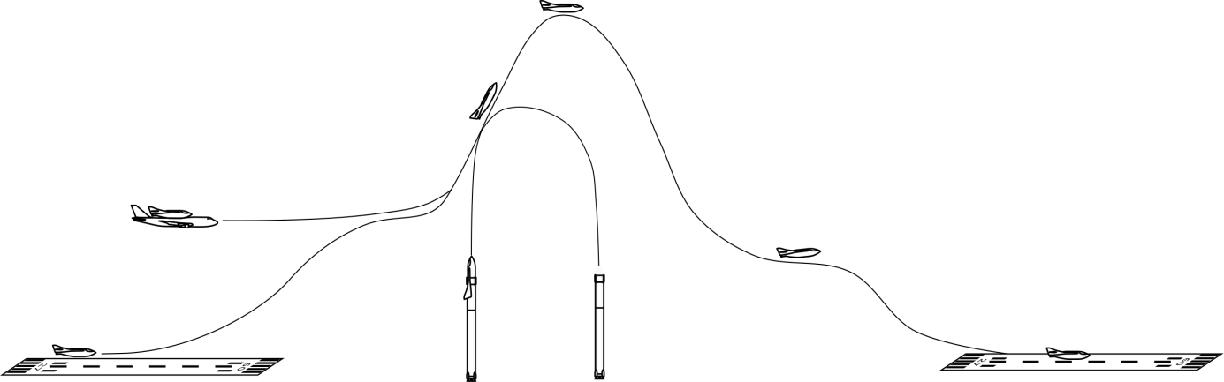

Figure 2
Examples of suborbital flights
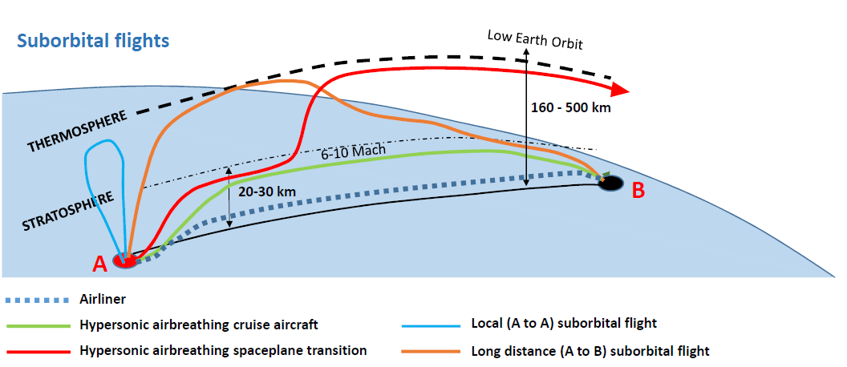
With the rapid development of the various suborbital flight concepts in recent years, such as hypersonic flight and reusable carrier rocket technology, suborbital flight has become an operational reality, which supports a wide range of fields including education, transportation, tourism, and scientific research. Current research and development aim to enable suborbital vehicles to be capable of carrying several thousand kilograms of cargo and passengers by 2035 and up to 6 000 flights per year by 2045.
One example of an operational concept, related to tourism, consists of a flight carrying crewmembers to beyond the Karman Line (the unofficial boundary between the Earth’s atmosphere and space), using a reusable suborbital rocket. The suborbital flight achieves Mach 3 velocity during launch and will spend a few minutes in zero gravity before deploying parachutes to return to the surface of the Earth.
Another example of an operational concept consists in suborbital vehicle ferried by a special airplane and then released at a high altitude for conventional aircraft. This suborbital vehicle, which is part airplane and part rocket, uses rocket thrust to increase altitude beyond the Karman line and then return to the surface of the Earth like a glider.
Another example of a more conventional space launch provider uses a first-stage reusable booster in these missions, which falls under the definition of suborbital vehicles in its concept of operation.

4 Functional and spectrum needs for communications between stations on-board sub-orbital vehicles and terrestrial/space stations

4.1 Radiocommunication functional needs
There are functional needs for radiocommunications between stations on-board sub-orbital vehicles and terrestrial/space stations providing functions such as, inter alia, voice/data communications, navigation, surveillance, and telemetry, tracking & telecommand (TT&C).

4.1.1 Telemetry, tracking and command
Telemetry, radio telemetry and space telemetry are defined in Radio Regulations (RR) Nos. 1.131, 1.132, and 1.133. Radio telemetry for sub-orbital vehicles provide information about the status of vehicle and its subsystems. It is envisioned that the real-time telemetry is transmitted to ground stations, relay satellites, or space stations over radio frequency links. Additionally, some sub-orbital vehicles may require transmitting real-time high definition digital videos from multiple feeds carrying visual information about the vehicle status to ground terminals directly or through relay satellites or space stations.
Telecommand and space telecommand are defined in RR Nos. 1.134 and 1.135. Radiocommunications for telecommand are used in order to initiate, modify or terminate functions of equipment on sub-orbital vehicles.
Space tracking is defined in RR No. 1.136. It is envisioned that sub-orbital vehicle will rely on dedicated radio frequency links to perform adjustments of its trajectory by means of radiodetermination. Such tracking is expected to be performed through either ground station terminals or relay satellites or space stations.
Like the communications link mentioned in Section 4.1.2, a desired aspect of sub-orbital vehicles’ TT&C links is the ability to maintain the link throughout various phases of flight including atmospheric re-entry where radio communication with the vehicle experiences significant attenuation due to plasma effects caused by extreme heating and ionization of air around the vehicle.

4.1.2 Communications
It is expected that sub-orbital vehicles will establish and maintain communications with ground-based mission control centres during the full duration of flight through either direct communication or through relay satellites or space stations. These communication links are like the communications commonly established by aircraft using internationally standardized systems when operated in shared airspace. It is noted, passenger communications which may, for example, be for entertainment purposes would not be considered safety of life.
An important aspect of sub-orbital vehicle communication requirements is the desire to maintain the link throughout various phases of flight. Therefore, consideration would have to be given to:
• atmospheric effects during re-entry where radio communication with the vehicle experiences significant attenuation due to plasma effects caused by extreme heating and ionization of air around the vehicle;
• additional Doppler effects caused by the increase in speed relative to conventional aircraft; and;
• the vehicle’s altitude, and increased separation distances from ground stations.

4.1.3 Surveillance
A surveillance service provides the identification and position of users of the airspace and obstructions. For example, the automatic dependent surveillance – broadcast (ADS-B), using the frequencies 978 MHz and 1 090 MHz, is an ICAO-standardized aeronautical surveillance system. It provides airspace navigation service providers and other users of the airspace surveillance data for high-altitude, high-velocity vehicles (compared to conventional aircraft), including suborbital vehicles. One of the use-cases for this system includes equipping the suborbital vehicle to report ADS-B messages in all phases of flight for the purpose of aeronautical surveillance and collision avoidance from other airspace users, such as conventional aircraft operating in the airspace at lower altitudes and at much lower comparative velocities. Other surveillance technologies exist for use by suborbital vehicles, such as automatic dependent surveillance – contract (ADS-C). Like ADS-B, the principal surveillance application would be the same as that used for conventional aircraft.

4.1.4 Navigation
Navigation is the determination of the position and velocity of a moving vehicle. It is expected suborbital vehicles would utilize the same navigation systems currently in use for conventional aircraft. Several electronic aids currently available for navigation, including global navigation satellite service (GNSS) navigation systems, are operated under the radio navigation satellite service (RNSS) allocation (space-to-Earth).
Since different technical requirements may be expected between the RNSS receivers, which will be operated under RNSS (space-to-Earth) allocations, and RNSS receivers, which will be operated under RNSS (space-to-space) allocations, whether the same RNSS receivers can function may be investigated by receiver manufacturers and/or sub-orbital vehicle operators. However, this kind of investigation should be conducted outside of ITU-R studies.

4.2 Spectrum needs for sub-orbital vehicles

4.2.1 Operations in non-segregated airspace
The operations in non-segregated airspace, the separation of aircraft from suborbital vehicles is ensured by the air traffic management.
The operational concepts of suborbital vehicles in non-segregated airspace consider its integration in that airspace under the relevant air traffic management system, thus the safety of existing aircraft and suborbital vehicles is ensured in a similar manner.
The expectation is that suborbital vehicles operated in non-segregated airspace will use the same space and terrestrial systems as conventional aircraft and possible additional communications. The communications requirements for suborbital vehicles are expected to be similar to those of conventional aircraft.
Considering that suborbital vehicles are expected to consist of only a small fraction of overall aviation traffic, the spectrum requirements for the operation of suborbital vehicles in non-segregated airspace are not expected to significantly impact on overall aviation spectrum requirements.

4.2.2 Operations in segregated airspace
The separation of suborbital vehicles from other aircraft may be provided using segregated airspace. The separation with other aircraft is provided by the segregated airspace ensuring the safety of life for the other aircraft. However, it is desirable to limit as much as possible the time during which the segregated airspace is needed, and the volume of airspace affected.
There are spectrum needs for radiocommunications between stations on-board sub-orbital vehicles and terrestrial/space stations providing functions in particular TT&C, which would not require to be under an aeronautical internationally standard. TT&C would be the main radiocommunication application used.
Aeronautical services may also be used with the purpose to provide information to and communicate with air traffic management (ATM) to identify when the suborbital vehicle has left an area and that the airspace could return to the status of non-segregated or organise entry into controlled airspace on its return.
Since the spectrum needs for the operation of any suborbital vehicle flights are in any case of limited duration, it is anticipated that spectrum needs for satellite and terrestrial systems to be used for TT&C can be met within current terrestrial and space service allocations.

5 Summary of studies
[To be added]
[Editor’s note: to be used for the section on summary for studies in draft CPM text]
[Editor’s Note: The difference in meaning between segregated airspace versus non-segregated airspace needs to be described and explained in relation to sharing between suborbital vehicles and other systems of allocated services in a frequency band.]

Annex 1
Technical studies on suborbital vehicles in non-segregated airspace

A1.1 Services and frequency bands under consideration for technical studies
[To be completed]

A1.2 Technical characteristics and protection criteria relevant for the following studies
[To be determined]

A1.3 Sharing and compatibility studies
[This section will contain sharing and compatibility studies with incumbent services that are allocated on a primary basis in the same and adjacent frequency bands in order to avoid harmful interference to other radiocommunication services and to existing applications of the same service in which stations on board sub-orbital vehicles operate, having regard to the sub-orbital flight application scenarios.]

Annex 2
Technical studies on suborbital vehicles in segregated airspace

A2.1 Services and frequency bands under consideration for technical studies
[To be completed]

A2.2 Technical characteristics and protection criteria relevant for the following studies
[To be determined]

A2.3 Sharing and compatibility studies
[This section will contain sharing and compatibility studies with incumbent services that are allocated on a primary basis in the same and adjacent frequency bands in order to avoid harmful interference to other radiocommunication services and to existing applications of the same service in which stations on board sub-orbital vehicles operate, having regard to the sub-orbital flight application scenarios.]

Annex 3
Regulatory considerations to facilitate operating stations
on board sub-orbital vehicles
Under this agenda item, it is recognized that the frequency accommodation for suborbital vehicles should not negatively impact the current use of frequencies by any other radiocommunication services.

A3.1 Examples of radiocommunications services and frequencies
There are several existing radiocommunications services that can be used by stations on-board suborbital vehicles using existing coordination processes and procedures. These services include, but may not necessarily be limited to:
– AM(R)S: The aeronautical mobile (route) service, e.g., VHF voice and data communications and ADS-B, when permitted by ICAO SARPs.
– RNSS: The GNSS systems using 1 164-1 215 MHz and 1 559-1 610 MHz can be used for navigation.
– MSS: The mobile satellite service in the frequency bands 1 518-1 544 & 1 545-1 559 MHz (space-to-Earth), 1 610-1 626.5 MHz, and 1 626.5-1 645.5 & 1 646.5-1 660.5 MHz (Earth-to-space), and 1 668-1 675 MHz (Earth-to-space) can be used for safety (AMS(R)S allocation in the 1 610-1 626.5 MHz band) and non-safety applications.
– [MS: in RR No. 5.394, some Administrations expressed the view that, the use of the band 2 300-2 390 MHz by the aeronautical mobile service for telemetry has priority over other uses by the mobile services. Some other Administrations expressed the view that, use of the band 2 360-2 400 MHz by the aeronautical mobile service for telemetry has priority over other uses by the mobile services.
TT&C applications in the aeronautical mobile service (AMS) are currently using aeronautical mobile telemetry (AMT) in the 2 200-2 290 MHz for telemetry and 2 025-2 110 MHz for command shared with other services including SOS, EESS, and SRS and upper S-band 2 360-2 395 MHz for telemetry. Therefore, there is no need for changes to the Article 5 of the Radio Regulations in these bands.]

A.3.2 Application of existing mobile satellite service radio regulations
The operation of MSS systems providing aeronautical radiocommunications in the above-identified frequency bands are regulated under existing RR provisions. The application of MSS systems to support suborbital vehicles would require communications between the MSS satellite and the MES at all stages of the flight, including when the mobile earth station (MES) is on the ground, in the atmosphere and when in space. The existing RR Article 9 procedures are/would be adequate to capture any new coordination requirements in the operation of MESs onboard sub-orbital vehicles in the 1.6/1.5 GHz bands that result with other MSS satellite systems and networks, and other space services operating in the 1.6/1.5 GHz bands.
This approach would permit the existing frequency coordination procedures identified under Section II of RR Article 9 to remain applicable in the coordination and operation of MSS communications to sub-orbital vehicles, during the intervals of time when a sub-orbital vehicle is in space.
For coordination and protection of terrestrial services, is noted that the operation of MESs on sub-orbital vehicles in space would result in less interference to terrestrial services, relative to the comparable case of an MES operating on the Earth’s surface or within the Earth’s atmosphere on an aircraft. This reduction in the potential for interference at the Earth’s surface results from the increased separation of the MES to the Earth when operating in regions of space.
Similarly, no changes would be necessary for MSS satellite transmissions to support the operation of MESs on sub-orbital vehicles, since the required satellite transmissions powers, if anything, would be lower. When operating earth stations on sub-orbital vehicles, there would be a lower path-loss between the MES and associated MSS satellite, together with a reduction in the atmospheric impairment and multipath degradation.
The above factors would ensure the protection of terrestrial services is maintained in the use of MSS communications, and that the existing regulatory provisions and coordination requirements in the use of MSS communication in the 1.6/1.5 GHz frequency bands remain effective. Additionally, it is noted that RR Nos. 5.208B and 5.379C would continue to apply to MESs operating on sub-orbital vehicles, to maintain the protection of radioastronomy operating in the frequency bands 1 660.0-1 660.5 MHz and 1 668-1 670 MHz.
Since the definition of an MES requires it to be either on the Earth’s surface or within the major portion of the Earth’s atmosphere (see Nos. 1.25 and 1.63), it would be necessary to clarify the regulations to ensure that MESs may also be used on suborbital vehicles when beyond the Earth’s atmosphere.

A3.3 Potential modifications to the Radio Regulations, in accordance with invites 2, Resolution 772 (WRC-19), that facilitate radiocommunications that support aviation to safely integrate sub-orbital vehicles into the airspace and be interoperable with international civil aviation
At this time, sub-orbital flight radiocommunications have been carried out using the existing regulatory provisions of the Radio Regulations. These have been recognized in Report ITU-R M.2477. They include both terrestrial and space services as provided for in RR Article 5.
Resolution 772 (WRC-19) has indicated the need to study any appropriate modifications to the Radio Regulations that “facilitate radiocommunications that support aviation to safely integrate sub-orbital vehicles into the airspace”. There are several options for achieving this objective:
a) Make no changes to the RR – this option recognizes the existing experience but provides no unique identification of sub-orbital use of spectrum. As identified above, the use of MESs on suborbital vehicles could be considered as inconsistent with the current Article 1 definitions, which would remain with no change to RR.
b) A Resolution (WRC-23) – in this option a new Resolution would appropriately recognize the services that may be used by sub-orbital vehicles.
c) Modify RR Article 4 – this Article, “Assignment and use of frequencies” contains statements relating to special conditions and use of certain stations and spectrum applications.
d) Modification of other parts of the RR – in this option other Articles of the RR could be modified to accommodate sub-orbital vehicle use of spectrum.

The delimitation between atmosphere and outer space has not been legally defined at an international level by the competent organizations.

