US Radiocommunications Sector
Fact Sheet

Working Party: ITU-R WP 5B | Document No: USWP5B28-10
Reference: 5B/481 Annex 31 | Date: 23 February 2022
Document Title: Working document towards a preliminary draft new Report ITU-R M.[NON-SAFETY AMS CHARACTERISTICS AND SHARING STUDIES] related to agenda item 1.10
Author(s)/Contributors(s):  Andrew Meadows  Air Force  Dominic Nguyen  eSimplicity for AFSMO | Phone : 334-467-4720  E-mail : andrew.meadows.1@us.af.mil  Phone : 703-606-7396  E-mail : dominic.nguyen@esimplicity.com
Purpose/Objective: The purpose of this document is to continue the sharing studies between non-safety aeronautical mobile service (AMS) and Radiolocation service in support of WRC-23 AI 1.10.
Abstract: WRC-19 approved AI 1.10 for the WRC-23 study cycle to consider a possible introduction of new non-safety AMS applications in the 15.4-15.7 GHz band. During the November 2021 meeting, France raised concern on some US assumptions and methodology for the sharing study. This contribution answers French questions and continues the sharing studies between non-safety AMS and Radiolocation service.

Fact Sheet preparer: Dominic Nguyen

Radiocommunication Study Groups | 
Source: Document 5B/481 Annex 31  Subject: WRC-23 agenda item 1.10 | Document 5B/XX
 | XX March 2022
 | English only
United States of America
Technical characteristics, operational scenarios, spectrum needs, coexistence, and sharing studies of non-safety aeronautical mobile systems in the frequency bands 15.4-15.7 GHz and 22-22.21 GHz

Introduction

The United States of America would like to continue progressing the sharing study between non-safety AMS and Radiolocation in the frequency band 15.4-15.7 GHz by providing some editorial and technical corrections.
The United States proposals are highlighted in turquoise and mostly in Annex 1, section A1.3.1.3.
Attachment revisions are presented for consideration.

ATTACHMENT
Annex 31 to Working Party 5B Chairman’s Report
WORKING DOCUMENT TOWARDS A PRELIMINARY DRAFT NEW
REPORT ITU-R [NON-SAFETY AMS CHARACTERISTICS AND SHARING STUDIES] RELATED TO wrc-23 AGENDA ITEM 1.10
Technical characteristics, operational scenarios, spectrum needs, coexistence, and sharing studies of non-safety aeronautical mobile systems in the
frequency bands 15.4-15.7 GHz and 22-22.21 GHz

There are no proposed changes prior to this point in the document.
…

Annex 1
Technical characteristics of systems considered in AMS and sharing and compatibility studies in the frequency band 15.4-15.7 GHz
There are no proposed changes prior to this point in the document.
…

A1.3 Results of the sharing and compatibility studies

A1.3.1 Studies with the radiolocation service

A1.3.1.1 Sharing study A
The analysis calculates the interference of AMS airborne and ground stations to the radiolocation system.
The protection criteria for the radiolocation service is assumed to be I/N=–6 dB.
The following equation can be used to determine if interference to the radiolocation System 6 receiver from AMS System-6 transmissions is likely to occur and what separation distance is required to eliminate the interference:

I = P_{Tx} + G_{Tx} + G_{Rx} – L_{Trans} – FDR (54)
where:
I : interference power at the receiver (dBm),
P_{Tx} : power of the interfering system (dBm), 30 dBm is used as an example,
G_{Tx} : antenna gain of the interfering transmitter in the direction of the victim receiver (dBi),we assume that the antenna of the AMS system is omni directional and the antenna gain is 0 dB,
G_{Rx} : antenna gain of the victim receiver in the direction of the interfering transmitter (dBi),
L_{Trans} : transmission loss between transmitting and receiving antennas (dB) using free space loss for air to air, and using Recommendation ITU-R P.528-2 for ground to air. Free space loss = 20 log(F) + 20 log(R) + 32.44,
F : frequency (MHz),
R : separation distance (km),
FDR_{IF} : frequency-dependent rejection produced by the receiver IF selectivity curve on an unwanted transmitter emission spectra (dB).
The FDR_{IF} value can be determined from Recommendation ITU-R SM.337-6. Since the radars will operate on a co-frequency basis, only the on-tune rejection (OTR) is considered. OTR for non-coherent chirped pulsed signals is given by:

OTR = 10 log (Rx_BW/Tx_BW) for Rx_BW ≤ Tx_BW (55)
Otherwise OTR = 0
where:
Rx_BW : receiver bandwidth (MHz),
Tx_BW : transmitter bandwidth (MHz).
When the transmitting bandwidth is set to be 50 MHz and the receiving bandwidth to be 25 MHz, FDR_{IF} is 3 dB.
The results for airborne AMS analysis are summarized in Table A1.19, and the ground / shipboard AMS analysis are summarized in Table A1.20. The assessment can be made regarding the separation distances that are required to ensure compatibility between the AMS system and the radiolocation system.
TABLE A1.19
The separation distance for the airborne aeronautical mobile service system
interfering with radiolocation system
 | Separation distances
The main lobe of radiolocation system | [219 km]
1st side-lobe level of radiolocation system | [5.8 km]
TABLE A1.20
The separation distance for the ground / shipboard aeronautical mobile service
system interfering with radiolocation system
 | Separation distances
The main lobe of radiolocation system | [187 km]
1st side-lobe level of radiolocation system | [1 km]

[Editor’s note –- The values provided in Tables A1.19 and A.1.20 should be updated based on the AMS characteristics in Table A1.1.]

A1.3.1.2 Sharing study B

A1.4.1.2.1 Methodology
–
–

A1.4.1.2.1.1 Input parameters
Table 10 below introduces the parameters of future AMS systems to take into consideration when performing Monte Carlo sharing and compatibility studies with incumbent services.
TABLE 10
Input parameters for Monte Carlo simulations
Scenario | 4.2 | 4.3 | 4.4 | 4.5
System 1 | - | Aircraft 1,2,3,5,6,7⁽²⁾ | Observation aircraft, Relay^{(3,4)} | -
System 2 | Platform 1,2⁽¹⁾ | Aircraft 4⁽²⁾ | Relay^{(3,4)} | -
System 3 | - | - | - | All aircraft⁽⁵⁾
System 4 | Fire truck⁽¹⁾ | - | - | -
System 5 | - | - | Control centre⁽⁴⁾ | -
Payload throughput per data link | 50 | 30 | 10, 20 | 20, 40, 60, 80, 160, 240, 320
Frequency reuse inside a cluster | 0 |  |  | 1
Payload throughput per control link | 500 kbps
Overhead factor | 10 %
Spectrum efficiency | 1 bps/Hz
Frequency band | 15.4-15.7 GHz or 22-22.21 GHz |  | Forward: 15.4-15.7 GHz;  Return 22-22.21 GHz
Altitude of ground station in m | 2 | - | 2 | -
Altitude of airborne stations above ground in m | 300 | Aircraft 1,2,3,5,6,7: 3,600; Aircraft 4: 1,000 | Observation aircraft : 3,000; Relay: 10,000 | 10,000
Air-to-air link distance in km | - | 6.9, 8.4, 12.6⁽⁶⁾ | 8.7⁽⁷⁾ | 150 to 800⁽⁸⁾
Air-to-ground link distance in km | 1 to 2⁽⁶⁾ | - | 50 to 250⁽⁷⁾ | -
Notes:
⁽¹⁾ See Figure 2 in section 4.2;
⁽²⁾ See Figure 3 in section 4.3;
⁽³⁾ The relay is equipped with two Systems: System 2 to gather data from the observation aircraft, and System 1 to transmit these to the control centre;
⁽⁴⁾ See Figure 4 in section 4.4;
⁽⁵⁾ See Figure 5 in section 4.5;
⁽⁶⁾ The relative positioning of observation aircraft with respect to the centre aircraft is shown in Figure 10 below;
⁽⁷⁾ The relative positioning of observation aircraft and relay aircraft is shown in Figure 11 below;
⁽⁸⁾ The minimum link distance between two communicating aircraft in scenario 4.5 is based on the minimum longitudinal separation over oceanic airspace between two aircraft on the same route, which is 10 minutes (Source: FAA). It results in a separation of 150 km when considering the standard flying speed of 900 km/h.
The separation distance is upper bounded by the maximum LOS distance between two aircraft flying at 10,000 m above mean sea level, which is about 800 km as per ITU-R Rec. P.528-5. Figures 12 and 13 below indeed show that the distance to the radio horizon of an aircraft flying at 10,000 m above ground level is about 400 km, whether in the frequency band 15.4-15.7 GHz or 22-22.21 GHz.
FIGURE 10
Relative positioning of the observation aircraft in scenario 4.3 (top view)
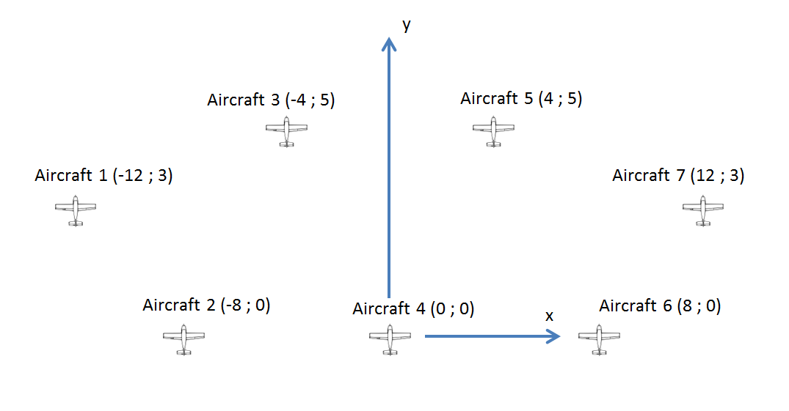
[Editor’s note– USA pointed out that the km scale should be indicated in this figure.]
FIGURE 11
Relative positioning of the observation and relay aircraft in scenario 4.4
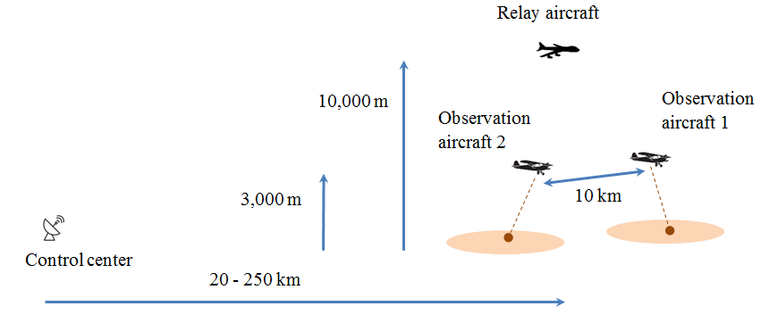
FIGURE 12
Propagation loss between an airborne station and a station at ground level, for f = 15.55 GHz, h = 10,000 m, vertical polarization, not exceeded for more than 50 % of the time
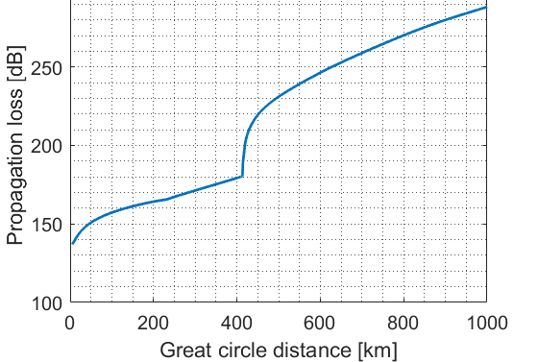
FIGURE 13
Propagation loss between an airborne station and a station at ground level, for f = 22.105 GHz, h = 10,000 m, vertical polarization, not exceeded for more than 50 % of the time
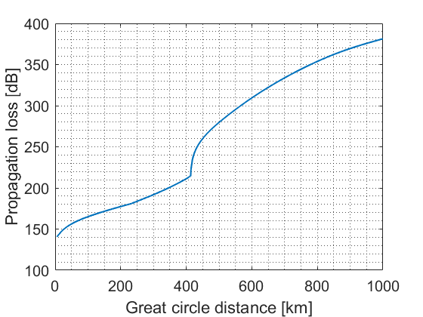
[Editor’s note– USA raised the question of which propagation model was used to generated figures 12 and 13, and whether the 50 % time assumption was valid. France and Germany answered that Rec. ITU-R P.528-5 had been used, and that the median assumption was justified because these figures are merely meant to help choose suitable distances between airborne stations in the operational scenarios.]

A1.4.1.2.1.1 Step-by-step approach
Table 11 below illustrates the methodology that was followed to perform Monte Carlo simulations between future AMS systems and incumbent services.

[Editor’s note– USA asked if 1,000,000 snapshots could be simulated in step 8. France and Germany answered that the number of snapshots is chosen to check if the protection criterion of the victim system is met with a given time percentage. For instance, an interference level not to be exceeded for more than 0.1% of the time would require 1,000 snapshots, 0.01 % 10,000 snapshots, and so on.]

TABLE 11
Step-by-step methodology for Monte Carlo simulations
Step | Description | Example
1 | Select a scenario among 4.2 to 4.5 and a victim service. | The scenario under study is 4.2 and the victim system is the radiolocation.
2 | Define a simulation radius RSimulation that delimits the simulation area as a spherical cap centred on the position of the victim station. RSimulation is chosen as the radius of the disc in which one cluster is expected or the maximum visibility distance when the victim and the interferer bith are at their maximum height. | The radius of the disc in which one cluster is expected is 254 km as per Table 2. The victim station has a maximum altitude of 13,700 m above ground level (see Table 10), which corresponds to a radio horizon of about 480 km using Figure . The airborne stations are flying 300 m AGL in scenario 4.2, which corresponds to a radio horizon of 88 km using Figure It follows that RSimulation=568 km.
3 | Compute the number of clustersnclusters to be deployed within the simulation area in accordance with the typical density values provided in section 4. | The typical density associated to scenario 4.2 is one cluster in a disc of radius 254 km. It follows that: nclusters= RSimulation2542≈3.6.
4 | Carefully increase RSimulation to obtain an integer number of clusters. | The closest integer to 3.6 is 4. It follows that RSimulation=2*254=508 km and nclusters=4.
5 | Deploy the victim using operational parameters as provided in sections A1.2 and A2.2. | The victim is deployed using parameters as provided in Table 10. The altitude is drawn uniformly between 300 m and 13,700 m, the antenna as provided in section A1.2.1.2 is offset in azimuth between -45° and 45°, and in elevation between +5° and -45°.
6 | Deploy the clusters within the simulation area using input parameters provided in Table 10. | 4 clusters are deployed within the simulation area using input parameters provided in Table 10. The location of the clusters is chosen with uniform distribution.
7 | Compute the aggregate interference power I at the victim receiver, taking into account geographical⁽¹⁾ and frequency separation⁽²⁾. | The aggregate interference power at the victim RLS receiver depends on the position of the four clusters within the simulation area relative to the victim, of the orientation of the stations inside each cluster, and the position of the channels within the frequency band 15.4-15.7 GHz.
8 | Repeat steps 5, 6 and 7nspapshots times. | The computation time increases as nspapshots increases. Therefore nspapshots=100,000 was found to be a good compromise between computational effort and precision of the results.
9 | Compare against the protection criterion, the empirical cumulative distribution function (ECDF) of I or IN, whichever is appropriate. | In this example, the protection criterion is IN<-6dB.
Notes:
⁽¹⁾ Propagation loss are accounted for using Rec. ITU-R P.528-5;
⁽²⁾ The frequency offset is accounted for using Rec. ITU-R SM.337-4;

FIGURE 14
Radio horizon as per Rec. ITU-R P.528-5
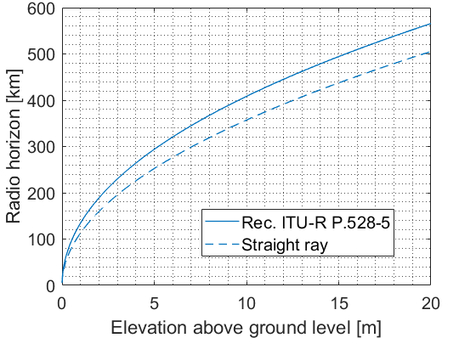

Isingle
Iaggregate Isingle
Iaggregate
Iaggregate

]

–
The possibility of sharing the frequency bands 15.4-15.7 and 22-22.21 GHz between the AMS and incumbent co-primary services, as well as the coexistence with services in adjacent bands may be assessed through a Monte Carlo simulation. In contrast to a more a conservative minimum coupling loss analysis, this approach can take into account the probability of interference. Depending on the considered victim system, other methodologies may be considered as more appropriate.
This section proposes a methodology which may be used for AMS sharing and compatibility studies, which involves a single victim surrounded by a number of so-called “interfering clusters”. Each of these clusters represents one of the AMS scenarios, which is again composed of multiple AMS stations.
The general setup of the simulation is depicted in Figure 7 below and obtained through the following steps:
1 Depending on the operational characteristics extracted from the relevant recommendation or reportITU-R Recommendation or Report, the victim receiver is randomly positioned according to a uniform distribution between a minimum and a maximum altitude above ground level. The pointing direction of its antenna is also uniformly distributed in its scanning range, as well as the operating channel that is chosen in the tuning range.
2 Interfering clusters are uniformly deployed inside the simulation volume. The simulation volume is defined as the space volume surrounding the victim in which interfering clusters are deployed.. Therefore, the simulation volume can be defined as the spherical cap whose base’s radius is the sum of the victim’s radio horizon and the interferer’s radio horizon when flying at maximum height and whose height corresponds to the maximum flying altitude of interfering clusters as defined in Section 5 of this report.
Each cluster is representing an operational scenario. A discussion on the number of clusters to be rolled out will be led in Section 5 of this Rreport. The freqeuncy channel of each terminal within is chosen randomly within the tuning range. However, within a cluster the channels of the terminals should not overlap to avoid self interference. The transmit power of each terminal is chosen in such a way that the target C/N is achieved.
3 Interfering clusters are uniformly deployed inside the simulation volume. As explained further above, each cluster is composed of a number of ADTs and GDTs that communicate with one another according to the scenarios depicted in Section 7 of WDPDN Report [AMS non-safety characteristics]. In the example given in Figure 7, each cluster comprises 4 ADTs (tagged 1 to 4 in Figure 7) that are connected in pairs through a so-called “wanted link” (tagged black in Figure 7). ADT 1 is connected to 1’ through link I and 2 to 2’ through link II. Note that this example does not reflect any of the operational scenarios considered in Section 5 of this Rreport.
4 To each wanted link in each interfering cluster corresponds a so-called “unwanted path” (tagged red in Figure 7). For instance, to the wanted link I in cluster #1 corresponds the inerfering link I. Each of these interfering paths produces a single interference level $I_{single}$ at the victim receiver.
5 The overall interference level $I_{aggregate }$at the victim is calculated from the sum of all individual contributions $I_{single}$
6 The $I_{aggregate }$can then be used to obtain the aggregate I/N level at the victim system
7 Steps 1 to 5 produce a value of aggregate I/N at the victim receiver, which is computed as the difference between $I_{aggregate }$ and N, the thermal noise in the victim receiver, that depends on the receiver bandwidth and the noise figure. As this value of I/N strongly depends on the choice of position for the interfering clusters in the simulation area, as well as on the positon of the AMS stations inside the clusters themselves.
8 Therefore, Steps 1 to 6 are repeated a number of times and each of these repetitions produces an aggregate I/N value.
9 The cumulative distribution function of the aggregate I/N values is plotted and compared to the protection criterion of the victim receiver
The proposed methodology allows to perform sharing and compatibility studies either with the same type of interfering clusters or, if needed, with different types of interfering clusters.

A1.4.1.2.1.1 Study results
Table A1.21 below presents the simulation settings for the Monte Carlo study between the AMS and the Radiolocation service in the frequency band 15.4 - 15.7 GHz. AMS parameters have been provided in section A1.1, operational characteristics in section 6.2.1, and Radiolocation characteristics in section A1.2.1 of this report.
TABLE A1.21
Input parameters for the Monte Carlo simulation
between the AMS and the RLS

Scenario | 4.2 | 4.3 | 4.4 | 4.5
RSimulation | 568 | 838 | 934 | 939
nclusters | 5 | 3 | 4 | 8
nspapshots | 100,000

Figure A1.14 below shows the ECDF of the propagation losses between the ground vehicle and the RLS receiver, or between the two helicopters and the RLS receiver. Propagation losses have been computed according to Rec. ITU-R P.528-5. The distribution of the propagation losses indicates that, in this scenario, air-to-air paths (i.e. from the helicopters to the RLS receiver) have a median value which is about 35 dB lower than air-to-ground paths (i.e. from the ground vehicle to the RLS receiver). However, this difference decreases for lower time percentages. For example, the propagation losses exceeded 90 % of the time for air-to-ground paths are not even 1 dB higher than for air-to-air paths.
FIGURE A1.14
ECDF of the propagation losses between helicopters and the RLS receiver (blue) and between the
ground vehicle and the RLS receiver (red) in scenario 4.2
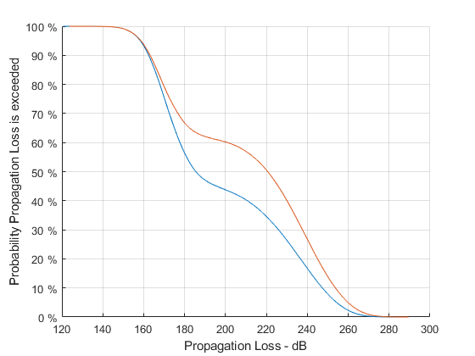
Figure A1.15 below shows the ECDF of the transmit power of System 2 (i.e. the helicopters) and System 4 (i.e. the ground vehicle) in scenario 4.2. One can see that System 2 almost reaches its maximum transmit power in some cases, which is 25 dBm (see Table A1.11). System 4 needs less power because it only uses a narrowband control channel.
Figure A1.16 below shows the ECDF of the gain at the RLS receiver. It shows that interference towards the RLS receiver has occurred through the main beam in less than 0.3 % of the cases.
Figure A1.17 shows the Frequency Dependent Rejection. In the case of System 4, which has a 500 kHz bandwidth, the minimum value is 0 dB and is attained when the signal falls within the RLS bandwidth (25 MHz), and the maximum value 50 dB is attained the frequency separation with the RLS bandwidth is the biggest. In the case of System 2, which has a bandwidth of 55 MHz, the minimum 1.9 dB value is attained when there is complete overlap with the RLS bandwidth, and the maximum value 70 dB, when the frequency separation with the RLS receiver bandwidth is the greatest.

FIGURE A1.15
ECDF of the transmit power of System 2 (blue) and System 4 (red) in scenario 4.2
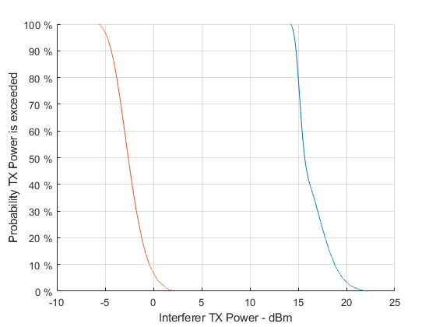
FIGURE A1.16
ECDF of the RLS antenna gain in the direction
of the interferer
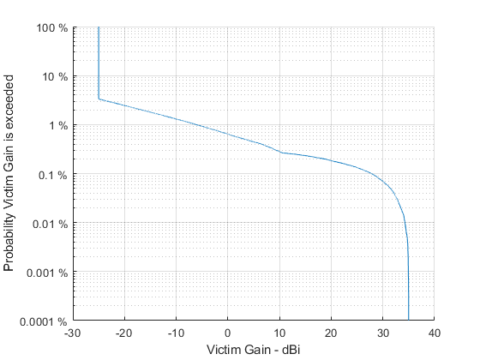
FIGURE A1.17
ECDF of the FDR between the RLS receiver and
system 2 (blue) and between the RLS receiver
and System 4 (red)
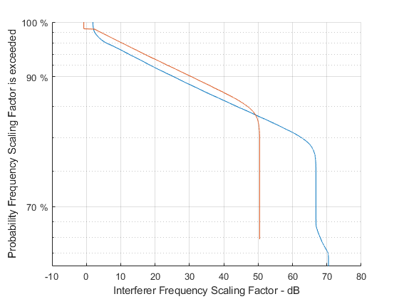
Results are shown in Figures A1.18, A1.19, A1.20 and A1.21 for scenarios 4.2, 4.3, 4.4 and 4.5, respectively. In scenarios 4.3, 4.4 and 4.5, no snapshot has led to an I/N value at the Radiolocation receiver of more than -6 dB.

[Editor’s note – USA asked what the AMS Tx power was in the simulation. France and Germany answered that the power was dependent on the distance between AMS stations. The power is chosen using an ATPC algorithm to reach the target C/N value of 3 dB indicated in Table A1.1. The AMS TX power is an intermediate result that will be provide for the next WP 5B meeting.]
FIGURE A1.18
ECDF of I/N in scenario 4.2 (victim: RLS)
(ECDF: blue; I/N = - 6 dB: red dotted)
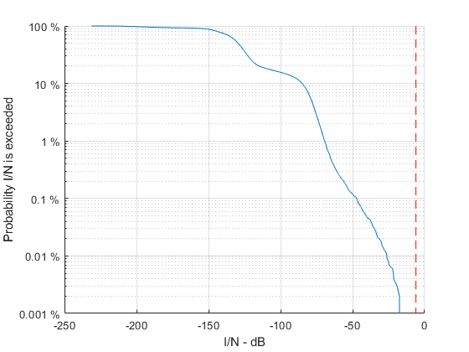
FIGURE A1.19
ECDF of I/N in scenario 4.3 (victim: RLS)
(ECDF: blue; I/N = - 6 dB: red dotted)
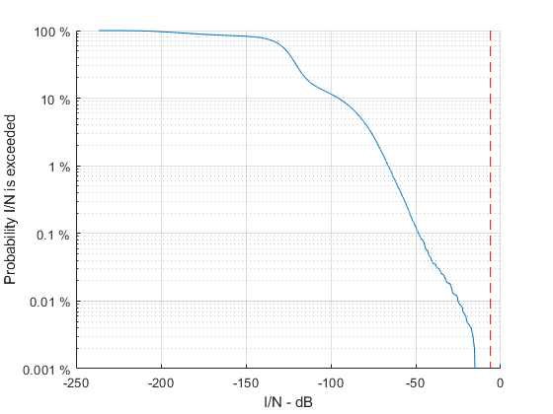
FIGURE A1.20
ECDF of I/N in scenario 4.4 (victim: RLS)
(ECDF: blue; I/N = - 6 dB: red dotted)
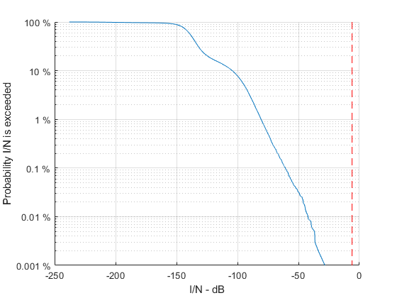
FIGURE A1.21
ECDF of I/N in scenario 4.5 (victim: RLS)
(ECDF: blue; I/N = - 6 dB: red dotted)
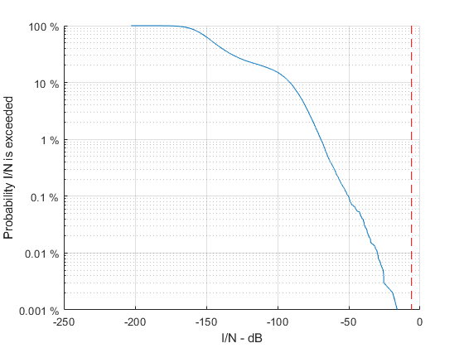

A1.3.1.3 Sharing study C
[Editor’s note – France and Germany remarked that:
- The randomized distance between AMS and radiolocation receiver is chosen based on the radio horizon, which is a similar assumption as in studies performed in Monte Carlo simulations.

This study should be updated to take the newest AMS parameters into account, and in particular to make sure that there is no discrepancy with the typical AMS density values.

The radiolocation receiver is always chose at the same altitude as the AMS, which is a very conservative assumption as it neglects vertical antenna discrimination.

It is not clear how the separation distances in Table 13 are derived from the CDf plots.]

[Editor’s note – For the next WP 5B meeting, USA will:
- Revise the document and conduct the sharing study with Rec. ITU-R P.528-5 and provide results.

Provide the revised calculations to determine the separation distances, as the non-safety AMS technical parameters (Ex: Antenna pattern, a new control link, bandwidth, etc.) have been changed]

A1.3.1.3.1 Introduction
This section introduces the co-frequency sharing and compatibility study between a non-safety AMS transmitter and a radiolocation system operating in the frequency range 15.4-15.7 GHz. The study determines the required separation distance between a non-safety AMS transmitter and a radiolocation system. Analysis scenarios will be based on Figures 2, 3, 4, and 5.

A1.3.1.3.2 Sharing studies scenario, assumptions, and methodology for a single cluster
Figures A1.22 to A1.25 below depict the interference analysis scenario used in the sharing studies according to Figures 2, 3, 4, and 5.
Figure A1.22
Sharing studies between non-safety AMS and Radiolocation based on the Wildfire observation scenario

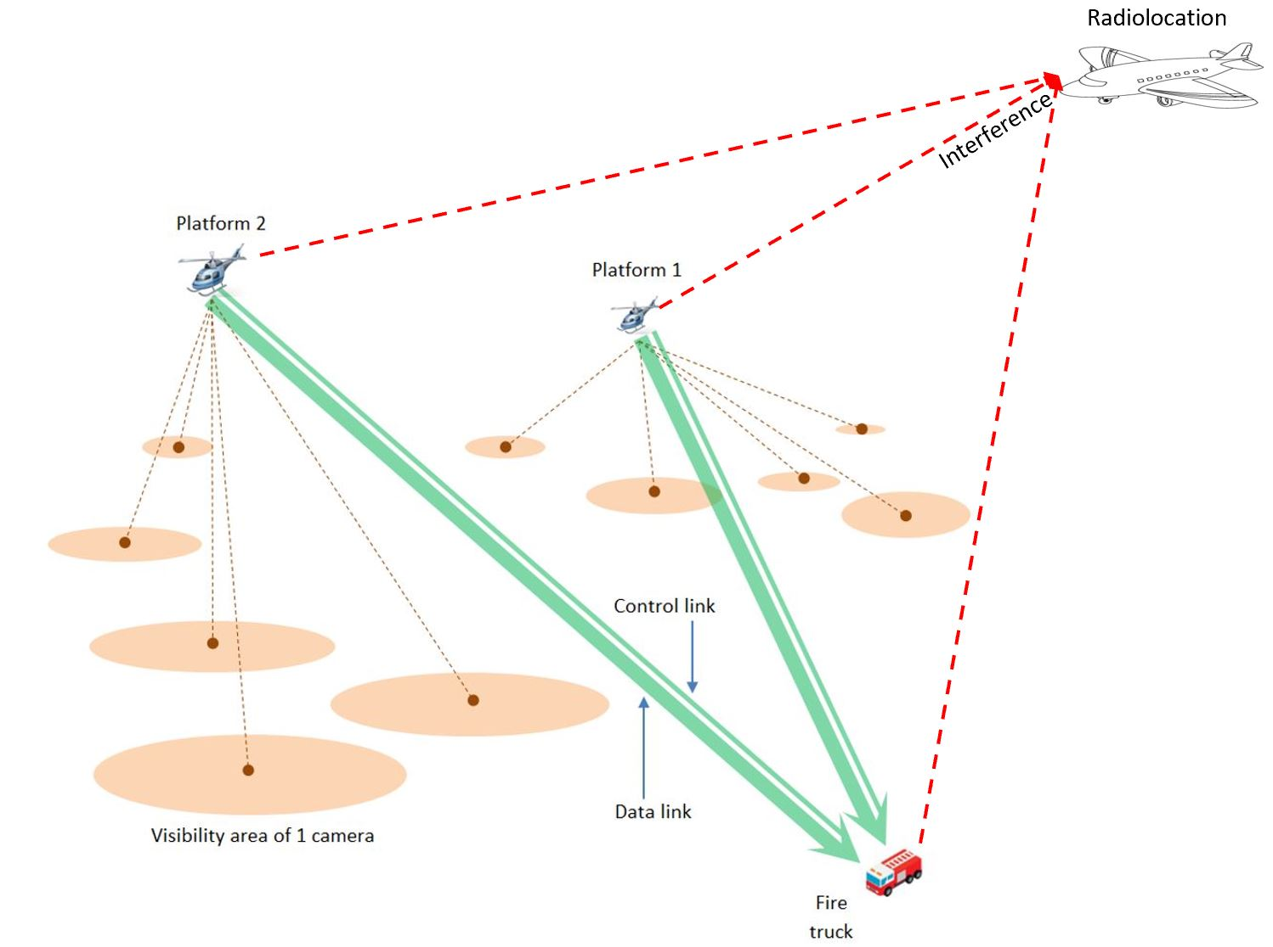
Below are the assumptions and methodology for a single cluster analysis based on Figure A1.22:
1. For the single entry analysis with the transmitted bandwidth of 100 MHz, only one transmitter which is assumed to be platform #1 can interfere with the Radiolocation receiver. The radiolocation receiver and the platform’s center frequency are 15.4 GHz. The transmitter is randomized within a 70 km radius from the fire truck.
2. For the single entry analysis with the transmitted bandwidth of 12.5 MHz, up to 2 transmitters can interfere with the Radiolocation receiver. The radiolocation receiver’s center frequency is 15.4 GHz. The center frequency for the 2 transmitters are: 15.39375, and 15.40625 GHz. Two transmitters are randomized within a 70 km radius from the fire truck.
3. For the analysis as show in 1 and 2 above, the following assumptions are u sed:
a. The location of a fire truck is fixed.
b. Transmission loss using Recommendation ITU-R P.528-5 – A propagation prediction method for aeronautical mobile and radionavigation services using the VHF, UHF, and SHF bands. The time percentage of 5% is used.
c. The altitude for all transmitting platforms is 300 m above the Earth’s surface, and 300 m above the Earth’s surface for the Radiolocation receiver.
d. The analysis assumes co-frequency.
e. The Radiolocation receiver is randomized within a 150 km radius of a transmitting platform.
f. The antenna pattern for a transmitting platform is an Omni antenna. The antenna pattern for the Radiolocation receiver can be modelled using Recommendation ITU-R M.1851 cosine square pattern.
g. The analysis is performed with both maximum and minimum transmitter power (0 and 25 dBm), and antenna gain (-3 and 3 dBi).
h. The pointing angle of the radiolocation receiver antenna is randomized between ± 45° horizontally, and +5° to −45° vertically.
i. The analysis was performed with 1 million sampling points since the protection criteria is I/N of -6 dB.
Figure A1.23
Sharing studies between non-safety AMS and Radiolocation based on the Search and Rescue scenario

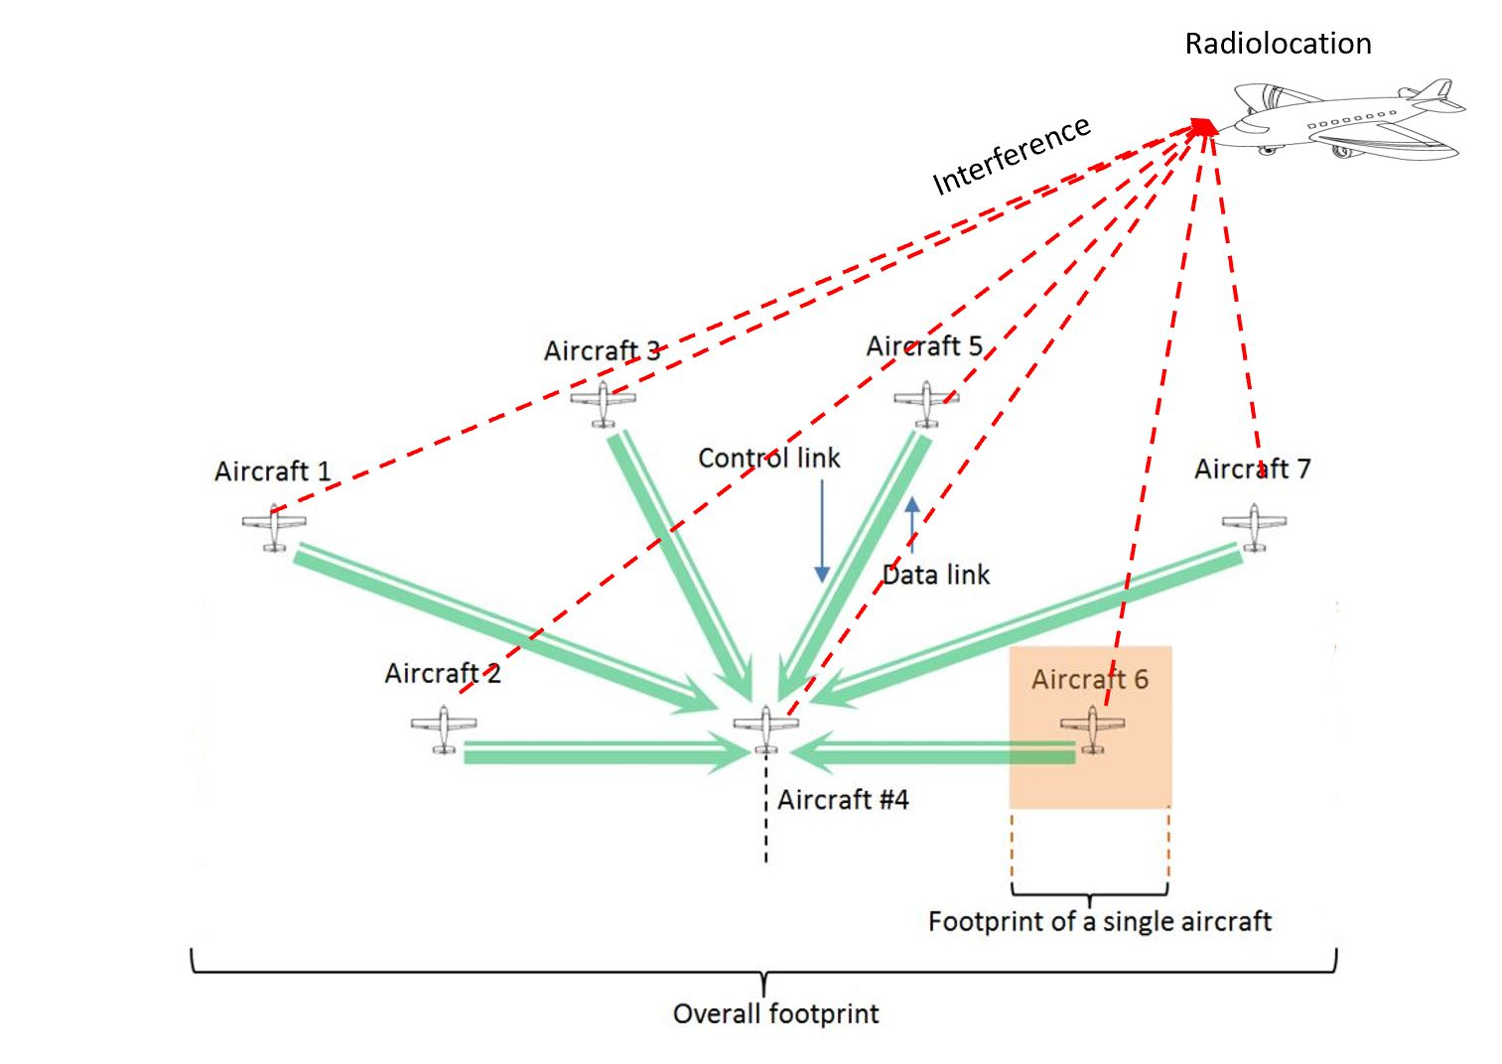
Below are the assumptions and methodology for a single cluster analysis based on Figure A1.23:
1. For the single entry analysis with the transmitted bandwidth of 200 MHz, only one transmitter which is assumed to be aircraft #2 can interfere with the Radiolocation receiver. The radiolocation receiver and aircraft transmitters’ center frequency are 15.4 GHz. The transmitter location is randomized within a ring of 8 km radius from the receiver (Aircraft #4).
2. For the single entry analysis with the transmitted bandwidth of 10 MHz, up to 3 transmitters which are assumed to be aircraft #1, #2, and #3, can interfere with the Radiolocation receiver. The radiolocation receiver’s center frequency is 15.4 GHz. The center frequency for the 3 transmitters are: 15.3925, 15.4025, and 15.4125 GHz. Three transmitters are randomized within a ring 12, 8, and 6 km radius from the receiver (Aircraft #4).
3. For the analysis as show in 1 and 2 above, the following assumptions are u sed:
a. Transmission loss using Recommendation ITU-R P.528-5 – A propagation prediction method for aeronautical mobile and radionavigation services using the VHF, UHF, and SHF bands. The time percentage of 5% is used.
b. The altitude for all non-safety AMS aircraft except aircraft #4 and Radiolocation aircraft is 3.6 km above the Earth’s surface. The altitude of aircraft #4 is 1 km above the Earth’s surface.
c. The analysis assumes co-frequency.
d. The Radiolocation aircraft is randomized within a 600 km radius of a transmitted aircraft.
e. The antenna pattern for a transmitting aircraft can be modelled using Section A1.1.2.1, with a cosine square pattern used for the Radiolocation receiver antenna.
f. The analysis is performed with both maximum and minimum transmitter power (0 and 40 dBm).
g. The pointing angle of the radiolocation receiver antenna is randomized ±45° horizontally, and +5° to −45° vertically.
h. The analysis was performed with 1 million sampling points since the protection criteria is I/N of -6 dB.
Figure A1.24
Sharing studies between non-safety AMS and Radiolocation based on the Surveillance mission scenario

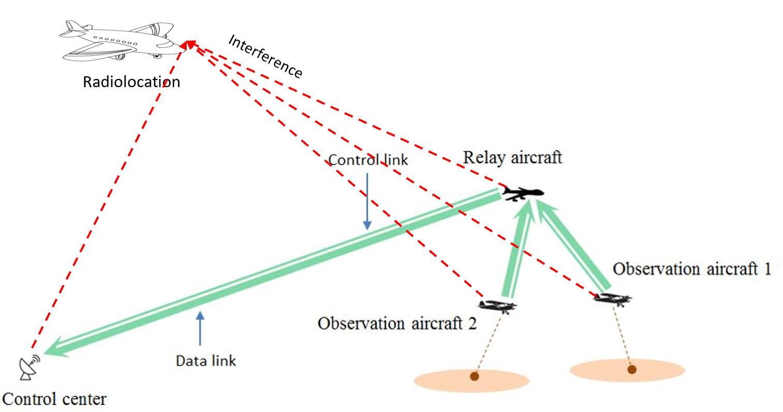
Below are the assumptions and methodology for a single cluster analysis based on Figure A1.24:
1. For the single entry analysis with the transmitted bandwidth of 200 MHz, only one transmitter which is assumed to be a relay aircraft can interfere with the Radiolocation receiver. The radiolocation receiver and aircraft transmitters’ center frequency are 15.4 GHz. The transmitter is randomized within a 300 km radius from the control center.
2. For the single entry analysis with the transmitted bandwidth of 10 MHz, up to 3 transmitters can interfere with the Radiolocation receiver. The radiolocation receiver’s center frequency is 15.4 GHz. The center frequency for the 3 transmitters link is: 15.3925, 15.4025, and 15.4125 GHz. The relay aircraft is randomized within a 300 km radius from the control center. The two observation aircraft are randomized within a 5 km radius from the relay aircraft.
3. For the analysis as show in 1 and 2 above, the following assumptions are u sed:
a. The location of the control center is fixed.
b. Transmission loss using Recommendation ITU-R P.528-5 – A propagation prediction method for aeronautical mobile and radionavigation services using the VHF, UHF, and SHF bands. The time percentage of 5% is used.
c. The altitude for two observation aircraft, and relay aircraft are at 3 and 10 km above the Earth’s surface respectively. The altitude for the Radiolocation aircraft is randomized between 3 and 10 km.
d. The analysis assumes co-frequency.
e. The Radiolocation aircraft is randomized within an 800 km radius of a transmitted relay aircraft.
f. The antenna pattern for the relay aircraft and observation aircraft can be modelled using Section A1.1.2.1, and cosine square pattern for Radiolocation receiver antenna.
g. The analysis was performed with both maximum and minimum transmitter power (0 and 40 dBm).
h. The pointing angle of the radiolocation receiver antenna is randomized ±45° horizontally, and +5° to −45° vertically.
i. The analysis was performed with 1 million sampling points since the protection criteria is I/N of -6 dB.
Figure A1.25
Sharing studies between non-safety AMS and Radiolocation based on the Internet above the clouds scenario

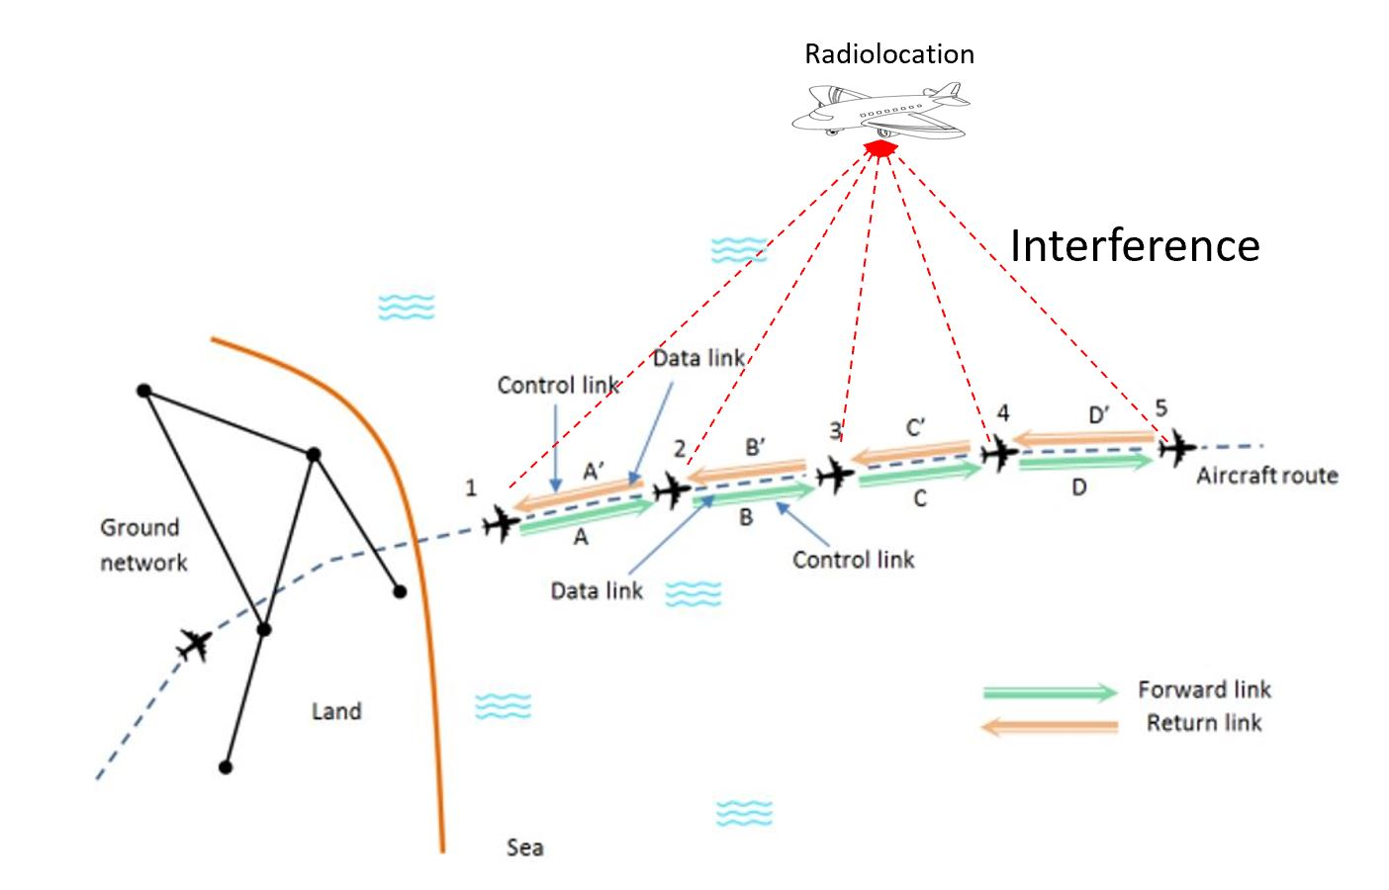

Below are the assumptions and methodology for a single cluster analysis based on Figure A1.2 5:
- For the single entry analysis with the transmitted bandwidth of 100 MHz, only one transmitter which is assumed to be aircraft #2 can interfere with the Radiolocation receiver. The radiolocation receiver and aircraft transmitters’ center frequency are 15.4 GHz. The transmitter is randomized within a ring of 500 km radius from aircraft #1.
2. For the single entry analysis with the transmitted bandwidth of 10 MHz, up to 3 transmitters which are assumed to be aircraft #1, #2, and #3 can interfere with the Radiolocation receiver. The radiolocation receiver’s center frequency is 15.4 GHz. The center frequency for the 3 transmitters are: 15.3925, 15.4025, and 15.4125 GHz. Aircraft #2 is randomized within a ring of 500 km radius from aircraft #1. Aircraft #3 is randomized within a ring of 500 km radius from aircraft #2.
3. For the analysis as show in 1 and 2 above, the following assumptions are u sed:
a. Transmission loss using Recommendation ITU-R P.528-5 – A propagation prediction method for aeronautical mobile and radionavigation services using the VHF, UHF, and SHF bands. The time percentage of 5% is used.
b. The altitude for all transmitting aircraft, and the Radiolocation aircraft is 10 km above the Earth’s surface.
c. The analysis assumes co-frequency.
d. The Radiolocation aircraft’s position is randomized within a 900 km radius of aircraft #2.
e. The antenna pattern for both a transmitting aircraft can be modelled using Section A1.1.2.1, and the Radiolocation receiver can be modelled using Recommendation ITU-R M.1851 cosine square pattern.
f. The analysis was performed with both maximum and minimum transmitter power (0 and 40 dBm).
g. The radiolocation receiver antenna is scanning ±45° horizontally, and +5° to −45° vertically.
h. The analysis was performed with 1 million sampling points since the protection criteria is I/N of -6 dB.

A1.3.1.3.3 Sharing studies results
Figures A1.26 to A1.29 provide the Cumulative Distribution Functions (CDFs) of I/N values based on Figures A1.22 to A1.25 respectively. The bandwidth of the non-safety AMS system is either 100 or 200 MHz.
Figure A1.26
Separation distance between non-safety AMS and Radiolocation based on the Wildfire observation scenario

Figure A1.27
Separation distance between non-safety AMS and Radiolocation based on the Search and Rescue scenario

Figure A1.28
Separation distance between non-safety AMS and Radiolocation based on the Surveillance mission scenario

Figure A1.29
Separation distance between non-safety AMS and Radiolocation based on the Internet above the clouds scenario

Figures A1.30 to A1.33 provide the CDFs of I/N values based on Figures A1.22 to A1.25. The bandwidth of the non-safety AMS system is either 10 MHz or 12.5 MHz.
Figure A1.30
Separation distance between non-safety AMS and Radiolocation based on the Wildfire observation scenario

Figure A1.31
Separation distance between non-safety AMS and Radiolocation based on the Search and Rescue scenario

Figure A1.32
Separation distance between non-safety AMS and Radiolocation based on the Surveillance mission scenario

Figure A1.33
Separation distance between non-safety AMS and Radiolocation based on the Internet above the clouds scenario

Table A1.22 below provides the separation distance between non-safety AMS and Radiolocation.
Table A1.22
Separation distance between non-safety AMS and Radiolocation
 | Non-safety AMS transmitter bandwidth (MHz) | Non-safety AMS transmitter EIRP (dBW) | Separation distance between non-safety AMS and Radiolocation (Km)
Figure 2  Wildfire observation scenario | 100 | -33 | TBD
 | 100 | -27 | TBD
 | 100 | -8 | TBD
 | 100 | -2 | TBD
 | 12.5 | -33 | TBD
 | 12.5 | -27 | TBD
 | 12.5 | -8 | TBD
 | 12.5 | -2 | TBD
Figure 3  Search and recure scenario | 200 | -5 | TBD
 | 200 | 35 | TBD
 | 10 | -5 | TBD
 | 10 | 35 | TBD
Figure 4  Surveillance mission scenario | 200 | -5 | TBD
 | 200 | 35 | TBD
 | 10 | -5 | TBD
 | 10 | 35 | TBD
Figure 5  Internet above the clouds scenario | 100 | 8 | TBD
 | 100 | 48 | TBD
 | 10 | 8 | TBD
 | 10 | 48 | TBD

A1.3.1.3.4 Sharing studies between non-safety AMS and radiolocation service for a multiple clusters
[To be populated later]

A1.3.1.3.5 Summary of preliminary results
The results from the dynamic analysis are summarized in Table A1.22 above. Depend on the interference scenario and systems characteristics, a separation distance is required between non-safety AMS and Radiolocation.
There are no proposed changes following this point in the document.
…

