U.S. Radiocommunications Sector
Fact Sheet
Working Party: ITU-R WP 5B | Document No: USWP5B29-xx
Ref: WP-5B/531 Annex 10 | Date: April 28, 2022
Document Title: WORKING DOCUMENT TOWARDS A PRELIMINARY DRAFT REVISION OF RECOMMENDATION ITU-R M.1851-1
Mathematical models for radiodetermination radar systems antenna patterns for use in interference analyses
Author(s)/Contributors(s):  Tan Ly  ASMO  Laura Deale  ACES Inc for US Army  Raafat Nasser  ACES Inc for US Army | Phone: 571-279-1676  Email: Tan.m.ly.civ@mail.mil  Phone: (703) 785-4910  Email: laura.deale@aces-inc.com  Phone: (571) 277-4030  Email: Raafat.Nasser@aces-inc.com
Purpose/Objective: Update the recommendation with several editorial changes.
This is related to AI 1.4 for HIBS
Abstract: Editorial changes and technical changes to one table.

Fact Sheet Preparer: Raafat Nasser, ACES Inc. for US Army

Radiocommunication Study Groups | 
Source: WP-5B/531 Annex 10  Subject: Revision of Recommendation ITU-R M.1851-1 | Document 5B/xx
 | x July 2022
 | English only
United States of America
WORKING DOCUMENT PRELIMINARY DRAFT REVISION OF RECOMMENDATION ITU-R M.1851-1
Mathematical models for radiodetermination radar and aeronautical mobile systems antenna patterns for use in interference analyses

Scope
The revision of this Recommendation updates the Cosecant-squared antenna pattern and adds parabolic antenna distribution mathematical models for radiodetermination radar and aeronautical mobile system antenna patterns to be used for single-entry and aggregate interference analysis. Depending on the antenna 3 dB beamwidth and first peak sidelobe level, the proper set of equations for both azimuth and elevation patterns may be selected for the purpose of interference analysis. Both peak sidelobe envelope patterns for single entry interferer and average sidelobe envelope patterns for multiple interferers are defined.
Proposal
The United States proposes to include a few editorial corrections to ITU-R M.1851-1.

Summary of revision

The revision of this Recommendation updates the Cosecant-Squared antenna pattern equations and adds parabolic antenna distribution mathematical modelsto be used for single-entry and aggregate interference analysis. Given the antenna 3 dB beamwidth and first peak sidelobe level, the proper set of equations for both azimuth and elevation patterns may be selected for interference analysis. Both peak sidelobe envelope patterns for single entry interferer and average sidelobe envelope patterns for multiple interferers are defined.
[Editor’s note: typical radiodetermination radars use narrow beamwidth antennas in azimuth or elevation (height radars). Typical aeronautical mobile antennas are non-directive. Comparison between the equations and measured patterns are essential, before inserting 'aeronautical mobile’ to the title and other proposed revisions.]
Attachment: 1

Attachment
WORKING DOCUMENT TOWARDS A PRELIMINARY DRAFT REVISION OF RECOMMENDATION ITU-R M.1851-1
Mathematical models for radiodetermination radar [and aeronautical mobile] systems antenna patterns for use in interference analyses
(2009-2018-202X)

Scope
This Recommendation describes mathematical models for radiodetermination radar and aeronautical mobile systems antenna patterns to be used for single-entry and aggregate interference analysis. Dependent on the antenna 3 dB beamwidth and first peak sidelobe level, the proper set of equations for both azimuth and elevation patterns may be selected. Both peak, for single interferer, and average patterns, for multiple interferers, are defined.
Keywords
Antenna patterns, current distribution, illumination field, peak and average mask pattern equations
[Editorial note: Consider to insert Table of Content] [USA note: Typically recommendations do not include table of contenet. This is usually reserved for ITU Reports.]
Abbreviations/Glossary
3-D Three-dimensional
ADP Antenna directivity pattern
CSC² Cosecant squared
SLL Sidelobe level ]Editorial’s note: appears in Fig 13 (15) ‘Antenna pattern comparison’[
Related ITU-R Recommendations

ITU-R F.699 Reference radiation patterns for fixed wireless system antennas for use in coordination studies and interference assessment in the frequency range from 100 MHz to 86 GHz
ITU-R F.1245 Mathematical model of average and related radiation patterns for point-to-point fixed wireless system antennas for use in interference assessment in the frequency range from 1 GHz to 86 GHz
ITU-R M.1638 Characteristics of and protection criteria for sharing studies for radiolocation (except ground based meteorological radars) and aeronautical radionavigation radars operating in the frequency bands between 5 250 and 5 850 MHz
ITU-R M.1652 Dynamic frequency selection in wireless access systems including radio local area networks for the purpose of protecting the radiodetermination service in the 5 GHz band
ITU-R M.1849 Technical and operational aspects of ground-based meteorological radars

The ITU Radiocommunication Assembly,
considering
that a mathematical model is required for generalized patterns of antennas for interference analyses when no specific pattern is available for radiodetermination radar and aeronautical mobile systems,
recognizing
that these mathematical models may not be applicable for all radiodetermination and aeronautical mobile systems, e.g. for some aeronautical mobile telemetry antenna patterns,
recommends
1 that, if antenna patterns and/or pattern equations applicable to a radar(s) are available in other ITU-R Recommendations dealing with radiodetermination radar system characteristics, then those should be used;
2 that, in the absence of information concerning the antenna patterns of the radiodetermination radar system antenna involved, one of the mathematical reference antenna models described in Annex 1 should be used for interference analysis;
3 that, in the absence of additional information, these antenna pattern equations should be considered as appropriate, for some directive antenna of systems operated under the aeronautical mobile service.

Annex 1
Mathematical models for radiodetermination radar [and aeronautical mobile] systems antenna patterns for use in interference analyses
TABLE OF CONTENTS
1 Introduction 5
2 Mathematical formulae 6
2.1 Antenna with a narrow beamwidth 6
2.1.1 Background 6
2.1.2 Theoretical antenna equations 8
2.1.3 Procedure for mask determination 10
2.2 Antenna with a cosecant-squared elevation pattern 12
2.3 Theoretical diagrams and masks for different antenna radiation patterns 17
3 Antenna pattern selection 20
4 Antenna pattern comparison 21
4.1 Parabolic taper aperture antenna 21
4.1.1 Parabolic antenna use and pattern description 21
4.1.2 Procedure to compute sidelobe envelope 23
4.1.3 Antenna pattern selection 27
5 Approximating three-dimensional (3-D) patterns 28
6 Measured pattern examples 30
7 Patterns for phased array antennas 30
7.1 Linear phased antenna array 30
7.2 Rectangular phased antenna array 33

1 Introduction
A generalized mathematical model for radiodetermination radar [and aeronautical mobile] systems antenna patterns are required when these patterns are not defined in ITU-R Recommendations applicable to the radiodetermination radar and aeronautical mobile systems under analysis. Generalized antenna pattern models could be used in analyses involving single and multiple interferer entries, such as that from other radar and communication systems.
This text describes proposed antenna patterns to be used. Given knowledge about beamwidth and the first peak sidelobe level, the proper set of equations for both azimuth and elevation patterns may be selected.
The result of typical antenna parameter ranges from ITU-R Recommendations are recorded in Table 1.
TABLE 1
Typical radiodetermination radar antenna parameter limits
Antenna parameter | Units | Description | Minimum value | Maximum value
Transmit and receive frequencies | MHz |  | 420 | [33 400]  > 250 GHz
Antenna polarization type |  | Horizontal, vertical,  circular
Antenna type |  | Yagi element array,  parabolic reflector,  phased array
Beam type – most common |  | Fan, pencil,  cosecant squared
Transmit and receive gain | dBi |  | 25.6 | 54
Elevation beamwidth (–3dB) | degrees | Pencil beam | 0.25 | 5.75
Elevation beamwidth (–3dB) | degrees | Cosecant squared (CSC²) (equation (12) and Table 4) | 3.6 (θ₃)  20 (θ_{Max}) | 7.0 (θ₃)  44 (θ_{Max})
Azimuth beamwidth (–3dB) | degrees | Pencil beam | 0.4 | 5.75
Elevation scan angle limit | degrees |  | –60 | +90
Azimuth scan angle limit | degrees |  | 30 sector | 360
First sidelobe level below main lobe peak | dB |  | –35 | –15.6

Table 1 was used to guide the development of the antenna types and patterns proposed.

2 Mathematical formulae

2.1 Antenna with a narrow beamwidth

2.1.1 Background
In the absence of neither particular information concerning the 3 dB beamwidth or the shape of the current distribution or illumination field on the antenna aperture, but in the presence of information given about the size of the antenna, the θ₃ half power beam-width (degrees) is approximated by 70 λ/D, where λ the wavelength and D the antenna length are expressed in the same units; see Recommendation ITU-R F.699, recommends 4.1.
If the information about the shape of the current distribution or illumination field on the antenna aperture is accessible, then a more accurate model of the antenna pattern can be used.
To simplify the analysis, the antenna current distribution is considered as a function of either the elevation or azimuth coordinates. The directivity pattern, F(μ), of a given distribution is found from the finite Fourier transform as:

(1)

where:
f (x): relative shape of field distribution, see Table 2 and Fig. 1;
μ: provided in the table below = ;
l: overall length of aperture;
λ: wavelength;
ω: beam elevation or azimuth pointing (scan) angle relative to aperture normal;
θ: point of interest direction angle relative to aperture normal;
α: point of interest direction angle relative to pointing angle direction (α=θ-ω);
x: normalized distance along aperture −1 ≤ x ≤ 1;
j: complex number notation.
Figure 1
Antenna polar diagram mask
The proposed theoretical antenna patterns for antennas having uniform phase field distribution are provided in Table 2.
The proposed theoretical antenna patterns for phased array antennas are given in § 7, taking into account specific sidelobes effects arising at large scan ω angles.
The parameters and formulae for determining antenna directivity patterns (ADP) that are presented in Table 2 (and thereafter in the related Table 3 and Figures) are correct only in the case where the field amplitude at the edge of the antenna aperture is equal to zero and within the bounds of the main lobe and first two sidelobes of the ADP.
With other values of field amplitude at the edge of the antenna aperture, the form of the ADP and its parameters may differ significantly from the theoretical ones presented in this Recommendation.
In the absence of any other information, a simplified antenna pattern fitting with the theoretical main lobe and a mask in other directions may be considered for sharing and compatibility studies with radar systems. Peak or average masks are recommended for doing such studies with single or multiple interferers respectively. The mask departs at break point from theoretical pattern and decreases over sidelobes down to a floor mask to represent antenna far sidelobes and backlobes, as described in § 2.1.3.
If real radar antenna patterns are available, then those should be digitized and used.

2.1.2 Theoretical antenna equations
Equations of directivity patterns and associated parameters are given in Table 2 for different shape of field distribution on the antenna aperture.
TABLE 2
Theoretical antenna directivity parameters
Relative shape of field distribution f(x)  where −1 ≤ x ≤ 1 | Directivity pattern F(μ)  (μ in radians) | θ₃ half power beam-width (degrees) | μ (in radians)as a  function of θ₃ (in degrees) | First sidelobe level below main lobe peak (dB) | Equation No.
Uniform value of 1 |  |  |  | −13.2 | (2)
COS(π*x/2) |  |  |  | −23 | (3)
COS ²(π*x/2) |  |  |  | −32 | (4)
COS ³(π*x/2) |  |  |  | −40 | (5)
COS⁴(π*x/2) |  |  |  | −47 | (6)

where θ₃ is the 3 dB antenna half-power beamwidth (degrees). The relative shapes of the field distribution functions f(x), as defined in Table 2, are plotted in Fig. 2.
Figure 2
Aperture distributions
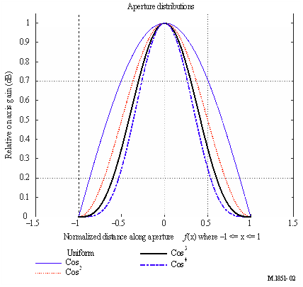

Given that the half power beamwidth, θ₃, is provided, the value of μ can be redefined as a function of the half-power antenna beamwidth. This is done by replacing the quantity in by a constant that depends on the relative shape of the field distribution; divided by the half-power beamwidth, θ₃, as shown in Table 2. These constant values of 50.8, 68.8, 83.2, 95 and 106, shown in Table 2, can be derived by setting the equation for F(μ) equal to −3 dB, and solving for the angle θ.
Figure 3 shows various linear aperture antenna patterns for uniform, cosine (COS), cosine-squared (COS²) and cosine-cubed (COS³) and cosine-to-the-fourth power (COS⁴) field distribution functions. As the patterns are mathematically symmetric, they have been partially traced on the diagram. For comparison, all patterns are set to a same 3 dB beamwidth of 6.0 degrees, meaning different ratios for λ/l.
Figure 3
Antenna pattern comparison for various linear aperture distributions,
3 dB beamwidth is 6.0 degrees (pattern is symmetric)

2.1.3 Procedure for mask determination
Using Fig. 3 above, the mask equations are derived by using a curve fit to the antenna peak sidelobe levels. It has been found, by comparing the integral of the theoretical and the proposed mask patterns, that the difference between the peak and average power in one principal plane cut is approximately 4 dB. The following definitions apply:
– convert equations (2) to (6) into dB using 20*log₁₀ (absolute value (field directivity pattern));
– normalize the antenna pattern gains. Uniform field distribution does not require normalization, for cosine one subtract −3.92 dB, for cosine-squared one subtract −6.02 dB and for cosine-cubed one subtract −7.44 dB, and for cosine-to-the-fourth power one subtract −8.52 dB;
– to plot the mask, use the theoretical directivity pattern from Table 2, as shown in the previous two steps, up to the break point for either the peak or average antenna pattern, as required. After the break point, apply the mask pattern as indicated in Table 3;
– the peak pattern mask is the antenna pattern that rides over the sidelobe peaks. It is used for a single-entry interferer;
– the average pattern mask is the antenna pattern that approximates the integral value of the theoretical pattern. It is used for aggregated multiple interferers;
– the peak pattern mask break point is the point in pattern magnitude (dB) below the maximum gain where the pattern shape departs from the theoretical pattern into the peak mask pattern, as shown in Table 3;
– the average pattern mask break point is the point in pattern magnitude (dB) below the maximum gain where the pattern shape departs from the theoretical pattern into the average mask pattern, as shown in Table 3;
– θ₃ is the 3 dB antenna beamwidth (degrees);
– θ is the angle in either the elevation (vertical) or azimuth (horizontal) principal plane cuts (degrees);
– the average mask is the peak mask minus approximately 4 dB. Note that the break points of the peak pattern are different from the average patterns.
Table 3 shows the equations to be used in the calculations.
TABLE 3
Peak and average normalized theoretical mask pattern equations
Field distribution | Mask equation beyond pattern break point where mask departs from theoretical pattern  (dB) | Peak pattern break point where mask departs from theoretical pattern  (dB) | Average pattern break point where mask departs from theoretical pattern  (dB) | Constant added to the peak pattern to convert it to average mask  (dB) | Mask floor level  (dB) | Equation No.
Uniform |  | −5.75 | −12.16 | −3.72 | −30 | (7)
COS |  | −14.4 | −20.6 | −4.32 | −50 | (8)
COS² |  | −22.3 | −29.0 | −4.6 | −60 | (9)
COS³ |  | −31.5 | −37.6 | −4.2 | −70 | (10)
COS⁴ |  | −39.4 | −42.5 | −2.61 | −80 | (11)

The function ln() is the natural logarithm function. An example of the break point is shown in Fig. 4.
FIGURE 4
Break point example

2.2 Antenna with a cosecant-squared elevation pattern
The cosecant-squared (CSC²) pattern is a special shape which provides to the radar receiver a nearly constant strength of echoes’ returns independently of the horizontal range, for aircrafts flying at a constant altitude. Figure 5 shows a typical diagram of range detection performance (km) of radars.

The cosecant-squared normalized power directivity pattern, in dB, is defined piecewise, as follows for ground radars:
GGroundθ=Gunifθif θ∈[θNull;θStart[]Gcsc²θif θ∈[θStart;θEnd[]G0otherwise (12)
For airborne radars, the cosecant-squared normalized power directivity pattern is given as:
GAirborneθ=Gunifθif θ∈[θStart;θNull[]Gcsc²θif θ∈[θEnd;θStart[]G0otherwise (13)
where:
Gunifθ: the normalized power directivity pattern associated with the uniform field pattern (defined in Tables 4 and 5 below), in dB;
Gcsc²θ: the normalized power directivity pattern associated with the cosecant-squared part of the pattern (defined in Tables 4 and 5 below), in dB;
G0: the normalized floor directivity level, in dB;
θStart: elevation (or depression) of the half-power point on the main lobe where cosecant-squared pattern starts (see details below), in degrees;
Null: one-half sinxx antenna Null-to-Null beamwidth given by θ30.88, [in degrees]. Using the antenna beam pointing angle, the value for Null is Tilt-θ30.88 in degrees for ground radar and Tilt+θ30.88 for airborne radar. This defines the lowest value of the uniform field pattern at the lowest level of the front-to-back ratio;
θEnd: maximum angle where cosecant-squared pattern stops;
θ: angle to evaluate the antenna pattern, in degrees;
θ₃: half power antenna beamwidth, in degrees;
Tilt: antenna beam tilt elevation angle or beam pointing angle, in degrees.
If the operational maximum range and height values, in km, for a radar system application are provided, then the angle where the CSC² starts is given by:
θstart=sin-1Maximum_HeightMaximum_Range-Maximum_Range2*43Re (14)
Where Re is the Earth radius of 6378 km. However, if the operational parameters are not provided then the CSC² start angle θStart is given by the following equations:
θStart=θ32+Tilt for ground radar and θStart=-θ32+Tilt for airborne radar.
The cosecant pattern is applied as shown in Tables 4 and 5.
TABLE 4

Cosecant-squared antenna pattern normalized equations for ground radars
Cosecant-squared equation |  | Comment | Equation  No.
Cosecant floor level G0 (example = −55 dB) | θ < θNull  θ θEnd | At angles less than θNull or more that θEnduse -55 dB front to back ratio  Note that Null is Tilt-θ30.88 | (15)
Gunifθ=20.log10sinμμ  μ=π⋅50.8⋅sinθ-Tiltθ3 | θ∈[θNull;θStart[ | Use sinxx from the lower one half the null to-null beamwidth to the start of the CSC² pattern at θ3 or θstart whichever is provided | (16)
Gcsc²θ=20.log10CSCθCSCθStart+20.log10sinπ⋅50.8⋅sinθStart-θtiltθ3π⋅50.8⋅sinθStart-θ_tiltθ3° | θ∈[θStart;θEnd[ | Start the CSC² pattern up to the maximum CSC² angle  The gain at θStart is the gain of the sinxxpattern at θStart. The pattern gain is lower than the peak antenna gain by 3 dB at θStart | (17)

TABLE 5
Cosecant-squared antenna pattern normalized equations for airborne radars

Cosecant-squared equation |  | Comment | Equation  No.
Cosecant floor level G0 (example = −55 ) | θ≥ θNull  θ< θEnd | At angles less than θNull or more that θEnduse -55 dB front to back ratio. Note that Null is Tilt+θ30.88 | (18)
Gunifθ=20.log10sinμμ  μ=π⋅50.8⋅sinθ-Tiltθ3 | θ∈[θStart;θNull[ | Use sinxx from the lower one half the null to-null beamwidth to the start of the CSC² pattern at θ3 or θstart whichever is provided | (19)
Gcsc²θ=20.log10CSCθCSCθStart+20.log10sinπ⋅50.8⋅sinθStart-θtiltθ3π⋅50.8⋅sinθStart-θtiltθ3° | θ∈[θEnd;θStart[ | Start the CSC² pattern up to the maximum CSC² angle  The gain at θStart is the gain of the sinxxpattern at θStart. The pattern gain is lower than the peak antenna gain by 3 dB at θStart | (20)

A graphical description of the patterns is shown in the figures below.

Figure 5
Cosecant squared beam coverage for ground search radar
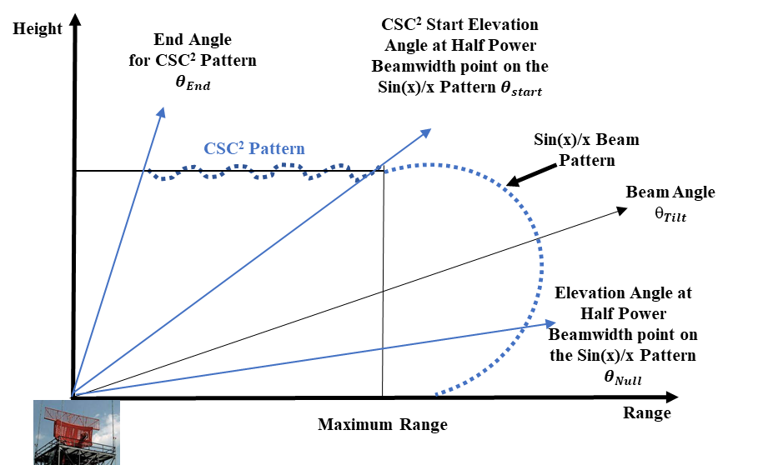
Figure 6
Cosecant squared beam coverage for Airborne radar
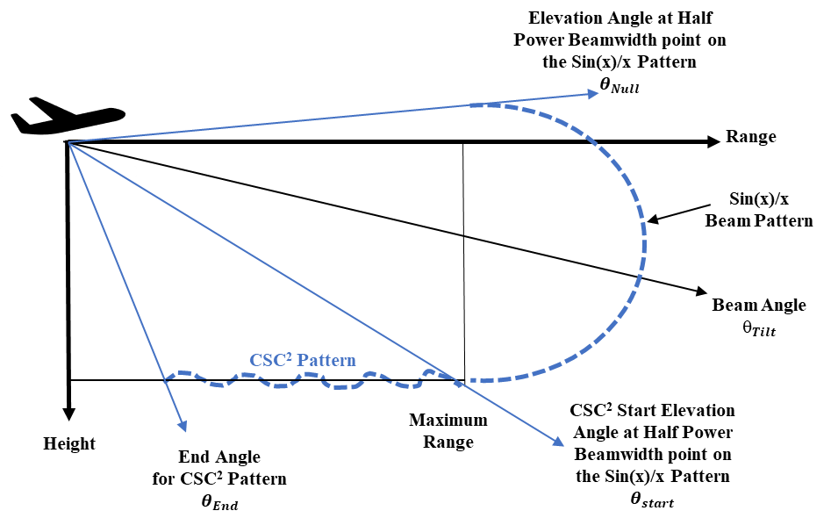
An example using the above procedure provides an antenna pattern for radar C (from Recommendation ITU-R M.1462-2) and is shown below.
Figure 7
Example of Ground Radar – Cosecant squared theoretical antenna directivity. Gain=33.5dBi, θ3dB=4.8°, θStart=4.4°, θEnd=30.0°, θNull=-3.5°, θTilt=2.0°
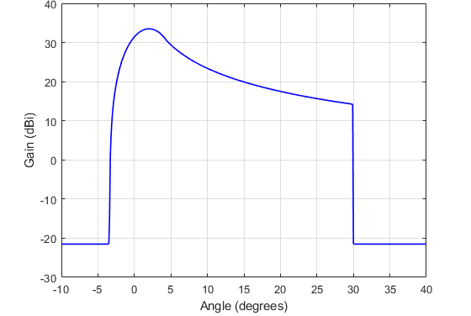
For airborne radar the inverted CSC² , elevation antenna pattern is shown below.
Figure 8
Example of Aircraft Radar – Cosecant squared theoretical antenna directivity. Gain=33.5dBi, θ3dB=4.8°, θStart=-7.4°, θEnd=-30.0°, θNull=0.5°, θTilt=-5.0°
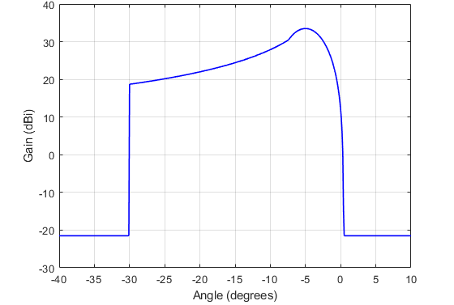

2.3 Theoretical diagrams and masks for different antenna radiation patterns
Figure 9
Antenna normalized pattern, peak { in radians} or in degrees, and average envelope for uniform field distribution
Figure 10
Normalized example polar plot antenna pattern, degrees, peak and average envelope for uniform field distribution
Figure 11
Antenna normalized pattern, degrees, peak and average envelope for cosine field distribution
Figure 12
Antenna normalized pattern, degrees, peak and average envelope for a cosine-squared distribution
Figure 13
Antenna normalized pattern, degrees, peak and average envelope for a cosine-cube distribution
Figure 14
Antenna normalized pattern, degrees, peak and average envelope for a cosine-to-the-fourth power distribution

3 Antenna pattern selection
A suggestion for how the antenna pattern should be selected is based on information about half-power beamwidth and peak sidelobe level. This is provided in Table 6 given information about half power beamwidth.
TABLE 6
Pattern approximation selection table
Range of first sidelobe level below normalized main lobe peak  (dB) | Possible antenna distribution type and cosine raised to power n | Theoretical pattern  equation number | Mask equation number
13.2 to  < 20 | Uniform | (2) | (7)
20 to  < 30 | n = 1 | (3) | (8)
30 to  < 39 | n = 2 | (4) | (9)
39  to <45 | n = 3 | (5) | (10)
>= 45 | n = 4 | (6) | (11)

4 Antenna pattern comparison
One mathematical model for a radiodetermination radar antenna pattern that has been used in interference analysis is given in Recommendation ITU-R M.1652. It includes equations for several patterns as a function of antenna gain. A comparison between the models developed in this Recommendation and Radar-C from Recommendation ITU-R M.1638-0 shows that the pattern in Recommendation ITU-R M.1652 is not optimal. As shown in Fig. 15, the pattern from Recommendation ITU-R M.1652 significantly overestimates the antenna gain off the antenna boresight (0°).
It should also be noted that the equations defined in Recommendation ITU-R F.699 tends to overestimate the sidelobe levels of some radar systems, and it was not developed for radar systems.
Figure 15
Antenna pattern comparison

4.1 Parabolic taper aperture antenna
This section describes parabolic taper aperture antenna peak and average envelope radiation patterns for use in interference analyses. When information on the antenna half-power beamwidth and peak sidelobe level are provided, the proper set of equations for peak and average patterns may be selected. Peak sidelobe envelope patterns are used for a single entry interferer and average sidelobe envelope patterns are used for multiple interferers.

4.1.1 Parabolic antenna use and pattern description
A parabolic antenna is an antenna that uses a parabolic reflector, a curved surface with the cross-sectional shape of a parabola, to direct the radio waves. The most common reflector antennas are the corner reflector antenna, parabolic antenna, paraboloidal antenna, and Cassegrain antenna. Parabolic antennas can have some of the highest gains and narrowest beamwidths of any antenna type. To achieve narrow beamwidths, the parabolic reflector diameter must be much larger than the wavelength of the radio waves used.
Parabolic antennas are used for tracking-radars (like ships, airplanes and clouds), point-to-point communications, wireless links for data communications, satellite communications and spacecraft communication antennas. They are also used in radio telescopes. The ITU-R has many Recommendations for these applications, such as F.699, specifying in recommends 4 that where only the beamwidths θ of the antenna are known:
D/λ (expressed in the same unit) may be estimated approximately by the following expression: where θ is the beamwidth (−3 dB) (degrees);
given θ, G_{max} may be estimated approximately by: .
The focus here is on the use of parabolic antennas in radar applications, in which there is a need to transmit a narrow beam of radio waves to locate objects. For compatibility and interference studies there is a need to develop a peak and average antenna sidelobe pattern envelops that only depend on the known antenna half-power beamwidth and peak sidelobe level. The approach used is similar to that of the linear aperture.
From references [1] and [3], the normalized directivity pattern function for parabolic distribution Fθ,n for different tapers is given by the following equation:
Fθ,n=2n+1n+1!Jn+1βasinθβasinθn+1 (21)
where
β is the free space constant = 2πλ;
a is the radius of the antenna, same unit as λ;
D is the antenna diameter, same unit as λ;
θ3 is the antenna pattern half power beamwidth.
In equation (21), a becomes πKθ3 [for ideal antenna θ₃ =D/λ (in radians)]
Jn is the Bessel function (can be evaluated in Excel or MATLAB, etc.);
λ is the wavelength;
n is the numeric parabolic taper power value.
The antenna dimension can be eliminated using βa=πKθ3, where the values for K (and θ3) in degrees are provided in Table 7 where K=2a θ3λ. Equation (21) can be written as:
Fθ,n=2n+1n+1!Jn+1πK/θ3sinθπK/θ3sinθn+1 (22)
For the parabolic distribution, the following relationships as provided in the table below from reference 1 where the normalized pattern is a function of the beamwidth θ3 and the estimated peak sidelobe level.
TABLE 7
Normalized radiation pattern characteristics produced by Parabolic poweraperture distributions (Reference-[1])
Parabolic power, n | Peak sidelobe level  (dB) | K  (°)
0 | -17.66 | 58.2125
1 | -24.64 | 72.5938
2 | -30.61 | 84.0529
3 | -35.96 | 96.3142
4 | -40.0 | 108.2317

4.1.2 Procedure to compute sidelobe envelope
Using equation (22) and Table 7, it is possible to develop the mask equations. These masks are derived using curve fits to the antenna peak sidelobe levels beyond the antenna pattern first null location. It has been found, by comparing the integral of the theoretical and the proposed mask patterns, that the difference between the peak and average envelopes in one principal plane cut is 6 dB. The following procedure is used for calculating the peak and average envelops:
1 compute equation (22) for different n values using the value of K from Table 7, then normalize the pattern and convert to dB using 20×log10Normalized Pattern ;
2 to plot the mask, use the theoretical directivity pattern from equation (22) up to the break point for either the peak or average antenna pattern, as required. After the break point, apply the mask pattern as indicated in Table 8;
3 the peak pattern mask is the antenna pattern that rides over the sidelobe peaks. It is used for a single-entry interferer;
4 the average pattern mask is the antenna pattern that approximates the integral value of the theoretical pattern. It is used for aggregated interferers;
5 the average pattern mask break point is the point in pattern magnitude (dB) below the maximum gain, where the pattern shape departs from the theoretical pattern into the average mask pattern;
6 the peak pattern mask break point is the point in pattern magnitude (dB) below the maximum gain, where the pattern shape departs from the theoretical pattern into the peak mask pattern;
7 θ₃ is the 3 dB antenna beamwidth (degrees);
8 θ is the angle in either the elevation (vertical) or azimuth (horizontal) principal plane cuts (degrees); and
9 the average mask is computed using the peak mask and subtracting approximately 6 dB. Note that the break points of the peak pattern are different from the average patterns.
Table 8 shows the equations to be used in the calculations of the average and peak antenna masks.
TABLE 8
Peak and average normalized theoretical mask pattern equations
Field distribution  Equation (22) | Mask equation beyond pattern break point where mask departs from theoretical pattern  (dB) | Peak pattern break point where mask departs from theoretical pattern  (dB) | Average pattern break point where mask departs from theoretical pattern  (dB) |  | Mask front-to-back floor level  (dB) | Equation No.
n=0 | -28.9×log10θθ3-11.9 | 0.8537×θ3 | 1.051×θ3 |  | −35 | (23)
n=1 | -49.0×log10θθ3-14.4 | 0.9893×θ3 | 1.161×θ3 |  | -50 | (24)
n=2 | -69.13×log10θθ3-15.46 | 1.13×θ3 | 1.273×θ3 |  | −60 | (25)
n=3 | -89.0×log10θθ3-16.12 | 1.2165×θ3 | 1.339×θ3 |  | −70 | (26)
n=4 | -108.8×log10θθ3-16.27 | 1.2835×θ3 | 1.3906×θ3 |  | −80 | (27)

The approach is shown in Figure 16.

FIGURE 16
Break point example
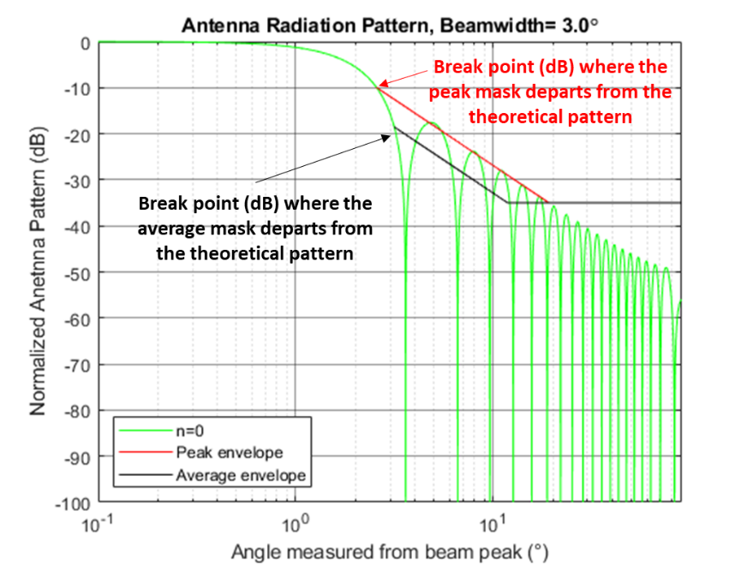
The following graphs show the results for field distribution of n = 0 to n = 4.
FIGURE 17
Example for n = 0
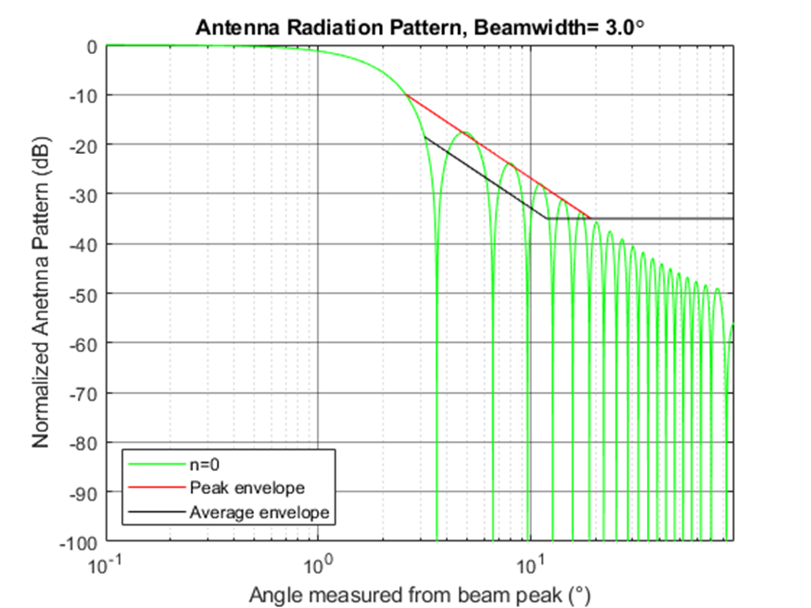
FIGURE 18
Example for n = 1
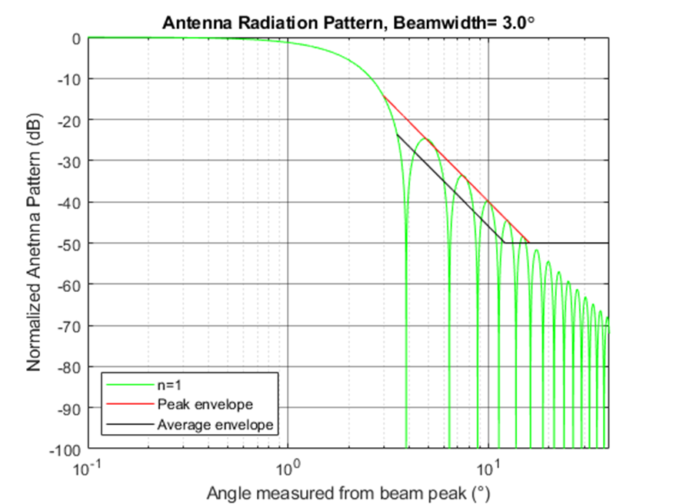
FIGURE 19
Example for n = 2
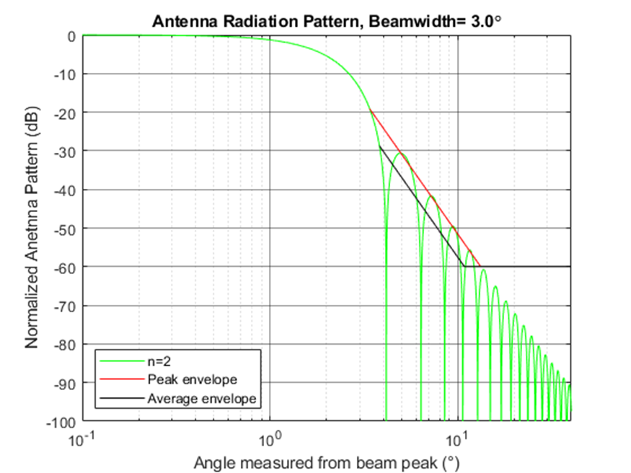
FIGURE 20
Example for n = 3
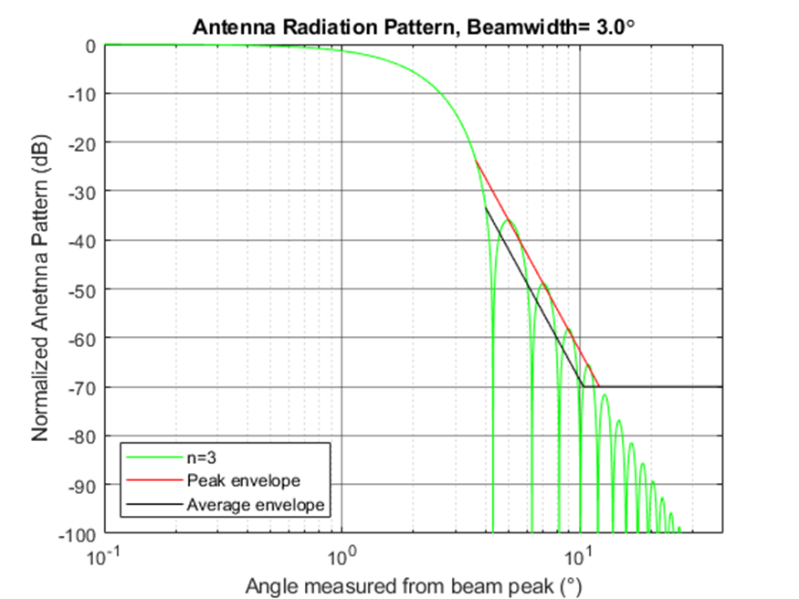
FIGURE 21
Example for n = 4
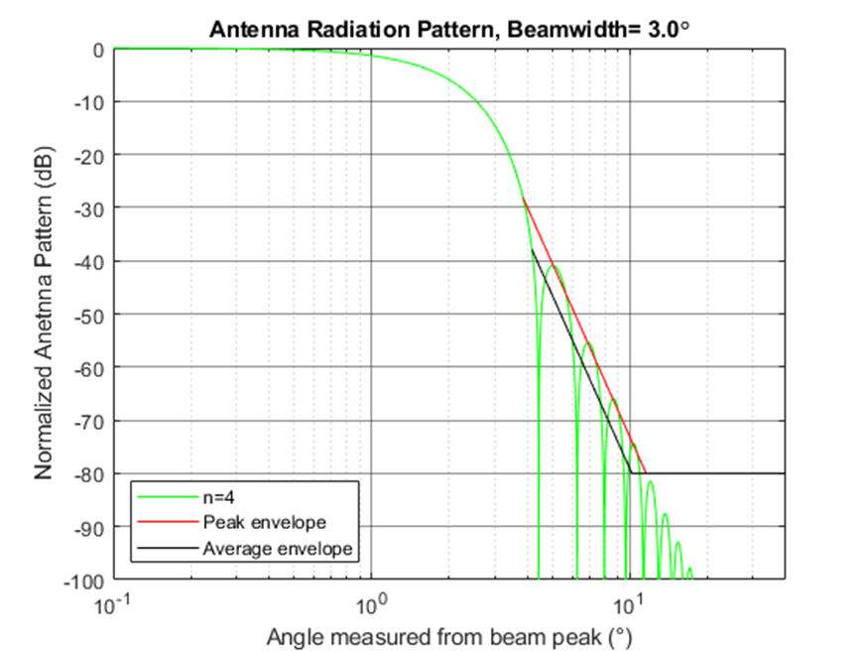

4.1.3 Antenna pattern selection
Table 9 provides suggestion for how the antenna pattern should be selected based on information about the peak sidelobe level.
TABLE 9
Parabolic taper as a function of peak sidelobe level
Range of normalized peak sidelobe level  (dB) | Parabolic antenna distribution power,  n | Equation No. from Table 8
-15 to -20 | n = 0 | 23
-20 to -27 | n = 1 | 24
-27 to -33 | n = 2 | 25
-33 to -38 | n = 3 | 26
Less than -38 | n = 4 | 27

References

[1] Barton, David K., and Ward, Harold R., Handbook of Radar Measurement, Artech House, 1984, Table A.15, page 264.
[2] Chang, Kai, editor-in-chief, et al., Encyclopaedia of RF and microwave engineering, 6 Volume set. Koazkoff, Dennis, Aperture Antennas, DeVry University, Alpharetta, Georgia, page 365. The Encyclopaedia of RF and Microwave Engineering is available online at http://www.mrw.interscience.wiley.com/erfme.
[3] Stutzman, Warren L. and Thiele, Gary A., Antenna theory and design, 3rd ed. 2013. Table 9-2, page 389.

5 Approximating three-dimensional (3-D) patterns
Data from the contour plots may be used as simulation analysis tools. The three-dimensional (3-D) antenna pattern can be approximated. This is done by multiplying the horizontal and vertical principal plane voltage cuts. To do this, place the vertical principal plane pattern in the centre column of a square matrix, and set all the other elements to zero. Place the horizontal principal plane pattern in the centre row of a square matrix and set all the other elements to zero. Multiply the two matrices together and plot. Note that all patterns must be normalized. The minimum gain of the 3-D pattern is capped by the mask floor level in Table 3 or the front-to-back floor level in Table 8, depending on the antenna pattern type. For example, if the peak sidelobe level is −50 dB for one principal plane pattern, then it has to remain at −50 dB in the combined 3-D antenna pattern.
The equation for calculating the 3-D pattern is given by:

(28)
where the elevation and azimuth matrices, in units of volts, are defined in the previous sections..
The vertical pattern is given by:

 | 0 | .... | 0 | El₁ | 0 | .... | 0
 | 0 | .... | 0 | El₂ | 0 | .... | 0
 | .... | .... | 0 | El₃ | 0 | .... | ....
Vertical matrix (V_{h,k}) = | .... | .... | .... | .... | .... | .... | .... | (29)
 | .... | .... | .... | .... | .... | .... | ....
 | 0 | .... | 0 | El_{N–1} | 0 | .... | 0
 | 0 | .... | 0 | El_{N} | 0 | .... | 0

The horizontal pattern is given by:

 | 0 | .... | .... | .... | .... | 0
 | .... | .... | .... | .... | .... | ....
 | 0 | 0 | .... | .... | 0 | 0
Horizontal matrix (H_{k,i}) = | Az₁ | Az₂ |  |  | Az_{N–1} | Az_{N} | (30)
 | 0 | 0 | .... | .... | 0 | 0
 | …. | …. | …. | …. | …. | ….
 | 0 | 0 | …. | …. | …. | 0

Figures 22 and 23 show an example of a 3-D pattern.
Figure 22
Contour Normalized (dB) Pattern
Figure 23
Example of a 3-D relative azimuth and elevation antenna plot, uniform field distribution of a rectangular aperture, attenuation (dB) versus off-axis angle; θ (elevation, degrees) and φ (azimuth, degrees)

6 Patterns for phased array antennas

6.1 Linear phased antenna array
The following equation could be used in the calculations for uniform linear array antenna normalized pattern:
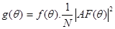 (31)
where:
g: uniform linear array antenna normalized gain pattern;
f: Elementary radiating elements normalized gain pattern inserted in the uniform linear array antenna;
N: number of elementary radiating elements;
AF: uniform linear array antenna factor; ᴪ (radians):
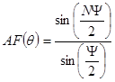 (32)
with
Ψ = 2π(d/λ)(sin(θ) - sin(ω)) (33)
where:
d: uniform elementary radiating element regular interspace;
λ: wavelength at the considered frequency;
ω: electronically beam steering angle;
θ: off-axis angle.
Figure 24
The specific nature of phased array antennas allows to steer electronically the mainlobe of the antenna pattern in a ±90° range from the mechanical antenna boresight. At large scan ω angles specific sidelobes effects in the antenna patterns should be taken into account as mainlobe significant enlargement and desymmetrization (see Fig. 25). In fact, the main lobe maximum value decreases as cos(ω) and further as the elementary radiating element pattern in the array. This result is a widened mainbeam, max gain losses, and consequently far sidelobes increase. For value of ω between ±60° and ±90° range from the mechanical antenna boresight the resulting pattern is so perturbed that it is no more usable (see Fig. 27). The practical values of ω are between 0° and ±60° range from the mechanical antenna boresight. Furthermore, if the array lattice is bigger than λ/2 among the elementary radiating elements in the array, grating lobes of the mainlobe could appear for ω even less than ±60° range from the mechanical antenna boresight (see Fig. 26). And even if the array lattice is λ/2 among the elementary radiating elements in the array, sidelobes of the grating lobes of the mainlobe, situated at −90° and +90° from the mechanical antenna boresight, disturb the array pattern (see Fig. 27).
Figure 25
Theoretical normalized radiating pattern of an uniform linear array of 30 radiating elements with
a λ/2 lattice (blue curve) with a cosine² radiating pattern
(red curve) steered at boresight
Figure 26
Theoretical normalised radiating pattern of an uniform linear array of 30 radiating elements with
a λ/2 lattice (blue curve) with a cosine² radiating pattern
(red curve) steered at 60°
Figure 27
Theoretical radiating pattern of an uniform linear array of 30 radiating elements with
a 0.6λ lattice (blue curve) with a cosine² radiating pattern
(red curve) steered at 45°
Figure 28
Theoretical radiating pattern of an uniform linear array of 30 radiating elements with
a λ/2 lattice (blue curve) with a cosine² radiating pattern
(red curve) steered at 80°

6.2 Rectangular phased antenna array
The following equation could be used in the calculations for uniform planar array antenna normalized pattern:
gθ, ϕ=fθ,ϕ.1N.AFθ,ϕ2 (34)
where:
θ: elevation angle (radians);
ϕ: azimuth angle (radians);
g: uniform planar array antenna normalized gain pattern;
f: elementary radiating elements normalized gain pattern inserted in the uniform planar array antenna;
Nx: number of elementary radiating elements along the x axis;
Ny: number of elementary radiating elements along the y axis;
N=Nx.Ny: total number of elementary radiating elements;
AF: uniform linear array antenna factor:
AFθ,ϕ=sinNxψx2sinψx2. sinNyψy2sinψy2 (35)
with
ψx=2π.dxλ.sinθ.cosϕ-sinωθ.cosωϕ (36
ψy=2π.dyλ.sinθ.sinϕ-sinωθ.sinωϕ (37)
where
dx: uniform elementary radiating element regular interspace along the x-axis (m);
dy: uniform elementary radiating element regular interspace along the y-axis (m);
λ: wavelength at the considered frequency (m);
θ: electronical beam elevation steering angle (radians);
ϕ: electronical beam azimuth steering angle (radians).
Figure 29
Similar to linear phased array of antennas, planar phased array allows to electronically steer the mainlobe of the antenna towards any spherical coordinates. However, large azimuth and elevation steering angles yields specific sidelobes effects in the antenna pattern, as well as significant mainlobe enlargement and desymmetrization. Furthermore, extra care has to be taken so that horizontal and vertical separation distances (dx and dy, respectively) between elements are strictly lower that λ/2, in order to prevent the formation of grating lobes.

7 Measured pattern examples
Figures 30 and 31 show examples of measured radar antenna patterns, in the 9 GHz band. The X axis represents the azimuth angle spanned on more than 360°, and Y axis represents the power level received at each azimuth angle. The power pattern is normalized to its maximum or to an isotropic antenna to be considered as the normalized antenna pattern or the directivity pattern.
First analysis of such measured antenna patterns indicates that first sidelobes appear near −30 dBc with a noticeable slope of sidelobes leading to estimate roughly that a cos² aperture illumination law was used. A theoretical mask floor at −60 dBc given by cos² model would appear in this case a bit too low due to presence of backlobe and rear diffraction lobes in this antenna pattern, then if necessary, use real antenna patterns instead of theoretical ones when possible.
Figure 32 shows an example of measured cosecant squared patterns. The radar beams are obtained from a reflector antenna, fed by two horns which deliver two beams tilted at different elevation angles.
Figure 30
Example measured antenna plot
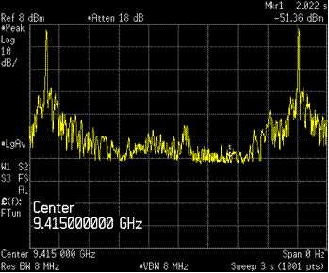
Figure 31
Example measured antenna plot
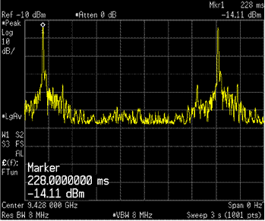
Figures 32 and 33 show two other examples.
Figure 32
Measurement from AN/SPN-6 radar antenna at 3.6 GHz and 38 dBi
Source: Statistical Characteristics of Gain and Mutual Gain of Radar Antennas, Project No. SF 010 204, Task 5727, Department of the Navy, 15 September 1963.
FIGURE 33
Doppler radar antenna pattern from meteorological radar with 25 dB 1st sidelobe
and 60 dB front-to-back ratio
Source: USA Federal Meteorological Handbook No. 11, December 2005 Part B, FCM-H11B-2005.
Figure 34 can be compared to the theoretical pattern of cosecant squared antenna given by equation (12).
Figure 34
Measurement from STAR2000 air traffic control (ATC) radar at 2.8 GHz
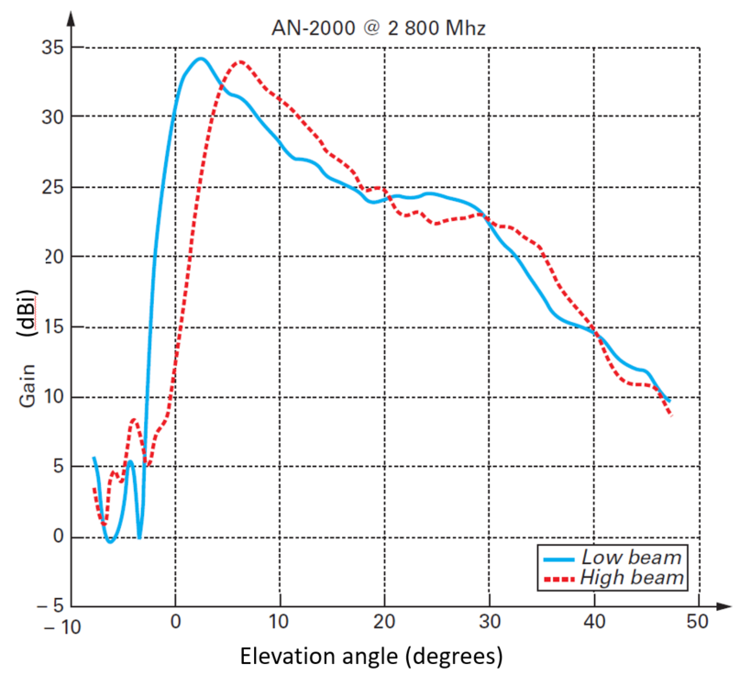
Source: Techniques de l’Ingénieur, TE6678V1, 2014-08-10, Radars de Surface- Radars Civils et Radar Côtiers, Ph. Billaud, N. Colin, G. Desodt, M.Moruzzis, M.Van Landeghem (Thales)

______________

See Barton, David K., Radar Equations for Modern Radar, Chapter 2, Artech House Radar Library, 2013.

