U.S. Radiocommunications Sector
Fact Sheet
Working Party: ITU-R WP-5B | Document No: USWP5B29-17- First Draft
Ref: Annex 19 to Document 5B/481-E | Date: 23 May 2022
Document Title: WORKING DOCUMENT TOWARDS A PRELIMINARY DRAFT NEW RECOMMENDATION ITU-R M.[24.45-24.65_GHz_ARNS] - Characteristics of and protection criteria for radars operating in the aeronautical radionavigation service in the frequency band 24.45-24.65 GHz
Author(s)/Contributors(s):  Don Nellis  Federal Aviation Administration  800 Independence Ave., S.W.  Washington, DC 20591  Mohammed Rahman  Federal Aviation Administration  800 Independence Ave., S.W.  Washington, DC 20591  Michael Neale  ACES Corporation for the FAA | Phone: (202) 267-9779  e-mail: Donald.Nellis@faa.gov  Phone: (202) 267-6573  e-mail: Mohammed.Rahman@faa.gov  Phone: (858) 705-8978  e-mail: Michael.Neale@ACES-INC.COM
Purpose/Objective: The purpose of this contribution is to develop a new recommendation for aeronautical radionavigation systems, including unmanned aircraft systems (UAS) Detect and Avoid (DAA) radar systems, in the 24.45-24.65 GHz band.
Abstract: This contribution will continue the process of developing a new recommendation for systems that operate in the 24.45-24.65 GHz Aeronautical Radionavigation Service allocation including UAS DAA systems. This contribution will be an update to the new report found in Annex 19 of the Chairman’s Report of the 21 December 2021 Document 5B/481-E virtual meeting.

(202X)

Introduction
This proposal is intended to provide characteristics and protection criteria for aeronautical radionavigation systems, including unmanned aircraft (UA) Detect and Avoid (DAA) radar system operating in the radionavigation service in the frequency band 24.45-24.65 GHz in Regions 2 and 3. These technical and operational characteristics can be used as a guideline in analyzing compatibility between radars operating in the aeronautical radionavigation service and systems in other services within this band.
Proposal
This contribution proposes to initiate a working document towards a preliminary draft new Recommendation ITU-R M.[24.45-24.65 GHz ARNS] pending the global deployment of DAA systems operating in the radionavigation service to provide the necessary characteristics for sharing studies with other systems in this band.
Attachment: 1

Radiocommunication Study Groups | 
Received:  Subject: 24.45-24.65 GHz ARNS radars | Document 5B/442-E
 | 23 May 2022
 | English only
United States of America
Characteristics of and protection criteria for radars operating in the aeronautical radionavigation service in the frequency band 24.45-24.65 GHz

Radiocommunication Study Groups
Source: Document 5B/TEMP/172  Subject: New Recommendation ITU-R  M.[24.45-24.65_GHZ_ARNS] | Annex 19 to  Document 5B/481-E
 | 21 December 2021
 | English only
Annex 19 to Working Party 5B Chairman’s Report
WORKING DOCUMENT TOWARDS A PRELIMINARY DRAFT NEW
RECOMMENDATION ITU-R M.[24.45-24.65_GHZ_ARNS]
Characteristics of and protection criteria for radars operating in the
aeronautical radionavigation service in the frequency
band 24.45-24.65 GHz
(202X)
Scope
This document specifies the characteristics and protection criteria of radars operating in the aeronautical radionavigation service (ARNS) in the frequency band 24.45-24.65 GHz. The technical and operational characteristics should be used in analysing compatibility between radars operating in the aeronautical radionavigation service and systems in other services.
Keywords
24.45-24.65 GHz, radar, characteristics, protection.
Abbreviations/Glossary
ABDAA: Airborne detect and avoid
ARNS Aeronautical radionavigation service
ATC: Air traffic control
CDMA Code-division multiple access
DAA Detect and avoid
e.i.r.p. Effective isotropically radiated power
ESA: Electronically scanned array
FDMA Frequency division multiple access
FMCW Frequency-modulated continuous wave
GBDAA: Ground based detect and avoid
GBSS Ground based surveillance system
LFM Linear frequency modulation

PSD Power spectral density
RR: Radio Regulation
TDMA Time-division multiple access
UA Unmanned aircraft
UAS Unmanned aircraft system
Related ITU Recommendations, Reports
Recommendations
ITU-R S.1340 Sharing between feeder links for the mobile-satellite service and the aeronautical radionavigation service in the Earth-to-space direction in the band 15.4-15.7 GHz
ITU-R M.1372 Efficient use of the radio spectrum by radar stations in the radiodetermination service
ITU-R M.1730 Characteristics of and protection criteria for the radiolocation service in the frequency band 15.4-17.3 GHz
Report
ITU-R M.2204 Characteristics and spectrum considerations for sense and avoid systems use on Unmanned Aircraft Systems (UAS)
The ITU Radiocommunication Assembly,
considering
a) that antenna, signal propagation, target detection, and wide necessary bandwidth of radar required to achieve their functions are optimum in certain frequency bands;
b) that the technical characteristics of radars operating in the aeronautical radionavigation service (ARNS) are determined by the mission of the system and vary widely even within a frequency band,
recognizing
a) that the frequency band 24.45-24.65 GHz is allocated on a primary basis to the radionavigation (including aeronautical radionavigation), fixed, mobile except aeronautical mobile, and inter-satellite services in ITU-R Region 2;
b) that the frequency band 24.45-24.65 GHz is allocated on a primary basis to the radionavigation (including aeronautical radionavigation), inter-satellite, fixed, and mobile services in ITU-R Region 3;
c) that numerous features of radiodetermination radars can be expected to help suppress low-duty cycle (less than 5%) pulsed interference, especially from a few isolated sources. Techniques for suppression of low-duty cycle pulsed interference between two or more pulsed system are contained in Recommendation ITU-R M.1372 – Efficient use of the radio spectrum by radar stations in the radiodetermination service;

d) that the inter-satellite service operating in the frequency band 24.45-24.65 GHz shall not claim protection from harmful interference from airport surface detection equipment stations of the radionavigation service,
recommends
1 that the technical and operational characteristics of the ARNS radars operating in the ARNS described in the Annex should be considered representative of those operating in the frequency band 24.45-24.65 GHz and used in studies of compatibility with systems in other services;

2 that the criterion of interfering signal power to radar receiver noise power level (I/N) of [−6 dB/−10 dB ], should be used as the required protection level for the aeronautical radionavigation radars, and that this represents the aggregate protection level if multiple interferers are present.

Annex
Technical and operational characteristics of radars operating in the
aeronautical radionavigation service in the
frequency band 24.45-24.65 GHz

1 Introduction
ARNS system operates in Regions 2 and 3 on a primary basis in the frequency band 24.45-24.65 GHz. This Annex presents the technical and operational characteristics of representative ARNS radars operating in this frequency band.
ARNS systems are installed in unmanned aircraft (UA) or on the ground to detect non-cooperative aircraft as a component of an UA Detect and Avoid (DAA) system. These radars are used for collision avoidance on-board UA and are a vital part of the integration of unmanned aircraft system (UAS) in non-segregated airspace.

2 Characteristics of aeronautical radionavigation detect and avoid radar

Unmanned aircraft are powered, aircraft that do not carry a human pilot, use aerodynamic forces to provide vehicle lift, and may fly semi-autonomously or autonomously, or be piloted remotely. The safe flight operation of UA in non-segregated airspace necessitates advanced techniques to detect and track nearby aircraft, terrain, remain well clear of obstacles, and properly act and respond to certain weather conditions. UA must avoid these objects in the same manner as manned aircraft. Two primary sensor systems are operational to allow a UAS to meet this requirement. The first class comprises sensor(s) or electronic system(s) on the air vehicle and is called airborne detect and avoid (ABDAA). The second class involves sensor(s) or electronic system(s) monitoring the air space from the ground and is refer to as ground based DAA (GBDAA).
The goal of airspace access for appropriately equipped UA systems is to achieve a level of safety equal to that of an aircraft with a pilot in the cockpit. The remote pilot will need to be aware of the environment within which the aircraft is operating, be able to identify the potential threats to the continued safe operation of the aircraft and take the appropriate action. In order for UAS to operate in non-segregated civil airspace, they must be integrated safely and adhere to current operational rules that provide an acceptable level of safety similar to that of a conventional manned aircraft. The DAA radar is part of an unmanned aircraft collision avoidance system whose primary function is to provide the capability to detect, track and report non-cooperative air traffic information to the remote pilot in order to maintain adequate separation from intruders. The system utilizes a “Pilot-in-the-Loop” approach in which the ground-based UA pilot will have final authority regarding UAS manoeuvres to avoid other aircraft (manned or unmanned).
The safe operation of UAS outside segregated airspace requires addressing the same issues as manned aircraft, namely integration into the air traffic control (ATC) system. There are scenarios that occur when traditional existing ground-based surveillance radars are unable to detect the UA when they are flying at low altitude. These scenarios are caused by terrain, man-made structures, flight below normal radar coverage and lack of a transponder. Implementation of GBDAA radar is necessitated to fill this gap by incorporating self-separation that requires the UAS operate in airspace inside a fixed threat detection airspace with no other air vehicles. If an aircraft enters the threat detection airspace, a ground-based surveillance system warns the operator. The operator will then execute the second phase and fly the UAS to a safe state. A safe state exists when the UAS lands, exits from its operating area into a safe area, or controlled or restricted airspace.
FIGURE 1
Ground-based detect and avoid
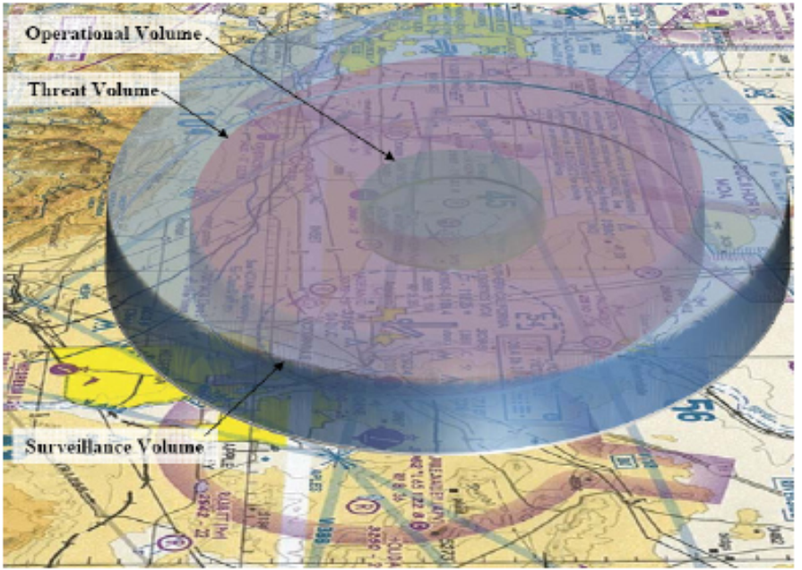
GBDAA is a critical component to the overall DAA solution and predominant solution to support all classes of UAS to operate in non-segregated airspace because many operations are conducted with relatively much small classes of UAS that do not have the power, cooling and physical space to accommodate the currently projected size and weight of current onboard ABDAA systems.

The technical parameters are provided in Table 1.
TABLE 1
Technical parameters of detect and avoid radar
[Editor’s note: parameters will need to be further reviewed and confirmed at future meetings]
Parameter | Units | Radar 1 | Radar 2
Platform |  | Airborne / Ground | Airborne / Ground
Platform height | km | Up to 20 (Air)  0 (Ground) | Up to 20 (Air)  0 (Ground)
Spectral usage |  | Air-to-air and Ground-to-air aeronautical radionavigation DAA radar | Ground-to-air and Ground-to-air aeronautical radionavigation DAA radar
Radar type |  | FMCW | FMCW
Range class |  | Short range | Medium range
Operating range | km | 3 | 8
Maximum number of drones within the same operating area |  | 3 (Air)  8 (Ground) | 3 (Air)  10 (Ground)
Ground speed | km/h | <430 | <430
Target speeds (max) | m/s | <200 | <200
Frequency tuning range  (Note 1) | GHz | 24.45-24.65 | 24.45-24.65
Channelization methods |  | FDMA: 3 ch 45 MHz  CDMA: 4 ch  TDMA: 4 ch  LFM-dir: up/down (gnd/air) | FDMA: 3 to 6 ch  CDMA: 4 ch  TDMA (gnd only): 4 ch  LFM-dir: up/down (gnd/air)
Channel selection method between radars  (Note 2) |  | SW selectable | SW selectable
Emission type |  | FXN | FXN
Radar Modulation |  | LFM | LFM
Modulation bandwidth | MHz | 45 | 10 to 50  (Note 3)
Pulse width | μs | 200 | 50 to 200  (Note 3)
Pulse rise and fall times | μs | < 1 | < 1
RF emission bandwidth at  −3 dBc  −20 dBc  −40 dBc | MHz | <48  <54  <60 | 110% BWchirp  120% BWchirp  130% BWchirp
Pulse repetition frequency | kHz | 4.7 | 2 to 10
Average transmitter power | W | 2 | 12
Out-of-band emission characteristics | dBc | < -75  (through 3rd harmonic) | < -75  (through 3rd harmonic)
Spurious emission characteristics | dBuV/m in 1MHz BW | < 83 | < 83
Receiver IF bandwidth  −3 dB  −20 dB  −60 dB | MHz | < 10  < 20  < 70 | <10  < 30  < 40
Sensitivity (MDS)  (at RX input. SNR = 12 dB) | dBm | −119 dBm | −122 dBm
Receiver noise figure | dB | 6 | 3
Calculated Rx noise power  (Note 4) | dBW | −131 dBm | −134 dBm
Saturation level | dBm | −40 | −40
Antenna type |  | ESA  (Note 5) | ESA  (Note 5)
Antenna placement |  | Fixed  (internally sealed package) | Fixed  (internally sealed package)
Antenna gain | dBi | 21 | 27
First antenna sidelobe | dBi | < −16 | < −16
Horizontal beamwidth  (2-way at 0,0) | degrees | 2 | 2
Vertical beamwidth  (2-way at 0,0) | degrees | 6 | 2
Polarization |  | Horizontal | Horizontal
Horizontal antenna scan  (from boresight) | degrees | ±60 | ±60
Vertical antenna scan  (from boresight) | degrees | ±40 | ±40
Protection criteria  [I/N or false detection ratio] | dB | [−6 dB/−10 ] | [−6 dB/−10 ]
Notes:
1 Utilized bandwidth - Inclusive of frequency-channel guard-bands.
2 Channel selection is purely SW-defined and can be on-the-fly dynamic. Some settings may allow radar to self-configure based on detected spectrum-conflict.
3 Waveform is software-defined on a CPI-by-CPI basis, and optimized for targets, and spectral environments.
4 Compressed bandwidth before processing gain.
5 High T/R ESA RF beamforming on both transmit and receive.

3 Protection criteria

The desensitizing effect on radars from other services of a continuous-wave or noise-like type modulation is predictably related to its intensity. In any azimuth sectors in which such interference arrives, its power spectral density (PSD) can, to within a reasonable approximation, simply be added to the PSD of the radar receiver thermal noise. If PSD of radar-receiver noise in the absence of interference is denoted by N₀ and that of noise-like interference by I₀, the resultant effective noise PSD becomes simply I₀ + N₀.
The effect of pulsed interference is more difficult to quantify and is strongly dependent on receiver/processor design and mode of operation. In particular, the differential processing gains for valid-target return, which is synchronously pulsed, and interference pulses, which are usually asynchronous, often have important effects on the impact of given levels of pulsed interference. Several different forms of performance degradation can be inflicted by such desensitization. Assessing it will be an objective for analyses of interactions between specific radar types. Assessing it will be an objective for analysis of interactions between specific pulsed radar types.
In general, numerous features of radiodetermination radars can be expected to help suppress low-duty cycle pulsed interference, especially from a few isolated sources. Techniques for suppression of low-duty cycle pulsed interference are contained in Recommendation ITU-R M.1372 – Efficient use of the radio spectrum by radar stations in the radiodetermination service. When multiple interferers are present, the recommended I/N protection criteria remains unchanged. The total interference level actually arriving at the radar receiver depends on the number of interferers, their spatial distribution and their signal structure and needs to be assessed in the course of an aggregation analysis of a given scenario. If interference were received from several azimuth directions, an aggregation analysis has to cumulate simultaneous contributions from all these directions, being received via the radar antenna’s main beam and/or side-lobes, in order to assess compatibility.
[Editor’s note: More information on the appropriate protection criteria will be provided once the technical and operational characteristics of radars in section 2 have been finalized.
– For typical radars an increase of about 1 dB would constitute significant degradation, equivalent to a detection-range reduction of about 6%. Such an increase corresponds to an I/N ratio of 1.26, or an I/N ratio of about −6 dB.
– For the radionavigation service considering the safety-of-life function, an increase of about 0.5 dB would constitute significant degradation. Such an increase corresponds to an (I/N) ratio of −10 dB.]
These protection criteria represent the aggregate effects of multiple interferers, when present; the allowable I/N ratio for an individual interferer depends on the number of interferers and their geometry and needs to be assessed in the course of analysis of a given scenario. The aggregation factor can be very substantial in the case of certain communication systems in which a great number of stations can be deployed.

