US Radiocommunication Sector
FACT SHEET
Study Group: USWP 5B |  | Document No: USWP5B-13
Reference: Document 5B/531 Annex 13 |  | Date: 11 May, 2022
Document Title: Updates to Working document towards a preliminary draft new
report ITU-R [NON-SAFETY AMS CHARACTERISTICS AND SHARING STUDIES]
Authors | Telephone |  | E-Mail
Daniel Bishop, NASA  Ryan S. McDonough, NASA | 216-433-5220  216-433-2862 |  | daniel.w.bishop@nasa.gov  Ryan.S.McDonough@nasa.gov
Purpose/Objective:
Propose updates to Working document towards a preliminary draft new report ITU-R [NON-SAFETY AMS CHARACTERISTICS AND SHARING STUDIES], building upon the chairman’s report from the April 2022 WP 5B meeting.
Abstract:
This contribution seeks to further this work by expanding and updating the studies of adjacent band compatibility between the potential new AMS allocation in 22-22.21 GHz and EESS (passive) in 22.21-22.5 GHz in section A.2.3.3 of the working document. This work will address comments from the April 2022 WP 5B drafting group discussion on these sections. The work will assess impacts to EESS (passive) due to scenarios 4.3 “search and rescue” and 4.4 “border surveillance” scenarios. Also, it will verify conformance of studies with updated deployment density section 5 as well as tabulated technical data in section 4.6.
Fact Sheet Preparer: Ryan McDonough, NASA
Radiocommunication Study Groups | 
Source: Document 5B/TEMP/220  Subject: Draft new Report on WRC-23 agenda item 1.10 | Annex 13 to  Document 5B/531-E
 | 27 April 2022
 | English only
Annex 13 to the Working Party 5B Chairman’s Report
WORKING DOCUMENT TOWARDS A PRELIMINARY DRAFT NEW
REPORT ITU-R [NON-SAFETY AMS CHARACTERISTICS AND SHARING STUDIES] RELATED TO WRC-23 AGENDA ITEM 1.10
Technical characteristics, operational scenarios, spectrum needs, coexistence, and sharing studies of non-safety aeronautical mobile systems in the
frequency bands 15.4-15.7 GHz and 22-22.21 GHz
[Editor’s note It was indicated by some administrations that due to heavy workload of WP5B they were not able to follow discussion of this document. These administartions are requisting un opportunity provided to express their opinion on the matter.]
ANNEX 14
Compatibility studies between systems operating in the aeronautical mobile service and the earth exploration satellite service (passive) in the frequency band 22 – 22.21 GHz
[Editor’s note A14-1: (Questions from France, Germany):
– Why did you model a broadband uplink in scenario 4.2 (wildfire detection) although the uplink (from the fore truck to the observation platforms) is only used for control (and hence uses narrowband communication, see section 4.2)?
– The deployment densities that you considered in Configuration 1 (Wildire detection) exceeds by far the typical deployment density given in section 5.1 (should be 49 clusters for an area of interest of 10,000,000 km². Why is that?
– The deployment densities that you considered in Configuration 2 (Data networks above the clouds) exceeds by far the typical deployment density given in section 5.1 (should be 29 clusters for an area of interest of 10,000,000 km². Why is that?
The deployment densities that you considered in Configuration 2 (Data networks above the clouds) exceeds by far the typical deployment density given in section 5.1 (should be 29 clusters for an area of interest of 10,000,000 km². Why is that?
– There seem to be mistakes in the parameters of Configuration 2 (data networks above the clouds):
With respect to the data networks above the clouds scenario, the operational altitude of the AMS systems was 10km and the antenna pattern was omnidirectional with maximum gain of 3dB.
(extract from section A14.1.2), see section 4.6 about the technical setup of operational scenarios, in this scenario very directive antennas (System 3) are used to cover large separation distance between aircraft)]
[Answer to Editor’s note A14-1:
- The uplink bandwidth is adjusted to match section 6.
- Deployment densities are adapted to accommodate a range of deployment densities including those values provided in section 5 in order to determine the maximum compatible density of systems.
- See previous comment.
- Operational altitude is 10km. Maximum gain for short distance is 3dB and for long distance the directive antenna (system 3) is employed.]

A14.1 Study A

A14.1.1 Calculation of Aggregate Interference
An assessment of the aggregate RFI expected from non–safety AMS systems into EESS (passive) is achieved by a dynamic simulation. The analysis will be conducted in which the orbit of the EESS (passive) spacecraft under investigation is dynamically simulated. Calculations will be performed to determine the potential interference from the proposed non–safety AMS systems into the EESS (passive) band and will consider the aggregate effect from multiple sources. The simulation will propagate the satellite based on its orbital parameters, and the time step is selected to be an irrational number to ensure that the beam dynamics of the passive sensor do not exhibit periodic behavior. At each time step, the simulation will compute the directional vectors from each source to the EESS (passive) and then compute the gain of the transmit and receive antennas using their respective antenna patterns.
The interfering signal power level, $I_{i,n}$ (W), received by a spaceborne radiometer at the $n^{\text{th}}$ timestep from the $i^{\text{th}}$ active transmitter is calculated from:
$$\begin{aligned}I_{i,n}=\frac{{ P}_{\text{TX} i,n}G_{\text{TX} i,n}{ G}_{\text{RX} i,n}}{L_{\text{a} i,n}{ L}_{\text{FSPL} i,n} L_{\text{pol} i,n}} \#\left(\text{A14-1}\right)\end{aligned}$$
where:
${ P}_{\text{TX} i,n}$: source transmitter power in the EESS (passive) band (W);
$G_{\text{TX} i,n}$: source antenna gain towards spaceborne sensor;
$G_{\text{RX} i,n}$: spaceborne receive antenna gain towards terrestrial source;
$L_{\text{a} i,n}$ : attenuation due to atmospheric absorption;
$L_{\text{FSPL} i,n}$: Free Space Path Loss;
$L_{\text{pol} i,n}$: losses due to polarization mismatch.
The aggregate interference at the $n^{\text{th}}$ timestep,${ AggI}_{n}$ (W), is calculated by the summation of the received interference from active stations within line of sight of EESS (passive):
$$\begin{aligned}{AggI}_{n}=\sum_{i}{I_{i,n}}=\sum_{i}{\frac{{P_{\text{TX }i,n} G}_{\text{TX} i,n}{ G}_{\text{RX} i,n}}{L_{\text{a} i,n}{ L}_{\text{FSPL} i,n} L_{\text{pol} i,n}}} \#\left(\text{A14-2}\right)\end{aligned}$$
Thus, the aggregate interference can be represented in the logarithmic domain as:
$$\begin{aligned}{AggI}_{n|\text{dB}}={\left(\sum_{i}{\frac{{ P}_{\text{TX} i,n}{ G}_{\text{TX} i,n}{ G}_{\text{RX} i,n}}{L_{\text{a} i,n}{ L}_{\text{FSPL} i,n} L_{\text{pol} i,n}}}\right) }_{|\text{dB}}\#\left(\text{A14-3}\right)\end{aligned}$$
Based on time series values for the interfering signal power level, a CCDF curve will be generated in order to assess if the result exceeds the recommended performance and interference criteria that are defined in Recommendation ITU-R RS.2017-0. The criteria will used as a metric to assess the impact the non–safety AMS identification would have on the EESS (passive) systems operating 22.21-22.5 GHz band. From Recommendation ITU-R RS.2017-0, outlined in Section A4.4.3, the following is prescribed:
– For frequency range: 22.21-22.5 GHz, reference bandwidth: 100 MHz:
• Maximum interference level: -169 dBW,
• Percentage of area or time permissible interference level may be exceeded: 0.1%. The area analyzed should be 10 000 000 km².
The selection of the simulation area will be chosen to reflect the operational area of sensors operating in the 22.21-22.5 GHz band.

A14.1.2 Simulation
The transmitter OOB information was numerically integrated from Figure A1-1 received power into the target range 22.21-22.31 GHz. The operational altitude of the EESS sensor and antenna pattern are described in A4.4.1 and are 833 km and 1813-1 respectively. With respect to the data networks above the clouds scenario, the operational altitude of the AMS systems was 10km and the antenna pattern was omnidirectional with maximum gain of 3dB. With respect to the wildfire observation scenario, the operational altitude of the flight systems were 0.1km and antenna pattern were omni-directional. The ground systems for this scenario utilized an omnidirectional pattern.
[Editor’s note 14-1: USA acknowledged that if the deployment densities computed in this section are significantly different from the values provided in section 4, the simulation will need an update.]
[Answer to Editor’s note 14-1: Deployment densities are adapted to accommodate a range of deployment densities including those values provided in section 5.]
The 22.21-22.5 GHz EESS (passive) analysis of this study will focus on current available representative characteristics of AMS systems within this frequency range. If the deployment densities are significantly different from the assumed values, the simulation will need an update to verify co-existence potential. The calculation methodology from Section A14.1.1 is inherited for consideration of aggregated emission reception.

A14.1.2.1 Simulation parameters and methodology
The analysis band for this study is 22.21-22.31 GHz centered at 22.26 GHz. An AMS emission center frequency of 22 160 MHz, 50 MHz from the band edge, with a 100 MHz bandwidth was chosen to be in line with the EESS (passive) protection criteria of -169 dBW/100 MHz. Subsequent channels incorporate a 100% bandwidth offset further away from the band edge to accommodate channel assignment specific to AMS scenarios (see section 6 on spectrum requirements). Analysis was done along the band edge to determine the level of unwanted emissions into the EESS (passive) band. Table A14-1 gives the rest simulation parameters that were assumed for this simulation.
[Editor’s note 14-2: It was asked why is the EESS (passive) band under study 22.21-22.31 GHz and not 22.21-22.5 GHz. USA replied that the protection criteria of RS.2017-0 Table 2 prescribes total interference power occurring inside a reference bandwidth. This means interference power may not exceed the stated value for the percentage time (or area) within the reference bandwidth regardless of total bandwidth utilized by the system (if greater). We chose to study the band edge case 100MHz reference bandwidth for this study. This results in the 22.21-22.31 GHz range which is indeed may be smaller than the full operational range.
There were also questions regarding the assummed bandwidth of the AMS systems and USA remarked that bandwidth values were taken from Table 13 where all scenarios include the possibility of 100MHz bandwidth. It was remarked that 50MHz is the updated value for wildfire observation. However, is it a median value or some systems use larger or smaller bandwidth?]
[Answer to Editor’s note 14-2: Bandwidth of forward, return, uplink, and downlink rates are taken from section 6 on spectrum requirements.]

Table A14-1
General simulation parameters
Parameter | Units | Value
Simulation Frequency | MHz | 22 160
Duration | days | 25
Time Step | S | 1×π
Atmospheric Losses |  | P.676-12
RF Prop. Models  Air-space  ground-space |  | P.1409  P.619
Polarization Losses | dB | 3 (C-V)
FDR | dB | 10.3 (C1), 47.0 (C2)
EESS (passive) Band Power | dBW/100MHz | -54

The simulation was run for a 25 day duration with a 1×π second time step to collect an appropriate amount of sample points to achieve statistical significance of results. Atmospheric losses (L_{a} ) were calculated using Recommendation ITU-R P.676-12. According to guidance from WP 3K and 3M liaison statement Document 5B/369 the preferred propagation model for ground-space interference computations is ITU-R P.619 and the preferred propagation model for ground-air interference computations is ITU-R P.1409. These were implemented to produce propagation losses noting that ITU-R P.619 and ITU-R P.1409 internally account for atmospheric losses attributed to use of ITU-R P.676. The irrational time step of 1×π was chosen to create a random non-uniform distribution of the EESS locations and azimuth pointing angles during satellite orbit within the simulation run time.
This analysis assumes the band edge reduction and incursion into the OOB region as described in Section A1.1 and Figure A1-1. This equates to -10.3 dB FDR (Channel 1) and -47.0 dB FDR (Channel 2) in the EESS (passive) frequency band of 22.21 to 22.31 GHz. If more than two channels are utilized by a scenario (e.g. scenario 4.5), then channels further away from the band edge than the two immediately adjacent band are subject to even more FDR and will have significantly less impact on observed interference power in-band of the EESS passive than the nearest two to the band edge. If the FDR is lower than the presumed value, the simulation and co-existence may have to be revaluated.
The RF and general parameters of the AMS system under simulation were derived from System 1 of Table A2-1 in Section A.2.1. In the absence of an explicit deployment, a generic one was considered and provisionally proposed to be representative. Two configurations were constructed: one aimed to approximate the description of the “Wildfire observation” found in section 4.2, and the other adopts aspects of “Internet above the clouds” found in Section 4.5.
Note that for the following four configuration scenarios the operational parameters were adapted from section 4.6 “Technical setup of the scenarios” or as described in the descriptive sections 4.2-4.5. For instance, geometric spacing and relative location are adapted from Table 4.6. Additional technical parameters implemented (which may not be explicitly stated in section 4) in order to illustrate interaction with the EESS passive system are taken into account individually in the following descriptions.
For the first configuration (operational scenario 4.2, wildfire observation, a density of randomly deployed ground central locations were placed in a ground centered 10 million sq. km EESS passive mission area of interest (MAI) centered at 68 W, 0 N, with associated ground stations taken in ratio 2 to 1 ground to air stations. See Figures A14-1 and A14-2., with associated ground stations taken in ratio 2 to 1 ground to air stations. Circular flight paths of radius 1 km-10 km were inscribed about the central focal point as described in Section 4.2. Communication between air and ground station enforced a pointing arrangement consistent with Section 4.2 were based on shortest distance to ground receiver. Channel assignment was allocated on a sequential basis in accordance with section 5 Spectrum Requirements Table 5-1. A single experimental simulation was performed for each transmitter density deployment and the repetition of the run may serve to establish bounds of uncertainty in a subsequent iteration of this study. The aim of this analysis was to determine what density of systems could operate a downlink main beam within the MAI without imposing harmful interference to the EESS passive service.
The second configuration (operation scenario 4.3, search and rescue), a density of randomly deployed clusters were placed in a ground centered 10 million sq. km EESS passive mission area of interest (MAI) centered at 68 W, 0 N. Each cluster was defined by seven coordinated aeronautical users operating bi-directional air-air links within the specially defined region. In this scenario, altitude is varied nominally, and average relative spacing between craft remains roughly constant with cluster center and individual craft performing exploration similar to behavior of a random walk (for purposes here adequately approximate expected flight trajectories).
The third configuration (operation scenario 4.4, border surveillance mission), a density of randomly deployed clusters were placed in a ground centered 10 million sq. km EESS passive mission area of interest (MAI) centered at 68 W, 0 N. Each cluster was defined by two coordinated aeronautical observation users operating in relay (air-air bidirectional links) with an additional aircraft which communicates (return link) with a single ground station located within the specially defined region.
For the fourth configuration (operational scenario 4.5, data networks above the clouds), a list of commercial air-routes was used to serve as the navigational reference basis for AMS device air platform station emissions. The density of flight paths is taken to be representative of the route traffic given by the dataset. Air-air transmissions consistent with the description in Section 4.5 were established which enforced a pointing arrangement based on shortest distance to air-based receiver. Channel assignment was allocated on a sequential basis. Operational altiude of a cluster is 10 km. A single experimental simulation was performed and the repetition of the run may serve to establish bounds of uncertainty in a subsequent iteration of this study. The aim of this analysis was to determine the density of systems that could operate a downlink (air-air link) within the MAI without imposing harmful interference to the EESS passive service. Two 10 million sq. km EESS passive MAIs centred at (68 W, 0 N) and (91 W, 0 N) were considered as representatives of overground and oversea areas, respectively. See Figures A.2.4.4.1.2.1-1A/B and A.2.4.4.1.2.1-3A/B.
A region of this size was selected over the Amazon River basin to be used for this simulation.
When the EESS R1 sensor main beam is within the MAI, the active air-air and air-ground links with line-of-sight to the R1 were computed and aggregated receive power density computed using Section A.2.4.4.1.1. Interference events are considered only for that time that the EESS R1 sensor is making measurements from within the MAI. However, an extension of the MAI of 1 degree in each direction was used to determine those aeronautical systems that could additionally contribute interference.
[Editor’s note 14-3 – France and Germany remarked that if AMS densities are derived from continental routes, a conservative activity factor should be introduced.]
[Answer to Editor’s note 14-3: The inclusion of an array of deployment densities accommodate in lieu of an activity factor as a simplification.]
Figure A14-1 shows the ground demark of the EESS R1 Area of Interest utilized for all simulation runs of configurations 1 and 4.
Figure A14-2 shows the ground demark of the EESS R1 Area of Interest utilized for all simulation runs of configurations 4 (oversea case).
FigureA14-3 shows the aeronautical flight paths utilized by subsequent simulation runs of configuration 4. The source of this data set given in public domain by link.
Figure A14-4 shows routes in and immediately around the MAI utilized by subsequent simulation runs of configuration 4.
Figure A14-6 shows routes in and immediately around the MAI utilized by subsequent simulation runs of configuration 4 (oversea).
Figure A14-7 shows the ground station segment utilized by subsequent simulation runs of configuration 1. Also plotted is the EESS R1 MAI for reference.
Figure A14-8 shows the air station segment utilized by subsequent simulation runs of configuration 1. Also plotted is the EESS R1 MAI for reference.
Figure A14-9 shows the antenna pattern for sensor R1 utilized by subsequent simulation runs.Figure A14-10 shows the antenna pattern for AMS air-stations utilized by subsequent simulation runs.
Figure A14-11 shows the selectivity curves used by simulations including both the receiver and emission source for the case of the emission occupying the band subset immediately adjacent to the receiver allocated band. These curves are used to determine the FDR used by the simulations as described in A.2.4.4.1.2.1.

[Chairman’s note: what does MAI stand for?]
[Answer to Chairman’s note: It stands for mission area of interest (MAI). See text for first configuration above.]
FIGURE 14-1  EESS R1 MAI  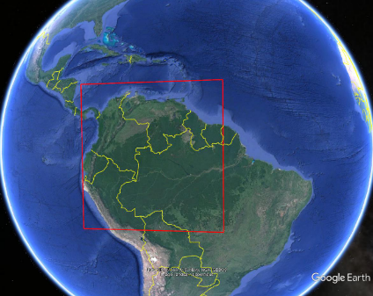 | FIGURE 14-2  EESS R1 MAI (oversea)  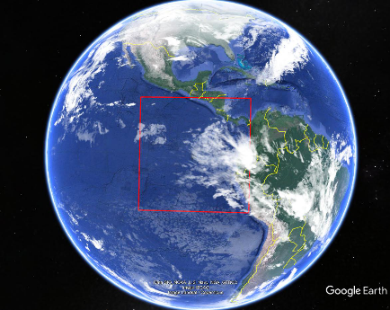
FIGURE 14-3  Aeronautical route deployment  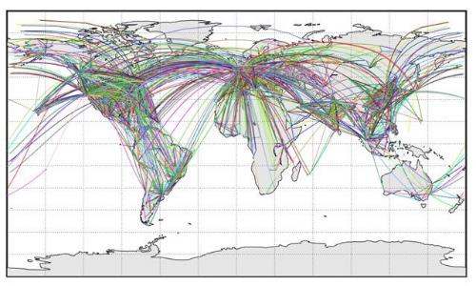 | FIGURE 14-4  Aeronautical route deployment  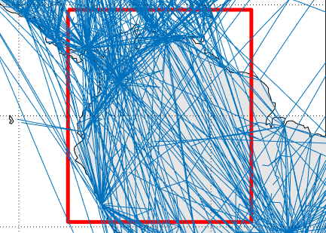
FIGURE 14-5  Aeronautical route deployment (low route number)  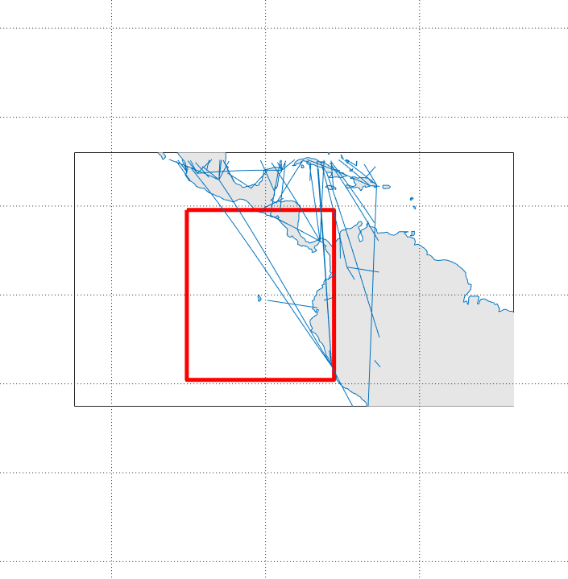 | FIGURE 14-6  Aeronautical route deployment (high route number)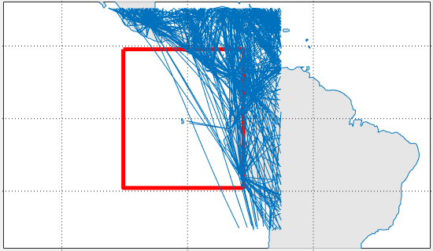

FIGURE 14-5  Aeronautical route deployment (low route number) | FIGURE 14-6  Aeronautical route deployment (high route number)
FIGURE 14-7  Ground station segment deployment (low density) | FIGURE 14-8  Ground station segment deployment (med. density)  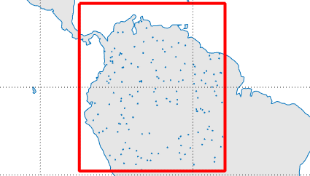
FIGURE 14-9  EESS (Passive) Sensor R1 Gain | FIGURE 14-10  Emission and Receiver Selectivity Curves  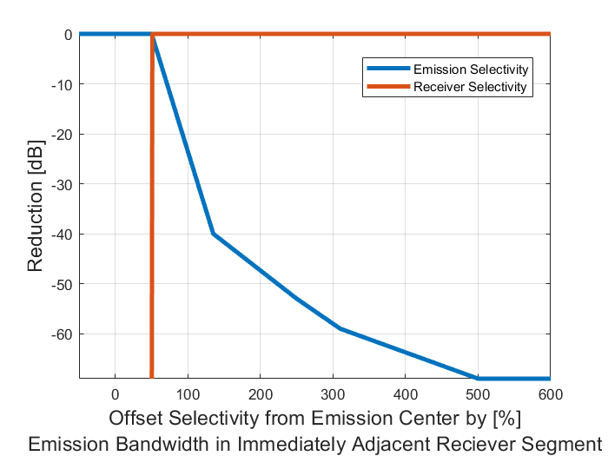

Figure A14-11
Aircraft station gain for systems operating in the aeronautical mobile service
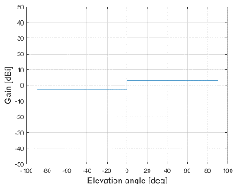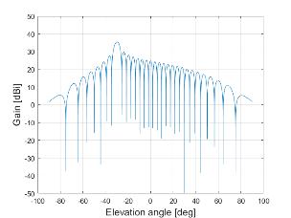

A14.1.2.2 Simulation results

The following figures illustrate the findings from the study of the RF interference impact configuration 1 and 2 type systems on EESS R1 sensors.
Figure A14-12 shows interference level CCDFs seen for operation system downlinks conforming to configuration 1 (wildfire observation section 4.2), where the total number of transmitters within or immediately around the MAI are stated in the legend. FDR and RF propagation losses are included in these plots.
Figure A14-13 shows interference level CCDFs seen for operation system uplinks conforming to configuration 1 (wildfire observation section 4.2), where the total number of transmitters within or immediately around the MAI are stated in the legend. FDR and RF propagation losses are included in these plots.
Figure A14-14 shows interference level CCDFs seen for operation system downlinks conforming to configuration 2 (search and rescue section 4.3), where the total number of transmitters within or immediately around the MAI are stated in the legend. FDR and RF propagation losses are included in these plots.
Figure A14-15 shows interference level CCDFs seen for operation system uplinks conforming to configuration 2 (search and rescue section 4.3), where the total number of transmitters within or immediately around the MAI are stated in the legend. FDR and RF propagation losses are included in these plots.
Figure A14-16 shows interference level CCDFs seen for operation system downlinks conforming to configuration 3 (border control section 4.2), where the total number of transmitters within or immediately around the MAI are stated in the legend. FDR and RF propagation losses are included in these plots.
Figure A14-17 shows interference level CCDFs seen for operation system uplinks conforming to configuration 3 (border control section 4.2), where the total number of transmitters within or immediately around the MAI are stated in the legend. FDR and RF propagation losses are included in these plots.
Figure A14-18 shows interference level CCDF for the air-air downlinks for configuration 2 (internet above the clouds, section 4.5) for aggregate representative interference sources. FDR and RF propagation losses of are included in this plot.

FIGURE 14-12  Received interference configuration 1 (wildfire observation) (aggregate source) (downlinks)  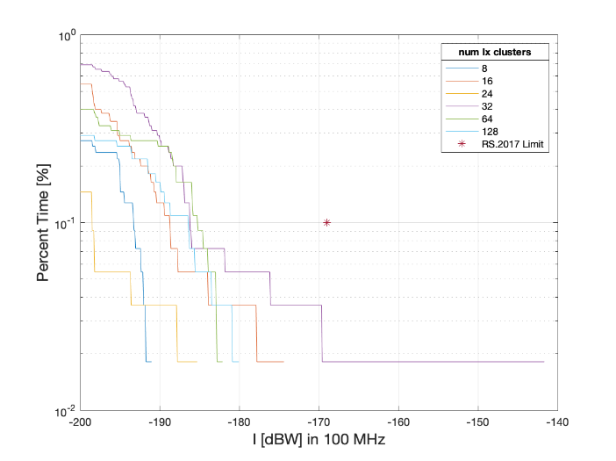 | FIGURE 14-13  Received interference configuration 1 (wildfire observation) (aggregate source) (uplinks)  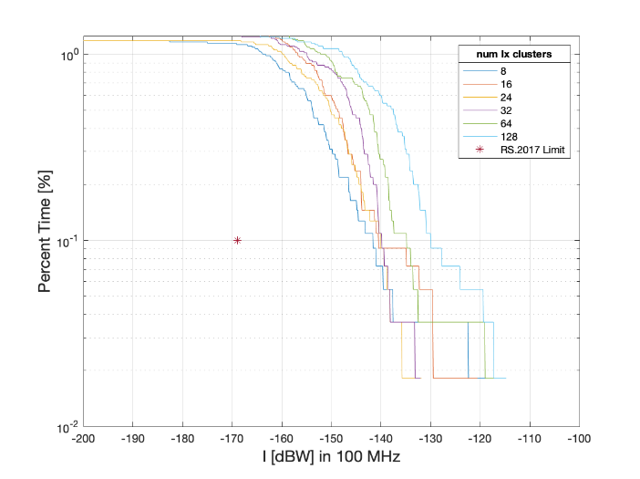
FIGURE 14-14  Received interference configuration 2 (search and rescue) (aggregate source) (forward)  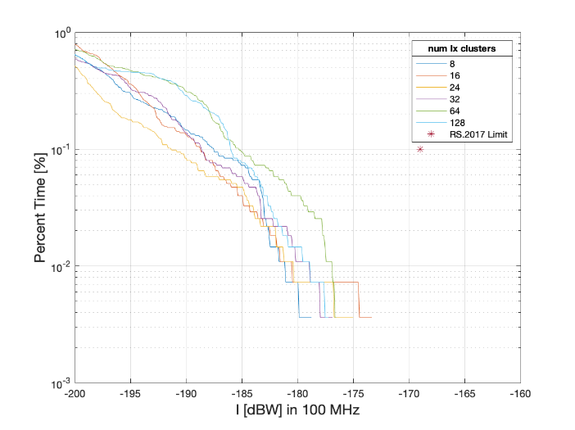 | FIGURE 14-15  Received interference configuration 2 (search and rescue) (aggregate source) (return)  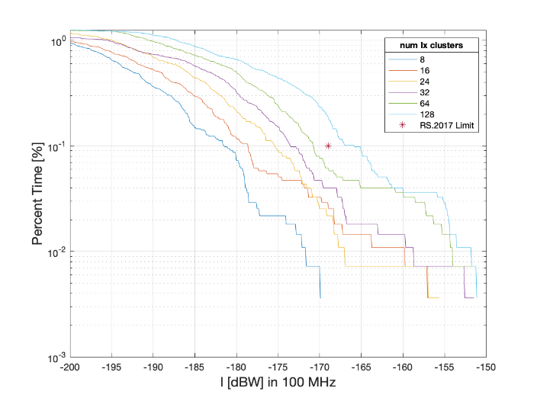
FIGURE 14-16  Received interference configuration 3 (border surveilance) (aggregate source) (downlinks)  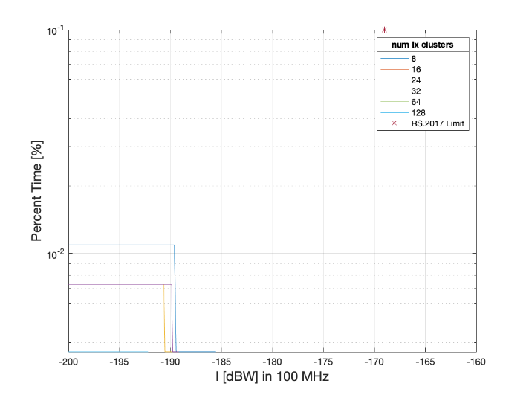 | FIGURE 14-17  Received interference configuration 3 (border surveilance) (aggregate source) (uplinks)  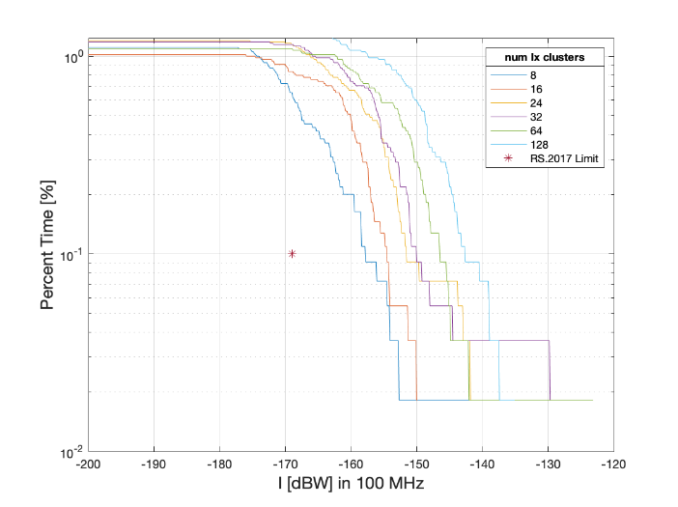
FIGURE 14-18
Received interference configuration 1 (data networks above the clouds) (aggregate source) (forward)
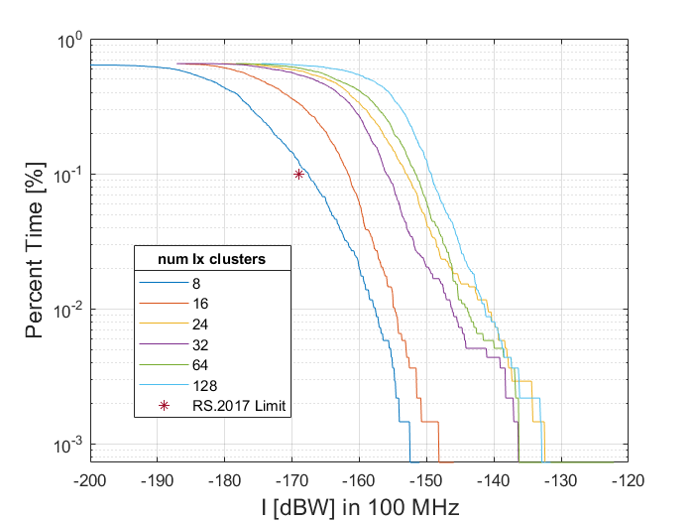

A14.1.2.3 Results of analysis
[Editor’s note 14-4: Given the lack of defined deployment information to model planned AMS operations over a large area, these studies make assumptions on potential deployments based on information derived from sections 4.2 (wildfire observation) and 4.5 (data networks above the clouds). Should different deployment information or operational scenarios become available or change, the results of the studies could change.]
The results of section A14.1 indicate that the first configuration (operational scenario 4.2, wildfire observation) can not support without imposing harmful interference into the EESS (passive) more than approximately 128 clusters, defined by ground station platforms and their associated aeronautical users operating within the specially defined region, for the downlink transmission direction. Considering the uplink transmission direction, this upper limit is .not met therefore emission limits or avoiding the adjacent band for uplink should be taken into account. Noting that the number of clusters defined in operational scenarios (see section 4 of Document 5B/XXX Annex YY, Table 5-1) are lower than these values for the downlink direction (but not the uplink).
The majority of the contribution to this harmful interference from wildfire observation comes from non-safety-of-life AMS uplink systems operating immediately adjacent to the EESS (passive) band specifically within 50 MHz of the band edge of 22.21 GHz. It is necessary to limit the OOB emissions of the AMS to -17 dBW/100MHz for operations within this 50 MHz band edge in order to ensure the protection of the EESS passive service.

The results of Section A14.1.2 indicate that the second configuration (operational scenario 4.3, search and rescue) can not support without imposing harmful interference into the EESS (passive) more than approximately 64 clusters, each defined by seven coordinated aeronautical users operating bi-directional air-air links within the specially defined region. Noting that the number of clusters defined in operational scenarios (see section 4 of Document 5B/XXX Annex YY, table 5-2) are lowerthan these values.
The majority of the contribution to this harmful interference from search and rescue operations comes from non-safety-of-life AMS air-air systems operating immediately adjacent to the EESS (passive) band specifically within 30 MHz of the band edge of the frequency band 22.21 GHz.
The results of Section A14.1.2 indicate that the third configuration (operational scenario 4.4, border surveillance) can not support without imposing harmful interference into the EESS (passive) , each defined by two coordinated aeronautical observation users operating in relay (air-air bidirectional links) with an additional aircraft which communicates (return link) with a single ground station located within the specially defined region. It is therefore necessary to limit the OOB emissions of specifically the return links to -23 dBW/100MHz in order to ensure the protection of the EESS passive service.
The majority of the contribution to this harmful interference from border surveillance operations comes from non-safety-of-life AMS air-air relay return systems operating immediately adjacent to the EESS (passive) band specifically within 20 MHz of the band edge of the frequency band 22.21 GHz.
The results of section A14.1indicate that the fourth configuration (operational scenario 4.5, data networks above the clouds) can support without imposing harmful interference into the EESS (passive) not more than approximately 8 aeronautical platforms operating over inland regions as well as not more than approximately 8 aeronautical platforms operating over oversea (near shore) regions. It is necessary to limit the OOB emissions of the AMS to 19 dBW/100MHz immediately adjacent to the EESS (passive) band specifically within 80 MHz of the band edge of the frequency band 22.21 GHz. in order to ensure the protection of the EESS passive service.
The majority of the contribution to this harmful interference from data networks above the clouds operations comes from non-safety-of-life AMS air-air relay forward systems operating immediately adjacent to the EESS (passive) band specifically within 80 MHz of the band edge of the frequency band 22.21 GHz.

