US Radiocommunication Sector
FACT SHEET
Working Party: ITU-R WP 5B | Document No: USWP5B29-08
Reference: 5B/531 Annex 13 | Date: 8 June 2022
Document Title: Working document towards a preliminary draft new Report ITU-R M.[NON-SAFETY AMS CHARACTERISTICS AND SHARING STUDIES] related to agenda item 1.10
Author(s)/Contributor(s):  Andrew Meadows  Air Force  Dominic Nguyen  eSimplicity for AFSMO | Phone: 334-467-4720  E-mail: andrew.meadows.1@us.af.mil  Phone: 703-606-7394  E-mail: dominic.nguyen@esimplicity.com
Purpose/Objective: The purpose of this document is to continue the sharing studies between non-safety aeronautical mobile service (AMS) and Radiolocation service in support of WRC-23 AI 1.10.

Abstract: WRC-19 approved AI 1.10 for the WRC-23 study cycle to consider a possible introduction of new non-safety AMS applications in the 15.4-15.7 GHz band. During the April 2022 meeting, France/German raised concern on certain US assumptions and methodology for the sharing study. This contribution answers French/German questions and continues the sharing studies between non-safety AMS and Radiolocation service.
Fact Sheet Preparer: Dominic Nguyen

Radiocommunication Study Groups | 
Source: Document 5B/531 Annex 13  Subject: WRC-23 agenda item 1.10 | Document 5B/XX
 | XX July 2022
 | English only
United States of America
Technical characteristics, operational scenarios, spectrum needs, coexistence, and sharing studies of non-safety aeronautical mobile systems in the frequency bands 15.4-15.7 GHz and 22-22.21 GHz

1 Introduction

The United States of America would like to continue progressing the sharing study between non-safety AMS and Radiolocation in the frequency band 15.4-15.7 GHz by providing some editorial and technical corrections.
The United States proposals are in track changes and mostly in Section 8, and Annex 5.
Attachment revisions are presented for consideration.

Attachment
Annex 13 to the Working Party 5B Chairman’s Report
WORKING DOCUMENT TOWARDS A PRELIMINARY DRAFT NEW
REPORT ITU-R [NON-SAFETY AMS CHARACTERISTICS AND SHARING STUDIES] RELATED TO WRC-23 AGENDA ITEM 1.10
Technical characteristics, operational scenarios, spectrum needs, coexistence, and sharing studies of non-safety aeronautical mobile systems in the
frequency bands 15.4-15.7 GHz and 22-22.21 GHz

There are no proposed changes prior to this point in the document.
…

8 Summary of sharing and compatibility studies
Table 8-1 below gathers the results of sharing and compatibility studies.
TABLE 8-1
Summary of sharing and compatibility studies
Systems operating in the RLS in the frequency band 15.4 – 17.3 GHz | Study A (A5.1) | Study A is an MCL analysis, aiming to derive separation distances between AMS systems and RLS systems. The study assumes a generic AMS system with an EIRP of 30dBm and shows such an airborne AMS system would need separation distances of TBD km when located in the main lobe of the RLS system and TBD km when located in the sidelobe. The required separation distances for such a ground-based AMS systems are TBD km when in the main lobe of the RLS system and TBD km when located in the sidelobe.  [Editor’s note 8-1: EIRP Should be 25 dBm. TBD separation distances to be updated once results are final.]
 | Study B (A5.2) | Study B is a Monte Carlo multiple entry analysis, that assesses the impact of the envisaged AMS scenarios and systems onto receivers operating in the RLS. The results have shown that, in all AMS scenarios, I/N level at RLS receivers is more than -6 dB for at most 0.001% of the time.
 | Study C (A5.3) | Study C is a Monte Carlo analysis that considers one AMS cluster within the radio horizon of the RLS receiver. This analysis concludes that I/N level at the RLS receiver is greater than -6 dB for at most 0.001 % of the time with the separation distance of 885 km.

There are no proposed changes prior to this point in the document.
…
ANNEX 5
Sharing between systems operating in the aeronautical mobile service (interferer) and the radiolocation service in the frequency band 15.4 – 15.7 GHz

A5.1 Study A

No change.

A5.2 Study B

No change.

A5.3 Study C
[Editor’s note A5-5: (Questions from France, Germany):
– The study does not take the density values computed in section 4 into account. The Radius around the AMS cluster in which the RLS receiver is located should be the radius computed in section 4, not the radio horizon.
Answer: Where can USA find the computed radius in section 4? Please provide the reference.

– Why did you use a time percentage of 5 %?
Answer: The RLS protection criteria is defined in Rec ITU-R M.1730. To meet the protection criteria and ensure sharing compatibility, sharing studies related to RLS systems commonly use low time percentages (i.e., 5 and 10%) for the propagation model. Thus, the USA uses a time percentage of 5%.

A5.3.1 Introduction
This section introduces the co-frequency sharing study between a non-safety AMS transmitter and a radiolocation system operating in the frequency range 15.4-15.7 GHz. The study determines the required separation distance between a non-safety AMS transmitter and a radiolocation system. Analysis scenarios will be based on Figures 4-2 through 4-5 in section 4.

A5.3.2 Sharing studies scenario, assumptions, and methodology for a single cluster
Figures A5-22, A5-23, A5-24 and A5-26 below depict the interference analysis scenario used in the sharing studies according to Figures 4-2, 4-3, 4-4 and 4-5.
Figure A5-22
Sharing studies between systems operating in the aeronautical mobile service (non-safety) and the radiolocation service based on the wildfire observation scenario

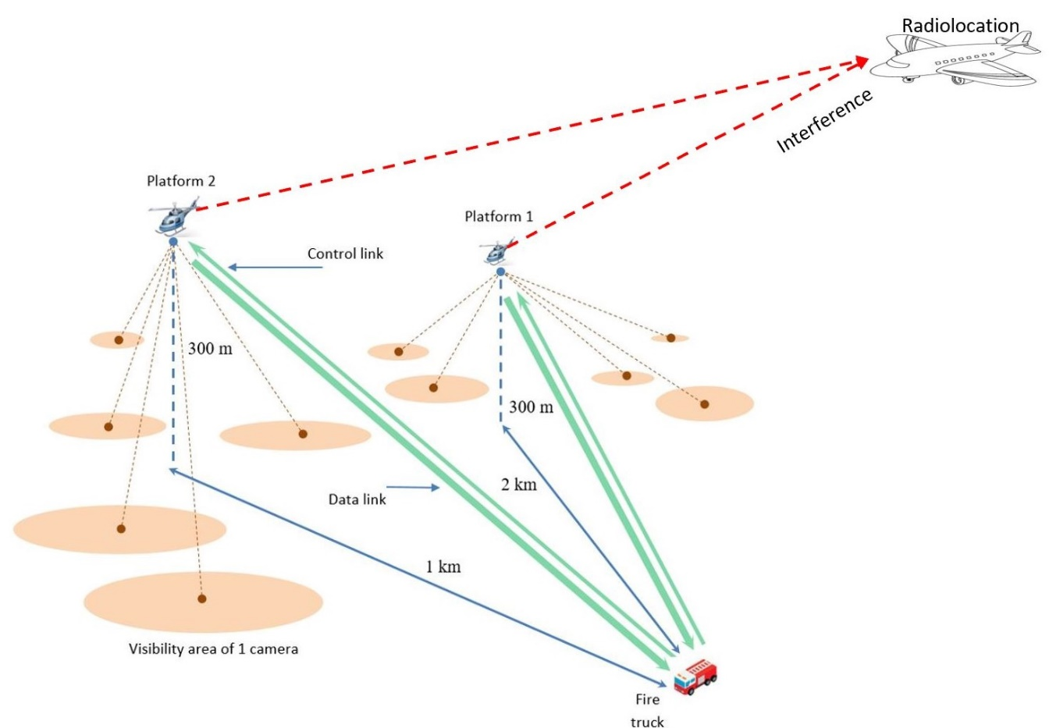
Below are the assumptions and methodology for a single cluster analysis based on Figure A5-22:
1. For the single entry analysis with the transmitted bandwidth of 150 MHz, only one transmitter which is assumed to be platform #1 can interfere with the Radiolocation receiver. The radiolocation receiver and the platform’s center frequency are 15.4 GHz. The transmitter is randomized within a 70 km radius from the fire truck.
2. For the single entry analysis with the transmitted bandwidth of 10 MHz, up to 2 transmitters can interfere with the Radiolocation receiver. The radiolocation receiver’s center frequency is 15.4 GHz. The center frequency for the 2 transmitters are: 15.3925, and 15.4025 GHz. Two transmitters are randomized within a 70 km radius from the fire truck.
3. For the analysis as show in 1 and 2 above, the following assumptions are used:
a. The location of a fire truck is fixed.
b. Transmission loss using Recommendation ITU-R P.528-5 – A propagation prediction method for aeronautical mobile and radionavigation services using the VHF, UHF, and SHF bands. The time percentage of 5% is used.
c. The altitude for all transmitting platforms is 300 m above the Earth’s surface, and randomized between 300 and 13 700 m above the Earth’s surface for the Radiolocation receiver.
d. The analysis assumes co-frequency.
e. The Radiolocation receiver is randomized within a 400 km radius of a transmitting platform.
f. The antenna pattern for a transmitting platform is an Omni antenna. The antenna pattern for the Radiolocation receiver can be modelled using Recommendation ITU-R M.1851 cosine square pattern.
g. The analysis is performed with the transmitter power of25 dBm).
h. The pointing angle of the radiolocation receiver antenna is randomized between ± 45° horizontally, and +5° to −45° vertically.
i. The analysis was performed with 1 million sampling points since the protection criteria is I/N of -6 dB.
Figure A5-23
Sharing studies between systems operating in the aeronautical mobile service (non safety) and the radiolocation service based on the search and rescue scenario

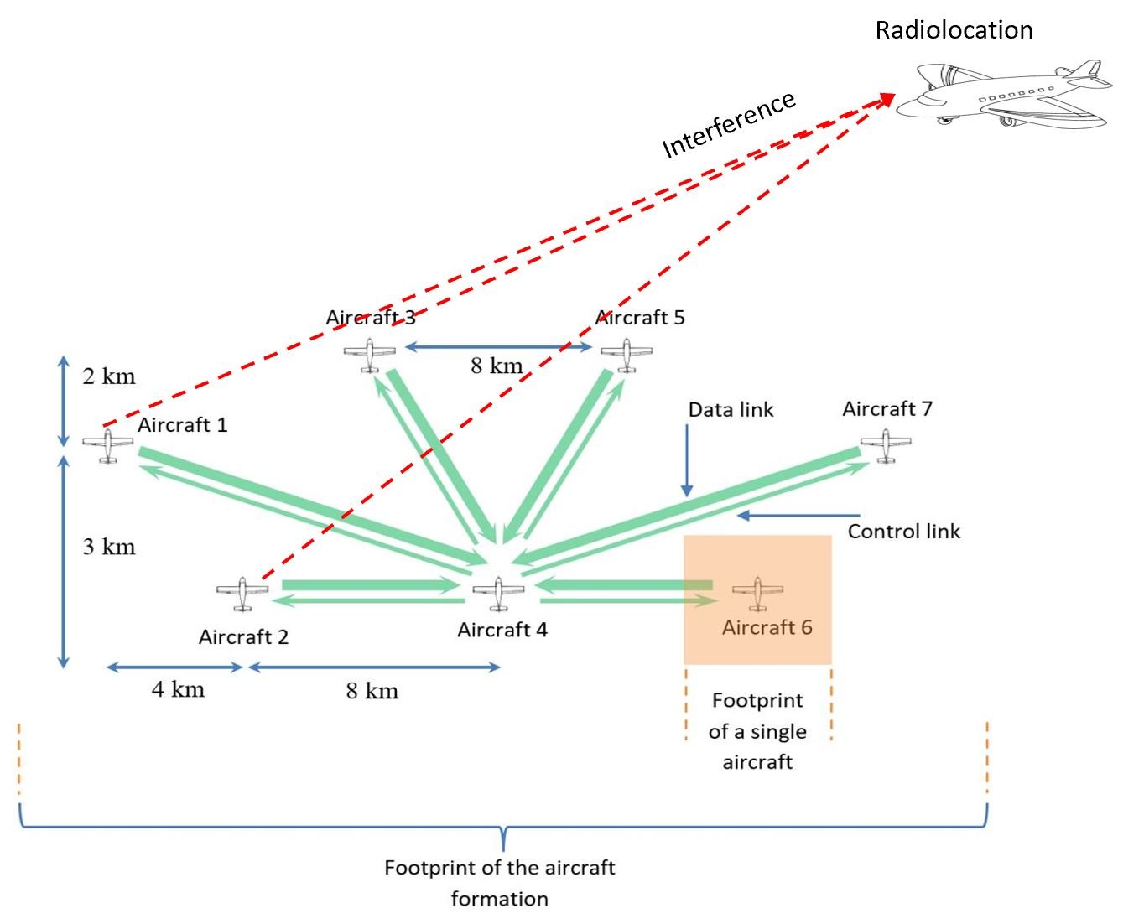
Below are the assumptions and methodology for a single cluster analysis based on Figure A5-23:
1. For the single entry analysis with the transmitted bandwidth of 200 MHz, only one transmitter which is assumed to be aircraft #2 can interfere with the Radiolocation receiver. The radiolocation receiver and aircraft transmitters’ center frequency are 15.4 GHz. The transmitter location is randomized within a ring of 8 km radius from the receiver (Aircraft #4).
2. For the single entry analysis with the transmitted bandwidth of 10 MHz, up to 3 transmitters which are assumed to be aircraft #1, #2, and #3, can interfere with the Radiolocation receiver. The radiolocation receiver’s center frequency is 15.4 GHz. The center frequency for the 3 transmitters are: 15.3925, 15.4025, and 15.4125 GHz. Three transmitters are randomized within a ring 12, 8, and 6 km radius from the receiver (Aircraft #4).
3. For the analysis as show in 1 and 2 above, the following assumptions are used:
a. Transmission loss using Recommendation ITU-R P.528-5 – A propagation prediction method for aeronautical mobile and radionavigation services using the VHF, UHF, and SHF bands. The time percentage of 5% is used.
b. The altitude for all non-safety AMS aircraft except aircraft #4 is 3.6 km above the Earth’s surface. The altitude of aircraft #4 is 1 km above the Earth’s surface. The altitude of Radiolocation is randomized between 300 and 13 700 m.
c. The analysis assumes co-frequency.
d. The Radiolocation aircraft is randomized within a 800 km radius of a transmitted aircraft.
e. The antenna pattern for a transmitting aircraft can be modelled using Section A1.2.1, with a cosine square pattern used for the Radiolocation receiver antenna.
f. The analysis is performed with the transmitter power of 40 dBm.
g. The pointing angle of the radiolocation receiver antenna is randomized ±45° horizontally, and +5° to −45° vertically.
h. The analysis was performed with 1 million sampling points since the protection criteria is I/N of -6 dB.
Figure A5-24
Sharing studies betweensystems operating in the aeronautical mobile service (non-safety) and the radiolocation based on the surveillance mission scenario

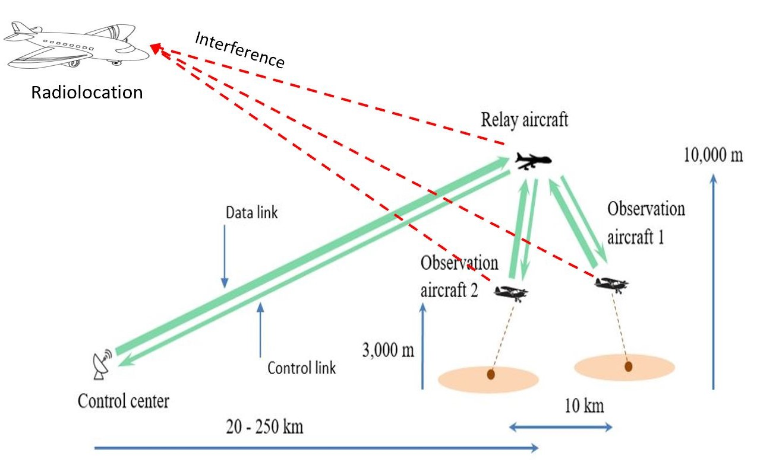
Below are the assumptions and methodology for a single cluster analysis based on Figure A5-24:
1. For the single entry analysis with the transmitted bandwidth of 200 MHz, only one transmitter which is assumed to be a relay aircraft can interfere with the Radiolocation receiver. The radiolocation receiver and aircraft transmitters’ center frequency are 15.4 GHz. The transmitter is randomized within a 300 km radius from the control center.
2. For the single entry analysis with the transmitted bandwidth of 10 MHz, up to 3 transmitters can interfere with the Radiolocation receiver. The radiolocation receiver’s center frequency is 15.4 GHz. The center frequency for the 3 transmitters link is: 15.3925, 15.4025, and 15.4125 GHz. The relay aircraft is randomized within a 300 km radius from the control center. The two observation aircraft are randomized within a 5 km radius from the relay aircraft.
3. For the analysis as show in 1 and 2 above, the following assumptions are used:
a. The location of the control center is fixed.
b. Transmission loss using Recommendation ITU-R P.528-5 – A propagation prediction method for aeronautical mobile and radionavigation services using the VHF, UHF, and SHF bands. The time percentage of 5% is used.
c. The altitude for two observation aircraft, and relay aircraft are at 3 and 10 km above the Earth’s surface respectively. The altitude for the Radiolocation aircraft is randomized between 300 and 13 700 m.
d. The analysis assumes co-frequency.
e. The Radiolocation aircraft is randomized within an 900 km radius of a transmitted relay aircraft.
f. The antenna pattern for the relay aircraft and observation aircraft can be modelled using Section A1.2.1, and cosine square pattern for Radiolocation receiver antenna.
g. The analysis was performed with the transmitter power of 40 dBm.
h. The pointing angle of the radiolocation receiver antenna is randomized ±45° horizontally, and +5° to −45° vertically.
i. The analysis was performed with 1 million sampling points since the protection criteria is I/N of -6 dB.
Figure A5-25
Sharing studies between systems operating in the aeronautical mobile service (non-safety) and the radiolocation based on the internet above the clouds scenario

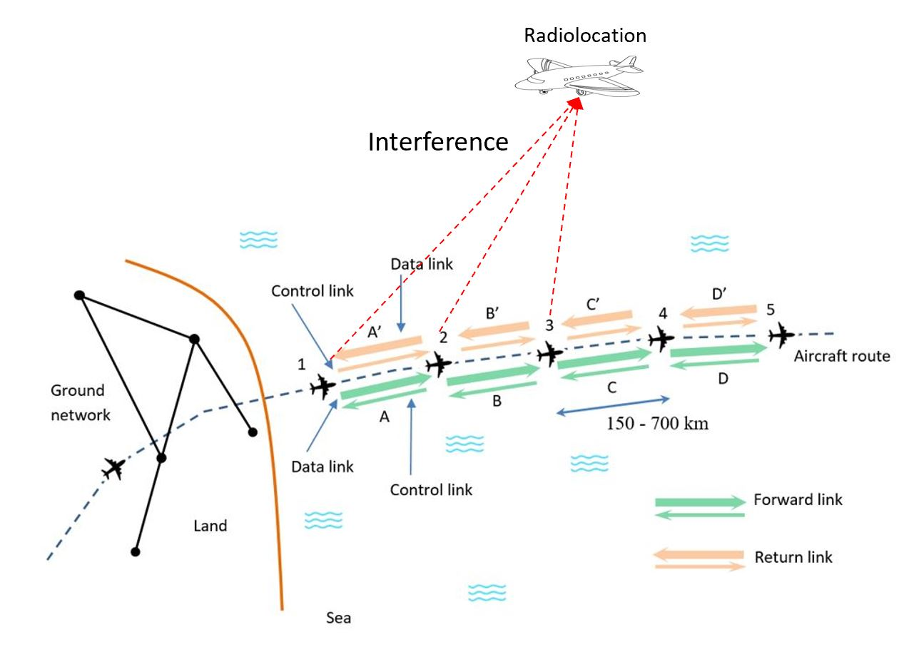
Below are the assumptions and methodology for a single cluster analysis based on Figure A5-25:
1. For the single entry analysis with the transmitted bandwidth of 150 MHz, only one transmitter which is assumed to be aircraft #2 can interfere with the Radiolocation receiver. The radiolocation receiver and aircraft transmitters’ center frequency are 15.4 GHz. The transmitter is randomized within a ring of 500 km radius from aircraft #1.
2. For the single entry analysis with the transmitted bandwidth of 10 MHz, up to 3 transmitters which are assumed to be aircraft #1, #2, and #3 can interfere with the Radiolocation receiver. The radiolocation receiver’s center frequency is 15.4 GHz. The center frequency for the 3 transmitters are: 15.3925, 15.4025, and 15.4125 GHz. Aircraft #2 is randomized within a ring of 500 km radius from aircraft #1. Aircraft #3 is randomized within a ring of 500 km radius from aircraft #2.
3. For the analysis as show in 1 and 2 above, the following assumptions are used:
a. Transmission loss using Recommendation ITU-R P.528-5 – A propagation prediction method for aeronautical mobile and radionavigation services using the VHF, UHF, and SHF bands. The time percentage of 5% is used.
b. The altitude for all transmitting aircraft is 10 km above the Earth’s surface. The altitude of Radiolocation is randomized between 300 and 13 700 m.
c. The analysis assumes co-frequency.
d. The Radiolocation aircraft’s position is randomized within a 900 km radius of aircraft #2.
e. The antenna pattern for both a transmitting aircraft can be modellled using Section A1.2.1, and the Radiolocation receiver can be modelled using Recommendation ITU-R M.1851 cosine square pattern.
f. The analysis was performed with the transmitter power of 40 dBm.
g. The radiolocation receiver antenna is scanning ±45° horizontally, and +5° to −45° vertically.
h. The analysis was performed with 1 million sampling points since the protection criteria is I/N of -6 dB.

A5.3.3 Sharing studies results
Figures A5-26 through A5-29 provide cummulative distribution functions (CDFs) of I/N values based on Figures A5-22 through A5-25, respectively for both single and aggregate interference.
Figure A5-26
Separation distance between systems operating in the aeronautical mobile service (non-safety) and radiolocation service based on the wildfire observation scenario
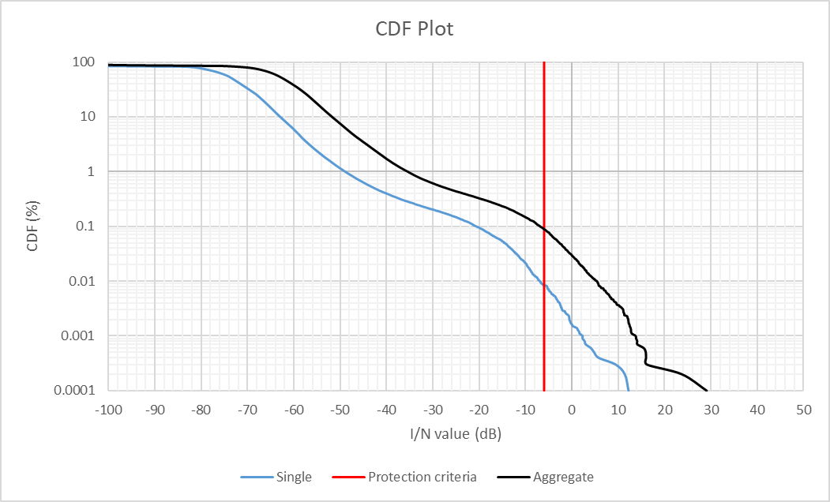
Figure A5-27
Separation distance between systems operating in the aeronautical mobile service (non-safety) and radiolocation service based on the search and rescue scenario
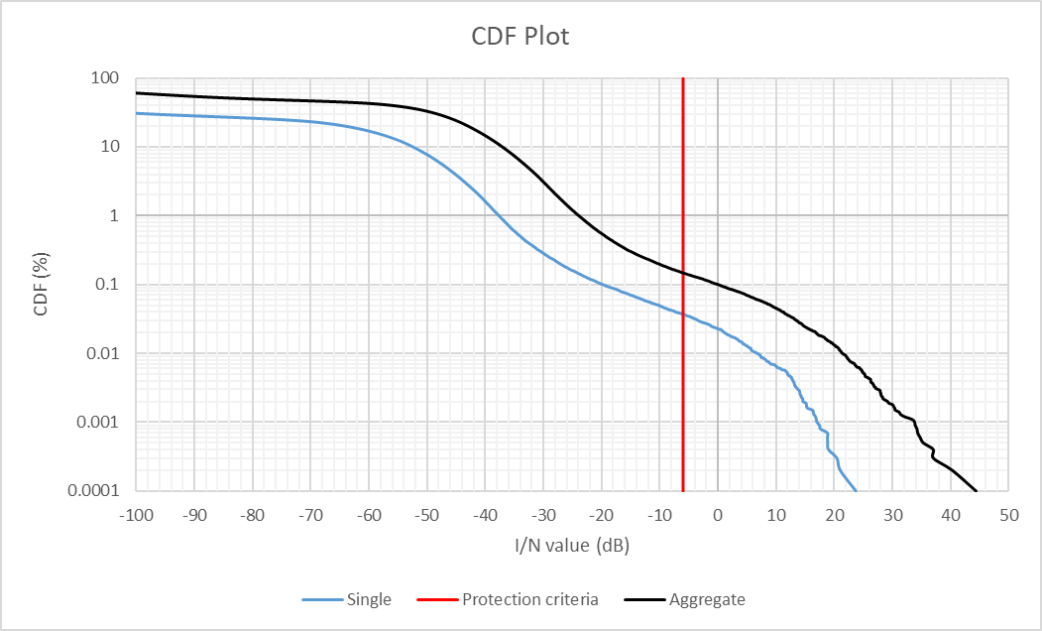
Figure A5-28
Separation distance between systems operating in the aeronautical mobile service (non-safety) and radiolocation service based on the surveillance mission scenario
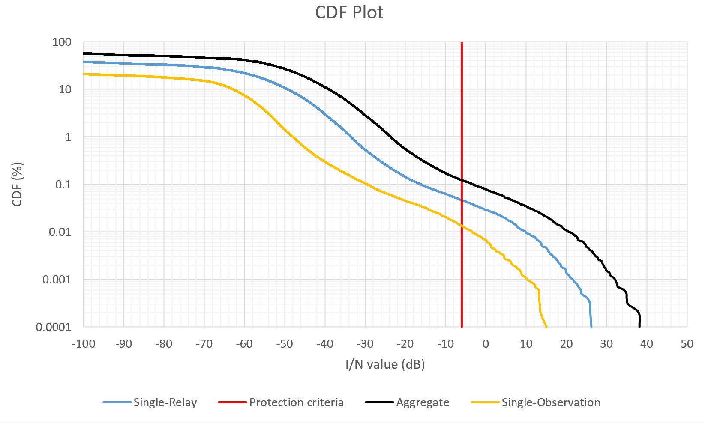
Figure A5-29
Separation distance between systems operating in the aeronautical mobile service (non-safety) and radiolocation service based on the internet above the clouds scenario
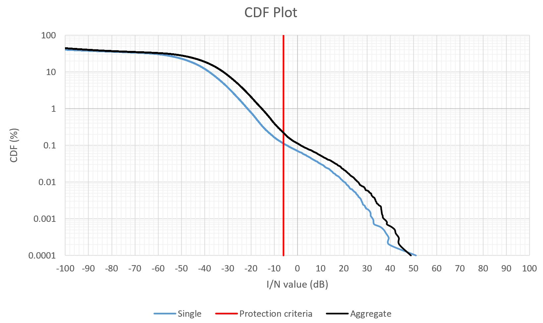
Figures A5-30 through A5-33 provide separation distance between non-safety AMS and Radiolocation based on Figures A5-22 through A5-25, respectively for both single and aggregate interference.
Figure A5-30
Separation distance between systems operating in the aeronautical mobile service (non-safety) and radiolocation service based on the wildfire observation scenario
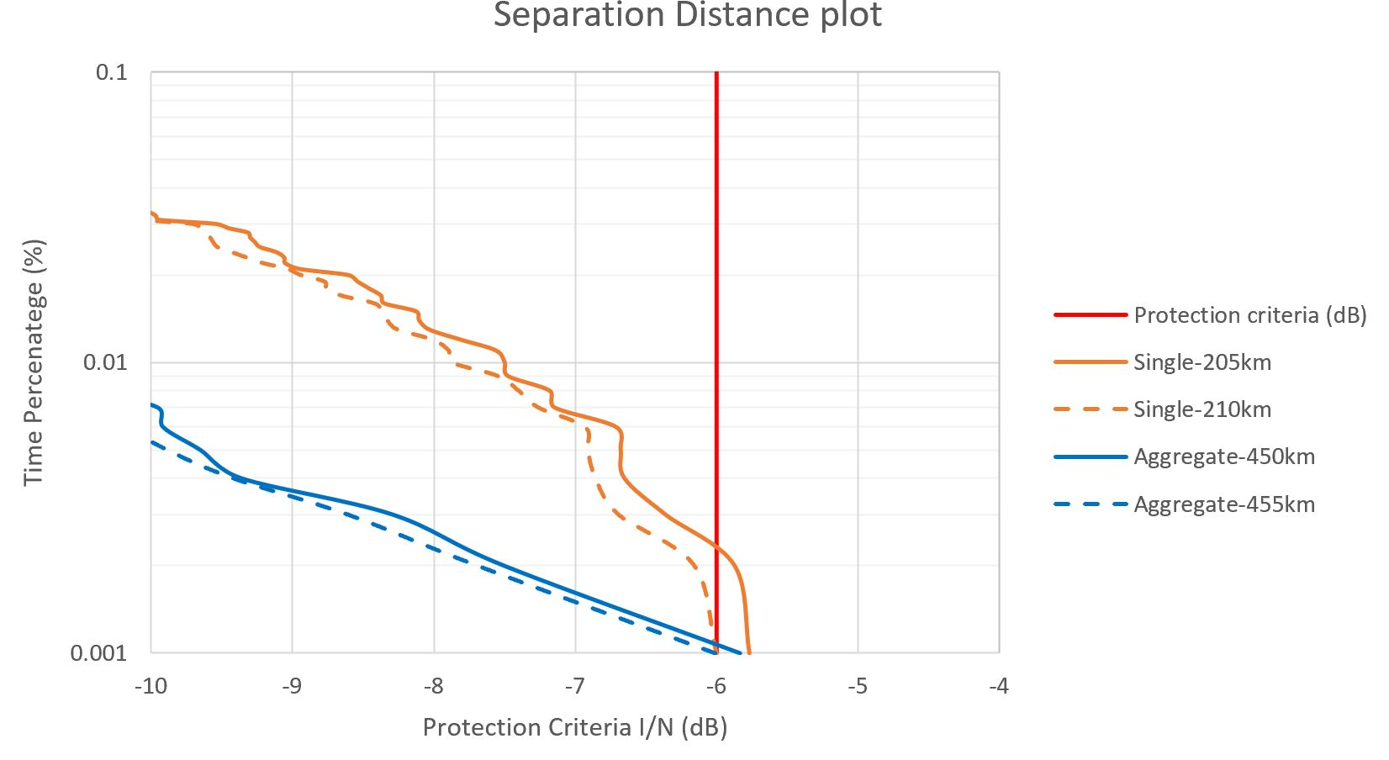
Figure A5-31
Separation distance between systems operating in the aeronautical mobile service (non-safety) and radiolocation service based on the search and rescue scenario
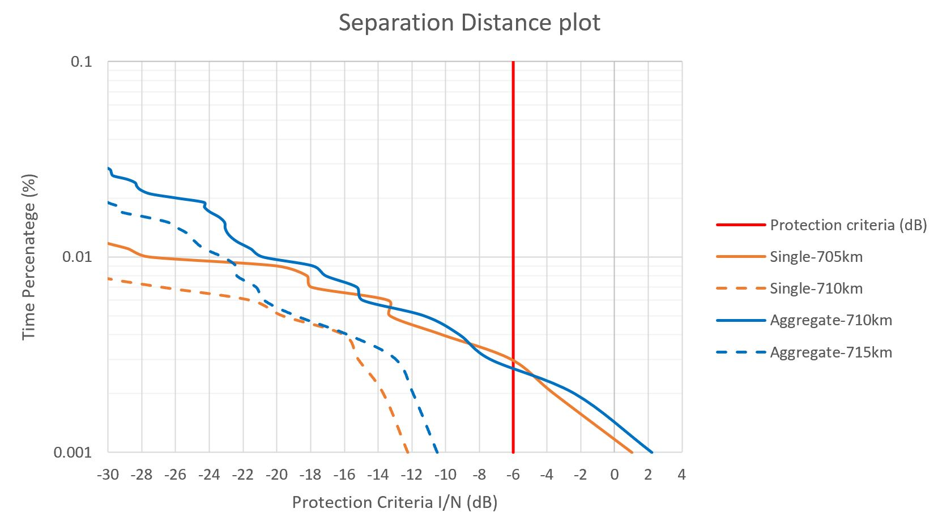
Figure A5-32
Separation distance between systems operating in the aeronautical mobile service (non-safety) and radiolocation service based on the surveillance mission scenario
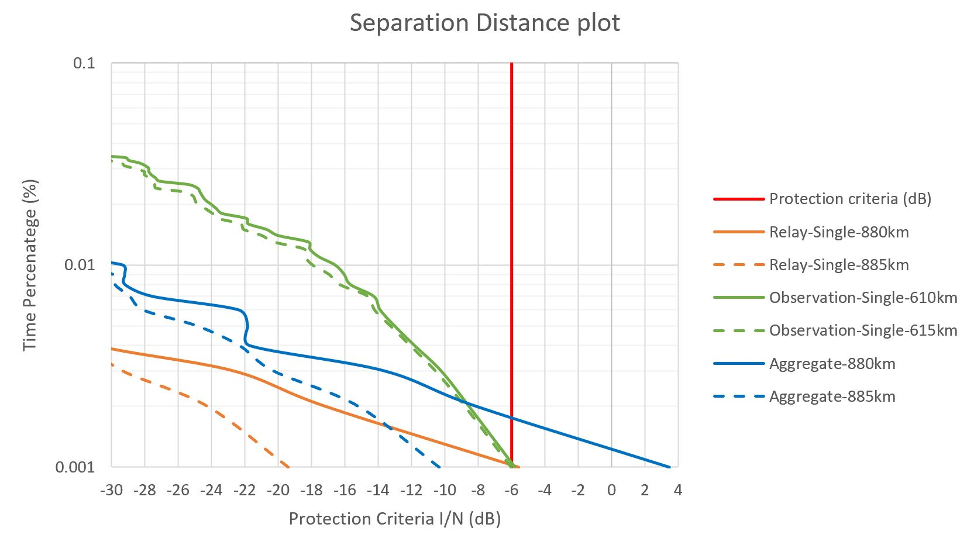
Figure A5-33
Separation distance between systems operating in the aeronautical mobile service (non-safety) and radiolocation service based on the internet above the clouds scenario
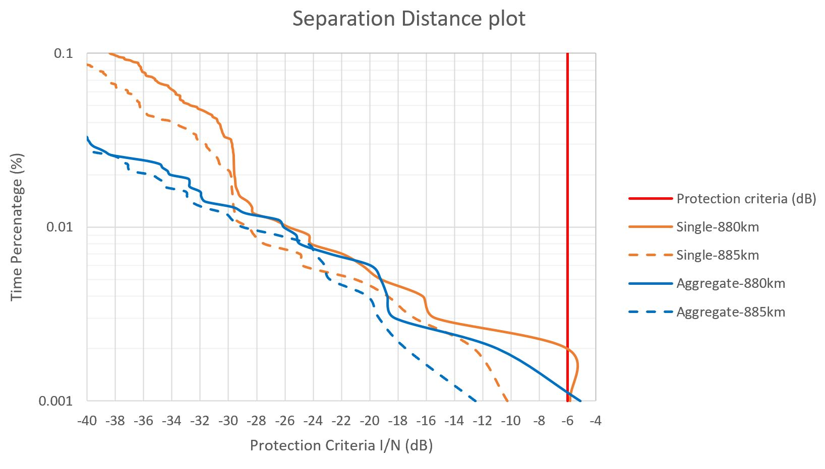
Table A5-3 below provides the separation distance between non-safety AMS and Radiolocation.
Table A5-3
Separation distance between systems operating in the aeronautical mobile service (non-safety)
and radiolocation service
 | Non-safety AMS transmitter bandwidth (MHz) | Non-safety AMS transmitter EIRP (dBW) | Separation distance between non-safety AMS and Radiolocation (Km)
Figure 4-2 Wildfire observation scenario
Figure 4-2 Wildfire observation scenario | 150 | -2 | 210
Figure 4-2 Wildfire observation scenario | 10 | -2 | 455
Figure 4-3
Search and recure scenario
Figure 4-3  Search and recure scenario | 200 | 35 | 710
Figure 4-3  Search and recure scenario | 10 | 35 | 715
Figure 4-4  Surveillance mission scenario | 200 (Relay) | 35 | 885
Figure 4-4  Surveillance mission scenario | 200 (Observation) | 35 | 615
Figure 4-4  Surveillance mission scenario | 10 | 35 | 885
Figure 4-5
Internet above the clouds scenario
Figure 4-5  Internet above the clouds scenario | 150 | 48 | 885
Figure 4-5  Internet above the clouds scenario | 10 | 48 | 885

A5.3.4 Sharing studies between non-safety AMS and radiolocation service for multiple clusters
[To be populated later]

A5.3.5 Summary of preliminary results
The results from the dynamic analysis are summarized in Table A5-3 above. Depend on the interference scenario and systems characteristics, a separation distance is required between non-safety AMS and Radiolocation.

There are no proposed changes following this point in the document.
…

