US Radiocommunications Sector
Fact Sheet

Working Party: WP 5B | Document No: USWP5B30-19-FS
Ref: Annex 11 to Document 5B/649 | Date: 16 August 2022
Document Title: PRELIMINARY DRAFT REVISION OF RECOMMENDATION ITU-R M.2010-1 Characteristics of a digital system, named Navigational Data for broadcasting maritime safety and security related information from shore-to-ship in the 500 kHz band

Author(s)/Contributors(s):  Jerry Ulcek  US Coast Guard, Washington DC  Johnny Schultz  Sev1Tech, Inc.  Ross Norsworthy  REC, Inc. | Phone : (202) 475-3607  E-mail: Jerry.l.Ulcek@uscg.mil  Phone : (727) 403-4029  E-mail: johnny.schultz@sev1tech.com  Phone : (727) 515-8025  E-mail: Ross_Norsworthy@msn.com
Purpose/Objective: The purpose of this document is to add an annex (ANNEX 8) to the preliminary draft revision of Recommendation ITU-R M.2010-1 to describe the utilization of the various bandwidths for transmission of data on various antenna towers of various heights which will vary in their ability to support the various data rates from 5 kbps to 27 kbps.
Abstract: This document is intended to provide the necessary information to complete this revision of M.2010. Specifically, it provides the information necessary for implementation of the MF NAVDAT shore facilities on antenna towers of various heights using the various optional data transmission rates.

- Purpose of this document (proposal to add ANNEX 8 to Recommendation ITU-R M.2010-1)
This document provides guidance for implementation of MF NAVDAT (495-505 kHz) on shore facilities, which may also possibly include NAVTEX to support the NAVTEX/NAVDAT transition.
- Antenna Characteristics of Radio Towers of Various Heights
Antenna characteristics of radio towers of various heights are shown in FIGURE 1 below.
FIGURE 1
Antenna impedance characteristics of radio towers of various heights
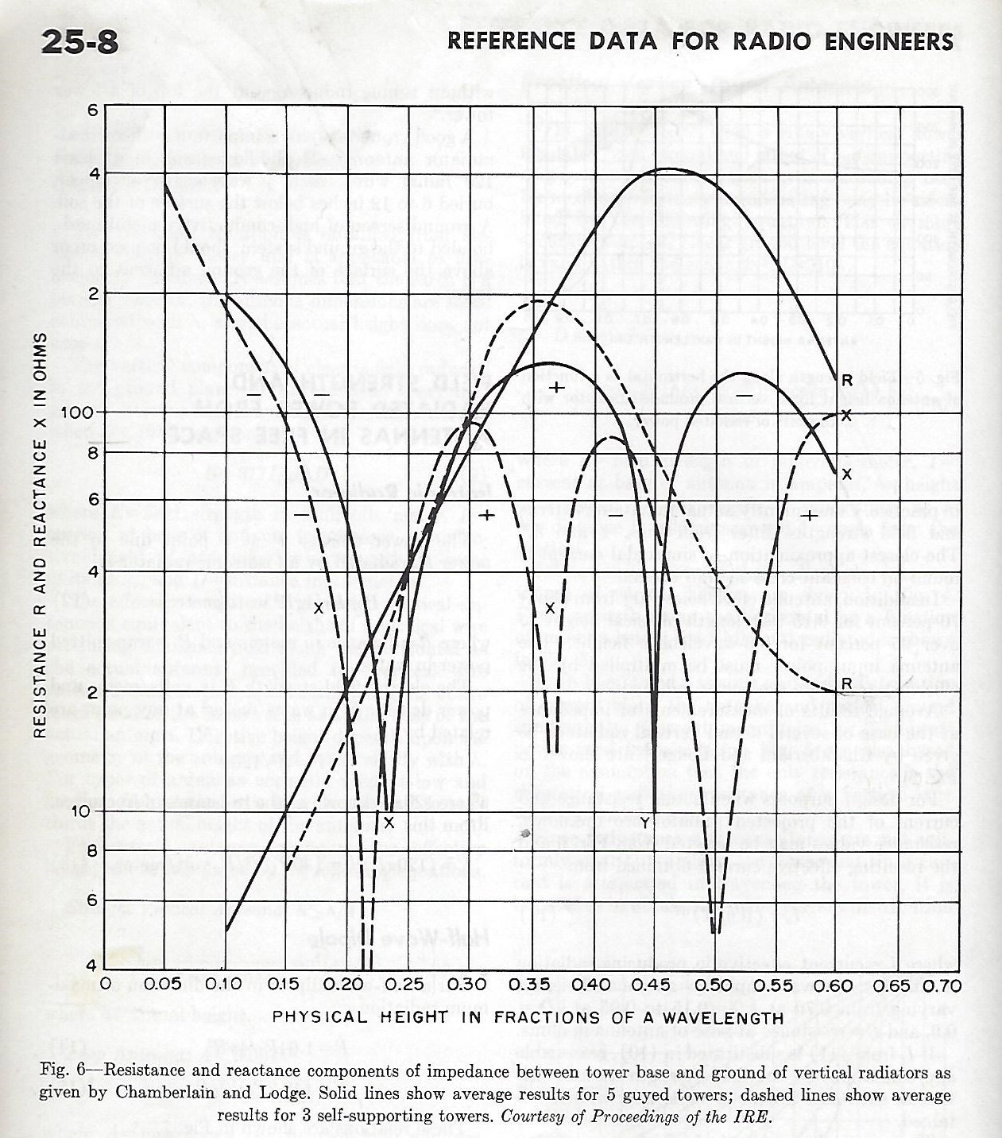
- Antenna requirements for NAVTEX and NAVDAT systems
The antenna requirements for NAVTEX and NAVDAT are different, but it is possible to transmit both NAVTEX and NAVDAT from the same transmitter and tower that is designed and configured for NAVDAT. This would provide a backward compatible system to serve in the transition period. For digital systems such as NAVDAT, a low-Q (Q = X/R, where Q = 1 or less) antenna is ideal to provide linear phase shift across the transmission bandwidth. Low-Q is achieved when the reactance Y is less than the resistance R such as in the vicinity of 0.25 wavelength antenna height as shown above. For NAVTEX and NAVDAT, this occurs at a height of approximately 150 meters for both guyed and self-supporting towers.
- NAVDAT Estimated Data Rates for Various Transmission Modes
Lower tower heights, e.g., 90 meters (0.15 wavelengths), can be impedance matched to the transmitter using a series matching inductor. This would result in a Q of 13, according to FIGURE 1. Although this is acceptable for NAVTEX, which is a narrow-band analog system, its application for NAVDAT should be carefully evaluated. TABLE 1 below describes the various NAVDAT transmission modes and the associated spectrum occupancy. For NAVDAT transmission, the 3 dB bandwidth of the antenna tower should be at least three times the spectrum occupancy to avoid inter-symbol interference caused by nonlinear group delay within the occupied bandwidth. For the 90-meter tower example above, the Q of 13 provides a 3 dB bandwidth of 500 kHz/13 = 38.4 kHz, which is adequate to support the NAVDAT transmission modes 0-23.
TABLE 1
Estimated data rates for 10, 5, 3, 1 kHz bandwidth for short frame transmissions

Mode | Spectrum occupancy (kHz) | Modulation  (n-QAM) | Code rate | Estimated data rate  (kbps)
0 | 10 | 4-QAM | 0.5 | 6.36
1 | 10 | 4-QAM | 0.75 | 9.56
2 | 10 | 16-QAM | 0.5 | 12.72
3 | 10 | 16-QAM | 0.75 | 19.12
4 | 10 | 64-QAM | 0.5 | 19.08
5 | 10 | 64-QAM | 0.75 | 28.68
6 | 5 | 4-QAM | 0.5 | 2.89
7 | 5 | 4-QAM | 0.75 | 4.35
8 | 5 | 16-QAM | 0.5 | 5.78
9 | 5 | 16-QAM | 0.75 | 8.69
10 | 5 | 64-QAM | 0.5 | 8.67
11 | 5 | 64-QAM | 0.75 | 13.04
12 | 3 | 4-QAM | 0.5 | 1.67
13 | 3 | 4-QAM | 0.75 | 2.52
14 | 3 | 16-QAM | 0.5 | 3.35
15 | 3 | 16-QAM | 0.75 | 5.03
16 | 3 | 64-QAM | 0.5 | 5.02
17 | 3 | 64-QAM | 0.75 | 7.55
18 | 1 | 4-QAM | 0.5 | 0.55
19 | 1 | 4-QAM | 0.75 | 0.84
20 | 1 | 16-QAM | 0.5 | 1.12
21 | 1 | 16-QAM | 0.75 | 1.68
22 | 1 | 64-QAM | 0.5 | 1.67
23 | 1 | 64-QAM | 0.75 | 2.52

Reference Data for Radio Engineers, Howard W. Sams & Co., Inc., Fifth Edition, Third Printing: March 1970

