|  |  |
| --- | --- |
| **US Radiocommunication Sector**  **FACT SHEET** | |
| **Working Party:** ITU-R WP 5B | **Document No:** USWP5B30-06 |
| **Reference:** 5B/649 Annex 24 | **Date:** 6 September 2022 |
| **Document Title:** Working document towards a preliminary draft new Report ITU-R M.[NON-SAFETY AMS CHARACTERISTICS AND SHARING STUDIES] related to agenda item 1.10 | |
| **Author(s)/Contributor(s):**  Andrew Meadows  Air Force  Dominic Nguyen  eSimplicity for AFSMO | Phone: 334-467-4720  E-mail: [andrew.meadows.1@us.af.mil](mailto:andrew.meadows.1@us.af.mil)    Phone: 703-606-7394  E-mail: [dominic.nguyen@esimplicity.com](mailto:dominic.nguyen@esimplicity.com) |
| **Purpose/Objective:** The purpose of this document is to continue the sharing studies between non-safety aeronautical mobile service (AMS) and Radiolocation service in support of WRC-23 AI 1.10. | |
| **Abstract:** WRC-19 approved AI 1.10 for the WRC-23 study cycle to consider a possible introduction of new non-safety AMS applications in the 15.4-15.7 GHz band. During the July 2022 meeting, France/German raised concern on certain US assumptions and methodology for the sharing study. This contribution answers French/German questions and continues the sharing studies between non-safety AMS and Radiolocation service. | |
| **Fact Sheet Preparer:** Dominic Nguyen | |

|  |  |
| --- | --- |
| **Radiocommunication Study Groups** |  |
|  |  |
|  |  |
| Source: Document 5B/649 Annex 24  Subject: WRC-23 agenda item 1.10 | **Document 5B/XX** |
| **XX November 2022** |
| **English only** |
| |  | | --- | | United States of America | | Technical characteristics, operational scenarios, spectrum needs, coexistence, and sharing studies of non-safety aeronautical mobile systems in the frequency bands 15.4-15.7 GHz and 22-22.21 GHz |   **1 Introduction**  The United States of America would like to continue progressing the sharing study between non-safety AMS and Radiolocation in the frequency band 15.4-15.7 GHz by providing some editorial and technical corrections for the single cluster analysis, and additional multiple clusters analysis.  The United States proposals are in track changes and mostly in Section 10, and Annex 5 Study C.  Attachment revisions are presented for consideration. | |

|  |
| --- |
| Attachment  Annex 13 to the Working Party 5B Chairman’s Report |
| WORKING DOCUMENT TOWARDS A PRELIMINARY DRAFT NEW  REPORT ITU-R [NON-SAFETY AMS CHARACTERISTICS AND SHARING STUDIES] RELATED TO WRC-23 AGENDA ITEM 1.10 |
| **Technical characteristics, operational scenarios, spectrum needs, coexistence, and sharing studies of non-safety aeronautical mobile systems in the  frequency bands 15.4-15.7 GHz and 22-22.21 GHz** |

There are no proposed changes prior to this point in the document.

…

**10.3 Summary of studies**

Table 10-4 gathers the results of sharing and compatibility studies.

TABLE 10-4

**Summary of sharing and compatibility studies**

*[Editor’s note: Table to be reviewed. Text from study summary in the draft CPM text added in square brackets. Could be used as a basis, with additional refinements and/or simplification.]*

|  |  |  |
| --- | --- | --- |
| **System** | **Study** | **Summary** |
| Systems operating in the RLS in the frequency band 15.4 – 17.3 GHz | Study A (A5.1) | Proposal 1 (China):  Study A is an MCL analysis, aiming to derive separation distances between AMS systems and RLS systems. The study assumes **airborne** AMS systems with EIRP of 25 or 40 dBm and different transmitter bandwidths from 10 to 200 MHz, and shows such an airborne AMS system would need separation distances of 61.7 to 978.3 km when located in the main lobe of the RLS system and 1.6to26km when located in the sidelobe  Proposal 2 (France, Germany):  Study A is an MCL analysis providing the required separation distance between an AMS and an RLS system to ensure I/N<-6 dB at the RLS receiver. Following conclusions can be drawn from this study:   * Under certain extreme conditions (alignment of the transmitter and receiver main beams, maximum power of the interferer, free space propagation conditions, no frequency dependent rejection), separation distances of up to 1,000 km might be necessary. * Under normal operating conditions, these distances rarely exceed a few tens of kilometres.   Study A is an MCL analysis which aims at calculating the required separation distance between an AMS and an RLS system to ensure I/N<-6 dB at the RLS receiver.  [From CPM text:  Study A is a minimum coupling loss (MCL) analysis. The study assumes aircraft stations operating in the AMS with transmit power of 25 or 40 dBm (no transmit power control), co-frequency operation, transmitter bandwidths from 10 to 200 MHz and free space propagation. It shows such an airborne AMS system would need separation distances of 61.7 to 978.3 km when its main lobe is aligned with the main lobe of the RLS system and 1.6 to 26 km when its main lobe is aligned with the first sidelobe of the RLS system.] |
| Study B (A5.2) | Study B is a Monte Carlo multiple entry analysis, that assesses the impact of the envisaged AMS scenarios and systems onto receivers operating in the RLS. The results have shown that, in all AMS scenarios, I/N level at RLS receivers is more than -6 dB for at most 0.001% of the time.  [From CPM text:  Study B is a multiple entry Monte-Carlo study. AMS channels are randomly selected within the tuning range, transmit power control is taken into account (making sure that the maximum power is reached in certain snapshots). It shows that, in all studied scenarios, the protection criterion of systems operated in the RLS in the frequency band 15.4-15.7 GHz is exceeded less than 0.001% of total simulation snapshots (100 000 snapshots).] |
| Study C (A5.3) | Study C includes 2 analyses:  - A single entry Monte-Carlo analysis that considers one AMS cluster within the radio horizon of the RLS receiver. This analysis concludes that I/N level at the RLS receiver is greater than -6 dB for at most 0.001 % of the time with the separation distance of 885 km.   * A multiple entry Monte-Carlo study. AMS channels are randomly selected within the tuning range. This analysis concludes that I/N level at the RLS receiver is greater than -6 dB for at most XX % of the time with the separation distance of YY km.   [From CPM text:  Study C is a multiple-entry Monte Carlo study that considers four scenarios for the non-safety AMS. It is a co-frequency analysis, with the transmit power of the AMS system assumed at its maximum value (i.e.: no power control for AMS). In that regard, this study C shows that the protection criterion of RLS is exceeded up to 0.2% of total simulation snapshots. Study C also shows that interference can be precluded by introducing additional separation distances.] |

ANNEX 5

**Sharing between systems operating in the aeronautical mobile service (interferer) and the radiolocation service in the frequency band 15.4 – 15.7 GHz**

**A5.1 Study A**

No change.

**A5.2 Study B**

No change.

**A5.3 Study C**

There are no proposed changes prior to this point in the document.

…

Table A5-3

|  |  |  |  |
| --- | --- | --- | --- |
| **Separation distance between systems operating in the aeronautical mobile service (non-safety)  and radiolocation service** | Non-safety AMS transmitter bandwidth (MHz) | Non-safety AMS transmitter e.i.r.p. (dBW) | Separation distance between non-safety AMS and Radiolocation (Km) |
| Figure 4-2 – Wildfire observation scenario | 150 | -2 | 210 |
| 10 | -2 | 455 |
| Figure 4-3 – Search and recure scenario | 200 | 35 | 710 |
| 10 | 35 | 715 |
| Figure 4-4 – Surveillance mission scenario | 200 (Relay) | 35 | 885 |
| 200 (Observation) | 35 | 615 |
| 10 | 35 | 885 |
| Figure 4-5 – Internet above the clouds scenario | 50 | 48 | 885 |
| 10 | 48 | 885 |

**A5.3.4 Sharing studies between non-safety AMS and radiolocation service for a multiple clusters**

### **A5.3.4.1 Introduction**

This section introduces the sharing study between multiple non-safety AMS transmitter clusters and a radiolocation system operating in the frequency range 15.4-15.7 GHz. The study determines the required separation distance between a non-safety AMS transmitter and a radiolocation system. Analysis scenarios will be based on Figures 6-2 through 6-5 in Section 6.

### **A5.3.4.2 Sharing studies scenario, assumptions, and methodology for multiple clusters**

Figures A5-34 through A5-37 below depict the interference analysis scenario used in the sharing studies according to Figures 6-2 through 6-5.

|  |
| --- |
| Figure A5-34  Sharing studies between multiple non-safety AMS clusters and Radiolocation based on the Wildfire observation scenario |

Below are the assumptions and methodology for multiple clusters analysis based on Figure A5-34:

1. Five clusters of non-safety AMS are deployed in this scenario. One cluster is fixed at the center. The other clusters are randomized within a ring of 254 km radius from a fixed cluster.
2. Within a single cluster, the location of a fire truck is fixed. Two transmitters (helicopter) are randomized within a 70 km radius from the fire truck.
3. Transmission loss using [Rec. ITU-R P.528-5](https://www.itu.int/dms_pubrec/itu-r/rec/p/R-REC-P.528-5-202109-I!!PDF-E.pdf) – A propagation prediction method for aeronautical mobile and radionavigation services using the VHF, UHF, and SHF bands. The time percentage of 5% is used.
4. The altitude for all transmitting platforms is 300 m above the Earth’s surface, and randomized between 300 m and 13 700 m above the Earth’s surface for the Radiolocation receiver.
5. The bandwidth for non-safety AMS systems is 10 MHz.
6. The centre frequency of non-safety AMS and Radiolocation stations is chosen uniformly within the tuning range 15.4-15.7 GHz in such a way that the necessary bandwidth is totally included inside this tuning range.
7. The Radiolocation receiver is randomized within a 400 km radius of a center cluster.
8. The antenna pattern for a transmitting platform is an Omni antenna. The antenna pattern for the Radiolocation receiver can be modelled using [Rec. ITU-R M.1851-1](https://www.itu.int/dms_pubrec/itu-r/rec/m/R-REC-M.1851-1-201801-I!!PDF-E.pdf) cosine square pattern.
9. The analysis is performed with the transmitter power of 25 dBm.
10. The pointing angle of the radiolocation receiver antenna is randomized between ± 45° horizontally, and +5° to −45° vertically.
11. The analysis was performed with 1 million sampling points since the protection criteria is I/N of -6 dB.

Figure A5-35

Sharing studies between multiple non-safety AMS clusters and Radiolocation based on the Search and Rescue scenario

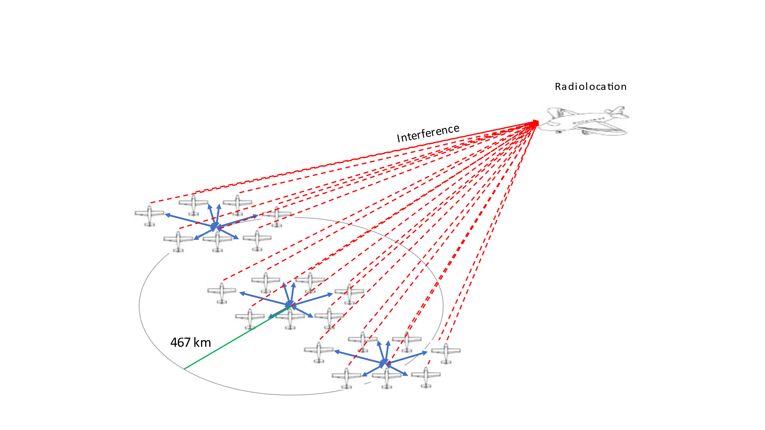

Below are the assumptions and methodology for multiple clusters analysis based on Figure A5-35:

1. Three clusters of non-safety AMS are deployed in this scenario. One cluster is fixed at the center. The other clusters are randomized within a ring of 467 km radius from a fixed cluster.
2. Within a single cluster, the receiver (Aircraft #4) is fixed. Aircraft #1 and 7 are randomized within a ring 12 km radius from the receiver. Aircraft #2 and 6 are randomized within a ring 8 km radius from the receiver. Aircraft #3 and 5 are randomized within a ring 6 km radius from the receiver
3. Transmission loss using [Rec. ITU-R P.528-5](https://www.itu.int/dms_pubrec/itu-r/rec/p/R-REC-P.528-5-202109-I!!PDF-E.pdf) – A propagation prediction method for aeronautical mobile and radionavigation services using the VHF, UHF, and SHF bands. The time percentage of 5% is used.
4. The altitude for all non-safety AMS aircraft except aircraft #4 3.6 km above the Earth’s surface. The altitude of aircraft #4 is 1 km above the Earth’s surface. The altitude of Radiolocation is randomized between 300 and 13 700 m.
5. The bandwidth for non-safety AMS systems is 10 MHz.
6. The centre frequency of non-safety AMS and Radiolocation stations is chosen uniformly within the tuning range 15.4-15.7 GHz in such a way that the necessary bandwidth is totally included inside this tuning range.
7. The Radiolocation aircraft is randomized within a 800 km radius of a center cluster.
8. The antenna pattern for a transmitting aircraft can be modelled using Section A1.2.1, with a cosine square pattern used for the Radiolocation receiver antenna.
9. The analysis is performed with the transmitter power of 40 dBm.
10. The pointing angle of the radiolocation receiver antenna is randomized ±45° horizontally, and +5° to −45° vertically.
11. The analysis was performed with 1 million sampling points since the protection criteria is I/N of -6 dB.

Figure A5-36

Sharing studies between multiple non-safety AMS clusters and Radiolocation based on the Surveillance mission scenario

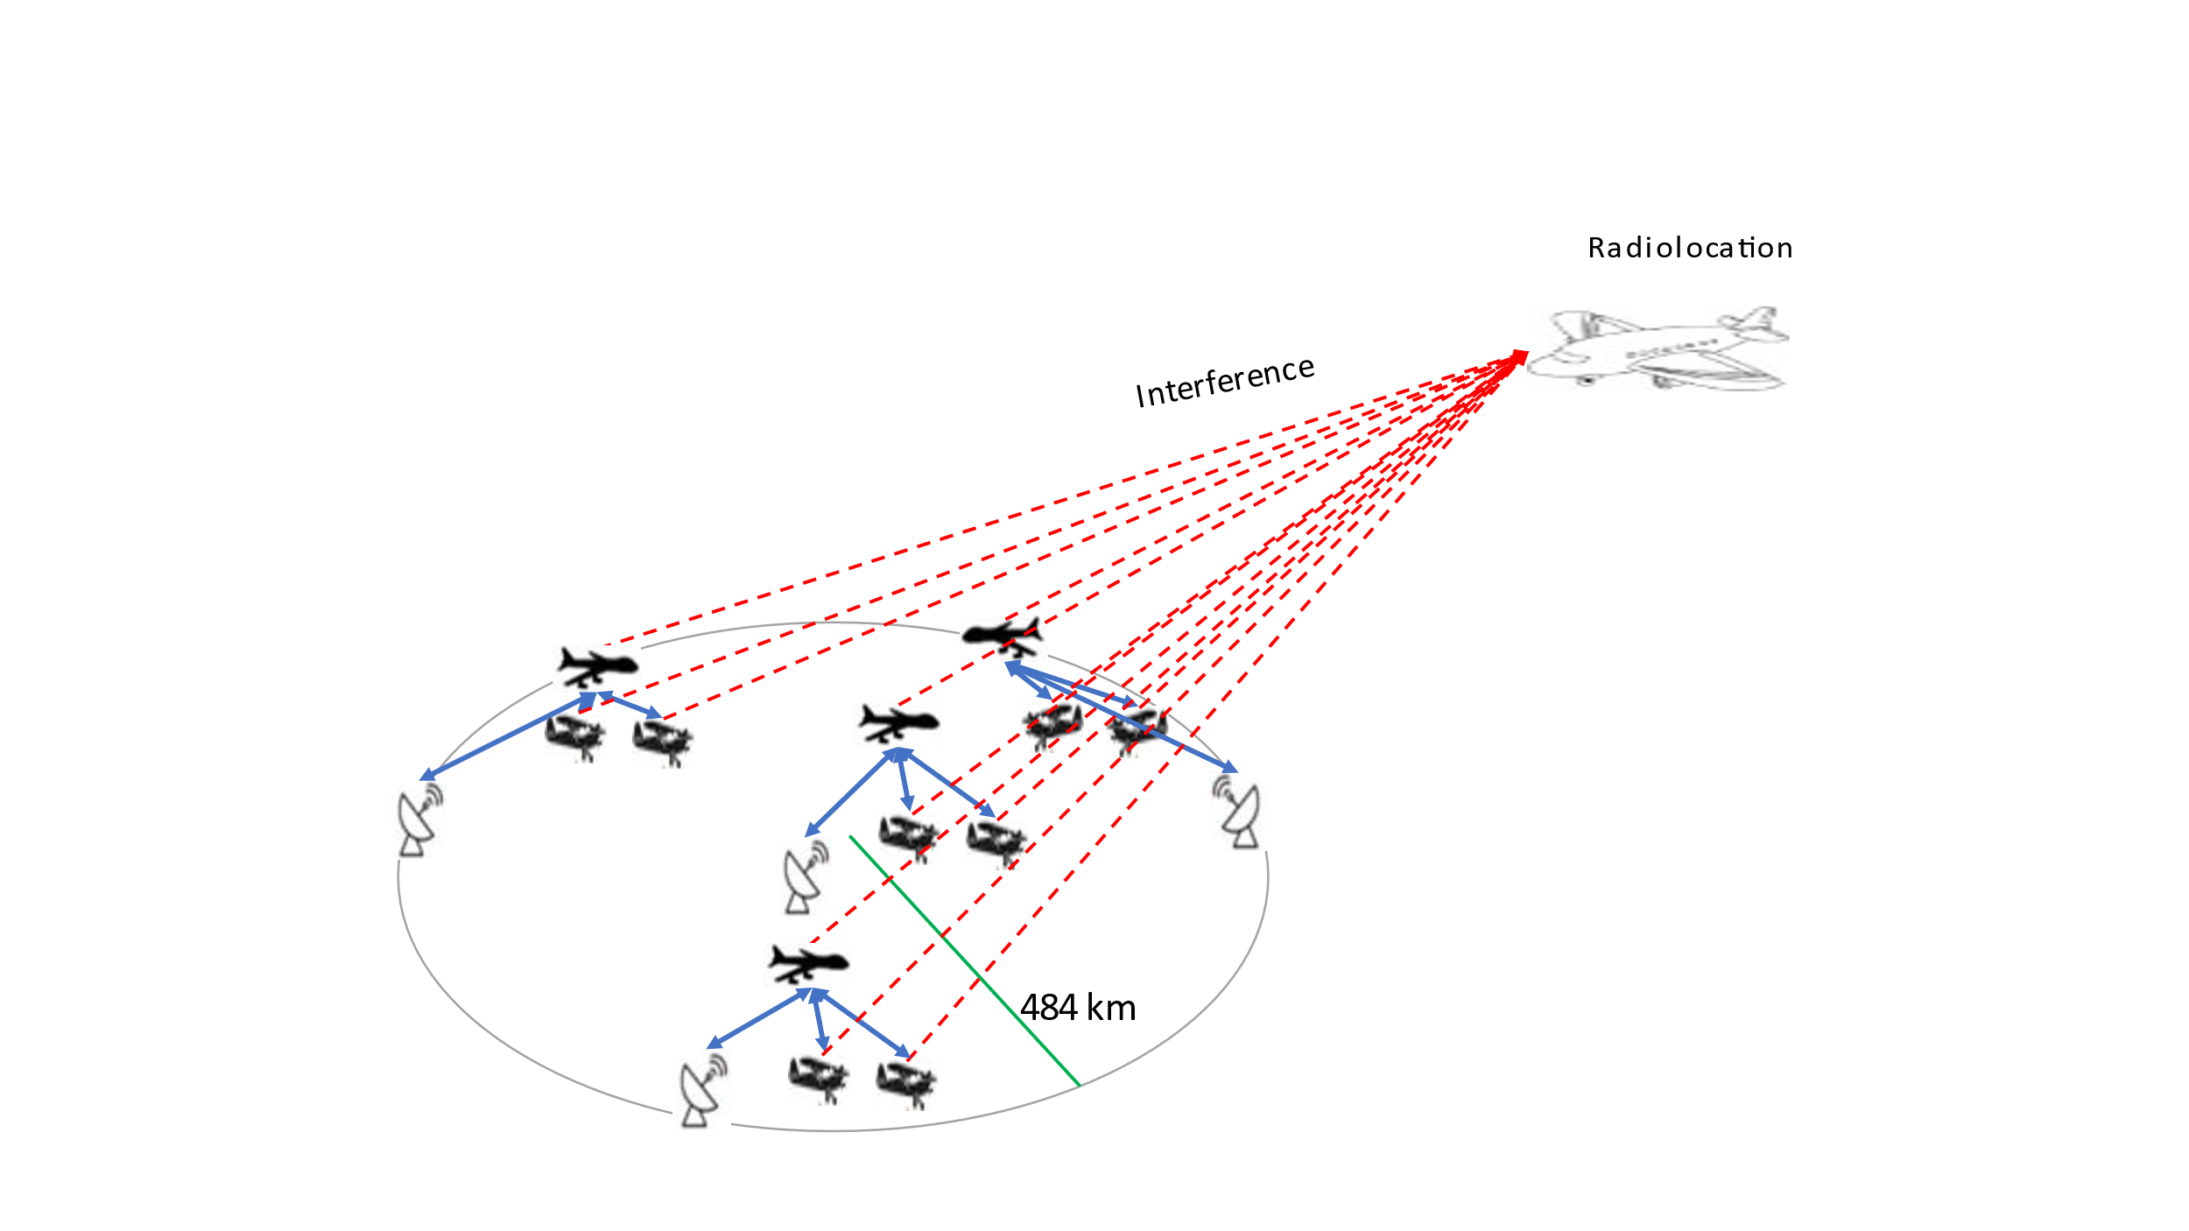

Below are the assumptions and methodology for multiple clusters analysis based on Figure A5-36:

1. Four clusters of non-safety AMS are deployed in this scenario. One cluster is fixed at the center. The other clusters are randomized within a ring of 484 km radius from a fixed cluster.
2. Within a single cluster, The location of the control center is fixed. The relay aircraft is randomized within a 300 km radius from the control center. The two observation aircraft are randomized within a 5 km radius from the relay aircraft.
3. Transmission loss using [Rec. ITU-R P.528-5](https://www.itu.int/dms_pubrec/itu-r/rec/p/R-REC-P.528-5-202109-I!!PDF-E.pdf) – A propagation prediction method for aeronautical mobile and radionavigation services using the VHF, UHF, and SHF bands. The time percentage of 5% is used.
4. The altitude for two observation aircraft, and relay aircraft are at 3 and 10km above the Earth’s surface respectively. The altitude for the Radiolocation aircraft is randomized between 300 and 13 700 km.
5. The bandwidth for non-safety AMS systems is 10 MHz.
6. The centre frequency of non-safety AMS and Radiolocation stations is chosen uniformly within the tuning range 15.4-15.7 GHz in such a way that the necessary bandwidth is totally included inside this tuning range.
7. The Radiolocation aircraft is randomized within an 900 km radius of a center cluster.
8. The antenna pattern for the relay aircraft and observation aircraft can be modelled using Section A1.2.1, and cosine square pattern for Radiolocation receiver antenna.
9. The analysis was performed with the transmitter power of 40 dBm.
10. The pointing angle of the radiolocation receiver antenna is randomized ±45° horizontally, and +5° to −45° vertically.
11. The analysis was performed with 1 million sampling points since the protection criteria is I/N of -6 dB.

Figure A5-37

Sharing studies between multiple non-safety AMS clusters and Radiolocation based on the Internet above the clouds scenario

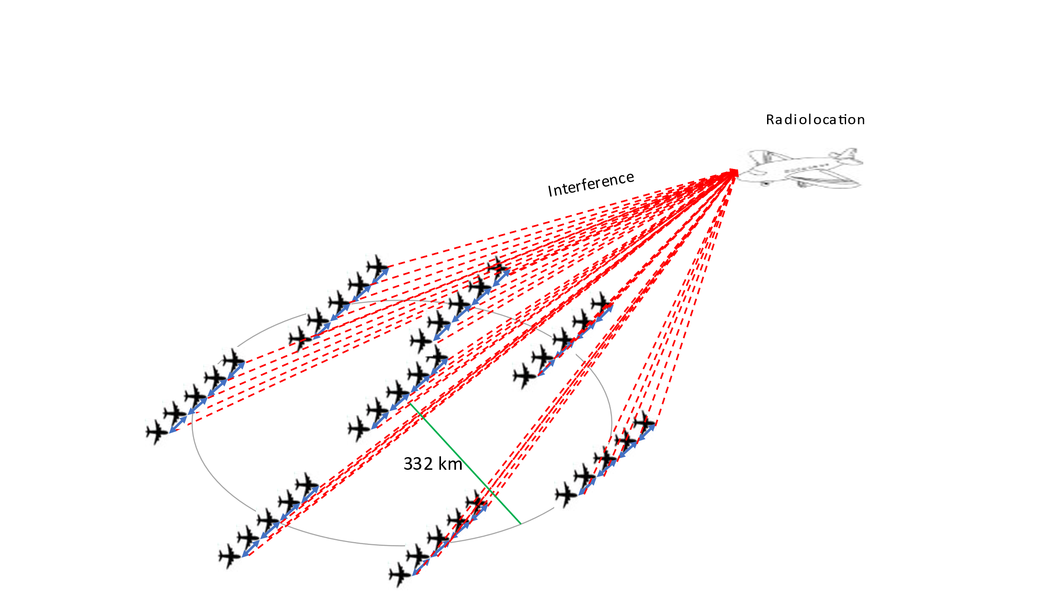

Below are the assumptions and methodology for multiple clusters analysis based on Figure A5-37:

1. Eight clusters of non-safety AMS are deployed in this scenario. One cluster is fixed at the center. The other clusters are randomized within a ring of 332 km radius from a fixed cluster.
2. Within a single cluster, aircraft #1 is fixed. Aircraft #2, 3, 4, and 5 are randomized within a ring of 500 km radius from aircraft #1, 2, 3, and 4 respectively.
3. Transmission loss using [Rec. ITU-R P.528-5](https://www.itu.int/dms_pubrec/itu-r/rec/p/R-REC-P.528-5-202109-I!!PDF-E.pdf) – A propagation prediction method for aeronautical mobile and radionavigation services using the VHF, UHF, and SHF bands. The time percentage of 5% is used.
4. The altitude for all transmitting aircraft is 10 km above the Earth’s surface. The altitude of Radiolocation is randomized between 300 and 13 700 m.
5. The bandwidth for non-safety AMS systems is 10 MHz.
6. The centre frequency of non-safety AMS and Radiolocation stations is chosen uniformly within the tuning range 15.4-15.7 GHz in such a way that the necessary bandwidth is totally included inside this tuning range.
7. The Radiolocation aircraft’s position is randomized within a 900 km radius from a center cluster.
8. The antenna pattern for both a transmitting aircraft can be modellled using Section A1.2.1, and the Radiolocation receiver can be modelled using [Rec. ITU-R M.1851-1](https://www.itu.int/dms_pubrec/itu-r/rec/m/R-REC-M.1851-1-201801-I!!PDF-E.pdf) cosine square pattern.
9. The analysis was performed with the transmitter power of 40 dBm.
10. The radiolocation receiver antenna is scanning ±45° horizontally, and +5° to −45° vertically.
11. The analysis was performed with 1 million sampling points since the protection criteria is I/N of -6 dB.

### **A5.3.4.3 Sharing studies results**

Figures A5-38 through A5-41 provide CDFs of I/N values based on Figures A5-34 through A5-37, respectively for both single and aggregate interference.

Figure A5-38

CDF plot of I/N values based on the Wildfire observation scenario

Figure A5-39

CDF plot of I/N values based on the Search and Rescue scenario

Figure A5-40

CDF plot of I/N values based on the Surveillance mission scenario

Figure A5-41

CDF plot of I/N values based on the Internet above the clouds scenario

Figures A5-42 through A5-45 provide separation distances between non-safety AMS and radiolocation based on Figures A5-38 through A5-41

Figure A5-42

Separation distance between non-safety AMS and Radiolocation based on the Wildfire observation scenario

Figure A5-43

Separation distance between non-safety AMS and Radiolocation based on the Search and Rescue scenario

Figure A5-44

Separation distance between non-safety AMS and Radiolocation based on the Surveillance mission scenario

Figure A5-45

Separation distance between non-safety AMS and Radiolocation based on the Internet above the clouds scenario

Table A5-4 below provides the separation distance between non-safety AMS and Radiolocation.

Table A5-4

Separation distance between systems operating in the aeronautical mobile service (non-safety) and radiolocation service

|  |  |  |  |
| --- | --- | --- | --- |
|  | Non-safety AMS transmitter bandwidth (MHz) | Non-safety AMS transmitter e.i.r.p. (dBW) | Separation distance between Radiolocation an the center of non-safety AMS cluster deployment (Km) |
| Figure 4-2 – Wildfire observation scenario | 10 | -2 |  |
| Figure 4-3 – Search and recure scenario | 10 | 35 |  |
| Figure 4-4 – Surveillance mission scenario | 10 | 35 |  |
| Figure 4-5 – Internet above the clouds scenario | 10 | 48 |  |

**A5.3.5 Summary of preliminary results**

The results from the dynamic analysis are summarized in Tables A5-3 and A5-4. Depend on the interference scenario and systems characteristics, a separation distance is required between non-safety AMS and Radiolocation.

**A5.4 Conclusion**

This Annex has studied the problem of sharing the frequency band 15.4-15.7 GHz between non-safety AMS and the RLS from three different perspectives:

- Study A has computed the minimum separation distances between RLS and AMS in a main beam to main beam configuration.

- Study B is a Monte carlo analysis that shows that the aggregate interference level generated by AMS transmissions at the RLS receiver is below the threshold for at least 99.999 % of the time.

- Study C includes 2 analyses:

A single entry Monte- Carlo analysis that considers one AMS cluster within the radio horizon of the RLS receiver. This analysis concludes that I/N level at the RLS receiver is greater than -6 dB for at most 0.001 % of the time with the separation distance of 885 km.

A multiple entry Monte-Carlo study. AMS channels are randomly selected within the tuning range. This analysis concludes that I/N level at the RLS receiver is greater than -6 dB for at most XX % of the time with the separation distance of YY km..

There are no proposed changes following this point in the document.

…