US Radiocommunication Sector
FACT SHEET
Study Group: USWP 5B |  | Document No: USWP5B30-X
Reference: Document 5B/649 Annex 24 |  | Date: 11 August, 2022
Document Title: Updates to Working document towards a preliminary draft new
report ITU-R [NON-SAFETY AMS CHARACTERISTICS AND SHARING STUDIES]
Authors | Telephone |  | E-Mail
Daniel Bishop, NASA  Ryan S. McDonough, NASA | 216-433-5220  216-433-2862 |  | daniel.w.bishop@nasa.gov  Ryan.S.McDonough@nasa.gov
Purpose/Objective:
Propose updates to Working document towards a preliminary draft new report ITU-R [NON-SAFETY AMS CHARACTERISTICS AND SHARING STUDIES], building upon the chairman’s report from the July 2022 WP 5B meeting.
Abstract:
This contribution seeks to further this work by updating the studies of adjacent band compatibility between the potential new AMS allocation in 22-22.21 GHz and EESS (passive) in 22.21-22.5 GHz in A14.1 (Study A) of the working document. Also this will include comments on the proponent study of the same topic in A14.2 (Study 2) This work will address comments from the July 2022 WP 5B drafting group discussion on these sections.
Fact Sheet Preparer: Ryan McDonough, NASA

ANNEX 14
Compatibility studies between AMS and EESS (passive) in 22-22.21 GHz
[Editor’s note: (Questions from France, Germany)
- Is it so that no power control on the AMS side has been taken into account?
- Is it so that a worst case configuration in terms of channel assignment has been envisaged, i.e. AMS Channel 1 between 22.01-22.11 GHz, AMS Channel 2 between 22.11-22.21 GHz, and EESS (passive) between 22.21-22.31 GHz?]
[Editor’s note: (Questions from France, Germany) Can one summarize the conclusion of the study in the following way?
- Ground to Air links have more severe impact in general than Air to Air or Air to Ground links.
- From the study of scenario ‘Wildfire detection’, you conclude that ground to air links should respect a limit of -17 dBW/100 MHz in the EESS (passive) band (I suppose based on the maximum simulated density?)
- From the study of scenario ‘Search and Rescue’, you do not conclude on a numerical value.
- From the study of scenario ‘Border Surveillance’, you conclude that air to air links should respect a limit of -23 dBW/100 MHz (based on the maximum simulated density?)
- From the study of scenario ‘Aircraft Data Networks’, you conclude that air to air links should respect a limit of -19 dBW/100 MHz (based on the maximum simulated density?)]
[Editor’s note: (Remark from France, Germany). If the OOB limits stated above are indeed based on worst case assumptions (in terms of deployment densities, location of the channels, maximum output power of AMS stations), then conclusion should clearly mention it. Further, a sensitivity analysis is needed to assess the impact of measures such as power control that is an essential part of non-safety AMS systems.]
Editor’s Note Response 1: Power control is now adjusted in the way described in A16.6.1. Note that the systems are populated in the adjacent channels between 22.01-22.11 GHz, AMS Channel 2 between 22.11-22.21 GHz, and EESS (passive) between 22.21-22.31 GHz . The out-of-band impact from systems operating outside of these two channels is subjected to significant frequency dependent rejection and therefore not useful for the scope of this study.
Editor’s Note Response 2: These comments are taken into consideration in the updated summaries.
- It is added in General Remarks of section A14.1.5 that ground-air and certain air-air links are more impactful.
- The power emission limits are intended to be relevant only within the 50 MHz band edge for this scenario as an aggregate power level based on the simulated deployment density within this segment which is maximally supported by the EESS protection criteria.
- Numerical value was inadvertently omitted and is included in this contribution.
- The power emission limits are intended to be relevant only within the 30 MHz band edge for this scenario as an aggregate power level based on the simulated deployment density within this segment which is maximally supported by the EESS protection criteria.
- The power emission limits are intended to be relevant only within the 80 MHz band edge for this scenario as an aggregate power level based on the simulated deployment density within this segment which is maximally supported by the EESS protection criteria.
Editor’s Note Response 3: Some description is added under section A14.1.2 and General Remarks in section A14.1.5 (Conclusion) to further clarify the interpretation of these results. It is not the intention of the study to employ worst case assumptions but rather to highlight subsets of scenarios, link directions, or system configurations that are more impactful from an interference perspective. Since power control is now implemented by the simulated systems a comparison could be made (sensitivity analysis) to illustrate the benefits of power control to spectrum sharing.

A14.1 Study A

A14.1.1 Calculation of Aggregate Interference
An assessment of the aggregate RFI expected from non–safety AMS systems into EESS (passive) is achieved by a dynamic simulation. The analysis will be conducted in which the orbit of the EESS (passive) spacecraft under investigation is dynamically simulated. Calculations will be performed to determine the potential interference from the proposed non–safety AMS systems into the EESS (passive) band and will consider the aggregate effect from multiple sources. The simulation will propagate the satellite based on its orbital parameters, and the time step is selected to be an irrational number to ensure that the beam dynamics of the passive sensor do not exhibit periodic behavior. At each time step, the simulation will compute the directional vectors from each source to the EESS (passive) and then compute the gain of the transmit and receive antennas using their respective antenna patterns.
The interfering signal power level, $I_{i,n}$ (W), received by a spaceborne radiometer at the $n^{\text{th}}$ timestep from the $i^{\text{th}}$ active transmitter is calculated from:
$I_{i,n}=\frac{{ P}_{\text{TX} i,n}G_{\text{TX} i,n}{ G}_{\text{RX} i,n}}{L_{\text{a} i,n}{ L}_{\text{FSPL} i,n} L_{\text{pol} i,n}}$ (A14-1)
where:
${ P}_{\text{TX} i,n}$: i-th AMS ource transmitter power (W) in the EESS (passive) band, adjusted for power control as described in A16.6.1;
$G_{\text{TX} i,n}$: i-th AMS source antenna gaintowards spaceborne sensor;
$G_{\text{RX} i,n}$: Spaceborne receive antenna gain towards i-th AMS source;
$L_{\text{a} i,n}$: Attenuation due to atmospheric absorption between i-th AMS source and space borne sensor;
$L_{\text{FSPL} i,n}$: Free Space Path Loss between i-th AMS source and space borne sensor;
$L_{\text{pol} i,n}$: Losses (dB) due to polarization mismatch between i-th AMS source and spaceborne sensor.
The aggregate interference at the $n^{\text{th}}$ timestep,${ AggI}_{n}$ (W), is calculated by the summation of the received interference from active AMS stations within line of sight of EESS (passive):
$$\begin{aligned}{AggI}_{n}=\sum_{i}{I_{i,n}}=\sum_{i}{\frac{{P_{\text{TX }i,n} G}_{\text{TX} i,n}{ G}_{\text{RX} i,n}}{L_{\text{a} i,n}{ L}_{\text{FSPL} i,n} L_{\text{pol} i,n}}} \#\left(\text{A1}\text{4}\text{-}\text{2}\right)\end{aligned}$$
Thus, the aggregate interference can be represented in the logarithmic domain as:
$$\begin{aligned}{AggI}_{n|\text{dB}}={\left(\sum_{i}{\frac{{ P}_{\text{TX} i,n}{ G}_{\text{TX} i,n}{ G}_{\text{RX} i,n}}{L_{\text{a} i,n}{ L}_{\text{FSPL} i,n} L_{\text{pol} i,n}}}\right) }_{|\text{dB}}\#\left(\text{A1}\text{4}\text{-}\text{3}\right)\end{aligned}$$
Based on time series values for the interfering signal power level, a CCDF curve will be generated in order to assess if the result exceeds the recommended performance and interference criteria that are defined in Recommendation ITU-R RS.2017-0. The criteria will be used as a metric to assess the impact that the non–safety AMS allocation would have on the EESS (passive) systems operating 22.21-22.5 GHz band. From Recommendation ITU-R RS.2017-0, outlined in section A4.4.3 of this Report, the following is prescribed for the frequency range 22.21-22.5 GHz:
- Reference bandwidth: 100 MHz;
- Maximum interference level: -169 dBW;
- Percentage of area or time permissible interference level may be exceeded: 0.1%;
- The area analyzed should be 10 000 000 km².
The selection of the simulation area will be chosen to reflect the operational area of sensors operating in the 22.21-22.5 GHz band.

A14.1.2 Simulation parameters for AMS
The AMS OOB emissions inside the target range 22.21-22.31 GHz was calculated from Figure A1-1 in Annex 1.
With respect to the data networks above the clouds scenario, the operational altitude of the AMS systems was 10 km and the antenna pattern was omnidirectional with maximum gain of 3 dB. With respect to the wildfire observation scenario, the operational altitude of the flight systems were 0.1 km and antenna pattern were omni-directional. The ground systems for this scenario utilized an omnidirectional pattern.
The 22.21-22.5 GHz EESS (passive) analysis of this study will focus on current available representative characteristics of AMS systems within this frequency range. If the deployment densities are significantly different from the assumed values, the simulation will need an update to verify co-existence potential. The calculation methodology from section A14.1.1 is inherited for consideration of aggregated emission reception.
This analysis assumes the band edge reduction and incursion into the OOB region as described in section A1.1 and Figure A1-1. This equates to -10.3 dB FDR (Channel 1) and -47.0 dB FDR (Channel 2) in the EESS (passive) frequency band of 22.21 to 22.31 GHz. If more than two channels are utilized by a scenario (e.g. scenario 6.5), then channels further away from the band edge than the two immediately adjacent band are subject to even more FDR and will have significantly less impact on observed interference power in-band of the EESS passive than the nearest two to the band edge. If the FDR is lower than the presumed value, the simulation and co-existence may have to be revaluated. It noted that the intended allocation of AMS frequency segments within the 22-22.21 GHz is not limited to the band edge cases. However, for this study it is the objective to determine the maximum density of AMS systems operational near the band edge (within 100 MHz of the edge), which can be supported and simultaneously protecting incumbent EESS systems in the neighboring band.

A14.1.3 Simulation parameters of EESS (passive)
The operational altitude of the EESS sensor and antenna pattern are described in A4.4.1 and A4.4.2 and are 833 km and Recommendation ITU-R RS.1813-1 respectively.
The analysis band for this study is 22.21-22.31 GHz centered at 22.26 GHz. An AMS emission center frequency of 22 160 MHz, 50 MHz from the band edge, with a 100 MHz bandwidth was chosen to be in line with the EESS (passive) protection criteria of -169 dBW/100 MHz. Subsequent channels incorporate a 50 MHz offset further away from the band edge to accommodate channel assignment specific to AMS scenarios. Analysis was done along the band edge to determine the level of unwanted emissions into the EESS (passive) band. Table A14-1 gives the rest simulation parameters that were assumed for this simulation.
Table A14-1
General simulation parameters
Parameter | Units | Value
Simulation Frequency | MHz | 22 160
Duration | days | 25
Time Step | Sec. | 1×π
Atmospheric Losses | - | P.676-12
RF Prop. Models  Air-space  ground-space | - | Rec. ITU-R P.1409-2  Rec. ITU-R P.619-5
Polarization Losses | dB | 3 (C-V)
FDR | dB | 10.3 (C1), 47.0 (C2)
EESS (passive) Band Power | dBW/100MHz | -54

The simulation was run for a 25 day duration with a 1×π second time step to collect an appropriate amount of sample points to achieve statistical significance of results. Atmospheric losses (L_{a} ) were calculated using Recommendation ITU-R P.676-12. According to guidance from WPs 3K and 3M liaison statement Document 5B/369 the preferred propagation model for ground-space interference computations is Recommendation ITU-R P.619-5 and the preferred propagation model for ground-air interference computations is Recommendation ITU-R P.1409-2. These were implemented to produce propagation losses noting that Recommendation ITU-R P.619-5 and Recommendation ITU-R P.1409-2 internally account for atmospheric losses attributed to use of Recommendation ITU-R P.676. The irrational time step of 1×π was chosen to create a random non-uniform distribution of the EESS locations and azimuth pointing angles during satellite orbit within the simulation run time.
The RF and general parameters of the AMS system under simulation were derived from System 1 of Table A2-1 in section A2.1. In the absence of an explicit deployment, a generic one was considered and provisionally proposed to be representative. Two configurations were constructed: one aimed to approximate the description of the “Wildfire observation” found in section 6.2, and the other adopts aspects of “Internet above the clouds” found in section 6.5.
Note that for the following four configuration scenarios the operational parameters were adapted from section 6.7 “Technical setup of the scenarios” or as described in the descriptive sections 6.2 to 6.5. For instance, geometric spacing and relative location are adapted from Table 6-1. Additional technical parameters implemented (which may not be explicitly stated in section 6) in order to illustrate interaction with the EESS passive system are taken into account individually in the following descriptions.
For the first configuration (operational scenario 6.2, wildfire observation, a density of randomly deployed ground central locations were placed in a ground centred 10 million sq. km EESS passive mission area of interest (MAI) centred at 68 W, 0 N, with associated ground stations taken in ratio 2 to 1 ground to air stations. See Figures A14-1 and A14-2., with associated ground stations taken in ratio 2 to 1 ground to air stations. Circular flight paths of radius 1 km-10 km were inscribed about the central focal point as described in Section 6.2. Communication between air and ground station enforced a pointing arrangement consistent with Section 6.2 were based on shortest distance to ground receiver. Channel assignment was allocated on a sequential basis in accordance with section 8 Spectrum Requirements Table 8-1. A single experimental simulation was performed for each transmitter density deployment and the repetition of the run may serve to establish bounds of uncertainty in a subsequent iteration of this study. The aim of this analysis was to determine what density of systems could operate a downlink main beam within the MAI without imposing harmful interference to the EESS passive service.
The second configuration (operation scenario 6.3, search and rescue), a density of randomly deployed clusters were placed in a ground centred 10 million sq. km EESS passive mission area of interest (MAI) centred at 68 W, 0 N. Each cluster was defined by seven coordinated aeronautical users operating bi-directional air-air links within the specially defined region. In this scenario, altitude is varied nominally, and average relative spacing between craft remains roughly constant with cluster centre and individual craft performing exploration similar to behaviour of a random walk (for purposes here adequately approximate expected flight trajectories).
The third configuration (operation scenario 6.4, border surveillance mission), a density of randomly deployed clusters were placed in a ground centred 10 million sq. km EESS passive mission area of interest (MAI) centred at 68 W, 0 N. Each cluster was defined by two coordinated aeronautical observation users operating in relay (air-air bidirectional links) with an additional aircraft which communicates (return link) with a single ground station located within the specially defined region.
For the fourth configuration (operational scenario 6.5, data networks above the clouds), a list of commercial air-routes was used to serve as the navigational reference basis for AMS device air platform station emissions. The density of flight paths is taken to be representative of the route traffic given by the dataset. Air-air transmissions consistent with the description in Section 6.5 were established which enforced a pointing arrangement based on shortest distance to air-based receiver. Channel assignment was allocated on a sequential basis. Transmissions are asusmed to be continual during nominal flight, and pointing assignment (pair-assignment) is on the basis of nearest neighbor. Operational altitude of a cluster is 10 km. A single experimental simulation was performed and the repetition of the run may serve to establish bounds of uncertainty in a subsequent iteration of this study. The aim of this analysis was to determine the density of systems that could operate a return (air-air link) within the MAI without imposing harmful interference to the EESS passive service. Two 10 million sq. km EESS passive MAIs centred at (68 W, 0 N) and (91 W, 0 N) were considered as representatives of overground and oversea areas, respectively. See Figures A14-1 and A14-2.
A region of this size was selected over the Amazon River basin to be used for this simulation.
When the EESS R1 sensor main beam is within the MAI, the active air-air and air-ground links with line-of-sight to the R1 were computed and aggregated receive power density computed using section A14.1.1. Interference events are considered only for that time that the EESS R1 sensor is making measurements from within the MAI. However, an extension of the MAI of 1 degree in each direction was used to determine those aeronautical systems that could additionally contribute interference.
Figure A14-1 shows the ground demark of the EESS R1 Area of Interest utilized for all simulation runs of configurations 1 and 4.
Figure A14-2 shows the ground demark of the EESS R1 Area of Interest utilized for all simulation runs of configurations 4 (oversea case).
FigureA14-3 shows the aeronautical flight paths utilized by subsequent simulation runs of configuration 4. The source of this data set given in public domain by link.
Figure A14-4 shows routes in and immediately around the MAI utilized by subsequent simulation runs of configuration 4.
Figures A14-5 and A14-6 show routes in and immediately around the MAI utilized by subsequent simulation runs of configuration 4 (oversea), for low and high route density, respectively.
Figure A14-7 shows the ground station segment utilized by subsequent simulation runs of configuration 1. Also plotted is the EESS R1 MAI for reference.
Figure A14-8 shows the air station segment utilized by subsequent simulation runs of configuration 1. Also plotted is the EESS R1 MAI for reference.
Figure A14-9 shows the antenna pattern for sensor R1 utilized by subsequent simulation runs. Figure A14-10 shows the antenna pattern for AMS air-stations utilized by subsequent simulation runs.
Figure A14-10 shows the selectivity curves used by simulations including both the receiver and emission source for the case of the emission occupying the band subset immediately adjacent to the receiver allocated band. These curves are used to determine the FDR used by the simulations as described in section.
FIGURE A14-1  EESS R1 MAI  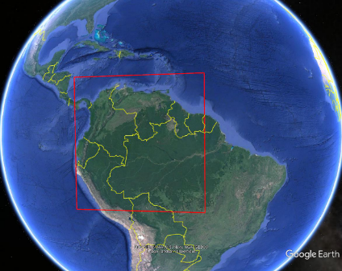 | FIGURE A14-2  EESS R1 MAI (Overseas)  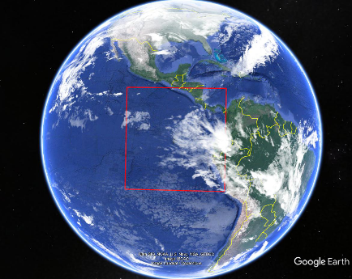

FIGURE A14-3  Aeronautical route deployment  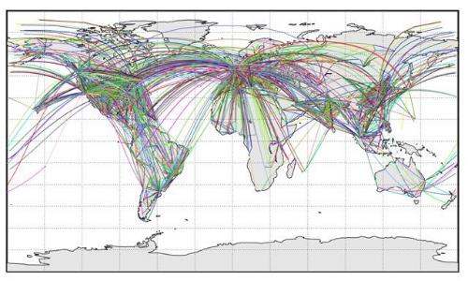 | FIGURE A14-4  Aeronautical route deployment  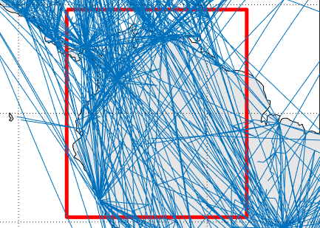
FIGURE A14-5  Aeronautical route deployment (low route number)  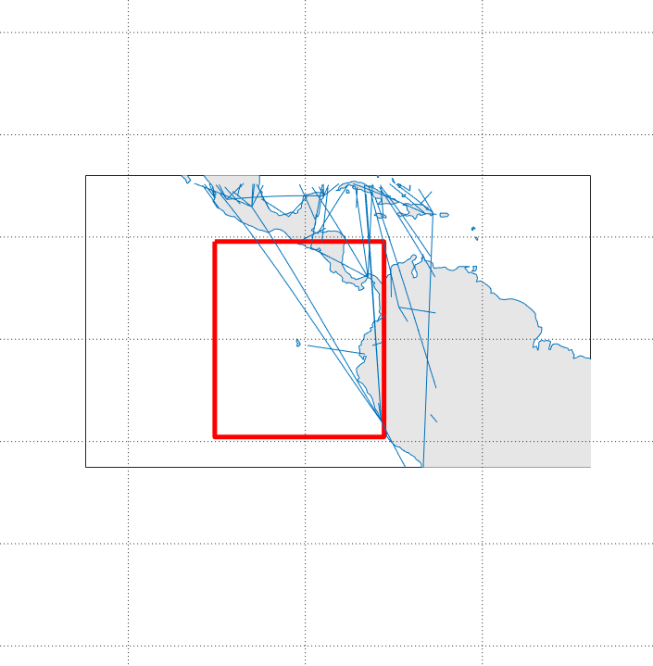 | FIGURE A14-6  Aeronautical route deployment (high route number)  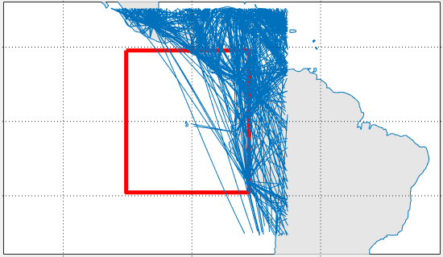
FIGURE A14-7  Ground station segment deployment (low density) | FIGURE A14-8  Ground station segment deployment (med. density)  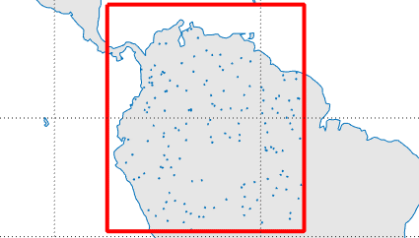

FIGURE A14-9  EESS (Passive) Sensor R1 Gain | FIGURE A14-10  Emission and Receiver Selectivity Curves  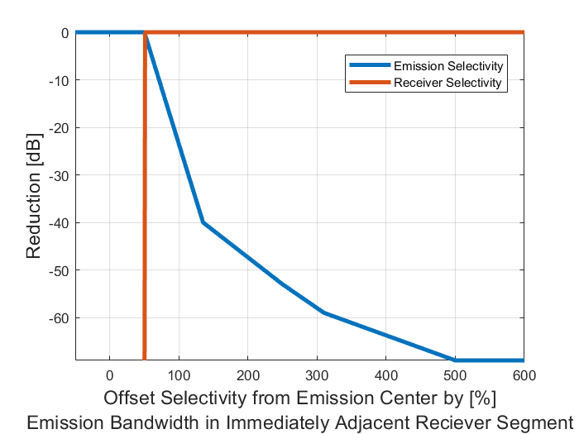
Figure A14-11
AMS air-stations Gain
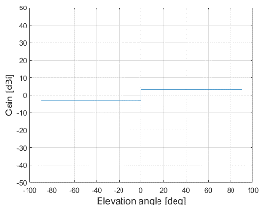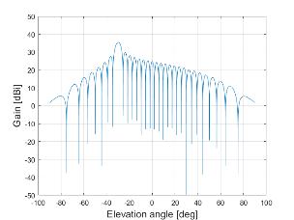

A14.1.4 Simulation results
The following figures illustrate the findings from the study of the RF interference impact configuration 1 and 2 type systems on EESS R1 sensors.
Figure A14-12 shows interference level CCDFs seen for operation system downlinks conforming to configuration 1 (wildfire observation section 6.2), where the total number of transmitters within or immediately around the MAI are stated in the legend. FDR and RF propagation losses are included in these plots.
Figure A14-13 shows interference level CCDFs seen for operation system uplinks conforming to configuration 1 (wildfire observation section 6.2), where the total number of transmitters within or immediately around the MAI are stated in the legend. FDR and RF propagation losses are included in these plots.
Figure A14-14 shows interference level CCDFs seen for operation system downlinks conforming to configuration 2 (search and rescue section 6.3), where the total number of transmitters within or immediately around the MAI are stated in the legend. FDR and RF propagation losses are included in these plots.
Figure A14-15 shows interference level CCDFs seen for operation system uplinks conforming to configuration 2 (search and rescue section 6.3), where the total number of transmitters within or immediately around the MAI are stated in the legend. FDR and RF propagation losses are included in these plots.
Figure A14-16 shows interference level CCDFs seen for operation system downlinks conforming to configuration 3 (border control section 6.2), where the total number of transmitters within or immediately around the MAI are stated in the legend. FDR and RF propagation losses are included in these plots.
Figure A14-17 shows interference level CCDFs seen for operation system uplinks conforming to configuration 3 (border control section 6.4), where the total number of transmitters within or immediately around the MAI are stated in the legend. FDR and RF propagation losses are included in these plots.
Figure A14-18 shows interference level CCDF for the air-air downlinks for configuration 2 (internet above the clouds, section 6.5) for aggregate representative interference sources. FDR and RF propagation losses of are included in this plot. This is the inland case.
Figure A14-19 shows interference level CCDF for the air-air downlinks for configuration 2 (internet above the clouds, section 6.5) for aggregate representative interference sources. FDR and RF propagation losses of are included in this plot. This is the over-sea case.

FIGURE A14-12  Received interference configuration 4.2 (wildfire observation) (aggregate source system 2) (downlinks)  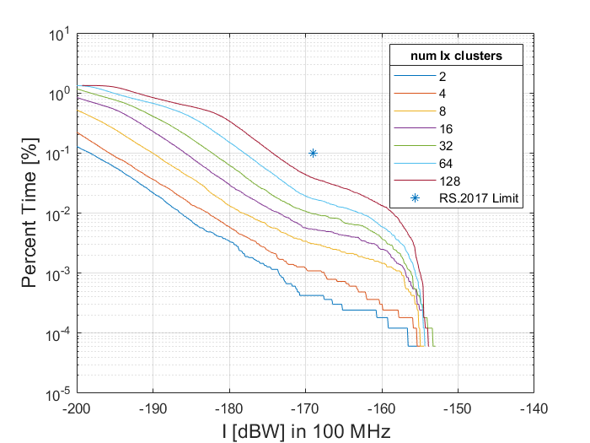 | FIGURE A14-13  Received interference configuration 4.2 (wildfire observation) (aggregate source system 4) (uplinks)  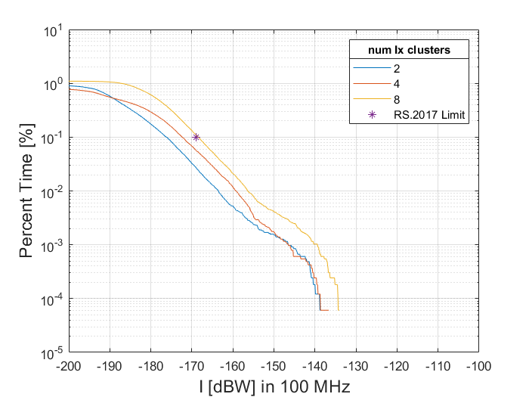
FIGURE A14-14  Received interference configuration 4.3 (search and rescue) (aggregate source system 1) (forward)  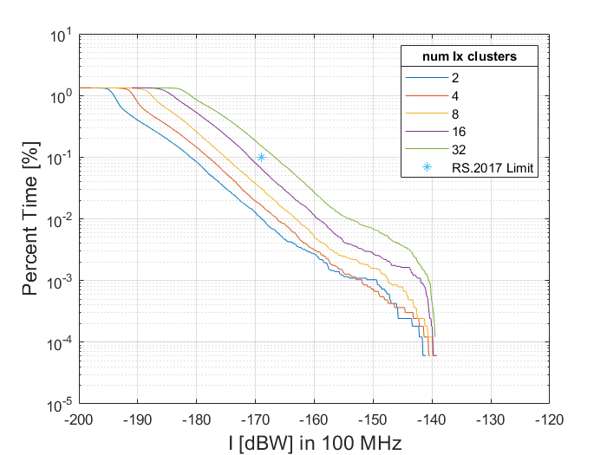 | FIGURE A14-15  Received interference configuration 4.3 (search and rescue) (aggregate source system 2) (return)  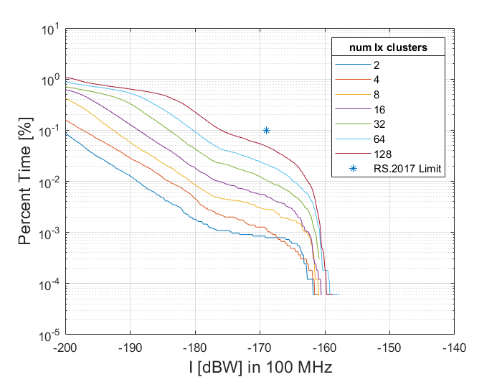

FIGURE A14-16  Received interference configuration 4.4 (border surveilance) (aggregate source system 1) (observation, relay links)  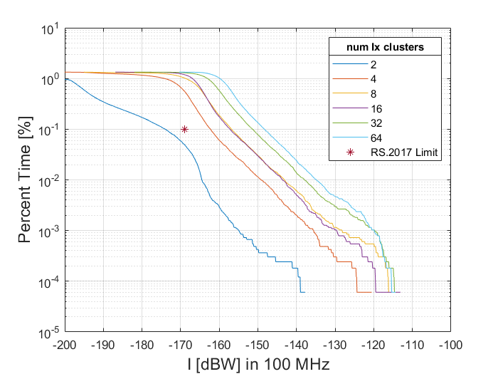 | FIGURE A14-17  Received interference configuration 4.4 (border surveilance) (aggregate source system 2) (relay links)  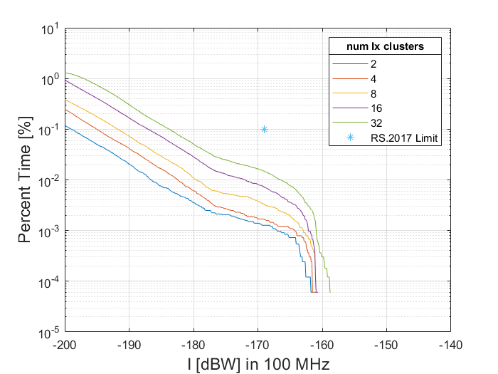
FIGURE A14-18  Received interference configuration 4.5 (data networks above the clouds inland case) (aggregate source system 4) (forward)  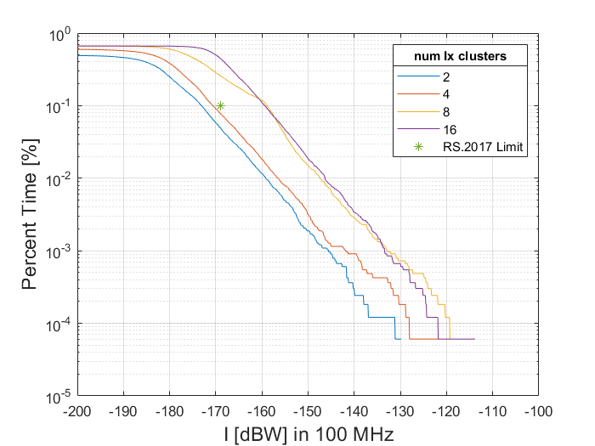 | FIGURE A14-19  Received interference configuration 4.5 (data networks above the clouds oversea case) (aggregate source system 4) (forward)

A14.1.5 Conclusion
The following results are based on studies conducted using densities below and above the typical deployment density numbers provided in section 7 (section 5 of Document 5B/531 Annex 13, Table 5-1) of the Report. The purpose of this sensitivity analysis was to assess the sensitivity of the interference predictions based on the deployment density assumptions. It is also remarked that deployment densities can vary by geographic regions, and it is useful to capture the results of a sensitivity analysis to reduce the need to re-run simulations and instead support extrapolation to different areas of the Earth.
Wildfire observation (operational scenario 6.2)
The results of section A14.1 indicate that the first configuration (operational scenario 6.2, wildfire observation) can support operations in the downlink transmission direction without imposing harmful interference into the EESS (passive), according to typical deployment densities, defined by ground station platforms and their associated aeronautical users operating within the specially defined region.
The downlink transmission direction (utilizing system 2 as described as an option in Table 6-1) appears to support the utilization of multiple clusters, which should be noted. Considering the return transmission direction, the interference potential is greater for the EESS passive, and a maximum number of clusters supporting operations in the uplink transmission in the immediate adjacent two channels is approximately 8.
The study conducted found the majority of the contribution to this harmful interference from wildfire observation comes from non-safety-of-life AMS uplink systems operating immediately adjacent to the EESS (passive) band specifically within 50 MHz of the band edge of 22.21 GHz. The study shows it is necessary to limit the uplink and downlink OOB emissions of the AMS to -17 dBW/100 MHz for operations within 50 MHz of the band edge in order to ensure the protection of the EESS passive service. It is advantageous (from a spectrum sharing perspective) to allocate uplink operations further away from the 22.21 GHz band edge as possible.
Search and Rescue (operational scenario 6.3)
The results of section A14.1 indicate that the second configuration (operational scenario 6.3, search and rescue) can support without imposing harmful interference into the EESS (passive), according to typical deployment densities, each defined by seven coordinated aeronautical users operating bi-directional air-air links within the specially defined region. It is noted that this assumption is greater than the typical number of clusters defined in operational scenarios (see Table 5-2).
The forward and return air-air transmission directions (utilizing systems 1 and 2 as described as options in Table 6-1) have a noted difference in impact to EESS. Considering the forward transmission direction, the interference potential is greater for the EESS passive, and a maximum number of clusters supporting operations in the forward transmission in the immediate adjacent two channels is approximately 4. This difference appeared to be exclusively due to the system configuration differences between 1 and 2.
The majority of the contribution to this harmful interference from search and rescue operations comes from non-safety-of-life AMS air-air systems operating immediately adjacent to the EESS (passive) band specifically within 30 MHz of the band edge in order to ensure the protection of the EESS passive service. This study found it is therefore necessary to limit the OOB emissions of specifically the return links to -20 dBW/100 MHz in order to ensure the protection of the EESS passive service.
Border surveillance (operational scenario 6.4)
The results of section A14.1 indicate that the third configuration (operational scenario 6.4, border surveillance) can, under certain system configurations, support without imposing harmful interference into the EESS (passive), each defined by two coordinated aeronautical observation users operating in relay (air-air bidirectional links) with an additional aircraft which communicates (return link) with a single ground station located within the specially defined region. This was taking into consideration typical deployment densities (see Tables 7-3A and 7-3B).
The observation/relay and exclusive relay transmission direction (utilizing systems 1 and 2 as described as options in Table 6-1) have a noted difference in impact to EESS. Considering the observation/relay transmission direction, the interference potential is greater for the EESS passive, and a maximum number of clusters supporting operations in the forward transmission in the immediate adjacent two channels is approximately 4. The use of system 1 for the observation/relay appeared to be primarily responsible for the greater interference levels compared to the relay exclusive transmission mode.
The majority of the contribution to this harmful interference from border surveillance operations comes from non-safety-of-life AMS air-air relay return systems operating immediately adjacent to the EESS (passive) band specifically within 30 MHz of the band edge in order to ensure the protection of the EESS passive service. This study found it is therefore necessary to limit the OOB emissions of specifically the return links to -23 dBW/100 MHz in order to ensure the protection of the EESS passive service.

Data networks above the clouds (operational scenario 6.5)
The results of section A14.1 indicate that the fourth configuration (operational scenario 6.5, data networks above the clouds) cannot support without imposing harmful interference into the EESS (passive) more than approximately 4 aeronautical platforms operating over inland regions as well as not more than approximately 4 aeronautical platforms operating over oversea (near the shore) regions. The study found it is necessary to limit the OOB emissions of the AMS to -22 dBW/100 MHz immediately adjacent to the EESS (passive) band specifically within 80 MHz of the band edge of the frequency band 22.21 GHz in order to ensure the protection of the EESS passive service.
The majority of the contribution to this harmful interference from data networks above the clouds operations comes from non-safety-of-life AMS air-air relay forward systems operating immediately adjacent to the EESS (passive) band specifically within 80 MHz of the band edge in order to ensure the protection of the EESS passive service.
General Remarks
It appears that ground-air and air-air links with certain system configuration are more impactful to out-of-band interference seen by EESS passive.
As noted in section A14.1.2, the objective of this study is to determine the maximum density of AMS systems operational near the band edge (within 100 MHz of the edge), which can be supported and simultaneously protecting incumbent EESS systems in the neighbouring band. The full deployment of AMS clusters for the various scenarios would likely make use of the 22-22.21 GHz range and some subset of systems could be assigned near the band edge. The results of this study indicate that certain AMS scenarios, link modes, or system configurations are less impactful to out-of-band interference seen in the neighbouring segment 22.21-22.31 GHz used by EESS passive service and can therefore allow greater population density of AMS near this segment and should be given preference over the other configurations. Conversely, the more impactful configurations/modes in adherence to the indicated power emission limits determined by this study will also help support protection of EESS passive service.

A14.2 Study B
Study B is a Monte Carlo analysis that evaluates the impact of AMS systems onto EESS (passive) in the four operational scenarios described in section 6 of this report. The general methodology is highlighted in Annex 16 of this report. The input parameters of AMS systems are taken from Annex 2 and the EESS (passive) characteristics from section A4.4. Propagation losses have been computed according to Recommendation ITU-R P.619-5 for Earth to space paths, and according to Recommendation ITU-R P.1409-2 for air to space paths.
Results are shown in Figures A14-19 to A14-22. These figures show that in all the operational scenarios described in section 4, the protection criterion of EESS (passive) highlighted in section A4.4.3 is met.
FIGURE A14-19  ECDF of I in scenario 6.2 (victim: EESS (passive))  (ECDF: blue; Protection criteria: red dot)  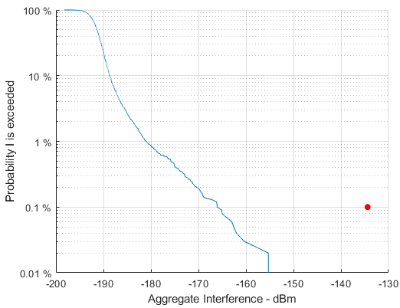 | FIGURE A14-20  ECDF of I in scenario 6.3 (victim: EESS (passive)) (ECDF: blue; Protection criteria: red dot)  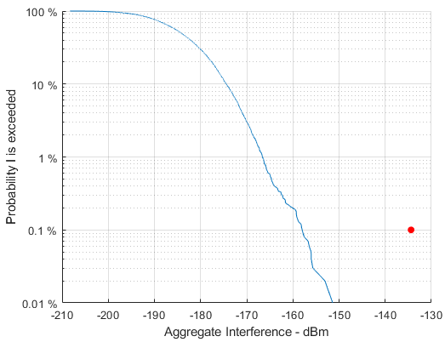

FIGURE A14-21  ECDF of I in scenario 6.4 (victim: EESS (passive))  (ECDF: blue; Protection criteria: red dot)  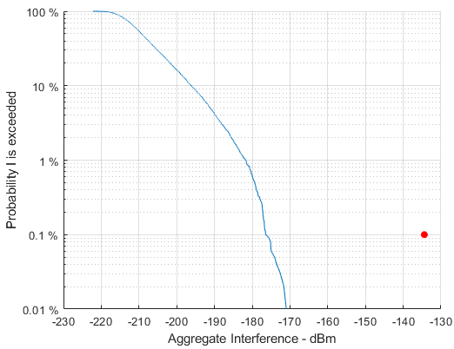 | FIGURE A14-22  ECDF of I in scenario 6.5 (victim: EESS (passive)) (ECDF: blue; Protection criteria: red dot)  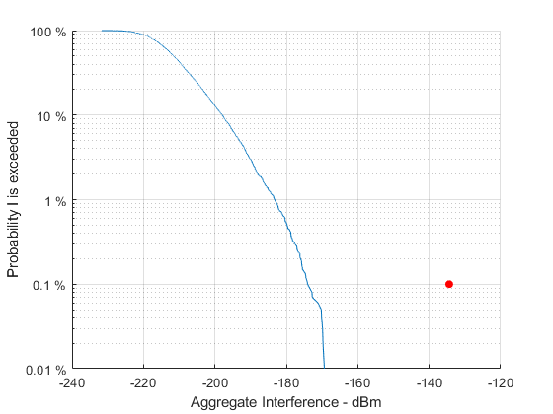

ANNEX 16
General methodology for Monte Carlo simulations
This Annex describes the generic methodology that was used in this Reportfor Monte Carlo sharing and compatibility studies in which AMS Systems are considered an interferer, i.e. in the cases listed in Table A16-1.
TABLE A16-1
Use of the Monte Carlo methodology in coexistence and sharing studies
Interfered-with service | Frequency band (GHz) | Relevant Section
RLS | 15.4-17.3 | Study B in Annex 5
ARNS ALS | 15.4-17.3 | Annex 7
ARNS DAA | 15.4-17.3 | Annex 8
FSS (Earth-to-Space) | 15.43-15.63 | Annex 10
RAS | 15.35-15.4 | Study B in Annex 11
FS | 21.2-23.6 | Study B in Annex 12
RAS | 22.21-22.5 | Study B in Annex 13
EESS (passive) | 22.21-22.5 | Study B in Annex 14
BSS | 21.4-22 | Annex 15
The steps described further below in sections a16.1 to A16.9 below are applicable in a similar way to all sharing and compatibility studies referenced above.

A16.1 General principle
Monte Carlo simulations performed in this Report have evaluated the impact of future non-safety AMS Systems in the frequency bands 15.4-15.7 and 22-22.21 GHz onto incumbent services operating in the same or in adjacent bands. The analysis has been limited to the four operational scenarios described in section 6. Due to the variety of these scenarios in terms of platforms configuration and operational deployments, they are assumed to build an envelope of future applications of the AMS in the aforementioned frequency bands.
The Monte Carlo approach consists in placing a single victim (representative of the interfered-with system under study) in the center of a simulation area, to deploy a number of AMS stations inside this area to assess the impact in terms of interference. To that purpose, the contributions of the different AMS stations are aggregated at the victim receiver, which produces a single interference level. To account for various configurations of the AMS platforms, this process is repeated multiple times, and each run of the simulation (called a snapshot) will produce an independent interference level value. These interference values can then be represented in an ECDF curve which is then compared against the protection criterion of the victim. The intermediary steps that lead to this ECDF curve are described in further detail in subsequent sections.

A16.2 Deployment of the victim
A single victim (representative of the incumbent service under study) is deployed in the middle of the simulation area and remains at the same position and in the same configuration throughout the snapshot.
The operational parameters of the victim in a particular snapshot such as altitude, pointing direction of the antenna, and position of the channel inside the tuning range are chosen with uniform probability from the description of the technical and operational parameters of the victim, i.e. according to Table A16-2 below.
TABLE A16-2
Technical and operational charactersitics of the services under study
Interfered-with service | Frequency band | Technical and operational characteristics
RLS | 15.4-17.3 GHz | Section A3.1.1
ARNS ALS | 15.4-17.3 GHz | Section A3.2.2.1
ARNS DAA | 15.4-17.3 GHz | Section A3.2.1.1
FSS (Earth-to-Space) | 15.43-15.63 GHz | Section A3.3.1
RAS | 15.35-15.4 GHz | Section A3.4.1
FS | 21.2-23.6 GHz | Section A4.1.1
RAS | 22.21-22.5 GHz | Section A4.3.1
EESS (passive) | 22.21-22.5 GHz | Section A4.4.1
BSS | 21.4-22 GHz | Section A4.6.1

For instance, in the case of the RLS in the frequency band 15.4-17.3 GHz, according to Table A3-1 in section a3.1.1, the operational altitude can take any value with uniform probability within the range 300 to 13 700 m, and the channel used for transmission can have any centre frequency within the range 15.4-17.3 GHz (however, with the constraint that the channel edges do not cross the boundaries of the tuning range). According to Table A3A-1 in Attachment A to Annex 3, the antenna can be directed from +5° to -45° in elevation, and from -45° to +45° in azimut.
This first step is illustrated in Figure A16-7 below.

A16.3 Size of the simulation area
The second step consists in setting up a simulation area around the victim in which AMS stations will be deployed. This area is a spherical cap (i.e. the curvature of the Earth is considered) whose size is chosen in such a way that the victim at its maximum altitude is always visible from an interfering AMS station. In that regard, the radius of the spherical cap representing the simulation area is the sum of the radio horizon of the victim at its maximum height and the radio horizon of the AMS stations in the considered scenario. This second step is illustrated in Figure A16-8 below.
The radio horizon is calculated using Recommendation ITU-R P.528-5, i.e. the curvature of the rays inside the atmosphere due to the variation of the refractive index as a function of the altitude, has been taken into account. This radio horizon is plotted against the altitude in Figures A16-1 and A16-2 below, together with the radio horizon considering free space propagation (i.e. unbended rays).Note that the Recommendation ITU-R P.528-5 also covers BLOS propagation paths. However, the impact of BLOS interferers was found to be negligible as compared to visible interferers. That is the rationale for limiting the simulation area to the “visibility area” of the victim. Finally, when the altitude of AMS stations exceeds the upper bound of the applicability range of Recommendation ITU-R P.528-5 (i.e. 20 km AGL), ray bending was neglected and the simplified Formula (A16-1) was used to compute the size of the simulation area.
This approach leads to the values provided in Table A16-3 for the 15 GHz band, and Table A16-4 for the 22 GHz band. For instance, one can consider RLS together with scenario 6.2 (wildfire detection). In this example, the radio horizon of an RLS receiver at the maximum altitude of 13,7 km AGL is 473.7 km as per Figure A16-1. The altitude of AMS platforms is 300 m, as per Table 6-1, and the corresponding radio horizon is 73.9 km as per Figure A16-1. Therefore the radius of the simulation area is $473.7+73.9=547.6 ≈548 km$. In scenario 6.3 (Search and Rescue), the maximum flying altitude of the AMS platforms is 3.6 km as per Table 6-1, and the corresponding radio horizon is 214.2 km as per Figure (A16-1). The maximum height of FSS (Earth to Space) satellites is 2,000 km as per Table A3-6 and the corresponding radio horizon is 4,496.8 km as per Formula (A16-1). Therefore, the radius of the simulation area is $214.2+4,496.8=4,711 km$.
TABLE A16-3  Simulation radius (km) in the 15 GHz band | TABLE A16-4  Simulation radius (km) in the 22 GHz band
   | Scenario
   | 6.2 | 6.3 | 6.4 | 6.5
  RLS | 548 | 725 | 882
  ARNS DAA | 640 | 817 | 974
  ARNS ALS | 263 | 440 | 597
  FSS (Earth-to-Space) | 4,559 | 4,711 | 4,854
  RAS | 80 | 257 | 414
   | Scenario
   | 6.2 | 6.3 | 6.4 | 6.5
  FS | 87 | 264 | 422
  RAS | 80 | 257 | 414
  BSS | 80 | 257
  EESS (passive) | 3,156 | 3,308 | 3,451

FIGURE A16-1  Radio horizon distance at 15.4 GHz as per Rec. ITU-R P.528-5 (blue) and considering  unbent rays (red)  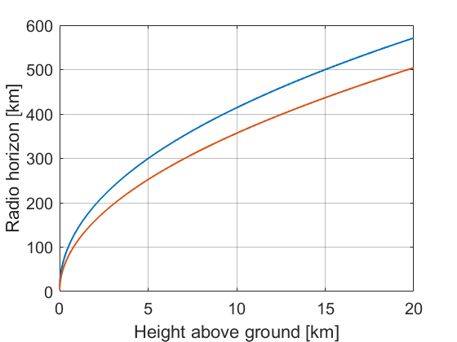 | FIGURE A16-2  Radio horizon distance at 22 GHz as per Rec. ITU-R P.528-5 (blue) and considering unbent rays (red)
Figures A16-1 and A16-2 above are not linked to any time percentage as Recommendation ITU-R P.528-5 computes the radio horizon independently of any time variation.
The radio horizon considering unbent rays is computed using Formula (A16-1):
$R=R_{e}∙acos\left(\frac{R_{e}}{R_{e}+h}\right)$ (A16-1)
where:
$R_{e}$: Earth Radius (km), i.e. 6 371 km;
$a$: Altitude AGL (km).
This step is illustrated in Figure (A16-8) below.

A16.4 Number and Position of clusters
The number of clusters (i.e. groups of AMS stations involved in a particular scenario) is determined from the simulation radius computed in Tables A16-3 and A16-4 above, and from the cluster density associated to each scenario as determined in section 7 of this Report (i.e. 1 cluster in a circle of radius 254 km in scenario 6.2, 484 km in scenario 6.3, 467 km in scenario 6.4, and 332 km in scenario 6.5).
First the number of clusters to deploy is estimated from the Formula (A16-2):
$N={\left(\frac{R_{simulation}}{R_{density}}\right)}^{2}$ (A16-2)
where:
$N$: Number of clusters to deploy;
$R_{simulation}$: Simulation radius as computed in Tables A16-3 and A16-4 above;
$R_{density}$: Radius in which one cluster is expected as computed in section 7.
The number of clusters obtained from Formula (A16-2) being most of the time a non-integer value, it is rounded to the superior unit, which provides the values in Tables A16-5 and A16-6.
In order to maintain the cluster density constant, the simulation radius needs to be slightly increased, according to Formula (A16-3):
$R_{simulation}=\sqrt{N}∙R_{density}$ (A16-3)
where:
$R_{simulation}$: Re-computed simulation radius;
$N$: Number of clusters to deploy as shown in Tables A16-3 and A16-4;
$R_{density}$: Radius in which one cluster is expected as computed in section 7.
This leads to the new values of $R_{simulation}$ shown in Tables A16-5 and A16-6 below. Note that this approach can lead to considering some AMS stations that are slightly Beyond the LOS distance (BLOS) of the victim.
This step is illustrated in Figure A16-5 below, taking as an example a snapshot where the victim is an ARNS ALS receiver, and the scenario under study is the wildfire detection (scenario 6.2). As per Table A16-7, the radius of the simulation area is 359 km, and two clusters are deployed within this area in accordance with Table A16-5. Each cluster is composed of one GDT (the ground vehicle) that communicates with two ADTs (the helicopters equipped with optical and IR cameras).
TABLE A16-5  No. of deployed clusters in the 15 GHz band | TABLE A16-6  No. of deployed clusters in the 22 GHz band
   | Scenario
   | 6.2 | 6.3 | 6.4 | 6.5
  RLS | 5 | 3 | 4 | 8
  ARNS DAA | 7 | 3 | 5 | 9
  ARNS ALS | 2 | 1 | 2 | 4
  FSS (Earth-to-Space) | 322 | 95 | 107 | 212
  RAS | 1 |  |  | 2
   | Scenario
   | 6.2 | 6.3 | 6.4 | 6.5
  FS | 1 |  |  | 2
  RAS |  |  |  | 2
  BSS |  |  |  | 2
  EESS (passive) | 155 | 47 | 55 | 108

TABLE A16-7  Simulation radius (km) in the 15 GHz band | TABLE A16-8  Simulation radius (km) in the 22 GHz band
   | Scenario
   | 6.2 | 6.3 | 6.4 | 6.5
  RLS | 568 | 838 | 934 | 939
  ARNS DAA | 672 | 838 | 1,044 | 996
  ARNS ALS | 359 | 484 | 660 | 664
  FSS (Earth-to-Space) | 4,559 | 4,711 | 4,831 | 4,834
  RAS | 254 | 484 | 467 | 469
   | Scenario
   | 6.2 | 6.3 | 6.4 | 6.5
  FS | 254 | 484 | 467 | 470
  RAS
  BSS
  EESS (passive) | 6,988 | 7,179 | 7,325 | 7,327

A16.5 Deployment of AMS stations

A16.5.1 Geometric Deployment
AMS stations (i.e. ADTs and GDTs) are deployed within a cluster according to the technical setup shown in Table 6-1 in section 6.6. When a range of values is provided rather that a single value (for example regarding the altitude of ADTs or the relative location of the AMS stations inside a cluster), a uniform probability is considered.
Antennas of AMS stations are directed in an optimal manner, i.e. the boresight of the transmitting station is in the direction of the receiving station and vice versa. This step is illustrated in Figure A16-9, taking as an example scenario 6.3 (Search and Rescue mission).

A16.5.2 Frequency and Bandwidth Allocation
The bandwidth $BW$ of WB LOS DLs depends on the throughput that the link must support and on the spectral efficiency. Numerical values have been provided for the various scenarios in Table 6-1. The centre frequency $f_{c}$ is chosen within the tuning range while respecting the following rules:
- The AMS channel must be completely included inside the tuning range, in other words:
$f_{c}-{BW}/2 ≤F_{min}$ $f_{c}+{BW}/2 ≤F_{max}$ (A16-4)

where:
$F_{min}$: Lower bound of the AMS tuning range (15.4 or 22 GHz);
$F_{max}$: Upper bound of the AMS tuning range (15.7 or 22.21 GHz).
- For the sake of simplicity, it is assumed that two different clusters can make use of the same channels even though they are in LOS. In other words, self-interference effects between two clusters are not taken into account. This simplification however does not change the impact of interference onto the incumbent service under study;
- The allocation of AMS channels inside a particular cluster depends on the assumed frequency reuse. If the frequency reuse is 1, WB LOS DLs inside a cluster can be deployed independently from one another. In other words, the channels inside a cluster may overlap, which is the case in scenario 6.5 (see Table 6-1). If the frequency reuse is 0 (scenarios 6.2, 6.3, and 6.4), two links in the same cluster should be established on non-overlapping channels.

A16.6 Link Budget of interfering paths
Each transmitting AMS station in the simulation area contributes an interference power $I_{i}$ at the victim receiver, which is evaluated using Formula (A16-5) below:
$I_{i}={\left(P_{Tx}\right)}_{i}+{\left(G_{Tx}\right)}_{i}+{\left(G_{Rx}\right)}_{i}-L_{i,victim}-{FDR}_{i}$ (A16-5)
where:
$I_{i}$: Power level (dBm) received by the victim from the i-th AMS transmitter inside the simulation area;
${\left(P_{Tx}\right)}_{i}$: Output power level (dBm) of the i-th AMS transmitter;
${\left(G_{Tx}\right)}_{i}$: Antenna gain (dBi) in the direction of the victim of the i-th AMS transmitter;
${\left(G_{Rx}\right)}_{i}$: Gain (dBi) of the victim in the direction of the i-th AMS transmitter;
$L_{i,victim}$: Path loss between the i-th AMS transmitter and the victim;
${FDR}_{i}$: Frequency Dependent Rejection (dB) between the i-th AMS transmitter and the victim.
The different terms of the link budget are addressed in subsequent sections.

A16.6.1 Output Power of AMS Stations
The output power of AMS stations inside a cluster is determined according to the simplified ATPC algorithm described in Formula (A16-6) below:
${\left(P_{Tx}\right)}_{i}= min\left(L_{i,wanted}-N_{i}+{\left(\frac{C}{N}\right)}_{i,target}-{\left(G_{Tx}\right)}_{i,max}-{\left(G_{Rx}\right)}_{i,max} ;P_{Tx,max}\right)$ (A16-6)
where:
$L_{i,wanted}$: Transmission losses (dB) between the i-th AMS transmitter and the corresponding AMS receiver, computed using the median value of Recommendation ITU-R P.528-5, i.e. considering a time percentage p = 50 %;
$N_{i}$: Thermal noise level (dBm) associated to the signal of the i-th AMS transmitter, computed using Formula (A16-7) below;
${\left(\frac{C}{N}\right)}_{i,target}$: Target SNR (dB) at the receiver of the i-th AMS transmitter, as given in Tables A1-1 and A2-1;
${\left(P_{Tx}\right)}_{i}$: Output power (dBm) of the i-th AMS transmitter;
${\left(G_{Tx}\right)}_{i,max}$: Peak gain (dBi) of the i-th AMS transmitter;
${\left(G_{Rx}\right)}_{i,max}$: Peak gain (dBi) of the AMS station receiving signal from the i-th AMS transmitter;
$P_{Tx,max}$: Maximum transmit power level (dBm) of the i-th AMS transmitter, according to Tables A1-1 and A2-1.
Note that the antenna gain at the i-th AMS transmitter in the direction of the receiver (as well as in the other direction) equals the peak gain because a perfect main beam to main beam alignment is assumed the AMS wanted links.
The noise power $N$ is computed using Formula (A16-7) below:
$N\left({BW}_{i},{NF}_{i}\right)= -\frac{174dBm}{Hz}+10\log_{10}\left({BW}_{i}\right)+{NF}_{i}$ (A16-7)
where:
$N\left({BW}_{i},{NF}_{i}\right)$: Thermal noise level (dBm) at the AMS station receiving signal from the i-th AMS transmitter;
${BW}_{i}$: Bandwidth of the i-th AMS transmitter as per Table 6-1;
${NF}_{i}$: NF (dB) of the AMS station receiving signal from the i-th AMS transmitter as per Table A1-1 and A2-1.
It follows that the transmit power of AMS stations depends on the link distances computed in Table 6-1.
Figures A16-3 to A16-6 below show the ECDF of the transmit power level of AMS systems in the four scenarios. The following remarks can be made:
- In all four scenarios, the power needed to close control links is lower than the power needed to close data links. For instance, the difference is about 20 dB in scenario 4.2 (see Figure A16-3), where System 2 is used for data links, and System 4 for control links. This difference corresponds to the noise floor difference between a control channel of 0.55 MHz and a data channel of 55 MHz (see Table 8-1 and Formula (A16-7)). In scenario 6.3 (see Figure A16-4), the difference is about 17 dB, which corresponds in the same way to the ratio in dB between data and control channel in this scenario (see Table 8-1). The same remark can be made in scenario 6.4, between System 1 (data) and System 2 (ctrl.) on the one hand, and between System 1 (data) and System 5 (ctrl.) on the other hand. In scenario 6.5 (Figure A16-6), no difference can be seen in terms of transmit power between data and control links as they use the same AMS System (System 3);
- In scenario 6.3 (Figure A16-4), the blue plain curve corresponding to the System 1 in the frequency band 15.4-15.7 GHz (and in the same way the red plain curve corresponding to the System 1 in the frequency band 22-22.21 GHz) shows a step that separates observation aircraft that are close to the central aircraft from those that are further away. The step occurs at 33 %, which can be explained by the fact that 2 observation aircraft out of 6 (aircraft 1 and 7) are far from the central aircraft (aircraft 4), see Figure 6-3 in section 6.3. The same phenomenon can be observed in scenario 6.4 (Figure A16-5), where, in a particular cluster, one instance of System 1 is used to transmit data from the relay to the remote control centre, together with two instances of the same system to transmit data from the observation aircraft to the relay, see Figure 6-4 in section 6.4;
- In all four scenarios, the maximum power of AMS Systems according to Table A1-1 is attained in at least one snapshot when they are used in the broadband mode, i.e. to transport data (25 dBm for System 2 in both frequency bands in scenario 6.2, see Figure A16-3; 40 dBm for System 1 in both frequency bands in scenario 6.3, see Figure A16-4; 40 dBm for System 1 in both frequency bands in scenario 6.4, see Figure A16-5; 40 dBm for System 3 in the frequency band 15.4-15.7 GHz and 50 dBm in the frequency band 22-22.21 GHz in scenario 6.5, see Figure A16-6);
- The curves related to System 5 in scenario 6.4 (Figure A16-5) and System 3 in scenario 6.5 (Figure A16-6) have the shape of a Gaussian CDF because the distances to cover vary within an interval with uniform probability (between 50 and 250 km for System 5, and between 150 and 800 km for System 3, as per Table 6-1).
FIGURE A16-3  ECDF of AMS Tx Power in scenario 6.2  (Syst. 2 (data): plain line; Syst. 4 (ctrl.): dotted line), blue in the 15 GHz band and red in the 22 GHz band  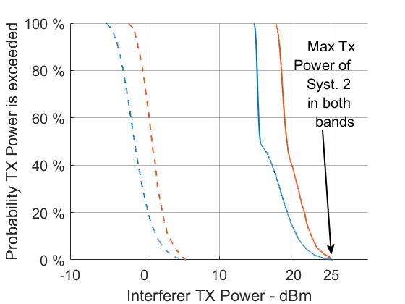 | FIGURE A16-4  ECDF of AMS Tx Power in scenario 6.3  (Syst. 1 (data): plain line; Syst. 2 (ctrl.): dotted line), blue in the 15 GHz band and red in the 22 GHz band  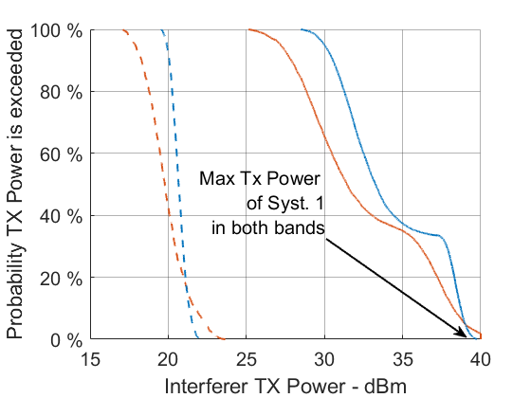

FIGURE A16-5  ECDF of AMS Tx Power in scenario 6.4 (Syst.1 (data): plain line; Syst. 2 (ctrl.): dash-dotted line; Syst. 5 (ctrl.): dotted line), blue in the 15 GHz band,  red in the 22 GHz band  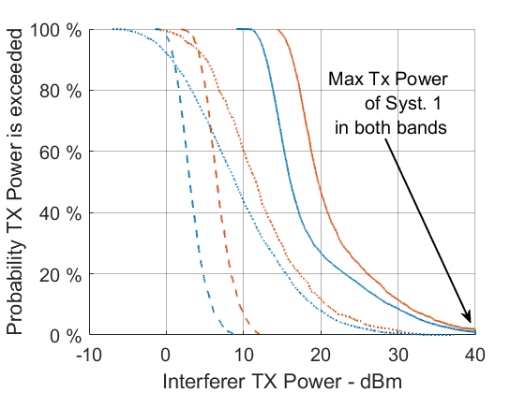 | FIGURE A16-6  ECDF of AMS Tx Power in scenario 6.5  (Syst. 3 (data + ctrl.): blue in the 15 GHz band,  red in the 22 GHz band  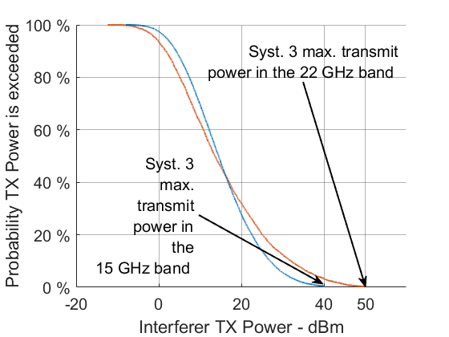

A16.6.2 Antenna Gains
The antenna gain of the i-th AMS transmitter in the direction of the victim receiver (denoted by ${\left(G_{Tx}\right)}_{i}$ in Formula (A16-5)), and conversely the gain of the victim receiver in the direction of the i-th AMS transmitter (denoted by ${\left(G_{Rx}\right)}_{i}$ in Formula (A16-5)) are computed by first determining off-axis angles in azimut and elevation at both the transmitter and the receiver sides, and then by using the right antenna pattern.

A16.6.3 Propagation model
The propagation loss $L_{i,victim}$ is evaluated by using one the ITU-R P Series model introduced in section 10.2 of this Report, depending on the position of the i-th AMS transmitter and the receiver. It is for instance possible that two different propagation models are used in a single snapshot, one for the paths between GDTs and the victim, and one for the paths between ADTs and the victim.
Note that two of the three possible models considered (Recommendation ITU-R P.528-5 and Recommendation ITU-R P.1409-2) take as input a time percentage. It means that, for these two propagation models, considering two points $P_{1}$ and $P_{2}$, the propagation loss is not a constant, but a random variable denoted by $L_{P_{1}→P_{2}}$.To generate a value of a random variable X, one must dispose of the inverse distribution function $F_{X}$ of this random variable (sometimes called quantile function), i.e. a function from $\left[0;1\right]$ into $\left[X_{min};X_{max}\right]$, where $X_{min}$and $X_{max}$ denote the minimum and maximum values that X can take (also known as the support of X). Then, one must simply generate a number $u$ with uniform probability between 0 and 1, and compute $F_{X}\left(u\right)$.
In the context of propagation models, the function $L_{P_{1}→P_{2}}\left(p\right)$, where $p$ is a time percentage is exactly the inverse distribution function of the random variable $L_{P_{1}→P_{2}}$. Therefore, according to the explanations above, to generate a value of $L_{P_{1}→P_{2}}$ between two particular points (one of the points being an AMS transmitter and the other the victim receiver), one can simply compute $L_{P_{1}→P_{2}}\left(p\right)$, where $p$ is a number generated with uniform probability between 0 and 100 % (or between 1 and 99%, depending on the applicability range of the propagation model).

A16.6.4 Frequency Dependent Rejection
The FDR between the i-th AMS transmitter and the victim receiver was comouted using the methodology laid out in Annex 1 of Recommendation ITU-R SM.337-6. In particular, Formula (A16-8) was adapted from Equation (2) in Recommendation ITU-R SM.337-6.
${FDR}_{i}= 10\log_{10}\left(\frac{\int_{0}^{+∞}{M_{Tx}\left(τ\right)dτ}}{\int_{0}^{+∞}{M_{Tx}\left(τ\right){M_{Rx}\left(∆f_{i}+τ\right)}^{2}dτ}}\right)$ (A16-8)
where:
${FDR}_{i}$: FDR between the i-th AMS transmitter and the victim receiver;
$τ$: Relative frequency defined as $τ=\frac{f - f_{c,i}}{f_{c,i}}$, where $f_{c,i}$ denotes the centre frequency used by the i-th AMS transmitter;
${NF}_{i}$: NF (dB) of the station receiving signal from the i-th AMS transmitter as per Tables A1-1 and A2-1;
$M_{Tx}\left(τ\right)$: Relative SEM (in the linear domain) of the i-th AMS transmitter at the relative frequency $τ$, as provided in Table A1-1 (and represented graphically in Figure A1-1 in Annex 1) for AMS systems operating in the frequency range 15.4-15.7 GHz, and in Table A2-1 for AMS systems operating in the frequency range 22-22.21 GHz;
$M_{Rx}\left(∆f_{i}+τ\right)$: Relative selectivity (in the linear domain) of the victim receiver at the relative frequency $∆f_{i}+τ$, where $∆f_{i}=\frac{f_{r} -{ f}_{c,i}}{f_{c,i}}$, where $f_{r}$ denotes the centre frequency of the victim. Note that in the case where this mask was not available for a particular incumbent system, a perfect selectivity mask was assumed (i.e., a mask that equals 1 in the receiver band, and 0 everywhere else).
In the particular cases where AMS transmitters use the same centre frequency as victim receivers (for instance in some cases of sharing studies), Formula (A16-8) can be approximated using Formula (A16-9):
$${FDR}_{i}≈\left\{\begin{aligned}10\log_{10}\left(\frac{{BW}_{i}}{{BW}_{i}}\right) \\ 0\end{aligned}\right.$$ | if | $${BW}_{r} ≤{BW}_{i}$$ | (A16-9)
 | otherwise |  | (A16-9)
where:
${BW}_{i}$: Bandwidth used by the i-th AMS transmitter;
${BW}_{r}$: Bandwidth used by the victim receiver.

A16.7 Aggregate Interference
In a particular snapshot, the aggregate interference value $I_{aggregate}$ at the victim receiver is evaluated by summing the contributions of all active transmitters in the linear domain, i.e. using Formula (A16-10):
$I_{aggregate}= 10\log_{10}\left(\sum_{i=1}^{n}{{10}^{{I_{i}}/{10}}}\right)$ (A16-10)
where:
$I_{i}$: Contribution in terms of power level (dBm) of the i-th AMS transmitter to the aggregate interference value $I_{aggregate}$ at the receiver;
$n$: Number of AMS transmitters in the simulation area.

A16.8 Number of Snapshots
The minimum number of snapshots chosen for the simulation (i.e. the number of times that the simulation is repeated) is related to the minimum percentage of time associated to the protection criterion of the victim system under study. For instance, if the percentage of time is 1%, 100 snapshots at least would be necessary, if the percentage of time is 0.1%, 1,000 snapshots at least would be required. The minimum number of snapshots in all cases studied is indicated in Table A16-9 below. Note that the actual number of simulation snapshots is in all cases greater than this minimum value in order to provide sufficient statistical diversity. Note also that the protection criterion associated to the RLS and to the ARNS in the 15 GHz frequency band is not associated to any time percentage, and therefore the number of snapshots is arbitrarily chosen equal to 100,000 to assess sufficiently low time percentages.
TABLE A16-9
Number of simulated snapshots
Interfered-with service | Freq. band (GHz) | Max time percentage associated to the protection criterion | Rel. Section | Min. no. of snapshots | Simulated snapshots
RLS | 15.4-17.3 | None | A3.1.3 | - | 100,000
ARNS ALS | 15.4-17.3 | None | A3.2.2.3 | - | 100,000
ARNS DAA | 15.4-17.3 | None | A3.2.1.3 | - | 100,000
FSS (Earth-to-Space) | 15.43-15.63 | 99.98 % | A3.3.3 | 5,000 | 10,000
RAS | 15.35-15.4 | 98 % | A3.4.3 | 50 | 100,000
FS | 21.2-23.6 | 99.9872 % | A4.1.4 | 7,813 | 100,000
RAS | 22.21-22.5 | 98 % | A4.3.3 | 50 | 100,000
EESS (passive) | 22.21-22.5 | 99.9 % | A4.4.3 | 1,000 | 10,000
BSS | 21.4-22 | 99.98 % | A4.6.3 | 5,000 | 100,000

A16.9 ECDF of the Aggregate Interference
Each snapshot produces an aggregate interference value $I_{aggregate}$ that is computed according to Formula (A16-7). Repeating the simulation over multiple snapshots allows one to plot the ECDF of the variable $I_{aggregate}$ and to compare it against the protection criteria of the victim system under study. Finally and in conclusion, the protection criterion is met if the ECDF curve lies “under” the point representing the protection criterion of the victim.
FIGURE A16-7  Deployment of the victim  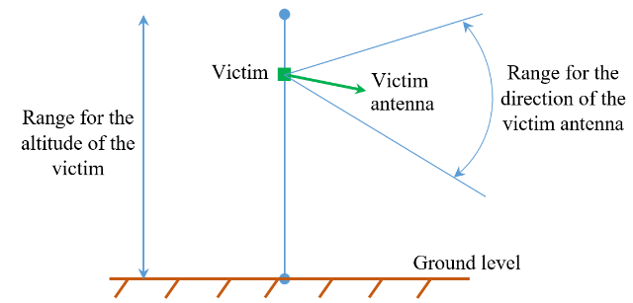 | FIGURE A16-8  Size of the simulation area  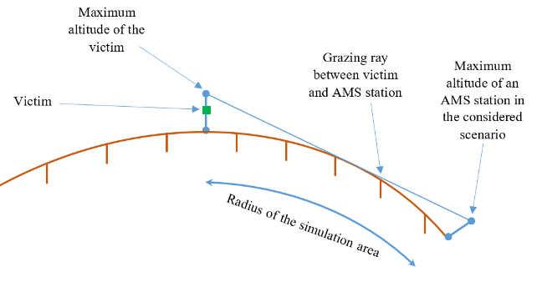

FIGURE A16-9  Deployment of the AMS clusters  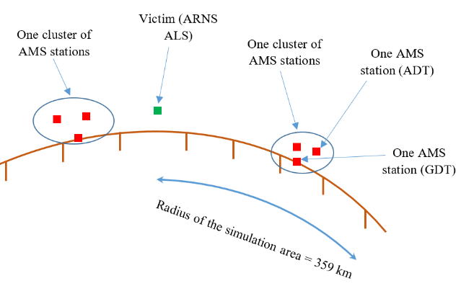 | FIGURE A16-10  Deployment of AMS stations inside a cluster  


