US Radiocommunications Sector
Fact Sheet

Working Party: WP 5B | Document No: USWP5B30-19-First Draft
Ref: Annex 11 to Document 5B/649 | Date: 30 August 2022
Document Title: PRELIMINARY DRAFT REVISION OF RECOMMENDATION ITU-R M.2010-1 Characteristics of a digital system, named Navigational Data for broadcasting maritime safety and security related information from shore-to-ship in the 500 kHz band

Author(s)/Contributors(s):  Jerry Ulcek  US Coast Guard, Washington DC  Johnny Schultz  Sev1Tech, Inc.  Ross Norsworthy  REC, Inc. | Phone : (202) 475-3607  E-mail: Jerry.l.Ulcek@uscg.mil  Phone : (727) 403-4029  E-mail: johnny.schultz@sev1tech.com  Phone : (727) 515-8025  E-mail: Ross_Norsworthy@msn.com
Purpose/Objective: The purpose of this document is to add an annex (ANNEX 8) to the preliminary draft revision of Recommendation ITU-R M.2010-1 to describe the utilization of the various bandwidths for transmission of data on various antenna towers of various heights which will vary in their ability to support the various data rates from 5 kbps to 27 kbps.
Abstract: This document is intended to provide the necessary information to complete this revision of M.2010. Specifically, it provides the information necessary for implementation of the MF NAVDAT shore facilities on antenna towers of various heights using the various optional data transmission rates.

Radiocommunication Study Groups | 
Source: Document 5B/649 Annex 11  Subject: Revision of Recommendation ITU-R M.2010-1 | USWP5B30-19
 | 30 August 2022
 | English only
United States
Revision to Annex 11 to Working Party 5B Chairman’s Report
PRELIMINARY DRAFT REVISION OF RECOMMENDATION ITU-R M.2010-1
Characteristics of a digital system, named Navigational Data for
broadcasting maritime safety and security related information
from shore-to-ship in the 500 kHz band

Summary of revision
This proposal is to add ANNEX 8 to describe the implementation of shore infrastructure with the possibility supporting the incumbent NAVTEX in the transition to NAVDAT.

Annex 11 to Working Party 5B Chairman’s Report
PRELIMINARY DRAFT REVISION OF RECOMMENDATION ITU-R M.2010-1
Characteristics of a digital system, named Navigational Data for
broadcasting maritime safety and security related information
from shore-to-ship in the 500 kHz band

Summary of revision
1) The proposed modifications of Recommendation ITU-R M.2010-1 update and complement the technical characteristics of the NAVDAT system in 500 kHz in the following points.
2) Modified terms and glossary and related ITU Recommendations.
3) In Annex 3, add table for the four bandwidths, modified Pilot sequence (section 1.6), section 4 new text for ship receiver. Table 5 (section 3), reception antenna (section 4.1.1), demodulator (section 4.1.3) and Table 6 of (section 5).
4) In Annex 4, modified structure (section 4.1), encoding (section 5.2) and LDPC check matrix (section 6) in order to reduce the bit error rate (BER) of MIS and TIS the coding is changed.
5) Modified Annex 5 as an example.
6) Added Annex 7 with the list of subject message.
7) Real and test bench experiments, as well as the preparation of manuals for the IMO, have led to some modifications and improvements in the parameters of the NAVDAT system.
8) The operation of the ship receiver and the method for identifying NAVDAT coast station has also been reviewed.

Attachment: 1

Attachment
PRELIMINARY DRAFT REVISION OF RECOMMENDATION ITU-R M.2010-1
Characteristics of a digital system, named Navigational Data for
broadcasting maritime safety and security related information
from shore-to-ship in the 500 kHz band
(2012-2019-202X)
Scope
The Recommendation describes an MF radio system, named navigational data (NAVDAT), for use in the maritime mobile service, operating in the 500 kHz band for digital broadcasting of maritime safety and security related information from shore-to-ship. The operational characteristics and system architecture of this radio system are included in Annexes 1 and 2. Technical characteristics and transmission structure are detailed in Annexes 3 and 4. Message file structure and a broadcast mode are introduced in Annexes 5 and 6. The list of subject messages is in Annex 7
Keywords
500 kHz, broadcasting, NAVDAT
Abbreviations/Glossary
BER: Bit error rate
BPSK: Binary phase shift keying
BW: Bandwidth
CDU: Control and display unit
CRC: Cyclic redundancy check
DRM: Digital radio mondiale
DS: Data stream
ECDIS: Electronic chart and display information system
GF: Galois Field or finite field
GMDSS: Global maritime distress and safety system
GNSS: Global navigation satellite system
HF: High frequency
IMO: International maritime organization
ITU: International Telecommunications Union
LDPC: Low density parity-check
MER: Modulation error rate
MF: Medium frequency
MIS: Modulation information stream
MMSI: Maritime mobile service identity
NAVDAT: Navigational data (the system name)
NAVTEX: Navigational telex (the system name)
NM: Nautical mile (1852 metres)
OFDM: Orthogonal frequency division multiplexing
PEP: Peak envelope power
PRBS: Pseudo-random binary sequence
QAM: Quadrature amplitude modulation
rms: Root mean square
RS: Reed-solomon codes
SAR: Search and rescue
SDR: Software defined radio
SFN: Single frequency network
SIM: System of information and management
S/N or SNR: Signal to noise ratio
TIS: Transmitter information stream
WRC: World radiocommunication conference
Related ITU Recommendations, Reports
Recommendations
ITU-R BS.1514 – System for digital sound broadcasting in the broadcasting bands below 30 MHz
ITU-R M.493 – Digital selective-calling system for use in the maritime mobile service
ITU-R M.585 – Assignment and use of identities in the maritime mobile service
ITU-R P.368 – Ground-wave propagation curves for frequencies between 10 kHz and 30 MHz
ITU-R P.372 – Radio noise
ITU-R M.2058 – Characteristics of a digital system, named navigational data for broadcasting maritime safety and security related information from shore-to-ship in the maritime HF frequency band
Reports
ITU-R M.2201 – Utilization of the 495-505 kHz band by the maritime mobile service for the digital broadcasting of safety and security related information from shore-to-ships
ITU-R M.2443 – NAVDAT Guidelines
The ITU Radiocommunication Assembly,
considering
a) that high speed data broadcast from shore-to-ships enhances operational efficiency and maritime safety;
b) that the navigational telex NAVTEX system has limited capacity;
c) that the e-Navigation system of the International Maritime Organization (IMO) increases the demand for data transmission from shore-to-ship;
d) that the 500 kHz band provides good coverage for digital systems,
recognizing
that the digital radio mondiale (DRM) system referenced in Annex 6 has been incorporated in Recommendation ITU-R BS.1514,
noting
- that Report ITU-R M.2201 provides the basis for the NAVDAT system;
b) that Recommendation ITU-R M.2058 describes the NAVDAT system operating in HF band;
c) that the NAVDAT system uses two international frequencies: 500 kHz in MF band and 4 226 kHz in HF band;
d) that the NAVDAT system may use other allocated frequencies in the maritime MF and HF bands for national or regional broadcasts,
recommends
1 that the operational characteristics for the broadcasting of maritime safety and security related information should be in accordance with Annex 1;
2 that the system architecture of the broadcasting system for maritime safety and security related information should be in accordance with Annex 2;
3 that the technical characteristics and modem protocols for digital data transmission from shore-to-ships in the 500 kHz band should be in accordance with Annexes 3 and 4;
4 that the data stream of the system and the message structure should be in accordance with Annex 5;
5 that the Single frequency network (SFN) mode of operation is described in Annex 6;
6 that information on subject message is given in Annex 7.

Annex 1
Operational characteristics
The NAVDAT system uses a time-slot allocation similar to the NAVTEX system which could be coordinated by IMO in the same manner.
That NAVDAT system can also work on a single frequency network (SFN) as described in Annex 6. In this case transmitters are frequency synchronized and the transmit data must be the same for all transmitter.
The NAVDAT 500 kHz digital system offers a broadcast transmission of any kind of message from shore-to-ships with possibility of encryption.

1 Type of messages and files
Any broadcasting message should be provided by a secure and controlled source.
Message types broadcast can include, but are not limited to, the following:
– safety of navigation;
– security;
– piracy;
– search and rescue;
– meteorological messages;
– piloting or harbour messages;
– vessel traffic system files transfer;
– electronic chart update packages.
See the Annex 7 which gives the message subjects and their encoding.

2 Broadcast modes

2.1 General broadcast
These messages are broadcasted for the attention of all ships.

2.2 Selective broadcast
These messages are broadcasted for the attention of a group of ships or in a specific navigation area.

2.3 Dedicated message
These messages are addressed to one ship, using the maritime mobile service identity.

3 Broadcast priority

[NAVDAT is capable of prioritizing messages (Refer to the NAVDAT manual published by IMO).]

Annex 2
System architecture

1 The broadcast chain
The NAVDAT system is organized upon five vectors performing the following functions:
– System of information and management (SIM):
• collects and controls all kinds of information;
• creates message files to be transmitted;
• creates transmitting programme according to message files priority and need of repetition;
• monitors the operating status and broadcast quality of the shore transmitter;
• controls the operating parameters of shore transmitter.
– Shore network:
• assures the transportation of the message files and monitor data from sources to the transmitters.
– Shore transmitter:
• receives the message files from SIM;
• translates message files to orthogonal frequency division multiplexing (OFDM) signal;
• transmits RF signal to the antenna for broadcast to ships;
• monitors operating status and reports to the SIM.
– Transmission channel:
• Transports the 500 kHz RF signal.
– Ship receiver:
• demodulates the RF OFDM signal;
• reconstructs the message files;
• sorts and makes the message files available for the dedicated equipment according to the message files applications, or displays the contents of the message files.
Figure 1 shows the diagram of the broadcast chain.
Figure 1A
NAVDAT 500 kHz broadcast chain block diagram
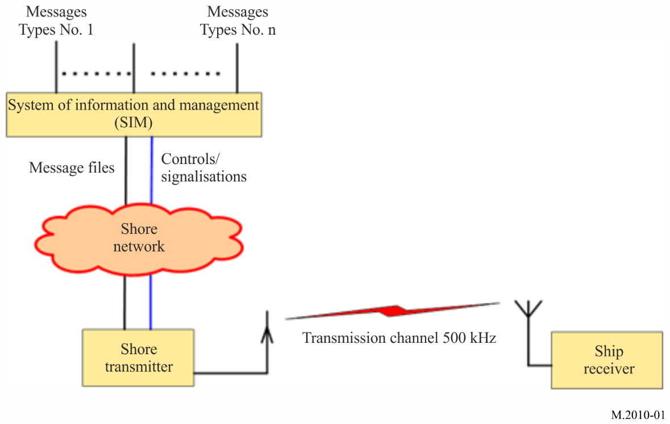
Figure 1 B
Global NAVDAT broadcast chain

1.1 System of information and management
The SIM term includes:
– all the sources that deliver file messages (e.g. meteorological office, safety and security organizations, etc.);
– the file multiplexer which is an application running on a server;
– the file multiplexer manager;
– the shore transmitter manager.
All the sources are connected to the file multiplexer through a network.
Figure 2 shows the general diagram of the SIM.
Figure 2
NAVDAT system of information and management block diagram
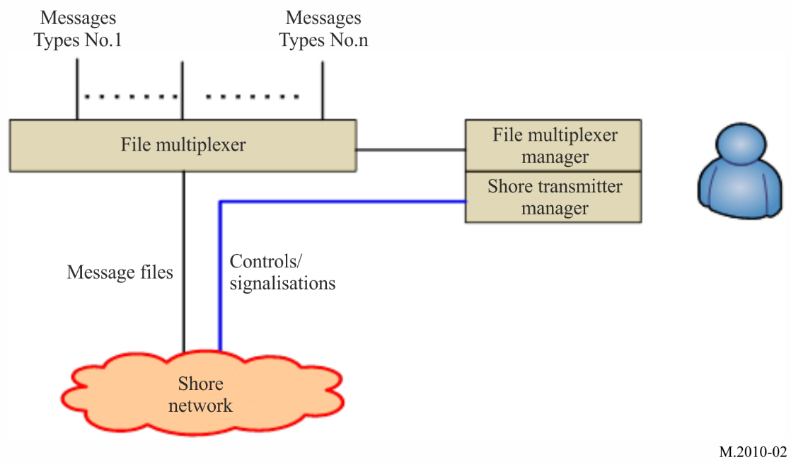

1.1.1 File multiplexer
The file multiplexer:
– takes delivery of the message files from the data sources;
– encrypts the message files if asked;
– formats the file messages with recipient information, priority status and time validity;
– sends the message files to the transmitter.

1.1.2 File multiplexer manager
The file multiplexer manager is a man machine interface that enables the user to, among other tasks:
– have a look at the message files coming from any source;
– specify the priority and periodicity of the any message file;
– specify the recipient of any message file;
– manage the file message encryption.
Some of these functionalities may be automated. As an example, the priority and the periodicity of a message may be selected according to the source it comes from or the source may specify the priority in the message.

1.1.3 Shore transmitter manager
The shore station manager is a man machine interface connected to the transmitter through the network; it makes it possible to supervise the transmitter status indications such as:
– transmit acknowledgment;
– alarms;
– effective RF transmit power;
– synchronization report;
– quality of transmission;
and to change the transmitter parameters, such as:
– RF transmit power;
– OFDM parameters (pilot subcarriers, modulation, error coding, etc.);
– transmission schedule.

1.2 Shore network
The shore network can use a broadband link, a low data rate link or a local file sharing.

1.3 Shore transmitter description
A coastal transmitting station consists of this minimum configuration:
– one controller, which is a local server with access protection;
– one OFDM modulator;
– one RF generator;
– one RF power amplifier;
– one transmit antenna with matching unit;
– one global navigation satellite system (GNSS) receiver or atomic clock for synchronization;
– one monitoring receiver with its antenna.

1.3.1 Shore system architecture
Figure 3 shows the block diagram of a 500 kHz digital transmitter.
Figure 3
NAVDAT 500 kHz transmitter functional block diagram
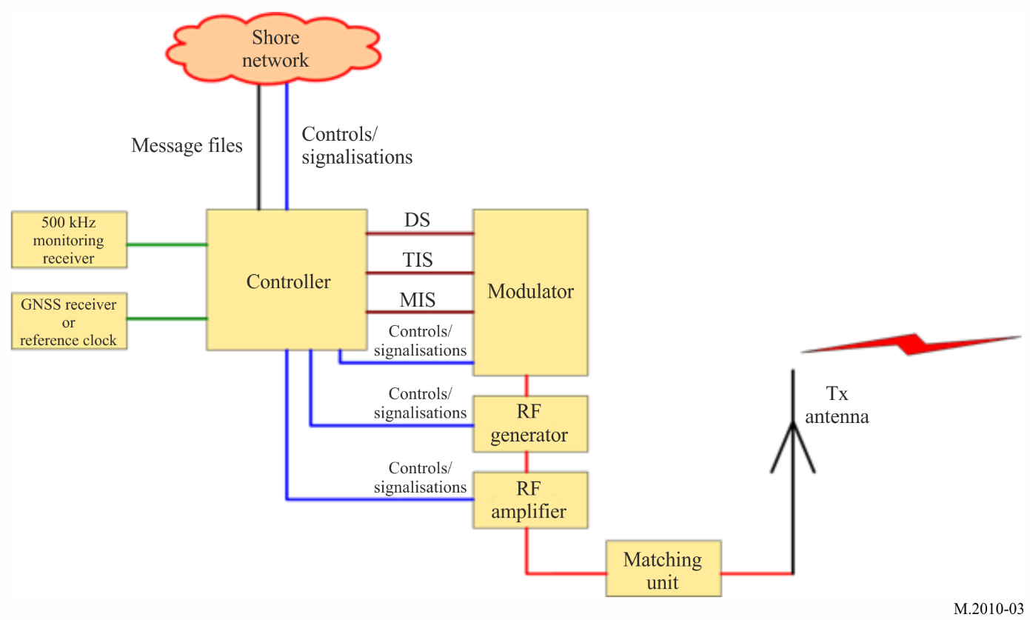

1.3.2 Controller
This unit receives and transmits some pieces of information:
– message files from SIM;
– GNSS or reference clock for synchronization;
– 500 kHz signal from monitoring receiver;
– Modulator, 500 kHz signal RF generator, RF power amplifier control signals and monitoring;
– Monitor signal from the RF signal generator and RF power amplifier
The function of the controller is:
– to check if the frequency band 495-505 kHz is free before transmission;
– to synchronize all signals on the coast station from synchronization clock;
– to control the transmission parameters, time and schedule;
– to format the message files to be transmitted (split files into packets).

1.3.3 Modulator
Figure 4 shows the diagram of the modulator.
Figure 4
NAVDAT 500 kHz modulator functional block diagram
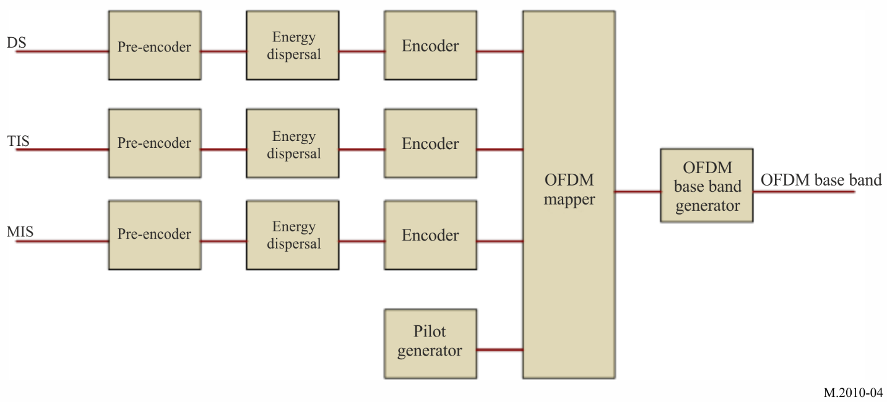

1.3.3.1 Input streams
In order to operate, the modulator needs three input streams:
– modulation information stream (MIS);
– transmitter information stream (TIS);
– data stream (DS).
These streams are transcoded and then placed on the OFDM signal by the cell mapper.

1.3.3.1.1 Modulation information stream
This stream is used to provide information about:
– the spectrum occupancy (1, 3, 5 or 10 kHz);
– the modulation for transmission information stream and data stream (4, 16 or 64-QAM).
This MIS stream is always coded on 4-QAM subcarriers for good demodulation into the receiver.

1.3.3.1.2 Transmitter information stream
This stream is used to provide information to the receiver about:
– error coding for data stream (should be different for surface wave propagation at day time and for surface + sky wave propagation at night time);
– identifier of the transmitter;
– date and time.
This TIS stream can be coded on 4 or 16-QAM.

1.3.3.1.3 Data stream
It contains the message files to transmit (these message files were previously formatted by the file multiplexer).

1.3.3.2 Error encoding
The error correction scheme determines the robustness of the coding. The code rate is the ratio between useful and raw data rate. It illustrates the transmission efficiency and can vary between 0.5 and 0.75 depending on the error correction schemes and modulation patterns.

1.3.3.3 Orthogonal frequency division multiplexing generation
The three streams (MIS, TIS and DS) are formatted:
– encoding;
– energy dispersal.
A cell mapper organizes the OFDM cells with the formatted streams and the pilot cells. The pilot cells are transmitted for the receiver to estimate the radio channel and synchronize on the RF signal.
An OFDM signal generator creates the OFDM base band according to the output of the cell mapper.

1.3.4 500 kHz RF generator
A 500 kHz RF generator transposes the base band signal to 500 kHz RF output carrier.
An amplifier brings the RF signal to the desired power.

1.3.5 RF power amplifier
The function of this stage is to amplify the 500 kHz signal from the generator output to the necessary level to obtain the desired radio coverage.
The OFDM transmission introduces a crest factor on the RF signal. This crest factor must be less than 10 dB at the RF amplifier output for a correct modulation error rate (MER).
The rms RF power of the transmitter must be adapted to the overall efficiency of the antenna and the desired radio coverage.
The output RF power of a shore transmitter may be adjusted up to 10 kW rms.

1.3.6 Transmit antenna with matching unit
The RF amplifier is connected to the transmit antenna through the impedance matching unit.

1.3.7 Global navigation satellite receiver and a backup atomic reference clock
The clock is used to synchronize the local controller and configure a high-precision reference clock when working in SFN mode.

1.3.8 Monitoring receiver
The monitoring receiver checks that the frequency band 495-505 kHz is free before transmission and offers possibility to check the transmission. A remote monitoring receiver is recommended for monitoring the local signal reception quality.

1.4 Transmission channel: Radio coverage estimation
The coverage could be calculated based on the most recent version of Recommendations ITU-R P.368 or ITU-R P.372via appropriate simulation software. See Report ITU-R M.2201 and ITU-R M.2443for an example.

1.4.1 Propagation channel
The ITU has defined several criteria concerning the propagation channel from which 4 modes can be defined:
Mode A: Gaussian channels with minor fading ; use with groundwave propagation
Mode B: Time and frequency selective channels, with longer delay spread. Use with mixed ground wave and sky wave propagation.
Mode C: As mode B, but with higher Doppler spread : sky wave propagation with multi-hops
Mode D: As mode B, but with severe delay and Doppler spread. Use with sky wave with multi hops on several ionospheric layers.
Only modes A and B are to be used for 500 kHz with surface wave propagation.
The NAVDAT in MF frequency band has two modes of propagation:
Mode A: Surface wave propagation with vertical polarization. Normal mode during the daytime. In this mode the coverages can be calculated with the GRWAVE or LFMFP software in connection with the most recent version of Recommendation ITU-R P.368, and NOISEDAT software in connection with the most recent version of Recommendation ITU-R P.372.
Mode B: Propagation by combination of surface wave and sky wave. This mode can be used during the night-time.
In daytime, the ionospheric layer D is absorbent. During this period, the mode A will therefore be used.
At sunset the layer D disappears and it’s better to use the mode B during the night period.
The station's radio coverage is closely related to the overall performance of the transmit antenna.

[Chairman’s note: What does LFMFP stand for and is it ITU produced software or commercial software in which case it cannot be quoted in an ITU document?]

Annex 3
NAVDAT technical characteristics

1 Modulation principle
The system uses OFDM which is a modulation technology for digital transmissions.

1.1 Introduction
The bandwidth of the radio transmission channel is divided in the frequency domain to form subcarriers.
The radio transmission channel occupancy is organized in the time to form OFDM symbols.
An OFDM cell is equivalent to one subcarrier in one OFDM symbol.
FIGURE 5
Orthogonal frequency division multiplexing introduction
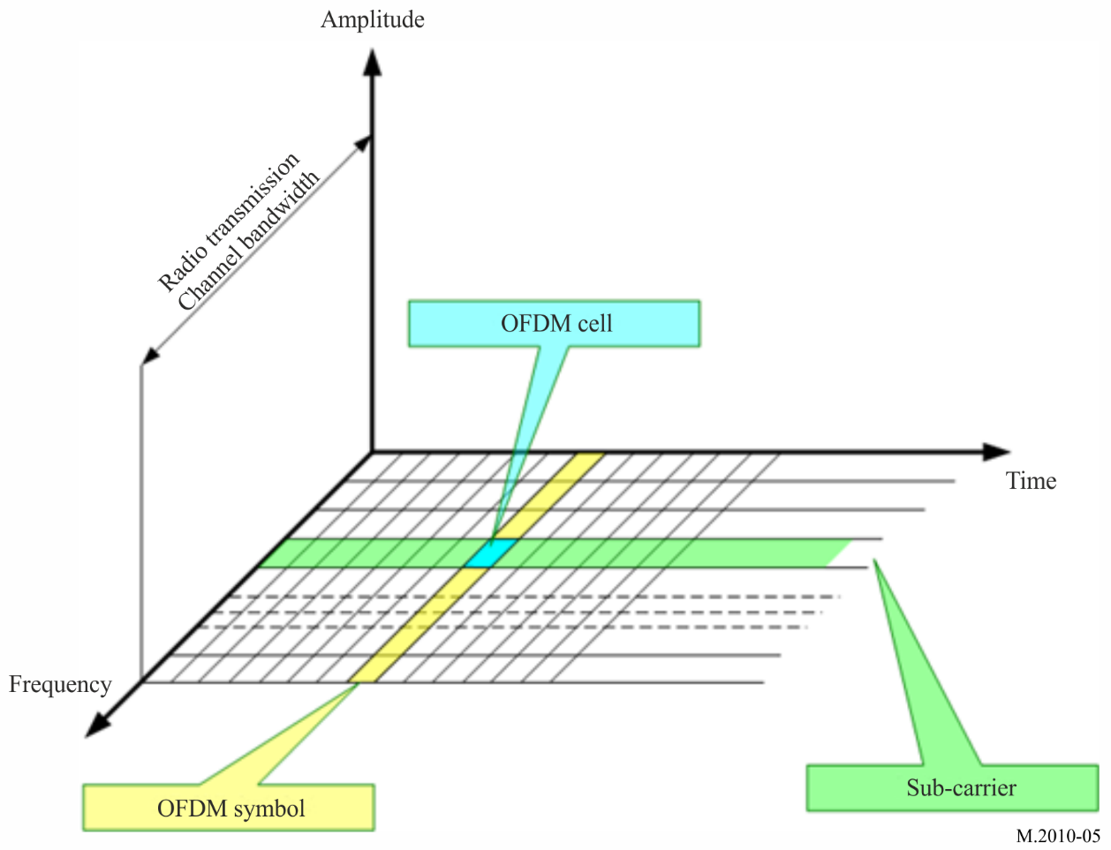

1.2 Principle
The OFDM uses a large number of closely-spaced (either 41.666 Hz (mode A) or 46.875 Hz (mode B in Table 1-A and 1-B) orthogonal subcarriers to obtain high spectral efficiency to transmit data. These subcarriers are frequency-spaced (Fu = 1/Tu), where T_{U} is the OFDM symbol duration of the useful part.
The phases of subcarriers are orthogonal one to each other to enhance signal diversity caused by the multipath, especially in long distance.
A guard interval (Td) is inserted in the OFDM symbol to reduce multipath effect, thus reducing the inter-symbol interference.
The OFDM symbol duration is Ts = Tu + Td
The OFDM symbols are then concatenated to make an OFDM frame.
The OFDM frame duration is Tf.
Figure 6
Spectral representation of an orthogonal frequency division multiplexing frame
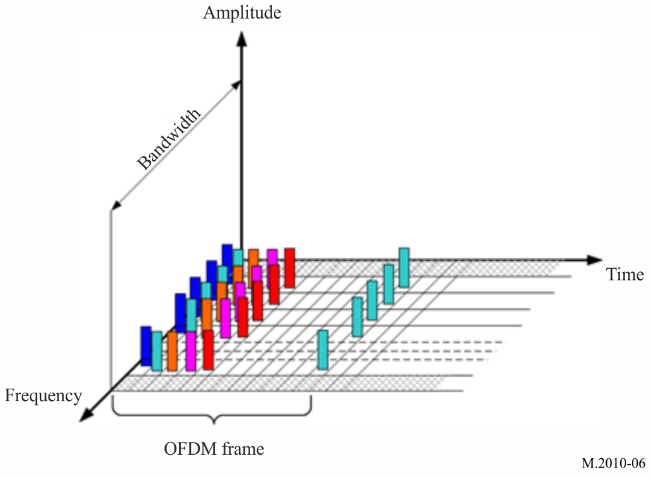
Figure 7
Temporal representation of an orthogonal frequency division multiplexing frame
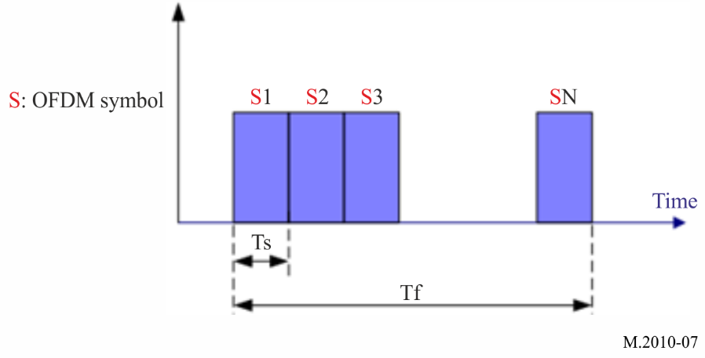

1.3 Orthogonal frequency division multiplexing parameters
OFDM parameter values are listed in Table 1.
TABLE 1A
Orthogonal frequency division multiplexing parameter values in Mode A
10 kHz
T_{u} | 1/T_{u} | T_{d} | T_{s}=T_{u}+T_{d} | N_{s} | T_{f}
24 ms | 41.666 Hz | 2.66 ms | 26.66 ms | 15 | 400 ms
5 kHz
T_{u} | 1/T_{u} | T_{d} | T_{s}=T_{u}+T_{d} | N_{s} | T_{f}
24 ms | 41.666 Hz | 2.66 ms | 26.66 ms | 33 | 880 ms
3 kHz
T_{u} | 1/T_{u} | T_{d} | T_{s}=T_{u}+T_{d} | N_{s} | T_{f}
24 ms | 41.666 Hz | 2.66 ms | 26.66 ms | 57 | 1 520 ms
1 kHz
T_{u} | 1/T_{u} | T_{d} | T_{s}=T_{u}+T_{d} | N_{s} | T_{f}
24 ms | 41.666 Hz | 2.66 ms | 26.66 ms | 171 | 4 560 ms

Table 1 B
Orthogonal frequency division multiplexing parameter values in mode B
10 kHz
T_{u} | 1/T_{u} | T_{d} | T_{s}=T_{u}+T_{d} | N_{s} | T_{f}
21.33 ms | 46.875 Hz | 5.33 ms | 26.66 ms | 15 | 400 ms

T_{u}: duration of the useful part of an OFDM symbol
1/T_{u}: carrier spacing
T_{d}: duration of the guard interval
T_{s}: duration of an OFDM symbol
N_{s}: the number of symbols per frame
T_{f}: duration of the transmission frame.

1.4 Channel bandwidth
NAVDAT digital broadcast defines different channel bandwidths and determines subcarrier numbers corresponding to different spectrum occupancy rates. Table 2 presents the channel bandwidth value and subcarrier numbers.
TABLE 2
Relationship between channel bandwidth and orthogonal frequency division multiplexing sub-carrier numbers

Propagation mode | Case | 1 | 2 | 3 | 4
Propagation mode | Channel bandwidth | 1 kHz | 3 kHz | 5 kHz | 10 kHz
A: surface wave | Numbers of sub carriers | 23 | 69 | 115 | 229
A: surface wave | N° of sub carriers | K -11 to 11 | K -34 to 34 | K -57 to 57 | K -114 to 114
B: surface wave + sky wave | Numbers of sub carriers | 19 | 61 | 103 | 207
B: surface wave + sky wave | N° of sub carriers | K -9 to 9 | K -30 to 30 | K -51 to 51 | K -103 to 103

1.5 Modulation
Every subcarrier is modulated in amplitude and phase (QAM: Quadrature amplitude modulation).
Modulation patterns can be either 64 states (6 bits, 64-QAM), 16 states (4 bits, 16-QAM), or 4 states (2 bits, 4-QAM).
The modulation pattern depends on the desired robustness of the signal.
Figure 8
4- quadrature amplitude modulation constellation
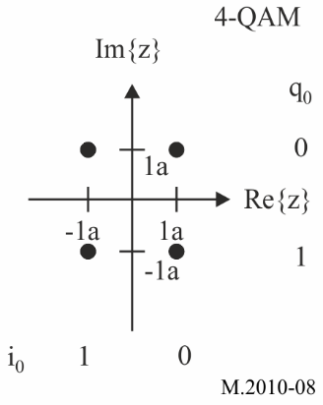
Figure 9
16-quadrature amplitude modulation constellation
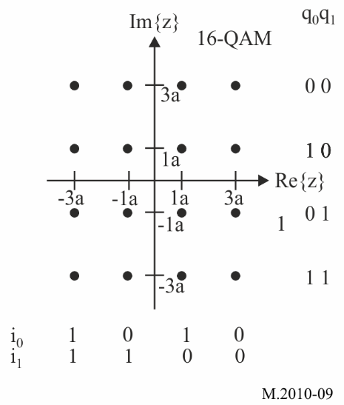
Figure 10
64-quadrature amplitude modulation constellation
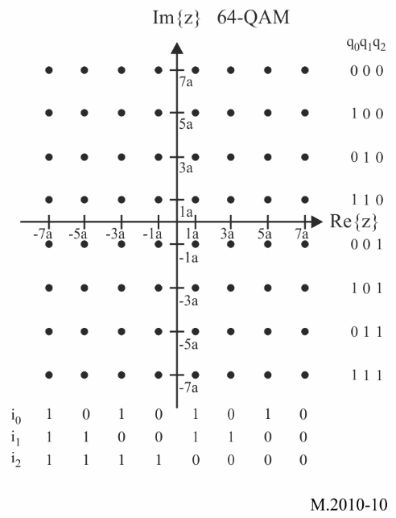

1.6 Synchronization
In order to allow a good demodulation of each subcarrier, the radio transmission channel response must be determined for each subcarrier and the equalization should be applied. For this, some of the subcarriers of the OFDM symbols may carry pilot signals.
The pilot signals allow the receiver to:
– detect if a signal is received;
– estimate the frequency offset;
– estimate the radio transmission channel.
The number of pilot signals depends on the desired robustness of the signal.
This pilot carriers are transmitting at maximum RF power in BPSK modulation.

Figure 11
Pilot orthogonal frequency division multiplexing signal
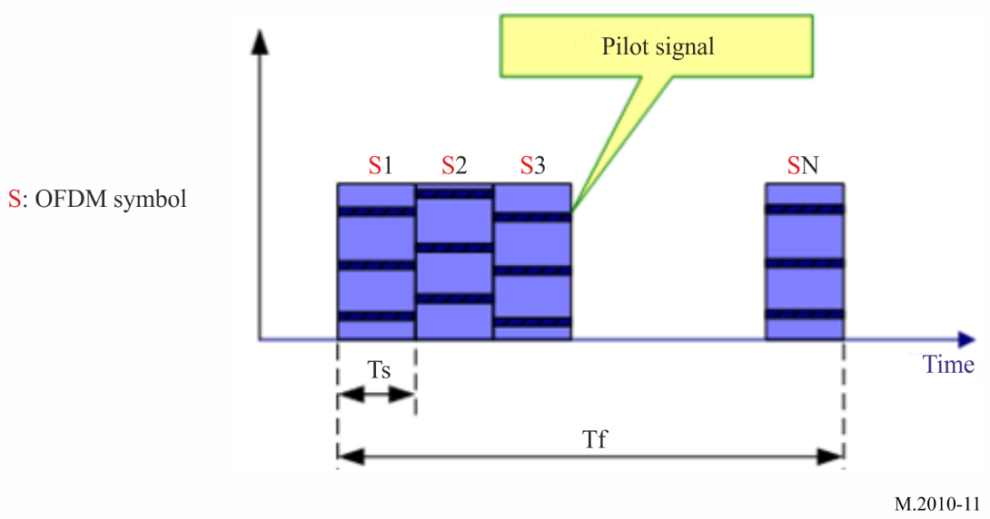
The pilot signal location in each OFDM symbol in a frame can be shown as follows:
Figure 12A
The pilot signal location in mode A
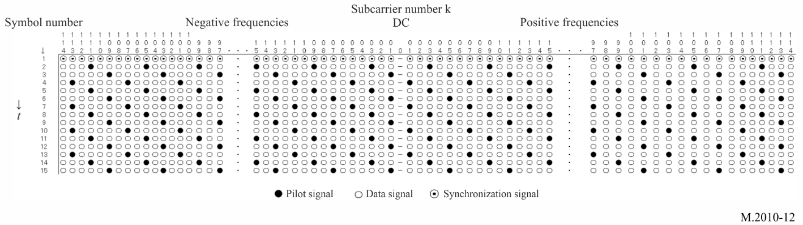
Figure 12 B
The pilot signal location in mode B
Where t is the direction of time domain, f is the direction of frequency domain. The first symbol of each OFDM frame should be filled by a sequence of synchronization signals that make up the synchronization head (refer to Table 7), all of which are used as a time reference to provide synchronization for the receiver. The black cell and the white cell represent the pilot signal and the data signal, respectively. The pilot signal value which is modulated in 2-QAM (BPSK) in an OFDM symbol is shown in Table 3.
TABLE 3
Pilot sequence (mode A)
Number of subcarriers | Pilot sequence
229 | -1 1 -1 1 -1 1 1 1 -1 1 1 1 1 -1 -1 -1 1 1 -1 -1 -1 1 1
115 | -1 1 -1 1 -1 1 1 1 -1 1 1 1
69 | -1 1 -1 1 -1 1 1
23 | -1 1 -1

Pilot sequence (mode B)
Number of subcarriers | Pilot sequence
207 | -1 1 -1 1 -1 1 1 1 -1 1 1 1 1 -1 -1 -1 1 1 -1 -1 -1 1 1 1 -1 -1 -1 -1 -1 -1 1 -1 1 -1 -1
103 | -1 1 -1 1 -1 1 1 1 -1 1 1 1 1 -1 -1 -1 1 1
61 | -1 1 -1 1 -1 1 1 1 -1 1
19 | -1 1 -1 1
In the first symbol of each OFDM frame, any subcarriers are used as time reference for the receiver to synchronize.
Figure 13
Synchronization symbol
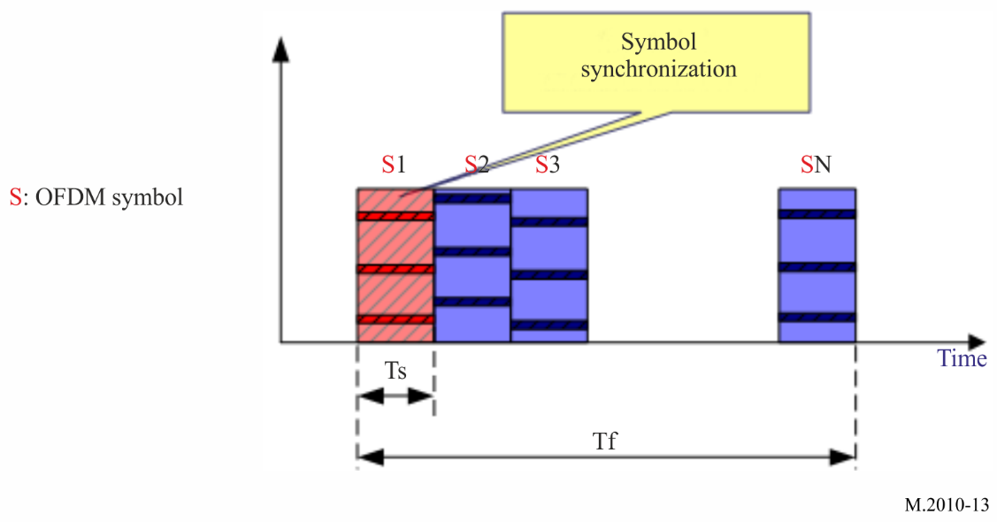

1.7 Energy dispersal
The purpose of the energy dispersal is to avoid the transmission of signal patterns resulted in an unwanted regularity. The individual inputs of energy dispersal scramblers should be scrambled by a modulo-2 with a pseudo-random binary sequence (PRBS), prior to channel encoding. The PRBS is defined as the output of the feedback shift register of Fig. 14. It should use a polynomial of degree 9, defined by:
P(X)=X⁹ +X⁵ +1
Figure 14
Pseudo-random binary sequence generator
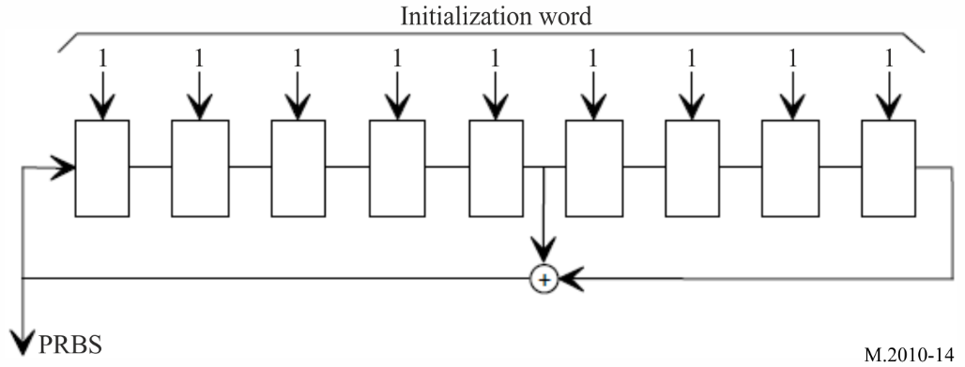

1.8 Spectral occupancy of RF signal
Figure 15
Spectral emission mask of NAVDAT RF signal with bandwidth F = 10 kHz
Emission masks for 5 kHz, 3 kHz and 1 kHz should fit within the mask for 10 kHz.

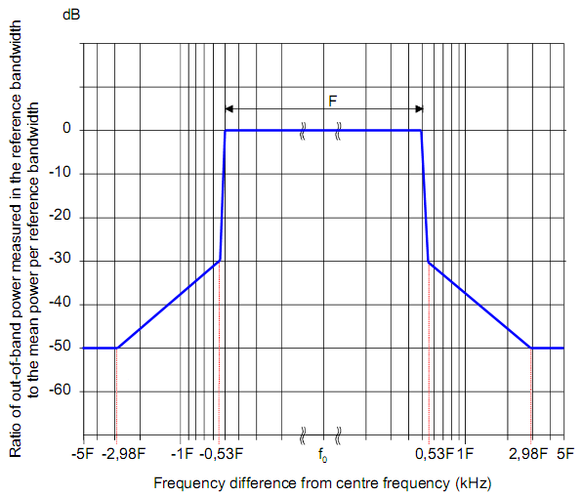

1.9 Sequence for receiving scanning possibility
To allow reception of national or regional frequencies assigned to the NAVDAT system, the receiver uses a scan function.
Frequencies should then be scanned to monitor the reception of the pre-signal transmitted by the station before broadcast.
To ensure proper operation of the receiver scan function, the transmitters of active National or Regional NAVDAT coast stations should transmit, before the NAVDAT broadcast, a pure carrier during 500 ms, extended by an identification of the station during 400 ms and a blank of 100 ms, all repeated 3 times for a total duration of 3 seconds (64 QAM / 10 kHz).
Figure 16
Transmission structure for scan facility
The frame structure is described in appendix 4.
Figure 17
Frame structure

2 Estimated usable data rate
In the 10 kHz channel bandwidth with 500 kHz propagation, the raw data rate available for the DS is typically around 25 kbit/s with 16-QAM signal.
The number of subcarriers that hold data can be varied in order to adjust the channel protection. Higher channel protection (protection against multipath, fading, delay, etc.) results in a lower number of useful subcarriers.
Error coding must then be applied to the raw data rate to obtain the useful data rate. With a code rate of 0.5 to 0.75, the useful data rate is then between 5 and 27 kbit/s.
A higher code rate provides a higher useful data rate but the radio coverage is accordingly reduced.
With the different modulation and code rate, the useful data rate is shown as below.
Note: The standard or short frame (400 ms) allows file transfer without repetition. In the case of the long frame, the file is repeated 3 times in order to obtain redundancy in the decoding of the signals by the receiver. The data rate in the long frame is reduced by a factor of 3.

TABLE 4
Estimated data rates for 10, 5, 3, 1 kHz bandwidth for short frame transmissions

Mode | Spectrum occupancy  (kHz) | Modulation  (nQAM) | Code rate | Estimated data rate  (kbps)
0 | 10 | 4-QAM | 0.5 | 6.36
1 | 10 | 4-QAM | 0.75 | 9.56
2 | 10 | 16-QAM | 0.5 | 12.72
3 | 10 | 16-QAM | 0.75 | 19.12
4 | 10 | 64-QAM | 0.5 | 19.08
5 | 10 | 64-QAM | 0.75 | 28.68
6 | 5 | 4-QAM | 0.5 | 2.89
7 | 5 | 4-QAM | 0.75 | 4.35
8 | 5 | 16-QAM | 0.5 | 5.78
9 | 5 | 16-QAM | 0.75 | 8.69
10 | 5 | 64-QAM | 0.5 | 8.67
11 | 5 | 64-QAM | 0.75 | 13.04
12 | 3 | 4-QAM | 0.5 | 1.67
13 | 3 | 4-QAM | 0.75 | 2.52
14 | 3 | 16-QAM | 0.5 | 3.35
15 | 3 | 16-QAM | 0.75 | 5.03
16 | 3 | 64-QAM | 0.5 | 5.02
17 | 3 | 64-QAM | 0.75 | 7.55
18 | 1 | 4-QAM | 0.5 | 0.55
19 | 1 | 4-QAM | 0.75 | 0.84
20 | 1 | 16-QAM | 0.5 | 1.12
21 | 1 | 16-QAM | 0.75 | 1.68
22 | 1 | 64-QAM | 0.5 | 1.67
23 | 1 | 64-QAM | 0.75 | 2.52

3 NAVDAT transmitter performance specification
TABLE 5
Minimum international NAVDAT MF transmitter performance specification
Parameters | Required results
Frequency band | 495 to 505 kHz (415 to 526.5 kHz recommended)
Carrier frequency error | Within ±2.5 Hz of the nominal frequency
Spectrum mask | Comply with the requirements of Figure 15
Transmitter third-order intermodulation rejection ratio | ≥40 dBc
Transmitter emission spurious  (all power range) | −50 dB without exceeding the absolute level of 50 mW (17 dBm)
Note: The transmitter may also cover the HF band. Refer to the Recommendation ITU-R M.2058 for technical specification.

4 NAVDAT ship receiver

4.1 NAVDAT ship receiver description
The ship receiver block diagram is shown in Fig. 19.

The NAVDAT ship receiver can receive and decode the main international MF channel (500 kHz) and the main international HF channel (4 226 kHz) at the same time with 2 complete independent channels.
The first channel should constantly listen to 500 kHz and the second channel should constantly listen to 4 226 kHz.
A third channel should scan all the other NAVDAT frequencies (regional in MF and attributed HF frequencies). The design of this third channel allow reception and decoding future potential national, regional or local transmitters using MF or HF channels:
1 The maritime MF band from 415 to 526.5 kHz (except 500 kHz).
2 The channels assigned to NAVDAT: 6 337.5, 8 443, 12 663.5, 16 909.5 and 22 450.5 kHz (except 4 226 kHz).
3 The frequency bands assigned to wideband digital transmissions of Appendix 17: 4, 6, 8, 12, 16, 19, 22 and 26 MHz.
The decoding of frequencies received by scanning can be demodulated in real time or with a time delay.
The choice of frequencies to be scanned should be based on information on the NAVDAT stations declared and stored by the receiver (table updated via message 63).
The receiver should first determine the NAVAREA and METAREA zone in which the vessel is located (from its position) with the possibility by the operator to add some NAVDAT stations outside of this NAVAREA / METAREA.
From the table, the receiver should determine the future allocated slots and the frequencies used.
These frequencies should then be scanned to monitor the reception of the pre-signal transmitted by the station before broadcast
The receiving antenna is common to the three channels. It is recommended that the antenna be equipped with 2 outputs for sharing with another MF/HF receiver.
Figure 18 describes a generic block diagram of an SDR receiver.
The design of NAVDAT receivers is left to the initiative of each manufacturer.
Figure 18
Model of generic SDR NAVDAT receiver

FIGURE 19
NAVDAT receiver logical diagram
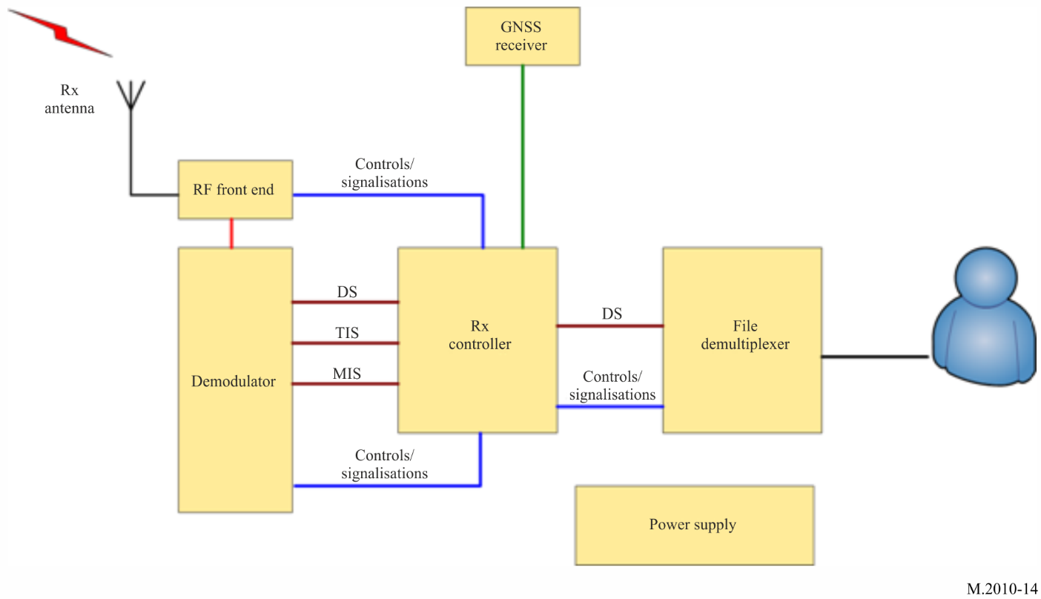

4.1.1 Reception antenna and global navigation satellite system antenna
The omnidirectional receiving antenna system should have a band from 415 kHz to 27.5 MHz. It may be a horizontal H-field antenna (recommended on a noisy ship) or a vertical E-field antenna. The ship’s NAVDAT receiver may also receive NAVDAT HF channels. In this case, the receiving antenna system should have a band from 300 kHz to 25 MHz.
A GNSS antenna (or a connection to an existing GNSS receiver on-board) is also needed in order to obtain the ship position.

4.1.2 RF front end
The RF front end includes the RF filter, RF amplifier and base band output.
High sensitivity and high dynamic range are necessary with protection against strong RF fields from ship transmitting antennae or lighting.
The passband of the input filters must allow reception of the maritime MF band from 415 to 526.5 kHz
It is recommended to place a notch filter on the MF broadcasting band (from 526.5 kHz).
The receiver design can either be conventional or SDR type with at least 3 channels

4.1.3 Demodulator
This stage demodulates the base band OFDM signal and recreates the data stream that holds the transmitted message files.
It implements:
– time/frequency synchronization;
– channel estimation;
– automatic modulation recovery;
– error correction.
The NAVDAT receiver should be able to detect the following modulation parameters automatically:
– 4, 16 or 64-QAM;

– type of error coding.
In addition to the DS, it reports the information filled in the TIS and MIS. Furthermore, it reports complementary information about the channel such as:
– estimated SNR;
– BER;
– MER.

4.1.4 File demultiplexer
The file demultiplexer:
– receives the message files from the controller;
– verifies that the message files are marked for its attention (type of broadcast mode);
– decrypts the message files if needed/able;
– makes the message files available for the terminal application that will use the message files;
– deletes the out-of-date message files.
Depending on the final application, the message file can be:
– stored on an onboard server accessible through the ship network;
– display on the receiver CDU directly;
– sent directly to the final application.

4.1.5 Controller
The controller:
– extracts the message files from the DS (merge packets into files);
– interprets the TIS and MIS and the other pieces of information given by the demodulator;
– collects the following information from the file demultiplexer:
• total number of decoded message files;
• number of available message files;
• error event (e.g. decrypt errors).

4.1.6 Control and display unit
The receiver can provide a display and control unit, the function of this unit is:
– display the special information and by configuring the interface to be connected to a dedicated equipment application (e.g. e-navigation) and manage the licensed contents of the ship (e.g. ship identification, encryption);
– display and check the receiving parameters;
– display the message content according to the application classification of the message file.
This CDU may be a special application running on an external computer, and the receiver may be a black-box device.

4.1.7 Data interface
The receiver gets the data from external devices such as GNSS through the data interface. The controller classifies the message files according to their applications and provides the message files to the application devices through the data interface.
The receiver should provide a configurable data interface that complies with the requirements of the IEC 61162 series. This data interface is for the purposes of connection to other onboard equipment. It is also recommended to provide Ethernet and USB interfaces for high-speed transmission of files and provide connectivity for printers.
When required the receiver should include an interface for alert management in accordance with the IMO performance standards for bridge alert management (IMO resolution MSC.302(87)).

4.1.8 Power supply
The power supply of the receiver should be connected to the power supply of the ship.

4.1.9 Receiver ID
It should be possible to configure the receiver with:
The identity (MMSI) of the vessel (according to Recommendation ITU-R M.585)
The group identity (MMSI) (according to Recommendation ITU-R M.585)
Additional lists of identities (MMSI’s) may be provided
(see table 18 and note)

4.1.10 Stored tables
The receiver should have the possibility of storing information in different memorized tables which can be updated by the reception of the message 63.
For example:
1 The list of coast stations with:
- Area
- Nation
- Longitude
- Latitude
-Name
-Slots
Frequency used
This stored table is queried when the identities (MMSI) of the stations received are received and the complete parameters of the received NAVDAT coast station should be displayed in plain text.
2 The list of subject messages
Table with subject message 01 to 63
Etc.
All the tables in memory can be updated by receiving the message 63.

4.1.11 Storage

4.1.11.1 Non-volatile files message memory
For each frequency provided it should be possible to record at least 100 message files in non-volatile memory. It should not be possible for the user to erase file messages from the memory. When the memory is full, the oldest file message must be replaced by the new messages.
The user should be able to mark the individual files of a message from permanent retention. These file messages can occupy up to 25% of available memory and should not be overwritten by new files. When no longer needed, the user must be able to delete the tag on these files, which can be overwritten normally.
Duplicate message could be recognized by the equipment and should not be stored.

4.1.11.2 Programmable control memories
Information identifying the transmitter service area and the designator of each type of message in programmable memory should not be erased by interruptions in the power supply of less than 24 h.
The equipment should be able to store at least the time, transmitter identification, message type and message content. The storage capacity should not be less than 1 GB.
When the power supply is unexpectedly interrupted, the equipment should protect the stored data and software parameters.
The equipment should be able to display, delete and query stored messages, and be able to output messages manually or automatically to appropriate ship equipment (such as the electronic chart and display information system (ECDIS)).

4.1.12 Alert
The receipt of a search and rescue (SAR) related information message should give a continuous audible alarm. It should only be possible to reset this alarm manually. The position information contained in the SAR messages may be transmitted to other navigation equipment (e.g. ECDIS, electronic navigational chart plotter).

4.1.13 Test facilities
The equipment should be provided with a facility to test that the radio receiver, the display and the non-volatile memory are functioning correctly and to display self-test results. In case of using a specific antenna it also must be checked by this process.

4.1.14 Updates
The software/firmware of the equipment should be able to be updated. The update should be performed by using the appropriate interface or reception of message 63 (update receiver software). This function is necessary to follow the evolutions of the GMDSS master plan for the new NAVDAT stations as well as for the future revisions of the ITU recommendations.

4.1.15 Scan function
As indicated in 4.1 the ship's NAVDAT receiver permanently monitors the frequencies 500 and 4226 kHz and can simultaneously decode the signals received on these 2 frequencies.
To allow reception of national or regional frequencies assigned to the NAVDAT system, the receiver uses a scan function on the following maritime frequency bands:
– The MF band from 415 to 526.5 kHz (except 500 kHz);
– The channels assigned to NAVDAT in appendix 17: 6 337.5, 8 443, 12 663.5, 16 909.5 and 22 450.5 kHz (except 4 226 kHz);
– The frequency bands assigned to wideband digital transmissions of Appendix 17 in the bands 4, 6, 8, 12,1 6, 19, 22 and 26 MHz.
The receiver should search its stored NAVDAT station table (updated via message code 63) for all frequencies that can be sequentially scanned in relation to allocated slots (time reference)
The signals received on the frequency selected by scan can be decoded in real time or in time shifted according to the resources of the NAVDAT receiver computer at this moment.
To ensure proper operation of the receiver scan function, the transmitters of active National or Regional NAVDAT coast stations should broadcast, before the NAVDAT frames, a pure carrier extended by an identification of the station and a blank, all repeated 3 times for a total duration of 3 seconds (see section 1.9 and figure 16 in Annex 3).
This should allow the receiver to detect the transmission and tune in to the frequency, measure its SNR, identify the station and its NAVAREA / METAREA area.

5 Minimum NAVDAT ship receiver performance specifications
These assumed ship receiver specifications are set out below with the objective to obtain minimum SNR for a good OFDM demodulation (4-QAM, 16-QAM or 64-QAM).
The ship's NAVDAT receiver must receive the 2 international NAVDAT frequencies:
500 kHz and 4 226 kHz but also the MF and HF frequency band in scan mode, see Table 6 below.
TABLE 6
NAVDAT ship receiver minimum performance specifications

Parameters | Requirements
Total Frequency band  Main MF frequency (center frequency)  Main HF frequency (center frequency) | 415 to 526.5 kHz and 4 to 27.5 MHz maritime band  500 kHz  4 226 kHz
MF maritime band | 415 to 526.5 kHz
HF maritime bands | Maritime HF bands Appendix 17
Adjacent channel protection | > 40 dB @ 5 kHz
Noise factor | < 10 dB (< 20 dB for MF band)
Usable sensitivity for BER = 10⁻⁴ after error correction | < -95 dBm
Dynamic | > 80 dB
Minimal usable RF field (with adapted receiving antenna) | 20 dB(µV/m)

Annex 4
Transmission structure

1 Frame structure
NAVDAT frame structure contains synchronization head (the first symbol), MIS, TIS, and DS (data stream) shown as follow:
FIGURE 20
NAVDAT Frame structure
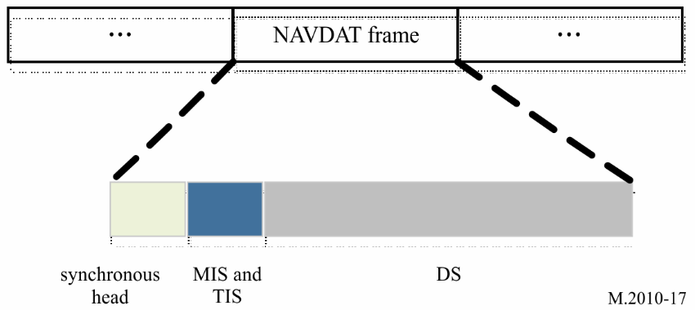
This frame can be transmitted in short or long frame (repeat 3 times) for redundancy.

2 Synchronization head
Synchronization head is the first OFDM symbol of each frame for the receiver to synchronize and for the information on every subcarrier is shown in Table 7.
TABLE 7
Synchronization head sequence in mode A
Bandwidth and number of subcarriers | Synchronization head sequence
10 kHz  229 | -1 1 1 1 1 1 1 -1 1 1 -1 -1 1 -1 1 1 1 1 1 -1 -1 1 -1 1 -1 -1 -1 1 1 1 1 -1 1 -1 -1 -1 -1 1 1 -1 1 1 1 -1 -1 -1 1 1 1 -1 1 -1 -1 1 1 -1 1 1 -1 1 1 -1 -1 -1 1 -1 1 -1 -1 1 -1 -1 1 -1 1 1 -1 -1 -1 -1 1 -1 -1 1 -1 -1 -1 1 -1 1 1 1 -1 -1 1 -1 -1 1 1 -1 -1 -1 1 1 -1 1 -1 -1 1 -1 1 -1 1 1 0 1 -1 -1 -1 1 -1 -1 -1 -1 -1 1 -1 -1 -1 1 1 -1 -1 1 1 1 1 -1 -1 1 1 -1 1 -1 1 -1 1 1 1 -1 1 -1 1 -1 -1 -1 -1 -1 -1 1 1 -1 -1 -1 -1 -1 1 1 1 1 1 -1 1 -1 1 1 1 1 -1 1 1 1 1 -1 -1 -1 -1 1 1 1 -1 -1 1 1 1 -1 1 1 1 -1 1 1 -1 1 -1 1 1 -1 -1 1 1 -1 -1 1 -1 -1 -1 -1 1 -1 1 -1 1 -1 1 -1 -1 1 1
5 kHz  115 | 1 -1 1 1 -1 -1 -1 1 -1 1 -1 -1 1 -1 -1 1 -1 1 1 -1 -1 -1 -1 1 -1 -1 1 -1 -1 -1 1 -1 1 1 1 -1 -1 1 -1 -1 1 1 -1 -1 -1 1 1 -1 1 -1 -1 1 -1 1 -1 1 1 0 1 -1 -1 -1 1 -1 -1 -1 -1 -1 1 -1 -1 -1 1 1 -1 -1 1 1 1 1 -1 -1 1 1 -1 1 -1 1 -1 1 1 1 -1 1 -1 1 -1 -1 -1 -1 -1 -1 1 1 -1 -1 -1 -1 -1 1 1 1 1 1 -1
3 kHz  69 | 1 -1 -1 1 -1 -1 -1 1 -1 1 1 1 -1 -1 1 -1 -1 1 1 -1 -1 -1 1 1 -1 1 -1 -1 1 -1 1 -1 1 1 0 1 -1 -1 -1 1 -1 -1 -1 -1 -1 1 -1 -1 -1 1 1 -1 -1 1 1 1 1 -1 -1 1 1 -1 1 -1 1 -1 1 1 1
1 kHz  23 | 1 -1 1 -1 -1 1 -1 1 -1 1 1 0 1 -1 -1 -1 1 -1 -1 -1 -1 -1 1

Synchronisation head sequence in mode B

Number of subcarriers | Synchronization head sequence
207 | -1 1 1 1 1 1 1 -1 1 1 -1 -1 1 -1 1 1 1 1 1 -1 -1 1 -1 1 -1 -1 -1 1 1 1 1 -1 1 -1 -1 -1 -1 1 1 -1 1 1 1 -1 -1 -1 1 1 1 -1 1 -1 -1 1 1 -1 1 1 -1 1 1 -1 -1 -1 1 -1 1 -1 -1 1 -1 -1 1 -1 1 1 -1 -1 -1 -1 1 -1 -1 1 -1 -1 -1 1 -1 1 1 1 -1 -1 1 -1 -1 1 1 -1 -1 -1 1 1 -1 1 -1 -1 1 -1 1 -1 1 1 0 1 -1 -1 -1 1 -1 -1 -1 -1 -1 1 -1 -1 -1 1 1 -1 -1 1 1 1 1 -1 -1 1 1 -1 1 -1 1 -1 1 1 1 -1 1 -1 1 -1 -1 -1 -1 -1 -1 1 1 -1 -1 -1 -1 -1 1 1 1 1 1 -1 1 -1 1 1 1 1 -1 1 1 1 1 -1 -1 -1 -1 1 1 1 -1 -1 1 1 1 -1 1 1 1 -1 1 1 -1 1 -1 1 1 -1 -1 1 1 -1 -1 1 -1 -1 -1 -1 1 -1 1 -1 1 -1 1 -1 -1 1 1
103 | 1 -1 1 1 -1 -1 -1 1 -1 1 -1 -1 1 -1 -1 1 -1 1 1 -1 -1 -1 -1 1 -1 -1 1 -1 -1 -1 1 -1 1 1 1 -1 -1 1 -1 -1 1 1 -1 -1 -1 1 1 -1 1 -1 -1 1 -1 1 -1 1 1 0 1 -1 -1 -1 1 -1 -1 -1 -1 -1 1 -1 -1 -1 1 1 -1 -1 1 1 1 1 -1 -1 1 1 -1 1 -1 1 -1 1 1 1 -1 1 -1 1 -1 -1 -1 -1 -1 -1 1 1 -1 -1 -1 -1 -1 1 1 1 1 1 -1
61 | 1 -1 -1 1 -1 -1 -1 1 -1 1 1 1 -1 -1 1 -1 -1 1 1 -1 -1 -1 1 1 -1 1 -1 -1 1 -1 1 -1 1 1 0 1 -1 -1 -1 1 -1 -1 -1 -1 -1 1 -1 -1 -1 1 1 -1 -1 1 1 1 1 -1 -1 1 1 -1 1 -1 1 -1 1 1 1
19 | 1 -1 1 -1 -1 1 -1 1 -1 1 1 0 1 -1 -1 -1 1 -1 -1 -1 -1 -1 1

For the different channel bandwidth, the OFDM symbol index corresponding to the synchronization header is shown in Table 8.
TABLE 8
Index of the synchronization head symbols
Channel bandwidth | N_{s} | Index of the OFDM symbol per frame
10 kHz | 15 | 1
5 kHz | 33 | 1, 2, 3
3 kHz | 57 | 1, 2, 3, 4, 5, 6, 7, 8
1 kHz | 171 | 1, 2, 3, 4, 5, 6, 7, 8, 9, 10, 11, 12, 13, 14, 15, 16, 17, 18, 19, 20, 21, 22, 23

3 Modulation information stream

3.1 Structure
MIS is used to provide the information about channel spectrum occupancy as well as TIS and DS modulation:
– information of spectrum occupancy 2 bits;
– information of TIS modulation 1 bits;
– information of DS modulation 2 bits;

– Cyclic redundancy check (CRC) 8 bits;
– Reserved 3 bits (default: 0).
TABLE 9
Information of channel bandwidth

Case  (refer to Table 2 above) | Patterns of bits | Channel bandwidth  (kHz)
1 | 00 | 1
2 | 01 | 3
3 | 10 | 5
4 | 11 | 10

TABLE 10
Information of transmitter information stream modulation
Patterns of bit | Modulation
0 | 4-QAM
1 | 16-QAM

TABLE 11
Information of data stream modulation
Patterns of bits | Modulation
00 | 4-QAM
01 | 16-QAM
10 | 64-QAM

3.2 Encoding

The MIS is encoded using a (16,48) polar code, where the positions of the information subchannels are determined by the 0's in the following vector [1 1 1 1 1 1 1 1 1 1 1 1 1 1 1 1 1 1 1 1 1 1 1 1 1 1 1 1 1 1 0 0 1 1 1 1 1 1 1 1 1 1 1 1 1 0 0 0 1 1 1 0 1 0 0 0 1 0 0 0 0 0 0 0].

4 Transmitter information stream

4.1 Structure
TIS is used to provide the information about encoding of DS, transmitter, and time for the receiver:
– error encoding of DS 5 bits;
– identifier of the transmitter 32 bits;
– day and time 17 bits;
– reserved 8 bits (default: 0);
– reserved 11 bit (4-QAM) or 87 bits (16-QAM) (default: 0);
– CRC 8 bits.
TABLE 12
Encoding of data stream
Patterns of bits | Transmission mode
Patterns of bits | Spectrum occupancy (kHz) | Code rate | Modulation
00000 | 1 | 0.5 | 4-QAM
00001 | 1 | 0.75 | 4-QAM
00010 | 1 | 0.5 | 16-QAM
00011 | 1 | 0.75 | 16-QAM
00100 | 1 | 0.5 | 64-QAM
00101 | 1 | 0.75 | 64-QAM
01000 | 3 | 0.5 | 4-QAM
01001 | 3 | 0.75 | 4-QAM
01010 | 3 | 0.5 | 16-QAM
01011 | 3 | 0.75 | 16-QAM
01100 | 3 | 0.5 | 64-QAM
01101 | 3 | 0.75 | 64-QAM
10000 | 5 | 0.5 | 4-QAM
10001 | 5 | 0.75 | 4-QAM
10010 | 5 | 0.5 | 16-QAM
10011 | 5 | 0.75 | 16-QAM
10100 | 5 | 0.5 | 64-QAM
10101 | 5 | 0.75 | 64-QAM
11000 | 10 | 0.5 | 4-QAM
11001 | 10 | 0.75 | 4-QAM
11010 | 10 | 0.5 | 16-QAM
11011 | 10 | 0.75 | 16-QAM
11100 | 10 | 0.5 | 64-QAM
11101 | 10 | 0.75 | 64-QAM

TABLE 13
Identifier of the transmitter

Coding | Identifier of the transmitter
I | 8 bits ASCII
D | 8 bits ASCII
NAV/MET AREA | 8 bits
STATION NUMBER | 8 bits
Total | 32 bits
The encoding of the I and D header should be in 8-bit ASCII.
The coding of the areas should be done in binary on 8 bits.
The station number allocated for a frequency should be coded on 8 bits (maximum of 255 stations by area).
Total of 32 bits should thus be used for the identification of each pair station / frequency
Examples of coast station identification code:
A NAVDAT station located in NAVAREA/METAREA III (3) and transmitting on 500 kHz would have the following identity (with the numbering 85 allocated to the station):
I 01001001 8 bits ASCII
D 01000100 8 bits ASCII
3 00000011 8 bits binary
85 01010101 8 bits binary
Total 32 bits

TABLE 14
Information of time
Parameter | Bit number | description
Hour of start time in UTC | 5 | hour
minute of start time in UTC | 6 | minute
Duration of broadcast | 6 | 0-59 minutes

TABLE 15
Mode of robustness
Mode | Pattern of bit
A | 000
B | 001
C | 010
D | 011

4.2 Encoding

The TIS is encoded using a (76, 152) polar code, where the positions of the information subchannels are determined by the 0's in the following vector 1 1 1 1 1 1 1 1 1 1 1 1 1 1 1 1 1 1 1 1 1 1 1 1 1 1 1 1 1 0 0 0 1 1 1 1 1 1 1 1 1 1 1 0 1 0 0 0 1 1 1 0 1 0 0 0 1 0 0 0 0 0 0 0 1 1 1 1 1 1 1 0 1 1 1 0 1 0 0 0 1 1 1 0 1 0 0 0 0 0 0 0 0 0 0 0 1 1 0 0 0 0 0 0 0 0 0 0 0 0 0 0 1 1 1 1 1 1 1 1 1 1 1 1 1 1 1 1 1 1 1 1 1 1 1 0 1 1 1 0 0 0 0 0 1 1 0 0 0 0 0 0 0 0 0 0 0 0 0 0 1 0 0 0 0 0 0 0 1 1 1 1 1 1 1 1 1 1 1 1 1 1 1 1 1 1 1 1 1 1 1 1 1 1 1 1 1 1 1 1 1 1 1 1 1 1 1 1 1 1 1 1 1 1 1 1 1 1 1 1 1 1 1 1 1 1 1 1 1 1 1 1 1 1 1 1 1 1 1 1 1 1 1 1 1 1 1 1 1 1 1 1 1 1 1 1.

4.3 Position
There are 100 (MIS:48, TIS:152) carriers for MIS and TIS transmission. Table 16 give the position of these carriers.
Table 16
Position of the modulation information stream and transmitter information stream carriers
Symbol  (1kHz) | Symbol  (3kHz) | Symbol  (5kHz) | Symbol  (10kHz) | Carrier number
24 | 9 | 4 | 2 | -10, -8, -6, -4, -2, 2, 4, 6, 8,10
25 | 10 | 5 | 3 | -10, -8, -6, -4, -2, 2, 4, 6, 8,10
26 | 11 | 6 | 4 | -10, -8, -6, -4, -2, 2, 4, 6, 8,10
27 | 12 | 7 | 5 | -10, -8, -6, -4, -2, 2, 4, 6, 8,10
28 | 13 | 8 | 6 | -10, -8, -6, -4, -2, 2, 4, 6, 8,10
29 | 14 | 9 | 7 | -10, -8, -6, -4, -2, 2, 4, 6, 8,10
30 | 15 | 10 | 8 | -10, -8, -6, -4, -2, 2, 4, 6, 8,10
31 | 16 | 11 | 9 | -10, -8, -6, -4, -2, 2, 4, 6, 8,10
32 | 17 | 12 | 10 | -10, -8, -6, -4, -2, 2, 4, 6, 8,10
33 | 18 | 13 | 11 | -10, -8, -6, -4, -2, 2, 4, 6, 8,10

5 Data stream

5.1 Structure
Data stream generally consist of either text information or files of information. A generalized packet delivery allows the delivery of text information and files for various services in the same data stream. And services can be carried by a series of single packets.
The structure of a packet is as follows:
– Head 32 bits
– Data field n bytes
– CRC 16 bits.
The head is made up as follows:
– Data length 12 bits
– toggle bit 1 bit
– first flag 1 bit
– last flag 1 bit
– packet ID 10 bits
– padded packet indicator 1 bit
– reserved 6 bits.
Data length: This 12-bit indicates the length of a packet in bytes.
Toggle bit: This bit should be maintained in the same state as long as packets from the same text message or file are being transmitted. When a packet from a different text message or file is sent for the first time, this bit should be inverted with respect to its previous state. If a text message or file, which may consist of several packets, is repeated, then this bit should remain unchanged.
First flat, Last flag: These flags are used to identify particular packets which form a succession of packets. The flags are assigned as follows:
TABLE 17
Coding of first flag and last flag
First flag | Last flag | The packet is
0 | 0 | an intermediate packet
0 | 1 | the last packet of a data unit
1 | 0 | the first packet of a data unit
1 | 1 | the one and only packet of a data unit

Packet ID: This 8-bit field indicates the packet ID of this packet.
Padded Packet Indicator: This 1-bit flag indicates whether the data field carries padding or not, as follows:
0: no padding is present: all data bytes in the data field are useful;
1: padding is present: the first two bytes give the number of useful data bytes in the data field.
Reserved: This 6-bit field is reserved for future use.
Data field: It contains the useful data intended for a particular service. It can be text information or file information.
The first information in the Data Field is as follows:
Broadcast mode according to the table below.
Table 18
Broadcast mode
MODE | Pattern of bit | Coding | Comments
General | 00
Selective ship | 01 | 36 bits | MMSI of the ship
Group of ships | 10 | 36 bits | Group of ship’s ID (main or secondary)
Selective area | 11 | 512 bits | Geographic coordinates of the defined area
Note:
In the case of selective broadcast over a specific area, this geographical area is defined as follows:
The zone number assigned by the server (maximum 99) + space
The area is determined by 4 geographical points in degrees minutes seconds (DMS) starting from the highest point and turning clockwise (Latitude followed by Longitude).
The + sign indicates North and East
The sign - indicates South and West
For: example
Position 1 47°42’22” N and 137°28’59” E
Position 2: 37°50’24” N and 139°00’10” E
Position 3: 32°04’57” N and 129°29’05” E
Position 4: 33°04’56” N and 127°30’28” E
Giving: Z01 +474222+1372859+375024+1390010+320457+1292905+330456+1273028
The server converts this text in binary:
01011010 00110000 00110001 00100000 00101011 00110100 00110111 00110100 00110010 00110010 00110010 00101011 00110001 00110011 00110111 00110010 00111000 00110101 00111001 00101011 00110011 00110111 00110101 00110000 00110010 00110100 00101011 00110001 00110011 00111001 00110000 00110000 00110001 00110000 00101011 00110011 00110010 00110000 00110100 00110101 00110111 00101011 00110001 00110010 00111001 00110010 00111001 00110000 00110101 00101011 00110011 00110011 00110000 00110100 00110101 00110110 00101011 00110001 00110010 00110111 00110011 00110000 00110010 00111000
Total 512 bits
The second information defines the level of the message: Routine, Important or Vital according to the table below:
Table 19
Level of the message
Coding | Definition level
00 | Routine
01 | Important
11 | Vital

The third information gives the number of the message from 1 to 999 coded on 10 bits
Example: 1 = 0000000001
999 = 1111100111
The fourth piece of information specifies the subject of the message according to the table in the Annex7 (from 1 to 63) coded on 6 bits:
1= 000001
63 = 111111

CRC: This 16-bit CRC should be calculated on the header and the data field.

5.2 Encoding
NAVDAT data stream is encoded by low-density parity-check (LDPC), and different encoding parameters will be adopted in different modes (see Table 11). The following Table gives the LDPC parameters in 10 kHz mode.
TABLE 20
low-density parity-check parameters of data stream

Mode | Modulation | Code rate | LDPC parameters
0 | 4-QAM | 0.5 | LDPC (2560,5120)
1 | 4-QAM | 0.75 | LDPC (3840,5120)
2 | 16-QAM | 0.5 | LDPC (2560,5120) × 2
3 | 16-QAM | 0.75 | LDPC (3840,5120) × 2
4 | 64-QAM | 0.5 | LDPC (2560,5120) × 3
5 | 64-QAM | 0.75 | LDPC (3840,5120) × 3

6 Low-density parity-check codes
The LDPC code is a linear block code that can be uniquely defined by the parity check matrix H. Since the number of “1” in the parity check matrix H is much smaller than the number of “0”, it is called low density check code. The matrix H has double diagonal characteristic.
The check matrix H can be expressed as an exponential matrix shown as follow:
Each number represents an L x L matrix. (L=160) denotes an all-zero matrix, 0 denotes a unit matrix, and p denotes a permutation matrix obtained by shifting the unit matrix to the right by p. The double diagonal matrix can be divided into two parts: information block and check block, namely: $H=\left[H_{s} H_{p}\right]$. And the vector of the encoded output symbols also can be divided into two parts, namely: $C=\left[S P\right]$. According to the check equation $\left[H_{s} H_{p}\right]{\left[S P\right]}^{T}=0$, the corresponding parity bit can be obtained.
The code length of LDPC in 10 kHz mode of NAVDAT is 5120, and the code rate is 1/2 and 3/4 respectively.
The check matrix of the 1/2 code rate is:

And the check matrix of the 3/4 code rate is:

7 Cyclic redundancy check
For the bit error detection in DS, the 16-bit cyclic redundancy check should be calculated
at the end of each DS. The generator polynomial should be .
For MIS and TIS, the 8-bit cyclic redundancy check should be calculated and the generator polynomial should be.
Annex 5
Message file structure
Figure 21 shows an example of how a data group is built for a message file. In the first step, a header is created to describe the body (a message file). The header contains the file’s management data. Afterwards, the header as well as the body are split into equally sized segments (only the last segment of each item may be smaller). A segment header is attached to a segment, and each segment is mapped into one data group. Then each data group with its header is mapped directly to a data unit. The data unit is split into packets for transportation. “FF” and “LF” represent the state of the “first flag” and “last flag” bits for each packet.
FIGURE 21
Message file structure
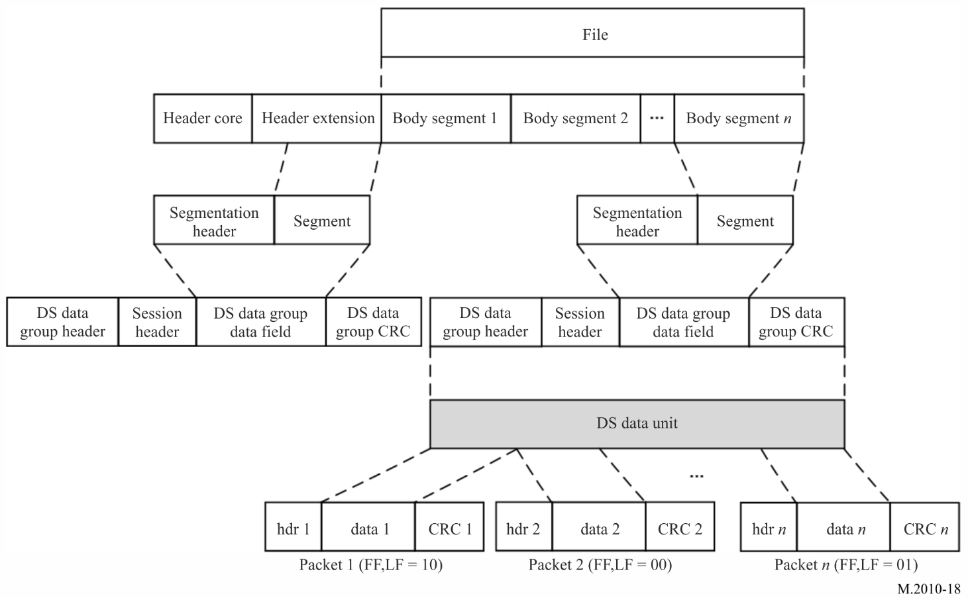

Annex 6
Single frequency network mode of Digital Radio Mondiale

1 Explanation of Digital Radio Mondiale
The international digital radio broadcast standard DRM is used for digital radio broadcasting at MF and HF. DRM is a proven technology that provides superior coverage, improves signal fidelity (through digital error correction coding), eliminates multi-path interference (including sky-wave interference) and thus extends coverage from sky-wave propagated signals. DRM broadcasts are implemented in both 16-QAM and 64-QAM modulation modes, depending on coverage requirements, transmitter location, power and antenna height.

1.1 Single frequency network operating mode
The NAVDAT system is capable of supporting what is called SFN operation. This is the case where a number of transmitters transmit on the same frequency, and at the same time, identical data signals. Generally, these transmitters are arranged to have overlapping coverage areas, within which a radio should receive signals from more than one transmitter. Provided that these signals arrive within a time difference of less than the guard interval, they should provide positive signal reinforcement. Thus, the service coverage should be improved at that location compared to that obtained if there was only a single transmitter providing service to that location. By careful design, and using a number of transmitters in a SFN, a region or country may be completely covered using a single frequency, and in this application, a single time slot, thus drastically improving spectrum efficiency and release broadcast slots.
In a single frequency network all the individual transmitters must be exactly time synchronized. Every transmitter must broadcast absolutely identical OFDM symbol at the same time.
Time synchronization of all transmitted packets in the transport stream of the final data multiplex is ensured by the time signal 1 pps (pulse per second), which is acquired from the GNSS system.
The frequency stability of transmitters should be better than 2 Hz.
The basic parameter that defines the size of the SFN area is the guard interval Tg.
In OFDM modulation method, its great robustness against inter-symbol interference as an effect of multipath reception (an impact of time delayed signals – echoes) consists in largely extending the very short bit time interval Tb in the serial original data stream.
This guard interval must be carefully configured according to the position of the transmitters in relation with the coverage areas.

Annex 7
NAVDAT subject message codes
This list is given only for information.
Refer to the documents published by IMO.
TABLE 22
List of NAVDAT subject message codes

Maritime Safety Information (MSI)
Subject message code | Type of message | Coding | can be rejected
Subject message code | Type of message | Coding | YES | NO
NAVIGATIONAL WARNINGS
1 | Sub-area warning |  |  | X
2 | Coastal warning |  |  | X
3 | Local warning (only on national NAVDAT services) |  |  | X
4 | drifting hazards (including derelict ships, ice, mines, containers, other large items over 6 metres in length, etc.) |  |  | X
5 | reserve
6 | reserve
7 | No message on hand |  |  | X
NAVIGATIONAL WARNINGS (following) – Positioning system Significant malfunctioning of radio-navigation services and shore-based maritime safety information radio or satellite services
8 | GNSS and RNSS |  |  | X
9 | LORAN and E LORAN/ Chayka and e Chayka |  |  | X
10 | Differential correction information |  |  | X
11 | Operating anomalies identified within ECDIS including ENC issues
12 | areas where search and rescue (SAR) and anti-pollution operations are being carried out (for avoidance of such areas) |  |  | X
13 | reserve
14 | reserve
NAVIGATIONAL WARNINGS (following) – Act of piracy and arm robbery
15 | Acts of piracy and armed robbery against ships |  |  | X
16 | Chart of piracy attacks |  |  | X
17 | reserve
NAVIGATIONAL WARNINGS (following) – Tsunamis and other natural phenomena warnings
18 | Tsunami warning / Abnormal changes to sea level |  |  | X
19 | reserve
NAVIGATIONAL WARNINGS (following) – Security In accordance with the requirements of the international Ship and port facility Security Code
20 | Security-related information |  |  | X
21 | Chart of security level areas |  |  | X
22 | reserve
23 | reserve
NAVIGATIONAL WARNINGS (following) – HEALTH Implementation of the International Health Regulation – IHR
24 | World Health Organization (WHO) health advisory information |  |  | X
25 | Pandemic warning |  |  | X
26 | reserve
METEOROLOGICAL
27 | Meteorological warning (Including tropical cyclone, storm, gale warning) |  |  | X
28 | Meteorological synopses (including weather chart) |  | X
29 | Meteorological forecast |  | X
30 | Current and tide |  | X
31 | Wave hight and direction |  | X
32 | reserve |  |  | X
33 | reserve |  |  | X
ICE REPORT
34 | Ice chart |  | X
35 | Iceberg |  | X
36 | Polar Road Information |  | X
37 | Icebreaker patrol information |  | X
Search and Rescue related information
38 | Distress alert relay to all ships (MAYDAY RELAY) |  |  | X
39 | Ship overdue (description and/or picture of the missing ship) |  |  | X
40 | SAR coordination (to ships involved in the SAR operation) |  |  | X
41 | SAR pattern (to ships involved in the SAR operation) |  |  | X
42 | reserve
43 | reserve
Other safety-related information
 | Pilot service
44 | Pilot service information |  | X
 | Tug services
45 | Tug service information |  | X
 | Port support service
46 | Time and height of the tide |  | X
47 | Local port information |  | X
48 | Hydrographic and environmental information |  | X
 | Vessel Traffic Service (VTS)
49 | VTS information |  | X
50 | reserve
51 | reserve
 | POLLUTION
52 | Pollution information
53 | Pollution chart
Other information
 | AIS messages (non-navigational aid)
55 | AIS |  | X
56 | LRIT |  | X
 | Nautical chart and publications service
57 | Electronic nautical chart and publications corrections |  | X
58 | Electronic Nautical chart and publications update |  | X
 | Fishing information (only on national NAVDAT services)
59 | Regulations |  | X
60 | Special maps |  | X
61 | Fishing Quota information |  | X
 | Encrypted message
62 | Receiving an encrypted message
63 | Update receiver software |  |  | X

1 Subject message coding
1.1 Information is grouped by subject in the NAVDAT broadcast and each subject group is allocated a subject message code from 1 to 63.
1.2 The subject message code is used by the receiver to identify the different classes of messages as listed in this table (from memorized information tables).
1.3 The software/firmware of the receiver should be able to be updated. The update should be performed by using an appropriate interface or reception of message 63 (update receiver software).
This function is necessary to follow the evolutions of the GMDSS master plan for new NAVDAT stations as well as for the future revisions of the ITU recommendations.

Annex 8
Implementation of NAVDAT shore infrastructure

- Purpose of this Annex
This annex provides guidance for implementation of MF NAVDAT (495-505 kHz) on shore facilities, which may integrate NAVTEX to support the NAVTEX/NAVDAT transition.
- Antenna Characteristics of Radio Towers of Various Heights
Antenna characteristics of radio towers of various heights are shown in FIGURE 22 below.
FIGURE 22
Antenna impedance characteristics of radio towers of various heights
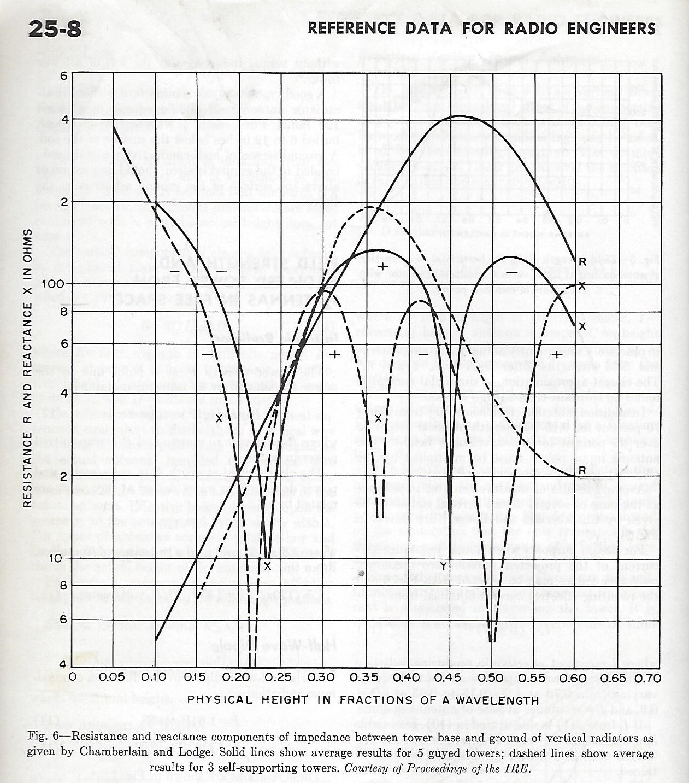
- Antenna requirements for NAVTEX and NAVDAT systems
The antenna requirements for NAVTEX and NAVDAT are different, but it is possible to transmit both NAVTEX and NAVDAT from the same transmitter and tower that is designed and configured for NAVDAT. This would provide a backward compatible system to serve in the transition period. For digital systems such as NAVDAT, a low-Q (Q = X/R, where Q = 1 or less) antenna is ideal to provide linear phase shift across the transmission bandwidth. Low-Q is achieved when the reactance Y is less than the resistance R such as in the vicinity of 0.25 wavelength antenna height as shown above. For NAVTEX and NAVDAT, this occurs at a height of approximately 150 meters for both guyed and self-supporting towers.
- NAVDAT Estimated Data Rates for Various Transmission Modes
Lower tower heights, e.g., 90 meters (0.15 wavelengths), can be impedance matched to the transmitter using a series matching inductor. This would result in a Q of 13, according to FIGURE 1. Although this is acceptable for NAVTEX, which is a narrow-band analog system, its application for NAVDAT should be carefully evaluated. TABLE 23 below describes the various NAVDAT transmission modes and the associated spectrum occupancy. For NAVDAT transmission, the 3 dB bandwidth of the antenna tower should be at least three times the spectrum occupancy to avoid inter-symbol interference caused by nonlinear group delay within the occupied bandwidth. For the 90-meter tower example above, the Q of 13 provides a 3 dB bandwidth of 500 kHz/13 = 38.4 kHz, which is adequate to support the NAVDAT transmission modes 0-23.
TABLE 23
Estimated data rates for 10, 5, 3, 1 kHz bandwidth for short frame transmissions

Mode | Spectrum occupancy (kHz) | Modulation  (n-QAM) | Code rate | Estimated data rate  (kbps)
0 | 10 | 4-QAM | 0.5 | 6.36
1 | 10 | 4-QAM | 0.75 | 9.56
2 | 10 | 16-QAM | 0.5 | 12.72
3 | 10 | 16-QAM | 0.75 | 19.12
4 | 10 | 64-QAM | 0.5 | 19.08
5 | 10 | 64-QAM | 0.75 | 28.68
6 | 5 | 4-QAM | 0.5 | 2.89
7 | 5 | 4-QAM | 0.75 | 4.35
8 | 5 | 16-QAM | 0.5 | 5.78
9 | 5 | 16-QAM | 0.75 | 8.69
10 | 5 | 64-QAM | 0.5 | 8.67
11 | 5 | 64-QAM | 0.75 | 13.04
12 | 3 | 4-QAM | 0.5 | 1.67
13 | 3 | 4-QAM | 0.75 | 2.52
14 | 3 | 16-QAM | 0.5 | 3.35
15 | 3 | 16-QAM | 0.75 | 5.03
16 | 3 | 64-QAM | 0.5 | 5.02
17 | 3 | 64-QAM | 0.75 | 7.55
18 | 1 | 4-QAM | 0.5 | 0.55
19 | 1 | 4-QAM | 0.75 | 0.84
20 | 1 | 16-QAM | 0.5 | 1.12
21 | 1 | 16-QAM | 0.75 | 1.68
22 | 1 | 64-QAM | 0.5 | 1.67
23 | 1 | 64-QAM | 0.75 | 2.52

The group call identification format of the ship station is defined in part 1 of Annex 1 of Recommendation ITU-R M.585.
Reference Data for Radio Engineers, Howard W. Sams & Co., Inc., Fifth Edition

