U.S. Radiocommunications Sector
Fact Sheet
Working Party: ITU-R WP-5C | Document No: USWP5C23_16 rev.1
Ref: Resoultion ITU-R 59-2 | Date: 23 September 2022
Document Title: WORKING DOCUMENT TOWARDS A PRELIMINARY DRAFT NEW REPORT ITU-R F.[ENG & PMSE]
Author(s)/Contributors(s):  Name: Joe Ciaudelli  Org: Sennheiser | Phone: (860) 848-3132 office landline  Phone: (860) 848-7422 mobile  Email: joe.ciaudelli@sennheiser.com
Purpose/Objective: The purpose of this contribution is to propose a report on aspects of ENG & PMSE related to fixed systems.

Abstract: At the WP 5 conference in May 2022, it was decided that a new report on Audio PMSE that was submitted to WP 5C would be segmented into land mobile, fixed, and broadcast components and managed by WP 5A, 5C, and 6A respectively. The document was attached to the WP 5C Chairman’s report pending contributions specific to fixed systems. This contribution proposes a new F series ENG and PMSE report that is loosely based on the original report.

Radiocommunication Study Groups | 
Source: Document 5C/TEMP/xxx  Subject: Resolution ITU-R 59-2 | Document 5C/xxx
 | xx November 2022
 | English only
United States of America
WORKING DOCUMENT TOWARDS A PRELIMINARY DRAFT
NEW REPORT ITU-R F.[ENG & PMSE]
ENG and PMSE Operations in Frequency Bands Allocated to Fixed Services

Background
At the WP 5 conference in May 2022, it was decided that a new report on Audio PMSE that was submitted to WP 5C would be segmented into land mobile, fixed, and broadcast components and managed by WP 5A, 5C, and 6A respectively. The document was attached to the WP 5C Chairman’s report as Annex 11 pending contributions specific to fixed systems. This effort is in support of the studies called for in Resolution ITU-R 59-2:
“ resolves
1 to carry out studies regarding possible solutions for global/regional harmonization of frequency bands and tuning ranges for ENG use, focused on bands already allocated, on a primary or secondary basis, to the fixed, mobile or broadcasting services, taking into account:
– that some frequency bands have more favourable properties suitable for ENG use;
– available technologies to maximize efficient and flexible use of spectrum;
– system characteristics and operational practices which facilitate the implementation of these solutions;
2 to develop ITU-R Recommendations and/or ITU-R Reports based on the aforementioned studies, as appropriate,
further resolves
1 to encourage administrations to develop relevant information concerning their national ENG use (e.g. a list of frequency bands available for ENG, spectrum management practices, technical and operational requirements, and spectrum authorization points of contact, as appropriate…) for use by foreign entities during worldwide newsworthy events;

Discussion
Annex 11 of the WP 5C Chairman’s report had limited information directly related to fixed services. Therefore, a new report that is focused on fixed services is appropriate.

Proposal
Suppress the existing Annex 11 and start a new report (see attachment).

Attachment:
WORKING DOCUMENT TOWARDS A PRELIMINARY DRAFT
NEW REPORT ITU-R F.[ENG & PMSE]
ENG and PMSE Operations in Frequency Bands Allocated to Fixed Services

ATTACHMENT

WORKING DOCUMENT TOWARDS A PRELIMINARY DRAFT
NEW REPORT ITU-R F.[ENG & PMSE]
ENG and PMSE Operations in Frequency Bands Allocated to Fixed Services

1 Scope
This Report provides information on the current use and spectrum needs of Electronic News Gathering (ENG) as well as Services Ancillary to Broadcasting (SAB); Services Ancillary to Programme making (SAP); and Outside Broadcasting (OB) operating in frequency allocated to fixed services, in accordance with resolves 1 and resolves 2 of Resolution 59-2 (RA-19). Where there is no distinction between the above-named activities the term Programme Making and Special Events (PMSE) is used in this Report.

2 Background
Resolution 59-2 (RA-19) invites for Studies on availability of frequency bands for worldwide and/or regional harmonization and conditions for their use by terrestrial electronic news gathering systems and resolves:
– to carry out studies regarding possible solutions for global/regional harmonization of frequency bands and tuning ranges for ENG use, focused on bands already allocated, on a primary or secondary basis, to the fixed, mobile or broadcasting services, taking into account:
– That some frequency bands have more favourable properties suitable for ENG use;
– Available technologies to maximize efficient and flexible use of spectrum;
– System characteristics and operational practices which facilitate the implementation of these solutions;
– to develop ITU-R Recommendations and/or ITU-R Reports based on the aforementioned studies, as appropriate.

3 Related documents
ITU-R Recommendations: M.1824, F.1777, M.1637, BT.1868, BT.1871, BT.1872, BS.1116, BS.1283, and BS.1284
ITU-R Reports: BT.2069, BT.2338, and BT.2344

4 List of acronyms and abbreviations
3GPP 3rd Generation Partnership Project
AV Audio-Video
AC Alternating Current
BAS Broadcast Auxiliary Systems
CEN European Committee for Standardization
CEPT European Conference of Postal and Telecommunications Administrations
DECT Digital Enhanced Cordless Telecommunications
DMR Digital Mobile Radio
ECC Electronic Communications Committee
ENG Electronic News Gathering
ETSI European Telecommunications Standards Institute
FCC Federal Communications Commission
FDMA Frequency Division Multiple Access
IEEE Institute of Electrical and Electronics Engineers
IEM In-Ear Monitoring
IMT International Mobile Telecommunications
ISO International Organization for Standardization
MPX Multiplexed
NB Narrow Band
NPN Non-Public Network
OB Outside Broadcasting
PLMN Public Land Mobile Network
PMR Personal Mobile Radio
PMSE Programme Making and Special Events
PSD Power Spectral Density
RF Radio Frequency
SAB Services Ancillary to Broadcasting
SAP Services Ancillary to Programme making
TDD Time Division Duplex
TDMA Time Division Multiple Access
WMAS Wireless Multi-channel Audio System

5 Overview on PMSE
Programme Making and Special Events (PMSE) comprises applications used in SAB/SAP, ENG and OB. More widely, PMSE also includes applications used in meetings, conferences, cultural and education activities, trade fairs, local entertainment, sport, religious, political and other public or private events.
There are three main groups of PMSE equipment:
– audio PMSE – the most commonly used audio PMSE applications are wireless microphones (handheld and body worn), in-ear monitors, intercom, conferencing solutions and talkback systems – relevant content is provided by this document – ;
– video PMSE – the most commonly used video PMSE applications are portable or mobile wireless video links and cordless cameras (these are the most common PMSE applications in bands allocated to the fixed service);
– PMSE service links – PMSE equipment that is used for data transmission for production such as effect and remote control and team connection) including OB, BAS and SNG.
Radiocommunication systems used in ENG and PMSE enable the capture of audio and video content. A variety of platforms distribute this content including terrestrial and satellite broadcast, internet streaming, and in the case of live events, directly to the audience attending the event. PMSE content capture takes place at the front end of every production and is the start of the supply and value chain of the creative and cultural industries (CCI) and enables activities such as the recording of live performances and archiving of culturally significant material.
Therefore, PMSE plays an important role for
– The social cohesion and citizenship;
– Supporting education and learning;
– Allowing creativity and cultural excellence;
– Capturing peoples’ opinions, statements and debates.
For these reasons, safeguarding the quality and reliability of the radio link are fundamental to ENG and PMSE. For live productions, radio links free of harmful interference are required as the moment to be captured cannot be repeated.
Consequently, content capture is expected to provide the highest quality possible, with producers and programme makers taking steps to ensure the quality and robustness of content capture and delivery.

6 ENG & PMSE applications that operate in the FS bands

6.1 Background/Introduction
The range of ENG and PMSE applications used at an event can range from the very simple, for example a single wireless microphone in a conference room, to the very complex with multiple wireless audio channels, and terrestrial and airborne video cameras and links, for example large sporting events such as the Formula 1 Grand Prix.
In relation to bands allocated to the fixed service, the most typical ENG and PMSE applications are for wireless cameras and video links, although they are also used for some audio links as well. These links can be fixed (temporarily or permanent, portable, or mobile including on vehicles and aircraft. Narrowband audio PMSE applications, such as wireless microphones, in ear monitors and communication links (referred to as Talkback), typically operate in bands other than those allocated to the fixed service, however, wideband audio systems such as WMAS could operate in some bands allocated to the fixed service (and used by video PMSE). Table 1 provides a summary of the categories of PMSE video links in regular use.
Table 1: Categories of ENG and PMSE video links in regular use
Type of link | Definition
Radio camera  (line-of-sight) | Handheld or otherwise mounted camera with integrated or Clip-on transmitter, power pack and antenna for carrying broadcast-quality video together with sound signals over short-ranges line-of-sight
Radio cameras  (non-line-of-sight) | Handheld or otherwise mounted camera with integrated or Clip-on transmitter, power pack and antenna for carrying broadcast-quality video together with sound signals over short-ranges non-line–of-sight
Miniature  camera/links | Very small transmitter and miniature camera for specialist action shots, e.g. helmet cam, covert assignments, UAV, etc. Can be body worn or covert assignments
Portable video link | Small transmitter, for deployment over greater ranges, typically up to 2km
Mobile air-to-ground  video link | Video transmission system employing radio transmitter and receivers mounted on helicopters, airships or other aircraft (includes repeaters and relays)
Mobile vehicular  video link (including  ground-to-air) | Video transmission system employing radio transmitter mounted in/on motorcycles, racing motorbikes, pedal cycles, cars, racing cars or boats. One or both link terminals may be used while moving
Temporary point-to-point  video links | Temporary link between two points (e.g. part of a link between an OB site and a studio or network terminating point), used for carrying broadcast quality video/audio signals. Link terminals are mounted on tripods, temporary platforms, purpose-built vehicles or hydraulic hoists. Two-way links are often required.
The PMSE elements described above are in the form of a digital transport stream which can include a number and combination of video, audio, data and metadata elementary streams

6.2 Efficient use of radio spectrum
PMSE operations for SAP/SAB, and OB are typically short-term events subject to significant planning. For example, sporting events, festivals and filming are subject to many months of preparation, while the event itself might only last a day or even less. Planning will involve site and spectrum surveys to identify the optimum use of equipment, resources and spectrum. The nature of spectrum access for these applications, therefore, is on the basis of ‘only when needed’.
ENG (electronic news gathering) is very different, often occurring at short notice at any time and in any place. Consequently, any time for planning is minimal and news broadcasters typically have prior agreements/arrangements with national administrations to access spectrum for cameras and video links quickly to respond to the breaking news story.
To maximise (spectrum) flexibility, PMSE equipment is designed to operate over a tuning range within bands assigned and in use by another user within a spectrum sharing model. For example, in some countries video PMSE is operates in bands used by the military under a coordination agreement.

6.3 Fixed Service Frequency Bands for ENG & PMSE
Ideally, spectrum availability for ENG and PMSE would be harmonized to benefit from economies of scale and interoperability across borders, particularly in the case of ENG. However, this is typically not the case and so equipment is designed for flexibility, with several band variants available to suit different markets and divergent national frequency plans. This is termed a “tuning range” which means:
- a range of frequencies over which the radio equipment is capable of operating; within the range of frequencies identified nationally (if any) within that country for PMSE, and in accordance with the related national regulatory conditions and requirements. Within each tuning range, countries may assign specific sub-bands or particular frequencies for PMSE links subject to availability, actual demand and sharing arrangements with other services and applications.
When considering the spectrum identified for use by ENG and PMSE on a tuning range basis, it can appear that there is a large amount of spectrum available. However, the available spectrum within the tuning ranges in any particular country is determined on a national basis; each tuning range may be wholly, partially or not available.
The following bands are identified as harmonized tuning ranges for video PMSE.
Table 2: harmonised tuning ranges for video ENG & pmse
 |  | Allocation to the Fixed Service in the RRs
Freq Band | PMSE Application
2010-2025 MHz | Cordless Cameras; Portable video links; Mobile video links | Primary: Regions 1, 2 & 3
2025-2110 MHz | Cordless Cameras; Portable video links; Mobile video links | Primary: Regions 1, 2 & 3
2200-2300 MHz | Cordless Cameras; Portable video links; Mobile video links | Primary: Regions 1, 2 & 3
2300-2400 MHz | Cordless Cameras; Portable video links; Mobile video links | Primary: Regions 1, 2 & 3
2400-2500 MHz | Cordless Cameras; Portable video links; Mobile video links | Primary: Regions 1, 2 & 3
7.0-8.5 GHz | Cordless Cameras; Portable video links; Mobile video links; Temporary point-to-point video links | Primary: Regions 1, 2 & 3
10.0-10.68 GHz | Cordless Cameras; Portable video links; Temporary point-to-point video links | 10-10.45 GHz-  Primary: Regions 1 & 3  10.45-10.68 GHz-  Primary: Regions 1, 2 & 3
21.2-24.5 GHz | Cordless Cameras; Temporary point-to-point video links | 21.2-23.6 GHz  - Primary: Regions 1, 2 & 3  23.6-24.25 GHz-  - Not allocated to the FS  24.25-24.5 GHz  - Primary: Regions 1, 2 & 3
47.2-50.2 GHz | Cordless Cameras | Primary: Regions 1, 2 & 3

In the United States the following bands are allocated to fixed services and are permitted for wireless microphone operations. Canada also allows microphones in this frequency range:
941.5 - 952 MHz
952.85 - 956.25 MHz
956.45 - 959.85 MHz

7 Technical characteristics [high-level]

7.1 Compression and Bandwidth Requirements for Video
The radio characteristics of video PMSE applications depend on the use particular use case, for example, if the link is from the handheld camera to the OB truck or from a mobile camera (mounted on a motorcycle) linked to a helicopter, then to a fixed-wing aircraft and then to the OB truck or TV compound.
A variety of different modulation schemes are used, with different parameters chosen to suit the particular application and link quality. The following technologies, generally used for television broadcast distribution, are in common use also for video PMSE equipment:
- DVB-T
- DVB-T2
- DVB-S2 (used for point-to-point links, air-to-ground links from aircraft, and for Sat-coms, where line-of-sight transmission can be maintained at all times, since it provides capacity advantages over other COFDM systems)
- LMS-T (proprietary modulation scheme)
- ISDB-T
- RUBY (designed for more difficult obstructed paths where line-of-sight transmission cannot be maintained)

While it is difficult to define a ‘typical’ use case, the most fundamental configuration is for a wireless camera to an OB truck. As the camera is the initial application for the onward production value chain, it is critically important that the wireless link is robust and with sufficient bandwidth to support the required video quality.
The data rate needed for a wireless camera link is based on the vertical and horizontal resolution (number of pixels), the colour depth (bit depth) and the frame refresh frequency. For example, the raw data rate for a high-definition camera operating at 60 fps (frames per second) is:
- 24 (colour depth) × (1920 × 1080 (resolution)) × 60 fps = 2.99 Gbit/s
A variety of video compression schemes are applied to reduce the video data-rate to suit the capacity of the radio link while maintaining high picture quality for subsequent editing and distribution. The following video compression schemes are in common use:
- MPEG2;
- JPEG2000 (very high bit rates, short range <300m);
- AVC, MPEG4 - H.264;
- HEVC (High Efficiency Video Coding) – H.265

7.2 Audio technology

7.2.1 Overview
The ETSI standard EN 300 422-1/2/3 [1][2][3] (see Section 7.1) describes the following three radio interfaces:
a) Narrow-Band Analogue – following a link-based approach;
b) Narrow-Band Digital – following a link-based approach; and
c) Wireless Multi Audio-channel System (WMAS) – following a system-based approach to serve N portables.
Scaling the number of links to support multi-audio channel applications in the link-based approach forms complex systems with microphone receivers and IEM transmitters being mounted to separate racks to avoid blocking. Each link requires its own centre frequency and RF channel.
Figure 2 shows the general setting for the link-based approach. The radio interface can employ analogue or digital modulation techniques for the audio plane, while the control plane is realized with an additional SRD link or IrDA interface.
Figure 2
Radio Interface for Link-based Approach
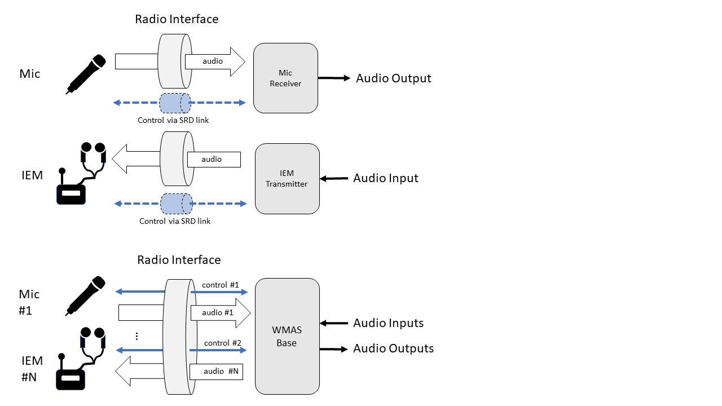
Figure 3 outlines the radio interface of a WMAS that offers multiple audio and control planes integrated in a single wideband radio interface. The direction of each dedicated audio plane is defined by the portable type connected. WMAS can support up to N devices.
Figure 3
Radio Interface WMAS for #N portables
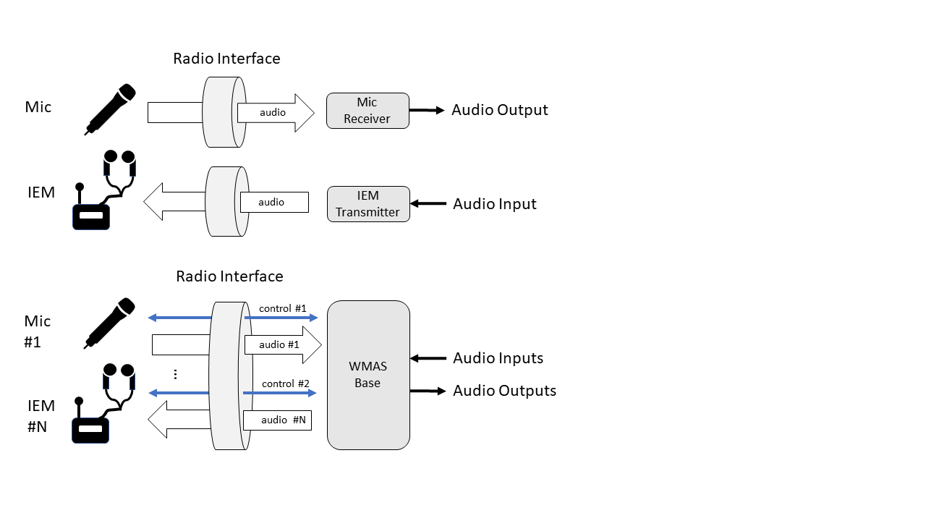
All audio PMSE equipment operate typically on a free tuning concept to accommodate specific radio spectrum deployment conditions and to account for existing radio spectrum occupancy within their service area.
The time parallel operation of PMSE applications e.g. wireless microphones, IEM and/or WMAS in the same service area require suitable frequency separations.
Frequency planning and coordination in the service area are assisted by spectrum scanning procedures and software tools including the support for mixed vendor deployments. This approach also supports the possible ad-hoc and nomadic deployments of Audio PMSE in service areas where Audio PMSE is already in use.

7.2.2 Narrow-Band Analogue
This is defined as an audio PMSE radio interface employing analogue modulation techniques (as summarized in Table 4) with a link-based approach (dedicated transmitter-receiver pair for a single audio link transmission on a dedicated centre frequency). The audio content plane is uni-directional carrying a Mono or MPX-Stereo signal. Additional audio links are established via deployment of additional, unique RF channels.
Table 4
Parameters Audio PMSE Narrow-band Analogue
Parameter | Description | Comments
Application | PMSE – link-based approach
Channel bandwidth / Channel Spacing | typical 200 kHz /  free tuning, placement on non-equidistant grid to account for transmitter intermodulation products. | 1
Modulation / Occupied Bandwidth | Analogue: Frequency Modulation
Direction | Audio plane:  uni-directional  Control data plane:  employing separate SRD radio interface
Transmit Power / PSD | Typical:  max. 50 mW e.r.p. below 1 GHz  max. 50 mW e.i.r.p. above 1 GHz | 2
Transmit Spectrum Mask | EN 300 422/ EN 301 357 / EN 300 454 | 3
Channel Access and occupation | Constant duty cycle, up to 100% occupancy in time.
Frequency planning assumptions |  | 4  5
Relevant Standard | EN 300 422/ EN 301 357 / EN 300 454
1 EN 300 422 enable certain other channel bandwidths within the range 50 kHz to 600 kHz
2 Configuration of portables via IrDA and/or a control plane is established via additional other radio interface in different frequency band.
3 The maximum transmit power is defined in national radio regulations and interface descriptions. Higher maximum transmit power may be allowed by licensing terms / special permits.
4 Audio PMSE, being a low latency critical application, does not allow co-channel operation by other radio interface technologies.
5 Frequency Planning assisted by spectrum scanning procedures and software includes support for mixed vendor deployments. Time parallel operation of radio microphones, IEM and/or WMAS in same coverage area require suitable frequency separation.

7.2.3 Narrow-Band Digital
This is an audio PMSE radio interface employing digital modulation techniques (as summarized in Table 5) with a link-based approach (dedicated transmitter-receiver pair for a single audio link transmission on a dedicated center frequency). Audio is Mono or Stereo. Additional audio links are established via deployment of additional, unique RF channels.

Table 5
Parameters Audio PMSE Narrow-band Digital
Parameter | Description | Comments
Application | PMSE – link-based approach
Channel bandwidth / Channel Spacing | typical 200 kHz /  free tuning, allowing equidistant grid, placement with typical 200 kHz to 600 kHz channel separation. | 1
Modulation / Occupied Bandwidth | Digital Modulation
Direction | Audio plane:  uni-directional  Control data plane:  employing separate SRD radio interface | 2
Transmit Power / PSD | Typical:  max. 50 mW e.r.p. below 1 GHz  max. 50 mW e.i.r.p. above 1 GHz | 3
Transmit Spectrum Mask | EN 300 422/ EN 301 357 / EN 300 454
Channel Access and occupation | Constant duty cycle, up to 100% occupancy in time.
Frequency planning assumptions |  | 4  5
Relevant Standard | EN 300 422/ EN 301 357 / EN 300 454
1 EN 300 422 enable certain other channel bandwidths within the range 50 kHz to 600 kHz
2 Configuration of portables via IrDA and/or a control plane is established via additional other radio interface in different frequency band.
3 The maximum transmit power is defined in national radio regulations and interface descriptions. Higher maximum transmit power may be allowed by licensing terms / special permits.
4 Audio PMSE, being a low latency critical application, does not allow co-channel operation by other radio interface technologies.
5 Frequency Planning assisted by spectrum scanning procedures and software includes support for mixed vendor deployments. Time parallel operation of radio microphones, IEM and/or WMAS in same coverage area require suitable frequency separation.

7.2.4 Wireless Multi-channel Audio System (WMAS)
WMAS is an audio PMSE radio interface establishing a system-based approach (as summarized in Table 6) for multi-channel audio applications serving e.g. microphone, IEM and talkback in a single RF channel. Additional scaling of capacity (e.g. more audio channels as supported by a single WMAS base) via deployment in additional RF channels is possible. WMAS allows a flexible configuration of each audio channel regarding direction (IEM or Mic), mapping of audio channels to a device, latency, audio quality and link reliability.

Table 6
Parameters Audio PMSE WMAS
Parameter | Description | Comments
Application | PMSE – system-based approach
Channel bandwidth / Channel Spacing | Typical {6,7,8} MHz (international DTT channel grid) or 10 MHz /  Free tuning but accommodating predominant channel raster of incumbent. | 1
Modulation / Occupied Bandwidth | Digital Modulation
Direction | Multiple audio planes, bi-directional  Multiple control data planes, bi-directional | 2
Transmit Power / Power Spectral Density (PSD) | Typical:  max. 50 mW e.r.p. below 1 GHz  max. 50 mW e.i.r.p. above 1 GHz | 3  4
Transmit Spectrum Mask | EN 300 422
Channel Access and occupation | Typical TDD TDMA  Constant duty cycle, up to 100% occupancy in time. | 5
Frequency planning assumptions | ETSI TR 103 450 | 6  7
Relevant Standard | EN 300 422
1 EN 300 422 enables a channel bandwidth of up to 20 MHz for WMAS. However, based on practical considerations, WMAS is likely to be utilized in the channel grid employed by an incumbent service (e.g. broadcasting or other). EN 300 422 requires WMAS to support at least one mode supporting in minimum three audio channels / MHz.
2 Bi-directional control data plane is available, enabling permanent control and reconfiguration of all portables. This enables resource re-assignments at run-time to other portables.
3 The maximum transmit power is defined in national radio regulations and interface descriptions. Higher maximum transmit power may be allowed by licensing terms / special permits. Larger occupied bandwidth results in lower PSD because maximum transmit power is per device. Example: PSD of an 8 MHz-wide WMAS is 16 dB lower than the one of a single 200 kHz link.
4 In systems employing TDMA, the total transmit power in a given RF channel is not scaled with the number of WMAS devices deployed because each device only transmits in a short time slot and is limited to the maximum transmit power.
5 ETSI TR 103 450 also envisions other duplex and multiple access schemes.
6 Audio PMSE, being a low latency critical application, does not allow co-channel operation by other radio interface technologies.
7 Frequency planning assisted by spectrum scanning procedures and software includes support for mixed vendor deployments. Time parallel operation of radio microphones, IEM and/or WMAS in the same coverage area require suitable frequency separation.

In ITU-R Res 59-2, electronic news gathering (ENG) is used to refer to SAB/SAP, ENG and OB.

