U.S. Radiocommunications Sector
Fact Sheet
Working Party: ITU-R WP 5C | Document No: USWP5C 28-17
Ref: | Date: 09/01/2022
Document Title: Working Document Towards a Preliminary Draft New Report on Spectrum and Link Availability for Channel Bandwidths of 12, 24 and 48 kHz within the 3-30 MHz Frequency Range
Author(s)/Contributors(s):  Fumie Wingo  Department of the Navy  Jerome Foreman  Department of the Navy  Robert Leck  ACES in support of the Department of the Navy  Taylor King  ACES in support of the Department of the Navy | Phone: +1-703-697-0066  Email: fumie.n.wingo.civ@us.navy.mil  Phone: +1-703-999-7911  Email: jerome.j.foreman.civ@us.navy.mil  Phone : +1-321-332-2111  Email : robert.leck@aces-inc.com  Phone : +1- 443-966-0550  Email : taylor.king@ACES-INC.COM
Purpose/Objective: This is a Fact Sheet for a Working Document Towards a Preliminary Draft New Report (PDNR) on Spectrum and Link Availability for Channel Bandwidths of 12, 24 and 48 kHz within the 3-30 MHz Frequency Range The objectives of this work are to conduct an analysis of allocations within the 3 to 30 MHz frequency band to assess the availability of a sufficient range of frequencies to support wide channel bandwidths and to summarize the results of existing channel availability measurments and studies to support the potential of operationally utilizing wider channel bandwidths within the 3 to 30 MHz frequency band.
Abstract: The availability of 12 to 48 kHz Channel Bandwidths within the 3 to 30 MHz frequency band is essential to providing enhanced, and advanced digital services. This report presents an assessment of available frequency ranges and a summary of various link availability studies to assess the feasibility of deploying systems that utilize 12 to 48 kHz channel bandwidths within the 3 to 30 MHz frequency band.

Radiocommunication Study Groups | 
Received: MM-DD-2022  Subject: | Document 5C/XX-E
Received: MM-DD-2022  Subject: | DD MMM YYY
Received: MM-DD-2022  Subject: | Original: English
United States of America
Working Document Towards a Preliminary Draft New Report on Spectrum and Link Availability for Channel Bandwidths of 12, 24 and 48 kHz within the 3-30 MHz Frequency Range
Proposal
The United States proposes that ITU-R Working Party (WP) 5C consider the Draft New Report regarding Spectrum and Link Availability for Channel Bandwidths of 12, 24 and 48 kHz within the 3-30 MHz Frequency

Attachment: Working Document Towards a Preliminary Draft New Report on Spectrum and Link Availability for Channel Bandwidths of 12, 24 and 48 kHz within the 3-30 MHz Frequency Range

ATTACHMENT
REPORT ITU-R F.XXX
Working Document Towards a Preliminary Draft New Report on Spectrum and Link Availability for Channel Bandwidths of 12, 24 and 48 kHz within the 3-30 MH Frequency Range
TABLE OF CONTENTS
TBD
Abbreviations/Glossary
HF – High Frequency
LAN – Local Area Network
AGILE-HG –
ALE – Automation Link Establishment
CMA –
DFS -
MESH Network –
FS –
MS –
LMS –
AMS –
MMS –
BS –
AMRS –
AMORS –
Amateur –
RLS –
SFTS –
ITU
Kbps

Introduction
HF systems that are currently providing emergency, financial, email, video and networking services have a need for higher data rates. To meet desired data rates up to 240 kbps channel bandwidths of between 30 and 48 kHz are required. To provide enhanced applications and advanced digital systems optimal performance HF systems must have: 1) the capability of supporting channel bandwidths of up to 48 kHz and 2) the ability to provide global access networking (MESH Networks).
A mesh network is a global local network topology in which infrastructure nodes connect directly, dynamically, and non-hierarchically to many other nodes and cooperate with one another to use and share spectral link space while efficiently routing data from and /to clients at optimal data transmission rates.
Spectral efficiency is realized utilizing Dynamic Frequency Selection (DFS) such as advanced Automatic Link Establishment (ALE) techniques and transmission waveforms that improves spectrum utilization and sharing with incumbents that can facilitate the deployment of enhanced digital services through advanced techniques that automatically negotiate the radio frequency (RF) environment and adjust and select channel sizing (bandwidth) while mitigating harmful interference to primary users in or adjacent to desired operational frequencies. To capitalize off of these advanced techniques and provide enhanced and advanced digital services within the HF band the availability of wider channel bandwidths within the HF Frequency band needs to be qualified. This document assesses the availability of frequency ranges within the HF Frequency Band that can support wide channel bandwidths by quantifying available spectrum through 1) an allocation-based analysis and 2) a summary of previously conducted link availability measurements. .
1.0 Channel Availability - Allocation Analysis
1.1 Methodology
This analysis is only concerned with identifying frequency segments within the 3 to 30 MHz frequency band that could support channel bandwidths of up to 48 kHz. It does not address any of the regulatory issues that would be associated with the use of the segments of the 3 to 30 MHZ frequency band identified as being able to support systems operating with channel bandwidths of up to 48 kHz
The allocation analysis is based upon ITU-R HF Frequency Band allocations. ITU Radio Regulations (RR) were used to identify current allocations in the 3 to 30 MHz frequency range. ITU RR and every HF frequency (2-30 MHz) band in the Article 5 allocations table including those regulated by ITU RR Appendices 17, 26, and 27 were considered. Each allocation was examined to determine if blocks within the frequency range that was associated with the allocation could support channel bandwidths up to and including 48 kHz. This was done to identify HF bands that could support 12, 24 or 48 kHz channel bandwidths. Services that utilized significant spectrum within a given allocation were not considered in the analysis.
Appendix 1 contains a spreadsheet that is associated with the analysis. The spreadsheet lists: frequency blocks, ITU- Regions, individual frequency ranges within a block, the block size, services that are operating within the frequency block and allocation footnotes that were considered during the analysis. .
1.2 Analysis Results
Considerations that were taken into account when analyzing the collected data included global Working Document Towards a Preliminary Draft New Report on Spectrum and Link Availability for Channel Bandwidths of 12, 24 and 48 kHz within the 3-30 MH Frequency Range availability, sufficient frequency range to support channel bandwidths of up to 48 kHz and the ability to operate across multiple services (fixed, aeronautical, maritime and land mobile).
Certain HF bands were excluded from consideration. These included HF bands without a Primary Mobile allocation, HF bands that did not have enough bandwidth to support wide band channel bandwidths, bands where wide channel bandwidths were not allowed and HF bands from Article 5 which were not allocated to the Mobile Service and are not governed by ITU RR Appendices 17, 26, or 27.
Allocation-based analysis results can be found in Appendix 1. The Appendix includes results for Frequencies and Frequency Blocks that cannot support wide band channel widths, Frequencies and Frequency Blocks that could support Wide Channel Bandwidths but could require interference, sharing and compatibility studies and Frequencies and Frequency Blocks that could support Wide Channel Bandwidths which are summarized in Table 1. Although other services are listed in Table 1 of interest for this analysis is limited to Fixed services. Green blocks in the ITU R1, R2 and R3 columns indicate ranges of frequencies that could support wide channel bandwidths. White blocks indicate that wide channel bandwidths are not supportable across the given frequency range.
Table 1
Frequencies and Frequency Blocks that could support Wide Channel Bandwidths
1.3 Summary of Results – Allocation Analysis
The allocation-based analysis shows that there is spectrum availability within segments across the 3-30 MHz frequency band that can support Channel Bandwidths of 12, 24 and 48 kHz. Of the frequency bands analyzed, the ITU RR in its current form provides sufficient bandwidth to meet wider channel bandwidth requirements. Additional clarification on regulations regarding interoperability across geographic regions needs to be investigated.
2.0 Link Availability Measurements
Given that frequency ranges are available that could support channel bandwidths of up to 48 kHz the next question that needs answering is whether there is sufficient link availability to operationally support the deployment of systems that use 12 to 48 kHz channel bandwidths.
Over the past 10 -15 years many experiments, trials and measurements have taken place. Including Wideband HF IP. The objectives of these efforts were to: 1) measure the Channel Minute Availability (CMA) and 2) use the data from those measurements to assess the link availability within the 3 to 30 MHz frequency range for channel bandwidths of 12, 24 and 48 kHz .
The data that was used in this report was collected at locations across ITU Regions 1,2 and 3
The following sections of this report discuss the measurement and analysis methodologies that were used to acquire the CMA data and provide a summary of those measurements across ITU Regions 1,2 and 3.
2.1 Measurement Methodology
Measurements were conducted using a spectrum sensing system that scanned the HF frequency band (3 MHz to 30 MHz) on a minute-by-minute basis collecting channel occupancy statistics by frequency and time of day. Although data was collected for 3, 6, 12, 24 and 48 kHz channel bandwidths this report is focused on the wider bandwidths (12, 24 and 48 kHz) that are required for advanced and enhance HF communications, data, and networking services. The collected data is processed to determine average hourly occupancy for 12, 24 and 48 kHz bands. The results are displayed as a matrix showing Channel Minute Availability (CMA) as a function of frequency and time of day. CMA is a very good metric to describe how much capacity is available and can be viewed as the best-case maximum channel availability. Figure 1 is an example of a CMA Matrix .

Figure 1
CMA Matrix (48 kHz Channel Bandwidth)
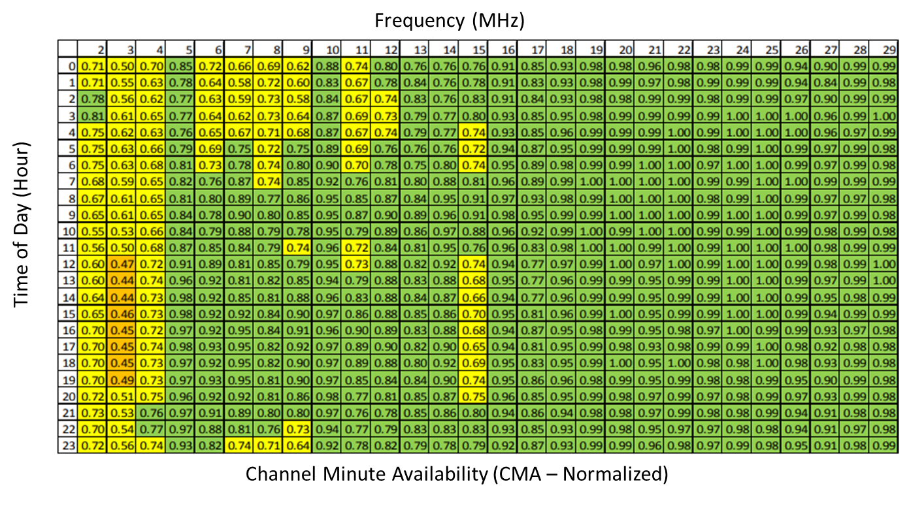
The Chanel-Minute Availability (CMA) metric is defined to give an indication of how much bandwidth is available without regard to channel assignments and allocations. If a single 3 kHz channel is shown to be available for three measurements in a row, signifying that the channel was available for at least two minutes, then that channel is considered available for that minute. This rule was applied to include channels that were statically available for several minutes and to discount channels that were sporadically changing in occupancy, such as an active communication channel with bi-directional digital traffic or voice. Applying the CMA metric, each 3 kHz channel, in the 3 to 30 MHz range could have a maximum availability of 60 in each hour.
2.2 Measurement Analysis
Each twenty-four-hour measurement generates a large amount of data. To effectively manage the analysis of the data, occupancy was cataloged on a per hour basis for each one MHz block .
Each measurement sweep is individually processed. The main goal of the processing software is to establish a noise floor so that any 3 kHz channels which have a received signal level more than a specified threshold above this noise floor can be considered as unavailable.
Initially, to establish a noise floor for each one MHz segment the 3 kHz-based power values were sorted and the average of the ten lowest values was calculated. Each 3 kHz segment was then compared to a threshold of 10 dB above the noise floor. If the segment value was greater than the threshold it was considered occupied, otherwise it was considered available.
At the end of this processing each sweep observation file, representing one minute’s observation, is represented by a vector of 9334 values of 1 or 0 (available or occupied). Once all the sweep data is converted in this fashion it is further processed to yield availability metrics for bandwidths of 3 to 48 kHz.
2.3 Measurement Analysis Results
Channel Minute Availability data was obtained and analyzed for predicted propagating channels over a 24-hour day . Link availability was derived from the CMA data from various reports and is summarized here as a function of ITU-R Region. (Figure 2) .
Figure 2 – ITU-R Regions Compiled CMA Data
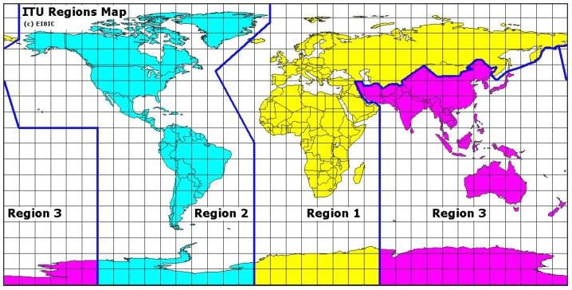

Overall availability in Region 1 was quite useable with CMAs ranging from 71% for 3 kHz channels to 54% for 24 kHz channels. Availability in Region 2 was good with CMAs ranging from 85% for 3 kHz channels to 75% for 24 kHz channels. . Even though the measurement systems were operated on a non-interfering basis link availability for a 48 kHz channel was 45%. While link availabilities for Bandwidths greater than 24 kHz were 70%.
Editors’ Note: Additional work needs to be done on summarizing data for Region 3.

2.4 Summary of Results – Link availability for 12, 24 and 48 kHz Channel Bandwidths
TBD
Editor’s Note : A table will be inserted in this section that summarizes the results of the studies.

3.0 Conclusions
An initial allocation-based analysis of the availability of frequency blocks within the 3-30 MHZ frequency band that can support channel bandwidths of 12, 24 and 48 has shown that there are blocks or segments of frequencies throughout the 3-30 MHz frequency band that can support global wide channel bandwidths. (e.g., 12,24 and 48 kHz channel bandwidth.)
An analysis based upon Channel Minute Availability (CMA) measurements has shown that CMA’s ranging from 45% to 75% are available across the 3-30 MHZ frequency band.
The combined results of the allocation-based channel availability analysis and the CMA measurments analysis have shown that there is sufficient bandwidth and link availability such that channel bandwidths of 12, 24 and 48 kHz can be supported in the 3-30 MHZ frequency band. However, to make use of this availability an adaptive wideband HF system that could find unused spectrum, coordinate its use, transfer data, and return the channel to availability with the minimum of overhead would be required.
To increase the channel availability statistical relevance; and to take solar cycle and seasonal effects into account , additional measurements should be considered across upper, mid, and lower latitudes within ITU-R Regions 1,2 and 3.

Appendix 1 – Allocation Analysis

ITU-R 1762 “Characteristics of enhanced applications for high frequency (HF) radiocommunication systems”
ITU-R 1821 “Characteristics of advanced digital high frequency (HF) radiocommunication systems”
M.B. Jorgenson, R.W. Johnson, R.W. Nelson, “An Extension of Wideband HF Capabilities,” Nov. 2013, IEEE
James Mahan, et al, “Wideband HF IP Experimentation”, January 2012, HFIA Conference
William N. Furman, John W. Nieto and William M. Batts, “Wideband HF Channel Availability – Measurement Techniques and Results”, IES 2015
William Furman, John Nieto, Eric Koski, “Interference Environment and Wideband Channel availability: August 2013, HFIA Conference
Wideband High frequency (WBHF) for Anti-Access Area-Denial (A2AD) Environments, James A. Stevens, L. Paul, T. Snodgrass and R.W. Nelson, IEEE Conference, October 2014
M. B. Jorgenson, Nigel T. Cook, “Results from a Wideband HF Usability Study”, April 2015, IEEE Conference

