U.S. Radiocommunications Sector
Fact Sheet
Working Party: ITU-R WP 5B | Document No: USWP5B30-yy
Ref: None | Date: August 30, 2022
Document Title: Approximation of 3-D Antenna Radiation Patterns from two orthogonal Pattern Slices for use in Radar simulations

Author(s)/Contributors(s):  Tan Ly  ASMO  Raafat Nasser  ACES Inc for US Army | Phone: 571-279-1676  Email: Tan.m.ly.civ@army.mil  Phone: (571) 277-4030  Email: Raafat.Nasser@aces-inc.com
Purpose/Objective: Discuss techniques to estimate the radar 3D antenna pattern from the independent radar antenna pattern slices for elevation (vertical) and azimuth (horizontal) defined in Recommendation M.1851.

Abstract: Recommendation M.1851 provides methodology to generate the independent radar antenna pattern slices for elevation (vertical) and azimuth (horizontal). The existing methodology to combine these slices into a 3D pattern for use is simulations works well for Omni directional antenna but is less accurate for radar directional antenna.
Propose to include an estimated 3D antenna pattern to use for radars to be included in M.1851 after discussions. This work is only technical and not related to any specific WRC agenda item.

Fact Sheet Preparer: Raafat Nasser, ACES Inc. for US Army

Radiocommunication Study Groups | 
Source: Document  Subject: | Document 5B/xx
Source: Document  Subject: | x November 2022
Source: Document  Subject: | English only
United States of America
Approximation of 3-D Antenna Radiation Patterns from two orthogonal Pattern Slices for use in Radar simulations
Introduction
Recommendation M.1851 provides methodology to generate the independent radar antenna pattern slices for elevation (vertical) and azimuth (horizontal). The existing methodology to combine these slices into a 3D pattern for use is simulations works well for Omni directional antenna but is less accurate for directional antenna.
Proposal
The United States of America would like to include, from existing literature and from methodology already being used in Matlab antenna toolbox, an estimated 3D antenna pattern to be use for radars to be included in M.1851 after discussions by the delegates.
Attachment: 1

Attachment: 1
Approximation of 3-D Antenna Radiation Patterns from two orthogonal Pattern Slices for use in Radar simulations Approximating three-dimensional (3-D) patterns

1 Introduction
In some cases, simulation and prediction techniques require the use of a 3-D antenna radiation pattern. Most antenna manufacturers provide information only about the two principal plane radiation cuts (azimuth/elevation) of the antenna used in the simulation. Since the 3-D pattern might be needed, a better estimate of the 3-D radiation using the azimuth and elevation cuts is provided.
In general, the simplest way to approximate the 3-D radiation pattern from its two principal cuts, is by summing the dB values of the available samples for each azimuth and elevation angle. This classic method is widely used in many simulation tools, when 3-D capabilities are required.
In the case of directional antennas, there are several methods that have been defined. See the reference list shows several of these references. Two simple methods have been selected from reference 3. These methods are the Summation method and the Weighted Summing Method. These methods are compared to the summing method.
The summing method is defined as adding the available samples of the horizontal and vertical planes in dB.
$$G_{sum}=G_{H}\left(φ\right)+G_{V}(θ)$$
For the weighted summing method in reference 3, the equations used in the reference depend on the horizontal cut G_{H} in dB, defined from -180° to 180°, and the vertical cut G_{V} in dB is defined from -90° to 90°. Only the front elevation gain pattern is used. The elevation backlobe gain pattern is not used in the methodology.
$G_{H}\left(φ\right)=10\log_{10}\left(gh(φ\right)$)
$G_{V}\left(θ\right)=10\log_{10}\left(gv(θ\right)$)
At point $(θ,φ)$, the weighted gain GW is approximated by (reference 3)
$$GW(θ,φ)=\frac{G_{H}\left(φ\right)×w1+G_{V}\left(θ\right)×w2}{\sqrt[k]{{w1}^{k}+{w2}^{k}}}$$
Where w1 and w2 are given by
$$w1\left(θ,φ\right)=gv(θ)×(1-gh(φ))$$
$$w2\left(θ,φ\right)=gh(φ)×(1-gv\left(θ\right))$$
It was stated in reference 3 that the concept behind this technique is that the estimation process of a radiation sample involves the actual data of the other principal elevation and azimuth pattern, as a function of angular distance between the point of interest and the sample point, in a cross-weighting manner between the two principal cuts.
In this approach, the weighting function provides with the means for appropriate angular distance weighting.
A value of k equal to 2 was found to work best for directional antennas.

2 Comparing Methods
The average radiation intensity can be found from a surface integral over the radiation sphere of the radiation intensity divided by 4π, the area of the sphere in steradians (Str). The total solid angle enclosed by any closed surface is 4π Str. Narrow antenna beams, like radar beams, have solid angles much smaller than 4π Str.
Since antenna models are used in studies, it is necessary to check which 3D antenna model may be used. To compare the models, it is proposed that the average radiation intensity be computed and compared. The average radiation intensity is given by the equation
$$Average Radiation Intensity =\frac{1}{4π} \int_{0}^{2π}{\int_{0}^{π}{G\left(θ,φ\right)\sin\left(θ\right)dθdφ}}$$
Assuming the number of the azimuth samples is M and the number of samples in elevation in N, then dθ = π/N and dϕ = 2π/M. The equation in summation form becomes
$$Average Radiation Intensity =\frac{π}{2NM} \sum_{j=1}^{M-1}{\sum_{i=1}^{N-1}{G\left(i,j\right)\sin\left(i\right)}}$$
The plots below show some examples.
TABLE 2
Results for several patterns
Pattern | Input Patterns and Results
ASR Radar Real Elevation Pattern | 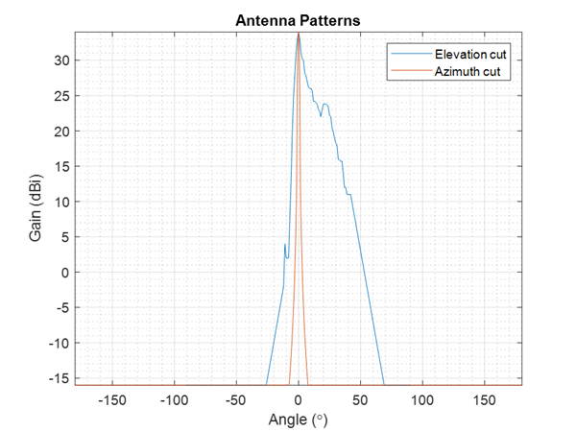
ARNS Radar Real Elevation Pattern. | 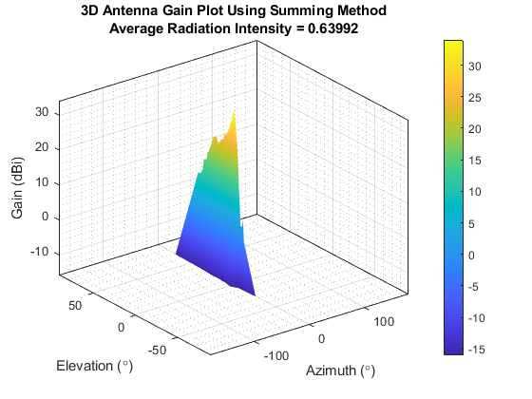
ARNS Radar Real Elevation Pattern. | 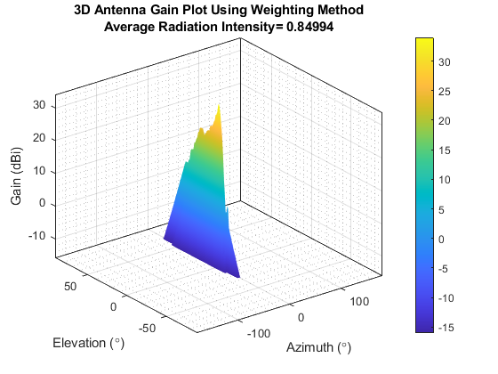
ARNS Radar Theoretical CSC² Elevation Radar Pattern
ARNS Radar Theoretical CSC² Elevation Radar Pattern | 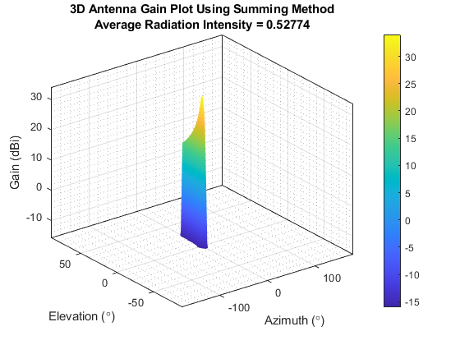
ARNS Radar Theoretical CSC² Elevation Radar Pattern | 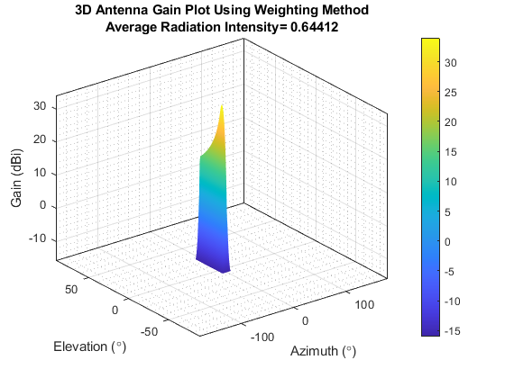
RF elements s.r.o. Antenna Pattern for STD-27-UM Antenna
RF elements s.r.o. Antenna Pattern for STD-27-UM Antenna | 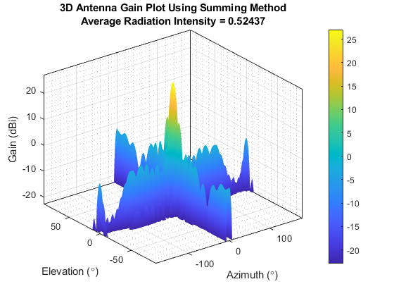
RF elements s.r.o. Antenna Pattern for STD-27-UM Antenna | 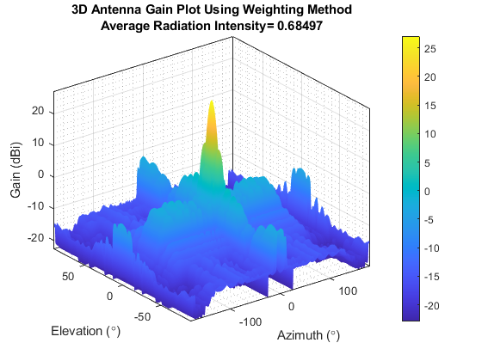
RF elements s.r.o. Antenna Pattern for UD-TP-27 Antenna
RF elements s.r.o. Antenna Pattern for UD-TP-27 Antenna | 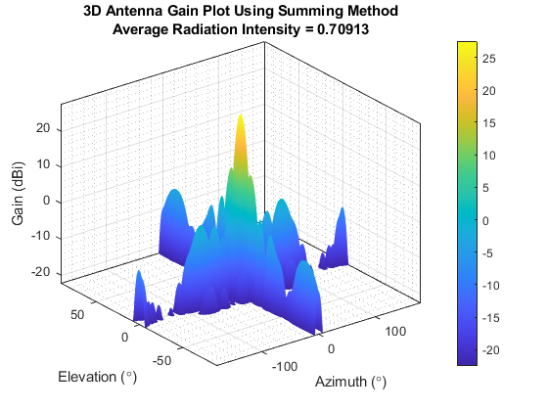
RF elements s.r.o. Antenna Pattern for UD-TP-27 Antenna | 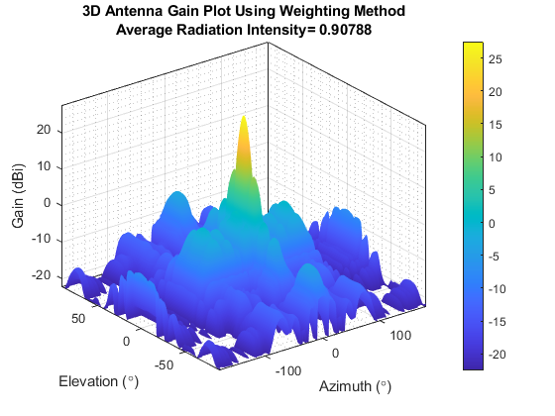

3 Summary
For the cases investigated the average radiation intensity value is larger for the weighting methodology than the summing gain methodology. It is encouraged to use the weighting methodology when a 3-D antenna radiation pattern is needed for studies.

4 References
- Makarov, Sergey N. Antenna and Em Modeling in MATLAB. Chapter3, Sec 3.4 3.8. Wiley Inter-Science.
- Balanis, C.A. Antenna Theory, Analysis and Design, Chapter 2, sec 2.3-2.6, Wiley.
- T. G. Vasiliadis, A. G. Dimitriou and G. D. Sergiadis, "A novel technique for the approximation of 3-D antenna radiation patterns," in IEEE Transactions on Antennas and Propagation, July 2005, vol. 53, no. 7: pp. 2212-2219.
- N. R. Leonor, R. F. S. Caldeirinha, M. G. Sánchez and T. R. Fernandes, "A Three-Dimensional Directive Antenna Pattern Interpolation Method," in IEEE Antennas and Wireless Propagation Letters, 2016, vol. 15, pp. 881-884.
- https://www.mathworks.com/help/antenna/ref/patternfromslices.html?searchHighlight=3d%20antenna%20from%202d&s_tid=srchtitle_3d%20antenna%20from%202d_5
- https://rfelements.com/products

______________

